MEMBERS
FINAL

Columbia Basin Fish and Wildlife Authority
Recommendations for Amendments to the
Northwest Power and Conservation Council
2000 Columbia Basin Fish and Wildlife Program

FINAL Draft for approval
Section 1, 2, and 5
April 2, 2008 Members meeting

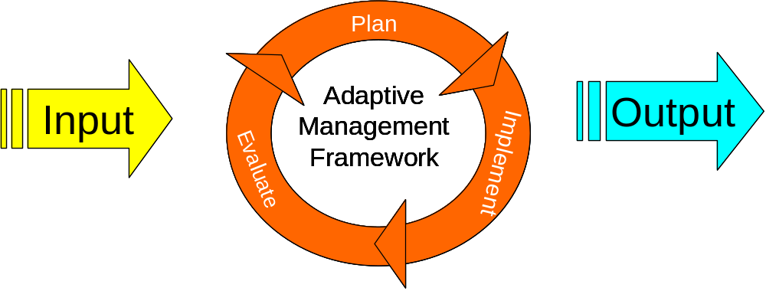

March 28, 2008

Table of Contents

Section 1.0. Amendments to the Introduction of the Program 5
Amendment 1.1. Include the Statutory Basis for the Federal and the region’s state fish and wildlife agencies and appropriate Indian Tribes participation in the Program 5
Amendment 1.2. Maintain the Geographic Program Structure and Include Anadromous Fish, Resident Fish, and Wildlife Sections at Each Level 6
Amendment 1.3. Combine the Elements of the Existing Program into One Document 7
Amendment 1.4. Include an Adaptive Management Architecture as the Framework of the Program 7
Amendment 1.5. Integrate Program the with the Plans of the Fish and Wildlife Managers (including Endangered Species Act) 9
Amendment 1.6. Integrate Program the with the Clean Water Act 10
Amendment 1.7. Clearly Establish the Intent of the Program’s Scope Consistent with the Northwest Power Act 10
Amendment 1.8. Clearly Define BPA’s Obligations in the Program, consistent with the Northwest Power Act. 11
Section 2.0. Recommended Amendment to the Basinwide Provisions 12
Amendment 2.0.1 Add Language to the Objectives for Biological Performance 12
Amendment 2.0.2 Reorganize the Strategies Section of the Program 12
Amendment 2.0.3 Include a Research, Monitoring and Evaluation Plan in the Overarching Strategies Section 12
Amendment 2.0.3.1 Status of the Resource Report 13
Amendment 2.0.3.2 Cooperative data compilation, development, distribution and reporting 13
Amendment 2.0.4 Add Coordination Measures as a Strategy in the Overarching Section 14
Amendment 2.0.5 Add Language Discussing the Impacts of Climate Change and Human Population Growth in the Overarching Strategies and Measures Section (Re-write) 15
Amendment 2.0.6 Add Language Supporting State Aquatic Nuisance Species Plans 15
Amendment 2.0.7 Fully Integrate the Columbia Basin Water Transactions Program into the Program 16
Amendment 2.0.8 Add Provisions to Support the Fish and Wildlife Strongholds 16
Amendment 2.0.9 Add Provisions to Reduce Sea Lion Predation 17
Section 2.1. Anadromous Fish 18
Amendment 2.1.1 Current Biological Condition 18
Amendment 2.1.2 Biological Objectives 19
Amendment 2.1.3 Limiting Factors 20
Amendment 2.1.4 Strategies and Measures 21
Amendment 2.1.4.4 Consider Results from Hatchery Review Processes 22
Amendment 2.1.4.5 Add Language Supporting Water Quality Measures in the Overarching Strategies and Measures Section 22
Amendment 2.1.5 Monitoring 23
Amendment 2.1.5.1 Monitoring Measures 27
Amendment 2.1.5.2 Collaborative Systemwide Monitoring and Evaluation 28
Amendment 2.1.5.3 Level 2 PIT Tag Needs 30
Amendment 2.1.5.4 Fish Passage Center 32
Amendment 2.1.5.5 Salmon and Steelhead Life Cycle Monitoring 32
Amendment 2.1.5.6 Columbia River PIT Tag Information System 33
Amendment 2.1.5.7 Regional Mark Processing Center (RMPC) (Evaluation Context) 33
Amendment 2.1.5.8 Anadromous Fish Evaluation Program (AFEP) (Level 3a) 34
Amendment 2.1.5.9 Harvest Specific Monitoring Measures (Level 3b) 34
Amendment 2.1.5.10 Hatchery Specific Monitoring Measures (level 3b) 35
Amendment 2.1.5.11 Habitat Specific Monitoring Measures (Level 3b) 36
Amendment 2.1.5.12 Critical Uncertainties 37
Amendment 2.1.6 Identify Specific Reporting Requirements for the Program 38
Amendment 2.1.7 Evaluation 38
Amendment 2.1.8 Adjustment in Program Direction 38
Section 2.2. Resident Fish 39
Amendment 2.2 Include in Appendix A: Glossary, the following information for the definition of Resident Fish 39
2.2.1 Report the Current Biological Condition for Resident Fish Populations 39
Amendment 2.2.2 Maintain the Current Basinwide Objectives for Biological Performance in the Program 39
Amendment 2.2.3 Outline the Current Limiting Factors Affecting Resident Fish Populations 40
Amendment 2.2.4 Provide Priorities and Principles for Resident Fish Strategies and Measures 41
Amendment 2.2.5 Include a Statement Regarding Monitoring of Resident Fish Populations 44
Amendment 2.2.6 Identify Specific Reporting Requirements for the Program 45
Amendment 2.2.7 Identify How Evaluation of the Resident Fish Section of the Program Will Occur 46
Amendment 2.2.8 Explain How Adjustment in Program Direction Will Occur Over Time 46
Section 2.3. Wildlife 47
Amendment 2.3.1 Include the Current Ledger for Wildlife 47
Amendment 2.3.2 Update the Current Basinwide Objectives for Biological Performance for Wildlife 50
Amendment 2.3.3 Include the Current Limiting Factors Affecting Wildlife 50
Amendment 2.3.4 Provide Priorities and Principles for Wildlife Strategies and Measures 52
Amendment 2.3.5 Include a Statement Regarding Monitoring of Wildlife 58
Amendment 2.3.6 Identify and Support Specific Reporting Requirements for the Program 58
Amendment 2.3.7 Identify How Evaluation of the Wildlife Section of the Program Will Occur 59
Amendment 2.3.8 Explain How Adjustment in Program Direction Will Occur Over Time 59
Section 3.0. Recommended Amendment to the Ecological Province, Subbasin, and Focal Species Provisions for Anadromous Fish 60
3.1 Columbia River Estuary Province and Ocean 60
3.2 Lower Columbia Province 60
3.3 Columbia Gorge Province 60
3.4 Columbia Plateau Province 60
3.5 Columbia Cascade Province 60
3.6 Blue Mountain Province 60
3.7 Mountain Snake Province 60
3.8 Lamprey 60
3.9 Eulachon (Smelt) 60
Section 4.0. Recommended Amendment to Subbasin and Focal Species Provisions for Resident Fish 61
Section 4.1 Lower Columbia Province 61
Section 4.2 Columbia Gorge Province 61
Section 4.3 Columbia Plateau Province 61
Section 4.4 Columbia Cascade Province 61
Section 4.5 Intermountain Province 61
Section 4.6 Mountain Columbia Province 61
Section 4.7 Blue Mountain Province 61
Section 4.8 Mountain Snake Province 61
Section 4.9 Middle Snake Province 61
Section 4.10 Upper Snake Province 61
Section 5.0. Recommended Amendment to the Implementation Provisions 62
Section 5.1. Implementation Funding Provisions 62
Amendment 5.1.1 The Program Should Define BPA’s In-Lieu Funding Restrictions 62
Amendment 5.1.2 The Program Should Ensure that Funding for Fish and Wildlife Actions can be Carried Over to Spend on Fish and Wildlife 63
Amendment 5.1.3 The Program Should Include a Capitalization Policy for Fish and Wildlife-related Expenditures 63
Amendment 5.1.4 The Council Should Investigate Innovative Ways to Ensure Cost Effective Administration of Program 64
Amendment 5.1.5 The Program Should Discuss the Relationship Between Project Funding and BPA Rate Case 65
Amendment 5.2. The Project Solicitation Process 65
Amendment 5.2.1 Coordination with other Implementation Processes 66

Appendices
Table of Figures
Table of Tables

Columbia Basin Fish and Wildlife Authority Program Amendment Recommendations
Section 1.0. Amendments to the Introduction of the Program
Amendment 1.1. Include the Statutory Basis for the Federal and the region’s state fish and wildlife agencies and appropriate Indian Tribes participation in the Program
Include the following language in the Introduction of the Program:
Under the Pacific Northwest Electric Power Planning and Conservation Act of 1980 (Northwest Power Act), Congress established the Northwest Power Planning Council (now the Northwest Power and Conservation Council (Council)) and directed the Council to develop “a program to protect, mitigate and enhance fish and wildlife, including related spawning grounds and habitat, on the Columbia River and its tributaries.” The Northwest Power Act envisions a participatory process that depends on the expertise of the fish and wildlife managers. The Northwest Power Act requires the Council to adopt the recommendations of federal, state and Tribal fish and wildlife agencies as part of the Fish and Wildlife Program (Program), unless the Council explains in writing how the recommendations are inconsistent with the Northwest Power Act or less effective than the adopted recommendations.
The Northwest Power Act directs the Council to request recommendations from federal agencies and the region’s state fish and wildlife agencies and appropriate Indian tribes for:
(A) measures which can be expected to be implemented by the [Bonneville] Administrator … to protect, mitigate, and enhance fish and wildlife, including related spawning grounds and habitat, affected by the development and operation of any hydroelectric project on the Columbia River and its tributaries;
(B) establishing objectives for the development and operation of such projects on the Columbia River and its tributaries in a manner designed to protect, mitigate, and enhance fish and wildlife; and
(C) fish and wildlife management coordination and research and development (including funding) which, among other things, will assist protection, mitigation, and enhancement of anadromous fish at, and between, the region’s hydroelectric dams.
The Northwest Power Act directs the Bonneville Power Administration [Bonneville (BPA)] and other federal agencies responsible for operating, or regulating federal or non-federal hydroelectric facilities to consider the Council’s Program “at each relevant stage of decision making,” and exercise statutory responsibilities, “to the fullest extent practicable” consistent with the Council’s Program. Bonneville also is to use the Bonneville Fund “to protect, mitigate, and enhance fish and wildlife" adversely affected by the production of hydroelectric power on the Columbia River “in a manner consistent with" the Council's Program.
The Council is directed to develop its fish and wildlife program on the basis of recommendations received from the fish and wildlife agencies, appropriate Indian tribes, the region’s water management and power producing agencies and their customers and the public generally. The Council is to include in the program measures that will:
(A) complement the existing and future activities of the federal and the region's state fish and wildlife agencies and appropriate Indian tribes;
(B) be based on, and supported by, the best available scientific knowledge;
(C) utilize, where equally effective alternative means of achieving the same sound biological objective exist, the alternative with the minimum economic cost;
(D) be consistent with the legal rights of appropriate Indian tribes in the region; and
(E) in the case of anadromous fish:
(i) provide for improved survival of such fish at hydroelectric facilities located on the Columbia River system; and
(ii) provide flows of sufficient quality and quantity between such facilities to improve production, migration, and survival of such fish as necessary to meet sound biological objectives.
The Northwest Power Act directs the Council to resolve inconsistencies between program recommendations by “giving due weight to the recommendations, expertise, and legal rights and responsibilities of the federal and the region's state fish and wildlife agencies and appropriate Indian tribes.” The Council may chose to reject a recommendation of a fish and wildlife agency or tribe only if the recommendation is inconsistent with the statutory requirements, or is “less effective than the adopted recommendations for the protection, mitigation, and enhancement of fish and wildlife.”
Amendment 1.2. Maintain the Geographic Program Structure and Include Anadromous Fish, Resident Fish, and Wildlife Sections at Each Level
Include the following language in the Introduction of the Program:
This Program will continue to maintain the geographic structure established by the 2000 Program. To complement the existing and future activities of the federal, state and Tribal fish and wildlife managers each of the geographic sections include separate anadromous fish, resident fish and wildlife sections.
The resident fish program has two important components: resident fish substitution and resident fish mitigation. The resident fish portion of the Program is most appropriately planned, implemented, and evaluated at the basinwide and subbasin scales.
Due to the strictly defined nature of habitat mitigation, and the migratory nature of much of the focal wildlife populations, the wildlife portion of the Program is most appropriately planned, implemented, and evaluated at the basinwide scale.
Amendment 1.3. Combine the Elements of the Existing Program into One Document
Include the following language in the introduction of the Program:
Currently the Fish and Wildlife Program consisted of the 2000 Program, the 2003 Mainstem Amendments, and the 57 subbasin plans adopted in 2004-2005. This Program now combines the Mainstem Amendments and updated subbasin plan summaries into one document. Consolidating Program documents will provide for the transparent linkages necessary for the adaptive management framework discussed in Amendment 1.4. Updated summaries of each subbasin plan are provided in Section 3 and 4, which include updated objectives for each species, based on existing fish and wildlife management plans, including NOAA Fisheries and U.S. Fish and Wildlife Service (USFWS) interim, proposed, and final recovery plans, and other updated fish and wildlife plans. The sub-basin plans will continue to be included as part of the Program in their entirety. Furthermore, where Endangered Species Act (ESA) recovery plans are available, those plans provide more specific detailed updates that will be incorporated into certain sections of subbasin plans where applicable, see recommended amendment 1.5. Adaptive management will be applied as new information becomes available.
Amendment 1.4. Include an Adaptive Management Architecture as the Framework of the Program
Include the following language in the introduction of the Program:
Adaptive management is built on the principle of learning by doing. Natural resource management is not an exact science. Therefore, the premise of this Program is to state hypotheses then implement measures contained herein and monitor, report, and evaluate outcomes to provide a clear sequential structure to decisions required in the continuing evolution of the Program.
The Program will contain or have provisions to develop or track the following essential adaptive management elements:
- Updates of the current status of the fish and wildlife resources this plan is intended to protect, mitigate, and enhance;
- Biological objectives and current gaps between objectives and status for the fish and wildlife resources of this plan;
- Limiting factors and threats, quantified in terms of their relationship to the biological objectives with associated assumptions, hypotheses and critical unknowns;
- Strategies and measures linked to limiting factors and threats with a quantification of expected outcomes toward the filling of the gaps identified in step 2;
- A Monitoring Plan and research priorities that will track status and trends of focal species and their threats and limiting factors, collect the information necessary to test assumptions and hypotheses, address critical uncertainties, and evaluate the implementation of measures;
- Reporting of accumulated monitoring and research information which will be used to carry out steps 7 and 8;
- An evaluation process that deliberately contemplates the information from steps 1–6 to verify or adjust assumptions and hypotheses, adjusts biological objectives, and adjusts strategies and measures; and,
- A process for adjusting the implementation of the Program to align with the changes identified in step 7.
Each of these eight steps is required to support a transparent, accountable, and effective planning, implementation and evaluation process. In this process, measures are the actions, or prescriptions for actions. They implement strategies to address the limiting factors that create the gaps in biological productivity of the focal populations.

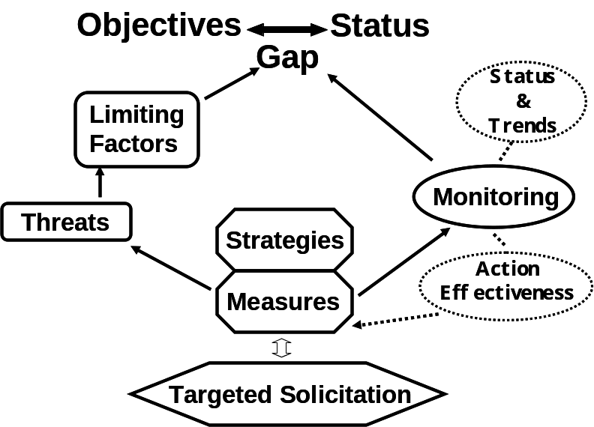

Figure 1.3. Adaptive management architecture to support decision making in the Columbia River Fish and Wildlife Program, arrows indicate quantifiable linkages.
Amendment 1.5. Integrate Program the with the Plans of the Fish and Wildlife Managers (including Endangered Species Act)
Include the following language in the introduction of the Program:
The Northwest Power Act calls on the Council to include in the Program measures that complement the existing and future activities of the federal, state, and Tribal fish and wildlife managers. To this end, the Program incorporates implementation of the ESA into the Fish and Wildlife Program to the extent possible. Specifically, the Program measures identified here were developed based on analyses that synthesized information from updated Subbasin Plans, NOAA Fisheries Recovery Plans, NOAA Fisheries Draft Biological Opinion(s) for the Federal Columbia River Power System (FCRPS), USFWS Biological Opinion(s) for the FCRPS, and other plans of the fish and wildlife agencies and tribes. The Program contains provisions that require BPA to clearly identify its ESA obligations early in the project selection process, so they can be considered during project review. Furthermore, the project selection process will be coordinated with the ESA recovery implementation forums, for example the State of Washington’s salmon recovery boards and Oregon’s emerging Recovery Sounding Boards.
This Program incorporates updates to subbasin plans from ESA recovery plans. Program biological objectives will be pursued in a manner that does not prevent, diminish, or slow the attainment of ESA recovery for these species. Furthermore, the ESA recovery plans provide limiting factors, strategies, actions, and implementation plans that are specific to each population.
The Council recognizes that federal agency responsibilities under Section 7 of the ESA represent the measures necessary to ensure their actions do not jeopardize listed species or adversely affect their critical habitat. In addition, those actions should ensure an adequate potential for the eventual recovery of the listed species. However, the Northwest Power Act requires more than just ensuring fish and wildlife resources in the Columbia River do not go extinct as a result of operations of the hydropower system. The Northwest Power Act requires the Fish and Wildlife Program to “protect, mitigate, and enhance” fish and wildlife resources of the Columbia Basin to the extent adversely affected by hydroelectric development. Examples include measures to protect fish and wildlife populations not listed under the ESA.
Amendment 1.6. Integrate Program the with the Clean Water Act
Include the following language in the introduction of the Program:
The Council recognizes that the Columbia River and many of its tributaries are currently listed as water quality-limited water bodies. Council understands that pollutants adversely affect several beneficial uses including a healthy functioning ecosystem, fish passage and migration. Council supports the region in meeting its collective Clean Water Act responsibilities and identifies measures that address water quality.
Amendment 1.7. Clearly Establish the Intent of the Program’s Scope Consistent with the Northwest Power Act
Include the following language in the introduction of the Program:
The Northwest Power Act requires BPA and other federal agencies to act in a manner consistent with the Council’s Program. Bonneville and other federal agencies responsible for operating, or regulating federal or non-federal hydroelectric facilities are required to consider the Program “at each relevant stage of decision making,” and exercise statutory responsibilities, “to the fullest extent practicable” consistent with the Council’s Program.
To that end this Program provides measures, where applicable, that are to be implemented by BPA, the U.S. Army Corp of Engineers (Corps), the Bureau of Reclamation, and the Federal Energy Regulatory Commission (FERC), through its licensing and re-licensing actions.
Additionally, the Council calls for BPA to provide funding to maintain a comprehensive data base of restoration activities occurring within each of the Program’s subbasins. This will insure coordination and integration between the BPA funded projects and those funded through other sources. The database shall be summarized within the federal and the region's state fish and wildlife agencies and appropriate Indian tribes Status of the Resource Report.

Amendment 1.8. Clearly Define BPA’s Obligations in the Program, consistent with the Northwest Power Act.
Include the following language in the introduction of the Program:
The Northwest Power Act directs the Council to request recommendations “for measures which can be expected to be implemented by the [Bonneville] Administrator.” The Northwest Power Act requires the Bonneville Administrator to use the Bonneville Fund “to protect, mitigate, and enhance fish and wildlife" adversely affected by the production of hydroelectric power on the Columbia River “in a manner consistent with" the Council's Program. Therefore, the Program identifies specific measures to be implemented with BPA funding, consistent with the Subbasin Management Plans described in the 2000 Program. These Measures are scientifically tied to biological objectives, with expected outcomes at the appropriate scale, and are set within the context of other known activities occurring within the subbasins or the broader Columbia River Basin. The analysis by the fish and wildlife agencies and tribes is an illustration of the linkage between impacts of the FCRPS and potential offsite mitigation actions.
Section 2.0. Recommended Amendment to the Basinwide Provisions

Amendment 2.0.1 Add Language to the Objectives for Biological Performance
Add the following language to this paragraph in the Objectives for Biological Performance – “The Council recognizes that significant losses of anadromous fish, resident fish, and wildlife and their habitats have occurred as a result of the development and operation of the hydrosystem. To be consistent with the Power Act, these losses establish the underlying basis for population objectives for the program as a whole. Collectively, specific biological objectives should represent what is considered to be mitigation for losses under the program.”
Construction and operation of the FCRPS is a major threat for many species of fish and wildlife in the Columbia River Basin, and the adverse impacts of the hydroelectric system are a major limiting factor. Achieving the biological objectives expressed in the Program may or may not represent the sole responsibility of the FCRPS. However, the FCRPS mitigation responsibility is large enough that for several species, progress towards meeting the overarching biological objectives identified in the Program are indicators of whether implementation of Program is adequate to meet mitigation responsibilities.
Amendment 2.0.2 Reorganize the Strategies Section of the Program
Maintain the language in the current Strategies section of the Program, but reorganize the information into Overarching Strategies and Measures, Anadromous Fish Strategies and Measures, Resident Fish Strategies and Measures, and Wildlife Strategies and Measures.

Amendment 2.0.3 Include a Research, Monitoring and Evaluation Plan in the Overarching Strategies Section
Include the following language in the Overarching Strategies section of the Program:
The Research Monitoring and Evaluation (RM&E) plan provides the foundation for the Program’s adaptive management framework [as presented previously in Amendment 1.4 of these recommendations]. The adaptive management framework supports management decisions to implement mitigation and enhancement measures by evaluating their effectiveness, and iteratively adjusting those decisions to meet management objectives.
The federal and state fish and wildlife agencies and Tribes are the legally recognized managers of the fish and wildlife resources based on federal and state statutes, treaties and court actions. These agencies and tribes maintain expertise and authority to manage fish and wildlife resources and, with relevant recovery planning efforts and habitat management entities, are key partners in the design, implementation and analysis of regional monitoring programs. The success of mitigation and recovery efforts under the Program will be assessed through regional monitoring and evaluation.
The RM&E plan is built upon the following principles:
- The RM&E plan is designed to be consistent with Section 4(h)(6) of the Northwest Power Act in that it “complements the existing and future activities of the federal and the region’s state fish and wildlife agencies and appropriate Indian tribes”, is “based on, and supported by, the best available scientific knowledge”, “utilize(s), where equally effective alternative means of achieving the same sound biological objective exist, the alternate with the minimum economic cost”, and is consistent with the legal rights of appropriate Indian tribes in the region.”
- The RM&E plan is designed to complement and enhance the existing and future programs of the fish and wildlife management agencies and tribes including ESA-based recovery plans.
- The RM&E plan integrates existing and planned status and trend, hatchery, harvest, hydro system and habitat monitoring into a framework that addresses local and regional needs.
- The RM&E plan is designed to provide the foundation for implementation of the adaptive management framework previously described in Amendment 1.4 of these program recommendations
- The RM&E plan will collect data to assess Program objectives and performance standards (e.g. Smolt-to-Adult returns, viability criteria, catch per effort, and habitat condition).
- The RM&E plan will be designed such that the accuracy and precision of the data are within acceptable risks associated with making decisions in a timely manner at the desired scale.
- The RM&E plan integrates life history stages and data are collected for multiple species in an efficient manner.
- The RM&E plan articulates the data management and reporting needs to support adaptive management.

Amendment 2.0.3.1 Status of the Resource Report
Include the following language in the Overarching Strategies section of the Program:
Bonneville will fund the production of an annual Status of the Resource Report to report progress towards Biological Objectives and implementation of the Fish and Wildlife Program, consistent with requirements of other regional reports such as the Council’s Fish and Wildlife Expenditures Report to the Governors and the Washington State of Salmon in Watersheds Report.

Amendment 2.0.3.2 Cooperative data compilation, development, distribution and reporting
Include the following language in the Overarching Strategies section of the Program:
Bonneville will fund the fish and wildlife managers in cooperation with other appropriate entities to provide access to data from collection through to reporting.
Specific activities include:
- Provide information management services to assist the agencies and tribes to make their data available to support regional reporting for the Program,
- Coordinate with the Status of the Resource Project to provide access support to agency and tribal fish and wildlife data,
- Maintain and update databases of fish and aquatic data (e.g., fish distribution, adult abundance, GIS streams layer, hatchery releases, hatchery returns, dams and fish passage facilities, hatchery facilities, harvest, Council Protected Areas, smolt density model data, Subbasin Planning data, independent data sets, genetics, etc.),
- Maintain the appropriate web sites to allow access to regionally consistent short and long-term time series data in both tabular and GIS formats,
- Support data inventory and other regional requirement for RM&E as necessary,
- Support development of advanced data management systems within data creating agencies to improve data flow to the Status of the Resource Project and other regional scale data outlets,
- Coordinate basinwide monitoring and data programs through interagency forums.
- Maintain depositories of region-wide fish and wildlife reports and publications, linked to StreamNet data where appropriate.
- Continue to use PISCES to track project implementation information.

Amendment 2.0.4 Add Coordination Measures as a Strategy in the Overarching Section
Include the following language in the Overarching Strategies section of the Program:
The Program requires the active participation by individual agencies and tribes in its planning, implementation, and evaluation to ensure goals and objectives, and other program measures, are effectively integrated with the management programs of each sovereign fish and wildlife agency and tribe and that the policy and technical basis for regional decision making is consistent with those programs. As coordinating entities, it is the responsibility of agencies and tribes to ensure their policy and technical representatives dedicate time and effort as necessary to ensure the Fish and Wildlife Program is integrated with other management programs and is designed, implemented, and evaluated so that anticipated benefits accrue to fish and wildlife. Bonneville will fund the fish and wildlife agencies and tribes’ coordination efforts to ensure appropriate and meaningful participation in Program decision making. The fish and wildlife agencies and tribes will define their coordination needs, which may or may not include membership organizations, and provide recommendations to Council and BPA.
Bonneville will fund data management and reporting that will support the monitoring and evaluation requirements for the Program. A significant amount of the information necessary to report and evaluate Program and project performance is collected outside of Program funding. Nevertheless, BPA funding is required for the activities necessary to make that information easily accessible and available in a regionally consistent format for decision makers to successfully implement the Program.

Amendment 2.0.5 Add Language Discussing the Impacts of Climate Change and Human Population Growth in the Overarching Strategies and Measures Section (Re-write)
Include the following language in the Overarching Strategies section of the Program:
The Program includes planning measures to address the potential impacts of global climate change and population growth on fish and wildlife resources in the Columbia River Basin.

Amendment 2.0.6 Add Language Supporting State Aquatic Nuisance Species Plans
Include the following language in the Appendix A: Glossary of the Program:
Nonnative aquatic species may be released or “introduced” into an aquatic environment intentionally or unintentionally. Most often, such species are unable to adapt to their new environments and do not form self-sustaining populations. However, if such a species is able to adapt, become established, and thrive, it has the potential to threaten the diversity or abundance of native species and aquatic habitats and may even affect economic resources and human health. Such species are considered aquatic nuisance species (ANS).
A definition for the term aquatic nuisance species is a “nonnative aquatic plant or animal species that threatens the diversity or abundance of native species, the ecological stability of infested waters, or commercial, agricultural, or recreational activities dependent on such waters.” Since few natural controls exist in their new habitat, ANS may spread rapidly, damaging recreational opportunities, lowering property values, clogging waterways, impacting irrigation and power generation, destroying native plant and animal habitat, and sometimes destroying or endangering native species.
Include the following language in the Overarching Strategies section of the Program:
Aquatic nuisance species can threaten the diversity and abundance of native species and aquatic habitat. They can also significantly threaten infrastructure such as hydroelectric facilities. Currently the greatest known ANS threat to the region is the zebra\quagga mussel (Dreissena sp). This invasive mussel has caused significant economic and ecological impacts in the Great Lakes region and eastern United States. It has now arrived in the lower Colorado River drainage and connected waterways in Arizona and California. Economic costs to manage this species are in the hundreds of millions dollars annually. Ecosystem impacts included a decline in food chain productivity for fish, loss of recreational beaches, and degradation of drinking water quality. Potential impacts to the Columbia Basin projects include significant increases in maintenance costs at existing dams to maintain turbine cooling water systems, cleaning fish passage systems to prevent cuts and abrasions to salmon and steelhead, along with loss of basic productivity.
The states of Washington, Oregon, Idaho, and Montana have all developed Aquatic Nuisance Species Management Plans, which have been accepted by the national Aquatic Nuisance Species Task Force. These complementary plans identify potential threats from ANS, preventative and early detection measures, invasion pathways, and control actions if ANS are found in the basin. Pacific States Marine Fisheries Commission (PSMFC), in collaboration with federal, state, Tribal and private sector organizations is coordinating various efforts to prevent and control ANS in the Pacific region. Additional effort and funding is needed to comprehensively address ANS issues specific to the Columbia River Basin.

Amendment 2.0.7 Fully Integrate the Columbia Basin Water Transactions Program into the Program
Include the following language in the Overarching Strategies section of the Program:
Bonneville will fund the continuation of the Columbia Basin Water Transactions Program (CBWTP) to pursue acquisition of water rights in subbasins where water quantity has been identified as a primary limiting factor to meet the biological objectives within the subbasin plans. The CBWTP will continue to support the full range of temporary and permanent transaction tools for instream flow restoration. The CBWTP will coordinate with the fish and wildlife managers and other project sponsors to integrate instream water transactions with efforts to address other ecological factors that are limiting fish habitat and to develop cost-effective water quantity reporting standards. Finally, the CBWTP will seek closer integration of land and water acquisition activities and move towards an integrated land and water acquisition program.

Amendment 2.0.8 Add Provisions to Support the Fish and Wildlife Strongholds
Include the following language in the Strategies section of the Program:
The Council will make fish and wildlife strongholds a focus in the Program. A stronghold refers to a watershed, multiple watersheds, or other defined spatial units (tributaries or focal action areas) where populations are strong, diverse, and includes areas that provide critical life-cycle requirements of aquatic species. Stronghold habitat has a high intrinsic potential to support a particular species, or suite of species, and is expected to afford a measure of productivity resilience under predicted scenarios of climate change. Focus strongholds must be consistent with the population objectives and measures identified in subbasin plans.

Amendment 2.0.9 Add Provisions to Reduce Sea Lion Predation
Include the following language in the Strategies section of the Program:
The vulnerability of fish to California and Steller sea lion predation is significantly exacerbated by Bonneville Dam as it restricts fish passage and favors these predators.
Bonneville and the Corps shall provide funding to support the following measures:
- Support land and water based harassment efforts by NOAA Fisheries, ODFW, WDFW and the Tribes to keep sea lions away from the area immediately downstream of Bonneville Dam;
- Provide and improve Sea Lion Exclusion Devices (SLEDs) to to protect fishway entry at Bonneville Dam;
- Support development, testing, and implementation of non-lethal deterrence alternatives;
- Provide assistance and support to the states for the removal of animals as authorized under Section 120 of the Marine Mammal Protection Act;
- Document foraging activities of individually identifiable pinnipeds in the Columbia River below Bonneville Dam;
- Provide assistance and support to states for the removal animals as authorized under section 120 of the MMPA;
- Estimate overall sea lion abundance immediately below Bonneville Dam; and,
- Monitor the spatial and temporal distribution of sea lion predation attempts and estimate predation rates.

Section 2.1. Anadromous Fish

Amendment 2.1.1 Current Biological Condition
Include the following language in the Anadromous Strategies section of the Program:
The Columbia River Basin includes six provinces in which anadromous salmonids are extant. These anadromous salmonid species include spring Chinook salmon, spring/summer Chinook salmon, summer/fall Chinook salmon, fall Chinook salmon, summer steelhead, winter steelhead, coho salmon, chum salmon, and sockeye salmon (Table 2.1). Pacific lamprey are also present in these provinces. Subbasin plans included biological objectives for many, but not all, anadromous populations.

Table 2.1.1: Recent aggregate adult returns in each province.

This table is incomplete at this time and should be revised to include estimates of natural, hatchery, harvest, and broodstock components during the development of the 2008 Program amendments and be clear about the relationship of this table to the objective of achieving 5 million salmon and steelhead above Bonneville Dam.
Province,  species | Number of subbasins with data | Recent aggregate adult returns
Lower Columbia
Spring Chinook | 6 of 8 | 36,617-110,999
Fall Chinook | 7 of 8 | 28,351-88,531
Summer steelhead | 3 of 8 | 1,072-2,335
Winter steelhead | 8 of 8 | 4,047-9,997
Coho | 1 of 8 | --
Chum | 1 of 8 | 3,032-10,932
Columbia Gorge
Spring Chinook | 2 of 6 | 968-1,285
Fall Chinook | 5 of 6 | 8,081-32,572
Summer steelhead | 3 of 6 | 1,472-2,599
Winter steelhead | 2 of 6 | 732-2,627
Coho | 0 of 6 | --
Chum | 0 of 6 | --
Columbia Plateau
Spring Chinook | 3 of 6 | 8,589-12,832
Fall Chinook | 4 of 6 | 16,037-24,266
Summer steelhead | 5 of 6 | 9,864
Coho | 1 of 6 | 3,820-8,319
Sockeye | 0 of 6 | --
Columbia Cascade
Spring Chinook | 3 of 4 | 242-14,794
Summer/fall Chinook | 1 of 4 | 2,209-4,630
Summer steelhead | 4 of 4 | 391-3,973
Coho | 2 of 4 | --
Sockeye | 1 of 4 | 10,586-78,053
Blue Mountain
Spring/summer Chinook | 3 of 4 | 1,436-1,486
Fall Chinook | 2 of 4 | 7,000
Summer steelhead | 1 of 4 | 814
Mountain Snake
Spring/summer Chinook | 1 of 2 | 11,802
Fall Chinook | 1 of 2 | 1,273
Summer steelhead | 0 of 2 | --
Coho | 1 of 2 | 512
Sockeye | 1 of 2 | 3-27
Pacific lamprey

Amendment 2.1.2 Biological Objectives
Maintain the current basinwide biological objectives expressed in the 2000 Program with two modifications shown here in bold (to represent a 10 year implementation plan for these recommendations):
“Halt declining trends in salmon and steelhead populations above Bonneville Dam by 2018 (2005). Obtain the information necessary to begin Begin restoring the characteristics of healthy lamprey populations.
Restore the widest possible set of healthy naturally reproducing populations of salmon and steelhead in each relevant province by 2018 (2012). Healthy populations are defined as having an 80 percent probability of maintaining themselves for 200 years at a level that can support harvest rates of at least 30 percent, so long as ESA recovery objectives can be met and there is no contribution to further ESA listings.
Increase total adult salmon and steelhead runs, in a manger consistent with achieving recovery of ESA listed populations and prevents additional listings of listed species, above Bonneville Dam by 2025 to an average of 5 million annually in a manner that supports tribal and non-tribal harvest. Within 100 years achieve population characteristics that, while fluctuating due to natural variability, represent on average full mitigation for losses of anadromous fish caused by development and operation of hydroelectric facilities in the Columbia Basin.”
Continue to recognize productivity objectives for salmon and steelhead:
“As an interim objective, contribute to achieving smolt-to-adult survival rates (SARs) in the 2-6 percent range (minimum 2 percent; average 4 percent) for listed Snake River and upper Columbia salmon and steelhead.”
In addition, the Program should continue to recognize the mitigation responsibility for areas where anadromous fish have been extirpated:
“Part of the anadromous fish losses has occurred in the blocked areas. A corresponding part of the mitigation for these losses must occur in those areas. The Program has a "Resident Fish Substitution Policy" for areas where anadromous fish have been extirpated. Given the large anadromous fish losses in the blocked areas, these actions have not mitigated these losses. The following objectives address anadromous fish losses and mitigation requirements in all blocked areas:
Restore native resident fish species (subspecies, stocks and populations) to near historic abundance throughout their historic ranges where original habitat conditions exist and where habitats can be feasibly restored.
Take action to reintroduce anadromous fish into blocked areas, where feasible.
Administer and increase opportunities for consumptive and non-consumptive resident fisheries for native, introduced, wild, and hatchery-reared stocks that are compatible with the continued persistence of native resident fish species and their restoration to near historic abundance (includes intensive fisheries within closed or isolated systems).”

Amendment 2.1.3 Limiting Factors
Add a section to the Program that summarizes the factors limiting naturally produced salmon and steelhead across all of “the Hs”.
Include the following summary of factors limiting production of anadromous fish:
The relative effect on anadromous species of the Columbia River hydrosystem varies among provinces and subbasins. The hydrosystem affects focal populations to varying degrees in large part because the number of dams passed during migration ranges from zero to nine. In general, as fish pass more dams it becomes harder to mitigate for the effects of those dams. Also, the relative condition of habitat varies greatly among subbasins, with habitat in some areas being in near-pristine condition, whereas other areas have been severely degraded by current and past land use. The relative effect of harvest and artificial production varies by province and focal population, as well.
Include Table 2.1.3 which provides a summary of hydrosystem limiting factors and threats.

Table 2.1.3. Summary of hydrosystem-related limiting factors and threats:
Limiting Factor | Threat | Mechanism
Juvenile salmonids
Direct mortality | Hydrosystem operations | Turbine mortality
 | Hydrosystem construction/operation | Predation
 |  | Modification of rearing/migration habitat
Increased travel time | Hydrosystem construction/operation | Velocity modification
 |  | Bypass operations
 | Low velocity | Impoundments
 |  | Irrigation withdrawals
Delayed mortality | Transportation
Latent mortality | Hydrosystem construction/operation
Water quality | Hydrosystem operations | Warm water discharge
 |  | Cold water discharge
 |  | Dissolved gas
Adult salmonids
Passage survival | Hydrosystem operations
 | Transportation as juveniles
Water quality | Hydrosystem operations | Thermal barriers

Amendment 2.1.4 Strategies and Measures
Include the following language in the Anadromous Strategies section of the Program:
Strategies and measures necessary to make progress towards biological objectives vary among subbasins. Strategies and measures to address subbasin habitat effects are detailed for each subbasin in Section 3. Because strategies and measures to address mainstem passage effects vary little among provinces and subbasins, they are summarized here. Potential responses by salmonid populations to the suite of hydrosystem measures summarized here are given for each subbasin in Section 3.
Strategies and measures relate directly to the limiting factors and threats specified in Section 2.1.3. Earlier arrival time at Bonneville Dam is a key factor in survival rates. Surface bypass has been shown to be effective in low flow periods. Spill especially increases survival because migrating fish avoid turbine and bypass passage.

Table 2.1.4. Hydrosystem-related strategies and measures (add limiting factors):
Strategy | General Measure
2.1.4.1:  Manage juvenile migration to achieve earlier arrival time at Bonneville Dam. | - Provide migration velocity  - Provide spill  - Provide and evaluate surface bypass  - Reduce turbine and bypass passage
2.1.4.2:  Manage hydrosystem to increase juvenile survival. | - Provide spill  - Provide and evaluate surface bypass
2.1.4.3:  Reduce delayed and latent mortality of juveniles | - Provide spill  - Implement “spreas the risk” transportation

Amendment 2.1.4.4 Consider Results from Hatchery Review Processes
Add the following language to the Anadromous Strategies section of the Program:
Optimization of hatchery practices is an integral component of an All-H (Hydro, Harvest, Hatchery, and Habitat) management strategy to address recovery, restoration, and mitigation for anadromous salmonids in the Columbia River Basin. Results from Columbia River Basin hatchery review processes (e.g., USFWS National Fish Hatchery review, Hatchery Scientific Review Group, etc.) may be used to evaluate hatchery and harvest performance and improvement options. Incorporation of appropriate recommendations from these review processes will supplement existing and ongoing analyses of hydrosystem and habitat performance options.

Amendment 2.1.4.5 Add Language Supporting Water Quality Measures in the Overarching Strategies and Measures Section
Include the following language in the Overarching Strategies section of the Program:
The Columbia River and many of its tributaries are currently listed as water quality limited water bodies. Pollutants affect several beneficial uses including a healthy functioning ecosystem, fish passage and migration. The Program identifies measures to address the effects of hydropower system development and operation on the natural seasonal thermal patterns of the Columbia and Snake Rivers. The development of large reservoirs increased the cross sectional area of the river and reduced water velocity, increasing the solar heating and increasing water temperatures. The natural seasonal thermal pattern has shifted and may continue to shift because of hydropower system operations. The shift may alter the timing of salmonid spawning and the emergence and out-migration of juveniles. Changes in the natural seasonal thermal pattern may also have additional adverse impacts to juvenile fish such as reducing the available food supply and increasing habitat for predaceous native and non-native fish species.
  - The Program includes measures that improve cold water refugia and improve thermal conditions to meet federal and state Water Quality Temperature criteria.
  - The Council calls on BPA and other federal agencies responsible for managing, operating, and regulating Columbia River hydroelectric facilities to develop water quality plans for total dissolved gas and temperature in the mainstem Columbia and Snake Rivers which includes a comprehensive update of both total dissolved gas and temperature with dam specific structural and operational objectives and implementation strategies to benefit juvenile and adult fish.
  - The Council directs the federal operators and regulators to work with state, Tribal, and federal water quality agencies to meet the Total Maximum Daily Load (TMDL) implementation and Total Dissolved Gas (TDG) waiver requirements and to implement the recommendations of the state, Tribal, and federal fishery managers.
  - The Council supports Columbia River monitoring to better understand toxics and the relationship between fish abundance and return rates in watersheds with high levels of contaminants and to better understand how those contaminants are taken up by juvenile salmon and their effects on out migration.
  - Also, source identification in the watersheds would help to better understand the toxic loadings of contaminants of concern to the mainstem Columbia Basin.

Amendment 2.1.5 Monitoring
Add the following Conceptual Framework for Anadromous Fish to the Program:
The RM&E plan for anadromous fish is based in part on the adaptive management framework shown in Figure 1.4 and informs and supports steps 2, 3, 4, 7, 8 and 9 of the Conceptual Framework (Figure 2.1.5.1). The Monitoring Framework for the Program is organized into three Levels (Figure 2.1.5.2). Level 1 tracks population status and trends across the overall life-cycle of focal species. Level 2 provides for action effectiveness monitoring that tracks effectiveness of overall hydro system actions. Level 3 provides focus at key life stages (and associated limiting factors) effected by individual Hs (Hydro, Harvest, Hatchery, and Habitat). The Evaluation Context uses and builds on existing monitoring projects to adaptively evaluate and coordinate these programs. It will provide periodic reports and updates to the Council, federal, state and Tribal fish managers to update information on population metrics and indicators that inform progress toward achieving biological objectives. Practically speaking, all populations cannot be intensively monitored to provide high resolution information. Collaborative teams formed under the Evaluation Context will work to determine a mix of cost effective intensively monitored and index monitoring to adequately report status of fish populations compared to the biological objectives.

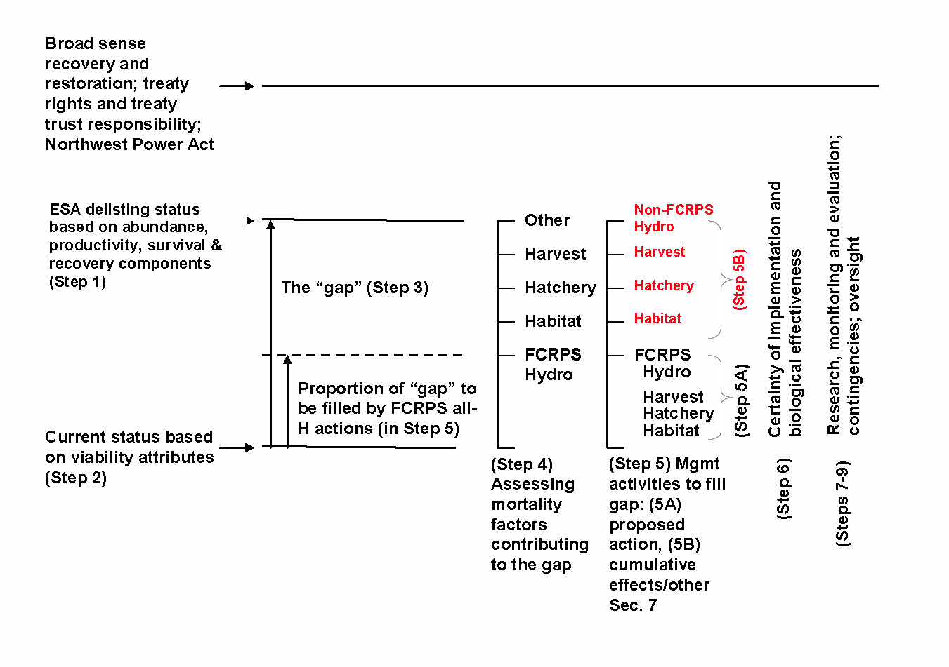

Figure 2.1.5.1. Conceptual Framework for Anadromous Fish.

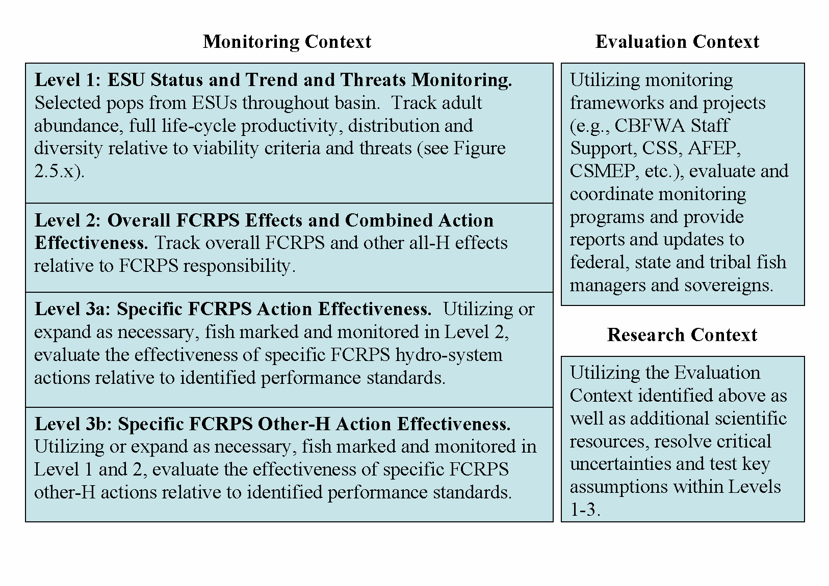
Figure 2.1.5.2. Monitoring Framework

Monitoring to track status and trend and action effectiveness is integrated throughout levels 1-3. This integration requires tracking survival at discrete life stages between spawning and the return of progeny to spawn for monitoring effectiveness of fish restoration management actions, as well as the effects of environmental stressors in tributaries, the mainstem Snake and Columbia Rivers, the estuary, and the ocean.
Monitoring of populations or population aggregates must (1) be spatially representative of the range and distribution of the various Columbia Basin populations, (2) be representative of both life-cycle experience differences and similarities (e.g., populations being directly compared share similar experiences within the estuary and ocean), and (3) be statistically valid with adequate sample sizes to detect differences among populations, across spatial distributions, and across temporal scales relative to varying human-induced and natural environmental stressors (Figure 2.1.5.3).

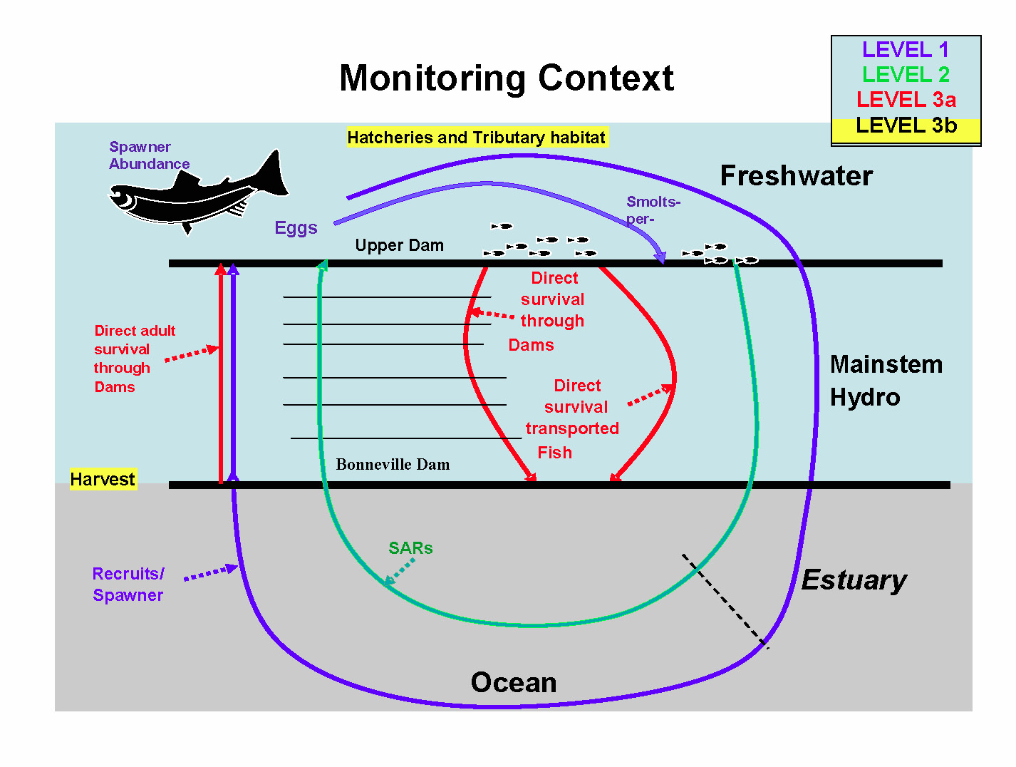
Figure 2.1.5.3. The monitoring context as it applies to anadromous fish population

The Program monitoring framework is consistent with NOAA Fisheries decision framework and monitoring guidance for ESA-listed salmon and steelhead (NOAA Fisheries 2007).
The evaluation context is based upon collaboration among the fish and wildlife agencies and tribes. To maximize efficiency, use of resources and application of developed products, the evaluation component of the RM&E plan should use existing, forums and structures wherever possible. The guiding principles for the evaluation component of RM&E are:
- Base RM&E on measuring progress towards quantifiable biological objectives.
- Collaboration among the fish and wildlife agencies, tribes, and others in the evaluation of the responses of listed salmon and steelhead and other focal species to management actions and in resolution of critical uncertainties about those responses.
- Maximize the use of existing entities and processes, as well as products and expertise. Maintain long-term continuity and consistency of established migration data time series such as survival, timing, travel time, passage distribution and smolt-to-adult return. Integrate RM&E programs basin-wide to maximize efficiency and multiple application to management questions.
- Emphasize increased efficiency and productivity of presently established RM&E programs and optimize the data collected for all species.
- Recognize and maintain the active management and decision making role of state, federal, Tribal and local resource managers in all levels of RM&E: Level 1- ESU status and trend monitoring, Level 2-Overall FCRPS Action Effectiveness, Level 3a- specific FCRPS Action Effectiveness, and Level 3b- Specific hatchery, harvest, and habitat (“Other-H”) action effectiveness.
A number of existing projects carry out functions and details of Level 1, 2 and 3 monitoring and evaluation in the Columbia River Basin. These include projects such as the Collaborative Systemwide Monitoring and Evaluation Project (CSMEP) number 200303600, Comparative Survival Study project 199602000, Smolt Monitoring Program project 198712700, and the Fish Passage Center project 199403300, funded by the BPA under the Fish and Wildlife Program, and projects by the Corps under the Anadromous Fish Evaluation Program (AFEP) of the Columbia River Fish Mitigation Project, as well as by project funded by various federal, state, local and Tribal agencies. To maximize funding efficiencies, ensure collaboration and improve transparency, the Council calls on the fish and wildlife managers, in collaboration with others, to develop and implement a regional monitoring and evaluation program that integrates ongoing monitoring and evaluation projects.

Amendment 2.1.5.1 Monitoring Measures
Add the following language to the Program to describe the monitoring measures for anadromous fish:
Level 1 monitoring tracks adult abundance, full life-cycle productivity, distribution, and diversity relative to Viable Salmonid Population (VSP) criteria as well as threats. The abundance and origin of spawners and their adult progeny, along with productivity, are the most important of the VSP metrics used to determine viability. Productivity is a derived metric based on abundance of adults. Recruitment requires knowing the origin of spawning fish (hatchery or wild) and their age at return. Because the estimate of productivity depends on knowing spawner abundance, the data quality of productivity can be no better than that of abundance. Tracking the status of the habitat and other subjects associated with threats and ESA limiting factors is an important aspect of Level 1 monitoring.
Level 2 monitoring tracks direct and delayed impacts of the FCRPS on fish survival relative to identified performance standards. This monitoring is long-term and concentrates on ESU and DPS stock aggregates to address potential impacts resulting from juvenile and adult migration experience through the FCRPS. This monitoring utilizes, or expands as necessary, fish marked and monitored in Level 1 to evaluate the overall effectiveness of FCRPS actions. For anadromous salmon and steelhead, effectiveness can be gauged relative to performance standards that quantify the magnitude of the actions’ effects on narrowing the survival gaps between current and desired status based on abundance/productivity, survival and recovery components (Figure 2.1.5.1).
Level 3 monitoring evaluates the effectiveness of specific actions intended to improve survival. Level 3a focuses on hydrosystem actions and Level 3b address hatchery, harvest, and habitat (“Other-H”) actions. Level 3a monitoring includes actions intended to alter/improve passage routing, reduce passage delay and travel time, and increase survival of fish migrating through the FCRPS. This monitoring utilizes, or expands as necessary, fish marked and monitored in Levels 1 and 2. Level 3b monitoring utilizes, or expands as necessary, fish monitored in Levels 1, 2 and 3a to evaluate the effectiveness of other-H actions. For salmonids, effectiveness is gauged relative to performance standards that provide a clear and defensible linkage to reducing the survival gaps between current and desired status based on abundance/productivity, survival and recovery components (Figure 2.5.1).
The evaluation context for RM&E includes components of federal, state, and Tribal collaboration and coordination of monitoring and evaluation efforts with other entities. This includes projects that evaluate and coordinate monitoring programs, and provide reports and updates to the region. In addition, this includes a process to optimize the efficiencies by integrating study design and implementation components across the monitoring levels. The research context addresses key assumptions and uncertainties within levels 1-3 that research projects should address. The following are the RM&E measures that should be incorporated into the Program. For each of the measures, the primary associated monitoring level is identified.

Amendment 2.1.5.2 Collaborative Systemwide Monitoring and Evaluation
Include the following language in the Program:
Fund the fish and wildlife managers to work with others to:
  - Coordinate, assemble, evaluate and report on fish status and trend monitoring metrics including abundance, productivity, spatial structure and diversity (VSP) (Level 1).
    - Develop standardized descriptions of the primary indicators used to assess VSP parameters in collaboration with fish and wildlife agencies and tribes
    - Characterize the metrics and methodologies used to estimate the primary indicators of VSP parameters
    - Inventory the available primary indicators used to estimate VSP parameters and identify populations without coverage.
    - Assess the metrics and methodologies used to estimate the primary indicators characterizing the adequacy of the information and identify the deficiencies
    - Evaluate and recommend the alternative integration and mix of monitoring activities that promote consistency so the data are comparable among all subbasins, and to optimize cost effective monitoring across all levels.
    - Annually report the VSP indicators through the Status of the Resource Report. Report on the findings and recommendations from the inventory, and the assessment of adequacies and deficiencies of the metrics and methodologies
  - Develop monitoring designs (informed by the findings and recommendations in 6, above), and estimate their accuracy, precision and cost to describe population status and trends that inform biological objectives. Ensure that the estimated metrics represent appropriate spatial, temporal, and population scales (Level 1).
  - Periodically estimate population status and trends of fish species (e.g. every five years) (Level 1).
  - Work with land and water resource management agencies to assemble and report habitat metrics at appropriate biological scales in the Status of the Resource Report. These may include watershed condition, miles of accessible stream, 303D listings Clean Water Act standards (examples: temperature, turbidity, contaminants). Coordinate with other regional reports such as EPA’s State of the River Report, Washington State of Salmon in Watersheds Report (Level 1)
  - Periodically assess the monitoring associated with management decisions and recommend improved designs integrated across the monitoring levels (Evaluation Context).
  - Develop and maintain run-reconstructions (systematic organization of all mortality sources by origin (hatchery or wild) and age in lifecycle framework data sets) for each appropriate biological scale. Continue maintenance of TRT data sets and include populations and focal species that are not protected under ESA (Evaluation Context).
  - Work with the Ad Hoc Supplementation Work Group (AHSWG) to implement the recommended Stray Ratio and Relative Reproductive Success designs as outlined in the Collaborative Systemwide Monitoring and Evaluation Project (CSMEP) Snake Basin Pilot reports (Marmorek et al. 2007a and b) and largely incorporated and expanded upon in the AHSWG report (Galbreath et al. 2008 draft), and in future habitat effectiveness monitoring. Annually oversee implementation of the regional monitoring program and reporting (Level 3b). Work jointly with the U.S. vs. Oregon Technical Advisory Committee and technical committees under the Pacific Salmon Commission to develop an improved modeling interface between Columbia River and ocean fisheries Level 3 b).
  - Review the results of Intensively Monitored Watersheds (IMW) and other habitat restoration programs. Facilitate the integration between the intensively monitored watersheds and other monitoring programs. Provide a forum so results from habitat restoration programs and research can be incorporated into future restoration programs (Level 3b).

Amendment 2.1.5.3 Level 2 PIT Tag Needs
Include the following language in the Program:
Table 2.1.5.3.1 estimates tagging levels that would enable monitoring of status and trends and estimates of overall FCRPS effects. These estimates build on and include ongoing and existing programs.

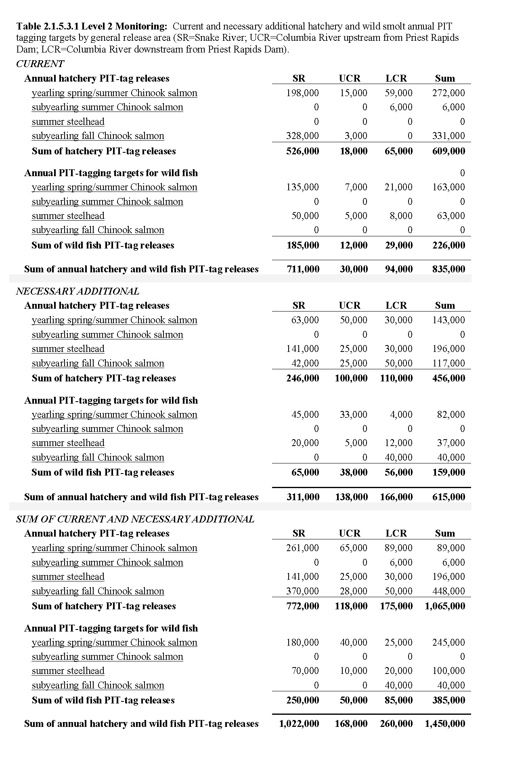

Amendment 2.1.5.4 Fish Passage Center
Include the following language in the Program:
Retain the existing Fish Passage Center language (2003 Mainstem Amendment, pages 27-28) in the Program with the following exceptions:
- Remove the reference to dual management/supervisory authority over the fish passage manager.
- Remove the reference to CBFWA providing a liaison position between the public and the Center.
- Remove the last paragraph that makes reference to a technical advisory committee.
- Add the following language to the Program: Bonneville will fund a position within the Fish Passage Center whose expertise can support storage reservoir operations analyses and identify in-season resident fish impacts of the FCRPS.

Amendment 2.1.5.5 Salmon and Steelhead Life Cycle Monitoring
Include the following language in the Program:
Bonneville will fund the life cycle monitoring field sampling, marking and real time data necessary to report on migration characteristics, smolt survival, travel time, passage distribution, migration characteristics, and other monitoring data required by regional fish and hydrosystem managers. This information forms the basis for short and long term hydrosystem fish passage management and mitigation decisions. Provide a long-term, consistent, continuous data base on lifecycle parameters of productivity such as smolt to adult returns and migration characteristics including, the movement of smolts out of major drainages and past the series of dams on the Snake and Columbia rivers. Assess smolt to adult return, survival, life cycle parameters and migration characteristics relative to environmental characteristics, hydrosystem operations and migration conditions.
Fund fishery managers to provide post season analysis to the region on indices of migration abundance and migration timing, smolt to adult return via passage route, and migration characteristics related to environmental factors and hydrosystem operations for fish migration. Migration characteristics will be collected for marked hatchery and wild fish. Other characteristics of fish condition such as de-scaling, and gas bubble trauma measures, will be collected to provide an indicator of health of the run. These data are used for in-season operational decisions relative to flow and spill management, particularly during periods when spill is being provided to improve smolt passage at dams (Level 3a) and will provide a consistent long term data base to support future fish passage discussions.
- The federal, state, and Tribal fish management agencies will review the design and implementation of the life cycle monitoring program annually (Evaluation Context)
- The life cycle monitoring data will be made available to the region on the Fish Passage Center Website and updated daily to facilitate hydro system fish passage management. The Fish Passage Center will report migration characteristics and life cycle parameters to the region in their annual report.

Amendment 2.1.5.6 Columbia River PIT Tag Information System
Include the following language in the Program:
The Columbia River PIT Tag Information System (PTAGIS) is a data collection, distribution, and coordination project. PTAGIS manages and maintains all of the PIT tag data collected since 1986 for anadromous salmon and steelhead in the Columbia River Basin.
The goal of this project is to operate and maintain the Columbia River Basin-wide database for PIT Tagged fish and to operate and maintain the established interrogation systems. The data collected by this system is accessible to all entities. The measurable goal for the system is to collect 100% valid data and provide that data in “near-real” time with downtime of any system component of not more than one percent as measured during the period of peak out-migration.
The PTAGIS project gets guidance from The Columbia Basin PIT Tag Steering Committee. The PTAGIS project will carry out the following tasks (Evaluation Context):
- Management of a long term Columbia River Basin-wide database system accessible to all entities;
- Maintenance and documentation of fish tagging and interrogation software;
- Operation and maintenance of equipment at the remote sites;
- Provision of technical support for the software and hardware;
- Provision of training to users; and
- Purchase and distribution of PIT tags and associated equipment.

Amendment 2.1.5.7 Regional Mark Processing Center (RMPC) (Evaluation Context)
Include the following language in the Program:
Fund the Regional Mark Processing Center (RMPC) to maintain the coded wire tag database, known as the Regional Mark Information System (RMIS), and to implement and coordinate coded wire tag recovery programs for Columbia River Basin origin fish with the basin’s fish and wildlife agencies and tribes. Coded wire tags are a tool used by the basin’s fish managers to identify salmon stocks, determine age composition and specific location of origin. The information provided by the use of coded wire tags is crucial to measure success of mitigation programs and fish population recovery plans. Specific activities include:
    - Provide a regional database and information management services used by the agencies and tribes to support regional reporting of coded wire tagged releases and recoveries.
    - Maintain, update and improve the RMIS database, especially as needs change and new methods are developed.
    - Cooperate with other regional data reporting projects to support data access for all entities within the region.
    - Maintain the RMPC web site to provide public access to the coded wire tag information and provide standardized reports for the regional fish managers.
    - Coordinate standardization of data formats so that collected coded wire tag data can be seamlessly entered into the RMIS database.
    - Provide custom queries and reports to scientists and managers as needed.
    - Coordinate the maintenance of a coded wire tag recovery laboratory for extracting, and reading and recording tags retrieved from salmon and steelhead.
    - Coordinate with regional fisheries agencies and tribes to implement sampling programs for tribal, sport and commercial fisheries, and at spawning grounds, hatcheries, fishways, and other sampling locations.
    - Support data inventory for the CSMEP project as needed.
    - Participate in regional data coordination programs such as StreamNet, PNAMP and NED.
These services are to be used to monitor salmon and steelhead survival, stock composition, and abundance in ocean and Columbia Basin freshwater fisheries and escapement to spawning grounds and to hatcheries.

Amendment 2.1.5.8 Anadromous Fish Evaluation Program (AFEP) (Level 3a)
Include the following language in the Program:
The Corps will continue improvements in collaboration with the fish and wildlife agencies and tribes to achieve objectives within the Fish and Wildlife Program.

Amendment 2.1.5.9 Harvest Specific Monitoring Measures (Level 3b)
Include the following language in the Program:
Improve estimates of stock composition in fisheries.
  - Fund deployment of PIT-tag detectors for fisheries sampling. Expand deployment of PIT-tag detectors in terminal areas.
  - Support the application of coded wire tags in representative groups of hatchery releases and appropriate naturally produced fish and the necessary sampling programs for recovering coded wire tags in sport, commercial and tribal fisheries.
  - Develop a regional Genetic Stock Identification (GSI) program with an emphasis on species for which broad-scale PIT tagging and/or coded wire tagging is not a viable option. The program shall include systematic establishment and maintenance of a regional fish stock DNA baseline, and systematic non-lethal tissue sampling of catch and encountered fish in the fisheries. This will require a central, standardized database that is closely coordinated with the genetics laboratories processing the tissue samples. In addition to baseline data, the database will contain the results of the samples for access by the fisheries managers and the public.
  - Determine the run timing and entry patterns of adult salmon returns of major population groups.
Support increased monitoring of encounter rates to better characterize harvest impacts in fisheries that release by-catch.

Amendment 2.1.5.10 Hatchery Specific Monitoring Measures (level 3b)
Include the following language in the Program:
Council supported hatchery monitoring programs as required under ESA consultation (HGMP monitoring programs) should be fully funded as a required cost for operating the facilities.
Implementation and compliance monitoring and reporting should be required for all Program funded hatcheries. Hatchery program implementation monitoring is simply the reporting of the number and characteristics of hatchery fish released, which already occurs in ongoing hatchery programs, albeit in a manner which is not fully standardized. This information should be described relative to the production goals and marking schemes within U.S. v. Oregon agreements. Standardized performance measures associated with implementation monitoring should include: hatchery production abundance, size at emigration (release), and condition of juveniles at emigration (release). A description of identifying marks applied (type of mark, unique code, and marking rate, including estimated marking efficiency/retention) is also included as implementation monitoring. Implementation monitoring performance measures are used to validate categorization of hatchery programs based on spawner composition (broodstock and natural spawners), rearing strategy, and release strategy. Of primary interest is the evaluation and reporting of:
- Confirmation of hatchery type (segregated harvest augmentation, integrated supplementation, or conservation),
- Status of Hatchery Genetic Management Plan (HGMP) or similar master plan,
- target and realized annual hatchery-natural composition of broodstock,
- target and realized annual hatchery-natural composition of natural spawners,
- target and realized annual Proportion of Natural Influence (PNI)
- target and realized annual rearing density,
- target and life stage at release,
- total release by life stage;
- target and realized size at release (length and weight);
- target and annual acclimation period,
- target and annual and release location, and
- duration of program (number of years operated).
The information above should be posted to the appropriate web sites (e.g., PSFMC and the Fish Passage Center), and described in annual reports. Implementation monitoring should be required on all artificial production programs releasing Chinook salmon, coho salmon, sockeye salmon, and steelhead in the Columbia River Basin.
Support the two-pronged approach to regional supplementation effectiveness monitoring: 1) through exploitation of standardized monitoring practices to provide comparable data for regional analyses of population trends in abundance and productivity, and 2) through coordinated analysis of relative reproductive success studies of a subset of hatchery supplementation programs, consistent with recommendations of CSMEP (Marmorek et al. 2007a and b) and of the Ad Hoc Supplementation Work Group (Galbreath et al. 2008 draft).

Amendment 2.1.5.11 Habitat Specific Monitoring Measures (Level 3b)
Include the following language in the Program:
Council should provide a web-based system for habitat project implementation reporting integrated with other funding sources. BPA should be directed to fund CBFWA to annually report implementation of fish and wildlife restoration projects through the Status of the Resource consistent with requirements for the Council’s Fish and Wildlife Expenditures Report to the Governors and with the needs of other regional reports such as the Washington State of Salmon in Watersheds Report.
A basic level of effectiveness monitoring and reporting should be required for all projects to determine if stated project habitat objectives have been achieved.
Intensively Monitored Watersheds – The Council, working with the fish and wildlife managers, NOAA Fisheries, Independent Scientific Advisory Board (ISAB), Salmon Recovery Funding Board (SRFB) and Oregon Watershed Enhancement Board (OWEB) should facilitate development of a process to identify a network of intensively monitored watersheds. Process should be established within one year of adoption of this program and a recommended network of IMWs within 2 years of Program adoption. All IMWs should have specific study objectives, regular reporting requirements and an estimated timeframe for completion.

Amendment 2.1.5.12 Critical Uncertainties
Include the following language in the Program:
The Research context of the RM&E plan relies on the guiding principles established in the Evaluation context, which are based upon collaboration of federal, state, Tribal and local resource managers. Emphasis will be on maximizing application of present RM&E methods and data to new and innovative analysis, and developing new research approaches and projects only where it proves necessary. The research context must be structured to inform critical management questions, information gaps, and key assumptions and working hypotheses, and it must take into consideration the life histories of each species. Thus, the research approach will be to complement, rather than precede, the implementation of actions. Some examples of identified research needs are:
- The feasibility of using genetic parental analysis of hatchery fish to determine its effectiveness as a monitoring tool compared to other marking techniques
- Use of genetic stock identification of adult steelhead and Chinook salmon at Lower Granite Dam (and/or any other facility) can be assessed in the research context as it might be applied and developed for Level 1 monitoring.
- Describe Elastomer tag (VIE) retention and detection rates by age class for Snake River fall Chinook salmon
- Support increased monitoring of encounter rates to better characterize harvest impacts in fisheries that release by catch.
- Hatchery critical uncertainties include:
- The effects of stray hatchery (harvest augmentation or supplementation) origin adults on the productivity of non-target natural populations.
- The effects of supplementation hatchery origin adults on the long term productivity of target natural populations.
- The effects of hatchery programs on hatchery/wild fish competition in terms of habitat use and nutrition/growth.
- The effects of hatchery programs on mortality rates of natural populations due to predation by hatchery origin fish.

Amendment 2.1.6 Identify Specific Reporting Requirements for the Program
Include the following language in the Basinwide Provisions for Anadromous Fish:
Bonneville will fund adequate monitoring to fill data gaps, to answer the following questions in an annual report to Council and the region -
- What rivers and reaches are currently accessible by anadromous salmon?
- How many salmon and steelhead populations occur above Bonneville Dam? How many of those populations demonstrate an increasing trend in abundance?
- How many naturally producing populations of salmon and steelhead occur within each relevant province? How many of those populations are healthy as defined by the Program?
- How many salmon and steelhead pass Bonneville Dam annually? How are they allocated across the Basin (harvest, hydrosystem and natural mortality, hatchery brood stock, and subbasin escapement)?
- What is the current knowledge about the characteristics of healthy lamprey populations?

Amendment 2.1.7 Evaluation
Include the following language in the Basinwide Provisions for Anadromous Fish:
A programmatic evaluation of the anadromous fish basinwide strategies will occur preceding Program amendments, to determine whether anadromous fish measures are moving the Program towards its biological objectives for performance.

Amendment 2.1.8 Adjustment in Program Direction
Include the following language in the Basinwide Provisions for Anadromous Fish:
The project solicitation process identified in Implementation Provisions of this Program (Amendment 5.2) will rely on conclusions from the evaluation of the anadromous fish to set project selection priorities. Monitoring, evaluation and reporting efforts will be used to help develop measures and amendments.
Section 2.2. Resident Fish

Amendment 2.2 Include in Appendix A: Glossary, the following information for the definition of Resident Fish
Include in Appendix A: Glossary, the following information for the definition of Resident Fish:
Resident fish are freshwater fish that live and migrate within the rivers, streams, and lakes of the Columbia River Basin, but do not travel to the ocean. For the purpose of this program, anadromous white sturgeon, bull trout, and coastal cutthroat trout shall be classified as resident fish. Resident fish exist throughout the basin and are particularly important in areas where anadromous fish runs are blocked by natural or manmade obstructions. This section of the program addresses mitigation for resident fish losses caused by hydropower development and operations, and substitutions of resident fish to compensate for losses of anadromous fish and harvest opportunities in areas blocked by hydropower projects.
The development and operation of the FCRPS has contributed to the reduction in diversity, abundance, and habitat of most resident fish species. As with anadromous fish, which have been extirpated from several areas of the basin, reservoir operations may interfere with flows needed for resident fish spawning, incubation, emergence, rearing, and migration. In addition, hydropower operations impair the reservoir environment for spawning, incubation, and rearing of some reservoir-inhabiting resident fish species. Hydropower development and operations have especially impacted bull trout, which are federally listed as threatened throughout the Columbia River Basin, the Oregon Chub which is federally listed as Endangered, as well as the Kootenai River and Upper Columbia white sturgeon populations which are listed as endangered in the United States and Canada, respectively. Other native resident fish species impacted by the hydrosystem include, but are not limited to, kokanee, redband trout, westslope cutthroat trout, burbot and mountain whitefish. Amendment

2.2.1 Report the Current Biological Condition for Resident Fish Populations
Include the following language in the Program:
The Council will work with the agencies and tribes to develop a summary of the current status of resident fish populations in the Columbia River Basin. This information will be presented annually in the Status of the Resource Report.

Amendment 2.2.2 Maintain the Current Basinwide Objectives for Biological Performance in the Program
In addition to the current Basinwide Objectives for biological performance for Resident Fish Losses, the fish and wildlife agencies and tribes recommend that the following performance objective be added at the basinwide level:
- Monitoring and evaluation strategies will be implemented to determine success and measure progress towards achieving biological objectives.
Include in the Program the following goal statement for resident fish measures:
The program goal for resident fish will emphasize the long-term stability of native fish in native habitats where possible, but also recognize that where impacts have severely changed the native ecosystem, the Program actions shall manage for, and utilize those species best suited for surviving in the altered ecosystem. Resident fisheries will be enhanced to allow for consumptive subsistence, commercial spiritual/cultural, and recreational fisheries for the region’s Indian tribes, as well as consumptive and non-consumptive recreational fisheries for sport anglers. A number of resident fish populations throughout the basin are depressed to an extent that they require immediate attention. To be effective, the Program will focus on funding resident fish measures that provide on-the-ground benefits, and use an adaptive management approach that employs monitoring and evaluation measures to monitor success.
The Program will continue to recognize the mitigation responsibility for areas where anadromous fish have been extirpated, and recognize that this portion of the Anadromous Fish Program is implemented through the Resident Fish Program:
“Part of the anadromous fish losses has occurred in the blocked areas. A corresponding part of the mitigation for these losses must occur in those areas. The program has a "Resident Fish Substitution Policy" for areas in which anadromous fish have been extirpated. Given the large anadromous fish losses in the blocked areas, resident fish substitution actions have not fully mitigated for these losses. The following objectives address anadromous fish losses and mitigation requirements in all blocked areas:
Restore native resident fish species (subspecies, stocks and populations) to near historic abundance throughout their historic ranges where original habitat conditions exist and where habitats can be feasibly restored.
Take action to reintroduce anadromous fish into blocked areas, where feasible.
Administer and increase opportunities for consumptive and non-consumptive resident fisheries for native, introduced, wild, and hatchery-reared stocks that are compatible with the continued persistence of native resident fish species and their restoration to near historic abundance (includes intensive fisheries within closed or isolated systems).”

Amendment 2.2.3 Outline the Current Limiting Factors Affecting Resident Fish Populations
Include the following language in the Program:
The Council will work with the fish and wildlife agencies and tribes to develop a summary of the current limiting factors for achieving resident fish population objectives (including Resident Fish Substitution) in the Columbia River Basin. This information will be presented annually in the CBFWA Status of the Resource Report. Table 2.2.3 provides a summary of hydrosystem-related limiting factors and threats for resident fish.

Table 2.2.3 Summary of hydrosystem-related limiting factors and threats for resident fish.
Limiting Factor | General Threat | Specific Threat
Water quantity | Hydrosystem operations | Flow fluctuations
 |  | Short-term flow reductions
Water quality | Hydrosystem operations | Warm water discharge
 |  | Cold water discharge
 |  | Dissolved gas
Habitat quality/quantity | Hydrosystem operations | Reservoir elevations
 |  | River stages
Community shifts | Hydrosystem operations | Enhanced competition and predation from native and non-native fish
 | Species introductions
Obstructions | Hydrosystem construction/operations | Dams; physical barriers

Amendment 2.2.4 Provide Priorities and Principles for Resident Fish Strategies and Measures
Include in the Program the following statement of priorities for resident fish measures:
The Program will accord highest priority to rebuilding to sustainable levels, weak, but recoverable, native resident fish populations affected by the hydropower system and resident fish substitution measures in areas that previously had salmon and steelhead, but where anadromous fish are now blocked by hydropower development. Because in-kind mitigation cannot occur for anadromous fish losses, projects satisfying the substitution priority shall be clearly distinguished from other projects. The Program will also accord priority to resident fish measures that meet the following criteria (not in rank order):
  - Provide benefits to wildlife and/or anadromous fish.
  - Protect and enhance the health of resident fish populations and associated habitat.
  - Address recovery and/or BiOp measures for ESA-listed resident fish
  - Construction and inundation habitat losses are most effectively mitigated thought the perpetual protection (easement or acquisition) of habitat in an amount at least equivalent to that which was lost.
  - Protect and enhance other native stocks that may be at risk due to the construction and operation of the FCRPS.
  - Substitution measures in areas that previously had anadromous fish, but where such fish are now blocked by hydropower facilities
Include in the Program the following statement on resident fish mitigation principles:
Hydropower development and operations have resulted in losses in abundance and diversity of resident fish. Measures to address the impacts, to resident fish and associated habitat, caused by hydropower development and operations shall be defined as resident fish mitigation. To promote comprehensive and cooperative watershed management, ecosystem diversity, productivity and stability as integral components of fish management strategies in the Columbia River Basin, and to conserve the natural genetic diversity within native resident fish species, subspecies, and unique stocks, the following resident fish mitigation principles will be applied:
- Protect, mitigate, and enhance resident fish and associated habitat to the extent that they were or are affected by hydropower development and operation
- Protect, mitigate, and enhance resident fish and associated habitat in hydropower system storage projects to the fullest extent from negative effects associated with water releases.
- In areas above, within, and below storage projects, protect, mitigate, and enhance resident fish and associated habitat that are affected by altered annual flow regimes, daily load following, temperature modifications, and nutrient trapping.
- Construction and inundation habitat losses are most effectively mitigated through the perpetual protection (easement or acquisition) of at least equivalent habitat that was lost.
- Land protection, operations, and maintenance activities are funded at current market rates.
- Land restoration funding shall be provided to restore degraded habitat.
- Long-term management funding (consisting of operations and maintenance and enhancements) shall be included in capital investments in the form of perpetual habitat protection activities to ensure habitat values are maintained.
- Managers also need the capacity to secure mitigation properties opportunistically and timely as they are operating in a highly competitive real estate market. This capacity can be increased via settlement agreements between fish and wildlife managers and BPA.
Include the following Measures in the Basinwide Provisions of the Resident Fish Section of the Program:
Develop Resident Fish Loss Assessment Methodology and Continue to Fund Existing Projects in the Interim: Bonneville will fund the fish and wildlife agencies and tribes to develop and implement a Columbia River Basin Resident Fish Loss Assessment Methodology that will be applied by each agency and/or tribe in their specific geographical area. This methodology may be customized to fit specific circumstances within a given subbasin. Include recommendations, to be completed by 2010, for assessing, in a consistent manner, resident fish and habitat losses due to: 1) development and 2) operation of hydropower facilities throughout the Columbia River Basin, notwithstanding existing resident fish projects. Implementation of existing and new resident fish mitigation and substitution measures and strategies will not be delayed pending the completion of loss assessments.
Complete Resident Fish Loss Assessments: Upon completion of the best scientifically based most feasible methodology, the fishery managers will complete assessments of resident fish losses related to construction and operation of each hydropower facility throughout the Columbia River Basin and submit to Council for inclusion into the Program, notwithstanding existing projects.
Include the following Table of Measures in the Basinwide Provisions of the Resident Fish Section of the Program:

Table 2.2.4 Hydrosystem-related strategies and measures for resident fish.
Strategy | Measure
Restore natural hydrograph to provide appropriate flow during critical periods. | Reduce flow fluctuations  Minimize short-term flow reductions  Reduce drawdown and improve reservoir refill  Provide appropriate flows for white sturgeon, bull trout and burbot;  Implement VARQ
Improve degraded water quality | Restore channel maintenance flows  Minimize effects of dissolved gas  Implement measures to restore normative hydrograph
Restore floodplain connectivity and function. | Reconnect floodplains to channels.  Reconnect side channels and off-channel habitats to stream channels.
Restore channel structure and complexity. | Restore natural channel form where feasible  Stabilize streambanks

Amendment 2.2.5 Include a Statement Regarding Monitoring of Resident Fish Populations
Include the following language in the Basinwide Provisions for Resident Fish:
The Program relies on the monitoring efforts of the fish and wildlife agencies and tribes for a majority of the information related to resident fish. Bonneville will fund monitoring efforts at the project scale where necessary to fill in information gaps necessary for supporting Program decision making. The monitoring for resident fish will be facilitated for the Program through collaboration and the coordination of the fish and wildlife agencies and tribes.
Amendment 2.2.5.1 Collaborative Systemwide Monitoring and Evaluation
Fund the fish and wildlife managers to work with others to:
  - Coordinate, assemble, evaluate and report on fish status and trend monitoring metrics including abundance, productivity, spatial structure and diversity.
      - Develop standardized descriptions of the primary indicators used to assess VSP parameters in collaboration with fish and wildlife agencies and tribes.
      - Characterize the metrics and methodologies used to estimate the primary indicators of VSP parameters.
      - Inventory the available primary indicators used to estimate VSP parameters and identify populations without coverage.
      - Assess the metrics and methodologies used to estimate the primary indicators characterizing the adequacy of the information and identify the deficiencies.
      - Evaluate and recommend the alternative integration and mix of monitoring activities that promote consistency so the data are comparable among all subbasins, and to optimize cost effective monitoring across all levels.
      - Annually report the VSP indicators through the Status of the Resource Report. Report on the findings and recommendations from the inventory, and the assessment of adequacies and deficiencies of the metrics and methodologies.
  - Develop monitoring designs (informed by the findings and recommendations in 6 above), and estimate their accuracy, precision and cost to describe population status and trends that inform biological objectives. Ensure that the estimated metrics represent appropriate spatial, temporal, and population scales.
  - Periodically estimate population status and trends of fish species (e.g. every 5 years).
  - Work with land and water resource management agencies to assemble and report habitat metrics at appropriate biological scales in the Status of the Resource Report. These may include watershed condition, miles of accessible stream, 303D listings Clean Water Act standards (examples: temperature, turbidity, contaminants). Coordinate with other regional reports such as EPA’s State of the River Report, Washington State of Salmon in Watersheds Report
  - Periodically assess the monitoring associated with management decisions and recommend improved designs.
  - Develop and maintain run-reconstructions (systematic organization of all mortality sources by origin (hatchery or wild) and age in lifecycle framework data sets) for each appropriate biological scale.
  - Review the results of Intensively Monitored Watersheds and other habitat restoration programs. Facilitate the integration between the intensively monitored watersheds and other monitoring programs. Provide a forum so results from habitat restoration programs and research can be incorporated into future restoration programs.

Amendment 2.2.6 Identify Specific Reporting Requirements for the Program
Include the following language in the Basinwide Provisions for Resident Fish:
Bonneville will fund adequate monitoring to fill data gaps, to answer the following questions in an annual report to Council and the region -
- How many native resident fish species (subspecies, stocks and populations) occur in areas affected by the FCRPS? How many of those populations demonstrate abundance similar to historic conditions?
- What actions have been taken to reintroduce anadromous fish into blocked areas?
- When loss assessments have been completed, what is the FCRPS mitigation responsibility for resident fish?
- What rivers and reaches currently have low ecological connectivity between aquatic areas, riparian zones, floodplains and uplands?
- Which rivers and reaches currently have poor water quality (temperature, toxics, etc.)?
- Which rivers and reaches have insufficient water quantity to support all life stages of resident and anadromous fish?
- Are hatchery projects meeting their production goals in terms of adult fish?
- Is the Program meeting its harvest objectives for resident fish populations?
- What actions are being taken to provide opportunities for consumptive and non-consumptive resident fisheries?

Amendment 2.2.7 Identify How Evaluation of the Resident Fish Section of the Program Will Occur
Include the following language in the Basinwide Provisions for Resident Fish:
A programmatic evaluation of the Resident Fish Section of the Program will occur preceding Program amendments, to determine whether resident fish measures are moving the Program towards its biological objectives for performance.

Amendment 2.2.8 Explain How Adjustment in Program Direction Will Occur Over Time
Include the following language in the Basinwide Provisions for Resident Fish:
The project solicitation process identified in Implementation Provisions of this Program (Amendment 5.2) will rely on conclusions from the evaluation of the Resident Fish Section of the Program to set project selection priorities. Monitoring, evaluation and reporting efforts will be used to help develop measures and amendments.

Section 2.3. Wildlife

Amendment 2.3.1 Include the Current Ledger for Wildlife
Include the Construction and Inundation Losses Ledger, Table 2.3.1, in the Program:
The Program calls for BPA and the Fish and Wildlife Managers to complete mitigation agreements that, in combination with existing projects, equals 200 percent of the habitat units identified in the loss assessments (NWPCC 2000 Fish and Wildlife Program: Table 11-4). The doubling of the losses is done in part to address the significant annualized impacts that have accrued since construction.
Table 2.3.1 reflects the current status of BPA’s obligation for construction and inundation losses.

Table 2.3.1 replaces Table 11-4 in the Council’s 2000 Fish and Wildlife Program and identifies BPA’s mitigation obligation for the losses due to hydropower construction at federal dams in the Columbia River Basin.
Table 2.3.1: Amended Losses Due to Hydropower Construction
Species by Hydropower Facility | Total Habitat Units
Albeni Falls  • Mallard Duck  • Canada Goose  • Redhead Duck  • Breeding Bald Eagle  • Wintering Bald Eagle  • Black-Capped Chickadee  • White-tailed Deer  • Muskrat | -11,970  -9,398  -6,758  -9,016  -8,730  -4,572  -3,360  -3,512
Lower Snake Projects  • Downy Woodpecker  • Song Sparrow  • Yellow Warbler  • California Quail  • Ring-necked Pheasant  • Canada Goose | -729.8  -575.2  -1,854  -41,016  -5,293.6  -4,079.6
Anderson Ranch  • Mallard  • Mink  • Yellow Warbler  • Black Capped Chickadee  • Ruffed Grouse  • Blue Grouse  • Mule Deer  • Peregrine Falcon  * Acres of riparian habitat lost. Does not require purchase of any lands. | -2,096  -3,464  -722  -1,780  -1,838  -3,960  -5,378  -1,222 acres*
Black Canyon  • Mallard  • Mink  • Canada Goose  • Ring-necked Pheasant  • Sharp-tailed Grouse  • Mule Deer | -540  -1,304  -428  -520  -1,064  -484
Deadwood  • Mule Deer  • Mink  • Spruce Grouse  • Yellow Warbler | -4,160  -1,974  -2,822  -618
Palisades  • Bald Eagle  • Yellow Warbler  • Black Capped Chickadee  • Elk/Mule Deer  • Waterfowl and Aquatic Furbearers  • Ruffed Grouse  • Peregrine Falcon*  * Acres of riparian habitat lost. Does not require purchase of any lands. | -11,882 Breeding  -37,130 Wintering  -1,436 scrub-shrub  -2,716 forested  -4,908  -11,406  -4,662  -3,354 acres forested wetlands  -1,664 acres scrub-shrub wetland
Willamette Basin Projects  • Black-tailed Deer  • Roosevelt Elk  • Black Bear  • Cougar  • Beaver  • River Otter  • Mink  • Red Fox  • Ruffed Grouse  • California Quail  • Ring-necked Pheasant  • Band-tailed Pigeon  • Western Gray Squirrel  • Harlequin Duck  • Wood Duck  • Spotted Owl  • Pileated Woodpecker  • American Dipper  • Yellow Warbler | -34,508  -30,590  -9,628  -7,706  -8,954  -4,816  -4,836  -5,180  -22,290  -5,972  -3,972  -6,974  -2,708  -1,102  -3,894  -11,422  -17,380  -1,908  -4,710
Grand Coulee  • Sage Grouse  • Sharp-tailed Grouse  • Ruffed Grouse  • Mourning Dove  • Mule Deer  • White-tailed Deer  • Riparian Forest  • Riparian Shrub  • Canada Goose Nest Sites | -5,492  -65,446  -33,004  -18,632  -54,266  -42,724  -3,264  -54  -148
McNary  • Mallard (nesting)  • Western Meadowlark  • Canada Goose  • Spotted Sandpiper  • Yellow Warbler  • Downy Woodpecker  • Mink  • California Quail | -13,918  -6,938  -6,968  -2,726  -658  -754  -2,500  -12,628
John Day  • Great Blue Heron  • Canada Goose  • Spotted Sandpiper  • Yellow Warbler  • Black-capped Chickadee  • Western Meadowlark  • California Quail  • Mallard  • Mink | -6,372  -16,020  -6,372  -2,170  -1,738  -10,118  -12,648  -14,798  -2,874
The Dalles  • Great Blue Heron  • Canada Goose  • Spotted Sandpiper  • Yellow Warbler  • Black-capped Chickadee  • Western Meadowlark  • Mink | -854  -878  -1,068  -340  -366  -494  -660
Bonneville  • Great Blue Heron  • Canada Goose  • Spotted Sandpiper  • Yellow Warbler  • Black-capped Chickadee  • Mink | -8,600  -4,886  -5,534  -326  -2,044  -3,244
Minidoka  • Yellow Warbler  • River Otter  • Mule Deer  • Sage Grouse | -684  -5,986  -6,826  -7,510
Chief Joseph  • Sharp-tailed Grouse  • Mule Deer  • Spotted Sandpiper  • Sage Grouse  • Mink  • Bobcat  • Lewis’ Woodpecker  • Ring-necked Pheasant  • Canada Goose  • Yellow Warbler | -4,580  -3,984  -2,510  -2,358  -1,840  -802  -572  -478  -426  -116
Note: Credits (against this losses ledger) assume BPA’s current crediting policy of full credit for existing values on properties permanently protected by Bonneville and/or as stated in project MOA’s with managers.

Include the operational and other wildlife losses in the Program:
The operational losses, while recognized, have not yet been quantified and will be formally added to the current status of losses following completion of loss assessments.

Amendment 2.3.2 Update the Current Basinwide Objectives for Biological Performance for Wildlife
Include the following language in the Basinwide Objectives for Biological Performance for Wildlife:
The overall biological objective for the wildlife program is to mitigate for all wildlife losses due to the FCRPS by protecting and enhancing the ecological function of wildlife habitat consistent with the subbasin plans and state conservation strategies and tribal management plans. The wildlife mitigation program should continue to mitigate for construction and inundation losses as expressed in habitat units displayed in Table 2.3.1.

Amendment 2.3.3 Include the Current Limiting Factors Affecting Wildlife
Include the following language to describe limiting factors based on FCRPS impacts:
Construction and inundation impacts of the hydropower system:
In previous Council programs, the wildlife habitat losses associated with construction and inundation impacts have received considerable attention. These impacts to wildlife were assessed using the Habitat Evaluation Procedure (HEP) to determine the habitat lost, expressed as habitat units (HUs), and published in loss assessments. The loss assessments were adopted in previous Council programs (i.e., Council’s 2000 Fish and Wildlife Program: Table 11-4) to create a ledger and serve as a starting point for wildlife mitigation measures.
HEP does not adequately reflect management priorities or characterize ecological conditions. The 2008 Program supports investigation of alternative habitat assessment methodologies to HEP. These alternatives represent a paradigm shift away from HEP to ecologically based assessment methods that better represent ecological functions and conditions.
Operational losses:
The ecological impacts to wildlife populations due to the loss of fish and the losses caused by the operations of the hydro system have not been assessed. The fish and wildlife resources of the Columbia Basin have been deprived of marine-derived nutrients associated with the return of adult anadromous fish. The implications of this impact, while not yet clearly defined or quantified in terms of wildlife, must be mitigated and the 2008 Program increases this emphasis.
Given the vision of this program, the strong scientific case for a more comprehensive, ecosystem-based approach, and the shift to implementation of this program through provincial and subbasin plans, wildlife mitigation projects should complement fish mitigation projects to the extent practical. Lands protected as part of fish mitigation may be credited to offset wildlife operational losses if the lands protect priority focal wildlife habitats.
Funding:
The rapid increase in human population, and associated land values in the Northwest necessitates the expeditious acquisition of habitats to minimize cost to BPA ratepayers. During the period from FY2002-2006, BPA expenditures on all wildlife projects totaled approximately $12.5 million annually (Status of the Resource website). At these funding levels, the amount of habitat required to fulfill the loss ledger cannot be obtained (Figure 2.3.1). With further delays, implementation costs will likely increase and the extent and quality of available habitat will be diminished. Managers also need the capacity to secure mitigation properties opportunistically and timely as they are operating in a highly competitive real estate market. This capacity can be increased via settlement agreements between fish and wildlife managers and BPA.

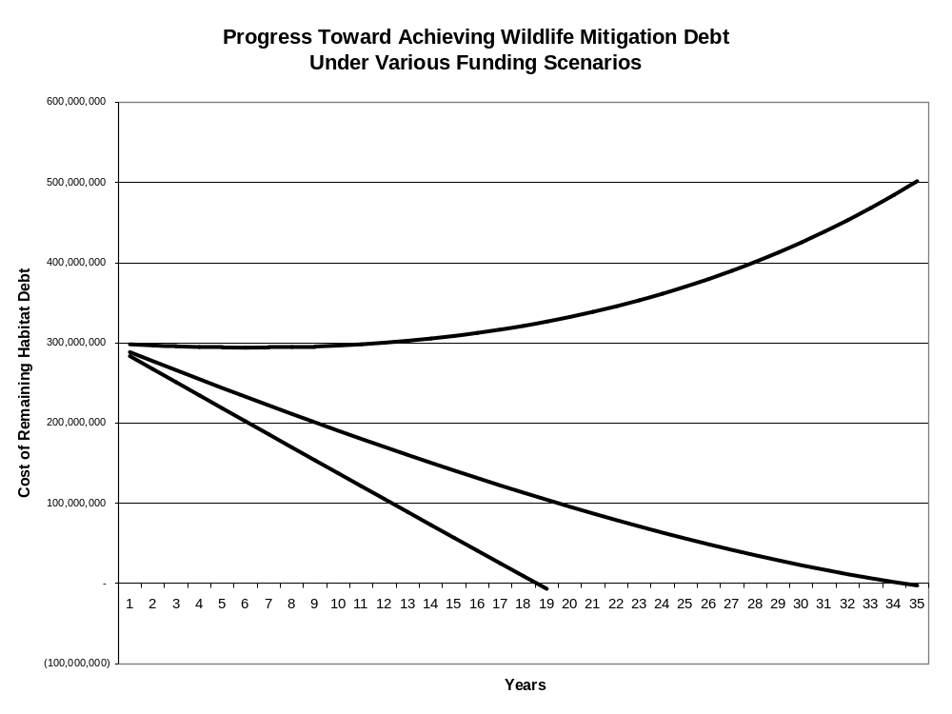
Figure 2.3.1 Progress Toward Achieving Wildlife Mitigation Debt (CBFWA May 1, 1998 http://www.cbfwa.org/FWProgram/Reports/FY1997/10YearBudget.doc).

Amendment 2.3.4 Provide Priorities and Principles for Wildlife Strategies and Measures
Include in the Program the following statement of priorities for wildlife measures:
Primary strategies: The FCRPS has impacted wildlife populations through the loss of habitat due to the hydropower facility construction and subsequent inundation of land. These losses were quantified using the HEP and expressed as habitat units. In addition there are un-quantified wildlife habitat losses due to the annual operation of the hydropower system. During the implementation of the 2000 Fish and Wildlife program subbasin plans were completed. The plans identified focal species and/or focal habitats as priorities for conservation and restoration. Further broad guidance for wildlife management is also contained in recently completed state conservation strategies.
The hypothesis/assumptions of the wildlife program strategy is that protection of acreage and restoration of ecological functioning habitat will support and restore native wildlife populations to meet mitigation obligations of the FCRPS. To evaluate this hypothesis/assumption, an adequate amount of land must be protected (represented by the identified construction and inundation losses and future loss assessments). A monitoring program needs to be in place to collect and analyze the biological information necessary to determine the habitat functionality which in turn allows the evaluation of the response in focal species abundance and use.
The Program should build on the eight scientific principles identified in the 2000 Program to introduce a new paradigm that emphasizes management for ecological function supported by the subbasin plans. In general, the subbasin plans identified focal habitats which, along with federal, state, and Tribal wildlife management plans, serve as the collective foundation for project sponsors to develop wildlife project management plans. These wildlife project management plans will establish specific ecological objectives for the protected focal habitats. The ecological objectives will be the basis for determining management needs, building a monitoring and evaluation framework, and determining and tracking enhancement credits.
The Program should include measures to:
1) quantify operational losses; 2) assure funding adequate to manage protected habitats to meet habitat and ecological objectives as expressed in project specific management plans which are linked to subbasin plan priorities; 3) establish a Wildlife Crediting Forum to develop and oversee crediting procedures for the Council and incorporate wildlife mitigation credits into the Fish and Wildlife Program to track progress towards mitigating for the lost habitat; and 4) assure an adequate funded Research, Monitoring and Evaluation (RM&E) program for wildlife to support adaptive management by monitoring ecological function on protected lands as described in the project management plans to ensure wildlife program investments are consistent with the plans of the wildlife managers.
Fund Operational Loss Assessments: Hydropower operational impact assessments are needed to determine the extent and directions of ecological alterations (direct and indirect) and to institute a standard, rigorous, transferable, and regionally accepted assessment methodology to describe and quantify ecological losses attributable to the FCRPS.
The 2000 Program initially defined operational loss as “the direct wildlife losses caused by the day-to-day fluctuations in flows and reservoir levels resulting from the operation of the hydrosystem”. This definition does not adequately describe the full extent of the ecological impacts due to the operation of the hydroelectric system. Assessment of operational losses must incorporate concepts of river ecology, accepted scientific and ecological principles, along with appropriate indices of biological or ecological integrity.
Bonneville will fund the Agencies and Tribes to complete operational loss assessments using methods that provide a systematic approach to characterize active physical and biological processes in watersheds and describes spatial distributions, histories and linkages among important ecosystem components. A framework for assessing operational losses shall be in place by the end of 2009 with loss assessments initiated in 2010.
Ecosystem management should maintain or recover the biological integrity of the system (Figure 2.3.2). Determining the extent to which ecological systems are experiencing anthropogenic disturbance and change in structure and function is critical for long-term conservation or restoration of biotic diversity in the face of changing and compromised landscapes and land use. To determine parameters needed to address ecological integrity, the Council, wildlife managers, and BPA will adopt a framework that can: (1) identify and isolate operational impacts from other basin changes, (2) assess operations-based influences on downstream physical processes, (3) link physical, biological, and ecological processes (4) account for natural floodplain dynamics, and (5) be used in a predictive capacity.

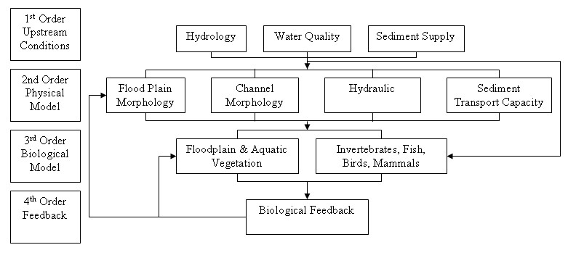

Figure 2.3.2. Order of Impacts (From Jorde et.al. 2005)

Bonneville will fund assessments of ecological impacts to wildlife from the reduction or loss of anadromous fish as part of the operational loss assessment. The assessments need to evaluate an array of core ecological parameters (e.g., biological/biotic and physical/abiotic) with the understanding that habitats, communities, and processes are ecologically linked (Figure 2.3.3). The results of these assessments will be the basis for quantification of operational impacts and subsequent mitigation obligation. Existing and future habitat actions implemented to benefit anadromous fish may be suitable mitigation for some of these impacts.

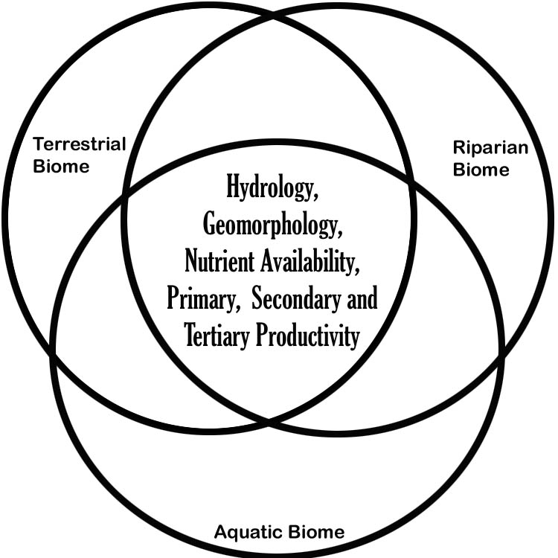

Figure 2.3.3. Integration of watershed/basin environmental parameters and ecological functions (e.g., aquatic, riparian, and terrestrial biomes) as part of an operational assessment framework (created by Kootenai Tribe of Idaho – Fish and Wildlife Department 2007).

Long-term funding agreements: Long-term funding agreements are necessary to provide the certainty required to optimize wildlife benefits and cost efficiencies. They must also retain flexibility to address changing needs on the landscape and address known and unforeseen external threats (e.g. invasive species, wildfires, etc). Agreements for ongoing and future projects must include provisions for adequate management funding to sustain the ecological functions and the minimum credited habitat values for the life of the project. Funding of these long-term agreements must occur prior to formally assigning mitigation credit to the ledger.
Consistent with the 2000 Program, the project sponsor and BPA will propose for Council consideration and recommendation a long-term funding agreement(s) adequate to sustain minimum credited value and maintain ecological functions for the life of the hydroelectric project impact.
Bonneville will enter into long-term funding agreements for existing and future mitigation projects that:
- Assure continuity of funding for the life of the hydroelectric project impact.
- Assure sufficient funding levels to implement the habitat management strategies and monitoring and evaluation needs identified in project area management plans.
- Provide flexibility to respond to uncertainties and unforeseen events.
- Provide adjustment for annual inflation.
Fund existing projects at levels adequate to implement management plans: Table 2.3.2 lists the existing wildlife program. Funding needs to continue to maintain the base level of habitat and credits accomplished to date. Bonneville will fund existing wildlife projects at levels determined to be consistent with the project management plans. Funding must be sufficient for habitat maintenance and enhancement, and appropriate monitoring as agreed upon in the management plans. Where management plans are not in place BPA will provide interim funding to manage the wildlife projects and complete the management plans.

Table 2.3.2 Ongoing Wildlife Habitat Projects Currently Funded by BPA.
Proposal # | Proposal Title | Organization
199206100 | Albeni Falls Wildlife Mitigation | Albeni Falls Interagency Work Group
200002700 | Acquisition Of Malheur River Wildlife Mitigation Project | Burns Paiute Tribe
200000900 | Logan Valley Wildlife Mitigation Site | Burns Paiute Tribe
200103300 | Hangman Restoration Project | Coeur d’Alene Tribe
199204800 | Colville Confederated Tribes Wildlife Mitigation Project | Colville Confederated Tribes
200702700 | Colville Confederated Tribes Acquisition Project | Colville Confederated Tribes
199009200 | Wanaket Wildlife Area | Confederated Tribes of the Umatilla Indian Reservation
199506001 | Iskuulpa Watershed Project | Confederated Tribes of the Umatilla Indian Reservation
200002600 | Rainwater Wildlife Area Operations and Maintenance | Confederated Tribes of the Umatilla Indian Reservation
199802200 | Pine Creek Conservation Area: Wildlife Habitat and Watershed Management on 33,557-acres to benefit grassland, shrub-steppe, riparian, and aquatic species. | Confederated Tribes of Warm Springs Reservation of Oregon
199505700 | Southern Idaho Wildlife Mitigation | Idaho Department of Fish & Game
199505701 | Southern Idaho Wildlife Mitigation | Idaho Department of Fish & Game
199205900 | Amazon Basin/Eugene Wetlands - | The Nature Conservancy
199608000 | Northeast Oregon Wildlife Project (NPT) Precious Lands | Nez Perce Tribe
199206800 | Willamette Basin Mitigation | Oregon Department of Fish & Wildlife
200002100 | Securing Wildlife Mitigation Sites - Oregon Ladd Marsh WMA and Grande Ronde Subbasin Wetlands | Oregon Department of Fish & Wildlife
199107800 | Burlington Bottoms Wildlife Mitigation Project | Oregon Department of Fish & Wildlife
199505703 | Southern Idaho Wildlife Mitigation | Shoshone Paiute Tribes
199505702 | Southern Idaho Wildlife Mitigation | Shoshone-Bannock Tribes
199106200 | Spokane Tribe Wildlife Mitigation | Spokane Tribe
199800300 | Spokane Tribe Wildlife Mitigation Operations & Maintenance | Spokane Tribe
200001600 | Tualatin River NWR Additions | Tualatin River NWR
200600400 | Wenas Wildlife Area O&M | Washington Department of Fish and Wildlife
199609401 | Scotch Creek Wildlife Area | Washington Department of Fish and Wildlife
200301200 | Shillapoo Wildlife Area | Washington Department of Fish and Wildlife
200201400 | Sunnyside Wildlife Mitigation | Washington Department of Fish and Wildlife
199404400 | Enhance, protect and maintain shrub-steppe habitat on the Sagebrush Flat Wildlife Area (SFWA) | Washington Department of Fish and Wildlife
199106100 | Swanson Lake Wildlife Mitigation Project (Swanson Lakes Wildlife Area) | Washington Department of Fish and Wildlife
200600300 | Desert Wildlife Area O&M (Wetland Enhancement) | Washington Department of Fish and Wildlife
200600500 | Asotin Creek Wildlife Area O&M (Schlee Acquisitions) | Washington Department of Fish and Wildlife
200102700 | Western Pond Turtle Recovery – Columbia River Gorge | Washington Department of Fish and Wildlife
199206200 | Yakama Nation - Riparian/Wetlands Restoration | Yakama Nation

Establish a Wildlife Crediting Forum for maintaining the crediting ledger: Bonneville, the Council, and the fish and wildlife managers will establish a BPA funded forum to develop a regional protocol for establishment and maintenance of a crediting ledger documenting progress towards achieving mitigation obligations. This crediting ledger will be formally included in the Program. The forum will track crediting of construction, inundation and operational mitigation actions and will address disputes, inconsistencies, and other issues related to application of credit against wildlife losses. This forum is to be in place by no later than one year after the adoption of the revised Program
The development of the above-mentioned procedures and protocols must not be considered a prerequisite to continuing wildlife mitigation efforts. New and on-going wildlife mitigation projects will continue during the development and review of crediting protocols.
Habitat enhancement credits will be provided to BPA when habitat management activities funded by BPA lead to a net increase in habitat value when compared to the baseline habitat inventory. This determination will be made through periodic monitoring of the project site. Bonneville shall be credited for habitat enhancement efforts at a ratio of one habitat unit credited for every habitat unit gained.
Funding for mitigation projects may be secured to supplement the ratepayer monies provided by BPA. These funds may be used to expand the project area, enhance or restore habitat or to support operations and maintenance of the project. The extent to which these funds may result in improvements in habitat suitability relative to ratepayer funding is difficult to quantify, complicating crediting against the mitigation debt. Therefore, Bonneville, the Council, and the fish and wildlife managers shall work through the crediting forum to develop an appropriate crediting methodology to avoid in-lieu funding from non-hydro mitigation sources and to assure BPA receives mitigation credit proportional to the ratepayer contribution.
For a project to be credited against construction and inundation losses it must be consistent with the Fish and Wildlife Program. Criteria shall include:
- Project areas must be permanently protected and dedicated to wildlife benefits through covenants, easements, fee title acquisitions or other appropriate agreements for the life of the hydroelectric project,
- Projects must benefit priority wildlife habitat, species, or populations as defined by federal, state, Tribal wildlife management plans or subbasin plans.
- A project area management plan must be completed.
- A long-term funding agreement adequate to support implementation of the management plan has been adopted.
If settlement agreements are reached between affected managers and BPA for a specific hydro project or projects, then the regional crediting protocol may not apply. Such settlement agreements are the preferred strategy to complete BPA’s wildlife mitigation responsibilities for the construction and inundation impacts.
Fund Adequate M&E: Bonneville will fund research, monitoring and evaluation of wildlife mitigation projects adequately to assure tracking of crediting, to evaluate trends in ecological functions of managed ecosystems, and provide managers the ability to assess the effectiveness of their strategies by evaluating species and habitat responses that contributes to broader monitoring efforts. Bonneville will continue funding HEP surveys on acquired land in support of the Wildlife Crediting Forum to track mitigation implementation progress against Table 2.3.1.

Amendment 2.3.5 Include a Statement Regarding Monitoring of Wildlife
Amend the Program to include the following language in the Basinwide Provisions for Wildlife:
The purpose of monitoring and evaluation is to determine the condition of existing ecological functions, develop project objectives, and implement adaptive management. Data generated by monitoring and evaluation are used to affirm, adjust, and improve site specific management actions as well as programmatic strategies based on scientific principles.
The program has used HEP to evaluate and credit properties and easements acquired with mitigation funding. HEP is also used to evaluate and credit enhancements on these projects. The Council’s Program will support the transition from HEP to a new ecologically-based paradigm where assessments of ecological functions are used to guide management decisions.
The level of RM&E will be based on the ecological objectives described in site specific management and subbasin plans. RM&E funding must be sufficient to allow project sponsors to track trends in ecological functions, to provide data to assess the effectiveness of management actions, and to effectively implement principles of adaptive management. Fundamental to the RM&E program is the establishment and measure of reference sites to address changing conditions (unforeseen events) or longer term objectives.
Where appropriate, project level RM&E will complement and be consistent with larger scale efforts including but not limited to State Conservation Strategies through use of compatible protocols and data sharing. Data summaries from each project should link to region-wide databases. Compatible protocols (across the Basin) should be developed and used to determine baseline wildlife and habitat conditions.

Amendment 2.3.6 Identify and Support Specific Reporting Requirements for the Program
Amend the Program to include the following language in the Basinwide Provisions for Wildlife:
Bonneville will fund adequate monitoring, data management, and reporting to answer the following questions in an annual report to Council and the region -
- How many habitat units have been mitigated for FCRPS construction and inundation caused losses of wildlife?
- How many of those habitat units are secured through long term funding?
- How are wildlife species and habitats responding to FCRPS mitigation actions?
- What is the FCRPS mitigation responsibility for wildlife operational losses?
Bonneville will fund the following activities in support of the Program:
- Operate and maintain the regional Interactive Habitat and Biodiversity Information System (IBIS),
- Update and refine wildlife basin, eco-province, and subbasin habitat maps,
- Develop wildlife and habitat GIS tools and services, and
- Develop and implement new Habitat Assessment protocols to evaluate mitigation impact and sites.

Amendment 2.3.7 Identify How Evaluation of the Wildlife Section of the Program Will Occur
Amend the Program to include the following language in the Basinwide Provisions for Wildlife:
A programmatic evaluation of the Wildlife Section of the Program will occur preceding Program amendments, to determine whether wildlife measures are moving the Program towards its biological objectives for performance.

Amendment 2.3.8 Explain How Adjustment in Program Direction Will Occur Over Time
Amend the Program to include the following language in the Basinwide Provisions for Wildlife:
The project solicitation process identified in the Implementation Provisions (Amendment 5.2) of this Program will rely on conclusions from the evaluation of the Wildlife Section (Amendment 2.3.7) of the Program to set project selection priorities.

Section 3.0. Recommended Amendment to the Ecological Province, Subbasin, and Focal Species Provisions for Anadromous Fish
3.1 Columbia River Estuary Province and Ocean
3.2 Lower Columbia Province
3.3 Columbia Gorge Province
3.4 Columbia Plateau Province
3.5 Columbia Cascade Province
3.6 Blue Mountain Province
3.7 Mountain Snake Province
3.8 Lamprey
3.9 Eulachon (Smelt)
Section 4.0. Recommended Amendment to Subbasin and Focal Species Provisions for Resident Fish
Section 4.1 Lower Columbia Province
Section 4.2 Columbia Gorge Province
Section 4.3 Columbia Plateau Province
Section 4.4 Columbia Cascade Province
Section 4.5 Intermountain Province
Section 4.6 Mountain Columbia Province
Section 4.7 Blue Mountain Province
Section 4.8 Mountain Snake Province
Section 4.9 Middle Snake Province
Section 4.10 Upper Snake Province

Section 5.0. Recommended Amendment to the Implementation Provisions
Section 5.1. Implementation Funding Provisions

Amendment 5.1.1 The Program Should Define BPA’s In-Lieu Funding Restrictions
Include the following language in Implementation Provisions section of the Program:
The Northwest Power Act authorizes the Council, “in appropriate circumstances,” to include off-site enhancement measures in the program to achieve protection from -- and mitigation for -- development and operation of hydroelectric facilities. However, the Northwest Power Act prevents BPA from making expenditures where ratepayer funding merely substitutes for funding from other sources. Specifically, section 4(h)(10)(A) states:
The Administrator shall use the Bonneville Administration Fund and the authorities available to the Administrator under this chapter and other laws administered by the Administrator to protect, mitigate, and enhance fish and wildlife to the extent affected by the development and operation of any hydroelectric project of the Columbia River and its tributaries in a manner consistent with the power plan, the fish and wildlife program adopted by the Council under this subsection, and the purposes of this chapter. Expenditures of the Administrator pursuant to this paragraph shall be in addition to, not in lieu of, other expenditures authorized or required from other entities under other agreements or provisions of law.
The Council will work with BPA, fish and wildlife managers and other interested parties to develop principles guiding BPA in its interpretation of the in-lieu funding restrictions of the Northwest Power Act. We recommend the following factors be considered:
- The in-lieu principles will be included in the Fish and Wildlife Program;
- The in-lieu principles will focus on whether expenditures are authorized and funding is available for another entity, not merely on whether an action is authorized;
- The first clause (i.e., “expenditures authorized … from other entities under other agreements or provisions of law”), will be interpreted to apply only to public entities, and restricts BPA funding only when funding is available for the same activity, not merely when an agency is authorized to conduct an activity.
- The second clause (i.e., “expenditures … required from other entities under other agreements or provisions of law”) will be interpreted to apply when expenditures are required under a FERC license or a court-ordered remediation, or under a provision of law that imposes a non-discretionary duty.

Amendment 5.1.2 The Program Should Ensure that Funding for Fish and Wildlife Actions can be Carried Over to Spend on Fish and Wildlife
Include the following language in Implementation Provisions section of the Program:
Bonneville will ensure that any funds that are made available for fish and wildlife expenditures, including payments for anticipated capitalization, should be reserved for fish and wildlife actions. If all the fish and wildlife funds are not expended within a fiscal year, BPA will carry those funds, in addition to anticipated future expenditures, into the next fiscal year to be spent on Program priorities. In addition, BPA is obligated to set rates sufficient to recover its costs for protection, mitigation and enhancement of fish and wildlife. Bonneville will carry over from one rate period to the next unspent ratepayer funds that were collected during a rate period to recover fish and wildlife costs.

Amendment 5.1.3 The Program Should Include a Capitalization Policy for Fish and Wildlife-related Expenditures
Include the following language in Implementation Provisions section of the Program:
In accordance with sound business principles, BPA will capitalize investments for fish and wildlife over the useful life of such investments. Bonneville will use its permanent borrowing authority to finance construction of capital facilities acquisition and improvements to land, water or other real property, even if the costs of each project are less than $1 million, or if the project has a useful life of less than 15 years, so long as such expenditures otherwise qualify as capital investments under commonly-accepted accounting principles. These projects include, for example, buildings, roads, culverts, stream bank stabilization, fences, utilities, sewage treatment and discharge, diversion screens and ladders, instream structures, fish propagation facilities, and other physical improvements. They also include the acquisition of real property, including water rights and conservation easements. Term acquisitions, such as multi-year water right leases, should be capitalized over the term of the acquisition. Section 4(h)(10(A) of the Northwest Power Act requires BPA to use its borrowing authority under the Federal Columbia River Transmission System Act to finance the construction of capital facilities with an estimated useful life of greater than 15 years and an estimate costs of at least $1,000,000. Bonneville will not interpret this requirement to prohibit the use of its borrowing authority to finance projects that otherwise qualify as capital investments under commonly-accepted accounting principles.
Include the following language in Implementation Provisions section of the Program:
The Council and the fish and wildlife managers should avoid the distinction between “capital” and “expense” when making project recommendations. When the Council implements the Fish and Wildlife Program, their primary task is to ensure that the highest priority fish and wildlife projects are forwarded to the BPA for funding, consistent with the current Fish and Wildlife Program and the established budget. The BPA has the responsibility to decide how to pay for the recommended fish and wildlife projects. Neither the Council nor the fish and wildlife managers should have a role in deciding the mechanism by which the BPA funds those projects. There are specific rules that govern the use of capital funding and the strategic decision to use capital or expense funding may depend on factors beyond the scope of the Fish and Wildlife Program and the Council’s expertise. Therefore, when deciding on which fish and wildlife projects to fund, the Council should focus strictly on the highest priority projects, regardless of whether those projects may or may not qualify as “capital” or “expense”.

Amendment 5.1.4 The Council Should Investigate Innovative Ways to Ensure Cost Effective Administration of Program
Include the following language in Implementation Provisions section of the Program:
As part of the on-going effort to ensure cost-effectiveness of the Fish and Wildlife Program, and to minimize duplicative implementation efforts the Council will explore the potential for improving Program implementation. In these discussions, the Council will consider the following innovations:
- Using biological objectives as performance measures, and the means to secure a commitment on the part of the implementing entities to carry out the Program.
- Developing mechanisms to hold the funding and implementing entities and agencies accountable for results, perhaps through the use of independent audits.
- Exploring an implementation work plan development process, which identifies measures to be funded tied to limiting factors with expected biological outcomes, and an implementation budget and planning target covering a five-year period.
- Delegating federal environmental compliance responsibilities to the project sponsors, where appropriate, and transferring other responsibilities from BPA’s Fish and Wildlife Division to fish and wildlife managers in an effort to reduce Program costs and to better align Program implementation with existing and future activities of the region’s fish and wildlife agencies and appropriate Indian tribes.
- Considering alternative methods of financing, including the establishment of long-term trust funds to support acquisition and management of mitigation projects.

Amendment 5.1.5 The Program Should Discuss the Relationship Between Project Funding and BPA Rate Case
Include the following language in Implementation Provisions section of the Program:
The Northwest Power Act requires the Bonneville Administrator to recover total system costs through BPA’s power rates. The Northwest Power Act requires Bonneville and other federal agencies to provide equitable treatment for fish and wildlife with the other purposes for which the FCRPS is managed. Rates must be sufficient for BPA to recover its costs for protection, mitigation and enhancement of fish and wildlife. In addition, the Northwest Power Act requires BPA to periodically revise its rates if necessary to ensure that it recovers its costs.
The Council will use the 2008 Program as a basis for working with the fish and wildlife agencies and tribes to develop an implementation budget, with allocations across categories and geographic provinces, to be submitted into the 2010 BPA rate process. Bonneville will use the 2008 Program measures – and cost estimates for implementing the Program provided by the fish and wildlife managers -- as the basis to estimate its fish and wildlife costs, and to periodically revise its cost estimates to protect, mitigate and enhance fish and wildlife as provided under this Program and other applicable laws.
Amendment 5.2. The Project Solicitation Process
Add the following language in to the Implementation Provisions section of the Program:
The project solicitation and selection process is the mechanism for evaluating project and Program success, adjusting the assumptions and hypotheses that previous decisions were based on, and redirecting the Program based on what has been learned. The Program will be evaluated consistent with the adaptive management architecture as nested adaptive management cycles based on previous Council decisions.
The first step in evaluating and adapting the Program will be to evaluate the Basinwide Provisions and measures to insure that the programmatic processes are satisfying their objectives. This will include a categorical review of overarching strategies and basinwide anadromous fish, resident fish, and wildlife strategies (e.g., hydrosystem operations, anadromous fish monitoring and evaluation, Columbia Basin Water Transactions Program, resident fish monitoring and evaluation, and wildlife operations, maintenance and monitoring and evaluation). The reviews would confirm the linkage between measures, threats, limiting factors, and gaps in objectives as described in Figure 1.3 resulting in targeted solicitations for new work. Following the reviews of the Basinwide Provisions, geographic reviews (as described in the 2000 Program) will be implemented which will provide similar linkages at the population scale. The reviews will result in implementation plans which are integrated with recovery plans for ESA implementation.
Preceding the request for amendment recommendations to the Fish and Wildlife Program, the Council will host a science/policy workshop to further review and update the assumptions and hypotheses used for Program decision making, which will lead into amending the Program with the most current science and knowledge.

Amendment 5.2.1 Coordination with other Implementation Processes
Add the following language in Implementation Provisions section of the Program:
The project solicitation process will be fully coordinated with local ESA recovery plan implementation forums, regional implementation forums, and consistent with the implementation plans and schedules for existing fish and wildlife management plans, including NOAA Fisheries and USFWS interim, proposed, and final recovery plans, and other updated fish and wildlife plans.

/tmp/lo/0000.doc

