National Marine Fisheries Service - Northwest Region
Guidance For Monitoring Recovery of Salmon and Steelhead
Listed Under the Federal Endangered Species Act (Idaho, Oregon, and Washington)
Bruce A. Crawford & Scott Rumsey
D_R_A_F_T

3

EXECUTIVE SUMMARY
[This draft only covers sections 1-6 of the guidance document. Future drafts will build off of the work of the Executive Summit and ongoing internal and external review.]
This guidance document is designed to better assist those involved with salmon recovery in understanding the recovery monitoring needs at the regional, local, and project level and the levels of certainty that may be needed. The recommendations included are for the salmon recovery entities within each ESU who are actively developing recovery plan monitoring programs, or are modifying existing monitoring. Recommendations include monitoring that addresses all of the VSP criteria and the listing factors and threats. Following are specific NOAA Fisheries Service recommendations

Access To Adequate Data
- In addition to building larger scale distributed data systems that can communicate between the various agencies involved in natural resources, the natural resource agencies should develop automated internal infrastructure to assess and evaluate their data and to report it through the various systems that require the information.
- All recovery entities should strive to have elements of the PCSRF database dictionary within their databases and or/ adequate data mapping to be able to provide data to the database when NOAA Fisheries Service is conducting a review.

VSP Adult Spawner Abundance
- Incorporate EMAP type probabilistic sampling in conjunction with index spawner surveys to verify spawner accuracy and to detect changes in spawner locations.
- Monitor ratio of marked hatchery salmon and steelhead with an external adipose clip to unmarked natural origin fish in all adult spawner surveys.
- Verify accuracy of adult spawner survey estimates by determining variance and confidence limits. Adult spawner data should have the power to be able to detect a change in abundance of ± 30% with 80% certainty.

VSP Productivity
- Develop estimates of juvenile migrants for at least one significant population for each MPG or DPS. Juvenile migrant data should have the power to be able to detect a change in primary population juvenile migrant abundance of ± 30% with 80% certainty.

Contents
EXECUTIVE SUMMARY Error! Bookmark not defined.
Contents 3
LIST OF TABLES 5
LIST OF FIGURES 6
1.0 INTRODUCTION 7
2.0 WHAT IS NEEDED FOR DE-LISTING OR DOWN-LISTING A SPECIES? 8
2.1 Three Levels of Monitoring 8
2.2 Demonstrated Viability 8
2.3 Reduction or Elimination of Threats to Viability 8
2.4 Adoption of Effective Recovery Plans 9
2.5 Development of Research Monitoring and Evaluation Plans 10
2.6 Recovery Plan Implementation (Lohn, 2008) 11
2.7 Access To Adequate Data 12
2.8 Pacific Coastal Salmon Recovery Fund (PCSRF) Error! Bookmark not defined.
3.0 SPECIES REVIEW 16
3.1 NOAA’s Tool Box For ESA Review 16
3.2 NOAA Fisheries Reporting Mechanisms 18
WHAT IS MOST IMPORTANT TO MONITOR? 19
4.0 VSP ADULT SPAWNER ABUNDANCE 22
4.1 Monitoring Design Considerations 23
4.1.1 Probabilistic Random Spawner Abundance Design 23
4.2 Hatchery Contributions 24
4.3 Quality Control/Quality Assurance 25
5.0 VSP PRODUCTIVITY 26
5.1 Simultaneous Monitoring of Juvenile Migrants and Adult Spawners 27
5.2 Juvenile Salmonid Parr Estimates 27
6.0 FISH DISTRIBUTION 28
7.0 SPECIES DIVERSITY 29
8.0 LOSS OF HABITAT OR RANGE 30
8.1 Habitat Restoration Implementation Monitoring Error! Bookmark not defined.
8.2 Habitat Action Effectiveness Monitoring Error! Bookmark not defined.
8.3 Intensively Monitored Watersheds Error! Bookmark not defined.
8.4 Habitat Status and Trend Monitoring Error! Bookmark not defined.
9.0 THREATS DUE TO HARVEST 32
9.1 Implementation (Compliance) Monitoring Error! Bookmark not defined.
9.2 Effectiveness Monitoring Error! Bookmark not defined.
9.3 Validation Monitoring Error! Bookmark not defined.
10.0 THREATS DUE TO DISEASE AND PREDATION 33
11.0 THREATS DUE TO REGULATORY ACTIONS 34
12.0 THREATS DUE TO HATCHERY PRODUCTION 35
12.1 Implementation (Compliance Monitoring) Error! Bookmark not defined.
12.2 Effectiveness Monitoring (Outputs) Error! Bookmark not defined.
12.3 Validation Monitoring (Outcomes) Error! Bookmark not defined.
13.0 THREATS DUE TO NATURAL CAUSES 36
14.0 WORKS CITED 37
15.0 LIST OF ACRONYMS 40
16.0 GLOSSARY OF TERMS 42

LIST OF TABLES
Table 1. Monitoring questions related to preparation and execution of recovery plans. 10
Table 2. ESU scale viability assessment monitoring questions and NOAA status assessments. 18
Table 3. Relative importance of monitoring VSP parameters and threats 20
Table 4. Relative risk analysis of having insufficient information for ESA status determinations 21
Table 5. Key population abundance status/trend monitoring questions and NOAA determinations. 22
Table 6. Analysis of optional designs for monitoring populations within MPGs (Courtesy of CBFWA CSMEP) 23
Table 7. Monitoring questions that address population productivity. Error! Bookmark not defined.
Table 8. Key monitoring questions for determining spatial structure of populations within an ESU. Error! Bookmark not defined.
Table 9. Monitoring questions associated with evaluating species diversity Error! Bookmark not defined.
Table 10. List of monitoring questions for loss of habitat Error! Bookmark not defined.
Table 11. Levels of risk associated with monitoring designs for determining the status of critical habitat. Error! Bookmark not defined.
Table 12. Key ESA harvest monitoring questions and NOAA evaluations Error! Bookmark not defined.
Table 13. Monitoring levels of risk for evaluating threats due to harvest Error! Bookmark not defined.
Table 14. Key monitoring questions that address threats due to disease and predation Error! Bookmark not defined.
Table 15. Data risks associated with threats due to disease and predation. Error! Bookmark not defined.
Table 16. Key monitoring questions that address threats due to regulatory actions Error! Bookmark not defined.
Table 17. Risks associated with monitoring regulatory actions. Error! Bookmark not defined.
Table 18. Key monitoring questions that address hatchery threats to recovery. Error! Bookmark not defined.
Table 19. Key monitoring questions that address threats due to climate and other natural causes. Error! Bookmark not defined.

LIST OF FIGURES
Figure 1. NOAA Fisheries Listing Status Decision Framework 9
Figure 2. The data pyramid. 14
Figure 3. Puget Sound Partnership Data Sharing Conceptual Model. (Courtesy of John Tooley Washington Department of Ecology). 15
Figure 4. Conceptual model for conducting five year review of listing status under the ESA. 16
Figure 5. Oregon Coastal Coho ODFW random adult surveys (Compliments of Steve Jacobs ODFW) 24
Figure 6. Example of coho distribution obtained from juvenile sampling of Oregon Coast ESU (Courtesy of Steve Jacobs ODFW). Error! Bookmark not defined.
Figure 7. Potential network of intensively monitored watersheds across the Pacific Northwest. (Courtesy of PNAMP) Error! Bookmark not defined.
Figure 8. Northwest Forest Plan AREMP status/trend locations Error! Bookmark not defined.
Figure 9. Charts showing oscillations in the North Pacific and California since 1960 (Taken from DiLorenzo, 2008) Error! Bookmark not defined.
Figure 10. El Nino warm layers in the mid pacific Ocean. Error! Bookmark not defined.

1.0 INTRODUCTION
This guidance document is designed to better assist those involved with salmon recovery in understanding the recovery monitoring needs at the regional, local, and project level and the levels of certainty that may be needed. The recommendations included are for the salmon recovery entities within each ESU who are actively developing recovery plan monitoring programs, or are modifying existing monitoring. Recommendations include monitoring that addresses all of the VSP criteria and the listing factors and threats.
NOAA’s National Marine Fisheries Service (NOAA Fisheries Service) has provided three documents detailing the need for various kinds of information for determining the status of salmon and steelhead listed under the Endangered Species Act of 1973(ESA). Viable salmonid populations were described in NOAA Technical Memorandum NOAA FISHERIES-NWFSC-42 (McElhany, 2000). Additional guidance has been given to the states and tribes through the Pacific Coastal Salmon Recovery Fund “Performance Goals, Measures, and Reporting Framework (December 2006)” (NOAA Fisheries Service, December 2006)and “Adaptive Management for ESA-Listed Salmon and Steelhead Recovery: Decision Framework and Monitoring Guidance” (NOAA Fisheries Service , May 2007) . This document also complements the recommendations of the Interior Columbia Basin TRT (Cooney, 2008).
The ESA requires that NOAA Fisheries Service Fisheries shall conduct, at least once every five years, a review of all species included in the ESA list and determine on the basis of such review whether any such species should—
- be removed from such list;
- be changed in status from an endangered species to a threatened species; or
- be changed in status from a threatened species to an endangered species.
The next salmon species review is 2010. This document is offered to assist in bringing together a regional monitoring strategy and guidance that will assist in obtaining the monitoring information in the most cost effective way for the region. Although the intent of this document is to focus on listed species, the recommendations included here should also be considered for salmon species that are currently not listed under the federal Endangered Species Act in order to develop an adequate monitoring schema for those populations.

2.0 WHAT IS NEEDED FOR DE-LISTING OR DOWN-LISTING A SPECIES?
This question is central to the efforts of local salmon recovery efforts and the states and tribes as the people work together to restore salmon and steelhead to our streams.

2.1 Four Levels of Monitoring
Implementation (compliance) monitoring is used to evaluate whether elements of the recovery plan have been implemented and whether activities are in compliance with sections of the ESA.
Action effectiveness monitoring tests whether management actions have been effective in creating the intended outputs of the management action.
Validation monitoring validates that the management actions resulted in the intended outcome. This monitoring maintains accountability for management decisions and provides the basis for adaptive management actions.
Status and trend monitoring assesses changes in the condition of a metric important for tracking progress in a population or listing factor.

2.2 Demonstrated Viability
The ESA requires NOAA Fisheries Service to determine the viability of the species. Viability is determined through the combined and complimentary measures of abundance, productivity, diversity, and spatial structure, the VSP criteria.

2.3 Reduction or Elimination of Threats to Viability
The ESA requires NOAA Fisheries Service to determine whether the listing factors and threats to viability have been addressed. Those are categorized in the act as:
- Present or threatened destruction or curtailment of its habitat or range
- Overutilization for commercial, recreational, or educational purposes
- Disease or predation
- Inadequacy of existing regulations
- Other natural or manmade factors affecting continued existence
The following diagram is taken from the Decision Framework and Monitoring Guidance document and illustrates the combination of VSP criteria and listing factors to be monitored and how implementation (compliance), action effectiveness monitoring and researching critical uncertainties work together to provide necessary information for determining listing status and for adaptive management.
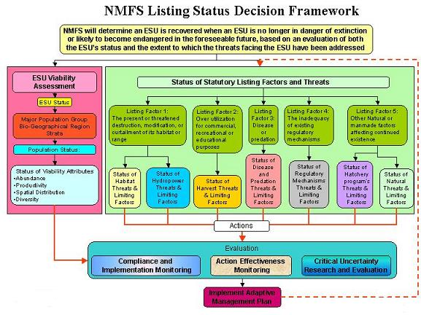
Figure 1. NOAA Fisheries Service Listing Status Decision Framework

2.4 Adoption of Effective Recovery Plans
The ESA directs NOAA Fisheries Service to develop and implement recovery plans for threatened and endangered species, unless such a plan would not promote conservation of the species. These plans must incorporate, at a minimum:
(1) A description of site-specific management actions necessary to achieve recovery of the species;
(2) objective, measurable criteria which, when met, would result in a determination that the species be removed from the list; and
(3) estimates of the time and costs required to achieve the plan's goal.
NOAA Fisheries Service is committed to developing recovery plans in a cooperative manner with local, state, and tribal governments that build local support and commitment. NOAA Fisheries Service is promoting a collaborative approach to recovery by:
- Supporting local efforts by using Domain Teams to coordinate and encourage recovery plan implementation.
- Using recovery plans to guide internal and external regulatory decisions.
- Using non-regulatory authorities and encouraging others to use their authorities to implement recovery plans.
- Providing leadership to regional forums to develop research, monitoring, and evaluation processes, and
- Providing periodic reports on species status and trends, limiting factors and threats.
NOAA Fisheries Service has been receiving locally prepared salmon recovery plans. The Northwest Region of NOAA is supplementing those plans to ensure they meet ESA requirements, and have already adopted many of them.
It is important that recovery plans contain a strong monitoring program that provides specific information about implementation, status/trends, and effectiveness monitoring and the proposed targets and benchmarks for the monitoring. Future monitoring and filling monitoring gaps should be prioritized based upon those ESUs and populations most critical for determining progress toward recovery. Some existing plans may need to be augmented to provide the specificity needed for an adequate monitoring strategy.
In keeping with this guidance, NOAA Fisheries Service will be reviewing the different ESUs/DPSs for answers to the following questions regarding recovery plans.
Table 1. Monitoring questions related to preparation and execution of recovery plans.
Criteria | Implementation (Compliance) Monitoring Questions | Effectiveness Monitoring Questions  (Outputs) | Validation Monitoring Questions (Outcomes)
Completion of a Recovery Plan | - Has a recovery plan been adopted for the ESU?  - Does the recovery plan contain a detailed monitoring and evaluation plan? | Has the recovery plan been effective in leading the watershed collaborators in implementing recovery actions? | Has the recovery plan been effective in recovering listed salmon species within its jurisdiction?
Adoption of a recovery plan in the Federal Register indicates that the plan is a NOAA approved approach.
Effectiveness of the plan can be demonstrated by reviewing the management actions within the ESU and the effects of the various agencies and tribes within the ESU upon viability and the threats.
Validating the recovery plan may take a number of years before sufficient recovery actions have taken place to improve the viability of the species or until the causes of failure of the recovery plan can be determined.

2.5 Development of a Strong Adaptive Management Process
The most significant way to ensure that management activities support salmon recovery and watershed restoration is to adopt the adaptive management process. Monitoring is a key component of a successful adaptive management process as shown in Figure 2.
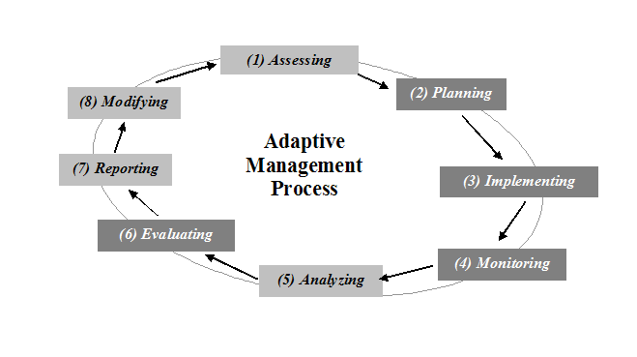
Figure 2. Adaptive Management Loop (Diagram taken from Washington Comprehensive Monitoring Strategy)
The analysis of information obtained from monitoring should be tied to predetermined performance targets, benchmarks, and action points. Without a well developed research, monitoring and evaluation (RM&E) plan with performance targets, monitoring can be ignored or fail to alert managers in a timely manner to needs for modifying management plans and in implementing new strategies.

2.6 Development of Research Monitoring and Evaluation Plans (RM&E)
As a component of the recovery plan, there should be a comprehensive research, monitoring and evaluation plan that identifies status/trends, implementation monitoring, effectiveness monitoring, and validation monitoring for the ESU. The plans should be specific as to what is currently monitored, how often, who monitors, and where. It should identify what new monitoring is anticipated and/or what changes will be made to existing monitoring programs. The RM&E plan should also identify what questions are being answered and what benchmarks or triggers are being used to track success and adaptive management actions. The plans should also clearly identify and prioritize gaps in existing monitoring, costs to fill those gaps, and how those gaps are proposed to be filled.

2.7 Recovery Plan Implementation
Domain Teams will continue to serve as NOAA Fisheries Service’ structural means to coordinate both internally and externally, the recovery implementation effort. Domain Teams will continue to be chaired by a recovery coordinator, organized based on geographic areas, and supported by staff representing the Salmon Recovery, Hydropower, Sustainable Fisheries, and Habitat Conservation divisions of NOAA Fisheries Service. It will also include, when appropriate, the Northwest Fisheries Science Center. When recovery plans are completed, the Domain Teams will shift their focus from recovery planning to implementation of the plans.
A Recovery Implementation Science Team (RIST) has been established by NOAA Fisheries Service as the successor to the Technical Review Teams (TRT). The RIST is a group of scientists that form task teams for analysis, review, or evaluation. RIST products are intended to inform policy and management decisions, not to proscribe or make decisions.

2.8 Access To Adequate Data
NOAA Fisheries Service does not have the staff or the mandate to collect and maintain most of the information needed for status determinations. The management of salmon and steelhead is a shared responsibility delegated to the states and co-managed under various federal tribal treaties. NOAA Fisheries Service must, therefore depend upon the state fish and wildlife agencies and tribes for much of the information collected for VSP criteria. However, each TRT (to varying degrees of specificity) has identified metrics or data types (raw and derived) for use in evaluating status against their criteria. There are a lot of common elements, some specific to particular settings. Likewise for many of the threats and listing factors, local governments, state agencies and others collect and maintain much of the pertinent information. Therefore NOAA needs,
- Access to data that can demonstrate the viability status/trends of listed fish populations and their associated MPGs and ESUs.
- Access to data that can demonstrate whether management actions that address the threats have been implemented.
- Access to data that demonstrates whether the management actions have been effective in reducing or eliminating the threats.

NOAA needs to know how summarized data used in status determinations are derived so that the derived information is repeatable and transparent. Methodologies generated by experts (usually associated with state agencies or tribes) should be documented, transparent, and consistent from year to year. For example, the Interior Columbia TRT status review of the South Fork Salmon Chinook population required input from Idaho Department of Fish and Game (IDFG) scientists, regional hatchery managers and Nez Perce scientists to translate from raw data spawning ground surveys and weir counts into population level statistics (abundance, productivity, hatchery/wild ratios, age structure, distribution across areas in pop etc.). It is important to document how this was done, the assumptions used, and the calculations involved.
In keeping with the common need for shared data, we encourage the development of regional distributed data sharing systems using nodes that can provide access to each of the types of data that address the threats and VSP factors. Substantial work has been done in the past to try to address data needs. Most recently the Northwest agencies and tribes have convened the Executive Data Summit to address sharing information in the region (Idaho, Oregon, and Washington). The 2003 findings and recommendations of the consulting firm Science Applications International Corporation (SAIC)to the Northwest Power and Conservation Council and NOAA Fisheries Service clearly pointed to the regional data needs in the following bullets.
- Currently, Information system development in the Columbia Basin and Puget Sound is, for the most part, ad-hoc.
- As different agencies, institutions or projects need to manage information they mostly go about it independently, creating for example, their own databases, collection methods and reports.
- While there have been some efforts at consolidation or standardization (CBSIS, NED) they have not succeeded across the Columbia basin and the region as a whole.
- These individual information systems are called disparate systems because they often don’t share the same operating system or language, don’t collect data of uniform quality or description and usually cannot “talk” directly to each other.
- Unless regional executives agree on common approaches to managing raw and processed information, and other approaches that benefit all users, the integration and sharing goals of the region cannot be realized and “business as usual” will remain the norm.

Figure 3 illustrates the dilemma of data management in terms of a pyramid with a broad base and a narrow top. At the bottom of the pyramid, a relatively few number of scientists collect and evaluate a broad based amount of information about specific sites, metrics, and temporal variations. As this information is synthesized and summarized it becomes usable to managers, modelers, and technical staff. Finally, as many metrics are combined they become useful as high-level indicators. High-level indicators generally provide status of the resource and trends that can be understood by the public and that informs congress and senior executives. Higher level indicators cannot be measured without combining and distilling the proper information from the bottom of the pyramid. The proper information at the bottom of the pyramid cannot be collected and funded until senior executives and the public decide what questions at the top of the pyramid need to be answered, how confident they need to be with their answer, what data will answer the question, and how much it will cost. These questions should be identified in the RM&E plan and they should be consistent with public reports. The challenge in creating a properly functioning data pyramid is to build one that will answer questions at different scales as one ascends the pyramid.
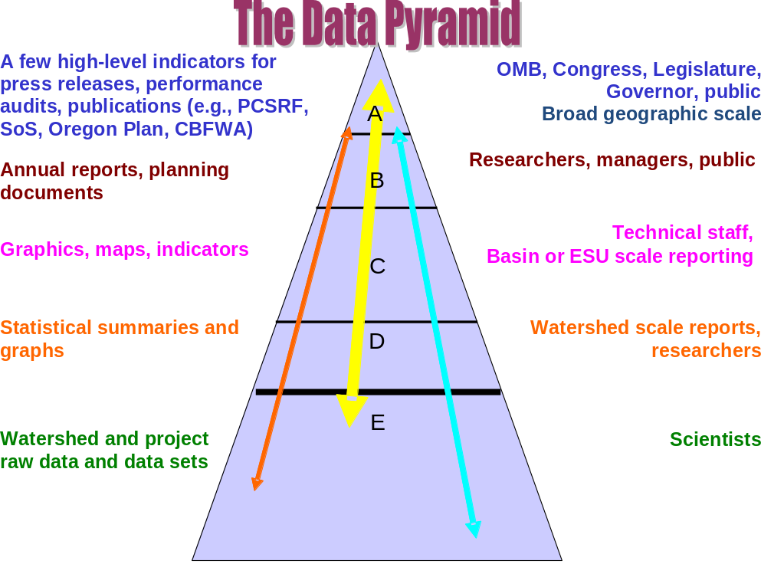
Figure 3. The data pyramid.
The regional executives are taking the following steps to move toward these goals:
- Integrate information management with regional goals and performance measures. The Executive Summit is approaching this task through its High Level Indicators Work Group. Their goal is to cut across and integrate individual agency mandates and missions to attempt to standardize as much as possible the top of the pyramid.
- Collaboratively establish a regional implementation and monitoring strategy. This is ongoing through the Columbia River Biological Opinion, state strategies, and NOAA Fisheries Service ESA monitoring needs.
- Develop and adopt regional information management protocols, data dictionaries, and field protocols so that data are capable of being combined and summarized across jurisdictions and state boundaries. This is being pursued through the Pacific Northwest Aquatic Monitoring Partnership (PNAMP) and other forums.
- Ensure long term support and commitments through adequate funding.
- Move toward a system of databases housed at various agencies that can share data readily through a node or portal. This will require establishing agreed to protocols, data dictionaries and guidelines in order to be able to be part of the regional node.
An example of a shared distributed database system is the Pacific Northwest Data Exchange Network developed jointly by the US EPA , Washington Department of Ecology, Oregon Department of Environmental Quality, Idaho Department of Environmental Quality and other participants. At present, the Northwest Indian Fisheries Commission (NWIFC) is entering water quality information into the system and a new contract is underway that will put Puget Sound juvenile migrant salmon and steelhead information into the system from the NWIFC and the Washington Department of Fish and Wildlife. A similar system could be developed for Columbia River fish and habitat data. Figure 3 demonstrates how such a system can benefit all participating agencies and the public in sharing information.
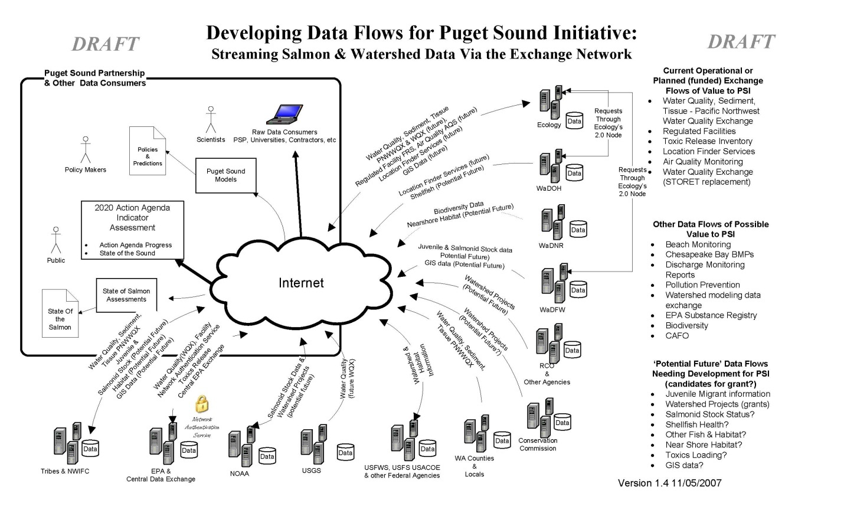
Figure 4. Puget Sound Partnership Data Sharing Conceptual Model. (Courtesy of John Tooley Washington Department of Ecology).
NOAA Recommendation: In addition to building larger scale distributed data systems that can communicate between the various agencies involved in natural resources, the natural resource agencies should develop automated internal infrastructure to assess and evaluate their data and to report it through the various systems that require the information.
Currently much of the data exists in various computers at various locations with little or no metadata available to support the data. Roll up reports require contacting numerous field staff to interpret and provide the data. This has led to inconsistent interpretation of data sets. This infrastructure is more than putting raw data into a computer. Some level of synthesis by technical experts familiar with the particular system is needed. Procedures used in developing the reporting statistics of previous reviews should be defined and the desired applications needed should be identified as metadata. In some cases additional funding will be required to make this happen in the desired timelines.

3.0 SPECIES STATUS REVIEWS
NOAA Fisheries Service is preparing for the beginning of five year reviews in 2010 of each of the listed ESUs and DPSs that have been listed. To prepare and evaluate the information within NOAA Fisheries Service, an internal review process is being developed. Also, typically recovery plans identify these status reviews as a first element in a more comprehensive periodic regional review of progress on recovery planning. In most cases, regional teams would complement the NOAA fisheries review with reviews of implementation, response to evaluation of key uncertainties, adaptive approaches etc. These teams usually involve regional interests (e.g. states and tribal experts, plus technical experts). In addition, a decision process will be needed to decide which ESUs will be evaluated first. The internal review will use the Northwest Fisheries Science Center (NWFSC) to test viability, coordinate the recommendations of the RIST, and to assist with data integration and standardization of data dictionaries and protocols. Staff at other offices will be involved with evaluating threats and listing factors and integrating the Columbia River Biological Opinion into the process. The NWFSC will also be involved in listing factor evaluation and the NWR will develop cooperative data sharing agreements to make the evaluations possible.

3.1 NOAA’s Tool Box For ESA Review
In order to review the various listed ESUs, NOAA is developing a series of internal tools to expedite the process. The following conceptual model will be followed.
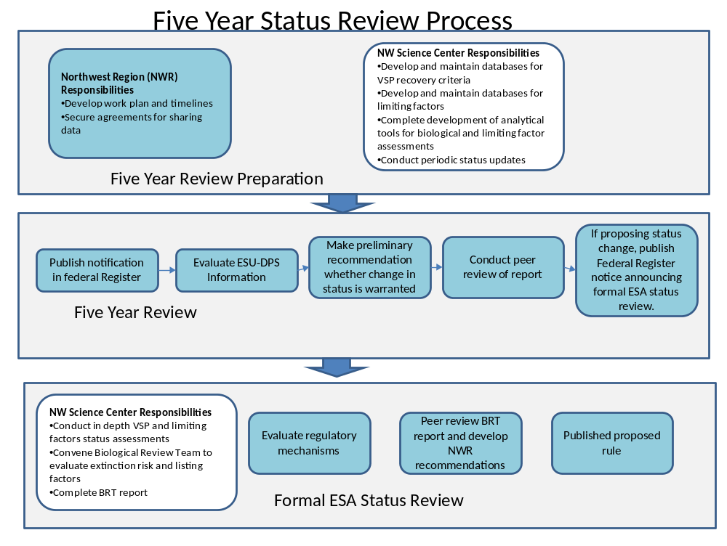
Figure 5. Conceptual model for conducting five year review of listing status under the ESA.
In preparation for the review, the Northwest Region will develop the work plans and timelines beginning in 2010 and secure any agreements for completing necessary tasks. The NWFSC will utilize their data tools and databases to conduct periodic status updates.
The five year review will begin with a formal notification in the Federal Register. The NWFSC will evaluate the ESUs and DPS to determine whether there is sufficient information to make a recommendation on a change of status. Also, the RIST will be providing recommendations to the NWFSC as they develop their findings. The recommendations will be given peer review. After addressing peer review, if an ESU or DPS status appears to have changed, a formal notification will be published in the Federal Register announcing that a formal status review will be conducted.
Once a formal review has begun, the NWFSC will conduct in depth VSP evaluations, convene the Biological Review Team (BRT) and complete a BRT report. The results of these evaluations will undergo peer review, and the NWR will consider the results and develop the formal rules for publication in the Federal Register.
In order to create the greatest clarity for conducting future ESA reviews, NOAA Fisheries Service is working collaboratively with the recovery entities to develop an agreed upon data dictionary for VSP metrics; this RM&E Guidance document to clarify the standards that should be attained for monitoring; and a cooperative regional strategy that contains an inventory of existing monitoring programs, the gaps that need to be addressed and the funds needed to provide an adequate Pacific Northwest monitoring structure. The following figure attempts to explain how these products will complement each other.
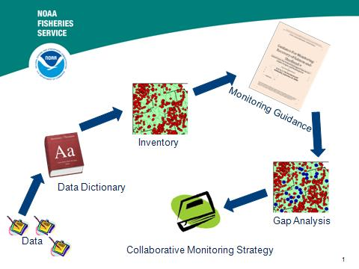
Figure 6. NOAA Fisheries Service Regional Monitoring Guidance and Structure
Key monitoring questions related to the status reviews are shown in Table 2 below and the related NOAA evaluation question. As can be seen, these are hierarchical questions beginning with each identified population within a major population group (MPG), then an evaluation of each MPG, and finally an evaluation of the entire ESU/DPS.
Table 2. ESU scale viability assessment monitoring questions and NOAA status assessments.
 | Population Level Viability Analysis | Major Population Group Level Viability Analysis | ESU or DPS Level Viability Analysis
Key Monitoring Questions | What is the overall status/trend of VSP criteria for each population within each MPG? | What is the overall status/trend of VSP criteria for the MPG? | What is the overall status/trend of VSP criteria for the ESU/DPS?
Key NOAA Evaluations  (NOAA Fisheries Service , May 2007) | - What is the abundance/productivity status of the populations based on viability curves or natural origin fish return ratio?  - What is the status of spatial structure of the population?  - What is the current state, and change in state, of measures of population diversity across each ESU? | - Is the number of populations within the MPG at high viability/low risk consistent with TRT recommended ESU viability criteria?  - Do at least one-half of the populations historically within the MPG meet viability standards  - Does at least one population within the MPG meet “highly viable” criteria? | - Are all MPGs within the ESU at, or clearly trending toward a low risk status?
Under the Listing factors and threats status review, it is important to determine for each factor whether there is sufficient information to detect the status of the listing factor and its future. Sufficient data should be available to provide those. Were the HCPs within the ESU implemented? Were the Section 7 and section 10 requirements implemented and monitored?

3.2 NOAA Fisheries Service Reporting Mechanisms
NOAA Fisheries Service will use Five Year Status Reviews, the ESA Biennial Report to Congress, the Pacific Coastal Salmon Recovery Fund Report to Congress and other reporting mechanisms to report status of plan implementation, provide assessments of status and trends, and to report progress in reversing limiting factors and threats. These reports rely on accurate data obtained from many collaborative sources as detailed under “Access To Adequate Data”.
4.0 WHAT IS MOST IMPORTANT TO MONITOR?
Criteria | Monitoring Priority |  | Confounding Effects or Sources of Error | Comments
VSP Adult Abundance (specific evaluation of spawners in natural production areas) | Highest | - Hatchery spawners  - Estimation methods  - Inaccurate Harvest or abundance estimates |  | It must be recognized that tracking spawning population is at the heart of TRT criteria. Measurements at other levels (e.g., run to the Columbia River, total natural production) may also contribute to assessments.  Measuring adult abundance for the populations within the ESU could be sufficient to determine recovery but may take a considerable number of years to be confident that the listing factors are apparently no longer threats to the continued existence of the species.
VSP Productivity | Very High | - Juvenile and adult supplementation  - Hatchery spawners |  | Productivity is only accurate if the estimates of adult abundance and (where employed) juvenile abundance are accurate. As used by the TRT (and previously by some BRT assessments), productivity is defined in terms of spawner to spawner ratios, juvenile info is valuable where available, but it is not available for many populations.
VSP Spatial Distribution | High | Lack of a periodic census or valid sampling program |  | Spatial distribution tends to be a collection of one time site records developed over time.
VSP Diversity | High | Inadequate baseline information  Hatchery effects  Harvest effects  Changes to habitat |  | Many diversity traits can be tracked through incidental harvest sampling and spawner surveys.
LISTING FACTORS AND THREATS
Threats Due to Curtailment or Destruction of Habitat or Range | Very High | Lack of Adequate habitat sampling program |  | Only tracking the number of restoration projects completed does not necessarily indicate net improvement in salmon habitat
Threats Due to Overutilization (Harvest) | High | - Poor stock identification techniques for naturally produced adults in the fisheries  - Unmarked hatchery adults in the fisheries  - Poor compliance with harvest regulations (unaccounted losses) |  | Exploitation rate management may not adequately control harvest to meet spawner goals for recovery of the ESU.
Threats due to Hatcheries | High | - Lack of spawning ground survey data on straying into natural production areas  - Lack of GSI measurements  - Marking of all hatchery fish  - Competition |  | It will probably not be feasible to determine the effectiveness of hatchery management plans in all locations, but specific studies will be needed
Threats due to Predation and Disease | Medium | - Seals & Sealions  - Avian predators (e.g. Caspian terns)  - Piscine predators (e.g., Pike minnow, small mouth bass, walleye, etc). |  | Most of the monitoring and control of marine migratory birds and marine mammals lie within the purview of the federal government.
Threats due to Regulatory Actions | Medium | - Poor compliance with zoning and other land use regulations  - Inadequate local or state environmental laws |  | An audit of state and local land use and environmental laws and regulations should be completed periodically to test for effectiveness.
Threat due to Climate and other Conditions | Low | - Unpredictable changing tributary (e.g. temperature and flow patterns) ,and ocean conditions |  | Although climate change may play an important part in whether a species will recover, it is not a factor that state and tribal entities are likely equipped and mandated to track.
Table 3. Relative importance of monitoring VSP parameters and threats
Table 3 above attempts to show what will be the most important to monitor for NOAA Fisheries Service to determine recovery. Those components having the highest priority would be most important for developing accurate monitoring programs and distributing limited funding. Those VSP elements and threats most likely to express actual fish viability were ranked highest.

Definition of a Viable Salmonid Population:
NOAA Fisheries Service will be evaluating each ESU in a manner that takes all four VSP criteria into consideration. A viable Salmonid population is defined as “an independent population of any Pacific salmonid (genus Oncorhynchus) that has a negligible risk of extinction due to threats from demographic variation, local environmental variation, and genetic diversity changes over a 100-year time frame. An independent population is defined as any collection of one or more local breeding units whose population dynamics or extinction risk over a 100-year time period are not substantially altered by exchanges of individuals with other populations. In other words, if one independent population were to go extinct, it would not have much impact on the 100-year extinction risk experienced by other independent populations. Independent populations are likely to be smaller than a whole ESU” .

“There may be structure above the level of a population as well as below it. This is explicitly recognized in the ESU designations: an ESU may contain multiple populations connected by some small degree of migration. Thus organisms can be grouped in a hierarchic system wherein we define the levels of individual, subpopulation, population, ESU and, finally, species. Other hierarchic systems made up of more or fewer levels could be constructed. (McElhany, 2000). All of the TRT viability criteria recognize that populations are an element in a hierarchy). Therefore all of the TRTs have recommended MPG/ESU level criteria that encourage low risk populations across the landscape within an ESU, protecting a range of diversity, providing for something akin to historical levels of exchange. Table 4 below attempts to show how these may work together and monitoring levels that can reduce the level of risk associated with choosing various strategies for monitoring recovery. Break points and criteria are the results of combining various TRT viability documents, CBFWA CSMEP modeling, and other attempts to determine how much monitoring is needed to reduce risks.

Table 4. Relative risk analysis of having insufficient information for ESA status determinations
 | Low Risk of Insufficient Data | Moderate Risk of Insufficient Data | High Risk of insufficient data
Adult Abundance | - Collecting abundance data on greater than 75% of populations within each MPG in the ESU | - Data collected >50% of populations but <75% within each MPG | - Data collected on 50% or less of the populations within the MPGs of the ESU
Juvenile Abundance | - Collecting juvenile abundance data in the same populations where adult abundance is taken for at least one population in each MPG  - Juvenile out-migrant abundance measured near the mouth of the streams in which adult abundance is measured | - Collecting juvenile abundance data in the same populations where adult abundance is taken within the ESU  - Juvenile out migrant abundance measured using probabilistic sampling of pre-migrant parr | - Collecting juvenile out-migrant data for some locations but not necessarily related to a strategy for selecting primary populations for each MPG.
Fish Distribution | - Active probabilistic sampling occurring within the ESU to document changes in fish distribution combined with  - Specific spawner abundance estimates in known spawning areas.  - Documentation of fish passage blockages removed  - Spawner surveys or red counts documenting extent of adult abundance distribution above former blockages. | - Documentation of fish passage blockages removed  - Spawner surveys or red counts documenting extent of adult abundance distribution above former blockages. | - Documentation of fish passage blockages removed  - Documentation of the presence of any salmonid life stage
Species Diversity | - Annual documentation of age distribution, sex ratio, length, fecundity, weight, run timing, spawn timing and genetic diversity by population | - Annual documentation of age distribution, sex ratio, length, fecundity, weight, run timing, spawn timing and genetic diversity by MPG | - Periodic documentation of genetic diversity, length, weight, run timing, and spawn timing by ESU

5.0 VSP ADULT SPAWNER ABUNDANCE
In order to address the status of adult abundance for TRT populations, a number of monitoring questions are of interest at the three scales or layers, population, MPG, and ESU/DPS.
Table 5. Key population abundance status/trend monitoring questions and NOAA determinations.
 | Population Level Adult Abundance | Major Population Group Level Adult Abundance | ESU or DPS Level Adult Abundance
Key Monitoring Questions | - What is the status/trend of primary populations within each MPG?  - What is the proportion of hatchery fish on the spawning grounds for each population within the MPG?  - What is the age structure and cohort structure for each population?  - Can the population be identified in the fisheries and throughout its range in order to determine harvest mortalities  - If this population is supplemented, what is the viability of the population with and without supplementation? | - What is the status/trend of each MPG?  - What is the proportion of hatchery fish on the spawning grounds for each MPG?  - Can the MPG be identified in the fisheries and throughout its range in order to determine harvest mortalities  - If one or more populations within the MPG are supplemented, what is the viability of the MPG with and without supplementation? | - What is the status/trend of each ESU/DPS?  - What is the proportion of hatchery fish on the spawning grounds for each ESU/DPS?  - Can the ESU be identified in the fisheries and throughout its range in order to determine harvest mortalities  - If one or more populations within the ESU/DPS are supplemented, what is the viability of the ESU with and without supplementation?
Key NOAA Evaluations | - Determine the change in status for each population with information at the time of listing.  - Determine whether the populations monitored have exceeded the minimum criteria recommended by TRTS for meeting long term ESU viability. | - Is the number of populations within the MPG at high viability/low risk consistent with recommended ESU viability criteria?  - Do at least one-half of the populations historically within the MPG meet viability standards  - Does at least one population within the MPG meet “highly viable” criteria? | - Determine the change in status for each ESU with information at the time of listing.  - Determine whether the ESU/DPS has met the TRT minimum requirements for long term viability.

Ideally NOAA Fisheries Service would like to have annual adult abundance data for all populations within each major population group and ESU. However, this may not be possible initially for a variety of reasons including cost, river conditions, spawn timing, etc. The following are key points that will be taken into consideration in evaluating adult abundance.

5.1 Monitoring Design Considerations
Does the ESU/DPS have an adequate monitoring design approach? The following table is based upon work completed by CSMEP for the Snake River basin and shows how different designs can affect the outcome in terms of cost and accuracy of data.
Table 6. Analysis of optional designs for monitoring populations within MPGs (Courtesy of CBFWA CSMEP)
MPG Status Monitoring Design and Strategy | Pros and Cons
Design 1: Data from populations within the MPG having data at the time of listing are sampled so that they have data at the time that a five year review is conducted to be able to compare before and after progress. | If the data were not accurate or had known flaws this may not be adequate
Design 2: Sample all populations within the MPG with even effort. An estimate of population abundance is calculated for each one. | - Sources of error are within each population  - Costs are maximized  - Accuracy for smaller populations may be greater than for larger populations
Design 3: Sample a few populations more intensively than when listed and use this better monitoring data to make inferences to the rest of the MPG | - Accuracy may be greater for those populations sampled  - Costs may be equal to or less than previous monitoring.  - Error is within each population and in the inferences derived for the other populations
Design 4: Place most of the effort on populations that are targeted for recovery and/or are representative of sets of populations. | - Will provide more accurate information about the greatest percentage of the population in terms of numbers of fish and importance to fisheries.  - Will provide some information about smaller components to address genetic diversity and distribution of the MPG.  - Costs may be greater than or equal to previous monitoring.
Design 5: Place most of the emphasis on the smaller populations within the MPG | - May provide a better picture of the overall diversity of the MPG and will be sensitive to declines or improvements in small populations normally not observed.  - May provide data with no initial comparative information to track changes against  - Costs may be higher as it may require more intensive monitoring to detect low populations of spawners and their distribution.
Design 6: Completely omit some populations based upon location, difficulty, etc. and make inferences from the other similar sampled. | - May leave holes in the data where it would be difficult to make inferences over time if there were no data to base inferences upon.

5.1.1 Probabilistic Random Spawner Abundance Design

NOAA Recommendation: Incorporate EMAP type probabilistic sampling in conjunction with index spawner surveys to verify spawner accuracy and to detect changes in spawner locations.
New sampling designs have been incorporated for adult spawners for Oregon coastal coho and for steelhead in the Wenatchee River system. Spawning areas accessible to adults are sampled using randomized tessellated locations with rotating panels. This methodology produces estimates of spawner abundance that are similar to mark recapture methods and produce results that are statistically valid and with known certainty. In many cases it can also detect changes in spawner distribution when spawner abundances using redd or carcass index areas will not (See Figure 7).

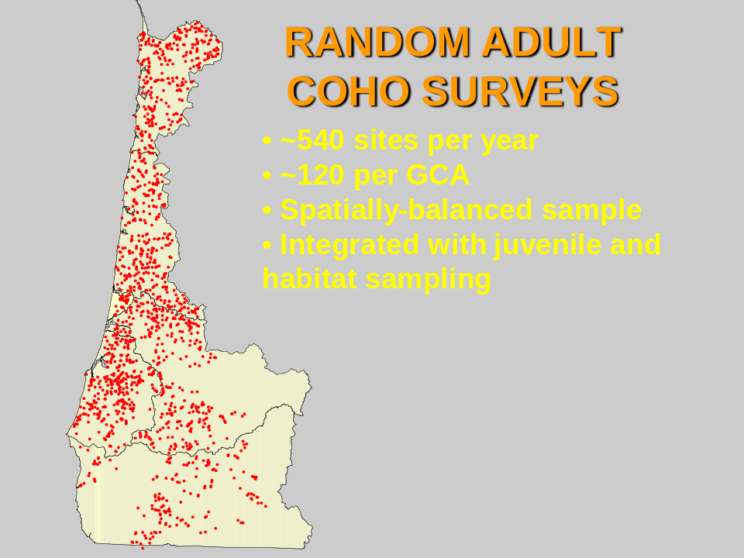
Figure 7. Oregon Coastal Coho ODFW random adult surveys (Compliments of Steve Jacobs ODFW)

5.2 Hatchery Contributions

NOAA Recommendation: Monitor ratio of marked hatchery salmon and steelhead with an external adipose clip to unmarked natural origin fish in all adult spawner surveys.
The quality of adult abundance information for naturally reared salmon and steelhead is questionable without knowing the contribution of hatchery fish to the spawning grounds. Mass marking of hatchery salmon combined with systematic spawning ground surveys in natural areas likely to incur hatchery straying will allow for more accurate information. Rivers where this cannot be accomplished will have difficulty showing that naturally produced adults within a given population are increasing.
In rivers where supplementation is occurring, the purpose and extent of supplementation will need to be considered. Have the managing agencies clearly identified the goal of supplementation? Can supplemented fish be identified in the watershed? Is the population viable without supplemention?

5.3 Quality Control/Quality Assurance
NOAA Recommendation: Verify accuracy of adult spawner survey estimates by determining variance and confidence limits.
It has been demonstrated that Pacific salmon have a naturally high degree of annual variance not related to measurement errors associated with various life stages (Paulsen. C.M., 2007).

Quality control and quality analysis of data collection procedures should be conducted. A power analysis should be conducted for each natural population being monitored within an ESU. A power analysis estimates the probability of concluding that a trend exists given that there actually is a trend. The greater the trend the easier it is to detect and therefore the greater the power. However, a significant trend may not be detectable if there is a high degree of variance. As the variance increases, the power to detect change lowers. Increasing the number of years monitored decreases the overall variance as also does increasing the number of populations sampled and pooled. Therefore, the power to detect change can be improved by decreasing the measurement error and/or increasing the number of years or populations evaluated (Monitoring Oversight Committee, 2002). One strategy for improving the measurement of trends in ESA listed fish is to pool data by MPG for all populations measured in order to maximize the number of years and populations and thereby reducing the overall variance of the results.

Paulson and Fisher (Paulsen, 2003)determined that changes of 30% should be detectable for Snake River spring-summer Chinook within 7 years using a BACI experimental design. Bisson et al. (2008)estimated that to be 80% certain it could take 26 years to detect a 50% change in the population. However, by pooling populations within an ESU it may be possible to detect statistically significant change within 3 years. Hahn (1998) found that the average variance of Chinook spawner surveys in the Skagit and Stillaguamish rivers was 40%.

NOAA Recommendation: Agencies should strive to have adult spawner data with the power to be able to detect a change in abundance of ± 30% with 80% certainty within 10 years.
The use of viability models has been employed to predict extinction risks into the future based upon population variances and productivity. Evaluations such as Paulsen et al. (2007) indicate that models may not have a strong capability of predicting future risks due to the high natural variability of the populations. The process error associated with the model may be more of a factor in creating erroneous predictions than the measurement errors. Therefore, emphasis should be placed on obtaining strong measurements of population status so that the longer term trend can be demonstrated that shows that adult populations are attaining recovery goals.

6.0 VSP PRODUCTIVITY
 | Population Level Productivity (Population growth rate) | Major Population Group Level Productivity (Population growth rate) | ESU or DPS Level Productivity (Population growth rate) | What steps have been taken to address knowledge gaps in natural populations?
Key Monitoring Questions | - What is the Adult to adult ratio of primary populations within each MPG?  - What is the smolt to adult ratio of primary populations within each MPG?  - What is the variance about the adult and smolt estimates? | - What is the proportion of populations within the MPG that are meeting viability standards?  - What is the smolt to adult ratio within each MPG? | - What is the proportion of populations within the ESU that are meeting viability standards?  - What is the composite smolt to adult ratio of MPGs within each ESU/DPS? | Do current adult spawner estimates and smolt estimates for each population have known variance and confidence limits within the ESU?
Key NOAA Evaluations | - Determine the change in adult to adult productivity for each population with information at the time of listing.  - Determine the change in smolt to adult productivity for those populations where juvenile abundance is monitored.  - Determine whether the populations monitored have met the TRT productivity goals for meeting long term viability. | - Determine the change in adult to adult productivity for each MPG with information at the time of listing.  - Determine the change in smolt to adult productivity for those MPGs where juvenile abundance is monitored.  - Determine whether the MPGs have met the TRT productivity goals for meeting long term viability. | - Determine the change in adult to adult productivity for each ESU/DPS with information at the time of listing.  - Determine the composite change in smolt to adult productivity for those populations within the ESU where juvenile abundance is monitored.  - Determine whether the ESU has met the TRT productivity goals for meeting long term viability. | Determine whether the variance associated with the estimates are within allowable limits for determining a change of listing status
VSP guidance states that “A population meeting or exceeding abundance criteria for viability should, on average, be able to replace itself. That is, spawner: spawner ratios or cohort-replacement ratios should fluctuate around 1.0 or above. When populations are at target levels recommended by the TRTs there is a need for resiliency where average productivities sufficiently above 1.0 are available for events where populations are driven below target levels by annual fluctuations in survival. This is an important feature of TRT viability criteria, but can be expressed in different forms (e.g., geometric mean productivity below threshold escapement, fitted s/r curve productivity, ‘test’ return per spawner for a historical ‘low survival period), etc. Natural productivity is typically measured as the ratio of naturally produced spawners born in one brood year to the number of fish spawning in the natural habitat during that brood year; population abundance estimates at other life-history stages may also be used, provided such estimates span the entire life cycle (e.g., smolt to smolt estimates)” (McElhany et al., 2000).

6.1 Simultaneous Monitoring of Juvenile Migrants and Adult Spawners

NOAA Recommendation: Develop estimates of juvenile migrants for at least one significant population for each MPG or DPS. Juvenile migrant data should have the power to be able to detect a change in primary population juvenile migrant abundance of ± 30% with 80% certainty.
Data on both emigrant juveniles and adults should be simultaneously and continuously collected for at least one of the primary populations for each major population group (MPG) within an ESU/DPS. Primary populations are those that must demonstrate low risk of extinction in order to recover the MPG and ESU. IN some areas smolt to adult returns (SAR) will be needed to calculate productivity. Incorporating SAR results into population productivity estimates can be a powerful tool in reducing uncertainties due to high variations in marine survivals (ICTRT, 2007).
These estimates are normally associated with a screw trap or inclined plane trap located at the mouth of a river or stream where it may capture emigrants from one or more primary populations. Ideally the trap would collect only one primary population. Where smolt trapping is used, the data should be able to measure trap efficiency and that the trapping is of sufficient duration to encompass at least 90% of the out-migration. Trapping of larger rivers and primary populations can provide important information, but may be difficult and expensive to do due to the size and characteristics of the river. See (Seiler, 2001) for examples of smolt trapping and estimation methods for larger rivers.
In other areas, a tributary stream of a major population may be used to estimate smolt to adult productivity and to determine marine and freshwater survival (life cycle streams). These sites are easier to monitor and to install due to their much smaller size, but assumptions must be made about the overall watershed smolt production based upon the smaller index sites (Nickelson, 1998).

6.2 Juvenile Salmonid Parr Estimates
In some areas it may be necessary or desirable to estimate overall juvenile migrant production from low flow summer parr estimates. This has most often been done for coho and for steelhead (Rodgers, 2002). For areas where juvenile in-stream population estimates are generated using probabilistic sampling, a clear statistical relationship between juvenile parr abundance estimates and total adult and Juvenile migrant production should be demonstrated.

7.0 FISH DISTRIBUTION

8.0 SPECIES DIVERSITY

9.0 THREATS DUE TO LOSS OF HABITAT OR RANGE

10.0 THREATS DUE TO HYDROPOWER UPON HABITAT

11.0 THREATS DUE TO HARVEST

12.0 THREATS DUE TO DISEASE AND PREDATION

13.0 THREATS DUE TO INADEQUACY OF REGULATIONS

14.0 THREATS DUE TO HATCHERY PRODUCTION

15.0 THREATS DUE TO NATURAL CAUSES

16.0 WORKS CITED
Bayley P.B. A review of studies on responses of salmon and trout to habitat change, with potential for application in the Pacific Northwest [Report] / Department of Fisheries and Wildlife. - Corvallis : Oregon State University, May 2002. - p. 26 p.. - Report to the Washington State Independent Science Panel.
Beechie T.J, E.A. Steel, P. roni, and E. Quimby Ecosysten Recovery Planning for isted Salmon [Report] : Memorandum / National Oceanic and Atmospheric Administration ; National Marine Fisheries Service. - Seattle : U.S Department of Commerce, National Marine Fisheries Service, 2003. - p. 183. - NMFS-NWFSC-58.
Bilby R.E. Evaluating watershed response to Land management and restoration actions: Intensively Monitored Watersheds (IMW) Progress Report. Submitted to Washington Salmon Recovery Funding Board. [Report]. - Olympia : Washington Salmon Recovery Funding Board, 2004. - Prepared by the PNAMP IMW Committee.
Bisson P.A., S.V. Gregory, T.E. Nickelson, and J.D. Hall The Alsea Watershed Study: A comparison with other Multi-year Investigations in the Pacific Northwest [Book Section] // Hydrological and Biologicsl Responses to Forest Practices / book auth. Stednick John D.. - [s.l.] : Springer, 2008.
Chilcote M.W. Relationship between natural productivity and the frequensy of wild fish in mixed spawning populations of wild and hatchery steelhead (Oncorhynchus mykiss) [Journal]. - [s.l.] : Canadian Journal of Fisheries Aquatic Science, 2003. - Vol. 60. - pp. 1057-1067.
Cooney T., M. McClure, C. Baldwin, R. Carmichael, P. Hassemer, P Howell, H. Shaller, P. Spruell, C. Petrosky, F. Utter, D. Holzer, D. Matheson, and L. Wright Current Status Reviews: Interior Columbia Basin Salmon ESUs and Steelhead DPSs Volume III Middle Columbia River Steelhead [Report] / NOAA Fisheries Service. - [s.l.] : NOAA Fisheries Service, 2008. - p. 23.
Currens K.P.,H.W. Li, J.D. McIntyre, D.R. Montgomery, and D.W. Reiser Recommendations for Monitoring Salmonid Recovery in Washington State [Report] : Report 2000-2 / Independent Science Panel. - Olympia : Governor's Salmon Recovery Office, 2000. - p. 48p.
DiLorenzo E., N. Schneider, K.M. Cobb, K. Chhak, P.J.S. Franks, A.J. Miller, J.C. McWilliams, S.J. Bograd, H. Arango, E. Curchister, T.M. Powell, and P. Rivere North Pacific Gyre Oscillation Links ocean climate and ecosystem change [Journal]. - [s.l.] : Geophysical Research letters, 2008. - LO8607 : Vol. 35. - doi:10.1029/2007GL032838.
Drivdahl Chris 2006 State of Salmon in Watersheds [Book]. - Olympia : State of Washington, 2006. - p. 101 pages.
Hahn P., C. Kraemer, D. Hendrick, P. Castle, and L.Wood Washington State Chinook spawning escapemnt assessment in the Stiilaguamish and Skagit Rivers [Report]. - Olympia, WA : Washington Department of Fish and Wildlife, 1998.
Heitke J.D., E.J. Archer, D.D. Dugaw, B.A. Bouwes, E.A. Archer, R.C. Henderson, and J.L. Kershner Effectiveness Monitoring For Streams and riparian areas: sampling protocol for stream channel attributes. [Report] : Unpublished manuscript / Forest Service. - [s.l.] : U.S. Forest Service, 2006. - p. www.fs.fed.us./biology/fishecology/emp..
Hillman T.W. Draft Monitoring Strategy For the Upper Columbia Basin, [Report]. - Eaglel, ID : Bioanalyists Inc, 2006. - Prepared for the Upper Columbia Basin Regionoal techincal Team and the Upper columbia Salmon recovery Board.
Kaufmann P.R., P. Levine, E.G. Robison, C. Seeliger, and D.V. Peck Quantifying Physical habitat in Wadeable Streams [Report]. - Washington, DC : U.S. Environmental Protection Agency, 1999. - EPA/620/R-99/003.
Larsen D.P., P.R. Kaufmann, T.M. Kincaid, and N.S. Urquhart Detecting Persistent Change in the Habitat of Salmon-bearing Streams in the Pacific Northwest [Journal]. - [s.l.] : Canadian Journal of Aquatic Science, 2004. - Vol. 61. - pp. 283-291.
Lower Columbia Fish Recovery Board Draft Research, Monitoring & Evaluation Program for Lower Columbia Salmon & Steelhead [Report]. - Longview : Lower Columbia Fish Recovery Board, 2008. - p. 198.
McElhaney P., M. Ruckelshaus, Viable Salmonid Populations [Book]. - Seattle : NOAA Fisheries, 2000. - Vols. NOAA Technical Memorandum NMFS-NWFSC-42.
McElhany P., M.H. Ruckelshaus, M.J. Ford, T.C.Wainright and E.P Bjorkstedt Viable Salmonid Populations and the Recovery of Evolutionarily Significant Units [Report] / NW Fisheries Science Center. - Seattle, WA : NOAA Fisheries Service, 2000. - p. 156 p.. - NOAA Tech. Memo. NMFS-NWFSC-42.
Monitoring Oversight Committee The Washington Comprehensive Monitoring Strategy For Watershed Health and Salmon Recovery: Volume 2 [Report]. - Olympia, WA : Washington Interagency Committee, 2002. - p. 377. - Volume 2.
Nickelson T.E. ODFW Coastal Salmonid Population and Habitat Monitoring Program [Report]. - Corvallis, Oregon : ODFW, 1998. - p. 50.
NOAA Fisheries Service Adaptive Management for ESA-Listed Salmon and Steelhead Recovery: Decision Framework and Monitoring Guidance [Report] : Informal Guidance Document. - Seattle, WA : Northwest Region and Fisheries Science Center, May 2007. - p. 56 p..
NOAA Fisheries Service Pacific Coastal Salmon Recovery Fund Performance Goals, Measures, and Reporting Framework [Report]. - Seattle, WA : NOAA Fisheries Service, December 2006. - p. 10 p..
Paulsen C.M. and T.R. Fisher Detecting juvenile survival effects of habitat actions: power analysis applied to endangered Sanke river spring-summer chinook (Oncorhynchus tsawytscha) [Journal]. - [s.l.] : Canadian Journal of Aquatic Science, 2003. - Vol. 60. - pp. 1122-1132.
Paulsen. C.M. R.A. Hinrichsen, and T.R. Fisher Measure Twice, Estimate Once: Pacific Salmon Population Viability Analysis for Highly variable Populations [Journal]. - [s.l.] : Transactions of the American Fisheries Society, 2007. - Vol. 136. - pp. 346-364.
Peck D., Lazorchak, J.M., D.J. Klemm Environmental Monitoring and Assessment Program - Surface Waters: Western Pilot Study Field Operations Manual for Wadeable Streams. [Report] : field manual. - Corvallis, OR : U.S. Environmental Protection Agency, Western Division, 2003. - p. www.epa.gov/r10earth/offices/oea/ieu/WADEABLE_MANUAL_APR_2003.PDF. - EPA/620/R-94/004F.
Peterson G. and S. Brewer Hood Canal Chum Recovery Plan Appendix H. Programmatic Actions Database, Summary Report [Report] : Appendix to Chum Recovery Plan. - Shelton, WA : Hood Canal Coordinating Council, 2007. - p. 9 p..
Puget Sound Shared Strategy Draft Puget Sound Chinook Salmon Recovery Plan "Monitoring and Adaptive Management Plan" Volume II. [Report]. - Seattle : [s.n.], October 31, 2007. - p. 51.
Rodgers J.D. Abundance Monitoring of Juvenile Salmonids in Oregon coastal Streams, 2001 [Report] / Western Oregon Rearing Project. - Corvallis : Oregon Department of Fish and Wildlife, 2002. - p. 50.
Roni P., T.J. Beechie, R.E. Bilby, F.E. Leonetti, M.M. Pollock, and G.R. Pess A review of stream restoration techniques and a hierarchical strategy for prioritizing restoration in Pacific Northwest watersheds [Journal] // North American Journal of Fisheries Management. - [s.l.] : American Fisheries Society, 2002. - Vol. 22. - pp. 1-20.
Seiler D., S. Neuhauser, L. Kishimoto 2000 Skagit River Wild 0+ Chinook Production Evaluation: Annual Project Report [Journal]. - Olympia : Washington Department of Fish and Wildlife, 2001. - p. 45.
Smith Carol J. Salmon Habitat Limiting Factors In Washington [Report] = http://www.scc.wa.gov/index.php/174-Salmon-Habitat-Limiting-Factors-Reports/View-category.html. - Olympia : Washington State Conservation Commission, 2005. - p. 222p.
U.S Department of Commerce NOAA Artificial Propagation for Pacific Salmon: Assessing Benefits and Risks and Recommendations for Operating Hatchery Programs [Report] : Internal / National Marine Fisheries Service ; Salmon Recovery Division. - Portland : NOAA Fisheries, June 2008. - p. 47 p..
U.S. Department of Agriculture Field Protocols Manual: Aquatic and Riparian Effectiveness Monitoring Program. regional Interagency Monitoring for the Pacific Northwest Forest Plan [Report] : 2006 Field Season / Forest Service ; AREMP. - Portland, OR : U.S. Forest Service, 2006. - http://www.reo.gov/monitoring/watershed/AREMP/2004/aremp.htm..
U.S. Department of Commerce 2007 Report to Congress Pacific Coastal Salmon Recovery Fund FY2000-2006 [Report] : Annual Report. - Seattle : National Marine Fisheries Service Northwest Region, 2007. - p. 47p.
Washington Forum On Monitoring Washington State Framework for Monitoring Salmon Populations Listed under the Federal Endangered Species Act and Associated Freshwater Habitats [Report]. - Olympia : Washington Recreation and Conservation Office, 2007. - p. 34p. - Edited By Bruce A. Crawford.

17.0 LIST OF ACRONYMS
Acronym | Title | Explanation of Abbreviation
ARS | Aquatic Resource Schema
NWFSC | Northwest Fisheries Science Center | Pacific Northwest laboratory of the National Marine Fisheries Service under the
TRT | Technical Review Team | Teams of experts appointed by NOAA Fisheries Service to determine the technical needs and requirements for determining the viability of each salmon and steelhead species listed under the ESA
PCSRF | Pacific Coastal Salmon Recovery Fund | A fund established by Congress in 1999 to address loss of habitat in the Pacific Northwest as a component of the Pacific Salmon Treaty
NOAA | National Oceanic and Atmospheric Administration | A branch of the Department of Commerce and the home of the National Marine Fisheries Service
NOAA FISHERIES | National Marine Fisheries Service | The branch of the Department of Commerce responsible for fisheries and marine mammals within the exclusive economic zone of the United States
S.P.A.Z |  | A computer model developed by the NWFSC that evaluates ESA listing factors and threats
S.P.S. | Salmon Population Summary | A database developed by the NWFSC to compile information concerning population viability for the ESUs listed under the ESA
ESU | Evolutionarily Significant Unit
DPS | Distinct Population Segment

18.0 GLOSSARY OF TERMS
Term | Definition
Domain

/tmp/lo/0000.doc

Columbia Basin Cooperative Information System. 2003. Power Point Presentation to the Northwest Power and conservation Council May 7, 2003.

