Bonneville Power Administration

FY 2001 High Priority Project Proposal Review

PART 2 of 2. Narrative

Title: Reintroduction of Lower Columbia River chum salmon into Duncan Creek

Section 3. Project description
Provide project detail for headings a through g.

a. Abstract

Duncan Creek, a Washington tributary that enters the Columbia at River Mile 140, was historically an important spawning area for chum salmon. In 1951, for example, over 500 chum were observed in Duncan Creek. In 1963, a dam was placed near the mouth of the creek and a culvert was installed for fish passage. However, chum returns rapidly declined and by 1969, no chum were found in the basin.

A three-pronged approach is being used to once again produce a self-sustaining chum salmon population in Duncan Creek. This approach includes modifying the dam, enhancing spawning habitat, and using local brood stock to reintroduce chum back into the basin. The first objective was accomplished in November 2000.

This proposal addresses the next two objectives. The spring seep areas that chum historically spawned in are still present in Duncan Creek. However, during the past 30 years they have been covered by sediment, debris, and infested with reed canary grass. These sites will be cleaned and appropriate spawning gravels will be imported to maximize egg-to-fry survival rates.

To “jump start” the reintroduction program, eggs collected from adjacent chum salmon stocks, e.g. Hardy and Hamilton Creeks, and the mainstem of the lower Columbia, will be incubated in streamside incubators installed in the basin. During the incubation period, thermally produced bar codes will be induced into the otoliths of the developing embryos. The otolith marks will be utilized to evaluate the fry-to-adult survival rates of the introduced fish.

The occurrence of non-marked adult chum entering the stream will be used to estimate how quickly wild fish are re-colonizing the stream. When chum start to return to Duncan Creek they will be allowed to spawn naturally in the protected spawning habitat. The physical conditions in this part of the stream will be monitored as well as egg-to-fry survival rates. This project will also help determine if artificial introductions of chum into newly created spawning habitats expedites the formation of self-sustaining populations or if straying can provide sufficient numbers of fish to re-colonize such areas.

b. Justification as high priority

Columbia River chum salmon are the species at risk. In March 1999, the NMFS listed Lower Columbia River chum salmon as a threatened species under the auspices of the Endangered Species Act (ESA). The enhanced spawning channels could be used as spawning and rearing areas for steelhead, coho, and cutthroat which also inhabit the area. Steelhead are also listed as threatened under ESA. Coho and cutthroat stock status are being reviewed for possible listings.

Currently, only two genetic enclaves of Lower River chum salmon are recognized, a population that returns to the Grays River and a constellation of populations that spawn just below the Bonneville Dam, e.g. the Hardy and Hamilton Creek stocks. In the early twentieth century hundreds of thousands of chum salmon utilized numerous Lower Columbia River tributaries and mainstem spawning sites. Since then, habitat alterations leading to altered flow regimes, riverbed movement and heavy siltation have been largely responsible for the decline in this species in the Columbia. The few stable spawning areas that are still extant are often in danger of being destroyed by flood events or development. This is evidenced by the recent loss of the Gorley Springs spawning channel and the previous flood events in Hamilton Spring which necessitated habitat restoration/protection efforts there.

The principle goal of this project is to create a stable, protected spawning refugia for chum salmon in the Duncan Creek drainage. Failure to rapidly create such areas will significantly increase the likelihood that the estimated 3,000 fish that currently return to the Columbia will become extinct because of poor habitat conditions.

Prior to this year, chum salmon were prevented from entering Duncan Creek because of a man-made dike and culvert. Recent fish-passage work and landowner agreements, however, have allowed chum salmon to once again enter this stream. Those efforts are an example of the Skamania Landing Owners Association members’ high commitment to the recovery of chum salmon in Duncan Creek. Designs/planning for spawning channels in Duncan Creek have been in place since at least 1960. In the interim, chum salmon have nearly disappeared from Duncan Creek. There may never be a better time to develop spawning channels in Duncan Creek than the present.

Chum salmon are known to prefer to spawn in areas with low velocities that contain springs, seeps, or upwelling flows. Duncan Creek has a high concentration of natural seeps, is relatively short watershed, and has a low gradient; all of which make it an ideal spawning location for chum salmon. Geographically, Duncan Creek is very similar to Hardy and Hamilton creeks.

The creation of protected spawning areas for this species has a long history, with the development of spawning channels in Canada representing the first use of this management tactic. Recently, the Grays River Hatchery Management Plan produced by WDFW and the Hood Canal ESU Summer Chum Conservation Initiative that was jointly developed by WDFW, Point-no-Point Treaty Tribes, USFWS, and reviewed by NMFS, propose that chum salmon recovery can be realized by creating natural, protected spawning areas for these fish. Both also advocate that donor brood stock from adjacent populations should be used to re-establish chum populations in streams where they used to exist.

This proposal is also consistent with the Columbia Basin System Planning Salmon and Steelhead Production Plan for chum salmon in the lower Columbia Subbasin. Planners recommended that a combination of natural and hatchery production would be the most likely way to produce the most rapid sustainable improvement in chum runs. Specifically, it was assumed that improving habitat conditions would promote efficient natural production. It was also assumed the most rapid way to rebuild the run would be to combine releases of an appropriate stock into the improved habitat (WDF, 1990).

The creation of such sites, requires the acquisition of a number of local permits, e.g. a HPA, COE Section 404, National Scenic Area permits will be applied for and obtained by WDFW before September 30, 2001 so that construction of the spawning site can be completed prior to the arrival of fish later that fall.

c. Rationale and relationship to criteria for high priority projects adopted in the 2000 Fish and Wildlife Program

As mentioned above, the principle goal of this project is to produce a largely self-sustaining habitat area in Duncan Creek where chum salmon would be allowed to spawn. The success of this habitat as a spawning refugia will be evaluated by adult fish counts, determining egg-to-fry survival rates and by monitoring a variety of physical parameters, e.g. intra-gravel and surface water temperatures, vertical hydraulic gradients, coefficients of permeability, intra-gravel DO, gravel composition, flow, water velocity and water depth in the created spawning area.

Secondarily, the project also will examine the utility of “jump-starting” chum salmon recovery efforts by importing eggs obtained from adjacent populations. All chum eggs imported into the system will be thermally marked making it possible to identify these fish at the adult stage. The number of adult chum salmon originating from strays and imported eggs returning to Duncan Creek will be determined making it possible for us to evaluate the relative contribution rates of artificially introduced fish and natural strays returning to the Duncan Creek site. The newly established habitat and our reintroduction effort will both provide clear survival benefits to the Lower Columbia chum salmon returning to the Bonneville portion of the Columbia. The project will also clearly open historical and ideal spawning habitat to an ESA listed species.

This project represents just one part of an ongoing effort to re-establish chum in the Duncan Creek basin. WDFW along with local Skamania landowners have forged a partnership to reopen this watershed. In the fall of 2000, salmon recovery funds from the State of Washington and the Skamania Landing Owners Association were used to significantly alter an outlet to a man-made lake that was created by damming Duncan Creek in 1963. All total, over $500,000 (including $130,000 in cash contribution from the Skamania homeowners) was spent to retrofit the dam with a passage structure.

The new outlet will finally allow chum salmon to re-enter this stream for spawning, incubation, and rearing. Thus, the restoration of protected spawning sites in the basin is a necessary step to producing a self-sustaining population of chum salmon in the stream. This type of approach is suggested in a number of recent plans that have been developed to recovery listed chum salmon populations, e.g. the Summer Chum Salmon Conservation Initiative, the Grays River HGMP, and Columbia River Subbasin Plans.

The biological and environmental data collected during the course of this recovery effort will be used to assess the success this type of recovery strategy in the Columbia. WDFW and ODFW staffs are currently surveying the Lower Columbia to ascertain the occurrence and abundance of chum salmon in this part of the river. Additionally, the habitat attributes of the spawning sites found are being recorded. These data will be used to examine the possibility of creating additional protected spawning sites for other locally adapted chum salmon populations (e.g. in the Elochoman, Lewis, Washougal and Cowlitz rivers plus Skamokawa, Mill, Germany, Abernathy creeks and elsewhere). Hence, this project is a vanguard effort that can be used to assess the basic idea of using protected spawning locations or other habitat improvements to watersheds as a tool for chum salmon recovery in the Columbia River.
d. Relationships to other projects

This proposed project is linked to the BPA funded project titled “Evaluate Spawning of Fall Chinook and Chum Salmon Just Below the Four Lowermost Columbia River Mainstem Dams” Project #199900301. The primary goal of that project is collect data concerning fall chinook and chum spawning just below Columbia River mainstem dams so that the hydrosystem can be managed in a manner to protect and enhance these spawning populations.

In recent years, it has become apparent that fluctuating flows may be negatively impacting this population through redd dewatering and lack of access to prime spawning areas. The federal agencies that operate or market power from the Federal Columbia River Power System (FCRPS), namely BPA, the U.S. Army Corps of Engineers, and the U.S. Bureau of Reclamation reinitiated consultation to consider the effects of the Federal Columbia River Power System on the six species listed during 1999. Those species listed under the Endangered Species Act at that time included Columbia River chum salmon. The objective of this consultation is to determine whether the operation of the FCRPS is likely to jeopardize the continued existence of any newly species or likely to destroy or adversely modify designated critical habitat.

During the consultation, NMFS informed the Action Agencies that currently available information would not be sufficient for determining whether any proposed long-term operation of the FCRPS will ensure the survival and recovery of Columbia River chum. NMFS informed the Action Agencies during consultation that it will be necessary to evaluate the contribution of the Ives Island spawning aggregation to the viability of the Columbia River chum salmon ESU in order to resolve uncertainties.

NMFS anticipates using six types of information to determine whether the Ives Island spawners constitute an independent population. That information includes genetic differentiation, environmental and habitat characteristics, life history and morphological traits, correlations in abundances, rate of exchange between spawning aggregations, and geographic distribution.

During consultation, NMFS informed the Action Agencies that this type of information would be critical to determining the appropriate long-term operation of the FCRPS to ensure the survival and recovery of Columbia River chum salmon. So that the Action Agencies will have sufficient information to satisfy the Section 7 (a) (2) obligations, NMFS has proposed to estimate the numbers of chum salmon spawning in Oregon and Washington tributaries below The Dalles Dam.

The spawning ground surveys are more intensive in terms of geographic coverage and level of effort than those currently performed. This information will be required by NMFS to determine the importance of Ives Island spawners to the population structure of the ESU. In addition, these surveys will provide preliminary information regarding chum salmon spawning habitat quality in lower Columbia River tributaries and opportunities for habitat restoration including Duncan Creek.

This project proposal compliments the BPA funded project titled “Evaluate Factors Limiting Columbia River Gorge Chum Salmon Populations, Project #200001200.” The primary purpose of that project is to evaluate factors limiting chum salmon production, spawning group relationships, population dynamics, and biological and ecological characteristics of chum in tributaries and mainstem below Bonneville Dam. That project will examines factors limiting chum production in Hamilton and Hardy creeks and adjacent mainstem Columbia River, including adult and juvenile abundance and egg-to-smolt survival, enhances and restores chum salmon production in Hamilton and Hardy creeks and nearby tributaries and evaluates the relationship between mainstem Columbia River and tributary chum salmon populations. This proposal will expand the coverage to include Duncan Creek.

Other brood stock efforts have been used within the Columbia River chum ESU. Grays River chum have been collected for releases into that system. In addition, fry have been released into Chinook River. Historically, Willapa Bay origin chum were released by Sea Resources Hatchery. Those releases have been replaced by Grays River stock. The attempt is to eventually develop a self-sustaining Chinook River natural spawning population of Columbia River origin.

e. Proposal objectives, tasks and methods

Objectives

This project has two over arching goals: 1) to reintroduce chum salmon back into Duncan Creek by providing them with a protected spawning and incubation environment, and 2) to simultaneously evaluate the effectiveness of natural re-colonization and a “jump start” introduction strategy as recovery strategies for Lower Columbia River chum salmon. The project also has a number of explicit biological objectives. They are: 1) to ensure that the effective population size of the fish artificially introduced into Duncan Creek is sufficiently large to limit inbreeding and genetic drift (i.e. > 50). This will be accomplished by collecting and utilizing eggs from at least 25 and up to 50 females, and by fertilizing these eggs in a factorial fashion with a minimum of 25 and up to 50 males. 2) To achieve a 90% egg-to-fry survival rate in the artificially spawned eggs and, when the spawning area is in operation, to achieve at least a 50% egg-to-fry survival rate in this habitat. 3) To achieve at least a 90% survival rate during the rearing period and to release fed fry after they have reached a 1.0 to 1.6 gram body weight.

The research question addressed by this work is whether it is necessary to import chum into newly created spawning areas in order for these sites to be quickly re-colonized. The null hypothesis is that colonization of chum salmon spawning areas will occur just as rapidly with or with out the use of artificially spawned eggs being imported into these locations. This hypothesis will be examined by counting the number of adult chum salmon entering Duncan Creek prior to the expected return of any of the introduced fish. This will provide us with several years of data that will indicate the occurrence of natural strays into Duncan Creek. In 2004, three-year old chum produced by the introduction effort are expected to return. Otoliths from all the fish returning to the site will be collected and decoded to ascertain how many were produced by the re-introduction program and how many were natural strays, or were produced from the newly created spawning area.

Once fry are produced from the spawning area, they will be passively marked at emergence by using solutions containing stable strontium chloride. Strontium is a close chemical analog to calcium and is quickly incorporated into otoliths by simple exposure to marking baths. These marks can be detected visually or by using Wave Dispersive Mass Spectrometry. Since all the artificially spawned eggs will have thermal marks in their otoliths, and channel fry will possess strontium marks it will be possible to document and compare the survival of fry produced from each environment.

Two products will be created by this project. First a spawning habitat, artificial incubation
(Streamside incubator) and chum salmon fry rearing area (5 fiberglass raceways) will be built
and maintained at Duncan Creek. In addition, a series of annual reports describing the results of
this work will be produced.

Tasks and Methods

To complete the work briefly described above the following tasks and methods will be employed.

Objective 1. Creation of a natural spawning area in the Duncan Creek Basin.

- Task 1: Development of a site plan. Currently, WDFW habitat managers and engineers are conducting on site evaluations of this area. They, along with assistance from a local Skamania Landing Owners Association and other experts within WDFW, will develop a final site plan for the habitat improvement work. All necessary permits will be obtained by using these same personnel. Locations of the proposed spawning channels (identified by letters and arrow positions) can be found in Figure 1. Table 1 shows the approximate lengths and widths of the proposed spawning channels. An estimated 18,727 square feet of improved spawning area will be created.

Figure 1. Proposed chum spawning channel locations in Duncan Creek.

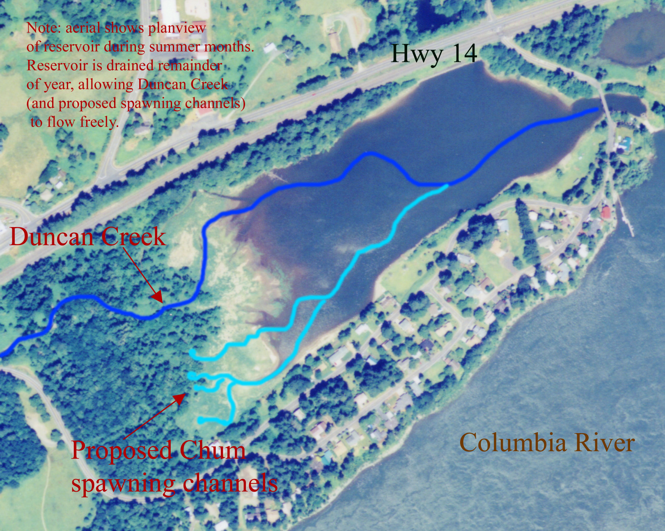

A
D

B

C

Table 1. Approximate lengths and widths of the proposed spawning channels and the volumes of gravel to be placed into each channel.

Channel | Total Length  (ft) | Total Width  (ft) | Mean Width  (ft) | No.  Points | Total Elev.  Gain (ft) | Mean  Slope  (%) | Spawning  Area  (sq. ft) | Spawning  Gravel  Volume  (cu. Yds)
“A” | 657 | 232 | 10.50 | 22 | 8.27 | 1.26 | 6,899 | 511
“B” | 706 | 184 | 12.27 | 15 | 7.37 | 1.04 | 8,663 | 642
“C” | 162 | 35 | 7.00 | 5 | 4.75 | 2.93 | 1,134 | 84
“D” | 108 | 94 | 18.80 | 5 | 2.16 | 2.00 | 2,030 | 150
Total | 1,633 | 545 | 11.6 | 47 | NA | NA | 18,726 | 1,387

b) Task 2: Excavation of the spawning sites in 4 spring channel reaches historically used by chum salmon. Existing habitat conditions are demonstrated in Figure 2.
Before excavation begins, haul roads will have to be constructed and dewater/water controls made. During excavation, invasive vegetation and silt/sediment will need to be removed using heavy equipment in the proposed approach and spawning channels. Erosion and sediment control will also be employed during excavation. After the excavation is completed, the sediment will be hauled off and disposed of.

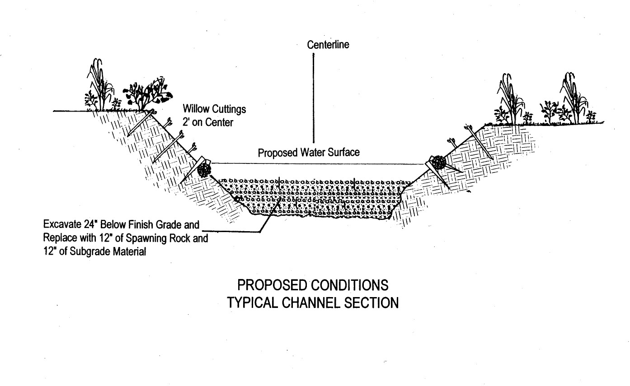
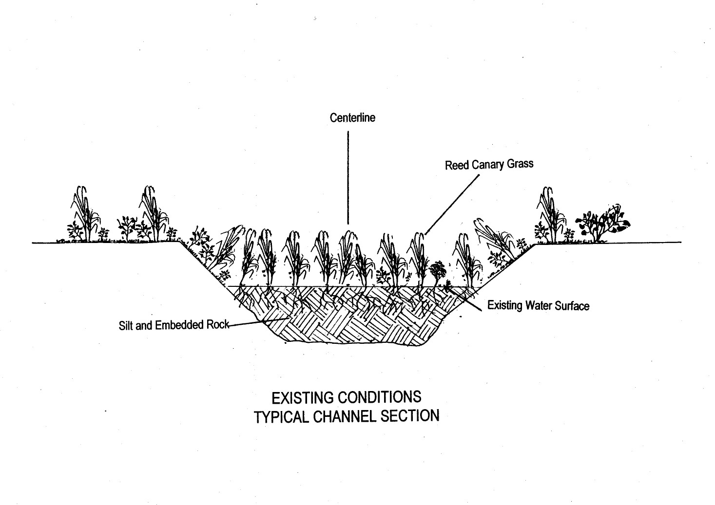
Figure 2. Existing spawning habitat conditions.
- Task 3: Construct the spawning channels. Sediment free spawning gravels and base rock will be imported into the excavated channels. The material will originate from a local quarry and be double washed in an effort to remove all sand size or smaller materials. New gravel depth should equal at least two feet throughout the area; no channel liners will be used so that seep water can percolate unimpeded through the gravel. The size of the gravel to be put into the Duncan Creek spawning channels is listed in Table 2.

The channel will be graded according to specifications developed in Task 1. Woody debris will be placed in the channel and the banks will be re-vegetated with native willows. Figure 3 displays the proposed spawning habitat conditions after the improvements have been completed.

Steps will be taken to prevent re-infestation of reed canary grass in restored spawning channels. Those will include the following: 1) establishment of shade producing shrubs (e.g. willows) adjacent to restored channels, and 2) manipulation of water levels during the growing season to inundate reed canary grass with at least 0.3 meters of water. (Note: This would only be conducted if reinfestation becomes evident).

A capture monitoring weir is proposed to be placed near the junction of the spawning channels. This weir will aid in the trapping of adult and juvenile chum salmon. This information will be used to evaluate the success of Objectives 2,3, and 4.

Table 2. The size composition of the gravel that will be added to the Duncan Creek spawning site.

Gravel Size Range | % By Volume
4 – 6 inch rock | 2
2.5 – 4 inch rock | 13
1- 2.5 inch rock | 35
¾ - 1 inch rock | 35
3/8 – ¾ inch rock | 10
No. 4 – 3/8 inch rock | 5

Figure 3. Proposed spawning habitat conditions

- Task 4: Measurement of the physical characteristics in the newly created spawning channel. After the spawning area has been created it is imperative that its physical conditions be measured. Hobo temperature loggers will be employed to record intra-gravel and surface water temperatures, and peizometers will be installed in the spawning area to so that vertical hydraulic gradients, coefficients of permeability, and intra-gravel DO levels can be obtained. In the latter case, a portable DO meter probe will be inserted into the peizometers so that it can register intra-gravel oxygen levels. In addition, gravel samples will be removed and analyzed to document the gravel composition in the spawning area to first see how closely it resembled the desired mixture and second to track any significant invasion of fines into this area. If large amounts of fines are entering this site, the gravel will have to be cleaned using portable pumps and air/water mixtures. Finally, a flow meter will be used to ascertain water velocities and depths in the created spawning area. This work is being conducted to monitor the site and allow managers to determine when maintenance or ancillary improvements may be necessary.

Objective 2. Capturing and artificial spawning chum salmon from adjacent stocks.

- Task 1: Capturing and holding brood stock. Brood stock may be collected from existing adult traps on Hamilton and Hardy creeks. The traps are a part of the “Evaluate Factors Limiting Columbia River Gorge Chum Salmon Populations. WDFW will work in cooperation with the USFWS project to make sure that study is not compromised by the brood stock collection.

If the adult traps are not available, a variety of gears will be used to obtain adult chum salmon from Hardy and Hamilton Creeks as well as the main stem of the Columbia River. Brood stock collection in the Grays River has indicated that two seines, one serving as a block net can be successfully used to capture adult chum salmon. In addition, if appropriate sites can be found, Hoop traps, can also be used to capture adult chum salmon. Hoop traps consist of four, ten foot in diameter hoops covered with 2” mesh. They are placed in deep slow moving water, usually lying parallel with the bank. Fish enter the trap and proceed through two small openings, eventually being contained in a chamber that has two hinged doors. Fish are removed by dip net. Under some circumstances these traps can be quite effective at capturing chum salmon. All captured fish will be transported via a planting truck to Duncan Creek and held in four foot long by 10” in diameter fish tubes (one fish per tube) until they are spawned.

- Task 2: Spawning and collection of biological data on the adults used as brood stock. Spawning protocols developed for other ESA chum salmon recovery efforts performed by WDFW will be used; these have been described in the Summer Chum Salmon Conservation Initiative. Briefly, prior to spawning each fish will be checked for maturity, if mature, the fish will be killed with a blow to the head, females will be bled by either severing a gill arch or the caudal peduncle. Body weights to the nearest gram will be obtained by using a portable, top loading electronic balance, and fork lengths to the nearest mm will be recorded. The egg mass of each female will be weighed to the nearest tenth of a gram, and will then be split into equal sized aliquots, usually two or three, depending upon the type of factorial cross employed. These aliquots are held in portable coolers until fertilization occurs. Milt is stripped form the males and factorial crosses are carried out. For example in a 3 x 3 factorial cross, three males and three females are used. In this case, each female has had her egg mass divided into thirds, and a different male will fertilize each third. Twenty seconds after gamete activation, milt from a different male will be added to the aliquots to ensure that a high level of fertilization occurs. After fertilization the eggs will be held in an idophore solution for one hour before being placed into an incubator. In Table 3, the other types of biological samples and information that will be collected from each fish used as brood stock is presented.

Table 3. Types of biological information that will be collected on chum salmon used as brood stock for the Duncan Creek reintroduction program

Type of Biological Sample Or Information | Sex Of Sampled Fish
Type of Biological Sample Or Information | Female | Male
Capture Date and Location | X | X
Spawning Date | X | X
Age as determined by scale reading | X | X
Length to the nearest mm | X | X
Weight to the nearest gram | X | X
Egg Mass Weight | X | -
Reproductive Effort (Body Wt/Egg Mass Wt) | X | -
Mean Green Egg Wt | X | -
Mean Water-Hardened Egg Wt | X | -
Fecundity Estimate (Egg Mass Wt/Mean Green Egg Wt) | X | -
DNA Samples | X | X
Allozyme Samples (Eye, Liver, Muscle, Heart) | X | X
Pathogen Samples (Ovarian Fluid, Kidney, Spleen) | X | X

Objective 3. Incubation and marking of chum salmon reintroduced into Duncan Creek.

- Task 1: Incubating newly fertilized eggs. Two, 50 gallon Remote Site Incubators (RSIs) with a gravity-fed water supply system and low water alarm will be established at Duncan Creek. These incubation systems (Manuel et al. 1991, Wampler and Manuel 1992) are large plastic barrels equipped with an up-welling water distribution system. A pressure plate made of screening and peagravel located just above the water distribution pipes uniformly distributes water throughout each barrel. An eighteen-inch layer of bio saddles or bio rings are placed directly above the pressure plate and screened trays that are used to hold eggs are situated above the bio saddles. Each barrel also has a lid to keep out light and an exit pipe. In most applications, eyed eggs are placed into RSIs and allowed to hatch and finish yolk absorption. Because of the barrel’s design, fry are able to volitionally leave a barrel when their incubation phase has been completed. In our situation, green eggs will be placed on the trays and allowed to reach the eyed stage of development. At that time, the eggs will be shocked and mortalities will be counted and removed. Our brood stocking efforts may provide up to one hundred and fifty thousand eggs, however, each RSI can accommodate one hundred thousand eggs so two of these incubators will meet the incubation needs of this project.

b) Task 2: Thermal marking of embryos and alevins. Well-established thermal marking techniques will be used to induce thermal codes into the otoliths of embryonic chum salmon both before and after hatching (Volk et al. 1990; Schroder et al. 1996; Volk et al. 1999). To quickly summarize, otoliths (ear bones) are the first calcified tissues produced by embryonic salmonids. They often deposit daily bipartite bands, consisting of a white, mostly calcium carbonate zone and a darker proteinaceous one. When water temperatures are relatively constant these zones are not clearly delineated exposure to cool water induces an optically dense zone in a developing otolith but when diurnal shifts in temperature occur they are clearly demarcated. This phenomenon was used by researchers to create visible marks in the micro-structure of otoliths by bathing incubating eggs and alevins in relatively cool water (often 3 to 4^{O} C below ambient) at predetermined times and durations. Each. Bar code rules (Volk et al. 1994) are employed to create distinctive codes that can be read at any time in the life cycle after the marking period has been completed. To create a reliable source of cold water at Duncan Creek we will bring in approximately 150 amps of 110 watt power and it will be used to run six, 10,000 BTU portable chillers and two water pumps. The chillers will be able to produce about ten gallons per minute of chilled water and this stream will be pumped into the RSIs to create the needed codes. At the conclusion of the incubation period, otoliths from up to ten fry from each barrel will be examined to document the code produced. This procedure is used throughout the world, with almost a billion salmon a year being marked in throughout the Northern Pacific Rim.

When fry are produced from the newly created spawning habitat, they will also be marked. Unlike the fish in the RSIs, simple water temperature manipulations cannot be used to mark them. Instead the fish will be placed into 1000 ppm solutions of strontium chloride and held for four to six hours. Since strontium is a chemical analog to calcium, the newly emerged fry will quickly absorb and deposit strontium into their calcified tissues (Schroder et al. 1995). As mentioned above, these marks can be detected in otoliths by using light microscopy and Wave Dispersive Spectrometry. This form of strontium marking, developed by WDFW researchers, is currently being used in Canada and Alaska to mark millions of salmonid fry.

Objective 4. Rear chum salmon fry and release them into Duncan Creek.

- Task 1: Establish portable fiberglass raceways at Duncan Creek. Earlier work cited by the Summer Chum Salmon Conservation Initiative showed that rearing chum salmon until they reached about 1 to 1.5 grams in size appreciably increased their early post-release survival rates (in one case by over 300%). Consequently, the recovery programs being implemented on summer chum salmon in Hood Canal and also on Lower Columbia River chum in the Grays and Chinook River drainages all call for the rearing of chum to this size prior to liberation. Initially, five, sixteen-foot long by three-feet deep by four-foot wide portable fiberglass raceways will be installed at Duncan Creek. A gravity water supply will be established, supplying each raceway with up to 20 gallons per minute.

- Task 2: Capture fry from incubators at emergence and load them into the raceways. Fry emerging from each RSI established at Duncan Creek will be trapped in a net lined holding box and removed daily. Gravimetric counts using a portable electronic balance will be made and the number of fry placed into each raceway will be recorded. The raceways can hold 20,000 fry, once a raceway has reached this loading density, fry will no longer be loaded into that raceway.

- Task 3: Rearing the fry in raceways. Standard rearing densities and feeding protocols will be followed, with the fish being fed by hand eight times per day at 3% of their body weight. In late March to mid-April the reared fish will be removed from their raceways and released into Duncan Creek at night on a falling tide. Releases under these conditions will be made in an effort to maximize early survival rates.

Additional project objectives will occur as the reintroduction program progresses. These will include 1) monitoring the abundance of chum salmon returning to Duncan Creek on a yearly basis, 2) collecting and decoding otoliths from these fish, 3) monitoring physical and biological parameters in the newly created spawning habitat, e.g. egg-to-fry survival rates, 4) and reporting the results of this work in reports and in the peer-reviewed literature.

f. Facilities and equipment

Besides the creation of a self-sustaining spawning and incubation habitat for chum salmon the project will also produce a an adult/juvenile trapping site, Remote Site Incubator location, an electrical outlet system and water chiller array, a portable raceway complex, and three water distribution systems. The water distribution systems will service the water chillers, the RSIs, and the portable raceways. All of these facilities are temporary and will be removed after a self-sustaining population of chum salmon has been established at Duncan Creek. Key equipment to carry out this work includes the RSIs, fiberglass raceways, water alarm system (standard WDFW design) Ohaus portable balances to weigh adult fish, eggs, and egg samples, a YSI DO meter and probe to measure dissolved oxygen in the newly created spawning habitat, peizometers, a McNeil gravel sampler, a digital flow meter, and Hobo temperature loggers. A portable shelter, either from tarp world or some other vendor will be used to create a protected location for spawning and also to provide protection for the water chillers. Depending upon security risks, cyclone fencing may be rented or purchased and placed around the incubation, thermal marking, and fish rearing facilities.

g. References

Throughout this proposal a number of reports and published literature are referred to, complete citations for these references are provided below. Copies of these materials can be provided to reviewers if desired. Electronic versions of the Grays River HGMP can be sent and an abridged version of the Summer Chum Conservation Initiative can be found on the Washington Department of Fish and Wildlife’s home page (http://www.wa.gov/wdfw/).

Literature and Other References Cited

Manuel, J., R. Kolb, and K. Dimmitt. 1991. Remote Site Salmon Egg Incubation. WDFW processed report from the Volunteer Fisheries Resource Program. 16 pp.

Schroder, S.L., C.M. Knudsen, and E.C. Volk. 1995. Marking salmon fry with strontium chloride solutions. Can. J. Fish. Aquat. Sci. 52:1141-1149.

Schroder, S.L., E.C. Volk, C.M. Knudsen, and J.J. Grimm. 1996. Marking embryonic and newly emerged salmonids by thermal events and rapid immersion in alkaline-earth salts. Bull. Natl. Res. Inst. Aquacult., Supple. 2:79-83.

Volk, E.C., S.L. Schroder, and J.J. Grimm. 1999. Otolith thermal marking. Fisheries Research 43:205-219.

Volk, E.C., S.L. Schroder, J.J. Grimm, and S. Ackley. 1994. Use of a bar code symbology to produce multiple thermally induced otolith marks. Trans. Am. Fish. Soc. 123:811-816.

Volk, E.C., S.L. Schroder, and K.L. Fresh. 1990. Inducement of unique otolith banding patterns as a practical means to mass-mark juvenile pacific salmon. American Fisheries Society Symposium 7:203-215.

Wampler, P.L. and J. L. Manuel. 1992. A test of remote site incubators using green, untreated fall chinook salmon eggs. USFWS processed report. 10 pp.

Washington Department of Fisheries. Co-writers: Washington Department of Wildlife and Oregon Department of Fish and Wildlife. 1990. Columbia Basin System Planning Salmon and Steelhead Production Plan. Lower Columbia River Subbasin (mouth to Bonneville Dam). Chum salmon section, pages 47-54.

Washington Department of Fish and Wildlife. 1996. Fish health manual. WDFW processed report from the Hatcheries Program. 69 pp plus appendices.

Washington Department of Fish and Wildlife. 1999. Hatchery and Genetic Management Plan (HGMP) for the Lower Columbia River Chum Salmon Recovery Project (Grays River). Document supplied to NMFS by WDFW. 42 pp.

Washington Department of Fish and Wildlife and Point no Point Treaty Tribes. 2000. Summer chum salmon conservation Initiative: an implementation plan to recover summer chum salmon in the Hood Canal and Strait of Juan de Fuca Region. Joint WDFW and PNPTT processed report to NMFS. 424 pp plus appendices.

Section 4. Key personnel

Name and Title
Steve Schroder
Fisheries Research Scientist II
One month or 0.08 FTE

Degrees earned and Dates
Bachelor of Fisheries Science, University of Washington: 1969
Master of Science, University of Washington: 1973
Doctor Of Philosophy, University of Washington: 1981

Current Employer
Washington Department of Fish and Wildlife

Current Responsibilities
Leader of the Ecological Investigations Unit located in the Science Division, Fish Program, Washington Department of Fish and Wildlife

List of Previous Employment
1970: Fisheries Technician, Washington Cooperative Fish Unit, University of Washington
1971: Fisheries Technician, Fisheries Research Institute, University of Washington
1971 – 73: Research Assistant, Fisheries Research Institute, University of Washington
1973 – 81: Predoctoral Research Associate, Fisheries Research Institute, University of Washington
1980 – 81: Biologist III, Fisheries Research Institute, University of Washington
1981: Fisheries Biologist IV, Washington Department of Fisheries
1981 – 1990: Fisheries Research Scientist I, Washington Department of Fisheries
1990 – 94: Fisheries Research Scientist I, Washington Department of Fisheries
1994 – Present: Fisheries Research Scientist II, Washington Department of Fish and Wildlife

Areas of Expertise
Steve Schroder has been a practicing fisheries research scientist for the past thirty years. His graduate work was centered on the reproductive ecology of chum salmon. In his role as leader of the Ecological Investigations Unit, he and his staff have invented and refined two methods that can be used to mass-mark embryonic salmonids, thermal marking and marking by immersion in solutions containing stable alkaline-earth elements. For the past three years he has lead efforts to recover ESA listed chum populations in the Hood Canal ESU and in the Lower Columbia River. Additionally he has lead efforts to recover coho and sockeye populations. These programs have included working with local enhancement groups, tribes, universities, non-profit organizations, and local governments. All of them have comprehensive evaluation components so that egg-t—adult survival rates be quantitatively assessed. Moreover, these efforts have been designed so that it will be possible to determine if any inadvertent domestication effects are manifested on the adults produced by each recovery project. Finally, Steve and other colleagues are also investigating whether exposure to hatchery environments significantly impacts the reproductive competence of hatchery-origin salmonids when they are allowed to reproduce under natural conditions. In summary he possesses expertise in general salmonid ecology, juvenile and reproductive behavior, salmonid recovery planning and evaluation, thermal and strontium marking, salmonid culture including the invention of alternative fish cultural practices, and project administration.

Selected Publications Relevant to this Proposal

Gaudemar, B., S.L. Schroder, and E.P. Beall. 2000. Nest placement and egg deposition in Atlantic salmon redds. Environmental Biology of Fishes 57:37-47.

Fresh, K.L. and S.L. Schroder. 1987. The influence of the abundance, size, and yolk reserves of juvenile chum salmon (Oncorhynchus keta) on predation by freshwater fishes in a small coastal stream. Can. J. Fish. Aquat. Sci. 44:236-243.

Schroder, S.L. 1982. The influence of intrasexual competition on the distribution of chum salmon in an experimental stream. Pages 275-285 in salmon and Trout Migratory Symposium. University of Washington, Seattle.

Schroder, S.L., C.M. Knudsen, and E.C. Volk. 1995. Marking salmon fry with strontium chloride solutions. Can. J. Fish. Aquat. Sci. 52: 1141-1149.

Volk, E.C., S.L. Schroder, and J.J. Grimm. 1999. Otolith thermal marking. Fisheries Research 43:205 – 219.

