Bonneville Power Administration

FY 2001 High Priority Project Proposal Review

PART 2 of 2. Narrative

Title: Acquire Prime Spawning and Rearing Habitat on Entiat River

Section 3. Project description
- Abstract

The Chelan-Douglas Land Trust seeks to acquire and permanently protect from development nearly three miles of some of the most important salmonid spawning and rearing habitat on the Entiat River. The Entiat River is one of four upper Columbia River tributaries that support anadromous Pacific salmonids and is critical to efforts to recover salmon in this region. These properties all occur in the "stillwaters" region of the Entiat between river mile 16 and 26. This section has the best spawning gravels, pools, and rearing habitat due to the low river gradient in this reach. See the attached diagram showing the river gradient. Spring and summer chinook, steelhead, and non-anadromous bull trout all utilize this stretch of river. This stretch of river is also mostly in private ownership and is subject to rapid residential and recreational development. It is not an exaggeration to say that the future of anadromous fish runs on the Entiat depends on the protection of habitat in this stretch. If this property is not acquired now, it will be more expensive or unavailable in the future. Accordingly we have targeted for acquisition the important habitat on the Entiat most threatened by development: This project is supported by a variety of groups, including Chelan County, WDOE, WDFW, Forest Service, U.S. Fish & Wildlife, NMFS, Trout Unlimited, Yakama Nation, Colville Confederated Tribes, and the Entiat Landowners Association.

b. Justification as high priority

- This project will protect critical spawning and rearing habitat for three listed species: endangered chinook, endangered steelhead, and threatened bull trout. The imminent risk to these species is that this stretch of the Entiat River will be developed and critical habitat will be lost or damaged. The Limiting Factor Analysis (WA Conservation Commission, 1999) identifies rearing habitat as a key component of salmonid survival and recovery in the Entiat. The Mid-Columbia Habitat Conservation Plan and supporting documents identify habitat protection and restoration projects in the Entiat as having a high priority for increasing biological productivity in the region (Chelan County Public Utility District, 1998). The Frank Thomas property has been identified as the “reference reach” by which the proper functioning of all other sections of the Entiat can be evaluated (Chelan County Conservation District, 1996). This project complements the salmon recovery efforts of virtually every resource group in the region, including, WDOE, WDFW, NMFS, USFWS, USFS, Chelan County, Chelan County Conservation District, Chelan County PUD, Entiat Planning Unit (ESHB 2514), Yakama Nation, Colville Confederated Tribes, and Trout Unlimited.

The targeted properties are all threatened by development. The Entiat Ranch River Tracts has already been subdivided. If a bridge to that property is built, several miles of riverfront will become accessible to development. If we can acquire the Entiat River Ranch Tracts and the adjacent Malone and Scofield properties, the bridge will never be built and the properties permanently protected from development. The Frank Thomas property has been designated the “reference reach” for the Entiat. It contains the most highly functioning habitat on the entire river. The property is up for sale and will be quickly lost to development if we do not acquire it. Similarly the Malone and Ritchie properties are up for sale and will soon be lost if we do not acquire them. It is more cost-effective to acquire and protect highly functioning habitat than it is to restore properties degraded by development. We have an unusual opportunity to acquire some of the best habitat on the Entiat River now. If we do not acquire it now, we may not have another chance. See the table and photos below and the maps attached to this document.

- The owners of all the targeted properties have agreed to sell their property for the amounts listed in the table below. These properties have all been appraised and in many cases the landowners are willing to sell their property for substantially less than the appraised value. If this project is funded, the acquisitions will all be completed within 60 days of receiving funding.

Priority Properties for Acquisition Along the Entiat River

Property | Acreage | River footage | Purchase Price | Appraised Price
Scofield Property | 15 | 1300 | $140,000 | $140,000
Entiat Ranch R. Tracts | 12 | 1300 | $555,000 | $1,110,000
McMahon Property | 18 | 1300 | $150,000 | $150,000
Malone Property | 34 | 5000 | $51,000 | $160,000
Frank Thomas | 152 | 8572 | $195,000 | $320,000
Ritchie Property | 63 | 3500 | $270,000 | $270,000
Totals | 294 | 20,972 | $1,361,000.00 | $2,150,000.00

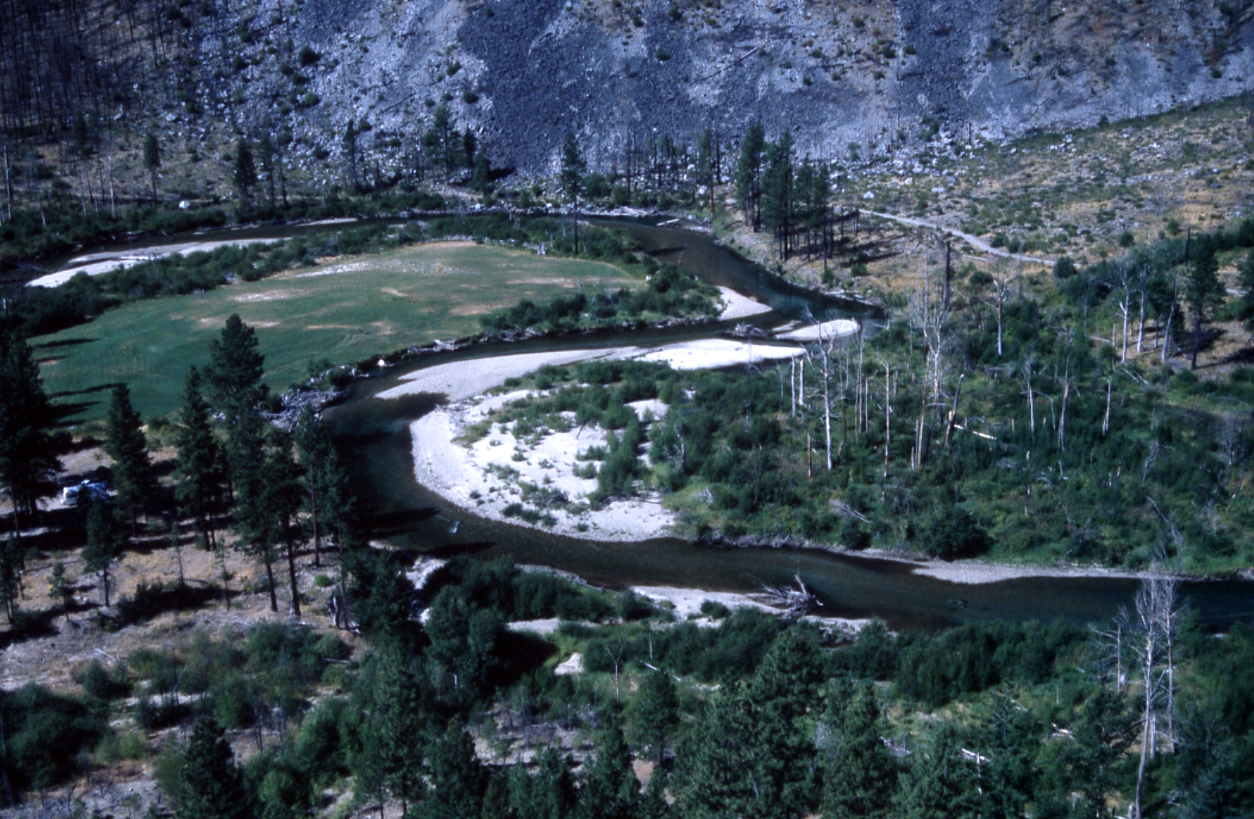
The Frank Thomas property has been identified as the “reference reach” for the entire Entiat River.

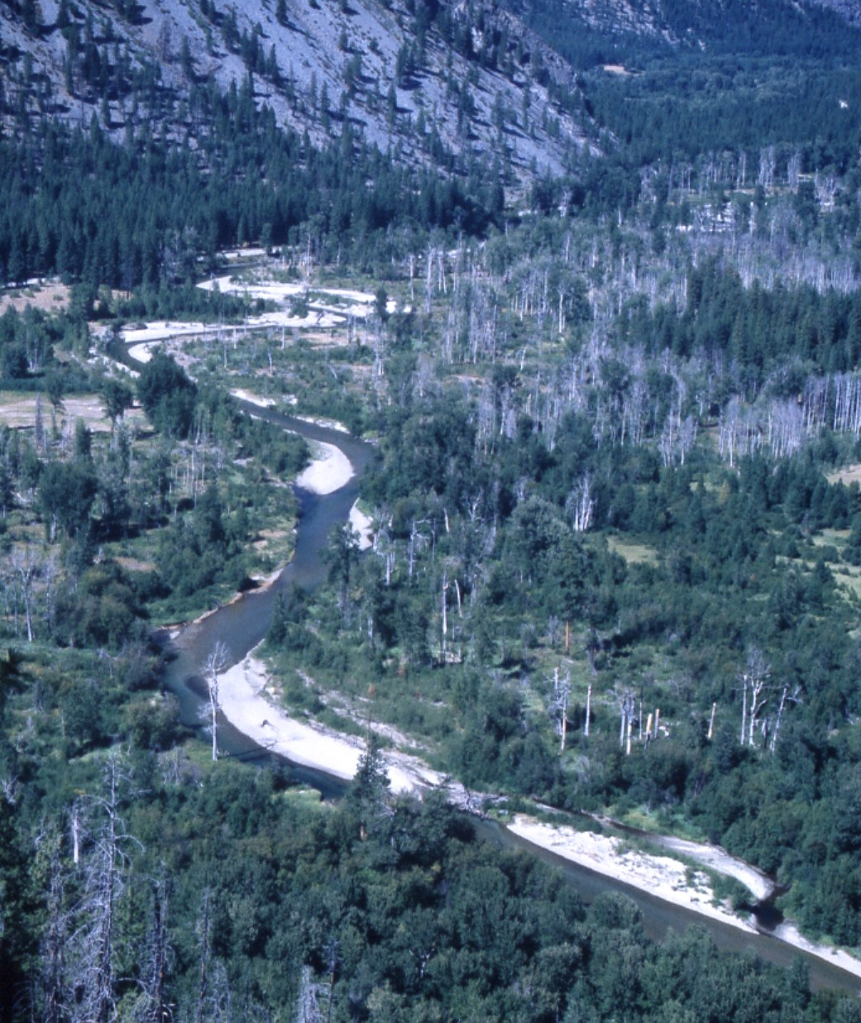
The “stillwaters” stretch of the Entiat River is the principal salmonid spawning and rearing area for the entire watershed. Development threatens the integrity and productivity of this critical area. This project would acquire and protect some of the most vulnerable and important parcels in this stretch of river.

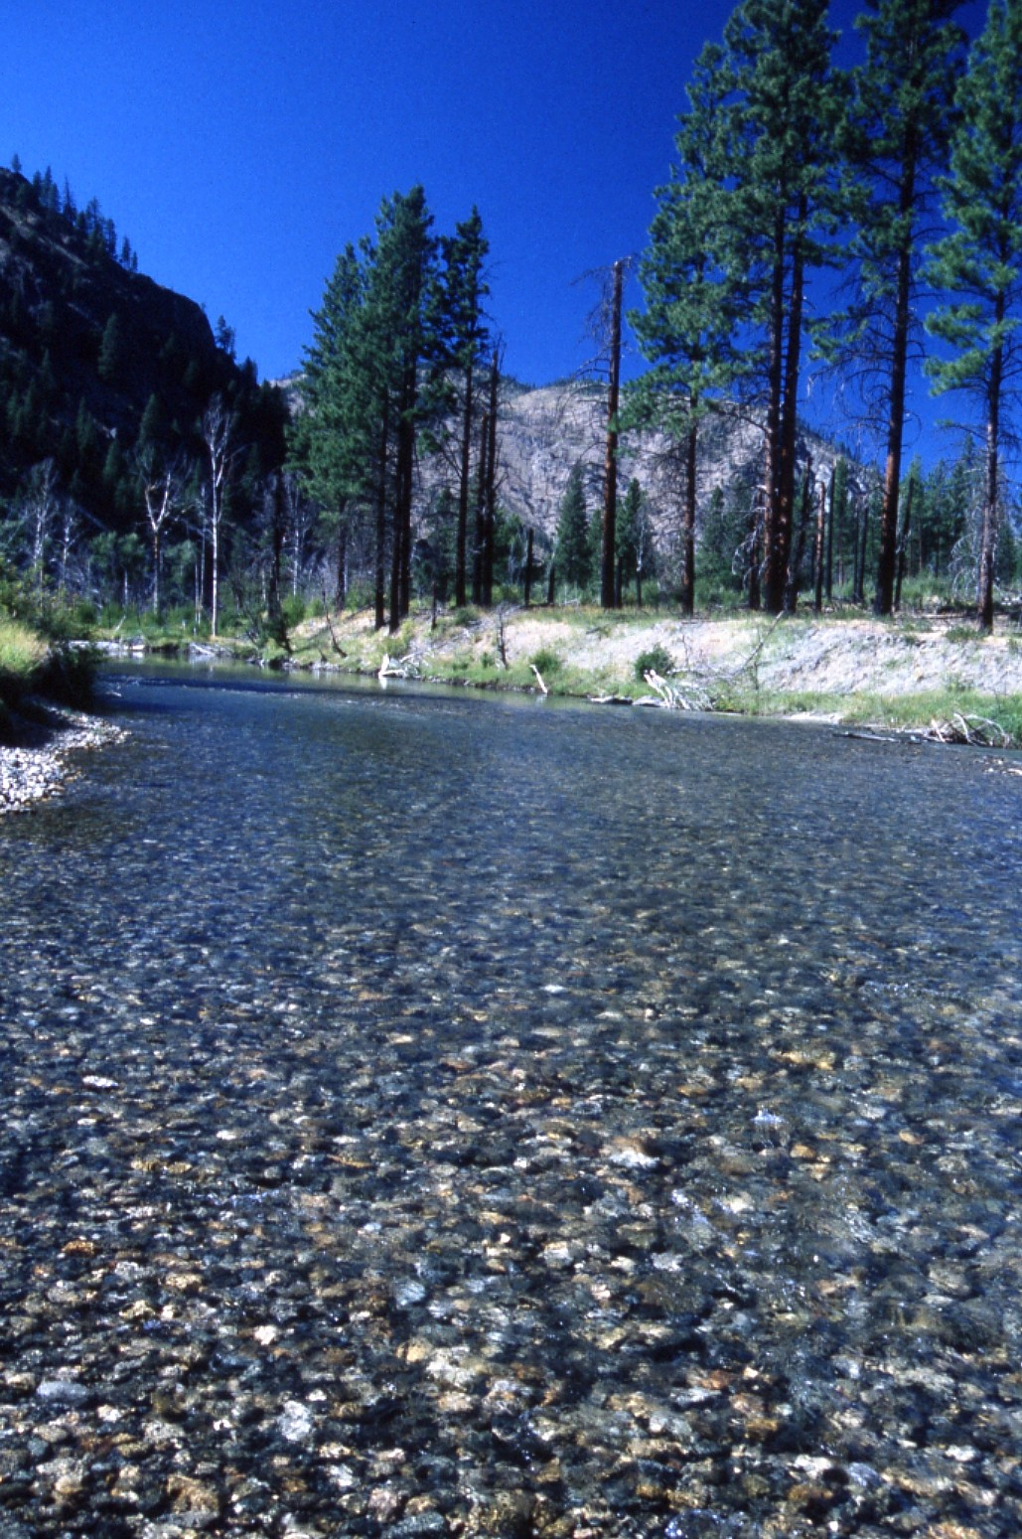
Spawning gravels on the Frank Thomas property. The low river gradient in this stretch of the river creates perfect spawning habitat.

c. Rationale and relationship to criteria for high priority projects adopted in the 2000 Fish and Wildlife Program

- This proposal will protect the best spawning and rearing habitat on the Entiat River. With minimal restoration, these properties will remain as highly productive self-sustaining habitats.

- The benefits of this proposal can be quantified in terms of amount of habitat protected, and more specifically by ongoing counts of numbers of redds created and used each year. The USFWS Mid-Columbia Resource Office conducts spawning ground surveys in this stretch of river each year.

- This proposal protects vital habitat for three listed species: chinook, steelhead, and bull trout.

- This proposal will provide permanent protection to nearly four miles of the most critical salmonid habitat in the watershed. These key acquisitions will be the cornerstone of an ongoing effort to protect more of the “stillwaters” reach from development.

- The Entiat is currently on Ecology’s 303d list for low flows. This project will protect the integrity and functioning of the floodplain, which should help to moderate fluctuations in the flow.

- While Chelan County has adopted a critical areas ordinance under the Growth Management Act, numerous variances and shortcomings in the enforcement of the law limit the effectiveness of the GMA. The acquisition of these properties will permanently protect them and make sure that the broader floodplain functions and the channel migration zone are not impaired by development.

- This proposal accomplishes many of the above objectives and is broadly supported by many other entities. The USFS, WFDFW, Chelan County Conservation District, USFWS, NRCS, Yakama Nation, and Colville Confederated Tribes will conduct research and monitoring activities on these properties.

- The project is supported by analysis in a number of documents including the USDA-Forest Service Watershed Assessment for the Entiat Analysis Area (USDA Forest Service, 1996), the Aquatic Species and Habitat Assessment for the Mid-Columbia HCP Bugert, 1996), the Coordinated Resource Management Plan for the Entiat, which includes the Entiat River Inventory and Analysis finalized by the NRCS in January 1998 (Chelan County Conservation District, 1999), the Limiting Factors Analysis for the Entiat Watershed (Washington Conservation Commission in July 1999), and the Spirit of the Salmon – Tribal Recovery Plan (Columbia River Intertribal Fish Commission, 1996). Region-wide project prioritization has not yet been completed for this area. However, the Mid-Columbia HCP and supporting documents place high priority on protection and restoration efforts associated with the "stillwaters" spawning reach of the Entiat River Chelan County PUD, 1998).

d. Relationships to other projects

The answers to Section 3c. apply to this question. This project integrates with and is strongly supported by every regional agency or organization involved in fish protection and restoration.

e. Proposal objectives, tasks and methods

- The primary objective of this proposal is to acquire and protect from development critical salmonid spawning and rearing habitat in the Entiat River watershed. While the benefits of acquiring high quality functioning habitat are difficult to quantify, most scientists believe that acquisition of high quality habitat is a very cost effective way to protect salmonids. Ongoing spawning surveys in this region conducted by the USFWS should help quantify the results over time.

  - The tasks and methods for this objective are simple and direct. We have already targeted the properties we seek to acquire, had them appraised, and have agreements with the landowners to purchase the property. If we get the necessary funding, we will do title research, surveys, and the usual steps necessary to close a deal.

- The second objective of this proposal is to develop a long-term management plan for the acquired properties. The tasks involved in completing this objective follow:

  - Meet with the Entiat Landowners Association, the USFS, WDFW, USFWS, Chelan County Conservation District, NRCS, Trout Unlimited, Yakama Nation, Colville confederated Tribes, and neighboring property owners to develop a management plan that will maintain and restore the ecological integrity of the acquired properties. Most of the properties are in excellent shape, but in some cases revegetation and bank stabilization will be required.

  - Develop a community-based management plan that addresses political and sociological concerns for this region. While residents of the Entiat Valley want to see the “stillwaters” region protected, they have concerns about removing property from the tax base and they do not want to see more land go into federal or state ownership. The Chelan-Douglas Land Trust has a unique opportunity to protect critical habitat while working closely with local people to address these concerns. See the attached letter from the Entiat Landowners Association. This proposal provides for a great opportunity to develop a management plan that will have broad community support. This proposal will serve as the first step in a long-term strategy to protect a majority of the “stillwaters” stretch from development.

f. Facilities and equipment

No special equipment or facilities are needed.
g. References

- Andonaegui, C. July 1999. Salmon and Steelhead Habitat Limiting Factors Report for the Entiat Watershed--WRIA 46. [Version 3]. Washington State Conservation Commission Report, Olympia, WA.
- Bugert, R. M. 1996. Aquatic Species and Habitat Assessment of the Wenatchee, Entiat, Methow and Okanogan Watersheds for the Mid-Columbia Habitat Conservation Plan. Chelan County Public Utility District, Wenatchee, WA.
- Carie, D.G. 1999. Spring and Summer Chinook Salmon Spawning Ground Surveys on the Entiat River, 1998. USFWS Mid-Columbia Fishery Resource Office, Leavenworth, WA.
- Chelan County Conservation District. 1996 Entiat River Inventory and Analysis
- Chelan County Conservation District. August 1999. Entiat Valley Watershed Study--Coordinated Resource Management Plan. [Final Draft; incorporates the Entiat River Inventory and Analysis report completed by the NRCS Stream Team on 1/6/98]
- Chelan County Public Utility District (PUD). 1998. Rocky Reach and Rock Island Anadromous Fish Agreement and Habitat Conservation Plan (HCP).
- Columbia River Intertribal Fish Commission. 1996. Spirit of the Salmon – Tribal Recovery Plan.
- USDA Forest Service. Wenatchee National Forest. 1996. Watershed Assessment for the Entiat Analysis Area, Version 2.0.
Acronyms:
BPA – Bonneville Power Administration
CDLT – Chelan-Douglas Land Trust
Chelan County PUD – Chelan County Public Utility District
Entiat RD – Entiat Ranger District
ESA – Endangered Species Act
ESU – Evolutionarily Significant Unit
FRO – Mid-Columbia Fisheries Resource Office
HCP – Habitat Conservation Plan
LWD – Large Woody Debris
NRCS – Natural Resource Conservation Service
WDFW – Washington State Department of Fish and Wildlife
WDOE – Washington State Department of Ecology
WRIA – Water Resource Inventory Area
USFS – United States Forest Service
USFWS – United States Fish and Wildlife Service

Section 4. Key personnel

Gordon Congdon, Executive Director of the Chelan-Douglas Land Trust, will direct this project. See the attached resume. The Chelan-Douglas Land Trust is supervised by a Board of Directors with broad experience in natural resource and conservation issues. The Board is listed below.

First | Last | Profession | Organization | Length of Service | Status
Peter | Bauer | M.D. | Central Washington Hospital | 3 | Treasurer
Ann | Derleth | Statistician | Retired | 2 | Board
Theresa | Druzak | Process Tech. | Alcoa | 5 | Board.
Steve | Eng | Accountant | Cordell, Neher, & Co. | 1 | Board
Peter | Hill | Lands Agent | WA Dept. of Fish and Wildlife | 1 | Board
Mike | Kaputa | Planner | Chelan County | 1 | Board
Gene | Kupferman | Scientist | WA St. Treefruit Res. Ctr. | 1 | Secretary
Edgar | Meyer | M.D. | Retired | 15 | Board
Pat | Rasmussen |  | Leavenworth Adopt a Forest | 10 | Board
Larry | Riegert | Engineer | Hammond, Collier, et.al. | 5 | Board
Eliot | Scull | M.D. | Retired | 15 | President
Tina | Scull | M.D. | Retired | 1 | Board
Mark | Shipman | M.D. | Central Washington Hospital | 15 | Vice-Pres

Gordon H. Congdon, Jr.
P.O. Box 4461
Wenatchee, WA 98807
509-667-9708
cdlt@cdlandtrust.org

Education

Harvard University
Cambridge, MA
B.A. 1973-1978

Harvard University
Cambridge, MA
M.A. Biology. 1981-1983

Washington Agriculture and Forestry Leadership Program 1998-2000

Professional Experience

Executive Director
Chelan-Douglas Land Trust
Wenatchee, WA 1999-Present

Congdon Orchards
Owner/Operator of 30-acre Cherry Orchard
Wenatchee, WA 1984-Present

Lake Chelan Water Quality Committee
Coordinator of Water Pollution Control Effort
Wenatchee/Chelan, WA 1994-1996

Hickok, Inc.
Owner and President of Tool Manufacturing Co.
Wenatchee, WA 1987-1994

World Wildlife Fund
Project Director of Sea Turtle Conservation Project
Tarutao National Park, Thailand 1980-1981

Prince of Songkhla University
Teacher and Herbarium Curator
Haad Yai, Thailand 1978-1981

Community Service

Chelan County Planning Commission 1994-2000
Distinguished Lecture Series Committee 1997-2000
Stemilt Irrigation District Board 1990-1995
Citizens Advisory Comm. for Chelan Co. Comp Plan 1993-1995

