Bonneville Power Administration

FY 2001 High Priority Project Proposal Review

PART 2 of 2. Narrative

Title: Collaborative Center For Applied Fish Science

Section 3. Project description
Provide project detail for headings a through g.

a. Abstract

Currently, the use of artificial propagation as a restoration tool is constrained by critical uncertainties. Regionally, the approach to addressing these uncertainties has focused on monitoring and evaluation efforts at existing and proposed facilities. These efforts are orchestrated through documents such as benefit/risk analyses (B/RA), research monitoring and evaluation plans (RM&E), and hatchery and genetic management plans (HGMP). Unfortunately, the data acquisition and analysis requirements of these documents has outpaced the regional infrastructure necessary to produce the data and reports in a timely manner.

This proposal addresses this bottleneck by directing funding at four necessary components: 1) facilities expansion; 2) data acquisition, analysis and reporting, 3) tool development; and, 4) education. Under the MOA between the University of Idaho and CRITFC, we propose to fund an expansion of the UofI Hagerman Fish Culture Experiment Station (HFCES) for genetic analysis, pathology, and ecological interactions, meet the data needs for formulation of population management plans; and the analysis capacity to monitor programs. An education component is included to provide the trained personnel necessary to operate state-of-the-art propagation facilities by providing students and technician’s classroom and hands-on experience.

This proposal is submitted as high priority for two reasons. First, we intend to dovetail the expansion of the HFCES with current expansion plans of the University of Idaho scheduled for summer 2001. Dovetailing these efforts will reduce the expansion costs to this proposal by approximately 50%. Secondly, there exists a critical need for the formulation and implementation of well-reasoned restoration programs. This proposal will relieve the bottleneck currently stalling implementation of such programs by providing the data and reports necessary to quantitatively address critical uncertainties. Finally, the products of this proposal will contribute to ongoing processes such as sub-basin planning.

b. Justification as high priority

Species at risk
The species that this proposal addresses are contained within the following ESUs: Snake River spring/summer chinook salmon, Snake River fall chinook salmon, Upper Columbia River spring chinook salmon, and middle Columbia River steelhead. The imminent risk to these populations is extirpation, according to the Artificial Production Review (2000) that states: “Populations that require preservation/ conservation face imminent demise or extirpation and, in most cases, are listed under the federal Endangered Species Act. In these situations, without immediate protection, the population will be extirpated, and the genetic resource lost.” This proposal links to tribal production projects on populations contained within the above-mentioned ESUs, as specified in Table (1).
This project will assist in the delineation and resolution of listed species, and identify appropriate management actions to prevent extirpation of endangered populations. This information will be used to develop Population Management Plans, and the ranking of priority actions for restoration and conservation purposes. The population Management Plans will identify priority actions in habitat, production and passage management.
This proposed project has many time-limited opportunities constraining it. The most obvious is coinciding with U of I planned construction activities at the Hagerman Fish Culture Experiment Station (HFCES). The U of I has earmarked $1.75 million (from federal USDA, state, and private sources) for improvements to the facility and plan to begin construction by late spring 2001. If funding for this proposed project is available prior to the U of I construction, design, construction, and disruption costs can be reduced substantially.
We will also compile data necessary for the assessment of risk, benefit, and population management of restoration programs for the subbasin planning exercise to begin in 2001. The listed status of most of these populations is threatened or endangered which behooves us to move swiftly toward finding solutions to improve their state. The CCAFS will generate clear, quantitative biological objectives through the development of PMPs, HGMPs, and Benefit/Risk analyses on a species by species and project by project basis, speeding implementation of recovery actions.

Agreements and permits required to begin this work and anticipated start date.
On July 20, 2000, the Columbia River Inter-Tribal Fish Commission and the University of Idaho signed a memorandum of agreement to advance research and educational opportunities, and to advance the state of knowledge in the conservation and restoration of fish stocks and fisheries. We propose to establish a working relationship between the Aquaculture Research Institute of the University of Idaho and the CRITFC for purposes of research and training in production, supplementation, life history, and recovery of salmon, steelhead, and native fishes of the Columbia Basin. In addition, they agreed to establish a collaborative research program between the two entities at the HFCES and other facilities of the University and the CRITFC associated with education, and fisheries research, such program to include fish culture, fish health, genetics, and fish production and supplementation research on the University campus and at Tribal hatcheries or field stations.
With this agreement in place, the only document that needs to be completed prior to beginning work is an Operation Plan. A draft Operation Plan has been reviewed by the University of Idaho and CRITFC and will be signed soon. Building permits for construction and modification of facilities will be sought by the U of I from local authorities in accordance with the law. We anticipate groundbreaking for the facilities improvements to occur by June 1, 2001.

c. Rationale and relationship to criteria for high priority projects adopted in the 2000 Fish and Wildlife Program

This proposal directly meets the following criteria:
- Has measurable, quantitative biological objectives and will result in clear benefits to the species survival.
- Has immediate, measurable benefits to ESA-listed species.
The proposal also has indirect benefits to the following criterion:
- Links of artificial production to breeding and rearing habitat will be clearly identified, as recommended in the Artificial Production Review.
In addition, the proposal has clear links to the following considerations
- The proposal fulfils more than one of the high priority criteria, as described previously.
- The proposal shares some of the cost of the action with other entities. 1) Restoration and enhancement of the Hagerman Experimental Fish Culture Station and the Aquaculture Research Institute is cost-shared with the University of Idaho, which is contributing $1.75 M obtained from the Department of Agriculture, Idaho State and private sources. 2) This proposal is tightly linked to tribal restoration projects funded by BPA/NPPC. The list of these projects is given in Table (1).
- The proposal is part of a collaborative effort with other entities or has synergistic effects with actions implemented by other entities. 1) This project is a collaborative effort in research and education between the University of Idaho and the CRITFC, as described in a Memorandum of Agreement signed in July 2000. (MOA 2000) 2) The proposal includes links to tribal programs with the Nez Perce Tribe, the Yakama Indian Nation, The Confederated Tribe of the Umatilla Indian Reservation, and the Confederated Tribes of the Warm Springs Reservation of Oregon.
- This proposal is recommended by an action plan derived from a science-based assessment. 1) This proposal ensues from the Tribal Restoration Plan. 2) It also draws extensively from recommendations of the Artificial Production Review of the NPPC.
- The proposal implements high-priority actions approved by a tribal or state governmental authority with fish and wildlife protection responsibility and identified by a tribal or state plan as necessary to protect or rebuild fish and/or wildlife in the Columbia River Basin. This proposal is the result of the desire of the tribes to strengthen their science based restoration program and coordination. It also aims to cut costs for M/E by sharing facilities among all tribes, while providing rigorous, regional-based scientific and technical expertise. The proposal is the fruit of tribal requirements to “delist” threatened and endangered species in 5 years and double naturally-spawning target populations in 25 years.
- The proposal either collects or identifies data that are appropriate for measuring biological outcomes identified in the objectives. This is a central theme in the CCAFS. The goals of the center are to develop a strong nucleus of experts in artificial production. Alliance with the University of Idaho will ensure objective and unbiased science and management recommendations that will best meet the needs of the region. Further, the CCAFS proposes to develop methods that will be necessary to determine the impacts and successes of artificial production and supplementation. Supplementation is expected to have subtle, difficult to measure impacts among the local populations of fish in targeted and non-targeted tributaries. The genetic and pathology (eg. Foott et al. 2000) tools necessary to detect the changes do not yet exist.

d. Relationships to other projects

This proposal directly relates to at least 12 projects (Table 1) that are currently funded under the Fish and Wildlife Program. Projects that are complemented by this proposal are located in the following subregions: Lower Snake, Upper Mid-Columbia, and Lower Mid-Columbia. In addition, the proposed project also relates to projects associated with the Pacific Salmon Treaty, the Lower Snake River Compensation Plan, and the U.S. Army Corps of Engineers projects (Table 1).

Table 1. Listing of projects directly related to the Collaborative Center for Applied Fish Science Proposal and an abbreviated statement of the nature of support given.
Project Title | Project Number | Funding Source | Project Support from CCAFS
Idaho Salmon Supplementation Study | 8909802 | NWPPC / BPA | Analysis of samples for baseline genetic profiles.
Johnson Creek Artificial Propagation and Enhancement Project | 9604300 | NWPPC / BPA | Strategies for broodstock acquisition and spawning protocols, monitoring (genetic) and evaluation, and pathology.
Grande Ronde River Supplementation Project – Lostine River | 9800702 | NWPPC / BPA | Evaluation of the potential impacts of supplementation using genetic and life history data.
Nez Perce Tribal Hatchery Monitoring and Evaluation Project | 8335000 | NWPPC / BPA | Evaluation of the potential impacts of supplementation using genetic and life history data.
Lower Snake River Compensation Plan hatchery evaluations project | FWS agreement 141101J005 | US Fish and Wildlife Service | Evaluation of the potential impacts of supplementation using genetic and life history data.
Captive Broodstock Program Project | 9801006 | NWPPC / BPA | Genetic monitoring and evaluation, and pathology.
Northeast Oregon Hatchery Monitoring and Evaluation Project | 8805301 | NWPPC / BPA | Genetic monitoring and evaluation, and pathology.
Listed Stock Gamete Preservation Project | 9703800 | NWPPC / BPA | Determine genetic profiles of cryopreserved germplasma.
Coho Restoration Mid-Columbia River Tributaries | 9604000 | NWPPC / BPA | Develop a M&E plan including a genetics monitoring program for coho reintroductions into the Yakima, Wenatchee, and Methow rivers.
Yakima River Coho Restoration | 9603302 | NWPPC / BPA | Genetic monitoring and evaluation.
Umatilla Basin Natural Production M&E | 9000501 | NWPPC / BPA | Evaluate genetic effects of supplementation on natural fish.
Hood River Supplementation | 8805303 | NWPPC / BPA | Review and re-write where necessary the Benefit / Risk Analysis & HGMP.
Methow River Evaluation |  | NWPPC / BPA | Genetic analysis and population structure of naturally spawning salmon.
Pacific Salmon Treaty Implementation |  | PSC | Stock identification, production, and assessment research.
Steelhead Kelt Reconditioning |  | USACOE | Benefit / Risk Analysis, genetic profiles and stock structure.

This proposed project complements the above-mentioned projects by providing planning services, sample analysis, monitoring and evaluation tasks, and experimentation in anadromous fish production and enhancement techniques. In addition, some cost savings will be realized because many the projects in Table (1) have funding associated with the tasks that link the projects to CCAFS.

Much of the work at the CCAFS in out-years will be funded through links with existing projects and new projects that become incorporated into the Fish and Wildlife Program. These links will specifically be associated with research, monitoring and evaluation programs for many projects. For example monitoring the genetic effects of supplementation on naturally spawning populations. This work would be tied to a particular project giving the work definition in terms of scope, objectives, and hypothesizes as well as funding. Such work may lead to additional research in order to partition the genetic from environmental effects and interactions. This will insure that the CCAFS is responsive to the Fish and Wildlife Program through relationships with specific projects. Investigating genetic effects was used as an example of the work to be carried out at CCAFS, however, other science activities like developing benefit / risk analysis, HGMP, population management plans, investigations in fish health, fish culture, and pathology will be accomplished in a similar fashion linking them to specific projects.

e. Proposal objectives, tasks and methods

Problem Statement

Artificial production is one of the tools that is the most effective at increasing fish abundance rapidly. However, this tool has come under severe criticism in the last few years. The tribes were the first to advocate for hatchery reform and the development of integrated Population Management Plans (PMPs) (CRITFC 1982), so that hatcheries could be used to increase fish abundance in the wild. However, details of how this was to be done were often subject to confounding regional policies: Those that favored production vs. those that favored wild fish at the expense of artificial production.

In the revised F&W program, the NPPC and the TRP goals have been well integrated, resolving many of the policy issues. Further, the Artificial Production Review and associated guidelines of the NPPC and NMFS have helped clarify the field of artificial production, and in most instances supports the Tribal Restoration Plan goals of producing wild-fish-friendly artificially produced salmon, sturgeon and lamprey. This provides the framework for technical focus.

Recognition of several limiting factors, both functional and technical, has led to the present proposal. Regionally, research and monitoring labs in the region have had increasing workloads. Lab capacity in genetics, pathology and ecological interactions is limiting. Many populations have continued to decline. The last 10 years have seen the listing of many more ESUs by the NMFS and USFWS. The regional demands for high performance of both the restoration efforts as well as monitoring have further exacerbated the shortage of lab capacity. As such, the hatchery reform guidelines and the need to integrate all H’s in decision-making down to the sub-basin level must be considered in developing solutions. Further, the tribes seek to fully integrate artificial production efforts into wild fish recovery and habitat restoration, beginning with the development of integrated Population Management Plans. The tribes wish to see artificially produced fish become successfully established in streams, and the resulting progeny be part of the recovery and restoration process. This can only be accomplished with total functional integration of facilities in population recovery, habitat protection and restoration, and system-wide reductions in migration mortalities.

In the scientific community it is generally recognized that there are wide-ranging goals among labs in the region, which has naturally led to the development and emphasis of methods that are not entirely compatible with the tribe’s desire to see its applied science, research and monitoring program work in support of its rigorous restoration goals. The technical needs for resolution on risk-related issues of the tribe’s science program had led to a close association in genetic research with the University of Idaho’s Aquaculture Research Institute. Over the past 3 years, this collaboration has led to key papers on the delineation of the proposed Snake River fall chinook ESU, stock composition of fall chinook in Zone 6, lamprey stock structure, sturgeon stock structure, and steelhead stock structure and phylogenetics. This collaboration between the tribe and the UI has recently grown to a comprehensive Memorandum of Agreement which provides the tribes with access to U of I research and education facilities on a cost-sharing basis, and a collaborative research and education program.

In addition to habitat restoration and conservation the tribes are developing restoration programs that are based on returning fish to the natural production areas where they once spawned, and in large enough quantities to impact ecosystem functions. Supplementation is a production tool proposed by the tribes to use the demographic benefits of hatcheries to outplant fish into tributaries. These efforts have resulted in several potential risks being described, such as:

- Stock structure: The loss of local adaptation resulting from outbreeding.
- Domestication: The reduction in fitness of wild fish from outbreeding with hatchery-reared fish.
- Fish Health: Supplementation hatcheries are potentially a source of diseases.
- Production: Production of fish that have a survival and return rate that is comparable to naturally-produced fish and that are genetically compatible with habitat to which the fish are destined to return.

Vision and Goals

To better fulfill the goal of providing technical assistance to the treaty tribes, the CRITFC is seeking to employ the CCAFS facilities to improve our ability to perform critical research and development of supplementation methods, and consequent links to natural productivity. Such a research and development (R/D) program includes elements of ecology, genetics, fish health, and factors limiting natural productivity. Specifically, the CRITFC would focus on the following goals:
- Determine the impact of supportive breeding techniques on metapopulation health and structure.
- Develop techniques of limiting impacts of artificial selection and domestication in non-natural spawning and rearing environments (hatcheries, rearing channels, acclimation facilities, captive rearing, etc.)
- Develop methods to minimize health risk of outplanting.
- Assessment of the ecological consequences of supportive breeding techniques, such as competition, predation, nutrient cycling and habitat use.
- Improve broodstock management and rearing methods for fish destined for outplanting.

Objectives

- Expand facilities and equipment to handle additional work needed.
- Develop draft Population Management Plans (addressing Benefit/risk analyses, HGMPs) for inclusion in subbasin plans where tribes have lead responsibility.
- Develop monitoring tools necessary to resolve critical uncertainties in integrated population management (incorporating supplementation).
- Coordinate research and education program, and fund a program to produce skilled hatchery personnel able to implement the Population Management Plans.

Tasks and Methods

Objective One: Facilities Improvement and Equipment
The purpose of objective one is to provide the infrastructure necessary to perform research in the areas of genetics, pathology, and ecological interactions and provide distance-learning capabilities.
On July 20, 2000, the CRITFC and the U of I signed a memorandum of agreement to establish a collaborative research program focusing on fish culture, pathology, genetics, supplementation research, and education. The program will be based at the U of I’s Hagerman Fish Culture Experiment Station (HFCES) located near Hagerman, Idaho. For additional information regarding the mission and scope, a copy of the MOA is attached (Appendix A).
The U of I is in the process of upgrading the facilities at the HFCES and plans to begin construction by the spring of 2001. The University has earmarked $1.7 million from this initiative to fund capital improvements to the HFCES. Sources of the $1.7 million are approximately 1/3 federal (USDA), 1/3 state and 1/3 private illustrating a substantial cost sharing. The current U of I plans for expansion of the HFCES facilities includes a fish pathology lab, gene bank, offices, conference room, distance learning center, and an additional wet lab (Figures 1-6). This proposal is designed to provide additional facilities at HFCES to enhance the capacity to develop monitoring and evaluation tools and perform research that can guide the implementation of the NPPC Fish and Wildlife Program. This component provides the facilities that are necessary to implement the development of population management plans including Benefit Risk Analyses (B/RA), Research, Monitoring and Evaluation plans (RM&E), and Hatchery and Genetic management Plans (HGMP) that are described in following sections of this proposal. To be most cost effective, funding for the capital improvements must coincide with the planned U of I construction schedule, therefore we are submitting this as an early action item.

Proposed Additional Expansion

Capital Improvements
This proposal seeks funding for the following capital improvements at the HFCES; increase office space, increase genetic laboratory space, increase outdoor tank capacity, make modifications to outflow streams to permit experiments in semi-natural conditions, refurbish raceways, and build a dorm (Figures 1-6). Additionally, furnishings and equipment costs are included. In an effort to reduce costs, the CRITFC plans to merge these capital improvements with those of the U of I. If construction plans cannot be coincided, these costs will increase substantially.

Equipment
In addition to the capital improvements, this component includes equipment that is necessary to make the facilities functional. Items that have been included are: office and dormitory furnishings, computers, laboratory equipment for pathology, and genetic work, distance learning equipment, and fish holding and hauling capabilities.

Figure 1. Plan view detailing the location of the capital facility (Dry lab, office, sturgeon tanks, experimental stream, and dorm) improvements.

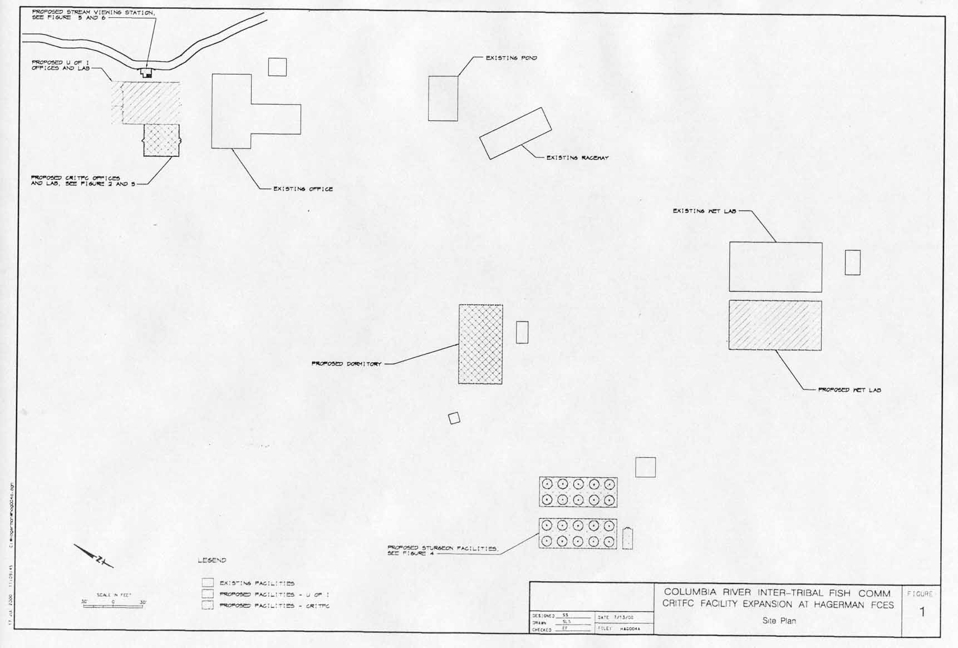

Figure 2. Conceptual drawing of the dry lab expansion.
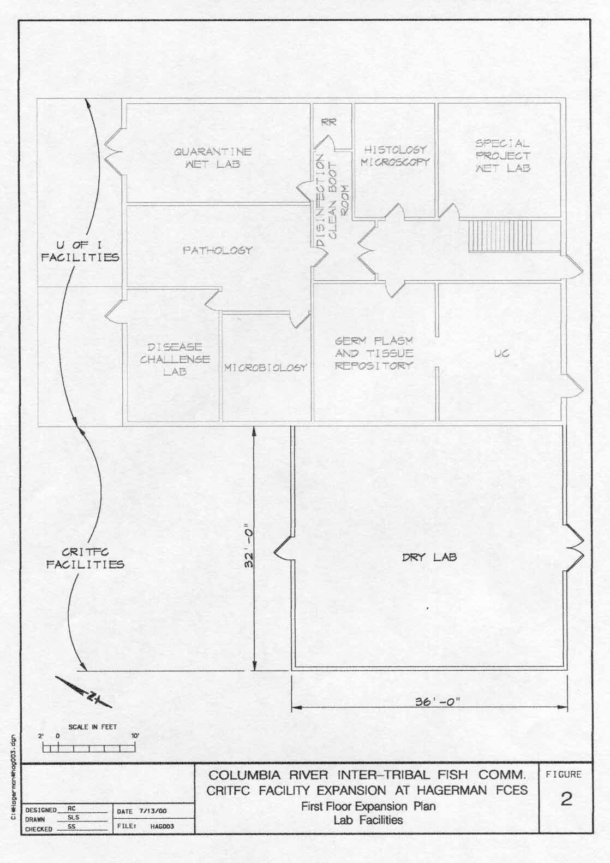
Figure 3. Conceptual drawing of the office expansion.
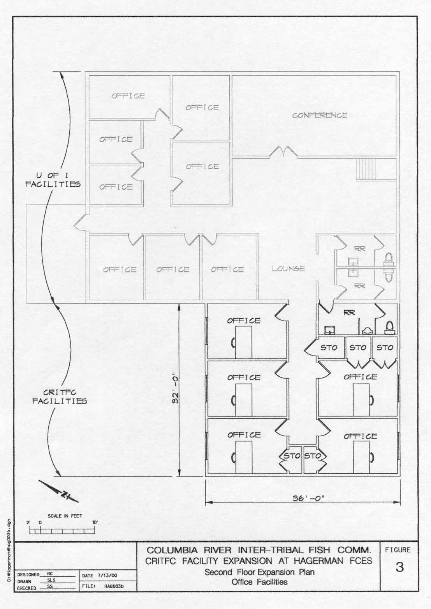

Figure 4. Conceptual drawing of the sturgeon facilities.
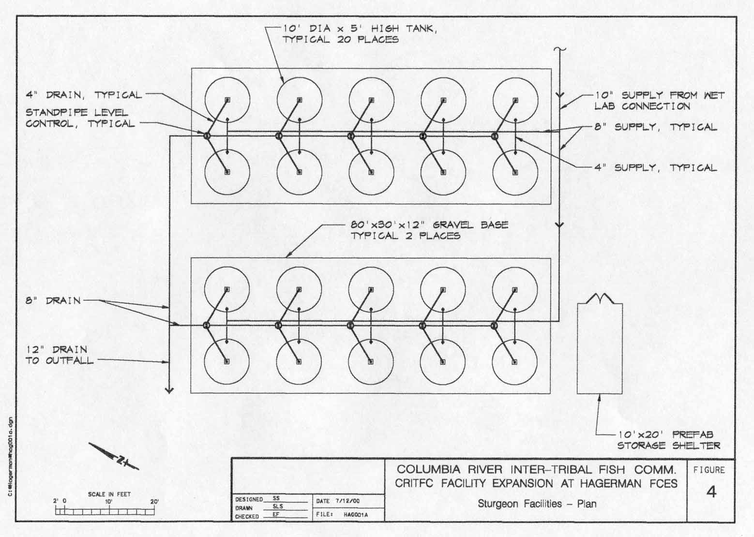
Figure 5. Plan view of the stream viewing station.
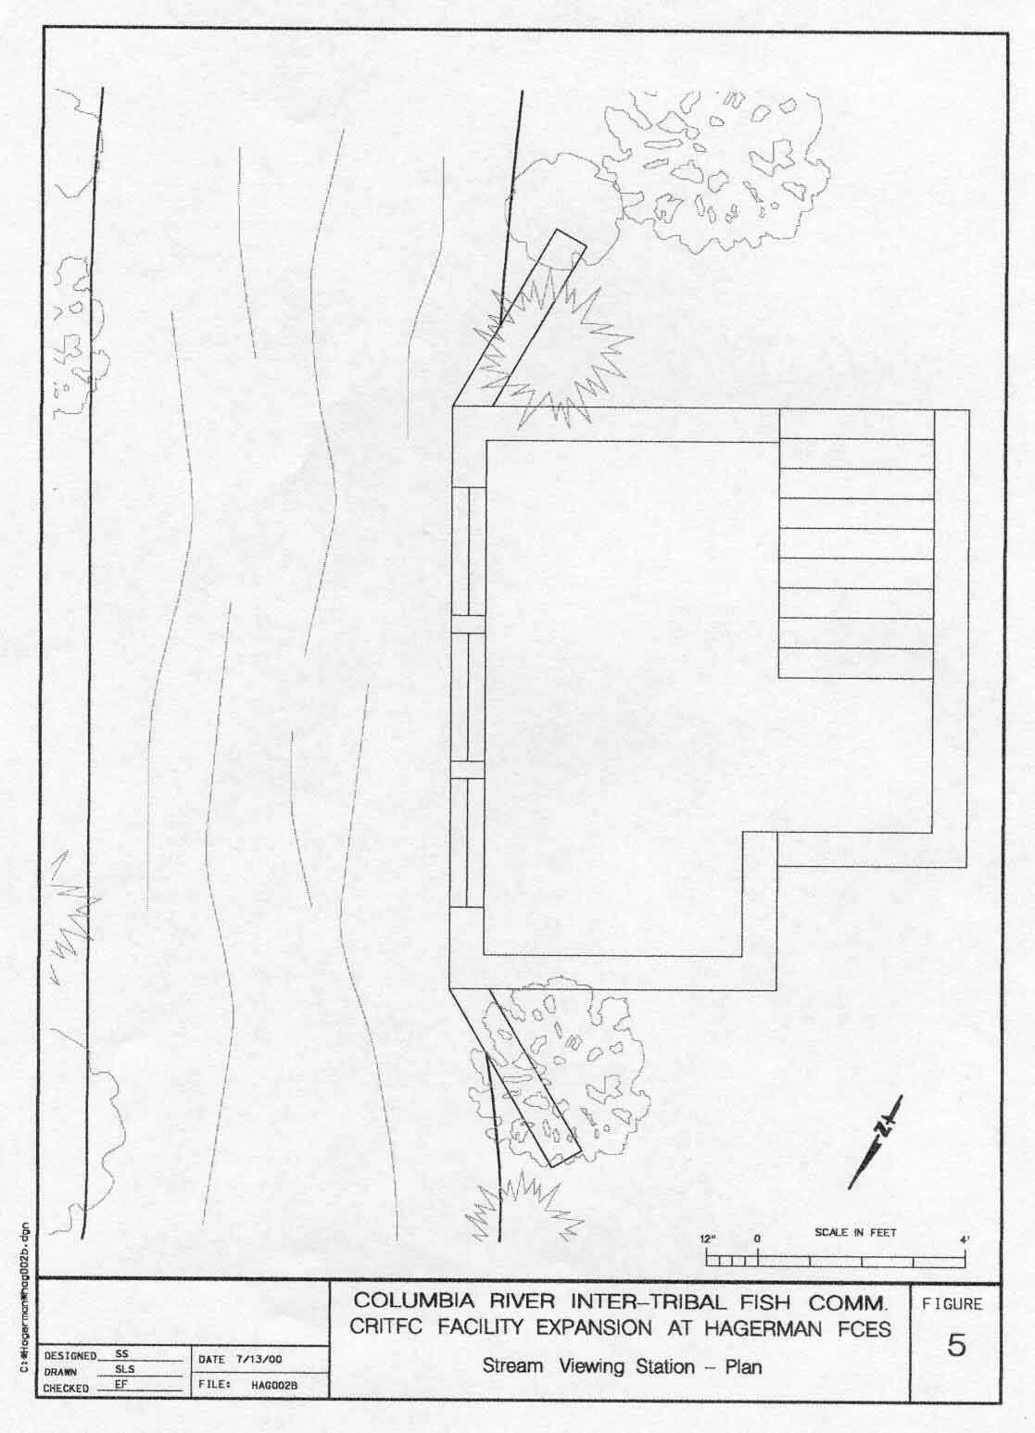
Figure 6. Stream view station.
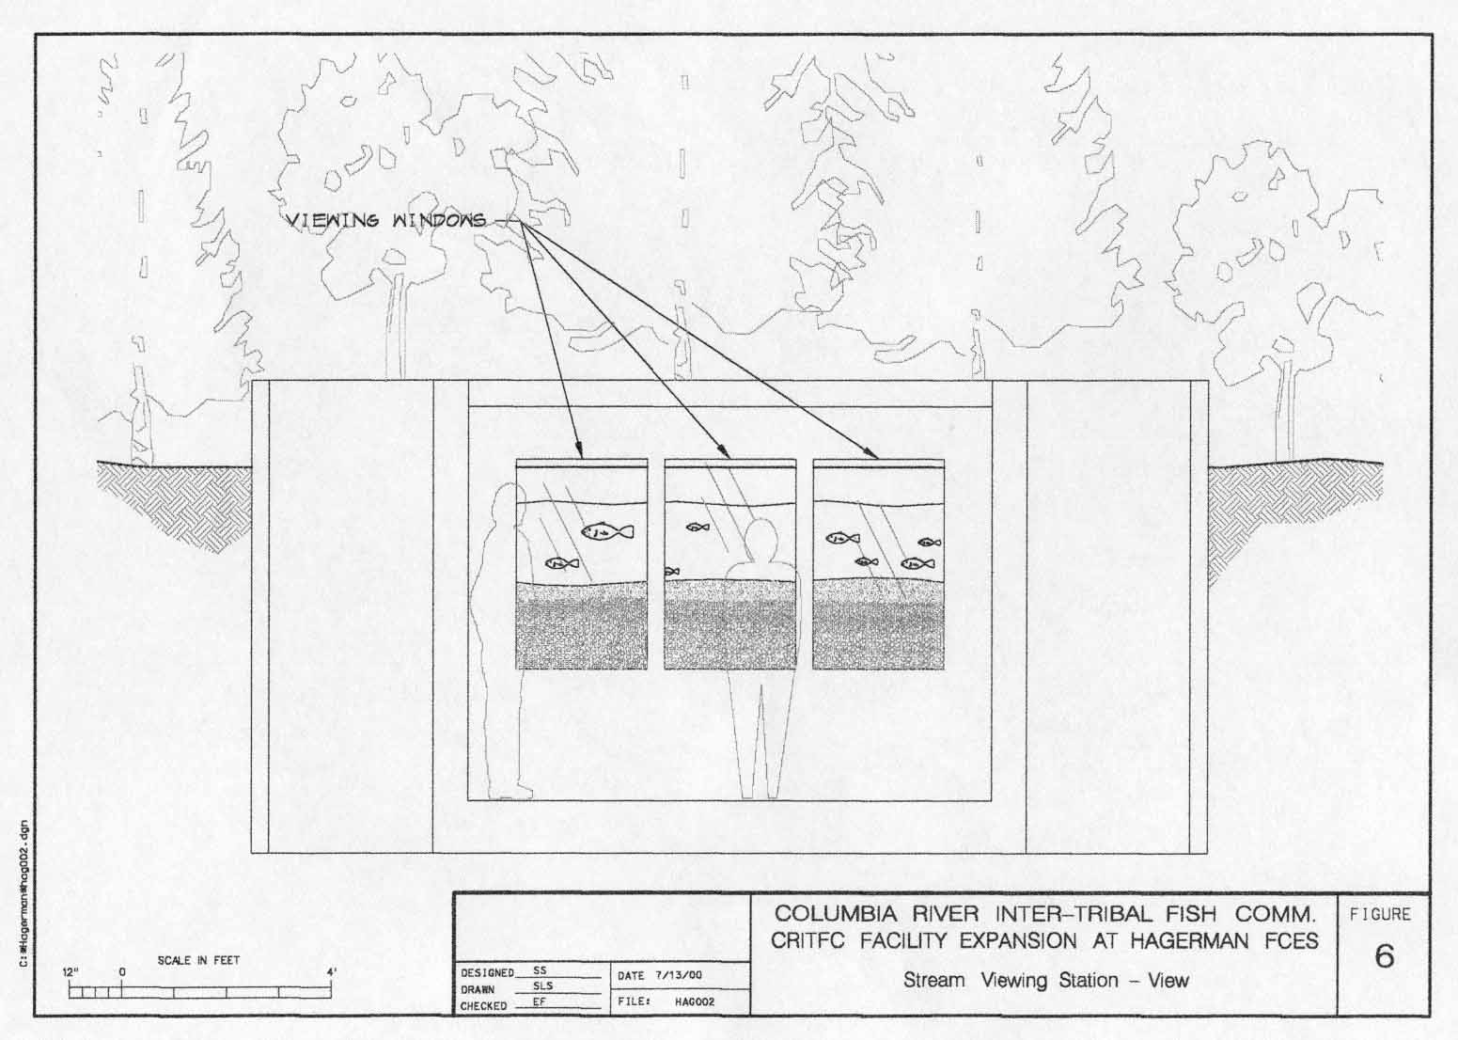

Objective 1: Expand facilities and equipment at the HFCES to accommodate research in genetics, pathology, and ecological interactions and provide distance-learning capabilities.

Task a: construct office, laboratory, and dormitory additions in concert with U of I planned site expansion, as per attached designs (Figures 1-6).
-office construction to accommodate five staff
-laboratory construction for genetics and pathology
-dormitory addition for visiting students and scientists

Task b: increase fish rearing, holding and observation capacity for research in genetics, pathology, and ecological interactions (Figures 1-6).
-refurbish existing raceways
-construct outdoor rearing ponds
-improve existing stream channel, and construct observation facilities
-construct sturgeon holding/spawning facilities
-construct storage shed

Task c: purchase equipment necessary for research in genetics, pathology, and ecological interactions and provide distance-learning capabilities.
-one GSA truck lease
-two fish transport tanks (one juvenile and one adult)
-one ABI (Advanced Biological) Fluorescence Based 3100 Capillary Genetic
Analyzer
- five laboratory and office computers
-autoclave, fume hood, and microscopes for pathology laboratory
-three sample cabinets for DNA archive
- five ultracold freezers and one backup generator for cryopreservation
-smartboard and videoconferencing equipment for distance-learning program
-desks, chairs, and miscellaneous office furnishings
-dormitory furnishings
-one tractor with front-end loader for stream and semi-natural manipulations

Objective 2. Compile population data required for subbasin plans where tribes have lead responsibility and develop Population Management Plans (addressing Benefit/risk analyses, HGMPs) for specific project implementations.

The region is about to embark on a new round of subbasin planning to coordinate restoration efforts and guide funding decisions over the next several years. The NWPPC desires that the subbasin planning process be completed as quickly as possible thus requiring a rapid evaluation of needs. It has been suggested that the subbasin plans include documents similar to benefit / risk analysis (BR/A) and hatchery genetic management plans (HGMPs). Therefore, the region has an immediate need to compile the data that will be required for these subbasin plans. Toward this end we are asking for short-term funding to provide essential products that will be used in subbasin planning for better population management (hatchery and natural). It must be recognized that the level of detail in subbasin plans is much coarser than the requirements that specific projects must have for implementation. It is also at this finer level of detail where hypothesizes are tested and critical uncertainties are addressed to build a strong scientific foundation to guide project implementation. The region also has an immediate need to build this strong scientific foundation for production strategies. Therefore on a parallel track, the CCAFS will be developing population management plans (PMPs) for specific production projects. These PMPs will contain BR/A, HGMP, and research monitoring and evaluation plans (RM&E). These PMP documents will contain the level of detail needed for implementation of specific projects. The majority of the funding for PMP development will be from O&M and M&E portions of existing and planned production projects. These funding requirements are incorporated in the hatchery master plans.

We will compile data for subbasin plans in areas where tribes have the lead responsibility which may include the following subbasins: Methow, Entiat, Wenatchee, Yakima, Rock Creek, Klickitat, Deschutes, Hood, John Day, Umatilla, Walla Walla, Grande Ronde, Clearwater, Imnaha, and Salmon.

Development of population management plans including Benefit / Risk Analysis, Hatchery and Genetic Management Plans, and Research, Monitoring and Evaluation Plans
Recent listing of many salmonid populations and their associated habitat under the endangered species act is driving a regional shift in hatchery management. Hatchery programs initially implemented to mitigate for lost habitat and decreased salmon production are actively being reprogrammed in an attempt to aid in conservation and recovery of salmonid stocks. In addition, the continued decline of many salmonid stocks is giving rise to a greater need for more intrusive management intervention. As a result of these factors, all management parties in the Columbia River Basin are considering some form of supportive breeding as a strategy for the maintenance of populations at risk of extinction. These approaches range from captive broodstock, where anadromous fish are held in captivity for nearly an entire generation, to release of fish beyond program needs from conventional hatcheries. Releasing fish in the wild for the specific purpose of increasing natural production as well as, potentially, natural productivity greatly increases the complexity of monitoring needs. Therefore, it is essential that the tools required for determination and refinement of the methods of successful supplementation be developed.
Under the Endangered Species Act, greater scientific scrutiny is required for ongoing and newly proposed hatchery programs that have the potential to directly or indirectly effect listed species or critical habitat. Recently, the National Marine Fisheries Service (NMFS) has mandated formulation of Hatchery and Genetic Management Plans (HGMP) as prerequisites for the implementation/operation of hatchery programs. Completion of an HGMP requires that a Benefit Risk Analysis (B/RA) and Research, Monitoring, and Evaluation Plan (RM&E) be completed. For reasons discussed below, we suggest that it is critical that these documents be prepared in a consistent manner using similar methodology for all hatcheries that are included in a concerted recovery effort. The result of such a program would be a Population Management Plan (PMP), which would not only fulfill permitting requirements, but would also specifically address goals for natural reproduction and integration of hatchery-reared and naturally spawned fish.
This proposal seeks support for technical staff of the Columbia River Inter-Tribal Fish Commission, technical staff of constituent tribes, and collaborators at the University of Idaho Hagerman Aquaculture Research Institute to begin formulation of HGMP, B/R analysis, and RM&E plans for tribally managed or co-managed hatchery programs that are deemed necessary for recovery in the WY-KAN-USH-MI WA-KISH-WIT, and sub-basin plans.
This work will be undertaken at the joint University of Idaho/CRITFC experimental research center, located in Hagerman, Idaho. The Center has established genetics, pathology, fish diet, and production research facilities. Because of the scale of the proposed research program, it is proposed in a complementary request for funding to increase the Center’s infrastructure to provide office and research space for an additional five research and technical staff.

Definitions
HGMP:
The Hatchery and Genetic Management Plan (HGMP) summarizes program specific information from the B/RA and RM&E associated with a hatchery program. In practice, the HGMP defines all program specific objectives and associated tasks, specific management actions, and a description of how the success and/or failure of the management actions will be assessed. The HGMP is required for a Section 10 permit for take of a listed species for hatchery production. In our experience, completion of an HGMP requires two months of effort by two full-time staff members, assuming that the background documents (B/RA and RM&E) have been completed.
B/R Analysis:
The B/RA is intended to serve four distinct purposes: 1) establishing the necessity of a management action and description of the goals of the program; 2) comparison of the range of management actions that could achieve the goals; 3) an assessment of the potential risks and benefits of the management actions that could achieve the goals; and 4) identification of critical uncertainties to be addressed by research elements of the RM&E plan. Although a B/RA is required before implementation of a proposed hatchery program, a consistent template for B/RA has not been developed. To date, B/RA documents prepared for tribal programs have contained the following elements:
- an analysis of risks to the recipient (target and non-target spawning aggregates) as well as donor stocks (if they differ), from impacts associated with:
  - captivity period in a hatchery facility, including:
    - artificial selection
    - rearing techniques
    - proportion of broodstock comprised of hatchery-reared and naturally-spawned adults
  - genetic interactions associated with interbreeding, including:
    - loss of diversity
    - outbreeding depression, inbreeding depression, and specific dysgenic and adaptation processes
  - ecological interactions such as competition, predation, and potential for increased exploitation
  - risk associated with no action/comparison of potential risks/benefits from alternate actions
- a list of objectives, criteria for evaluation, and an estimated timeframe to achieve objectives
- a list of potential benefits expected to result from implementation of the proposed action including:
  - conservation/generation of genetic diversity
  - conservation/generation of life-history types
  - potential to halt or reverse declining abundance
  - conservation of culturally and socially important resources
  - restoration/conservation of spawning aggregates throughout the range of available habitat
  - restoration of ecosystem processes
  - restoration of tributary fisheries for sports and tribal fishing opportunities
  - normative river functions

The preceding elements of a tribal B/RA incorporate and expand the draft B/RA presented by the NMFS (Waples 1996). To date, a given B/RA completed by the CRITFC has averaged 140 pages, and included citations from more than 300 published papers and 120 "grey literature" reports (PRRG 1999, 2000). Compilation of this information requires an average of two full time staff members working for six months to complete each B/RA. This level of effort has allowed us to produce comprehensive and scientifically rigorous B/RA methodology that includes analyses of genetic data, analyses of coded wire tag data, and a substantial review of published and grey literature relevant to the programs.

PMP
The goal of the PMP is integration of required ESA documentation with specific program objectives, such as goals for increasing natural reproduction and productivity. Specifically, the PMP will shift the focus of the broader ESA required documents to the requirements of a supplementation program, such as the integration of hatchery-reared and naturally spawning fish.

Proposal
This proposal is intended to start the formulation of a B/RA, RM&E, and HGMP for each newly proposed or existing high priority tribal hatchery program. Funds to complete these documents will come from each individual project. Currently, a B/RA, RM&E, and HGMP are required for; the Cle Elum Hatchery (co-managed by the Yakama Nation and Washington Department of Fish and Wildlife), the Klickitat Hatchery (co-managed by the Yakama Nation and Washington Department of Fish and Wildlife), the Warm Springs Hatchery (co-managed by the Confederated Tribes of the Warm Springs Reservation and the Oregon Department of Fish and Wildlife), the Umatilla Hatchery (co-managed by the Confederated Tribes of the Umatilla Indian Reservation and the Oregon Department of Fish and Wildlife), the Nez Perce Tribal Hatchery (Nez Perce Tribe), and the Northeast Oregon Hatchery Program (co-managed by the Nez Perce Tribe and the Oregon Department of Fish and Wildlife). Each of these programs is intended to mitigate for loss of salmon habitat and productivity resulting from the construction and operation of the Columbia River hydrosystem, and hence are appropriate for BPA funding. All but the last two listed programs are currently operating, the Nez Perce Tribal Hatchery is under construction, and the Northeast Oregon Hatchery is at step three of the Council three step process. We have completed a B/R analysis for the Nez Perce Tribal Hatchery (PRRG 1999), however an HGMP and integrated RM&E have yet to be formulated for this program.
Completion of a B/RA, RM&E, and HGMP for the previously listed hatchery programs is necessary for continuing operation or implementation. While the NMFS has produced a final HGMP template, no such template has been developed for B/RA or RM&E. The lack of a B/R analysis template is problematic because in order for a B/RA and HGMP to be useful as tools to compare across conservation/recovery programs in a coherent manner, it is critical that the documents are compatible. This proposal would provide the funds necessary for the CRITFC and tribal technical staff to work towards the completion of a B/RA, RM&E, and HGMP for tribal and tribally co-managed projects, such that this consistency may be achieved.
For newly proposed hatchery programs, formulation of a B/RA, RM&E, and HGMP will ensure that the programs offer the greatest possible benefit to conservation and recovery while minimizing possible adverse consequences of hatchery operation. The formulation of RM&E within this context will ensure that data are generated to address the specific uncertainties associated with a program, in addition to providing adequate monitoring to ensure that program success and/or failure is evaluated, and to employ adaptive management to fine-tune management actions.
For currently operating programs, we anticipate that formulation of a B/RA and HGMP will guide hatchery reform, hence optimizing the conservation and restoration potential while altering current hatchery management to minimize adverse impacts. In both cases, the formulation of a B/RA will focus and identify RM&E needs to efficiently address the specific scientific uncertainties associated with the program. Over the long-term, we anticipate that focusing RM&E programs in this manner will provide greater scientific clarity and reduce overall monitoring costs.
Finally, if applied consistently, the B/RA, RM&E, and HGMP will provide a useful metric of hatchery reform for regional managers and funding organizations. For example, the number of potential risk categories receiving a low, medium, or high rating in the B/RA can be used to visualize the degree of risk associated with recovery efforts. Within a given subbasin, the composite score of all the hatchery programs will form a distribution (Figure 7). During formulation of the B/RA and HGMP within a given subbasin, we anticipate that the distribution of risks will shift as lower risk management actions are implemented (Figure 8). Information provided by the associated RM&E will allow a similar visualization of program success. Managers could use the projected change in the composite distribution of risks and successes as a method to prioritize funding, or quantitatively assess the value of proposed hatchery reform and newly proposed hatchery programs.

Figure 7: Composite distribution of the percent of total risks receiving a low risk ranking for all currently operating Columbia River hatcheries. This graph is provided for illustration only, the distribution does not reflect actual ranks of real hatchery operations.

Composite
Distribution
of Low Risk Ranks
% Risks Receiving a Low Risk Rating
0
100
Figure 8: As hatchery reform is implemented, the composite distribution of low risk ranks should shift toward the lower risk tail of the distribution.
0
100
0
100
0
100
% Risks Receiving a Low Risk Rating
% Risks Receiving a Low Risk Rating
% Risks Receiving a Low Risk Rating
Time
Summary
Completion of a B/RA, RM&E, and HGMP is a requirement for continuing and newly proposed hatchery programs that have the potential to effect species or associated critical habitat listed pursuant to the Endangered Species Act. We propose to complete a B/RA, RM&E, and HGMP for tribally managed and co-managed facilities used as mitigation for losses of anadromous salmonids resulting from construction and operation of the Columbia River hydrosystem.
While the NMFS has completed an HGMP template, no such template has been completed for B/RA or RM&E, therefore it is critical that any B/RA and RM&E completed for tribally managed and co-managed facilities be completed in a consistent manner, using the same methodology. To accomplish this goal, we are seeking multi-year funding to formulate a B/RA, RM&E, and HGMP for all tribally managed and co-managed hatchery facilities. Funding this proposal would:
- ensure that currently operating and proposed hatchery programs have the necessary documentation for NMFS permitting
- allow comparisons between hatchery programs
- provide a metric of progress of hatchery reform
- efficiently channel monitoring and evaluation programs to address the specific uncertainties associated with recovery programs
- develop the technologies and methods necessary to provide the greatest probability of program success, and evaluate the success and/or failure of prescribed management actions

Objective 2. Compile population data required for subbasin plans where tribes have lead responsibility and develop Population Management Plans (addressing Benefit/risk analyses, HGMPs) for specific project implementations.
Task a. Compilation of data necessary for assessment of risk, benefits, and population management of restoration programs for tribal and regional Subbasin Planning (including travel to tribal facilities, meetings, conferences)
Task b. Generate Benefit/Risk analysis.
Task c. Generate Hatchery Genetics Management Plans (HGMPs)
Task d. Develop Population Management Plans (PMPs)
Task e. Genetic analyses and pathology
Task f. Indirect costs (36.9% on personnel, travel, supplies)

Objective 3: Develop monitoring tools necessary to resolve critical uncertainties in integrated population management (incorporating supplementation)

Regional review of hatchery programs has shown that some hatchery practices may be harmful. For example, overharvest of mixed stocks, unintentional straying, poor breeding practices, shifts in run timing, and others can reduce the viability of fishes and reduce their suitability for natural population enhancement (ISG 1996, NRC 1996, NPPC 1999).
Other impacts have been hypothesized (NPPC 1999), but have not been fully evaluated. These fall under the following categories:
- Stock structure: The loss of local adaptation resulting from outbreeding.
- Domestication: The reduction in fitness of wild fish from outbreeding with hatchery-reared fish.
- Fish Health: Supplementation hatcheries are potentially a source of diseases.
- Production: Production of fish that have a survival and return rate that is comparable to naturally-produced fish and that are genetically compatible with habitat in which the fish are destined.
While these concerns are voiced throughout the Columbia River Basin, little or nothing is done to address the need for resolution. The monitoring tools and methods that are required to address these issues have yet to be fully developed. The facilities planned and available at the new Collaborative Center for Applied Fish Science (CCAFS), associated with the University of Idaho, are ideally suited to provide the region with a research basis for adaptive management. Development of a collaborative research program at the CCAFS will be closely associated with tribal supplementation and production facilities. Such a research and development (R/D) program includes elements of ecology, genetics, fish health, and factors limiting natural productivity. Specifically, the CCAFS would focus on the following:
- The impact of supportive breeding techniques on metapopulation health and structure.
- Methods of limiting impacts of artificial selection and domestication in non-natural spawning and rearing environments (hatcheries, rearing channels, acclimation facilities, captive rearing, etc.)
- Methods of minimizing health risk of outplanting.
- Assessment of the ecological consequences of supportive breeding techniques, such as competition, predation, nutrient cycling and habitat use.
- Improve broodstock management and rearing methods for fish destined for outplanting.

The need for RM&E
The Benefit/Risk Analysis and HGMP framework for supplementation programs will highlight the need for detailed protocols regarding broodstock selection, mating, rearing, acclimation and release. This process will identify research and tool development needs to resolve many of the hypothesized risks and benefits. This will be done in a proactive manner that moves restoration of salmon and other species forward. The data and results generated by the R,M/E program will be fed back into the draft Benefit/Risk Analyses and HGMPs of Objective 2 and lead to final Population Management Plans and monitoring and evaluation protocols.
Each element of the protocol will require specialized and sensitive monitoring methods, yet these do not exist on a scale that has the statistical power needed to reject hypotheses. Evaluation of the goals of the programs will require powerful tools to detect potentially subtle effects.
The collaborative approach of the CRITFC and the University of Idaho is an ideal arrangement to balance the implementation of a pragmatic approach to salmon restoration with state of the art research to guide programs.
Genetics
One of the goals of supplementation is to ensure that the hatchery-reared component of the target population fully integrates with the naturally spawning component, to avoid dual stocks within the same population. Supplementation may result in populations that behave demographically and genetically as core-satellite populations in a metapopulation structure. The effects of supplementation on existing metapopulation structure may be subtle, and detection will require powerful tools and precise sample design (Hard 1995). We will develop methods of determining the impact of supplementation on population structure, genetic drift and genetic diversity and variability on a fine scale (among tributaries within a watershed). In order to be most effective, baseline data on unsupplemented populations will be gathered. Specific hypotheses will be developed and tested, and the statistical power of the tools estimated. Our results will be used to evaluate changes over time of supplemented streams, as compared to control streams. This will assist the region in determining the long-term genetic impact of supplementation on natural fish runs, and evaluate progress towards recovery goals.
We will extract DNA in a non-lethal method from fin clips and other body parts, which will allow us to work on listed species. The resulting DNA will be amplified via Polymerase Chain Reaction (PCR) using standard methods. We will explore a number of highly variable loci to determine which are the most informative towards the stated goals. Other techniques will be explored, such as fingerprinting, mtDNA haplotype diversity, and DNA sequencing and allozyme frequencies at a number of standard loci. Results will be shared with other interested management parties.
Fish productivity
One of the continuing debates in Pacific Northwest salmon recovery efforts pertains to the breeding value and reproductive success of hatchery-reared fish. Using an artificial spawning and rearing stream, we will evaluate a series of test populations whose potential genetic divergence from wild stocks range from less than a single-generation in captivity (captive rearing, supplementation) to putatively domesticated, mixed stocks (from conventional hatchery programs, for example, Carson stock spring Chinook, Skamania stock steelhead, or coastal hatchery coho which forms the broodstock of present upriver recovery efforts). Expected results include the determination of life history divergence among stocks (similar to Unwin et al. 2000), level of genetic introgression resulting from overlap in spawning (using genetic pedigrees (similar to Arkush et al. 1997)), and survival estimates for a variety of life stages of parental stocks and crossed lines (similar to Edmands 1999).
The results of these studies will help determine the appropriate techniques for supplementation under specific conditions. The fish used in these experiments will undergo detailed genetic profiling as described in the genetics section. These fish will also be assayed for potential disease transmission and condition.
In addition to the determination of productivity of hatchery stocks under controlled conditions, we will develop small-scaled fish releases, where all released smolts will be individually tagged (using PIT tags). All parents and returning smolts will be pedigreed. This approach will help us determine the among-family smolt-to-adult survival rates, and develop a strong quantitative genetic approach to salmon restoration.
Fish Health
One of the primary concerns with supplementation and fish releases from hatcheries in general is that the hatchery environment could potentially be a vector for transmission of disease into naturally spawning populations, thus impacting the survival of both supplemented and naturally spawning fish (IHOT 1995). We will undertake a study of disease transmission and vectors in both hatchery and natural conditions, with and without supplementation. We intend to approach the problem from fine-scaled analyses of supplemented and unsupplemented tributaries within watersheds.
Objective 3: Develop monitoring tools necessary to resolve critical uncertainties in integrated population management (incorporating supplementation)

Task a: Develop hypotheses for monitoring methods defined in Draft Population Management Plans (under Objective 2) and required for Monitoring and Evaluation (M/E).

This task requires the development of a rigorous scientific program staffed with top University and CRITFC science staff. We will draw from expertise in genetics, population dynamics, metapopulation ecologists, pathologists and risk analysts. At the onset, we expect the contribution of 6 scientists holding PhDs (3 of which are senior scientists in their respective organizations) and 3 holding MSc degrees. We require funding for 3 FTEs, supplies and equipment for research, and travel.

Task b: Acquire data required for testing monitoring methods

Before the methods proposed and integrated into monitoring and evaluation programs of Population Management Plans (or subbasin plans, final HGMPs, Section 10 permits, etc.), some of the methods will require laboratory or field testing.

Task c: Analyze information and publish results

The ultimate goal of the CCAFS is to focus on rigorous and objective research for ultimate publication and dissemination to the scientific and management community. We ask for funding to cover expenses associated with analysis, report writing and publication, as well as participation in conferences and technical meetings (Task d). This funding is seldom available through contract for services associated with production programs.

Task d: Tribal and regional coordination direct costs (travel to tribal facilities, meetings, and conferences)

These are costs associated with coordination of work done offsite at supplementation facilities, as well as for coordination with production and restoration program managers.

Task e: Provide expendable supplies and materials

Although the bulk of this work may be associated directly with production programs (and funded by them), we ask for startup funding to provide the CCAFS with the supplies and equipment necessary to be fully operational.

Task f: Indirect costs (36.9% on personnel, travel, and supplies)

Objective Four: Education
The primary goal of the education program is to provide a means to enable tribal members to uphold their portion of the conservation burden. Specifically, the education program will provide competitive scholarship opportunities for high school and college graduates who are members of federally recognized tribes. Students enrolled in this program will receive technical training in the fields of genetics, aquaculture, pathology and ecology. These skills will enable graduates to effectively manage the state-of-the-art supplementation and conservation facilities that are commonplace in the Columbia River Basin. In addition, a technician-training component is included in this proposal. We envision a series of workshops with hands-on training addressing pertinent topics in areas of aquaculture, genetics, and ecology aimed at informing and updating technicians from tribal, state, federal, and special interest agencies. These workshops are intended to make new techniques and scientific applications accessible to currently operating programs as a means to promote more effective management

Target Groups
The education component of this integrated proposal will target four categories of qualified tribal employees and students; 1) graduate interns, 2) undergraduate interns, 3) technicians, and 4) high school students.
Participants in the CCAFS education program will be selected based on the following criteria: 1) enrollment in a federally recognized tribe; 2) commitment to work for the sponsoring tribe for a period of not less than two years following completion; 3) willingness to complete assignments on behalf of a project; 4) demonstrated ability to complete all requested projects, assignments, and technical work; 5) pursuit of a degree within the aquatic sciences discipline; and 6) education must represent a demonstrated need from regional artificial propagation programs.
Participants in the CCAFS education program will be assigned to the following efforts: 1) graduate program (M.S. or PhD.) in aquatic sciences or related field; 2) undergraduate program (B.S.) in aquatic sciences or natural resources; and 3) high school program (Junior/Senior students) Math and Science Emphasis.
Technician training will target tribal employees that are currently involved in the management and application of artificial propagation technology. Participants in these workshops will be guided through a series of classroom lectures, laboratory, and hands-on field exercises. The costs associated with these workshops (e.g., travel, lodging, per diem, and materials) will be borne by the attendees. Topics will include, but are not limited to; genetic data collection techniques, identification and control of infectious pathogens, and application of new aquaculture techniques. We envision these workshops as a means to make advances in propagation technology developed at the HFCES accessible to the managers who might benefit from this knowledge. Finally, these workshops will provide a forum for mangers to express research needs, and act as a locus for regional coordination.

Anticipated Budget
The budget in section two lists the anticipated costs for training ten students per year seeking either graduate or undergraduate training. In addition to classroom work at the U of I campus, education components will consist of workshops conducted at the CCAFS, the College of Southern Idaho, federal/state hatcheries, or tribal production sites. Off-site learning will be conducted via “smart boards” and/or internet based and videoconferencing classes.
Cost Sharing
Support for high school internships will be provided by the American Fisheries Society “Hutton Fund,” from which we anticipate receiving four $3,000 stipends. Support for undergraduate students will be provided, in part, by the United States Department of Agriculture (USDA) “Multicultural Scholars Program.” We anticipate that this program will support approximately five undergraduate student scholarships. Partial graduate student support is anticipated through the USDA Graduate Fellowship Program.
Task a: provide funds necessary to award scholarships to competitive students from federally recognized tribes.
-tuition
-fees (including materials)

Task b: provide funds for supervisor travel.
-airfare (6 trips)
-auto rental (6 trips)
-lodging (12 nights)
-per diem (24 days)

Task c: provide funds for oversight of the education program.
-project leader (0.25 FTE)
-administrative assistant (0.25 FTE)

Task d: provide funds for indirect costs.
-36.9% applied to personnel, travel, and supplies

f. Facilities and equipment

The major facilities and equipment to be used in this project are located at the University of Idaho’s Hagerman Fish Culture Experiment Station (HFCES). Much of this proposed project involves upgrading the existing facilities to increase throughput and accommodate a larger number of researchers. The HFCES is sited on 4.15 acres providing ample room to accommodate new buildings and fishponds. The existing wet lab building is adequately equipped with small containers for experiments. Adequate additional gravity-fed spring water is available for the large ponds and outdoor rearing areas proposed in this project. The large ponds and outdoor rearing areas are needed to accommodate the planned supplementation experiments. These experiments will require holding and spawning adult salmon.

Vehicle leases are included in the proposal as well as laboratory and office equipment. A genetic analyzer is included in the budget and is required to accommodate the increased need for genetic profiling called for in the proposal.

A facilities section in the proposal provides specific details on facilities and equipment requests. The facilities improvements were conceptually designed by Fishpro Inc. a fish biology and engineering firm.

g. References

Arkush, D.K., M.A. Banks, D. Hedgecock, P.A. Siri, and S. Hamelberg. 1997. Winter-run chinook salmon captive broodstock program: progress report through April 1996. U.S. Fish and Wildlife Service. Technical Report 49.
CRITFC (Columbia River Inter-Tribal Fish Commission). 1982. Mitigation of anadromous fish losses: Efforts related to Columbia and Snake River dams and a plan for reprogramming hatcheries. Report to Bonneville Power Administration Contract No. DE-AI 79-81 BP 31835. Portland, Or.
Edmands, S. 1999 Heterosis and the Outbreeding Depression in interpopulations Crosses Spanning a wide Range of Divergence. Evolution, 53(6), 1999 pp.1757-1768.
Foott, J.S., R. Harmon, K. Nichols, D. Free, and K. True. 2000. Release of IHNV infected Chinook smolts from Coleman NFH: Risk assessment of the disease impacts on natural Chinook. Proceedings of the 5th Annual Pacific Northwest Fish Culture Conference, 5-7 December 2000, Sacramento, Cal., California-Nevada Fish Health Center, USFWS.
Hard, J.J. 1995. Genetic monitoring of life history characters in salmon supplementation: problems and opportunities. American Fisheries Society Symposium 15:212-225.
IHOT (Integrated Hatchery Operations Team). 1995. Policies and procedures for Columbia Basin anadromous salmonid hatcheries. Annual Report 1994. BPA 92-043. 115 p.
ISG (Independent Scientific Group). 1996. Return to the River: Restoration of Salmonid Fishes in the Columbia River Ecosystem. Development of an alternative conceptual foundation and review and synthesis of science underlying the fish and wildlife program of the Northwest Power Planning Council, Portland, Oregon.
NFHRP (National Fish Hatchery Review Panel). 1994. Report of the National Fish Hatchery Review Panel, 1994. The Conservation Fund, Arlington, VA.
NMFS 2000. Draft Biological Opinion Operation of the Federal Columbia River Power System. July 27, 2000.
NPPC (Northwest Power Planning Council). 1999. Artificial Production Review. NPPC, 851 SW 6th Ave., Suite 1100, Portland, Or 97204-1348. 238 pp.
NRC (National Research Council). 1996. Upstream: salmon and society in the Pacific Northwest. National Academy Press, Washington DC. 452 p.
PRRG (Production and Restoration Research Group). 1999. Nez Perce Tribal Hatchery Benefit Risk Analysis. Columbia River Inter-Tribal Fish Commission. 150 pp.
PRRG (Production and Restoration Research Group). 2000. Johnson Creek Artificial Propagation Enhancement Program Benefit Risk Analysis. Columbia River Inter-Tribal Fish Commission. 112 pp.
Unwin, M.J., T.P. Quinn, M.T. Kinnison, and N.C. Boustead. 2000. Divergence in juvenile growth and life history in two recently colonized and partially isolated chinook salmon populations. Journal of Fish Biology. 57: 943-960.

Section 4. Key personnel
Name FTE
Dr. André Talbot, Senior Scientist, Co-Principal Investigator 0.8
Coordinator of CCAFS
Dr. Ernest Brannon, Co-Principal Investigator 0.2
Director of the Aquaculture Research Institute (ARI)
Dr. Madison Powell, Research Scientist 0.4
Lead geneticist for ARI
Dr. Ronald Hardy, Director for HFCES 0.1
Facilities management and nutritionist
Douglas Hatch, Fisheries Scientist 0.8
Population Management Plan project leader
Chris Beasley, Fisheries Scientist 0.8
Risk Analyst project leader
Molecular Geneticist to be filled 1.0
Pathologist to be filled 1.0

Contractors
Fishpro Inc.
Confederated Tribes of the Warm Springs Reservation of Oregon
Yakama Nation
Nez Perce Tribe
Confederated Tribes of the Umatilla Indian Reservation
André Talbot, Columbia River Inter-Tribal Fish Commission

Education:
Ph.D. (Biology). Dalhousie University, Halifax, NS, Canada. 1994.
M.Sc. (Biology). McGill University, Montreal, Qc, Canada. 1983.
B.Sc. Honours (Biology). University of Ottawa, Ottawa, Ont, Canada. 1980.
Post-Graduate Scholarships:

Ph.D.: Natural Science and Engineering Research Council (NSERC). 1986
M.Sc.: Natural Science and Engineering Research Council (NSERC), 1981.
Fonds FCAR pour l'aide et le soutien à la recherche (Québec), 1982.
McGill University Travel Fellowship, 1982, 1983.

Relevant Experience
Position |  | Dates |  | Institution and description
Ecologist/geneticist and Senior Scientist |  | 1997-present |  | Columbia River Inter-Tribal Fish Commission
Fisheries Scientist and Regional Unit Manager |  | 1994-1997 |  | Caribbean Fisheries Resource Assessment and Management Program/Canadian International Development Agency
Managing Partner &  Consultant |  | 1989-1994 |  | Talbot and Associates (biostatistics, population dynamics, genetics, development)
Research Associate |  | 1990-1994 |  | Département des Sciences Fondamentales, Université du Québec à Chicoutimi, Québec, Canada
Research Associate & Project Manager |  | 1983-1989 |  | Biology Department, Dalhousie University, Halifax, Nova Scotia
Project Director |  | 1982 |  | National Museums of Natural History, Ottawa, Canada

Relevant Projects
Project description |  | Institution or Client

Resource Assessment & Conservation Biology
Development of a conceptual framework for ecological genetics of Pacific salmon conservation |  | CRITFC
ESA Project Leader |  | CRITFC
Co-ordinator for Collaborative Center for Applied Fish Science |  | CRITFC
Development of research strategies and co-ordinating project implementation for South American and Caribbean Shrimp/Groundfish Research Program |  | Canadian International Development Agency
Development of a management plan and stock assessment capabilities, and technical assistance in artisanal and industrial groundfish and shrimp fisheries in Benin (Africa). |  | International Centre for Ocean Development / Canadian International Development Agency
Technical support for pelagic, groundfish and octopus fisheries research (Mauritania, Africa). |  | International Centre for Ocean Development.
Evaluation of management requirements for the Saguenay Marine Park groundfish fisheries and population dynamics of the turbot (Reinhardtius hippoglossoides), cod (Gadus morhua) and redfish (Sebastes mentella). |  | Environment Canada / Fisheries and Oceans
Sport and commercial fishing activities in the Saguenay fjord and its potential effects on the groundfish population. |  | Environment Canada / Fisheries and Oceans
Development of a population estimation method based on the Bayesian principle of simultaneous analysis of removal data from many sites. |  | Fisheries and Oceans Canada
Development of a monitoring methodology for the evaluation of the exploitation and fishing activities of landlocked Atlantic salmon (Salmo salar ouananiche) in Lac St-Jean |  | Ministry of the Environment and Fauna, Québec
Analysis of the effect of fishing pressure on the burbot (Lota lota) populations in Lac St-Jean |  | Ministry of the Environment and Fauna, Québec

Fisheries & Aquaculture
Genetic improvement of common carp (Cyprinus carpio) and Tilapia (Oreochromis spp.) stocks. (Several individual projects, including cryopreservation of sperm) |  | International Development Research Centre
Genetics of growth and productivity of fish in aquaculture and the inter-relationship of life history strategies in relation to intraspecific competitive ability in fish. |  | International Development Research Centre
Dynamics of habitat use in relation to population abundance in Atlantic salmon parr: Test of ecological principles. |  | Fisheries and Oceans Canada
Study of the fecundity of Atlantic salmon (Salmo salar) in relation to growth at time at sea and its impact on production in rivers. |  | Ministry of the Environment and Fauna, Québec
Analysis of the effect of fishing pressure on landlocked salmon (Salmo salar ouananiche) populations in Lac St-Jean. |  | Ministry of the Environment and Fauna, Québec
Determination of productive capacity of habitat for juvenile Atlantic salmon and the application of juvenile density and production models in assessing the status of salmon stocks. |  | Fisheries and Oceans Canada
Determination of a classification method for the productive capacity of juvenile salmon habitat. |  | Ministry of the Environment and Fauna, Québec
Prediction of the productivity of juvenile salmon in relation to physical and biological stream parameters. |  | Fisheries and Oceans Canada

Relevant Publications and Reports

PHILLIPS, J.L., J. ORY and A.J. TALBOT. 2000. Anadromous Salmonid Recovery in the Umatilla River Basin, Oregon: A Case Study. p. xxx-xxx in "Watershed management for endangered species" . Journal of American Water Resources Association Vol XXX. In press.

BRANNON, E., D. CAMPTON, M. POWELL, A.J. TALBOT, and T. QUINN. 2000. Population structure of Columbia River chinook salmon and steelhead trout and application to existing populations. BPA Contract No. 98BI08319.

BEASLEY, C.A., A. TALBOT, D.R. HATCH, and A. RITCHIE. 2000. Johnson Creek artificial propagation and enhancement project (JCAPE) benefit risk analysis. Prepared for the Nez Perce Tribe.

BEASLEY, C.A., A. TALBOT, D.R. HATCH, and M. WISHNIE. 1999. Nez Perce tribal hatchery benefit risk analysis. Prepared for the Nez Perce Tribe.

TALBOT, A. and R. A. MYERS. 200X. Density-dependent habitat use and population expansion in juvenile Atlantic salmon. Can. J. Fish. Aquat. Sci. In press.

TALBOT, A. and J.-M. SÉVIGNY. 1994. Caractéristiques de la population du flétan du Groënland (Reinhardtius hippoglossoides) du fjord du Saguenay. in Sévigny, J.M. et C. Couillard (eds.) 1994. Le Fjord du Saguenay: un milieu exceptionnel de recherche. Rapp. tech. can. sci. halieut. xxxx : xx + xx p.

TALBOT, A., A. BOURGEOIS and J.-M. SÉVIGNY. 1994. Évaluation de l'exploitation du Sébaste atlantique (Sebastes mentella) par la pêche sportive hivernale sur le Saguenay. in Sévigny, J.M. et C. Couillard (eds.) 1994. Le Fjord du Saguenay: un milieu exceptionnel de recherche. Rapp. tech. can. sci. halieut.xxxx: xx + xx p.

TALBOT, A. 1994. Habitat-dependence of population abundance and variability in juvenile Atlantic Salmon (Salmo salar). Ph.D. Thesis, Dalhousie Univ., Halifax, Nova Scotia, Canada B3H 4J1. 214 pp.

CARON, F. and A. TALBOT. 1993. Re-evaluation of habitat classification criteria for juvenile salmon, p. 139-148. In R.J. Gibson and R.E. Cutting [ed.] Production of juvenile Atlantic salmon, Salmo Salar, in natural waters. Can. Spec. Publ. Fish. Aquat. Sci. 118.

TALBOT, A.J. and R.W. DOYLE. 1992. Statistical interrelation of length, growth, and scale circulus spacing: II. Use of marginal ossification to detect non-growing fish. Can. J. Fish. Aquat. Sci. 49(4):701-707.

TALBOT, A.J. and R.J. GIBSON. 1992. Habitat utilization by juvenile Atlantic salmon in Newfoundland rivers. p. 163-184 In J.B. Dempson [ed.] Collected papers on fish habitat with emphasis on Salmonids. Canadian Atlantic Fisheries Scientific Advisory Committee. CAFSAC Res. Doc. 90/77. 423 pp.

DOYLE, R.W., N.L. SHACKELL, Z. BASIAO, S. URAIWAN, T. MATRICIA and A.J. TALBOT. 1991. Selective diversification of aquaculture stocks: a proposal for economically sustainable genetic conservation. Can. J. Fish. Aquat. Sci. 48(1):148-154.

TALBOT, A.J. and R.W. DOYLE. 1990. Statistical properties and power of growth estimation using scale microstructure. p. 421-424 in R. Hirano and I. Hanyu (eds.). The Second Asian Fishery Forum. 991 pp. Asian Fisheries Society, Manila, Philippines.

MATRICIA, T., A.J. TALBOT and R.W. DOYLE. 1989. Instantaneous growth rate of Tilapia genotypes in undisturbed aquaculture systems. I. "Red" and "Gray" morphs in Indonesia. AQUACULTURE. 77:295-306. (also internal report to IDRC)

DOYLE, R.W. and A.J. TALBOT. 1989. Repeatability of relative size-specific growth in Tilapia. p. 451-456 in R.S.V. Pullin, T. Bhukasawan, K. Tonguthai and J.L. MacLean (eds.) The Second International Symposium on Tilapia in Aquaculture. ICLARM Conference Proceedings 15. 623 pp. Department of Fisheries, Bangkok, Thailand, and International Centre for Living Aquatic Resources Management, Manila, Philippines.

TALBOT, A.J., T.K. HAY, R.W. DOYLE and A.E.L. McNAUGHTON. 1989. "Current growth" estimators in Tilapia. p. 509-513 in R.S.V. Pullin, T. Bhukasawan, K. Tonguthai and J.L. MacLean (eds.) The Second International Symposium on Tilapia in Aquaculture. ICLARM Conference Proceedings 15. 623 pp. Department of Fisheries, Bangkok, Thailand, and ICLARM, Manila, Philippines.

DOYLE, R.W., A.J. TALBOT and R.R. NICHOLAS. 1987. Statistical interrelation of length, growth and scale circulus spacing: appraisal of a growth-rate estimator for fish. Can. J. Fish. Aquat. Sci. 44(9):1520-1528.

DOYLE, R.W. and A.J. TALBOT. 1986. Effective population size and selection in variable aquaculture stocks. Aquaculture. 57:27-36.

DOYLE, R.W. and A.J. TALBOT. 1986. Artificial selection on growth and correlated selection on competitive behaviour in fish. Can. J. Fish. Aquat. Sci. 43(5):1059-1064.

TALBOT, A., M. BENFIELD, and L. MORTON. 1996. Biology of selected shrimp and Groundfish species on the Guiana/Brazil Continental Shelf. The Joint CFRAMP Sub-Project Specification Workshop and Fourth Meeting of the WECAFC Ad Hoc Shrimp and Groundfish Working Group on the Guiana/Brazil Continental Shelf, Hotel Normandie, St. Ann's, Trinidad. 8-12 January 1996, Vol. Technical Papers. CFRAMP, Shrimp and Groundfish Resource Assessment Unit, PO Box 3150, Carenage Post Office, Carenage, Trinidad.

TALBOT, A.J. 1991. Simultaneous analysis of removal data from many sites. Presented to the Salmon Association of Eastern Newfoundland, St-John's, NFLD A1C 5N8 as part of the Habitat Modelling Project. 33 pp.

TALBOT, A.J. 1990. Production of juvenile Atlantic salmon in Newfoundland rivers: Test of habitat models using a structural approach. Final report of the habitat modelling project, Phase I, presented to the Salmon Association of Eastern Newfoundland, St-John's, NFLD, A1C 5N8. 84 pp. et 1 app.

TALBOT, A.J. and R. J. GIBSON. 1990. Habitat utilization by juvenile Atlantic salmon in Newfoundland rivers. Report to the members of the Canadian Atlantic Fisheries Scientific Advisory Council (CAFSAC, #90/118).

TALBOT, A.J.1989. Improved abundance estimation of Atlantic salmon parr. Contract with Fisheries and Oceans (Number XAQ88-00132-(021)).
Ernest Leroy Brannon
December 2000

EDUCATION:
B.S., Fisheries, University of Washington, 1959
Ph.D., Fisheries, University of Washington, 1973

EXPERIENCE:
1988-pres: Director of the Aquaculture Research Institute, Professor of Fisheries Resources and Animal Science, and State Aquaculture Extension Specialist, University of Idaho, Moscow
1973-1988: Assistant/Associate/Full Professor, School of Fisheries, College of Ocean and Fisheries Sciences, Univ. of Washington, Seattle
1974-1983: Director, Finfish Aquaculture Prog., College of Fisheries, Univ. of Washington, Seattle
1971-1972: Chief Biologist, Int’l Pacific Salmon Fisheries Comm. (IPSFC), New Westminster, B.C., Can.
1969-1971: Supervisor, Sockeye Management Research, IPSFC, New Westminster, B.C., Can.
1962-1969 Habitat, incubation, and rearing habitat assessment, IPFSC, New Westminster B.C., Can.
1959-1969: Research Biologist, Fisheries Management, Artificial Propagation, Spawning Channel Development and Fish Culture, IPSFC, New Westminster, B.C., Can.

CURRENT RESEARCH:
2000-2003 Partnership for Innovation: Feeds and Generics, NSF
1999-2000 Columbia Basin White Sturgeon Genetic Variation, BPA.
1998-1999 Columbia River Chinook Salmon and Steelhead Population Structure, BPA.
1998-1999 Wastewater Treatment for Aquaculture and Confined, EPA.

RECENT PUBLICATIONS:
Brannon, E., D. Campton, M. Powell, A. Talbot, and T. Quinn. 2000. Population structure of Columbia River chinook salmon and steelhead trout and application to existing populations. BPA Contract No. 98BI08319.
Collins K., E. Brannon, L. Moulton, M. Cronin, and K. Parker. 2000. Hydraulic sampling protocol to estimate natural embryo mortality of pink salmon. Trans. Am. Fish Soc. 129:627-834.
Brannon E.L., K. Collins, L. Moulton, and K. Parker. Accepted. Resolving allegations of oil damage to incubating pink salmon eggs in Prince William Sound. Canadian Journal of Fisheries and Aquatic Sciences.
Brannon, E.L., D. Campton, M. Powell, A. Talbot, and T. Quinn. 2000. Population structure of Columbia River chinook salmon and steelhead trout and applications to existing populations. BPA Contract No. 98BI08319.
Brannon, E.L., K. Currens, D. Goodman, J. Lichatovich, B. Riddell, R. Williams. April, 1999. Review of artificial production of anadromous and resident fish in the Columbia River Basin Part 1 - A scientific basis for Columbia River production programs. Council Document 99-4, Program Evaluation and Analysis Section, Portland, Oregon. 132 pp
Brannon, E.L. 1998. Columbia River downstream migrant passage and habitat recovery. Pages 193 - 199 in E.L. Brannon and W.C. Kinsel, editors. Proceedings of the Columbia River anadromous salmonid rehabilitation and passage symposium (June 5-7, 1995, Richland, WA). Sponsored by the University of Idaho and Washington State University. Aquaculture Research Institute, Moscow, Idaho.
Cummings, S. A., E. L. Brannon, K. Adams, and G. H. Thorgaard. 1997. Genetic analyses to establish captive breeding priorities for endangered Snake River sockeye salmon. Conservation Biology 11(3):662-669.
Brannon, E.L. and A.W. Maki. 1996. The Exxon Valdez oil spill: Analysis of impacts on the Prince William Sound pink salmon. Reviews in Fisheries Science 4(4):289-337.
Brannon, E. L. 1993. The perpetual oversight of hatchery programs. J. Fish Res. 18:19-27.
Brannon, E. L. and T.P. Quinn. 1990. Field test of the pheromone hypothesis for homing Pacific Salmon. J. Chem. Ecol. 16(2):603-609.

MADISON S. POWELL, Ph.D.
Senior Personnel

Address

Hagerman Fish Culture Experiment Station
3059F National Fish Hatchery Road
University of Idaho
Hagerman, ID 83332

Professional Preparation

1995 Ph.D., Zoology, Texas Tech University
1990 M.S., Zoology, University of Idaho
1985 B.S., Zoology/Biology, University of Idaho

Appointments

1997-present Research Scientist, Hagerman Fish Culture Experiment Station,
University of Idaho, Hagerman, Idaho
1996-1997 Research Scientist, Aquaculture Research Institute, University of
Idaho, Moscow, Idaho
1995-1996 Postdoctoral Fellow, Aquaculture Research Institute, University of
Idaho, Moscow, Idaho

Five Closely Related Publications

Powell, M.S. and P. Anders. (submitted). Karyotypic analysis of Kootenai River white sturgeon (Acipenser transmontanus). Journal of Fish Biology.

Paragamian, V.L., M.S. Powell, J.C. Faler, and S. Snelson. 1999 Mitochondrial DNA analysis of burbot Lota lota stocks in the Kootenai River Basin of British Columbia, Montana, and Idaho. Trans. Am. Fish. Soc. 128:868-874

Powell, M.S., V.L. Paragamian, and J.C. Faler 1998. Genetic characteristics of burbot in the Kootenai River drainage of Montana, Idaho, and British Columbia. Proceedings of the International Congress on the Biology of Fish. Burbot Symposium. pp1-4.

Anders, P. and M. Powell. 1998. Comprehensive management and conservation of Columbia Basin white sturgeon (Acipenser transmontanus): A zoogeographic approach. Proceedings of Ecosystem Based Management in the Upper Columbia River Basin. Castlegar, British Columbia, Canada. pp53-54.

Powell. M.S. 1998. Quantitative genetics in aquaculture. Extension Focus, 12:6-8.

Synergistic Activities

American Society of Ichthyologists and Herpetologists
American Fisheries Society (Genetics Section)
Society for Conservation Biology
World Aquaculture Society
Phi Sigma (non-active)
Sigma Xi (non-active)

1999 (July) Grant Review Panel (Strengthening), U.S. Dept. of Agriculture.
1999-present Fisheries Genetics Consultant (Montgomery Watson Inc.)
1998-present White Sturgeon Genetics Workgroup. (Bonneville Power Admin.)
1996-present Technical Oversight Committee for Threatened Snake River Chinook
Salmon. (Bonneville Power Admin.)
1995-present Technical Oversight Committee for Endangered Snake River Sockeye
Salmon. (Bonneville Power Admin.)

Collaborators & Other Affiliations

- Idaho Department of Fish and Game (current)
- Montana Department of Fish, Wildlife and Parks (current)
- Oregon Department of Fish and Wildlife (current)
- Washington Department of Fish and Wildlife
- Nevada Department of Wildlife
- Kootenai Tribe of Idaho (current)
- Columbia River Inter-Tribal Fish Commission (current)
- Nez Perce Tribe (current)
- Confederated Tribes of the Warm Springs Reservation (current)
- Makah Tribe (current)
- Confederated Tribes of the Umatilla Indian Reservation (current)
- Henry’s Fork Foundation (current)
- Nature Conservancy (current)
- Montgomery Watson Inc. (current)
- Utah State University
- U.S. Fish and Wildlife Service (current)
- Bureau of Land Management (current)
- U.S. Forest Service (current)
- National Marine Fisheries Service

RONALD W. HARDY, Ph.D.
Senior Personnel

Address

Hagerman Fish Culture Experiment Station
3059F National Fish Hatchery Road
University of Idaho
Hagerman, ID 83332

Professional Preparation

B.S., Zoology, University of Washington, 1969
M.S., Nutrition, Washington State University, 1973
Ph.D., Fisheries, University of Washington, 1978

Appointments

1978-1984 Research Associate Professor, School of Fisheries,
University of Washington, Seattle, Washington
1984-1996 Supervisory Research Chemist, Utilization
Research Division, NWFSC, NMFS, Seattle,
Washington
1984-Present Affiliate Professor, School of Fisheries, University
of Washington, Seattle, Washington
1996-Present Professor, Animal & Vet. Sciences, University of
Idaho, Moscow, Idaho, and Director, Hagerman
Fish Culture Experiment Station

Five Closely Related Publications
Hardy, R. W. 1998. Feeding Salmon and Trout. Pp. 175-197 In Nutrition and Feeding of Fish, 2nd Edition, R. T. Lovell (ed). Kluwer Academic Press, Dordrecht, The Netherlands.
Sugiura, S. H., Dong, F. M., Rathbone, C. K. and Hardy, R. W., 1998. Apparent protein digestibility and mineral availabilities in various feed ingredients for salmonid feeds. Aquaculture, 159: 177-202.
Hardy, R. W., 1999. Collaborative opportunities between fish nutrition and other disciplines in aquaculture: an overview. Aquaculture, 177: 217-230.
Hardy, R.W., 1999. Aquaculture’s rapid growth requirements for alternate protein sources. Feed Management, 50(1): 25-28.
Sugiura, S.H., Dong, F.M., and Hardy, R.W., 2000. A new approach to estimating the minimum dietary requirement of phosphorus for large rainbow trout based on nonfecal excretions of phosphorus and nitrogen. J. Nutrition, 130: 865-872.

Synergistic Activities

World Aquaculture Society (Secretary, 1997 to 2001)
American Institute of Nutrition
Fish Nutrition Expert, Food and Agriculture Organization of the United Nations (FAO), Bangkok, Thailand. 1990-1991
Subcommittee on Warmwater Fish Nutrition, National Resource Council, National Academy of Science. 1981-1984.
Committee on Animal Nutrition, National Resource Council, National Academy of Science. 2000-2002.
Research Subcommittee of Technical Committee, Western Regional Aquaculture Consortium, USDA. Seattle, WA. 1987-2000.
Scientific Editor of FISHERY BULLETIN and NOAA TECHNICAL REPORTS, 1992-1995.
Member, Editorial Advisory Board, AQUACULTURE, Elsevier Publications, 1991-Present, and REVIEWS IN FISHERIES SCIENCE, CRC Press, 1992-present, AQUACULTURE NUTRITION, 1994-present.
Co-Editor of AQUACULTURE RESEARCH, Blackwell Science, Ltd., 1999 to present.

Collaborators & Other Affiliations

Arndt, R. (Utah F&G)
Babbitt, J.K. (U of Alaska)
Barrows, F.T. (USFWS/Bozeman)
Brannon, E.L. (UI)
Casten, M. (UI)
Collins, K. (UI)
Dominy, W. (Oceanic Inst.)
Dong, F.M. (UW)
Erickson, J.D.
Flagg, T. (NMFS)
Fornshell, G. (UI)
Forster, I.P.
Gabaudon, J.
Gatlin, D. (Texas A&M)
Haard, N.F. (UC-Davis)
Halver, J.E. (UW)
Hatch, C.R. (UI)
Hendry, A. (Vancouver)
Higgs, D.A. (Vancouver)
Kissil, G.Wm. (Israel)
Lupatsch, I. (Israel)
Majack, T. (NMFS)
Massee, K.C. (NMFS)
Nelson, C.
Overturf, K.E. (USDA/ARS)
Peterson, M. (NMFS)
Powell, M.S. (UI)
Pruder, G. (Oceanic Inst.)
Raboy, V. (USDA/ARS)
Rasco, B.A. (WSU)
Rathbone, C.K. (NMFS)
Roberts, R.J.
Rust, M.B. (NMFS)
Satoh, S. (Japan)
Schelling, G.T. (UI)
Scott, T.M. (NMFS)
Shearer, K.D. (NMFS)
Skonberg, D.I. (U of Maine)
Smiley, S. (U of Alaska)
Stickney, R.R. (Texas A&M)
Sugiura, S. (UI)
Swanson, P. (NMFS)
Tacon, A. (Oceanic Inst.)
Wesenberg, D. (USDA/ARS)
Young, K. (USDA/ARS)

DOUGLAS R. HATCH

Address

Columbia River Inter-Tribal Fish Commission
729 NE Oregon St., Suite 200
Portland, OR 97232

Professional Preparation

1991 M.S., Fishery Resources, University of Idaho
1986 B.S., Fishery Resources, University of Idaho

Appointments

1991-present Fisheries Scientist, Columbia River Inter-Tribal Fish Commission,
Portland, Oregon
1990-1991 Fisheries Biologist, Columbia River Inter-Tribal Fish Commission,
Portland, Oregon

Publications

Beasley, C.A., A. Talbot, D.R. Hatch, and A. Ritchie. 2000. Johnson Creek artificial propagation and enhancement project (JCAPE) benefit risk analysis. Prepared for the Nez Perce Tribe.

Hatch, D.R., Jeffrey K. Fryer, Matthew Schwartzberg, and D.R. Pederson. 1998. A computerized editing system for video monitoring of fish passage. North American Journal of Fisheries Management 18:694-699.

Hatch, D.R., M. Schwartzberg, and P.R. Mundy. 1994. Estimation Pacific salmon escapement with a time-lapse video recording technique. North American Journal of Fisheries Management 14:626-635.

Synergistic Activities

American Fisheries Society
Pacific Fishery Biologists

Collaborators & Other Affiliations

- University of Idaho (current)
- Confederated Tribes of the Umatilla Indian Reservation (current)
- Nez Perce Tribe (current)
- Confederated Tribes of the Warm Springs Reservation of Oregon (current)
- Confederated Tribes and Bands of the Yakama Indian Nation (current)
- Oregon Department of Fish and Wildlife (current)
- Washington Department of Fish and Wildlife
- Idaho Department of Fish and Game
- Pacific Salmon Commission (current)
- Chelan County Public Utility District
- Grant County Public Utility District
- Douglas County Public Utility District
- Oregon State University
- U.S. Forest Service

Chris A. Beasley

Address

Columbia River Inter-Tribal Fish Commission
729 NE Oregon St., Suite 200
Portland, OR 97232

Professional Preparation

1997 M.S., Zoology, North Carolina State University
1995 B.S., Systematics and Ecology, University of Kansas

Appointments

1998-present Fisheries Scientist, Columbia River Inter-Tribal Fish Commission,
Portland, Oregon

Publications

Beasley, C.A., and J.E. Hightower. In Press. Effects of a low-head dam on the distribution and characteristics of spawning habitat used by striped bass and American shad. Transactions of the American Fisheries Society.

Beasley, C.A., A. Talbot, D.R. Hatch, and A. Ritchie. 2000. Johnson Creek artificial propagation and enhancement project (JCAPE) benefit risk analysis. Prepared for the Nez Perce Tribe.

Beasley, C.A. 2000. Hatchery and genetic management plan for the Johnson Creek artificial propagation enhancement program. Prepared for the Nez Perce Tribe.

Beasley, C.A., A. Talbot, D.R. Hatch, and M. Wishnie. 1999. Nez Perce tribal hatchery benefit risk analysis. Prepared for the Nez Perce Tribe.

Synergistic Activities

American Fisheries Society
Pacific Fishery Biologists

Collaborators & Other Affiliations

- University of Idaho (current)
- Confederated Tribes of the Umatilla Indian Reservation (current)
- Nez Perce Tribe (current)
- Confederated Tribes of the Warm Springs Reservation of Oregon (current)
- Confederated Tribes and Bands of the Yakama Indian Nation (current)
- Oregon Department of Fish and Wildlife (current)
- Washington Department of Fish and Wildlife (current)
- Idaho Department of Fish and Game
- Pacific Salmon Commission (current)
- Oregon State University
- U.S. Forest Service
- National Marine Fisheries Service (current)
- North Carolina State University (current)
- University of Kansas

