Response to the ISRP Comments For Project No. 1994043, Lake Roosevelt Fisheries Evaluation Program

General Response

The Preliminary ISRP comments are arranged and grouped by like subject matter to facilitate a cohesive response. Each response should be view as an independent, stand alone response, particularly for the first response that contains many independent sub-responses. Several project biologists worked on the sub-responses and time did not allow for review and refinement into a document with strong continuity.

ISRP Comments

- Fundable only if a response is provided that shows the results of past efforts and addresses the other ISRP concerns described below.
- The proposal is not scientifically sound without description of past efforts and their success or failure. What have the project leaders learned? They should show analyzed data in the project history section of the proposal to document their progress and competence. The ISRP has commented on the lack of data in the past and again data presentation was lacking in this proposal and the presentation. If the PIs cannot show and synthesize the results, a different contractor should do the evaluation.
- The project has gathered data for 12 years so they should at least be able to show stock status.
- Too much emphasis on models takes away from producing descriptive data analyses intermediate in the process, yet these data are critical to operation of the many projects for which monitoring and evaluation data are provided.
- The project history is informative but lacks specific project results (as requested last year by the ISRP).
- The project is represented as adequately transferring its information to other projects for their M&E needs, but no data were presented in the proposal and little data appeared in the other proposals to illustrate or substantiate this.
- The PIs do make recommendations for management actions, but the basis of the their recommendations need to be better substantiated.

Response

The Hydrology of Lake Roosevelt

Lake Roosevelt is a dynamic reservoir with aquatic environments that resemble neither a lake nor a river (Figure 1). Instead, this and other reservoirs like it exists in a state of transition from that of a river in the upper reaches to that of a lake in the waters that back-up behind the impoundment. The cause of the transition is water flow. The impounded river is never truly impeded in its original course and it is the effect of flow within the system that makes reservoirs difficult environments to study (Marzalof 1990, Dirnberger and Threlkeld 1983, Saunders and Lewis 1989, Pace et al. 1992, Ryder and Pesendorfer 1989).

Lake Roosevelt is unique among large impoundments due to its size, the seasonal variation in flow, and the magnitude of annual manipulation of the water level (figure 2). The reservoir receives inflow from a 200,000 km² drainage area extending into Idaho, Montana and British Columbia, Canada (Figure 1). Lake Roosevelt is a long and narrow reservoir (167:1 length to width ratio) reaching over 151 in length. The pool elevation can rise and fall as much as 90 feet in a single year (figure 2). Although the reservoir inundates 335 square kilometers, is approximately 112 m deep at Grand Coulee Dam, and has a volume just under 12 billion cubic meters, the water residence time rarely exceeds 70 days).

Lake Roosevelt water levels are drawn down annually, reducing the water level by an average of 24 meters, the mean depth by an average of seven meters. The surface area and lake volume typically drop to 55% and 45% of their full pool values, respectively. Drawdowns typically begin in January, and by late April or early May the reservoir level is at it lowest (Figure 2). The reservoir is returned to full pool in July. Then, as in the last three years, an early august drawdown occurs where the lake level is reduced three meters from full pool to facilitate outmigration of lower Columbia salmonids.

Perhaps the most illustrative statistic associated with the dynamic lake level fluctuations is the annual variation in water residence time. In its most lacustrine condition, the water residence time in Lake Roosevelt approaches 70 days. However, during the late winter and spring drawdowns, when lake volume is essentially reduced to half, the water residence times can be as low as 10 days.

According to a review conducted by Pace et al. (1992) the seasonal hydrodynamics of Lake Roosevelt more closely resemble what one would expect in a regulated reach of a large river than in a large reservoir or lake. Pace et al. (1992) states water residence time in large lakes typically exceeded 1000 days. In large impoundments, water residence time averaged just above 500 days. In regulated reaches of large rivers, water residence time averaged 18 days. Lake Roosevelt, with water residence time ranging from 10 - 70 days, and with an average of approximately 44 days, far more closely typifies a regulated river than a reservoir, let alone a lake (Wilson et al. 1996).

Vertical temperature profiles further substantiate the argument that Lake Roosevelt is a regulated river and not a reservoir (Figure 4). The inflow/outflow of Lake Roosevelt was enormous during 1997 and was considered a 130% of normal runoff year. During 1997 Lake Roosevelt remained strongly isothermal. In contract 1998, was considered a normal water year with 100% of normal runoff. In 1998, the metalimnion was detected only at Spring Canyon (the sample site nearest Grand Coulee Dam) for no more than a month. Lake Roosevelt water retention time are believed to be too low for thermal stratification to build epi- and hypo-limnions.

It has taken biologist many years to recognition that Lake Roosevelt is a regulated river. In the late 1980 and early 1990 during the period when Lake Roosevelt began receive focused fisheries mitigation activities, biologists viewed Roosevelt as a large deep body of water, viewed it as a lake. Biologist assumed Lake Roosevelt was subject to classical lake limnology, however it was not. As a result both sampling methods and mind set were inappropriate for the system they wore working in, causing poor fisheries management decisions (i.e., release net pen fish before lake drawdowns). The Lake Roosevelt Fisheries Evaluation Project have provided biologist with a new view of the lake and acceptance by those working in the lake that it indeed is not a lake nor a reservoir, but a regulated river.

Dirnberger, J.M., S.T. Threlkeld. 1983. Advective effects of a reservoir flood on zooplankton abundance and dispersion. Freshwater Biology 16:387-396.
Marzalof, G.R. 1990. Reservoirs as environments for zooplankton. In Thornton, K.W., B.L. Kimmell, F.E. Payne. Reservoir Limnology: Ecological Perspectives. John Wiley & Sons, NY.
Pace, M.L., S.E.G. Findlay, D. Lints. 1992. Zooplankton in advective environments: the Hudson River community and a comparative analysis. Can. J. Fish Aquat. Sci. 49:1060-1069.
Ryder, R.A., and J. Pesendorfer, 1989. Large rivers are more than flowing lakes. Pages 65-85 in: D.P. Dodge (ed.), Proceedings of the International Large River Symposium (LARS). Can. Spec. Publ. Fish. Aquat. Sci. 106.
Saunders, J.F., W.M. Lewis. 1988. Zooplankton abundance in the lower Orinoco River, Venezuela. Limnol. Oceanogr. 34(2): 397-409.
Wilson, G.A., W.H. Funk and S. T.J. Juul. 1996. Limnological Evaluation of the Upper Columbia River Basin. Washington State University Water Research Center. Pullman, WA

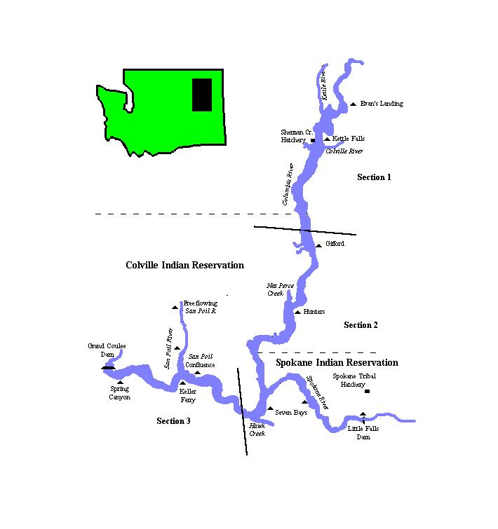

Figure 1. Map of Lake Roosevelt. Section 1 outlines the riverine area, Section 2 outlines the transition area and Section 3 indicates the lacustrine area.

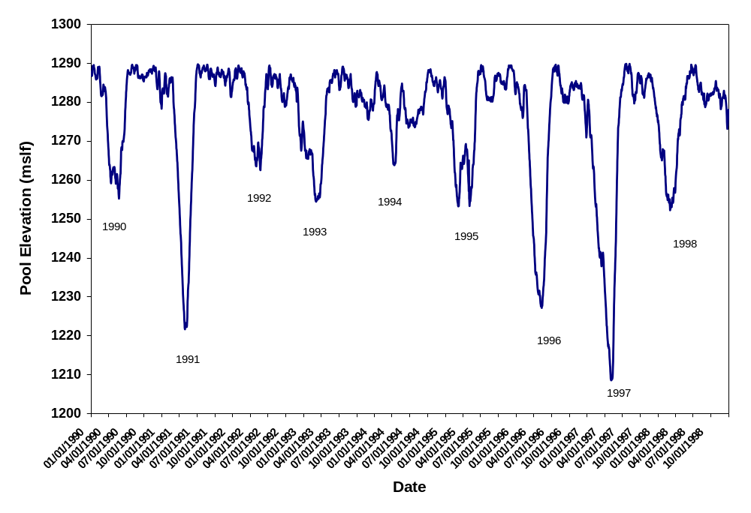

Figure 2. Mean daily Lake Surface elevation from 1990 through 1998.

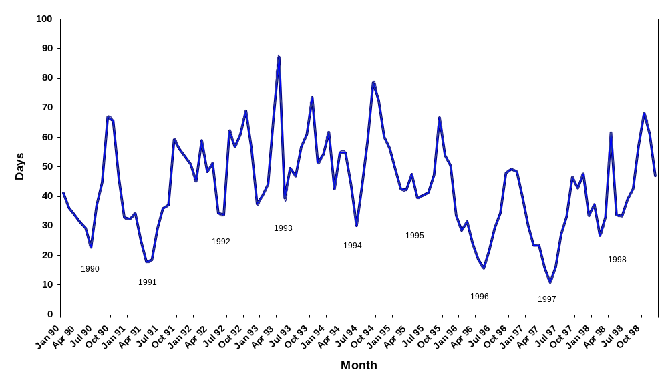
Figure 3. Mean monthly water retention time in Lake Roosevelt 1990 through 1998

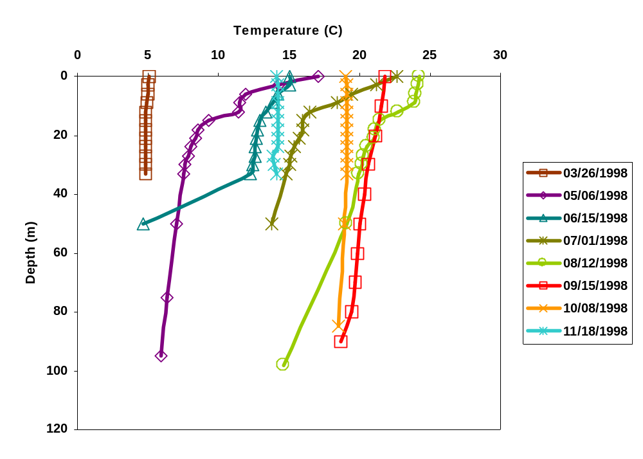
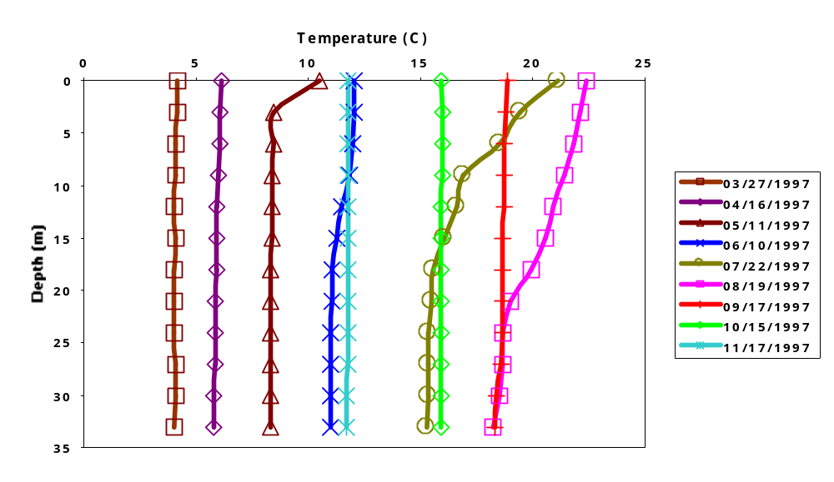
Figure 4. Isotherms of Lake Roosevelt at Spring Canyon (10 miles upstream from Grand Coulee Dam) during 1997 (top) and 1998 (bottom).

Zooplankton Composition in Lake Roosevelt: seasonal dynamics, spatial variation, and potential regulatory factors.

The Lake Roosevelt reservoir of the Columbia River (WA) possesses a rich assemblage of crustacean zooplankton that shows strong spatial and seasonal variation. The numerically important and planktonic species are presented in Table 1. Littoral taxa (i.e. Chydorus) are observed within plankton samples during periods of high flow, though they are of little significance. Of the species occurring in Table 1, most noteworthy are the large bodied lacustrine species. The inclusion of the large bodied herbivores Daphnia schodleri and Leptodiaptomus ashlandi, and the invertebrate predators Epischura nevadensis and Leptodora kindti, in the plankton community suggests Lake Roosevelt can support typical large-bodied limnetic species for at least part of the year. Additionally, the observation suggests visual, vertebrate planktivores are not an important regulatory factor shaping the constituency of the zooplankton community (Brooks and Dodson 1965, Zaret 1980).

Seasonal Compositional Dynamics: Daphnia schodleri and Leptodiaptomus ashlandi represent the majority of the biomass present during the late autumn and winter. Concomitant with draw-down, and the dramatic changes in water residence times (reduced), turbidity (increased), and turbulence (increased), densities of these large lacustrine species drop to undetectable levels. The plankton are instead composed of riverine-tolerant cyclopoid copepods and the small bodied Bosmina longirostris. Juvenile calanoids are also present. All are typical of turbid and turbulent moving waters (Hynes 1970, Pace et al 1992, Thorp et al. 1993), and they persist as the dominant planktivores in Lake Roosevelt until the reservoir is again close to full pull (figure 1).

With decreased turbidity, and increased lake elevation and water residence time, there begins a very regular transition back to the lacustrine-like community of late autumn. First, Cyclopoid densities drop as Daphnia retrocurva and the predatory copepod Epischura nevadensis become numerically important. This first shift occurs in June and early July. Daphnia retrocurva is then replaced by D. galeata and D. schodleri during July. Daphnia galeata is numerically dominant at this time. Shortly after the reservoir has been at full pool, the zooplankton community shifts again. Densities of Epischura drop while Leptodiaptomus ashlandi becomes more abundant. Daphnia schodleri increase. Daphnia galeata becomes less abundant but typically does not disappear to undetectable levels (see figures 2, 3, and 4 to see the Daphnia transition). Leptodora kindti replaces Epischura as the numerically dominant planktivore. This late summer constituency, with Daphnia schodleri and Diaptomus ashlandi together representing 90% or more of zooplankton density and biomass, continues into winter (figure 1).

Spatial and temporal patterns of abundance and biomass: Zooplankton biomass and abundance is low during the late winter and spring draw-down. Biomass and abundance increase through early summer and maximum levels are observed typically in late July or early August (figures 5 & 6). Biomass and abundance decline from August through autumn. Comparing up-river locations to more lacustrine downstream locations (figures 5 & 6: Gifford Ferry represents an upstream location, Seven-Bays and Keller represent downstream locations), biomass and density are higher downstream. Although studies investigating variation in vertical distribution were conducted during the summers of 1998 and 1999, there is no evidence to suggest density varies with depth within the top 30 meters of the reservoir. Additionally, there is no evidence of a diel pattern in vertical distribution.

Planktonic Secondary Productivity and Potential Regulatory Factors: Observational studies of zooplankton composition, biomass, and abundance in advective reservoirs and large rivers, conducted using classic limnological techniques, have revealed few regulatory factors (Geddes 1984, Sheil 1985, Dumont 1986, Bothar 1987, Saunders and Lewis 1989, De Ruyter Van Steveninick et al. 1990). During the 1998 through 2000 field seasons, pelagic enclosures have been used to measure planktonic secondary productivity in an effort to help identify regulatory factors. Large mesh enclosures have aided plankton ecologists in riverine systems elsewhere (Thorp et al. 1996). On Lake Roosevelt, replicated 10,0000 liter enclosures have been used to make 96 hour estimates of zooplankton productivity every week, without the complication that advection introduces to measures of traditional productivity (biomass change) and population growth (r).

The enclosure study suggests up-river productivity is often negative or near zero, while downstream, in the more lacustrine portion of the reservoir, productivity can exceed 10 ug l⁻¹ over 96 hours (figure 7). Estimates of Daphnia population growth show populations experience dramatic shifts in growth rate throughout the spring summer and fall. Positive growth tends to occur during July and August, and low, negative growth rates can occur during late summer and autumn (figures 8 & 9).

Preliminary multivariate analyses (multiple linear regression, and binary logit regression) of enclosure productivity estimates indicate temperature, chlorophyll density, water residence time, and lake elevation have positive effects on zooplankton productivity and growth rates (Table 2). Multivariate procedures suggest these four factors (or subsets thereof) have positive effects on combined zooplankton productivity, combined zooplankton growth, pooled branchiopod birth rates, and productivity and growth rates of the following species: D. schodleri, D. galeata, D. retrocurva, and L. ashlandi. Additionally, preliminary analyses suggest turbidity has a negative effect on productivity and growth rates of the more lacustrine Daphnia schodleri and Leptodiaptomus ashlandi.

During late August 2000, mesocosm experiments were conducted to further investigate turbidity and chlorophyll effects on the zooplankton. In a community, which was composed primarily of Daphnia schodleri, Daphnia galeata, and Leptodiaptomus ashlandi, increased turbidity levels significantly reduced Daphnia schodleri and D. galeata density and D. schodleri fecundity (figure 10). Leptodiaptomus density was not significantly affected by turbidity. The addition of algae from laboratory cultures significantly increased D. schodleri abundance and fecundity, but had no detectable effect on D. galeata or Leptodiaptomus (figure 11).

Final Remarks: Zooplanktonic composition and abundance in Lake Roosevelt, WA is typical of large regulated river systems. During periods of high flow, turbidity, and turbulence, the zooplankton densities are low and constituents are typically small bodied and consist of those species tolerant of turbulent and turbid environments (Dirnberger and Threlkeld 1983, Geddes 1984, Sheil 1985, Dumont 1986, Bothar 1987, Saunders and Lewis 1989, De Ruyter Van Steveninick et al. 1990, Pace et al. 1992, Thorp et al. 1993). Population regulation and productivity are controlled by density-independent physical factors. Only when physical conditions edge closer to those of a lacustrine system (reduced turbidity, turbulence, and increased residence time in July in Lk. Roosevelt) does a limnetic community of large bodied species have the opportunity to develop (Hynes 1970, Ryder and Pesendorfer 1989). It is during this phase of the rivers annual cycle that there is the opportunity for density-dependent population regulation and the species interactions we more typically associate with lacustrine systems to control zooplankton productivity and composition. There exists some evidence suggesting food limitation in lake Roosevelt during late summer (figure 11). Additionally in September and October, D. schodleri abundance during 96 hour productivity trials tends to increase in the enclosures while densities remain low in the lake. Concomitant with existing stomach analysis and vertebrate planktivore feeding trials (figure 12), this observation suggests fishes may be an important late summer fate of D. schodleri production.

Literature Cited

Bothar, A. 1987. The estimation of production and mortality of Bosmina longirostris (O.F. Muller) in the River Danube (Danubialia Hungarica, CIX). Hydrobiologia 145:285-291.
Brooks, J.L., and S.I. Dodson. 1965. Predation, body size, and composition of plankton. Science 150:28-35.
De Ruyter Van Steveninick, E. D., B. Van Zanten, and W. Admiraal. 1990. Phases in the development of riverine plankton: examples from the Rivers Rhine and Meuse. Hydrobiol. Bull. 24:47-55.
Dirnberger, J.M. and S.T. Threlkeld. 1983. Advective effects of a reservoir flood on zooplankton abundance and dispersion. Freshwater Biology 16:387-396.
Dumont, H.J. 1986. Zooplankton of the Nile system. In, B.R. Davies and K.F. Walker (eds.), The Ecology of River Systems. Dr. W. Junk Publishers, Dordrecht, the Netherlands.
Geddes, M.C., 1984. Seasonal studies on the zooplankton community of Lake Alexandrina, River Murray, South Australia, and the role of turbidity in determining zooplankton community structure. Aust. J. Mar. Freshw. Res. 35:417-426.
Hynes, H. N. N. 1970. The ecology of running waters. University of Toronto Press, Toronto. 555 pp.
Pace, M.L., S.E.G. Findlay, and D. Lints. 1992. Zooplankton in advective environments: the Hudson River community and a comparative analysis. Can. J. Fish. Aquat. Sci. 49:1060-1069.
Ryder, R.A., and J. Pesendorfer, 1989. Large rivers are more than flowing lakes. Pages 65-85 in: D.P. Dodge (ed.), Proceedings of the International Large River Symposium (LARS). Can. Spec. Publ. Fish. Aquat. Sci. 106.
Saunders, J.F., and W.M. Lewis. 1989. Zooplankton abundance in the lower Orinico River, Venezuela. Limnol. Oceanogr. 34(2): 397-409.
Shiel, R. J. 1985. Zooplankton of the Darling River system, Australia. Verh. Internat. Verein. Limnol. 22:2136-2140.
Thorp, J.H., A.R. Black. K.H. Haag, and J.D. Wehr. 1993. Zooplankton assemblages in the Ohio River: Seasonal, Tributary, and Navigational Dam Effects. Can. J. Fish. Aquat. Sci. 51:1634-1643.
Thorp, J.H., A.R. Black, J.D. Jack, and A.F. Casper. 1996. Pelagic enclosures: modification and use for experimental study of riverine plankton. Arch Hydro. Suppl. 113:583-589.
Zaret, T.M., 1980. Predation and Freshwater Communities. Yale University Press, New Haven.
Table 1. Numerically important planktonic crustaceans encountered in samples collected from the Lake Roosevelt reservoir of the Columbia River, WA, 1997 - 2000.

Branchiopoda | Copepoda
Daphnia schodleri | Calanoida
Daphnia galeata mendotae | Leptodiaptomus ashlandi
Daphnia retrocurva | Epishura nevadensis
Ceriodaphnia quadrangula | Cyclopoida
Bosmina longirostris | Diacyclops thomasi
Diaphanosoma brachyurum | Mesocyclops edax
Leptodora kindti

Table 2. Factors potentially regulating zooplankton productivity in Lake Roosevelt, WA identified using correlation, multiple linear regression, and log regressions. P-values for all factors included are < 0.05. Sign (+/-) indicates the factor's effect on productivity.

Measure | Environmental Factor
Combined Zooplankton  Productivity  Biomass | Temp. (+)  Residence Time (+)  Chlorophyll (+)  Lake Elev. (+)
Pooled Zooplankton  Growth Rates | Chlorophyll (+)  Lake Elev. (+)  Temp. (+)
Pooled Branchiopod  Birth Rates | Chlorophyll (+)  Residence Time (+)
Daphnia schodleri  Productivity & Popln. Growth (r) | Turbidity (-)  Residence Time (+)  Elevation (+)  Temperature (+)  Chlorophyll (+)
Daphnia galeata  Productivity & Popln. Growth (r) | Temperature (+)  Residence Time (+)
Daphnia retrocurva  Productivity & Popln. Growth (r) | Elevation (+)  Chlorophyll (+)  Turbidity (+)
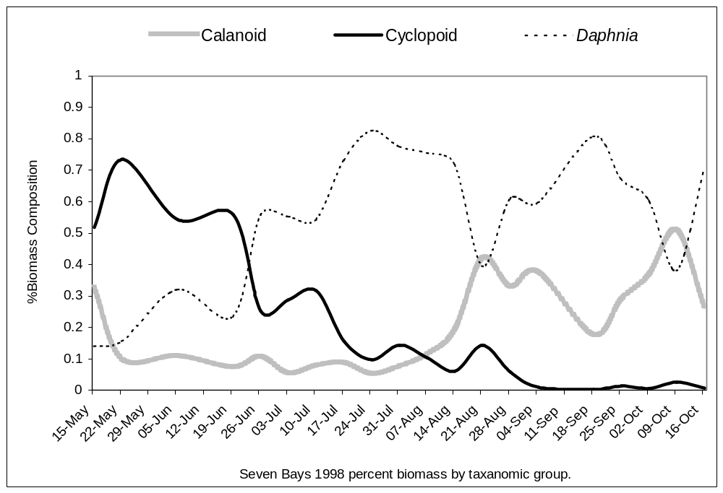
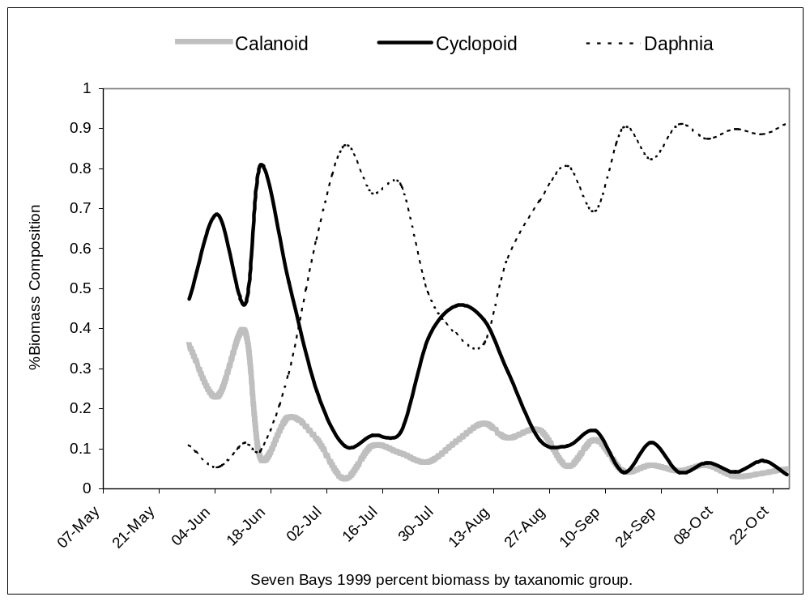
Figure 1. Seasonal composition of Lake Roosevelt zooplankton as percent of biomass at Seven Bay during 1998 and 1999.

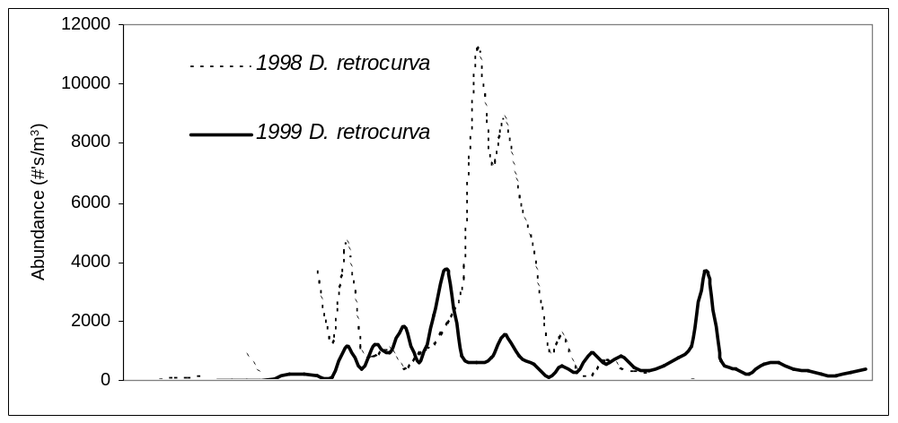
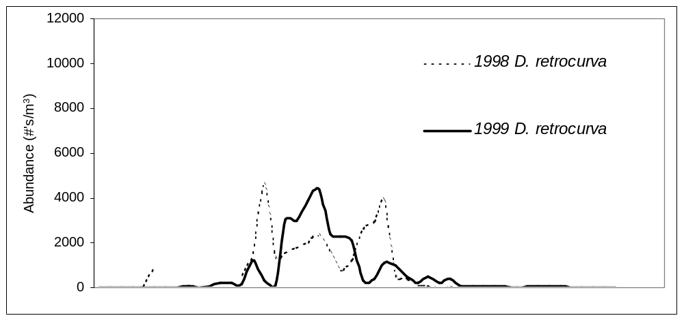
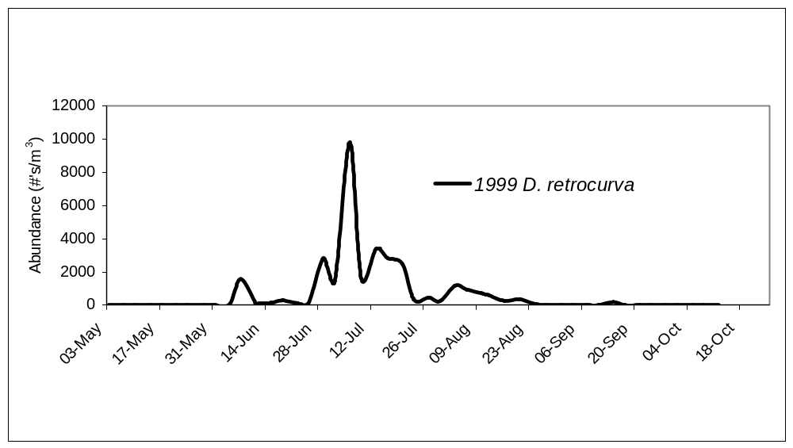
Figure 2. A comparison of D. retrocurva abundance at Seven Bays (top), Keller Ferry (middle) and Spring Canyon (bottom) during the 1998 and 1999 study period.

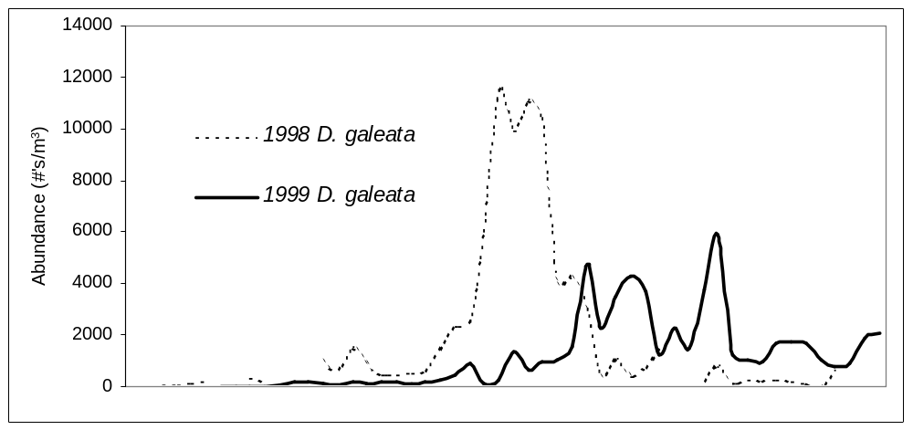
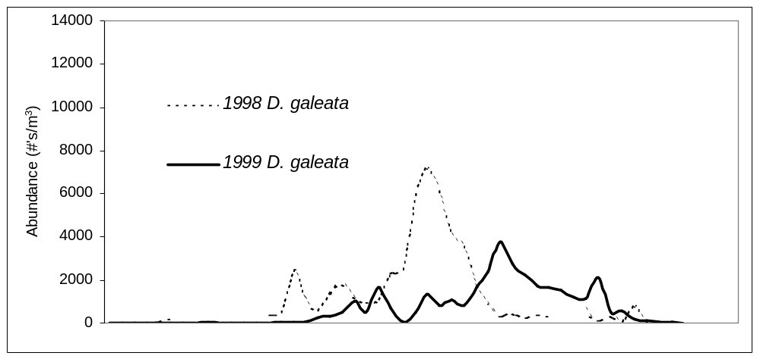
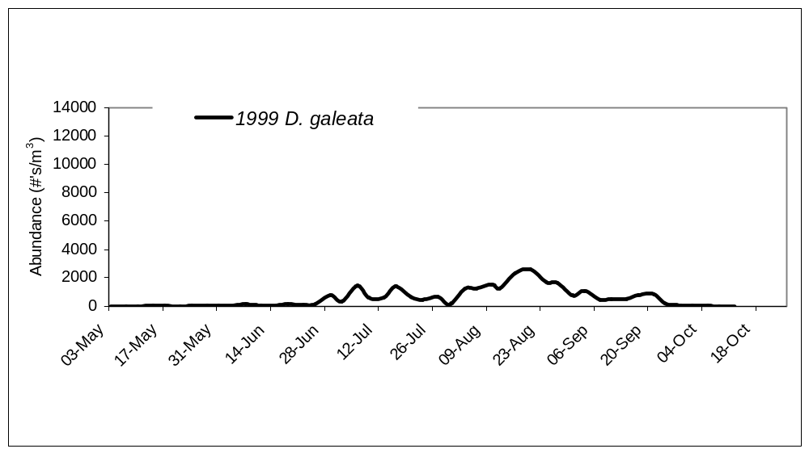
Figure 3. A comparison of D. geleata abundance at Seven Bays (top), Keller Ferry (middle) and Spring Canyon (bottom) during the 1998 and 1999 study period.
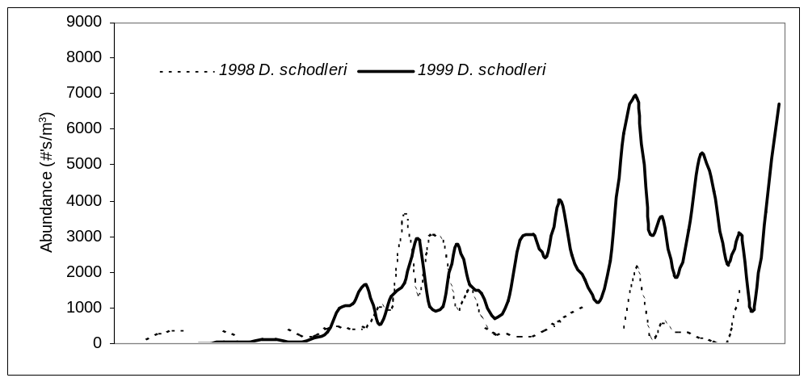
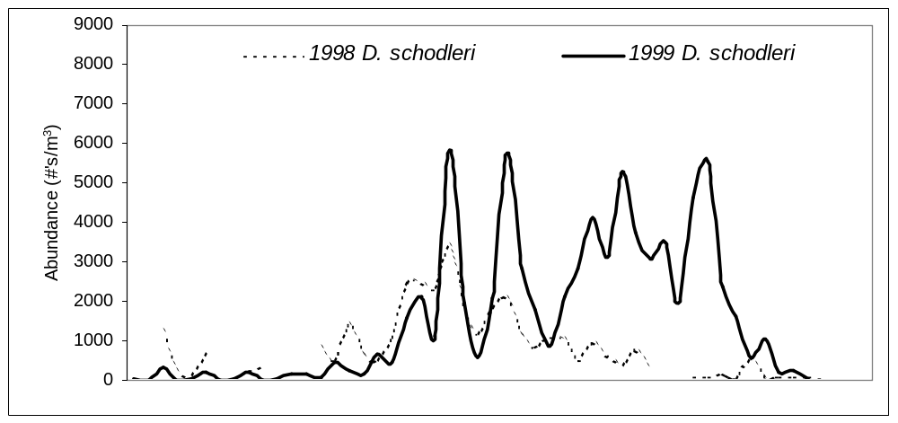
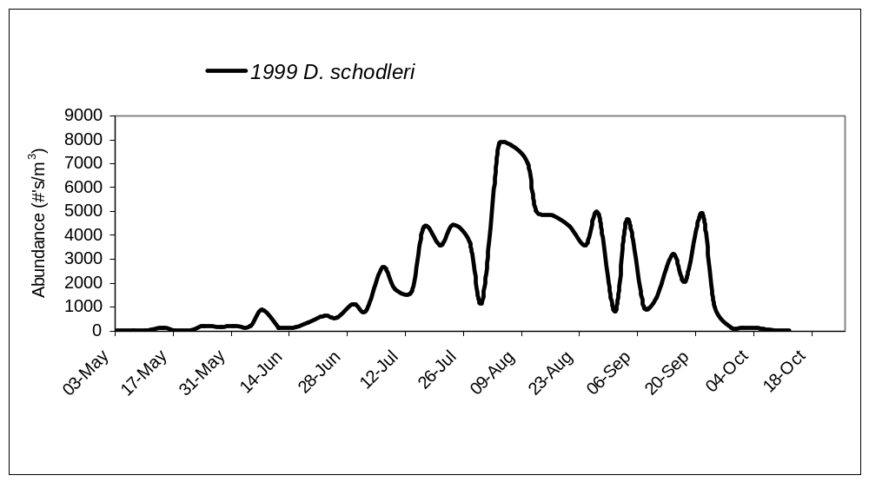
Figure 4. A comparison of D. schodleri abundance at Seven Bays (top), Keller Ferry (middle) and Spring Canyon (bottom) during the 1998 and 1999 study period.
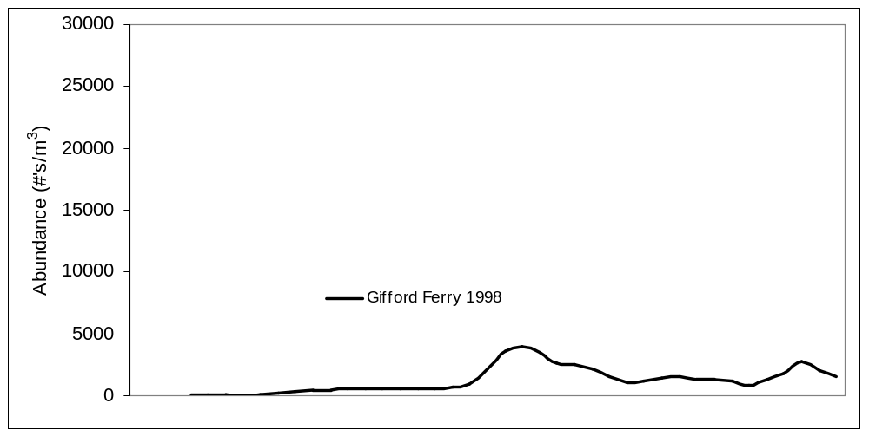
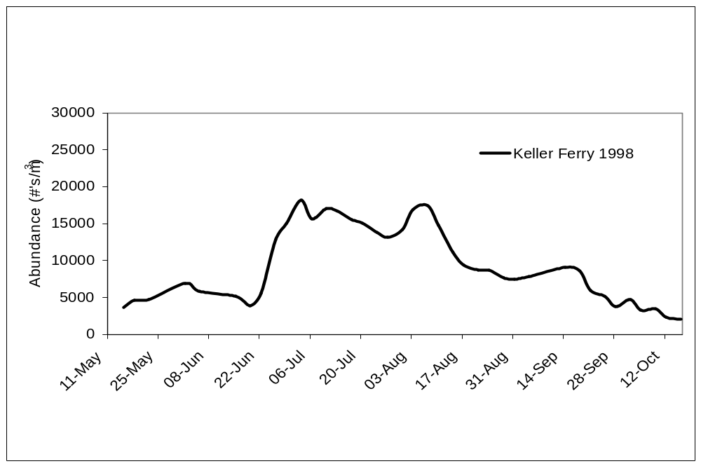
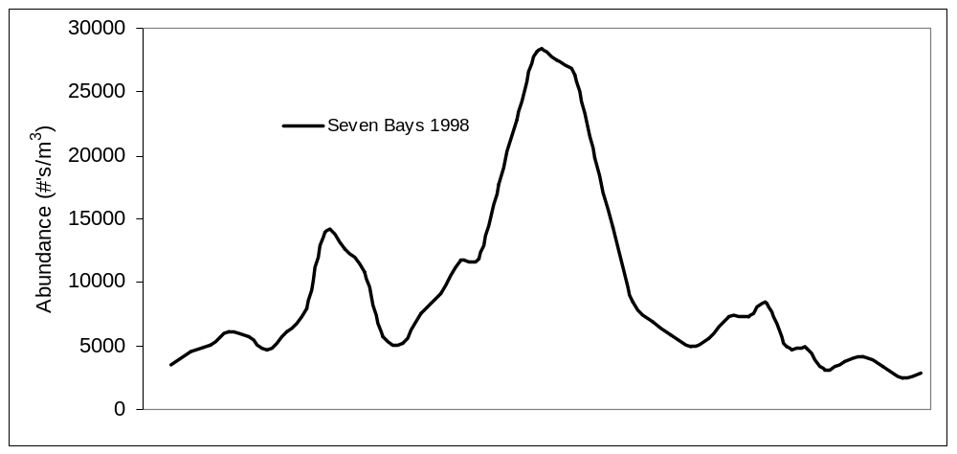
Figure 6. A comparison of reservoir zooplankton abundance by three-day average from Gifford Ferry (top) Seven Bays (middle) and Keller Ferry (bottom) during 1998.
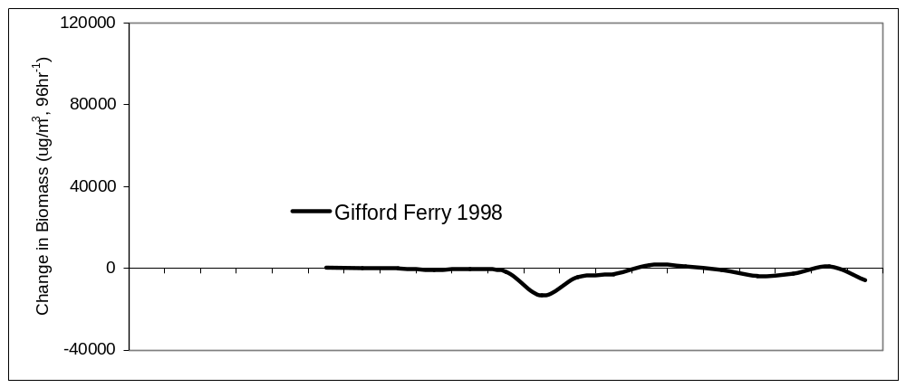
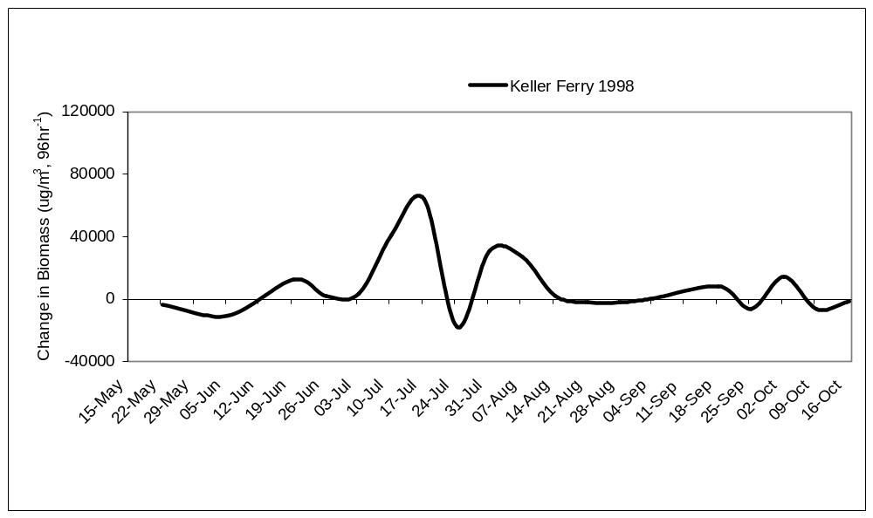
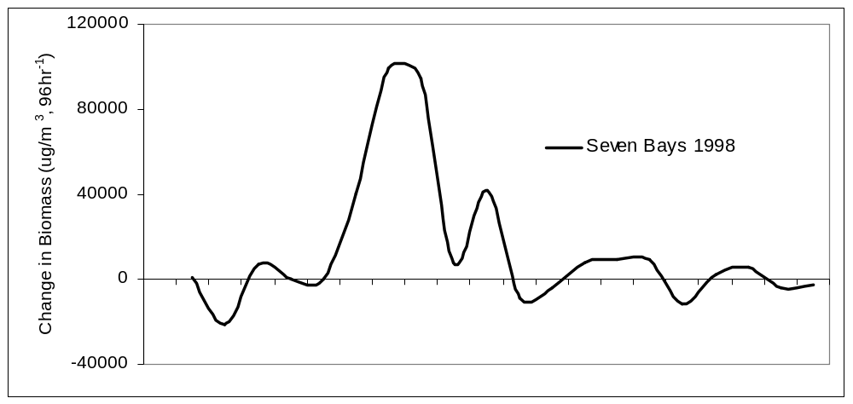
Figure 7. A comparison of enclosure zooplankton change in biomass from Gifford Ferry (top) Seven Bays (middle) and Keller Ferry (bottom) during 1998 study period.
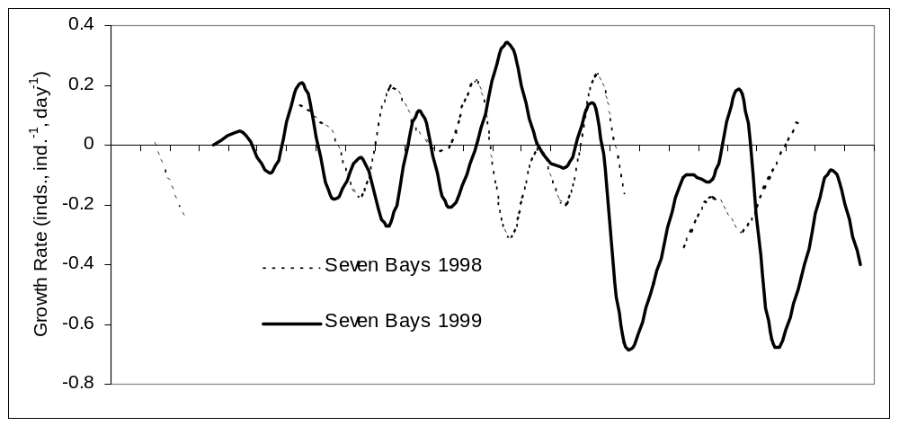
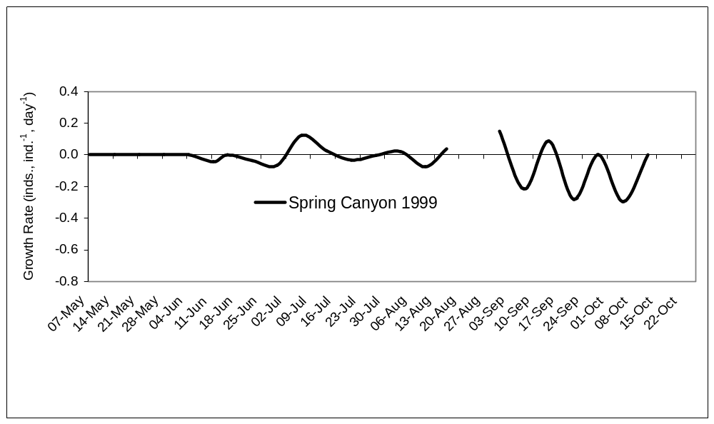
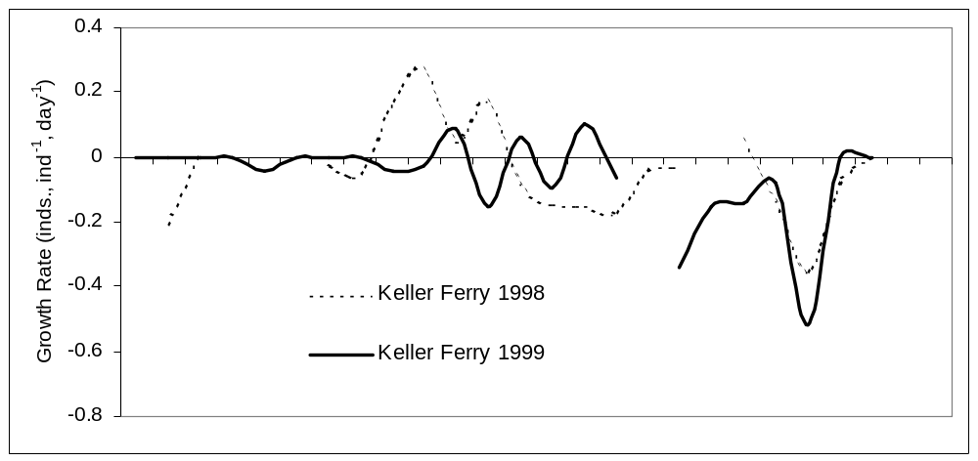
Figure 8. A comparison of D. Galeata enclosure growth rate at Seven Bays (top) Keller Ferrry (middle) and Spring Canyon (bottom) during 1998 and 1999 study periods.
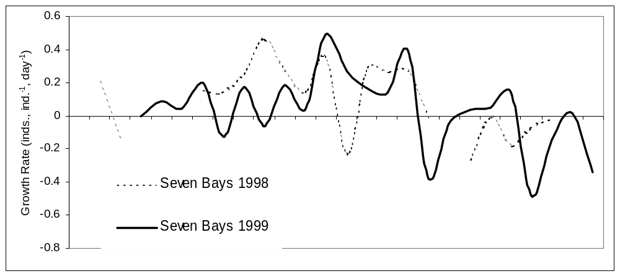
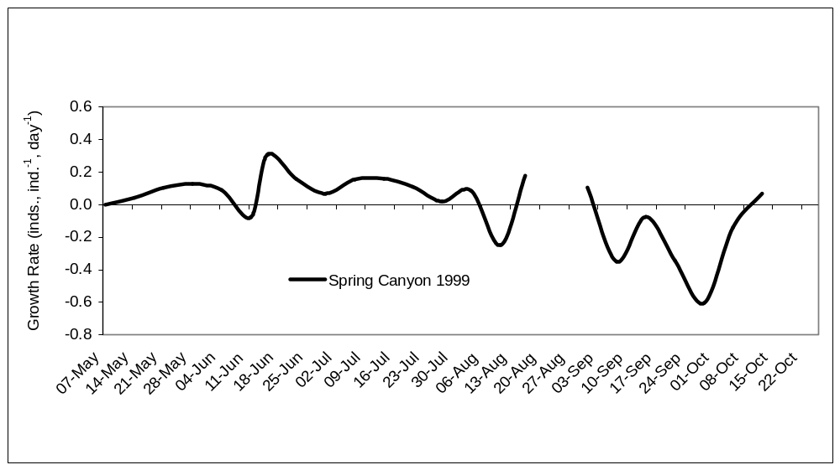
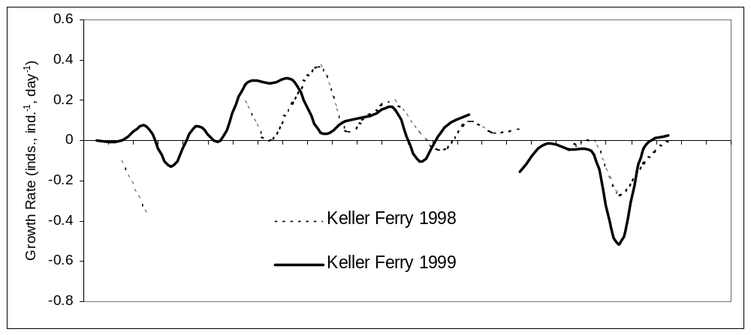
Figure 9. A comparison of D. Galeata enclosure growth rate at Seven Bays (top) Keller Ferry (middle) and Spring Canyon (bottom) during 1998 and 1999 study periods.

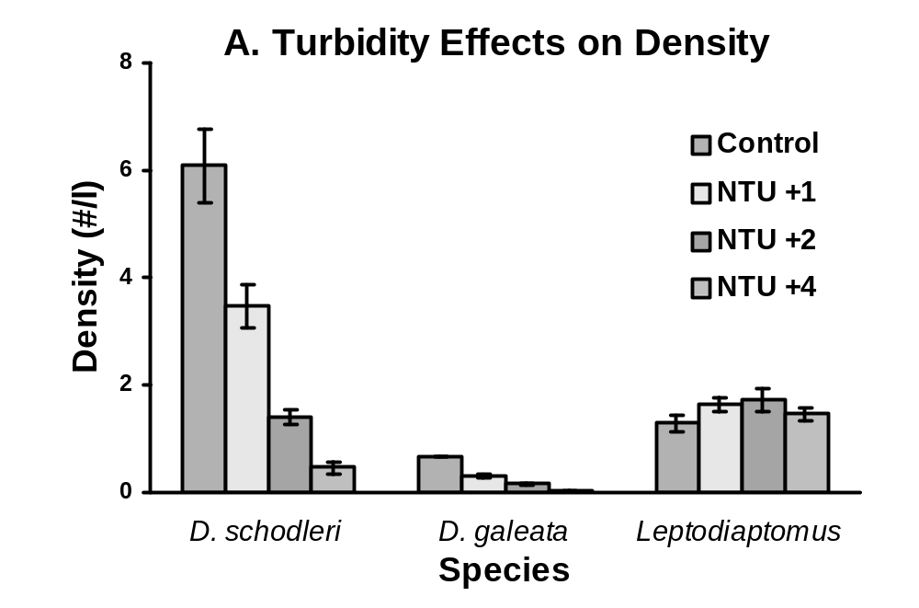
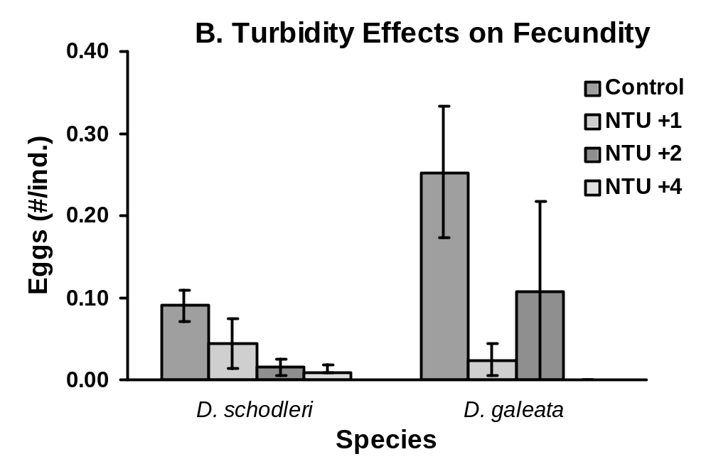

Figure 10. Turbidity effects on zooplankton density (A) and brachiopod fecundity (B). Treatments include the addition of bentonite clay to increase turbidity 1, 2, and 4 NTU’s over ambient turbidity. Experiments were conducted in 20-liter mesocosms (7 replicates per treatment), and run for 96 hours. The negative turbidity effects on D. schodleri and D. galeata abundance, and D. schodleri fecundity, are significant (P<0.01).
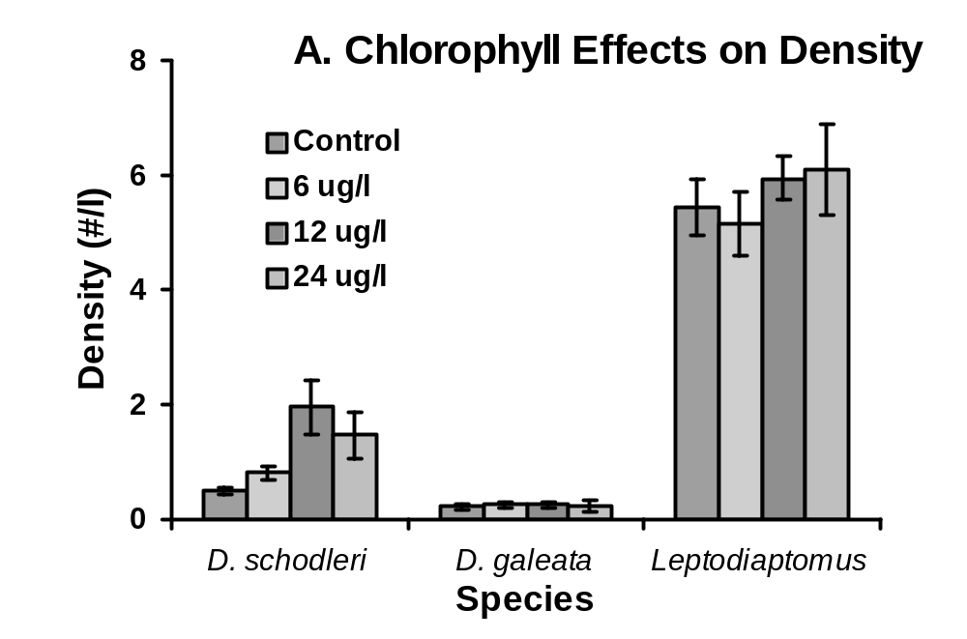
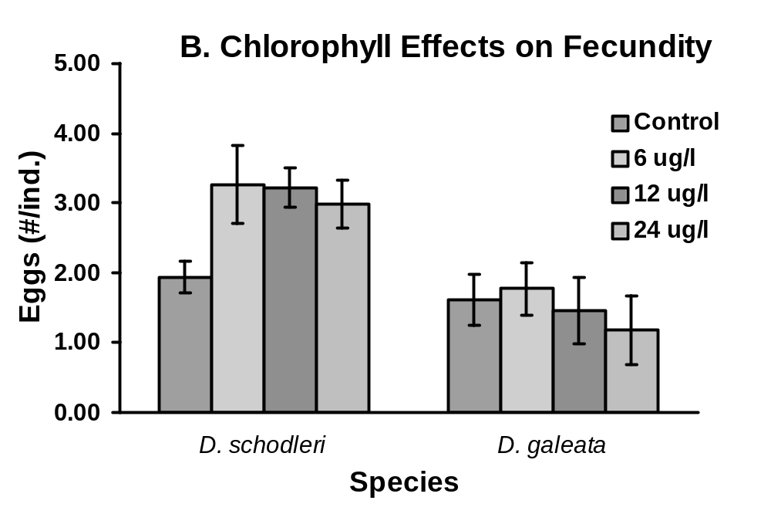

Figure 11. The effects of algal supplementation on zooplankton density (A and Fecundity (B). Treatments included the addition of a 50:50 suspension of Selenastrum and Scenedesmus to increase chlorophyll readings 6, 12, and 24 ug Chl per liter above the ambient concentrations. Experiments were conducted in 20-liter mesocosms (7 replicates per treatment), and run for 96 hours. The positive supplementation effects on D. schodleri abundance and fecundity are significant (P<0.05).

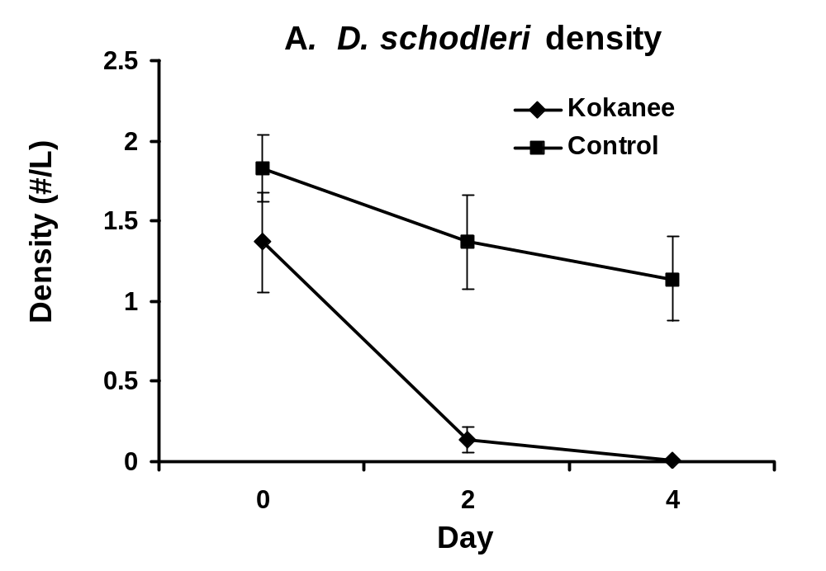
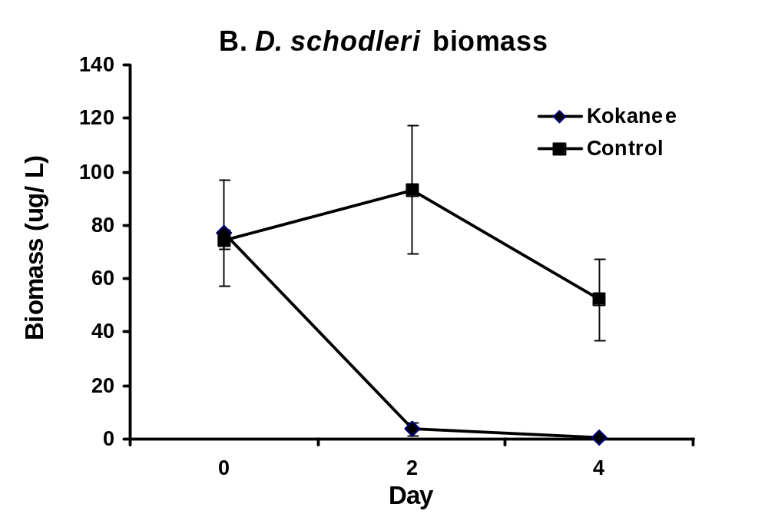
Figure 12. Planktivorous fish effects on daphnia schodleri density (A) and biomass (B). Experiments were conducted in 10,000-litter mesh enclosures filled with ambient zooplankton constituents and densities. Three 95-110 cm (total length kokanee (Onchorhynchus nerka) were added to each of four enclosures on day 0. Four fish-free enclosures served as the controls. Enclosures were sampled just prior to fish additions on day 0, day 2 and again on day 4 with a single 5m vertical tow using a 20 cm dia, plankton net.

Littoral Habitats of Lake Roosevelt

Reservoirs represent a continuum of ecological conditions. Limnologists view this continuum as one defined primarily by water retention time, and have developed a conceptual model to classify the expected longitudinal gradient in reservoir characteristics (Kimmel and Groeger 1984). The model identifies three main reservoir zones: riverine, transitional and lacusterine. Our experience in Lake Roosevelt suggests this conceptual model may accurately represent conditions in the lake, as it has been subdivided into three sections by previous researchers (Underwood et. al. 1996). These sections appear to correspond to the three ecotypes described by Kimmel and Groeger (1984).

The study sites being utilized by this project in 1998 and 1999 are listed in the following tables, which contain specific transect information. These study sites are separated by ecotype with transects set by predominate substrate type. Table 2. lists the percent of substrate type by site transect with Table 3. listing the % of substrate by type within each zone. These figures only represent specific transects and are not to be used as total substrate percents within a zone.

The effect that hydro operations will have on the availability of habitat will vary from year to year, and is dependent on drawdown depth and refill timing. The availability of certain types of substrate is dependent on the refill curve and maintenance of reservoir level. The availability of mud / silt and sand habitat is important to juvenile and young of the year fish due to the presence of macrophyte which provide cover from predators for these same fish. These mud / silt and sand habitats are usually located in embayments which are also critical to the production of phytoplankton and zooplankton for the entire reservoir. The majority of these areas are dry or non-productive when the reservoir is maintained below 1278 MSL and when a refill occurs late in the year. Spring spawning fish species are forced to spawn in poor, steep habitat with little macrophyte production for cover. Young of the year fish are targeted by predators earlier and at a smaller size since they have no place to hide. Production will not be successful and the survivors become targets by other predator fish species as their normal prey base collapses. The trophic levels can begin to collapse.

Kimmel, B.C. and A.W. Groeger. 1984.Lake and Reservoir Management. EPA 44/5-84-001.

Underwood, K., J. Shields and M. B. Tilson. 1996. Lake Roosevelt Fisheries and Limnological Research. Annual Report 1994. Prepared by Department of Natural Resources, Spokane Tribe of Indians for Bonneville Power Administration, Portland, Oregon. 358 pp

Table 1. Slope, substrate type (SD=sand, CG=cobble, GR=gravel and MS= mud/sand) and percent macrophyte cover by ecotype and geomorphic type.

Ecotype | Geomorphic Type | Estimated Slope | Substrate Code | Macrophyte % of Area
Riverine | Embayment | <2% | SD | 10%
Riverine | Steep Bank | >10% | CG | <1%
Riverine | Shoal | <1% | GR | <1%
Riverine | Shoal | <1% | SD | 40%
Riverine | Shoal | <1% | MS | 80%
Riverine | Embayment | <1% | MS | 60%
Riverine | Steep Bank | >20% | CB | <1%
Riverine | Embayment | <3% | MS | 40%
Riverine | Creek | <2% | MS | 30%
Riverine | Embayment | <5% | SD/CB | <1%
Transitional | Embayment | >4% | MS | <5%
Transitional | Embayment | <4% | MS | 10%
Transitional | Steep Bank | >10% | CB | <1%
Lacustrine | Embayment | <2% | SD | <1%
Lacustrine | Embayment | <3% | MS | 30%
Lacustrine | Shoal | <2% | GR | <1%
Lacustrine | Shoal | <2% | SD | <1%
Lacustrine | Steep Bank | >13% | CB | <5%

Table 2. Substrate Length and Transect % of Site

ZONE | SITE | TRANSECT | SUBSTRATE | LENGTH | % OF SITE
Riverine | PB | T-1 | SD | 1666 ft. | 45.4
Riverine | PB | T-2 | CB-GR | 2000 ft. | 54.6
Riverine | BC | T-1 | GR | 500 ft. | 7.5
Riverine | BC | T-2 | SD | 3000 ft. | 44.8
Riverine | BC | T-3 | MS | 3200 ft. | 47.7
Riverine | CR | T-1 | MS | 1887 ft. | 43.0
Riverine | CR | T-2 | CB | 381 ft. | 8.7
Riverine | CR | T-3 | MS | 620 ft. | 14.1
Riverine | CR | T-4 | MS | 500 ft. | 11.4
Riverine | CR | T-5 | SD | 1000 ft. | 22.8
Transitional | HN | T-1 | MS | 4000 ft. | 72.7
Transitional | HN | T-2 | MS | 1500 ft. | 27.3
Transitional | GF | T-1 | CB | 3500 ft. | 100.0
Lacustrine | KF | T-1 | MS | 1600 ft. | 33.3
Lacustrine | KF | T-2 | GR | 950 ft. | 19.8
Lacustrine | KF | T-3 | SD | 2250 ft. | 46.9
Lacustrine | SP | T-1 | CB | 3500 ft. | 100.0
Lacustrine | SW | T-1 | SD | 3200 ft. | 100.0

Table 3. Percent composition of substrate in three ecotypes.

Type | Riverine | Transitional | Lacustrine
Mud/Sand | 42.1 | 61.1 | 13.9
Sand | 38.4 | 0 | 47.4
Gravel | 3.4 | 0 | 8.3
Cobble/Gravel | 13.6 | 0 | 0
Cobble | 2.5 | 38.9 | 30.4
Total | 100.0 | 100.0 | 100.0

Macroinvertebrates

The species composition and density of macro invertebrates collected by ponar dredge in 1988 and by collection jugs/substrate in 1999 is shown on the following table. The 1999 samples were collected throughout the season and are more representative of the total area since placement was not restricted to substrate size. Samples were collected from all types of substrate in 1999.

The drying out of the littoral zone for extended periods of time (months) and exposure of organisms to freezing and thawing conditions has to have a detrimental effect on macro invertebrates. Many of the most productive areas are ledge habitat in embayments. These areas are subject to the large shifting of substrate materials due to wind action through the winters. Any macro invertebrates in dormant stages are subject to being blown with the sand and sediment to adjacent on-shore areas. This same wind action will remove many of the nutrients that are necessary for production and that are in short supply in the reservoir. Rapid refilling of the reservoir causes sluffing of the banks and shorelines. When the reservoir is below full pool the water residence time is reduced with flows increasing as the level is lowered. There is no settling of nutrients from upstream possible when the reservoir is lowered. The littoral habitat will receive no benefit from snow runoff carried nutrients at lowered reservoir levels

Table 4. Average macroinvertebrate species composition and density by ecotype (organisms per sq. meter)

 | 1998 Ponar |  | 1999 Collectors
 | Riverine | Lacustrine | Riverine | Transitional | Lacustrine
Diptera | 93 | 20 | 718 | 156 | 303
Trichoptera | 28 | 46 | 49 | 45 | 229
Isopoda | 0 | 13 | 0 | 0 | 0
Gastropoda | 0 | 0.1 | 864 | 760 | 271
Osteichthyes | 0 | 0 | 2 | 0 | 0
Bivalvia | 0 | 0 | 5 | 13 | 0
Terrestrial | 0 | 0 | 2 | 10 | 10

.

Lake Roosevelt Kokanee Investigations

Status Overview:
In 1998, approximately 500,000 rainbow trout and 500,000 kokanee were stocked into Lake Roosevelt, and the resulting harvestable return to anglers was approximately 233,036 and 9,980, respectively (Table 1). For rainbow trout this represents an approximate hatchery to angler harvest return rate of 47 percent, and a 2 percent return rate on kokanee salmon (Table 1). The discrepancy between the equivalent number of kokanee salmon and rainbow trout stocked versus the number of each species captured is under investigation. Test fisheries and creel data conducted from 1996 to 2000 indicate that the hatchery origin kokanee salmon planted into the reservoir contribute little (0-12-12%) to the overall kokanee fishery. The numbers and ages of each species stocked is approximately the same, however, the inconsistencies of kokanee salmon in the creel and relative abundance samples, indicate that the number of rainbow trout annually recruited to the creel is approximately 7 to 8 times the number of kokanee observed for the years of record 1990 to 1998 (Table 1 and Figure 2). The kokanee fishery is limited by a combination of entrainment losses, predation, and fish culture related precocity.

It is strongly suspected that piscivory, primarily by walleye, may play a bigger role in annual mortality rates for kokanee salmon than historically recognized. Substantial piscivory, only recently documented at release and return sites, at which hatchery origin fish have been previously been released and imprinted have been recovered from walleye stomachs by gill net and electro-fishing capture methods. These collection efforts have identified walleye as a major predator of hatchery origin kokanee salmon. (Baldwin et al. 1999).

In 1994 Tilson et al. (1994) recommended that fry releases for kokanee salmon be discontinued, and that kokanee salmon be released as yearlings. The recommendation was made based on CWT tag return data indicating increased survival of kokanee salmon released as yearlings relative to those released as fry. Therefore, beginning in 1995, a shift towards yearling production of kokanee salmon was undertaken at both Sherman Creek Hatchery and the Spokane Tribal Hatchery in hopes of increasing angler harvest, and adult returns to egg collection facilities. This stocking strategy has not increased angler harvest, or hatchery returns, and has reduced the number of kokanee salmon being stocked into Lake Roosevelt. This strategy to over-come predation and reservoir entrainment has resulted in increased numbers of precocious individuals in the hatchery population.

Year of Record | 1990 |  | 1991 | 1992 | 1993 | 1994 | 1995 | 1996 | 1997 | 1998
Economic Value Million/Dollars | $5.30 |  | $12.80 | $9.70 | $20.70 | $19.20 | $8.70 | $6.90 | $5.80 | $8.00
Angler Trips | 171,725 |  | 398,408 | 291,380 | 594,508 | 469,998 | 232,202 | 176,769 | 146,264 | 196,775

No. Fish Caught
Kokanee salmon | 17,756 |  | 31,651 | 8,146 | 13,986 | 16,567 | 32,353 | 1,265 | 588 | 10,188
Rainbow trout | 81,560 |  | 81,529 | 167,156 | 402,277 | 499,460 | 125,958 | 76,915 | 5,356 | 233,036
Walleye | 116,473 |  | 231,813 | 163,995 | 337,413 | 123,612 | 73,667 | 142,873 | 147,316 | 133,241

No. Fish Harvested
Kokanee salmon | 17,515 |  | 31,651 | 8,021 | 13,960 | 16,567 | 32,353 | 1,265 | 588 | 9,980
Rainbow trout | 79,683 |  | 73,777 | 140,609 | 398,943 | 499,293 | 122,939 | 76,782 | 5,356 | 226,809
Walleye | 82,284 |  | 168,736 | 118,863 | 307,663 | 53,589 | 40,185 | 104,055 | 87,515 | 119,346
CPUE (per hr)
Kokanee salmon | 0.03 |  | 0.06 | 0.03 | 0.01 | <0.01 | 0.02 | <0.01 | <0.01 | 0.02
Rainbow trout | 0.13 |  | 0.2 | 0.22 | 0.17 | 0.21 | 0.08 | 0.1 | 0.01 | 0.18
Walleye | 0.11 |  | 0.11 | 0.15 | 0.12 | 0.08 | 0.13 | 0.3 | 0.34 | 0.1
HPUE (per hr)
Kokanee salmon | 0.02 |  | 0.06 | 0.03 | 0.01 | <0.01 | 0.02 | <0.01 | <0.01 | 0.02
Rainbow trout | 0.12 |  | 0.2 | 0.18 | 0.16 | 0.21 | 0.08 | 0.1 | 0.01 | 0.18
Walleye | 0.08 |  | 0.08 | 0.11 | 0.08 | 0.05 | 0.06 | 0.16 | 0.17 | 0.09
Mean Length (mm)
Kokanee salmon | 391 |  | 361 | 436 | 486 | 481 | 467 | 438 | 338 | 356
Rainbow trout | 346 |  | 348 | 422 | 471 | 473 | 410 | 363 | 395 | 364
Walleye | 376 |  | 397 | 361 | 382 | 385 | 370 | 372 | 372 | 352

Mean
Mean WRT (Days) | N/A |  | 36.1 | 52.5 | 56.5 | 54.7 | 47.8 | 31.7 | 29.2 | 45.1
Std. Dev. | N/A |  | ± 14.3 | ± 11.3 | ± 14.9 | ± 14.1 | ± 8.7 | ± 12.1 | ± 12.1 | ± 13.7
Lake Elevation
Add 1,200 ft=ft (MSL) | N/A |  | 75.4 | 80.6 | 77.1 | 54.7 | 54.7 | 71.4 | 66.2 | 76.2
Std. Dev. | N/A |  | ± 19.8 | ± 7.4 | ± 10.1 | ± 17.8 | ± 11.2 | ± 19.4 | ± 27.4 | ± 21.7
Mean Reservoir
Outflow (KCFS) | N/A |  | 121.9 | 90.7 | 82.1 | 84.6 | 95.9 | 134.8 | 147.9 | 101.9
Std. Dev. | N/A |  | ± 28.9 | ± 19.3 | ± 20.3 | ± 21.4 | ± 19.5 | ± 30.6 | ± 48.2 | ± 26.1

Table 1. Summary of economics, angler trips, number of fish caught and harvested, catch and harvest per unit of effort and mean lengths of kokanee, rainbow trout., and walleye; annual mean WRT days, annual mean reservoir elevations, and annual reservoir discharges (KCFS), for the years of record 1990-1998.

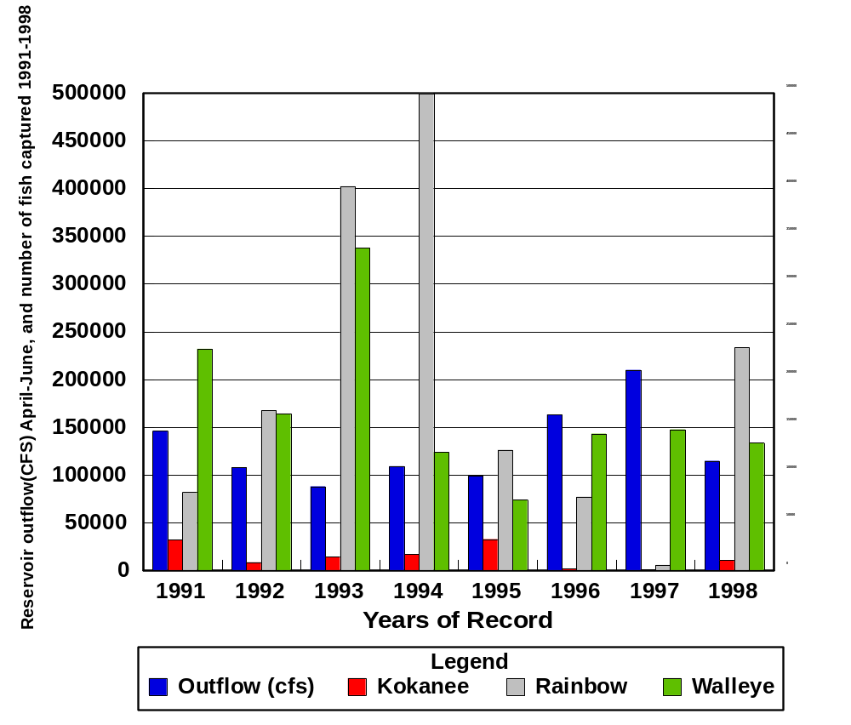

Figure 1. Reservoir discharge for years of record 1991-1998 (avg daily cfs) during peakspring runoff (April-June), as related to annual standing crop of catchable sport fish species.
*Note: Charted catch data assumes that the catchable population of target fish species is related to the standing crop of fish in the reservoir. Chart also assumes that reservoir outflow and corresponding low WRT’s from April-June are responsible for majority of springtime instantaneous fish entrainment from reservoir. High water years (high reservoir outflow/low WRT’s) result in poor angling success.

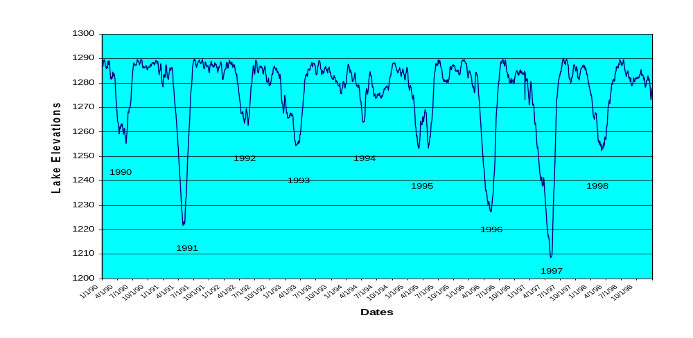
Figure 2. Lake Roosevelt hydrograph 1990-1998 illustrating the magnitude of spring flood control and hydropower releases on reservoir elevations (MSL). The extreme reservoir drawdown years of record 1991, 1996 and 1997 resulted in marginal angling success rates.

Bioenergetics Modeling (Overview):
Fish Bioenergetics 3.0 (Hanson et al. 1997) has been and is currently being used by WDFW to model consumption by planktivores and piscivores in Lake Roosevelt. The model uses a mass balanced energetics based approach that focuses on the physiological processes that regulate growth by individual fish. It is dynamic with ontogeny and provides user input on the most important, dynamic and site-specific parameters including growth, temperature and diet. Model output for specific cohorts within each species is expanded to age structure and (when possible) abundance to quantify trophic interactions. Bioenergetics modeling has proven effective for quantifying the impact of predators on prey populations in many systems for both planktivores and piscivores (Ney 1990; Yule and Luecke 1993; Beauchamp et al. 1995; Hartman and Brandt 1995; Baldwin et al. 2000). Currently, we are using the model to compare the consumptive demand of the stocked salmonids to the available biomass of Daphnia. Likewise, we are modeling seasonal consumption by piscivorus fishes and evaluating annual impacts to stocked salmonids. We have also conducted short term studies following hatchery releases to capture interactions that may be overlooked with seasonal sampling.

Kokanee Population Characteristics:
Seasonal hydroacoustic, gill net, and midwater trawl surveys have proven effective at determining seasonal horizontal and vertical distribution of offshore fishes larger than 200 mm. We have determined that kokanee spend the late summer period in the deepest depths of Lake Roosevelt, presumably to avoid the warm temperatures present throughout the water column from late July to mid September (Figures 3 and 4). We have
not detected a gradient of increasing or decreasing total fish density from lower to middle to upper section transects; however, fish density has been highly variable among transects (Figure 5). Sample size of fish captured in gill nets and trawls was too small to determine definitive differences in relative abundance or CPUE between the three sections of Lake Roosevelt. However, kokanee were captured more consistently in the lower section of the reservoir, particularly in June and October of 1999 when 87% and 81% were captured in the lower section.

The relative abundance of fish captured offshore has been fairly consistent with kokanee (20-47%) and lake whitefish (17-35%) dominating the catch and walleye (8-22%), rainbow trout (4-15 %) and burbot (0-16%) as other consistent contributors (Table 2). Abundance was estimated using mobile hydroacoustics and results were highly variable between seasons. For example, in 1999 abundance of age 1-4 kokanee was estimated to increase from 10,677 (3,224-22,995) fish in June to 79,047 (38,535-134,436) fish in October (Table 2). This was not due to recruitment of hatchery fish because the proportion of adipose clipped fish dropped from 36 % in June to 6% in October. Abundance estimates for other offshore fishes have been estimated; however, these estimates are incomplete due to the propensity of burbot, lake whitefish, rainbow trout and walleye to use benthic and littoral zones.
Entrainment:
In Lake Roosevelt, it is apparent that the entrainment of fish occurs from a significant to catastrophic degree, depending on species and water year. Based on species abundance, it is suspected that entrainment of kokanee greatly exceeds that of rainbow trout. However, due to sampling difficulties, the magnitude of the impact on the fishery has not been precisely quantified regarding species quantification, and total numbers entrained. To date reservoir entrainment has been indirectly estimated from tag returns of rainbow trout by the Spokane Tribal Fisheries, hydro acoustical estimates at the Grand Coulee Dams penstock intakes conducted by the Colville Confederated Tribes, and hydroacoustical pelagic estimates conducted by the Washington Department of Fish and Wildlife.

Entrainment of kokanee is a major limiting factor for hatchery production in Lake Roosevelt. The Chief Joseph Kokanee Enhancement Project counted acoustic fish targets with fixed location transducers in the proximity of the powerhouses of Grand Coulee Dam (GCD) from 1996 to 1999. Estimates of total losses exceeded 1.5 million fish; however, netting efforts were inconclusive so absolute impact to the fishery could not be determined. We conducted 5 mobile hydroacoustic surveys concurrent with the GCD study and compared the results to determine impacts to the fishery. Monthly entrainment totals ranged from 2-16% of the reservoir wide offshore abundance estimate during any one month. When modeled over a year this would result in a 22-88% loss of stocked fish, depending on how unmonitored months were extrapolated and assuming all fish have equal probability of entraining. Because Lake Roosevelt is not a static system we also examined the effects of the previous months entrainment on the monthly offshore abundance estimate. Although we had very few data points (5), there was a strong negative relationship when regressing the abundance of kokanee at time (t) versus the entrainment at time (t-1 month)(Figure 6).

Mortality:
Initial modeling runs of historical data from 1996 and 1997 have shown walleye to be a serious threat as a limiting factor for recruiting salmonids in Lake Roosevelt. Our worst case modeling scenario showed a 73% loss of stocked kokanee; however, the accuracy of this estimate was limited because no direct abundance estimate for walleye was available for 1996. No salmonids were observed in the diet of walleye in 1997 and it became evident that the seasonal sampling interval was not sufficient to determine losses of stocked salmonids. In 1999, we implemented a predation study that characterized the diet of walleye over a 41-day period following the release of kokanee from Sherman Ck. Hatchery. The diet of walleye within several kilometers of the hatchery was primarily kokanee (75-92%) through day 33 and dropped to 53% by day 41. With an abundance estimate generated by EWU we modeled the impact of the local walleye population and predicted losses to be around 20%. The final results of this study are still pending, and will be compiled and reported in conjunction with our 1999 annual modeling and 2000 “expanded” predation study.

Growth:
Growth of kokanee is considered excellent in Lake Roosevelt. Wild kokanee in Lake Roosevelt captured in offshore gill nets are often over 400 mm. Likewise, the average spawner length was 394 mm in Lake Roosevelt (1996-1998; EWU data) and only 255 mm in 11 other lakes and reservoirs around the northwest (see Baldwin et al. 1999 for summary data sources). Low fish densities likely allow for good growth rates in this oligotrophic system.

Figure 3. Vertical distribution of acoustic targets (39.2-33.5 -dB; fish ~ 200-400 mm TL) during various months in 1999 from the lower section of Lake Roosevelt.

Figure 4. Vertical distribution of kokanee from net and trawl sampling in 1999 and mean water temperature profiles from the lower section of Lake Roosevelt.

Table 2. Relative abundance of fish collected from the offshore zone of Lake Roosevelt by gill net and trawl surveys. No trawling was conducted in October of 1998 and August of 1999.

 | June |  |  | August |  |  | October
 |  | Lower | Upper |  | Lower | Upper |  | Lower | Upper
 | (a) | 95 % CI |  | (a) | 95 % CI |  | (a) | 95 % CI
Acoustic targets | 54,098 | 23,030 | 85,167 | 78,273 | 52,355 | 104,192 | 266,783 | 162,786 | 370,779
 | (r) | 80 % CI |  | (r) | 80 % CI |  | (r) | 80 % CI
Burbot | 0.16 | 0.11 | 0.23 | 0.06 | 0.03 | 0.10 | 0.05 | 0.02 | 0.08
Kokanee | 0.20 | 0.14 | 0.27 | 0.44 | 0.36 | 0.53 | 0.30 | 0.24 | 0.36
Lake whitefish | 0.34 | 0.27 | 0.42 | 0.18 | 0.12 | 0.25 | 0.27 | 0.21 | 0.33
Rainbow trout | 0.16 | 0.11 | 0.23 | 0.07 | 0.04 | 0.13 | 0.06 | 0.04 | 0.11
Walleye | 0.12 | 0.07 | 0.18 | 0.22 | 0.13 | 0.30 | 0.20 | 0.15 | 0.27
Other fish | 0.03 |  |  | 0.03 |  |  | 0.12
 |  | Abundance |  |  | Abundance |  |  | Abundance
 | a * r | range (a * r) |  | a * r | range (a * r) |  | a* r | range (a * r)
Burbot | 8,542 | 2,533 | 19,588 | 4,604 | 1,353 | 10,711 | 12,351 | 3,695 | 31,250
Kokanee | 10,677 | 3,224 | 22,995 | 34,532 | 18,738 | 54,990 | 79,047 | 38,535 | 134,436
Lake whitefish | 18,507 | 6,218 | 35,770 | 13,813 | 6,156 | 26,239 | 71,636 | 34,061 | 123,175
Rainbow trout | 8,542 | 2,533 | 19,588 | 5,755 | 1,895 | 13,777 | 17,291 | 5,915 | 39,609
Walleye | 6,406 | 1,612 | 15,330 | 17,266 | 7,033 | 31,263 | 54,345 | 24,607 | 98,357
Other fish | 1,424 |  |  | 2,302 |  |  | 32,113

Figure 5. Hydroacoustic fish target density per transect each month for targets from 45.1-28.8 -dB (~100-700 mm TL). The line represents a linear regression of transect number (i.e. distance upstream) regressed against total fish density. In all cases r² was less than 0.03 and the slope of the line was not significantly different than zero (P > 0.10). The lower section (transects L1-L8) extended from Grand Coulee Dam to Whitestone Rock; the middle section (transects M1-M9) from Lincoln to Hunters and the upper section (Transects U1-U8) from Gifford to Marcus Flats.
Figure 6. Monthly acoustic abundance estimates from reservoir wide mobile surveys and from fixed location surveys (entrainment) on Grand Coulee Dam. The percentage above each column represents the number of fish entrained divided by the reservoir abundance.

Figure 7. Abundance of kokanee 200 mm and larger (t-1) regressed against total estimated entrainment the previous month (t-1). Kokanee abundance estimates are from September 1998, October 1998, June 1999, August 1999 and October 1999.

KOKANEE CODED WIRE TAGGING INVESTIGATIONS
Kokanee salmon coded wire tag (CWT) investigations have been conducted in Lake Roosevelt since 1992 to evaluate hatchery out plantings and provide information to hatchery managers for improving their operations. The stock of fish used for all these releases was from Lake Whatcom. Detailed results of these studies have been reported in a series of annual reports to Bonneville Power Administration (Scholz et al. 1992, 1993; Tilson et al. 1994, 1995, 1996; Tilson and Scholz 1998; Chichosz, Shields and Underwood 1998; and Tilson et al. 1999). Here we provide a summary of our most significant findings.
Three measures have been employed to assess hatchery effectiveness through CWT studies:
- Recoveries of coded wire tagged fish in Lake Roosevelt during electrofishing, gillnetting, trawling and trapping operations conducted by the Spokane Tribe of Indians (STOI), Eastern Washington University (EWU), Colville Confederated Tribes (CCT) and Washington Department of Fish and Wildlife (WDFW). Both STOI and WDFW sample index stations encompass the entire lake. Since 1997 EWU has sampled the mouths of all Lake Roosevelt tributary streams several times during the spawning season (late August to early December) to recover spawning CWT Kokanee. Egg collection sites at Sherman Creek and Little Falls Dam on the Spokane River were sampled once per week. The CCT has maintained traps on the Sanpoil River, Big Sheep Creek and Hall Creek during the kokanee spawning season. Collectively, these surveys provided information about dispersal of hatchery fish from release sites and return to those sites during the spawning migration.

- Recoveries of CWT kokanee by STOI, WDFW and CCT creel clerks, who are conducting a randomized access point creel survey to estimate fishing pressure, as well as catch and harvest-per-unit-effort (CPUE, HPUE) by species. These parameters are expanded to estimate the annual catch and harvest by species. Kokanee observed by creel clerks may be CWT or be unmarked. Total contribution of a particular coded wire tagged group to the harvest is estimated by dividing the number of fish recovered by that tag lot by the total number of kokanee observed by creel clerks, then multiplying the resulting decimal fraction by the expanded harvest estimate. Additional recoveries of CWT kokanee have been made by anglers who have turned in heads of adipose clipped kokanee and by targeted creel surveys conducted by EWU for the purpose of obtaining CWT kokanee from anglers. These raw numbers were added to the data in Table 2 but were not used to estimate harvest of CWT fish in Table 3 since these augmented surveys were not randomized.
- Recoveries of CWT kokanee below Grand Coulee Dam provided information about entrainment. Recoveries of CWT kokanee at the Rock Island Dam Fish Passage Facility were used to estimate entrainment. The number of each lot of CWT kokanee observed at Rock Island Dam was adjusted to account for counting efficiency (5%). The adjusted number was then expanded to estimate the number entrained at Grand Coulee by assuming a mortality rate of 15% as fish passed through each of the four dams between Lake Roosevelt and Rock Island Dam. This value was back calculated based on the adjusted Rock Island account (Table 3). Additional CWT kokanee were reported at Rocky Reach, John Day and McNary Dam, and also from the tailrace of Chief Joseph Dam and in Lake Rufus Woods (the reservoir behind Chief Joseph Dam), in some years. These numbers are incorporated in Table 3 but were not used in back-calculating entrainment (Table 4), as these data were not collected in a consistent fashion.
Initially, the kokanee hatcheries were designed to release fry. However, fry releases did not produce harvest by anglers or adult returns to release sites. CWT fry releases were made from 1992 to 1995 and from 1998 to 1999, totaling 789,904 fish (Table 3). Collectively, these releases produced only 15 fish recovered in Lake Roosevelt during fish surveys, no recoveries in the creel and 58 recoveries below Grand Coulee Dam (Table 3).
Physiological/behavioral studies demonstrated that Lake Whatcom stock kokanee raised at the Spokane Fish Hatchery experienced smolt transformation and exhibited saltwater tolerance, increased gill Na⁺/K⁺ ATPase activity and downstream migratory activity in the spring (Tilson 1994). Although the tendency to migrate downstream was not as pronounced as observed in anadromous salmonids, the water residence times in Lake Roosevelt ranges from about 13 to 30 days at the time when kokanee smolt. Hence, the weak tendency for kokanee to migrate downstream in the spring, coupled with the strong downstream flush of the reservoir at that time, has the potential to displace kokanee downstream of Grand Coulee Dam. We therefore suspected that kokanee fry released in Lake Roosevelt may have undergone smoltification in the reservoir the year following planting, resulting in their displacement below the dam. Support for this conjecture comes from the Fish Passage Facility at Rock Island Dam. Biologists at Rock Island first began observing kokanee, which were distinguished from sockeye because of their large size (>200 mm), the year after the first fry plants were made in Lake Roosevelt (Chuck Peven, Chelan County PUD, personal communication).
Consequently, we thought that the release of residualized smolts might improve harvest, improve returning the release sites and reduce entrainment, and therefore recommended this strategy to the hatchery coordination team (representatives of TOI, WDFW, CCT and BPA). From 1992 to 1999, a total of 1.43 million CWT residualized smolts were released in the reservoir (Table 3). Collectively, these releases produced 5,854 recoveries in Lake Roosevelt (most were 2 or 3 year old fish recovered at planting sites during the spawning migration), 73 recoveries by creel clerks or anglers and 87 fish recovered below Grand Coulee Dam (Table 3). Based upon these results the hatcheries have shifted production from producing predominantly fry to producing predominantly residualized smolts. This is an example of adaptive management (i.e., learning from experience or, in this case, feedback from monitoring and evaluation), which is a cornerstone of the Power Council’s framework for promoting fish recovery and enhancement in the Columbia River Basin.
Because of their relatively larger size in comparison to fry, which places greater demands for space and water flow/oxygen requirements in hatchery raceways, fewer residualized smolts could be held at the hatcheries. One approach to solving this problem was to place yearling fish in net pens and release them after they became residualized smolts. Between 1995 and 1999, a total of 522,285 CWT kokanee were released from net pens at Sherman Creek, Kettle Falls, Colville River (upper net pens sites) and Seven Bays, and Lincoln (lower net pen sites) (Table 3). Collectively, these releases produced 601 recoveries in Lake Roosevelt, 1 fish in the creel and 153 recoveries below Grand Coulee Dam. Recoveries of fish released from net pens are lower in Lake Roosevelt and greater below Grand Coulee Dam than fish released as residualized smolts at Sherman Creek. However, there was a significant difference in the recoveries of fish released from upper reservoir net pens as compared to lower reservoir net pens. In 1998, releases of 154,913 net pen fish from upper reservoir net pens produced 359 recoveries in Lake Roosevelt and 2 below Grand Coulee Dam; whereas 71,876 released from lower reservoir net pens produced 29 recoveries in Lake Roosevelt and 125 from below Grand Coulee Dam. These results were significantly different (x² = 101.2, df = 1). The primary problem with using net pens is that fish are potentially subjected to early release in the event of a large spring drawdown. The fish in the lower reservoir net pens were released early in 1998 for this reason. The fish were smolting when they were released, a factor that may have contributed to their relatively high entrainment.
Although the recovery data from release of residualized smolts is somewhat encouraging, there are still problems with age at recovery. Perusal of Table 3 indicates that the bulk of recoveries occurred at age 2. Of 6,014 total recoveries of fish released as residualized smolts, 5,505 or (91.5%) were recovered as two year old jacks and jills, about 95% precocious males and 5% females), with the remainder captured at age 3 or 4 (about equal numbers of males and females). This is a matter of concern since the kokanee do not enter the sport fishery in Lake Roosevelt until they achieve a total length of about 300 mm. Many 2-year-old fish do attain this length before spawning but they only contribute for a few weeks to one month. In contrast, three-year-old fish are available for harvest for about one year. Several factors may potentially contribute to this pattern of predominance of 2-year-old returns:
- Predation by piscivorus fish such as walleye between age two and three. Evidence includes presence of four CWT kokanee fry found in the guts of walleye collected at Sherman Creek release sites in 1991 (Thatcher et al. 1993), the presence of 14 CWT residualized smolts collected from walleye guts at the Little Falls release site (Tilson et al. 1999) and additional numbers of residualized smolts collected from walleye guts at the Sherman Creek release site in 1999 and 2000 (Casey Baldwin, personal communication), and the presence of a CWT 2-year-old spawner in the gut of a 708 mm walleye collected at Little Falls Dam in 1996. However, during the same time periods analysis of feeding habits of walleye collected from throughout the reservoir indicated that salmonids (kokanee, rainbow, whitefish) constituted a relatively minor portion of the walleye diet. This result led us to postulate that predation occurs during a brief period when kokanee are released, but decreases markedly after kokanee disperse.
- Entrainment below Grand Coulee Dam. In 1998 and 1999, we documented that 1, 2 and 3-year-old kokanee entrained. During the two years a total of 75 three-year-olds were recovered below Grand Coulee. We theorize that this may be related to an annual “smolt event” that takes place in the spring of each year. Lake Whatcom stock kokanee possess a tendency to migrate at this time, which in combination with short water retention time produced by large spring draw downs, may provide conditions that cause entrainment to take place. If so, more three-year-old kokanee would potentially be lost in years when deep drawdowns occur than in years when shallow draw downs occur. This, indeed, seems to be the case. For example, in 1998 when the spring drawdown was relatively shallow (elevation = 1,270 ft), we recovered 167 3-year-old fish in Lake Roosevelt and 18 below Grand Coulee Dam. In 1999, when the drawdown was deep (elevation = 1213.4 ft. MSL), we recovered 25 three-year-old fish in Lake Roosevelt and 35 below Grand Coulee Dam. However, the main point here is that even under the best reservoir conditions, we collect very few 3-year-old fish in Lake Roosevelt. In a normal population, returns of 3-year-old fish should outnumber returns of 2-year-old jacks and jills by a factor greater than ten to one. Returns of Lake Whatcom stock kokanee show the opposite pattern. This genetic stock of kokanee may be poorly adapted to Lake Roosevelt. Therefore, the Hatchery Coordination Team should place a high priority on testing other stocks of kokanee that may be better adapted to Lake Roosevelt.
- Precocity-Pre stocking gonadal examination of kokanee was conducted in the early summer of 2000 and indicated that between 30 to 80 percent of both male (jacks), and female (jills) would sexually mature by September to October of 2000. The examinations were made at the Spokane Tribal Hatchery, and the Sherman Creek State Fish Hatchery and Net Pen production facilities. High egg incubation water temperatures were suspected of having had the greatest effect on the observed “hatchery induced precocity” with fish reared in net-pens having the lowest observed precocity. Although rearing and incubation temperatures appeared to be the greatest catalyst for this magnitude of this event, it is suspected that fish stocks cultured, water quality, rearing densities/stress, and feeding rates also played a role. We suspect that a trade-off was made when converting to the release of older/larger fish to release after springtime reservoir draw down, and to reduce entrainment losses and predation on fry. That tradeoff was a substantially higher precocity rate. We are currently investigating, and considering alternative management actions to achieve a satisfactory kokanee fishery.
Relative contributions of these three factors amount to critical uncertainties in the present time. We are currently evaluating each of these factors. The first factor, predation, is being addressed by WDFW personnel, who are using bioenergetics models to ascertain the impacts of walleye predation on kokanee both throughout the reservoir and during the release period.
The second factor, “Are we using an appropriate genetic stock?” is being addressed by testing a kokanee stock from Kootenai Lake, British Columbia, in a matched-pair release with Lake Whatcom stock fish as a control. The Kootenai Lake stock may be better adapted to Lake Roosevelt since they are from upper Columbia System. The first groups of fish were released in 2000, with a repeat of the experiment planned for 2001. We are testing the null hypothesis that there is no significant difference between the two stocks in terms of numbers returning to the stocking site, numbers recovered in Lake Roosevelt, numbers harvested by anglers in Lake Roosevelt, and numbers recovered below Grand Coulee Dam.
The third factor, precocity, is being addressed by an examination of hatchery practices that may cause the degree of precocity observed in 2000.
Table 4 presents data on hatchery fish harvested by anglers. The first column indicates that estimated total kokanee harvest (hatchery + “wild” fish) by anglers based upon expansion of angler pressure and HPUE statistics compiled by creel clerks. The second column indicates the total number of kokanee observed by creel clerks. The third column indicates the number of fish of hatchery origin as denoted by adipose clips plus coded wire tags. The fourth column indicates the minimum hatchery contribution to the creel. We emphasize that this represents a minimum estimate because it is likely that a substantial number of unmarked kokanee were released from the hatcheries prior to 1998. For example, through 1996 a total of 3.8 million kokanee were released, only 1.4 million of which were adipose clipped or adipose clipped plus coded wire tagged. The first year that all hatchery fish released were given adipose clips or adipose clips plus coded wire tags was 1998. Thus, it is probable that some of the unmarked fish captured in the creel prior to 1998 were of hatchery origin. For the 1998 releases, the only year for which accurate records about hatchery contribution could be obtained, adipose clipped fish accounted for one-third of the fish observed by the creel clerks, with an estimated harvest of 3,323 hatchery fish.
Table 5 provides an estimate of entrainment of kokanee at age 2 and age 3 based on counts of CWT kokanee at Rock Island Dam. We emphasize that this is a minimum estimate because it did not account for kokanee that may have residualized in any of the four reservoir pools between Grand Coulee and Rock Island Dams. We know that this occurs to some extent because three CWT kokanee were recovered in the Wells Dam pool at the tailrace of Chief Joseph Dam, and two CWT kokanee have been recovered from Rufus Woods Reservoir. Additionally, this Rock Island Facility does not monitor fish passage until about April 1 in most years, so kokanee emigrating from Lake Roosevelt prior to that time would not be counted. Substantial winter entrainment of kokanee from Lake Kookanusa has been reported (Skaar et al. 1996) and we have noticed kokanee from Coeur d’Alene Lake emigrating through the Spokane River system from early December through late February. In Lake Roosevelt, kokanee are bunched in the fore bay of Grand Coulee Dam in January, so there is a high potential for winter entrainment. If entrainment occurs at this time, it is unaccounted for. This remains a critical uncertainty that should be addressed in the future, possibly by negotiating with the Rock Island Fish Passage Facility to being counting at an earlier date.
The kokanee CWT investigations have also yielded information about abundance of “wild or emigrant” kokanee in Lake Roosevelt. In EWU electrofishing surveys conducted at the mouths of all Lake Roosevelt tributary streams during the spawning seasons (August – December) from 1997-1999, the following data were obtained:

Recovery Year | Adipose clipped/CWT kokanee¹ | Unclipped kokanee | Total kokanee | Percent hatchery origin
1996 | 1,548 | 40 | 1,588 | 97%
1997 | 1,051 | 37 | 1,088 | 97%
1998 | 3,705 | 155 | 3,860 | 96%
1999 | 981 | 43 | 1,024 | 96%
¹ Includes Ad only, Ad + CWT and CWT only

In 1998, WDFW conducted trawl and gillnet surveys throughout the reservoir and recovered 92 kokanee, of which 87 (95%) were marked with adipose clips, coded wire tags or both. Collectively, these data indicate that the majority of kokanee in Lake Roosevelt are of hatchery origin. However, results of creel surveys and results from a winter test fishery (angling by trawling) in the lower reservoir provides a different picture. In 1998 release year, the only year when hatchery fish could be definitively separated from “wild” kokanee because all hatchery fish were adipose clipped, only 33 percent of the kokanee observed by creel clerks were of hatchery origin. Additionally, results from the test fishery indicate that the majority of the fish were not of hatchery origin. Since 1996, the co-managers of Lake Roosevelt have conducted a test fishery near Grand Coulee Dam. The percentages of hatchery-produced fish have ranged from 0 to 10 percent. It is suspected that substantial recruitment of kokanee is occurring from upstream reservoirs and/or in-reservoir spawning at unknown locations. Regardless, the hatchery production program is not, under current management regimen, living up to program expectations.
The origin of unmarked kokanee in Lake Roosevelt is unknown at this time. Genetic data, based upon electrophoretic patterns of proteins indicated that the fish are genetically distinctive from the Lake Whatcom fish (Leary 1999). The two stocks are also morphologically distinctive. Some of these fish may spawn in Lake Roosevelt tributaries. For example, small numbers of sexually “wild” kokanee are known to enter the Sanpoil River and Hawk Creek during the spawning season. Nearly all of the wild fish we observe are three-year-olds; we rarely observe two-year-olds. Thus, these fish may be particularly suited to Lake Roosevelt and should be investigated as a potential stock source for the Lake Roosevelt kokanee hatcheries. However, since “wild” fish are not recovered routinely at Lake Roosevelt tributary mouths, the contribution of tributary fish probably cannot explain the number of wild fish in the lake. Other possibilities are that some of the “wild” fish are either produced by shoreline spawning in deep water or immigrate into the lake from upriver locations. Deep water shoreline spawning of kokanee has been reported in Flaming Gorge Reservoir, Wyoming-Utah by Gipson and Hubert (1993). Displacement of fish from upriver areas is also known to occur (Skaar et al. 1996).
The origin of the wild kokanee is currently being investigated by collecting biopsy samples (fin punches) from unmarked kokanee from Lake Roosevelt, unmarked individuals entering Lake Roosevelt tributaries (particularly the Sanpoil River and Hawk Creek), as well as several potential upstream sources (Kootenai Lake, Arrow Lake, and Norns Creek in British Columbia), Coeur d’Alene Lake and Pend Oreille Lake in Idaho, and Chain Lakes on the east branch of the Little Spokane River in Washington. Microsatellite DNA from these samples is being amplified by PCR (polymerase chain reaction) techniques and DAN “fingerprints” made. This will enable us to discern the genetic distinctiveness or similarity between these different groups of fish. CCT, STOI, WDFW and EWU personnel are currently collecting samples in the field, which will be analyzed by the WDFW genetics laboratory in Olympia.
Growth rates of a sample of coded wire tagged kokanee collected each fall from 1992 to 1999 is recorded in Table 4. A sample of 2,205 two-year-old kokanee averaged 319 mm in total length and 397 grams in weight. A sample of 132 three-year-old kokanee averaged 426 mm in total length and 1,012 grams in weight.

Summary:

Fish culture practices, stocking strategies, reservoir water management operations, and predation have previously been identified as major factors effecting recruitment of hatchery origin kokanee salmon into the Lake Roosevelt fishery. The previously identified limiting factors are considered to be valid.

However, recent emphasis on planting large numbers of yearling kokanee may have created a new limiting factor. Since 1995 with the implementation of yearling kokanee salmon stocking, the relative proportions of precocious (sexually mature) hatchery origin kokanee salmon in the population have increased. These increases in precocious individuals were first identified in the kokanee culture program in 1997, and the precocious individuals are suspected of contributing little to the fishery. In fact the number of creeled kokanee is substantially lower now with plants of yearling fish than it was previously with fry plants, and this may only be a coincidence (Table 1 and Figure 1).

In 1997 and 1998, approximately 500,000 plus rainbow trout and 500,000 plus kokanee were stocked into Lake Roosevelt, and the resulting harvestable return to anglers was approximately 233,036 and 9,980, rainbow trout and kokanee salmon, respectively. For 1998 rainbow trout creel data this represents an approximate hatchery to angler harvest return rate of 47 percent, and a 2 percent return rate on kokanee salmon. These discrepancies (1995-1998) between the equivalent number of kokanee salmon and rainbow trout stocked versus the number of each species captured should raise a red flag about our current kokanee culture practices, and warrants further investigations, and is a high priority if the kokanee production program can be justified to continue.
Table 3. Summary of coded wire tagged (CWT) kokanee salmon released as fry (F) or residualized smolts (RS) into Lake Roosevelt tributary streams, or directly into the lake from net pens (NP), from 1992-1999. Recoveries of CWT fish in Lake Roosevelt during electrofishing/gillnetting surveys (FS) and creel surveys (CS), and those collected at sites below Grand Coulee Dam (BGC) are also noted. Numbers are actual counts, not expanded estimates. All fish are Lake Whatcom stock kokanee. ND = no data, NA = not available until 2000 field season is complete.

 |  |  | # recovered at age 2 @ |  |  | # recovered at age 3/4 @
Release year | Type of release | # CWT released | LR | CS | BGC | LR | CS | BGC
1992 | F | 256,553 | 4 | 0 | ND | 0 | 0 | ND
 | RS | 15,856 | 17 | 2 | ND | 1 | 1 | ND
1993 | F | 223,169 | 0 | 0 | ND | 0 | 0 | ND
 | RS | 59,494 | 187 | 3 | ND | 149 | 37 | ND
1994 | F | 165,340 | 3 | 0 | ND | 0 | 0 | 0
 | RS | 114,783 | 30 | 0 | ND | 37 | 15 | 2
1995 | F | 51,411 | 0 | 0 | 0 | 0 | 0 | 0
 | RS | 253,676 | 1,175 | 3 | 0 | 4 | 0 | 4
 | NP | 68,715 | 32 | 0 | 0 | 4 | 0 | 7
1996 | RS | 177,496 | 1,070 | 0 | 0 | 11 | 0 | 2
 | NP | 102,107 | 128 | 0 | 8 | 0 | 0 | 0
1997 | RS | 223,958 | 552 | 0 | 0 | 167 | 0 | 18
 | NP | 45,710 | 6 | 0 | 0 | 0 | 0 | 2
1998 | F | 41,685 | 8 | 0 | 58 | 0 | 0 | 4
 | RS | 257,494 | 1,535 | 3 | 22 | 17 | 8 | 35
 | NP | 226,789 | 378 | 0 | 123 | 4 | 1 | 16
1999 | F | 51,746 | 0 | 0 | 0 | NA | NA | NA
 | RS | 327,703 | 902 | 0 | 4 | NA | NA | NA
 | NP | 78,964 | 49 | 0 | 2 | NA | NA | NA
Total | F | 789,904 | 15 | 0 | 58 | 0 | 0 | 4
 | RS | 1,430,460 | 5,468 | 11 | 26 | 386 | 62 | 61
 | NP | 522,285 | 593 | 0 | 133 | 8 | 1 | 20

Table 4. Expanded estimates of hatchery fish caught by anglers. Does not include fish creeled by EWU in augmented creel surveys. NA = data not available.

 |  | Kokanee observed by creel clerks
Year | Kokanee harvest estimate | Total No. | No. with adipose clips/CWT | Minimum hatchery contribution to creel
1993 | 13,786 | 33 | 0 | 0
1994 | 16,567 | 232 | 14 | 1,000
1995 | 32,353 | 467 | 22 | 1,540
1996 | 1,265 | 9 | 0 | 0
1997 | 588 | 8 | 0 | 0
1998 | 9,908 | 36 | 12 | 3,323
1999 | NA | NA | NA | NA

Table 5. Expanded estimate of entrainment of coded wire tagged kokanee stocked in Lake Roosevelt captured below Grand Coulee Dam. Estimates made by correcting the observed value to account for Rock Island Dam counting efficiency (5%), then assuming 15% mortality as fish passed each of four dams above that point. Expanded estimate is for fish exiting Lake Roosevelt over or through Grand Coulee Dam. NC = not checked, NA = data not available until end of 2000 field season, F = fry, RS = residualized smolts, NP = net pen.

 |  | At age 2 |  | At age 3
 |  | Observed at RI | Expanded estimate | Observed at RI | Expanded estimate
1992 | F | NC | NC | NC | NC
 | RS | NC | NC | NC | NC
1993 | F | NC | NC | NC | NC
 | RS | NC | NC | NC | NC
1994 | F | NC | NC | 0 | 0
 | RS | NC | NC | 2 | 69
1995 | F | 0 | 0
 | RS | 0 | 0 | 4 | 140
 | NP | 0 | 0 | 7 | 245
1996 | RS | 0 | 0 | 2 | 69
 | NP | 8 | 284
1997 | RS | 0 | 0 | 18 | 624
 | NP | 0 | 0 | 2 | 69
1998 | F | 58 | 2,029 | 4 | 140
 | RS | 22 | 769 | 35 | 1,225
 | NP | 123 | 4,302 | 16 | 559
1999 | F |  |  | NA | NA
 | RS | 4 | 140 | NA | NA
 | NP | 2 | 69 | NA | NA

Table 6. Growth rates of coded wire tagged kokanee collected in Lake Roosevelt.

 | Age 2 |  |  | Age 3
Recovery year | n = | Mean length (mm) | Mean weight (g) | n = | Mean length (mm) | Mean weight (g)
1992 | 2 | 326 | 347 | 2 | 425 | 1,231
1993 | 66 | 350 | 490 | 2 | 503 | 1,542
1994 | 37 | 337 | 418 | 24 | 454 | 1,181
1995 | 1,163 | 321 | 486 | 46 | 389 | 650
1996 | 453 | 311 | 465 | 3 | 413 | 956
1997 | 257 | 299 | 331 | 9 | 408 | 853
1998 | 227 | 305 | 342 | 39 | 411 | 875
1999 | 125 | 304 | 303 | 7 | 403 | 805
Total means | 2,205 | 319 | 397 | 132 | 426 | 1,012

Bibliography
Baldwin, C. B., D. A. Beauchamp, and J. J. VanTassell. 2000. Bioenergetic assessment of temporal food supply and consumption demand by salmonids in the Strawberry reservoir food web. Transactions of the American Fisheries Society 129:429-450.
Beauchamp, D. A., M. G. LaRiviere, and G. L. Thomas. 1995. Evaluation of competition and predation as limits to juvenile kokanee and sockeye salmon production in Lake Washington. North American Journal of Fisheries Management 15:193-207.
Cichosz, T.A., J.P. Shields and K. Underwood. 1999. Lake Roosevelt Monitoring/Data Collection Program: 1997 Annual Report. Spokane Tribe of Indians, Wellpinit, WA. Final report submitted to United States Department of Energy, Bonneville Power Administration, Portland, OR. Project No. 91-6000-624. 128 pp. + appendices.
Gipson, R.D. and W.A. Hubert. 1993. Spawning-site selection by kokanee along the shoreline of Flaming Gorge Reservoir, Wyoming-Utah. North American Journal of Fisheries Management 13(3):475-482.
Hanson, P. C., T. B. Johnson, D. E. Schindler, and J. F. Kitchell. 1997. Fish Bioenergetics 3.0. Center for Limnology, University of Wisconsin-Madson WISCU-T-97-001.
Hartman, K. J. and S. B. Brandt. 1995. Predatory demand and impact of striped bass, bluefish, and weakfish in Chesapeake Bay: applications of bioenergetics models. Canadian Journal of Fisheries and Aquatic Sciences 52:1667-1687.
Leary, R. 1999. Genetic analysis of kokanee salmon (Oncorhynchus nerka) in Lake Roosevelt, Washington. Genetic analysis report prepared for the Confederated Tribes of the Collville Reservation, Nespelum, Washington.

Ney, J. J. 1990. Trophic economics in fisheries: Assessments of Demand-Supply
relationships between predators and prey. Reviews in Aquatic Sciences 2:55-81.
Scholz, A.T., R.J. White, V.A. Koehler and S.A. Horton. 1992. Measurement of thyroid concentration as an indicator of the critical period for imprinting in kokanee salmon (Oncorhynchus nerka): Implications for operating Lake Roosevelt kokanee hatcheries. Unites States Department of Energy, Bonneville Power Administration, Portland, OR. Report No. DOE/BP-91819-5. 96 pp.
Scholz, A.T., R.J. White, M.B. Tilson and S.A. Horton. 1993. Artificial imprinting of Lake Roosevelt kokanee salmon (Oncorhynchus nerka) with synthetic chemicals: Measurement of thyroxine content as an indicator of the sensitive period for imprinting to olfactory cues. Unites States Department of Energy, Bonneville Power Administration, Portland, OR. Report No. DOE/BP-91819-6. 60 pp.
Skaar, D., J. DeShazer, L. Garrow, T. Ostrovski and B. Thornburg. 1996. Quantification of Libby Reservoir levels needed to maintain or enhance reservoir fisheries: Investigation of fish entrainment through Libby Dam, 1990-1994. Montana Department of Fish, Wildlife and Parks. Final Report 1996. Submitted to Unites States Department of Energy, Bonneville Power Administration, Portland, OR. 110 pp.
Tilson, M.B. 1994. Smolt transformation in kokanee salmon, Oncorhynchus nerka kennerlyi suckley. MS Thesis. Eastern Washington University, Cheney, WA. 150 pp.
Tilson, M.B. and A.T. Scholz. 1998. Artificial imprinting of juvenile kokanee salmon (Oncorhynchus nerka): Implications for operating Lake Roosevelt kokanee hatcheries. Pages 265-331 in T.A. Cichosz, J.P. Shields and K.D. Underwood, Editors. 1998. Lake Roosevelt Fisheries and Limnological Research: 1996 Annual Report. United States Department of Energy, Bonneville Power Administration, Portland, OR. Report No. DOE/BP-32148-2. 331 pp.
Tilson, M.B., A.T. Scholz and J.G. McLellan. 1999. Kokanee salmon (Oncorhynchus nerka) coded wire tagging investigation in Lake Roosevelt, Washington. Report submitted to United States Department of Energy, Bonneville Power Administration, Portland, OR. Project No. 91-6000-624. 74 pp.
Tilson, M.B., A.T. Scholz and J.L. Miller. 1996. Artificial imprinting of juvenile kokanee salmon (Oncorhynchus nerka): Implications for operating Lake Roosevelt kokanee salmon hatcheries. Pages 281-340 in K.D. Underwood and J.P. Shields, Editors. 1996. Lake Roosevelt Fisheries and Limnological Research: 1995 Annual Report. Unites States Department of Energy, Bonneville Power Administration, Portland, OR. Report No. DOE/BP-91819-16. 340 pp.
Tilson, M.B., A.T. Scholz, R.J. White and H. Galloway. 1994. Thyroid-induced chemical imprinting in early life stage and assessment of smoltification in kokanee salmon: Implications for operating Lake Roosevelt kokanee salmon hatcheries. Unites States Department of Energy, Bonneville Power Administration, Portland, OR. Report No. DOE/BP-91819-7. 156 pp.
Tilson, M.B., A.T. Scholz, R.J. White and J.L. Hendrickson. 1995. Artificial imprinting and smoltification in juvenile kokanee salmon: Implications for operating Lake Roosevelt kokanee salmon hatcheries. United States Department of Energy, Bonneville Power Administration, Portland, OR. Report No. DOE/BP-91819-10. 127 pp.
Yule, D. L., and C. Luecke. 1993. Lake trout consumption and recent changes in the fish
assemblage of Flaming Gorge Reservoir. Transactions of the American Fisheries
Society 122:1058-1069.

Rainbow Trout Investigations

Rainbow trout stocked into Lake Roosevelt from net pens contribute substantially to the fishery, and are the most successful of the mitigation hatchery/net pen fish culture programs. The majority of rainbow trout stocked from net pens recruit into the fishery in the same year as being stocked (Peone et al. 1990, Griffith and Scholz 1991, Griffith et al. 1995, Griffith and McDowel 1996, Voeller 1996). Since 1994, rainbow trout have accounted for approximately 63% (range 5-82%) of the estimated total harvest from Lake Roosevelt (Spotts et al. 2000). The annual percentage of rainbow trout harvested that were determined to be of net pen origin has ranged from 91.5% (1995) to 100% (1997). During 1998, rainbow trout accounted for 64 percent of the estimated harvest of all species from Lake Roosevelt and over 98 percent of those harvested were of net pen origin (Spotts et al. 2000).

Estimates of rainbow trout catch and harvest showed an increasing trend from 1991 through 1994, declined steadily through 1997, especially the years 1996 to 1997, and increased during 1998 (Spotts et al. 2000). Based on our creel data, estimated catch of rainbow trout in 1998 was the third highest since 1990, being surpassed only in 1993 and 1994 (See Figure 1) in the Lake Roosevelt Kokanee Investigations sections).

Relative abundance surveys imply that substantial annual harvest of rainbow trout may not be adversely impacting natural origin rainbow trout within Lake Roosevelt. Natural origin rainbow trout have accounted for approximately 50 percent of all rainbow trout observed in our relative abundance surveys since 1994. This is, however, not reflective of our creel survey data. Hatchery origin rainbow trout comprise greater than 90 percent of angler creeled fish. Fisheries surveys indicate that natural origin adfluvial rainbow trout are most commonly associated with inlet streams flowing into Lake Roosevelt, throughout shoreline and pelagic areas of the lake. This association is presumed to be associated with reproductive behavior, tributary macroinvertebrate drift, nutrient inputs, other food sources, and behavioral characteristics associated with more complex riverine/lacustrine interface habitats.

Lengths, weights and condition factors were determined for 139 rainbow trout collected during gillnet and electrofishing surveys in 1998 (Table 1). Condition factors of rainbow trout, which have been observed on Lake Roosevelt and ranged from 1.32 (age 1), to 1.21 (age 4; Table 2). Annual growth increments taken from mean back calculated lengths at each age show a slight decline in growth with increased age, however, it should be noted that a trout with a condition factor of 1.00 is considered to be in good condition (Table 1). Estimated annual growth increments for rainbow trout ranged from 122 mm age 1 to 47 mm age 4 (Table 2).

Rainbow Trout Culture: The Lake Roosevelt Development Association (LRDA) a nonprofit group operates the Net Pen Program for rainbow trout. The LRDA operates approximately 30 net pens at Hunters, Seven Bays, Two Rivers, Keller Ferry, Lincoln, Hall Creek and Kettle Falls, largely through volunteer efforts. Stocking strategies for rainbow trout have historically involved hatchery incubation to juvenile size, and then net pen rearing to a yearling stage, and have to date been the most successful of the hatchery production programs (Table 3). Rainbow trout fry are stocked from hatchery production facilities into net pens during October and held until May or June, depending on reservoir operational scenarios, when they are released as yearlings.

Entrainment:
Historically, net-pen rainbow have been released into Lake Roosevelt in spring or early summer (March-June). Cichosz et al. (1998) suggested that entrainment rates are not only a function of WRT, but also draw down/refill scenarios at the time when fish are released into Lake Roosevelt. To evaluate this hypothesis, the relationship between entrainment and WRT for rainbow trout released during draw down was evaluated (March-April) and refill (May-June) in Lake Roosevelt for the years of record 1988 to 1998 (Figure 1). Based on this analysis, if monthly WRT’s are less than 20 days when rainbow trout are released from net-pens, high entrainment rates can be expected, regardless of the timing of release (Figure 1).
However, when monthly WRT’s and corresponding high reservoir discharges exceed 20 days in the month of release, there appears to be a distinct advantage to holding fish until June, or later depending on the level of reservoir refill and corresponding WRT’s to minimize entrainment. The data (Figure 1) indicates that entrainment may be reduced by approximately 12 percent at a WRT of 30 days, and approximately 20 percent at a WRT of 40 days by holding rainbow trout for even later release in June or early July (Cichosz et al. 1998; Thatcher et al. 1993 and 1994, Griffith et al., 1995). In contrast 1992 through 1995 had higher mean water levels and water retention times, and were less detrimental to the fishery based on creel results. Extensive draw downs in 1996 and 1997 combined, resulted in detrimental fishery entrainment conditions withich coincided with extreme reservoir elevation reductions (Table 3). In contrast 1992 through 1995 had higher mean water levels and water retention times, and were less detrimental to the fishery based on creel results.
Spring draw downs in, 1990-1991, and 1996-1997 resulted in water levels well below 1,240 MSL and water retention times less than 30 days (Table 3), and were considered particularly detrimental to the fishery (Peone et al. 1990; Griffith and Scholz 1991; Thatcher et al. 1993 and 1994; Griffith et al. 1995; and Cichosz et al. 1997).
In 1998, kokanee salmon and rainbow trout were released into Lake Roosevelt following the draw down period, and the success of those releases and overall reservoir water management probably contributed to the 1998 harvest. The draw down of Lake Roosevelt during 1998 was relatively ‘fish friendly’ resulting in monthly mean minimum water levels of 1,255’ MSL (Table 3), and did not entrain fish in numbers similar to the previous two years (1996 and 1997). These two factors in all likelihood resulted in larger numbers of hatchery fish recruited into the Lake Roosevelt fishery during 1998.
While entrainment losses in 1998 were not as severe as the previous two years, the fishery, and reservoir ecosystems are still recovering from the entrainment losses experienced the previous two years. High water years, and corresponding high reservoir discharges and reduced WRT’s have an extremely detrimental effect on overall reservoir ecology, and future fish populations including both prey and predator species.
Mortality
Predation (piciverism by apex predators and angling mortality) are the primary mortality factors in the initial survival of net pen release rainbow. Limited data shows considerable instantaneous post release predation. The majority of released trout is captured within the first year of release by anglers.

Diet
Rainbow trout in Lake Roosevelt ate a variety of prey items. Daphnia sp., chironomid larvae and pupae, Leptodora kindtii (a large cladoceran), and terrestrial insects predominated (Table 4).
Other items routinely reported in rainbow trout diets over the 11 year period included: fish (sculpins, cyprinids, fish eggs (particularly walleye and sucker eggs), percids, catostomids and to a lesser extent salmonids and centrarchids, totaling about 12%, copepods (Epischura, Draptomus, Cyclops), snails (Bassomatophora, Lymnaeidae, Physidae, Planorbidae), clams (Sphaeriidae), caddisflies (Trichoptera: principally Hydropsychidae, Hydroptilidae, Limnephilidae and Brachycentridae, Leptoceridae and Helico), stoneflies (Plecoptera), bugs (Hemiptera: Corixidae), mayflies (Ephemeroptera: Baetidae, Ephemerillidae), dragonflies (Odonata: Zygoptera, Anisoptera), spiders (Hydrachnellae: Hydracarina), amphipods (scuds), e.g., Gammerus sp., aquatic earthworms (Ologochaeta: Lumbriculidae), and terrestrial insects.

Cichosz, T.C., J.P. Shields, and K.D. Underwood. 1998. Lake Roosevelt monitoring/data collection program, 1996 Annual Report in T.A. Cichosz, J.P. Shields, K.D.

Cichosz, T.C., J.P. Shields, and K.D. Underwood. 1999. Lake Roosevelt monitoring/data collection program, 1997 Annual Report in T.A. Cichosz, J.P. Shields, K.D.

Griffith, J.R. and A.C. McDowel. 1996. Measurement of Lake Roosevelt biota in relations to reservoir operations, Annual Report 1992. Bonneville Power Administration. Portland, OR. Project No. 88-63.

Griffith, J.R., A.C. McDowel and A.T. Scholz. 1995. Measurement of Lake Roosevelt biota in relation to reservoir operations. Annual Report 1991. Bonneville Power Administration. Portland, OR. Project No. 88-63.

Griffith, J.R. and A.T. Scholz. 1991. Lake Roosevelt Fisheries Monitoring Program, Annual Report 1990. Bonneville Power Administration. Portland, OR. Project No. 88-63.

Peone, T., A.T. Scholz, J.R. Griffith, S. Graves, and M.G. Thatcher. 1990. Lake Roosevelt Fisheries Monitoring Program. Annual Report, 1988-89. Bonneville Power Administration. Portland, OR.

Spotts, J.V., J.P. Shields, K.D. Underwood, and T.C. Cichosz. 2000. Annual Report 1998, Lake Roosevelt Fisheries Evaluation Program, Creel Survey and Population Status Analysis. Spokane Tribe of Indians. Department of Natural Resources. Prepared for the Bonneville Power Administration. Division of Fish and Wildlife. Portland, OR. Project Number 199404300.

Thatcher, M.G., J.Griffth, A.C. McDowell, A.T. Scholz. 1993. Lake Roosevelt Fisheries Monitoring Program, Annual Report 1991. Prepared for Bonneville Power Administration. Portland, Oregon. Project No. 88-63. 237 p, plus appendices.

Voeller, A. C. 1996. Measurements of Lake Roosevelt biota in relations to reservoir operations. Annual Report 1993. Bonneville Power Administration. Portland, Oregon. Project No. 94-43.

Table 1. Lengths, weights, and condition factors (mean ± standard deviation) of rainbow trout collected during 1998.
Age | n | Length (mm) |  |  | Weight (g) |  |  | Condition Factor
0+ | 0 | - |  | - | - |  | - | - |  | -
1+ | 139 | 122 | ± | 35 | 144 | ± | 114 | 1.32 | ± | 0.38
2+ | 95 | 222 | ± | 56 | 327 | ± | 147 | 1.29 | ± | 0.28
3+ | 297 | 370 | ± | 73 | 669 | ± | 734 | 1.25 | ± | 0.26
4+ | 4 | 344 | ± | 28 | 750 | ± | 204 | 1.21 | ± | 0.19

Table 2. Back calculated total length (mean ± standard deviation) of rainbow trout sampled during 1998.
 |  | Back calculated total length (mm) at annulus
Cohort | n | 1 |  |  | 2 |  |  | 3 |  |  | 4
1997 | 44 | 127 | ± | 43
1996 | 70 | 125 | ± | 28 | 234 | ± | 49
1995 | 21 | 104 | ± | 38 | 194 | ± | 67 | 303 | ± | 78
1994 | 4 | 104 | ± | 27 | 170 | ± | 24 | 265 | ± | 32 | 344 | ± | 28
Total n: | 139
Mean: |  | 122 | ± | 35 | 222 | ± | 56 | 279 | ± | 73 | 344 | ± | 28
Annual
Growth: |  | 122 |  |  | 100 |  |  | 75 |  |  | 47
Table 3. Summary of hatchery origin rainbow trout (catchables) released into Lake Roosevelt from 1986 though 1998.
Year | Hatchery | Number
1986 | Spokane (WDFW) | 50,000
1987 | Spokane (WDFW) | 80,000
1988 | Spokane (WDFW) | 150,000
1989 | Spokane (WDFW) | 175,000
1990 | Spokane (WDFW) | 276,500
1991 | Spokane Tribal | 326,461
1992 | Spokane Tribal | 424,395
1993 | Spokane Tribal | 446,798
1994 | Spokane Tribal | 449,183
1995 | Spokane Tribal | 415,844
1996 | Spokane Tribal | 565,172
1997 | Spokane Tribal | 565,172
1998 a/ | Spokane Tribal | 541,447
a/ In 1998 an additional 125,674 fry were stocked at different locations in Lake Roosevelt.

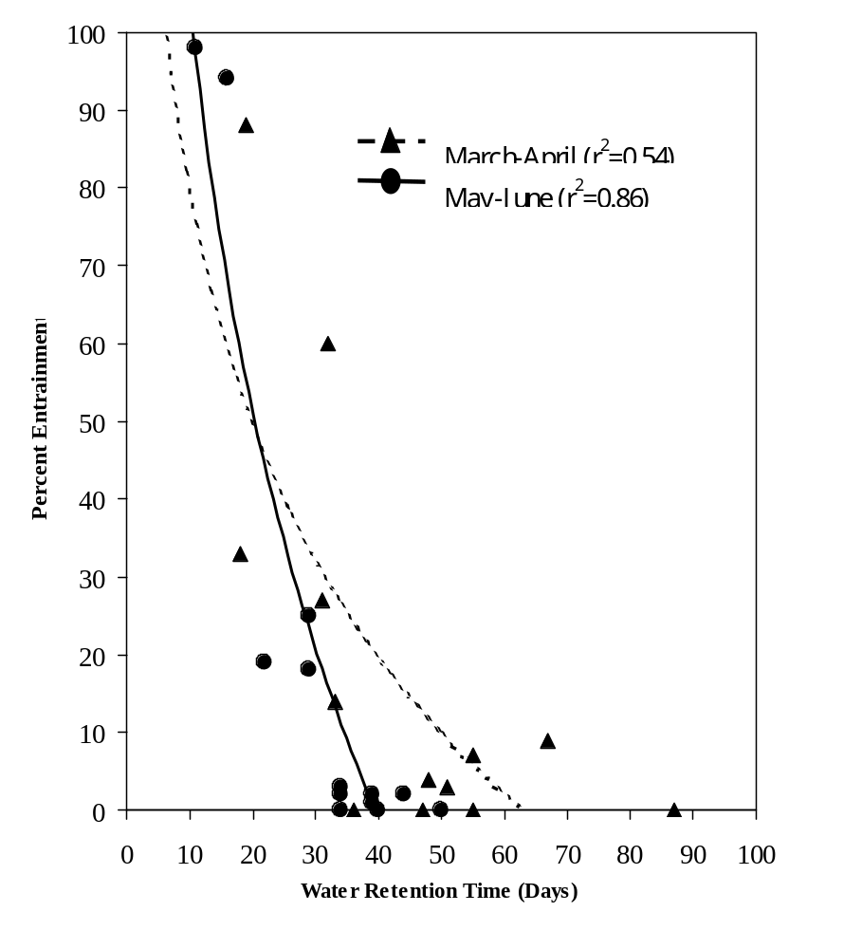
Figure 1. Entrainment index of rainbow trout (percent released) and water retention time (WRT) from 1988 to 1998. Data includes angler tag returns (above and below Grand Coulee Dam), and Fish Passage Center tag reports (below Grand Coulee Dam).

 | Year of  Record |  | 1991  a/ |  | 1992 |  | 1993 |  |  |  | 1994 |  |  |  | 1995 |  |  |  | 1996  a/ |  | 1997  a/ |  | 1998

Mean Outflow (kcfs)
 | January |  | 142.0 |  | 101.5 |  | 100.5 |  |  |  | 77.2 |  |  |  | 88.3 |  |  |  | 154.9 |  | 141.6 |  | 107.2
 | February |  | 131.3 |  | 77.7 |  | 85.9 |  |  |  | 103.6 |  |  |  | 94.0 |  |  |  | 154.9 |  | 142.4 |  | 129.6
 | March |  | 151.0 |  | 92.6 |  | 53.9 |  |  |  | 77.7 |  |  |  | 90.1 |  |  |  | 144.4 |  | 129.2 |  | 107.4
 | April |  | 153.4 |  | 79.3 |  | 48.4 |  |  |  | 73.0 |  |  |  | 84.5 |  |  |  | 147.7 |  | 152.7 |  | 67.8
 | May |  | 146.4 |  | 112.1 |  | 119.0 |  |  |  | 99.6 |  |  |  | 93.5 |  |  |  | 167.8 |  | 218.4 |  | 132.9
 | June |  | 145.7 |  | 131.7 |  | 95.7 |  |  |  | 135.9 |  |  |  | 117.8 |  |  |  | 173.1 |  | 258.1 |  | 142.6
 | July |  | 129.6 |  | 80.6 |  | 97.2 |  |  |  | 95.8 |  |  |  | 110.5 |  |  |  | 157.9 |  | 169.2 |  | 116.3
 | August |  | 125.7 |  | 81.7 |  | 81.7 |  |  |  | 73.3 |  |  |  | 91.9 |  |  |  | 131.2 |  | 135.3 |  | 105.3
 | September |  | 78.0 |  | 73.0 |  | 73.0 |  |  |  | 55.9 |  |  |  | 65.9 |  |  |  | 90.8 |  | 97.5 |  | 76.2
 | October |  | 84.7 |  | 65.9 |  | 62.5 |  |  |  | 64.0 |  |  |  | 80.6 |  |  |  | 90.7 |  | 106.6 |  | 65.6
 | November |  | 87.9 |  | 81.9 |  | 84.2 |  |  |  | 75.7 |  |  |  | 91.9 |  |  |  | 93.9 |  | 95.1 |  | 76.0
 | December |  | 87.9 |  | 109.9 |  | 109.9 |  |  |  | 83.5 |  |  |  | 141.6 |  |  |  | 110.7 |  | 127.8 |  | 95.7
 | Mean WRT (Days)
 | January |  | 32.2 |  | 45.1 |  | 40.2 |  |  |  | 61.8 |  |  |  | 49.3 |  |  |  | 28.4 |  | 30.3 |  | 37.3
 | February |  | 34.1 |  | 59.0 |  | 44.0 |  |  |  | 42.5 |  |  |  | 42.6 |  |  |  | 31.7 |  | 23.3 |  | 26.7
 | March |  | 25.0 |  | 48.4 |  | 67.1 |  |  |  | 54.9 |  |  |  | 42.4 |  |  |  | 23.9 |  | 23.4 |  | 32.9
 | April |  | 17.7 |  | 51.2 |  | 87.1 |  |  |  | 55.0 |  |  |  | 47.5 |  |  |  | 18.6 |  | 15.9 |  | 61.6
 | May |  | 18.5 |  | 34.4 |  | 39.4 |  |  |  | 44.0 |  |  |  | 39.4 |  |  |  | 15.7 |  | 10.8 |  | 33.8
 | June |  | 29.2 |  | 33.7 |  | 49.6 |  |  |  | 30.1 |  |  |  | 40.1 |  |  |  | 21.8 |  | 16.1 |  | 33.3
 | July |  | 35.8 |  | 62.1 |  | 46.9 |  |  |  | 43.5 |  |  |  | 41.4 |  |  |  | 29.4 |  | 27.1 |  | 39.0
 | August |  | 37.0 |  | 56.8 |  | 56.8 |  |  |  | 58.7 |  |  |  | 47.2 |  |  |  | 34.3 |  | 33.2 |  | 42.6
 | September |  | 59.1 |  | 61.0 |  | 61.0 |  |  |  | 78.4 |  |  |  | 69.0 |  |  |  | 47.9 |  | 46.5 |  | 57.2
 | October |  | 55.8 |  | 69.0 |  | 73.5 |  |  |  | 72.6 |  |  |  | 56.7 |  |  |  | 49.2 |  | 42.8 |  | 68.3
 | November |  | 53.2 |  | 56.3 |  | 51.4 |  |  |  | 60.1 |  |  |  | 50.4 |  |  |  | 48.3 |  | 47.7 |  | 61.1
 | December |  | 53.2 |  | 37.5 |  | 37.5 |  |  |  |  |  |  |  |  |  |  |  |  |  | 33.5 |  | 47.0
 | Mean elevation (add 1,200 = ft. MSL)
 | January |  | 83.9 |  | 87.1 |  |  | 67.5 |  | 85.4 |  |  |  |  | 78.3 |  |  |  | 81.6 |  | 73.0 |  | 68.8
 | February |  | 85.1 |  | 87.8 |  |  | 63.5 |  | 81.8 |  |  |  |  | 66.3 |  |  |  | 80.7 |  | 53.7 |  | 58.2
 | March |  | 67.5 |  | 81.4 |  |  | 56.0 |  | 76.5 |  |  |  |  | 59.0 |  |  |  | 58.5 |  | 39.4 |  | 55.0
 | April |  | 35.4 |  | 67.9 |  |  | 71.8 |  | 68.1 |  |  |  |  | 65.8 |  |  |  | 35.1 |  | 20.8 |  | 69.5
 | May |  | 34.9 |  | 66.4 |  |  | 84.7 |  | 80.5 |  |  |  |  | 59.8 |  |  |  | 32.3 |  | 23.4 |  | 81.6
 | June |  | 75.2 |  | 81.1 |  |  | 87.5 |  | 76.0 |  |  |  |  | 83.6 |  |  |  | 67.8 |  | 75.3 |  | 87.6
 | July |  | 88.3 |  | 86.6 |  |  | 86.4 |  | 74.9 |  |  |  |  | 86.9 |  |  |  | 87.9 |  | 87.7 |  | 86.6
 | August |  | 88.5 |  | 85.9 |  |  | 85.9 |  | 77.1 |  |  |  |  | 80.9 |  |  |  | 84.9 |  | 85.8 |  | 82.4
 | September |  | 87.0 |  | 81.3 |  |  | 81.3 |  | 81.3 |  |  |  |  | 85.1 |  |  |  | 80.7 |  | 84.4 |  | 81.0
 | October |  | 87.0 |  | 84.1 |  |  | 81.9 |  | 87.2 |  |  |  |  | 85.8 |  |  |  | 84.1 |  | 83.9 |  | 83.1
 | November |  | 86.7 |  | 84.2 |  |  | 78.8 |  | 84.7 |  |  |  |  | 86.5 |  |  |  | 84.2 |  | 86.5 |  | 81.3
 | December |  | 86.0 |  | 73.0 |  |  | 79.0 |  | 84.2 |  |  |  |  | 87.0 |  |  |  | 78.5 |  | 80.3 |  | 79.2
Table 4. Comparison of monthly mean outflow, water retention times (WRT), and elevations in Lake Roosevelt for years of record 1991 to 1998.

Table 5. The three predominant items in the rainbow trout diet, based on relative importance index values from 1988 to 1998, are given in the table below.

 |  | Top three food items based on IRI (%)
Year | Number of stomachs examined (n) | 1 | 2 | 3 | Reference
1988 | 190 | Daphnia sp.  (36%) | Chinomids  (12%) | Leptodora kindtii  (8%) | Peone et al. (1990)
1989 | 223 | Fish (walleye eggs) (34%) | Daphnia sp.  (3%) | Chinomids  (3%) | Peone et al. (1990)
1990 | 136 | Daphnia sp.  (18%) | Chironomids  (15%) | Leptodora kindtii  (8%) | Griffith and Scholz (1991)
1991 | 89 | Daphnia sp.  (20%) | Leptodora kindtii  (18%) | Chironomids  (16%) | Thatcher et al. (1993); Griffith et al. (1995)
1992 | 80 | Daphnia sp.  (44%) | Chironomids  (19%) | Fish (cottidae)  (6%) | Thatcher et al. (1994); Griffith et al. (1996)
1993 | 73 | Daphnia sp.  (51%) | Chironomids  (22%) | Terrestrial insects  (5%) | Underwood and Shields (1996a)
1994 | 93 | Daphnia sp.  (38%) | Chironomids  (17%) | Terrestrial insects  (9%) | Underwood et al. (1996)
1995 | 90 | Daphnia sp.  (37%) | Chionomids  (18%) | Terrestrial insects  (10%) | Underwood and Shields (1996b)
1996 | 56 | Daphnia sp.  (31%) | Chironomids  (15%) | Leptodora kindtii  (10%) | Cichosz et al. (1997)
1997 | 27 | Daphnia sp.  (56%) | Chironomids  (14%) | Leptodora kindtii  (10%) | Cichosz et al. (1999)
1998 | 111 | Daphnia sp.  (38%) | Chironomids  (25%) | Leptodora kindtii  (5%) | Spotts et al. (2000)

Walleye Investigations
Walleye (Stizostedion vitreum vitreum) play a key role in the ecosystem of Lake Roosevelt and serve as a primary fishery for anglers. Walleye are the apex predator, who appears to have a significant affect on the fish composition of the lake. As a result, this project has conducted studies to determine the walleye population size, growth, diet and mortality (i.e. harvest and natural mortality).

We estimated the size of the walleye population in Lake Roosevelt using Chapman’s version of the Schnabel model, with adjustments to insure that all the assumptions were met. The size of the walleye population (± 95% confidence interval) ≥ 200 mm total length on April 1st, 1998 was 130,921 (97,271 ≤ N ≤ 192,991). We estimated the size of the spawning run in the upper eight kilometers of the Spokane Arm to be 22,483 (2,750 ≤ N ≤ 42,216). We used the Jolly-Seber model for the spawning run estimate (Seber 1982).

From 1997 through 1999, we tagged a total of 10,751 walleye in Lake Roosevelt. Anglers and fish survey crews recaptured 812 (7.6%) of the tagged walleye. Of those 812 recaptures, and 519 had adequate data returned regarding the recapture event to allow for movement analysis. Adequate information included tag number, date, and specific location. We also marked a total of 2,155 (274 in 1997, 1,640 in 1998, 241 in 1999) walleye while they were on their spawning run in the upper Spokane River in 1997, 1998, and 1999. We defined the spawning run as the period of time between April 1st and May 31st, except in 1998 when we concluded that the run ended on May 22nd, which was the last day that we collected a ripe walleye.

We divided the walleye tagged in Lake Roosevelt into two groups for movement analysis. The first group (non-spawning) included all walleye tagged outside of the Spokane Arm and those tagged in the Spokane Arm after the spawning run (generally May 31st). The second group (spawning) included those walleye tagged in the Spokane Arm between April 1st and the end of the spawning run (generally May 31st).

There were a total of 404 (4.7% of non-spawning walleye marked) non-spawning walleye that were recaptured and had adequate information provided about the recaptures to allow for analysis of movements. Two hundred and sixty (64.4%) of those fish were recaptured in the same general location that they were marked. Eighty-one (20.0%) moved upstream and 63 (15.6%) moved downstream. Most of the movement occurred in years following marking (i.e. walleye tagged in 1997 did not move during the 1997 study, but moved some time prior to recapture in a subsequent study year). Of those fish that did move, 15 moved upstream and into the Spokane Arm and 13 moved downstream and into the Spokane Arm. During 1998 and 1999, 15 and 3 (a total of 64.3%) of those walleye that entered the Spokane Arm did so during the spawning run. Ten (12.3%) of the 81 walleye that moved upstream, traveled into British Columbia, one as far as Keenleyside Dam north of Castlegar. Other distinctive movements included a walleye tagged in the Spokane Arm that moved downstream to Rufus Woods Reservoir and a walleye tagged near Sherman Creek (Kettle Falls) in 1997 that was recaptured in the Spokane Arm during spawning in 1998, and was recaptured a second time in July 1999 near the Hawk Creek campground. The walleye was 561mm at the initial capture, and 578mm and 677mm at the subsequent recaptures.

There were a total of 115 (5.3%) spawning walleye that were recaptured after the spawning run and had adequate information provided about the recapture to allow for analysis of movements. The recapture data is summarized in Table 1. A walleye tagged during the 1997 spawning run was recaptured at the mouth of the Nespelem River, Rufus Woods Reservoir 21 days later. Three walleye tagged on the spawning run in 1998 were recaptured in the Spokane Arm in June, all of which were captured again in the Spokane Arm, two in July and one in September of 1998. A walleye tagged on the spawning run in 1998 was recaptured in the Colville River in June 1998 and 1999. Five walleye tagged on the spawning run in the Spokane Arm were recaptured in British Columbia.

Our walleye movement data indicates a general trend of walleye movement in Lake Roosevelt, in which they spawn in the upper reaches of the Spokane River Arm in April and May (peak mid-April to mid-May). After spawning they rapidly migrate downstream and of those walleye that leave the Spokane Arm, the majority move upstream, with some traveling as far as Canada. A higher percentage of walleye probably leave the Spokane Arm than our data indicates, because the fishing season opens June 1st before all of the spawning walleye can migrate out and fishing pressure is high at this time. After migrating from the spawning run, the walleye establish summer home ranges and move very little. The following spring, spawning walleye make a rapid migration back to the spawning area. This trend is also supported by tagging and radio telemetry data collected by the U.S. Fish and Wildlife Service, and R.L.&L. Environment, Castlegar, B.C.

Walleye Growth

Fish growth is an indication of population health. As result, walleye growth has been calculated annual using length at age estimates from scales (table 2). From the period of 1983 through 1999 the growth of walleye has not change considerable, however size structure has. In 1983 the walleye size structure was dominated by 4, 5, 6, and 7 year old fish, in the 1990’s the size structure was dominated by 2, 3, and 4 year old fish.

Walleye Diet

It is strongly suspected that piscivory, primarily by walleye, may play a bigger role in annual mortality rates for salmonids, specifically kokanee salmon than historically recognized. Substantial piscivory, only recently identified at release and return sites, at which hatchery origin fish have been previously been released and imprinted have been recovered from walleye by gill net and electro-fishing capture methods. These collection efforts have identified walleye as a major predator of hatchery origin salmonids. The Washington Department of Fish and Wildlife (WDFW), performed the capture and subsequent stomach analysis of the captured walleye.
Fish were the dominant items in all age classes of walleye (Table 3). Types of fish eaten routinely by walleye in order of importance were: Cyprinids, sculpins, percidae, catostomids, and salmonids. Relative abundance of salmonids in the diet was 4.9% in 1988, 0% in 1989, 1.3% in 1990, 5.6% in 1991, 0% in 1993, 9.2% in 1994, 11.2% in 1995, 28.3% in 1996, 0% in 1997 and 7% in 1998. Walleye frequently cannibalized other walleye. Types of fish occasionally eaten by walleye included: Centrarchids (smallmouth bass). Other items routinely reported in walleye diet over the 11 year period included: Cladocerans (Leptoadora kindtii, Polyphemius sp., Pedociulus, Sida crystallina, Bosmina sp., ostracods and terrestrial insects. Diet items less frequently found in the walleye stomachs included: Tipulidae, caddis flies (particularly Hydropsychidae), bugs (Hemiptera: Corixidae), snails (Planorbidae), clams (Sphaeriidae), mayflies (Ephemeroptera: Baetidae, Heptagenidae), dragonflies (Odonata: Anisoptera, Zygoptera), spiders (Hydracarina: Hydrachnallae), stoneflies (Plecoptera: Nemouridae, Pteronarcydae), beetles (Coleoptera: Elmidae), Tabanidae, seeds, Perlodidae sp., aquatic earthworms (Oligochaetae: Lumbriculidae).

Walleye Mortality
Lake Roosevelt walleye mortality appears to be similar to walleye of other lakes (table 4). Harvest is one of the primary sources of mortality with an average harvest of 120,248 walleye a year for the period 1990 through 1998 (refer to the kokanee section table 1 for further information).

Cichosz, T.C., J.P. Shields, and K.D. Underwood. 1998. Lake Roosevelt monitoring/data collection program, 1996 Annual Report in T.A. Cichosz, J.P. Shields, K.D.
Beckman, L.G., J.F. Novotny, W.R. Persond, and T.T. Terrel. 1985. Assessment of the fisheries and limnology in Lake Franklin Delano Roosevelt, 1980-83. Final report prepared for the U.S. Bureau of Reclamation. U.S. Fish and Wildlife Service. Willard, WA
Griffith, J.R. and A.C. McDowel. 1996. Measurement of Lake Roosevelt biota in relations to reservoir operations, Annual Report 1992. Bonneville Power Administration. Portland, OR. Project No. 88-63.
Griffith, J.R., A.C. McDowel and A.T. Scholz. 1995. Measurement of Lake Roosevelt biota in relation to reservoir operations. Annual Report 1991. Bonneville Power Administration. Portland, OR. Project No. 88-63.
Griffith, J.R. and A.T. Scholz. 1990. Lake Roosevelt fisheries monitoring program, 1990 annual report. Bonneville Power Administration, Portland, Oregon. Project No. 88-63.
Griffith, J.R. and A.T. Scholz. 1991. Lake Roosevelt Fisheries Monitoring Program, Annual Report 1990. Bonneville Power Administration. Portland, OR. Project No. 88-63.
Peone , T. L. , A.T. Scholz, J.R. Griffith, S. Graves, M.G. Thatcher Jr. 1990. Lake Roosevelt Fisheries Monitoring Program: Annual Report August 1988-Decmber 1989. Bonneville Power Administration. Project No.. 88-63. 234pp.
McLellan, J.G. 1998. Assessment of walleye (Stizostedion vitreum vitreum) abundance, movements, and growth in Lake Roosevelt, Washington. MS Thesis. Eastern Washington University, Department of Biology, Cheney, WA.
McLellan, J.G., A.T. Scholz, H.J. Moffatt, and B.J. Tucker. 1998. Walleye (Stizostedion vitreum vitreum) population dynamics in Lake Roosevelt, Washington, 1997. 1997 Annual Report. Unpublished report submitted to the Lake Roosevelt Monitoring Program, Spokane Tribe of Indians, Wellpinit, WA.
McLellan, J.G., H.J. Moffatt, and A.T. Scholz. 1999. Assessment of the Lake Roosevelt Walleye Population. 1998 Annual Report. Unpublished report submitted to the Lake Roosevelt Monitoring Program, Spokane Tribe of Indians, Wellpinit, WA.
McLellan, J.G., H.J. McLellan, and A.T. Scholz. 2000. Assessment of the Lake Roosevelt Walleye Population. 1999 Annual Report. Unpublished report submitted to the Lake Roosevelt Monitoring Program, Spokane Tribe of Indians, Wellpinit, WA.
Seber, G.A.F. 1982. The estimation of animal abundance and related parameters. Charles Griffin and Company, Ltd. London.
Underwood, K.D. and J.P. Shields. 1996. Lake Roosevelt Fisheries Monitoring Program, Annual Report 1993. Bonneville Power Administration. Portland, Oregon. Project No. 88-63.
Underwood, K.D., J.P. Shields and M.B. Tilson. 1997. Lake Roosevelt Fisheries Monitoring Program, 1995 Annual Report in K.D. Underwood and J.P. Shields. Lake Roosevelt Fisheries and Limnological Research, 1995 Annual Report. Bonneville Power Administration. Portland, Oregon. Project No. 88-63.
Underwood, A.T. Scholz, and M.B. Tilson. 1996 Lake Roosevelt Fisheries and Limnological Research, 1996 Annual Report. Bonneville Power Administration. Portland, OR. Project No.94-043.
Underwood, K.D., J.P. Shields and M.B. Tilson. 1996. Lake Roosevelt Fisheries Monitoring Program, 1994 Annual Report in K.D. Underwood and J.P. Shields. Lake Roosevelt Fisheries and Limnological Research, 1994 Annual Report. Bonneville Power Administration. Portland, Oregon. Project No. 88-63.

Table 1. Summary of movements of Lake Roosevelt walleye following spawning.
Year Tagged | Recaptured in…
Year Tagged | 1997 |  |  | 1998 |  |  | 1999
 | Down | Up | S.A. | Down | Up | S.A | Down | Up | S.A.
1997 (n=247) | 2 | 1 | 10 | 0 | 0 | 6 | 0 | 0 | 0
1998 (n=1,640) |  |  |  | 3 | 12 | 47 | 0 | 10 | 14
1999 (n=241) |  |  |  |  |  |  | 1 | 3 | 3
ª Down = walleye move downstream after leaving Spokane Arm.
^{b} Up = walleye move upstream after leaving Spokane Arm.
^{c} S.A.= walleye remain in or return to Spokane Arm (13 (56.5%) recaptured in upper S.A
during a subsequent spawning run).

Table 2. Comparison of walleye mean back-calculated total lengths (mm) at annulus formation in Lake Roosevelt for the years 1980 through 1999.

 |  | Mean Total Length (mm) at Annulus Formation
Year | n | 1 | 2 | 3 | 4 | 5 | 6 | 7 | 8 | 9 | 10 | 11 | 12 | 13 | Reference
1980-83 | 3,248 | 189 | 307 | 385 | 450 | 515 | 569 | 629 | 668 | 702 | 742 | 740 | 761 | 780 | Beckman et al. (1985)
1988 | 369 | 204 | 273 | 348 | 410 | 470 | 532 | 590 | 635 | 688 | 689 |  |  |  | Peone et al. (1990)
1989 | 467 | 210 | 282 | 351 | 418 | 493 | 571 | 603 |  |  |  |  |  |  | Peone et al. (1990)
1990 | 311 | 184 | 295 | 380 | 439 | 511 | 597 | 651 | 698 | 734 |  |  |  |  | Griffith and Scholz (1990)
1997 | 2,355 | 172 | 279 | 363 | 424 | 478 | 535 | 617 | 662 |  |  |  |  |  | Cichosz et al 1999.
1998 | 320 | 179 | 290 | 364 | 427 | 481 | 530 | 576 | 616 | 667 | 717 | 748 | 801 | 829 | McLellan et al. (1999)
1999 | 171 | 188 | 301 | 375 | 427 | 476 | 518 | 578 | 643 |  |  |  |  |  | Unpublished data

Table 3. The three predominant food items in the diet of walleye, based on relative importance index values from 1988 to 1998, are given in the table below.
 |  | Top three food items based on IRI (%)
Year | Number of stomachs examined (n) | 1 | 2 | 3 | Reference
1988 | 257 | Fish  (47%) | Daphnia sp.  (12%) | Chironomids  (9%) | Peone et al. (1990)
1989 | 289 | Fish  (56%) | Chironomids  (14%) | Daphnia sp.  (8 | Peone et al. (1990)
1990 | 182 | Fish  (51%) | Leptadora kindtii  (16%) | Daphnia sp.  (9%) | Griffith and Scholz (1991)
1991 | 98 | Fish  (74%) | Leptadora kindtii  (11%) | Chironomids  (11%) | Thatcher et al. (1993); Griffith et al. (1995)
1992 | 94 | Fish  (50%) | Chironomids  (29%) | Leptadora kindtii  (28%) | Thatcher et al. (1994); Griffith et al. (1996)
1993 | 47 | Fish  (46%) | Chironomids  (26%) | Daphnia sp.  (17%) | Underwood and Shields (1996a)
1994 | 91 | Fish  (53%) | Chironomids  (32%) | Daphnia sp.  (10%) | Underwood et al. (1996)
1995 | 153 | Fish  (68%) | Leptadora kindtii  (11%) | Daphnia sp.  (5%) | Underwood and Shields (1996b)
1996 | 126 | Fish  (77%) | Chironomids  (10%) | Leptadora kindtii  (6%) | Cichosz et al. (1997)
1997 | 72 | Fish  (65%) | Daphnia sp.  (14%) | Chironomids  (7%) | Cichosz et al. (1999)
1998 | 181 | Fish  (48%) | Daphnia sp.  (16%) | Chironomids  (10%) | Spotts et al. (2000)

Table 4. Comparison of mean annual mortality rates (%) between Lake Roosevelt and other walleye producing waters from McLellan et al. (1999).

Location | Mean Annual Mortality (%) | Source
20 NW Wisconsin Lakes | 47 | Klingbiel (1986)ª
32 N. Cent. Wisconsin Lakes | 48 | Klingbiel (1986)ª
Leech Lake, MN | 37 | Schupp (1972)ª
Boyd Lake, CO | 48 | Weber (1976)ª
Lake of Woods, MN, 1980-84 | 65 | Payer et al. (1987)ª
W. Blue Lake, Ontario | 80 | Kelso and Ward (1977)ª
Manistee Lake, MI (ages 3 to 7) | 56 | Laarman (1981)ª
Lake Oneida, NY, 1960-74 | 34 | Forney (1977)ª
Lake Roosevelt, 1980-83 | 52 | Beckman et al. (1985)
Lake Roosevelt, 1997 | 48 | McLellan et al. (1998)
Lake Roosevelt, 1998 | 46 | Present study
ª Cited in Carlander (1997).

B. ISRP Comment
- The technical and scientific background is adequate but could benefit from more explicit use of the scientific literature on reservoirs as unique aquatic environments. Although the PI said in oral presentation that there is little conceptual literature on reservoirs, there actually is quite a lot (for example papers by Kimmell, Thornton and others, and management experiences with other storage reservoirs with deep drawdowns such as in the TVA system, as well as many papers in the journal Regulated Rivers).

Response

The intent of the PI’s comments during the oral presentation was to suggest that the body of science is less extensive for reservoirs than for lakes. It was not the PI’s intent to suggest that the literature does not contain papers on reservoir. Also, there are a growing number of books dedicated to reservoirs limnology and biology over the last several decades such as Reservoir Fisheries and Limnology (Hall 1971), Reservoir Limnology Ecological Prospectives (Thornton et al 1990), Restoration and Management of Lakes and Reservoirs (Cooke et al. 1993), and Lake and Reservoir Bioassessment and Biocriteria: Technical Guidance Document (Garritsen et al. 1998). However, we still believe our understand of reservoir is still lack in comparison to lakes.

Moreover, the PI is a member of the North American Lake Management Society (NALMS). The NALMS symposia and journals have provided interactions with other professionals working on reservoirs and provided new ideas. This project has benefited greatly from interaction with NALMS. For example, during NALMS conferences, we have discussed with professionals working on TVA Reservoirs whether those reservoirs are similar to Lake Roosevelt. Our discussions led to the determination that TVA reservoirs are very different from Lake Roosevelt. Unlike Lake Roosevelt, TVA reservoirs: are relatively shallow, have long water retention times, stratify biannually, and contain biota dominated by warmwater fisheries. We may learn from studies conducted by those working on TVA reservoirs and others reservoirs, but Lake Roosevelt is unique and requires a unique understanding. Finally, the journal of Regulated Rivers has not been a resource relied on in the past, but we will use reviewed from here on out, thank you for the suggestion.

Cook, G.D., E.B. Welch, S.A. Peterson, and P.R. Newroth. 1993. Restoration and Management of Lakes and Reservoirs, Second Edition. Lewis Publishers. New York.548 pp.
Gerritsen, J., R.E. Carson, D.L. Dycus, C. Faulkner, G.R. Gibson, J. Harcum and S. A. Markowitz. 1998. Lake and Reservoir Bioassessment and Biocriteria, Technical Guidance Document. United States Environmental Protection Agency. EPA 841-B-98-007. 190pp.
Hall, G.E [ed]. 1971. Reservoir Fisheries and Limnology. American Fisheries Society. Bethesda, MD. 511 pp.
Thornton, K.W., B. L. Kimmel, and F. E. Payne [eds]. 1990. Reservoir Limnology: Ecological Perspectives. John Wiley & Sons, Inc. New York. 246pp.

C. ISRP Comment
- Facilities and personnel are adequately described but may not be adequate for the goal of managing fisheries in such a large and complex system. Collaborative use of personnel from other projects is important for mounting large field operations
- The project needs consultation and oversight.
- A senior biometrician should supervise data collection design and data analysis.
- Synthesis of information through use of a model for reservoir hydraulics and water quality is a good idea as a conceptual foundation, but its use could be improved with outside consultation.
- Additional use of outside consultants, including a senior biometrician, could bolster the professional capabilities.
- A major concern is that the project is behind schedule for both modeling and data collection (p11) but there is no indication of how extra money will allow catch-up.
- Both the proposal and the oral presentations caused us to wonder if staff is adequate to handle the statistical analysis and modeling aspects of the project. Outside consultation by a senior statistician and a trained modeler could be helpful.
- The project could benefit from additional outside assistance from reservoir managers who have dealt with large reservoirs with deep drawdowns.

Response

As noted in the proposal, the water quality and habitat models will be set-up, calibrated and validated by consultants. The consultants will also be used to help validate descriptive analyses conducted by this project. We agree with the need for a biometricians input and will adjust the budget for a biometrician to be involved with the study. However, we do not believe it is fair to suggest that we have not been consulting biometricians, modelers and other professional input from the beginning of this project. Following is a list of professionals, who have and are being consulted.

Name | Expertise | Subject
Dr. Scott Wells,  University of Portland | Hydro dynamic and water quality modeling | Use of Water quality models and CE-Qual-W2
Tom Cole,  USACOE | Hydro dynamic and water quality modeling | Use of Water quality models and CE-Qual-W2
Dave Beauchamp,  University of Washington | Ecological modeling | Bioenergetics modeling and fish sampling design.
Barbara Alvin,  Eastern Washington University | Biostatistician | Imprinting analyses and statistics
Christian Hanson,  Eastern Washington University | Biostatistician | Tagging analyses and statistics
Bruce Haines,  USFWS | Fisheries Research | Population modeling using the CAPTURE program
Nancy Birch,  Eastern Washington University | Mathematician | Multivariate analyses of variables effecting zooplankton population dynamics
Jim Ehleringer,  University of Utah | Biologist | Use of stable isotopes to trace food webs
Jack Rensel,  Rensel and Associates | Net pen environmental studies | Net pen impact study plan for Lake Roosevelt
Dr. Allan Scholz,  Eastern Washington University | Fisheries Biology | Imprinting, tagging, creel, and population dynamic studies
Dr. Ross Black,  Eastern Washington University | Zooplankton Biology | Zooplankton identification, and zooplankton population dynamic studies
Beak Consultants | Habitat and macroinvertebrate studies | Developed study design and sampling plan for habitat and macroinvertebrate studies

D. ISRP Comments
- The project has budgeted $40K per year for "writing studies for the public in professional journals.” We applaud publication, but wonder if the expectation of $40k/year worth is a realistic target. There is no publication yet from the project but one has been submitted.
- Results from this project should be integrated with the other projects to be useful.
- The relationship to other projects is clear, but might have been described in more detail.

Response

The project is moving from a data acquisition phase to synthesis and reporting stage. As a result, in 2001 we do believe a number of papers will be coming from this project. The $40/k includes the salaries of five professionals to analyses data; write publish grade papers and review drafts. The following are titles of papers to be submitted for publication while operating under 2001 funding.

- The use of open and closed population models to estimate the size of a walleye population in a large reservoir.
- Walleye migration behavior in Lake Roosevelt, WA.
- Plankton community dynamics and productivity in Lake Roosevelt, WA.
- Stable isotope analysis of Lake Roosevelt, WA.
- Seasonal patterns for food limitation and turbidity effects on riverine zooplankton
- Short term predation losses of hatchery released kokanee to walleye in Lake Roosevelt, WA.

Other potential papers include,

- Gas bubble trauma in fishes of Lake Roosevelt, WA.
- Lake Roosevelt kokanee salmon population dynamics.

Besides reports, the data collected by this project is presented at quarterly Hatchery Coordination Team meetings. Proponents of this and other projects attend the meeting to present findings and recommend actions. Moreover, Hatchery Managers receive recommendations to change production and release strategies in order to surmount environmental and hatchery fish performance problems. We also share data and coordinate at numerous professional and public symposia. The following are a list of papers presented over the last three years.

Black, A.R., M.R. Cooper. 2000. “The potamoplankton conundrum: searching for regulatory factors in a large advective reservoir”. Prepared at Ecological Society of America: 85th Annual Meeting, Snowbird, August Utah
Baldwin, C. M. 2000. “Limiting Factors for Kokanee and Rainbow Trout in Lake Roosevelt.” Presented at Northwest Scientific Association 2000 Annual Meeting. March 17, Moscow, ID.
Baldwin, C. M. 2000. “Limiting Factors for Kokanee and Rainbow Trout in Lake Roosevelt”. Presented at 26th International Kokanee Workshop. March 28, Coeur D’ Alene, ID.
Baldwin, C. M. 2000. “Limiting Factors for Kokanee and Rainbow Trout in Lake Roosevelt”. Presented at Lake Roosevelt Forum Spring Conference; Water Quality and Fisheries: A Lakeside View. May 23, Spokane, WA.
Baldwin, C. M. 2000. “Mobile Hydroacoustics: Applications for Inland Fish Research and Management”. Presented at Washington Department of Fish and Wildlife, Fish Program Managers Meeting. August 23, Olympia, WA.
Baldwin, C. M. 1999. “Bioenergetic Assessment of Limiting Factors for Rainbow Trout and Kokanee in Lake Roosevelt, WA”. Presented at 25th International Kokanee Workshop. March 23, Nelson, British Columbia.
Baldwin, C. M. 1999. “Bioenergetic Assessment of Limiting Factors for Rainbow Trout and Kokanee in Lake Roosevelt, WA”. Present at Washington Lake Protection Association (WALPA) Annual Conference. April 9, Spokane, WA.
Baldwin, C. M. 1999. “Entrainment Research Needs of the Next Decade; the State Perspective”. Presented at Bureau of Reclamation Fish Entrainment Conference. August 17, Grand Coulee, WA.
Barlow, G.W., A.R. Black. 2000. “Investigating the utilization of benthic versus pelagic primary production in Lake Roosevelt, WA: a stable isotope analysis”. Presented at Ecological Society of America: 85th Annual Meeting, Snowbird, Utah, August 2000.
Barlow, G.W., A.R. Black. 2000. “Is benthic production in Lake Roosevelt inhibited: a stable isotope analysis”. Presented at the annual meeting of the Northwest Scientific Association, March, Moscow, ID,.
Cichosz, T. 1998. “Observed Total Dissolved Gas Trends in Lake Roosevelt, Washington During 1997”. Presented at Toward Ecosystem-Based Management in the Upper Columbia River Basin: an International Conference and Workshop. April 30, Castlegar, BC, Canada
Cooper, M.R., A.R. Black. 1999. “Secondary planktonic productivity in a large reservoir: can enclosures beat the advection complication”. 84th annual meeting of the Ecological Society of America, August, Spokane, WA,
Cooper, M.R., G.W. Barlow, A.R. Black. 1998. “Planktonic secondary production estimation is aided by enclosures in large advective reservoirs”. Annual meeting of Northwest Scientific Association, March, Olympia, WA,.
Cooper, M.R., G.W. Barlow, A.R. Black. 1999. “Using enclosures to estimate planktonic secondary productivity in Lake Roosevelt of the Columbia River”. Presented at 62nd annual meeting of the American Society of Limnology and Oceanography, February, Santa Fe, NM.
Lenhart, J. and T. Cichosz. 1998. Entrainment of Rainbow Trout with Implications for Fisheries Management in Lake Roosevelt, Washington. Presented at Toward Ecosystem-Based Management in the Upper Columbia River Basin: an International Conference and Workshop. April 30, Castlegar, BC, Canada
Polacek, M. C. 1999. “Implementing Hydroacoustics to Assess Pelagic Fish Abundance and Distribution in Lake Roosevelt, Washington”. Presented at 25th International Kokanee Workshop. March 23, Nelson, British Columbia.
Underwood, K. 2000. “Lake Roosevelt – It’s a River Not a Lake” Presented at 26th International Kokanee Workshop. March 28,. Coeur D’Alene, ID.
Underwood, K. 2000. “The Kokanee Shuffle”. Presented at 26th International Kokanee Workshop. March 28, Coeur D’Alene, ID.
Underwood, K 2000. “Sustaining Lake Roosevelt’s Fishery” Presented at Water Quality and Fisheries a Lake side View. Lake Roosevelt Forum. May 23, Spokane, WA.
Underwood, K. 1998. “An Update on the Lake Roosevelt Fisheries Management Plan”. Presented at Toward Ecosystem-Based Management in the Upper Columbia River Basin: an International Conference and Workshop. April 29, Castlegar, BC, Canada
Scholz, A., J. McLellan and H. Moffatt. 1998. “Incidence of Gas Bubble Trauma in Lake Roosevelt Fishes in 1997”. Presented at Toward Ecosystem-based Management in the Upper Columbia River Basin: an International Conference and Workshop. April 30, Castlegar, BC, Canada
Shields, J. 2000. “The Importance of Embayment Habitats on the Zooplankton Productivity of Lake Roosevelt”. Presented at 26th International Kokanee Workshop. March 28,. Coeur D’Alene, ID.
Shields, J. 1999. “The Role of Zooplankton in Lake Roosevelt”. Presented at 26th International Kokanee Workshop. March 24, Nelson, BC, Canada.
Shields, J. and A.R. Black 1998. “Using Pelagic Enclosures to Estimate Planktonic Secondary Production in Lake Roosevelt”. Presented at Toward Ecosystem-Based Management in the Upper Columbia River Basin: an International Conference and Workshop. April 30, Castlegar, BC, Canada.
Shields, J.P., and A.R. Black. 1998. “A New Technique for Estimating Planktivorous Secondary Productivity: A Field Test Conducted in Lake Roosevelt, Washington”. Presented at 1998 annual meeting of Northwest Scientific Association, Olympia, WA.

Finally, this project is developing a website capable of providing data for researchers and data for laymen, such as anglers. The website will not only better inform other researches, but the public as well.

E. ISRP Comments
- A description of the model would have been helpful
- Having more modest expectations for the usefulness of the model for obtaining specific results is essential, although the model is a useful conceptual guide and synthesis tool.
- The establishment of an ecosystem model for Lake Roosevelt is a laudable goal, but will it be able to capture the unique features of this system and truly be useful as a fisheries management tool?

Proposed Response:

PC-HYDROSYM is a model developed and operated by Bonneville Power Administration. This model routes water through the existing Columbia River Hydro system based on 50 years (1928-1978) of weather and hydrologic data (Anonymous 1997). The user of the model is able to set different water routing rules which influence lake elevations, flood control targets, anadromous fish flows, power generation and other less significant factors. This model is used by the Columbia River professional to test the effect of various hydro operations rules on water routing as measured by monthly flow, reservoir elevations, water retention times at all hydro facilities. For example what happens to Lake Roosevelt elevations and water retention times monthly, if Grand Coulee dam is operated to meet historical power demands with no regard for other needs. This model will be set up and operated by a qualified contractor.

“CE-QUAL-W2 is a two-dimensional, longitudinal/vertical, hydrodynamic and water quality model. Because the model assumes lateral homogeneity, it is best suited for relatively long and narrow water bodies exhibiting longitudinal and vertical water quality gradients. The model has been applied to rivers, lakes, reservoirs and estuaries.” (Cole and Buchak 1995). CE-QUAL-W2 is capable of modeling hydrodynamics, water quality, long term simulations, head boundary conditions, multiple branches, variable grid spacing, adjusting surface layer and upstream segment location, Multiple inflows and outflows, ice cover on and off, selective withdrawals, and time–varying boundary conditions (Cole and Buchak 1995). This model requires set-up by a qualified operator. PI and staff have taken classes to become acquainted with the model, but do not expect to set-up, calibrate of validate this sophisticated tool. Consultants will be employed to do this work

Fish Bioenergetics 3.0 (Hanson et al. 1997) has been and is currently being used by WDFW to model consumption by planktivores and piscivores in Lake Roosevelt. The model uses a mass balanced energetics based approach that focuses on the physiological processes that regulate growth by individual fish. It is dynamic with ontogeny and provides user input on the most important, dynamic and site specific parameters including growth, temperature and diet. Model output for specific cohorts within each species is expanded to age structure and (when possible) abundance to quantify trophic interactions. Bioenergetics modeling has proven effective for quantifying the impact of predators on prey populations in many systems for both planktivores and piscivores (Ney 1990; Yule and Luecke 1993; Beauchamp et al. 1995; Hartman and Brandt 1995; Baldwin et al. 2000). Currently, we are using the model to compare the consumptive demand of the stocked salmonids to the available biomass of Daphnia. Likewise, we are modeling seasonal consumption by piscivorus fishes and evaluating annual impacts to stocked salmonids. We have also conducted short term studies following hatchery releases to capture interactions that may be overlooked with seasonal sampling.

Consultants will be employed to integrate of the various models. We currently do not know whether the models will be linked together to provide feed back loops or rather a matrix approach will be taken. Until we validate the models outputs will we not be able to determine how much energy should be place towards integrating the models.

Finally, our expectation for the usefulness of the models may be overly optimistic. However even if the modeling endeavor does not meet our expectations, we still would need to have collected the descriptive data to manage the reservoir and fishery. The question of whether the model misses unique features of the reservoir can be answered right now. Yes. The model will miss unique features. The next appropriate question is “Does the missed unique feature have a significant effect on reservoir and ecosystem operation?”. If no, we did what we set out to achieve. If yes, we will be somewhere short of our goal.

Anonymous. 1997. Hydro System Simulator (HYDROSIM): User Manual. Bonneville Power Administration. 107pp.

Baldwin, C.B., D. A. Beauchamp, and J. J. VanTassell. 2000. Bioenergetic assessment of temporal food supply and consumption demand by salmonids in the Strawberry reservoir food web. Transactions of the American Fisheries Society 129:429-450.

Beauchamp, D. A., M. G. LaRiviere, and G. L. Thomas. 1995. Evaluation of competition and predation as limits to juvenile kokanee and sockeye salmon production in Lake Washington. North American Journal of Fisheries Management 15:193-207.

Cole, T.M. and E.M. Buchak. 1995. CE-QUAL-W2: A Two-Dimensional, Laterally Average, Hydrodynamic and Water Quality Model, Verson 2.0. U.S. Army Corps of Engineers. Report No. EL-95-1. 317pp.

Hanson, P. C., T. B. Johnson, D. E. Schindler, and J. F. Kitchell. 1997. Fish Bioenergetics 3.0. Center for Limnology, University of Wisconsin-Madson WISCU-T-97-001.

Hartman, K. J. and S. B. Brandt. 1995. Predatory demand and impact of striped bass, bluefish, and weakfish in Chesapeake Bay: applications of bioenergetics models. Canadian Journal of Fisheries and Aquatic Sciences 52:1667-1687.

Ney, J. J. 1990. Trophic economics in fisheries: Assessments of Demand-Supply relationships between predators and prey. Reviews in Aquatic Sciences 2:55-81.

Yule, D. L., and C. Luecke. 1993. Lake trout consumption and recent changes in the fish assemblage of Flaming Gorge Reservoir. Transactions of the American Fisheries Society 122:1058-1069.

F. ISRP Comment
- The proposal is informative but contains parts that lead to concern. One example: on narrative p. 6, paragraph 2, is it really meant that “all kokanee with an adipose fin clip” (i.e., those from the hatchery) are to be excluded from harvest, or should it be that all unclipped kokanee are to be excluded from harvest?

Response:

The proposal states that both hatchery and wild fish are legal to harvest as of 2000 with a 2 fish daily bag limit. In 1998, a harvest moratorium was place on wild kokanee with a 5 hatchery kokanee daily bag limit. The Lake Roosevelt Fisheries Evaluation Project reviewed the effectiveness of the regulations geared to protect wild kokanee. The project came up with the following consideration to the Hatchery Coordination Team and later to the WDFW Commission.

Approximately 12% of the kokanee captured in the January fishery during 1998 and 1999 had a clipped adipose fish (hatchery origin). If one assumes an annual handling mortality of 10% for kokanee captured and released, and assumes 12% of the fish caught are of hatchery origin, for every 100 adipose clipped kokanee salmon harvested from Lake Roosevelt under the 1998 harvest regulations, approximately 73 non-adipose clipped kokanee (wild) were inadvertently killed due to handling mortality. It is important to note that our estimate of 10% handling mortality is likely conservative, and will vary seasonally from probably less than 5% during the winter when kokanee are near the surface to nearly 100% during the summer when kokanee are caught at depths of 50 feet or greater. Wild kokanee realizes approximately 42% (73:173) of current angler induced mortality in Lake Roosevelt, with no angler benefits. This estimated degree of handling mortality coupled with a liberal 5 fish daily bag limit may have had substantial impacts on wild stocks which was not the intent of the 1998 regulation. The harvest of 2 kokanee regardless of origin based on the numbers will reduce harvest by up to 24% annually by reducing allowable catch by 60%. The change in harvest regulations will afford greater protection for wild kokanee and provide the angler the opportunity to harvest kokanee without needless killing.

Your concern appears to stem from a grammatical error leading to what you believe to be a break in logic. Unfortunately, this proposal did not receive a through review prior to submission primarily due to the fact that the 30-day request for proposals occurred during the middle of the sampling season. Please forgive the errors and we hope the above explanation satisfies your concerns.

G. ISRP Comment
- The objective of affecting hydro operations because of fishery objectives in the reservoir is probably unrealistic when taken in a regional perspective. Lower river managers expect Lake Roosevelt to provide water when needed. The project would be more realistically scoped in the context of managing fisheries in an unstable and non-natural environment.

Response

A primary goal of this project is not to inhibit the use of Lake Roosevelt for lower river flow augmentation. Rather, a primary goal of this project is to understand flow augmentation needs, the affect of flow augmentation on Lake Roosevelt flora and fauna, and finally recommend actions to alleviate impacts by adjusting lake operations compatible with both lower and upper river needs and to recommend in-lake actions to mitigate impacts (e.g., nutrient enhancement).

In addition, the creation of Grand Coulee Dam blocked an annual run of over 1.1 million anadromous fish. The loss of salmon has had a devastating effect on the biology, economy and sociology of this region. As a result, we do not believe it is unreasonable to request hydro operators consider our needs. Our needs cannot be articulated without projects like this one, which is attempting to find solutions to the biological problems faced within Lake Roosevelt.

H. ISRP Comment
- Another project is proposing evaluation of strobe lights as an entrainment deterrent at Grand Coulee Dam. There was no mention of whether this monitoring project is gearing up to be able to detect differences in kokanee population dynamics in the reservoir when (if?) strobe lights are successful at reducing entrainment. If that technology works, it could mean a big change in the way several hatchery and net pen projects are operated. Monitoring the reservoir for effects of reduced entrainment should be a major objective of this project.

Response:

The Lake Roosevelt Fisheries Evaluation Program is designed to detect changes over time in the fishery by using the creel survey, hydro acoustic population studies, and relative abundance, growth and diet studies surveys with electrofishing and gillnetting. This project will not be able to prove that the strobe lights have had an effect of the fish populations of Lake Roosevelt. Rather this project will detect changes in fish populations over time, if they do occur. We agree with the notion that we must be focused on detecting fish population changes in order to manage the fishery appropriately.

I. ISRP Comments
- This project conducts the overall monitoring and evaluation of Lake Roosevelt limnology, aquatic ecosystem, fish, and fisheries, which is used as a basis for measuring success of several other projects, especially hatcheries. It is a core project of the subbasin with high regional significance.
- The project has developed over the years, embodies a comprehensive and appropriately basic approach, and has resulted in improved management. The project personnel obviously continue to work toward improving the work plan. The objectives are clear, and the tasks and methods are appropriate and related to objectives (a problem noted last year). We appreciate the difficulty of focusing on specific tasks in a system so large and hydraulically complex.
- The project should have a large and important benefit for fish and fisheries of Lake Roosevelt. There are likely benefits to non-target species and habitats from increasing general understanding of the system. All consistency criteria are met.

Response

Thank you for the positive comments. We agree this project provides a core need for the province.

