Project ID: 27010

Title: Snake River Hells Canyon Tributary Restoration

Section 9 of 10. Project description

a. Abstract

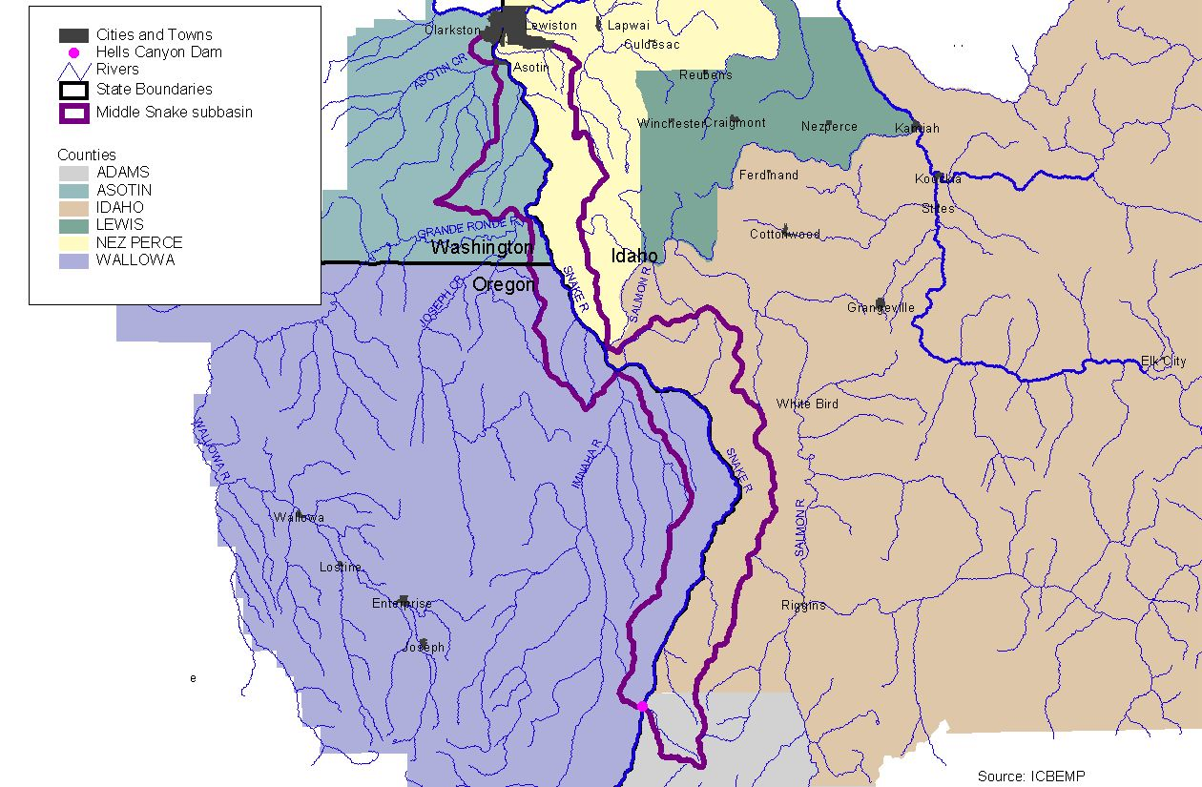
Protect and enhance aquatic and terrestrial habitats in key tributaries to the Snake River in Idaho, through the acquisition of conservation easements, fee-title, land trades, or long-term agreements. Specific area includes from Granite Creek (below Hells Canyon Dam) to Tammany Creek (south of the city of Lewiston, Idaho) (Figure 1.) First year activities will include the development of a landscape level plan for the study area, including a prioritized list of actions. Restoration actions will improve water quality, enhance riparian and native grassland habitats, and benefit steelhead trout, spring chinook salmon, bull trout, bighorn sheep, mountain quail, and a variety of other fish and wildlife species in the Snake Hells Canyon subbasin.

b. Technical and/or scientific background

High-quality freshwater habitats are critical to the long-term strength and persistence of native resident and anadromous salmonid populations in the Snake Hells Canyon Subbasin and elsewhere within the Columbia River Basin. These fish have generally fared best in areas least disturbed by humans.

Figure 1. Snake Hells Canyon Subbasin.

b. Technical and/or scientific background

Much of the Idaho portion of the Snake Hells Canyon Subbasin is characterized by a large amount of private land (Figure 2), and in many cases past disturbances due to intensive land management activities. In addition to supporting native resident and anadromous salmonids, tributaries along the Snake River provide historical or current habitat for bighorn sheep, mountain quail, wintering big game, and a variety of other wildlife species. Many opportunities exist to work with private landowners and other agencies to improve habitat conditions in tributaries to the Snake Hells Canyon Subbasin.

Since summer steelhead rely on tributaries for spawning and a majority of rearing (Figure 3), they are most limited by access and/or habitat suitability. A variety of land uses have impacted steelhead trout and their associated habitats within the subbasin. These include roads, timber harvest, livestock grazing, mining, agriculture, and recreation. Many tributaries have elevated levels of sediment and high summer water temperatures or low summer flows (Statler et al. 2001).

The primary factor limiting bull trout in the Snake Hells Canyon subbasin is a decline in the amount, quality, and availability of habitat (Statler et al. 2001). Six tributaries to the Snake River in the Idaho portion of the project area are included on the state of Idaho 303d water quality impaired list, including Divide, Wolf, Gretta, Cottonwood, Deep, and Tammany Creeks (Statler et al. 2001).

The Snake Hells Canyon subbasin contains some of the healthiest grassland communities remaining in the Columbia Basin, but has still been affected by the disturbances that have eliminated most of these communities in the region. Overgrazing, particularly in the late 1800’s and early 1900’s led to alterations in the community structure and aided in colonization by exotic annual grasses and noxious weeds (USDA Forest Service 1999).

Heavy grazing has also impacted the health of the riparian communities in the subbasin. Poor shrub regeneration was observed in riparian and shrubby draw habitats in the Craig Mountain area that were heavily used by livestock, which reduced the suitability of these areas for yellow warblers and other shrub nesting birds (Mancuso and Mosely 1994).

The introduction of non-native plant and animal species to the Snake Hells Canyon subbasin has reduced its ability to support native wildlife and plant species (Statler et al. 2001). The majority of non-native species on Craig Mountain are found in grassland habitats. Weedy species such as the annual bromes and yellow starthistle are nearly ubiquitous within the canyon grasslands (Mancuso and Mosely 1994).

Evidence suggests that bighorn sheep were historically more common than deer along the Snake River above Pittsburg landing (Statler et al. 2001). By the mid 1940’s bighorn sheep were extirpated from Hells Canyon by a combination of overhunting, competition
with livestock for forage, and diseases contracted from domestic sheep (BLM 1997). Domestic sheep continue to be grazed in some areas of the subbasin and may influence bighorn sheep populations on both private and public lands. In 1997, a cooperative
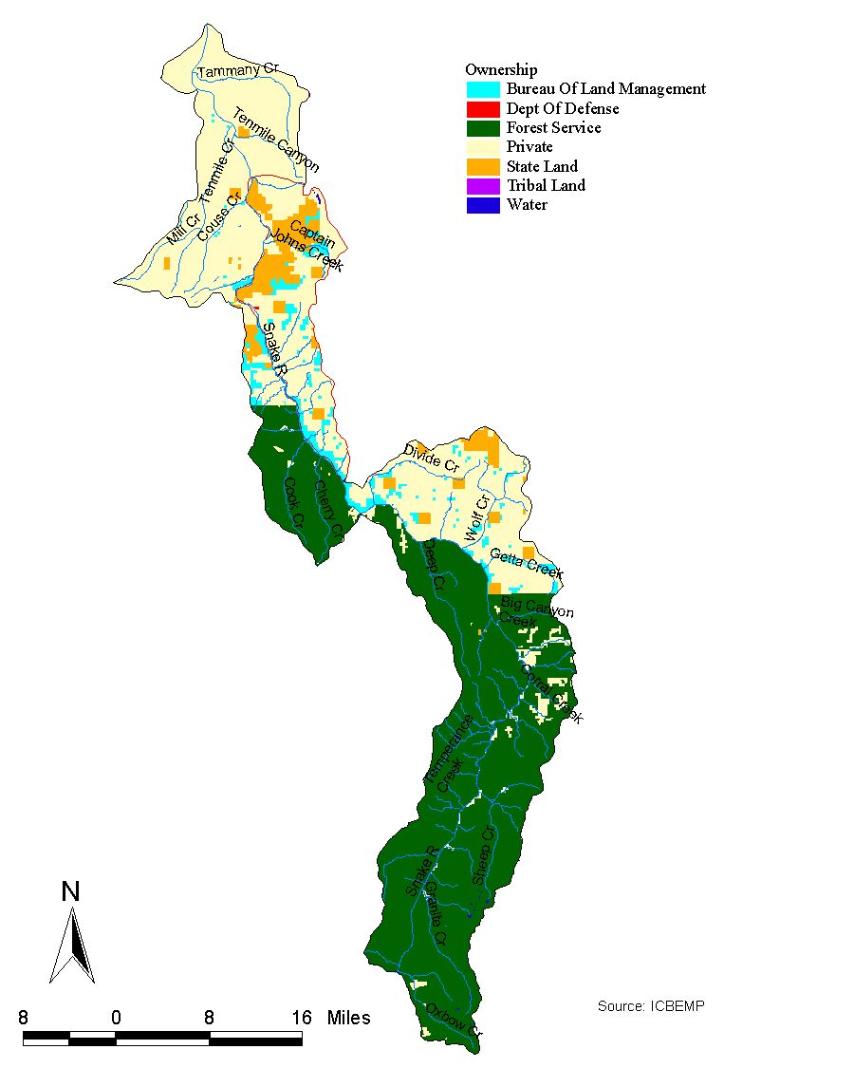

Figure 2. Land ownership in Snake Hells Canyon Subbasin.

interagency project, the Hells Canyon Initiative, was initiated to accelerate the restoration of bighorns to the Hells Canyon area. Habitat acquisition and easements are high priority in the initiative (BLM 1997).

Mountain quail were historically abundant in northwestern shrub and riparian communities (Statler et al. 2001). The species has experienced dramatic population declines throughout its range primarily due to habitat loss. Because of their secretive nature and reliance on brushy habitats that are usually associated with riparian zones, they are not capable of extensive movements away from suitable patches of habitat. Once these habitats are degraded or removed, mountain quail become isolated from other habitat that may be available (Larsen and Nordstrom 1999 in Statler et al. 2001). Remnant populations remain in the riparian stringers and shrubby uplands of the Snake River corridor. Mountain quail were reported in the South Fork Captain John Creek on Craig Mountain in October 1992 (Cassirer 1995).

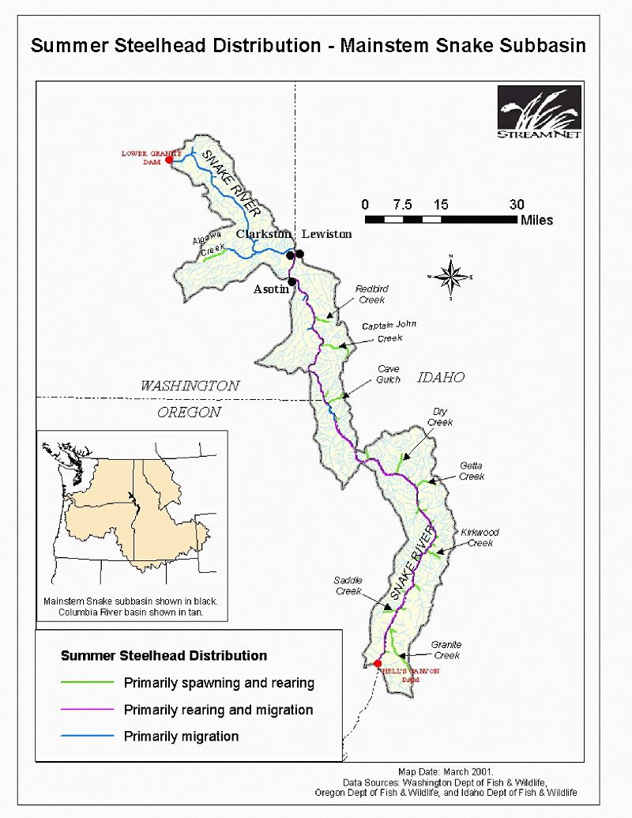

Figure 3. Summer Steelhead Trout distribution in Snake Hells Canyon Subbasin.
Limiting factors and the many needs of fish and wildlife in the Snake Hells Canyon Subbasin are well chronicled by Statler et al. 2001. Implementation of habitat protection and enhancement measures in tributaries to the Snake River in Idaho will benefit a variety of fish and wildlife species and begin to reduce factors limiting those populations.

c. Rationale and significance to Regional Programs

The Northwest Power Planning Council’s 2000 Fish and Wildlife Program calls for maintenance and restoration of healthy ecosystems and watersheds to ensure the continued persistence, health and diversity of all species including game fish species, non-game fish species, and other organisms.

Protection and enhancement of Snake River tributaries addresses several reasonable and prudent actions listed in the FCRPS Biological Opinion.

The FCRPS concluded that off-site mitigation in tributaries is necessary to continue to operate the hydropower system.

High water temperatures have been linked to stress and disease. Reducing water temperatures in tributaries can influence water temperatures in main migratory corridor and provide cooler water sanctuaries for migrating juvenile fish (RPA141).

Project implementation will increase tributary water flow, and comply with water quality standards and watershed health (RPA 149).

Project implementation will provide protection and restoration of non-Federal habitat that is severely degraded (RPA 150).

Project implementation will provide opportunities to fund long-term protection of riparian buffers in concert with existing federal programs (RPA 153).

The Snake Hells Canyon Subbasin Summary identifies several aquatic and terrestrial needs in the subbasin. These include:

-Acquire lands when opportunities arise for improved habitat protection, restoration, and connectivity and for mitigation of lost fish and wildlife habitat (land purchases, land trusts, conservations easements, landowner cooperative agreements, exchanges).

-Protect existing pristine and key fish and wildlife habitat directly threatened by subdivisons, recreation, or extractive resource uses.

-Develop and implement BMP’s on agricultural, mining, grazing, logging and development activities to protect, enhance, and/or restore fish and wildlife habitat, streambank stability, watershed hydrology, and floodplain function.

Habitat acquisition and easements are high priority and will emphasize protection of critical habitat under the Restoration of Bighorn Sheep Hells Canyon Initiative (BLM 1997).

d. Relationships to other projects

NRCS/DEQ – Tammany Creek is included on the Idaho 303d water quality limited stream list. Listed pollutants include sediment. The Tammany Creek PL-566 Supplemental Watershed Protection Plan/Environmental Assessment was developed by the Idaho NRCS. Watershed sponsers include the Nez Perce Soil and Water Conservation District, Nez Perce County Commissioners, Nez Perce Tribe, Idaho Department of Fish and Game, Idaho Department of Environmental Quality, and the Idaho Soil Conservation Commission. The primary objective of the supplemental plan is to reduce the maximum mid-summer stream temperature in Tammany Creek by 2 degrees centigrade to help maintain the optimum temperature for anadromous and resident cold-water fish. Conservation practices will be installed to enhance and protect riparian vegetation, which will reduce streambank erosion, improve fish cover, and improve the overall efficiency of the Tammany Creek riparian system to filter and retain sediment and associated nutrients and bacteria. The planned action will reduce off-site sediment yields from 169,940 tons to 56,080 tons per year, a 67 percent reduction.

NRCS – Several important federal programs exist to help establish permanent cover and reduce soil erosion and water quality degradation. The Continuous Conservation Reserve Program is one of the key programs to improve riparian areas, water quality, and fish and wildlife habitat. Other programs include the Wildlife Habitat Improvement Program (WHIP), the Environmental Quality Incentives Program (EQUIP), and the Wetland Reserve Program (WRP). Project implementation will be coordinated with NRCS staff in each county to ensure that actions complement any on-going NRCS activities.

IDFG- Idaho Natural Production Monitoring and Evaluation (Project No. 9107300). This is an ongong project in place to monitor trends in spring/summer chinook salmon and steelhead trout populations in the Salmon, Clearwater and lower Snake River drainages. Project goals include establishing a long-term parr monitoring database, estimating adult escapement in key tributaries, evaluating egg-to-parr survival in streams treated with habitat improvement structures, monitoring stock-recruitment trends, and estimating smolt-to-adult survival. Since 1984, parr density surveys have been conducted in 146 tributaries and over 1,300 sites in the Salmon and Clearwater subbasins. A total of 684 of these sites have been in the Salmon Subbasin. The project has quantified the benefits in parr carrying capacity observed from different habitat enhancement projects, developed Snake River and stream specific stock-recruitment relationships, and estimated smolt-toadult survival of Snake River spring/summer chinook. A comprehensive database has been developed that includes resident fish species observed while monitoring anadromous fish. This database has been invaluable in providing distribution and densities of bull trout and westslope cutthroat trout, as well as amphibian observation data.

IDFG – The Idaho Department of Fish and Game has been involved in habitat protection and enhancement activities on the 60,000 Peter T. Johnson Wildlife Mitigation Unit since 1992 (BPA #92205700). This area, near the confluence of the Salmon and Snake Rivers, was purchased by BPA in 1992 as partial mitigation for the inundation of wildlife habitat associated with the construction of Dworshak Dam and Reservoir. Enhancement activities include grassland and forestland restoration and noxious weed management.

ACCD – The Asotin County Conservation District in the Washington portion of the subbasin has implemented riparian projects to reduce sedimentation and temperature, and to improve bank stability. Specific actions have included fencing, alternative water developments, tree plantings, and instream structures. Best management practices targeted to improve water quality and fish habitat in Washington have included upland sediment basins, terraces, grassed water ways, filter strips, strip cropping, and direct seeding of crops to reduce summer-fallow acres (Brad Johnson pers. comm. in Statler et al. 2001).

Hells Canyon Bighorn Sheep Restoration – The Hells Canyon Initiative is a state, federal, and private partnership to restore Rocky Mountain bighorn sheep to the Hells Canyon area of Oregon, Idaho, and Washington. Under the Hells Canyon Initiate, state and federal agencies will increase efforts reintroduce bighorn sheep and manage habitat and populations to establish new herds and increase the size of existing herds.

e. Project history

This is a new project in Idaho.

f. Proposal objectives, tasks and methods

Overall goal is to protect and enhance Snake River tributary habitats in the Idaho portion of the Snake Hells Canyon Subbasin.

Objective 1. Develop a comprehensive restoration plan or Snake River tributaries in the Idaho portion of the Snake Hells Canyon Subbasin.

Task a. Assess habitat conditions and constraints to fish and wildlife populations in Snake River tributaries. The Snake Hells Canyon Subbasin summary provides a good overview of watershed conditions. Additional site specific information will be collected from past IDFG, DEQ, BLM, and USFS surveys.

Task b. In coordination with Soil Conservation Districts, the Wallowa- Whitman National Forest, Natural Resources Conservation Service, Idaho Department of Environmental Quality, the Bureau of Land Management, the Nez Perce Tribe, and others, identity habitat protection and enhancement measures to improve aquatic and/or terrestrial habitats. Estimate and describe expected fish and wildlife benefits with each project. Prioritize projects based on expected fish and wildlife benefits, cost/benefit ratios, scientific certainty, willing participants, etc. Project design will be in accordance of standard procedures following templates of other watershed restoration projects such as the Hood River Fish Habitat Project. These may include but not limited to purchase of conservation easements or fee-title of high priority habitats, fencing of riparian areas for livestock exclusion, seeding of high erosion areas, placement of instream structures, alternate water developments, plantings of riparian vegetation, etc.

Task c. Develop monitoring and evaluation plan that will provide a measurement of the incremental improvement that each project will provide to overall habitat improvement in Snake River tributaries. Monitoring methods will at least provide Tier 2 level inductive inferences, while being cost-effective and easily replicated by new personnel. Monitoring protocols will likely include already established Soil Conservation District water quality monitoring methods, in addition to long-term species response data.

Task d. After development of projects and priority list, the principal biologist will coordinate funding sources with state, federal and private entities to insure timely implementation of projects, followed by monitoring and evaluation.

Objective 2. Implement actions which protect and enhance tributary habitats in the Idaho portion of the Snake Hells Canyon subbasin.

Task a. Prioritize annual implementation plan with interagency team, including NRCS, SCC, USFS, BLM, Nez Perce Tribe, and other interested entities.

Task b. Work with landowners and implement actions identified in annual implementation work plan.

Objective 3. Conduct annual operation and maintenance activities on project lands .

Task a. Control noxious weeds.

Task b. Maintain fences.

Task c. Maintain other equipment, facilities, signs, habitat improvements, associated with implementation of protection/enhancement activities.

Objective 4. Monitor and evaluate the incremental improvement that each activity provides to overall habitat conditions in each tributary of the Snake River.

Task a. Coordinate methods with on-going DEQ/SCC water quality monitoring.

g. Facilities and equipment

The project coordinator will require a computer and office space. Clerical staff will be provided by IDFG’s Clearwater regional office in Lewiston, Idaho.

h. References

Reference (include web address if available online) | Submitted w/form (y/n)
Cassirer , F.E. 1995. Wildlife inventory, Craig Mountain mitigation area, IDFG, Lewiston, Idaho.  Mancuso, M., and r. Moseley 1994. Vegetation description, rare plant inventory, and vegetation monitoring for Craig Mountain, Idaho.  Statler, D., D. Saul, A. Davidson, and C. Rabe. 2001. Snake Hells Canyon subbasin summary. Northwest Power Planning Council. 178 p.  U.S. Bureau of Land Management. 1997. Restoration of Bighorn Sheep to Hells Canyon: the Hells Canyon Initiative. Written by the Hells Canyon restoration committee. USBLM Tech. Bulletin No. 97-14.  USDA Forest Service. 1999. Hells Canyon National Recreation Area comprehensive management plan, revised Draft Environmental Impact Statement. Wallowa-Whitman Forest. | N  N  N  N  N

Section 10 of 10. Key personnel

The principal investigator will be a fishery/wildlife biologist to be assigned on initiation of the project.

Project Manager: Tim Cochnauer, PhD

Postion: Regional Fish Manager, Idaho Department of Fish and Game, Clearwater Region, Lewiston, ID 83501

Address: Idaho Department of Fish and Game
Clearwater Region
1540 Warner
Lewiston, ID 83501

Phone: 208-799-5010
FAX: 208-799-5012
e-mail: tcochnau@idfg.state.id.us

Education: Doctorate in Fishery Resources, 1983, University of Idaho, Moscow, ID
MS in Zoology, 1973, University of Oklahoma, Norman, OK
BS in Zoology, 1967, University of Oklahoma, Norman, OK

Current responsibilities:

As regional fish manager, the project manager has responsibility for both anadromous and resident fish populations and fisheries within the Clearwater Region of north central Idaho. The area encompasses the entire Clearwater River drainage, the Snake River drainage upstream to Hells Canyon Dam, the Palouse River drainage, the Salmon River drainage (north side) from its mouth upstream to Horse Creek (rkm 300), and the entire Palouse River drainage within Idaho. The IDFG Clearwater Region has a staff of four fishery scientists conducting a variety of activities including data collection, creel census, fish management decisions, establishing and implementing fishing seasons, etc., throughout the region.

The project manager has over twenty-five years experience with Idaho Department of Fish and Game working in fish research, fish management and the hatchery system. Experience includes working with a variety of fish species as well as addressing aquatic habitat needs. Daily work responsibilities include cooperating with federal land management agencies as well as private landowners to protect and restore aquatic habitat for sustainable aquatic communities.

Publications:

Cochnauer, T.G. 1983. Abundance, Distribution, Growth and Management of White Sturgeon in the Middle Snake River, Idaho. Doctoral Dissertation. University of Idaho. Moscow, ID.

Cochnauer, T., J.R. Lukens, and F.E. Partridge. 1985. Status of white sturgeon, Acipenser transmontanus, in Idaho. In: North American Sturgeons: Biology and Aquaculture Potential. Dr W. Junk Publishers.

Cochnauer, T., E. Schriever, and J. Brostrom. 1993. River and Stream Investigations. F-71-R-17. Federal Aid in Sport Fish Restoration. Idaho Department of Fish and Game.

Cochnauer, T., E. Schriever, and J. Brostrom. 1994. River and Stream Investigations. F-71-R-18. Federal Aid in Sport Fish Restoration. Idaho Department of Fish and Game.

Cochnauer, T., E. Schriever, and J. Brostrom. 1995. River and Stream Investigations. F-71-R-19. Federal Aid in Sport Fish Restoration. Idaho Department of Fish and Game.

Cochnauer, T., E. Schriever, and J. Brostrom. 1996. River and Stream Investigations. F-71-R-20. Federal Aid in Sport Fish Restoration. Idaho Department of Fish and Game.

Cochnauer, T., E. Schriever, and J. Brostrom. 1997. River and Stream Investigations. F-71-R-21. Federal Aid in Sport Fish Restoration. Idaho Department of Fish and Game.

Cochnauer, T., E. Schriever, and J. Brostrom. 1998. River and Stream Investigations. F-71-R-22. Federal Aid in Sport Fish Restoration. Idaho Department of Fish and Game.

