Project ID: 9603501

Title: Satus Watershed Restoration

Section 9 of 10. Project description

a. Abstract

Satus Creek, contained entirely within the Yakama Reservation, is one of the two most productive steelhead stream in the Yakima Subbasin - in recent years accounting for more than 1/3 of returning adults. The Satus watershed, comprising approximately 10% of the Yakima subbasin, is largely undeveloped and has no irrigation diversions. This setting offers a unique opportunity to continue the landscape-scale restoration and monitoring undertaken by the Yakama Nation Satus Watershed Project. Several major complementary projects, funded by six state and federal agencies, are also underway within the watershed. Project staff work closely with BIA and Tribal programs to assure that management activities in the watershed will be complementary.
The Satus Watershed Project was conceived as a long-term, large-scale restoration and monitoring effort designed to develop, apply, and evaluate cost-effective methods for restoring fish habitat degraded by impaired watershed functioning. This approach was accepted by the BPA, and the project was initiated in June 1996. We are increasing the productivity of fish and wildlife habitat by improving ecological function of the watershed (Brooks et al., 1991; FWP 1995). Restoration activities also favor reestablishment of coho and spring chinook. Upcoming activities will improve channel stability and complexity, and riparian structure, diversity and productivity along key reaches of Satus Creek and several of its triburaries. We are continuing to improve grazing management. Restoration is proceeding in upland source areas as grazing pressure is reduced. Through our project activities we will continue to restore natural riparian and upland vegetation patterns, reduce erosion, moderate the flow regime on fish bearing streams and improve aquatic and wildlife habitat. We will also continue to monitor changes in fish populations, watershed behavior and results of restoration treatments.

b. Technical and/or scientific background

Rising from the rainshadow of the Cascade Mountains, the 612 square mile Satus Creek watershed comprises nearly ten percent of the Yakima River basin and lies wholly within the Yakama Indian Reservation. The two largest tributaries to Satus Creek are Dry Creek (158 square miles) and Logy Creek (109 square miles). Approximately 75% of the watershed is comprised of shrub-steppe rangelands, with most of the balance in forest. Satus Creek begins at an elevation of 5,500 feet on the north slopes of the Simcoe mountains, near the south boundary of the Yakama Indian Reservation, and flows northeastward to the lower Yakima Valley.

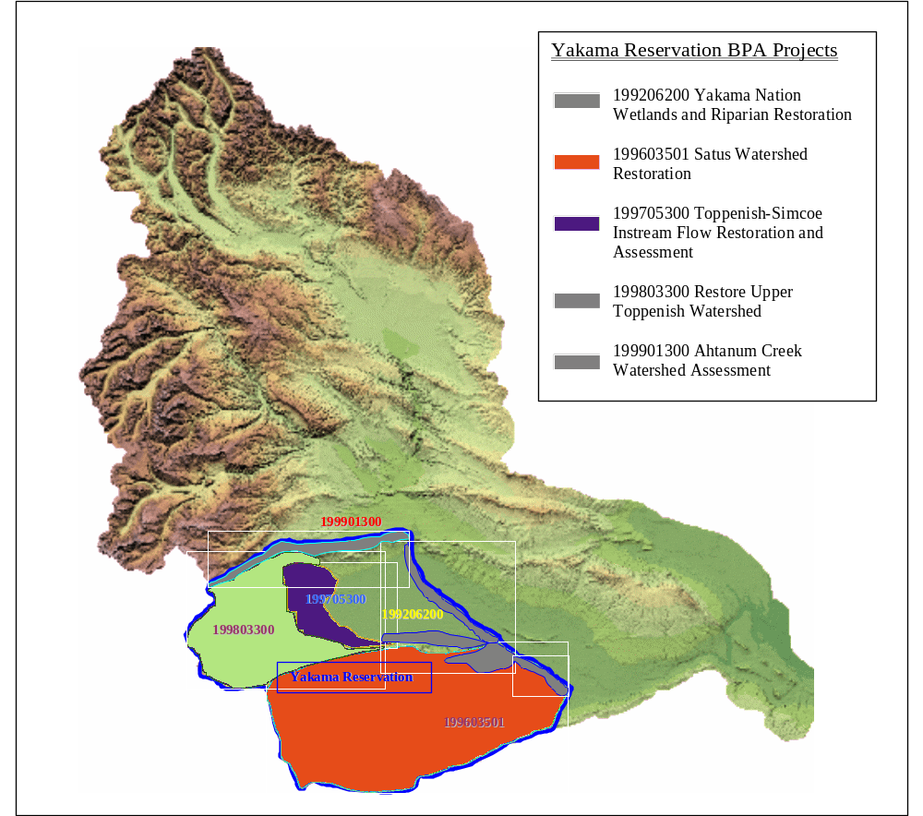
Map of the Yakima Subbasin showing the geographical relationship
between the YN’s on-reservation BPA funded projects.

Satus and Toppenish creeks are the most significant remaining natural production areas for the declining population of Yakima River steelhead. Together, these watersheds produce 60-75% of the Yakima River steelhead, while comprising only 20% of the land area of the Yakima Sub-Basin. The Yakama Nation has recently acquired control over the last remaining irrigation diversion on Satus Creek. Satus Creek is now the only significant tributary of the Yakima River that is undiverted.
The Yakima River steelhead population has suffered a serious decline since monitoring began in 1988. This trend is unlikely to reverse itself soon, judging by the low outmigrations of summer steelhead smolts from the Yakima Sub-Basin in recent years. Poor smolt production indicates that spawning and rearing conditions are limiting steelhead populations. Management of this watershed has profound implications for the Satus Creek steelhead run and, in turn, for the entire Yakima Basin run.
While anadromous fish are the primary focus of this project, wildlife are also intended beneficiaries. No upland restoration projects are implemented without first consulting with tribal wildlife staff. Furthermore, any improvements made to aquatic habitat through riparian recovery will similarly benefit any riparian dependent species. Specifically, these wildlife species include neo-tropical birds, big game, fir bearers, and others. Beaver recovery is a primary objective of this project.

In 1996, the Bureau of Indian Affairs funded an analysis of the Satus Creek watershed. This document has guided our restoration activities. Following are key passages from the watershed analysis, along with comments relating the quoted passage to project activities.

Fisheries
“Experimental evidence suggests that water temperature is the most critical water quality parameter for Satus Creek. There are several relevant types of temperature responses, including individual and population growth rate, avoidance, and mortality. The upper incipient lethal temperature (lethal to half the test fish in 96 hours) for rainbow trout was 78 F in a study by Hokanson et al. (1977). These authors also reported that rainbow trout avoided waters warmer than 70-73 F. Effects on individual and population growth rates occurred at temperatures of 70 degrees and lower.
More summer temperature data are needed to predict long-term temperature effects on Satus basin steelhead. Using mortality and avoidance responses, it is reasonable to assume that water temperatures above 70 F decrease the usefulness of habitat, and that a temperature of 78 F is lethal. Diel temperature fluctuations in Satus and Logy creeks can be accounted for using the finding of Hokanson et al. that fish subjected to fluctuating temperatures responded as they would to a constant temperature about midway between the mean and the maximum. Accordingly, during the hot period of August 24-27, 1993, juvenile steelhead would tend to avoid 35 miles of Satus Creek downstream from Wilson Charley Creek and upstream of a point between North Satus Road and Mule Dry Creek, and 2.5 miles of Logy Creek from the second crossing to the mouth. Outright mortality could be expected in part of the 13-mile reach of Satus Creek between the first crossing and Mule Dry Creek.”

Comments: Habitat restoration efforts have been focused on the stream reaches with temperature regimes favorable to steelhead rearing. Changes in the stream temperature regime are symptomatic of impaired watershed functioning (i.e., flashy flows, channel widening and instability, loss of groundwater inputs, etc.) and will be reversed as watershed condition condition improves.

Wildlife
“Wildlife habitat in the Satus watershed has been dramatically altered by land uses during the last 100 years. Extensive logging has resulted in fragmented habitats, loss of old growth forest stands, and high road densities. Road-building associated with forest management has undoubtedly increased siltation in tributaries of Satus Creek and is clearly implicated in high vulnerability of elk and deer to hunting mortality. In particular, high mortality among adult male elk appears to be limiting the number of breeding age males in the population, and high road densities are an extremely important factor in reduced survival of male elk in the Satus elk herd relative to other reservation subpopulations.
Heavy grazing by domestic livestock and a large wild horse population also has substantially altered the composition, biomass, and structure of shrub-steppe grasslands, riparian areas, and meadows of the Satus watershed. Physiographic conditions of the lower Satus watershed appear appropriate to support a much higher density of wintering elk and deer, but reduced forage biomass associated with livestock and wild horse grazing may currently limit use by wintering big game. Reductions in non- big game grazing and habitat enhancement could effectively increase the value of the lower Satus for wintering elk and deer and could also facilitate favorable habitat for the reintroduction of pronghorn antelope.
Degradation of riparian habitats from years of heavy livestock use have probably altered wildlife species assemblages and abundance in many Satus watershed tributaries. Reducing heavy livestock use in riparian areas could be extremely effective in rehabilitating riparian plant communities and restoring faunal diversity in these habitats. Reducing livestock presence in riparian habitats would also undoubtedly increase use of riparian habitats by wildlife species that are sensitive to disturbance by livestock. These species would include elk, deer to a lesser degree, and ground and shrub-nesting birds.
Grazing and wildfire have also altered sagebrush-dominated habitats of the Satus watershed. Conservation of remaining sagebrush-dominated habitats and habitat enhancements are likely to be major determinants of the suitability of habitat for reintroductions of sage grouse and pronghorn antelope to the lower Satus watershed. In the absence of effective sagebrush habitat conservation, species with strong affinities for these communities will continue to decline and biodiversity of the lower watershed will continue to be negatively impacted by intensive land use effects. With proper planning and appropriate changes to land uses in the Satus watershed, the large undeveloped area of the lower watershed could produce one of the largest remnant tracts of functional shrub-steppe habitat in eastern Washington.”

Comments: Effective management of both cattle and wild horses has the potential to improve watershed functioning and fish and wildlife habitat. Improving grazing management throughout the Satus Creek watershed has been an objective since the inception of the project. Results of our efforts are discussed below.

Hydrologic Change
Two periods: pre-1950 (1910 – 1949), and post-1950 (1950 – 1989) were utilized in the analysis of climate and streamflow records. This division reflects an approximately even partitioning of the period of record. It also coincides with the initiation of large-scale logging and road-building activities in the watershed, and with the earliest complete aerial photograph set of the watershed.
Analysis of flow records indicates changes in the flow regime in Satus Creek since gaging began. Runoff characteristics during the high flow season have become more extreme. The post-1950 period has had average annual water yields approximately 38% higher than the pre-1950 period. Figure 7 illustrates the peak monthly runoffs for both periods. In addition to higher yields, the post-1950 period exhibits earlier peak runoff, greater variability among years, and greater relative variation among the high flow months (December through May). Flows from the watershed are generally earlier and flashier.
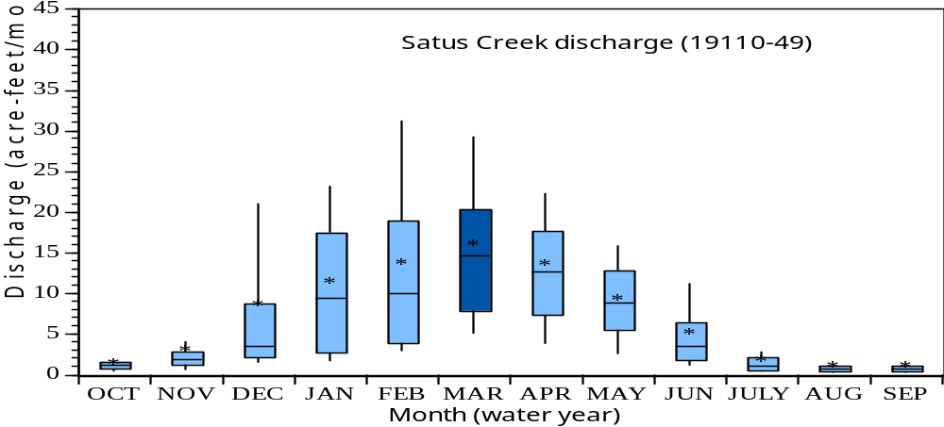

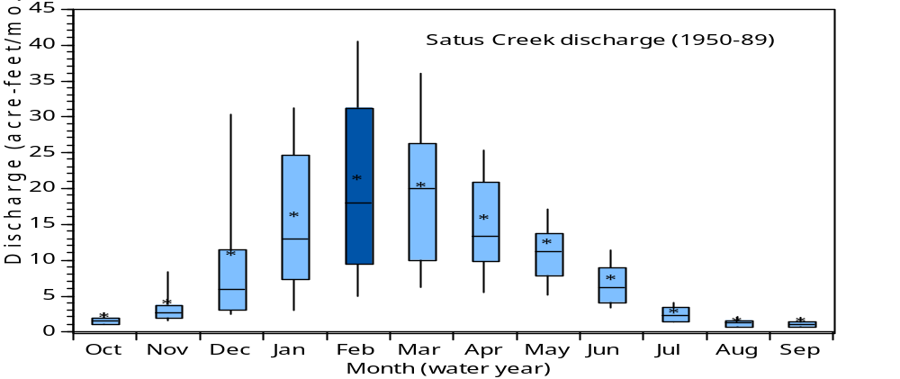

Analysis of precipitation data reveals that there are also climatic differences between the pre- and post -1950 periods. Post-1950 average annual precipitation has been approximately 15% higher than in the pre-1950 period. Peak precipitation has shifted from December, before 1950, to January, after 1950. Additionally, there has been a striking change in June precipitation, which averaged 0.9 inch before 1950, and 0.4 inch after 1950.

Channel Change
Satus Creek and its tributaries have undergone both types of channel change. The mainstem of Satus and lower reaches of Dry, Kusshi, and Wilson-Charley creeks, subject to the cumulative effects of watershed changes exhibit a trend toward widening and straightening - typical channel responses to increased bedload and peak flows. Aerial photograph analysis has revealed changes in both channel structure and the stabilizing riparian vegetation between 1949 and 1997 along the mainstem of Satus Creek.
The channel has widened substantially throughout the unconfined reaches of Satus Creek, as shown by the increase in stream bars (both mid-channel and point) between 1949 and 1997 (figure 10), with the trend increasing in the downstream direction. These changes, often occurring despite the presence of a robust riparian plant community, are indicative of a cumulative loss of channel stability due to increased high flows and/or bedload. Two floods occurring between the 1995 and 1997 photo sets were the driving force causing the large increase in stream bars. Channels in semi-arid systems typically have a pattern of greater disturbance, followed by longer recovery periods, than do streams draining more mesic watersheds of similar size. The magnitude of the recent increase in stream bars suggest that the stream’s natural ability to recover from disturbance is being exceeded by the disturbance factors now operating on the stream. The result is channel destabilization.

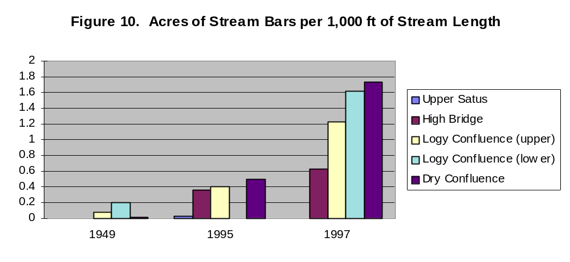

Comments: Headwater restoration treatments are intended to moderate runoff characteristics. Riparian restoration activities focus on vegetating point bars. Stabilizing the point bars supports narrowing of the channel, sediment capture, floodplain interactions and increased channel complexity and sinuosity.

Sediment transport
Due to the difficulty in directly measuring suspended sediment, turbidity is a common surrogate for suspended sediment in water quality studies and standards, and in watershed analyses. This approach was adopted in characterizing suspended sediment transport in Satus Creek. Periodic measurements of turbidity throughout the stream system have been conducted since January, 1997. Although this is not a sufficient record to fully characterize suspended sediment transport within the watershed, analysis of turbidity data reveals trends in sediment production and transport along Satus Creek. Figure 9 shows the average relative turbidity at each of 12 stations along Satus Creek. Relative turbidity was determined by indexing the reading at each station to the maximum reading collected along the creek on the day of sampling. These indexed readings were then averaged for all the dates on which data were collected.

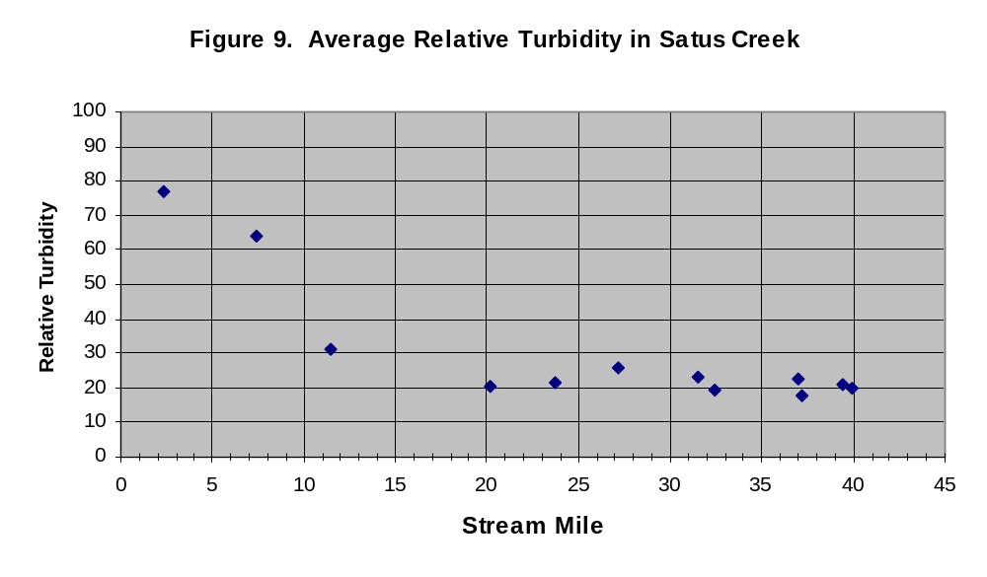

Suspended sediment concentrations, as represented by turbidity values, through the length of Satus Creek are generally inversely related to valley gradient. This pattern can be expected under natural conditions in the moderate- to high-gradient stream reaches found above stream mile 11. Natural surface erosion rates are maximum in the 15-18 inch precipitation zone. This is the interface between rangelands and the forest, where there is incomplete coverage of the ground surface by vegetation, combined with adequate precipitation to cause substantial erosion. The tributaries draining the forest edge (i.e., Wilson-Charley, Kusshi, and Dry creeks) would naturally contribute high sediment loads relative to those with alpine headwaters (i.e., Satus and Logy creeks). However, natural erosion processes usually cause the great majority of suspended sediment transport to occur during the ascending stage of a runoff event, as the system flushes out the fines accessed by rising flows and expanding stream systems. Observation indicates high suspended sediment concentrations throughout high flow periods, indicating accelerated erosion. The primary sources appear to be from road surfaces, cut, and fill slopes, road ditches, and erosion of unstable streambanks.

Comments: Moderating flow patterns and increasing floodplain connectivity are watershed-scale means of reducing bank erosion. We are also addressing road-related erosion through working with tribal and BIA personnel to improve the transportation system.

Vegetation
Analysis of aerial photos circa 1949 confirms that rangeland riparian plant communities were generally intact and functional. However, from 1949 to 1995, there was almost no recruitment of black cottonwood and various riparian shrubs into the overstory vegetation along Satus Creek. There was extensive conversion to more xeric (e.g. big sagebrush) vegetation or to post-disturbance colonial species such as sitka and thinleaf alder (figure 11). Note that these vegetative measurements were taken from 1995 aerial photos, before the major floods of 1996 and 1997.

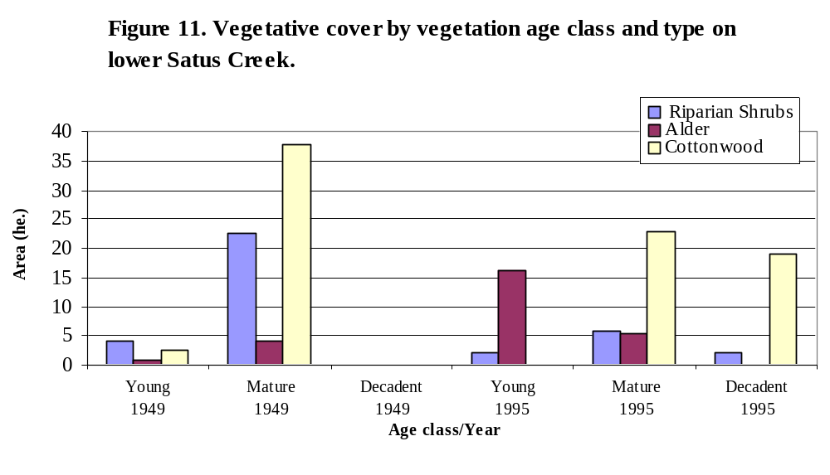

Comments: Loss of cottonwood recruitment is a common problem in the western U.S., indicative of a loss of floodplain interactions. We are applying direct treatments to restore cottonwoods in certain areas of the watershed, but the long-term solution is to recover normative channel/floodplain interactions.

Riparian Proper Functioning Condition (PFC) Assessment
We have conducted Riparian PFC assessment on 25 miles of streams in the Satus Creek watershed. Assessments include sample reaches of perennial streams within the forested area (upper Satus Creek, South Fork Logy Creek, North Fork Dry Creek), and perennial and intermittent stream reaches in the range area (Kusshi Creek, Tenie Creek, lower Dry Creek, and lower Satus Creek). Ten miles of the surveyed reaches were assessed as seriously degraded and not functioning properly; approximately eight miles were assessed as impaired but functional; approximately seven miles were assessed as being in good condition and functioning properly. The general trend in the assessments indicates that riparian functioning condition is degraded in the lower watershed, but improves with increasing elevation. This is partly due to less disturbance and cumulative effects high in the watershed, and partly due to the increasing sensitivity of the lower gradient, alluvial stream reaches in the lower watershed. Assessments completed to date have supported the identification of restoration priorities.

c. Rationale and significance to Regional Programs

The long term goal of the Yakama Indian nation is to restore summer steelhead to harvestable levels, while maintaining the genetic integrity and adaptability of the population. The Yakima Subbasin Plan outlined in Volume II, Wy-Kan-Ush-Mi-Wa-Kish-Wit, establishes a summer steelhead adult return goal of 29,700 for the entire sub-basin. This will involve restoring terrestrial and aquatic habitat to conditions capable of supporting all freshwater life history stages of summer steelhead. As noted in the FWP, “improv[ed] habitat quality [is] needed to increase the productivity of many stocks. Reduced habitat quality results in lower survival during critical spawning, incubation, rearing and migration periods… Improved habitat quality would allow greater juvenile and adult survival at each freshwater life stage and can result in more offspring surviving to begin migration to the ocean”. The Yakima Subbasin Summary corroborates this assertion by stating “Success in implementing this measure, (restoring floodplain connectivity) in combination with restoring the riparian community, will go far toward alleviating perhaps the single greatest constraint on natural production in the Yakima today: a lack of habitat complexity and diversity.” Additionally, improvements made to aquatic habitat through providing a more normative flow regime and healthier riparian/wetland areas will have commensurate benefits to a wide variety of wildlife species.
This project “build[s] form strength” in that “efforts to improve the status of fish and wildlife populations in the basin should protect habitat that supports existing populations that are relatively healthy and productive.” (2000 FWP, pp.26) The proposed actions are also consistent with the scientific principles outlined in section III B and habitat strategies in Section III D.
The National Marine Fisheries Service recently published a set of Reasonable and Prudent Alternatives to guide land use in the basin. While not all of them apply to this project, those that do are being given due consideration. This proposal will: help protect currently productive salmonid habitat (Action 150), increase instream flows (Action 151), and utilize funding from a variety of sources (Action 151, 153) including the Bureau of Indian Affairs, Yakama Nation, and tribal livestock permittees.
Analysis of data collected indicates a suite of changes to the functioning of the Satus Creek watershed over the last 50 years. These changes include vegetative changes across the watershed, increased drainage density, extensive road construction, stream diking and channelization, removal of large woody debris, channel changes (i.e., straightening, widening/bank erosion, channel incision, braiding), changes in the structure and composition of riparian vegetation, and a more extreme flow regime. Although some habitat degradation is attributable to local disturbance, our working hypothesis is that aquatic habitat is created by the watershed-scale interactions between water, soil, and vegetation. It follows that changes to these interactions will cause changes to the aquatic, as well as terrestrial, habitat. The altered, more extreme flow regime identified by watershed analysis in the Satus watershed, accompanied by wide-spread habitat degradation not attributable to on-site disturbances, is indicative of impaired watershed functioning as a cause of the habitat degradation.
This view of the influence of upland conditions on aquatic habitat is supported by the FWP: “Maintaining and improving the productivity of salmon and steelhead habitat… requires coordination of virtually all activities that occur in a subbasin… [I]f watershed restoration is to be successful, instream restoration should be accompanied by riparian and upslope restoration. A comprehensive watershed approach can help fisheries resources recover from their depressed state”. It is also consistent with the ‘Statement of Fish and Wildlife Needs’ in theYakima Subbasin Summary (Columbia Fish and Wildlife Authority, 2000). The principal need listed in this document is ‘Restore normative structure and function to aquatic and terrestrial habitat throughout the basin to the greatest degree practicable’. In elaborating on this need, subcategories include: ‘Restore/preserve floodplain connectivity’, ‘Restore normative flows’, ‘Restore normative water quality to basin streams’, and ‘Restore and preserve riparian communities and normative watershed function’.

FWP 7.6A Habitat Goal: Protect and improve habitat conditions to ensure compatibility with the biological needs of salmon, steelhead and other fish and wildlife species. Pursue the following aggressively.
7.6A.1 Ensure human activities affecting production of salmon and steelhead in each subbasin are coordinated on a comprehensive management basis.
The Satus Creek watershed is a vital element in the Yakima River subbasin. The scope of this project includes, to a large degree, coordinating human activities throughout most of the watershed, and throughout all the steelhead spawning and rearing habitat in the watershed.
7.6A.2 At a minimum, maintain the present quantity and productivity of salmon and steelhead habitat. Then, improve the productivity of salmon and steelhead habitat critical to recovery of weak stocks. Next, enhance the productivity of habitat for other stocks of salmon and steelhead. Last, provide access to inaccessible habitat that has been blocked by human development activities.
Aquatic and terrestrial habitat in the Satus Creek watershed is being protected through the previously-mentioned grazing exclosures and leases (Kauffman and Kreuger 1984, Kauffman et al. 1995). Additionally, habitat is being directly improved through riparian revegetation (Beschta 1994), addition of large woody debris (National Research Council 1992), and reconnection of high flow channels. Restoration treatments aimed at restoring watershed functioning include headwater meadow restoration, beaver habitat improvement, revegetation, prescriptions for controlled burning, further improving cattle and wild horse management, and actions to reduce erosion from roads.
Satus Watershed, by virtue of being under single ownership and in a largely undeveloped state, offers a rare opportunity to practice ecologically-based restoration of fish and wildlife habitat the watershed scale.

d. Relationships to other projects

The Satus Project is collaborating with a number of agencies and tribal programs, as well as related restoration projects including:

- The BPA-funded Yakima Fisheries Project’s goal is to increase natural production of salmon and steelhead. Habitat improvements in the Satus Creek watershed support this goal.
- The Yakama Nation’s Restore Upper Toppenish Creek Watershed Project (9803300) The Satus Project is extending restoration activities into the upper Toppenish Creek corridor, utilizing existing personnel and equipment.

- The Yakama Nation’s Lower Yakima Valley Wetlands and Riparian Area Restoration Project (926200) is receiving $ 1.5 million annually from the Bonneville Power Administration to purchase, restore and manage riparian lands along the Yakima River, lower Toppenish Creek, and in lower Satus Creek. These efforts are coordinated with and support the goals of the Satus Watershed Project.

- The Bureau of Indian Affairs funded a watershed analysis and a large headwater restoration project in FY97. The analysis, now complete, has been the guiding document for Satus Creek restoration efforts and the headwater project was designed and implemented in close coordination with Satus Project staff.

- We are sharing staff and resources with a U.S. Department of Defense-funded project to reintroduce sage grouse (proposed for ESA listing) to the Yakama Reservation.

- The Federal Emergency Management Agency has provided funding to repair roads damaged during the flood of February 1996. Satus Project staff took the lead role in this project in order to meet FEMA and transportation requirements while furthering restoration efforts. This project was completed in November 1998.

- Satus staff worked closely with Washington State Department of Transportation on a mitigation plan for original construction/maintenance impacts of U.S. HWY 97 and a proposed realignment of a segment of the highway.

- We are collaborating with the area BPA right-of-way maintenance crew to minimize the affects of right-of-way maintenance activities on Satus Creek and its tributaries.

e. Project history (for ongoing projects)

Overview

The Satus Watershed Project was initiated as an early implementation project in July, 1996. Project restoration efforts have primarily centered on areas having the highest potential for improved spawning and rearing, using approaches suited to limiting factors as we understand them. Upper Satus Creek (above the highest crossing by State Route 97) is the only contiguous, accessible reach of Satus Creek with suitable summer temperatures for rearing juvenile steelhead, and has some of the highest densities of steelhead redds. Active restoration of habitat structure was deemed to have the most benefit in this reach, which has been degraded by floodplain constriction. Dry Creek attracts a significant number of spawners, but the juvenile survival rate is limited by low summer discharge and high summer temperature. In Dry Creek, activities designed to slow runoff from the upper watershed were deemed to have the most potential benefit to steelhead. Logy Creek, the other large tributary of Satus Creek, is the least disturbed of the subwatersheds of Satus Creek. Accordingly, we have not prioritized restoration in the Logy Creek subwatershed.
Ongoing fisheries population, habitat, and stream temperature monitoring have been conducted to identify baseline populations and conditions An extensive monitoring network was established for the measurement of climate and streamflow. Development of these records create the opportunity to track the relationships between climatic input and watershed output, (i.e., changes in watershed functioning). This year we added a continuously-recording turbidity measurement station on a tributary affected by a close-proximity logging road. Although this intensity of watershed monitoring is not generally justified, it was included in this project because the unique cost-sharing opportunities and the ability to perform watershed-scale restoration treatments.

Restoration

Adaptive management is central to achieving the Satus Watershed Project’s restoration goals. Because the basin is entirely under the ownership of the Yakama Indian Nation and the YIN Fisheries Program is holding 5 year grazing leases for 40% of the basin, a unique opportunity exists to apply adaptive management. Small-scale, high-intensity restoration activities are appropriate where acute problems exist (e.g. dikes), however, our restoration philosophy is to develop and apply large-scale, low input restoration techniques which are compatible with sustained economic land use, and that capitalize on natural processes and seasonal opportunity. Based on examination of aerial photographs and land use, streamflow, and climate records, we have drawn inferences on how land uses have affected to fish and wildlife habitat. This provides a context for adaptive management prescriptions that integrate watershed restoration and continued uses such as livestock grazing, forest management, and prescribed burning.
Much of the stream system accessible to anadromous fish in the Satus Creek watershed is unsuitable for rearing habitat due to high summer temperatures. We believe that some of the temperature problems in these stream reaches are attributable to changes in the channel and floodplain, some to changes in the flow regime, and some to natural conditions over which we have no control. Restoring channel function by active means can provide early benefits in certain locations. However, addressing the causes of high summer temperatures is necessarily a long-term proposition where habitat losses due to temperature and flow problems are assumed to have occurred.

Grazing Management
We are resting approximately 40% of the Satus Creek watershed from cattle grazing. This effort began in 1995 with the Satus Creek corridor, and was expanded to Logy Creek and uplands surrounding both streams in 1996. In 1997 we began a system of regular patrols, contacting ranchers or moving cattle ourselves to minimize trespass.
In 2000 our crew repaired or rebuilt more than 40 miles of Range Unit boundary or pasture fences throughout the project. This fence maintenance, combined with daily patrol, has improved grazing permit compliance considerably over the past year. We expect that compliance will continue to improve. This is an ongoing task.
Range Unit 17, which includes all of the North Fork and mainstem of Dry Creek, and the upper Middle Fork, shows the most injury from poorly managed grazing of both wild horses and cattle. Consequently, we have worked closely with the permittees and BIA Range Management Program to develop a much-improved grazing strategy that will essentially eliminate cattle grazing in upper Dry Creek until after the critical growing season. This plan will provide improved forage for stock and easier management for permittees. A contract is under preparation to develop stock water in areas with good forage but relatively low sensitivity. This strategy will remove livestock from the extensive headwater meadow areas of Dry Creek sub-watershed during most of the growing season for riparian/wetland plants.
We have started to implement this plan by repairing or rebuilding the eastern most boundary fences of Range Unit 17. All totaled, nearly 18 miles of fences were upgraded last winter with more scheduled for this summer. Additionally, we have nearly completed 5 miles of new boundary fence which will make available several thousand more acres for grazing rotations. Sites for two stock water wells were established on the opposite side of Toppenish Ridge from Seattle Springs. We are currently in the final stages of the tribal well permitting process and will install the wells this summer. We also solicited a U.S.D.A grant to supplement the Satus Projects and tribal funds for this Range Unit 17 grazing management project.
As we systematically restructure grazing management in the Satus Watershed, Range Unit by Range Unit, the impacts of cattle grazing should be reduced to virtually zero within the next several years. A wild horse management plan, developed in collaboration with theYakama Nation Wildlife Program Sage Grouse reintroduction team and BIA Range Management Program, has been approved by YN Tribal Council. Implementation will begin this spring, as the rangeland and forest areas become fully accessible. This effort will ‘close the loop’ in regards to grazing management in the Satus Watershed.

Vegetation Management
Previous Years
Revegetating areas critical to watershed functioning has been emphasized since our project inception. Earlier revegetation efforts include:
- Floods in 1996 and 1997 created substantial fresh sediment deposits on the floodplains in the Satus Creek watershed. These areas were broadcast seeded with native grass seed as soon as they became accessible.
- Experimental treatments were performed in spring 1997 and 1998 with willow propagation. Willow sticks were dumped into Satus and Dry creeks at various locations and differing flows. Other sticks were secured into the bed of point and mid-channel bars. A subsample of sticks from each treatment were marked for monitoring survival rates and transport characteristics. Establishment rates (83%) from the secured sticks has been very encouraging, however beaver damage has been severe.
- Experimental treatments were performed with root severing of aspen and cottonwoods to promote a suckering response. These treatments are being monitored.
- Sedges were transplanted into incised intermittent stream channels to act as seed sources for downstream propagation.
- 400 ponderosa pine seedlings were planted in strategic locations on the Satus Creek floodplain to provide stream shading and high quality large woody debris in the future. Success has been very limited (approximately 25%) due to flood damage, animal damage and the marginal conditions low in the watershed. The seedling that have persisted are growing vigorously.
- Aspen is in decline across the landscape due to changes in the disturbance regime which have severely reduced regeneration. As the preferred beaver fodder, its decline has reduced beaver habitat. We have removed encroaching conifers in many of the aspen stands in the Satus Creek watershed, and will be applying treatments such as prescribed fire to stimulate propagation.

Years 2000 & 2001
Planting riparian hardwood species has been widely practiced as a means of restoring riparian areas. Unfortunately, many of these projects have met with limited success, as specific site conditions and species requirements are not always taken into consideration. The Satus Project is currently developing new “high volume – low cost” techniques to reestablish riparian hardwoods. While success with these methods has been mixed, we have refined one technique that consistently establishes plants. In past years we have emphasized two willow species, coyote willow (Salix exigua) and arroyo willow (Salix lasiolepis). In April of 1999 and 2000, Satus Project personnel planted approximately 100 black cottonwood (Populus trichocarpa) sucker cuttings. Final result won’t be tallied until the end of the current growing season, but preliminary observations suggest success will be quite high.
This past year we have performed a number of revegetation projects throughout the watershed. These projects include a couple of reseedings where past efforts failed. Portions of the decommissioned Lakebeds road along upper Satus Creek were reseeded with considerable success. The perennial grass cover will now be sufficient to all but eliminate surface erosion into the prime spawning sites in this area. Second, we reseeded a portion of the 1998 Logy Cow Camp fire that had been disturbed by trespass cattle. The seed mix was altered to optimize seedling rooting characteristics for the site and broadcast in November 1999. Establishment this spring was excellent and we have had no further problems with trespass cattle.
In the winter of 2000, a 30-acre prescribed burn was carried out on the Satus Creek floodplain. This was the first step in the process of restoring native vegetation to this site. Other revegetation activities are described in the Fire Rehabilitation section below.

Reseeding at Logy Cow Camp. May, 2000.

Fire Rehabilitation
Following forest and range fires in the Satus Creek drainage in 1994, 1996,1997, and 1998 we fenced and revegetated approximately 3,000 acres of burned areas, and mechanically rehabilitated fire lines and other sites associated with suppression efforts.
Range fires in the summer of 2000 burned 56,000 acres in the eastern areas of the Satus Creek watershed, threatening serious degradation to water quality and spawning habitat. In addition to reseeding approximately 60 miles of floodplain,and rehabilitation of 30 miles of fire lines, we have installed 150 straw bale structures to trap sediment in the ephemeral and intermittent channels throughout the burned area. These structures are proving to be effective in capturing sediment, and we are in the process of seeding and planting cottonwood cuttings into the fresh deposits.

Upper Satus Creek Sub-watershed
Road removal. In 1998 we decommissioned 4 .4 miles of road located in the floodplain of a key reach spawning and rearing reach. Three large culvert crossings of Satus Creek were removed, road drainage features altered to convert channelized surface flow to subsurface flow, and the road surface was ripped and seeded. An additional 2.2 miles of new road were constructed to provide an alternative route to upper Satus Creek.

Dike removal. Concurrent with the road obliteration we removed approximately 2,000 linear feet of dikes from the banks of the highest quality spawning and rearing reach of Satus Creek. The larger material was used to construct sills with the objective of reconnecting high flow channels and increasing channel/floodplain interactions.
The road obliteration/dike removal project to this point is a qualified success. Most of the structural treatments installed during the 1998 field season are still in place and functioning reasonably well. Two of the grade control structures were damaged by high flows but are still providing some of the intended benefits. The ripping and installation of water bars on the retired road surface have been effective in preventing concentration of surface runoff, thereby minimizing erosion. Seeding the road surface has resulted in the successful establishment of native grasses. We will continue to monitor this area in the coming year.

Large woody debris (LWD) placement. Large windthrown trees, with rootwads attached, have been added to upper Satus Creek, using a combination of helicopter and excavator placement. Large stumps generated during the course of relocating the Wilson-Charley road (above) have been placed into Wilson-Charley Creek to improve hydraulic complexity.

Boulders. We treated another section of Satus Creek which had long ago been straightened to accommodate a highway by blasting a new channel through bedrock. We revegetated a fillslope prone to surface erosion, and placed boulders in the artificial channel to harbor juvenile and migrating adult steelhead.

Gravel. A 15,000 cubic yard rock crushing operation was completed in December, 1997 to provide road surfacing material at stream crossings and other locations which contribute fine sediment to Satus Creek and its tributaries. About 8,000 cubic yards of this material has now been used to surface the 4 miles of Wilson-Charley Road that are in close proximity to Wilson-Charley Creek. Continuous turbidity monitoring is being conducted to determine if the road improvements are effective.

Wilson Charley Creek
In 1998, in the aftermath of severe damage caused by the 1997-1998 New Years flood, we replaced three undersized culverts with large arched culverts on Wilson Charley Creek, and obliterated and rehabilitated 1.5 miles of obsolete road that was causing heavy sediment inputs to the creek. Construction activities for this project were funded by FEMA; we utilized the opportunity to provide technical input to the planning to ensure that the flood repairs would not merely recreate the pre-flood problems. We prepared and administered the construction contract and performed the associated revegetation activities.
The arch culverts are functioning as planned, allowing unrestricted fish passage and the recovery of natural stream processes and structure.

Dry Creek Sub-watershed
Meadow restoration. Incised channels have been treated to prevent further downcutting and headcutting, and to create sufficient stability that natural recovery can proceed. A headwater area of several hundred acres in extent is being cooperatively worked on by personnel funded by a Bureau of Indian Affairs watershed restoration grant, and by Satus Watershed Project personnel. In its third year, this project is beginning to show significant channel aggradation. Improved grazing management will accelerate recovery processes.

Seattle Creek
Seattle Creek, lowermost of the 5 small tributaries of upper Dry Creek, is disproportionately important in its effect on fish habitat in Dry Creek. Its confluence occurs where Dry Creek changes from perennial to intermittent; any increase in summer flows in this area would extend the perennial reach of Dry Creek. With respect to anadromous fish rearing, this area is critical to survival during the summer months.
Seattle Creek is deeply incised (up to 12 ft) through its alluvial valley; numerous headcuts, initiating from the main channel, have greatly increased the drainage density of this catchment. Consequently, the valley has lost much of its ability to store groundwater and has developed very flashy runoff patterns. Our activities are aimed at aggrading the channel system in order to recover groundwater storage capacity in the valley.
In September of 1998, we relocated a road in the vicinity of Seattle Springs. This effort included abandoning and reclaiming more than a mile of badly eroding road from a previously wet meadow, and relocating it upslope. Revegetation of the abandoned road with native grasses and shrubs has been largely successful, although some control of exotic weeds is still needed. Additionally, we made a trial planting of aspen seedlings near the stream channel. Grazing has been controlled by fencing the valley bottom and by the constant vigilance of our range rider.
In the course of relocating the road, the creek crossing was moved to the bottom of the project area. The crossing consists of an elevated ford designed to initiate channel aggradation. The ford was hardened with cable-concrete mats to protect the crossing from high flows. In the first runoff season (1998-1999) sediment approximately 3 ft deep filled the pond created by the dam.

Hardened ford at Seattle Springs crossing. March, 2000.

In the summer of 2000 we installed straw bale sediment-trapping structures throughout the channel system. This spring we will be vegetating the sediments captured by these structures. Our intention is to return beavers to this stream system as the vegetation and streamflow recover the capability of supporting beaver activity.
We have installed a continuously-recording stream gage at the lower end of the valley. In addition to monitoring vegetation and channel geometry, we intend to track changes in base flow as the valley regains its water storage capacity.

Land Use
As we have progressed in our efforts to restore the Satus Creek watershed, and the historic fish runs, it has become clear that land use decisions have been, are, and will be a dominant influence on the state of our natural systems. We have found that educational outreach as a passive restoration technique is one of the most effective tools at our disposal. Accordingly, we are spending more time with the people who most affect the land: cattle grazers, foresters, road maintenance personnel, elected officials, etc., with the objective of reconciling land use with watershed restoration.

Over the course of the last year we have made notable strides in these areas:
- We provide technical input to Yakama Nation Water Code personnel to ensure that permitted near-stream and in-stream work minimizes and mitigates for disturbance to riparian and aquatic resources.
- We work with BPA powerline maintenance personnel to improve maintenance plans for powerline right-of-ways that are located in stream corridors within the Satus Creek watershed (i.e., Satus and Shinando creeks).
- We cooperated with the Washington State Department of Transportation to develop a slope stabilization and mitigation plan for their HWY 97 segment relocation project.
- Vastly improved communication and cooperation from tribal livestock permittees.
- Increased interaction and cooperation with BIA Forest Engineering (roads) staff.

Caveat
Our restoration activities, like those of everyone else involved in watershed restoration, are still subject to failure due to climatic events. Because our efforts rely largely on natural stream and vegetative processes, they tend to increase in stability, becoming more resistant to disturbance over time. However, there is an element of chance in playing the restoration game. It is our aim to maintain a diverse approach, seeking cost-effective restoration opportunities across the landscape. This approach increases the chance that a given climatic event will create conditions favorable to our efforts in at least part of the watershed.

Fish Habitat and Population Monitoring
Adult Spawning
Steelhead spawning ground surveys were repeated from early March through early June, 2000. As in previous years, reaches in Satus, Logy and Dry Creeks with significant spawning were surveyed three times on foot at approximately 3-week intervals. Due to the early decline in runoff, Mule-Dry Creek was surveyed only twice. Redd locations were flagged and labeled on each survey to prevent counting the same redd more than once.
Surveyors counted a total of 155 redds, which is near the average for the 1990’s. Redd density was highest in Satus Creek with 2.9 redds per mile surveyed, while Logy Creek had 1.4 redds per mile and Dry Creek had 1 redd per mile.
Spawning ground surveys for 2001 were begun in March and will be completed in June. Preliminary findings indicate high numbers of early spawners. It is not clear whether the total number of spawners will be high this year. Unusually low flow conditions may be affecting the timing of spawning activities.
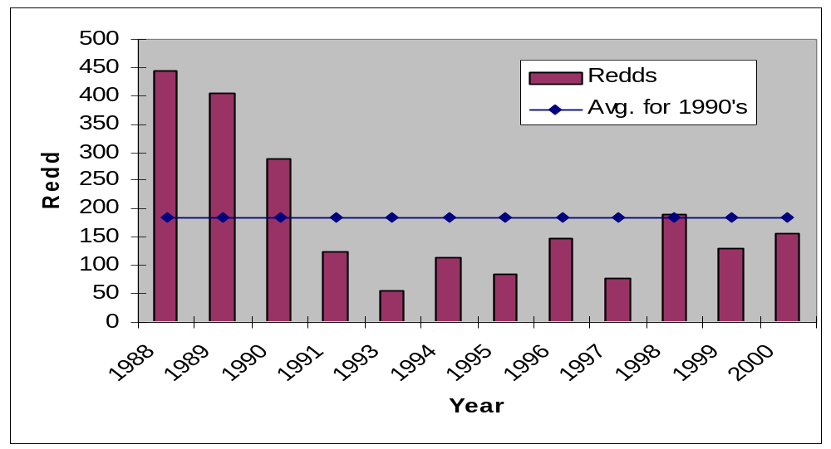

Figure 1) Steelhead redd count totals in the Satus Creek Watershed; 1988-present (no data was collected in 1992).

Stream Temperature
Summer temperature data were collected in the Satus Creek watershed in 1994, 1996, 1997, 1998, 1999, and 2000. Data are collected at sites along Satus Creek from mile 2.3 to mile 44.4 near the headwaters of Satus Creek (Figure 2).
Seven-day average maximum temperatures have been calculated to summarize water temperature extremes in the Satus Creek watershed. The highest average temperatures for all years occurred from late July to early August. Maximum temperatures have been higher than the preferred level at all sites in Satus Creek, and potentially lethal in the lower 30 miles of the stream. Field investigations in 1998

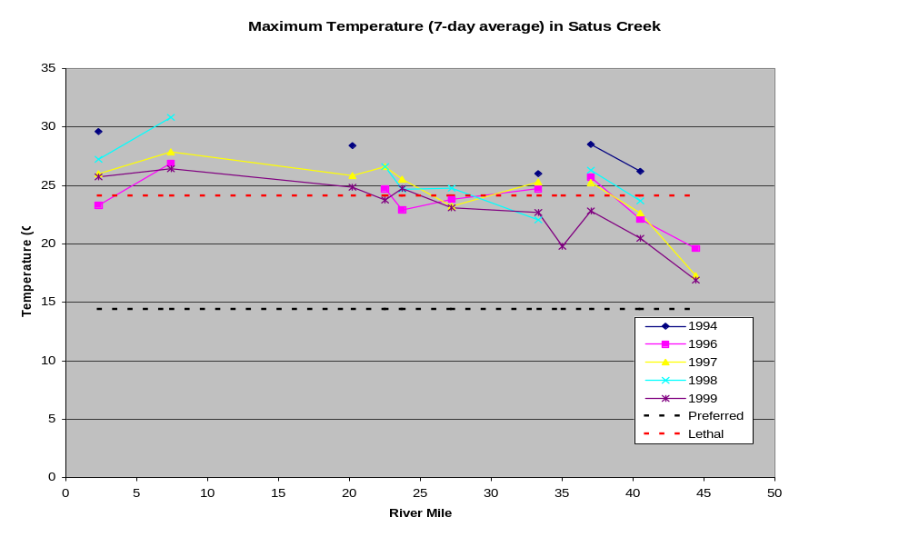
Figure 2. Seven day average maximum temperatures in Satus Creek

showed that upwelling zones could serve as low-temperature refugia in middle reaches of Satus Creek during hot weather.
High water temperatures in the Satus Creek watershed are the result of a combination of natural causes and human activity. A legacy of damaging land use and destructive flooding have degraded channel structure (i.e., wide, shallow, and simplified) throughout much of Satus Creek, exposing surface flow to excessive solar heating. Loss of channel structure and stream/floodplain interactions exacerbate the natural factors (i.e., low elevation, semi-arid landscape) that cause a relatively warm temperature regime.
Warm temperatures can benefit steelhead by increasing the production of prey items, with corresponding rapid growth of juveniles. However, this benefit probably peaks at a temperature below 20 ^{C} (Hubble 1992). Field data indicate that Satus Creek steelhead appear to smolt at an earlier age and migrate downstream earlier in the season than steelhead from cooler watersheds. Both of these characteristics are associated with a rapid growth rate, and can confer a survival benefit that partly offsets the negative effects of high temperature

Watershed Monitoring
We are continuing to monitor our extensive network of stream gages (11 sites) and precipitation gages (10 sites). Our technicians conduct periodic discharge measurements near the stream gaging sites to allow the refinement of stage-discharge relationships. The flow data form the basis for long-term assessment of watershed functioning (i.e., the relationship between precipitation inputs and stream flow) and the way it changes in response to land use, restoration, and natural processes. It has become apparent that these dynamic, high gradient stream systems may undergo frequent channel change, creating a corresponding need to recalculate the relationship between stage (i.e., water surface elevation) and discharge. Accordingly, a more intensive effort to collect discharge measurements may be needed in order to develop good stage-discharge relationships for the periods between channel-changing events. We may consider relocating or decommissioning some of the most problematic gages.
As previously mentioned, we recently added a continuously-recording turbidity measurement station on Wilson-Charley Creek, an important fish-bearing tributary to upper Satus Creek. Although Wilson-Charley Road has been greatly improved in the last 5 years, it is still in close proximity to the creek for about 2 ½ miles. We are monitoring to assess the effect of road use on water quality.
We are in the process of integrating our watershed monitoring data into a newly-developed database that will incorporate all the flow data being collected on the Yakama Reservation. When this process is complete, we will have the capability to compare streamflow and precipitation patterns between different reservation watersheds.

f. Proposal objectives, tasks and methods

The Yakama Indian Nation proposes to improve fish and wildlife habitat in the Satus Creek watershed by ameliorating the effects of past and present land uses. Because this project is founded on the assumption that aquatic habitat is a function of watershed-scale interactions between soil, water, and vegetation, some objectives listed are intended as indicators of the functionality of those interactions. These watershed-scale processes will not change quickly, hence the monitoring of watershed functioning is intended to be a long-term effort.

Objectives
- Restore natural riparian and upland vegetation patterns,

- Reduce erosion,

- Moderate the flow regime on fish bearing streams,

- Improve aquatic habitat,

- Improve wildlife habitat, and

- Monitor changes in fish populations, watershed behavior and results of restoration treatments.

Tasks
Restoration activities (and related objectives)
- Restore grass and woody vegetation in areas critical to watershed function (Objectives 1, 2, 3, 4 and 5).
- Continue the patrol and maintenance of range fences in the Satus Creek watershed (Objectives 1, 2,3, 4 and 5).
- Enhance beaver habitat by propagating riparian hardwoods (Objectives 1, 2,3, 4 and 5).
- Rehabilitate incised ephemeral and intermittent channels (Objectives 2, 3, and 4).
- Reintegrate fire as a landscape process (Objectives 1, 3, 4, and 5).

Monitoring activities (Objective 6)
- Annual spawning ground surveys.
- Repeat fish habitat surveys at 5-year intervals (WDF&W Ambient Monitoring Protocol).
- Monitor streamflow.
- Characterize suspended sediment transport.
- Monitor climate.
- Monitor revegetation success.
- Evaluate effectiveness of sediment-trapping structures.

Methods
Our restoration activities are based on the following assumptions:
- The stream/riparian ecosystem is an expression (integration) of the functioning of the entire watershed, i.e., the landscape-scale interactions between soil, water, and vegetation.
- Long-term sustainability of aquatic and terrestrial ecosystems rely on developing land uses which allow the soil-water-vegetation interactions to remain within a natural range of variability.
- Vegetation is the key to stabilizing soils and moderating the routing of water and sediment through the watershed; manipulation of the vegetation is our primary tool for restoring watershed functioning and normative channel conditions.
- Our restoration activities will gradually alter the routing of sediment and water through the watershed, returning them to within the range capable of supporting healthy aquatic ecosystems.

RESTORATION ACTIVITIES

Task a. Restore grass and woody vegetation in areas critical to watershed function (Objectives 1, 2, 3, 4, and 5) We will continue seeding and planting eroding or sensitive uplands and riparian/wetland areas with appropriate native grass, shrub, and tree species. Our focus is directed toward reestablishing natural vegetative patterns and complexity in key areas of the watershed, especially floodplains, headwater source areas, and eroding uplands.

Task b. Continue the patrol and maintenance of range fences in the Satus Creek watershed (Objectives 1, 2, 3, 4 and 5) We currently patrol and assist with fence maintenance on all rangelands and stream corridors we manage under this project. The project has a full-time technician dedicated to this task monitoring range units daily. This continuing task ensures secure boundaries for recovering areas, preventing new damage caused by livestock trespass.

Task c. Enhance beaver habitat by propagating riparian hardwoods (Objectives 1, 2, 3, 4 and 5) The loss of water and sediment storage behind beaver dams was identified in the watershed analysis as a contributing factor in the degradation of anadromous fish habitat. GIS and aerial photo interpretation, and a literature review on beaver habitat preference are supporting the identification of potential beaver habitat within the watershed. We are reinvigorating and aiding the reestablishment of riparian cottonwood, willow, and aspen stands throughout the Satus Creek watershed through root severing, removal of encroaching conifers, planting on point bars, release of willow sticks under moderately high flow conditions, and prescribed burning. Each site will be monitored with a combination of photo points and cover or density measurements to assess vegetative response and beaver use.

Task d. Rehabilitate incised ephemeral and intermittent channels (Objective 1, 2, 3 and 5). Incised channels around the watershed are being rehabilitated by stabilizing headcuts, constructing sediment traps, and revegetating to stabilize sediments and to promote self-perpetuating channel aggradation. Headcuts will be evaluated in three years to measure stabilization and headward movement. A subsample of sediment traps will be monitored with erosion pins above the upstream face and permanent line-intercept cross-sections to track vegetative establishment.

Task e. Reintegrate fire as a landscape process (Objectivse 1, 3, 4 and 5) We are introducing prescribed fire into the Satus Creek basin, with the goals of improving watershed functioning and restoring high quality aquatic habitat. Under contract with the Yakama Nation, Dr Steve Bunting and Dr Lee Eddleman prepared an ecologically-based prescribed burning plan for the rangelands of the Satus Creek watershed. Implementation of this fire reintroduction plan will play a vital role in ongoing long-term restoration efforts. We will continue burning as soon as conditions allow. The in-house analytic and monitoring capabilities of the YIN Department of Natural Resources will allow us to assess the cumulative effects of fire reintroduction on ecosystem functioning and anadromous fish habitat. A combination of methods will be used to assess vegetative response, soil stability, and water quantity and quality changes.

With respect to vegetation, streamflow, channel morphology, climate, and fish habitat/populations, The Satus Creek watershed is one of the most intensely monitored watersheds of its size in the western United States. This network gives the Satus Project the unique opportunity to precisely monitor changes to watershed function and anadromous fish habitat/populations at both the site and watershed scales.

MONITORING ACTIVITIES (Objective 6)

Task f. Annual spawning ground surveys. The redds of spawning adults are surveyed with three passes through the accessible reaches between March and the first half of June.

Task g. Repeat fish habitat surveys at 5-year intervals. Using theWDF&W Ambient Monitoring Protocol, previously selected stream reaches will be resurveyed during the upcoming field season.

Task h. Monitor streamflow. We will continue to maintain and collect data from our network of continuously-recording stream gages. We will continue to refine our stage-discharge relationships through collection of wading discharge measurements. Streamflow data is being integrated with a newly developed database of Yakama Reservation flow data.

Sharp crested V-notch weir on Seattle Creek. March, 2000.

Task i. Characterize suspended sediment transport. We will continue to take turbidity measurements at all stream gaging sites and at other selected locations throughout the watershed. Additionally, we are field-testing a continuously-recording turbidity measurement station on an important fish-bearing stream.

Task j. Monitor climate. We will continue to maintain and collect data from ten permanent climate stations that continuously monitor precipitation and temperature across the watershed. This information will be used monitor changes in precipitation-streamflow.

Task k. Monitor revegetation success. The success of revegetation projects that were initiated in 1999 will be evaluated and documented through site visits and photographs taken from photo points.

Task l. Evaluate effectiveness of sediment-trapping structures. Photo points documenting sediment accumulation and revegetation behind sediment-trapping structures will be updated.

Uncertainties
Weather is the critical uncertainty associated with the success of our restoration efforts. Various project restoration activities are designed to capitalize on a range of climatic conditions (e.g., high flow periods), however, success in manipulating the vegetation in any given year will still be dependent upon at least moderately favorable weather. The secondary uncertainty lies in the assumption that improving spawning and rearing conditions will increase steelhead numbers in the Satus Creek basin. No single project can encompass the entire steelhead life cycle; this project deals with providing a larger supply of outmigrants to benefit from downstream improvements and accelerate the stock recovery process. Mainstem river and ocean conditions are being addressed by other projects.

g. Facilities and equipment

The Satus Watershed Project has already acquired virtually all the facilities and equipment required to perform most of the tasks listed above. These include: a fully-furnished office, vehicles, tractor, trailer, snow machines, quads, hand tools and monitoring equipment. Other special equipment which is infrequently used or too expensive to justify purchasing, such as an excavator, will be leased, rented, or contracted.

h. References

Reference (include web address if available online) | Submitted w/form (y/n)
Beschta, R.L. 1997. Restoration of riparian and aquatic systems for improved aquatic habitats in the upper Columbia River basin. Pages 475-491 in D. Stouter, P.A. Bisson, and R.J. Naiman, eds. Pacific salmon and their ecosystems: status and future options.
Brooks, K.B., P.F. Ffolliott, H.M. Gregersen, and J.L. Thames. 1991. Hydrology and the management of watersheds. Iowa State University Press, Ames, Iowa.
Columbia River Tribal Fish Commission, 1996. Wy-Kan-Ush-Mi-Wa-Kish-Wit, Spirit of the Salmon: The Columbia River Anadromous Fish Restoration Plan of the Nez Perce, Umatilla, Warm Springs, and Yakama Tribes, Volume II. 129 pp. + appendices.
Hubble, J.D. 1992. A study of the summer steelhead, Oncorhyncus mykiss, in several intermittent tributaries of the Satus Creek basin, Washington. M.S. Thesis, Central Washington University.
Kauffman, J.B. and W.C. Kreuger. 1984. Livestock impacts on riparian ecosystems and stream management implications: a review. Journal of Range Management 37: 430-437.
Kauffman, J.B., R.L. Case, D. Lytjen, N. Otting, and D.L. Cummings. 1995. Ecological approaches to riparian restoration in northeastern Oregon. Restoration and Management Notes 13:12-15.
Megahan, W.F. 1987. Pages 335-348 in A.S. Balasubramanian et al, eds. Environmental geotechnics and problematic soils and rocks, proceedings of the symposium, December 1985. Balkema, Rotterdam.
National Research Council. 1992. Restoration of Aquatic Ecosystems: Science, Technology, and Public Policy. National Academy Press.
Ringer, G., T. McCoy, D. Lind, S. Adams, G. Wiltse, and C. Landreau. 1998. Satus Creek watershed analysis. Yakama Nation/Bureau of Indian Affairs internal document, Toppenish, Washington.
Schuett-Hames, D, A. Pleus, L. Bullchild and S. Hall, eds, 1994. Timber-Fish-Wildlife Ambient Monitoring Program Manual. TFW-AM9-94-001. Northwest Indian Fisheries Commission, Olympia, Washington.

Section 10 of 10. Key personnel

GINA RINGER
509) 865-6262, ext. 6647 (W) email: gringer@yakama.com
Education:
M.S., Forest Hydrology, 1994 B.S., Civil Engineering, 1979
minor in ecology B.S., Agricultural Engineering,
Oregon State University University of California at Davis

Experience:
Watershed Hydrologist July 1996 - present
Yakama Indian Nation Satus Watershed Project, Toppenish, Washington
Develop and manage the Satus Watershed Project, implementing grants to perform watershed analysis and restoration; designing and supervising the installation of an extensive monitoring network; analyzing streamflow and climate records; planning and supervising the implementation of watershed restoration treatments; interdisciplinary assessment of riparian and upland areas; interdisciplinary watershed analysis and report preparation; hiring personnel; supervising; preparation and administration of contracts; preparation and delivery of presentations; preparation of funding proposals.

Hydrologist October 1994 - July 1996
Yakama Indian Nation Water Program, Wapato, Washington
Evaluate the effects of land use on the surface waters of the Yakama Reservation; advise staff and policy makers; make recommendations on issues involving surface waters; collect and analyze hydrologic data; hydrologic modeling; technical support; interdisciplinary planning of timber sales.

Hydrologist/Civil Engineer May 1994 - September 1994
Washington Department of Fish and Wildlife, Engineering and Technical Support Section of the Habitat Division, Olympia, Washington.
Hydrologic and hydraulic analysis of natural channels; interdisciplinary development of aquatic habitat restoration and flood risk management plans for the Dungeness and Quilcene rivers; verification and improvement of a model specifying design flows for fish passage.

Publications:
Adams, P.W. and G.O. Ringer. 1994. Summary and annotated bibliography of the effects of timber harvesting and forest roads on water quantity and quality in the Pacific Northwest. Oregon Forest Resources Institute.
Ringer et al. 1998. Satus Creek Watershed Analysis (unpublished – internal Bureau of Indian .

Professional Licenses, Credentials, and Activities:
- Professional Engineer, California, license no. C35359 (License pending in Washington State).
- Member/Instructor, Washington State cadre for providing Riparian Proper Functioning Condition (PFC) training.
- Instructor, Washington State University Cooperative Extension Master Watershed Steward Program.
- Member, American Water Resources Association.
- Member, Society for Range Management.
- Member, Toastmasters International.
.

RESUME´

Thomas H. McCoy
40 Gopher Rd.
wk. (509) 865-6262 Ext. 6647
hm. (509)698-5005

EDUCATION:

M.S. Rangeland Ecology / Watershed Management, (Completed June 1994)
University of Wyoming, Laramie
Graduate advisor Dr. Thomas Wesche

Preceded by graduate studies in rangeland ecology (1991-1992)
Oregon State University, Corvallis
Graduate advisor Dr. John Buckhouse

B.A. Business Administration, (August 1989) followed by 1 year of undergraduate studies in natural resource sciences.
Washington State University, Pullman

PROFESSIONAL EMPLOYMENT:

Watershed Restoration Biologist, (September 1994 to present) Served the past 5 years as the Satus/Toppenish Creek Watershed Restoration Project co-manager for the Yakama Nation. The primary responsibility of this position is identifying natural resource problems that negatively affect anadromous fish habitat, and develop, implement and evaluate restoration treatments. Specifically, these treatments include: developing/implementing a watershed scale fire reintroduction plan; improving grazing management; developing a watershed scale horse management program, developing and implementing road rehabilitation projects; large scale upland and riparian rehabilitation and revegetation projects; interdisciplinary team member for performing proper functioning condition assessment and developing land management activities; developing/implementing monitoring network to track changes in watershed processes (i.e. stream discharge, water quality, climate, vegetative change, and fish habitat/population trends); and performing watershed analysis.

Additional responsibilities include: soliciting funds to implement project activities; budget administration; project reporting; supervision of up to 80 full and part-time employees; public relations; developing documents to meet regulatory requirements (e.g. Environmental Assessments); and presenting project accomplishments to funding entities and appropriate professional meetings.

Graduate Research Assistant, (summer 1992-summer 1994) Department of Range Management and the Wyoming Water Resources Center at the University of Wyoming. Completed a masters thesis on plant-groundwater relationships and riparian vegetative response to flooding. Conducted year-round research on two densely instrumented research watersheds in subalpine and montane zones which include vegetation, precipitation, streamflow, and groundwater well monitoring networks. Supervised 1-6 field technicians. Assisted with sediment transport/flushing flow and riparian/fish habitat restoration projects.

Ranch Worker, (1991-1992) Assisted with daily operations on a small cattle ranch near Falls City Oregon while attending graduate courses at Oregon State University.

Preserve Manager/Ecologist, (summer 1991) The Nature Conservancy's Middle Fork of the John Day River Preserve. Oversaw 1 full time employee and all on site activities, including public relations, designing and implementing long term vegetation and stream channel monitoring programs, and coordinating joint projects with land management agencies. Also assisted local permittees with grazing management programs.

PUBLICATIONS
McCoy, T.H. and G.O. Ringer. 2000. Toppenish Creek Watershed Assessment (unpublished). Yakama Nation internal document, Toppenish, Washington.

PROFESSIONAL MEMBERSHIPS:

Washington State Proper Functioning Condition (PFC) Assessment training Cadre

Society for Range Management

Ecological Society

