Project ID: 199801800

Title: John Day Watershed Restoration

Section 9 of 10. Project descriptions

a. Abstract

This proposal represents a continuation and expansion of the ongoing Watershed Restoration Program within the John Day basin. The proposed projects are intended to improve water quality and quantity, aquatic habitat, and fish production; reduce bank instability, sedimentation, bedload movement, and summer water temperatures thereby improving water quality, reducing or eliminating migratory delays from passage impediments, and improving riparian condition. The proposal also includes implementing an annual monitoring program to evaluate each of these projects.

b. Technical and/or scientific background

Contextual Background

Much of the current limitation on anadromous and resident cold-water fish production is related to degraded habitat condition within the basin. Salmon production issues in the John Day Subbasin Summary are as varied and complex as they are in other river systems (Knapp et al. 2001). However, the John Day lacks any large-scale dams, and fish entering the John Day only pass three Columbia River mainstem dams, much of the Mismanaged grazing and irrigation withdrawals are the primary causes of riparian habitat degradation. Such activities have led to high spring and low summer flows, high summer and low winter water temperatures, reduced pool habitat quality and quantity, increased streambank erosion and sedimentation, decreased instream habitat, decreased riparian vegetation, and weed invasions. Low flows occur in many of the streams in the John Day as a combined result of over-allocation of water, riparian degradation, and the natural characteristics of a semi-arid climate. The John Day Subbasin Summary notes over 600 miles of stream within the John Day Subbasin that have degraded riparian conditions (Knapp et al. 2001). The ecosystem’s natural ability to withstand and recover from damage is impaired by ongoing impacts from unmanaged grazing and irrigation practices, unmitigated historical impacts, and natural effects such as stand replacement fires and flooding.

Destruction of riparian vegetation, as described above, has compromised the quantity and quality of spawning and rearing habitats of native salmonid stocks. Livestock and heavy equipment activities within riparian systems accelerate surface runoff and erosion, leading to elimination of spawning habitat, siltation of spawning beds and suffocation of eggs. Peak flows from increased runoff scour redds and dislodge eggs or alevins. Human activities that occurred over 100 years ago continue to impede salmonid production through altered stream hydrology, reduced riparian vegetation, and scoured streambeds. Certain irrigation practices, such as gravel push-up diversions, have lead to decreased stream flows and channel obstructions that interfere with movement, spawning, and rearing. This reduction in flows and riparian vegetation also affects stream temperatures, one of the most common measures of water quality. All major watersheds within the subbasin experience reduced water quality as defined by temperature. Temperatures far exceeding the preferred range for cold-water salmonids have been recorded in the mainstem and tributaries during summer months. The combination of these factors dramatically shrinks historic ranges of salmonid spawning and rearing habitats, and directly affects pre-spawning mortality (Knapp et al. 2000).

Habitat issues in the John Day have been extensively studied over the last thirty years and are detailed in numerous reports, watershed assessments, management plans, and other similar documents. The Tribes, Oregon Department of Fish and Wildlife (ODFW), Oregon Water Resources Department (OWRD), Northwest Power Planning Council (NPPC), Bonneville Power Administration (BPA), Bureau of Reclamation (BOR), Oregon State University (OSU), and many others have conducted assessments and research, prepared management plans, or implemented restoration activities in response to identified or suspected issues. Managers believe that irrigation system efficiency improvements, along with upland and riparian restoration, would provide the greatest long-term benefits for fish and wildlife while improving late season stream flow for other purposes as well (John Day Subbasin Summary 2001). Where riparian management and watershed restoration activities have occurred, improvements in vegetative structure, density, and diversity, as well as stream temperature, stream flow (i.e.: unimpeded flow), fish activity, wildlife use, and channel structure have been achieved (USDI 2000, Unterwegner and Gray 1998).

In Volume II of The Spirit of the Salmon (Anonymous 1996), the Tribes summarize the following problems in the basin:

“Riparian habitat degradation is the most serious habitat problem in the John Day River Basin with approximately 660 degraded stream miles identified. Degraded fish habitat in the [basin] is a result of low winter water temperature, high spring flows, depressed beaver populations, accelerated streambank erosion, excessive stream sedimentation and reduced instream cover. The basin's ability to naturally repair itself from riparian habitat degradation and other impacts is slow in the John Day's semiarid environment and some areas are adversely affected by activities that ceased long ago. In other cases, poor management practices continue and problems are escalating. As soil erosion increase, flooding occurs and streambanks erode away, degrading habitat quality. In many tributary streams, excessive water volumes are deepening channels, thus lowering water tables in the immediate proximity [internal citation omitted]. Such loss of habitat quantity and quality, managers believe improved irrigation systems along with restoration of the uplands and riparian systems would provide the greatest long-term natural benefits for fish and improve late season stream flow as well.”

Further, the John Day Subbasin Summary (Knapp et al. 2001) states that:

“The most critical need in the John Day Subbasin is associated with habitat, either in protecting currently productive habitat or restoring degraded habitat.”

Other research and assessments, such as the ODFW spring chinook study (Lindsay et. al. 1985) and the OSU multi-year research project, identify similar problems. The Integrated System Plan (Anonymous 1991) summarizes spring chinook salmon production issues as follows:

“Limiting factors on the John Day include a number of habitat-oriented problems. Passage and spawning is limited during low water years due to natural flow condition, but further aggravated by water withdrawals. This invokes high temperatures in certain areas that further restrict spawning.”

In response to identified issues and recommended restoration actions, the basin’s principal management agencies have developed and implemented both active and passive restoration programs, focusing primarily on improving in instream and riparian habitat, water quality and quantity, and channel stabilization. Project efforts rely and build adaptively upon previous and ongoing activities. The John Day Basin Watershed Restoration Program, conducted by the John Day Basin Office of the Confederated Tribes of Warm Springs, is a result of long-term study and planning processes to develop a comprehensive suite of projects that address not only identified issues associated with production, but also gaps in ongoing agency restoration efforts.

Natural Resource Background

Spring Chinook. Over the last 20 years, spring chinook production has been on an upward trend overall in the John Day, with 70% of the last ten year’s spawner-recruit ratios above replacement (Figure 1, Figure 2).
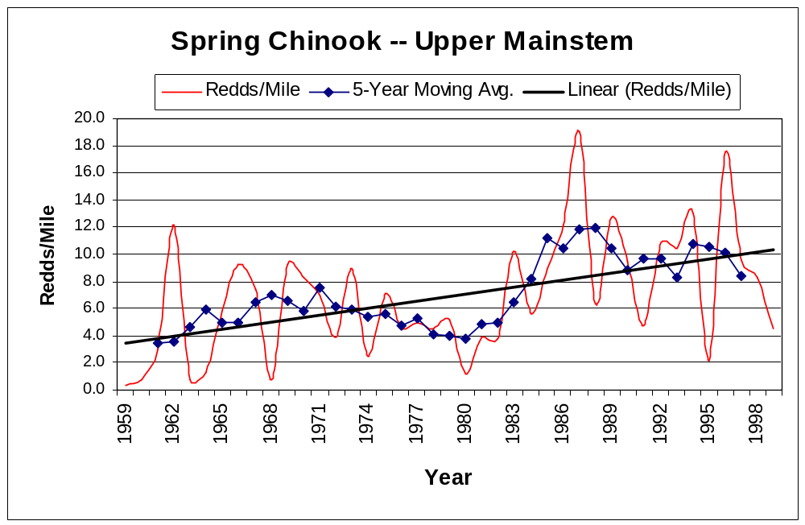

Figure 1. Spring Chinook spawning escapement -- Upper Mainstem John Day River.

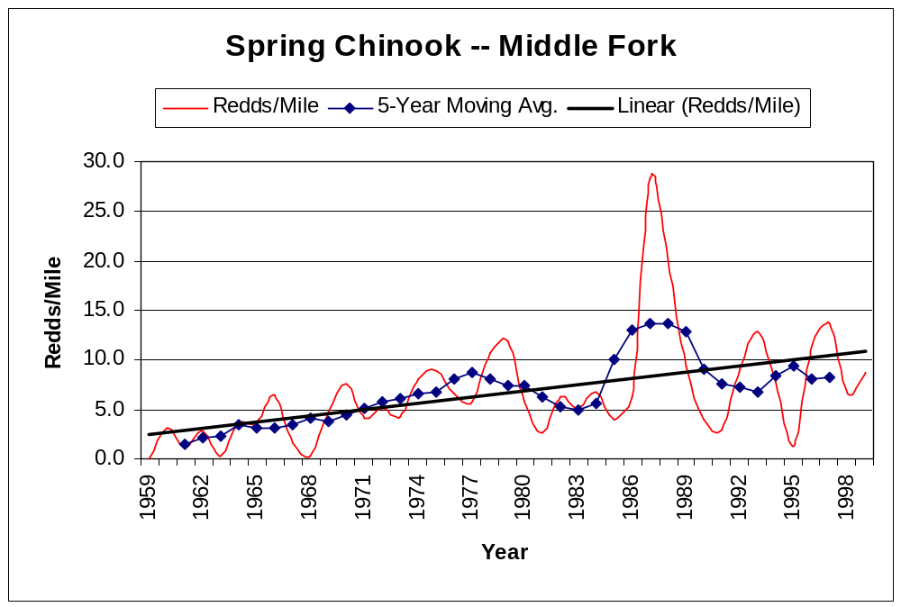

Figure 2. Spring chinook spawning escapement -- Middle Fork John Day River.

In 2000, record numbers spawned within index areas of the John Day River; the highest observed since 1959 (ODFW, unpublished data on file in the JDBO). Adult spring chinook require deep, cool pools with adequate cover, temperature, and food supply. Adults enter the John Day River in late spring and migrate to headwaters to spawn by September. Fry may emerge as early as late February and as late early July, though most emergence occurs between mid-March to mid-June. Emergence may commence earlier depending on water temperature regimes within spawning areas. Rearing habitat is characterized by pools, eddies, side channels, and other areas of moderate velocity. The juveniles will distribute up and downstream depending upon water flow and temperature, and may be forced upstream into cooler tributaries or confined within scarce refugia during the peak of summer and the corresponding irrigation season. Smolts begin their oceanward migrations between April and May, prior to the irrigation season when water demand affects stream flow and temperature (Lindsay et al. 1985).

Habitat as a whole is improving, particularly in the upper mainstem and Middle Fork, where restoration activities have been the most intense. The combination of corridor fencing, push-up diversion replacement, and improved irrigation management has resulted in decreased passage impediments, significant shade increases, stabilized banks, decreased water temperatures, and extended juvenile rearing (Unterwegner and Gray 1998).

Steelhead Trout: In 1999, John Day summer steelhead were listed as a threatened species within the Middle Columbia Evolutionarily Significant Unit (ESU) (NMFS 1997). Due to their spawning and rearing primarily in smaller basin tributaries, steelhead are heavily influenced by changes in habitat (Unterwegner and Gray 1998). Recent declines in abundance have been attributed to poor ocean conditions and a decrease in smolt to adult survival (Chilcote 1998). Although steelhead populations are on a downward trend basin-wide, certain positive elements suggest that restoration efforts may show significant beneficial results. The North Fork and upper mainstem populations are currently the most robust (the upper mainstem has been a focus of previous habitat restoration activities). Passage improvement projects on several tributaries have increased potential spawning and rearing habitat by almost 151 miles. Chilcote (2000) found steelhead populations within the John Day Basin to be low, however, he further states that

“…periods of low smolt to adult survival may be cyclic… assuming this pattern is cyclic, the observed declines can be expected to reverse in the next three to five years. In addition, periods of low smolt to adult survival may be cyclic and can be expected to reverse in the next three to five years… The underlying recruitment relationships… suggest that their capacity to respond to environmental changes is still intact.”

Chilcote’s evaluation provides encouragement for the recovery of wild steelhead populations within the John Day Basin while viable populations are still present.

Bull Trout. Though historical bull trout range covered much of the upper John Day Basin, today their spawning areas are limited to a few key tributaries where stream temperatures are low enough to support reproduction (Claire and Gray 1993). Though current populations are obviously reduced, the population trend is unknown (Knapp et al. 2001). Bull trout are the most sensitive salmonid with respect to habitat conditions, preferring colder temperatures than most other related species. Therefore, individual adults are limited to the cold, deep pools of certain rivers and tributaries, while redds are created in the gravel-lined riffles of small streams. When the young emerge, they remain in the small streams until they are able to migrate along larger waterways. Within the John Day basin, low flows along migratory routes and between suitable spawning tributaries, high temperatures within potential spawning habitat, habitat destruction, reduction in prey base, and hybridization and competition with brook trout are major challenges to bull trout populations within the basin (Knapp et al. 2001, Claire and Gray 1993). The Bull Trout Recovery Team, composed of State, Federal, and Tribal professionals, are currently developing a plan for assessing the health and addressing the limiting factors for bull trout within the John Day Basin.

Stream Water Flows. The John Day Water Optimization Study identified a primary need to increase late season flows, which are often below 25 cfs, in primary spawning and rearing habitat (approximately 13 cfs less than what is needed) (BOR 1994). Accompanying this objective, was a need to lower summer water temperatures within the same general locations. Although water temperatures are greatly affected by the nature and extent of riparian vegetation, stream flow magnitude is potentially the most significant stream parameter leading to stream temperature change (Boyd and Sturdevant 1997). In addition, the 1978—1985 spring chinook study (Lindsay et. al. 1985) identified habitat limitations in the mainstem as a cause of depressed production, and specifically noted areas of suitable habitat that were currently unoccupied due to affects from water withdrawals. Efficient upgrades in irrigation practices allow more water to stay instream without impediment, thereby contributing towards increased stream flows.

Another limiting factor for stream flows is the invasion of upland drainages and springs by junipers. Current juniper densities may range from 200 to 8,000 junipers per acre, compared to historical densities of just one to a few per acre (Stelljes 1994). Dense stands of juniper pose intense competition for nutrient and water competition, and cause decreased soil infiltration, decreased plant species richness and diversity, increased soil temperatures, increased overland erosion (AES OSU 1994, AES OSU 1999, Miller 1994, Miller 1999, Buckhouse 1999). Junipers can sequester and evapotranspire incredible amounts of water. Regarding evapotranspiration alone, a single mature juniper can cycle 29 gallons of water a day. Even during wet years junipers still pose intense competition for water resources (Bates 2000). Upon removal of juniper stands, understory productivity, cover, biomass, diversity, and growth rate of other vegetation has been able to increase (Bates 1998). Significant increases in stream flows have been noted days after juniper removal.

Stream Water Temperatures. The John Day River is listed on the 303(d) list for rearing temperature from the confluence with the North Fork to Reynolds Creek (DEQ). Monitoring stations in the upper mainstem generally reflect water temperatures above the recommended preferred range (below 18°C), and a maximum as high as 29.5°C has been recorded (Robertson and Delano, 1998). Water temperatures in the Middle Fork can exceed 20°C between June and August. Tributaries may be as much as 10°C cooler (Buchanan 1997). Factors leading to these degraded conditions include lack of riparian vegetation, unstable streambanks, and water diversion practices that lower water levels and contribute warmer water in return flows.

Historic Irrigation Practices Background

Generally, irrigation is initiated around April 1 and concludes on September 30, coinciding with legal appropriation dates, however, some diversion for stock watering occurs outside of this period. Diversion rates will generally be lower in the spring, when temperatures are cooler. Irrigation intensifies until haying season, during which it is temporarily shut off, and following which, it is resumed for regrowth and a second cutting of hay. Diversion rates are highly dependent upon temperature, spring moisture, and river levels. Wild flood irrigation is by far the single most common irrigation method and surface water is the most heavily used water source (Anonymous 1996).

Irrigation systems were historically constructed without regard to water efficiency. In many cases, water must travel many miles within the ditch before being applied on the field. Conveyance losses due to evaporation, seepage, and spill can be significant. Diversions that are ineffectively designed and constructed can result in additional misappropriations due to insufficient hydraulic head or seepage and spillage. The 1978—1985 spring chinook study, and other watershed assessments, identified irrigation withdrawals, which reduce flows and increase temperatures, as a possible limiting factor for spring chinook salmon in the mainstem (Lindsay et al 1985).

The interagency watershed assessment and stream restoration plans identify efficiency measures as having the potential for significant, positive effects on flows throughout the irrigation season. Changes in diversion points, where late season water rights in a tributary stream are exchanged for rights in the mainstem and points of diversion are moved downstream closer to the point of application, as well as eliminating late season diversions, should all improve instream flows.

Temporary push-up diversions. Currently, the most common method of irrigation diversion is to construct a push-up dam, using heavy equipment, within the stream at or near the legal point of diversion. The dam is usually constructed of locally available materials, such as cobble, gravel, and boulders that are scavenged from the site, either within the stream channel or off the stream banks. Frequently, other materials such as PVC plastic sheeting, concrete, car bodies, timbers, plywood or other objects are used to provide structural integrity and seal the diversion dam. See (Photo 1) for an example of this type of diversion. Use of heavy equipment can remove riparian vegetation along stream banks. Annual scavenging of materials leads to acute and chronic destabilization of stream banks and beds. Sediment transport to streams from actively eroding banks and headcutting stream channels may contribute to impaired water quality. Increased velocity over the diversion dam scours downstream banks leading to additional bank instability.

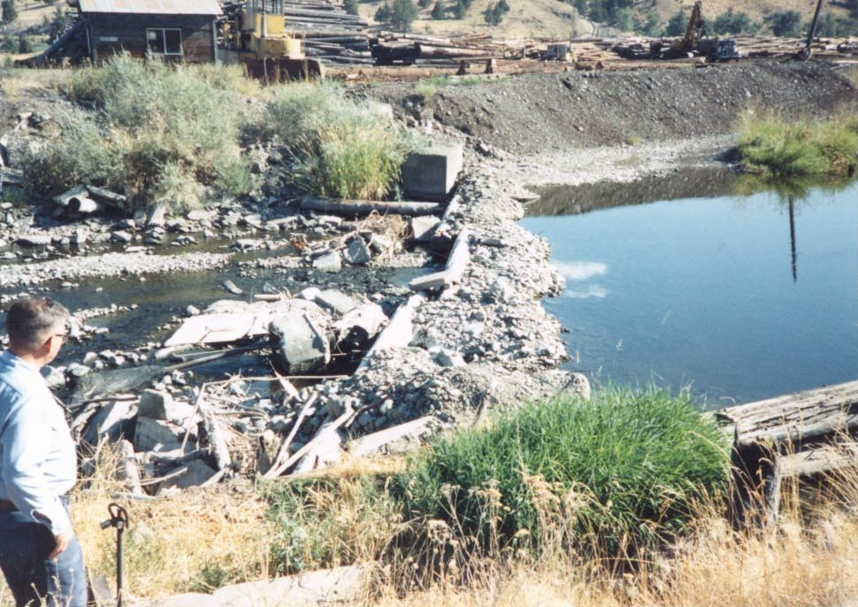

Photo 1. Gravel push-up diversion in the John Day.

As flows decrease through the summer season, additional excavation and placement of material on the dam face (especially plastic sheeting) is often necessary to provide for diversion to rate and duty. Dam materials are usually left in-place throughout the summer and may wash out during spring flows the following year. The effects of annual construction and periodic reconstruction of the push-up diversions, in addition to the affect of the immediate fish passage barrier, is gradual destabilization of the channel and banks and sediment delivery to the stream. As materials are continually pushed-up below the dam and scoured the following spring, a gradual lowering (through headcutting) of the streambed occurs. This typically causes the irrigator to either move the diversion point upstream or to raise the elevation of the diversion structure due to the loss of hydraulic head. This has resulted in diversion points being moved hundreds of feet upstream, causing destabilization all along the stream length.

The principle threat posed by push-up diversions is the physical barrier to passage along a natural waterway. Passage barriers pose significant direct threats to fish production primarily in the following four ways:

- If stream flow is low and diversions are installed prior to the upstream spring migration of steelhead and resident adults, migration may be impeded or delayed leading to pre-spawn mortality or reduced production;
- If streamflows drop prior to adult chinook migration in the summer and adequate fish passage is not assured at diversions, migration may also be delayed or impeded;
- If diversions do not have adequate passage and fish screens have been removed prior to the fall out-migration to over-wintering habitats or spring smolt out-migration of juveniles, fish may become entrained within ditches; and
- If diversions do not have adequate passage or push-up diversions are installed prior to the summer migration out of the mainstem to avoid high water temperatures, summer mortality or reduced production may occur.
Photo 2. Typical push-up diversion prior to replacement.

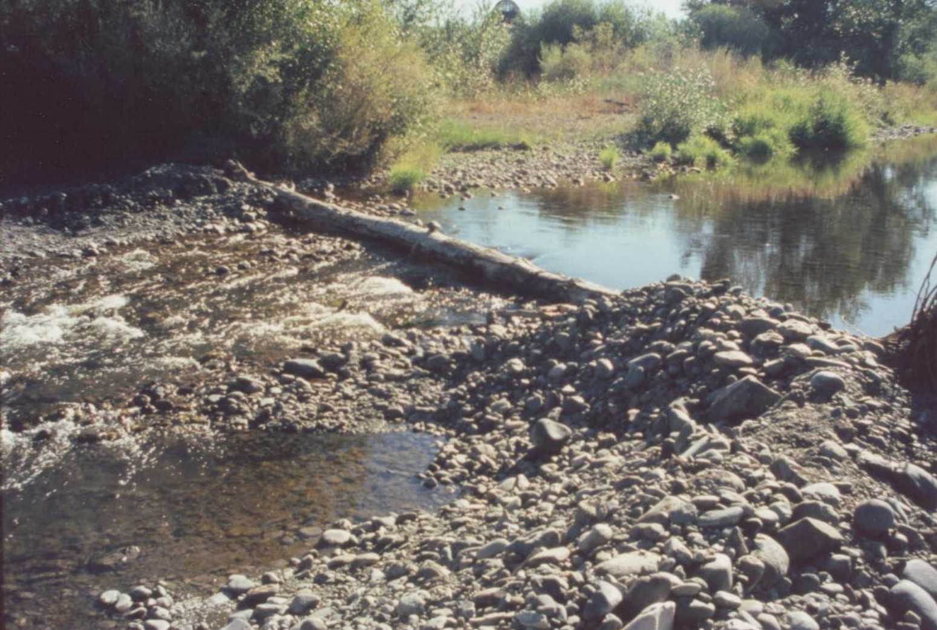
Irrigation conveyance systems. Water is typically diverted from a diversion dam through a headgate and fish screen, through an open conveyance system (usually a ditch or canal), and applied to the field though open laterals. Many ditches were constructed over 70 years ago, without regard to efficiency. The effect has resulted in significant conveyance losses due to long travel times and poorly constructed systems. The cumulative effect has been a reduction in instream flow from inefficiencies in irrigation systems.

Irrigation return flows. Typically, returns from irrigation are collected from the field in open ditches or wooden pipes and carried back to the river. Long travel times with extended exposure to sunlight and ambient air contributes to significant warming of the water prior to reentering the river. In addition, return flows that collect and transport tailwaters in open conveyance systems, or belowground systems that have failed and result in open field ponding, contribute poor quality water to the river. These open conveyance systems may be more than 70 years old. The flows that drain from these systems may be 16°F degrees warmer than the stream they drain into (Robertson and Delano 1998) and be well in exceedance of state water quality standards. Return flows have been noted entering the river at temperatures greater than 80°F and may increase already elevated local river temperatures. In addition, they may convey nutrients and other contaminants to the river.

John Day Watershed Program Construction Features

The John Day Watershed Program focuses its activities on upgrading historical irrigation practices to more efficient, “fish friendly” alternatives. Temporary push-up diversions are replaced by permanent lay-flat diversions, pump stations, or infiltration galleries. Open conveyance and distribution systems may be replaced by enclosed or gated pipe to reduce seepage and evaporative losses. Return flows may be redirected underground to cool as they return to the river, or they may be collected and reused rather than diverting additional, relatively cleaner water from the stream.

Infiltration galleries. Infiltration galleries are well screens that are buried below the surface of the streambed and bedded in gravel. They collect subsurface flow and carry it to a gated valve located at least as far back as the streambank. At this point, flow may be pumped or gravity fed to a conveyance system of pipe or open ditch, and then out to the field where it is either applied through gated valves, open laterals, or sprinklers. A bypass valve and pipe allows for regulation of the diversion to legal rate and duty. The minimal installation depth of the permanent diversion and the nature of intergravel flows precludes any significant interception of subsurface flows. Although infiltration galleries have the least long-term effect on fish passage and bank stability, they can be the most expensive to install, maintain and operate. Photo 2 shows a temporary diversion that was replaced by an infiltration gallery and Photo 3 shows the same site after installation of the infiltration gallery.

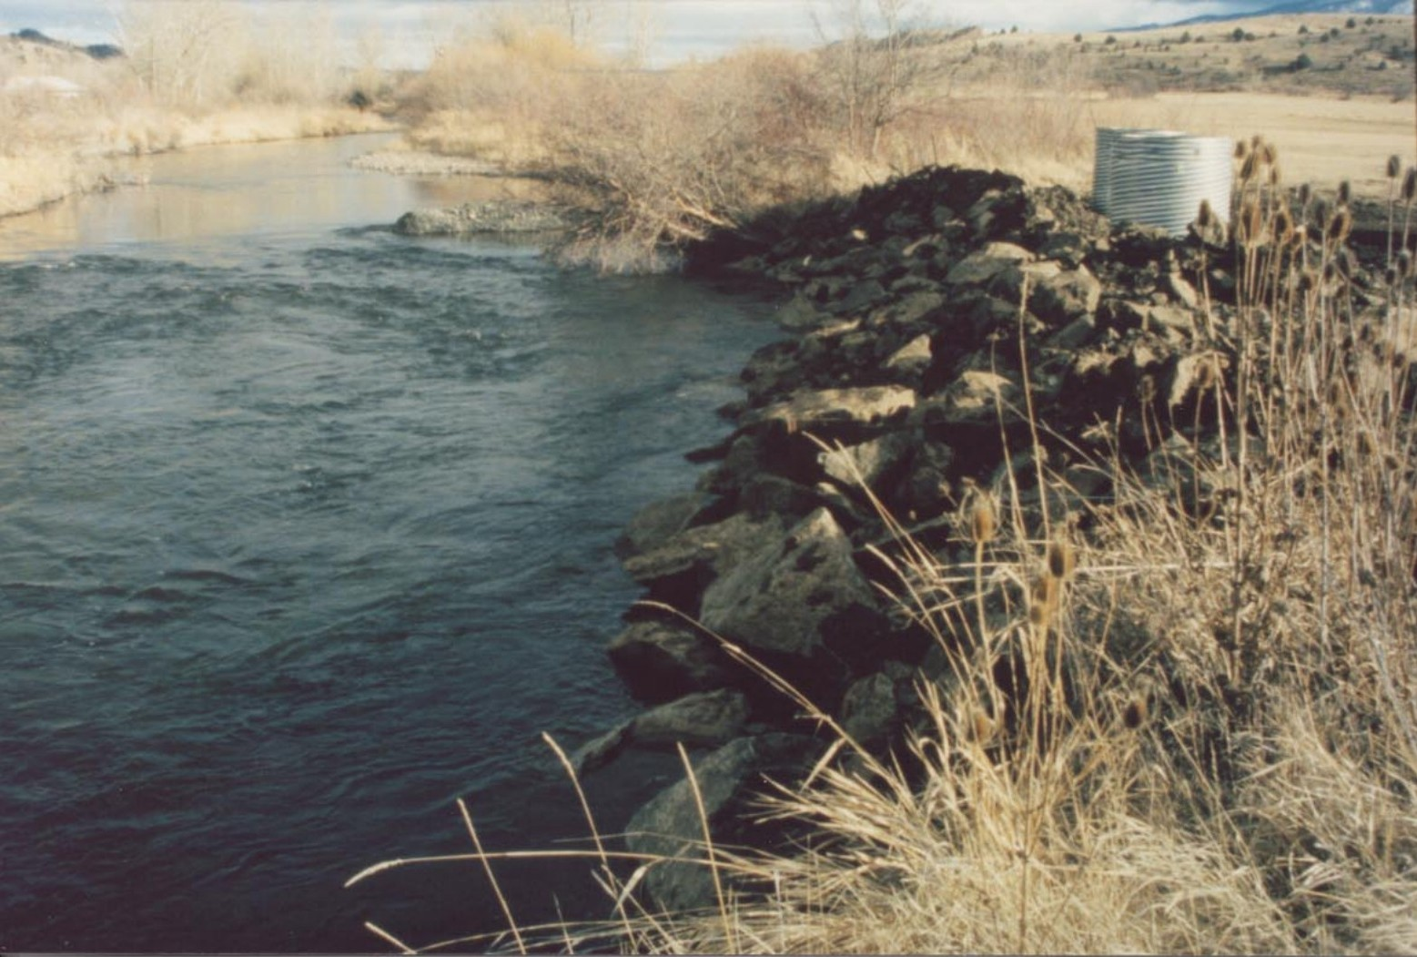

Permanent diversions. Permanent diversions are similar in theory to the temporary push-up diversion but are constructed from concrete and steel, provide fish passage at all water levels, eliminate the need for annual construction, and are significantly more effective and efficient.. The permanent diversions consist of a concrete pad at riverbed grade, two sidewalls, lay-flat stanchions, and a fishway (Photo 4). When the diversion is not in use, the stanchions can be lowered for unrestricted fish passage at all river levels (Photo 5)n, Boards man be placed in front of the stanchionatt raise the water level behind the structure as well as through the fishway. Evaluation of previous projects has shown that when the sill of the spillway is set equal to the elevation of the headgate, flashboards are not even needed until late July or early August in a normal water year, and in some instances, are not even installed (allowing fish passage through both openings). When in use, permanent diversions provide more efficient headgate control and water measurement to ensure legal rate and duty at all flow conditions. To ensure adequate fish passage when the diversion is in use, they are constructed with two separate openings on opposite sides of the river. The spillway is located on the side closest to the headgate, while the fish-way is on the far side of the river. As flashboards are installed in the spillway, the water level rises concurrently in the fish-way (flashboards are not installed in the fish-way), providing additional water for fish passage. The permanent lay-flat diversions are not prone to damage by high flows, therefore maintenance is minimal, sediment input is reduced, streambed/streambank degradation ceases, and aquatic and terrestrial system recovery is possible.
Photo 3. Typical infiltration gallery site after installation. The push-up diversion that was replaced is shown in Photo 2.

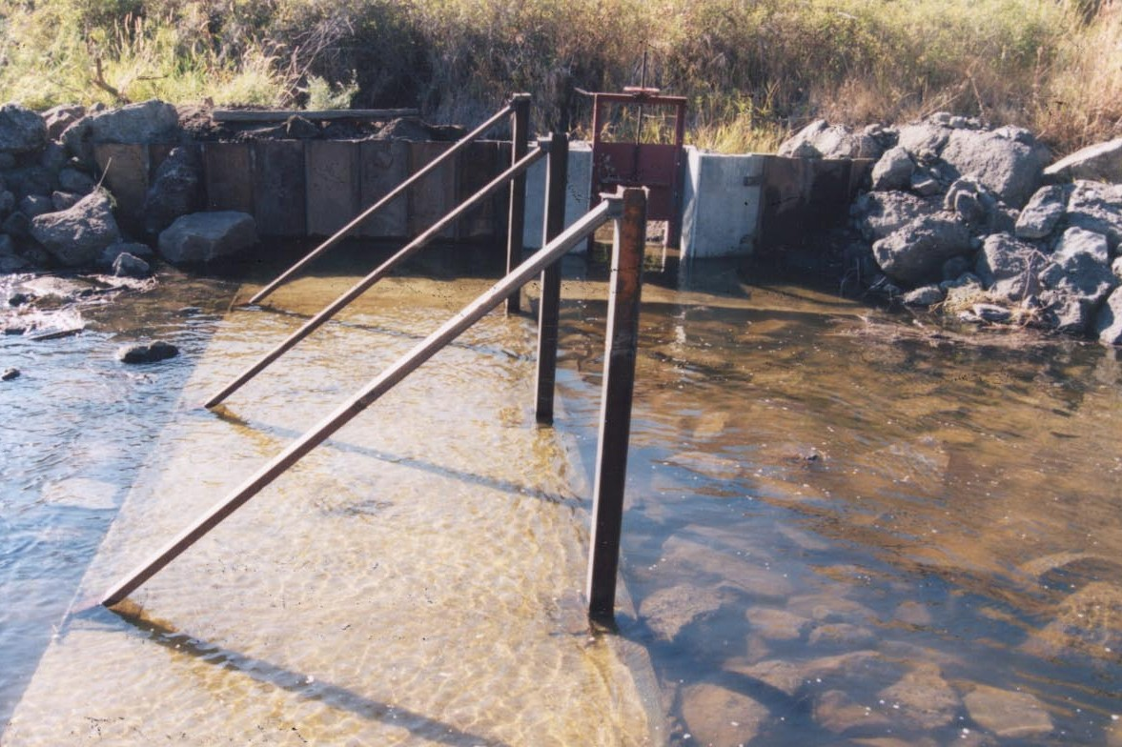
Photo 4. Typical permanent diversion after installation

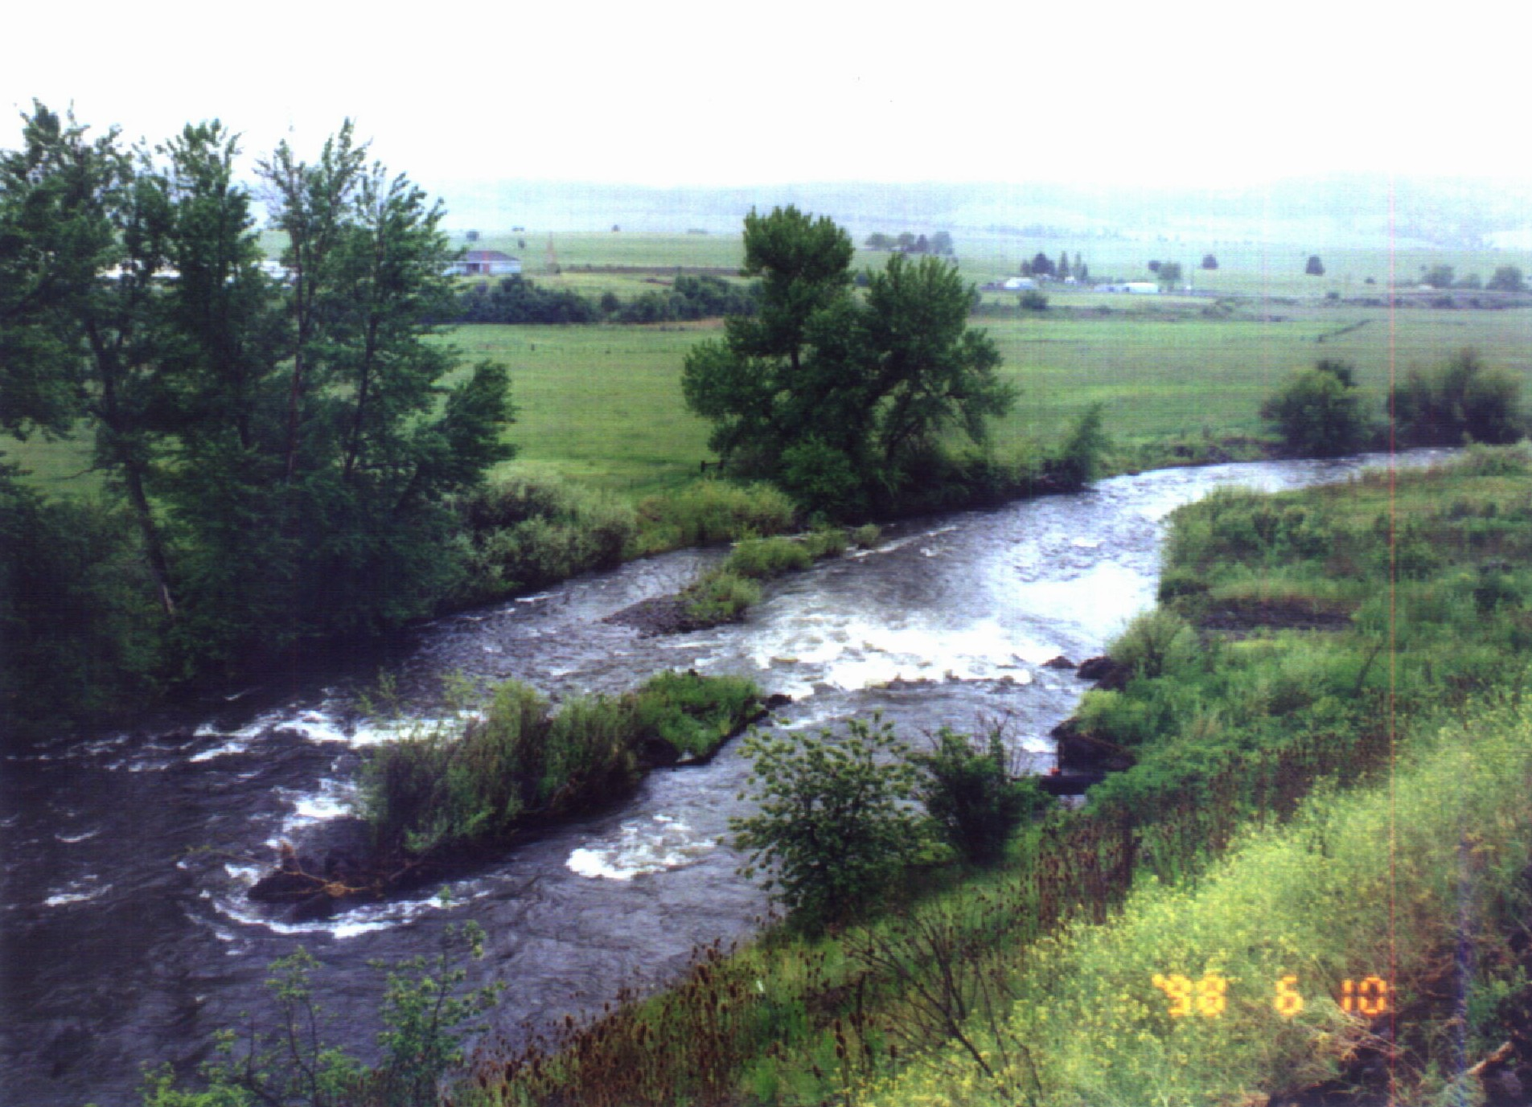

Photo 5. Typical permanent diversion site following construction

Pumping stations. Pumping stations are proposed as an alternative to push-up dams, and generally eliminate the need for any instream diversion structure. However, as with infiltration galleries, operation of a pumping station is often cost prohibitive. Since pumping stations are installed in close proximity to the point of application, all conveyance losses associated with long, open delivery systems are eliminated. Pumping stations are more effective in that they allow removal of the temporary push-up diversions and deliver a regulated water supply close to the point of application, lowering the amount of water taken from the river. By locating the pump station closer to the point of application, river water stays instream longer. Many lengths of old conveyance systems may be retired and removed. Photo 6 provides an example of one type of pump station that may be installed.

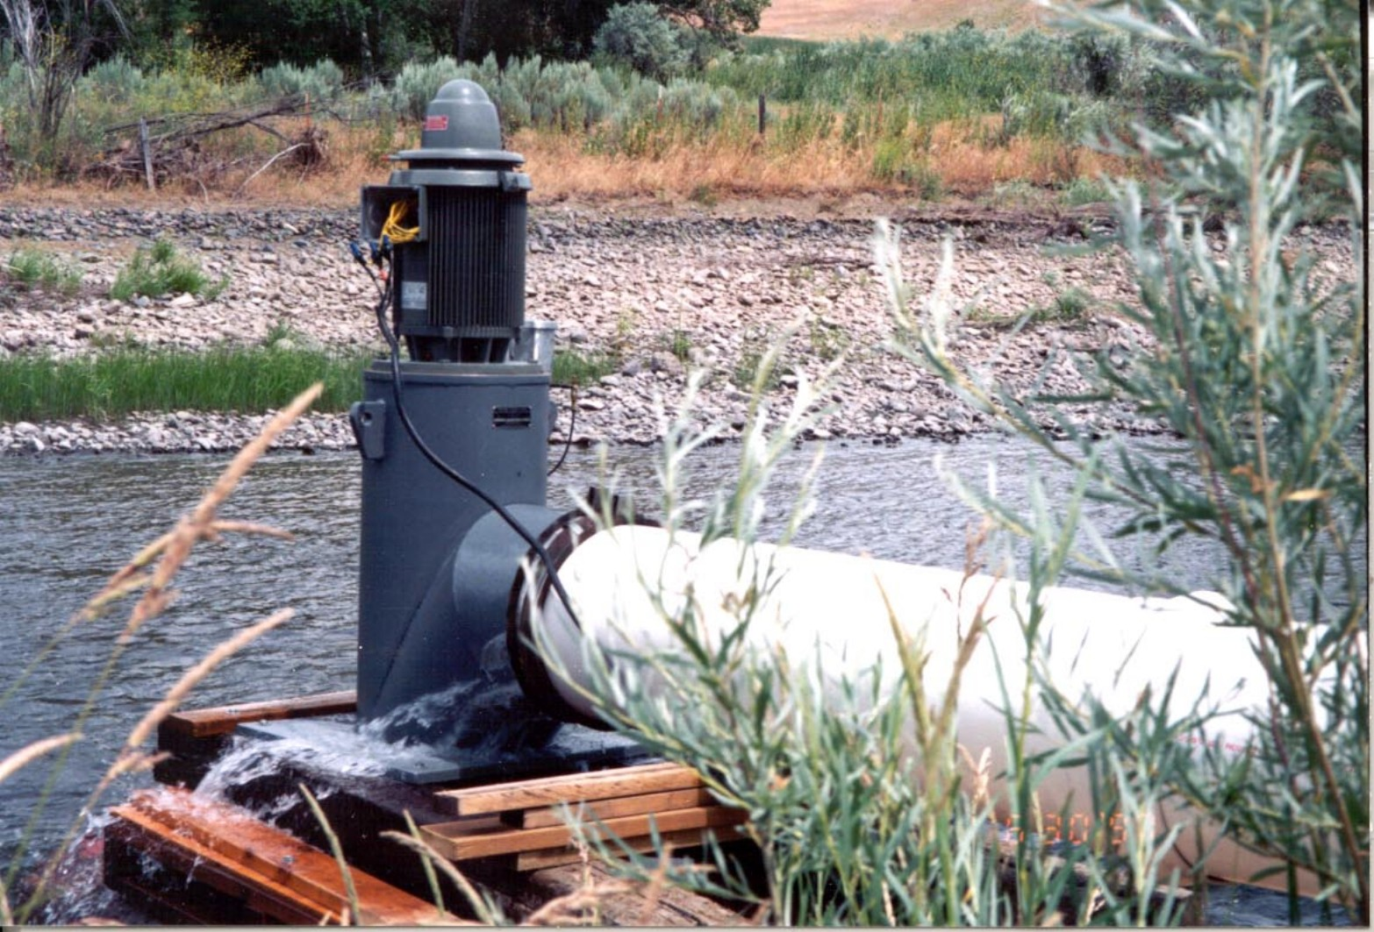

Photo 6. Typical pump station.

Return flow cooling. Return flow cooling projects generally consist of replacing old open return ditches with underground PVC pipe. The primary benefits are to eliminate nutrient and thermal loading, by filtering flows underground where they cool before returning to the river. Previous conversions from surface to below-ground return systems have resulted in decreases in return flow temperatures to less than 62°F (Robertson and Delano 1998). Improvements in return flow outfalls may provide refugia, which are critical for holding adult migrating salmon. Research in the upper basin funded by the CTWSO John Day Basin Office shows that adult holding areas are closely tied to thermal refugia (Torgersen 1996). Increasing the numbers of return flows that are designed to cool as they return to the river may add refugia within the John Day River system.

Off-site water developments.

Off site watering developments are typically spring-fed or draw water from a stream via a PVC pipeline. site preparation includes any necessary ground leveling and installation of the trough foundation. When a spring is accessed and relative elevations allow, a collection system utilizing gravity-fed pressure is installed. If a stream is accessed, a solar pump may be used to supply water through a pipeline. Post-construction activities include system tests, shaping spoils, and seeding all disturbed areas. Projects are installed under cost-share agreements with landowners. Facility designs are site specific and the selected option much meet the “needed and feasible” criteria.

Juniper removal. The local NRCS (Natural Resource Conservation Service) has assisted with some juniper removal projects within the John Day Basin. Monitoring of these projects is limited to yearly photographs or periodic landowner evaluations. Landowners have found the treatments to be very beneficial, noting increases in ground cover, forage, wildlife use, and re-surfacing of springs. The NRCS program follows conservation agreements and management plans for prescribed grazing, and in some cases, re-seeding after treatment. For the purposes of this program, landowner agreements will allow juniper carcasses to remain on the ground for at least five years following cutting. In addition, grazing will be deferred for one year. This project seeks to target 500 acres per year for juniper removal where junipers have formed dense woodlands along drainages, streams, or around springs. Trees will be reduced to maximum densities of 2 to 6 trees per acre. Carcasses will lie where fallen unless they accumulate so that they cover the ground and prevent moisture and sunlight from reaching seed sources below. Monitoring sites will be established within each removal site, and yearly monitoring of plant species abundance, diversity, and growth will be conducted, once pre-treatment, and for five years following removal treatments. The number of monitoring sites will depend on the acreage treated, but plots will be established under a goal of 10 1-m² plots per 100 treated acres. Adjacent drainages, streams, or springs will be observed for renewed flow following juniper removal. Sites will be evaluated at the end of their five-year monitoring cycle, and all monitoring efforts will be analyzed at the end of the juniper treatment program.

c. Rationale and significance to Regional Programs

2000 Federal Columbia River Power System (FCRPS) Biological Opinion.

The BiOp (http://www.nwr.noaa.gov/1hydrop/hydroweb/docs/final/2000biop.html) recommends that the upper John Day be treated as a high priority subbasin. While the BiOp listed goals and objectives, which are essentially consistent with the John Day Subbasin Summary, it also specifically identified actions to be undertaken by the three federal “action” agencies. Pertinent recommendations and actions (RPAs) are listed below, with our response as to how the John Day Watershed Restoration Program assists BPA and the federal agencies in meeting these actions.

i) Issue: Water quantity - increase tributary water flow to improve fish spawning, rearing, and migration.
Program Response: Upgrades to irrigation systems increase efficiency and increase instream flows; and juniper removals from strategic drainages may release water that is currently sequestered.

ii) Issue: Water quality - comply with water quality standards, first in spawning and rearing areas, then in migratory corridors.
Program Response: The above-mentioned measures to increase flow will also improve water quality. Return flow cooling projects will lower irrigation return flow temperatures. Ceasing stream bank/bed construction will facilitate riparian recovery and indirectly improve elements of water quality such as temperature.

iii) Issue: Passage and diversion improvements – address in-stream obstructions and diversions that interfere with or harm listed species.
Program Response: Pumping stations and infiltration galleries completely eliminate passage obstructions. Permanent diversions are erected only temporarily and include fish passages.

iv) Issue: Watershed health – manage both riparian and upland habitat, consistent with the needs of the species.
Program Response: Ceasing streambank/bed construction, as mentioned above, will reduce impact and facilitate riparian recovery. Decreasing temperatures in return flows will create thermal refugia and improve water quality and habitat suitability. Juniper removal may release water previously unavailable and improve forage condition by eliminating competition for native and desirable vegetation.

In addition, Reasonable and Prudent Actions (RPAs) of high priority were outlined for areas within the Columbia River Basin. The following RPAs, as outlined in Section 9.6.2.1, are addressed by the proposed projects:

i) Action 149 – BOR shall initiate programs in three priority subbasins (identified in the conceptual Recovery plan) per year over 5 years, in coordination with NMFS, FWS, the states and others, to address all flow, passage, and screening problems in each subbasin over 10 years. The Corps shall implement demonstration projects to improve habitat in subbasins where water-diversion-related problems could cause take of listed species.
Program Response: All proposed projects address impaired flow and passage conditions identified in the John Day subbasin.

ii) Action 150 – In subbasins with listed salmon and steelhead, BPA shall fund protection of currently productive non-federal habitat, especially if at risk of being degraded.
Program Response: All proposed projects are within habitats of steelhead, which are a federally listed species. Those habitats are at risk from degradation due to ongoing operation and maintenance activities associated with diversions.

iii) Action 151 - BPA shall, in coordination with NMFS, experiment with innovative ways to increase tributary flows by, for example, establishing a water brokerage. BPA will begin these experiments as soon as possible and submit a report evaluating the efficacy at the end of 5 years.
Program Response: The intent of our irrigation efficiency projects is to make water available for instream flows. This water could be available under a brokered lease agreement.

iv) Action 152 – The Action Agencies shall coordinate their efforts and support offsite habitat enhancement measures undertaken by other Federal agencies, states, Tribes, and local governments…
Program Response: All proposed projects are off-site habitat measures and are coordinated with two of the action agencies and the state of Oregon.

v) Action 153 - fund long-term protection for 100 miles of riparian buffers per year
Program Response: All projects towards, or indirectly benefit, improvements in riparian areas.

Columbia Basin Fish and Wildlife Program (Northwest Power Planning Council).

The CBFWP has established objectives for salmonid recovery, which are addressed by the proposed projects, and are described in detail under the following sections:

i) Section 2.2A. “Support Native Species in Native Habitat: the Program preference is to support and rebuild native species in native habitats, especially weak stocks.”
Program Response: John Day spring chinook are classified as a wild stock that is depressed but stable, with a recommended enhancement strategy focusing on natural production. All John Day summer steelhead are wild and classified as a threatened species within the Middle Columbia ESU. Improving natural production is recommended as the key restoration strategy for steelhead (John Day Subbasin Summary 2001).

ii) Section 2.2.C.1 (the NWPPC) “…expects that costs will be shared among parties to implement measures in the Program, in particular, for projects that mitigate the effects of non-hydropower caused problems.”
Program Response: The Oregon Water Resources Department, John Day Basin Office of the CTWSRO, Oregon Department of Fish and Wildlife, and Bureau of Reclamation all contribute cost-share funding to fund projects considered under this proposal. In addition, private landowners contribute all operation and maintenance costs associated with the projects.

iii) Chapter 5.4D.8. “[e]valuate the potential for water conservation, water efficiency or other measures in [BOR] programs with the most potential to benefit anadromous fish and with the least impact on third parties.”
Program Response: The BOR has sponsored and assisted in the preparation of the water optimization and stream restoration plans. The BOR also funded the initial demonstration projects, and currently cost-shares a portion of the construction and planning for current projects and funds all of the monitoring and project evaluations. Monitoring of the initial demonstration projects has identified the positive benefits of these actions. The proposed projects are the continuation of successful irrigation improvement projects and continually broaden the nature and scope of the projects with new technology.

iv) Section 7.6.B.3. “Give highest priority to habitat protection and improvement in areas of the Columbia Basin where low or medium habitat productivity or low pre-spawning survival for identified weak populations are limiting factors. Give priority to habitat projects that have been integrated into broader watershed improvement efforts and that promote cooperative agreements with private landowners”.
Program Response: As established within this document and a number of other program plans (John Day Subbasin Summary, CBFWA Program, Spirit of the Salmon), habitat productivity has been identified the primary limiting factor for salmon production in the John Day. The proposed projects have been incorporated into broader watershed assessments and restoration efforts, and rely exclusively on cooperation with private landowners. A strong public relations effort has been implemented by the Tribes and GSWCD, and has resulted in overwhelming interest and support for the program.

v) Section 10.2.C.2 states “….provide funding for state and tribal fish screen programs to implement all priority screening projects. Innovative solutions that accomplish the same purpose as fish screening, i.e., conversion to electric pumping, conversions from surface ground water, consolidations of diversions, etc., shall all be encouraged.” In so doing, “funding shall be sufficient to: develop preliminary designs, see that necessary permit processes are carried out; make certain private landowner and public concerns are addressed; review detailed designs to ensure that biological and engineering criteria are met; monitor construction phases; establish written operating criteria; monitor operation and maintenance phases in compliance with criteria and recommend corrective actions if necessary; and conduct project evaluations.”
Program Response: All irrigation improvement projects proposed under this plan are supported by this research direction, and generally follow the pattern described above in planning, implementation, and evaluation activities.

2000 Framework Amendments

The fourth version of the Columbia Basin Fish and Wildlife Program was drafted in November of 2000. This new plan is a departure from previous versions in that the implementation will be established within subbasin plans that are amended into the NWPPC plan. These habitat-based subbasin plans are guided by the following scientific principles (Section III.C.2):
- Maintain and restore healthy ecosystem and watersheds, which preserve functional links among ecosystem elements to ensure the continued persistence, health and diversity of all species including game fish species, non-game fish species, and other organisms.
- Protect and expand habitat and ecosystem functions as the means to significantly increase the abundance, productivity, and life history diversity of resident fish at least to extent they have been affected by the development and operation of the hydrosystem.
- Develop and implement habitat acquisition and enhancement projects to fully mitigate for identified losses.
- Coordinate mitigation activities throughout the basin and with fish mitigation and restoration efforts specifically by coordinating habitat restoration and acquisition with aquatic habitats to promote connectivity of terrestrial and aquatic areas.
- Monitor and evaluate habitat and species responses to mitigation actions.

The plan encourages projects that “restore entire ecosystems, not just single species” (Section III.D.7). Plans at this level will guide Bonneville funding of fish and wildlife activities.” This allows for specific restoration and research to be tailored to the region of implementation and under the direction of experienced professionals currently working in those regions and, in the case of the John Day Basin Office CTWSRO, with an established set of cooperating agencies and public already in place.

John Day Subbasin Summary (various agencies)

The John Day Subbasin Summary outlines key limiting factors for fish and wildlife resources within the John Day Subbasin (Knapp et al. 2001). The following strategies were established within Subbasin Summary as objectives to guide restoration efforts:
1. Protect existing anadromous habitat by preventing further watershed degradation in the form of water quality, quantity, and instream habitat.
2. Restore optimum habitat (temperature, flows) for all life history stages of anadromous salmonids.
3. Protect, restore, and maintain suitable habitat conditions for all bull trout life history stages.

In addition, Restoration, Protection, and Enhancement and Research, Monitoring and Evaluation needs were defined. The proposed projects specifically address the following needs:

i) RP&E Habitat Need #1: Need to restore and protect riparian habitat and structure, channel function and form, flows, and water quality for primarily bull trout, spring chinook salmon and summer steelhead; habitat and water quality improvements needed for other resident trout species as well.
Program Response: This need encapsulates the desired future condition as envisioned by the John Day Watershed Restoration Program. Off-site watering developments will create alternate water sources for cattle that otherwise would need river access, reducing the impact on the riparian area from cattle. Removing temporary diversions and repeated machine and scouring activity within and along a river will allow for riparian recovery and natural flow conditions. Return-flow cooling projects contribute cooler waters to the river, improving water quality.

ii) RP&E Habitat Need #5: Need to eliminate passage barriers within the basin to facilitate movement of adult and juvenile salmonids, create suitable flow conditions, and restore inundated habitat
Program Response: Temporary push-up diversions remain instream until high flows destroy them, and then are rebuilt when irrigation starts. Permanent lay-flat diversions include fish passages and are erected only during the hours when irrigation water is diverted. Pump stations and infiltration galleries completely eliminate instream structures. By eliminating or reducing the material within the stream, water can flow with less impediments. By eliminating the need for repeated construction within and along the stream, riparian vegetation can recover and instream materials will not be disturbed.

iii) RP&E Habitat Need #14: Need to reduce stream temperatures.
Program Response: Return flow cooling projects collect irrigation returns into buried perforated pipes that facilitate conduction between the water and soil, cooling the water as it flows back to the river by as much as 16°F. Stream temperature standards can be reached in compromised areas by using a return-flow cooling system (Robertson and Delano 1998).

v) C&E Need #4: Need to continue to enhance the cooperative/shared approach in research, monitoring and evaluation between tribal, federal, state, and local entities to facilitate restoration and enhancement measures.
Program Response: All project sites are monitored cooperatively between the GSWCD and JDBO (CTWSRO). In addition, when applications are made to fish populations, data is shared between other researchers, including ODFW.

iv) NMFS RP&E Habitat Goal #1: Restore and increase tributary flows to improve fish spawning, rearing, and migration.
Program Response: by removing dense stands of juniper that have invaded drainages, streams, and springs, significant quantities of water may be released to supply instream flows. In addition, moisture will be released for understory plants better adapted to control erosion, and which provide better wildlife forage and habitat.

Upper John Day Water Optimization Plan (Bureau of Reclamation)

The Water Optimization Study was a comprehensive assessment, completed by the Bureau of Reclamation in 1990, which reviewed most of the ongoing agency watershed restoration programs, rated those programs as to their benefits, and identified gaps in both agency programs and project efforts. Further, that study recommended a complement of projects and programs that would best provide the highest benefit to fish and wildlife in an effective, feasible, and efficient manner.

Wy-Kan-Ush-Mi Wa-Kish-Wit, Spirit of the Salmon (Nez Perce, Umatilla, Warm Springs and Yakama Tribes)

Specifically, the Spirit of the Salmon plan recommended habitat enhancement actions for the John Day subbasin regarding instream flow and passage. The implementation section of the plan recommends activities to “[i]mplement more efficient irrigation methods and water conservation practices benefiting landowners and instream flows.” The proposed projects deal directly with improving irrigation methods in ways that benefit all interests.

Integrated System Plan for Salmon and Steelhead Production in the Columbia River Basin (Columbia Basin Fish and Wildlife Authority)

The Integrated System Plan (CBFWA 1991) identifies the following goals & policies:

i) Area above Bonneville Dam is accorded priority:
Response: The John Day basin is above Bonneville Dam.

ii) Genetic risks must be assessed:
Response: The John Day supports one of the largest remaining, completely wild populations of anadromous fish in the Columbia River basin. The projects are intended to increase productivity of wild stocks.

iii) Harvest management must support rebuilding:
Response: No sport fishing for spring chinook salmon has been permitted in the basin since 1978 (Anonymous 1991) and subsistence fishing has been estimated at between approximately 2% and 20% and do not appear to impact John Day River stocks (Lindsay et al 1985). Although sport fishing for summer steelhead is currently allowed, a “no-kill” regulation is in effect. Catch and release mortality on summer steelhead is assumed to be negligible.

iv) System integration will be necessary to assure consistency:
Response: All projects have been integrated in the watershed assessments and stream restoration plans. Computer modeling has identified the most complementary combination of projects with the greatest benefit to stream flow and temperatures. Additional collaboration with other agencies and publics occurs during planning and in the field during project construction. Monitoring has been coordinated through county committees, formally through agreements among the agencies, and informally through regular agency contact.

v) Adaptive management should guide action and improve knowledge:
Response: Proposed actions build upon previous project activities and monitoring information gathered from these projects. These projects are a result of identified gaps in previous agency programs and respond to critiques of past restoration actions.

The Integrated System Plan further identifies the following recommended actions specific to the John Day: “Enhance streamflows through improvement of irrigation efficiency, water conservation, enforcement of established minimum streamflows, instream water rights, and watershed improvement, riparian storage, and beaver management.”

d. Relationships to other projects

Ongoing watershed restoration and research programs in the basin are conducted by the Confederated Tribes of Warm Springs (John Day Basin Office), ODFW, Soil and Water Conservation Districts, Watershed Councils, Natural Resource Conservation Service, USFS, BLM, and other agencies, organizations, and landowners. Each group implements activities within their particular area of expertise, funding sources, authorities, capabilities, and available opportunities. Tribal efforts are generally guided by the Water Optimization Study, John Day Basin Anadromous Fish Production Plan, Tribal Restoration Plan, and individual stream restoration plans. The John Day Subbasin Summary relied heavily upon the strategies recommended under these plans and assessments with much greater attention at the implementation level.

The restoration effort in the upper John Day basin has been ongoing for over thirty years. A critical component of the John Day Subbasin Summary, Water Optimization Study, and stream restoration plans was to identify gaps in the ongoing agency programs. Each proposed project is viewed as a integral part of the overall watershed effort, contributing to the greater, positive cumulative benefit of increased late-summer flow, reduced sedimentation, lowered water temperature, and improved riparian condition within areas of importance for salmonid production. Restoration actions may have contributed to the overall improvement in habitat condition and increased returns of spring chinook. The cumulative effects of long term implementation and operation have been modeled, analyzed, and evaluated by numerous agencies. Project design and monitoring procedures are further evaluated by an interagency team of professionals. The projects are being proposed as the best, given the current extent of scientific knowledge, methods to achieve accomplishable objectives with regards to flow enhancement.

A directly complementary program is project 8402100, Protect and Enhance John Day River Fish Habitat, implemented by the ODFW. The ODFW effort focused in the past on instream habitat restoration and most recently on riparian recovery through riparian corridor fencing. Our proposed projects are complementary since many are located within past ODFW project areas; consequently instream and riparian habitat restoration components have already been completed. Completion of the water quality related projects, therefore, may have a significant cumulative beneficial effect.

The Oregon Fish Screening Project #9306600 is generally affected through implementation of the John Day Watershed Restoration program. Irrigation screening began in the late 1950s and continues under the BPA fish screening and passage improvement program. In some cases, the proposed projects reduce the need for fish screens by providing alternative measures (see 10.2C of the Program), or by converting flood diversion to pumping stations. In other situations, the effectiveness of the screening device is enhanced through reconfiguration of the diversion structure. Project construction schedules are coordinated between the ODFW and Tribes/GSWCD in order to avoid any potential conflicts and to maximize cost effectiveness.

Part of the John Day Basin Office’s efforts is to work cooperatively with landowners, the Oregon Water Trust, and others to identify opportunities to secure instream flows using water “freed up” through the implementation of conservation projects. Under current Oregon water law, there are a number of opportunities to accomplish this objective. However, our experience has been that landowners are very reluctant to discuss this issue concurrently with discussing the construction portion of the project. Rather, our greatest successes have been realized by approaching the landowner or irrigation district after the conservation project has been implemented and actual “surplus” water amounts can be presented for consideration of instream lease. However, potential compromises made in the past involve transferring consumptive uses to instream flows as the landowners cost-share contribution to the project. As with construction alternatives, this aspect will always be considered where appropriate. Each construction project is a permanent installation of a project structure. The landowner accepts all responsibility for operations and maintenance. Since these projects are usually the only available means for diversion, conveyance, or application, we assert that they will remain a permanent fixture of the ranch operations. Consequently, the benefits of the project are anticipated to last as long as the structure is in place, which should be as long as an active agricultural operation persists.

The CTWS currently have a signed agreement with the GSWCD for coordination of restoration projects. These agreements are anticipated to be updated for FY2002-2004. In addition, issues and opportunities in the basin are coordinated through a multi-agency team of professionals. Although this team is not formally coordinated through an interagency agreement, the completed restoration projects demonstrate the success of ongoing project collaboration. A responsibility exists to the BOR and BPA for National Environmental Policy Act compliance. Since planning has already been initiated, early funding will allow submission of permit applications in sufficient time to perform instream construction activities during the 2002, 2003, and 2004 instream construction windows.

Other complimentary projects include: Study of Wild Spring Chinook Salmon in the John Day River System (ODFW, Project No. 7900400), John Day Basin Spring Chinook Salmon Escapement and Productivity Monitoring (ODFW, Project No. 980160), Bull Trout Life History Project – NE Oregon (ODFW, Project No. 9405400), Genetic Profiling, Habitat Inventories Project, Eliminate Gravel Push-up Dams on Lower North Fork John Day (NFWC, Project No. 980170), various Oregon State University studies, Oregon Watershed Enhancement Board programs, North Fork Watershed Council projects, Grant Soil and Watershed Conservation District programs, and US Bureau of Reclamation programs.

e. Project history (for ongoing projects)

In 1988 the John Day Basin Council enlisted the help of the Bureau of Reclamation to provide technical assistance in preparing a watershed improvement plan. The goal was to create a list, using scientifically credible assessment methods, of “do-able” projects, with positive effects on water quality and quantity and aquatic habitat. In 1990, the planning efforts of the Tribes, agencies, and public culminated in the Upper John Day River Basin Master Water Plan Working Paper (BOR 1990). The Working Paper identified critical gaps and areas for improvement in ongoing agency programs and outlined projects that addressed these deficiencies. In subsequent years, individual stream restoration plans were prepared for the major watersheds in the upper and middle subbasins. These documents detail a comprehensive restoration program involving multiple agencies that targets all components of the watershed. The implementation strategy involves numerous measures, which used in combination, will result in beneficial effects to the watershed.

Implementation activities began in 1995 under the guidance of the Water Optimization Study. Since then, ten permanent diversion projects, twenty-one pump stations, eight infiltration galleries, and six return-flow cooling projects have been installed. Under the 2001 project implementation schedule, four permanent diversions, four pump stations, four infiltration galleries, and one return-flow cooling projects are being completed. All projects were funded cooperatively by BPA and BOR.

Each irrigation efficiency project is selected from a range of construction and habitat improvement alternatives. For example, when considering alternatives to push-up diversions, wide ranges of structures are evaluated. These may include major or minor structures such as installation of a permanent diversion, pumping station (electrical or internal combustion), or an infiltration gallery. The cost of constructing each type of installation, the costs of operation and maintenance, and the site conditions are all compared to the anticipated benefit to the resources (e.g., landowner operations, bank stability, instream flows, etc.). Although infiltration galleries have been constructed in the past, they do not work at all sites (i.e., availability of on-site electrical power since not all can be used without a pump installation), nor do all landowners desire to accept the higher costs of electrical pumping in perpetuity. Numerous pumping stations have also been installed in the past, and for similar reasons, they cannot be used at every site. In addition, the use of combustion engine pumps posses other inherent hazards such as elevated fuel costs and noise/air pollution.

Irrigation efficiencies take many forms but usually feature improvements or reconfiguration of an existing irrigation system, such as converting from open ditches to pumps or from flood to sprinkler irrigation. They may occur in combination with improvement in the diversion structure, but may rely upon traditional methods of diversion where a significant resource issue is not present. Unfortunately, structural approaches are the only option for diverting water from a river, for which the irrigators have a legal right. After long periods of study and evaluation, the proposed projects have been chosen as the best alternatives to the current conditions. The general features of each type of project are discussed below. Less intensive structures (pumping and infiltration galleries) are considered wherever feasible.

The Projects have been evaluated and modeled by the interagency team working on the water optimization study. The USDI Fish and Wildlife Service has evaluated the construction projects from 1993 through 1998, which were permanent diversions, pumping stations, return flow cooling projects, irrigation stream crossings, and infiltration galleries similar to the proposed projects. They conclude that reducing diversion requirements and reducing warm water return flows, will increase juvenile rearing adult holding survival (U.S. Fish and Wildlife Service 1996) and provide “significant benefits to spring chinook salmon, summer steelhead, and resident species” (U.S. Fish and Wildlife Service 1995). Further, they conclude that without the projects, adverse impacts on fish and wildlife resources, destruction of riparian vegetation, destabilized streambanks, removal of invertebrates and other aquatic life forms, increased turbidity, siltation, and migratory barriers will continue (U.S. Fish and Wildlife Service 1998). Their conclusions were essentially the same as those that the agencies and Tribes reached during the proposal and design phase of the projects and during the water optimization study. It is these positive reviews and beneficial actions that promote the continuation of the John Day Basin program and the projects proposed herein.

The John Day Basin Water Quality Monitoring Plan, 2001 Interim Plan describes the monitoring procedures used to evaluate restoration project success. Water quality and habitat parameters and fish and invertebrate responses to project implementation are monitored under the Water Quality Monitoring Plan. Each activity is guided by published research and protocols. Monitoring techniques include:
- installation of thermal loggers (DEQ 1996, EPA 1993)
- measurement of thermal profile (Platts et al 1987, Bohn and King 2000)
- aquatic invertebrate abundance and diversity (Platts et al. 1983, Bauer and Burton 1993)
- water flow (Harrelson et al. 1994)
- fish abundance (Platts et al 1983, Hankin 1986, Thurow 1994)
- channel cross section surveys (Platts et al 1983, Winward 2000, Bohn 2000, Bauer 1993, Platts et al 1987)
- fish mark-recapture surveys (Platts et al 1983)
- riparian greenline analyses (Winward 2000, Smelser 1998)

Monitoring intensity varies depending on project site characteristics and priority status. Example of positive monitoring results includes the return-flow temperature monitoring on the Holliday RFC project. Return flows have has shown remarkable temperature decreases as they enter the river. Prior to implementing the project, only 27.5% of return flows were less than 64 degrees (the State water quality standard), while over 83% of post-project return flows were below the standard (Robertson and Delano 1998).

f. Proposal objectives, tasks and methods

The effects of the various project implementation scenarios on river flows and stream temperatures were analyzed through simulation studies of the basin hydrology (BOR 1990 Supporting Vol. I and II). The effects of individual project implementation were assessed for impacts on streamflow, temperature, sediment, fish, and other resources (e.g., crop production). Projects are selected using an interagency evaluation and prioritization process. Anticipated outcomes are weighed against costs to determine cost—benefit ratios for the proposed projects and alternatives.

The GSWCD utilizes project design criteria which follow the USDA Natural Resource Conservation Service’s standard engineering guidelines as described in their National Cooperative Agreement. Calculations of ground water interception and flow rates are partially based upon “The Design and Construction of Infiltration Galleries” (Bennett 1970), other literature, and past experience with these projects. Instream construction activities follow specific standards established by the Oregon Department of Fish and Wildlife. Instream construction follows guidelines established by the Oregon Department of Fish and Wildlife for timing considerations to protect migrating, spawning, and emerging fish. Standard methods of construction for protection of instream resources are followed to ensure minimization of acute affects to aquatic and terrestrial resources in the area of impact. Compliance with the National Environmental Policy Act, Endangered Species Act, and other mandates, through preparation of project level documents, provides additional assurances of and attention to biological protection requirements. Risks to species from short term, construction impacts have been weighed against the long term risks of failing to complete restoration actions. In all cases, the risks and chronic impacts of not implementing the projects have been significantly higher to resources than the negligible effects of project activities.

The following recommendation, adopted from the John Day Subbasin Summary, describes the desired future condition that provides program guidance:

Restore and protect riparian habitat and structure, channel function and form, flows, and water quality for primarily bull trout, spring chinook salmon and summer steelhead; habitat and water quality improvements needed for other resident trout species as well.

Our general project objectives, which are also adopted from the Subbasin Summary, follow:

- Restore and protect riparian habitat and structure, channel function and form, flows, and water quality for primarily bull trout, spring chinook salmon and summer steelhead; habitat and water quality improvements needed for other resident trout species as well.
- Eliminate passage barriers within the basin to facilitate movement of adult and juvenile salmonids, create suitable flow conditions, and restore inundated habitat; Reduce stream temperatures.
- Increase tributary water flow to improve fish spawning, rearing, and migration by regaining water sequestered and transpired by juniper woodlands.
- Continue to enhance the cooperative/shared approach in research, monitoring and evaluation between tribal, federal, state, and local entities to facilitate restoration and enhancement measures.

Projects slated for the 2002 Fiscal Year include the Rice Diversion, Lower Island Diversion, Mountain Creek Irrigation Consolidation, Wisenhunt Pump Station, Vanier Pump Station, Walker Pump Station, Enterprise RFC Pump Station, Pike Project Phase II Infiltration Gallery, and Emmel Ranch Return-Flow Cooling Project. See Attachment #1 for a map of project locations.

Project Planning and Design Phase

Objective 1. Complete project planning and design activities.

Task A. Complete administration of project planning and design.

i. Complete compliance documents.

ii. Complete subcontractor agreements.

iii. Complete landowner agreements.

Task B. Complete project planning and design

Construction/Implementation Phase

Objective 2. Install off-site watering systems to remove grazing impacts from riparian areas.

Task A. Prepare design and cost-share package.

Task B. Install off-site watering systems (three per year).

i. Prepare level base.

ii. Install collection system or solar pump, hardware, and pipeline.

iii. Install water trough.

iv. Shape spoils and seed disturbed area.

Objective 3. Install permanent lay-flat diversions to remove passage barriers.

Task A. Install permanent diversions t the Rice, Lower Island Ditch, and Mountain Creek Irrigation Consolidation sites.

(the following subtasks apply to all the above Tasks.)

i. Remove temporary diversion materials.

ii. Install concrete pad.

iii. Install lay flat stanchions.

iv. Install PVC pipe to connect diversion to delivery system.

v. Install measuring device.

vi. Shape construction spoils, repair disturbed fence, and plant riparian vegetation to reduce erosion and increase rate of riparian recovery.

Objective 4. Install pump stations to remove passage barriers.

Task A. Install pump stations at the Wisenhunt Diversion, Vanier Diversion, Walker Diversion, and Enterprise RFC sites.

(the following subtasks apply to all above tasks)

i. Remove temporary diversion materials.

ii. Install pump sump.

iii. Install pump station with fish screen and totalizing flow meter.

iv. Install buried PVC delivery pipe to connect pump station to delivery system.

v. Shape construction spoils, repair disturbed fence, and plant riparian vegetation to reduce erosion and increase rate of riparian recovery.

Objective 5. Install infiltration gallery to remove passage barriers.

Task A. Install infiltration gallery at the Pike Project Phase II site.

i. Replace temporary push-up diversion

ii. Install well screen collector and valve station.

iii. Install PVC pipe to connect conveyance system.

iv. Install measuring device.

v. Shape construction spoils, repair disturbed fence, and plant riparian vegetation to reduce erosion and increase rate of riparian recovery.

Objective 6. Install return-flow cooling system to reduce stream temperatures.

Task A. Install return-flow cooling system at the Emmel Ranch

i. Remove failing drains.

ii. Install perforated PVC pipe.

iii. Install water level control structures on tailwater lines.

iv. Place riprap around pipe discharge.

v. Shape construction spoils, repair disturbed fencing, and plant riparian vegetation to reduce erosion and increase rate of riparian recovery.

Objective 7. Implement juniper removal program to increase tributary flows and decrease erosion.

Task A. Implement subcontract to remove junipers from 500 acres per year.

Objective 8. Administer implementation of subcontract

Task A. Administer subcontract and provide technical assistance.

Operation and Maintenance Phase

Objective 9. Perform periodic maintenance in response to unanticipated conditions.

Task A. Backflush infiltration galleries, rework rock placements, or similar as needed.

Monitoring and Evaluation Phase

Objective 10. Implement annual monitoring program that facilitates a cooperative approach.

Task A. Implement project monitoring activities and prepare report.

i. Monitor irrigation improvement projects according to the John Day Basin Office 2002 Interim Water Quality Monitoring Plan.

ii. Monitor effects of juniper removal

iii. Prepare annual reports.

g. Facilities and equipment

Construction equipment to be used varies depending upon site characteristics, materials to be installed, and site objectives. For example, the diversion projects use a trackhoe and loader to place rip-rap rock and a pump to dry the site for placement of concrete. Sites with additional excavation requirements may utilize a bulldozer as well. Equipment is readily available within the project areas.

In addition, the Tribes maintain a fully staffed and generally fully equipped office in John Day. The office possesses or has access to all equipment and materials necessary for completing these projects and managing properties. This includes—in addition to professional and clerical support staff—computers, vehicles, flow meters, GPS units, sampling and survey equipment, and other similar equipment and supplies.

h. References

Reference (include web address if available online) | Submitted w/form (y/n)
AES OSU (Agricultural Experiment Station, Oregon State University). 1999. Range Field Day 1999 Progress Report – Juniper woodlands: History, ecology, and management. Special Report 1002. Department of Rangeland Resources, Eastern Oregon Agricultural Research Center, Oregon State University and U.S. Department of Agriculture, Agricultural Research Service. | n
Angell, R.F. and R.F. Miller. 1994. Simulation of leaf conductance and transpiration in Juniperus occidentalis. Forest Science 40(1):5-16. | n
Anonymous. 1996. Wy-Kan-Ush-Mi Wa-Kish-Wit. The Columbia River anadromous fish plan of the Nez Perce, Umatilla, Warm Springs and Yakama Tribes, Vol. I and II. | n
Bates, J.D., R.F. Miller and T.J. Svejcar. 2000. Understory dynamics in cut and uncut western juniper woodlands. Journal of Range Management 53(1):119-126. | n
Bates, J.D., R.F. Miller, T. Svejcar. 1998. Understory patterns in cut western juniper (Juniperus occidentalis spp. Occidentalis Hook.) woodlands. Great Basin Naturalist 58(4):363-374 | n
Bohn, C.C., J.G. King. 2000. Stream Channel Responses to streamflow diversion on small streams of the Snake River drainage, Idaho. Research Paper, RMRS-RP-20. Feb. 2000. | n
Bonneville Power Association (BPA). 1992. Bonneville Power Administration Watershed Management Program Final Environmental Impact Statement (DOE/EIS-0265). Bonneville Power Association, Portland, OR, with Bureau of Reclamation, Natural Resources Conservation Service. July 1992. | n
Boyd, M. and D. Sturdevant. 1997. The scientific basis for Oregon’s stream temperature standard: common questions and straight answers. Oregon Dept. of Enc. Quality. pp 28. | n
Buchanan et al. 1997. Status of Oregon’s Bull Trout. Oregon Department of Fish and Wildlife, Portland, OR. | n
Buckhouse, J.C. 1999. In: AES OSU (Agricultural Experiment Station, Oregon State University). 1999. Range Field Day 1999 Progress Report – Juniper woodlands: History, ecology, and management. Special Report 1002. Department of Rangeland Resources, Eastern Oregon Agricultural Research Center, Oregon State University and U.S. Department of Agriculture, Agricultural Research Service. | n
Columbia Basin Fish and Wildlife Authority (CBFWA). 1991. Integrated system plan for salmon and steelhead production in the Columbia River basin. Prepared by the agencies and Indian Tribes of the Columbia Basin Fish and Wildlife Authority. CBFWA and Northwest Power Planning council. | n
Hankin, D.G. 1986. Sampling designs for estimating the total number of fish in small streams. Research Paper PNW-360. May 1986. | n
Harrelson, C.C., C.L. Rawlins, J.P. Potyondy. 1994. Stream channel reference sites: an illustrated guide to field technique. General Technical Report RM-245. | n
John Day Basin Office (JDBO) and Grant Soil and Water Conservation District. 2001. John Day Basin Water Quality Monitoring Plan. 2001 Interim Plan. John Day Basin Office, The Confederated Tribes of the Warm Springs Reservation of Oregon. | n
Knapp, S. et al. 2001 (in prep). John Day Subbasin Summary. Prepared for the Northwest Power Planning Council. | n
Lindsay R.B., W.J. Knox, M.W. Flesher, F.J. Smith, E.A. Olsen, and L.S. Lutz. 1985. Study of wild spring chinook salmon in the John Day River system. U.S. Dept. of Energy, Bonneville Power Administration, Division of Fish and Wildlife. DOE/BP-39796-1. | n
Miller, R.F. and J.A. Rose. 1999. Fire history and western juniper encroachment in sagebrush steppe. Journal of Range Management 52(11):550-559. | n
Miller, R.F. and P.E. Wigand. 1994. Holocene changes in semiarid pinyon-juniper woodlands. BioScience 44(7):465-474. | n
National Marine Fisheries Service. 1997. Endangered and Threatened Species: Listing of Several Evolutionary Significant Units (ESUs) of West Coast Steelhead. Federal Register 62(159). 50 CFR Parts 222 and 227. Aug. 18, 1997. | n
Oregon Department of Environmental Quality (DEQ). Oregon’s 303(d) list of water quality limited stream segments. Salem, OR. | n
Oregon Department of Environmental Quality (DEQ). 1996. Procedural Guidance for Water Temperature Monitoring. Portland, OR. | n
Oregon Water Resources Department (WRD). 1986. John Day River Basin Report. State of Oregon Water Resources Department. November 1986. | n
Platts, W.S. et al. 1987. Methods for evaluating riparian habitats with applications to management. General Technical Report INT-221. February 1987. | n
Robertson, S.W. and K. Delano. 1998. Holliday Ranch return flow fooling project, 1995-1998 monitoring report. Confederated Tribes of Warm Springs, John Day Basin Office. In Prep. | n
Robertson, S.W. 1999. 1999 Interim consensus water quality monitoring plan. Confederated Tribes of Warm Springs, John Day Basin Office, John Day, OR. In prep.
Smelser, M.G., J.C. Schmidt. 1998. An assessment methodology for determining historical changes in mountain streams. General Technical Report RMRS-GTR-6. | n
Stelljes, K.B. 1994. Harmonizing rangeland interests – Technology transfer brings foes together. Agricultural Research, Feb. 1994: 14-16. | n
Thurow, R.F. 1994. Underwater methods for study of salmonids in the intermountain west. General Technical Report INT-GTR-307. July 1994 | n
Torgersen, C.E. 1996. Multiscale assessment of thermal patterns and the distribution of chinook salmon in the John Day River basin, Oregon. M.S. Thesis. Oregon State Univ. pp 99. | n
U.S. Bureau of Reclamation (BOR). 1990. Upper John Day river basin master water plan working paper. Pacific Northwest Region. Boise, ID. | n
U.S. Bureau of Reclamation (BOR). 1994. Water conservation demonstration project, John Day basin, Oregon. Pacific Northwest Region. Boise, ID. pp 20. | n
U.S. Environmental Protection Agency. 1993. Monitoring Protocols to Evaluate Water Quality Effects of Grazing Management on Western Rangeland Streams. EPA Region 10, EPA 910/R-93-017, Seattle, WA. | n
U.S. Fish and Wildlife Service (USFWS). 1995. John Day River water conservation demonstration project, phase II, planning aid memorandum. Oregon State Office. | n
U.S. Fish and Wildlife Service (USFWS). 1996. John Day River water consecration demonstration project, phase III, planning aid memorandum. Oregon State Office. | n
U.S. Fish and Wildlife Service (USFWS). 1998. John Day River water conservation demonstration project, phase II, planning aid memorandum. Oregon State Office. | n
U.S. Forest Service (USFS). 1999. Galena Watershed, Ecosystem Analysis at the Watershed Scale – Watershed Analysis. USDA Forest Service, Pacific Northwest Region, Malheur National Forest, Long Creek/Bear Valley Ranger District, Grant Co., OR. June 1999. | n
Unterwegner T. and M. Gray. 1998. U.S. v Oregon John Day River status report: spring Chinook. Oregon Dept. of Fish and Wildlife. John Day District Office. | n
Winward, A.H. 2000. Monitoring the vegetation resources in riparian areas. General Technical Report RMRS-GTR-47. April 2000. | n

Section 10 of 10. Key personnel

Shaun Robertson. B.S. Oregon State University, 1990. Watershed Restoration Coordinator and manager of the John Day Basin Office. Over fifteen years experience working in areas of land management, fish and wildlife biology, habitat restoration, land acquisition, tribal treaty rights protection, and other similar. Represents Tribes on the Grant, Monument and Wheeler County Soil and Water Conservation Districts, South Fork Coordination Group, North Fork, Mid-John Day, and Wheeler Point Watershed Councils. Administers numerous successful grants and contracts from the Governor's Watershed Enhancement Board, BPA, and BOR.

Jennifer Stafford. M.S. Biology-Ecology, Utah State University, 2000. Employed by the Confederated Tribes of Warm Springs. Fish and Wildlife Biologist for the John Day Basin Office. Duties include project planning and design, implementation, monitoring, and data collection, analysis, and report composition. Seven years experience in wildlife risk assessment in agricultural settings.

Wendi Leeper – Administrative assistant and data entry clerk. Employed by the Confederated Tribes of the Warm Springs, John Day Basin Office. Assists with project information dissemination and public relations, data entry, and administration. Experience with Microsoft Access, Excel, Word, Work Publications, and various Internet search engines. Lifelong resident of John Day.

Complete resumes on file at the John Day Basin Office, Confederated Tribes of the Warm Springs Reservation of Oregon, John Day, Oregon.

ATTACHMENT #1

2002 Irrigation Improvement Project

Locations Map
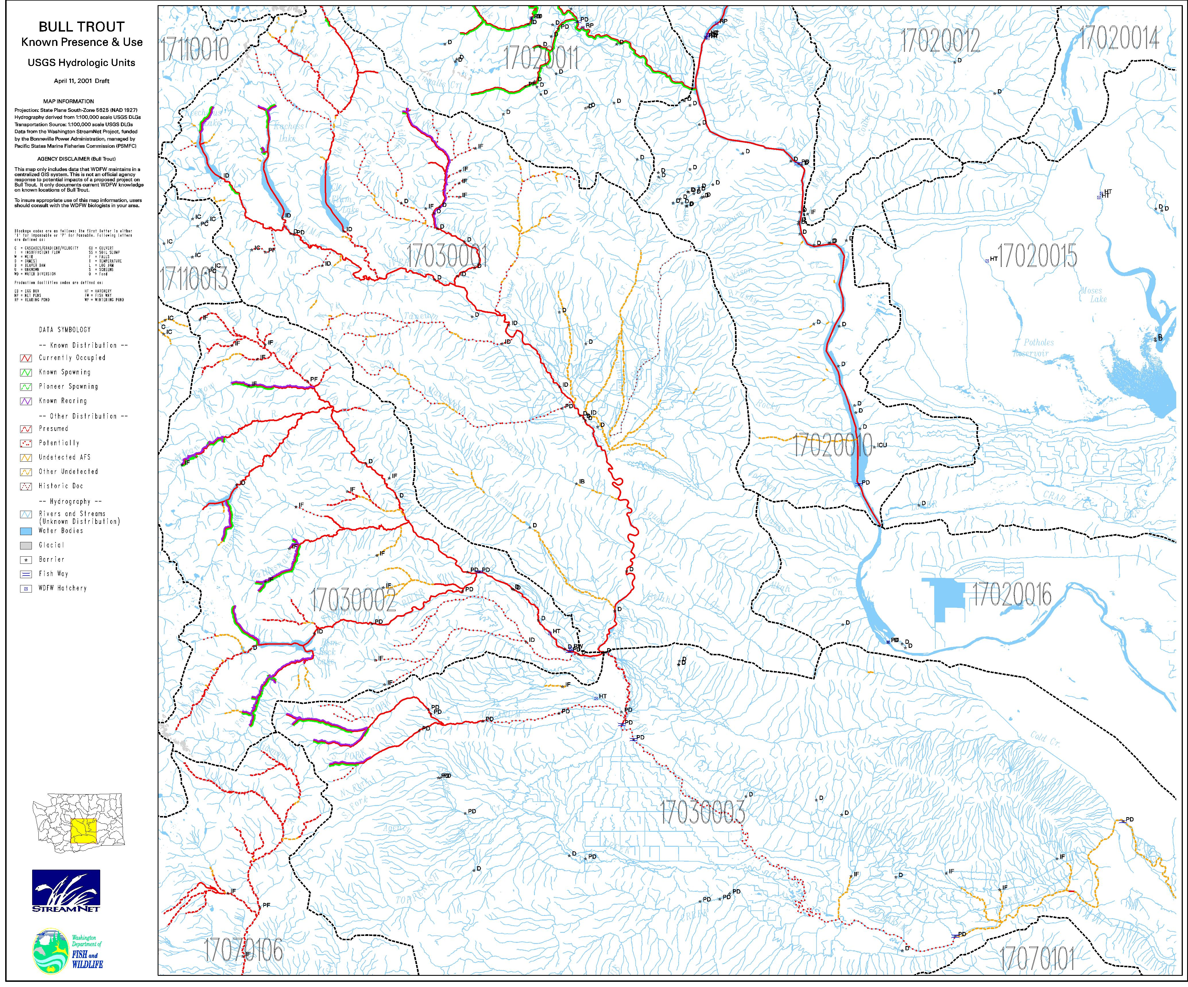

The Water Optimization Study was a comprehensive assessment, completed by the Bureau of Reclamation in 1990, which reviewed most of the ongoing agency watershed restoration programs, rated those programs as to their benefits, and identified gaps in both agency programs and project efforts. Further, that study recommended a complement of projects and programs that would best provide the highest benefit to fish and wildlife in an effective, feasible, and efficient manner.

