Project ID: 9803300

Title: Restore Upper Toppenish Creek Watershed

Section 9 of 10. Project description

a. Abstract

Restoration of the Toppenish watershed (comprising more than 10% of the Yakima sub-basin) is critical to restoring healthy runs of steelhead to the Yakima River. Recent spawning ground surveys and smolt trap data indicate that Toppenish Creek and it's tributaries contribute far more to the Yakima River summer steelhead run than was previously believed. Combined, the steelhead runs in Satus and Toppenish Creeks account for 60%-70% of the steelhead in the entire Yakima Subbasin.

The upper Toppenish Creek Watershed Restoration Project was originally concieved as an extension of the Satus Watershed Restoration Project in the adjacent Satus Creek Watershed. This proposal addresses degradation in the upper watershed, complementing three major restoration efforts underway in the lower, agricultural area. Proposed activities are those recommended in the FY98-99 watershed assessment. Our goal is to improve steelhead habitat by moderating flows from the upper watershed and reestablishing the watersheds natural recuperative processes. The methods identified in the watershed assessment for achieving these goals include: 1) improving grazing management, 2) rehabilitating degraded channels – including stabilizing headcuts, removing dikes, etc., 3) revegetating meadows, floodplains and denuded uplands, 4) reestablishing beaver habitat, 5) participating in landuse management planning efforts (e.g. prescribed burning, transportation, timber harvest,…), and 6) monitoring the effectiveness of the various treatments. Restoration treatments will also favor riparian dependent wildlife species and reestablishement of coho and spring chinook. Meeting these objectives will gradually increase the hydrologic retentiveness of the upper watershed, thereby moderating flow regimes in the fish bearing reaches of Toppenish and Simcoe Creeks.

This proposal is consistent with the 1994 Columbia Basin Fish and Wildlife Program, Measures (principles 1-5, pp.15, and habitat strategies, pp. 25-26), Wy-Kan-Ush-Me-Wa-Kish-Wit, and the Yakima River Subbasin Summary, Statement of Fish and Wildlife Needs, pp. 353-375 which emphasize the importance of healthy watershed functioning to both aquatic and terrestrial habitat.

b. Technical and/or scientific background

Physical Setting
Toppenish Creek is approximately 75 miles long, discharging into the lower Yakima River near Granger at mile 80.4. Its 625-square-mile watershed comprises more than ten percent of the Yakima Basin and lies wholly within the Yakama Indian Reservation (Figure 1). Simcoe Creek, which drains an area of 141 square miles, discharges into Toppenish Creek near its midpoint. Both Toppenish and Simcoe Creek flow through the Wapato Irrigation Project (WIP). Upon reaching the agricultural lands of the Toppenish Valley, both creeks are heavily diverted by private irrigators and by WIP. Farther downstream, both creeks receive heavy flows of warm and turbid Project tailwater.

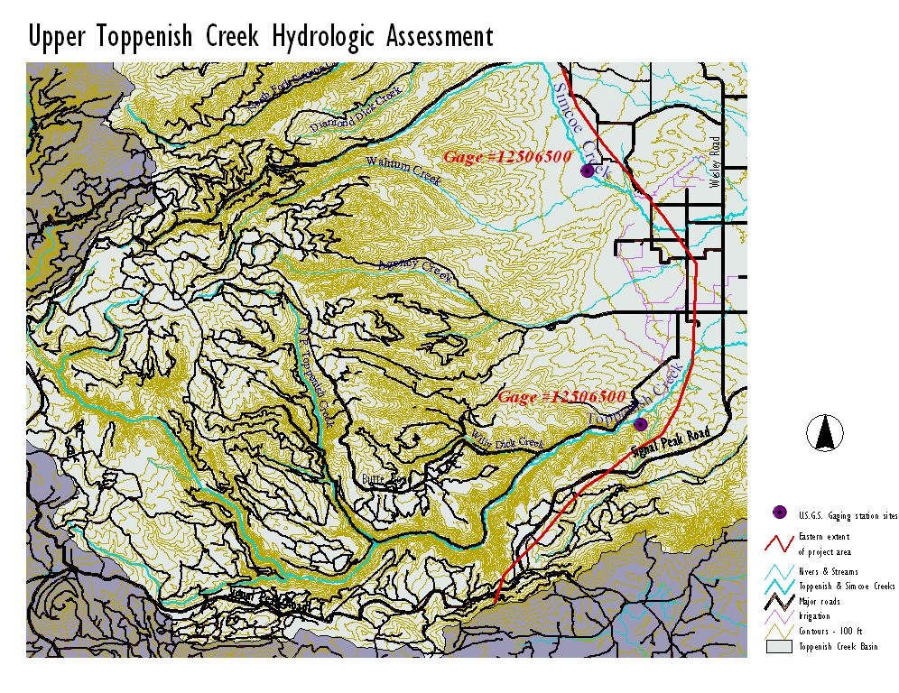Figure 1. Map of the upper Toppenish Creek Watershed.

The Toppenish Creek watershed can be broadly subdivided into an upland region and a lowland region (Anonymous 1975). The lowland region consists of a broad valley floor made up of gravels and other sediments delivered to the valley by Toppenish Creek, its tributaries, and the Yakima River. The lower 40 miles of Toppenish Creek flow across this alluvial valley. Through this valley reach, the creek is subjected to a host of alterations by agricultural activities, flood control, and road building.
In the upper Toppenish Creek watershed, the most important natural mechanisms for moderating runoff occur in the meadow complexes high in the watershed, and in flood plain reaches in the complex of canyon streams draining the upland.
The drainage divide separating the Toppenish Creek drainage from the Klickitat River drainage to the west is not a sharp, well-defined divide, but rather a broad plateau underlain by nearly horizontal volcanic rocks. This plateau features several large meadow complexes. These meadows capture a portion of the snowmelt-generated seasonal runoff and return this water to the stream system along flow paths varying in length from a few feet to tens of miles. Much of the late summer flow in Toppenish Creek is sustained by rainfall and snowmelt which had earlier infiltrated into the soils on the plateau. Previous studies indicate that recharge from this plateau area is also the source of water for groundwater flow in the deep aquifer system discharging to the Yakima River, tens of miles east of the source (Hendry et al. 1992).
Lower in the watershed, streamflow is largely in narrow canyons having little ability to store and release water. At places within the drainage, however, gravel flood plains act to retard runoff, diffuse stream energy and cool the streams by storing and releasing cold spring runoff. Such alluvial flood plain reaches serve as centers of productivity of the aquatic food web upon which steelhead rely.
The irrigated valley serves as the eastern boundary of this project. Thus, the Toppenish Project, combined with the Toppenish/Simcoe Instream Flow Project (551200), YN Lower Yakima Valley Wetlands and riparian Area Restoration Project (92600), and other projects encompass the entire Toppenish Creek Watershed. (Figure, 2)

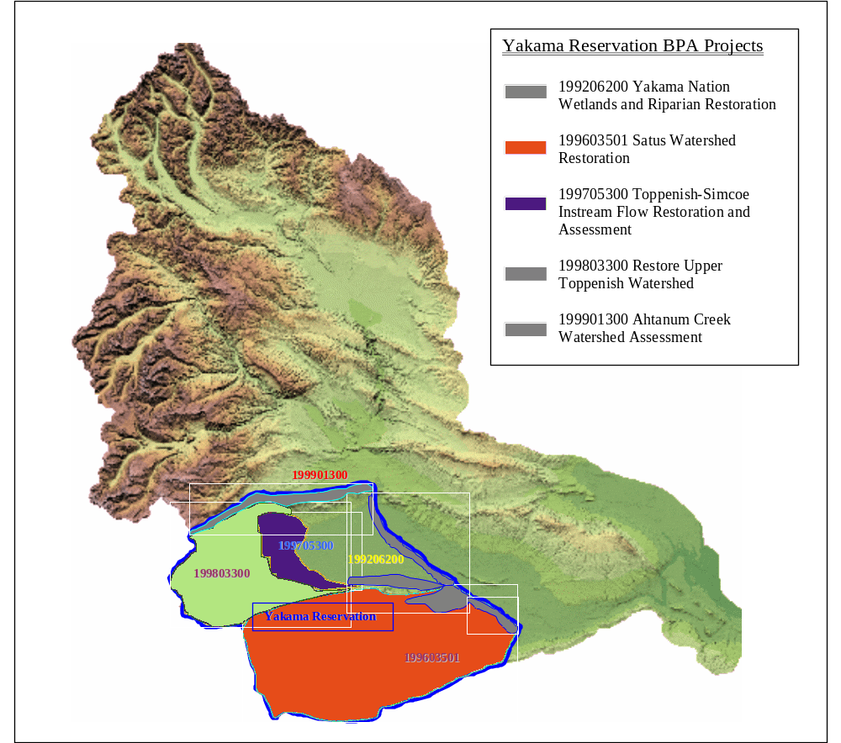
Figure 2. Map of the Yakima Subbasin showing the geographical relationship between the YN’s on-reservation BPA funded projects.

Several resource issues were identified in the watershed assessment as contributing to degraded watershed function and resulting declines in fish and wildlife habitat. Foremost is an altered flow regime (i.e., more extreme high flows and lower low flows). The secondary influences of more extreme flows are far reaching (Toppenish Creek Hydrologic Assessment, 2000). “This type of flow regime [early, short duration-high intensity] also has a propensity to scour young, delicate hardwood regeneration on gravel bars. Hence, recruitment and recovery of riparian vegetation can be diminished. Disturbance, from flooding for instance, is a critical mechanism for shaping and maintaining the health of most riparian areas. However, to frequent flooding does not allow recuperative mechanisms to redevelop channel structure and mature vegetative characteristics” (Toppenish Creek Hydrologic Assessment, 2000).
It is a first principle of watershed hydrology that runoff of snowmelt or rainfall is slowed by natural watershed processes, with the result of decreasing peak flows and increasing base flows (e.g., Dunne and Leopold 1978). This process occurs as water enters temporary storage within the watershed during times of high precipitation or runoff and is released from storage as streamflow during times of limited precipitation and runoff. Streamflow regime – a reflection of climate and storage and release mechanisms within the watershed – drives the evolution of the drainage system and associated aquatic/riparian ecosystems. Because of the climatic patterns and general aridity of the Toppenish Creek basin, these mechanisms are especially critical to sustaining aquatic life. Because these processes naturally moderate the magnitude of floods and increase the delivery of streamflow to lowland areas during summer, they are also of great importance to downstream residents of the watershed.
The natural capacity of a watershed to store water is not evenly distributed across the landscape. Some areas have a high capacity to allow the infiltration of water from the surface and a disproportionately large volume in which to store precipitation and runoff, while other areas are relatively impervious to infiltration and have a relatively low volume of porous material in which to store water. Watersheds that have a high capacity to store water have relatively lower peak flows and higher base flows than watersheds with similar climate, but less natural storage. When the storage mechanisms in a watershed become degraded, peak flows increase and base flows decrease. Effects of these changes include destabilization of stream beds and banks, hotter summer stream temperatures, loss of native vegetation and animal life, and proliferation of non-native species. Restoring the hydrologic function of storage areas and removing the causes of degradation have been shown to drive rapid change back toward natural runoff patterns and native ecosystem function (Stanford and Ward, 1992).
Several causal factors for the altered flow regime were identified in the watershed assessment. “The effects of a century or more of: roading, timber harvest, grazing, fire suppression, beaver removal and other land uses has exacted their toll.” (Toppenish Creek Watershed Assessment, 2000) An extensive road network, averaging >4mi/mi² has been developed in the upper Toppenish Watershed. There are also abundant example of roads directly affecting stream and riparian function. However, the cumulative effect of the entire road network is also interrupting natural runoff patterns. (Jones and Grant, 1994).
Fire suppression and timber harvest practices of the past have combined to alter the forest composition and pattern. (Toppenish Creek Watershed Assessment, 2000) The result has changed snowpack accumulation and melt, transpiration rates, and infiltration. These changes are contributing to an altered watershed yield, flow timing, and peak and low flow patterns (Troendle and Reuss, 1997).
Beaver can provide a variety of benefits to a stream system including flow moderation, sediment retention, and improved floodplain connectivity (Naiman, et. al., 1988). The Toppenish Watershed abounds with evidence of past beaver use, yet little remains today.
The deleterious influence of poorly managed grazing on natural resources has been well documented throughout the west. The Toppenish Watershed has a long history of grazing by cattle and sheep. Today, the upper portion of the Toppenish watershed shows evidence of excessive grazing from more than a century ago. However, a dramatic decrease in the number of permitted cattle combined with the recently implemented grazing plan is yielding immediate and positive results.
It is our working hypothesis that aquatic habitat is created by the watershed-scale interactions between water, soil, and vegetation. It follows that changes to these interactions will cause changes to the habitat. This view of aquatic conditions being influenced by upland conditions is supported by the 1994 FWP: "Maintaining and improving the productivity of salmon and steelhead habitat ... requires coordination of virtually all activities that occur in a subbasin... [I]f watershed restoration is to be successful, instream restoration should be accompanied by riparian and upslope restoration. A comprehensive watershed approach can help fisheries resources recover from their depressed state". The upper Toppenish watershed, being under single ownership and in a largely undeveloped state, offers a nearly ideal opportunity to translate this perspective into action.

Fisheries Resources
The long term goal of the Yakama Indian Nation is to restore summer steelhead to harvestable levels, while maintaining the genetic integrity and adaptability of the population. The Yakima Subbasin Plan outlined in Volume II, Wy-Kan-Ush-Mi-Wa-Kish-Wit, establishes a summer steelhead adult return goal of 29,700 for the entire sub-basin. This will involve restoring terrestrial and aquatic habitat to conditions capable of supporting all freshwater life history stages of summer steelhead.
A recently expanded steelhead spawner survey and smolt trapping effort has revealed that Toppenish Creek is the most productive spawning/rearing watershed in the Yakima Subbasin. It is now estimated that Toppenish Creek and its tributaries annually produce 35%-50% of the steelhead smolts in the Yakima Subbasin. In the year 2000 an estimated 425 steelhead spawned in Toppenish Creek and its tributaries.
The population also appears to be genetically distinct from other populations in the Yakima Subbasin (C. Busack, WDFW, pers. comm.). Juvenile steelhead are spawned and reared primarily in the upper irrigated valley reaches, or higher, in both Toppenish and Simcoe Creeks.

Wildlife Resources
While anadromous fish are the primary focus of this project, wildlife are also intended beneficiaries. No upland restoration projects are implemented without first consulting with tribal wildlife staff. Furthermore, any improvements made to aquatic habitat through riparian recovery will similarly benefit any riparian dependent species. Specifically, these wildlife species include neo-tropical birds, big game, fir bearers, and others. Beaver recovery is a primary objective of this project.
The YN wildlife refuge supports the largest wintering population of deer and elk on the Yakama Reservation and is encompassed entirely within the boundaries of this project.

c. Rationale and significance to Regional Programs

Rationale:
Relation to regional plans

This project is consistent with Wy Kan Ush Me Wa Kish Wit, theYakima River Subbasin Summary, Yakima River Subbasin Salmon and Steelhead Production Plan, Steelhead Strategies 2-7. This project was also derived with due consideration to the following tenets of the 1994 FWP:
7.6A Habitat Goal: Protect and improve habitat conditions to ensure compatibility with the biological needs of salmon, steelhead and other fish and wildlife species. Pursue the following aggressively.
7.6A.1 Ensure human activities affecting production of salmon and steelhead in each subbasin are coordinated on a comprehensive management basis.
The Toppenish Creek watershed is a vital element in the Yakima River subbasin. The scope of this project includes the potential to coordinate the human activities throughout most of the watershed, and throughout all the steelhead spawning and rearing habitat in the watershed.
7.6A.2 At a minimum, maintain the present quantity and productivity of salmon and steelhead habitat. Then, improve the productivity of salmon and steelhead habitat critical to recovery of weak stock. Next, enhance the productivity of habitat for other stocks of salmon and steelhead. Last, provide access to inaccessible habitat that has been blocked by human development activities.
As noted in the 1994 FWP, "improv[ed] habitat quality [is] needed to increase the productivity of many stocks. Reduced habitat quality results in lower survival during critical spawning, incubation , rearing and migration periods.... Improved habitat quality would allow greater juvenile and adult survival at each freshwater life stage and can result in more offspring surviving to begin migration to the ocean.". The Yakima Subbasin Summary corroborates this assertion by stating “Success in implementing this measure, (restoring floodplain connectivity) in combination with restoring the riparian community, will go far toward alleviating perhaps the single greatest constraint on natural production in the Yakima today: a lack of habitat complexity and diversity.” Additionally, improvements made to aquatic habitat through providing a more normative flow regime and healthier riparian/wetland areas will have commensurate benefits to a wide variety of wildlife species.
This project is an extension of the restoration activities undertaken by the Satus Watershed Project into the adjoining Toppenish watershed. Collectively, these two watersheds account for approximately 20% of the Yakima River subbasin land area, and 60%-75% of the wild steelhead production. These watersheds constitute the stronghold for steelhead in the Yakima Subbasin. This project “build[s] form strength” in that “efforts to improve the status of fish and wildlife populations in the basin should protect habitat that supports existing populations that are relatively healthy and productive.” (2000 FWP, pp.26) The proposed actions are also consistent with the scientific principles outlined in section III B and habitat strategies in Section III D.
The National Marine Fisheries Service recently published a set of Reasonable and Prudent Alternatives to guide land use in the basin. While not all of them apply to this project, those that do are being given due consideration. This proposal will: help protect currently productive salmonid habitat (Action 150), increase instream flows (Action 151), and utilize funding from a variety of sources (Action 151, 153) including the Bureau of Indian Affairs, Yakama Nation, and tribal livestock permittees.
As with the FWP, this project meets multiple goals and “needs” stated in the Yakima Subbasin Summary. This project is consistent with the following goals (pp. 319-336): protecting high quality habitats (Goal 1), Restoring degraded areas an returning natural ecosystem functions (Goal 2), restoring …wildlife populations to sustainable levels (Goal 3), and increasing the information… needed to restore and manage fish, wildlife and their habitatis (Goal 4). Most of the “Fish and Wildlife Needs” (pp. 353-375) are also directly addressed by this proposal. Specifically these include:
- Restore/Preserve floodplain connectivity
- Restore normaative flows,
- Restore access to historical production areas to all stages of resident and anadromous salmonids,
- Restore normative water quality to basin streams,
- Restore normative ecological interactions among target species and aquatic communities in all portions of the basin,
- Restore and preserve riparian communities and normative watershed function,
- Planning and management,
- Data management and technical support,
- Education and training,
- Habitat, and
- Passage.

In summary, the rationale underlying this project is that the stream/riparian system is an expression (integration) of the functioning of the entire watershed, i.e., the landscape-scale interactions between water, soil, and vegetation. Furthermore, the long-term sustainability of aquatic and terrestrial ecosystems rely on developing land uses which allow the water-soil-vegetation interactions to remain within a natural range of variability.

d. Relationships to other projects
The Toppenish Watershed Project extends the restoration activities undertaken by Satus Watershed Project personnel into the Toppenish watershed. Key personnel will include the interdisciplinary originators of this proposal (hydrologist and watershed biologist) who co-authored the proposal for the Satus Watershed Project, and have managed the Project since its inception in June 1996. This project dovetails with several others in the Toppenish Creek Basin, including the:

Yakima/Klickitat Fisheries Project (8812001). This project complements the activities of the YKFP by providing restoration and access to high quality anadromous fish habitat in the Yakima Subbasin.

Toppenish-Simcoe Instream Flow Restoration and Assessment (9705300). This project and the “Top-Sim” are closely related. Recovering the normative flow regime which feeds into the irrigated valley is directly related to resolving irrigation issues in the agricultural zone.

Yakama Nation Lower Valley Wetlands/Riparian Restoration (9206600). This project and the Wetlands/Riparian Restoration Project are also closely related. In essence, they perform the same functions in adjacent portions of the watershed. This project in the uplands and the Wetlands/Riparian Project in the irrigated valley.

Satus Watershed Restoration (9603501). As stated earlier, this project is an extension of the Satus Project into the adjacent Toppenish Creek Watershed. The primary objectives are the same as is most of the staff.

Yakama Nation Flood Management Project. The Flood Management Project was originated from a $ 6,000,000 congressional funding allocation intended to repair damage from the 1996 and 1997 floods, and prevent damage from occurring in the future. The Toppenish staff is currently participating in with their program in a major project to re-access the head of the Toppenish Creek alluvial fan. The efforts of this project and the Flood Management Program are very closely linked.

Yakima River Basin Water Enhancement Project, (P.L. 96-182), is a long term project administered by the Bureau of Reclamation to address irrigation issues and restore streamflow, habitat and fish runs in the Yakima River Basin. The Upper Toppenish Project will play an integral role in the implementation of YRBWEP on the reservation by addressing water supply delivered to the irrigated area.

e. Project history (for ongoing projects)

An assessment of the upper Toppenish Creek Watershed was completed in early 2000. The restoration recommendations from that assessment very much parallel those from the Fish and Wildlife Needs section of the Yakima Subbasin Summary. Guided by the recommendations section of the assessment, restoration activities were initiated in the late of spring of 2000. However, full restoration implementation is scheduled to begin in the spring of 2001. Many of the restoration activities are extensions of those undertaken in the adjacent Satus watershed by the Satus Watershed Project (begun in 1996).
An improved livestock grazing management strategy was developed with the BIA Range Program, YN Wildlife Program and the permittees. This effort required simply asking the permittees to avoid grazing sensitive headwater source areas in exchange for improving livestock accessibility to more abundant upland forage. No fences were constructed but a series of gathering corrals are being built. The initial results are impressive. Vegetative and channel recovery processes have begun and will be monitored closely to track progress. Several of the headwater meadows that were heavily grazed on an annual basis went untouched by livestock in 2000. This project will be expanded on a watershed scale in 2001.
Additionally, the Toppenish staff has initiated several intensive planning efforts to address issues highlighted in the assessment. These include: improved road crossings of Simcoe Creek (one of them is a low flow passage barrier) and three headwater meadows, prescribed fire management in the upper watershed, beaver habitat recovery, road maintenance practices, flood management at the interface with the irrigated valley, and in-channel/riparian vegetation rehabilitation.
In 1999 the professional staff from the Toppenish Project directed a Federal Emergency Management Agency (FEMA) funded stream crossing improvement on Willy Dick Creek; a tributary of Toppenish Creek. The crossing, damaged by the flood of 1996, had been a total fish passage barrier since 1972. The whole project was completed in August 1999. The season following the project, steelhead made extensive use of the high quality spawning and rearing habitat above the project site. In fact, the redd density above the improved crossing was the highest of any of Toppenish Creek’s tributaries.

f. Proposal objectives, tasks and methods

Objectives
The Yakama Indian Nation proposes to improve aquatic and terrestrial habitat in Toppenish and Simcoe creeks by:

- moderating the flow regime within the watershed,
- fostering vegetative recovery,
- participating in landuse management planning activities,
- Improving fish spawning/rearing and wildlife habitat.
- Monitoring and evaluating results.

These objectives were derived directly from the Upper Toppenish Creek Assessment.

Objective 1 : moderate the flow regime within the watershed.

Task a. Rehabilitate degraded channels.
- Continue implementing comprehensive revegetation program in the upper watershed. Particular emphasis will be placed on headwater meadows and other source areas.
- Develop improved livestock management infrastructure including: upland water development and strategically placed gathering corrals and handling facilities.
- Where necessary install small grade control structures in degraded channels to initiate recovery processes. Materials will include woody debris, straw bales, straw wattles, and rock. Installation will be accomplished
- Arrest all headcuts.

Task b. Reestablish access to floodplains.
- Remove dikes and other floodplain constrictions.
- Reincorporate large woody debris where practicable.

Task c. Improve road drainage.
- Cooperate with tribal and BIA programs to improve road drainage throughout the watershed.
- Assist with culvert maintenance.

Task d. Improve Beaver habitat.
- Restore riparian hardwood and herbaceous vegetation.

Objective 2: foster vegetative recovery.

Task e. Re-integrate fire as a vegetation management tool.
- Cooperate with BIA fuels program to return fire as a means to restore natural vegetative patterns.
Task f. Restore vegetation where natural revegetation is not occuring.
- Plant appropriate native vegetation where needed in source areas.
- Manage grazing.

Objective 3: participate in landuse management planning activities.

Task g. Continue participating in land management planning processes.
- Timber harvest
- Fire management
- Grazing
- Road construction and maintenance
- Irrigation
- Fish and wildlife management

Objective 4: Improve fish spawning/rearing and wildlife habitat.

See all of the tasks outlined above.

Objective 5: Monitor and evaluate results.

Task h. Monitor treatments.
- Measure sediment retention associated with instream structures.
- Measure grazing utilization and use results to apply adaptive management.
- Measure vegetative recovery.

Task i. Monitor fish and wildlife population parameters.
- Assist with spawning surveys.
- Assist with wildlife population and habitat surveys.

Task j. Evaluate findings and integrate into adaptive management strategies.
- PFC Assessment.
- Apply adaptive management.

g. Facilities and equipment

This proposal is intended to capitalize on the expertise, facilities, and equipment possessed by the YIN Satus Watershed Project by continuing our restoration efforts into the Toppenish Creek watershed. Facilities include a fully furnished office, including computers and a copying machine. Equipment includes: vehicles, a tractor, ATV’s, snow machines, stream discharge meters, water quality meters, pumping sampler, irrigation equipment, a variety of revegetation equipment and fencing material, and other miscellaneous equipment.

h. References

Reference (include web address if available online) | Submitted w/form (y/n)
Jones, J.A. and G.E. Grant. 1996. Peak flow responses to clear-cutting and roads in small and large basins, western Cascades, Oregon. Water Resources Research 32(4), 959-974.

McCoy, T.H. and G.O. Ringer. 2000. Toppenish Creek Watershed Assessment (unpublished). Yakama Nation internal document, Toppenish, Washington.

Naiman, R.J., C.A. Johnston, and J.C. Kelley. 1988. Alteration of North American streams by beaver. BioScience 38(11)753-762

Stanford, J.A. and J.V. Ward. 1992. Management of aquatic resources in large catchments: recognizing interactions between ecosystem connectivity and environmental disturbance’ in Naiman, R.J. (Ed.), Watershed Management. Springer-Verlag, New York. Pp. 91-123.

Troendle, C.A. and J.O. Reuss. 1997. Effects of clear-cutting on snow accumulation and water outflow at Fraser, Colorado. Hydrology/Earth Systems Science 1(2), 325-332

Section 10 of 10. Key personnel

Thomas H. McCoy
40 Gopher Rd.
wk. (509) 865-6262 Ext. 6647
hm. (509)698-5005

EDUCATION:

M.S. Rangeland Ecology / Watershed Management, (Completed June 1994)
University of Wyoming, Laramie
Graduate advisor Dr. Thomas Wesche

Preceded by graduate studies in rangeland ecology (1991-1992)
Oregon State University, Corvallis
Graduate advisor Dr. John Buckhouse

B.A. Business Administration, (August 1989) followed by 1 year of undergraduate studies in natural resource sciences.
Washington State University, Pullman

PROFESSIONAL EMPLOYMENT:

Watershed Restoration Biologist, (September 1994 to present) Served the past 5 years as the Satus/Toppenish Creek Watershed Restoration Project co-manager for the Yakama Nation. The primary responsibility of this position is identifying natural resource problems that negatively affect anadromous fish habitat, and develop, implement and evaluate restoration treatments. Specifically, these treatments include: developing/implementing a watershed scale fire reintroduction plan; improving grazing management; developing a watershed scale horse management program, developing and implementing road rehabilitation projects; large scale upland and riparian rehabilitation and revegetation projects; interdisciplinary team member for performing proper functioning condition assessment and developing land management activities; developing/implementing monitoring network to track changes in watershed processes (i.e. stream discharge, water quality, climate, vegetative change, and fish habitat/population trends); and performing watershed analysis.

Additional responsibilities include: soliciting funds to implement project activities; budget administration; project reporting; supervision of up to 80 full and part-time employees; public relations; developing documents to meet regulatory requirements (e.g. Environmental Assessments); and presenting project accomplishments to funding entities and appropriate professional meetings.

Graduate Research Assistant, (summer 1992-summer 1994) Department of Range Management and the Wyoming Water Resources Center at the University of Wyoming. Completed a masters thesis on plant-groundwater relationships and riparian vegetative response to flooding. Conducted year-round research on two densely instrumented research watersheds in subalpine and montane zones which include vegetation, precipitation, streamflow, and groundwater well monitoring networks. Supervised 1-6 field technicians. Assisted with sediment transport/flushing flow and riparian/fish habitat restoration projects.

Ranch Worker, (1991-1992) Assisted with daily operations on a small cattle ranch near Falls City Oregon while attending graduate courses at Oregon State University.

Preserve Manager/Ecologist, (summer 1991) The Nature Conservancy's Middle Fork of the John Day River Preserve. Oversaw 1 full time employee and all on site activities, including public relations, designing and implementing long term vegetation and stream channel monitoring programs, and coordinating joint projects with land management agencies. Also assisted local permittees with grazing management programs.

PUBLICATIONS
McCoy, T.H. and G.O. Ringer. 2000. Toppenish Creek Watershed Assessment (unpublished). Yakama Nation internal document, Toppenish, Washington.

PROFESSIONAL MEMBERSHIPS:

Washington State Proper Functioning Condition (PFC) Assessment training Cadre

Society for Range Management

Ecological Society

GINA RINGER
509) 865-6262, ext. 6647 (W) email: gringer@yakama.com
Education:
M.S., Forest Hydrology, 1994 B.S., Civil Engineering, 1979
minor in ecology B.S., Agricultural Engineering,
Oregon State University University of California at Davis

Experience:
Watershed Hydrologist July 1996 - present
Yakama Indian Nation Satus Watershed Project, Toppenish, Washington
Develop and manage the Satus Watershed Project, implementing grants to perform watershed analysis and restoration; designing and supervising the installation of an extensive monitoring network; analyzing streamflow and climate records; planning and supervising the implementation of watershed restoration treatments; interdisciplinary assessment of riparian and upland areas; interdisciplinary watershed analysis and report preparation; hiring personnel; supervising; preparation and administration of contracts; preparation and delivery of presentations; preparation of funding proposals.

Hydrologist October 1994 - July 1996
Yakama Indian Nation Water Program, Wapato, Washington
Evaluate the effects of land use on the surface waters of the Yakama Reservation; advise staff and policy makers; make recommendations on issues involving surface waters; collect and analyze hydrologic data; hydrologic modeling; technical support; interdisciplinary planning of timber sales.

Hydrologist/Civil Engineer May 1994 - September 1994
Washington Department of Fish and Wildlife, Engineering and Technical Support Section of the Habitat Division, Olympia, Washington.
Hydrologic and hydraulic analysis of natural channels; interdisciplinary development of aquatic habitat restoration and flood risk management plans for the Dungeness and Quilcene rivers; verification and improvement of a model specifying design flows for fish passage.

Publications:
- Adams, P.W. and G.O. Ringer. 1994. Summary and annotated bibliography of the effects of timber harvesting and forest roads on water quantity and quality in the Pacific Northwest. Oregon Forest Resources Institute.
- Ringer et al. 1998. Satus Creek Watershed Analysis (unpublished – internal Bureau of Indian .

Professional Licenses, Credentials, and Activities:
- Professional Engineer, California, license no. C35359 (License pending in Washington State).
- Member/Instructor, Washington State cadre for providing Riparian Proper Functioning Condition (PFC) training.
- Instructor, Washington State University Cooperative Extension Master Watershed Steward Program.
- Member, American Water Resources Association.
- Member, Society for Range Management.
- Member, Toastmasters International.

