Project ID: 25095

Title: Pesticides and the environmental health of salmonids in the Yakima subbasin.

Section 9 of 10. Project description

a. Abstract

Current use pesticides are an emerging issue of concern for the environmental health of anadromous salmonids in the Columbia River Basin. Pesticides are toxic chemicals that degrade the quality of salmon habitat, and they represent a potentially important obstacle to the 2000 Fish and Wildlife Program's habitat-based approach to rebuilding naturally producing fish populations. Pesticide use is extensive in the Yakima subbasin of the Columbia Plateau, one of the most intensively irrigated areas in the United States. Surface water monitoring investigations by the U.S. Geological Survey (past and present) have shown that salmon habitat in the lower basin is frequently contaminated with diverse mixtures of insecticides, herbicides, and other biocidal compounds. The consequences of pesticide exposures for salmon health and fitness are largely unknown. To address this scientific uncertainty, we will evaluate the toxicological effects of pesticides on different life history stages of chinook salmon. We will specifically focus on pesticides that target the salmon nervous system since these account for the majority of chemicals detected in lower reaches of the subbasin. Our approach has three key elements: (1) determine the toxicological effects of real-world pesticide exposures on the normal function of the chinook nervous system, (2) evaluate neurological impairment in the context of salmon fitness, and (3) relate sublethal losses of performance and fitness to possible impacts at the scale of natural populations. This investigation will incorporate techniques in neurochemistry, neurophysiology, developmental biology, reproductive physiology, animal behavior, and population modelling. The results will provide empirical and modelling data on a poorly understood and potentially critical aspect of salmon habitat quality in the Yakima subbasin.

b. Technical and/or scientific background

Salmon need cool, clean water in adequate supply to survive critical periods of early development, juvenile growth, smoltification, adult migration, and spawning (NMFS, 1998). Exposures to environmental contaminants at critical life history stages can have important negative effects on the survival and reproductive success of wild fish. For example, in the case of salmon, embryonic exposure to Polycyclic aromatic hydrocarbons has been shown to decrease marine survival (Heintz et al., 2001). Exposures to environmental contaminants during critical life history stages such as smoltification may also contribute to large-scale declines in local salmon populations (Fairchild et al., 1999). There are numerous other examples of the effects of contaminants on the biology of salmon, including such sensitive physiological processes as disease resistance (e.g. Arkoosh et al., 1998).

Migratory salmonids in the Columbia Basin are exposed to a wide range of environmental contaminants in surface waters and sediments during different stages of their freshwater and estuarine life histories. These may include metals, PCBs, PAHs, organotins, dioxins/furans, organochlorines, and current use pesticides. Among these different classes of contaminants, current use pesticides represent perhaps the greatest area of existing scientific uncertainty for salmonids.

Approximately 750 different pesticides (active ingredients) are currently registered for use in Washington State (B. Moran, WA Dept. Agriculture, personal communication). Collectively, these substances are designed to repel, kill, or regulate the growth of undesirable biological organisms. This diverse group includes fungicides, herbicides, insecticides, nematicides, molluscicides, rodenticides, fumigants, disinfectants, repellents, wood preservatives, and antifoulants. The most common pesticides are insecticides, herbicides, and fungicides. These are used for pest control on forested lands, agricultural crops, tree farms and nurseries, highways and utility rights of way, parks and golf courses, and residences. Pesticides often enter the aquatic environment as single chemicals or complex mixtures (Fuhrer et al., 1999). This can arise from direct applications, surface runoff, spray drift, agricultural return, or through groundwater influx.

Pesticides are frequently detected in salmon habitat throughout the Columbia Basin. For example, 50 different pesticides were recently detected by the U.S. Geological Survey in the Willamette basin (Wentz et al., 1998). In addition, a USGS pilot study in the Yakima basin detected 43 different pesticides in surface waters of the lower reaches that provide habitat for several species of salmonids (Rinella et al., 1999). A partial list of the pesticide detects in the Yakima system is shown in Table 1.
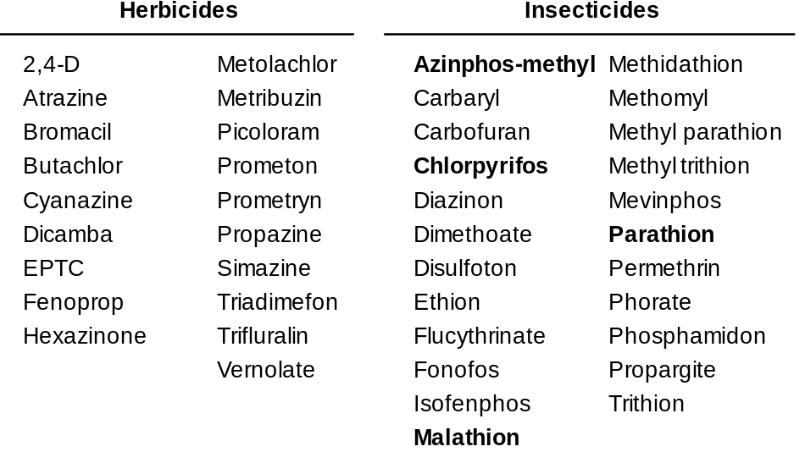
Table 1. A partial list of pesticides detected in the Yakima River Basin (adapted from Rinella et al., 1999). Those pesticides that are in bold are the only pesticides that have established EPA Aquatic Life Criteria.

Many current use pesticides are known to interfere with the behavior or physiology of salmonids at concentrations that are well below the levels that cause mortality. For example, several of the pesticides that have been detected in the Yakima River and its tributaries have been shown to interfere with salmonid swimming behavior (Brewer et al., 2001; Beauvais et al., 2000), foraging behavior (Morgan and Kiceniuk, 1990), homing behavior (Scholz et al., 2000), antipredator behaviors (Scholz et al., 2000; Kruzynski and Birtwell, 1994), and reproductive physiology (Moore and Waring, 2001, 1998, 1996a; Waring and Moore, 1997). These effects occur at pesticide concentrations that are very low and, in many cases, within the range of exposure conditions in salmon habitat. With a few exceptions, however, the biological consequences of real-world exposures to single chemicals and pesticide mixtures are not known for salmon.

Due in part to the prevalence of pesticides in salmon habitat, and the extent of the scientific uncertainty surrounding these chemicals, the NMFS has recently identified pesticides as habitat factor of special concern for the conservation and recovery of threatened and endangered species of Pacific salmon (NOAA, 2000). In addition, an Interagency Task Force on Pesticides and Salmon was recently convened to address the issue of current use pesticides and ESA-listed salmonids in Washington State (see Appendix A - letter from Governor Locke). The Task Force includes technical and policy representatives from the U.S. EPA, USFWS, NMFS, and the Washington State Departments of Agriculture, Ecology, Fish and Wildlife, and Natural Resources. This Task Force is presently developing a science-based approach to determine whether pesticides are limiting the biological requirements of anadromous salmon and bull trout in Washington (see "A process for evaluating pesticides in Washington State surface waters for potential impacts to salmonids" at www.wa.gov/agr/pesticideesastrategy).

c. Rationale and significance to Regional Programs

The stated vision of the 2000 Fish and Wildlife Program (FWP, Section III.A.1) is a Columbia River ecosystem that sustains an abundant, productive, and diverse community of fish. Where feasible, this will be accomplished by restoring the natural ecological functions and habitats of the Columbia River Basin. This includes a specific planning assumption (Section III.A.2) that the FWP is a habitat-based program that will rebuild healthy, naturally producing fish populations by protecting, mitigating, and restoring habitats and the biological systems within them, including anadromous fish migration corridors. One of the six recovery goals of the Federal Caucus is to "conserve ecosystems upon which salmon and steelhead depend". The stated scientific principle for this goal is that "conservation requires a network of diverse, high quality, interconnected habitats and high water quality".

The Yakima subbasin contains one of the most degraded rivers systems in the western United States in terms of the number of different pesticides that contaminate salmon habitat. Pesticides are synthetic and natural toxicants that are specifically designed to kill animals, plants, and other biological organisms. In this respect they are very different from more conventional water quality parameters such as temperature, suspended solids, or dissolved oxygen. They are also very numerous and difficult to measure in the aquatic environment. Of the 180+ pesticides applied in the Yakima subbasin, a USGS pilot monitoring study analyzed for 54 different chemicals and detected 43 in streams (Rinella et al., 1999).

Recent research on salmonids has shown that short term exposures (i.e., hours to days) to very low concentrations of a single pesticide can disrupt reproductive physiology (Moore and Waring, 2001) as well as behaviors related to survival (Brewer et al., 2001; Scholz et al., 2000) and homestream migration (Scholz et al., 2000). Depending on their specific patterns of habitat use, salmonids in the Yakima River and its tributaries can be exposed to repeated pulses of pesticides, in complex mixtures, throughout extended periods of the year. Collectively, the exposure and biological effect data suggest that pesticides in salmon habitat may have significant impacts on natural populations.

The FWP's primary habitat strategy (Section III.D.3) is to identify the current condition and biological potential of the habitat. Moreover, the FCRPS biological opinion calls for habitat actions that provide offsite mitigation (9.4.2.6 Offsite Mitigation-Habitat Plan). Identifying the actions relies heavily on the subbasin planning process. The Federal Caucus Basinwide Recovery Strategy places a specific emphasis on restoring tributary and estuarine habitat. The FWP relies heavily on the protection of, and improvements to, inland habitat as the most effective means of restoring and sustaining fish populations. Moreover, a primary strategy for research, monitoring, and evaluation (Section II.D.9) is to identify and resolve key uncertainties for the program.

Pesticides are a critical source of scientific uncertainty in the Yakima subbasin, and natural resource managers do not have the necessary information to evaluate the biological significance of pesticides in the larger context of habitat quality for salmon. For example, the BPA cannot rely on the EPA's aquatic life criteria for scientific guidance. This is because the majority of pesticides that have been detected in the Yakima subbasin do not have criteria (see Table 1). Furthermore, the aquatic life criteria that have been developed are for single pesticides only, and they fail to address the fact that most pesticides enter the aquatic environment as complex mixtures. In a national analysis of surface water quality, the USGS found that more than 50% of all streams sampled contained five or more pesticides (Fuhrer et al., 1999). The cumulative impacts of pesticide mixtures on the biology of fish are almost completely unknown. Finally, existing criteria are derived from mortality measures (LC50s) in surrogate fish species. LC50s cannot be used predict the sublethal effects of real-world pesticide exposures on the sensitive life history stages of migratory salmonids, including those stocks that are listed for protection under the Endangered Species Act (Scholz and Collier, 2000).

Within the context of subbasin planning, this uncertainty presents an obstacle to effective prioritization of actions to restore water quality where it is significantly degraded in the Yakima river and its tributaries. The USGS National Water Quality Assessment (NAWQA) Program is currently involved in an extensive surface water monitoring effort for pesticides in the basin. Our objective is to place these monitoring data in a biological context for salmonids. The Tasks outlined in this proposal represent a mechanistic and integrative approach to the problem of uncertainty, and the research will substantially advance our understanding of the relative importance of pesticides in the larger context of salmon habitat quality.

d. Relationships to other projects

The USGS is currently involved in a large scale monitoring effort for pesticides and other water quality parameters throughout the Yakima basin. A pilot monitoring study revealed a high degree of pesticide contamination in surface waters of the lower basin (Rinella et al., 1999). Importantly, these monitoring efforts have established pesticide exposure conditions for salmonids in the Yakima river system and its tributaries. The research proposed here will evaluate these monitoring results in the context of the environmental health of salmonids, with a specific focus on chinook. We expect USGS efforts in the basin and our proposed research to be complimentary and, to the extent possible, coordinated.

This project will also generate sublethal pesticide toxicity data that will be very useful for the purposes of the Washington State Task Force on pesticides and salmon. The Task Force is facing considerable scientific uncertainty for most current use pesticides with regard to their direct effects on salmonids. The results of the research proposed here will help to fill this information gap and provide context for future, salmon-specific pesticide monitoring (see Appendix B - Letter from Curt Smitch).

Finally, this proposal is being coordinated with a complimentary proposal being submitted by David Johnson of the Washington Department of Fish and Wildlife entitled "Salmon and Steelhead Habitat Inventory and Assessment Project (SSHIAP)". It is our eventual goal to relate the distributions of pesticides in surface waters in the Yakima basin to the stage-specific distribution of Fall and Spring chinook. These spatial data will be an important element of the spatial population model we propose in Task #3 (see below). New SSHIAP efforts in the Yakima subbasin to link existing pesticide datasets to the hydrolayer and the distribution of salmonids in the basin will be of significant benefit to our project.

e. Project history (for ongoing projects)

N/A - this is a new project.

f. Proposal objectives, tasks and methods

Objective: Evaluate the impacts of current use pesticides on the environmental health of salmon and the viability of native populations in the Yakima River and its tributaries.

The specific aim of this research proposal is to answer the following questions regarding pesticides and salmon in the Yakima subbasin:

- Are pesticide pulses in salmon habitat sufficient to disrupt the normal function of the salmon nervous system?

- If so, do these impacts have measurable and negative consequences for the performance or fitness of exposed animals?

- What limits do pesticides impose on the genetic integrity and productivity of wild salmonid populations?

As mentioned previously, several hundred pesticides are currently registered for use in Washington State, and 180 or more are applied in the Yakima subbasin (Rinella et al., 1999). Several classes of biocides are represented in this diverse group, including the organophosphate, carbamate, and pyrethroid insecticides, the triazine, acetamide, phenoxy, and pyridine herbicides, and the dithiocarbamate fungicides. It is not technically feasible to screen all of these pesticides, individually or in mixtures, for sublethal effects on the biology of salmonids. Instead, the proposed research will focus on chemicals that are known to interfere with the normal function of the nervous system in salmon and other fish species. These include the organophosphates (Brewer et al., 2001; Scholz et al., 2000; Beauvais et al., 2000; Moore and Waring, 1996; Morgan and Kiceniuk, 1990), the carbamates (Waring and Moore, 1997; Carlson et al., 1998; Little et al., 1990), the pyrethroids (Moore and Waring, 2001; Little et al., 1993), and the triazines (Saglio and Trijasse, 1998; Moore and Waring, 1998). Collectively, these chemical classes account for the majority of current use pesticides that have been detected in Yakima subbasin surface waters (Rinella et al., 1999).

The pesticides identified above are known to specifically target key functions of vertebrate neurons and neural networks. Consequently, sublethal exposures to these chemicals might be expected to impair the neurochemistry, neurophysiology, or behavior of exposed salmonids. This is a significant concern for at-risk species in the Yakima subbasin because the nervous system is the basis for behaviors that are critical to the survival and reproductive success of the animal. All behaviors, including hatching, swimming, schooling, sheltering, foraging, predator avoidance, imprinting, seaward migration, homing and spawning are potentially vulnerable to sublethal, pesticide-induced neurotoxicity.

The proposed research will focus on the salmon olfactory system as a sensitive indicator of sublethal neurophysiological and behavioral toxicity. Direct measures of nervous system function will be made using in vivo electrophysiological recordings from the peripheral olfactory system in chinook salmon. Salmon have a highly developed sense of smell, and previous studies have shown that measures of olfactory capacity are linked to sublethal neurotoxicity that has ecological significance (reviewed in Klaprat et al., 1992).

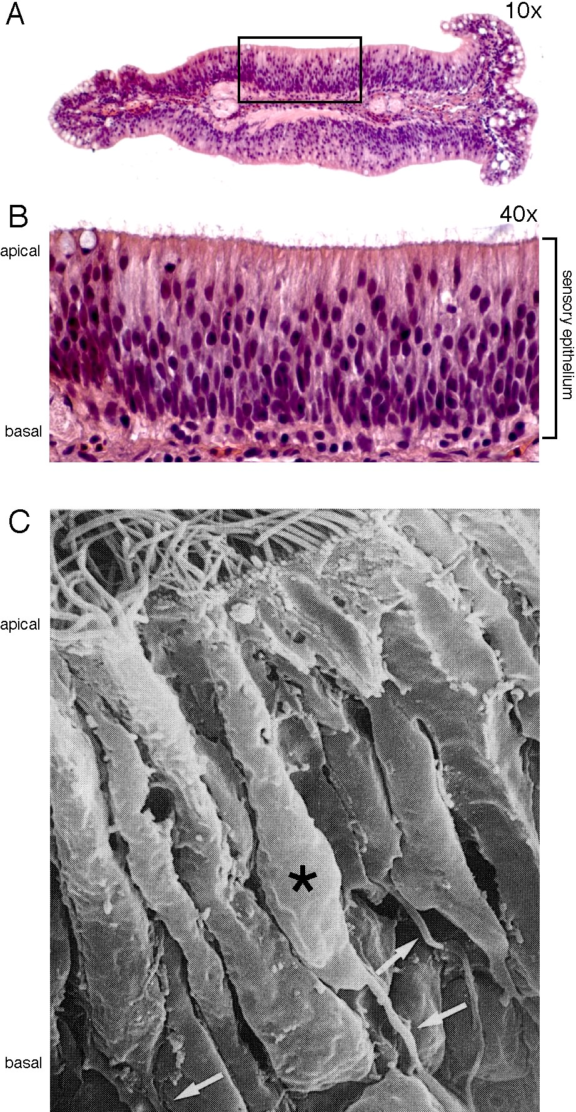

Figure 1. Architecture of the fish olfactory epithelium. A) Low magnification light micrograph of a single olfactory lamella from a salmon rosette, shown in cross-section and stained with haemotoxylin-eosin. Box denotes region of higher magnification shown in the next panel. B) Pseudostratified, columnar structure of the olfactory sensory epithelium. C) Freeze-fracture scanning electron micrograph of the sensory epithelium. Individual olfactory receptor neurons are visible (asterisk). Note ciliated apical dendrites and axons projecting towards the basal lamina (arrows) and olfactory forebrain. (A&B, M. Bushnell and N.L. Scholz, unpublished results; C, Crnjar et al., 1992)

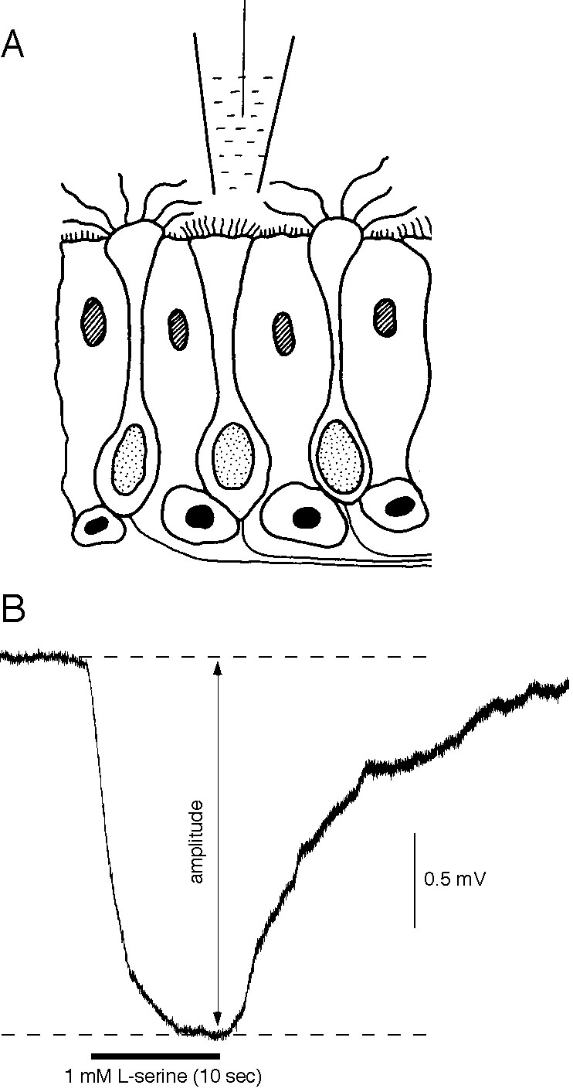

Figure 2. The electroolfactogram (EOG). A) Schematic illustration of the fish sensory epithelium indicating the placement of a recording electrode in proximity to the olfactory receptor neurons (modified from Hara, 1992). B) An EOG produced in response to a short pulse of the amino acid L-serine in a juvenile salmon. The amplitude of the negative potential is measured from the baseline prior to the onset of the stimulus pulse. (D.H. Baldwin and N.L. Scholz, unpublished results)

The salmon nose consists of an olfactory chamber with openings to the surrounding environment and an olfactory rosette (Zeiske et al., 1992). The rosette is situated on the floor of the olfactory chamber and is composed of a longitudinal ridge surrounded by two rows of olfactory lamellae. Thousands of olfactory receptor neurons cover the surface of each lamella. These form a columnar, pseudostratified sensory epithelium (Fig. 1A&B). The individual receptor neurons are bipolar. They send a single dendrite to the apical surface of the epithelium and an axon through the basal lamina to the olfactory bulb in the forebrain (Fig. 1C). The binding of waterborne odor molecules and olfactory signal transduction takes place in cilia that extend from the apical tip of the dendrite.

The electroolfactogram (EOG) is commonly used to measure the stimulus-evoked activity of receptor neurons in the sensory epithelium (Fig. 2A). The EOG is a large negative voltage transient or field potential that is measured with a recording electrode placed near the surface of the sensory epithelium. The amplitude of the EOG represents a summation of the active properties of olfactory receptor cells in the epithelium (Hara, 1992). An example of an odor-evoked EOG in coho salmon is shown in Fig. 2B. The olfactory nervous system in general, and the EOG recording technique in particular, is well suited for studying the sublethal effects of pesticides on the salmon nervous system. Several specific advantages are discussed below.

First, unlike cells in the brain that are protected by the blood-brain barrier, olfactory neurons are in direct contact with the surrounding environment. For this reason, they are likely to be more vulnerable to pesticide-induced toxic injury than neurons in central networks. Also, olfactory neurons are very sensitive, with detection thresholds in the low picomolar range (10⁻¹² M) for some classes of odorants (e.g. Moore and Waring, 1996b).

Second, the olfactory epithelium is easily accessible for the purpose of measuring odor-evoked voltage potentials. This allows for a quantitative analysis of nervous system function in an intact, living animal. Moreover, standard methods for electrophysiological recording, data acquisition, and data analysis are well established in the peer-reviewed scientific literature (e.g. Evans and Hara, 1985).

Third, it’s possible to directly perfuse the olfactory chamber with a dissolved pesticide. This allows for precise control over the duration and concentration of pesticide exposure to the animal’s nervous system (the olfactory rosette), and makes it possible to simulate real-world pesticide pulse conditions (Domagalski, 1996) in the laboratory.

Fourth, fundamental mechanisms of olfaction have been studied extensively in salmon and other fish species (Hara, 1992). The physiological properties of receptor neurons and the pathways for integrating chemosensory information into forebrain networks are well understood when compared to other areas of the fish nervous system. Also, olfactory receptor cells contain much of the basic cellular machinery typically found in neurons. Therefore, olfactory neurons are useful as a general screen for neurotoxic pesticides that target a wide range of cellular proteins, including receptors, ion channels, protein kinases, phosphatases, G-proteins, and phosphodiesterases.

Fifth, there are established relationships between olfactory function and the performance and fitness of individual salmonids. For example, predator avoidance (Brown and Smith, 1997), kin recognition (Griffiths and Armstrong, 2000), imprinting (Nevitt et al., 1994), homing behavior (Dittman and Quinn 1996), and reproductive priming (Moore and Waring, 1996b) are all mediated by olfaction.

Finally, a salmon’s sense of smell determines, in part, the long-term genetic integrity of wild populations. Salmon rely on chemical cues to form olfactory memories and return to their natal stream to spawn (Dittman and Quinn, 1996), and functional anosmia (or a loss of olfactory capacity) has been shown to disrupt homing behavior (Wisby and Hasler, 1954). This is a significant management concern because an increase in straying could have negative consequences for the long-term viability of at-risk salmonid ESUs in the Yakima subbasin.

Task 1. Functional measures of pesticide neurotoxicity in chinook salmon.

In the Statement of Fish and Wildlife Needs, The Yakima Subbasin Summary identifies pesticide transport from agricultural practices and uncontrolled urban runoff as a significant water quality concern. Surface water monitoring data indicate that pesticides are widespread in salmon habitat in the mainstem and lower reaches of the Yakima River system. The aim of this Task is to evaluate the biological significance of these pesticide exposures for salmonids. More specifically, we will use in vivo measurements from the chinook olfactory nervous system to establish cause-and-effect relationships between pesticide levels in the environment and thresholds for neurotoxic injury in salmon. We will also consider the relative sensitivities of different life history stages, the extent of olfactory impairment, and the cumulative impacts of pesticides mixtures.

The studies proposed for this task will test the following four hypotheses:

H₁: Pesticides in salmon habitat reach concentrations that are high enough to cause
neurological dysfunction in juvenile chinook salmon.

H₂: Chinook salmon are more susceptible to pesticide-induced neurotoxic injury at
sensitive life history stages.

H₃: Single pesticides interfere with multiple olfactory pathways in salmon.

H₄: Mixtures of pesticides produce additive toxicity in the salmon nervous system.

Study 1: Sublethal thresholds for neurotoxic injury (Scholz and Baldwin).

Scope. We will evaluate sublethal toxicity of current use pesticides using electrophysiological recordings from the peripheral olfactory nervous system of chinook salmon. As mentioned previously, the odor-evoked EOG recording technique is a very sensitive and reproducible measure of neuronal function in intact, living animals. Our aim is to determine the concentrations at which common pesticides produce sublethal neurotoxicity, and relate these values to pesticide pulse conditions that have been documented in salmon habitat.

Approach. Three active ingredients will be screened in this experiment. These include the organophosphate insecticide malathion, the carbamate insecticide carbaryl, and the triazine herbicide simazine. The majority of pesticides detected in the lower Yakima belong to the organophosphate, carbamate, and triazine classes (see Table 1). Since pesticides within a class generally have the same mechanism of toxicity, dose-response date for these three chemicals should give some indication of the relative neurotoxicity of the different classes as a whole.

Methods. The experimental setup for recording EOGs in salmon will be modified from Evans and Hara (1985) and Baatrup et al. (1990), and is shown in Fig.3. This design permits continuous recording of electrical activity in the animal’s sensory epithelium for periods of four hours or more (Moore and Waring, 1996a; N.L. Scholz, unpublished observations). The computer-controlled perfusion system has a 10-ms valve switching time, allowing for a precise temporal delivery of different stimuli and pesticides to the olfactory organ. The responsive properties of olfactory receptor neurons will be viewed on an oscilloscope and digitized using a computer and data acquisition hardware and software. Data will be analyzed on a separate computer and archived on compact discs.
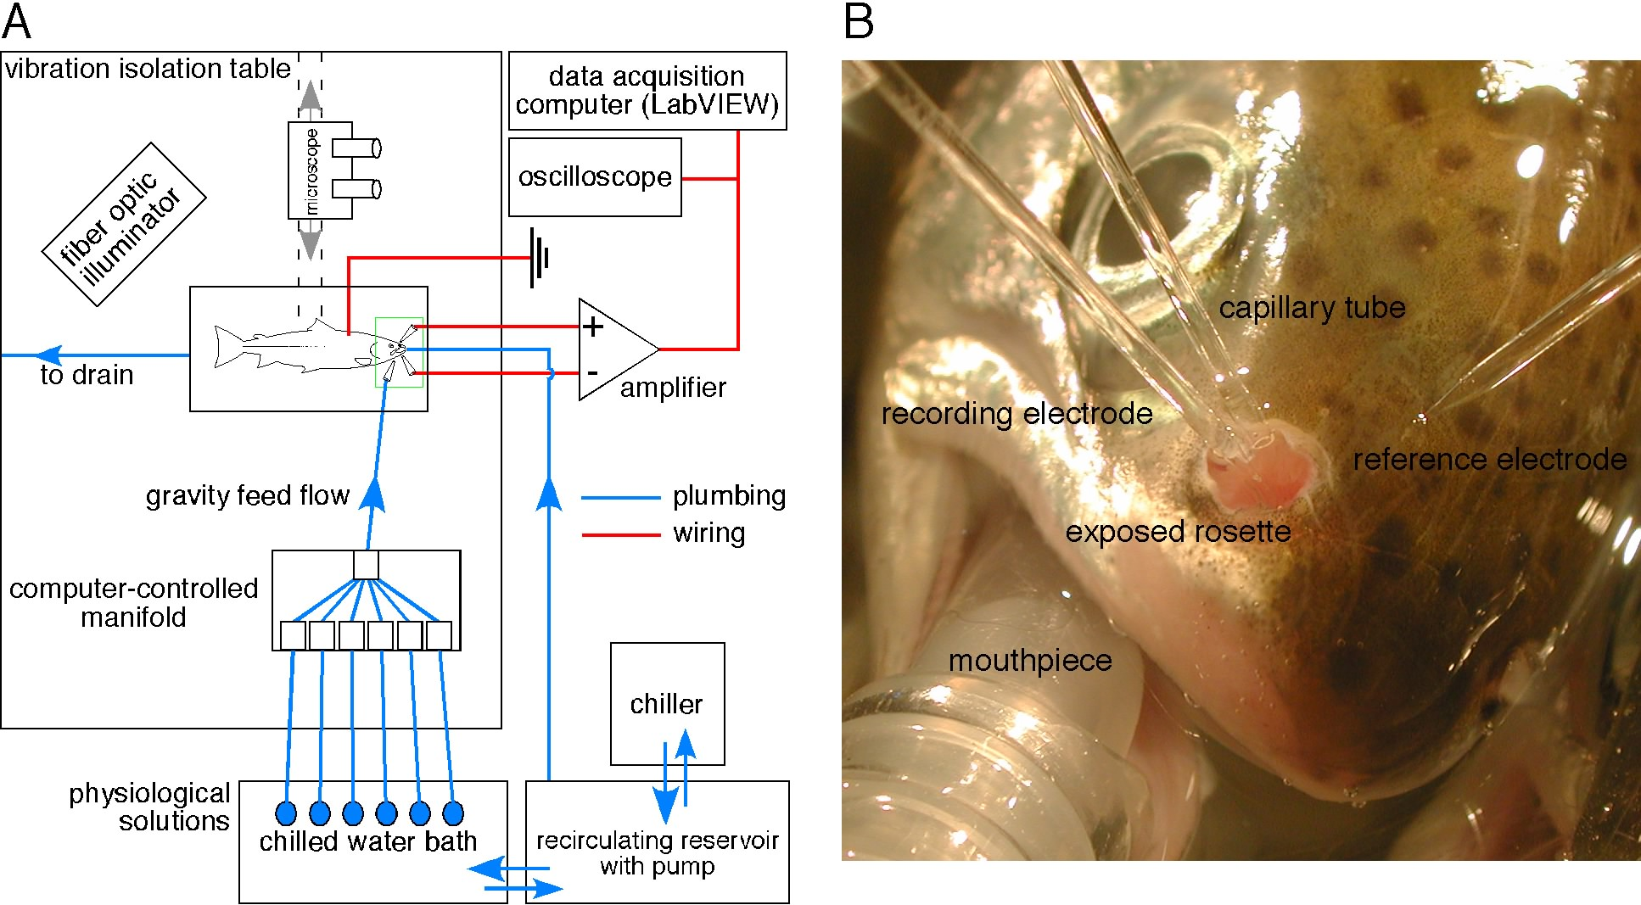

Figure 3. Apparatus for using the EOG to measure neurophysiological effects of dissolved pesticides on Pacific salmon. A) Schematic diagram showing the major components of the apparatus. The fish is anaesthetized and placed in a plexiglass holding chamber on the surface of a vibration isolation table. A reservoir of chilled water provides the gills with oxygenated water and maintains physiological (perfusion) solutions at a constant temperature (12ºC). Solutions are delivered to the exposed rosette by gravity at a constant flow rate (7 mls/min). A computer-controlled manifold allows for rapid switching between odorant and pesticide-containing solutions for perfusing over the olfactory rosette. The green box denotes the area shown in more detail in B. A custom LabVIEW software program controls stimulus delivery to the olfactory rosette and captures the physiological recording for later analysis. B) Photograph showing the rostrum of a coho salmon and the placement of the perfusion tube and glass microelectrodes. The mouthpiece provides a steady supply of chilled, anaesthetic-containing, oxygenated water to the animal’s gills. The capillary tube delivers test solutions to the exposed rosette (neurosensory epithelium). The recording electrode is placed near the surface of the rosette and the reference electrode is placed nearby on the surface of the skin. The perfusion capillary and the glass microelectrodes are positioned and held in place with micromanipulators.

The amino acid L-serine is an effective odorant in fish (e.g. Evans and Hara, 1985; Moore and Scott, 1992) and will be used as a model stimulus to characterize the basic properties of the EOG in juvenile chinook. We will monitor the amplitude and waveform of the evoked field potential while varying several aspects of the stimulus delivery, including pulse duration, interval, and concentration. These data will be used to design a stimulus paradigm that elicits the largest and most consistent response from olfactory receptor neurons. Blank pulses of artificial fresh water will be included to control for mechanical artifacts, and repeated L-serine pulses will be used to monitor rundown of the preparation.
A B
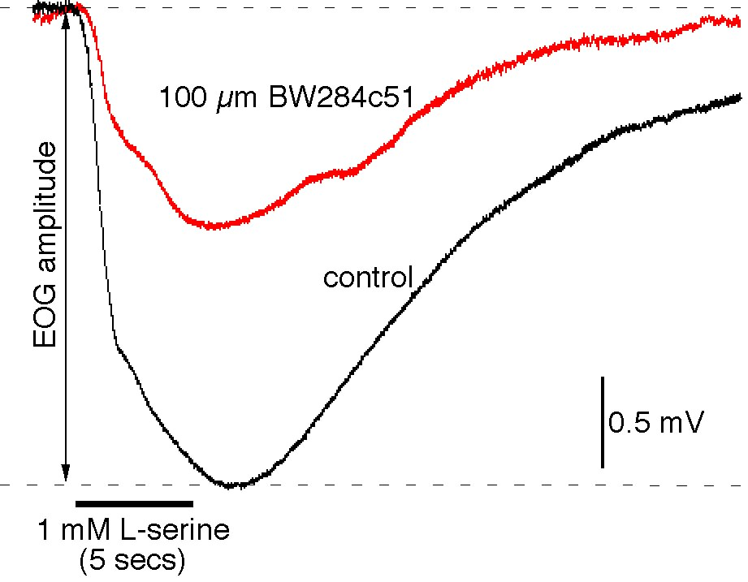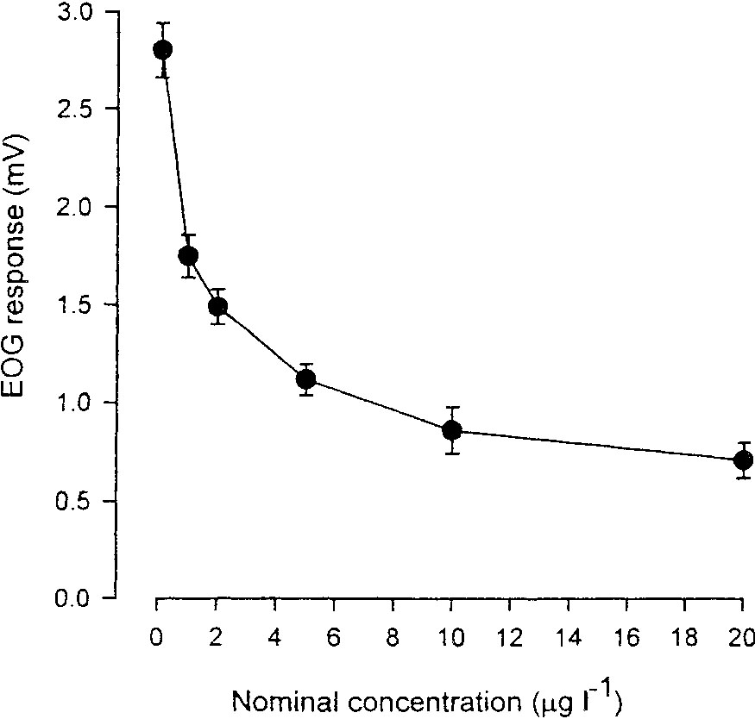

Figure 4. A) The anticholinesterase BW284c51 reduces the olfactory response from coho sensory epithelium. A ten-minute perfusion of the rosette with 100 μM BW284c51 substantially diminished the peak amplitude of the serine-evoked EOG. B) Carbofuran reduces the olfactory response from Atlantic salmon rosettes. A 30-minute exposure to carbofuran reduced the pheromone-evoked EOG in a dose dependent manner. (A, D.H. Baldwin and N.L. Scholz, unpublished results; B, from Waring and Moore, 1997)

A baseline set of stimulus-evoked EOGs will be measured for each fish. The olfactory organ will then be perfused with pesticide-containing water and a second set of stimulus-evoked EOGs will be recorded. Sublethal neurotoxicity will be expressed as a decrease in the amplitude of the post-exposure EOG relative to the animal’s baseline response (see Fig. 2). We will vary both the duration and concentration of pesticide exposure to reflect environmental conditions in the lower Yakima. We will also measure the time to effect and time to recovery. We’ll use approximately 80 juvenile chinook to obtain dose-response data for each pesticide. This includes a sample size of eight fish for each of 10 treatments (water control, vehicle control, and eight exposure concentrations).

Expected results. The organophosphate and carbamate insecticides are well-established neurotoxins, and we expect malathion and carbaryl to disrupt chinook olfactory function at concentrations that are at or near pulse conditions in salmon habitat. This would be consistent with the results of similar studies in Atlantic salmon (Waring and Moore, 1997; Moore and Waring, 1996). Both pesticides block acetylcholinesterase (AChE), an enzyme involved in cholinergic neurotransmission. As shown in Fig. 4A, inhibition of AChE in the salmon's olfactory epithelium substantially diminishes the animal's olfactory response to L-serine. An example of a carbamate's effect on an odor-evoked EOG in Atlantic salmon is shown in Fig. 4B. The triazine herbicides are not anticholinesterases; however, atrazine also disrupts salmon olfactory function in a dose-dependent fashion (Moore and Waring, 1998).

Study 2. Pesticide impacts as a function of salmonid life history (Scholz and Baldwin).

Scope. Chinook salmon (and related anadromous species) undergo important changes in their physiology and behavior as they transition between life history stages. Many of these changes involve developmental modifications of the animal's olfactory nervous system. For example, there is a dramatic period of maturation of olfactory networks during the juvenile freshwater phase of development (Jarrard, 1997). As salmon begin to smolt, olfactory pathways show an enhanced sensitivity to natural odorants. This change in sensitivity has been observed in olfactory receptor neurons (Nevitt et al., 1994) as well as the primary centers for chemosensory integration in the olfactory forebrain (Morin and Døving, 1992). The heightened olfactory sensitivity of pre-smolts may reflect the importance of a salmon's homestream odors for imprinting (Nevitt and Dittman, 1998). Since the active properties of the salmon olfactory system are stage-specific, neurophysiological measures of pesticide neurotoxicity may not be representative of the animal's life history as a whole. This is an important consideration because chinook salmon in the Yakima subbasin can be exposed to pesticides at multiple stages of development.

Approach. To evaluate the susceptibility of chinook salmon to pesticides at different stages, we will compare physiological thresholds for neurotoxicity in fry, parr, smolts, and pre-spawning adults.

Methods. Odor-evoked EOGs will be measured using the standard technique outline in Study #1. For parr exposures in Study #1, dose-response data for a single pesticide (malathion) will be used to calculate the concentration necessary to produce a 25% reduction in the amplitude of the L-serine-evoked EOG. Malathion will be used as a representative of the numerous anticholinesterase insecticides that have been detected in surface water monitoring studies. For 10 fish at each developmental stage, dose-response curves for L-serine perfusions alone (no pesticide) will be used to quantify the relative sensitivity of the olfactory epithelium to amino acids (Nevitt, et al., 1994; Morin and Døving, 1992). Additionally, 10 fish at each stage will be exposed to and the response to a graded series of L-serine stimulus pulses will be recorded. The effects of malathion on the L-serine dose-response curves will be compared among age groups to determine if there are any differences in the magnitude of malathion's toxicological effect.

Application of results. The results from this experiment will determine the extent to which sublethal neurotoxicity data from chinook parr can be extrapolated to other life history stages where olfaction plays an important role in the animal's survival, migration, or reproductive success. This information will be incorporated into the population model in Task #3 (see below). If the neurotoxic effects of a pesticide are independent of chinook life history stage, the model will apply the olfactory toxicity data generated for parr in Study #1 to other life history stages as well. If the effects of malathion are disproportionate (i.e., malathion inhibits the odor-evoked EOG to a greater extent in smolts), the parr data will be adjusted for the model.

Study 3. Effects of pesticides on olfactory capacity (Scholz and Baldwin).

Scope. The electrophysiological recordings in Study #1 are designed to evaluate the effects of pesticides on the olfactory nervous system's sensitivity to a model odorant. The amino acid L-serine was chosen for this purpose because it is known to be an effective physiological and behavioral stimulus in salmonids (Evans and Hara, 1985). However, the fish odorant receptor gene family contains ~100 different genes (Ngai et al., 1993) and these receptor proteins bind to several different classes of odor molecules. Moreover, the olfactory cues that guide important salmon behaviors such as home stream migration are not known (Dittman and Quinn, 1996). Since homing behavior will be considered in the spatial population model in Task #3, it will be important to determine whether pesticides have a general impact on chinook olfactory pathways (i.e., whether they impair the olfactory response to all known classes of odorants), or if their effects are restricted to a specific class such as the amino acids.

Approach. To determine if a given pesticide acts on multiple olfactory pathways, we will perfuse the olfactory chamber of chinook parr with a bile salt, a steroid, a prostaglandin, and an amino acid. These compounds represent four distinct classes of odorants in salmonids (Hara, 1992). They are available from commercial suppliers and their stimulatory effects on the salmon olfactory nervous system have been previously characterized (e.g. Moore and Waring, 1996b). The relative effects of a triazine herbicide (simazine) and an anticholinesterase insecticide (malathion) on the amplitude of evoked EOGs for each compound will be compared.

Methods. Electrophysiological experiments will be conducted as described in Study #1. For simazine exposures, baseline dose-response curves will be generated in 10 fish for each of the four different odorants (40 fish total). The olfactory chambers will then be perfused with simazine at a concentration and duration sufficient to inhibit 25% of the L-serine evoked EOG. Following the simazine exposure, another series of graded odor stimuli will be presented. The relative effects of simazine on the different olfactory pathways will be determined by comparing the pre- and post-simazine dose-response curves for each of the four odorants. Malathion will be screened in the same way in an additional 40 fish.

Expected results. We expect simazine and malathion to inhibit all four major olfactory pathways in juvenile chinook salmon. This would be consistent with previous findings in Atlantic salmon that pesticides from the triazine (Moore and Waring, 1998), carbamate (Waring and Moore, 1997), organophosphate (Moore and Waring, 1996), and pyrethroid (Moore and Waring, 2001) classes inhibit olfactory responses to prostaglandins and amino acids. An example for a pyrethroid is shown in Fig. 5.

Study 4. Cumulative neurotoxicity following exposures to pesticide mixtures (Scholz and Baldwin).

Scope. Pesticides frequently occur as complex mixtures in the aquatic environment (Fuhrer et al., 1999). However, the effects of mixtures on the biology of aquatic species, and salmon in particular, are very poorly understood. Pesticide toxicity data (e.g. EPA Aquatic Life Criteria) are generally available for single chemicals only. One approach to this problem is to focus on pesticides that share a common mechanism of toxicity, such as the organophosphates and carbamates that inhibit neuronal isoforms of AChE. These two classes account for the large majority of insecticides detected in the lower reaches of the Yakima subbasin (Fig. 6A). Preliminary data indicate that AChE is expressed in the chinook olfactory epithelium (Fig. 6B), and that mixtures of carbamates and organophosphates produce additive AChE inhibition in vitro (Fig. 6C). Consequently, organophosphates and carbamates may contribute additively to the total amount of pesticide neurotoxicity in salmon habitat. To test this hypothesis, we will use in vivo EOG recordings in combination with biochemical measures of enzyme activity to compare the inhibitory effects of single pesticides and mixtures on odor-evoked field potentials.
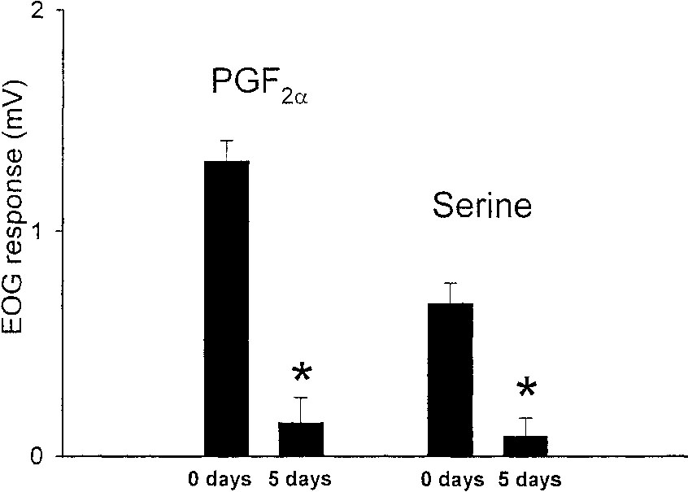
Figure 5. Atlantic salmon exposed to <0.004 μg/l cypermethrin for five days show significant reductions in their peak EOG responses to both a prostaglandin (PGF2α) and to an amino acid (L-serine). (from Moore and Waring, 2001)

Approach. Because of the labor involved, it is beyond the scope of this study to generate EOG dose-response data for each of the carbamate and organophosphate insecticides in Fig. 6A, and then evaluate the neurophysiological effects of different mixtures. Instead, we will use an in vitro biochemical approach to characterize the inhibitory effects of each pesticide on AChE activity in extracts from the chinook olfactory nervous system. AChE is the common target enzyme for these pesticides, and the degree of enzyme inhibition in in vitro preparations of the olfactory epithelium should scale proportionally to the inhibitory effects of each pesticide on the amplitude of the odor-evoked EOG. Assuming strict additivity and a consistent relationship between olfactory sensitivity and AChE activity, we will use in vivo and in vitro dose-response curves to calculate toxic "equivalents" for the different anticholinesterase pesticides.

A
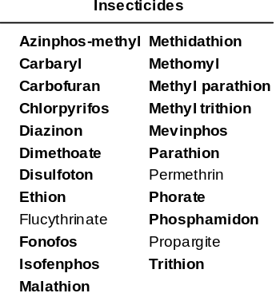

B C
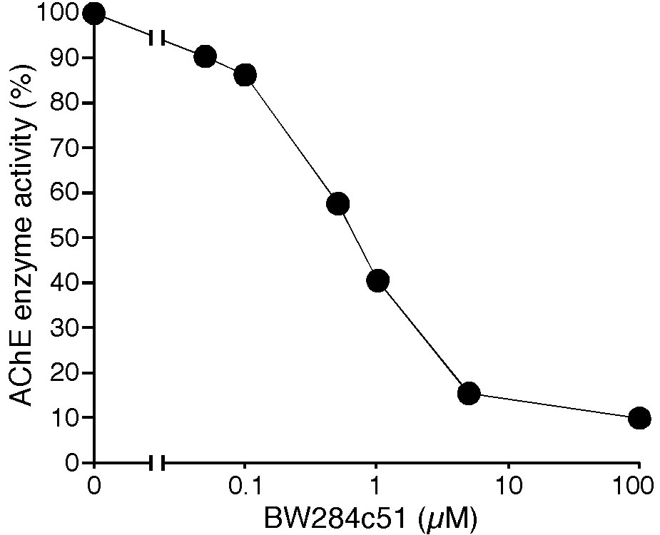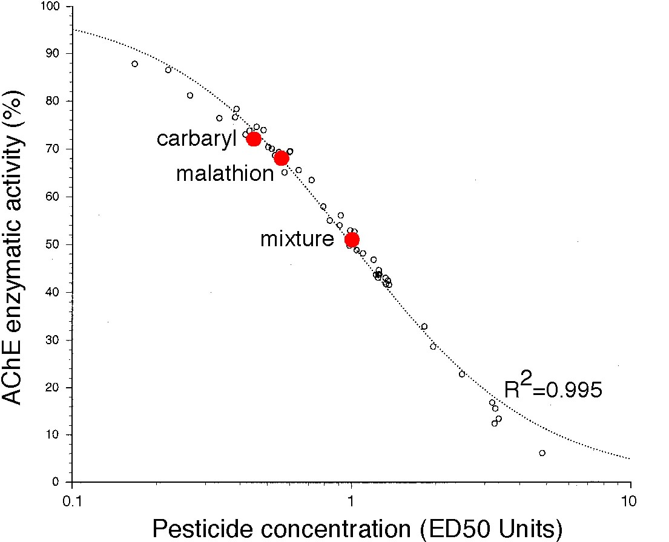

Figure 6. A) Partial list of insecticides detected in the Yakima River Basin. Insecticides shown in bold are all anticholinesterases. B) Acetylcholinesterase (AChE) activity in chinook olfactory rosettes is inhibited by the anticholinesterase inhibitor BW284c51, as monitored by an Ellman-based microtiter plate reader assay. This demonstrates the presence of enzymatically active acetylcholinesterase in the olfactory rosettes. C) Inhibition of AChE activity by anticholinesterase pesticides is additive. The plot shows data from five pesticides tested alone and in binary combinations. Pesticide concentrations have been normalized based on their respective IC50s to allow direct comparisons. All the data falls on the same logistic function indicating a common and additive mechanism of action. The red circles highlight the data from one pairing of pesticides (carbaryl with malathion). (J. Labenia and N.L. Scholz, unpublished results)

Methods. To test the hypothesis that a pesticide's inhibitory effects on AChE scale proportionally to decreases in the amplitude of the L-serine evoked EOG, we will compare in vitro and in vivo dose-response curves for four different chemicals (malathion, azinphos methyl, carbaryl, and methomyl). Electrophysiological recordings will be conducted as described in Study #1. Measures of AChE enzymatic activity will be performed using standard procedures (Beauvais et al. 2000). Briefly, olfactory rosettes will be removed from approximately 100 animals and homogenized. Neuronal isoforms of AChE will be extracted by ultracentrifugation in high salt and detergent buffers, and purified enzyme extracts will be aliquoted and stored at -80 ºC. AChE enzyme kinetics and the inhibitory effects of carbamate and organophosphate pesticides will be determined spectrophotometrically using a modified version of the Ellman assay (actylthiocholine iodide hydrolysis) and a 96-well plate reader.

Expected results. We expect to generate toxicity equivalents for the anticholinesterase pesticides using the approach outlined above. Consequently, for the purposes of the spatial population model in Task #3, we will estimate the cumulative neurotoxicity (or loss of olfactory capacity) arising from a chinook salmon's exposure to mixtures of insecticides that have been detected in the Yakima subbasin. In the event that the relationship between AChE activity and olfactory sensitivity is not consistent, we will use EOG recordings to collect in vivo inhibitory dose-response data for a subset of pesticides (n = 3) from each class, and use these data to calculate an average or representative inhibitory curve for that class. This approach may be less accurate than generating threshold and dose-response data, but it will still allow us to make an estimate of additive neurotoxicity for pesticides within a class.

Task 2. Pesticide impacts on salmon fitness.

The experiments in Task #1 are to designed to provide mechanistic data for the effects of current use pesticides on the olfactory performance of chinook salmon at different life history stages. These data will be important for evaluating the significance of existing pesticide monitoring data in the Yakima subbasin i.e., whether pesticides or mixtures of pesticides in the aquatic environment reach levels that are high enough to cause physiological impairment. However, a more important challenge is to determine whether the impacts of pesticides on the chinook olfactory nervous system have measurable consequences for the fitness of exposed animals.

The experiments proposed in this Task will explore the possibility that short term, ecologically-representative pesticide exposures reduce the survival and reproductive success of chinook salmon. The olfactory nervous system underlies critical aspects of a salmon's behavior and physiology. The impacts of pesticides on two of these biological processes will be studied here.

The experiments proposed for this task will test the following two hypotheses:

H₁: Environmentally-realistic pesticide exposures increase mortality in juvenile
chinook salmon.

H₂: Environmentally-realistic pesticide exposures decrease reproductive success in
adult chinook salmon.

Study 5. Predators, alarm behaviors, and juvenile mortality (Scholz, Baldwin, and Berejikian).

Scope. When juvenile salmonids are attacked by a predator, the injured fish releases a chemical alarm substance that signals danger to nearby conspecifics (Berejikian et al., 1999; Brown and Smith, 1998; 1997). In chinook salmon, the alarm pheromone triggers a stereotypical suite of antipredator behaviors in fish that detect the chemical cue (Scholz et al., 2000; Berejikian et al., 1999). In general, alarm behaviors substantially reduce the likelihood that a fish will be preyed upon during an encounter with a predator (Smith 1992). For example, Mathis and Smith (1993) found that minnows exposed to a conspecific alarm pheromone survived predation by a pike for ~ 40% longer than minnows which were not exposed to the pheromone. Moreover, hatchery fish learn to associate the alarm stimulus with the smell of a predator, improving their survival in the wild (Berejikian et al., 1999). We have recently shown that a two hour exposure to a single organophosphate insecticide at concentrations detected in agriculturally-impacted surface waters is sufficient to disrupt alarm behaviors in juvenile chinook salmon (Scholz et al., 2000; Fig. 7). These data suggest that pesticide-induced anosmia in salmonids could have subtle but important impacts on juvenile mortality due to predation. Importantly, the Yakima Subbasin Summary's statement of fish and wildlife needs identifies excessive predation on juveniles as a significant problem throughout the basin (under 'Restore Normative Ecological Interactions').
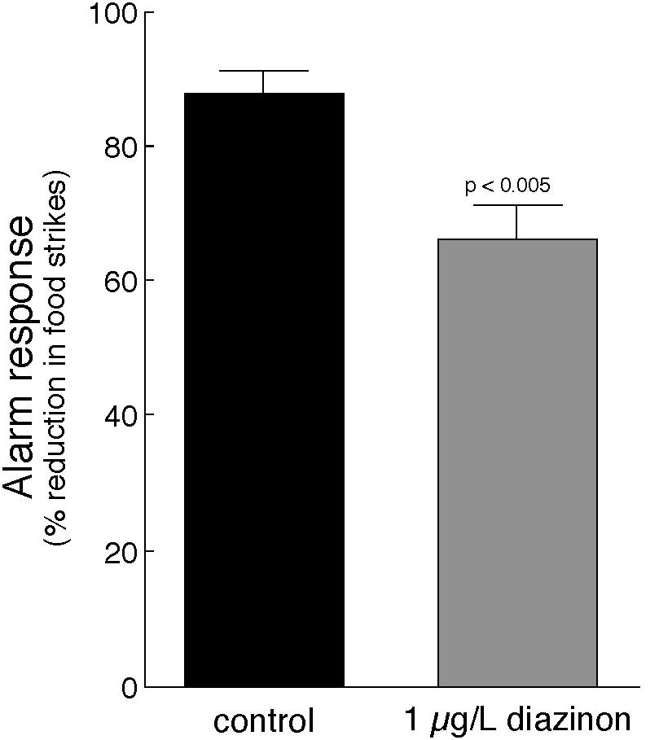

Figure 7. The antipredator response of diazinon-exposed chinook parr is significantly reduced compared to controls. Parr were exposed to diazinon for 2 hours and alarm behaviors were measured in response to a conspecific skin extract. (modified from Scholz et al., 2000)

Approach. To test the hypothesis that pesticides increase predation on juvenile chinook salmon, we will analyze predator-prey interactions in pesticide-exposed and unexposed fish. These experiments will be conduced in the behavioral testing facility at the Manchester Research Station. In addition, we will determine the effects of a short-term pesticide exposure on post-release survival through a downstream migration in a creek containing natural predators.

Methods. The sensitivity of the chinook alarm system to anticholinesterase neurotoxocity has already been established (Scholz et al., 2000). The results of experiments in Study #1 (time to effect and time to recovery) and #4 (cumulative toxicity of mixtures) will be used to establish exposure conditions and the timeframe for behavioral testing in this Study. A single pesticide (malathion) will be used at a concentration adjusted for toxicity equivalence. Exposure conditions will reflect that maximum impacts to the olfactory system that could reasonably be expected in the lower reaches of the Yakima basin. We will quantify the effect of this exposure regime on the magnitude of the chinook alarm response as described previously (Scholz et al., 2000). Pesticide exposed and unexposed fish will be placed together in a behavioral testing arena. A skin extract will be introduced (to simulate an upstream predation event). After a short delay, a predator will be allowed access to the juveniles. The actual predator used (e.g. pikeminnow, trout, or sculpin) will depend on availability. We will quantify predation success on the control and treatment groups in separate experiments using standard measures (Berejikian et al, 1999; Kruzynski and Birtwell, 1994) i.e., time to first capture, overall rate of capture, total prey consumed, etc. A total of 20-80 fish will be used for each experiment. We will also release approximately 2000 chinook smolts into a natural stream containing a healthy population of fish predators. Prior to release, half will be treated with a pesticide. The treatment and control groups will be marked with a fluorescent dye. The fish will be collected downstream in a fish trap, and the effects of pesticide exposure on instream survival during outmigration will be determined.

Expected results. Given the importance of the chemical alarm system for prey survival (Mathis and Smith, 1993) and the preliminary data for chinook juveniles (Fig. 7), we expect pesticide exposures to significantly increase predation mortality in exposed fish.

Study 6. Pheromones, reproductive behaviors, and fertilization success (Scholz, Dittman, and Berejikian).

Scope. Many fish release chemical cues to signal their reproductive status to their mates (Sorensen, 1992). This form of chemical communication serves to synchronize the pre-spawning physiology of male and female fish. Reproductive synchronization is particularly important for semelparous species of salmonids that must spawn within a restricted temporal window. In Atlantic salmon, ovulating females release an F-type prostaglandin in their urine. This pheromone primes the reproductive physiology of the male, triggering increases in reproductive hormones and expressible milt (Moore and Waring, 1996b). It has previously been shown that exposures to low levels of pesticides from the pyrethroid (Moore and Waring, 2001), triazine (Moore and Waring, 1998), carbamate (Waring and Moore, 1997) and organophosphate (Moore and Waring, 1996a) classes inhibit the male's sensitivity to the female's priming pheromone. Exposures to these pesticides also completely eliminate the male's reproductive response (Fig. 8). Collectively, these data suggest that adult salmon migrating through pesticide-contaminated habitat may suffer olfactory impairments that subsequently interfere with the reproductive synchronization of mated pairs (Moore et al., 2001). However, the actual effects of pesticide exposures on the reproductive success (i.e., fertilization success) of Pacific salmon have not been determined. In the Yakima basin, this is a potential concern for salmon that spawn in the lower reaches (fall chinook) as well as those that migrate through contaminated waters to reach spawning grounds in the upper reaches of the basin (spring chinook).
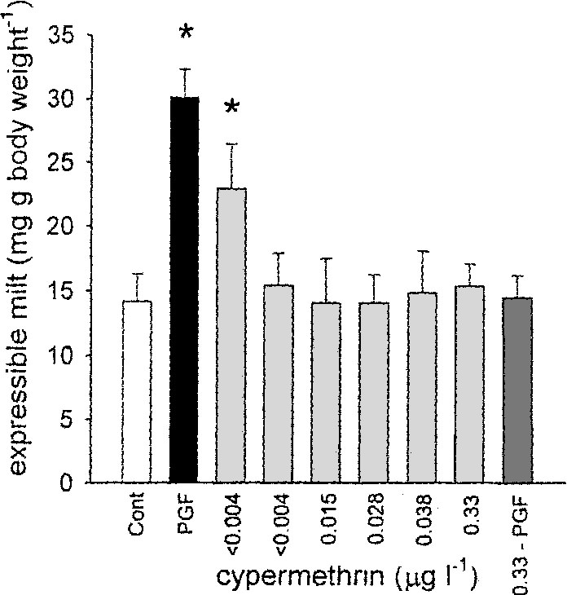

Figure 8. Cypermethrin exposure reduces the priming response in Atlantic salmon. Male salmon exposed to a sex pheromone (prostaglandin, PGF) for five hours significantly increased their milt production (the priming response). The priming response was abolished in fish treated with cypermethrin at concentrations above 0.004 μg/l. Treatments with cypermethrin alone had no effect on expressible milt. (from Moore and Waring, 2001)

Approach. To assess the effects of current use pesticides on the olfactory sensitivity and priming physiology of male chinook salmon, we will measure olfactory responsiveness and milt production in pesticide exposed and unexposed animals. To assess the effects of pesticides on spawning behaviors and fertilization success, we will expose adult chinook salmon to pesticides, pair males and females in an experimental spawning channel, and evaluate the consequences of pesticide exposures in terms of the relative proportions of fertilized eggs in a redd.

Methods. As in Study #5, this study will base pesticide exposures on the electrophysiological results generated in Task #1. The specific priming pheromone(s) have not yet been identified in Pacific salmon, so we will harvest and pool urine from ovulating females (n = 5) using standard cannulation procedures. The effects of ovulated urine on the olfactory nervous system of males will be measured (n = 10 fish) using EOG recordings. The priming effect of female urine on males (n = 20 fish for control and primed animals) for will be measured as the volume of expressible milt (Moore and Waring, 1996b). Once the baseline priming response in chinook salmon has been characterized, we will evaluate the effects of pesticide exposures on olfactory function (n = 50) and reproductive priming (n = 50) (e.g., Moore and Waring, 2000). We will use established experimental methods for quantifying spawning behaviors in chinook salmon (Berejikian et al., 2000). Specifically, we will compare female nest construction behaviors and male courtship behavior in pesticide exposed and unexposed pairs (n = 12 pairs for each treatment). Subsequent to spawning, nests will be excavated and the proportion of fertilized eggs will be determined.

Expected results. As in Atlantic salmon, we expect pesticide exposures to inhibit the male's sensitivity to ovulated urine and the reproductive priming response. Given that current use pesticides have been shown to completely eliminate a male's pre-spawning increase in milt production, and the presumed significance of increased milt for egg fertilization, we expect the reproductive success of pesticide exposed spawning pairs to be significantly reduced.

Task 3. Developing a useful predictive tool for population level impacts of pesticide exposure for Yakima River Chinook populations.

As we expect to show in the first two tasks of this proposal, pesticide exposure based on environmental conditions in the Yakima River basin are sufficient to impair the olfactory performance and fitness of juvenile and adult Chinook salmon. The aim of the final task is to scale the autecological responses of individual fish up to population ecological properties. There are two primary manners in which individual behaviorial modification could be manifested at the level of populations – demographic health and genetic integrity. Any behavioral impacts of pesticide exposure that increases mortality, even during a limited ontogenetic time frame can map to population level effects. In fact, subtle changes in life stage specific survival rates can have profoundly nonintuitive impacts on population growth rates (Kareiva et al., 2000). Similarly, though in a more intuitive sense, population growth rates are directly related to reproductive success. As such, behavioral impacts due to pesticide exposure that decrease mating success will have strong demographic consequences.

More subtle, however, are the contributions of individual behavior to population genetic structure. As little as one effective migrant between populations each generation is sufficient gene flow to prevent genetic isolation from developing (Wright, 1969). Alternatively, given genetic structure between isolated populations, as little as one effective migrant per generation is sufficient to remove fixed allelic differences. Therefore, the potential exists for even subtle changes in stray rate to markedly influence inter-population genetic integrity. Since return migration is thought to be highly dependent on olfactory cues (Dittman and Quinn, 1996), pesticide induced anosmia may result in increased rates of straying, resulting in unnatural levels of gene flow in effected population. This is a source of concern for chinook salmon, because preliminary evidence indicates that pesticide treatments can disrupt homing behavior (Fig. 9).
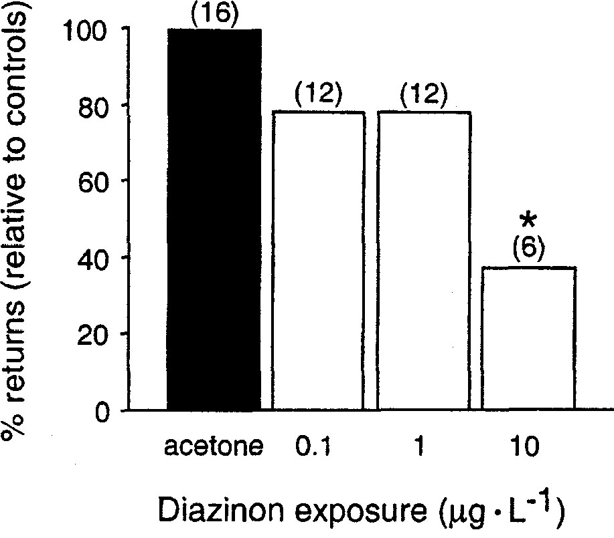

Figure 9. Diazinon exposures disrupt homing behaviors in Chinook salmon. Salmon (n=40 per treatment) were exposed to diazinon for 24 hours and released 2 kilometers downstream from a hatchery. Salmon exposed to 10 μg/l returned in significantly fewer numbers. (from Scholz, et al., 2000)
In this task we will link the mechanistic basis of pesticide impacts on Chinook salmon behavior to population level effects through the use of spatially explicit population demographic and genetic models. The use of predictive mechanistic models allows us to generate testable hypotheses regarding the demographic and genetic consequences, at the level of the entire Yakima River basin, of pesticide exposure of rearing and migrating Chinook salmon.

The empirical models proposed for this task will test the following two hypotheses:

H₁: Pesticide exposures increase the rate of straying in wild and hatchery salmon (Study 7; Feist, Jordan, and Dittman).

H₂: Pesticides limit the productivity of wild salmon populations (Study 8; Feist and Jordan).

Approach. Our approach to both H₁ and H₂ will be to generate a spatially explicit population dynamical model based on a mechanistic representation of life stage specific population processes. The spatially explicit nature of the model allows us to ask realistic questions regarding meta-population structure with respect to both demographic and genetical dynamics. The mechanistic basis of the model’s stage specific population processes allows direct incorporation of the consequences of unnatural fish behavior. The goal of the modeling effort will be to predict the levels of demographic and genetic impact resulting from the behavioral changes measured in Tasks 1 & 2.

Our modeling approach will be to construct a spatially explicit stage structured population model for the Yakima River basin Spring and Fall Chinook populations. The population component of the model will be stage structured Leslie matrices. The individual populations, within each run-type, will be linked in a spatially explicit meta-population framework. The spatially explicit component of the model will allow us to explicitly include demographic coupling of populations through straying, as well as landscape level impacts on population processes during breeding, rearing and migration.

Modeling methods. Life-stage based matrix population models are the most general framework for a mechanistically based population projection tool. A life-stage based matrix population model is the mathematical representation of a survival, or life table, based population process (Caswell, 2000). If an organism’s life cycle can be broken into discrete stages, a matrix model is the framework by which the within stage survival and between stage transitions are used to project the population into the future. Matrix population models differ from population level models like Beverton-Holt or Ricker stock recruitment models in that they do not impose a functional form to the inter-stage process. In fact, since the components of a matrix population model are the stage specific survivals and transition probabilities, the model’s inherent structure is mechanistic, and as such, easily accommodates mechanistically based population processes. To incorporate the effects of pesticide exposure on population processes we will estimate decreased survival probabilities for juvenile life stages based on the results of predation studies in Study 5. Additionally, we will use our results from Study 6 to decrement reproductive output of those individuals exposed to pesticides during key migratory phases.

To include population processes that are mediated by landscape level impacts or that arise from demographic coupling of neighboring populations, we will place individual stage structured populations in a spatial context. The basic form of the model is similar to a classic meta-population, where individual sub-populations are coupled to varying degrees, and the entire population’s dynamics emerges from the aggregate behavior of the individual populations (Hanski, 1996). In the model the breeding, rearing and migrating areas are located within a branched network that represents the Yakima River basin.

The spatial structure comes into play in that there is not complete natal-site fidelity. To represent straying the population from each reach has a finite, although sometimes very small, probability of ending up in all of the other reaches. Therefore, all reaches are potentially demographically coupled through straying. We determine the matrix of straying probabilities by thinking of the branching structure of the reaches as a series of choices that the migrating individuals must make. We will set the probability of making the correct choice from literature values of natural stray rates (Quinn, 1993; Pascual et al., 1995; Hard and Heard, 1999). In this framework, physiological impacts on the individual’s ability to correctly navigate the stream network during migration will be included as increased probabilities of making the wrong choice at each branch. To parameterize the stray matrix for pesticide exposed fish, we will draw on the physiological result from Task 1 to determine the degree to which exposed fish have lost their ability to discriminate olfactory signatures of their natal streams. Although this may be a somewhat simplistic view of migration, it does allow us to explicitly incorporate the behavior of individuals into the dynamics of the entire meta-population.

In addition to tracking the population dynamics of each breeding population, we also track genetic markers in each cohort. We assume that we can identify 10 loci, each with 10 possible alleles in all populations. These loci are not subject to mutation or selection, but are inherited and are subject to drift due to small breeding population size and small number of strays. By initializing the simulations with a known degree of genetic heterogeneity across the basin, we can track the impacts of demographic coupling as manifested by maintenance or loss of genetic diversity. While natural levels of gene flow and the degree to which populations of Chinook salmon are reproductively isolated or locally adapted is not well understood (Myers et al. 1998), any disruption of long terms patterns of gene flow are potentially detrimental to population health (Slatkin, 1987). Therefore, we will explore relative, rather than absolute, metrics of the change in population level genetic integrity.

Expected performance and results from the model. The modeling approach that we will develop is that of a general framework for exploring spatially explicit population processes. As a metric of populations’ behavior we will track the status of demographic units (abundance and trend) and genetic integrity of the entire basin as reflected by maintenance of genetic diversity. The population process component of the model will be sufficiently mechanistic that we can incorporate explicit measures of stage specific survival and their role as determinants of population status and gene flow. We expect to link pesticide exposure induced behavioral changes to population level impacts through explicit decreases in survival at single life stage and modifications of home stream fidelity during spawning migrations.

Obviously the model, though somewhat complex, is a gross simplification of the biological, spatial and dynamical properties of salmonids; however, it captures what are generally considered to be the major features that drive patterns of population persistence and extinction (Policansky and Magnuson, 1988; Reiman and Dunham, 2000). To be of use in decision support for salmonid population management, the model must predict the dynamical consequences of imposed actions. In the case of a model population, management actions are nothing more than directed parameter variation. We will assess the impact of pesticide exposure on Yakima River Chinook by reporting two features of population dynamics: demographic status and genetic integrity.

g. Facilities and equipment

The proposed experiments will be conducted at the NMFS Northwest Fisheries Science Center and Manchester Research Station. Both locations have facilities for rearing chinook salmon. The Center can provide adequate office space and computers for contract personnel. The PI supervises a research laboratory with standard equipment that can support the biochemical and electrophysiological experiments in Studies #1-4. The Manchester field facility has an experimental spawning channel and a large flow-through flume for investigations of predator-prey interactions (Studies #5 & 6). Tanks for pesticide exposures are also available at Manchester for the stress study (Study #7). Spatial population modelling (Studies #8 & 9) will be conducted using computers located at the Center.

In addition to minor laboratory equipment (e.g. computers, refrigerator, freezer, vortexer, homogenizer, etc.) we are requesting support for an electrophysiological recording setup. This includes a chilled perfusion system, recording equipment, and a data acquisition system (computers and hardware) at a total cost of ~ $31K. There is an existing electrophysiology setup at the Center, but a second one is needed for the parallel completion of Studies #1-4.

h. References
Arkoosh, M.R., Casillas, E., Clemons, E., Kagley, A.N., Olson, R, Reno, P., Stein, J.E.
(1998). Effect of pollution on fish diseases: Potential impacts on salmonid
populations. J. Aquat. Anim. Health. 10:182-190.
Baatrup, E., Døving, K.B. and Winberg, S. (1990). Differential effects of mercurial compounds on the electroolfactogram (EOG) of salmon (Salmo salar L.). Ecotoxicol. Environ. Saf. 20(3):269-76.
Beauvais, S.L., Jones, S.B., Brewer, S.K. and Little, E.E. (2000). Physiological measures of neurotoxicity of diazinon and malathion to larval rainbow trout (Oncorhynchus mykiss) and their correlation with behavioral measures. Environmental Toxicology and Chemistry. 19:1875-1880.
Berejikian, B.A., Smith, R.J., Tezak, E.P., Schroder, S.L., and Knudsen, C.M. 1999. Paired chemical alarm signals and complex hatchery rearing habitats affect anti-predator behavior and survival of chinook salmon (Oncorhynchus tshawytscha) juveniles. Can. J. Fish. Aquat. Sci. 56:830-838.
Bertmar, G. (1982) Structure and function of the olfactory mucosa of the migrating baltic trout under environmental stresses, with special reference to water pollution. In: Chemoreception in fishes: Developments in aquaculture and fisheries science, Volume 8 (T.J. Hara ed.). Elsevier. pp. 363-393.
Brewer, S.K., Little, E.E., DeLonay, A.J., Beauvais, S.L., Jones, S.B., and Ellersieck, M.R. (2001). Behavioral dysfunctions correlate to altered physiology in rainbow trout (Oncorynchus mykiss) exposed to cholinesterase-inhibiting chemicals. Arch. Environ. Contam. Toxicol. 40:70-76.
Brown, G.E. and Smith, R.J.F. (1997). Conspecific skin extracts elicit antipredator responses in juvenile rainbow trout (Oncorhynchus mykiss). Can. J. Zool. 75:1916-1922.
Brown, G.E. and Smith, R.J.F. (1998). Acquired predator recognition in juvenile rainbow trout (Oncorhynchus mykiss): conditioning hatchery-reared fish to recognize chemical cues of a predator. Can. J. Fish. Aquat. Sci. 55: 611-617.
Brown, S.B., Evans, R.E., Thompson, B.E. and Hara, T.J. (1982). Chemoreception and aquatic pollutants. In: Chemoreception in fishes: Developments in Aquaculture and fisheries science, Volume 8 (T.J. Hara ed.). Elsevier. pp. 395-422.
Carlson, R.W., S.P. Bradbury, R.A. Drummond, and D.E. Hammermeister. (1998). Neurological effects on startle response and escape from predation by medaka exposed to organic chemicals. Aquat. Toxicol. 43:51-68.
Caswell, H. (2001). Matrix Population Models. 2nd ed. Sinauer, Sunderland, MA.
Crnjar, R., Scalera, G., Bigiani, A., Barbarossa, I.T., Magherini, P.C. and Pietra, P. (1992). Olfactory sensitivity to amino acids in the juvenile stages of the European eel Anguilla anguilla (L.). J. Fish Biol. 40:567-576.
Detzel, T. (2001). Kitzhaber asks Bush to add $500 million for salmon. The Oregonian Feb. 27, 2001.
Dittman, A.H. and Quinn, T.P. (1996). Homing in Pacific salmon: mechanisms and ecological basis. J. Exp. Biol. 199:83-91.
Domagalski, J. (1996). Pesticides and pesticide degradation products in stormwater runoff: Sacramento River basin, California. Water Res. Bull. 32: 953-964.
Evans, R.E. and Hara, T.J. (1985). The characteristics of the electro-olfactogram (EOG): its loss and recovery following olfactory nerve section in rainbow trout (Salmo gairdneri). Brain. Res. 330(1):65-75.
Environmental Protection Agency/Fish and Wildlife Service/National Oceanic and Atmospheric Administration (EPA/FWS/NOAA). (2001). Memorandum of agreement between the Environmental Protection Agency, Fish and Wildlife Service and National Marine Fisheries Service regarding enhanced coordination under the Clean Water Act and Endangered Species Act. Federal Register 66 (36):11201-11217.
Fairchild, W.L., Swansburg, E.O, Arsenault, J.T., and Brown, S.B. (1999). Does and association between pesticide use and subsequent declines in catch of Atlantic salmon (Salmon salar) represent a case of endocrine disruption? Environ. Health. Perspect. 107:349-358.
Fuhrer, et al. (1999). The quality of our nations waters: nutrients and pesticides. USGS Circular 1225.
Griffiths S.W. and Armstrong J.D. (2000). Differential responses of kin and nonkin salmon to patterns of water flow: does recirculation influence aggression? Anim. Behav. 59:1019-1023.
Hanski, I.A. (1996). Metapopulation dynamics: from concepts and observations to predictive models. In: Hanski, I.A. & Gilpin, M.E., ed. Metapopualtion biolgy: ecology, genetics, and evolution. New York: Academic Press. pp. 69 - 71.
Hara, T.J. (1992). Mechanisms for olfaction. In: Fish Chemoreception (T.J. Hara ed.). Chapman & Hall. pp. 150-170.
Hard, J.J. and Heard, W.R. (1999). Analysis of straying variation in Alaskan hatchery Chinook salmon (Oncorhynchus tshawytscha) following transplantaion. Can. J. Fish. Aquat. Sci. 56:578-589.
Jarrard, H.E. (1997). Postembryonic changes in the structure of the olfactory bulb of the chinook salmon (Oncorhynchus tshawytscha) across its life history. Brain Behav Evol. 49:249-60.
Kareiva, P., Marvier, M., and McClure, M. (2000). Recovery and Management Options for Spring/Summer Chinook Salmon in the Columbia River Basin. Science. November 3; 290: 977-979.
Klaprat, D.A., Evans, R.E. and Hara, T.J. (1992). Environmental contaminants and chemoreception in fishes. In: Fish Chemoreception (T.J. Hara ed.). Chapman & Hall. pp. 321-341.
Kruzynski, G.M. and Birtwell, I.K. (1994). A predation bioassay to quantify the ecological significance of sublethal responses of juvenile chinook salmon (Oncorhynchus tshawytscha) to the antisapstain fungicide TCMTB. Can. J. Fish. Aquat. Sci. 51:1780-1790.
Little, E.E., Archeski, R.D., Flerov, B.A. and Kozlovskaya, V.I. (1990). Behavioral indicators of sublethal toxicity in rainbow trout. Arch. Environ. Toxicol. 19: 380-385.
Mathis, A. and Smith, R.J.F. (1993). Chemical alarm signals increase the survival time of fathead minnows (Pimephales promelas) during encounters with northern pike (Esox lucius). Behav. Ecol. 4: 260-265.
Moore, A. and Scott A.P. (1991). Testosterone is a potent odorant in precocious male Atlantic salmon (Salmo salar L.) parr. Phil. Trans. R. Soc. Lond. B 332:241-244.
Moore, A. and Scott A.P. (1992). 17,20-dihydroxy-4-pregnen-3-one 20-sulphate is a potent odorant in precocious male Atlantic salmon (Salmo salar L.) parr which have been pre-exposed to the urine of ovulated females. Proc. R. Soc. Lond. B Biol Sci 249(1325):205-209.
Moore, A. and Waring, C.P. (1996a). Sublethal effects of the pesticide Diazinon on olfactory function in mature male Atlantic salmon parr. J. Fish. Biol. 48:758-775.
Moore, A. and Waring, C.P. (1996b). Electrophysiological and endocrinological evidence that F-series prostaglandins function as priming pheromones in mature male Atlantic salmon (Salmo salar) parr. J. Exp. Biol. 199:2307-2316.
Moore, A. and Waring, C.P. (1998). Mechanistic effects of a triazine pesticide on reproductive endocrine function in mature male Atlantic salmon (Salmo salar L.) parr. Pest. Biochem. Physiol. 62:41-50.
Moore, A. and Waring, C.P. (2001). The effects of a synthetic pyrethroid pesticide on some aspects of reproduction in Atlantic salmon (Salmo salar L.). Aquatic Toxicol. 52:1-12.
Morgan, M.J. and Kiceniuk, J.W. (1990). Effect of fenitrothion on the foraging behavior of juvenile Atlantic salmon. Environ. Toxicol. Chem. 9:489-495.
Myers, J.M., Kope, R.G., Bryant, G.J., Teel, D., Lierheimer, L.J., Wainwright, T.C., Grant, W.S., Waknitz, F.W., Neely, K., Lindley, S.T., and Waples, R.S. (1998). Status and review of Chinook Salmon from Washington, Idaho, Oregon and California. U.S. Dept. Commer., NOAA Tech Memo. NMFS-NWFSC-35, 443.
National Marine Fisheries Service (NMFS). (1996). Factors for decline: A supplement to the notice of determination of west coast steelhead under the Endangered Species Act. Protected Species Branch, NMFS, 525 NE Oregon St., Suite 500, Portland, OR 97232. 83 p.
National Marine Fisheries Service (NMFS). (1998). Factors contributing to the decline of chinook salmon: An addendum to the 1996 west coast steelhead factors for decline report. Protected Resources Branch, NMFS, 525 NE Oregon St., Suite 500, Portland, OR 97232. 74 p.
National Oceanic and Atmospheric Administration (NOAA). (1991). Notice of policy: Policy on applying the definition of species under the Endangered Species Act to Pacific salmon. Federal Register 56 (224):58612-58618.
National Oceanic and Atmospheric Administration (NOAA). (1999). Endangered and threatened wildlife and plants; definition of “harm”. Federal Register 64 (215):60727-60731.
National Oceanic and Atmospheric Administration (NOAA). (2000a). Endangered and threatened species: Final rule governing take of 14 threatened salmon and steelhead evolutionarily significant units (ESUs). Federal Register 65 (132: 42422-42281.
National Oceanic and Atmospheric Administration (NOAA). (2000b). Designated critical habitat: Critical habitat for 19 evolutionarily significant units of salmon and steelhead in Washington, Oregon, Idaho, and California. Federal Register 65 (32):7764-7787.
Nevitt, G.A., Dittman, A.H., Quinn, T.P. and Moody, W.J. (1994). Evidence for a peripheral olfactory memory in imprinted salmon. Proc. Natl. Acad. Sci. U S A. 91:4288-4292.
Ngai, J., Dowling, M.M., Buck, L., Axel, R. and Chess, A. (1993). The family of genes encoding odorant receptors in the channel catfish. Cell 72:657-666.
Pascual, M.A., Quinn, T.P., and Fuss, H. (1995). Factors Affecting the Homing of Fall Chinook Salmon from Columbia River Hatcheries. Trans. Amer. Fish. Soc. 124:308-320.
Policansky, D. and Magnuson, J.J. (1998). Genetics, metapopulations, and ecosystem management of fisheries. Ecological Applications. 8:S119-S123.
Quinn, T.P. (1993). A review of homing and straying of wild and hatchery-produced salmon. Fish. Res. 18:29-44.
Relyea, R.A. and Mills, N. (2001). Predator-induced stress makes the pesticide carbaryl more deadly to gray treefrog tadpoles (Hyla versicolor). Proc. Natl. Acad. Sci. 98:2491-2496.
Rieman, B.E. and Dunham, J.B. (2000). Metapopulations and salmonids: a synthesis of life history patterns and empirical observations. Ecology of Freshwater Fish. 9:51-64.
Rinella, et al., (1999). Surface Water Quality of the Yakima River Basin, WA. USGS Water Supply Paper 2354-B.
Saglio, P. and Trijasse, S. (1998). Behavioral responses to atrazine and diuron in goldfish. Arch. Environ. Contam. Toxicol. 35:484-491.
Scholz, N.L., Truelove, N.K., French, B.L., Berejikian, B.A., Quinn, T.P., Casillas, E. and Collier, T.K. (2000). Diazinon disrupts antipredator and homing behaviors in chinook salmon (Oncorhynchus tsawytscha). Can. J. Fish. Aquat. Sci. 57:1911-1918.
Scholz, N.L. and Collier, T.K. (2000). Endangered salmon and probabilistic risk assessments for organophosphate pesticides. SETAC Globe 1:32-33.
Smith, R.J.F. 1992. Alarm signals in fishes. Rev. Fish. Biol. Fish. 2: 33-63.
Slatkin, M. (1987). Gene flow and the geographic structure of natural populations. Science 236:787-792.
Sorensen, P.W. (1992). Hormones, pheromones and chemoreception. In: Fish Chemoreception (T.J. Hara ed.). Chapman & Hall. pp. 199-228.
U.S. Fish and Wildlife Service (USFWS) and National Oceanic and Atmospheric Administration (NOAA). (1994). Endangered and threatened wildlife and plants; notice of interagency cooperative policy on information standards under the Endangered Species Act. Federal Register 59 (126):34271.
Waring, C.P. and Moore, A.P. (1997). Sublethal effects of a carbamate pesticide on pheromonal mediated endocrine function in mature male Atlantic salmon (Salmo salar) parr. Fish. Physiol. Biochem. 17: 203-211.
Wentz, D.A., Bonn, B.A., Carpenter, K.D., Hinkle, S.R., Janet, M.L., Rinella, F.A., Uhrich, M.A., Waite, I.R., Laenen, A. and Bencala, K. (1998). Water quality in the Willamette Basin, Oregon, 1991-95. U.S. Geological Survey Circular 1161.
Wisby, W.J. and Hasler, A.D. (1954). Effect of occlusion on migrating silver salmon (Oncorhynchus kisutch). J. Fish. Res. Board Can. 11:472-478.
Wright, S. (1969). Evolution and the Genetics of Populations, Vol. 2. The Theory of Gene Frequencies. Univ. Chicago Press, Chicago, IL.
Zeiske, E., Theisen, B. and Breucker, H. (1992). Structure, development, and
evolutionary aspects of the peripheral olfactory system. In: Fish Chemoreception
(T.J. Hara ed.). Chapman & Hall. pp. 13-39

Section 10 of 10. Key personnel

Nathaniel Scholz Research Zoologist Principal Investigator
David Baldwin NRC Postdoc Co-Investigator (Studies 1-5)
Barry Berejikian Fisheries Research Biologist Co-Investigator (Studies 5 & 6)
Andrew Dittman Fisheries Research Biologist Co-Investigator (Studies 6 & 7)
Blake Feist Biological Statistician Co-Investigator (Studies 7 & 8)
Christopher Jordan Fisheries Research Biologist Co-Investigator (Studies 7 & 8)

Nathaniel L. Scholz, Principal Investigator

Education:
- Ph.D., Zoology, University of Washington, Seattle, WA, 1997.
- M.A., Biology, Boston University Marine Program, Boston, MA, 1991.
- B.A., Marine Biology, Boston University Marine Program, Boston, MA, 1991.

Employer: National Marine Fisheries Service, Northwest Fisheries Science Center, Environmental Conservation Division, Montlake Facility. Previous employment: National Research Council Postdoctoral Associate, National Academies of Science and Engineering (1998-1999).

Position: Research Zoologist, Team Leader (Fish Neurobiology and Development), Ecotoxicology and Environmental Fish Health Program. NMFS employee since 1999.

Present assignment: Dr. Scholz supervises a research laboratory at the NWFSC that is currently investigating the effects of pesticides on Pacific salmon, with an emphasis on species that are listed as threatened or endangered under the ESA.

Previous research/expertise: Dr. Scholz's expertise is in the areas of developmental biology, neurobiology, and animal behavior. His postdoctoral research focused on the impacts of pesticides on the neurobiology and behavior of chinook salmon. His doctoral research explored biochemical and physiological mechanisms of cell-cell signaling in the nervous system, and he studied the behavioral ecology of marine animals for his masters. He has published numerous papers in the field of neuroethology, and is regularly invited to speak at regional and national meetings and universities.

Five Relevant Publications:
Scholz, N.L. 2001. NO/cGMP signaling and the flexible organization of motor behavior in crustaceans. American Zoologist. In press.
Scholz, N.L., J. de Vente, J.W. Truman, and K. Graubard. 2001. Neural network partitioning by NO and cGMP. Journal of Neuroscience, 21:1610-1618.
Scholz, N.L., N. Truelove, B. French, B. Berejikian, T. Quinn, E. Casillas, and T.K. Collier. 2000. Diazinon disrupts antipredator and homing behaviors in chinook salmon (Oncorhynchus tshawytscha). Canadian Journal of Fisheries and Aquatic Sciences, 57:1911-1918.
Scholz, N.L., K. Graubard, and J.W. Truman. 1998. The NO/cGMP signaling pathway and the development of neural networks in postembryonic lobsters. Journal of Neurobiology, 34:208-226.
Scholz, N.L., M.F. Goy, J.W. Truman, and K. Graubard. 1996. Nitric oxide and peptide neurohormones activate cGMP synthesis in the crab stomatogastric ganglion. Journal of Neuroscience, 16:1614-1622.
David H. Baldwin, Co-investigator for Studies #1-5 (1.0 FTE).

Education:
- Ph.D., Zoology, University of Washington, Seattle, WA, 2000.
- B.A., Biology, Reed College, Portland, OR, 1986.

Employer: National Marine Fisheries Service, Northwest Fisheries Science Center, Environmental Conservation Division.

Position: National Research Council Postdoctoral Associate, (Fish Neurobiology and Development) Ecotoxicology and Environmental Fish Health Program.

Present assignment: Member of the Fish Neurobiology and Development Team. Dr. Baldwin’s primary responsibility is establishing and performing electrophysiological recordings from the salmon olfactory system.

Previous research/expertise: Dr. Baldwin is a neurophysiologist whose research has focused on sensory physiology and behavior. His graduate research dealt with the role of specific visual pathways in the behavior of the fruit fly, Drosophila melanogaster. These experiments involved genetic manipulation, electrophysiological recording, and behavioral testing. His additional skills include immunocytochemistry, image analysis, and computer programming.

Recent Publications:
Christie, A.E., D.H. Baldwin, E. Marder, and K. Graubard. 1997. Organization of the stomatogastric neuropil of the crab, Cancer borealis, as revealed by modulator immunocytochemistry. Cell and Tissue Research, 288: 135-148.
Christie, A.E., D. Baldwin, G. Turrigiano, K. Graubard, and E. Marder. 1995. Immunocytochemical localization of multiple cholecystokinin-like peptides in the stomatogastric nervous system of the crab Cancer borealis. Journal of Experimental Biology, 198:263-271.
Baldwin, D.H. and K. Graubard. 1995. Distribution of fine neurites of stomatogastric neurons of the crab Cancer borealis: evidence for a structured neuropil. Journal of Comparative Neurology, 356:355-367.
Zirpel, L., D. Baldwin, and K. Graubard. 1993. Nickel induces oscillatory behavior and enhanced synaptic and electrotonic transmission between stomatogastric neurons of Panulirus interruptus. Brain Research, 617:205-213.
Barry A. Berejikian, Co-investigator for Studies #5 and #6 (0.16 FTE).

Education:
- Ph.D., Fisheries Science, University of Washington, Seattle, WA, 1995.
- M.S., Fisheries Science, University of Washington, Seattle, WA, 1992.
- B.S., Fisheries Science, California Polytechnic State University, San Luis Obispo, CA., 1990.

Employer: National Marine Fisheries Service, Northwest Fisheries Science Center, Resource Enhancement & Utilization Technologies Division, Manchester Research Station.

Position: Fisheries Research Biologist, Team Leader (Behavioral Ecology). NMFS employee since 1994.

Present assignment: Project Leader of the BPA funded Assessment of Captive Broodstock Technologies Project (93-056). Dr. Berejikian’s responsibilities include identifying the effects of captive rearing on adult reproductive behavior and success. Dr. Berejikian is also a Principal Investigator on the “NATURES” project, evaluating the effects environmental parameters on the behavioral attributes of salmonids, including anti-predator behavior.

Previous research/expertise: Dr. Berejikian is a behavioral ecologist. His graduate research dealt with juvenile steelhead behavior and predator-prey interactions. He is an expert in quantifying Pacific salmon breeding behavior and success and juvenile behavioral ecology of salmonids. He has published numerous papers and is regularly invited to speak at national and international meetings.

Five Relevant Publications:
Berejikian, B. A., E. P. Tezak, and S. L. Schroder. 2001. Reproductive behavior and breeding success of captively reared chinook salmon (Oncorhynchus tshawytscha). N. Am. J. Fish. Manage. In press.
Berejikian, B. A., E. P. Tezak, L. Park, S. L. Schroder, E. P. Beall, and E. LaHood. 2001. Male dominance and spawning behavior of captively reared and wild coho salmon (Oncorhynchus kisutch). Can. J. Fish. Aquat. Sci. 58: 804-810.
Berejikian, B. A., E. P. Tezak, and A. L. LaRae. 2000. Female mate choice and spawning behavior of chinook salmon (Oncorhynchus tshawytscha) under experimental conditions. J. Fish. Biol. 57: 647-661.
Berejikian, B. A., R. J. F. Smith, E. P. Tezak, S. L. Schroder, and C. M. Knudsen. 1999. Chemical alarm signals and complex hatchery rearing habitats affect anti-predator behavior and survival of chinook salmon (Oncorhynchus tshawytscha) juveniles. Can. J. Fish. Aquat. Sci. 56: 830-838.
Berejikian, B. A. 1995. The effects of hatchery and wild ancestry and experience on the relative ability of steelhead trout fry (Oncorhynchus mykiss) to avoid a benthic predator. Can. J. Fish. Aquat. Sci. 52: 2076-2082.
Andrew H. Dittman, Co-investigator for Studies #6 and #8 (0.16 FTE).

Education:
- Ph.D., Fisheries/Pharmacology, University of Washington, Seattle, WA, 1994.
- B.A., Biochemistry, Dartmouth College, Hanover, NH, 1982.

Employer: National Marine Fisheries Service, Northwest Fisheries Science Center, Resource Enhancement & Utilization Technologies Division.

Position: Fisheries Research Biologist, Behavioral Ecology/Integrative Fish Biology, NMFS employee since 2000.

Present assignment: Principal Investigator for the Imprinting/Homing components of the BPA funded Assessment of Captive Broodstock Technologies Project (93-056). Dr. Dittman’s responsibilities include development of rearing and reintroduction strategies to minimize straying in captively reared salmon populations.

Previous research/expertise: Dr. Dittman is an integrative biologist whose research focuses on olfactory physiology and olfactory–mediated behaviors in fishes. The focus of his current research is olfactory imprinting and homing in salmon. His graduate research dealt with behavioral and biochemical mechanisms involved in olfactory imprinting and homing. His post-doctoral research focused on the endocrine control of maturation and migratory behavior in salmon and the molecular physiology of fish olfaction. He is an expert in a wide range of techniques from field-based behavior to molecular biology. He has published numerous papers and is regularly invited to speak at national and international meetings.

Five Relevant Publications:
Speca, D. J., D. M. Lin, P. W. Sorensen, E. I. Isacoff, J. Ngai, and A. H. Dittman. 1999. Functional identification of a goldfish odorant receptor. Neuron, 23:487-498.
Nevitt, G. A, and A. H. Dittman. 1998. A new model for olfactory imprinting in salmon. Integrative Biology, 1:215-223.
Dittman, A. H., T. P. Quinn, G.A. Nevitt, B. Hacker, and D. R. Storm. 1997. Sensitization of olfactory guanylyl cyclase to a specific odorant in coho salmon. Neuron, 19:381-389.
Dittman, A. H., T. P. Quinn, and G. A. Nevitt. 1996. Timing of imprinting to natural and artificial odors by coho salmon (Oncorhynchus kisutch). Canadian Journal of Fisheries and Aquatic Sciences, 53:434-442.
Dittman, A. H. and T. P. Quinn. 1996. Pacific salmon homing: mechanisms and ecological basis. Journal of Experimental Biology, 199:83-91.
Blake E. Feist, Co-investigator for Studies #7 and #8 (0.16 FTE).

Education:
- Ph.D., Fisheries Science, University of Washington, Seattle, WA, 1999.
- M.S., Fisheries Science, University of Washington, Seattle, WA, 1991.
- B.S., Zoology, University of Wisconsin, Madison, WI, 1986.

Employer: National Marine Fisheries Service, Northwest Fisheries Science Center, Environmental Conservation Division, Watershed Program.

Position: Statistician (Biology), NMFS employee since 1999.

Present assignment: Dr. Feist is responsible for designing and participating in research that examines the relationship between Pacific salmon fitness and survival, and terrestrial/estuarine habitat type and condition. He uses a landscape scale approach for building spatial models for most of his research, but he also studies the effect of differing spatio-temporal scales on ecosystems.

Previous research/expertise: Dr. Feist is a spatial ecologist with additional experience in basic ecology, ethology, neurobiochemistry, and biology. His doctoral research focused on the spatio-temporal dynamics of the invasion of a non-indigenous aquatic plant in Pacific Northwest estuaries. For his master’s research, he examined the impact of industrial noise on the estuarine ecology of juvenile Pacific salmon. He has published this work in the peer-reviewed literature, and is frequently invited to present at scientific symposia. In addition, he have given numerous guest lectures on topics ranging from spatial ecology to GIS technology.

Five Relevant Publications:
Feist, B.E., E.A. Steel, G.R. Pess, and R. E. Bilby. 2001. What is the correct scale for habitat analyses aimed at prioritizing restoration efforts for salmon? Conservation Biology. In review.
Pess, G.R., D.R. Montgomery, R.E. Bilby, E.A. Steel, B.E. Feist, and H.M. Greenberg. 2001. Influence of landscape characteristics and land use on coho salmon (Oncorhynchus kisutch) abundance, Snohomish River, Washington State, USA, Canadian Journal of Fisheries and Aquatic Sciences. In review.
Feist, B.E., and C. A. Simenstad. 2000. Expansion rates and recruitment frequency of exotic smooth cordgrass, Spartina alterniflora (Loisel), colonizing unvegetated littoral flats in Willapa Bay, Washington. Estuaries, 23(2):267-274.
Simenstad, C.A., J.R. Cordell, W.G. Hood, B.E. Feist, and R.M. Thom. 1997. Ecological status of a created estuarine slough in the Chehalis River Estuary: Assessment of created and natural estuarine sloughs, January - December 1995. FRI-UW-9621. Wetland Ecosystem Team, University of Washington, Seattle, WA. 47 p.
Simenstad, C.A., and B.E. Feist. 1996. Restoration potential of diked estuarine wetlands: Inferring fate and the recovery rate of historically-breached sites. EPA 910/R-96-005. 115 p.
Chris Jordan, Co-investigator for Studies #7 and #8 (0.16 FTE).

Education:
- Ph.D., Zoology, University of Washington, Seattle, WA, 1994.
- B.A., Biology with honors, University of Chicago, Chicago, Illinois, 1985.

Employer: National Marine Fisheries Service, Northwest Fisheries Science Center, Conservation Biology Division and Cumulative Risk Initiative.

Position: Operations Research Analyst (Mathematical Population Biologist). NMFS employee since 1999.

Present assignment: Population risk assessment modeling, spatial population dynamical modeling and basic population processes exploration with historical data sets. In addition, leading the development of a region wide monitoring and evaluation program for anadromous salmonid population status and recovery action effectiveness.

Previous research/expertise:

- Research Assistant Professor Washington State Univ., Pullman 1999 - present
- Assistant Professor University of Colorado, Boulder 1995 - 1999
- Research Associate University of Chicago, Chicago 1994 - 1995

Training and research experience includes mathematical modeling of populations and physiological processes and experimental approaches to neurobiological bases of behavior, fluid dynamics and population processes.

Five Relevant Publications:
Jordan, C.E. 2001. A predictive mathematical model to simulate swimming in the medicinal leech Hirudo medicinalis. J. Theor. Biol. In review.
McClure, M. M., B. L. Sanderson, E. E. Holmes, and C. E. Jordan. 2001. A large-scale, multi-species risk assessment: Anadromous salmon in the Columbia River Basin. Ecol. Apps. In Review.
Jordan, C.E. 1998. Scale effects in the kinematics and dynamics of swimming leeches. Can. J. Zool., 76(10):1869-1877.
Steinberg, E.K. and C.E. Jordan. 1997. Using genetics to learn about the ecology of threatened species: the allure and the illusion of measuring genetic structure in natural populations. In: Conservation Biology. eds, P. Fiedler and P. Kareiva. Chapman Hall, New York.
Jordan, C.E. 1996. Coupling internal and external mechanics to predict swimming behavior: a general approach? Amer.

Appendix A
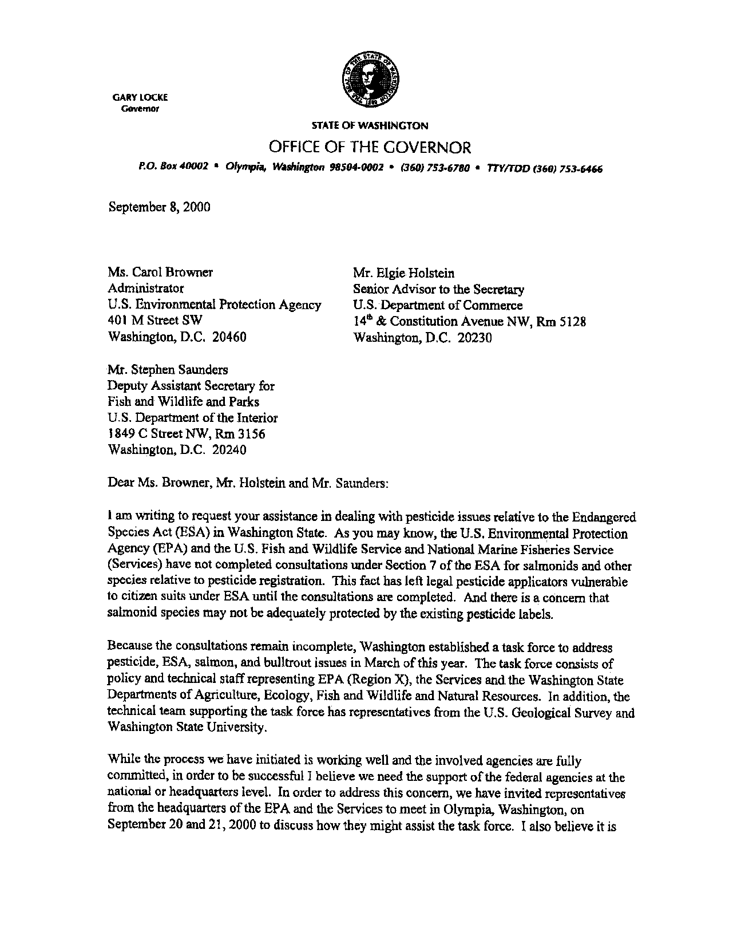
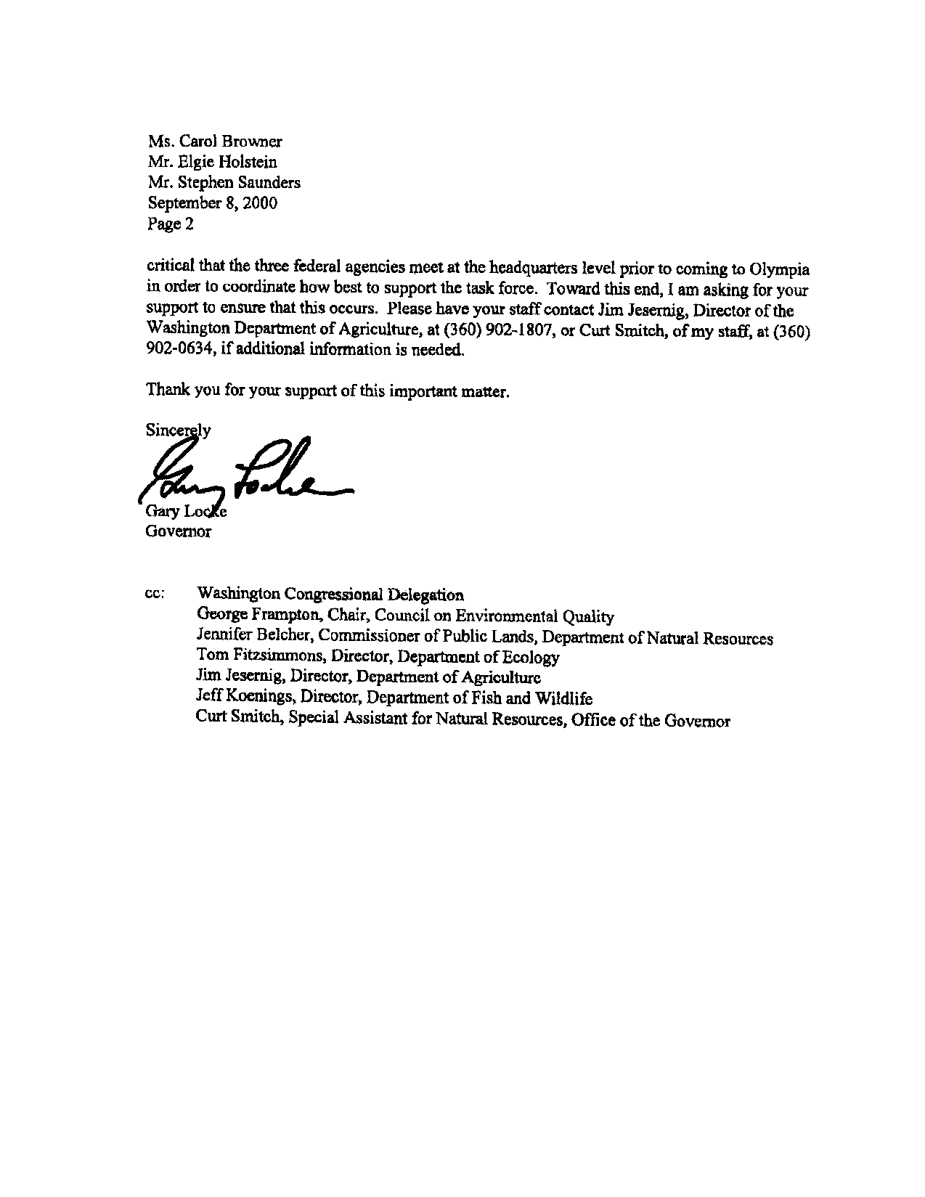

Appendiz B


