Project ID: 25097 25097response.doc

Title: Salmon and Steelhead Habitat Inventory and Assessment Project (SSHIAP)

Sponsor: WDFW
Subbasin: Mainstem Columbia
2002 Request: $522,710
2002-04 Estimate: $945,260
Short Description: Project will provide routed & segmented hydrolayer, and collate and synthesize data on 19 aquatic habitat variables & pesticide data over an estimated 59,000 miles of streams in 8 salmonid-bearing subbasins in the WA portion of this Province.
Response Needed: Yes
ISRP Preliminary Comments:
Fundable if adequate responses are given to ISRP concerns.

In the response below, the ISRP comments/concerns have been identified in italics. Our response follows. This response was organized by David H. Johnson, WDFW, Olympia, WA. 360-902-2603; johnsdhj@dfw.wa.gov

ISRP 1. The proponents provide a strong case for their integration with other habitat managers and agencies and show a strong awareness of the need for habitat related databases in Regional projects and programs (sections 9c and 9d).

Thank you. This feature reflects one of the fundamental issues embodied in the development and delivery of SSHIAP data and products.

ISRP 2. However, there is no evidence of other agencies/tribes in western Washington supporting or participating in the creation of this database.

Respectfully, we were surprised by this comment, as quite the opposite of this is true. We appreciate that during the presentation of this proposal in Yakima, the ISRP members may have been quite tired from the 3 days of back-to-back presentations, and might have missed this point when it was noted.

In 1995, the Northwest Indian Fisheries Commission (NWIFC) and WDFW began SSHIAP (http://www.wa.gov/wdfw/hab/sshiap/index.htm). The NWIFC represents 20 separate Treaty Tribes from Puget Sound, Hood Canal, the Straits and the open Coast. SSHIAP is now being supported by 31 additional organizations (Table 1). Partnership status is most often reflected by contributions valued at $5,000 or more. The NWIFC and WDFW continue to co-manage this effort, and the 25 SSHIAP staff involved are located in tribal, agency, and university offices across western Washington. SSHIAP Project Partners contribute funding, in-kind staff time, and/or substantial data for the development and delivery of core and secondary SSHIAP data attributes.

Table 1. SSHIAP data system Project Partners.

33 SSHIAP Project Partners: Batelle Northwest Laboratory; Evergreen State College; Grays Harbor College; Green River Community College; Jefferson County; King County; Kitsap County; National Marine Fisheries Service; People for Puget Sound; Pierce County Conservation District; Salmon Recovery Funding Board; University of Washington; US Forest Service; US Geological Survey; South Sound Regional Enhancement Group; Washington Conservation Commission/Limiting Factors Analysis; Washington Conservation Commission/Conservation Reserve Enhancement Program; Washington Department of Ecology; Washington Department of Natural Resources; Washington Department of Transportation; Western Washington University; Central Washington University; the Lower Columbia Fish Recovery Board; the Yakama Nation; Bureau of Reclamation; Thurston Conservation District; Chelan Conservation District; Okanogan Conservation District; Chelan County; Pacific County; Okanogan County; Marshall and Associates. The Northwest Indian Fisheries Commission (representing the 20 Western Washington Treaty Tribes) and the Washington Department of Fish and Wildlife are the co-managers of this project.

ISRP 3. Will other groups and projects benefit from its availability so that costs to other projects are offset?

Yes. There are actually two important dimensions to this question; one deals with aspects of a) the datasets themselves (e.g., data acquisition related to projects, analysis, product delivery), and the other b) with the larger aspects of making intelligent societal investments in natural resources. SSHIAP is about providing high-quality data for making sound conservation decisions and investments.

a) A core underpinning of SSHIAP is that all data and products are fully available to users. All data and products are free, with the exception of custom-made hard-copy maps. A key function of the SSHIAP system involves the systematic acquisition, assemblage, synthesis and delivery of salmon distribution and habitat information. Thus, users of SSHIAP products are able to provide the important value-added functions, without undertaking many of the same, labor-intensive, data development steps. The majority of SSHIAP users are not fiscally or infra-structurally capable of assembling, organizing, or maintaining large data systems. Particularly valuable to SSHIAP users, is how SSHIAP organizes data from many local sources into watershed- and ESU-level assessments.

b) As a society, we are all in this together, and with limited time and fiscal resources, data systems must be designed effectively and operated to maximize the benefits that can be garnered from the investments. There is nearly an endless list of potential projects to be undertaken for fish and wildlife conservation in the Columbia Basin. It is critically important that data systems be able to address the organization and prioritization of these efforts. Questions such as: “What are the highest priority projects?” and “Given human population growth, and subsequent changes in land use, is this project still a good investment in natural resources?” are challenging and data-intensive. Based on our experiences to date, SSHIAP is playing a uniquely valuable role in these aspects.

ISRP 4. Support for the proposal would be substantially improved if other groups in the Columbia Plateau region provided written support for this activity.

We agree, and have actively begun formalizing Project Partnerships with Columbia Plateau groups. Letters of support are attached (Appendix I).

Among the initial groups being contacted for partnership opportunities are: Bureau of Land Management, Natural Resources Conservation Service, Colville Confederated Tribes, NMFS (Middle and Upper Columbia TRTs – when established), Irrigation Districts, Public Utility Districts, Universities, and NGOs.

ISRP 5. The panel would like to see an independent evaluation of what they did on the westside. This evaluation should be related to how this system would aid in identifying and guiding management actions for salmonid issues.

An independent evaluation of the SSHIAP data system was conducted by Jeff L. Waldon, Assistant Director of the Conservation Management Institute at Virginia Tech. His full and complete review comments and vitae follow. His suggestions for refining SSHIAP features are already being acted upon.

Memo:
Date: June 28, 2001
To: David Johnson, Washington Department of Wildlife
From: Jeff Waldon, Assistant Director
Subject: Review of the SSHIAP Database

Thank you for the opportunity to review your Salmon and Steelhead Habitat Inventory and Assessment Program database. I have looked at all the sections and provided detailed comments below.

In general, I think you should be commended for your work. You and your staff have done a fine job at putting together a professional database project that meets my standards for quality in this type of work. You have addressed the breadth of your potential audience by providing data in a very graphical, easy-to-understand method while at the same time providing professionals with access to the detail needed to make a sophisticated interpretation of the results. Your documentation is superb. You seem to have taken into account other efforts that are ongoing in Washington, and have plans for integration. I particularly liked the focus on application. In many of these projects, there is a tendency to become focused on the database system rather than the application of the system. You’ve laid out some very clear uses of the system which quite obviously will contribute to the conservation and recovery of salmon stocks.

There are a few loose ends in terms of metadata and protocols, but it appears that both are well in hand for addition in the near future. The documents reviewed appear to be intended for a mixture of audiences i.e. some for general audiences, and some for technical audiences. It would be helpful to identify the audience for future reviews.

- Executive Summary

I presume the Executive Summary is intended for the general public and decisionmakers that are looking for an entry point to find out about SSHIAP. Very nice use of graphics. I think your emphasis on application is right on particularly for a summary.

- Data Dictionary

This document is sufficiently detailed to support the system. My only criticism is editorial in nature. I would suggest that you try to stay away from jargon unless it’s necessary to explain some component of the system. When jargon is necessary be sure to explain it. I would also suggest one more edit to address syntax, spelling, consistency, white space, etc… It’s not bad now, but could be much better with very little time spent focusing on the details.

- Auto-segmenting method

Excellent summary.

- Core and Secondary Elements - definitions and science behind them

This is a good overview of the elements and their definitions. I would recommend developing a more detailed document that lays out the tables, fields, allowable values, data types, and ranges. There are several methods for doing this sort of metadata definition.

- Methods Manual and QA/QC Standards - data protocols

The document that underlies this summary is exceptional, and I’m looking forward to getting a copy. When it’s ready, I you can fill in the data protocols by summarizing and referencing back to the data protocol survey.

- SSHIAP Architecture

I’m not sure exactly what this is supposed to be. It appears to be a list of topics that compose SSHIAP.

- Product example: Cleaned and Routed Hydrolayer

Excellent summary of how to go about this. I had our GIS specialist, who happens to be working on a similar project, look at it, and she had no comments that could improve it.

- Product example: Barriers

I presume this map is intended to be distributed with some explanation of the legend. Other than that, it looks fine. A scale and a north arrow would be helpful.

- WRIA Status Map

The map is just fine. I presume it doesn’t necessarily stand on it’s own so that explanation isn’t required for individual map classes. For instance if the map were to be distributed on its own, you’d need to explain “Hydro Layer Cleaned”. If it is only distributed in the context of a report that explains it, then that part wouldn’t be necessary on the map itself, although footnotes that refer to the appropriate part of the report would be helpful.

10. Data Pipeline

I’m not sure what this graphic is depicting other than a list of data sources and a list of applications with SSHIAP in the middle. If that’s the case, it may be more explanatory to center the SSHIAP box and put the two lists on opposite sides. I also don’t see why the application list is in one box, but the data sources are all in separate boxes. Is there some significance to the boxes? Again I presume this graphic doesn’t stand alone, and there is no need to explain acronyms.

Independent Reviewer: Jeff L. Waldon. Review conducted June 28, 2001
Biographical Sketch
Mr. Waldon is the Assistant Director of the Conservation Management Institute, a center within the College of Natural Resources at Virginia Tech. He has been involved in dozens of projects related to the development and use of information technology in natural resources management. The Conservation Management Institute currently employs over 50 faculty, staff, and students working on projects ranging from field surveys of animals and plants to GIS and remote-sensing to web-based decision support systems development for agency land management.
Mr. Waldon received his Master’s Degree in Forestry and Wildlife at Virginia Tech in 1987. He is currently the Software Editor for The Wildlife Society Bulletin, serves on the The Wildlife Society’s Electronic Publishing Work Group, and is the President of the VA Chapter of The Wildlife Society. He has served as an advisory to many natural resource agencies on information management issues, including USGS, The World Bank, state fish and wildlife agencies, and many others. He was recently recognized as one of the top ten researchers at Virginia Tech.

ISRP 6. There appears to be a good capability for information transfer but how would this be used in the Columbia Basin?

As a data system, SSHIAP assembles, organizes, and delivers salmon habitat and fish distribution data. Conceptually, there are many organizations and entities that feed data to (and from) SSHIAP (Figure 1). This data is developed at the 1:24,000 scale (or finer) under specific protocols, QA/QC’d, and packaged in GIS, database, and hardcopy products. Besides the final map products, users have found the data, protocols, GIS layers, summary statistics, and other components of SSHIAP useful to them. Thus, we have openly identified the basic architecture of SSHIAP, so that users will be able to better understand more about what kind of information are available, its format, and its accessibility.

Briefly, the basic architecture of SSHIAP follows:

1) The science behind selection of SSHIAPs Core and Secondary Data Variables
- Freshwater (13 core and 6 secondary variables)
- Estuarine (5 core variables)
- Salmonid species addressed by SSHIAP

2) The Cleaned and Routed Hydrolayer
- development and editing

3) The Stream Segmentation Process
- autosegmentation method
- hand-segment methodology
- comparison of the two methods

4) Fish Distribution
- context and definitions
- SaSI (fish status) integration

5) Methods Manual and QA/QC Standards
- Data Protocols

6) Data Dictionary

7) SSHIAP Staff
- geographical context (map) of staff locations

8) Automation of Data Pipelines
- Listing of primary data sources for SSHIAP

9) Summary statistics
- Product preparation/finalization by WRIA and ESU

10) Digital Products
a) Product preparation/finalization
- MOAs for data distribution
- Cleaned/routed Hydrolayer edits
- Interactions and transactions of data with EDT
b) Delivery - Web interface
- SSHIAP Web page

11) Hardcopy Products
- Product preparation/finalization
- Memorandum of Agreements
- Infrastructure for products
- Delivery, e.g., WDFW standard and custom SSHIAP maps

12) Project Partners
- Listing of Project Partner organizations and entities

13) SSHIAP Status Map & Matrix
  - 1-page matrix depicting status of SSHIAP data collection w/in each Watershed Resource Inventory Areas (WRIA)
  - Statewide view (map) of SSHIAP status by WRIA

ISRP 7. Also, how would this project relate to the GIS work already in place in the basin?

SSHIAP staff are keenly aware of other GIS efforts in the Washington portion of the Columbia Basin, and generally aware of related GIS efforts outside of Washington. Several of the SSHIAP staff are co-located with staff of these other GIS efforts, or are employed (part-time) by these other GIS programs. SSHIAP’s GIS work has been found to compliment, or replace, other GIS work in Washington. It compliments other GIS efforts by providing salmon distribution and habitat information not readily available elsewhere. SSHIAP replaces other GIS efforts in Washington in that it provides data at the 1:24,000 scale – typically much finer resolution – being more relevant for users working at the project-level scale.

Of particular relevance to GIS efforts in the basin are the recent efforts, at the national level, to develop a ‘cleaned and routed hydrolayer’. This 1:24,000 hydrolayer reflects the composite hydrolines on USGS 7.5 minute quadrangle maps scanned-in and put into a GIS system. This is a complex technical task, and being able to correctly depict actual streams and rivers accurately is important. With staff from the Washington Department of Natural Resources, SSHIAP staff are leading the cleaning and routing of the digital hydrolayer in Washington. This fundamental hydrolayer becomes the ‘backbone’ for all aquatic- and riparian-associated data, and provides a crucial analysis tool. We cannot overemphasize the value (fiscally and organizationally) that this digital hydrolayer represents to SSHIAP and the many and varied users in Washington. Although not originally intended, SSHIAP’s cleaned and routed hydrolayers are in very high demand as a product unto themselves – even before the salmonid distributions, habitat data, fish passage barriers, etc., are added.

Other GIS aspects are worth mentioning here. While Streamnet is a GIS-based system, they are primarily involved in fish distribution and population data at the 1:100,000 scale. Little, if any habitat data is in Streamnet, and the 1:100,000 scale does not readily address project-level efforts.

ISRP 8. If many programs are generating habitat data but all at different spatial scales and methods, etc., then there is a serious need to standardize these activities to avoid these additional costs. How pervasive is this problem?

A diversity of methods is desirable in the initial stages of any rapidly developing field, but enough time has passed to now assess the state-of-the-science and identify selected data collection methods and techniques that robustly capture data on freshwater habitats.

While it used to be a more significant issue a decade ago, the aspect of spatial scale is a relatively small issue today (in the GIS sense). Regarding the integration of existing data, or the acquisition of new data, more emphasis is appropriately being placed on “What is the question we are trying to answer?” However, it has become increasingly important to provide sufficient documentation to adequately understand the data being offered (i.e., methods, QA/QC, metadata, analysis).

To both guide the collection of data for SSHIAP, as well as guide the collection of habitat data for the rest of the Pacific Northwest, key individuals involved in SSHIAP have undertaken the project “Inventory and Monitoring of Salmon Habitat in the Pacific Northwest” (Johnson et al. 2001 – a final review draft version of this project is available at http://www.wa.gov/wdfw/hab/sshiap/dataptcl.htm). This project assembled and analyzed some 400 data collection protocols covering freshwater, water quality, riparian/upslope, and estuarine/nearshore habitats. Further, they recommended a subset of these protocols for consistent use across the Pacific Northwest.

Finally, the SSHIAP effort will be integrating monitoring data. The principal purpose of monitoring is to help make decisions by reducing uncertainty and tracking progress toward identified goals. This requires: 1) confirming that management decisions were implemented; 2) making accurate status assessments of the resource to determine whether management objectives are being achieved, and 3) improved understanding of salmonids and their environments to determine the extent to which changes in status were the result of management actions. Many entities already monitor habitat components relevant to salmonids, but the efforts are largely uncoordinated or unlinked among programs, have different objectives, use different indicators, and lack support for sharing and statistically analyzing the data.

SSHIAP is, by design, addressing the important data quality, organization, synthesis, and delivery aspects of fundamental importance to our monitoring applications.
Appendix I. Letters of Support for SSHIAP from Columbia Plateau (Washington) entities.

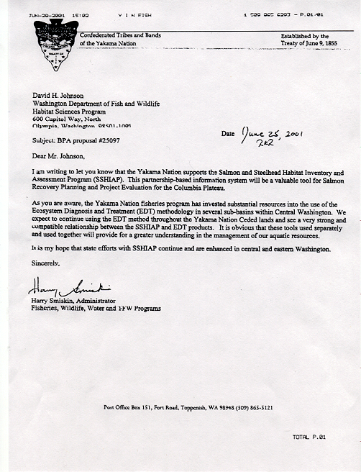

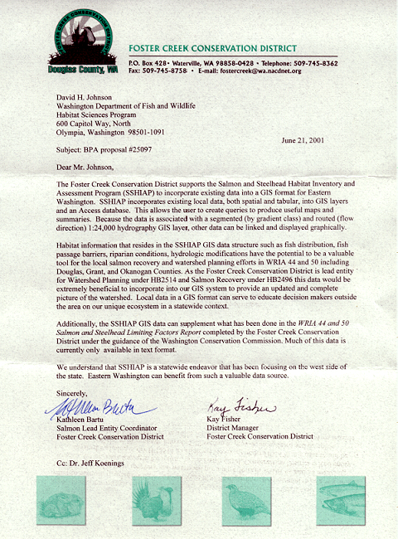
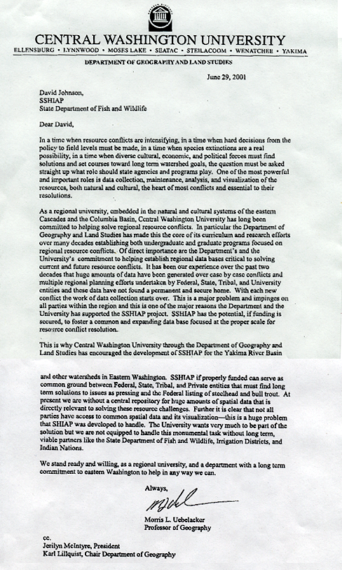
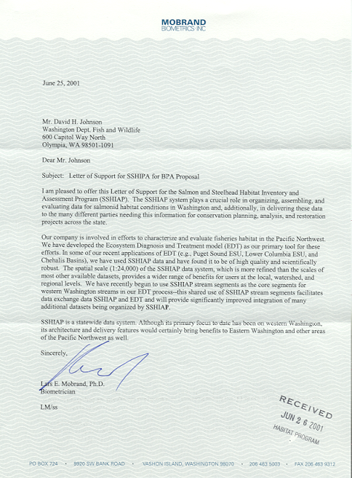
Figure 1. Conceptual design of SSHIAP, data flow, and products

SSHIAP
Salmon and Steelhead
Habitat Inventory & Assessment Program
NGO’s
(Habitat Data)
Federal Services
(Habitat and Stock Data)
Private Land Owners
(Habitat Data)
DOE
(Water Quality &
Quantity)
Tribes
(Habitat & Stock
Data)
Cities & Counties
(Habitat Data)
TFW
(Habitat Data)
WDFW
(Habitat & Stock Data)
DNR
(Habitat Data)
DOT
(Fish Passage)
WACC
(Limiting Factors)
Product Delivery:
Subbasin Planning
Recovery Plans
Regional Fisheries

Enhancement Groups
Alternative Mitigation
Growth Management Act
Regulatory Compliance
State Fish/Wildlife
Conservation Strategy

Conservation Districts
Universities
(Population/Habitat Data)

