Bonneville Power Administration

FY 2002 Innovative Proposal Project Review

PART 2. Narrative
Project ID: 34021

Title: Using stable isotope ratios to explore positive or negative impacts of American shad on salmon and the aquatic community in the Columbia River

Section 3. Project description

- Abstract
American shad Alosa sappidissima were imported from eastern North American and have become extremely abundant in the Columbia River, but their impact on endangered salmonids, especially subyearling fall chinook Oncorhynchus tshawytscha migrants, is poorly understood. During the last decade, 2-3 million adult shad have passed Bonneville Dam per year, with as many as 4 million adults in 1990. Based on food web studies, we hypothesize that American shad may have either negative (competition or supplementation to predator diets) or positive (energy source) impacts on endangered salmonids. Impacts may be especially critical for naturally spawned populations of subyearling fall chinook salmon of Snake River origin, which pass through the lower river during June-August. We propose to use stable isotopes of carbon and nitrogen, which have been used in a variety of other systems, to test these hypotheses. Samples of predators, American shad, subyearling fall chinook salmon, zooplankton, and other taxa will be collected in the lower Columbia River, John Day Reservoir, and the Hanford Reach. Temporal and spatial comparison of isotope ratios will be used to test whether: 1) juvenile American shad are contributing to predator diets, 2) if larval American shad are an important prey for subyearling fall chinook salmon, and, 3)whether shad and salmon may compete for similar plankton resources.

b. Technical and/or scientific background

Invasive species are generally thought to have only negative impacts on native communities, often reducing the number, abundance, or distribution of indigenous species. The impact of an invasive species, however, can be complex and may not be negative to all native species (Crowder et al. 1980). Exotic species have been used to provide a new food resource in a modified habitat or to control another unwanted species. American shad Alosa sappidissima were imported from eastern North American and have become extremely abundant in the Columbia River (see below), but their impact on endangered salmonids, especially subyearling chinook migrants, is poorly understood. In this proposal we develop some hypotheses about the potential negative or positive influence of American shad in the lower Columbia River. Understanding and quantifying the specific role that American shad is playing in this system could provide managers with information for managing the river. If American shad are having a neutral or positive effect on endangered species, as has been assumed to this point, then the river can be managed without concern about shad. If American shad are having a negative effect on certain stocks of endangered salmon, either directly or indirectly, then options for management of the problem can be explored. We believe that research is needed as a first step in this process, to better understand the role of abundant American shad in the lower Columbia River.
This proposal describes an innovative approach to examine changes in the aquatic community in the mainstem Columbia River that may be due to American shad. In this section, we:
- describe the timing and magnitude of the invasion by American shad and briefly discuss the ecology of shad,
- speculate on the possible direct and indirect effects of American shad upon salmonids, which leads to our primary hypotheses,
- describe a methodology for testing these hypotheses, which has been used extensively in other freshwater systems but is an innovative approach for the Columbia River.
Our work would concentrate on the mainstem Columbia River because of cost and time considerations, although methods and results may be applicable to other aquatic systems in the Pacific Northwest.

American shad in the Columbia River
American shad Alosa sappidisima are native to the east coast of North American and were originally introduced into the Sacramento River in 1871 (Green 1874). The shad population expanded rapidly north and south, and American shad were first detected in the Columbia River in 1896 (Smith 1896). American shad have become very abundant in the lower Columbia River during the last 60 years, with 2-3 million adults passing Bonneville Dam per year during the last decade, and as many as 4 million in 1990 (Figure 1; Quinn and Adams1996; Petersen et al. In press). The number of adult American shad decreases with distance from the ocean, but considerable numbers of adults appear to enter John Day Reservoir (river kilometer rkm 347) for spawning (Figure 2). Each year, few adult shad pass Lower Granite Dam on the Snake River and Priest Rapids Dam on the Columbia River.
American shad are anadromous and iteroparous; adults appear to spawn several times in the Columbia River over about 6 years, although this has not been well documented. Adult shad migrate into the Columbia River during May through July and adults spawn soon after migration. Incubation of eggs is 3-8 days and juvenile shad rear in the mainstem Columbia River during July through late fall, when they migrate to the ocean (Petersen et al. In press).
The abundance of juvenile American shad in the Columbia River has not been estimated, but some data are available. In John Day Reservoir, American shad are the predominant species in larval fish surveys during July (Gadomski and Barfoot 1998), and juvenile shad dominate seine hauls and hydroacoustic surveys in late summer (Gilbreath et al. 2000; Petersen et al. In press [Attachment]). Larval and juvenile American shad have relatively high densities in the Columbia River, which may be sufficient to produce changes in lower and higher trophic levels. Maximum density estimates for juvenile American shad in John Day Reservoir (1.2 fish/1000 m³) was greater than total prey fish densities (all species combined) in Lake Tahoe (0.07 fish/1000 m³) and Lake Washington (0.9 fish/1000 m³), but was less than the density measured in Strawberry Reservoir, Utah (2.4 fish/1000 m³ ; Beauchamp et al. 1999; Petersen et al. In press).
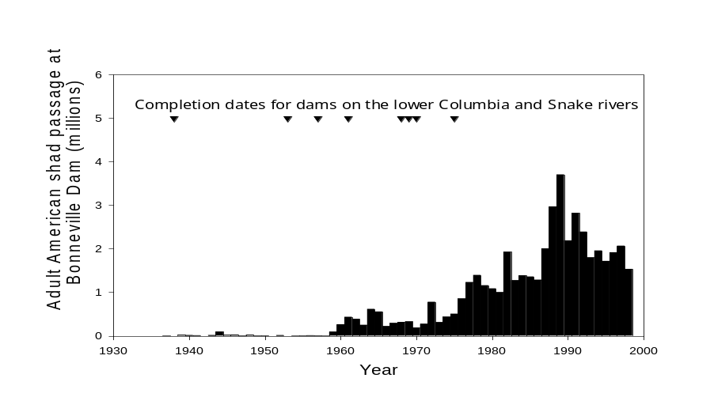Figure 1. Counts of adult American shad passing Bonneville Dam and completion dates for mainstem dams ().

Juvenile American shad have been observed throughout the water column using trawl and hydroacoustic surveys (Figure 3; see Petersen et al. In press). Estimated densities of juvenile American shad were higher during nighttime hydroacoustic surveys than during daytime surveys. During the early September surveys, fish density was as much as 10-12 times higher at night. The density of fish was highest at about 7 m depth and the majority of fish occurred between 5 and 20 m water depth (Petersen et al. In press). Cross-channel transects conducted during day and night, combined with trawl surveys to verify species, suggested that juvenile American shad stayed near the bottom, or were in inshore areas during the day and dispersed throughout the water column at night. Juvenile American shad were 100% of mid-water trawl catches in early September and 97% of the catch during late September. Other species commonly caught in mid-water trawling included juvenile chinook salmon, juvenile steelhead, and northern pikeminnow (Petersen et al. In press).
Commercial and recreational fisheries for American shad in the Columbia River have each removed about 4% of the run annually during the last decade (ODFW and WDFW 2000). Adult shad migrate up the Columbia River via the salmonid fish ladders, and there have been occasional interference with adult salmon (Monk et al. 1989). Aside from the commercial and sport fisheries, there is no active management directed at the shad population. We do not propose active management of shad at this time, but instead emphasize the need to better understand the potential impacts – possibly negative or positive (see below) – of this abundant species. We also recognize that adult shad may have an influence on the community through their feeding or nutrient transfer, but this topic cannot be addressed here.
For more general information on American shad in the Columbia River, see the manuscript submitted as an attached file (Petersen et al. In press).

#
Lower
Granite
Columbia
River
Snake
River
100 km
Washington
Oregon
Bonneville
The
Dalles
John
Day
McNary
Priest
Rapids
Pacific
Ocean
Idaho
British Columbia

Figure 2. The range of adult American shad in the Columbia River. American shad have successfully migrated past five dams on the Columbia River (Bonneville, The Dalles, John Day, McNary, and Priest Rapids), and four dams on the Snake River (as far as Lower Granite). American shad have not passed dams shown as open rectangles. For 2000, the percent of the adult American shad run migrating past dams is indicated by the width of the light gray bars in the figure, relative to Bonneville Dam passage as 100%.
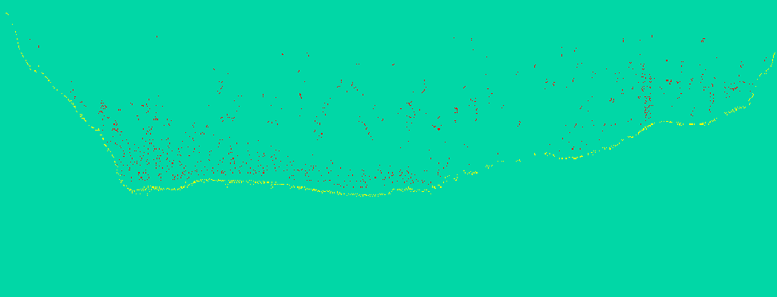
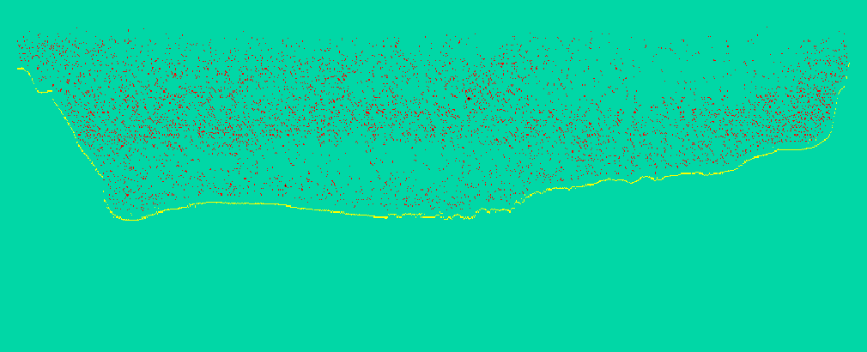
A
B
River bottom
River bottom
Day
Night
Figure 3 . Vertical and horizontal distribution of juvenile American shad in John Day Reservoir (Columbia River) during day (A; 1200 h) and night (B; 2200 h), from cross-river hydroacoustic transects. The water surface is the dashed line and the river bottom is the heavy dotted line. From Petersen et al. In press.

Potential Impacts of American shad on Endangered Salmon
Invasive clupeids, such as American shad in the Columbia River, have been shown to cause dramatic effects at several trophic levels in other large aquatic systems, with the addition of alewife Alosa pseudoharengus into Lake Michigan being perhaps the best example. Alewife flourished in Lake Michigan during the 1950s and 1960s following the collapse of the lake trout population, the dominant piscivore in the system (Hatch et al. 1981). As a consequence of intense interactions with abundant alewife, nearly one-half of the 20 or so native fish species that fed heavily on zooplankton during some stage of their life history were displaced (Crowder 1980). Top predators became abundant in the system following control of sea lampreys Petromyzon marinus and introduction of a new predator, Pacific salmon, into Lake Michigan. Lake trout growth rate varies among nearshore and offshore areas in Lake Michigan, probably related to prey availability, including alewife and bloater (Madenjian et al. 1998). Collapse of the lake trout population followed by increased abundance of the herbivorous alewife in Lake Michigan also caused dramatic changes in the zooplankton community, including shifts in species composition and changes in zooplankton morphology (Wells 1970; Kitchell and Carpenter 1987).
A simplified food web for the lower Columbia River is shown in Figure 4, demonstrating some ways by which juvenile shad might affect trophic dynamics and endangered salmon. Primary producers in the system are phytoplankton and benthic algae, which are eaten by different consumer groups. Benthic algae and benthic invertebrates are likely consumed by crayfish, suckers, sculpins, and other benthic-oriented fishes, while phytoplankton is eaten primarily by copepods and cladocerans. Juvenile salmon and juvenile American shad are the only planktivorous fish in the system, with salmon eating largely cladocerans (Rondorf et al. 1990) and shad eating primarily cyclopoid copepods (Petersen et al. In press). Northern pikeminnow and smallmouth bass are the most abundant and important predators in both the free-flowing and impounded reaches (e.g., Rieman et al. 1991; Tabor et al. 1993; Petersen 1994; Zimmerman 1999; Petersen et al. 2000). These predators consume crayfish, sculpins, salmonids, American shad, and a variety of other prey types (Poe et al. 1991; Zimmerman 1999).

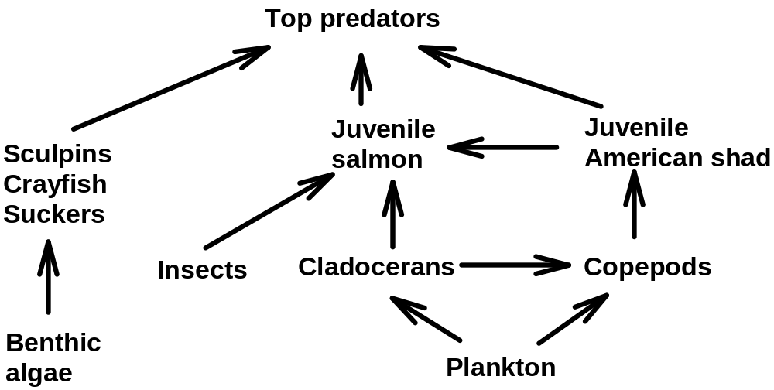

Figure 4. Simplified food web of the lower Columbia River.

The dynamics of simple food webs such as this may be complex with several positive and negative feed-back loops (e.g., Adams and DeAngelis 1986; Power et al. 1995). Here we present some hypotheses about the potential role of juvenile American shad as a diet supplement to top predators, competitors with juvenile salmon, and as potential prey for juvenile salmonids.
Juvenile American shad may be supplementing the diet and increasing the growth rates of predators in the system, thus having an indirect effect on juvenile salmonids. Past and ongoing studies indicate that up to 80% of the diet of northern pikeminnow in late summer and fall may be juvenile American shad (Petersen et al. 1994; J. H. Petersen, USGS, unpublished data). Juvenile shad were not present in great numbers prior to the construction of dams, and shad are likely replacing crayfish and sculpins in the diet during fall. Bioenergetic simulations of northern pikeminnow growth rates suggest that replacing even 20% of the diet in the fall period with juvenile American shad may be causing quite substantial increases in fall growth rates and predator size going into the winter period (Figure 5). Water temperatures during late summer and fall are optimal for northern pikeminnow growth and the predators may be doing much of their growth during this period (Petersen and Ward 1999). Enhanced growth in the fall, stimulated by optimum temperature and shad in the diet, may cause the predators to be larger and contain higher stores of lipids as they enter the winter period. These larger predators would likely have a higher overwinter survival rate and be in a better condition the following spring. [These studies are being conducted under BPA Project 199007800, and results will be complete in 2002].

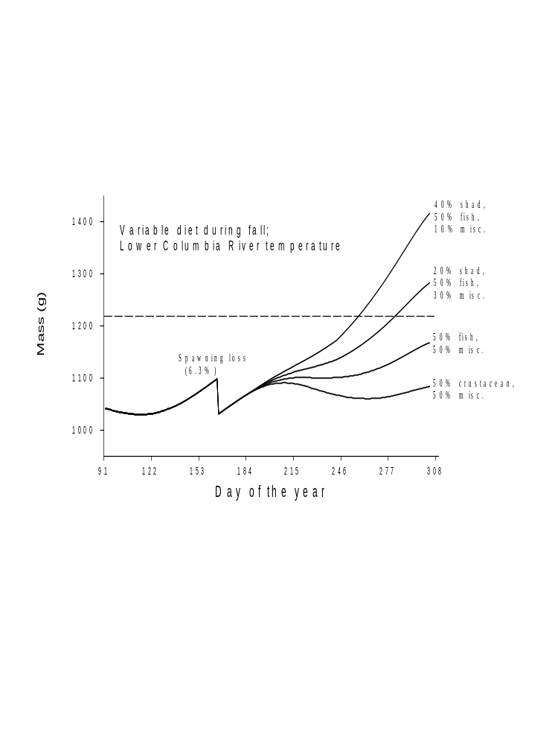
Figure 2. Predicted mass of an 10-year old northern pikeminnow whose diet varies during late summer and fall. Increasing proportions of juvenile American shad (0-40%) in the diet are shown, replacing such prey as crustaceans, mollusks, and insects. The horizontal dashed line is the expected size of the predator at the end of the period based on a typical diet with no shad, and age-length measurements. Predictions were made with a bioenergetics model (Petersen and Ward 1999).

Most stocks of Pacific salmon and steelhead migrate to the sea prior to the peak abundance of juvenile American shad (August – October), so there has been little concern about direct competition. Fall chinook salmon, however, migrate during mid- to late-summer and may have significant temporal and spatial overlap with juvenile American shad (Figure 6). Fall chinook salmon have two distinct phases during their early life history in freshwater—a near-shore rearing phase (38-80 mm) and an off-shore migratory phase (80-170 mm). During the nearshore phase, fry and parr rear in mainstem habitats with low velocities and lateral slopes (Tiffan et al. 2001). During this time, fish feed primarily on aquatic-derived insects in free-flowing reaches such as the Hanford Reach (USGS unpublished data; Becker 1973; Dauble et al. 1980). When fall chinook salmon begin seaward migration, they leave near-shore habitats and use off-shore habitats, which commonly overlaps with that of juvenile American shad in August (Kofoot et al. 1994). During the off-shore migratory phase, fall chinook salmon consume zooplankters (Rondorf et al. 1990) and shad may act as competitors for zooplankton food resources, either directly or indirectly (see Figure 4). The timing of larval and some juvenile American shad migrating past McNary Dam coincides closely with endangered fall chinook salmon from the Snake River that are naturally spawned (Figure 6), suggesting there could be competition between these groups.
Subyearling fall chinook salmon have also been observed to consume larval or small juvenile American shad (K. Tiffan, USGS, unpublished data), thus shad may provide a positive supplement to salmon in the system. The timing of fall chinook salmon outmigration through the reservoirs, and especially the lower Columbia River, coincides closely with the presumed hatch of American shad (e.g., Figure 6). Densities of larval and small juvenile shad must be high to produce the high densities of juvenile shad, perhaps providing an important source of energy for outmigrating juvenile salmon during this period. Tiffan et al. (2000) concluded that Snake River subyearling fall chinook salmon migrants from the middle and later part of the run (July-August) contributed as much to adult returns as the early migrants (~June). Shad would be available for the subyearling salmon during the late summer, and may be an important energy source.

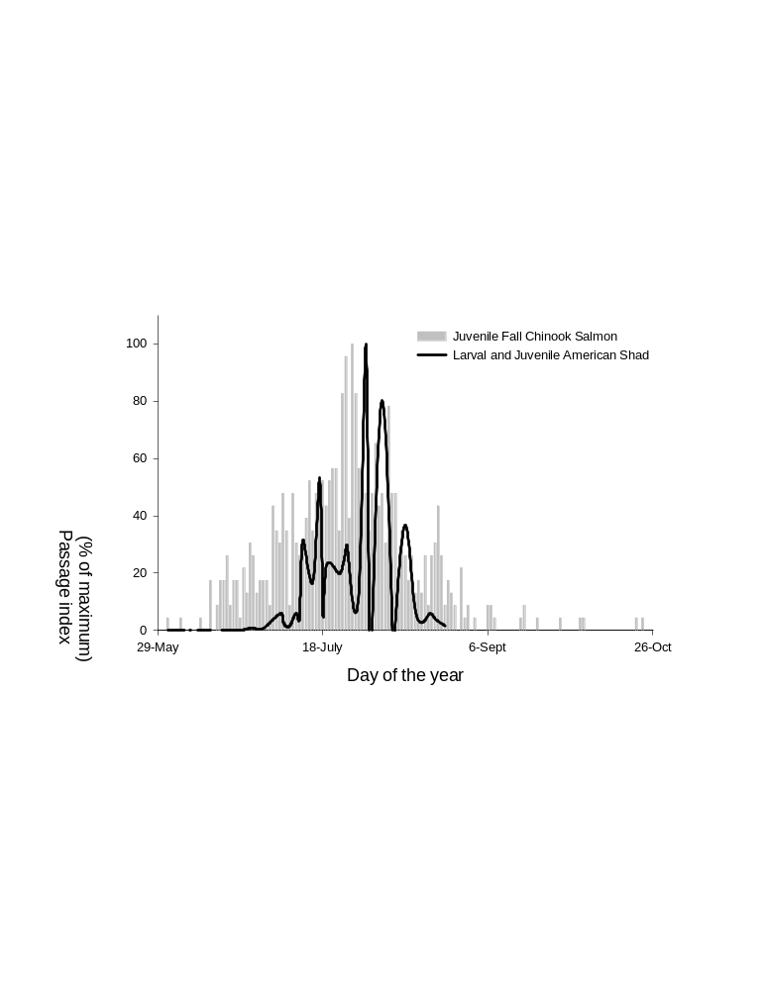

Figure 6. Passage index for naturally spawned PIT tagged subyearling fall chinook salmon (1992 - 2000) originated in the Hells Canyon reach at McNary dam compared to net catch of larval (and some early juvenile) American shad (1993 – 1996) from the Upper John Day reservoir (Petersen et al. In press).

Using Stable Carbon and Nitrogen Isotopes for Testing Trophic Hypotheses

Stable isotopes tracers of Carbon (C) and Nitrogen (N) are a powerful tool for estimating the contribution of food sources to a consumer and determining a consumer’s trophic position in the food web and (Fry 1991). When organisms assimilate food, their tissues reflect the isotope ratios of their food sources, plus a small enrichment in the consumer’s isotope ratio called trophic fractionation. Consumer isotope ratios become enriched in ¹⁵N by 3-5‰ (‰ = parts per thousand or “per mil”) and up to 1‰ in ¹³C relative to their diet (Peterson and Fry 1987, Vander Zanden and Rasmussen 2002, Post 2002). Nitrogen isotopes are often used as an indicator of trophic level because of the large predictable increase in δ¹⁵N with each trophic level. Carbon isotope ratios are most often used to estimate relative contribution of food sources to consumer because δ¹³C changes little across trophic levels. However, either C or N isotopes can be used to estimate contribution of food sources to a consumer if food source isotope ratios are significantly different.
Recently, isotope ratios have been used successfully to quantify trophic relationships in riverine food webs supporting salmon. Nitrogen isotopes have been used to document contribution of marine-derived nutrients from salmon carcasses to juvenile salmonids (Kline et al. 1990, Kline et al. 1993, Bilby et al. 1996, Bilby et al. 2001), and carbon isotopes have been used to quantify contribution of terrestrial organic matter to juvenile Atlantic salmon, Salmo salar (Doucett et al. 1996). Because δ¹³C exhibits little trophic transfer shift, but δ¹⁵N exhibits a large predictable shift, the combination of C and N isotopes can be used to determine both pathways of organic matter transfer (i.e., energy sources) and trophic structure in river ecosystems.
Estimating the quantitative contribution of a prey to a predator using stable isotope ratios requires assuming that the predator has achieved equilibrium with it’s food, or application of a mixing model. Researchers have utilized both single isotope mixing models and dual isotope mixing models. Precision of mixing model estimates is dependent on variation in isotope ratios of the consumer and the food sources, and on the difference between the isotope ratios of the food sources (Vander Zanden and Rasmussen 2002; Post 2002). Examples of single isotope mixing models can be found in Doucett et al. (1996), Junger and Planas (1994), and Kline et al. (1990). Up to three energy sources can be included in a dual isotope mixing model if any two sources have different isotopic signatures in a given element (Kline et al. 1993). Examples of dual isotope mixing models can be found in Whitledge and Rabeni (1997) and Kline et al. (1993).
In the Columbia River, we expect long-lived predators to fulfill equilibrium assumptions because of long tissue turnover times (Hesslein et al. 1991), thus mixing models should perform well with these taxa. More complex bioenergetic models may also be used to compare data with specific field samples from other studies (Harvey et al. 2002). Because of the high turnover rates expected in juvenile shad and salmon, we will use a tissue-turnover model to predict trends in their isotope ratios (Fry and Arnold 1982, Herzka and Holt 2000, Maruyama et. al 2001). The isotope ratio of fish at time t, δ_{t}, is:
(1) 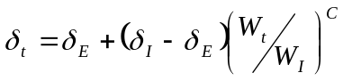
where δ_{E} is the equilibrium isotope ratio, δ_{I} is the initial (t = 0) isotope ratio, W_{I} is the initial weight, and W_{t} is the weight at time t. The equilibrium isotope ratio, δ_{E}, is the fish’s expected isotope ratio after consuming a specific diet or energy source for extended growth. When the metabolic constant (C) is –1, the initial mass of tissue is diluted only by growth, and the model reduces to a growth-dependent mixing model. Typically, a value of –1 is assumed for C because lab studies on growing juvenile fish found that tissue accrued during growth accounted for most isotopic turnover, and metabolic tissue-turnover contributed little (Hesslein et al. 1993; Herzka and Holt 2000).
Collection and sorting of gut contents from fish, classic dietary studies, is the primary alternative to stable isotope analysis. Gut content studies provide only a snapshot of diets during a period and do not integrate long-term changes in diet, which isotope measures do (Vander Zander et al. 1998; Vander Zander and Rasmussen 2001). Diets determined through gut contents often vary greatly among individuals, thus necessitating large sample sizes for statistical testing. Finally, gut content studies are often labor-intensive and large-scale studies can be prohibitively expensive; the cost of the work that we have proposed using a gut analysis approach would likely cost several times as much as we estimate for the stable isotope approach.

c. Rationale and significance to Regional Programs

This proposal has relationships to the following regional programs:

NMFS -FCRPS Biological Opinion:
Conservation Recommendations: 11.4 Evaluate Effects of shad: “The Corps and BPA should also evaluate the effects large numbers of juvenile shad may have on the food base for juvenile salmon.

RPA 190.
“The Action Agencies shall continue to fund studies that monitor survival, growth, and other early life history attributes of Snake River wild juvenile fall chinook.”

Mainstem Columbia River Subbasin Summary, (Ward et al. 2001):
Washington Department of Ecology objectives: “Include in this assessment the spatial and temporal relationships among the habitat requirements of all life history stages, including the role of predation (e.g., channel catfish), competition (e.g., American shad), and primary productivity in setting limits on juvenile (salmon) production.”

Exotic Species: “There is also a need to determine if American shad create deleterious conditions to juvenile salmonids through predation and competition in the rearing environment.”

Proposed Recovery Plan for Snake River Salmon (NMFS 1995):
2.8.b.3) The BPA and NMFS should work with appropriate fisheries agencies to reduce American shad in the Columbia River. “The diet of juvenile shad may overlap with that of juvenile salmon, and adult shad may prey upon juvenile salmon.”

Return to the River (ISG 1996):
The River Discontinuum: the Ecology of the Regulated River. 2. “Reasons for non-native proliferation vary, but a general non-native species are often better competitors in the homogeneous habitats of regulated river reaches.”

BPA’s Recommendations for the 2001 Mainstem Rulemaking:
Exotics and competition: “The Council has been very diplomatic in its approach to the effect of competition or predation on the basin’s native anadromous fish from exotic species from exotic species such as walleye, smallmouth bass, catfish, and shad. BPA recommends the Council take a more aggressive position against measures that essentially direct the action agencies to manage the FCRPS for the benefit of both native anadromous fish and non-native exotic fish species………This is a difficult societal issue that must be addressed to achieve the vision of the Council’s program.

d. Relationships to other projects
Project 199007800 - Evaluate Predator Removal: Large-scale patterns The proposed project follows up on the influence of American shad on northern pikeminnow diet and growth. Project 199007800 will be complete in 2002.
Project 199007000, The Northern Pikeminnow Management Program. This project should aid in evaluating some aspects of the NPMP, such as indirect effects of prey types and potential for interactions with system management.
Project 199702900. Understanding the effects of summer flow augmentation on migratory behavior and survival of fall chinook salmon. This project will develop protective measures for threatened fall chinook salmon originating in the Hells Canyon Reach.
Project 199406900. Development of a conceptual spawning habitat model for fall chinook salmon. The habitat characterization and modeling for subyearling fall chinook salmon that might rear in John Day Reservoir will be a natural complement to the spawning model study.
Project 199102900 Life History and Survival of Fall Chinook Salmon in Columbia River Basin. Facilitate implementation of federal and tribal fall chinook salmon recovery plans by monitoring and evaluating post-release attributes and survival of natural and hatchery juvenile fall chinook in the Snake River and Hanford Reach of the Columbia River.
Project number 9403400. Assessing Summer and Fall Chinook Salmon Restoration -- Snake River Basin. Assess summer and fall chinook salmon spawning habitat, incubation survival, growth rates, emigration timing and survival for evaluating recovery and restoration potential through supplementation in the Clearwater, Middle Fork Clearwater, South Fork Clearwater, Selway, Lochsa, Grande Ronde, Salmon, and Imnaha Rivers.

e. Project history (for ongoing projects)

New project proposal.

f. Proposal objectives, tasks and methods

Overall strategy

We propose to test three general hypotheses related to American shad. We state these general hypotheses here, and develop them in more detail below in separate objectives.

- Energy sources for the top piscivores within the Columbia River have/have not been altered by invasion of American shad and the resulting high densities of juvenile American shad.
- Juvenile salmonids, particularly fall chinook salmon, compete/do not compete directly or indirectly with abundant American shad in the Columbia River.
- Juvenile salmonids, particularly fall chinook salmon, use/do not use larval or early juvenile American shad as a significant source of energy in the lower Columbia River.

Study sites

Field collections will take place in the estuary of the Columbia River, John Day Reservoir, and the Hanford Reach (see Figure 2). These locations were selected to span a range of potential densities of American shad (high to low), and to allow us to sample subyearling fall chinook salmon during their nearshore feeding phase (Hanford Reach) and as the migrate offshore in the lower river.

Objectives, tasks and methods

Objective 1. Energy sources for the top piscivores within the Columbia River have/have not been altered by invasion of American shad and the resulting high densities of juvenile American shad.

Rationale: During spring and summer, top predators such as northern pikeminnow, smallmouth bass, and walleye feed largely on crayfish, sculpins, suckers, and other benthic prey (Table 1; Poe et al. 1991; Petersen and Ward 1999; Zimmerman 1999). Most of these prey feed on periphyton, benthic invertebrates, or benthic-oriented fishes, thus the primary source of energy for predators is from benthic algae. If juvenile American shad have become a significant proportion of the diet to top predators during fall, then the predator’s source of energy at the base of the food web is much different (Figure 4). American shad are filter-feeders with a diet of >80% copepods (Petersen et al. In press), thus their energy comes from pelagic plankton such as diatoms rather than benthic algae. Many of the top predators have not been sampled during the late summer and fall, but Petersen et al. (1994) found that shad could be as much as 80% of the predator’s diet during August and September. Shad would likely be replacing crayfish and other benthic prey that have lower energy densities, and thus could be influencing the growth rates of predators (see above section).
Because American shad are abundant only in the lower Columbia River, longitudinal sampling along the river can be used to test this hypothesis. Samples of predators lower in the system should have isotopic signatures of shad in the diet of predators, while samples further up in the system should show little or no evidence of shad replacing benthic prey (e.g., crayfish). A shift in δ¹³C from higher to lower can be used to test the hypothesis that predators are consuming American shad and deriving their energy from plankton rather than benthic sources.
Two specific questions will be addressed based on this general hypothesis:
- What proportion of the total annual energy budget of top predators can be ascribed to American shad? We will use bioenergetic models to estimate the percent contribution by different prey types (Harvey et al. 2002, e.g.).
- Has the trophic level of top predators changed due to consumption of shad? Northern pikeminnow often have crayfish as 40-60% of their diet during spring and summer months (Poe et al. 1991; Petersen and Ward 1999). In the fall months when juvenile American shad become abundant, crayfish may be largely replaced by shad, and there may be fewer trophic links between primary production and the top predator. δ¹⁵N should decrease in those areas with high densities of American shad (lower river) compared to areas with few shad (upper reservoirs).

Table 1. Summer diet (% weight) of top predators in the lower Columbia River reservoirs.

Prey type  / Taxa | Predator
 | Northern  Pikeminnow | Smallmouth  Bass | Walleye
Benthic prey
Crayfish | 56 | 48 | 0
Cottids | 20 | 30 | 52
Catostomids | 10 | 5 | 6
Cyprinids | 3 | 2 | 10
Percopsids | 2 | 2 | 10
Pelagic prey
Salmonids | 3 | 10 | 14
Other | 6 | 3 | 8
Sources: Poe et al. (1991), Petersen and Ward (1999), Zimmerman (1999), and unpublished USGS data.

Task 1.1 Collect top predators in the Columbia River at four locations (below Bonneville Dam, Bonneville Reservoir, John Day Reservoir, the Hanford Reach, and Priest Rapids Reservoir. Predators will be collected either by boat electroshocking, angling, or through the Northern Pikeminnow Bounty Program. Samples will be collected during summer or fall when predators are most active. Sample size requirements are discussed in detail below (see Sample Sizes).
Task 1.2 Predators will be sacrificed and tissue samples from dorsal musculature will be collected. Tissue samples will be stored at –80 ºC until processed. Samples will be dried 75 ºC for 48 h at the Columbia River Research Laboratory. Dried samples will be ground to a fine powder and packed for stable isotope analysis in tin capsules.
Task 1.3 Dried samples will be submitted to the University of California-Davis Stable Isotope Laboratory for processing. Ten percent of the samples will be analyzed in duplicate to estimate the processing error.
Task 1.4 Data analysis. Stable isotope data will be converted to standard delta (δ) notation defined as the parts per thousand (‰ or “per mil”) deviation from a standard. Standards are PeeDee belemnite limestone for Carbon and atmospheric Nitrogen. Data will be plotted as δ¹⁵N versus δ¹³C for each location sampled. Specific hypotheses about changes in the position of δ¹⁵N or δ¹³C will be tested with 2-sample t-tests.
Task 1.5 Modeling. Bioenergetics models for northern pikeminnow and smallmouth bass will be used to estimate the annual energy contributed to predator growth by American shad. Parameters for these models are available from Roell and Orth (1993) and Petersen and Ward (1999). The software of Hanson et al. (1999) will be altered following the methods described in Harvey et al. (2002). The trophic position of top predators will be computed following the methods in Vander Zanden and Rasmussen (1999). This method requires estimation of a “baseline” for primary consumers; these data will be collected in Objectives 2 and 3 below.
Task 1.6 Preparation of a final report and manuscript for publication. Information will also be distributed through regional and national meetings.

Objective 2. Juvenile salmonids, particularly fall chinook salmon, compete/do not compete directly or indirectly with abundant American shad in the Columbia River.

Rationale: Stable isotope ratios of carbon and nitrogen have been used in several studies to examine competition between species (e.g., Welch and Parsons 1993; Sierszen et al. 1997; Persson and Hansson 1999). Welch and Parsons (1993) concluded that adult chum salmon occupied a unique trophic position compared to other species of salmon, and that chum salmon were unlikely to compete with other species. Persson and Hansson (1999) used stable isotopes to detect an increase in the benthic diet of roach following a fish removal program, although they concluded that isotopes may not replace traditional gut analyses in all cases.
The general diets of subyearling fall chinook salmon and juvenile American shad are shown in Table 2. Salmon in the riverine Hanford Reach derive energy largely from insects, including both terrestrial and aquatic species (Rondorf et al. 1990). As subyearling fall chinook salmon shift to their offshore, migratory phase (Rondorf et al. 1990; Tiffan et al. 2001) they consume a higher proportion of pelagic zooplankters such as cladocerans. During this phase of life (summer to early fall), diets of migratory salmon and shad likely overlap, especially in the lower Columbia River where individuals are similar in size. Corbicula maniliensis, an introduced bivalve, calanoid copepods, and Daphnia spp. were the principal prey of American shad in pelagic samples from the estuary (McCabe et al. 1983), while juvenile shad and salmon occupied similar habitat in the estuary (Bottom and Jones 1990).
We hypothesize that competition between juvenile shad and salmonids for pelagic food resources, such as copepods, may be most intense in the lower Columbia River and in the estuary. In the reservoirs of the Columbia River, such as John Day, The Dalles, and Bonneville, competition may be less intense and shad may actually be providing a diet supplement to subyearling fall chinook salmon (see Objective 3).
To investigate this hypothesis, samples of juvenile shad, juvenile salmon, terrestrial and aquatic insects, and zooplankton will be collected weekly during the period when the fish species overlap (July to October). As juvenile salmon move offshore and downriver, we would expect a change in food sources that would gradually overlap with American shad in the lower river. During their near-shore rearing phase, fall chinook salmon likely consume benthic prey items, switching to pelagic food items later in the season as they migrate downriver. Because of high mass-specific growth rates of juvenile salmon, this hypothesized diet switch would cause isotope ratios of salmon to change from a benthic to pelagic signal. We will use this change in isotopes over to identify the spatial and temporal overlap in food sources of juvenile salmon and shad. For example, shad and salmon energy sources may differ considerably early in the summer, but overlap later as salmon grow. Likewise, benthic energy sources may be most important for juvenile salmon at upstream sites, close to their natal habitat where juvenile shad are less abundant. If energy sources of juvenile shad and salmon overlap in space and time, then shad may negatively affect salmon through direct or indirect trophic interactions.

Task 2.1 Collect field samples of subyearling fall chinook salmon, American shad, terrestrial and aquatic insects, and zooplankton at three sites: the lower Columbia River estuary, John Day Reservoir, and the Hanford Reach. Samples will be collected weekly between about August 1 and September 30 (8 weeks). The timing of collection will be important and we will monitor passage indices of juvenile American shad and subyearling fall chinook salmon at dams on the Columbia River through the Fish Passage Center to be sure and sample during the proper time. Fish sampling will done with beach seines. Zooplankton will be sampled by towing a 330 μm mesh net from a boat. Terrestrial and aquatic insects will be sample with drift sampling nets or by hand netting.
Task 2.2 Fish will be sacrificed and tissue samples will be taken from dorsal musculature. Tissue samples will be stored at –80 ºC until processed. Samples will be dried 75 ºC for 48 h at the Columbia River Research Laboratory. Dried samples will be ground to a fine powder and packed for stable isotope analysis.
Task 2.3 Dried samples will be submitted to the University of California-Davis Stable Isotope Laboratory for processing. Ten percent of the samples will be analyzed in duplicate to estimate the processing error.
Task 2.4 Data analysis. Stable isotope data will be converted to standard delta (δ) notation defined as the parts per thousand (‰ or “per mil”) deviation from a standard. Standards are PeeDee belemnite limestone for Carbon and atmospheric Nitrogen. Data will be plotted as δ¹⁵N versus δ¹³C for each location sampled. Plots will also be made for separate species. Specific hypotheses about changes in the position of δ¹⁵N or δ¹³C will be tested with 2-sample t-tests.
Task 2.5 Modeling. Mixing models, such as equation 1 above, will be used to estimate the percent contribution to salmon diet caused by consuming larval or early juvenile shad. If shad are a significant supplement to the salmon diet, further studies with bioenergetics or growth models might examine the degree to which growth has changed since the shad invasion.
Task 2.6 Preparation of report and publications.

Table 2. Diet (% wet weight) of juvenile American shad and subyearling fall chinook salmon in the Columbia River. Shad data are from the mid-reservoir area of John Day Reservoir (Haskell et al. 2001; Petersen et al. In press), while salmon data are from McNary Reservoir and the riverine Hanford Reach (Rondorf et al. 1990).

Taxa | American shad | Fall chinook salmon
 |  | Mid-reservoir | Riverine
Cyclopoid copepods | 85.8 | <0.1 | <0.1
Calanoid copepods | 5.7 | <0.1 | <0.1
Cladocerans | 8.3 | 49.6 | 0.8
Amphipods | 0.0 | 0.3 | <0.1
Insects | <0.1 | 41.7 | 96.3
Other | 0.2 | 8.4 | 2.8
Average fish size (mm) | 75 | 67 | 63

Objective 3. Juvenile salmonids, particularly fall chinook salmon, use/do not use larval or early juvenile American shad as a significant source of energy in the lower Columbia River.

Rationale: Adult American shad spawn throughout the lower Columbia River during May through July, with peak adult passage at Bonneville Dam (rkm 235) being in mid-June. American shad larvae first appear in plankton tows in late June and were most abundant during July (Petersen et al. In press). The density of larval and early juvenile shad was often as high as 18 per 100 m ³. The high density of juvenile American shad observed in John Day Reservoir (see Figure 3 and Petersen et al. In press) also suggests larval densities could be high enough to contribute significantly to the diet of fall chinook salmon of Snake River origin. The timing of this high-density larval pulse of American shad coincides closely with the outmigration timing of naturally spawned subyearling fall chinook salmon, which pass through the lower river during June-August (Tiffan et al. 2000).
It has been shown that the eggs and early larvae of anadromous fishes have isotopic signatures reflective of their parents and marine conditions, rather than freshwater (Bilby et al. 1996; Doucett et al. 1999; R. Perry, USGS, unpublished manuscript). Bilby et al. (1996), for example, observed that coho salmon eggs had the highest δ¹³C and δ¹⁵N values of a variety of fish and invertebrate samples collected in Grizzly Creek, Washington. Marine plankton, which are the food of adult American shad, have high δ¹³C values compared to freshwater plants and animals (Deegan 1993; Garman and Macko 1998). We propose to use this fact to test the hypothesis that subyearling fall chinook are feeding on larval American shad. If shad are contributing a significant diet component to fall chinook salmon, then the δ¹³C and δ¹⁵N signature should be shifted toward “marine” values, compared to freshwater food sources.
Because of the rapid turnover of tissue in fast-growing juvenile salmon, it will be necessary to sample at short time intervals to detect and estimate the potential contribution of American shad. We anticipate that the “marine” signature of larval American shad will dissipate quite rapidly as they grow, feed on freshwater plankton, and come to equilibrium with their freshwater diet. Studies of the rate of change of the marine signature in alevins, however, suggests that it should persist for at least a couple weeks and would be detectable (Doucett et al. 1999; R. Perry, USGS, unpublished manuscript).

Tasks 3.1 to 3.3 are the same as Tasks 2.1 to 2.3. The same field collection, pre- processing of samples, and contracting for isotope analyses will provide data to address the questions in Objective 3.
Task 3.4 Data analysis. Stable isotope data will be converted to standard delta (δ) notation and will be plotted as δ¹³N versus δ¹³C for each location sampled. Plots will also be made for separate taxa or groups. Specific hypotheses about changes in the position of δ¹³N or δ¹³C will be tested with 2-sample t-tests. To test hypotheses about shad as a diet item for subyearling fall chinook salmon, we will concentrate on data collected in the John Day Reservoir and in the estuary.
Task 3.5 Modeling. Mixing models, such as equation 1 above, will be used to estimate the percent contribution to salmon diet caused by consuming larval or early juvenile shad. If shad are a significant supplement to the salmon diet, further studies with bioenergetics or growth models might examine the degree to which growth has changed since the shad invasion.
Task 3.6 Report and manuscript preparation.

Time line for Tasks:

2003 2004
J F M A M J J A S O N D J F M A M J J A S O N D

Contracting---------

Task

1.1 -----
1.2 --
1.3 ---
1.4 ------------
  - ------------

2.1 -----
2.2 --
2.3 ---
2.4 ------------
2.5

3.1 -----
3.2 --
3.3 ---
3.4 ------------
3.5

Final reporting ------------

Sample sizes:
We used the tissue turnover model briefly described above (equation 1; section Using Stable Carbon and Nitrogen Isotopes for Testing Trophic Hypotheses) to describe how stable isotope ratios might change for juvenile salmon under different feeding scenarios. Modeled changes in ratios were used to develop samples size estimates – large changes in a ratio should be detected with a smaller sample size and vice versa. We modeled δ¹³C and δ¹⁵N in chinook salmon that ranged in size from alevins (0.4 g) to smolts (20 g). Alevins have a strong “marine signal” as mentioned above, which dissipates rapidly with growth. We assumed that salmon switch from a benthic to a pelagic feeding mode at about 6 g (80 mm FL; Tiffan and Rondorf 2001). For our purposes, we assumed a switch from a 100% benthic prey diet having a benthic isotopic signature to a 100% larval shad diet. Details of the model are available from the authors on request.
Simulations of δ¹³C and δ¹⁵N for juvenile salmon under two scenarios are shown in Figure 7. In all cases, the δ¹³C and δ¹⁵N values decrease rapidly as the alevins grow, feed, and lose their marine-enriched signature. If juvenile salmon move offshore at 6 g and switch to a pelagic diet of non-predatory plankton such as cladocerans, δ¹³C declines rapidly to about -21‰ when the fish are 15 g, but δ¹⁵N remains constant at about 11‰ (Figure 7, left panels). By contrast, if the 6-g juvenile salmon switch to larval shad rather than cladocerans, we would expect δ¹³C to be about –18.5‰ and δ¹⁵N to be about 15‰ when the fish are 15 g (Figure 7, right panels). These predicted difference between diets of cladocerans versus larval shad are about 2.5‰ for δ¹³C and 4‰ for δ¹⁵N. To be conservative in our sample size estimates below, we consider the chance of detecting a 1 or 2‰ change in the two ratios. This would also help to detect a diet shift, which will not likely be 100% larval shad as we simulated.
A literature review was conducted to estimate the variance of δ¹³C and δ ¹⁵N values in top predators, juvenile shad, and juvenile salmon. Results are presented in Table 3, with coefficients of variation (CV) ranging from 3-17%. The particularly high CV for northern pikeminnow (17%; Table 3) was caused by an estimate of 25% from one study, which appeared to be somewhat of an outlier. For power analyses, we used CV estimates of 6% for δ ¹³C and 11% for δ ¹⁵N (Table 3). Sample size is the number of fish needed to detect a change in an isotope ratio using a two-sample, 2-sided, t-test for typical values of δ¹³C (-25‰) and δ¹⁵N (+10‰). Power calculations were conducted at α = 0.05 and α = 0.1.
Power analyses suggested that fairly large sample numbers of fish per sample (>25) would be needed to detect changes as small as 1‰ in δ¹³C or δ¹⁵N, but detection of changes on the order of 2‰ would be possible with ~10 fish per sample (Figure 8). Raising type I error (α) to 0.1 would enable detection of a change of 1‰ in δ ¹⁵N with samples of ~20 fish (Figure 8, top left panel). Note that in most cases we will be able to use a one-sided test since we will expect a change in one direction based on our hypothesis, thus our power will be higher (roughly 10%) than shown in Figure 8. Based on these results, we will target 15 juvenile shad and juvenile salmon per time and location.
The predators that we will sample are relatively long-lived (12-17 years; Beamesderfer and Rieman 1990), and should thus have fed on American shad over several years. Predators should thus be in equilibrium with respect to the shad diet. We will not attempt to distinguish short-term changes in isotopic signatures caused by the migratory American shad, which would require large sample sizes or rapidly growing individuals (MacAvoy et al. 2001; Harvey et al. 2002). Target sample size for predators, benthic algae, and benthic prey of predators will be 25 fish or samples per location. These sample size estimates are similar to, or greater than, numbers used in a variety of fisheries studies (e.g., Doucett et al. 1996; Vander Zanden et al. 1998; Overman and Parrish 2001). Based on these sample size estimates, we anticipate requiring about 2,175 samples for this study (Table 4).

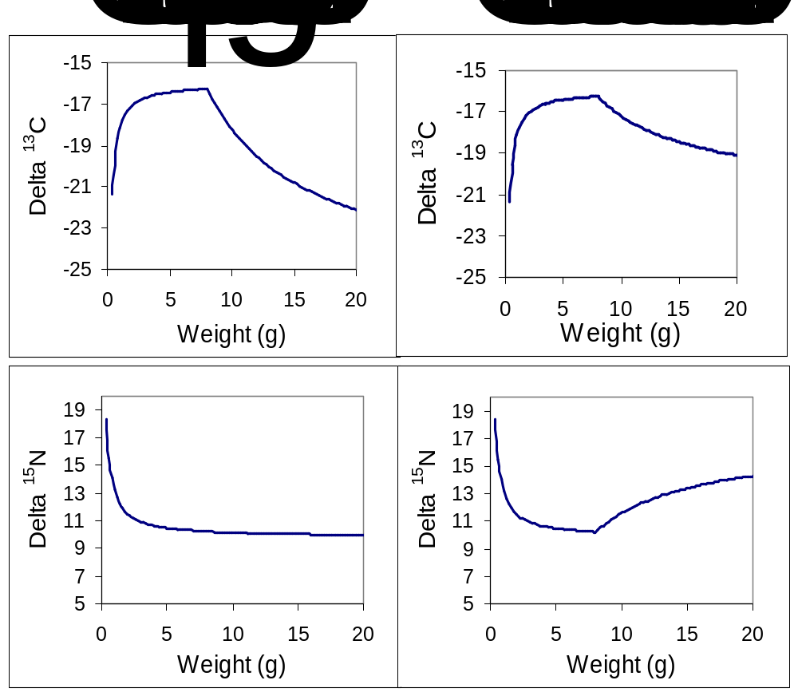

Figure 7. Simulations of the change in C (top panels) and N (bottom panels) for subyearling fall chinook salmon as they grow and change feeding behavior. The left two panels show the shift that is expected if salmon feed on pelagic, non-predatory prey such as cladocerans (see Table 2). In the right two panels, salmon shift to a diet of larval American shad, which have a strong marine signature.

Table 3. Variance, expressed as coefficient of variation (CV = SD/mean x 100; %), of δ¹³C and δ¹⁵N for various taxa that may be sampled in the Columbia River.

Species or taxa | Average coefficient of variation¹ (number of studies)
 | δ¹³C | δ¹⁵N
Northern pikeminnow² | 6 (2) | 17 (2)
Smallmouth bass | 4 (1) | 4 (1)
Walleye | 3 (2) | 8 (1)
Alosa spp. (shad) | 6 (4) | 12(4)
Juvenile salmonids³ | 6 (9) | 10 (4)
Weighted average CV | 6% | 11%
¹Sources: Bilby et al. (1996); Doucett et al. 1996; Gu et al. (1996); Mitchell et al. (1996); Garman and Macko (1998); Vander Zander et al. (1998); Kidd et al. (1999); Sterner and George (2000); Overman and Parrish (2001).
²No specific data were available for northern pikeminnow, so we used data for cyprinids.
³Includes age-0 coho salmon, age-0 cutthroat trout, and age-0 Atlantic salmon.

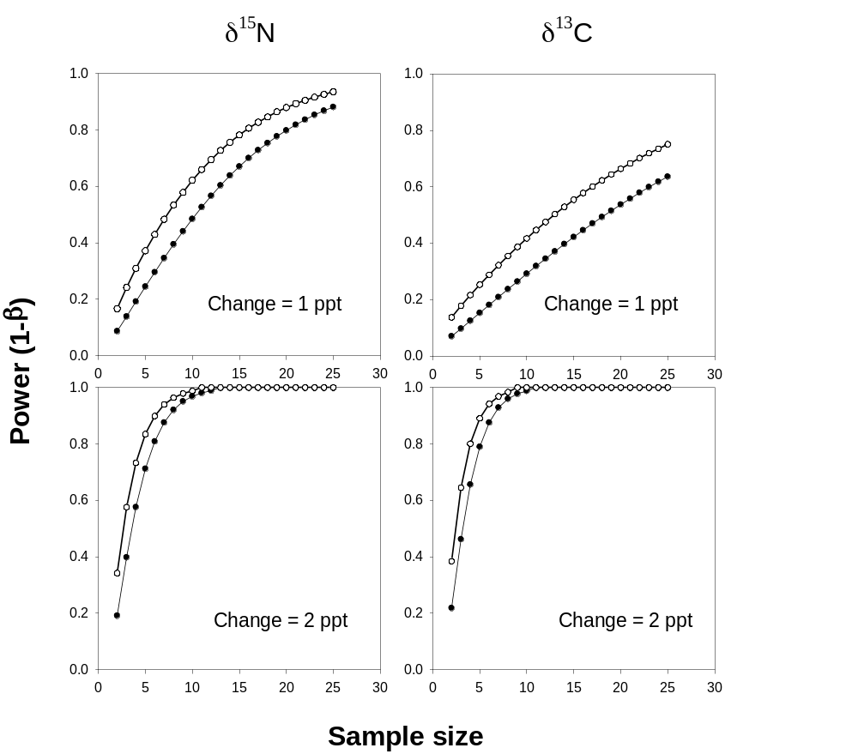

Figure 8. Power and sample size analyses for detecting changes of 1 ‰ (1 ppt, top panels) or 2‰ (2 ppt, bottom panels) in stable isotope ratios of nitrogen and carbon. Power was calculated for a two-sample t-test using average CV’s in Table 3. α = 0.05 for filled circles (●) and α = 0.1 for open circles (○).

Table 4. Number of samples to be collected by Objective, taxa, and location. Sampling for Objective 1 will occur during a 2-3 week period, while sampling for Objectives 2 and 3 will occur weekly over an 8-week period (N = 15 samples per taxa per week).

Objective / Taxa or group | Location
 | Estuary | John Day Reservoir | Hanford Reach
Objective 1
Benthic algae | 25 | 25 | 25
Crayfish | 25 | 25 | 25
Sculpins | 25 | 25 | 25
Smallmouth bass | 25 | 25 | 25
Northern pikeminnow | 25 | 25 | 25
Objectives 2 and 3
Aquatic insects | 120 | 120 | 120
Terrestrial insects | 120 | 120 | 120
Zooplankton | 120 | 120 | 120
Juvenile American shad | 120 | 120 | 120
Subyearling fall chinook salmon | 120 | 120 | 120

g. Facilities and equipment

Field and laboratory studies will be carried out by staff at the Columbia River Research Laboratory (CRRL), a field laboratory of the Western Fisheries Research Center of USGS. The CRRL has about 70 year-round fisheries biologists, 7 administrative staff, and regularly employs over 60 seasonal biologists and technicians. The CRRL has a fleet of boats from 14-32’, and has been conducting field studies on the Columbia River since 1983. All boats are equipped with appropriate safety equipment and operators are trained through the Department of Interior boat operators program. Most boats are equipped with GPS and state-of-the-art navigational instruments. Habitat studies have been conducted on white sturgeon, subyearling fall chinook salmon, lamprey, northern pikeminnow, walleye, and smallmouth bass. Field studies often use radio telemetry, hydroacoustics, side-scan sonar, acoustic Doppler current profilers (ADCP), and other state-of-the-art methods. Wet laboratories are equipped with three sources of flowing, heated water, systems for observing fish behavior and conducting feeding experiments, and facilities for investigating the physiology of fishes. Offices are equipped with modern personal computers, an in-house network, a GIS laboratory, and software for statistical, modeling, and spatial analyses (SAS, ARCInfo, etc.).
h. References

Reference (include web address if available online) | Submitted w/form (y/n)
Adams, S. M., and D. L. DeAngelis. 1986. Indirect effects of early bass-shad interactions on predator population structure and food web dynamics. In W. C. Kerfoot and A. Sih (eds.). Predation: Direct and Indirect Impacts on Aquatic Communities. New England Press, Hanover.
Beamesderfer, R. C., and B. E. Rieman. 1991. Abundance and distribution of northern squawfish, walleyes, and smallmouth bass in John Day Reservoir, Columbia River. Transactions of the American Fisheries Society 120:439-447.
Becker, C.D. 1973. Food and growth parameters of juvenile chinook salmon, Oncorhynchus tshawytscha, in central Columbia River. U.S. National Marine Fisheries Service Fishery Bulletin 71:387-400.
Bilby, R. E., B. R. Fransen, and P. A. Bisson. 1996. Incorporation of nitrogen and carbon from spawning coho salmon into the trophic system of small streams: evidence from stable isotopes. Can. J. Fish. Aquat. Sci. 53:164-173.
Bilby, R. E., Fransen, B. R., Walter, J. K., Cederholm, C. J., and Scarlett, W. J. 2001. Preliminary evaluation of the use of nitrogen stable isotope ratios to establish escapement levels for Pacific salmon. Fisheries 26: 6-14.
Bottom, D. L., and K. K. Jones. 1990. Species composition, distribution, and invertebrate prey of fish assemblages in the Columbia River estuary. Prog. Oceanogr. 25:243-270.
Bradford, M. J. 1995. Comparative review of Pacific salmon survival rates. Can. J. Fish. Aquat. Sci. 52:1327-1338.
Crowder, L. B. 1980. Alewife, rainbow smelt and native fishes in Lake Michigan: competition or predation? Environ. Biol. Fish. 5:225-233.
Dauble, D.D., R.H. Gray, and T.L. Page. 1980. Importance of insects and zooplankton in the diet of 0-age chinook salmon (Oncorhynchus tshawytscha) in the central Columbia River. Northwest Science 54:253-258.
Deegan, L. A. 1993. Nutrient and energy transport between estuaries and coastal marine ecosystems by fish migration. Can. J. Fish. Aquat. Sci. 50:74-79.
Doucett, R. R., G. Power, D. R. Barton, and R. J. Drimmie, and R. A. Cunjak. 1996. Stable isotope analysis of nutrient pathways leading to Atlantic salmon. Can. J. fish. Aquat. Sci. 53:2058-2066.
Doucett, R. R., W. Hooper, and G. Power. 1999. Identification of Anadromous and Nonanadromous Adult Brook Trout and Their Progeny in the Tabusintac River, New Brunswick, by Means of Multiple-Stable-Isotope Analysis. Trans. Am. Fish. Soc. 128-278-288.
Fry, B. 1991. Stable isotope diagrams of freshwater food webs. Ecology 72: 2293-2297.
Fry, B. and Arnold, C. 1982. Rapid ¹³C/¹²C turnover during growth of brown shrimp (Penaeus aztecus). Oecologia 54: 200-204.
Gadomski, D. M., and C. A. Barfoot. 1998. Diel and distributional abundance patterns of fish embryos and larvae in the lower Columbia and Deschutes rivers. Environ. Biol. Fishes 51:352-368.
Garman, G. C., and S. A. Macko. 1998. Contribution of marine-derived organic matter to an Atlantic coast, freshwater, tidal stream by anadromous clupeid fish. J. N. Am. Benthol. Soc. 17:227-285.
Gilbreath, L. G., D. A. Smith, and S. J. Grabowski. 2000. Limnological investigations in John Day Reservoir including selected upper reservoir habitats, April, 1994 to September, 1995. Report prepared for the U.S. Army Corps of Engineers, Portland, OR. National Marine Fisheries Service, Seattle, WA.
Green, S. 1874. In Report of the [New York] Commissioner of Agriculture for the year 1872. Government Printing Office, Washington D.C., pp. 278-274.
Gu, B., C. L. Schelske, and M. V. Hoyer. 1996. Stable isotopes of carbon and nitrogen as indicators of diet and trophic structure of the fish community in a shallow hypereutrophic lake. J. Fish. Biol. 49:1233-1243.
Harvey, C. J., P. C. Hanson, T. E. Essington, P. B. Brown, and J. F. Kitchell. 2002. Using bioenergetics models to predict stable isotope ratios in fishes. Can. J. Fish. Aquat. Sci. 59:115-124.
Haskell, C.A., D.W. Rondorf, and K.F. Tiffan. 2001. Community, temporal, and spatial dynamics of zooplankton in McNary and John Day reservoirs, Columbia River. Pages 107-133 in K.F. Tiffan, D.W. Rondorf, W.P. Connor, and H.L. Burge, editors. Post-release attributes and survival of hatchery and natural fall chinook salmon in the Snake River. Annual Report to the Bonneville Power Adminstration, contract DE-AI79-91BP21708, Portland, Oregon.
Hatch, R. W., P. M. Haack, and E. H. Brown. 1981. Estimation of alewife biomass in Lake Michigan, 1967-1978. Trans. Am. Fish. Soc. 110:575-584.
Hecky, R. E. and Hesslein, R. H. 1995. Contributions of benthic algae to lake food webs as revealed by stable isotope analysis. Journal of the North American Benthological Society 14: 631-653.
Herzka, S. Z. and Holt, G. J. 2000. Changes in isotopic composition of red drum (Sciaenops ocellatus) larvae in response to dietary shifts: potential applications to settlement studies. Canadian Journal of Fisheries and Aquatic Sciences 57: 137-147.
Hesslein, R. H., Capel, M. J., Fox, D. E., and Hallard, K. A. 1991. Stable isotopes of Sulfur, Carbon, and Nitrogen as indicators of trophic level and fish migration in the Lower Mackenzie River Basin, Canada. Canadian Journal of Fisheries and Aquatic Sciences 48: 2258-2265.
Junger, M. and Planas, D. 1994. Quantitative use of stable carbon isotope analysis to determine the trophic base of invertebrate communities in a boreal forest lotic system. Canadian Journal of Fisheries and Aquatic Sciences 51: 52-61.
Kidd, K. A. M. J. Paterson, R. H. Hesslein, D. C. G. Muir, and R. E. Hecky. 1999. Effects of northern pike (Esox lucius) additions on pollutant accumulation and food web structure, as determined by C and N, in a eutrophic and an oligotrophic lake. Can. J. Fish. Aquat. Sci. 56:2193-2202.
Kitchell, J. A., and J. F. Kitchell. 1980. Size-selective predation, light transmission and oxygen stratification: evidence from the recent sediments of manipulated lakes. Limnol. Oceanogr. 25:389-402.
Kitchell, J. F., and S. R. Carpenter. 1987. Piscivores, planktivores, fossils, and phorbins. In: Predation: Direct and indirect impacts on aquatic communities. W. C. Kerfoot and A. Sih, eds. New England Press, Hanover, NH.
Kline, T. C., Jr., Goering, J. J., Mathisen, O. A., Poe, P. H., and Parker, P. L. 1990. Recycling of elements transported upstream by runs of Pacific salmon: I. δ¹⁵N and δ¹³C evidence in Sashin Creek, southeastern Alaska. Canadian Journal of Fisheries and Aquatic Sciences 47: 136-144.
Kline, T. C., Jr., Goering, J. J., Mathisen, O. A., Poe, P. H., Parker, P. L., and Scalan, R. S. 1993. Recycling of elements transported upstream by runs of Pacific salmon: II. δ¹⁵N and δ¹³C evidence in the Kvichak River Watershed, Bristol Bay, southwestern Alaska. Canadian Journal of Fisheries and Aquatic Sciences 50: 2350-2365.
Kofoot, E.E., D.H. Feil, and W.S. Stastny. 1994. Comparison of field and in situ acoustic target strengths of subyearling fall chinook salmon and American shad. 1993 Annual Report to the Bonneville Power Administration, contract DE-AI79-91BP21708, Portland, Oregon.
MacAvoy, S. E., S. A. Macko, and G. C. Garman. 2001. Isotopic turnover in aquatic predators: quantifying the exploitation of migratory prey. Can. J. Fish. Aquat. Sci. 58:923-932.
Madenjian, C.P., T. J. DeSorcie, and R. M. Stedman. 1998. Ontogenic and spatial patterns in diet and growth of lake trout in Lake Michigan. Trans. Am. Fish Soc. 127:236-252.
Maruyama, A., Yamada, Y., Rusuwa, B., and Yuma, M. 2001. Change in stable nitogen isotope ratio in the muscle tissue of a migratory goby, Rhinogobius sp., in a natural setting. Canadian Journal of Fisheries and Aquatic Sciences 58: 2125-2128.
McCabe, G.T., W.D. Muir, R.L. Emmett, and J.T. Durkin. 1983. Interrelationships between juvenile salmonids and nonsalmonid fish in the Columbia River estuary. Fishery Bulletin 81:815-826.
Mitchell, M. J., E. L. Mills, N. Idrisi, and R. Michener. 1996. Stable isotopes of nitrogen and carbon in an aquatic food web re ently invaded by Dreissena polymorpha (Pallas). Can. J. Fish. Aquat. Sci. 53:1445-1450.
Monk, B., D. Weaver, C. Thompson, and F. Ossiander. 1989. Effects of lfow and weir design on the passage behavior of American shad and salmonids in an experimental fish ladder. N. Am. J. Fish. Manage. 9:60-67.
National Marine Fisheries Service (NMFS). 2000. A standardized quantitative analysis of risks faced by salmonids in the Columbia River Basin. Report of the Cumulative Risk Initiative, Northwest Fisheries Science Center, Seattle, Washington.
Nessler, T. P., and E. P. Bergersen. 1991. Mysids and their impacts on fisheries: an introduction to the 1988 mysid-fisheries symposium. American Fisheries Society Symposium No. 9:1-4.
ODFW and WDFW (Oregon and Washington Departments of Fish and Wildlife) 2000. Status Report: Columbia River Fish Runs and Fisheries, 1938-1999. Oregon Department of Fish and Wildlife, Clackamas, OR.
Persson, A., and L-A. Hansson. 1999. Diet shift in fish following competitive release. Can. J. Fish. Aquat. Sci. 56:70-78.
Petersen, J. H., D. M. Gadomski, and T. P. Poe. 1994. Differential predation by northern squawfish (Ptychocheilus oregonensis) on live and dead juvenile salmonids in the Bonneville Dam tailrace (Columbia River). Canadian Journal of Fisheries and Aquatic Sciences 51:1197-1204.
Petersen, J. H., and D. L. Ward. 1999. Development and corroboration of a bioenergetics model for northern pikeminnow feeding on juvenile salmonids in the Columbia River. Transactions of the American Fisheries Society 128:784-801.
Petersen, J. H., C. A. Barfoot, S. T. Sauter, D. M. Gadomski, P. J. Connolly, and T. P. Poe. 2000. Predicting the effects of dam breaching in the lower Snake River on predators of juvenile salmon. Report submitted to the Army Corps of Engineers, Walla Walla District.
Petersen, J. H., R. A. Hinrichsen, D. M. Gadomski, D. H. Feil, and D. W. Rondorf. In press. American shad in the Columbia River. AFS Special Publication of the World Shad Conference Proceedings, Baltimore.
Peterson, B. J. and Fry, B. 1987. Stable isotopes in ecosystem studies. Annual Review of Ecology and Systematics 18: 293-320.
Poe, T. P., H. C. Hansel, S. Vigg, D. E. Palmer, and L. A. Prendergast. 1991. Feeding of predaceous fishes on out-migrating juvenile salmonids in John Day Reservoir, Columbia River. Transactions of the American Fisheries Society 120:405-420.
Post, D. M. 2002. Using stable isotopes to estimate trophic position: models, methods, and assumptions. Ecology 83: 703-718.
Power, M. E., A. Sun, G. Parker, W. E. Dietrich, and J. T. Wooton. 1995. Hydraulic food-chain models. BioScience 45:159-167.
Quinn, T. P., and D. J. Adams. 1996. Environmental changes affecting the migratory timing of American shad and sockeye salmon. Ecology 77:1151-1162.
Rieman, B. E., R. C. Beamesderfer, S. Vigg, and T. P. Poe. 1991. Estimated loss of juvenile salmonids to predation by northern squawfish, walleyes and smallmouth bass in John Day Reservoir, Columbia River. Transactions of the American Fisheries Society 120:448-458.
Roell, M. J., and D. J. Orth. 1993. Trophic basis of production of stream-dwelling smallmouth bass, rock bass, and flathead catfish in relation to invertebrate bait harvest. Trans. Am. Fish. Soc. 122:481-491.
Rondorf, D. W., G. A. Gray, and R. B. Fairley. 1990. Feeding ecology of subyearling chinook salmon in riverine and reservoir habitats of the Columbia River. Trans. Am. Fish. Soc. 119:16-24.
Sierszen, M. E., J. R. Keough, and C. A. Hagley. 1997. Stable isotope analyses of the potential for competition between ruffe (Gymnocephalus cernuus) and native fishes in a Lake Superior coastal wetland. In International Symposium on biology and management of ruffe, Ann Arbor, MI.
Smith, H. M. 1896. A review of the history and results of the attempts to acclimatize fish and other water animals in the Pacific states. Pages 379-472 in bulletin of the U. S. Fish Commission, Vol. XV, for 1895.
Sterner, R. W., and N. B. George. Carbon, nitrogen, and phosphorus stoichiometry of cyprinid fishes. Ecology 81:127-140.
Tabor, R. A., R. S. Shively, and T. P. Poe. 1993. Predation on juvenile salmonids by smallmouth bass and northern squawfish in the Columbia River near Richland, Washington. North American Journal of Fisheries Management 13:831-838.
Tiffan, K. F., D. W. Rondorf, and P. G. Wagner. 2000. Physiological development and migratory behavior of subyearling fall chinook salmon in the Columbia River. N. Am. J. Fish. Manage. 20:28-40.
Tiffan, K.F., R.G. Garland, and D.W. Rondorf. 2001. Modeling flow-dependent changes in subyearling fall Chinook salmon rearing habitat and entrapment areas in the Hanford Reach of the Columbia River. Pages 61-90 in Tiffan et al. Post release attributes and survival of hatchery and natural fall Chinook salmon in the Snake River. Annual Report 1999 by U.S. Geological Survey and U.S. Fish and Wildlife Service to Bonneville Power Administration, Portland, Oregon.
Vander Zanden, M. J., M. Hulshof, M. S. ridgway, and J. B. Rasmussen. 1998. Application of stable isotope techniques to trophic studies of age-0 smallmouth bass. Trans. Am. Fish. Soc. 127:729-739.
Vander Zanden, M. J., and J. B. Rasmussen. 1999. Primary consumer δ ¹³C and δ ¹⁵N and the trophic position of aquatic consumers. Ecology 80:1385-1394.
Ward, D. L., J. H. Petersen, J. J. Loch. 1995. Index of predation on juvenile salmonids by northern squawfish in the lower and middle Columbia River and in the lower Snake River. Transactions of the American Fisheries Society 124:321-334.
Ward, D. L., and numerous contributors. 2001. Draft Mainstem Columbia River Subbasin Summary. Prepared for the Northwest Power Planning Council. Available on the BPA website.
Welch, D. W., and T. R. Parsons. 1993. C-N values as indicators of trophic position and competitive overlap for Pacific salmon (Oncorhynchus spp.). Fish. Oceanogr. 2:11-23.
Wells, L. 1970. Effects of alewife predation on zooplankton populations in Lake Michigan. Limnol. Oceanogr. 15:556-565.
Whitledge, G. W. and Rabeni, C. F. 1997. Energy sources and ecological role of crayfishes in an Ozark stream: insights from stable isotopes and gut analysis. Canadian Journal of Fisheries and Aquatic Sciences 54: 2555-2563.
Zimmerman, M. P. 1999. Food habits of smallmouth bass, walleyes, and northern pikeminnow in the lower Columbia River Basin during outmigration of juvenile anadromous salmonids. Transactions of the American Fisheries Society 128:1036-1054.

Section 10 of 10. Key personnel

Key Personnel (resumes attached):

James H. Petersen, Ph. D.
Research Fishery Biologist
U.S. Geological Survey
0.4 FTE
Co-Principal Investigator.
Duties: Project overview. Expert on predation and American shad in the Columbia River. Data analysis overview and modeling. Report preparation.

Dennis W. Rondorf
Research Fishery Biologist
U.S. Geological Survey
0.1 FTE
Co-Principal Investigator.
Duties: Provide information on the ecology of fall chinook salmon. Report preparation.

Russell M. Perry
Research Fishery Biologist
U.S. Geological Survey
0.4 FTE
Duties: Field Supervisor and Data Analysis. Expertise on stable isotopes in juvenile salmonids. Coordination of field work. Data analysis, modeling, and report preparation.

Resume for: James H. Petersen

Experience
1995-Present Research Fishery Biologist, U.S. Geological Survey, Western Fisheries Research Center, Columbia River Research Laboratory, Cook, WA.
Current responsibilities: Project leader on research projects on various mainstem Columbia and Snake River projects concerning juvenile salmon passage, predation, reservoir drawdown, habitat modeling, and American shad.
1994 Acting Director, Columbia River Research Laboratory, USGS, Cook, WA.
1988-93 Research Fishery Biologist, Columbia River Research Laboratory, U.S. Fish and Wildlife Service.
1984-88 Associate Research Curator, Section of Fishes, Natural History Museum of Los Angeles County, Los Angeles, CA.
1983-84 Environmental Scientist, Section of Fishes, Natural History Museum of Los Angeles County.
1977-83 Graduate Teaching Assistant, University of Oregon, Eugene, OR.

Education: School Degree and Date Received
University of Oregon, Eugene Ph.D. Marine Ecology, 1983
University of Queensland, Australia Rotary Fellowship, 1976
Boise State University, Boise, Idaho B.S. Biology, 1975

Expertise: Predator-prey dynamics, bioenergetics, fish behavior, and application of various modeling techniques to fisheries.

Publications (most relevant)
Ward, D. L., J. H. Petersen, and J. J. Loch. 1995. Index of predation on juvenile salmonids by northern squawfish in the lower and middle Columbia River and in the lower Snake River. Trans. Am. Fish. Soc. 124:321-334.
Petersen, J. H., and D. L. Ward. 1999. Development and corroboration of a bioenergetics model for northern pikeminnow feeding on juvenile salmonids in the Columbia River. Transactions of the American Fisheries Society 128:784-801.
Petersen, J. H., and D. L. DeAngelis. 2000. Dynamics of prey moving through a predator field: a model of migrating juvenile salmon. Mathematical Biosciences 165:97-114.
Petersen, J. H. 2001. Density, aggregation, and body size of northern pikeminnow preying on juvenile salmonids in a large river. J. Fish Biol. 58:1137-1148.
Petersen, J. H., and J. K. Kitchell. 2001. Climate regimes and water temperature changes in the Columbia River: bioenergetic implications for predators of juvenile salmon. Can. J. Fish. Aquat. Sci. 58:1831-1841.
DeAngelis, D. L., and J. H. Petersen. 2001. Importance of the predator’s ecological neighbourhood in modeling predation on migrating prey. Oikos 94:315-325
Petersen, J. H., R. A. Hinrichsen, D. M. Gadomski, D. Feil, and D. Rondorf. In press. American shad in the Columbia River. Special Publication of the American Fisheries Society, Balitmore, MD.

Dennis W. Rondorf

Research Fishery Biologist

EDUCATION:
M.S. Oceanography and Limnology, University of Wisconsin, Madison, 1981
B.S. Wildlife Management, University of Minnesota, St. Paul, 1972

PROFESSIONAL EXPERIENCE:
October1996- Present: Research Fishery Biologist, Project Leader for Anadromous Fish
Ecology, Columbia River Research Laboratory, U.S. Geological Survey, Cook, WA
November 1993-October 1996: Research Fishery Biologist, National Biological Survey
July 1979-November 1993: Research Fishery Biologist, Fishery Biologist, Research and
Development, U.S. Fish and Wildlife Service.

CURRENT EMPLOYMENT AND RESPONSIBILITIES:
D.W. Rondorf serves as a Research Fishery Biologist and Section Leader for the Anadromous Fish Ecology section at the Columbia River Research Laboratory, U.S. Geological Survey, Cook, Washington. Current areas of research include the behavior, ecology, and habitat use by chinook salmon in the Snake and Columbia rivers. Other research activities include the distribution of smolts and the relation to gas supersaturation in the main stem Columbia River and behavior of smolts to evaluate a prototype surface collector at Lower Granite Dam, Washington. In recent years, D.W. Rondorf has lead research teams studying behavior and habitat using radio telemetry, geographic information systems (GIS), global positioning systems (GPS), remotely operated underwater vehicles (ROV), hydroacoustic fish stock assessment systems, and acoustic Doppler current profilers (ADCP) as research tools.

RECENT PUBLICATIONS:
Adams, N.S., G.E. Johnson, D.W. Rondorf, S.M. Anglea, and T. Wik. 2001. Biological evaluation of the behavioral guidance structure at Lower Granite Dam on the Snake River, Washington in 1998. American Fisheries Society Symposium 26:145-160.

Perry, R.W., N.S. Adams, and D.W. Rondorf. 2001. Buoyancy compensation of juvenile Chinook salmon implanted with two different size dummy transmitters. Transactions of the American Fisheries Society. 130:46-52.

Tiffan, K.F., and D.W. Rondorf. 2000. Physiological development and migratory behavior of subyearling fall Chinook salmon in the Columbia river. North American Journal of Fisheries Management. 20:28-40.

Tiffan, K.F., R.D. Garland, and D.W. Rondorf. 2002 Quantifying flow-dependent changes in subyearling fall Chinook salmon rearing habitat using two-dimensional spatially explicit modeling. North American Journal of Fisheries Management. (In press).

Venditti, D.A., D.W. Rondorf, and J.M. Kraut. 2000. Migratory behvior and forebay delay of radio-tagged juvenile fall Chinook salmon in a Lower Snake River Impoundment. North American Journal of Fisheries Management 20:41-52.

Russell W. Perry, M.R.M.

Fishery Biologist

EDUCATION:
M.R.M. Resources and Environmental Management, Simon Fraser University, Burnaby, B.C., Canada, anticipated 2002
B.S. Fisheries and Wildlife Management, Utah State University, Logan, Utah, 1995

PROFESSIONAL EXPERIENCE:
October 2001- Present: Fishery Biologist, Principal Investigator for Anadromous Fish Ecology, Columbia River Research Laboratory, U.S. Geological Survey, Cook, WA
September 1999-September 2001: Master’s Candidate, Simon Fraser University
March 1995-September 1999: Fishery Biologist, U.S. Geological Survey, Cook, WA

CURRENT EMPLOYMENT AND RESPONSIBILITIES:
R.W. Perry serves as Fishery Biologist and a Principal Investigator for the Anadromous Fish Ecology section at the Columbia River Research Laboratory, U.S. Geological Survey, Cook, Washington. Current areas of research include the behavior, ecology, and habitat use by chinook salmon in the Snake and Columbia rivers. Other research activities include investigating turbulent attraction flows to increase fish collection at Cowlitz Falls Dam, and using 3D acoustic telemetry at Grand Coulee to evaluate fish entrainment into the turbines. Past research has involved laboratory studies on the effects of radio tags on fish physiology, and radio telemetry in the Columbia and Snake rivers.

RECENT PUBLICATIONS:
Perry, R.W., N.S. Adams, and D.W. Rondorf. 2001. Buoyancy compensation of juvenile Chinook salmon implanted with two different size dummy transmitters. Transactions of the American Fisheries Society. 130: 46-52.

Adams, N.S., D.W. Rondorf, S.D. Evans, J.E. Kelly, R.W. Perry, J.M. Plumb, and D.R. Kenney. 1999. Migrational characteristics of radio-tagged juvenile salmonids during operation of a surface collection and bypass system in M. Odeh, editor. Innovations in Fish Passage Technology. American Fisheries Society, Bethesda, Maryland.

Adams, N.S., D.W. Rondorf, S.D. Evans, J.E. Kelley, and R.W. Perry. 1998. Effects of surgically and gastrically implanted radio transmitters on swimming performance and predator avoidance of juvenile chinook salmon. Canadian Journal of Fisheries and Aquatic Sciences 55:781-787.

