Project ID: 199004400

Title: Implement Fisheries Enhancement Opportunities on the Coeur d’Alene Reservation

Section 9 of 10. Project description

a. Abstract
This is an ongoing project sponsored by the Coeur d'Alene Tribe to implement stream enhancement projects that will help protect wild fish stocks by restoring native habitats and improving the function of key watershed processes (NWPPC Program Measures 10.8B.20). Overall objectives are to increase production of westslope cutthroat trout in four target watersheds by removing and mitigating the causes of habitat degradation. Off-site harvest opportunities have been developed to reduce fishing pressure on target stocks and restoration activities are coordinated with area schools, other Tribal Programs and agencies, and private landowners to perpetuate the benefits of protection and enhancement. This project proposes increased cooperation and participation with private, industrial landowners through development of memoranda of agreement that lead to implementation of BMP’s in the primary source areas for each target watershed.
Watershed assessment techniques were used to identify priority areas for restoration by examining channel stability, sediment routing, riparian function, as well as the abundance and distribution of target species. Demonstration projects were developed in 1995 and 1996 to test the restoration techniques used to reclaim degraded habitat. Passive regeneration of habitat, using riparian exclosure fencing as a primary method, and active remediation using plantings, off-site water developments, and instream structures are implemented to improve habitat conditions for trout. A Tribal Fisheries Management Plan (Lillengreen et. al., 1998) provides guidance for uniform evaluation, implementation and monitoring of projects. Projects planned for each target watershed are submitted to BPA for supplemental analysis under the watershed management program EIS.
Enhancement progress is monitored by measuring standardized habitat variables at individual project sites and by tracking trends in water quality and population abundance and distribution. Monitoring parameters will be input into a habitat based carrying capacity model to compare program goals with gains realized from habitat improvement. Participating landowners have signed agreements to ensure long-term commitment to cost sharing, project maintenance and monitoring.

b. Technical and/or scientific background
The activities called for under this proposal provide partial mitigation for the extirpation of anadromous fish resources from usual and accustomed harvest areas and Reservation lands (Goal 2, Objective 1: Coeur d’Alene Subbasin Summary 2000). Additional mitigation is also occurring to address impacts to resident fish and wildlife populations and habitats attributable to development of the Federal Columbia River Power System (Goal 1, Objective 1: Coeur d’Alene Subbasin Summary 2000). Furthermore, preservation and recovery of the genetically pure populations found in the tributaries addressed by this proposal serve an important role in preserving the genetic integrity of native fishes in the Coeur d’Alene subbasin as a whole (Goal 3, Objective 2: Coeur d’Alene Subbasin Summary 2000). Restoration efforts aim to increase the abundance and distribution of target populations through improvements in instream habitats and watershed processes critical to the survival of westslope cutthroat trout. The relationship between this project and the goals for the subbasin is represented schematically in Figure 1.
The Coeur d’Alene Indian Reservation encompasses 139,005 hectares (343,478 acres) in the panhandle section of north Idaho. Lake and stream resources form the heart of the Reservation and have always been an integral part of Tribal culture. Tribal peoples utilized abundant anadromous and resident fisheries within their aboriginal territory until the advent of large-scale land use changes by settlers and the construction of dams in the Columbia River system. Since the extirpation of anadromous fisheries in the mainstem Columbia River and Spokane River basin, the Coeur d’Alene Tribe has relied solely on the resident fish resources of Coeur d’Alene Lake and its tributaries to supplement their traditional subsistence diet.
Historically, westslope cutthroat trout were the dominant salmonid in streams of the Coeur d’Alene basin (Behnke and Wallace 1986). Historic harvest by Tribal fishermen has been estimated at 42,000 trout annually (Scholz et. al. 1985). This number decreased to 3,300 fish in 1967, a reduction of 92 percent (Mallet 1968). Recent efforts to document changes in the distribution of westslope cutthroat trout show significant reductions within Reservation watersheds when compared with the known historic range at various landscape scales (See Table 1). Furthermore, as the result of persistent, adverse conditions, the average spawning escapements from target watersheds are thought to fall between the minimum viable population and the number of adults needed to produce 50 percent of the carrying capacity of stream environments (Lillengreen et al. 1998, Vitale et al. 1999). To illustrate the extent of damage, the probability of persistence was calculated for several Reservation populations (See Table 2) using the methods described by Reiman and McIntyre (1993).

Table 1. Historical and occupied range for westslope cutthroat trout (various sources).
Historical range occupied (%) | Occupied range classed as strong (%) | Assessment Area | Source
65 | 0 | CDA Reservation | CDA Tribe (Unpublished data)
82 | 11 | Idaho | Reiman/Apperson (1989)
85 | 25 | Interior Columbia Basin | ICBEMP (USFS/BLM)

Table 2. Mean annual population estimates, the estimated mean annual variance in the infinitesimal rate of population growth, and probabilities of persistence over 100 years for westslope cutthroat trout populations monitored on the Coeur d’Alene Reservation. The 95% confidence interval is shown in parentheses (From: Vitale et al. 1999).
Stream | Years  1996-98 | Mean Annual  Population Estimate | Variance | Probability  Of  Persistence
Alder Creek | 3 | 808 | 0.03 (0.02-0.04) | 0.58
Benewah Creek | 3 | 5,553 | 0.16 (0.04-0.36) | 0.67
Evans Creek | 3 | 2,675 | 0.33 (0.05-0.71) | 0.45
Lake Creek | 3 | 4,946 | 0.14 (0.02-0.26) | 0.70

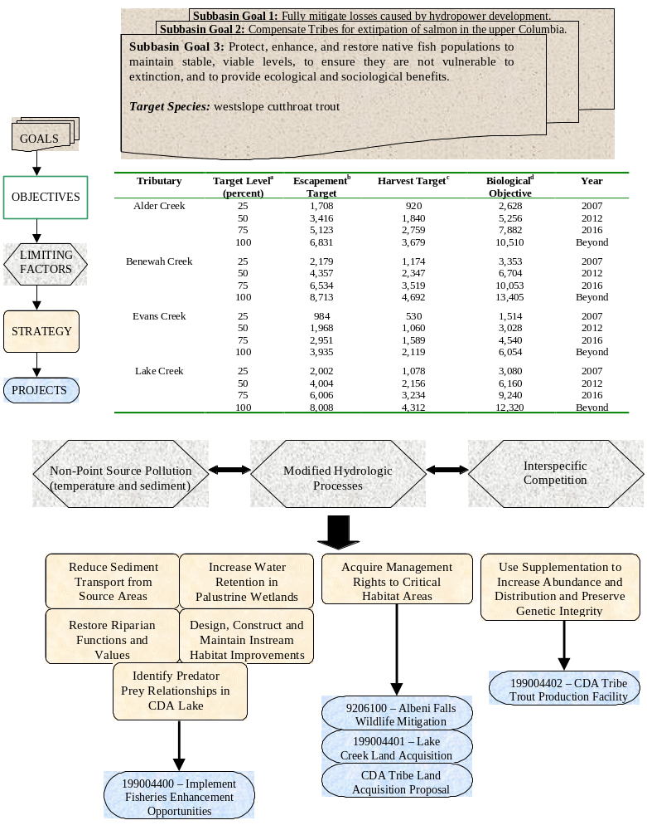

Figure 1. Logic Path for BPA Project 199004400 - Implement Fisheries Enhancement Opportunities on the Coeur d’Alene Reservation and for related projects in the Coeur d’Alene subbasin.
Despite the apparent instability of cutthroat trout populations in lower elevation tributaries to Coeur d’Alene Lake, preliminary genetic analyses of 16 populations show that relatively pure stocks exist in Reservation waters (Spruell et al. 1999). Only minimal amounts of hybridization with rainbow trout (Oncorhynchus mykiss) have occurred and some populations show no hybridization at all. For these same populations, allelic distributions, estimators of pair-wise divergence, and significance measures indicate little correlation between geographic distance and genetic differentiation (Knudsen and Spruell 1999). Based on an island model of migration, the estimated rate of gene flow among populations is approximately seven individuals per generation (Allendorf & Phelps 1981). However, this estimate is based on past conditions. The current level of migration may be reduced since the number of migrants decreases in proportion to the reduction in population size. Nevertheless, sufficient migration to prevent the loss of rare alleles has probably taken place in the recent past.
The level of genetic differentiation estimated in Coeur d’Alene cutthroat trout by microsatellites appears to be considerably less than estimates from other areas obtained using allozymes. For example, across the range of the species, the estimated FST is 0.333 (R. F. Leary, pers. comm.). Within the South Fork of the Flathead River, FST was estimated to be 0.150 (R. F. Leary, pers. comm.). Both of these values were based on allozymes in which genetic distinction should arise more slowly. Thus, the microsatellite-based FST estimates presented by Knudsen and Spruell (1999) appear to be quite low for westslope cutthroat trout. However, levels of heterozygosity appear to be reasonably high, minimizing the possibility that inbreeding depression is currently a problem.
Based on the results of genetic research initiated by this project, it could be theorized that even though westslope cutthroat trout populations are not “strong”, they are not threatened to a large extent with hybridization. Implications are that if the effect of habitat limiting factors can be reduced, then genetically pure populations would have a chance to recover.
The target watersheds in this proposal have a combined basin area of 34,853 hectares (86,123 acres) and include 529 kilometers (328 miles) of perennial and intermittent stream channel (See Table 3). It appears that there are a number of factors that contributed to the decline of resident fish stocks within Coeur d'Alene Lake and the tributaries targeted by this proposal. These factors include construction of Post Falls Dam in 1906, conversion of forested areas to agricultural and pasture lands, increased density of unimproved forest roads, loss of wetlands, and introduction of exotic fish species (Ellis 1932; Oien 1957; Mallet 1969; Scholz et. al. 1985, Lillengreen et. al. 1994, 1996; Peters et al. 1999). Fragmented ownership presents a particular challenge to restoration efforts. Tribal ownership represents less than 10 percent of the combined watershed area and private lots are generally less than 80 acres. Private lands are heavily managed with land use consisting primarily of managed forest (53%), agriculture (25%), and grazed pasture (22%). For the most part, these agricultural and pasturelands represent lands that were converted from forest and wetland cover types.
Table 3. Basin morphometry of the Lake Creek, Benewah Creek, Alder Creek and Evans Creek watersheds (From: Lillengreen et al. 1998).
Characteristic | Lake Creek | Benewah Creek | Alder Creek |  | Evans Creek
Basin Area | 36.1 mi² (23,117 ac.) | 58.5 mi² (37,447 ac.) | 26.6 mi² (17,047 ac.) |  | 13.3 mi² (8,512 ac)
Basin Length | 10.1 mi. | 13.8 mi. |  | 12.6 mi. | 6.5 mi.
Basin Relief | 3,077 ft. | 2,534 ft. | 2,690 ft. |  | 3,278 ft.
Basin Perimeter | 34.3 mi. | 51.2 mi. | 26.9 mi. |  | 17.3 mi.
Relief Ratio | 0.057 | 0.034 | 0.040 |  | 0.095
Channel Length* | 95.0 mi. | 136.5 mi. | 68.4 mi. |  | 29.0 mi.
Drainage Density | 2.51 mi/mi² | 2.33 mi/mi² | 2.54 mi/mi² |  | 2.18 mi/mi²
*Includes intermittent tributaries

On private lands, agricultural and forest practices that failed to consider water resources have contributed to the degradation of water quality and habitat suitability for resident salmonids through modification of hydrology, increased sediment transport and delivery, and alteration of riparian plant communities (Kootenai-Shoshone SCD 1991; Peters et al. 1999; CDA Tribe 1998). Demand for agricultural production and timber products increased sharply following the homesteading of the Reservation, beginning in 1910. In the Benewah valley, three splash dams and a flume were built in 1915 to float logs out of the watershed. An estimated 50 MMBF of logs were harvested, principally from riparian areas, between 1915 and 1929 (Hodgson 1998). Rail lines were developed in both Lake Creek and in Alder Creek to access valuable timber. The Alder Creek Railroad was built and operated between 1913 and 1927. Over its fourteen year operational history, some 300 MMBF of logs were sent to market by three or four logging camps with as many as 150 men per camp (St. Maries Gazette Record). In the late 1930s to mid 1950s the USDA provided incentives for clearing nearly 8,000 acres of forest in the Lake Creek watershed alone (CDA Tribe 1998, 2000). Consequently, the natural stream flow fluctuations characteristic of these low elevation watersheds was exacerbated (See Figure 2); the target watersheds exhibit extremely low flows in the summer and peak flows have increased by measurable amounts. In the Lake Creek watershed, for example, peak flows have increased by an estimated 57% and 54% for the 50 and 100 year return intervals, respectively (CDA Tribe 1998).
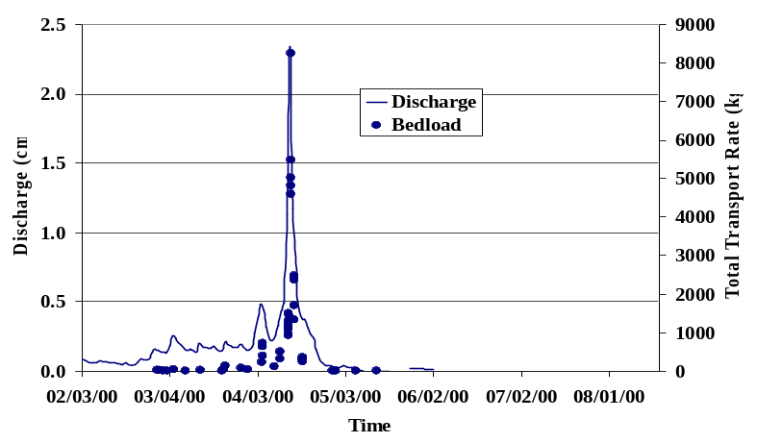
Increased sediment loads from agricultural runoff and unimproved forest roads, and increases in water temperature due to riparian canopy removal may be two of the most critical problems currently affecting tributary populations of westslope cutthroat trout (Peters et. al. 1999). Lake and Benewah creeks are listed on the current 303(d) list revised in 1996 for sediment and temperature violations (USEPA, 1996). Approximately 97 percent of cropland in the Lake Creek watershed is considered Highly Erodible Land (HEL) under the 1985 Food Security Act, and measured turbidity exceeds water quality criteria of 50 NTU during most significant runoff events (Bauer 1998). Sheet and rill erosion on these highly erodible agricultural lands, as estimated by the KSSCD (1991) using the Universal Soil Loss Equation (SCS, 1975), was shown to be the primary transport mechanism (See Table 4). Forest roads, another primary source of sediment, have proliferated in the target watersheds, with densities ranging from 3.4 – 5.7 miles/sq. mile.
Figure 2. Water discharge and sampled bedload over time within a second order tributary in the Lake Creek watershed (Boll 2000).
Alteration and/or conversion of forested riparian habitats have been especially dramatic in the target watersheds. Agricultural uses, including grazing and cropping, have direct effects on 23%, 36%, 10%, and 60% of riparian habitats in the Alder, Benewah, Evans and Lake Creek watersheds, respectively (Coeur d’Alene Subbasin Summary 2000). Measured water temperatures in Alder, Benewah, and Lake creeks regularly exceed 20°C in mainstem reaches during late summer months (Peters et al. 1999; Bauer 1998; Lillengreen et. al. 1996). These increases in water temperature over time have reduced the range of resident salmonids to a fraction of its historic extent. Within this new range, sediment has reduced the quality of both spawning and rearing habitats. Recent population estimates for westslope cutthroat trout indicate that more than 80 percent of available habitat supports less than 2.8 fish/100 sq. meters, while the remaining headwater areas support populations that range from 2 to 15 times greater (Peters et al. 1999). These headwater “strongholds” illustrate the resiliency of native fish populations and represent the potential for habitat and species recovery in the target watersheds.
Table 4. Sediment budget summary for the Lake Creek watershed (From: CDA Tribe 1998).
 | Source |  | Amount generated (tons/year) |  | Delivery to streams (tons/year) |  | Percent of total delivery
 | Soil creep |  | 1050 |  | 1050 |  | 7.7
 | Mass wasting |  | 14000 |  | 840 |  | 6.2
 | Road system |  | 5600 |  | 336 |  | 2.5
 | Cropland sheet and rill erosion |  | 115070 |  | 10615 |  | 78
 | Cropland gully erosion |  | 12100 |  | 726 |  | 5.4
 | Export
Sediment yield |  | NA |  | 1500** |  | 11
**Estimated export by Lake Creek, 11% of combined inputs
To address these problems, restoration efforts are necessarily targeting the most degraded lands under private ownership, and treating source areas as high priorities.

c. Rationale and significance to Regional Programs
Past mitigation within the Coeur d’Alene subbasin has occurred primarily through implementation efforts of the Coeur d’Alene Tribe as off-site protection, mitigation, enhancement and compensation activities called for under Section 4(h) of the Pacific Northwest Electric Power Planning and Conservation Act and the Northwest Power Planning Council Fish and Wildlife Program. The activities called for under this proposal provide partial mitigation for the extirpation of anadromous fish resources from usual and accustomed harvest areas and Reservation lands. Additional mitigation is also occurring to address impacts to resident fish and wildlife populations and habitats attributable to development of the Federal Columbia River Power System (Goal 1, Objective 1 and Goal 2, Objective 1: Coeur d’Alene Subbasin Summary 2000).
This project shares the FWP objectives of: maintaining biological diversity in the Upper Columbia River basin; maintaining genetic integrity by preserving wild fish stocks; providing needed habitat protection; and increasing run sizes and resident fish populations by implementing effective restoration projects. The priorities and objectives of this proposal are described in the 1995 Fish and Wildlife Program [10.8B.20].
Within the Coeur d’Alene subbasin, Coeur d’Alene Lake serves as the principle focal area for the interaction of migratory, resident fishes and the dispersal of genetic material. It is widely accepted that the persistence of species is linked to the resilience of local populations as well as to the condition, structure, and interaction of populations and habitats at larger scales (Soule 1987; Rieman and McIntyre 1993). The efforts of this project have helped illustrate that migration of individual westslope cutthroat trout over time has prevented the loss of rare alleles in low elevation populations (Knudsen and Spruell 1999; Spruell et al. 1999). Furthermore, preservation and recovery of the genetically pure populations found in the tributaries addressed by this proposal serves an important role in preserving the genetic integrity of native fishes in the subbasin as a whole (Goal 3, Objective 2: Coeur d’Alene Subbasin Summary 2000).
Habitat degradation caused by overgrazing, road construction, timber harvest and agriculture has adversely affected instream habitat and riparian and floodplain function in streams on the Coeur d’Alene Indian Reservation and throughout the Coeur d’Alene subbasin. Low summer stream flows, high water temperatures, poor bank stability, sedimentation and a lack of instream and riparian habitat diversity limits trout production and rearing capacity in all but the upper tributaries within the target watersheds (Coeur d’Alene Subbasin Summary 2000; Lillengreen et. al. 1996; Peters et al. 1999). Despite these challenges, wild fish stocks still persist in each of the target watersheds and demonstrate an ability to respond positively to restoration projects.
Restoration projects called for under this proposal are prioritized for implementation in the most critical habitat areas using widely accepted passive and active techniques. Riparian and upland plantings are carefully selected from local, native propagates to maintain and increase diversity. Four years of intensive implementation efforts has resulted in cooperative relationships with more than twenty-five landowners and eight partnership agencies. Much work still needs to be accomplished. With continued funding we anticipate: protecting and enhancing one to two miles of stream channel each year; reducing sediment transport and delivery to streams from highly erosive upland areas; increasing infiltration of water in riparian wetlands; and providing continued protection, maintenance and monitoring of existing projects.
Planning for project implementation is coordinated on a watershed basis that includes the participation and involvement of private landowners, state and federal agencies, and other Tribal programs. Significant progress was made in recent years to integrate stringent protection measures for riparian dependent resources into management plans adopted by the Coeur d’Alene Tribal Council. Additional efforts detailed in this proposal call for development of consolidated memoranda of agreement to address forest road standards and guidelines and schedules for road closure and obliteration on Tribal and privately owned forestlands within the Reservation boundaries. Furthermore, this project serves as a model for adaptive management by implementing projects based on watershed assessment and limiting factor analysis, sharing data and objectives with partnership agencies and private landowners, and incorporating effectiveness and trend monitoring to evaluate project responses.
The recent ESA listing of bull trout in June, 1998 and the petition to list westslope cutthroat trout across its range has led to increased recognition that habitat degradation must be reversed to promote species recovery efforts (IDFG 1996; State of Idaho Bull Trout Conservation Plan 1996; USFWS 1998; USDA 1996). Because private ownership comprises more than 90 percent of the area within the target watersheds, enhancement efforts must necessarily target these lands. Existing federal programs sponsored by the Farm Service Agency and Natural Resource Conservation Service complement the efforts of this project by providing cost-share monies to implement Best Management Practices on agricultural lands. Other grants administered by the Tribe (e.g., EPA 319 and 106 grants) leverage additional funding to increase the scope of this project. The Coeur d’Alene Tribe Fisheries Enhancement Project has become a logical and integral part of species recovery in the subbasin by implementing projects that establish long term riparian and instream habitat protection on both private and Tribal lands within the Reservation.

d. Relationships to other projects

Other BPA funded projects
199004401 – Lake Creek Land Acquisition. BPA is providing funding to the Coeur d’Alene Tribe to acquire 2,100 acres of high quality riparian wetlands and adjacent upland habitat in the Lake Creek watershed. This acquisition will secure critical habitat for protection of fish, water and wildlife, allow for enhancement of degraded areas, and partially mitigate for resident fish and wildlife losses attributed to the Grand Coulee and Albeni Falls hydroelectric facilities. Restoration projects will be designed and implemented under the BPA project: Implement Fisheries Enhancement Opportunities to facilitate the recovery of this property once acquisition is finalized.
199004402 – The Coeur d’Alene Tribe Trout Production Facility. Project activities are directed at supplementation of westslope cutthroat trout into local reservation streams and restoration of degraded habitats. These actions include the construction of a hatchery, four acclimation ponds, and three put and take trout fishing ponds. Depleted native cutthroat trout populations in the Alder, Benewah, Evans and Lake creek watersheds will be supplemented with hatchery raised cutthroat trout taken from the selected tributaries. Restored sites will provide increased availability of suitable habitats for wild and hatchery reared fish. Hatchery fish will be acclimated in ponds adjacent to selected tributaries prior to their release. Put and take trout fishing ponds have been constructed to ease fishing pressure on native salmonid stocks and will be stocked with rainbow trout (Oncorhynchus mykiss) produced in the hatchery.
9206100 – Albeni Falls Wildlife Mitigation Project. The Coeur d’Alene Tribe is proposing to acquire 411 acres of riparian and floodplain habitat that encompasses nearly 3 miles of the mainstem of Benewah Creek. The property represents critical rearing habitat for westslope cutthroat trout in the watershed, but is severely degraded under current conditions. National Wetland Inventory (NWI) wetlands cover nearly 30% of the property. The uniqueness of this property is emphasized by the fact that 25% of the mapped NWI wetlands in the Benewah Creek watershed are located within its boundaries. Restoration projects will be designed and implemented under the BPA project: Implement Fisheries Enhancement Opportunities to facilitate the recovery of this property once acquisition is finalized.
CDA Tribe – New Proposed Land Acquisition Project. This is an new project proposed by the Coeur d'Alene Tribe to enhance habitats for native fish and wildlife species within the Coeur d'Alene Subbasin, as well as to complement the ongoing Implement Fisheries Enhancement Opportunities on the Coeur d'Alene Reservation (Project #199004400). To date, 42 individual projects have been implemented since 1995 in the Coeur d'Alene Subbasin, improving 850 acres of riparian and upland habitats and 4 miles of streams. However, these mitigation efforts, directed at restoring stream habitats to recover westslope cutthroat trout populations, rely on the support of private landowners and lack a provision for long-term habitat protection. This project proposes to provide the needed habitat protection component to ongoing efforts by acquiring management rights (fee title or easement) to key wetland/riparian habitats within the priority watersheds. The principal goal of this project is to maintain the native diversity that persists within the Subbasin and restore and enhance native habitats to support a full complement of native fish and wildlife species.
A trust fund is proposed as part of this project both for securing management rights to priority areas and for long-term operation and maintenance. Trust funds would provide both a) the necessary funding stability and flexibility and b) reduction of long-term financial obligations of the Northwest Power Planning Council Fish and Wildlife Program.
Partnerships with projects that receive funding from other sources represent a substantial benefit to this proposal.

EPA
The EPA is working with the Water Resources Division of the Coeur d'Alene Tribe Fish, Water, and Wildlife program under sections 319 and 106 of the Clean Water Act to reduce non-point source pollution and to gather baseline water quality data in the four target watersheds. Implementation priorities for this program parallel the priorities for this project and are: 1.) Reduction of sediment outputs from agricultural sheet and rill erosion; 2.) Restoration of riparian zones and increasing of streambank canopy cover; 3.) Augmentation of base flows; and 4.) Mitigation of flow disturbances and sedimentation due to forest roads.
Annual funding for section 106 grants will provide approximately $50,000/year to monitor surface water quality of streams, conduct watershed assessments, and provide the framework for TMDL development on the Reservation. Monitoring is conducted at 25 sites within the Reservation, including 15 sites within the target watersheds. Data is compiled and used to supplement the analysis of fish and macroinvertebrate abundance and distribution. Data on temperature, discharge and turbidity, in particular, are important in evaluating restoration project effectiveness. Annual funding for section 319 grants has ranged from $100,000 to $164,000 during the past two funding cycles. Examples of projects that will be funded include BMP’s for agricultural lands, forest road mitigation and enhancement, and riparian and wetland enhancement.

USDA
Local soil conservation districts have received State Agricultural Water Quality Program (SAWQP) grants totaling $900,000 to fund projects that reduce non-point source pollution from cropland erosion. The grants are used to implement best management practices in the upper Lake Creek watershed for reduction of non-point source non-irrigated cropland erosion. The Kootenai-Shoshone Soil Conservation District recently enrolled 55% of the Lake Creek agricultural acreage within Idaho into the State Agricultural Water Quality Program (SAWQP). This commits watershed producers to a variety of agricultural BMP’s including conversion to bluegrass. The majority of the contracts written are in their first two years of a five-year implementation plan. As the contracts are completed, the Lake Creek watershed should receive reduced sediment loads. Tribal Fish, Water, and Wildlife Program staff are coordinating fish and wildlife habitat restoration efforts with this agency so that critical areas receive priority treatment. A considerable amount of momentum has been generated to promote restoration work through integration of this grant with BPA funding. Cost sharing, as well as sharing of technical expertise, has led to implementation of wetlands enhancement projects and planting of trees to restore native upland forest on formerly cropped land.
A current project designed to study and develop the watershed restoration process in Lake Creek has been implemented with funding from the USDA (Boll et al., 2000). Related studies will address a key habitat issue that has not been fully addressed in the past within the Lake Creek watershed, namely, the restoration of salmonid spawning habitat impacted by excess fine sediment at the reach scale. To accomplish this, the following objectives have been identified and are being addressed: (1) determine the feasibility of natural flows to perform sediment maintenance, and (2) determine what reductions in fine sediments from observed are required to increase embryo survival to an acceptable level.

Tribal
The Tribe is initiating the development of an Integrated Resources Management Plan (IRMP) with funding assistance from the USEPA General Assistance Program, USDI Bureau of Indian Affairs, Administration for Native Americans, and Department of Health and Human Services. The Tribe’s natural resource department is taking the lead on the project, with participation coming from all Tribal programs and departments. Goals of the project are to create a common vision for the future use and sustainability of Tribal natural, environmental and cultural resources; provide clear goals and objectives to reach the Tribe’s common vision; and coordinate the management of tribal natural, environmental and cultural resources. Direct benefit will come to the BPA project: Implement Fisheries Enhancement Opportunities through adoption of standards and guidelines for the protection of fish and wildlife resources, and through identification and remediation of conflicting management practices. The IRMP is the first Tribal management plan that will encompass all natural resources and environmental elements on the Reservation.
The Coeur d’Alene Tribe Education Department funds a summer internship program for high school students interested in natural resources management. The Fish, Water and Wildlife Program supervises 3-5 of these interns each year and benefits by using them in tree planting and fence building projects, among other things. Several graduates of the internship program have continued working on restoration projects as seasonal technicians and as full-time employees.

e. Project history
This proposal describes an ongoing mitigation project: BPA Project 90-044, entitled Implement Fisheries Enhancement Opportunities on the Coeur d’Alene Indian Reservation. It has been underway since 1990. Annual funding for this project has averaged $442,342 and total costs from 1990 through 2000 were $4,423,416. For the period 1995-2001, this project will supplement regular program funding with more than $900,000, with monies coming from EPA Clean Water Act Grants, an EPA Environmental Education Grant, a USDA research grant, and State Agricultural Water Quality Program funds, among others. Since 1997, landowner contracts have provided for additional cost shares where private landowners provide long term maintenance of projects.
Previous project reports include: annual and biennial project evaluation reports 1990, 1991, 1992, 1993-94, 1996-97, 1998 (Graves, et. al. 1992; Lillengreen et. al. 1993; 1994; 1996; Vitale et al. 1999); Tribal management plan for enhancement of resident fisheries (Lillengreen et. al. 1998); a supplementation feasibility report (Peters et al. 1999); Trout Production Master Plan (Peters et al. 1999); a stock assessment for westslope cutthroat trout (Peters and Vitale 1999); and two reports on genetic analysis of westslope cutthroat trout in tributaries of Coeur d’Alene Lake (Spruell et al. 1999 and Knudsen and Spruell 1999). A biennial report for 1999-2000, evaluating restoration projects and monitoring efforts, is currently being prepared. Information derived from this project has also been disseminated through project presentations given to the American Fisheries Society (Vitale 2000) and Idaho Academy of Sciences (Peters 1999), at conferences on native species and habitat restoration (Vitale 1999; Vitale 1997), and at numerous regional caucuses sponsored by NWPPC, CBFWA and BPA.
In 1987, the NPPC amended the Columbia River Basin Fish and Wildlife Program to include baseline stream survey of tributaries located on the Coeur d'Alene Indian Reservation [section 903 (g)(1)(B)]. Initial work rated reservation streams according to their potential for habitat development for westslope cutthroat trout and bull trout. Physical and biological surveys incorporated measures of stream bank and bed stability, riparian condition, land use, urbanization, migration barriers, water quality, stream flow, substrate suitability, channel modification, relative abundance estimates, and macroinvertebrate densities (Fejen and Wehnes 1981). Four streams (Alder, Benewah, Evans, and Lake Creeks) were identified as having the best potential for habitat restoration and species recovery and targeted for further study.
Between 1992 and 1994 watershed assessment techniques were used in the target drainages to identify priority areas for restoration by examining sediment routing (Washington Forest Practice Board 1992; Kappesser 1992), channel function and stability (Rosgen 1994; Pfancuch 1975;), instream habitat composition (Bisson et. al. 1981), riparian function (Platts et. al 1983), as well as the abundance and distribution of target species. Parameters looked at included: number of pools, riffles, and secondary channels; large organic debris volume; riparian vegetation diversity and stream canopy closure; land use practices in floodplain areas; and water quality parameters. Measures of substrate composition and percent fines were also used as habitat quality indicators. Biological assessments included trout population and biomass estimates, individual stock assessments, and quantification of macroinvertebrate populations (Plafkin et. al. 1989).
It was determined that in all four target streams base flow, summer water temperature, and fine sediment are limiting the quality of trout habitat. Average annual base flows of less than 25% of average annual flows were reported in all streams. Temperatures above those values reported as optimal were recorded in each of the four streams. Non-point source sediment runoff is also considered limiting in all four drainages. Average % fines for all streams were above the recommended 10% fines value. It was determined that habitat degradation (a result of the cumulative effects of many land use practices), as well as, introduction of exotic salmonid fish species has caused the extinction of bull trout and severely depressed native populations of westslope cutthroat trout. Land use practices have altered natural ecosystem processes with which native fishes have evolved. This alteration has created conditions less favorable for native salmonids and more favorable for introduced exotics, as well as, less desirable native fishes.
In 1994, the NPPC adopted the recommendations set forth by the Coeur d'Alene Tribe to improve the reservation fishery. These actions included: 1.) Implement habitat restoration and enhancement measures in Lake, Benewah, Evans, and Alder Creeks; 2.) Purchase critical watershed areas for protection of fisheries habitat; 3.) Conduct an educational/outreach program for the general public within the Coeur d'Alene Indian Reservation to facilitate a “holistic” watershed protection process; 4.) Develop an interim fishery for tribal and non-tribal members of the reservation through construction, operation and maintenance of five trout ponds; 5.) Design, construct, operate and maintain a trout production facility; and 6.) Implement a five-year monitoring program to evaluate the effectiveness of the hatchery and habitat improvement projects. These principles, priorities, and objectives were adopted into the 1995 FWP (10.8B.20).
Demonstration projects were implemented in 1995 and 1996 with the cooperation of private landowners. A primary objective of these first projects was to evaluate the application of a variety of techniques to specific watershed conditions. Passive regeneration techniques, using riparian exclosure fencing as the primary method, were subsequently adopted to restore degraded habitat. This has been proven in other studies to be an effective means of improving riverine/riparian habitats (Beschta et. al. 1991; Platts 1990). Active remediation techniques using plantings, bioengineered stream bank protection, and placement of instream structures made from native materials have also been used when natural processes have been deemed unlikely to result in recovery within a desired time frame.

Highlighted Results
Work has progressed on 42 individual projects since 1995. Long-term agreements have been signed with 12 landowners in three watersheds, providing protection and enhancement for more than 850 acres of upland and riparian habitat and 4 miles of stream channel. More than 50,000 trees and shrubs have been planted over a five year period to enhance water retention and riparian function. Eight acres of constructed wetlands have reduced non-point source pollution from 630 acres of farm land and instream habitat improvements have elicited positive responses from fishes at several sites. Cost shares for implementation, monitoring and evaluation activities currently occur with seven partnership agencies. Watershed work groups comprised of landowners and other interested agencies have been formed in two target watersheds and meet on a quarterly basis. The work groups have proven effective in highlighting restoration work and in generating additional interest among landowners. In addition, work has been ongoing on Coeur d’Alene Lake to evaluate limiting factors for adfluvial westslope cutthroat trout during sub-adult and adult rearing.
Table 5. Temperature profile at pond FR1 (7/30/99). (Unpublished data, CDA Tribe)
Depth (meters) | Temperature (°C)
0.2 | 23.1
0.8 | 21.7
1.3 | 20.7
1.8 | 18.8
2.3 | 16.4
2.8 | 13.5
3.3 | 11.9
3.8 | 10.4
4.3 | 8.9
4.8 | 7.4
5.3 | 5.9
5.8 | 4.3

The need to address limiting factors related to elevated summer water temperatures has elicited an implementation approach that combines storage and timed release of water from constructed wetlands, and rehabilitation of riparian wetlands through coniferous and deciduous plantings. To date, eight acres of palustrine wetlands have been constructed in the Lake Creek watershed, with a combined storage capacity of approximately 46 acre-feet. Water depth at full pool ranges from 15-20 feet at each of four sites and the thermocline that develops during summer months keeps water temperatures at or below 16°C for approximately 40% of the storage capacity (See Table 5). This established network of constructed wetlands present an opportunity for addressing the short-term peaks in summer water temperatures that effectively limit the distribution of juvenile fish in the watershed. An experimental release of water from one such pond indicated that stored water was 3-8 degrees colder than measured instream water temperatures during the release period (August 13 - 27, 1999). A coordinated release of 0.5 cubic feet/second of water from the existing network could provide cooling effects for more than 18 days during critical summer rearing periods and increase base flow by more than 15 percent. The goal of this project is to double the combined storage capacity of constructed wetlands over the next four years.
While it is difficult to quantify the short-term benefits to riparian function of planting 50,000 trees and shrubs over the last five years, the long-term benefits of healthy riparian plant communities are well documented. Platts and Nelson (1989) described a positive correlation between stream canopy and salmonid biomass in the Intermountain west, citing beneficial effects from thermal regulation and input of allochthonous plant material and terrestrial invertebrates. Input of woody debris from project plantings will provide cover for fish (Boussa 1954; Hartman 1965), serve as shelter from current (Bustard and Narver 1975; Fausch 1984; Bisson et al. 1987), and provide sites from which foraging can be staged while predation risk is reduced (Crowder and Cooper 1982; Huntingford et al. 1988). These benefits are being realized incrementally as plantings begin to mature. At planting sites in Lake, Benewah and Evans creeks, survival has approached 70% and measured growth of live, willow pole plantings has exceeded four feet per year (See Figure 3). Continued monitoring and evaluation will help to further quantify the benefits of these riparian measures.
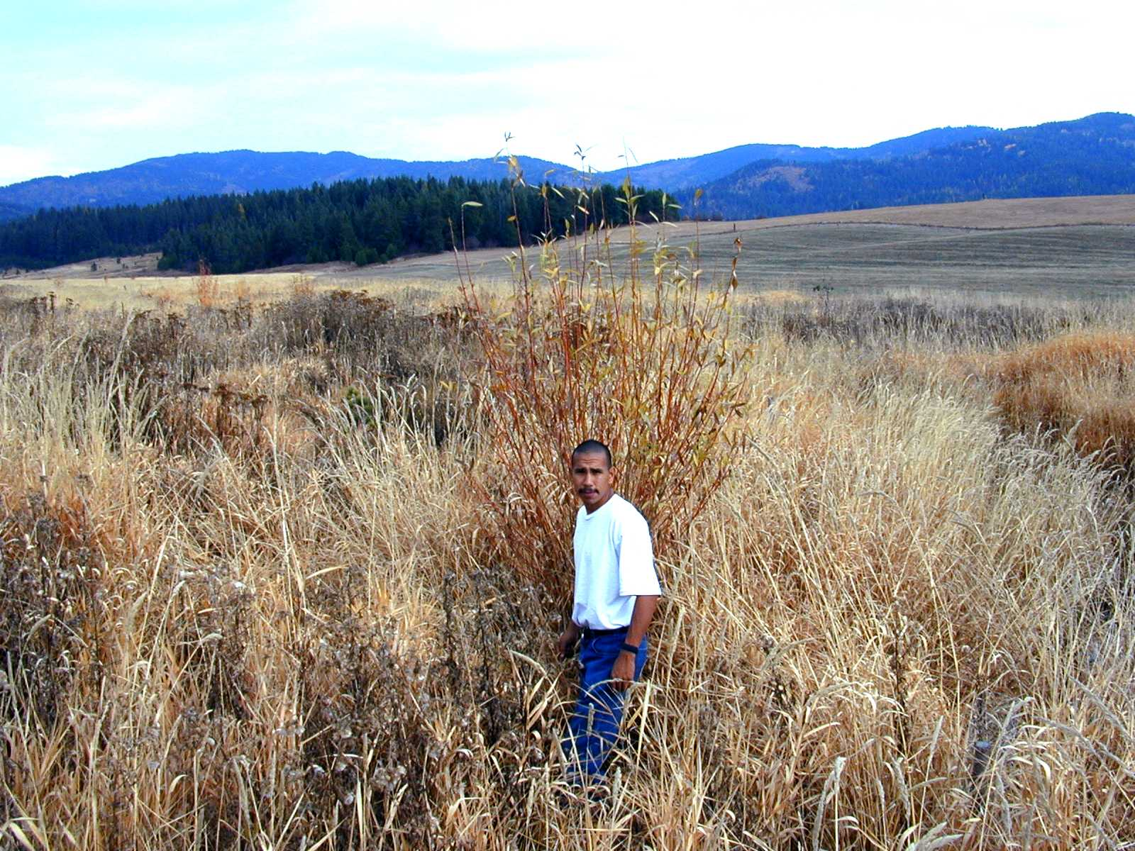
Figure 3. Live willow pole showing two seasons of growth.
Reduction of sediment transport and delivery from source areas has been an overall objective of this project. In the Lake Creek watershed, where cropland sheet and rill erosion is the principle sediment source, identification and mapping of Highly Erodible Land (HEL) has helped to prioritize the placement of erosion control measures, such as gully plugs and large sediment basins (See Figures 4 and 5). Gully plugs inhibit gully formation in farmland by capturing surface flow from up to 7 acres and transporting it via underground conduit to a safe outlet, such as a grassed waterway. The larger sediment basins treat sheet, rill and gully erosion from much larger tracts of land by acting as a sediment sink. The construction of large sediment basins, beginning in 1997 has reduced annual sediment delivery to Lake Creek from 630 acres of farmland. Operating at an estimated 75% efficiency, total delivery has decreased from 1801.8 tons of sediment/year to 450 tons/year. Partnership projects implemented by the NRCS have reduced delivery by comparable amounts from more than 600 additional acres of HEL.
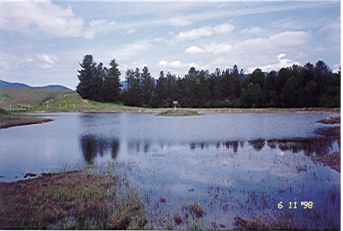
Figure 4. Large sediment basins significantly reduce sediment delivery to Lake Creek.
Several instream habitat projects have elicited positive responses from the fish community. A project completed in 1999 in the Lake Creek watershed rehabilitated a 600 meter long stream reach which had been cleaned and straightened and was completely devoid of woody debris. Annual population surveys indicated a complete absence of cutthroat trout prior to construction. A total of 44 individual logs with a combined biomass of approximately 47 tons were introduced to the test reach to approximate historic volumes of debris at the site. In addition, a 3,000 sq. ft. brush mattress was constructed by hand to introduce fine woody debris and to help narrow and deepen a particularly degraded section where the width_{bf}/depth_{bf} ratio was >100. One year after construction, average residual pool depth had increased by 15 percent, substrate conditions showed a shift from sand (D₆₃<2mm) to a mixture of predominantly fine gravels (D₅₀<11.3mm), and cutthroat trout from 3 different year classes were observed at the site. Whether fry carrying capacity for the entire stream reach increased cannot be assessed from our experiment. A redistribution of existing fish could have produced a similar result, but it is logical that if locally improved habitat attracts fish away from unimproved parts of the stream, then the fish that remain in the improved parts have better chances for survival, growth, and production.
Project actions such as these are addressing limiting factors at the reach scale and are based on a large body of peer reviewed scientific literature. Large woody debris (LWD) has long been considered an essential structural element of habitat in forested streams (Bisson et al. 1987). The addition of LWD to streams can raise fish abundance by increasing cover (e.g., Angermeier and Karr 1984; Shirvell 1990) and streambank stability (Keller and Swansan 1979). Such debris can control stream channel geometry and hydraulic diversity (Keller and Swanson 1979; Bilby 1984) and increase its storage capacity for inorganic sediments (Bilby 1981) and organic matter (Bilby and Likens 1980). Fine woody debris (FWD) accumulations have been hypothesized to provide cover for fish and increase habitat complexity in a manner similar to that of large debris (Bryant 1983), as is well known to trout stream biologists. Other investigators have noted that fry were most abundant in areas that had natural accumulations of FWD consisting of branches and sticks (Beers 1990; Culp et at. 1996). Culp et al. (1996) demonstrated that FWD can increase the density and total biomass of rainbow trout fry without negatively affecting individual size and body condition.
Within the Reservation boundaries, westslope cutthroat trout utilize one of three different life history strategies, including adfluvial, fluvial and resident. Of these forms, adfluvial production is considered the most important in the Coeur d'Alene basin. The reasons for this are that they attain the largest size and played an important role in the subsistence economy of the Coeur d’Alene Tribe (Peters et. al. 1999). Because of their dependency on multiple habitats, adfluvial fish are more sensitive to widespread changes in habitat quality and complexity than the fluvial and resident forms. The Coeur d'Alene Tribe Fisheries Program has been monitoring fishery interactions and baseline water quality parameters in Coeur d'Alene Lake to define limiting factors for sub-adult and adult westslope cutthroat trout.
Non-game natives such as largescale suckers (Catostomus macrocheilus) and non-native yellow perch (Perca flavescens) are the most abundant fish, comprising almost 40% of the sampled population, while cutthroat trout comprise about 1% of the average annual sampled population (See Table 6). Cutthroat trout have appeared most frequently in beach seining samples. We hypothesize that adult and juvenile cutthroat trout use the bays of Coeur d'Alene Lake as staging areas before migrating upstream to spawn as adults and before migrating to deeper water as sub-adults (Vitale el. al, 1999). Migration of cutthroat trout occurs from March-June, and therefore occupy these bays at the same time that northern pike (Esox lucius), smallmouth bass (Micropterus dolomieui) and largemouth bass (Micropterus salmoides) are using these bays to spawn. The potential for competitive interactions is intensified at these times. As indicated by sampling efforts, cutthroat trout move to deeper water by July to avoid unsuitable water temperatures in shallow areas. Increasing abundance and distribution of smallmouth bass during the last seven years could increase the threat to cutthroat trout since there is some degree of niche overlap in the spring and early summer.
Table 6. Relative abundance of fishes sampled in the southern 1/3 of Coeur d'Alene Lake, 1994-2000.
Species¹ | 1994 (n=1629)² | 1995 (n=1805)² | 1996 (n=822)² | 1997 (n=5235)² | 1998 (n=7843)³ | 1999 (n=3364)⁴ | 2000 (n=5084)⁴
BBH | 2.27% (37) | 5.71% (103) | 2.55% (21) | 4.43% (232) | 4.70% (69) | 15.13% (509) | 9.48% (1)
BC | 5.83% (95) | 3.21% (58) | 3.28% (27) | 7.79% (408) | 13.87% (1088) | 10.17% (342) | 25.39% (1291)
BLT | - | 0.06% (1) | - | - | - | 0.03% (1) | -
CCF | 0.06% (1) | - | 0.36% (3) | 0.15% (8) | 0.06% (5) | - | -
CHN | - | - | - | 0.36% (19) | 0.37% (29) | 0.36% (12) | 0.22% (11)
CTT | 1.17% (19) | 0.72% (13) | 0.36% (3) | 0.86% (45) | 0.62% (49) | 0.42% (14) | 2.10% (107)
KOK | 1.35% (22) | 0.17% (3) | 0.73% (6) | 1.51% (79) | 0.31% (24) | 0.30% (10) | 0.53% (27)
LMB | 16.21% (264) | 12.63% (228) | 4.87% (40) | 8.71% (456) | 15.05% (1180) | 12.03% (405) | 6.22% (316)
LSS | 26.40% (430) | 27.09% (489) | 33.45% (275) | 27.66% (1448) | 23.33% (1830) | 14.98% (504) | 7.00% (356)
MWF | 0.06% (1) | 0.39% (7) | - | 0.15% (8) | 0.13% (10) | 0.09% (3) | -
PIK | 1.84% (30) | 0.06% (1) | 0.85% (7) | 0.53% (28) | 0.65% (51) | 0.71% (24) | 0.30% (15)
PSS | 6.57% (107) | 10.03% (181) | 10.34% (95) | 9.38% (497) | 8.62% (676) | 9.22% (310) | 10.90% (554)
RBT | - | - | - | 0.02% (1) | 0.01% (1) | - | -
SCP | 0.43% (7) | 0.28% (5) | - | 0.38% (20) | 0.11% (9) | 0.03% (1) | 0.06% (3)
SMB | - | - | - | 0.04% (2) | 0.22% (17) | 0.18% (6) | 0.83% (42)
SQW | 11.36% (185) | 7.48% (135) | 15.45% (127) | 10.47% (548) | 9.12% (715) | 5.56% (187) | 5.13% (261)
TCH | 2.21% (36) | 3.99% (72) | 2.43% (20) | 3.23% (169) | 3.83% (300) | 2.85% (96) | 2.01% (102)
YP | 30.76% (501) | 28.2% (509) | 25.30% (208) | 24.32% (1273) | 19.0% (1490) | 17.85% (601) | 29.80% (1515)
¹ BBH = Brown Bullhead; BC = Black Crappie; BLT = Bull trout; CCF = Channel Catfish; CHN = Chinook Salmon; CTT = Cutthroat Trout; KOK = Kokanee Salmon; LMB = Largemouth Bass
LSS = Large Scale Suckers and Long Nose Suckers; MWF = Mountain Whitefish; PIK = Northern Pike; PSS = Pumpkin Seed; RBT = Rainbow Trout; SCP = Sculpin; SMB = Smallmouth Bass
SQW = Northern Pikeminnow; TCH = Tench; YP = Yellow Perch
Since 1994 the Coeur d’Alene Tribe Fisheries program has conducted an extensive mark-recapture study (Peters et al. 1999). From 1994-1998 636 fish have been tagged, there have been 23 recaptures between the Fisheries program and anglers and anglers have harvested 15 fish. Eleven out of 21 species occupying the Lake have been tagged. The mark-recapture study relies heavily on the effectiveness of our sample gear and on angler’s participation. We realize these results are biased because not all anglers report their catch, tags can be removed by anglers and they can fall out. Through these efforts we are finding that northern pike have a tendency to migrate from the original sampling site, while largemouth bass are very territorial rarely moving from the site where they were tagged. It appears that both northern pike and largemouth tend to occupy shoreline habitat areas almost exclusively (Peters et al., 1999).
The Coeur d'Alene Tribe Fisheries Program has also spent the past four years monitoring baseline water quality and relating it to a lacustrine cutthroat trout habitat suitability index (HSI) developed by Hickman and Raleigh (1982). Six out of the thirteen water quality sites have low dissolved oxygen values in the hypolimnion and extremely high surface water temperatures in the epilimnion. Benewah Lake, Chatcolet Shallow, Round Lake and Coeur d’Alene River have very poor HSI values throughout the water column. Windy Bay Shallow and Rockford Bay have poor HSI values at the surface, while Hidden Lake and Chatcolet Deep have poor HSI values in both the epilimnion and hypolimnion (See Table 7). The low dissolved oxygen values that are being recorded are thought to have indirect affects on cutthroat trout suitability in the southern lakes area (Peters et al., 1999).
A more serious problem associated with low dissolved oxygen values in the hypolimnion is the high concentration of metals that are bound up in the sediment north of the Coeur d'Alene River. The deposition of trace elements in the sediments of Coeur d'Alene Lake is well-documented (Funk 1973; Rieman 1980; Woods 1989; Woods and Beckwith 1996). Lakebed geochemistry analyses revealed that most of the trace elements in surficial and subsurface sediments are associated with a ferric oxide phase and, thus, under reducing (anoxic) conditions, the trace elements would be readily solubilized and available for release to the overlying water column (Woods and Beckwith, 1996). Continued monitoring of water quality throughout the southern 1/3 of Coeur d'Alene Lake will allow the Coeur d'Alene Tribe Fisheries Program to observe any sudden changes.
Table 7. Lacustrine habitat suitability index (HIS) values for cutthroat trout based on water quality data from Coeur d’Alene Lake, 1997-2000 (From Peters et al. 1999).
Location |  | Depth |  |  | Habitat Suitability Index
 |  |  | 1997 | 1998 |  | 1999 | 2000
Rockford Bay | 0-7 meters |  | 0.25 SI | 0.0 SI |  | 0.37 SI | 0.0 SI
 | 7-11 meters |  | 0.845 SI | 0.0 SI |  | 0.89 SI | 0.76 SI
 | 11-bottom (14)ª |  | 1.0 SI | 0.89 SI |  | 1.0 SI | 1.0 SI
Windy Bay Shallow | 0-7 meters |  | 0.0 SI | 0.0 SI |  | 0.0 SI | 0.0 SI
 | 7-10 meters |  | 0.94 SI | 0.0 SI |  | 0.84 SI | 0.82 SI
 | 10-bottom (16)ª |  | 1.0 SI | 0.77 SI |  | 1.0 SI | 1.0 SI
Windy Bay Deep | 0-10 meters |  | 0.0 SI | 0.0 SI |  | 0.70 SI | 0.63 SI
 | 10-15 meters |  | 0.94 SI | 0.77 SI |  | 1.0 SI | 1.0 SI
 | 15-bottom (32)ª |  | 1.0 SI | 1.0 SI |  | 0.98 SI | 0.97 SI
Coeur d’Alene River | 0-bottom (12)ª |  | 0.0 SI | 0.0 SI |  | 0.0 SI | 0.37 SI
Mid-Lake Coeur d’Alene | 0-10 meters |  | 0.0 SI | 0.0 SI |  | 0.70 SI | 0.70 SI
 | 10-13 meters |  | 0.94 SI | 0.98 SI |  | 0.98 SI | 1.0 SI
 | 13-bottom (19)ª |  | 1.0 SI | 0.95 SI |  | 1.0 SI | 0.98 SI
Carey Bay | 0-10 meters |  | 0.0 SI | 0.0 SI |  | 0.82 SI | 0.70 SI
 | 10-12 meters |  | 0.94 SI | 0.94 SI |  | 0.98 SI | 1.0 SI
 | 12-bottom (14)ª |  | 1.0 SI | 0.99 SI |  | 1.0 SI | 0.98 SI
Conkling Point | 0-10 meters |  | 0.0 SI | 0.0 SI |  | 0.84 SI | 0.70 SI
 | 10-13 meters |  | 0.94 SI | 0.91 SI |  | 1.0 SI | 0.98 SI
 | 13-bottom (16)ª |  | 1.0 SI | 0.95 SI |  | 1.0 SI | 0.87 SI
Hidden Lake | 0-5 meters |  | 0.0 SI | 0.0 SI |  | 0.37 SI | 0.0 SI
 | 5-7 meters |  | 0.92 SI | 0.58 SI |  | 0.89 SI | 0.98 SI
 | 7-bottom (9)ª |  | 0.0 SI | 0.67 SI |  | 0.0 SI | 0.0 SI
Round Lake | 0-bottom (2)ª |  | 0.0 SI | 0.0 SI |  | 0.37 SI | 0.0 SI
Chatcolet Lake Deep | 0-6 meters |  | 0.0 SI | 0.0 SI |  | 0.37 SI | 0.0 SI
 | 6-9 meters |  | 0.94 SI | 0.80 SI |  | 0.36 SI | 0.84 SI
 | 9-bottom (11)ª |  | 0.0 SI | 0.88 SI |  | 0.0 SI | 0.0 SI
Chatcolet Lake Shallow | 0-bottom (1.1)ª |  | 0.0 SI | 0.0 SI |  | 0.0 SI | 0.0 SI
Benewah Lake | 0-bottom (5)ª |  | 0.0 SI | 0.0 SI |  | 0.0 SI | 0.0 SI
St. Joe River | 0-bottom (13)ª |  | 0.4 SI | 0.0 SI |  | 0.61 SI | 0.0 SI
ª Numbers in parenthesis represent bottom depth in meters.

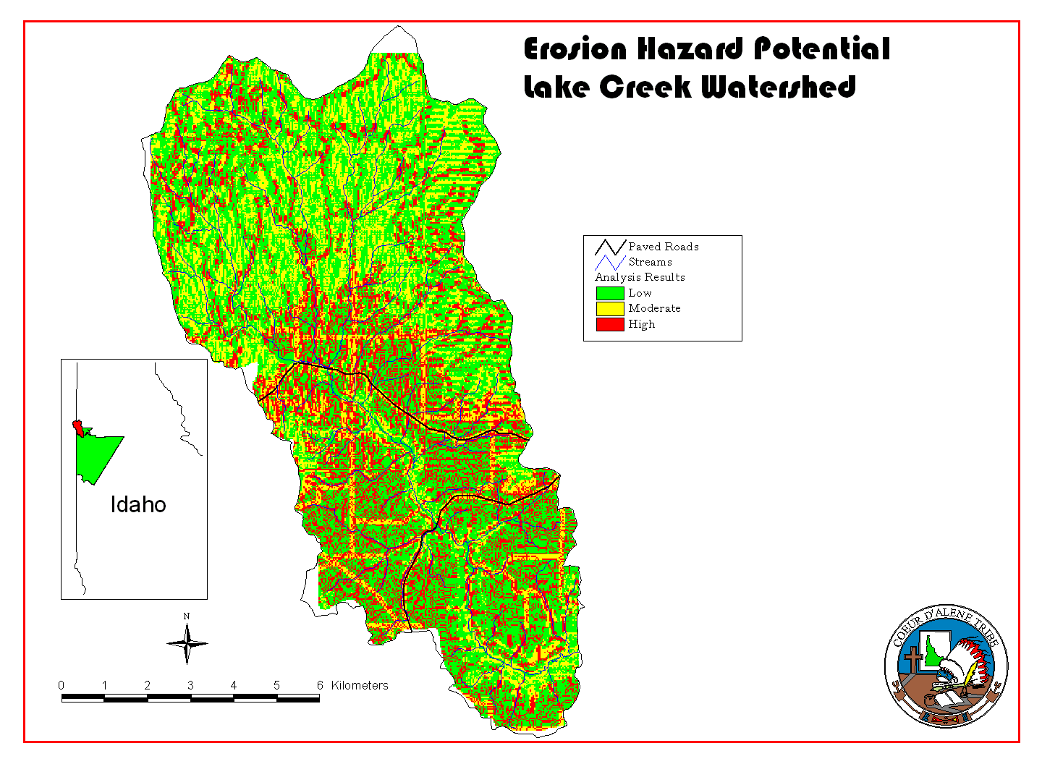

Figure 5. Location of sediment entrainment projects in relation to erosion hazard potential in the Lake Creek watershed (From: Vitale 2000).

Project Monitoring
The cumulative effects of project activities are being assessed through collection and analysis of meta-data that are being used in development of ecological indicators using aquatic macroinvertebrates, fish population assessments, and water quality trend analysis.
Benthic samples are collected from paired sites at three different locations in the target watersheds (upper, middle, and lower) in order to capture existing variation in watershed condition. Collection and analysis follows EPA Rapid Bioassessment Protocol (RBP) II of Plafkin et al. (1989) and recent revisions (Chandler and Maret 1991; Clark and Maret 1991). Similar assessments were performed in 1993 and 1994, as reported by Lillengreen et al. (1996). These previous assessments established the biological baseline information for each target watershed, which will be compared to all additional samples, as well as information from reference sites.
Sample collection takes place at three times during the year to reflect seasonal changes in population characteristics (biomass, species richness, and number of individuals). Cross channel transects are randomly selected at riffle and run habitats at each of three sites; sample sites coincide with the location of water quality monitoring stations where possible. At each transect, semi-quantitative benthic samples are taken and then composited, using a subsampling procedure that is consistent with the EPA RBPII. Samples are identified to the generic level and numerical values are calculated for each of 8 metrics using raw numerical benthic data. The following eight metrics are used: taxa richness; Hilsenhoff Biotic Index; ratio of scrapers/scrapers + filtering collectors; ratio of EPT/chironomid + EPT; percent contribution of dominant taxon; EPT index; community similarity index; and ratio of shredders/total. Calculated values can be compared to values derived from other sites in the region. Each metric is assigned a score according to the comparability (percent similarity) of calculated and reference values. Scores for the eight metrics will be totaled and compared to the total metric score for reference data. The percent comparison between the total scores provides a final evaluation of biologic condition.
Channel type delineations identified during previous surveys (Lillengreen et al. 1996) serve as the basic geomorphic units for selecting sample sites for conducting fish population surveys. In these early channel type surveys, stream reaches were classified into relatively homogeneous types according to broad geomorphological characteristics of stream morphology as defined by Rosgen (1994). Sample sites within each reach have been selected to include habitat types representative of the reach as a whole. The length of each sample unit is defined as twenty times the average stream width, with a minimum sample distance of 100 meters.
Sites are sampled in the summer to quantify the abundance and distribution of fishes during base flow conditions. Trout populations are estimated using the removal-depletion method (Seber and LeCren 1967, Zippen 1958). Blocknets are placed at the upstream and downstream boundaries to prevent immigration and emigration. Each sample site is electrofished using the standard guidelines and procedures described by Reynolds (1983) and as recommended by NMFS (1999). Fish are collected by spot shocking using a Smith-Root Type VII backpack electrofisher. Only direct current (DC) is used. Each sample session begins with pulse width and rate set to the minimum needed to capture fish. Population estimates are calculated using the equations published by Armour et. al. (1983). The population estimates are converted into density values (# fish/100 meters) for each sample site then extrapolated to the reach in which the samples were collected. The confidence intervals are converted in the same manner.
Continuous water quality monitoring is performed in the Lake Creek watershed with assistance from partnership agencies to establish trends in pollutant loading over time. Because of the high variability in storm intensity and soil conditions from year to year, effects of management in reducing pollutant loading are difficult to separate from annual hydrologic and climatic variation using pollutant loading alone. To compensate for this difficulty, pollutant concentrations are indexed to discharge by applying the standard hydrologic approach of sediment rating curves to pollutants as described by Bauer (1998). The sediment rating curve approach is based on concepts in part contained in Bestcha 1978, Brunskill et al. 1975, Farr and Clarke 1984, Ferguson 1985, Walling 1977, VanSickle 1983, Kunkle and Comer 1971, and Thomas 1985.
Two monitoring stations are set up to measure pollutants over a long-term period. Footbridges with hand railing provides access to samples flows, collect depth integrated samples, and serves as an attachment sites for an optical particle sensor. A USGS style sheet metal gage structure houses the stilling well and electronic equipment. Station components include a data logger, optical particle sensor for turbidity, pressure transducer for flow stage determination, telephone and modem for off-site data transmission, and a tipping rain gage. Conductivity and air, ground, and water temperature are included, as these measures are useful in interpreting results.
At other water quality monitoring sites, data (discharge, DO, pH, temperature, conductivity, TDS, Turbidity) are collected using a Hydrolab multiparameter water quality testing probe, HACH Model 2100P portable turbidimeter, and a Gurley Price AA digital flow meter. Water samples are collected using methods described in the Standard Methods for the Treatment of Water and Wastewater (APHA 1992) and are sent to an accredited contract laboratory for analysis of nutrients.
Implications of Restoration for Increasing Carrying Capacity
Initial attempts to quantify the effect on carrying capacity of rehabilitating physical, chemical, and biological components of stream ecosystems, has been completed for the target watersheds. The carrying capacity of the target tributaries was predicted by inputting measured habitat and water quality parameters into a Habitat Quality Index (HQI) model which was developed to predict trout standing crop in Wyoming streams (Binns and Eiserman 1979). The HQI Model II was originally used to predict trout biomass in Wyoming streams using eleven attributes: late-summer stream flow, annual stream flow variation, maximum summer water temperature, nitrate nitrogen, fish food abundance, fish food diversity, instream cover, eroding streambanks, submerged aquatic vegetation, water velocity, and stream width. The model explained 96% of the variation in trout biomass for the 36 streams from which it was developed, and 87% of the variation for 16 Wyoming streams examined in a follow-up study by Conder and Annear (1987).
Griffith (1993) reported that attempts to apply the HQI to populations of salmonids in streams outside of Wyoming have generally not been successful, citing that trout populations in different areas respond to different sets of factors. Binns and Eiserman (1979) acknowledged such weaknesses in the original model, indicating that anomalies in trout population densities caused by extremes in climatic conditions or by anthropogenic influence could cause variability in HQI predictions. They suggested that specific understanding of the life history requirements of target species would justify modifications of model variables to provide more accurate evaluations of local habitat conditions.
We felt that modifications of the attribute for maximum summer water temperature were needed to reflect the specific tolerances of westslope cutthroat trout. The original model was applied to streams that supported multiple salmonid species (including brook, brown, rainbow, and cutthroat trout) and used temperature ranges that were, in some cases, higher than the upper incipient lethal temperature reported for cutthroat trout (Behnke 1979; Behnke and Zarn 1976; Bell 1973). We modified the temperature rating characteristics of the model by using values that corresponded to 20-100% suitability on the suitability index graph published by Hickman and Raleigh (1982). In addition, we changed the lower rating characteristic for the late summer stream flow attribute to reflect the fact that tributaries on the Reservation support juvenile trout to a much greater extent than resident adults. Therefore, in our model late summer stream flows ≥8% of average annual stream flow provide at least sporadic but limited support for juvenile rearing. Data published by Hickman and Raleigh (1982) indicating 100% suitability for juvenile cutthroat residing in small streams when the average thalweg depth reaches 30 cm, seem to support this assumption.
When HQI scores (Ŷ) were plotted against the three-year mean of measured trout standing crop (Y), the scatter of data points was best fitted by the linear equation Y = 1.779 + 0.911(Ŷ) (See Figure 6). The model explained 83% of the variation in trout standing crop for 8 tributaries that were tested, and a high correlation coefficient (R = 0.915) suggested a strong relationship between HQI score and trout standing crop (See Table 9). Given the results of model predictions and in consideration of mitigating factors, we believe the HQI Model II is a reasonable predictor of cutthroat trout standing crop for Reservation streams and can be used as an indicator of juvenile carrying capacity.
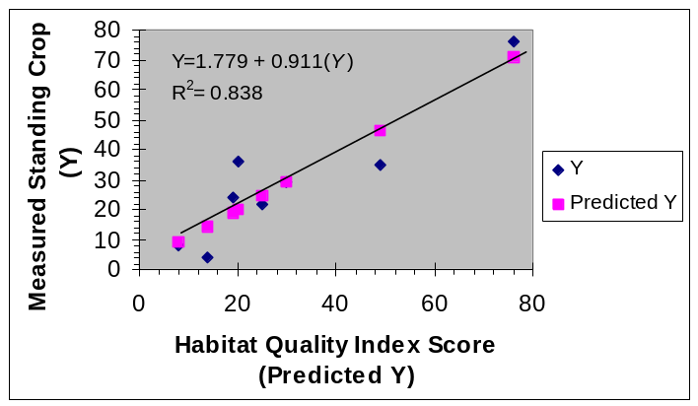
Figure 6. Relationship between HQI score and trout standing crop (kg/hectare) at 8 tributaries evaluated with HQI Model II (From: Peters et al. 2000).
The tested model was used to predict changes in carrying capacity given several projections of expected improvements in habitat quality resulting from ongoing restoration efforts. The projections correspond to 25%, 50%, 75% and 100% improvement targets as adopted into the 1995 Columbia River Basin Fish and Wildlife Program (10.8B.20). Realistic dates for these respective levels of habitat improvement have been designated as 2007, 2012, 2016 and beyond. The habitat attributes that are thought to be most responsive to restoration techniques during these time frames, and which have been manipulated during iterations of model predictions, include eroding streambanks, instream cover, fish food abundance, maximum summer water temperature, and late summer stream flow. Late summer stream flow was only manipulated in the final iteration (beyond category) of the model.
The 2007 prediction of carrying capacity constitutes a 2.4% increase in the total number of juveniles compared with current values (See Table 8). This prediction was arrived at by improving the instream cover and eroding streambank attributes by a 5% increment in all tributaries that did not receive the highest attribute rating. All other attributes were left unchanged. The 2012 prediction constitutes a 34.7% increase in the total number of juveniles compared with 1998 values (See Table 8). This prediction was arrived at by improving the instream cover and eroding streambank attributes by an additional 5% increment in all tributaries that did not receive the highest attribute rating. In addition, maximum summer water temperature was decreased by 1°C in all tributaries that exceeded 17°C. The 2016 prediction constitutes a 117.1% increase in the total number of juveniles compared with 1998 values (See Table 8). This prediction was arrived at by improving the instream cover and eroding streambank attributes by an additional 5% increment in all tributaries that did not receive the highest attribute rating. In addition, maximum summer water temperature was decreased by 1°C in all tributaries that exceeded 16.8°C.
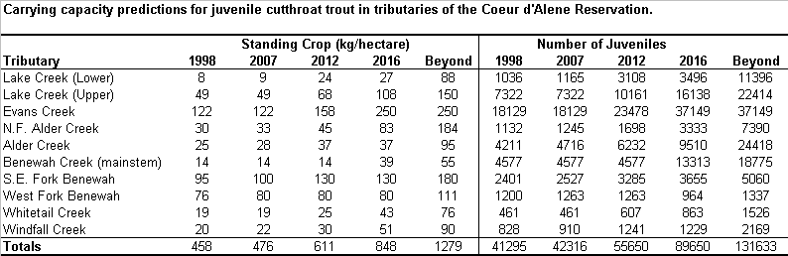
Table 8. Carrying capacity predictions for juvenile cutthroat trout in target waters (From: Peters et al. 2000).
The prediction for the “beyond” category is a best professional judgment that approximates the desired future condition for Reservation tributaries. Desired future condition is defined as being equivalent to the potential natural community. In other words, biological productivity and diversity at the landscape level is equivalent to the site potential. This concept can be described as a situation where natural aquatic ecosystem functions are similar to those in which the landscape developed and its component parts evolved, but with the recognition that a number of human-caused factors will preclude a complete return to the historical condition. However, under this scenario ecological processes (succession, natural disturbances, competition, evolution, etc.) and hydrological processes (sediment transport and deposition, flood plain storage and subsurface recharge, nutrient cycling, etc.) function in such a manner as to ensure a sustainable intact ecosystem. This prediction constitutes a 218.7% increase in the number of juveniles compared with 1998 values (See Table 8).

Adaptive Management Implications
Baseline information and on going data collection efforts help to promote an adaptive management strategy in this project. Watershed assessments, population surveys, and water quality data are used to identify high priority areas for treatment and conservation. Ongoing monitoring of demonstration projects, trout migration, habitat use, incubation success, and genetic analysis are providing data used to refine treatment priorities. Program data and objectives are shared with partnership agencies and private landowners so that a watershed based approach to habitat conservation will be encouraged.
A further example of adaptive management is found in a current project, implemented through a partnership grant that is administered by the University of Idaho, which is designed to study and develop the watershed restoration process in Lake Creek (Boll et al., 2000). The project is developing an integrated systems approach using five steps: 1) establishment of baseline conditions; 2) assessment of physical and anthropogenic processes; 3) risk analysis and definition of restoration goals and strategies; 4) implementation; and 5) evaluation of restoration achievements. Interviews and surveys of landowners and other stakeholders have been conducted to document their beliefs, attitudes and farming practices as they relate to erosion control and water quality. Integration of all disciplines and evaluation of BMP’s is helping to establish a mathematical optimization technique for restoration at the farm and watershed scales.
A graduate student research project associated with this grant is being conducted to determine the feasibility of natural flows to perform sediment maintenance. The importance of this aspect of the study is to address a key habitat issue that has not been fully addressed in the past, namely, the restoration of salmonid spawning habitat impacted by excess fine sediment at the reach scale. Preliminary analysis of discharge and bedload data suggests that the flows in the West Fork Bozard Creek (a second order tributary to Lake Creek) appear to have the ability to perform sediment maintenance. Selective or preferential transport of sand over gravel occurred at flows less than flood stage despite a narrow range in the critical shear stress of the unimodal bed sediments (See Figure 7). However, selective transport of sand at these flows may be obscured by the excessive supply of fine sediment to the reach. Equal mobility of the sediment bed and entrainment of the coarser grains occurred at the highest flows sampled, i.e. severe flooding associated with rain-on-snow. At the instrumented potential spawning gravels, entrainment of the bed surface was noted by exchange of tracers with non-tracers, though the extent of entrainment associated with the flood peak is presently unknown. Also, intrusion of fine sediments completely filled the interstitial spaces of the framework gravels and in some instances surface sealing was noted.
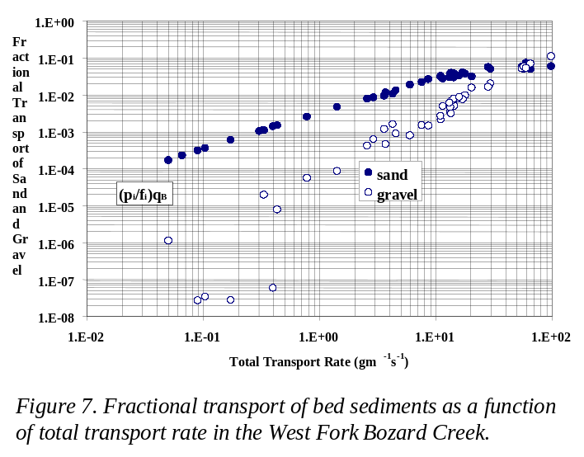
(From: Boll et al. 2000)
This ongoing research raises questions regarding the return interval for flow conditions that result in equal mobility and the potential for year class failures under these conditions. Answering these questions will be important in defining the role of supplementation in maintaining recovering fish populations. Furthermore, we hope that continued study will help refine restoration priorities by addressing the problem of excess fines. In continued analysis and modeling, the following questions will be answered: (1) what reductions in fine sediments are necessary to allow for successful cleansing of the sediment bed, and (2) what reductions in fine sediments are necessary to increase embryo survival to an acceptable level?

Table 9. Habitat Quality Index attribute measurement data, ratings and calculations for tributaries of the Coeur d’Alene Reservation, based on current conditions as of 1998 (From: Peters et al. 2000).
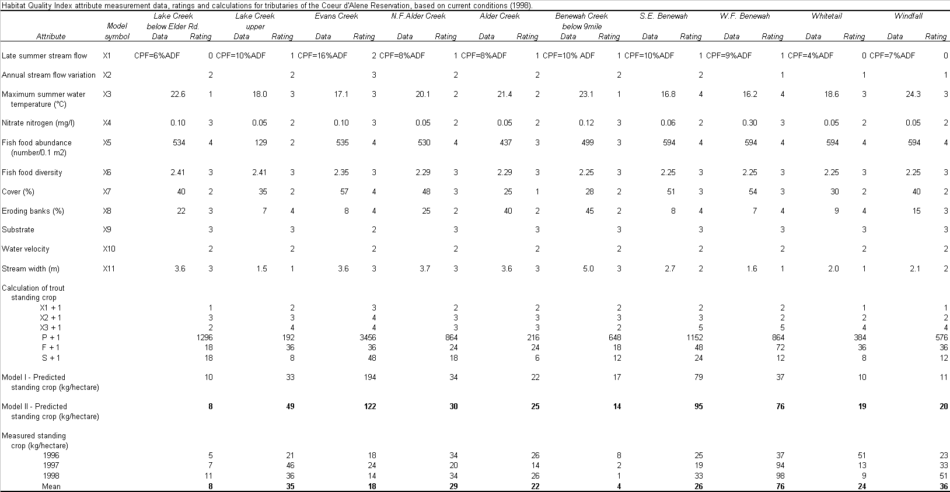

f. Proposal objectives, tasks and methods
The overall program goal is to increase production of native westslope cutthroat and bull trout by removing and mitigating the causes of habitat degradation. Quantifiable biological objectives have been developed for each target watershed and are described in the 1995 Fish and Wildlife Program [10.8B.20] (See Table 10). The tasks and methods detailed in the following section comprise the strategies adopted by this project to address limiting factors for production of westslope cutthroat trout. Expected benefits of implementation are reduced sediment loading, improved water quality and quantity, and improved riparian and instream habitat diversity in target watersheds. Education and outreach efforts will foster a conservation ethic in community members. This project will maintain long term program investments by continuing to work with private landowners on new projects in high priority areas.
Table 10. Biological objectives for wild adfluvial cutthroat trout in tributaries of the Coeur d'Alene Reservation (From:Peters et al. 2000).
Tributary | Target Levelª  (percent) | Escapement^{b}  Target | Harvest Target^{c} | Biological^{d}  Objective | Year
Alder Creek | 25 | 1,708 | 920 | 2,628 | 2007
 | 50 | 3,416 | 1,840 | 5,256 | 2012
 | 75 | 5,123 | 2,759 | 7,882 | 2016
 | 100 | 6,831 | 3,679 | 10,510 | Beyond
Benewah Creek | 25 | 2,179 | 1,174 | 3,353 | 2007
 | 50 | 4,357 | 2,347 | 6,704 | 2012
 | 75 | 6,534 | 3,519 | 10,053 | 2016
 | 100 | 8,713 | 4,692 | 13,405 | Beyond
Evans Creek | 25 | 984 | 530 | 1,514 | 2007
 | 50 | 1,968 | 1,060 | 3,028 | 2012
 | 75 | 2,951 | 1,589 | 4,540 | 2016
 | 100 | 3,935 | 2,119 | 6,054 | Beyond
Lake Creek | 25 | 2,002 | 1,078 | 3,080 | 2007
 | 50 | 4,004 | 2,156 | 6,160 | 2012
 | 75 | 6,006 | 3,234 | 9,240 | 2016
 | 100 | 8,008 | 4,312 | 12,320 | Beyond
ª Target level (percent) is defined as percent improvement over current conditions based on escapement target estimates.
^{b} Escapement target is defined as the number of adult fish needed to fully seed available spawning habitat, given the following assumptions:
- Spawning is primarily restricted to 2nd order tributaries (CDA Tribe population data, 1994-1998);
- Usable spawning habitat comprises 4.1% of the total stream area in 2nd order tributaries, when averaged across the four target watersheds (CDA Tribe habitat assessment data, 1998);
- Potential spawning gravel was defined according to Magee et al. (1996) as patches of substrate at least 0.25 m² in area with particles 2-35 mm in diameter;
- Average redd size is 0.15m² (Magee et al. 1996).
- 1:1.6 male to female spawner ratio (IDFG 1998);
- 3 redds for every 2 spawning females (Scott and Crossman 1973);
^{c} Harvest target is calculated as an exploitation rate of 35 percent.
^{d} Biological objective is the sum of escapement and harvest targets.
Scope: This project addresses habitat degradation and resulting reductions in native trout populations in the Coeur d’Alene subbasin by: 1) planning implementation projects based on limiting factor analysis and coordination with agencies and landowner groups; 2) implementing new restoration projects through lease agreements with private landowners in four target tributaries and maintaining project investments over the term of lease agreements; 3) monitoring and evaluating projects and applying adaptive management; 4) providing compensatory harvest opportunities to affected community members; and 5) integrating restoration activities into local school curriculum and coordinating activities with agencies, organizations and other Tribal programs.
Underlying Assumptions: Overgrazing of riparian areas, timber harvest, road construction and agricultural practices have led to habitat degradation and reductions in resident trout populations within target tributaries on the Coeur d’Alene Indian Reservation. Encouraging recovery of riparian and upland vegetation, improving streambank stability and instream habitat diversity will result in an overall improvement in water quality and quantity. By addressing limiting factors to juvenile rearing and adult spawning and by encouraging natural successional processes, improvements in habitat will result in an increase in carrying capacity in target tributaries.
Project Planning and Design Phase
Objective 1 – Complete advanced project planning and design.
Task 1a: Implementation activities will be pursued for stream reaches needing some level of enhancement based on physical and biological conditions and watershed assessments. Priority areas for restoration treatment have been identified in the Coeur d’Alene Tribe Project Management Plan (Lillengreen et. al. 1998). These areas occur where existing habitat conditions (e.g., average residual pool depth, average canopy cover, number of large woody debris/lineal distance, riffle/pool ratio, and average percent fines) fall short of optimal conditions for the target species as defined by habitat suitability indices (Hickman and Raleigh 1982) and where measurements of stream condition (e.g., depositional pattern, meander pattern, aggradation/degradation trends, altered channel features, etc.) indicate departure from the stream potential as described by Rosgen (1996). The concept of stream potential as used here is defined as the best channel condition, based on quantifiable morphological characteristics, for a given stream type. Seasonal, temporary violations of water quality criteria and low trout abundance are secondary indications of a need for treatment at these sites. Restoration projects will be prioritized using a cost/benefit analysis that considers the potential for long-term ecological recovery and landowner participation. In the prioritization process, it is recognized that projects that restore habitat linkages to highly productive habitats have the greatest potential for increasing the abundance and distribution of trout.
Agreements will be developed with landowners to formalize the commitments involved in implementing the activities planned for high priority areas. A generalized landowner agreement has been developed that creates a legal foundation to establish the commitments of the landowner and the Coeur d’Alene Tribe Natural Resource Department, while addressing liability issues. Several exhibits that specifically identify the location of the project and define the work to be accomplished accompany the agreement. The terms of the agreement are flexible, but have been long reaching enough (10-25 years) to ensure that monitoring and evaluation procedures can be completed. An average of three new landowner agreements have been signed each year during the period 1997 and 1999. In addition, new projects have been implemented as part of existing agreements. Landowner interest in restoration projects has increased as demonstration projects are scrutinized. We estimate that between 3-5 new agreements will be signed in FY2002.
Task 1b: Restoration designs will be developed with the expertise of program personnel and the assistance of qualified consultants, when needed. Restoration in the purest sense is often associated with returning a stream to a pristine or to predisturbance condition. Since the sediment and flow regime, as well as many other variables, have been significantly altered in the target watersheds, returning a stream to a pristine condition is often not possible. Restoration as used in the context of this proposal is associated with restoring natural function, stability and biological condition. To be done properly, restoration designs that target stream channels must take into consideration the morphological potential of the stream (Rosgen 1994, 1996; Leopold 1994; Leopold and Maddock 1953). Project designs using this geomorphological approach and natural channel design concepts will begin with an understanding of the following criteria:
- The cause of the instability or disequilibrium
Assessment of watershed and stream condition/stability
Evidence of change
- The potential and/or the morphological character of the natural stable form
Stream classification – matching the appropriate stream type to valley type
The reference reach – blueprint for the stable dimension (width, mean depth, width/depth ratio, maximum depth, floodprone area width, and entrenchment ratio); Pattern (sinuosity, meander wavelength, belt width, meander width ratio, radius of curvature); and Profile (mean water surface slope, pool/pool spacing, pool slope, riffle slope).
Evolutionary tendency, adjustment processes
Task 1c: All projects will be described and submitted to participating agencies and BPA for supplemental analysis under the watershed management program EIS prior to implementation. Past data collection efforts for the project site will be described and data gaps will be identified to facilitate implementation and effectiveness monitoring. Project specific goals and objectives that are quantifiable and measurable will be developed. These objectives will be consistent with biological objectives identified in the FWP and should facilitate the implementation of monitoring and evaluation procedures (NPPC 1994). Project implementation will be coordinated with the appropriate regulatory agencies so that all pertinent applications and permits may be obtained.
Objective 2 – Coordinate restoration and management activities with other managers
Task 2a: Meetings of an inter-agency work group will be conducted on a quarterly basis. The group is comprised of representatives from the FSA, NRCS, local conservation district offices, University of Idaho extension Office, and all Tribal Natural Resource Department Programs. The primary purposes of this group are to coordinate the management of natural resources on the Reservation and to promote education regarding land stewardship. Restoration projects developed under this proposal are peer reviewed by this planning group as a means of engendering quality control and ensuring multiple project benefits. Participation in this planning process is a critical step in applying uniform management standards in watersheds targeted by this proposal and in forming partnerships that improve the cost-effectiveness of implementation efforts.
Task 2b: Fisheries staff will participate as members of the interdisciplinary team (IDT) during development of the Tribal Integrated Resource Management Plan (IRMP). The IRMP is the first Tribal management plan that will encompass all natural resources and environmental elements on the Reservation. Goals of the project are to create a common vision for the future use and sustainability of Tribal natural, environmental and cultural resources; provide clear goals and objectives to reach the Tribe’s common vision; and coordinate the management of tribal natural, environmental and cultural resources. Direct benefit will come to the BPA project: Implement Fisheries Enhancement Opportunities through adoption of standards and guidelines for the protection of fish and wildlife resources, and through identification and remediation of conflicting management practices.
The Tribe is currently in a pre-planning phase for the project; the IDT is being formed and is in the process of finalizing a work plan. The IDT for the project will act as a policy recommending body, reporting to the Tribal Council on all matters related to the IRMP. The team members will oversee the day to day development of the plan, requesting Council approval at various points in the process. IDT members will be responsible for interacting with and overseeing work of consultants, preparing educational material for the public, and obtaining public input throughout the developmental stages of the plan. A projection of specific tasks to be accomplished, are as follows: [Year 2001] develop desired future conditions by resource category for a 50-100 year planning period (see table); document minimum management requirements, both federal and tribal; develop a tribal review process that parallels the NEPA process; develop Tribal landuse and zoning ordinances; [Year 2002-2003] develop a detailed 10 year plan with goals and objectives for each resource category; develop alternatives and an environment assessment of alternatives (adaptive management); select a preferred alternative and finalize the management plan. After completion of the plan, the IDT will continue to act as a policy body to recommend necessary revisions and oversee implementation efforts.
Task 2c: Fisheries staff will work to develop a consolidated memorandum of agreement for management of forest roads on the Reservation. Fisheries staff will work with the Tribal Forestry Program and private industrial forest landowners on the Reservation to adopt uniform standards and guidelines for the management of forest roads. Goals for management will be to limit non-point source sediment transport from the forest road network through a combination of strategies that include reconstruction and/or decommissioning of problem areas, limiting access to sensitive areas, revegetation of road cuts, and implementation of other erosion control practices.
Construction and Implementation Phase
A conceptual approach to the restoration of fish habitat has been adapted from various sources as a guide for management efforts on the Reservation (Lillengreen et al. 1998; National Research Council 1992; Kauffman et. al. 1993). The conceptual model is based on the ecological processes that shape riparian/stream ecosystems and focuses on 1) removing or modifying those land use impacts that are causing habitat degradation, 2) re-establishing riparian/stream linkages, and 3) restoring natural ecosystem processes.
The desired future condition for target watersheds has been defined as being functionally equivalent to the potential natural community. In other words, the goal is to restore those essential ecological conditions and processes necessary to maintain diverse and productive resident trout populations. This concept recognizes that a number of human-caused factors will preclude a complete return to the historical condition. However, under this scenario ecological processes (succession, natural disturbances, competition, evolution, etc.) and hydrological processes (sediment transport and deposition, flood plain storage and subsurface recharge, nutrient cycling, etc.) function in such a manner as to ensure a sustainable intact ecosystem. Such a system has the potential to support a healthy resident trout fishery.
Objective 1 – Increase Carrying Capacity in Target Tributaries
Task 1a: This program will continue to implement riparian enhancement projects as a primary means of restoring ecological function. Control of livestock utilization will be done through construction of exclusion fences and development of off-site water sources. Degraded riparian areas will be restored as needed by planting native shrubs and trees, seeding with grasses and sedges, and controlling noxious weeds. Streambank stability will be improved on a site-specific basis using bioengineering techniques. Information on planting techniques and considerations for riparian rehabilitation has been based on the work of several authors (Lambert and Boswell, 1994; Hoag, 1991; 1993; Van Haveren and Jackson, 1986; USDA, 1981).
Task 1b: This program will continue to implement projects that will restore proper function to stream channels and floodplains, provide high quality rearing areas for juvenile trout, and improve available spawning habitat for adult trout. Many of the techniques to be used have been previously compiled by Hunt (1993) and Rosgen (1996).
Rearing habitat for juvenile fish may be enhanced by increasing instream habitat diversity through placement of large woody debris (LWD), fine woody debris (FWD), boulders or other native materials. Project actions such as these will be used to address limiting factors at the reach scale and are based on a large body of peer reviewed scientific literature. LWD has long been considered an essential structural element of habitat in forested streams (Bisson et al. 1987). The addition of LWD to streams can raise fish abundance by increasing cover (e.g., Angermeier and Karr 1984; Shirvell 1990) and streambank stability (Keller and Swansan 1979). Such debris can control stream channel geometry and hydraulic diversity (Keller and Swanson 1979; Bilby 1984) and increase its storage capacity for inorganic sediments (Bilby 1981) and organic matter (Bilby and Likens 1980). FWD accumulations have been hypothesized to provide cover for fish and increase habitat complexity in a manner similar to that of large debris (Bryant 1983), as is well known to trout stream biologists. Other investigators have noted that fry were most abundant in areas that had natural accumulations of FWD consisting of branches and sticks (Beers 1990; Culp et at. 1996). Culp et al. (1996) demonstrated that FWD can increase the density and total biomass of rainbow trout fry without negatively affecting individual size and body condition.
Restoration of incised stream reaches will utilize a reference reach approach, which involves developing a template from stream types that are stable in similar valley types (Rosgen 1996). A priority system described by Rosgen (1997) uses a decision matrix that considers a range of options based on numerous factors, and will be followed when developing these types of projects (See Table 11).
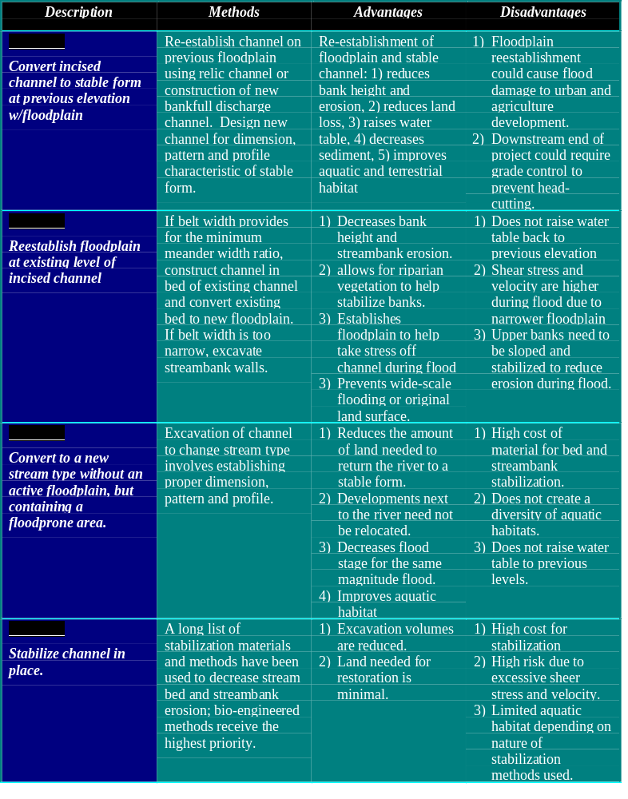Table 11. Priorities, descriptions and summary for incised river restoration (From: Rosgen 1997).
Task 1c: This program will continue to implement projects that reduce sediment mobilization and transport from upland source areas. One strategy to be employed will be the enhancement of palustrine wetlands in areas that historically supported hydric soils and wetland vegetation. Projects will consist of constructing embankment ponds, sediment basins and gully plugs that capture and store surface water runoff. Target sites have been identified using GIS technology that overlays information on drainage density, soil erosion hazard, land use and vegetative cover type, channel function, and fish abundance and distribution (Montgomery and Buffington 1993; Washington Forest Practices Board 1997). High priority sites are located at the lower end of small (>200 acres) subbasins dominated by agricultural activities that have generally been managed to promote rapid surface water runoff. Soil erosion hazard and transport at these sites is severe.
Increasing emphasis will be placed on forest road management and implementation of forest road BMP’s developed by a Tribal interdisciplinary team for adoption into the Tribal Forest Management Plan (currently being updated). Possible projects will include stabilization of roadbeds, road decommissioning, installation of gates to restrict access, revegetation, and installation of other erosion control measures.
Implementation of these projects will decrease transport of non-point source sediment from source areas to sensitive stream reaches, promote local infiltration of water, increase the diversity of native plant communities and provides habitat for wildlife. Design and implementation efforts are cost shared with EPA 319 grant monies and the local Soil Conservation District and linked to other projects that reduce non-point source pollution. Planning, design and construction activities are consistent with engineering specifications adopted by the Soil Conservation Service (USDA 1989).
Operation and Maintenance Phase
Objective 1 – Improve awareness of Program activities to encourage long-term support of restoration activities within the Reservation community.
Task 1a: A quarterly newsletter, Watershed Wrap, will be published and distributed to all landowners, tribal members, and other parties with a vested interest in habitat restoration. The newsletter focuses on educating the general public in regard to fish populations and watershed health issues specific to Reservation watersheds. Additionally, program awareness is promoted through presentations targeting civic organizations, local schools, the general public and other interested parties. Field trips will be used to showcase restoration projects. A summary of these activities will be presented in quarterly reports submitted to BPA.
Task 1b: Watershed Working Group (WWG) meetings will be conducted on a quarterly basis, or as needed to allow for project review and planning. WWG comprised of local landowners, farm operators, special interest groups and interested agencies, have been formed in two of the target watersheds. These groups are the primary method used in fostering landowner cooperation and on modifying land use practices that impact fisheries habitat. These working groups are greatly responsible for engendering public support and cooperation for ongoing restoration work. In addition the WWG help identify and solicit other sources of revenue for restoration work through interagency interaction. Minutes are kept for each meeting which include an attendance list, agenda, and summary of discussion points.
Objective 2 – Provide educational opportunities in the local schools to improve student/teacher involvement in Program activities.
Task 2a: Environmental education will focus on interaction with and integration of ongoing restoration work with area students, grades K-12. The Fish, Water and Wildlife Program will coordinate Water Awareness Week for local school districts. This event offers hands on learning stations that expose students to the scientific method, restoration techniques, and biological inventory and monitoring. Additional field trips will be held during the school year and will provide students with an opportunity to assist with monitoring at established restoration sites. A summary of these activities will be presented in quarterly reports submitted to the BPA.
Task 2b: A summer internship will be made available for high school students using funding provided by the Coeur d’Alene Tribe Education Department. Interns will assist with restoration activities, such as fencing, tree planting and monitoring, as appropriate. Interns assist with implementation of restoration projects, maintenance of a native plant nursery, and .
Monitoring and Evaluation Phase
Objective 1 – Compile physical, chemical and biological trend data in target tributaries. Trend monitoring of abiotic and biotic factors has been an ongoing component of this project. The purpose of monitoring streams on the Reservation is to obtain information for use in evaluating the responses of native westslope cutthroat populations to riparian and stream management practices. The fundamental objectives of the monitoring and evaluation program are to: 1) establish a record of mitigation for trout populations and the aquatic/riparian interface, 2) account for enhancement costs, and 3) acquire new knowledge about the physical and/or biological effects and interactions of stream enhancement measures.
Task 1a: Migration of adult and juvenile fish will be monitored in each watershed through use of a modified weir and holding pen developed after Conlin and Tuty (1979). Migration traps are maintained during peak run timing, typically from mid-March through mid-June. Individual fish are identified, weighed, measured for total length and tagged. Scale samples are collected for age determination using methods described by Jearld (1983). Data are summarized in annual reports submitted to BPA.
Task 1b: Abundance and distribution of trout species will be assessed annually at 95 sample sites within the target watersheds using collection methods and analysis techniques described in Armour (1983). Sample sites are stratified by channel type (Rosgen 1996) and by habitat unit to allow for comparisons between streams of similar size and type. Channel type delineations identified during previous surveys (Lillengreen et al. 1996) serve as the basic geomorphic units for selecting sample sites for conducting fish population surveys. In these early channel type surveys, stream reaches were classified into relatively homogeneous types according to broad geomorphological characteristics of stream morphology as defined by Rosgen (1994). Sample sites within each reach have been selected to include habitat types representative of the reach as a whole. The length of each sample unit is defined as twenty times the average stream width, with a minimum sample distance of 100 meters.
Sites are sampled in the summer to quantify the abundance and distribution of fishes during base flow conditions. Trout populations are estimated using the removal-depletion method (Seber and LeCren 1967, Zippen 1958). Blocknets are placed at the upstream and downstream boundaries to prevent immigration and emigration. Each sample site is electrofished using the standard guidelines and procedures described by Reynolds (1983) and as recommended by NMFS (1999). Fish are collected by spot shocking using a Smith-Root Type VII backpack electrofisher. Only direct current (DC) is used. Each sample session begins with pulse width and rate set to the minimum needed to capture fish.
Population estimates are calculated using the equations published by Armour et. al. (1983). The population estimates are converted into density values (# fish/100 meters) for each sample site then extrapolated to the reach in which the samples were collected. The confidence intervals are converted in the same manner. Results are summarized in annual reports submitted to BPA.
Task 1c: Benthic samples will be collected from paired sites at three different locations in selected target watersheds (upper, middle, and lower) in order to capture existing variation in watershed condition. Collection and analysis follows EPA Rapid Bioassessment Protocol (RBP) II of Plafkin et al. (1989) and recent revisions (Chandler and Maret 1991; Clark and Maret 1991). Sample collection takes place at three times during the year to reflect seasonal changes in population characteristics (biomass, species richness, and number of individuals). Cross channel transects are randomly selected at riffle and run habitats at each of three sites; sample sites coincide with the location of water quality monitoring stations where possible. At each transect, semi-quantitative benthic samples are taken and then composited, using a subsampling procedure that is consistent with the EPA RBPII. Samples are identified to the generic level and numerical values are calculated for each of 8 metrics using raw numerical benthic data. The following eight metrics are used: taxa richness; Hilsenhoff Biotic Index; ratio of scrapers/scrapers + filtering collectors; ratio of EPT/chironomid + EPT; percent contribution of dominant taxon; EPT index; community similarity index; and ratio of shredders/total.
Calculated values can be compared to values derived from other sites in the region. Each metric is assigned a score according to the comparability (percent similarity) of calculated and reference values. Scores for the eight metrics will be totaled and compared to the total metric score for reference data. The percent comparison between the total scores provides a final evaluation of biologic condition.
Task 1d: Measurements of abiotic factors (e.g. stage/discharge, temperature, dissolved oxygen, pH, conductivity, turbidity, TSS, nutrients) will be tracked at 10 sites within the target watersheds. Monitoring parameters to include discharge, DO, pH, temperature, conductivity, TDS, turbidity . Temperature is measured continuously, while other parameters are measured weekly from April through October. Data are collected using a Hydrolab multiparameter water quality testing probe, HACH Model 2100P portable turbidimeter, and a Gurley Price AA digital flow meter. Water samples are collected using methods described in the Standard Methods for the Treatment of Water and Wastewater (APHA 1992) and are sent to an accredited contract laboratory for nutrient analysis.
Continuous water quality monitoring will be performed at two additional sites in the Lake Creek watershed to establish trends in pollutant loading over time. Because of the high variability in storm intensity and soil conditions from year to year, effects of management in reducing pollutant loading are difficult to separate from annual hydrologic and climatic variation using pollutant loading alone. To compensate for this difficulty, pollutant concentrations are indexed to discharge by applying the standard hydrologic approach of sediment rating curves to pollutants as described by Bauer (1998). The sediment rating curve approach is based on concepts in part contained in Bestcha 1978, Brunskill et al. 1975, Farr and Clarke 1984, Ferguson 1985, Walling 1977, VanSickle 1983, Kunkle and Comer 1971, and Thomas 1985.
Two monitoring stations are set up to measure pollutants over a long-term period. Footbridges with hand railing provides access to samples flows, collect depth integrated samples, and serves as an attachment sites for an optical particle sensor. A USGS style sheet metal gage structure houses the stilling well and electronic equipment. Station components include a data logger, optical particle sensor for turbidity, pressure transducer for flow stage determination, telephone and modem for off-site data transmission, and a tipping rain gage. Conductivity and air, ground, and water temperature are included, as these measures are useful in interpreting results.
Task 1e: Effectiveness monitoring will be used to evaluate individual restoration projects. Techniques include: population assessments that describe habitat utilization; physical habitat assessments that describe changes to channel morphology, hydrology, and riparian function; and water quality assessments that document fluctuation in temperature and dissolved oxygen over time. Monitoring protocols are summarized in Table 12.
Photo documentation has been used at sites where specialized measurements are not needed (e.g. exclusion fencing projects). The purpose of these photographs is to show changes in riparian vegetation, such as increased canopy and shading, improved bank stability, etc. Several photopoints are established at each project site prior to implementation. Pictures are taken at these sites annually or semi-annually.
The results of monitoring efforts have been included in quarterly, annual, and semi annual reports that are published by BPA and shared with other agencies or interested parties.
Objective 2 - Evaluate relationships between large piscivorous fish and their prey in Coeur d'Alene Lake.
Task 2a: Electrofishing, netting, and beach seining techniques will be used to document changes in relative abundance and distribution of fishes. A custom-built aluminum boat equipped with a Smith Root 7.5 GPP electroshock unit is used to conduct shoreline electrofishing. Electrofishing is effective to a depth of 0 to 8 feet. Each reach is sampled at a fixed unit of effort. Captured fishes are measured for length and weight, and scale samples are taken from game and native species. Gillnetting is the primary method for sampling limnetic zones within the Lake. Two different types of nets are used for fish sampling in Coeur d'Alene Lake: vertical nets are used in areas with water depths greater than 30 feet (pelagic zones); and horizontal nets are used in areas that are transitional between littoral and pelagic zones (8-30 feet). These nets are specifically designed to sample areas that are inefficiently sampled using the electrofishing technique. Depth of capture, as well as, length, weight and age data is collected when using these methods.
Young of the year fish were missing from early sample efforts, despite the fact that these fish are conspicuous inhabitants of near shore areas. Beach seining techniques were adopted for use in littoral areas as a means of compensating for sampling biases in the electroshocking and gillnetting techniques. Beach seining is completed using a 200-foot net that is tapered from 10 feet in the middle to 4 feet on each end. The seine is set along the shoreline where water depth is 10 to 12 feet. Two pulls are completed at each sampling site. All fish are measured for total length, while length, weight and scales samples are taken for a subset of the fishes sampled.
Sampling is initiated just prior to the onset of the growing season and continues until the lake turns over in the fall, which typically marks the end of the growing season. Sampling will begin in April and end in October. We will try to capture a representative sample during the winter and apply this data to the rest of the winter season. Fish will be sampled twice along each sample reach each month in May, July, and September by electroshocking. One sample will be completed during daylight hours and one sample will be completed during the nighttime hours. Gillnetting will coincide with the electroshocking schedule. Beach seining will occur in April, June, August and October. Each transect will have one site that will be receive two pulls it will be sampled once during the day and once at night.
Data will be compiled on an electronic data logger and downloaded at the end of each sampling effort. Data will be summarized in an annual report and submitted to BPA for publication.
Task 2b: Mapping of physical habitat characteristics is proposed for littoral areas to allow for correlation of abundance and distribution data with attributes of depth, cover, and macrophyte community characteristics. Survey transects will be subdivided into 1-meter grids and grids will be randomly selected for detailed sampling to achieve statistical confidence. A team of two divers will collect mapping attributes. Data will be collected on cover provided by overhanging shoreline vegetation, species composition of macrophyte community, percent substrate covered by submerged aquatic macrophytes, water depth, slope and orientation of lake bed, substrate composition, and other predominant features that may affect species distribution.
Task 2c: Measurements of water quality parameters and productivity will be tracked at 13 sites within the Lake. Monitoring parameters include DO, pH, temperature, conductivity, TDS, turbidity, nutrients, metals, chlorophyll_{a}, and plankton. Data are collected using a Hydrolab multiparameter water quality testing probe, a HACH Model 2100P portable turbidimeter, and a secchi disk. Instrumentation will be calibrated prior to each use according to manufacturers specifications outlined in the operating manual. A calibration log will be kept in order to verify that calibration procedures were completed. In addition, calibrations will be verified on a monthly basis using scientific grade reference solutions.
Water samples will be collected using methods described in the Standard Methods for the Treatment of Water and Wastewater (APHA, 1992). Analyses of samples of this type will be conducted by an accredited (either state or EPA certification) contract laboratory (e.g. Spokane Tribal Laboratory). Composite water samples will be taken in the epilimnion and hypolimnion at each site. The epilimnion sample is taken 1m below the surface and 1m below the secchi reading. The hypolimnion sample is taken 1m above the lake bottom and 1m below the thermocline. All water samples are put on ice and are delivered to a contract laboratory the same day that they are collected. All samples will follow strict chain of custody procedures as outlined in section 1060.B.: Chain of custody procedures (APHA, 1992).
Composite metal samples will be taken in the epilimnion and hypolimnion as described above in the water collection methods. Metal samples are preserved by acidification to 2% HNO₃ as soon as possible after the collection is taken. Metals will be analyzed using EPA method 200.7 Inductive coupled plasma. The following trace elements were analyzed: zinc, silica, antimony, barium, beryllium, magnesium, arsenic, sodium, aluminum, calcium, copper, silver, lead, cadmium, cobalt, nickel, manganese, iron, chromium (Peters et. al., 1998).
Nutrient water samples will be taken as described in the water collection methods. Nutrients will be analyzed using EPA method 300.0 Ion chromatography. Ions sampled are chloride, fluoride, nitrate, nitrite, ortho-phosphate, and sulfate. Total Kjeldahl Nitrogen water samples will be taken as described in the water collection methods. Organic nitrogen is defined functionally as organically bound nitrogen in the tri-negative oxidation state. Analytically, organic nitrogen and ammonia can be determined together and have been referred to as “kjeldahl nitrogen, a term that reflects the technique used in their determination (APHA, 1992). Total kjeldahl nitrogen will be analyzed using standard method 4500-N_{org}B by a qualified laboratory. Total Phosphate water samples will be taken as described in the water collection methods. Phosphorus is essential to the growth of organisms and can be the nutrient that limits the primary productivity. Total phosphate measures the amount of orthophosphate, condensed phosphate and organically bound phosphate in the system. Orthophosphates applied to agricultural or residential cultivated land as fertilizers are carried into surface waters with storm run off and to a lesser extent melting snow. Small amounts of certain condensed phosphates are added to some water supplies during treatment and laundry detergents may also have condensed phosphates. Organic phosphates are formed primarily by biological (APHA, 1992). Total phosphate will be analyzed using EPA method 200.7 Inductively Coupled Plasma by a qualified laboratory.
Chlorophyll_{a} water samples will be taken as described in the water collection methods. Chlorophyll_{a} is the pigment aquatic plants use for photosynthesis. Chlorophyll_{a} samples allow us to measure algae abundance. Determination of chlorophyll_{a} will be by Standard Method 10200.H Spectrophotometric by a contract laboratory.
Phytoplankton and zooplankton will be collected using a turtox plankton net. The net size is 200mm at the mouth X 890mm long with an aperture size of 80μm. A 125mL plastic bottle will be placed on the end of the net to collect the samples. Samples will consist of near shore and limnetic tows. Samples will be preserved using 10% Lugols. Samples will be sent to a certified laboratory for identification.
All lake sites will be sampled for hydrolab parameters (dissolved oxygen, temperature, pH and conductivity) on a bi-weekly basis March 1 - October 30 and on a monthly basis November 1 - February 28 except when ice covered. Secchi disk sampling will be completed concurrently with hydrolab sampling. Nutrients, Turbidity, TSS, TKN, and TP will be sampled monthly from March 1 – October 30 (eight times) and once November 1 – February 28.
Data will be compiled on an electronic datalogger and downloaded into a Microsoft Excel spreadsheet. Data will be summarized in an annual report and submitted to BPA for publication.

Table 12. Summary of restoration monitoring attributes, parameters and protocols (From: Coeur d’Alene Tribe project management plan: enhancement of resident fish resources within the Coeur d’Alene Indian Reservation; Lillengreen et al. 1998).
Attribute | Parameter/  Protocol | Frequency (time/year) | Collection Time  (hours/site) | Comments | Equipment | Lab Costs*  ($/sample) | Expertise**
I. Water Column  a. Temperature | Min/Max Thermometers | 6-10 during summer | <1 | Good for initial evaluation. | Min/Max  Thermometers | None | F: Technician  A: Fisheries/  Hydrology
 | Recording Thermograph | Continuous during summer | 1-2 | Provides a complete data record. | Recording  Thermograph | None | F: Technician  A: Fisheries/  Hydrology
b. Shade | Canopy Density/  Densiometer  Platts et al. (1987) | 1 | 2-4 | Applies to streams with woody vegetation | Densiometer | None | F: Technician  A: Fisheries/  Hydrology
 | Solar Heat Input/  Solar Pathfinder  Platts et al. (1987) | 1 | 4-8 | Limited to small and medium streams | Solar Pathfinder | None | F: Technician  A: Fisheries/  Hydrology
c. Nutrients | T. Phosphorus, T Nitrates  Standard Methods  APHA (1992) | Twice/Month or  Flow dependent | <1 | Flow dependent- requires frequent sampling | Grab samples or automatic samplers | $30-$50 | F: Technician  A: Fisheries/  Water Quality
d. Fecal Bacteria | Fecal Coliform, Fecal Strep.  Standard Methods  APHA (1992) | Twice/Month or dependent on objectives | <1 | Flow dependent when associated with bottom sediments | Grab samples | $10-$20 | F: Technician  A: Water Quality
II. Stream Channel/ Streambank  a. Channel Morphology | Channel Cross Section  Rod and Level or  Sag Tape Methods  Platts et al. (1987) | 1 | 4-8 | Bankfull level may be difficult to locate. | Rod and level | None | F: Technician  A: Hydrology
 | Width/Depth ratio  Platts (1983) – 3 point method | 1 | 2-4 | Water width and depth vary within season | Tape and rod | None | F: Technician  A: Technician
b. Streambank Stability | Streambank Soil Alteration and Stability Rating  Platts et. al. (1987) | 1 | 1-2 | Soil alteration measures false, broken, or eroding banks. Bank stability rates bank protective cover. | Tape | None | F: Technician  A: Fisheries/  Hydrology
Attribute | Parameter/  Protocol | Frequency (time/year) | Collection Time  (hours/site) | Comments | Equipment | Lab Costs*  ($/sample) | Expertise**
 | Streambank Cover and Stability Rating (bank length)  USDA Forest Service (1992) | 1 | 1-2 | Uses simplified rating of cover and stability. | Tape or rod | None | F: Technician  A: Hydology/  Fisheries
c. Substrate Sedimentation | Particle Size Distribution- Percent Fines  Pebble Count  Wolman (1954) | 1 | 1 | Estimates percent of substreate surface area covered by fines. | Rulers | None | F: Technician  A: Hydrology/  Fisheries
 | Percent Surface Fines  Grid Method | 1 | 2-4 | Requires numerous plots to assess spatial variability. | Metal or plexiglass grid | None | F: Technician  A: Hydrology/  Fisheries
 | Cobble Embeddedness Skille and King (1989) | 1 | 4-8 | Use is limited by high variability. | Hoop and scale | None | F: Technician  A: Hydrology/  Fisheries
d. Pool Quality | Pool Quality Rating  Platts et al. (1983, 1987) | 1 | <1 | Rates pool quality according to depth and cover. | Measuring rod | None | F: Fisheries  A: Fisheries
 | Pool Quality Rating  USDA Forest Service (1992) | 1 | <1 | Rates pool quality on depth, substrate and cover. | Measuring rod | None | F: Fisheries  A: Fisheries
e. Vegetative Overhang | Vegetative Overhang (at transect)  Platts et al. (1987) | 1 | <1 | Measures length of overhang at each point transect. | Measuring rod and tape | None | F: Technician  A: Hydrology/  Fisheries
 | Vegetative Overhang (bank length)  USDA Forest Service (1992) | 1 | <1 | Measures length of overhang at each point transect. | Measuring rod and tape | None | F: Technician  A: Hydrology/  Fisheries
f. Streambank Undercut | Streambank Undercut (at transect)  Platts et al. (1987) | 1 | <1 | Measures depth of undercut at each point transect. | Measuring rod | None | F: Technician  A: Hydrology/  Fisheries
 | Streambank Undercut (bank length)  USDA Forest Service (1992) | 1 | <1 | Measures length of bank with undercuts. | Measuring rod and tape | None | F: Technician  A: Hydrology/  Fisheries
Attribute | Parameter/  Protocol | Frequency (time/year) | Collection Time  (hours/site) | Comments | Equipment | Lab Costs*  ($/sample) | Expertise**
III. Streambank Vegetation  a. Vegetative Composition | Green Line Survey  USDA Forest Service (1992) | 1 | 1-2 | Measures length of vegetation community types. | Measuring tape | None | F: Botany  A: Botany/  Fisheries
b. Woody Species Regeneration | Woody Species Regeneration  USDA Forest Service (1992) | 1 | 1-4 | Measures number of woody plants by age class. | Measuring tape and 2 meter rod | None | F: Technician  A: Botany/Range  Fisheries
c. Vegetative Utilization | Herbage Stubble Height  Cook & Stubbendieck (1986) | 1-3 depending on objective | 1 | Measured on top of bank after grazing and plant growth. | Pacing or measuring tape | None | F: Botany/Range  A: Botany/Range
 | Herbage Biomass Utilization  Cage method  Cook & Stubbendieck (1986) | 1-3 depending on objective | 1-2 | Compares grazed plot to ungrazed plot. | Cage, hoop, clippers, weighing scales | None | F: Technician  A: Botany/Range
 | Woody Species Utilization Twig count  Cook & Stubbendieck (1986) | 1 | <1 | Measures percent of twigs browsed. | 2 meter rod | None | F: Technician  A: Botany/Range
IV. Biological Evaluation  a. Macroinvertebrate | Macroinvertebrate Community  Plafkin et al. (1989) Protocol III | 1 (or seasonal) | 1-3 | RBP protocols are being locally refined. | Sampler, sieve, alcohol | $75 - $90 | F: Technician  A: Entomology
b. Fish Community | Fish Communities  Plafkin et al. (1989) Protocol V | 1 (or seasonal) | 1-5 | RBP protocols are being locally refined. | Electrofishing unit, nets, weighing scales | None | F: Fisheries  A: Fisheries
* Cost per sample is based on 1990 economic valuation.
** Expertise is described for collection of data in the field, as well as for data analysis.
Expected Results: This project ensures that streams and associated native plant communities are allowed to evolve through natural stages of succession. Planting native plant species and implementing best management practices for controlling soil erosion reclaims degraded riparian and upland habitats. Near term changes (1-5 years) in target streams include: increases in sedges, grasses, forbs and shrubs; narrowing and deepening of stream channels; and increased habitat diversity. Long term changes (>5 years) include: increased shading of stream channels through overstory development; reduced summer water temperatures; increased base flows; reduced sediment recruitment and streambank erosion; and increased instream and riparian habitat diversity. Increased large woody debris recruitment and pool development will occur naturally as late succession plant communities develop.
Improvement of the quality and quantity of spawning and rearing habitat for native westslope cutthroat and bull trout will result from restoration techniques. Increases in natural production should occur. This project will also provide multiple benefits for wildlife as well. Benefits to participating landowners include reduced soil loss, increased soil productivity, better pasture management, etc. Feedback from landowners on existing projects indicate that the majority have recognized improvements in the project sites and are willing to continue maintenance beyond the terms of the effective agreements.
Factors that may limit success of this project include the response of private landowners to restoration practices, catastrophic natural events, changes in upslope management practices, or changes in land use regulations. Regardless of the outcome for target species, project results will be generally beneficial to all other stream and riparian dependent native species.

g. Facilities and equipment
The personnel required for this proposal will be housed in the existing Coeur d'Alene Tribe Fish and Wildlife Program office. The following is a list of equipment that will be used but is by no means comprehensive.
- Smithroot Backpack Electroshocker Model 12-B Pow 400 Watt.
- Trimble Navigation GPS Pathfinder Basic Plus.
- Juniper Systems Pro 2000 and 4000 Field Computers.
- Gurley Model 1100 Digital Flow Meter.
- Minisonde Water Quality Multiprobes.
- Hydrolab Water Quality Multiparameter Water Quality Monitoring Instrument.
- HACH Model 2100P Trubidimeter.
- Ryan Temperature Monitors Model RL100.
- GSA Vehicles
- Pentium II Computer

h. References

Reference (include web address if available online) | Submitted w/form (y/n)
Allendorf, F.W. and S.R. Phelps. 1981. Use of allelic frequencies to describe population structure. Canadian Journal of Fisheries and Aquatic Sciences 38:1507-1514.
American Public Health Association. 1992. Standard methods for the examination of water and wastewater, 18th ed., American Public Health Association, Washington, D.C.
Angermeier, P.L. and J.R. Karr. 1984. Relationships between woody debris and fish ahabitat in a small warmwater stream. Transactions of the American Fisheries Society 113:716-726.
Armour, C.L., K.P. Burnham, and W.S. Platts. 1983. Field methods and statistical analyses for monitoring small salmonid streams. USDI, Fish and Wildlife Service, FWS/OBS 83/33. Washington, D.C. | N
Bauer, S.B. 1998. Lake Creek 1996 interim monitoring report, Kootenai County, Idaho. Kootenai-Shoshone Soil Conservation District, Coeur d’Alene, Idaho. 27p.
Beers, C.E. 1990. Effect of density, microhabitat and food on growth and survival of rainbow trout fry, Oncorhynchus myikss (Richardson). Master’s thesis. University of Calgary, Calgary, Alberta.
Behnke, R.J. and R.L. Wallace. 1986. A systematic review of the cutthroat trout, Salmo clarki Richardson, a polytypic species. Pages 1-27 in J.S. Griffith, editor. The ecology and management of interior stocks of cutthroat trout. Special Publication of the Western Division, American Fisheries Society.
Behnke, R.J. 1979. Monograph of the native trouts of the genus Salmo of western North America. Rep. prepared for U.S. Fish and Wildlife Service, Region 6, Denver, CO. 215pp.
Behnke, R.J. and M. Zarn. 1976. Biology and management of threatened and endangered western trout. U.S. Forest Service General Technical Report RM-28. 45pp.
Bell, M.C. 1973. Fisheries handbook of engineering requirements and biological criteria. U.S. Army Corps Eng., North Pacific Division, Contract DACW57-68-C-0086. 92pp.
Beschta, R.L. 1978. Long-term patterns of sediment production following road construction and logging in the Oregon coast range. Water Resources Research 14(6):1011-1016.
Beschta, R.L., W.S. Platts, and B. Kaufman. 1991. Field review of fish habitat improvement projects in the Grande Ronde and John Day River basin of Eastern Oregon.
Bilby, R.E. 1984. Post-logging removal of woody debris affects stream channel stability. Journal of forestry 82:609-613.
Bilby, R.E. 1981. Role of organic debris dams in regulating the export of dissolved and particulate matter from a forested watershed. Ecology 62:1234-1243.
Bilby, R.E. and G.E. Likens. 1980. Importance of organic debris dams in the structure and function of stream ecosystems. Ecology 61:1107-1113.
Binns, N.A. and F.M. Eiserman. 1979. Quantification of fluvial trout habitat in Wyoming. Transactions of the American Fisheries Society 108:215-228.
Bisson, P.A. and eight coauthors. 1987. Large woody debris in forested streams in the Pacific Northwest: past, present, and future. Pages 143-190 in E.O. Salo and T.W. Cundy, editors. Streamside management: forestry and fishery interactions. University of Washington, Seattle.
Bisson, P.A., J.L. Nielsen, R.A. Palmason, and L.E. Grove. 1981. A system of naming habitat types in small streams, with examples of habitat utilization by salmonids during low streamflow. American Fisheries Society Symposium, Portland, OR.
Boll, J., D. van Buren, C.R. Campbell, E. Brooks, S. Chen, C. Stockle, D. McCool and D. Feichtinger. 2000. Distributed Modeling and Economic Analysis of Erosion in GIS for Watershed Restoration. To be presented at the Integrated Decision-Making for Watershed Restoration Symposium, Chevy Chase, Maryland, January 7-9, 2001.
Boussa, M.F. 1954. Relationship between trout populations and cover on a small stream. Journal of Wildlife Management 18:229-239.
Brunskill, G.J., P.C. Campbell, S.E.M. Elliot, B.W. Graham, W.J. Dentry, and R. Wagerman. 1975. The chemistry, minerology, and rates of transport of sediment in the MacKenzie and Porcupine River watersheds. Tech. Rep 546. Fisheries and Marine Service Environment, Canada. Winipeg, Manitoba.
Bryant, M.D. 1983. The role and management of woody debris in west coast salmonid nursery streams. North American Journal of Fisheries Management 3:322-330.
Bustard, D.R. and D.W. Narver. 1975. Aspects of the winter ecology of juvenile coho salmon (Oncorhynchus kisutch) and steelhead trout (Salmo gairdneri). Journal of the Fisheries Research Board of Canada 32:667-680.
Chandler, G.L. and T.R. Maret. 1991. Protocols for assessment of biotic integrity (fish) in Idaho streams. Water Quality Monitoring Protocols-Report6. Idaho Dept. of Health and Welfare, Division Of Environmental Quality. Boise, Idaho. 7pp. | N
Clark, W.H. and T.R. Maret. 1991. Protocols for assessment of biotic integrity (macroinvertebrates) in Idaho streams. Water Quality Monitoring Protocols-Report6. Idaho Dept. of Health and Welfare, Division Of Environmental Quality. Boise, Idaho. 7pp.
Coeur d’Alene Tribe and others. 2000. Coeur d’Alene Subbasin Summary. Columbia Basin Fish and Wildlife Authority, Portland, Oregon. 94p. www.cbfwf.org | N
Coeur d’Alene Tribe. 2000. Environmental Action Plan (EAP) project assessment of environmental concerns on and near the Coeur d’Alene Reservation. Volume 1, Executive Summary. Coeur d’Alene Tribe, Plummer, Idaho. 182p.
Coeur d’Alene Tribe. 1998. Lake Creek watershed assessment. U.S. Environmental Protection Agency. 27p.
Conlin, K. and B.D. Tutty. 1979. Juvenile salmon field trapping manual. Dept. of Fisheries and Oceans, Fisheries and Marine Service Resource Services Branch, Habitat Protection Division, Vancouver, B.C. 136 pp.
Cook, C.W. and J. Stubbendieck. 1986. Range Research: Basic principles and techniques. Society for Range Management. Denver, CO.
Crowder, L.B., and W.E. Cooper. 1982. Habitat structural complexity and the interaction between bluegills and their prey. Ecology 63:1802-1813.
Culp, J.M., G.J. Scrimgeour, and G.D. Townsend. 1996. Simulated fine woody debris accumulations in a stream increase rainbow trout fry abundance. Transactions of the American Fisheries Society 125: 472-479.
Ellis, M.N. 1932. Pollution of the Coeur d'Alene River and adjacent waters by mine wastes. U.S. Bureau of Fisheries. Mimeo Report. 55p.
Fajen, O.F. and R.E. Wehnes. 1981. Missouri’s method of evaluating stream habitat. In: Armantrout (ed.), Acquisition and Utilization of Aquatic Habitat Inventory Information. American Fisheries Society, Portland, Oregon.
Farr, I.S. and R.T. Clarke. 1984. Reliability of suspended load estimates in chalk stream. Arch. Hydrobiol. 102(1):1-19.
Fausch, K.D. 1984. Profitable stream positions for salmonids: relating specific growth rate to net energy gain. Canadian Journal of Zoology 62:441-451.
Ferguson, R.I. 1985. Accuracy and precision of methods for estimating river loads. Earth Surface Processes and Landforms 12:95-104.
Funk, W.H., Rabe, F.W., and Filby, Royston. 1973. The biological impact of combined metallic and organic pollution in the Coeur d'Alene-Spokane River drainage system. Water and Energy Resources Research Institute. Moscow, Idaho. 202p.
Graves, S., K.L. Lillengreen, D.C. Johnson, and A.T. Scholz. 1992. Fisheries habitat evaluations on tributaries of the Coeur d’Alene Indian Reservation: Annual report 1990. U.S. Department of Energy, Bonneville Power Administration, Portland, Oregon. Project Number 90-044
Griffith, J.S. 1993. Coldwater streams. Pages 405-425 In: C.C. Kohler and W.A. Hubert, editors. Inland fisheries management in North America. American Fisheries Society, Bethesda, Maryland.
Hartman, G.F. 1965. The role of behavior in the ecology and interactions of underlying coho salmon (Oncorhynchus kisutch) and steelhead trout (Salmo gairdneri). Journal of the Fisheries Research Board of Canada 22:1035-1081.
Hickman, T. and R.F. Raleigh. 1982. Habitat suitability index models: Cutthroat trout. USDI Fish and Wildlife Service. FWS\OBS-82\10.5. 38p.
Hoag, J.C. 1993. How to plant willows and cottonwoods for riparian rehabilitation. In: Proceedings-Streambank Stabilization Workshop: Bioengineering Techniques. Pendleton, OR, February, 1995.
Hoag, J.C., G.L. Young, and J.L. Gibbs. 1991. Planting techniques for vegetating riparian areas from the Aberdeen Plant Materials Center. Paper presented at The 45th Annual Meeting of the Society for Range Management, Spokane, WA. 6pp.
Hodgson, T. 1998. Historical Tour of the Benewah Valley. Benewah Valley Association. Benewah, ID.
Hunt, R.L. 1993. Trout Stream Therapy. University of Wisconsin Press, Madison, Wisconsin. 74 pp.
Huntingford, F.A., N.B. Metcalfe, and J.E. Thorpe. 1988. Choice of feeding station in Atlantic salmon, Salmo salar, parr: effects of predation risk, season and life history strategy. Journal of Fish Biology 33:187-211.
IDFG. 1998. Letter to USFWS Regarding petition to list westslope cutthroat trout as threatened under the endangered species act.
IDFG. 1996. Fisheries Management Plan, 1996-2000. Idaho Department of Fish and Game, Boise, ID. | N
Jearld, T. 1983. Age determination. In: Nielsen, L.A. and D.L. Johnson (eds.), Fisheries Techniques. American Fisheries Society, Bethesda, MD. 468p.
Kappesser, G. 1992. Riffle Armor Stability Index. Version 4.1. USDA, Forest Service. 7p. | N
Kauffman, J.B., R.L. Beschta, and W.S. Platts. 1993. Fish habitat improvement projects in the Fifteenmile Creek and Trout Creek basins of Central Oregon: field review and management recommendations. USDE, Bonneville Power Administration, Portland, Oregon.
Keller, E.A. and F.J. Swanson. 1979. Effects of large organic material on channel form and fluvial processes. Earth Surface Processes 4:361-380.
Knudsen, K.L. and P. Spruell. 1999. Genetic analysis of westslope cutthroat trout in tributaries of Coeur d’Alene Lake. Coeur d’Alene Tribe Fisheries Program, Final Report WTSGL99-106, Plummer, Idaho.
Kootenai-Shoshone Soil Conservation District. 1991. Agricultural pollution abatement plan, Lake Creek watershed. Final Planning Report. USDA Soil Conservation Service, Coeur d’Alene, Idaho.
Kunkle, S.H. and G.H. Comer. 1971. Estimating suspended sediment concentration in streams by turbidity measurements. J. Soil and Water Conservation. Jan-Feb: pages 18-20.
Lambert, S.M., and M. Boswell. 1994. Selecting, preparing, and handling native plant materials. In: Proceedings-Streambank Stabilization Workshop: Bioengineering Techniques. Pendleton, OR, February, 1995.
Leopold, L.B. 1994. A view of the river. Harvard University Press, Cambridge, Mass. 298 pp. | N
Leopold, L.B. and T. Maddock. 1953. The hydraulic geometry of stream channels and some physiographic implications. U.S. Geological Survey Prof. Paper 252. U.S. Government Printing Office, Washington, D.C.
Lillengreen, K., A.J. Vitale, R. Peters. 1996. Fisheries habitat evaluation on tributaries of the Coeur d’Alene Indian Reservation: 1993, 1994 Annual Report. U.S. Department of Energy, Bonneville Power Administration, Portland, Oregon. Project Number 90-044. www.efw.bpa.gov
Lillengreen, K.L., A.J. Vitale, R. Peters. 1998. Coeur d’Alene Tribe project management plan: enhancement of resident fish resources within the Coeur d’Alene Indian Reservation. Bonneville Power Administration, Project Number 90-044, Portland, Oregon.
Lillengreen, K.L., D.C. Johnson, and A.T. Scholz. 1993. Fisheries habitat evaluations on tributaries of the Coeur d’Alene Indian Reservation: Annual report 1991. U.S. Department of Energy, Bonneville Power Administration, Portland, Oregon. Project Number 90-044
Lillengreen, K.L., T. Skillingstad, and A.T. Scholz. 1994. Fisheries habitat evaluations on tributaries of the Coeur d’Alene Indian Reservation: Annual report 1992. U.S. Department of Energy, Bonneville Power Administration, Portland, Oregon. Project Number 90-044
Magee, J.P, T.E. McMahon, and R.F. Thurow. 1996. Spatial variation in spawning habitat of cutthroat trout in a sediment-rich stream basin. Transactions of the American Fisheries Society 126:768-779.
Mallet, J. 1969. The Coeur d’Alene Lake fishery. Idaho Wildlife Review. May-June, 1969. 3-6p.
Mallet, J. 1968. Coeur d’Alene Lake fisheries investigations. Idaho Dept. of Fish and Game. 3-6 pp.
Montgomery, D.R. and J.M. Buffington. 1993. Channel classification, prediction of channel response, and assessment of channel condition. Wash. Dpt. Nat. Res. Rep. TFW-SH10-93-002. Olympia, WA. 86p.
National Research Council (NRC). 1992. Restoration of aquatic ecosystems: science, technology, and public policy. National Academy Press, Washington, DC.
National Marine Fisheries Service. 1999. Suggested protocol for the use of backpack electrofishing equipment in water containing fish listed under the Endangered Species Act (ESA). Letter.
Northwest Power Planning Council. 1994. Columbia River Basin Fish and Wildlife Plan.
Northwest Power Planning Council. 1995 Ammendment. Columbia River Basin Fish and Wildlife Plan.
Oien, W.E. 1957. A pre-logging inventory of four trout streams in northern Idaho. M.S. Thesis. University of Idaho. Moscow, Idaho. 92p.
Peters, R., A.J. Vitale, and K.L. Lillengreen. 1999. Supplementation Feasibility Report. U.S. Department of Energy, Bonneville Power Administration. Project Number 90-044. www.efw.bpa.gov
Peters, R., K.L. Lillengreen and A.J. Vitale. 2000. Coeur d’Alene Tribe Trout Production Master Plan. U.S. Department of Energy, Bonneville Power Administration, Portland, Oregon. Project Number 90-044. www.efw.bpa.gov
Peters, R. 1999. Coeur d'Alene Tribe Fisheries Program. Presented at the Idaho Academy of Sciences annual conference.
Peters, R.L. and A.J. Vitale. 1999. Stock Assessment of westslope cutthroat trout on the Coeur d’Alene Reservation. Technical Report. Coeur d’Alene Tribe, Fisheries Program, Plummer, Idaho.
Pfancuch, D.J. 1975. Stream reach inventory and channel stability evaluation. USDA, Forest Service. 15p.
Plafkin, J.L., M. Barbour, K. Porter, S. Gross, and R. Hughes. 1989. Rapid bioassessment protocols for use in streams and rivers: benthic macroinvertebrates and fish. EPA Report 444/4-89-001, Washington, D.C.
Platts, W.S. 1990. Managing fisheries and wildlife on rangelands grazed by livestock. Nevada Department of Fish and Wildlife.
Platts, W.S. and R.L. Nelson. 1989. Stream canopy and its relationship to salmonid biomass in the Intermountain west. North American Journal of Fisheries Management 9:446-457.
Platts, W.S., and 12 coauthors. 1987. Methods for evaluating riparian habitats with applications to management. USDA Forest Service, General Technical Report, INT-221. 177 pp.
Platts, W.S., W.F. Megahan, and G.W. Minshall. 1983. Methods for evaluating stream, riparian, and biotic conditions. U.S. Forest Service General Technical Report INT-138.
Reynolds, J.B. 1983. Electrofishing. In: Nielsen, L.A. and D.L. Johnson (eds.), Fisheries Techniques. American Fisheries Society, Bethesda, MD. 468p.
Rieman, B.E. and J.D. McIntyre. 1993. Demographic and habitat requirements for conservation of bull trout. USDA Forest Service, General Technical Report INT-302, Ogden, UT.
Reiman, B.E. and K.A. Apperson. 1989. Status and analysis of salmonid fisheries: Westslope cutthroat trout synopsis and analysis of fishery information. Idaho Dept. of Fish and Game, Job Performance Report, Project F-73-R-11. Boise, Idaho.
Rieman, B.E. 1980. Coeur d'Alene Lake limnology: Idaho Department of Fish and Game, Lake and Reservoir Investigations, Job Performance Report F-72-R-2. 27-68p.
Rosgen, D.L. 1994. Classification of natural rivers. Catena 22:169-199.
Rosgen, D.L. 1996. Applied river morphology. Wildland Hydrology, Pagosa Springs, CO. 246 pp.
Rosgen, D.L. 1997. A geomorphological approach to restoration of incised rivers. In: S.S.Y. Wang, E.J. Langendoen and F.D. Shields, Jr. (eds.), Proceedings of the Conference on Management of Landscapes Disturbed by Channel Incision.
Seber, G.A.F., and E.D. LeCren. 1967. Estimating population parameters from catches large relative to the population. Journal Animal Ecology 36:631-643.
Scholz, A. T., and 9 coauthors. 1985. Compilation of information on salmon and steelhead total run size, catch and hydropower related losses in the upper Columbia River Basin, above Grand Coulee Dam. Fisheries Technical Report No. 2, UCUT. Cheney, WA
Scott, W.B., and E.J. Crossman. 1973. Freshwater fishes of Canada. Fisheries Research Board of Canada, Ottawa. Bulletin 184. 966p.
Shirvell, C.S. 1990. Role of instream rootwads as juvenile coho salmon (Oncorhynchus kisutch) and steelhead trout (O. mykiss) cover habitat under varying streamflows. Canadian Journal of Fisheries and Aquatic Sciences 47:852-861.
Skille, J. and J. King. 1989. Proposed cobble embeddedness sampling procedure. Unpublished paper available from the USDA Forest Service, Intermountain Research Station, Boise, ID
Soil Conservation Service. 1975. Computing sheet and rill erosion using the Universal Soils Loss Equation (USLE). Agronomy Technical Note #19. USDA Soil Conservation Service, Boise, Idaho.
Soule, M.E., editor. 1987. Viable populations for conservation. Cambridge University Press, Cambridge, England.
Spruell, P., K.L. Knudsen, J. Miller, and F.W. Allendorf. 1999. Genetic analysis of westslope cutthroat trout in tributaries of Coeur d’Alene Lake. Coeur d’Alene Tribe Fisheries Program, Progress Report WTSGL99-101, Plummer, Idaho.
St. Maries Gazette Record. 1913-1927. St. Maries, Idaho.
State of Idaho. 1996. Governor Philip E. Batt’s Bull Trout Conservation Plan.
Thomas, R.B. 1985. Estimating total suspended sediment yield with probability sampling. Water Resources Research 21(9):1381-1388.
USDA Forest Service, USDI Bureau of Land Management. 1996. Status of the Interior Columbia Basin, Summary of Scientific Findings. USDA, Forest Service, General Technical Report PNW-GTR-385. Portland, OR.
USDA Forest Service. 1992. Integrated riparian evaluation guide. USDA Forest Service, Intermountain Region, Ogden, UT.
USDA. 1989. Ponds - Planning, Design and Construction. USDA, Soil Conservation Service, Agricultural handbook Number 590.
USDA Soil Conservation Service. 1981. Idaho Tree Planting Handbook. C.E. Mowry (ed.). USDA Soil Conservation Service, Boise, ID. 94 pp.
USEPA. 1996. National Water Quality Inventory, 1996 Report to Congress. EPA 841-R-97-008. Washington, DC: Office of Water.
USFWS. 1998. Determination status for the Klamath River and Columbia River Distinct Population Segments of Bull Trout. USDI, Fish and Wildlife Service. Federal Register, 63(111). Pg. 31647-31674.
Van Haveren, B.P. and W.L. Jackson. 1986. Concepts in stream riparian rehabilitation. In: Transactions of the 51st North American Wildlife and Natural Resources Conference. Pp 280-289.
Van Sickle, J. and R.L. Beschta. 1983. Supply-based models of suspended sediment transport in streams. Water Resources Research 19(3):768-778.
Vitale, A.J. 2000. Status and recovery potential for westslope cutthroat trout (Oncorhynchus clarki lewisi) in waters of the Coeur d’Alene Indian Reservation. Presented at American Fisheries Society Annual Meeting, Coeur d’Alene, Idaho. March.
Vitale, A.J. 1999. Stream restoration approaches on the Coeur d’Alene Reservation. Presented at The Value of Native Coldwater Fish, Coeur d’Alene, ID. February.
Vitale, A.J., D.A. Bailey, and R. Peters and K.L. Lillengreen. 1999. Implementation of fisheries enhancement opportunities on the Coeur d’Alene Indian Reservation. 1998 Annual Report to the Bonneville Power Administration. U.S. Department of Energy, Bonneville Power Administration, Portland, Oregon. Project Number 90-044.
Vitale, A.J. 1997. Restoration planning and implementation: Using watershed analysis to identify effective restoration tools. Presented at Landscape Connections: Restoring Ecological Integrity in the Inland Northwest, Washington State University, Pullman, WA. September.
Walling, D.E. 1977. Assessing the accuracy of suspended sediment rating curves for a small basin. Water Resources Research 13(3):531-538.
Washington Forest Practices Board. 1997. Standard methodology for conducting watershed analysis. Version 4.0. Olympia, WA.
Washington Forest Practices Board. 1992. Standard methodology for conducting watershed analysis. Version 1.1. Olympia, WA.
Wolman, G.M. 1954. A method of sampling coarse river-bed material. Transactions, American Geophysical Union 35:951-956.
Woods, P.F. 1989. Hypolimnetic concentrations of dissolved oxygen, nutrients, and trace elements. USGS- Water Resources Investigations Report 89-4032. 56p.
Woods, P.F., and M.A. Beckwith. 1996. Nutrient and trace-element enrichment of Coeur d'Alene Lake, Idaho. Open file report 95-740.
Zippen, C. 1958. The removal method of population estimation. Journal of Wildlife Management 22:82-90.

Section 10 of 10. Key personnel
Summary of Key Personnel
Name | Title | FTE/Hours | Experience
Ron Peters | Program Manager | Part time | 12 years
Angelo Vitale | Project Coordinator | Full time | 11 years
TBD | Project Biologist | Full time | Unknown
Dee Ann Bailey | Project Biologist | Full time | 6 years
Mark Stanger | Outreach Specialist | Full time | 3 years
Resumes

Ron Peters

Education and Certifications:
B.S.; Eastern Washington University; Zoology/Fisheries Management; 1987
M.S.: Eastern Washington University; Fish Pathology/Fisheries Management; 1995

Current Employer and Responsibilities:
Coeur d’Alene Tribe; Fisheries Program Manager; 2/2000 to Present
Responsible for oversight, coordination and implementation of all fisheries projects undertaken by the Coeur d’Alene Tribe. Principle responsibilities include supervision of professional and technical staff, preparation of policy recommendation for Council Action, preparation and approval of implementation and monitoring plans, annual reports, and budgets.

Previous Employment:
Coeur d’Alene Tribe; Fisheries Biologist; 5/1996 to 2/2000
Quinault Indian Nation; Fisheries Biologist; 1992 to 1996
Upper Columbia United Tribes; Research Associate; 1991 to 1992
Eastern Washington University; Research Assistant; 1989 to 1991

Expertise:
Mr. Peters has over ten years professional experience in the evaluation and management of aquatic ecosystems. In other positions, he coordinated and implemented BPA funded harvest enhancement projects. Was responsible for all aspects of Coeur d'Alene Tribe water quality monitoring and analysis. Supervised professional and technical staff, prepared and implemented monitoring and evaluation plans. Prepared of quarterly and annual reports, and budgets. He was also the lead technical person in charge of management of the Quinault River sockeye salmon run. His duties included collecting, recording, and interpreting information related to the enhancement and preservation of the Quinault River sockeye salmon run. He was also lead investigator in charge of the Quinault Indian Nation Water Quality Laboratory where primary duties included oversight of all activities, development of experimental design, quality control, and data analysis.

Publications and Presentations:
Peters, R., K.L. Lillengreen and A.J. Vitale. 2000. Coeur d’Alene Tribe Trout Production Master Plan. U.S. Department of Energy, Bonneville Power Administration, Portland, Oregon. Project Number 90-044.
Peters, R. 1999. Coeur d'Alene Tribe Fisheries Program. Presented at the Idaho Academy of Science annual conference.
Peters, R., A.J. Vitale, and K.L. Lillengreen. 1999. Supplementation Feasibility Report. U.S. Department of Energy, Bonneville Power Administration. Project Number 90-044.
Vitale, A.J., D.A. Bailey, and R. Peters and K.L. Lillengreen. 1999. Implementation of fisheries enhancement opportunities on the Coeur d’Alene Indian Reservation. 1998 Annual Report to the Bonneville Power Administration. U.S. Department of Energy, Bonneville Power Administration, Portland, Oregon. Project Number 90-044.
Peters, R.L. and A.J. Vitale. 1999. Stock Assessment of westslope cutthroat trout on the Coeur d’Alene Reservation. Technical Report. Coeur d’Alene Tribe, Fisheries Program, Plummer, Idaho.
Lillengreen, K., A.J. Vitale, R. Peters. 1999. Coeur d’Alene Tribe project management plan - enhancement of resident fish resources within the Coeur d’Alene Indian Reservation. U.S. Department of Energy, Bonneville Power Administration. Project Number 90-044.
Lillengreen, K.L, A.J. Vitale, R. Peters. 1996. Fisheries habitat evaluation on tributaries of the Coeur d’ Alene Indian Reservation: 1993, 1994 Annual Report. U.S. Department of Energy, Bonneville Power Administration, Portland, Oregon. Project Number 90-044.
Peters, R. 1995. Ecological investigations into the life history of the nematode Eustrongylides sp. (Nematoda: Dioctophymatoidea) found in Franklin D. Roosevelt Lake, WA. M.S. Thesis. Eastern Washington University. Cheney, WA. pp. 83.
Peters, R. 1994. Hydroacoustic estimate of escapement of Quinault River sockeye salmon. Presented to North Pacific International Chapter American Fisheries Society. March.

Angelo J. Vitale

Education and Certifications:
B.S.; University of Idaho; Biology/Botany; 1991
Designing and Negotiating Studies Using IFIM; Ft. Collins, CO; 1993
Watershed Analysis Methodology; Olympia, WA; 1995
Wildlife Habitat Evaluation Procedures; Ft. Collins, CO.; 1997
Applied Fluvial Geomorphology; Dave Rosgen, Instructor; San Jose, CA; 2000

Current Employer and Responsibilities:
Coeur d’Alene Tribe; Restoration Project Coordinator; 10/95 to Present
Principle responsibilities are coordination and implementation of BPA funded habitat restoration projects. Emphasis is placed on developing professional relationships with private landowners and other agency personnel, overseeing engineering designs, and supervising the construction of projects. Additional responsibilities include supervision of technical staff, preparation of annual implementation and monitoring plans, data reduction and analysis, and documentation of activities through preparation of annual reports.

Previous Employment:
Integrated Resource Management; Project Scientist; 1995
EA Engineering, Science, and Technology, Inc.; Fisheries Scientist; 1991 to 1995
University of Idaho; Research Assistant; 1990 to 1991
Idaho State University; Research Assistant; 1988 to 1989

Expertise:
Mr. Vitale has over ten years professional experience in the evaluation and management of aquatic and terrestrial ecosystems. In other positions, he has conducted instream flow analysis for site specific studies and basin wide projects, mapped fisheries habitat characteristics, studied fish population characteristics, conducted watershed analysis using Timber-Fish-Wildlife ambient monitoring methodologies, and evaluated the potential impacts of forest management practices on aquatic resources. He also has extensive experience identifying, mapping and interpreting plant community assemblages and conducting site specific surveys for candidate threatened and endangered wildlife species.

Publications and Presentations:
Vitale, A.J. 2000. Status and recovery potential for westslope cutthroat trout (Oncorhynchus clarki lewisi) in waters of the Coeur d’Alene Indian Reservation. Presented at American Fisheries Society Annual Meeting, Coeur d’Alene, Idaho. March.
Peters, R., K.L. Lillengreen and A.J. Vitale. 2000. Coeur d’Alene Tribe Trout Production Master Plan. U.S. Department of Energy, Bonneville Power Administration, Portland, Oregon. Project Number 90-044.
Peters, R.L. and A.J. Vitale. 1999. Stock Assessment of westslope cutthroat trout on the Coeur d’Alene Reservation. Coeur d’Alene Tribe, Fisheries Program, Plummer, Idaho.
Vitale, A.J., D.A. Bailey, and R. Peters and K.L. Lillengreen. 1999. Implementation of fisheries enhancement opportunities on the Coeur d’Alene Indian Reservation. 1998 Annual Report to the Bonneville Power Administration. U.S. Department of Energy, Bonneville Power Administration, Portland, Oregon. Project Number 90-044.
Vitale, A.J. 1999. Stream restoration approaches on the Coeur d’Alene Reservation. Presented at The Value of Native Coldwater Fish, Coeur d’Alene, ID. February.
Peters, R., A.J. Vitale, and K.L. Lillengreen. 1999. Supplementation feasibility report. U.S. Department of Energy, Bonneville Power Administration, Portland, Oregon. Project Number 90-044.
Lillengreen, K., A.J. Vitale, and R. Peters. 1998. Coeur d’Alene Tribe project management plan -enhancement of resident fish resources within the Coeur d’Alene Indian Reservation. U.S. Department of Energy, Bonneville Power Administration, Portland, Oregon. Project Number 90-044.
Vitale, A.J. 1997. Restoration planning and implementation: Using watershed analysis to identify effective restoration tools. Presented at Landscape Connections: Restoring Ecological Integrity in the Inland Northwest, Washington State University, Pullman, WA. September.
Lillengreen, K., A.J. Vitale, and R. Peters. 1996. Fisheries habitat evaluation on tributaries of the Coeur d’ Alene Indian Reservation: 1993, 1994 Annual Report. U.S. Department of Energy, Bonneville Power Administration, Portland, Oregon. Project Number 90-044.
Klowden, M.J., A.J. Vitale, M.J. Trumble, C.R. Wesson, and W.R. Trumble. 1992. A bioassay for cobra cardiotoxin activity using semi-isolated cockroach heart. Toxicon 30(3):295-301.
Peterson, C.R. and A.J. Vitale. 1989. Measuring the activity patterns of free-ranging animals with radiotelemetry. American Zool. 29(4):43A.
Vitale, A.J. 1989. Measuring the activity patterns of free-ranging garter snakes with radiotelemetry. Presented to Idaho Academy of Sciences. May.

Dee Ann Bailey

Education and Certifications:
B.S.; University of Idaho; Fisheries Management; 1995
Aerial photo interpretation of renewable natural resources workshop, Moscow, Id., 1999

Current Employer and Responsibilities:
Coeur d’Alene Tribe; Fisheries Biologist; 10/98 to Present
Responsible for coordination and implementation of lake studies related projects and for quality assurance/quality control of water quality data collection and analysis on the Reservation. Also responsible for the planning and construction of put and take fishing ponds that are integral to the Compensatory Harvest Project. Mrs. Bailey supervises technician staff, and prepares annual work plans, budgets and reports.

Previous Employment:
Coeur d’Alene Tribe; Water Resources Technician; 5/97 to 10/98
Pacific Northwest National Laboratory (PNNL), Battelle; 1996
US Forest Service, Walla Walla Ranger District; 1995

Expertise:
Mrs. Bailey has five years professional experience in the evaluation of fisheries habitat and populations. She has assisted in the collection and analysis of habitat and population data in both riverine and lacustrine environments. In other positions, she mapped fisheries habitat characteristics in the Hanford Reach of the Columbia River and assisted in the evaluation of spawning conditions for chinook salmon.

Publications and Presentations:
Vitale, A.J., D.A. Bailey, and R. Peters and K.L. Lillengreen. 1999. Implementation of fisheries enhancement opportunities on the Coeur d’Alene Indian Reservation. 1998 Annual Report to the Bonneville Power Administration. U.S. Department of Energy, Bonneville Power Administration, Portland, Oregon. Project Number 90-044.

Jeffery Jordan

Education:
BS; Eastern Washington University: 1998
Completed Cold Water Fish Culture USFWS, 1998
Complete Fish Disease and Pathology USFWS, 1999
Completed One Full season as Hatchery intern at the IDFG facility in Clark Fork, ID

Current Employer and Responsibilities
Coeur d’ Alene Tribe of Indians; Tribal Biologist; August 1998- Present
Complete tasks related to Coeur d'Alene Lake shoreline habitat study
Complete tasks related to construction of Coeur d'Alene Tribe Trout Production
Facility. Supervision of technical staff
Preparation of annual workplans, annual reports, and budgets.

Previous Employment
Coeur d’ Alene Tribe of Indians; Seasonal Technician; 1994- 1997
Upper Columbia United Tribes Fishier Research Center; Seasonal Technician; 1994-1998

Expertise:
Mr. Jordan just completed his bachelors degree requirements two years ago. He has worked on several fisheries related projects for the Coeur d'Alene Tribe Fish, Water, and Wildlife Program. He has worked on several stream restoration projects, as well as, lake studies projects, and water quality monitoring projects. His work at the University included rainbow trout and kokanee salmon tagging, migration, and imprinting studies on Lake Roosevelt, WA.,

