15 February 2001

Northwest Power Planning Council
Attention: Kendra Phillips
Response to ISRP
851 SE 6th Avenue, Suite 1100
Portland, OR 97204

Re: Project # 24010 response to ISRP [Mountain Columbia Province]

This letter is the requested comments to the ISRP Phase 1 review relative to proposed project #24010 (Reconnection of floodplain slough habitat to the Kootenai River). Comments by the ISRP have been well received by identifying proposal oversights, key to successful project implementation. This letter is organized to address each point identified by the ISRP, individually.

- Site map: Several maps are attached. Map 1 displays the Kootenai River Valley between Bonners Ferry, Idaho and the U.S./B.C. border. The four potential reconnection sloughs identified in the original proposal are highlighted on the map (Ball Creek Ranch Slough, Webber Slough, Jerome Slu, and Smith Creek Channel). Further, site specific maps of each of the aforementioned sites are included (maps 2-5). It must be mentioned that these sites are simply potential sites that have been identified. Results of the feasibility study may reveal more appropriate site(s). For comparison, map 6 is a survey of the Smith Creek Channel that was conducted in 1928. Comparison of map 6 and map 5 will allow reviewers to get a feel for changes in the Kootenai River Valley as a result of diking and channelization.

- Flood pulse concept: The ISRP comment referencing the importance of the flood pulse concepts to river/floodplain ecology are precise. The original proposal overlooked the specific inclusion of this concept as described by Junk et al. (1989). However, it should not be assumed by reviewers that this concept was overlooked as the central motivation for implementing this project. The proposal mentions specific components of the generic flood pulse concept that will be enhanced by slough reconnection (nutrient contribution, rearing habitat for multiple fish species, and enhanced wildlife habitat) suggesting multi-species benefits and ecosystem level enhancement.

The flood pulse concept relates specifically to Kootenai River white sturgeon populations because 10,000 years of isolation have resulted in the species adaptations to natural conditions characterized by frequently large spring freshets, an extensive large-river-floodplain, and delta marshland habitats in the portions of the river upstream from Kootenay Lake. The flood pulse model of large river-floodplain ecosystems (Junk et al. 1989) suggests that the mosaic of such habitats, as historically present in the Kootenai River, were valuable sources of nutrients required for system productivity. Modification of the Kootenai River by human activities including industrial and residential development, extractive land use practices, floodplain isolation by diking, and construction and operation of a hydropower dam drastically changed the river's natural thermograph and hydrograph (Partridge 1983; Anders 1991; Apperson and Anders 1991; Anders and Richards 1996; USFWS 1999; Duke et al. 1999; Anders et al. 2000). These changes also altered white sturgeon spawning, incubation and rearing habitats, changed community structure and species composition across trophic levels, and resulted in depressed biological system productivity (Anders et al. 2000; Anders and Richards 1996; Paragamian 1994; Snyder and Minshall 1996).

- Northwest Power Planning Council’s 2000 Columbia River Basin Fish and Wildlife Program: “The vision for this program is a Columbia River ecosystem that sustains an abundant, productive, and diverse community of fish and wildlife…Wherever feasible, this program will be accomplished by protecting and restoring the natural ecological functions, habitats, and biological diversity of the Columbia River Basin.” The reconnection of slough habitat in the Kootenai River Basin facilitates a diverse community including but not limited to; native plant species, increased invertebrate density/diversity, several native fish species (white sturgeon, burbot, kokanee), aquatic mammals (beaver, muskrat), shorebirds, and waterfowl. Increased community diversity will be the product of restored natural ecological functions related to the flood pulse concept described by Junk et al. (1989) and summarized above. This project has been developed consistent with the eight identified scientific principles and addresses the points outlined in the biological objectives section to address resident fish losses (page 19 lines 24 through 32).
- “Maintain and restore healthy ecosystems and watersheds, which preserve functional links among ecosystem elements to ensure the continued persistence, health and diversity of all species including game fish species, non-game fish species, and other organisms.”
- “Protect and expand habitat and ecosystem functions as the means to significantly increase the abundance, productivity, and life history diversity of resident fish at least to extent they have been affected by the development and operation of the hydrosystem.”
- “Achieve population characteristics of these species within 100 years that, while fluctuating due to natural variability, represent on average full mitigation for losses of resident fish.”

- Relate project specific objectives to subbasin summary objectives: Three objectives listed in the subbasin summary that are mentioned in the original proposal are directly addressed by objectives of the proposal for 2002. Subbasin summary Objective 8 (headwaters/upland section) states “determine the rehabilitation potential of floodplain and river connectivity by 2005.” Proposal Objective 2, Task 2 states “Determine the structural and physical feasibility of reconnecting the potential slough sites such that natural ecosystem functions are enhanced.” Simply excavating a hole in the levee will not achieve the desired outcome and may result in degraded conditions. Physical reconnection is a very complex issue that needs to be well thought out, and specifically engineered. Operation of Libby Dam prevents a natural, single peak hydrograph. The connection needs to be made to mimic natural conditions as much as possible. Additionally, the connectivity with the river needs to be regulated to the extent that areas outside the project zone aren’t flooded but biological connectivity is maintained. Studying the river hydraulics and potential options to achieve desired outcomes will allow for a higher success probability. Civil and hydraulic engineers licensed in the state of Idaho will complete this task.

Proposal Objective 2 Task 1 is designed to establish baseline limnological conditions in the area to be reconnected. Parameters that will be measured include primary productivity, nutrient concentrations, macroinvertebrate community/density, zooplankton density, and fish community. Monitoring such parameters addresses subbasin summary Objective 12 (headwaters/upland section) which states “Continue monitoring key water quality parameters.” Given the implications of nutrient contributions related to the flood pulse concept (Junk et al. 1989) we will analyze the water for four forms of nitrogen and two forms of phosphorous and estimate their impact on the trophic (proposal Objective 2, Task 1). Subbasin summary Objective 16 (headwaters/upland section) states “Determine the effect of nutrient additions on sport fish populations in the Kootenai River downstream of Montana.”

The original proposal listed subbasin summary objectives that would be addressed by completing slough reconnection rather than relating specific objectives outlined in the feasibility phase of this project to specific objectives in the subbasin summary. In other words the proposal was written to link the project goal with subbasin summary objectives. Rationale for this approach was to exhibit the overall positive impact to natural ecological functions that are anticipated upon completion of the project. For example; successful slough reconnection potentially reconnects tributary habitats [objective 1 (headwaters/upland section)], potentially removes delta blockages from a tributary mouth [objective 6 (headwaters/upland section)], rehabilitates floodplain habitat [objective 7 (headwaters/upland section)], facilitates rehabilitation of channelized stream reaches [objective 1 (Lower Valley tributaries & wetlands section)], facilitates rehabilitation to a self sustaining condition [objective 2 (subbasin wide section)], facilitates wetland rehabilitation [objective 3b (subbasin wide section)].

- Similar work outside the basin: Similar floodplain reconnection projects have been done or are in the process of being done on other river systems outside of the Columbia Basin. Certainly, building on the successes and failures of similar projects is a significant part of the feasibility study and project design. Successes and failures of similar projects will be examined and applied to this project, where appropriate. Since the project review in Kalispell we have identified similar projects in the Mississippi/Missouri River basins, Skagit River Basin, and Tolt River Basin. We have made contacts and had discussions with appropriate people involved in each respective project, however, we do not have detailed reports and design plans at this time.

- Remobilization of chemical pollutants: Potential redistribution of contaminants in dike fill material and riparian sediments is an issue that will be addressed when considering reconnection of the floodplain ecosystem and slough habitat within the lower Kootenai River. Organochlorine pesticides used in agricultural practices, Polychlorinated biphenyls (PCBs) and metals from mining activities in the Kootenai River basin are potential sources of contamination. These compounds are generally bound to sediments and can be redistributed or resuspended in the aquatic ecosystem where they could potentially cause reproductive and developmental problems in aquatic and terrestrial organisms. In order to address the issue of potential contaminant redistribution, the KTOI will develop a protocol for baseline sampling and monitoring of organochlorine pesticides, PCBs and metals in standing water, aquatic organisms, dike fill material as well as riparian and aquatic sediments from each proposed slough reconnection site. Development of a template protocol will take place during the investigation phase and the methods will be customized and applied at each site prior to implementation of a reconnection project. The purpose of contaminant testing would be to determine residual levels of metals, organochlorine pesticides and PCBs. Testing would indicate the presence of contaminants in aquatic and riparian media in and around the slough, at levels that could potentially negatively impact the Kootenai River ecosystem if reconnection occurred. Some other issues the KTOI will address when considering the effects of contaminant redistribution from slough habitat reconnection are 1) if the sediment is significantly contaminated, how will sediment transport be abated, 2) which applicable federal and state permits will be required for streambed alteration in relation to contaminant loading (ie. 404 permit or USFWS consultations for critical habitat), and 3) how deep and where sediment samples (for contaminant testing) will be collected in order to make considerations for scouring and bedload transport; in other words, to what depth will sediments (and potentially associated contaminants) be redistributed in the Kootenai River and which layer will be left exposed in the slough.

- Two phase funding: Clearly, this project is a two-phase project. If results of phase one (feasibility) are not favorable we will not proceed with phase two. It is appropriate to have peer review of phase one by the ISRP prior to implementing the second phase. Because projects are proposed on a three year rolling schedule we assume phase one will be favorable, thus facilitating timely project implementation. By not having a phase two placeholder, project implementation will be delayed for up to three years, assuming the feasibility study is favorable.

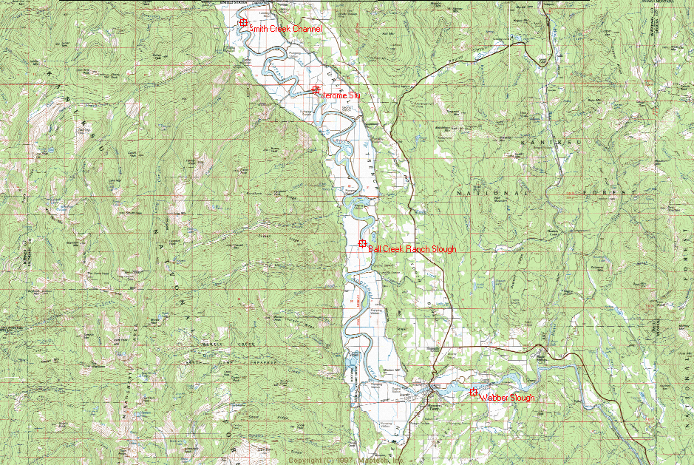
Map 1. View of the entire lower Kootenai River Valley including locations of four potential slough
reconnection projects.

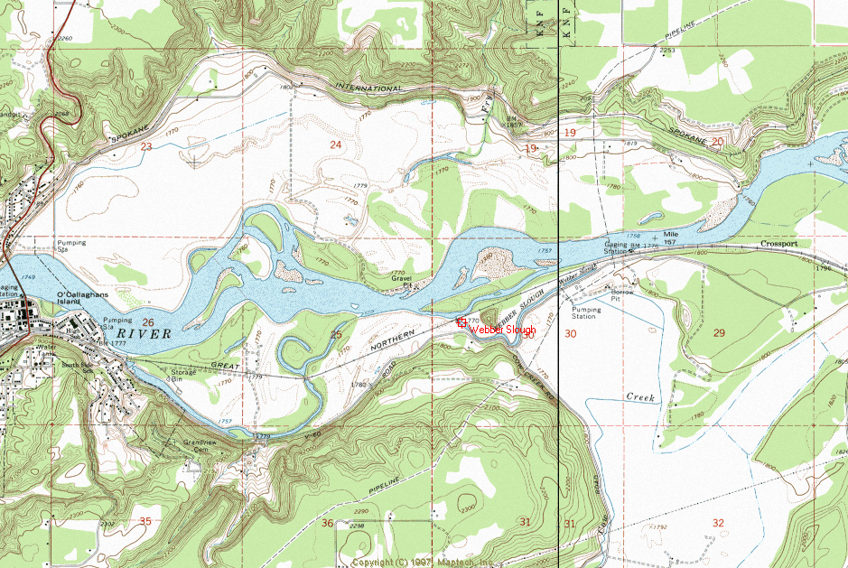
Map 2. Webber Slough project location.

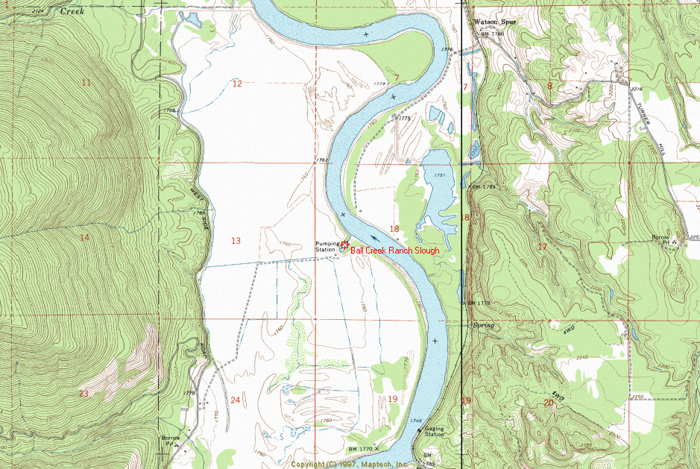
Map 3. Ball Creek Ranch Slough.
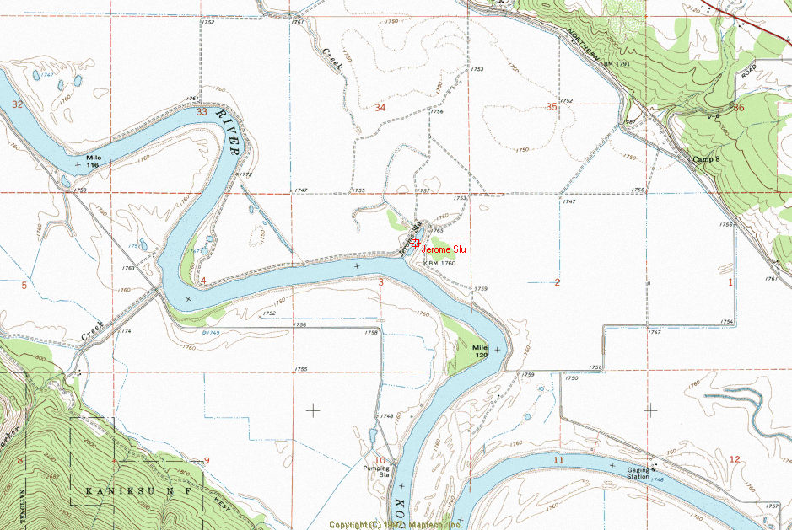
Map 4. Jerome Slu.

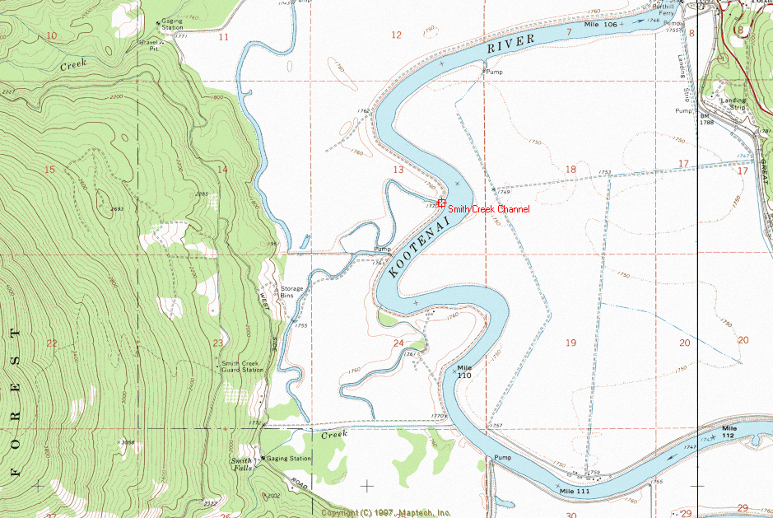
Map 5. The Smith Creek Channel.

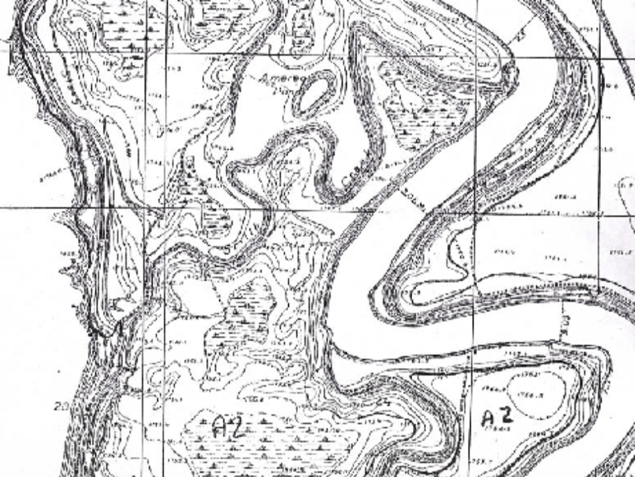
Map 6. Smith Creek area in 1928.
Literature Cited

Anders, P. J. 1991. White Sturgeon (Acipenser transmontanus) movement patterns and habitat utilization in the Kootenai River system, Idaho, Montana and British Columbia. MS Thesis, Eastern Washington University. 153pp.

Anders, P. J., and D.L. Richards. 1996. Implications of ecosystem collapse on white sturgeon in the Kootenai River, ID, MT, and BC. Pages 27-40 In S. Doroshov, F. Binkowski, T. Thuemeder, and D. MacKinlay, eds. Culture and Management of Sturgeon and Paddlefish Symposium Proceedings. Physiology Section, American Fisheries Society, Bethesda, MD.

Anders, P.J., D. L. Richards, and M. S. Powel. 2000. The first endangered white sturgeon population: Repercussions in an altered large River-Floodplain ecosystem. In: Proceedings of the 130th Annual Meeting of the American Fisheries Society. St. Louis MO., August 20-24, 2000.

Apperson, K.A. and P.J. Anders. 1991. Kootenai River white sturgeon investigations and experimental culture. Annual Progress Report FY 1990. Idaho Department of Fish and Game and Bonneville Power Administration. Contract No. DE-A179-88BP3497; Project No. 88-65. Portland, Oregon.

Duke, S., P. Anders, G. Ennis, R. Hallock, J. Hammond, S. Ireland, J. Laufle, R. Lauzier, L. Lockard, B. Marotz, V. Paragamian, and R. Westerhof. 1999. Recovery plan for the Kootenai River white sturgeon. Journal of Applied Ichthyology 15(1999): 157-163.

Junk, W. J., P.B. Bayley, and R.E. Sparks. 1989. The flood pulse concept in river floodplain systems. Can. Spec. Publ. Fish. Aquati. Sci. 106:110-127.

Paragamian, V.L. 1994. Kootenai River Fisheries Investigations. Annual Progress Report FY 1993. Prepared for U.S. Department of Energy, Bonneville Power Administration. Contract No. DE-AI79-88BP93497; Project No. 88-65, Portland, Oregon.

Snyder, E.B., and G.W. Minshall. 1996. Ecosystem metabolism and nutrient dynamics in the Kootenai River in relation to impoundment and flow enhancement for fisheries management. Annual Report. Stream Ecology Center, Idaho State University, Pocatello, Idaho.

U.S. Fish and Wildlife Service. 1999. Recovery plan for the Kootenai River population of the white sturgeon (Acipenser transmontanus). Region 1, USFWS, Portland, OR.
http://endangered.fws.gov/RECOVERY/RECPLANS/Index.htm

