Project ID: 199303501

Title: Enhance Fish, Riparian, and Wildlife Habitat Within the Red River Watershed

Section 9 of 10. Project description

a. Abstract

The Red River watershed has been impacted by mining, logging, and agricultural practices for the past several decades. As a result, the Red River was straightened, the channel length was reduced, and large portions of riparian vegetation were eliminated. These activities caused numerous adverse impacts including an incised channel, unstable banks, increased erosion rates, altered substrate composition, elevated water temperatures, reduced floodplain function, drained wet meadows and wetlands, altered vegetative communities, and degraded fish habitat. The Lower Red River Meadow Restoration Project is a multi-phase ecosystem enhancement effort based on a natural channel restoration philosophy. The natural physical and biological processes are restored to guide the stream channel into a state of dynamic equilibrium and, in turn, improve the quantity, quality, and diversity of habitats for fish and wildlife. Specifically, restoration work is designed to increase channel sinuosity, reconnect floodplain function, reduce streambed and bank erosion rates, improve substrate quality, reestablish the disturbance frequency of bed features and substrate, maintain deep pools and clean spawning gravels, and create diverse instream and off-channel habitats. Native woody and herbaceous plantings expedite the return of riparian vegetative communities that, in time, will stabilize streambanks, provide overhanging vegetation, develop undercut banks, and help lower summer water temperatures. Implementation (short-term) monitoring results are used to apply adapative management strategies that improve restoration designs, constuction techniques, and monitoring protocols in each consecutive project phase. Effectiveness monitoring results are used to evaluate the long-term success of the restoration work relative to project goals and objectives. Phases I through IV on the Red River Wildlife Management Area (RRWMA) are complete. Upon successful conservation easement negotiations, similar restoration work in Phases V-X (proposed for 2002-2007) will move to private land parcels upstream and downstream of the RRWMA. An educational component transfers restoration techniques, successes, and lessons to the public, natural resource-oriented agencies, scientific community, and students of all ages.

b. Technical and/or scientific background

The headwaters of the Red River form in north central Idaho about four miles northwest of Green Mountain in the Nez Perce National Forest (Appendix, Figure 1). The river drains approximately 100,000 acres and flows northwest about 28 miles where it joins the American River to become the South Fork of the Clearwater River.
On a watershed scale, logging, road building, and gold mining activities altered the hydrology, sediment delivery, and water quality characteristics of Red River (USDA Forest Service, 1998; LRK Communications et al., 1999). Reservoirs and hydroelectric dams constructed in the higher-order rivers downstream (Snake and Columbia) inhibited the migration of anadromous fish species [Northwest Power Planning Council (NWPPC), 1994, 2000]. On a local scale, expansion of grazing and haying area and dredge mining for gold straightened the river channel and eliminated the native riparian vegetation in several meadow reaches (Appendix, Figures 2 and 3). The ecology of Red River has been negatively impacted in several ways. First, channelization reduced the length of river channel, increasing the water velocity through the meadow, accelerating streambank erosion, and degrading the channel bed by approximately 2 feet. Channel incision is likely to continue until checked by bedrock or some other geomorphic control. Over-steepened banks succumb easily to erosional and gravitational forces, contributing an increase in sediment supply – often of fine-grained material. Second, a depressed groundwater table and a reduced floodplain hydroperiod accompanied the channel bed degradation. In response, the Red River meadow soils provide inadequate moisture conditions to sustain the native riparian and wetland plant communities once thriving there (Brunsfeld et al., 1996). Third, the removal of riparian vegetation has contributed to streambank instability, accelerated erosion, increased width-depth ratios, and reduced shade and cover habitat for fish. Fourth, overall instream habitat (pools, riffles, overhanging banks, woody debris) is reduced. Water temperatures are elevated in the summer months due to the wide, shallow low flow channel and lack of riparian vegetative cover.
The decline of both resident and anadromous fish populations in the Red River has been linked to the degraded habitat and water quality conditions [Bonneville Power Administration (BPA), 1996; USDA Forest Service, 1998]. Although currently in a degraded condition, the Red River watershed is classified as a “historic stronghold” for naturalized spring chinook salmon (Oncorhynchus tshawytscha), steelhead trout (Oncorhynchus mykiss), bull trout (Salvelinus confluentus), and westslope cutthroat trout (Oncorhynchus clarki lewisi). Red River has a very high habitat potential for bull trout, spring chinook salmon, and westslope cutthroat trout and a high habitat potential for steelhead trout (USDA Forest Service, 1998). In addition, the river is recognized as a potential major spring chinook and steelhead production stream by the Nez Perce Tribe (NPT) and Idaho Department of Fish and Game (IDFG) (1990).
Restoration of the lower gradient meadow reaches within the Red River watershed are of particular importance since spring chinook, steelhead, bull trout, and westslope cutthroat trout use these areas for migration corridors and/or spawning and rearing habitat. These meadow stream sections possess high aquatic habitat potential and existing conditions are such that recovery is feasible [Dave Mays, Fisheries Biologist, Nez Perce National Forest (NPNF), personal communication, 1997; USDA Forest Service, 1998; Nick Gerhardt, Hydrologist NPNF, personal communication, 1999].
The Lower Red River Meadow Restoration Project (LRRMRP) encompasses four separate land parcels (1,300 acres) and 4.5 miles (prior to restoration) of stream channel. The primary goal is to restore the diverse physical and biological features of the river/wet meadow ecosystem, thereby stabilizing the stream channel and providing high quality spawning and rearing habitat for anadromous and resident fish and aquatic species [Idaho County Soil and Water Conservation District (ISWCD), 1995].

c. Rationale and significance to Regional Programs

The Red River’s upper and lower meadows have been identified in several plans as a high priority for aquatic habitat restoration, primarily for spring chinook salmon, steelhead trout, bull trout and westslope cutthroat trout (NWPPC, 1987; USDA Forest Service, 1987 and 1998). The Red River drainage includes critical habitat for two listings under the Endangered Species Act, steelhead trout and bull trout, placing even greater emphasis on timely and successful habitat restoration work. Habitat improvements at the watershed scale are addressed by way of changing land management practices (Nez Perce National Forest Plan, USDA Forest Service, 1987) and at the stream reach scale through implementation of riverine-riparian habitat restoration such as the Lower Red River Meadow Restoration Project.
The restoration philosophy and work completed in the Lower Red River Meadow employs a natural channel design approach that integrates geomorphic design criteria and detailed hydrodynamic modeling. Various design scenarios can be tested and analyzed. The geomorphic criteria predict the natural channel shape and the computer model routes flood flows and sediment through the project area. The comprehensive, hydrodynamic and mass transport computer model (MIKE-11, Danish Hydraulic Institute, 1996) is being set up to accurately simulate the channel-floodplain interactions and is run through ArcView in a new software package called MIKE-View. All physical and biological data are stored in ArcView. The LRRMRP is likely the first application of this level of detailed monitoring and modeling. Over 100 permanently monumented cross-sections have been established throughout the lower meadow and 55 of these have been surveyed annually since 1997. Longitudinal profiles have been surveyed in five years since 1994. An additional 22,000+ points define the floodplain and wetlands. This information is stored in a relational database (Filemaker Pro) and Geographic Information System (GIS) (ArcView) and integrates directly with the hydrodynamic and water quality model (MIKE-11). This detail allows the project team to determine the level of survey information and modeling complexity required for meaningful results.
The LRRMRP is a full-scale enhancement effort that guides the evolution of the river/wet meadow ecosystem into a state of dynamic equilibrium. Although this approach is not applicable to all sites, there are relatively few projects of similar scope that attempt to increase sinuosity and stabilize the channel over an extended reach. A light touch or natural recovery (passive) approach is less controversial, less expensive, and requires fewer regulatory permits. However, a pre-project review by an interdisciplinary team of experts (Brunsfeld et al., 1996) determined that a passive restoration approach would have limited success in establishing native riparian vegetation within a reasonable time frame and questioned if the vegetation would establish at all. This determination was based on pre-existing ecosystem conditions in the meadow including lack of native seed sources, reduced floodplain hydroperiod, competition from exotic herbaceous plants, and mid-summer water tables below the rooting zone of the once prevalent native, woody vegetation. For example, active grazing on the RRWMA was eliminated in 1993 and, to date, visual evidence of natural recruitment of woody vegetation is essentially nonexistent. The project team agreed that channel modifications that raise the water table would be required to establish soil moisture conditions necessary to support extensive native riparian plant communities similar to those that existed historically. In the long-term, the evolution of overhanging vegetation and dense, fibrous root systems will enhance fish habitat by providing shade and cover, stabilizing eroding streambanks, and supplying food for aquatic insects.
In addition to the unique opportunity to restore and protect high quality fish and wildlife habitat on the RRWMA, the original collaborative purchasers were equally impressed with the educational opportunities and the potential of the site to serve as a natural resource and conservation learning center. This educational vision is being fulfilled. The LRRMRP is being used as a local and regional model/demonstration for other stream and watershed restoration efforts. The RRWMA offers both outdoor and indoor classroom facilities, not only for students but for local landowners as well, to learn about the benefits of restoration and the importance of wise watershed management. Successes in the first four restoration phases on the RRWMA have sparked neighboring landowners to contemplate participating in some form of restoration or to consider changing land use practices that may have a negative impact to the ecology of Red River. Participation of private landowners will expand and link restoration efforts throughout the entire watershed.

Relationship and Significance of the LRRMRP to needs in the Clearwater Subbasin Summary [Washington State University (WSU), 2001]:

(Note: underlined sentences are excerpts from the “Needs” section of the summary document; italicized sentences are the LRRMRP contributions toward satisfying the need)

- Continue ongoing, and establish new, monitoring and evaluation programs for fish supplementation, habitat restoration and improvement, habitat baseline conditions, water quality and water quantity improvements, conditions and trends. These M & E activities are critical to evaluating the effectiveness of projects in improving habitat, watershed health and enhancing production of target species. Phases I through IV of the LRRMRP on the RRWMA have been established as our long-term monitoring site to evaluate the success of the restoration objectives. Data has been collected since 1997 and is currently being analyzed for reporting in the 1997-2000 Effectiveness Monitoring Report (LRK Communications et al., 2001, in preparation). Preliminary summary data is available and reported below in the “Project History” section of this proposal.
- Continue and expand the cooperative/shared approach in research, monitoring and evaluation between tribal, federal, state, local and private entities to facilitate restoration and enhancement measures. Protection and restoration of fish and wildlife populations and habitat will not be successful without the interest and commitment by all. Monitoring tasks are a cooperative effort among the project consultants, IDFG, Department of Environmental Quality (DEQ), and the NPNF. The Technical Advisory Committee (TAC) made up of agency and tribal representatives assists the monitoring team on appropriate data collection and analysis methods, selection of performance criteria, and review of draft reports. In addition, the TAC actively encourages site visits from independent reviewers and professionals working in the restoration field. These external comments have been used to make adaptive management decisions related to project design, implementation, and monitoring.
- Acquire lands when opportunities arise for improved habitat protection, restoration, and connectivity and for mitigation of lost fish and wildlife habitat (land purchases, land trusts, conservation easements, landowner cooperative agreements, exchanges). Acquisition of the RRWMA initiated Phases I-IV and the two adjacent landowners to the RRWMA are now interested in restoration work on their properties. Initial easement discussions have occurred with both landowners. A Level I Hazardous Waste Survey has been performed on one property. Establishing such conservation easements will link and expand the restoration work in the lower meadow and other meadow sections within the watershed.
- Ensure natural river strategy alternative is implemented as required for recovery of listed anadromous species. A natural channel design has been implemented in Phase I – IV and is proposed for future phases. The design approach has been refined at each phase based on the performance of earlier phases.
- Reduce stream temperature, sediment and embeddedness to levels meeting appropriate standards for supporting self-sustaining populations of aquatic species. Restoration work completed and proposed in the lower meadow is designed to lower stream temperature, decrease erosion rates, and reduce fine sediment accumulation in spawning gravels. A diversity of geomorphic channel features is being restored at the site and these conditions will provide ranges of sediment sizes, thermal refugia, and reduced width to depth ratios at low flows. Detailed performance criteria have been established to demonstrate the evolution of the channel toward standards for aquatic species.
- Protect and restore riparian and instream habitat structure, form and function to provide suitable holding, spawning, and rearing areas for anadromous and resident fish. Restoration work completed and proposed in the lower meadow is designed to improve hydrologic conditions and restore the physical processes that will sustain suitable habitat. The work also reconnects the floodplain to the main channel and reduces channel incision. The shallower groundwater and increased inundation of the floodplain will increase soil moisture for the establishment and survival of native riparian plantings and natural recruitment of native vegetative species. An intact riparian corridor will provide bank stabilization, shade and cover, and lower stream temperatures. A mature riparian community will contribute woody debris and nutrients to the stream. Channel cross section modifications are designed to deepen pools, promote pool/riffle sequences, and reconnect floodplain function.
- Protect, restore and create riparian, wetland, and floodplain areas within the subbasin and establish connectivity. In addition to the information provided in #6 above, new off-channel wetlands have been created as part of the restoration work. Increased hydroperiod and floodplain function will naturally increase wetland area as well. The reduction in temperature gain through the meadow will eliminate the risk of the meadow becoming a thermal barrier to connectivity.

Relationship and Significance of the LRRMRP to the Columbia River Basin Fish and Wildlife Program (1994, 2000):

All previous and proposed restoration work on the LRRMRP meets the need for off-site mitigation, helping to compensate for the negative impacts to fish and wildlife caused by the existence of the hydropower generation system in the Columbia River Basin. The LRRMRP is also consistent with the eight underlying scientific principles that form the foundation of the Columbia Basin Fish and Wildlife Program (FWP). The following list illustrates how the LRRMRP is serving to further several goals and objectives of the FWP:

(Note: underlined sentences are excerpts from the 2000 FWP document; italicized sentences are the LRRMRP contributions toward satisfying the objective and/or implementing the strategies linked to the objective)

Biological Objectives for Anadromous Fish Losses
- Halt declining trends in salmon and steelhead populations above Bonneville Dam by 2005. Obtain the information necessary to begin restoring the characteristics of healthy lamprey populations.
- Restore the widest possible set of healthy naturally reproducing populations of salmon and steelhead in each relevant province by 2012. Healthy populations are defined as having an 80 percent probability of maintaining themselves for 200 years at a level that can support harvest rates of at least 30 percent.
- Increase total adult salmon and steelhead runs above Bonneville Dam by 2025 to an average of 5 million annually in a manner that supports tribal and non-tribal harvest. Within 100 years achieve population characteristics that, while fluctuating due to natural variability, represent on average full mitigation for losses of anadromous fish.

The number of returning anadromous fish is controlled by down-river and ocean conditions. However, by improving local spawning and rearing habitat conditions, we expect to see more redds in the restored reaches and increased numbers and survival of fry and juveniles. Increased offspring survival means more fish able to begin migration downstream, thus furthering the FWP’s salmon and steelhead goal [Also consistent with Section 4.1 (NWPPC, 1994)]. In addition, the project will improve conditions for fish passing through the meadow to upstream reaches or tributaries by providing resting cover and reducing thermal barriers.

Biological Objectives for Resident Fish Losses (2000 FWP)
- Maintain and restore healthy ecosystems and watersheds, which preserve functional links among ecosystem elements to ensure the continued persistence, health and diversity of all species including game fish species, non-game fish species, and other organisms.
- Protect and expand habitat and ecosystem functions as the means to significantly increase the abundance, productivity, and life history diversity of resident fish at least to extent they have been affected by the development and operation of the hydrosystem.
- Achieve population characteristics of these species within 100 years that, while fluctuating due to natural variability, represent on average full mitigation for losses of resident fish.

In accomplishing the goal related to chinook salmon and steelhead, habitat quantity and quality is also improved for other anadromous and resident fish and aquatic organisms. (Also consistent with underlying scientific Principles 1, 5, and 6 (NWPPC, 2000) and Section 10.2B (NWPPC, 1995)].

Biological Objectives for Wildlife Losses
- Develop and implement habitat acquisition and enhancement projects to fully mitigate for identified losses;
- Coordinate mitigation activities throughout the basin and with fish mitigation and restoration efforts, specifically by coordinating habitat restoration and acquisition with aquatic habitats to promote connectivity of terrestrial and aquatic areas;
- Maintain existing and created habitat values;
- Monitor and evaluate habitat and species responses to mitigation actions.

In accomplishing the goal related to chinook salmon, steelhead, bull trout, westslope cutthroat and other fish and aquatic organisms, a holistic approach targets restoration of the riparian/wet meadow ecosystem and associated uplands and links the local watershed and downstream habitats. For this reason, additional benefits accrue to waterfowl; upland wildlife; and other aquatic, wetland, and riparian-dependent species [Also consistent with underlying scientific Principles 1, 5, and 6 (NWPPC, 2000) and Section 11.1 (NWPPC, 1995)].

Additional phases are proposed for restoration work with willing private landowners within the lower meadow and other potential habitat improvement sites, continuing a coordinated and cooperative effort to protect and improve both fish and wildlife habitat conditions within the watershed [Also consistent with Section 7.7 (NWPPC, 1994)]. Easement acquisitions that protect valuable riparian habitat and fully compensate private landowners [Also consistent with Section 7.8E (NWPPC, 1994)] are being explored and negotiated. And, the project will seek cost-sharing opportunities with relevant state and federal entities for conservation easements, riparian fencing, and/or off-channel water development (Also consistent with Section 7.6, NWPPC, 1994).

Habitat Strategies
Habitat within the Lower Red River Meadow is considered restorable habitat as defined in the 2000 FWP: “Where the habitat for a target population is absent or severely diminished, but can be restored through conventional techniques and approaches.” According to the 2000 FWP, the biological objective for a restorable habitat is “to restore the habitat with the degree of restoration depending on the biological potential of the target population. Where the target population has high biological potential, the objective will be to restore the habitat to intact condition, and restore the population up to the sustainable capacity of the habitat.”

Primary strategy: Identify the current condition and biological potential of the habitat, and then protect or restore it to the extent described in the biological objectives.

Pre-existing conditions and biological potential have been identified and summarized in the 1996-97 Biennial Report (http://boise.uidaho.edu/redriver) and documented in detail in several reports including:
- Fisheries Habitat Reconnaissance [Pocket Water, Inc. (PWI), 1994a],
- Water Temperature Analysis (PWI, 1994b),
- Cultural Resources Survey (Luttrell, 1995),
- Analysis of Restoration Options (Brunsfeld et al., 1996),
- Environmental Assessment (BPA, 1996), and
- SF Clearwater River Landscape Assessment (USDA Forest Service, 1998).

Secondary Strategies: 1) Build from strength, 2) restore ecosystems, not just single species, and 3) use native species wherever feasible.

The Red River, and particularly the low-gradient meadow reaches within the watershed, was historically a highly productive fisheries stream and is classified as a “historic stronghold” for naturalized spring chinook salmon, steelhead trout, bull trout, and westslope cutthroat trout. The habitat potential in Red River is rated high to very high for these species. The existing conditions of the meadow reaches are such that, given the appropriate restoration techniques and land use management practices (consistent with underlying Scientific Principle 8), habitat improvement and the return of healthy fish populations are feasible (USDA Forest Service, 1998).

The project’s design philosophy for fish and wildlife habitat enhancement is based on the restoration of the physical and biological processes and functions of the natural river/wet meadow ecosystem (consistent with underlying Scientific Principles 2, 4, 5 and 6). Consequently, the resulting channel configuration, floodplain function, in-stream habitat features, and riparian/wetland plant communities will develop with time, become self-sustaining, and able to respond to natural disturbances without compromising the integrity of the ecosystem. The ecosystem restoration approach targets the river corridor as well as the associated uplands and links the local watershed and downstream habitats thus, additional benefits accrue to waterfowl; upland wildlife; and other aquatic, wetland, and riparian-dependent species. All riparian and wetland plantings are native to the site. Seed and cuttings are collected on site or on nearby sites with similar environmental characteristics. [Also consistent with Section 7.6D (NWPPC, 1994)].

Relationship and Significance of the LRRMRP to the NMFS 2000 FCRPS Biological Opinion and Associated RPAs

(underlined sentences are excerpts from the “Habitat” and “RPA Action” sections of the document; italicized sentences are the LRRMRP contributions toward satisfying the RPA or BO Action)

9.6.2 HABITAT ACTION: The habitat strategy is intended to accelerate efforts to improve survival in priority areas in the short term, while laying a foundation for long-term strategies through subbasin and watershed assessment and planning. In the short term, Federal agencies commit in the Basinwide Recovery Strategy to focus immediate attention on priority subbasins, i.e., those with potential for significant improvement in anadromous fish productive capacity as a result of habitat restoration….Over the long term, the habitat strategy has three overarching objectives: 1) protect existing high quality habitat, 2) restore degraded habitats on a priority basis and connect them to other functioning habitats, and 3) prevent further degradation of tributary and estuary habitats and water quality.

Red River has a very high habitat potential for spring chinook salmon, bull trout, and westslope cutthroat trout and a high habitat potential for steelhead trout (USDA Forest Service, 1998). In addition, the NPT and IDFG (1990) recognize the river as a potential major spring chinook and steelhead production stream.

Restoration of the lower gradient meadow reaches within the Red River watershed are of particular importance since spring chinook and steelhead use these areas for migrating, spawning, and rearing habitat. In addition, these meadow stream sections possess high aquatic habitat potential and existing conditions are such that recovery is feasible [Dave Mays, Fisheries Biologist, NPNF, personal communication, 1997; USDA Forest Service, 1998; Nick Gerhardt, Hydrologist NPNF, personal communication, 1999].

Action 150: In subbasins with listed salmon and steelhead, BPA shall fund protection of currently productive non-Federal habitat, especially if at risk of being degraded, in accordance with criteria and priorities BPA and NMFS will develop by June 1, 2001.

This opinion puts high priority on protecting habitat that is currently productive, especially if it represents a habitat type that already limits an ESU’s productivity (e.g., summer rearing or over-wintering habitat). BPA should protect these habitats through conservation easements, acquisitions, or other means, working with non-profit land conservation organizations and others.

Purchase of the RRWMA and the associated restoration of Phases I-IV have protected migration corridors and improved potentially productive spawning and rearing habitats for spring chinook, steelhead, bull trout, westslope cutthroat, and other fish. Additional phases are proposed for restoration work with willing private landowners within the lower meadow and other potential habitat improvement sites, continuing a coordinated and cooperative effort to protect and improve both fish and wildlife habitat conditions within the watershed. Easement acquisitions that protect valuable riparian habitat and fully compensate private landowners are being explored and negotiated. We also seek cost-sharing opportunities with relevant state and federal entities for conservation easements, riparian fencing, and/or off-channel water development (also supports strategies and priorities in Section 5.2, Habitat, and Section 2.2, Goal 2, of the Implementation Plan Outline by BPA).

Relationship and Significance of the LRRMRP to the NMFS Guidance Regarding the BPA/NW Council Columbia Basin Provincial Review Solicitations (2001)

(underlined sentences are excerpts from the document listed above; italicized sentences are the LRRMRP contributions toward satisfying the RPA)

…NMFS suggests that priority be given to proposals that:
- are based on at least a watershed assessment, and that identify and provide rationale for measurable benefits to specific salmonid life stages in a spatially explicit manner;

Based on a landscape scale assessment (USDA Forest Service, 1998), Red River has a very high habitat potential for spring chinook salmon, bull trout, and westslope cutthroat trout and a high habitat potential for steelhead trout.

- protect and restore land and water habitat in ways that permanently address underlying ecosystem processes, reconnect isolated habitats or improve connections between habitats; and

Acquisition of the RRWMA initiated restoration Phases I-IV. Two adjacent landowners to the RRWMA in the Lower Red River Meadow have now expressed interest in restoration work on their properties. Initial easement discussions have occurred with both landowners. A Level I Hazardous Waste Survey has been performed on one property. Such conservation easements will link and expand the restoration work in the lower meadow and other meadow sections within the watershed.

The project’s design philosophy for fish and wildlife habitat enhancement is based on the restoration of the physical and biological processes and functions of the natural river/wet meadow ecosystem. Consequently, the resulting channel configuration, floodplain function, in-stream habitat features, and native riparian/wetland plant communities will develop with time, become self-sustaining, and able to respond to natural disturbances without compromising the integrity of the ecosystem. The ecosystem restoration approach targets the river corridor as well as the associated uplands and links the local watershed and downstream habitats and thus, additional benefits accrue to waterfowl; upland wildlife; and other aquatic, wetland, and riparian-dependent species. All riparian and wetland plantings are native to the site. Seed and cuttings are collected on site or on nearby sites with similar environmental characteristics.

- include, as appropriate, monitoring and evaluation consistent with the principles outlined in section 9.6.5.3 of the biological opinion and Research, Monitoring, and Evaluation RPA Actions 183 and 184.

Phases I through IV of the LRRMRP on the RRWMA have been established as our long-term monitoring site to evaluate the success of the restoration objectives. Data has been collected since 1997 and is currently being analyzed for reporting in the 1997-2000 Effectiveness Monitoring Report (LRK Communications et al., 2001, in preparation). This information may be used to complement and contribute to research studies initiated under RPA 183 related to the evaluation of active restoration techniques that aim to improve instream habitat and riparian conditions and to the assessment of habitat changes dues to altered grazing practices.

The habitat section of the Biological Opinion outlines an approach to habitat problems from an ESA perspective. The opinion seeks to build on and support the Council’s fish and wildlife program in two primary ways:

- First, by emphasizing the need for ecological context in habitat initiatives. For the most part, the opinion expects this context to be produced by scientifically sound subbasin and watershed assessments and plans and related recovery plans. For that reason, the opinion calls on BPA to support the continued development and implementation of the Council’s subbasin planning process. NMFS views this work as fundamental to the development and success of a long-term habitat program.

Several recent assessments (Quigley et al., 1996; USDA Forest Service, 1998; USDA Forest Service, 1999) set the context of the South Fork Clearwater River subbasin and the Red River watershed in terms of aquatic restoration priority. Stream surveys, biological inventories, and accumulated knowledge of the Red River watershed consistently point to the meadows in the vicinity of the Red River Wildlife Management Area as crucial for spawning and rearing of chinook salmon and steelhead within the watershed. An Ecosystem Analysis at the Watershed Scale (EAWS) (USDA Forest Service et al., 1995 a and b) of the Red River watershed is planned for completion in 2003. This analysis is part of and will support the Clearwater Subbasin planning process (also supports strategies and priorities in Section 5.2, Habitat, of the Implementation Plan Outline by BPA, Draft 2001).

- Pending these assessments and plans, the opinion calls for specific initiatives to produce biological benefits in the short term (water solutions in priority subbasins), protect currently productive habitat (BPA habitat protection fund), test innovative mechanisms for habitat protection (water marketing demonstration project and leveraging for agricultural incentive programs), clear up important uncertainties (mainstem habitat program), and reestablish ecological function in the estuary.

Acquisition of the RRWMA initiated the restoration of productive habitats in Phases I-IV and protects the restoration investment. Two adjacent landowners to the RRWMA in the Lower Red River Meadow have now expressed interest in restoration work on their properties. Easements and restoration will further enhance and protect these portions of the Lower Red River Meadow (also supports Section 2.2, Goal 2, of the Implementation Plan Outline by BPA, Draft 2001).

Relationship and Significance of the LRRMRP to other Regional and Local Management Plans:
The design philosophy and goals and objectives of the LRRMRP are congruent with and further the management goals and objectives of the following agencies/organizations (excerpts from the Clearwater Subbasin Summary (WSU et al., 2001):
- Idaho County SWCD – develop and implement programs to protect and conserve natural resources on nonfederal lands, improve fish and wildlife habitat, and continue to support the Lower Red River Meadow Restoration Project by providing sponsorship and administrative assistance.
- Clearwater Focus Program – facilitate implementation of fish and wildlife habitat protection, enhancement, and restoration within the Clearwater subbasin.
- Idaho DEQ – restore cold water biota and salmonid spawning beneficial uses to full support
- NMFS – support actions that develop riparian vegetation and restore streamflow and appropriate hydrologic conditions to achieve recovery of ESA species.
- NPT – restore all species, stocks, populations, and their habitat throughout the Nez Perce Treaty Territory using a holistic approach that encompasses entire watersheds . . . .
- US Fish and Wildlife Service – protect, restore, and enhance native anadromous and resident fish populations in the Clearwater River basin.
- Natural Resources Conservation Service (NRCS) – maintain, restore, or enhance wetland ecosystems and fish and wildlife habitat.
- IDFG – support, participate in, and advocate activities and land management practices that protect, enhance, or restore water quality and fish and wildlife habitat to maintain or enhance natural fish and wildlife production and preservation.
- Interagency Memorandum of Agreement between BPA and IDFG (1994) – BPA deeded land parcel to IDFG to manage for habitat restoration and fish and wildlife benefits, in perpetuity, as the Red River Wildlife Management Area.
- IDFG’s Red River Wildlife Management Area Plan:
- manage the area to maintain and/or enhance quality of wildlife, fisheries, scenic values, and overall biodiversity through ecosystem-based management;
- provide a setting for natural resource-oriented educational and research opportunities through cooperative efforts with federal, state, and private individuals;
- provide a meeting facility for natural resource-oriented agencies and organizations and the local community; and
- promote continued use of the RRWMA for recreational purposes consistent with wildlife, fisheries, and educational goals.
- According to the Nez Perce National Forest, restoration of aquatic habitat within the meadows of the Red River watershed is a high priority as documented by the following quotes and paraphrased excerpts:
- “Restoration of this watershed is necessary to stabilize existing populations, along with providing the best opportunity for a long term population source area in the future . . . . [The] riparian and instream processes need to be restored in some areas, primarily in the meadow sections. . . . The aquatic restoration in this watershed needs to proceed as quickly as possible . . [since] . . it would take a sustained effort over many years to restore the aquatic function of Red River . . . This watershed contains a disproportionately high amount of the aquatic potential in the subbasin” (USDA Forest Service, 1998).
- The aquatic priority is rated "very high" and an area theme of "restore aquatic processes" is recommended for Red River. This combination of aquatic priority and management theme was applied to only three 5th code watersheds in the South Fork Clearwater subbasin. Also, when prioritized at the scale of the Nez Perce National Forest, Red River is listed among the top six 5th code watersheds for aquatic restoration (USDA Forest Service, 1999).
- The first step in the Red River watershed restoration effort should be the completion of an Ecosystem Analysis at the Watershed Scale (EAWS). This recommendation is considered a high priority from an aquatics perspective (USDA Forest Service, 1998). The Nez Perce National Forest has plans to complete the EAWS for Red River in 2003. Field data will be collected during 2001-2002.
- Several recent assessments (Quigley et al., 1996; USDA Forest Service, 1998; USDA Forest Service, 1999) set the context of the South Fork Clearwater River subbasin and the Red River watershed in terms of aquatic restoration priority. Stream surveys, biological inventories, and accumulated knowledge of the Red River watershed consistently point to the meadows in the vicinity of the Red River Wildlife Management Area as crucial for spawning and rearing of chinook salmon and steelhead within the watershed.

d. Relationships to other projects

Related Projects:
- The coordinated restoration program of the Clearwater Subbasin Focus Watershed [sponsored by the Idaho State Soil Conservation Commission (SCC) and NPT, BPA Project #199608600 and #199706000] encompasses the Red River drainage.
- IDFG’s Idaho Supplementation Studies (BPA Project #198909800), Idaho Natural Production Monitoring and Evaluation (BPA Project #199107300), Steelhead Supplementation Studies (BPA Project #199305500), and Chinook and Steelhead Redd Counts in Trend Areas (non-BPA funded project) contribute to and complement the LRRMRP monitoring efforts related to aquatic habitat diversity, fish populations and densities, and chinook redd counts.
- The McComas Meadow/ Meadow Creek Project, a related and complementary restoration project in the South Fork Clearwater drainage, is funded by BPA and is a cooperative project of the Nez Perce National Forest and NPT (USFS, BPA Project #199607705). Representatives from the McComas project and the LRRMRP share restoration insights and knowledge during tours of the Red River project and TAC meetings. Ms. Heidi McRoberts, representative for the NPT on the Red River TAC, assures collaboration between projects and compares restoration approaches through graduate studies at the University of Idaho (UI). Her thesis will focus on McComas Meadows. Co-major professors, Dr. Mike Falter (Department of Fisheries) and Ecohydraulics Research Group (ERG) leader Dr. Peter Goodwin (Department of Civil Engineering) are supervising her research.
- The Conservation Data Center (CDC) Rare Plant and Animal Surveys (non-BPA funded project) has contributed native riparian/wetland community type data that helped establish performance criteria for the LRRMRP’s riparian composition/greenline monitoring.
- In 1987, the lower Red River area of the watershed was estimated at 50 percent of its habitat potential and the Nez Perce National Forest Plan described the need for restoration of the lower meadow (USDA Forest Service, 1987). The NPNF fishery/water quality objective for the Red River watershed, as outlined in the Forest Plan, is to restore the watershed’s habitat potential to 90 percent. The NPNF and the LRRMRP are addressing water quality issues together. The project focuses on solutions at the local reach level by reshaping channel cross-sectional shape and planform alignment and planting native riparian vegetation. The NPNF has implemented habitat improvements in both riparian and upland areas of the Red River watershed for several years. Since 1984, BPA and the NPNF have focused restoration activities on critical habitats within the watershed using bank stabilization techniques, fencing, and vegetative plantings (Baer et al., 1990; Siddall, 1992). A USFS stream restoration project (Mullins property) in Red River’s upper meadow provided examples of restoration technique effectiveness. A USFS wildlife fencing exclosure at the downstream end of the lower meadow provides information on the potential natural riparian vegetation. The NPNF will continue habitat enhancement work initiated in the early 1980s, both in channel and in upland areas, to achieve overall recovery of the watershed. Road stabilization is a major component of upland work. Since 1990, new road construction and timber harvest have decreased significantly in the watershed (Nick Gerhardt, Hydrologist, NPNF, personal communication, 1999).
- The Red River Hatchery, a spring chinook rearing facility, located upstream of the project receives funding from the “Lower Snake River Compensation”. This hatchery assists the restoration of anadromous fish runs via supplementation of smolts for the Crooked River, Red River, and the South Fork of the Clearwater drainages.
- The project team is cooperating with several related projects to evaluate and document results of varying restoration philosophies in an effort to provide additional scientific information for restoration efforts in the region. For example, in a collaborative effort (funded independently from Red River), the NPNF, NPT, and UI are undertaking monitoring to allow a comparative study of the performance of three restoration projects within the South Fork Clearwater drainage that have utilized different philosophies:
- Red River Upper Meadow (Mullins Ranch) - classification design
- Red River Lower Meadow (RRWMA) – natural channel design, with minimal hard stabilization structures, relies on natural processes to restore channel form and function
- Meadow Creek (McComas Meadows)– a natural recovery design that includes removal of grazing and minor modifications to artificial floodplain structures.
- One of the primary objectives of acquiring the RRWMA was to develop the site as a public outreach, education and research site. Several educational and research activities funded externally from BPA are currently underway at the RRWMA and a number of agencies and individuals have contributed to this objective including the following:
- A National Science Foundation (NSF) grant geared toward K-12 education is funding high school teachers and disadvantaged high school students to participate in research and educational activities at the RRWMA.
- Recent additional NSF funding will allow Mr. Greg Fizzell (Communities Creating Connections, Kooskia/Elk City School District) and two high school teachers to work on integrating data collected at the RRWMA into mathematics and science courses.
- Scientists from IDFG, DEQ and UI will continue to work with the students and teachers on additional data collection beyond the core monitoring program by expanding snorkel counts, benthic surveys, sediment sampling, channel surveys, water discharge, temperature and turbidity monitoring efforts.
- Another grant from Fund for the Improvement of Post-Secondary Education (FIPSE) is investigating remote sensing and telemetry as a means for posting real-time data and images on the project web page to keep students involved in the project and bring the site into classrooms. The images are taken from a surveillance camera viewing the entire meadow and a remotely controlled underwater camera designed and constructed by the final year, undergraduate mechanical engineering students at the UI. The camera will be used to investigate issues such as: 1) When do fry emerge from the redds? and 2) How do fish utilize different habitats in the restored and non-modified reaches of the meadow? During the next few years, plans are to develop this real-time imaging and data collection for a broad range of classes from grade school to undergraduate classes.

Agency Cooperation and Support:
- The TAC for the LRRMRP meets regularly throughout the year to review designs, evaluate constructed features and monitoring results, and advise the ISWCD in decision-making. Interdisciplinary members of the TAC provide a wide range of expertise and include members from the NPT, IDFG, DEQ, NPNF, Clearwater Focus Watershed, Idaho State Soil Conservation Commission (SCC), BPA, ISWCD, and NRCS.
- The USDA ARS Northwest Watershed Research Center loaned weirs and other monitoring equipment for a turbidity field test undertaken during the summer of 1998.
- Watershed data collected by the USFS as part of the State Water Adjudication process is proving useful in understanding the linkages between the restoration actions at the RRWMA and watershed processes.
- A landscape-scale analysis of the South Fork of the Clearwater River (USDA, 1998) provided information about existing conditions and historical land uses in the Red River drainage. Findings from this study recommended EAWS (USDA et al., 1995a and b) for the Red River drainage that is slated for completion in 2003. Project data collected by the consultant team and UI will be an important contribution to this EAWS. Information resulting from the EAWS will be shared with the project team.

Collaboration with Other Organizations and Scientists:
- The ERG from UI actively seeks additional, non-BPA funding for research and supplemental educational components of this project. A 1997-98 UI Seed Grant for $6,000 was funded to initiate a database to support research proposals related to ecohydraulics and to assist agencies in documenting lessons learned from this type of restoration.
- The Danish Hydraulic Institute has selected the UI Ecohydraulics Research Group as one of the international partners in a $3 million TALENT grant funded by the Danish Academy of Sciences. The Lower Red River Meadow Restoration Project is one site being considered for testing several recent mathematical models, such as Genetic Algorithms, for stream response.
- The project team works closely with the NPNF to collect and exchange current and historical land use, discharge, and sediment delivery data pertinent to the computer modeling and design of this project and other projects within the Red River watershed and the Clearwater subbasin. Monitoring results and restoration outcomes will be shared with all collaborators and interested parties.
- The TAC and consulting team encourage visits from experts in geomorphology, restoration and fisheries recovery. Recent or proposed visits before August 1, 2001 include: Dr. Tony Minns (Technical University of Delft), Dr. Steve Wright (Department of Civil and Environmental Engineering, University of Michigan), Dr. Nigel Wright (University of Nottingham, UK), Dr. Chris Bowles and Dr. Tim Abbe (Phillip Williams and Associates), Dr. Mike Weinstein (NJ Institute of Marine Sciences), and Dr. Rob Dillinger (formerly of Henry’s Fork Foundation).

UI In-Kind Donations
- Classes from the Department of Civil Engineering and Biological Systems and Agricultural Engineering have assisted with the on-site collection of survey and monitoring data. This popular student event has generated valuable data for the project. Students learn about restoration and monitoring, display their results through GIS, and compare data with earlier years. This program will continue after the BPA-funded restoration work is completed. Plans include extending outdoor classroom experiences to limnology students in future years. [During the academic year, one-month support of ERG faculty (Drs. Goodwin and Jankowski) provides an in-kind contribution of $15,700, with computer software and facilities estimated at a value to the project in excess of $25,000.]
- The computer center at the College of Engineering, Boise Center maintains the project web-site (http://boise.uidaho.edu/redriver). This service was provided at no charge to the project for the first two years of operation. [Average time: 4 hours per month for the Boise Center Computer Systems Manager]. Plans are to expand the web site to include real-time imaging and more interactive features. Initial funds ($2,000) for this endeavor were contributed from the UI College of Engineering.
- During 1998, Rick Marbury, a professional surveyor and graduate student with the ERG, supervised the wetland delineation survey, at no cost to the project (estimated in-kind contribution of $5000).
- Since 1998, UI has provided various survey and monitoring equipment for use during the field season at no cost to the project.
- New field monitoring equipment is now provided through the 2001 Congressional Award "Hydroinformatics: A computational Center" to the Ecohydraulics Research Group at the UI. This new GPS survey and automated total station survey equipment will dramatically increase the accuracy and speed of data collection at the site.
- Telemetry equipment and other data recorders are being provided by the FIPSE Hydroinformatics Center grant awarded to the Ecohydraulics Research Group.
- Mr. Steve Clayton, (Ph.D. Student) is working on statistical methods for assessing the performance of restoration projects using the RRWMA as an example. He is funded 25% by the project funding and 75% by the National Science Foundation.

Additional undergraduate/graduate projects and volunteers:
- During planting season 1998, Americorps volunteers recruited through the IDFG, assisted planting 2000 willow poles. IDFG contributes other funds and volunteer help for supplemental monitoring, education, and field work.
- During the 2001 research/field season, two UI undergraduate students will be working at the RRWMA funded by NSF Research Experience for Undergraduates (REU) grants. These students are developing an underwater camera system and a means for using wireless technology to transfer real-time data from automated recorders to the ranch house and telephone lines to the Ecohydraulics Research Group in Boise.
- S. Clayton (Ph. D., University of Idaho), Dissertation Title: “A Methodology for Quantifying the Performance of Stream Restoration”
- G. Beattie (M.S., University of Idaho), Thesis Title: “Predicting the Rate of Stream Channel Evolution and Hydroperiod Changes”
- K. Donley (MS, Boise State University), Thesis Title: “Groundwater - Stream Flow Interactions at the Red River Wildlife Management Area”

Permits:
All in-channel work (below the high water mark) proposed by the project requires the following two permits:
- Nationwide Permit 4 (per Section 404 of the U.S. Clean Water Act) issued by the U.S. Army Corps of Engineers (USACE);
- Stream Alteration Permit (per Section 42-3805) of the Idaho State Code) issued by the Idaho Department of Water Resources (IDWR). DEQ water quality standards (1996) must be upheld during the construction phase of the project using Best Management Practices (BMP), detailed mitigation plans, and permit stipulations. Throughout the construction phase, the project constantly monitors turbidity and maintains a feedback loop with DEQ to ensure compliance with water quality standards.

e. Project history (for ongoing projects)

Past Costs and Years Underway:
The Lower Red River Meadow Restoration Project completes its eighth year at the end of February 2002. To date, the project has cost $3,065,909 resulting in an average project cost of approximately $400,000 per year. This expenditure has funded planning, design, and administrative efforts; construction and implementation activities; and short- and long-term monitoring data collection, analyses, and reporting; and educational and public information material production for Phases I-IV. Planning and easement negotiations for Phase V are currently underway. The construction contract for each seven-week field season has averaged $135,000. The phased approach is necessary due to the very short construction season permitted by agencies to protect elk calving and salmon spawning. Experiences and short-term monitoring data from each phase have been used in an adaptive management strategy to refine design criteria and improve efficiency and construction, planting, and monitoring methods.

Reports/Technical Papers:
- Fisheries Habitat Reconnaissance (PWI, 1994a)
- Water Temperature Analysis (PWI, 1994b)
- Cultural Resources Survey (Luttrell, 1995)
- Design Criteria (River Masters Engineering, 1995)
- Analysis of Restoration Options (Brunsfeld et al., 1996),
- Environmental Assessment (BPA, 1996),
- Lower Red River Meadow Restoration Project Monitoring Plan: 1997 (PWI, 1997)
- 1st-4th Quarter Reports, 1996 - 2000
- 1997 Draft Monitoring Report (PWI, 1998)
- 1998 - 2000 Field Season Newsletters (http://boise.uidaho.edu/redriver)
- Klein, L.R, D. Dawes, P. Goodwin, and S. Bauer. 1998. Lower Red River Meadow Restoration: A Case Study. Conference and Annual Meeting of the Society for Ecological Restoration. Ecosystem Restoration: Turning the Tide, October 28-30, 1998, Tacoma, WA.
- Biological Assessment for Updated ESA Species List # (BPA, 1999)
- 1996-1997 Biennial Report (LRK Communications et al., 1999) (http://boise.uidaho.edu/redriver)
- Lower Red River Meadow Restoration Project: Phases III and IV Conceptual Design (UI Echohydraulics Research Group, 1999)
- Sediment and Erosion Control Plan (TerraGraphics Environmental Engineering, Inc., 1999)
- 1999 Post-Construction Summary (Wildlife Habitat Institute et al., 1999)
- S.R. Clayton, P. Goodwin, G.B. Beattie, A.W. Minns, S. Bauer, 1999. Monitoring performance of river restoration Projects. 3rd International Conference on Ecohydraulics, IAHR. Salt Lake City, July.
- 2000 Post-Construction Summary (Wildlife Habitat Institute et al., 2000)
- 1997-2000 Implementation Monitoring Report (LRK Communications et al., 2000) (http://boise.uidaho.edu/redriver)
- Lower Red River Meadow Restoration Project Monitoring Plan: 2000 Working Draft (LRK Communications, 2000)
- 1st-2nd Quarter Reports, 2001
- Beattie, G.S. , P. Goodwin, S.R. Clayton, S. Bauer and A.W. Minns, 2000. Performance evaluation of river restoration. In New Trends in Water and Environmental Engineering for Safety and Life: Eco-compatible Solutions for the Aquatic Environment. U. Maione, B.M. Lehto, R. Monti (eds.). A.A. Balkema, 18-29.
- 1997-2000 Effectiveness Monitoring Report. In preparation (LRK Communications et al., 2001).
- Clayton, S.R, G.S. Beattie and P. Goodwin. Performance evaluation of river restoration. 21st century: The New Era for Hydraulic Research and Its Application. XXIX IAHR Congress of the International Association for Hydraulic Research. Beijing, China. September 17-21, 2001.

Short Courses:
- Graduate Seminar in River Restoration. University of California, Berkeley. (Instructors included L.B. Leopold and A.L. Riley). Fall 1998.
- Ecohydraulics - Quantitative Approaches to Watershed Processes. Short course as part of the 7th Biennial Watershed Management Council Conference. Boise, October 19, 1998.
- New Paradigms in River Management. Short Course for US Army Corps of Engineers, Walla Walla, Washington. February, 1999.
- MIKE-11 River Modeling Short Course. Boise, October 23-25, 2000

Summary of Major Results:
1993:
- BPA, IDFG, Trout Unlimited, Rocky Mountain Elk Foundation, and National Fish and Wildlife Foundation collectively purchased one of the four properties in the Lower Red River Meadow.
- This property was deeded to IDFG in an Interagency MOA (BPA and IDFG, 1994) to manage for habitat restoration and fish and wildlife benefits as the Red River Wildlife Management Area.
1994:
- Stream habitat reconnaissance survey (PWI, 1994a and b) was completed to document existing conditions and to use as baseline data in the monitoring program.
- The project team utilized the stream habitat survey (PWI, 1994a), a channel morphology survey, and an analysis of historical conditions (using stream gauging/sediment delivery data and 1936 aerial photos) to develop a natural stream restoration approach.
- The overall restoration philosophy was discussed and accepted by the interagency and tribal TAC.
1995:
- An environmental assessment in accordance with NEPA (BPA, 1996), a cultural resources survey (Luttrell, 1995), and an analysis of options at Red River (Brunsfeld et al., 1996) were completed.
- TAC was organized and project planning was initiated for on-the-ground-work. Design criteria (RME, 1995) was established.
- Conceptual restoration design options developed as a cooperative effort between the ISWCD, project consultants, and TAC. Due to the 6-week in-channel work window, the group decided to implement the project in sequential phases with the intent of completing one phase per year.
1996:
- On the ground restoration work in Phase I was implemented (Appendix, Figure 4).
- Stream channel length increased by approximately 1,200 feet by reconnecting historic meanders and creating new channel bends. Sinuosity increased from 1.7 to 1.9 and gradient decreased from 0.0025 to 0.0022.
- Channel cross section and planform dimensions were designed to minimize lateral bank erosion on newly constructed outside banks. With time, net sediment accumulation on point bars will result in a narrower channel cross section eventually evolving into equilibrium conditions.
- Several log habitat structures were keyed into the outside banks of Big Bend and Hopeful Barb Bend to protect bank from erosion by diverting flow. Localized scour is anticipated to create fish habitat.
- Five rock grade control structures were placed to raise low flow water surface elevations and create pool/riffle habitat.
- Native grass mix and coir fiber matting were used to stabilize disturbed construction areas and surfaces of reinforced banks.
1997:
- On the ground restoration work in Phase II was implemented (Appendix, Figure 4).
- Stream channel length increased by approximately 1,900 feet, sinuosity increased from 1.9 to 2.3, and gradient decreased from 0.0022 to 0.0018.
- Giant Bend channel cross section and planform dimensions were designed and constructed to minimize lateral bank erosion on newly constructed outside banks. With time, net sediment accumulation on point bars will result in a narrower channel cross section eventually evolving into equilibrium conditions.
- Historic S-Curve Loops were constructed narrower than the estimated equilibrium conditions. The project team recognized that short term accelerated erosion was likely to occur, but expected the channel to adjust at a faster rate toward equilibrium conditions compared to the intentionally over-widened design described above.
- Created new wetland/off-channel pond area.
- Native grass mix and coir fiber matting were used to stabilize disturbed construction areas and surfaces of reinforced banks.
- Twenty-foot wide riparian buffer (Appendix, Figure 5) in Phases I and II was planted with 31,500 native woody and herbaceous cuttings and seedlings. As vegetation establishes, riparian corridor will provide overhanging vegetation, undercut banks, streambank stability, reduced summer water temperatures, cover and shade for fish, and foraging and nesting habitat for waterfowl and other wildlife.
- One rock grade control structure was installed at the upstream end of Phase III.
- Eight wildlife exclosures were built and planted with native riparian plants to monitor browsing impacts on growth and survival rates of new plantings.
- Monitoring program was initiated to evaluate the short- and long-term success of the restoration work.
- Fish habitat area increased by approximately 35 percent on the entire RRWMA and by nearly 95 percent in Phases I and II alone.
1998:
- Hydraulic, geomorphic, watershed, monitoring, and topographic survey data were incorporated into MIKE-11 hydrodynamic model and preliminary conceptual designs were initiated for Phase III and IV restoration work.
- Revegetation was completed in Phase II for a total of 46,250 plantings in Phases I and II; three wildlife exclosures were built in Phase II and planted with native woody plant species.
- Turbidity control test was completed to improve best management practices and mitigate for construction-related suspended sediment.
- Second year of post-construction monitoring was performed; monitoring and surveying stations were expanded to collect baseline information in Phases III and IV the adjacent upstream property.
- ArcView/GIS database developed and used to evaluate monitoring data and prepare restoration designs.
- Monitoring data collected in the 1997 field season was analyzed and reported in a preliminary, draft monitoring report.
- Average first-year survival rate of herbaceous and woody riparian plantings in Phases I and II equaled 84 percent, meeting the performance criterion of >50 percent.
- Project web site was established (http://boise.uidaho.edu/redriver).
1999:
- Channel cross-section dimensions were refined, using monitoring results and additional stream discharge data, to reflect a more accurate estimate of dynamic equilibrium and dominant flow (UI ERG, 1999).
- Final engineering drawing package completed for Phase III and permits obtained.
- On the ground restoration work in Phase III and enhancement work in Phase II implemented (Appendix, Figure 6).
- Stream channel length increased by approximately 450 feet, point bars were reshaped, wetland created, sedge sod placed, and bioengineered features installed. Overall sinuosity increased from 2.3 to 2.4 and gradient decreased 0.0018 to 0.0017.
- Check dam system was used for sequential and control former channel dewatering and new flow diversion into restored reaches.
- Developed Sediment and Erosion Control Plan (TerraGraphics Environmental Engineering, Inc., 1999).
- Seeded disturbed construction areas with a native seed mix, salvaged and installed sedge/meadow sod, and planted 18,775 native woody and herbaceous plants in Phases II and III for a total of approximately 65,000 plantings in Phases I-III.
- Average first-year survival rate of willow plantings in Phase II equaled 60 percent, meeting the performance criterion of >50 percent.
- Third year of implementation and effectiveness monitoring was performed; preliminary 1998 monitoring data compiled in a draft monitoring report.
- 1996-97 Biennial Report (LRK Communications et al., 1999) was completed (http://boise.uidaho.edu/redriver).
- Preliminary planning was initiated for Phase IV, including channel alignment alternative analysis.
2000:
- Channel cross-section dimensions were refined, using monitoring results and additional stream discharge data, to reflect a more accurate estimate of dynamic equilibrium and dominant flow.
- Conceptual design alternatives were presented and discussed with TAC.
- Final engineering drawing package was completed for Phase IV and permits obtained.
- On the ground restoration work in Phase IV was implemented (Figure 7, available for viewing on line only, at http://boise.uidaho.edu/redriver).
- Stream channel length increased by an additional 1,500 feet, sinuosity increased from 2.4 to 2.7, and gradient decreased from 0.0017 to 0.0015.
- Channel cross section dimensions were constructed according to design for equilibrium conditions, bioengineered streambank features were installed, and wetlands were created.
- Disturbed construction areas were reseeded with a native seed mix, sedge/meadow sod was salvaged and placed on new banks, and 26,000 native woody and herbaceous plants installed in Phase III and IV for a total of approximately 91,000 plantings in Phases I-IV.
- Fourth year of implementation and effectiveness monitoring was performed.
- Average first-year survival rate of herbaceous and woody seedlings in Phase III equaled 67 percent, meeting the performance criterion of >50 percent.
- 1997-2000 Implementation Monitoring Report (LRK Communications et al., 2000) was completed (http://boise.uidaho.edu/redriver).
- Preliminary discussions with neighboring landowners occurred regarding conservation easements necessary to proceed with Phase V.

Preliminary Effectiveness Monitoring Results, Post-Restoration, Phases I-IV:
Tables 1 through 8, below, present summary results from four years of effectiveness monitoring on the LRRMRP. These data are currently being compiled and analyzed for the 1997-2000 Effectiveness Monitoring Report (due by the end of 2001). Until finalized, data reported here are considered preliminary and subject to change; however, early findings indicate that the river/wet meadow system is on a trajectory to achieving desired conditions. In addition to evaluating the long-term success of the restoration efforts, the effectiveness monitoring data will be used to identify the key monitoring parameters and the spatial and temporal density of monitoring required in this type of project.

Table 1. Channel length, slope, and sinuosity changes due to restoration work on the Red River Wildlife Management Area, Phases I-IV of the Lower Red River Meadow Restoration Project. Comparison of 1936, 1996, and 2000 channel configuration is illustrated in Appendix, Figure 2.
 | Pre-restoration Phase I  (1994) |  | Post-restoration Phase I  (1996) |  | Pre-restoration Phase II  (1994) | Post-restoration Phase II  (1997)
Channel Characteristic | Phase I | Entire RRWMA | Phase I | Entire RRWMA | Phase II | Phase II | Entire RRWMA
Length (feet) | 3,233 | 8,434 | 4,398 | 9,591 | 1,032 | 2,963 | 11,522
Slope | 0.0022 | 0.0025 | 0.0016 | 0.0022 | 0.0033 | 0.0012 | 0.0018
Sinuosity | 1.8 | 1.7 | 2.5 | 1.9 | 1.7 | 4.9 | 2.3

 | Pre-restoration Phase III  (1994) |  | Post-restoration  Phase III  (1999) |  |  | Pre-restoration Phase IV  (1994) |  | Post-restoration Phase IV  (2000)
Channel Characteristic | Phase III | Phase III | Entire RRWMA | Phase IV | Phase IV | Entire RRWMA
Length (feet) | 2,280 | 2,728 | 11,970 | 1,881 | 3,390 | 13,479
Slope | 0.0025 | 0.0021 | 0.0017 | 0.0026 | 0.0015 | 0.0015
Sinuosity | 1.7 | 2.0 | 2.4 | 1.3 | 2.4 | 2.7

Table 2. Comparison of pre-restoration (1994) and post-restoration (2000) Red River channel characteristics on the Red River Wildlife Management Area, Phases I-IV of the Lower Red River Meadow Restoration Project.
Bankfull Conditions  (668 cfs) | Velocity  (ft/s) | Flow Width  (ft) | Thalweg Depth  (ft) | Width/Depth | Distance from WSE³ to TOB⁴ (high⁵)  (ft) | Distance from WSE³ to TOB⁴ (low⁵)  (ft)
1994 Channel¹ | 4.7 | 75.0 | 3.6 | 41.7 | 2.8 | 2.1
2000 Channel² | 4.0⁶ | 101.3 | 4.3⁷ | 61.4 | 2.0⁶ | 1.3⁶

Low-Flow Conditions  (17 cfs) | Velocity  (ft/s) | Flow Width  (ft) | Thalweg Depth  (ft) | Width/Depth | Distance from WSE³ to TOB⁴ (high⁵)  (ft) | Distance from WSE³ to TOB⁴ (low⁵)  (ft)
1994 Channel¹ | 0.8 | 33.8 | 1.2 | 56.9 | 5.2 | 4.5
2000 Channel² | 0.7 | 31.5 | 1.6⁸ | 43.0⁹ | 4.7⁹ | 4.0⁶
¹Based on the average measurement of 18 cross sections
²Based on the average measurement of 61 cross sections
³WSE = Water surface elevation
⁴TOB = Top of bank
⁵high = the difference from the WSE to the higher bank (right or left); low = the difference from the WSE to the lower bank (right or left) (e.g., on a bend, the point bar is the low bank and the outside bank is the high bank)
⁶ 2000 channel significantly lower (p<0.05) than 1994 channel according to a two-sample t-test
⁷2000 channel significantly higher (p<0.05) than 1994 channel according to a two-sample t-test
⁸2000 channel significantly higher (p<0.05) than 1994 channel according to a Mann-Whitney test
⁹2000 channel significantly lower (p<0.05) than 1994 channel according to a Mann-Whitney test

Table 3. Channel and floodplain inundation areas at bankfull discharge (668 cfs) comparing the 1994 (pre-restoration) channel geometry to the 2000 (post-restoration) channel geometry on the RRWMA, Phases I-IV of the Lower Red River Meadow Restoration Project. Comparison of 1994 and 2000 bankfull inundation is illustrated in Appendix, Figures 8 and 9.
 | 1994 | 2000 | 1994 | 2000
Inundation Depth (ft) | Area (acres) |  | Volume (acre-feet)
< 1 | 5.7 | 9.9 | 2.9 | 5.0
1 to 2 | 6.2 | 12.1 | 9.3 | 18.2
2 to 3 | 3.7 | 10.9 | 9.1 | 27.3
3 to 4 | 1.2 | 7.1 | 4.1 | 24.9
4 to 5¹ | 0.2 | 2.3 | 0.9 | 10.1
> 5 | 0.0 | 0.5 | 0.2 | 2.9
Total Area | 17.0 | 42.9 | 26.5 | 88.4
¹Nearly all inundation depths > 4 feet are contained within the channel.

Table 4. Spawning substrate characteristic comparisons by restoration phase and overall on the Red River Wildlife Management Area. Data summary represents a baseline, post-restoration Phases I-IV (2000), from which changes will be tracked in the future.
Spawning Substrate Characteristic | Phase I | Phase II | Phase III | Phase IV | Overall  Phases I-IV
D16 (mm) | 0.062-2 | 0.062-2 | 6 | < 0.062 | 0.062-2
D50 (mm) | 20 | 15 | 28 | 6 | 20
D84 (mm) | 54 | 66 | 65 | 43 | 58
% Fines ≤ 6 mm | 28 | 33 | 17 | 52 | 28
% Fines ≤ 2 mm | 20 | 26 | 8 | 38 | 20
Dominant Particle Size (mm) | 33-48 | 0.062-2 | 33-48 | < 0.062 | 33-48
% Suitable Size | 61 | 53 | 71 | 40 | 60

Table 5. Percent of substrate transects per phase and overall on the Red River Wildlife Management Area that currently (2000) meet performance criteria for spawning characteristics preferred by chinook salmon.
Project Area | Performance Criteria
Project Area | Fines (≤ 6 mm) ≤ 20%¹ | D50 =  13 – 128 mm² | Suitable Size  (13 – 128 mm)  > 50%³ | a) Fines (≤ 6 mm) ≤ 20%,  b) D50 = 13 – 128 mm,  c) Suitable Substrate  (13 – 128 mm) > 50%
Project Area | Percent of Transects
Phase I (n=10) | 40 | 80 | 80 | 40
Phase II  (n=3) | 33 | 67 | 67 | 33
Phase III  (n=7) | 71 | 100 | 100 | 71
Phase IV  (n=3) | 33 | 33 | 33 | 33
Phases I-IV  (n=23) | 48 | 78 | 78 | 48
¹NWPPC, 1994
²Bjornn and Reiser, 1991
³Selected by project team as a standard until a documented source can be found.

Table 6. Percent composition of native and non-native vegetative communities in 1997 and 1998 along the eight riparian and greenline transects in Phase I, Lower Red River Meadow Restoration Project. One-year change in percent native community composition is reported in the right-hand column.
Riparian Transect # | 1997  % Native | 1997  % Non-Native | 1998  % Native | 1998  % Non-Native | % Change  Native
Phase I
Transect 1 | 28 | 72 | 23 | 77 | -5
Transect 2 | 34 | 57 | 43 | 56 | 9
Transect 3 | 41 | 56 | 65 | 29 | 24
Transect 4 | 40 | 60 | 58 | 42 | 18
Transect 5 | 22 | 78 | 27 | 73 | 5
Transect 6 | 13 | 87 | 61 | 39 | 48
Transect 7 | 4 | 86 | 64 | 13 | 60
Transect 8 | 75 | 25 | 64 | 36 | -11
Mean | 32 | 65 | 51 | 46 | 19¹

Greenline Transect # | 1997  % Native | 1997  % Non-Native | 1998  % Native | 1998  % Non-Native | % Change  Native
Phase I
Transect 1 | 88 | 12 | 94 | 6 | 6
Transect 2 | 73 | 27 | 70 | 24 | -3
Transect 3 | 50 | 50 | 62 | 38 | 12
Transect 4 | 45 | 55 | 97 | 3 | 52
Transect 5 | 21 | 79 | 49 | 47 | 28
Transect 6 | 0 | 100 | 91 | 9 | 91
Transect 7 | 56 | 44 | 59 | 34 | 3
Transect 8 | 55 | 43 | 60 | 40 | 5
Mean | 49 | 51 | 73 | 25 | 24²
¹ % Change native significantly greater (p<0.05) than 0 according to a paired t-test
² % Change native significantly greater (p<0.05) than 0 according to a Wilcoxon Signed Rank test

Table 7. Three-year growth (height) comparisons for riparian species planted inside and outside the eight wildlife exclosures located in Phase I, Lower Red River Meadow Restoration Project.
Plant Species | Growth (Height) Comparison
Plant Species | Inside Exclosure  (average height in feet) | Outside Exclosure  (average height in feet) | Difference in Height
Drummond Willow  (Salix drummondiana) | 4.6 | 3.7 | 25 % taller inside
Geyer Willow  (Salix geyeriana) | 3.9 | 1.7 | 131 % taller inside
Red Osier Dogwood  (Cornus stolonifera) | 1.3 | 1.2 | 7 % taller inside
Serviceberry  (Amelanchier alnifola) | 1.1 | 1.3 | 13 % shorter inside
Thinleaf Alder  (Alnus incana) | 2.0 | 1.1 | 78 % taller inside

Table 8. Summary of changes in total number of individual birds and bird species and cumulative number of bird species based on five consecutive bird transect surveys, spanning the restoration of Phases I – III, on the Red River Wildlife Management Area.
Phases I-IV | restoration Status
Phases I-IV | Pre-restoration  (6/6/96) | 1 year post-Phase I  (6/17/97) | 1 year post- Phase II  (6/23/98) | 2 years post-Phase II  (6/21/99) | 1 year post-Phase III  (6/17/00)
Total # individuals | 52 | 75 | 72 | 93 | 63
Total # species | 14 | 17 | 23 | 17 | 19
Cumulative # species | 14 | 18 | 27 | 29 | 32

Adaptive Management Implications:
Additional site and watershed data collection and monitoring data results have allowed us to refine our restoration design, implementation procedures, monitoring protocols, methods, and performance criteria. For example:
- Modified methods used for channel diversion, channel dewatering, and construction sequencing and refined our turbidity monitoring protocol. Proper construction sequencing and adequate timing for the slow release of construction-induced turbid water are key to mitigating suspended sediment impacts. A check dam system is now being used with excellent results. For example, the peak turbidity was 16.5 nephelometric turbidity units (NTU) during the 1999 field season and 25 NTU during the 2000 field season, well below the 50 NTU performance criterion.
- Data and field observations suggest that reconnecting historic meanders, where portions of the existing streambank vegetation and structure can be left intact, will develop higher quality fish habitat and will evolve toward dynamic equilibrium sooner compared to creating new meanders and streambanks.
- A stream gage was placed at the upstream property within the lower meadow to aid the project team in refining the estimate of bankfull and dominant discharge. These data, along with additional NPNF stream discharge gage data and project topographic and monitoring data, were input into the MIKE-11 model to increase the accuracy of the project’s estimate of dynamic equilibrium dimensions. “Model” reaches that appeared to exhibit equilibrium conditions were identified and used as guides along with the modeling output. Later phases (III and IV) were designed and constructed to match these more accurate estimated dimensions.
- Based on wildlife exclosure monitoring (Table 7), revegetation success monitoring (LRK Communications et al., 2000), and visual observations, deer and elk browsing damage to newly planted vegetation was greater than anticipated. In response, browse control has been used on plantings in Phases III and IV.
- Three monitoring transects were relocated to better target pool-tailouts.
- Coir fiber erosion control placement methods were improved to reduce the possibility of smolt entrapment.
- With the experience from earlier phases, construction methods for installing bioengineered bank treatments were improved. Bank treatments are now more diverse and selection of a particular treatment is based on a streambank’s erosive potential.
- Sedge/meadow sod was more prevalent in downstream reaches and the construction team was able to use the sod extensively, with appreciable success, in Phases III and IV.
- Pacific willow (Salix lasiandra) failed to thrive in Phases I and II, even though the species was speculated as part of the original riparian community. Therefore, this species was removed from the planting plan in Phases III and IV.
- Drier and coarser soils on south facing reinforced banks need to be planted with vegetation adapted to those conditions. Serviceberry (Amelanchier alnifola) and douglas hawthorn (Crateagus douglasii), native species adapted to drier soils, will be planted in these sites during the 2001 field season.
- Due to an unanticipated amount of accelerated erosion in the intentionally undersized Historic S-Curve Loops, the slope of several point bars in this reach were reduced (made flatter) to increase the cross sectional area and reduce the amount of erosion on the bed and banks.
- The monitoring program was reevaluated in early 1999 and 2000 by the project team and independent consultants (Dillinger, 2000; Alldredge, 2000). Adjustments were made to refine methods, define performance criteria, and incorporate statistical analyses and the project’s monitoring plan (LRK Communications, 2000) is being updated.
- The TAC, consultant team, and UI encourage technical review and comments. Site visitors during the past two years include:
- Dr. A.W. Minns (formerly IHE, Technical University of Delft, the Netherlands, 1999)
- Dr. N.G. Wright (University of Nottingham, 2001)
- Dr. M. Weinstein (NJ Consortium of Marine Sciences, 2001)
- Dr. T. Abbe and Dr. C. Bowles (Phillip Williams and Associates, San Francisco, 2001)
- Mr. Gary Decker (Hydrologist, Bitterroot National Forest, 1999)

f. Proposal objectives, tasks and methods

Project Goal: Restore the Lower Red River Meadow, using a holistic watershed approach, to a naturally functioning wet meadow ecosystem to increase the quality and quantity of fish and wildlife habitat, improve water quality, and promote watershed and river restoration education.

Project Scope: The Lower Red River Meadow Restoration Project uses a holistic approach targeting restoration of the riparian/wet meadow ecosystem and the adjacent uplands and linking the local watershed and downstream habitats. Benefits accrue to salmon, steelhead, bull trout, and westslope cutthroat trout as well as other anadromous and resident fish; waterfowl; upland wildlife; and other aquatic-, wetland-, and riparian-dependent species. The project is being used as a local and regional demonstration project for other stream restoration and watershed projects and as an outdoor educational facility for students of all ages. Phases I through IV are complete on the Idaho Department of Fish and Game’s Red River Wildlife Management Area, one of the four land parcels in the Lower Red River Meadow. Upon successful conservation easement negotiations, years 2002 through 2007 will move restoration efforts to willing private landowners within the lower meadow (Phases V-X). Easement agreements with private landowners are necessary to protect previously constructed reaches, to ensure that certain land uses will not undermine future habitat improvements, and to continue a coordinated and cooperative effort for protecting and improving habitat conditions within the watershed. In 2001, we will continue conservation easement negotiations with private landowners, survey topographic features and current channel dimensions on the proposed Phase V site, monitor the performance of the previously constructed phases, and update hydrologic and watershed inputs to refine hydrodynamic modeling output. Survey data and monitoring results will be used to adjust design criteria and methodology, as necessary, using adaptive management principles and guidance from the TAC and to prepare conceptual design alternatives for Phase V.

Natural Channel Restoration Approach: The most important element in restoration planning is to restore the natural physical processes and functions of the site [Barinaga, 1996; Independent Scientific Group (ISG), 1996; National Research Council (NRC), 1996; Rosgen, 1996]. Physical processes enable a river to evolve toward a sustainable dynamic equilibrium to which the habitat and ecology are adjusted. A channel in dynamic equilibrium adjusts its form in response to natural fluctuations in discharge and sediment supply but maintains a constant cross-sectional shape over time (Leopold et al., 1964). Channel instability and inadequate hydrologic conditions in much of the Lower Red River Meadow prevent the use of passive restoration or the reestablishment of the native riparian plant communities based on re-planting alone (Brunsfeld et al., 1996). Therefore, the project team chose an active restoration approach using a natural channel philosophy to create a new channel alignment and dimensions designed to reach a dynamic equilibrium condition with minimal use of artificial bank stabilization measures. The restoration design mimics natural river/wet meadow ecosystem conditions by restoring natural physical and biological processes given current watershed inputs, using established geomorphic and ecological design criteria, empirical relationships for natural stream characteristics, hydrodynamic modeling using MIKE-11 [Danish Hydraulic Institute (DHI), 1996], and 1936 photographs as guides. Specific characteristics of a natural channel restoration approach include the following:
- The stream is unconfined by rigid, unnatural bank stabilizing structures.
- The stream is returned to a self-regulating state of dynamic equilibrium by restoring
- river channel geometry and meander pattern,
- floodplain hydroperiod,
- groundwater-meadow floodplain relationship,
- sediment transport regime, and
- high quality and diverse fish habitat.
- Riparian plant communities provide the natural bank stabilizing force where
- plantings accelerate the establishment of native communities,
- plants are produced from cuttings or seed collected on-site or as near the site as possible,
- deep and dense root systems increase bank stability, thereby reducing erosion and improving water quality,
- restoration of the river’s hydrologic function improves conditions for natural regeneration of native riparian and wetland plant communities in the future, and
- Improvements to fish habitat include overhanging vegetation, undercut banks, and sources of nutrients and instream woody debris. Reduced water temperatures are achieved by vegetative shading, lower width-depth ratios, deep pools, and wetland-stream connectivity.

Critical Assumptions:
- The consecutive-phase implementation structure of the restoration design is by necessity a multi-year endeavor. Degradation processes in the non-restored reaches are likely to continue until checked by natural geologic or geomorphic controls. The potential, therefore, exists for the development of a physical or associated habitat discontinuity at the downstream or upstream end of the restored channel area. Continuing the project throughout the lower meadow will ensure channel continuity and the long-term protection of improvements completed to date.
- The establishment and survival of the native, wet meadow/riparian plant communities is dependent on the restoration of the hydrologic conditions necessary to sustain them.
- Restoring natural river function and processes will result in a long-term trend toward habitat recovery with minimal need for further human intervention.
- Restoring historic river channel morphology, geometry, and riparian vegetation will result in high quality and diverse instream habitat for spring chinook salmon, steelhead trout, bull trout, and other anadromous and resident fish species.
- Restoring stable river channel sinuosity, geometry, sediment transport regime, and riparian vegetation will result in an increase in the quantity, quality, and diversity of instream habitat for anadromous and resident fish. In turn, improved spawning and rearing habitat conditions are expected to increase the number of salmon spawners (and redds) in the restored reaches and improve the health and survival rates of fry and juveniles. Increased offspring survival means greater numbers of salmon and steelhead juveniles that begin their migration to the ocean from Red River.

I. Planning and Design Phase

Objective 1: Prepare conceptual restoration design.
Tasks and Methods
- Perform detailed topographic and wetland survey. Each restoration phase is surveyed using GPS and ground survey techniques. The surveys provide topographic details; stream cross-sectional shape, profile, and meander pattern; and aquatic habitat and riparian/wetland community features necessary to evaluate existing conditions and to produce conceptual design alternatives. A wetland delineation is performed by a certified wetland scientist, according to USACE guidelines, and surveyed by a professional land surveyor. The proposed channel alignment is superimposed over the existing wetland area to assess impacts. Mitigation for wetland loss is included in the restoration design, as necessary, and in accordance to USACE requirements as stated within the stream alteration permit.
- Use monitoring results, adaptive management analysis, current watershed data and site conditions, and hydrodynamic modeling to refine design criteria and propose restoration alternatives. Recent research has shown the importance of selecting an appropriate model for restoration/management activities (Willetts and Hardwick, 1993; Ackers, 1993; Interagency Floodplain Management Review Committee, 1994; Havno and Goodwin, 1995). The UI applies a hydrodynamic river model (DHI, 1996) to simulate water discharge, depth, and velocity; sediment transport potential; and hydroperiod throughout the meadow reaches of the Red River. The results of the model simulations are displayed through GIS. In addition, analytical tools for the geomorphic characteristics of the channel (for example, Leopold et al., 1964) and surface water-groundwater interactions are used. Modeling of each consecutive phase expands the current design criteria (LRK Communications et al., 1999; UI ERG, 1999) using information gathered in monitoring the previously constructed phases and the experiences of other watershed restoration projects, such as Napa River (Napa River Community Coalition, 1996). Design dimensions are determined using the estimated bankfull discharge, field observation data, hydraulic geometry calculations, and modeling results.
- Prepare informational materials for TAC meetings and public information. Maps, graphic illustrations, and text descriptions of proposed restoration work are prepared for presentation and distribution at planning meetings involving various entities such as the project consultant team, the TAC, affected landowners, and other interested public and private groups and individuals. In addition, project activity reports, photographs, post-construction summaries, newsletters, and monitoring results are prepared and made available in hard or electronic copy or posted on the project web site (http://boise.uidaho.edu/redriver).
- Conduct meetings to discuss and select the best restoration alternative and obtain approval for the final conceptual design from TAC, landowners, and other affected parties. Meetings are based on consensus decision-making and are planned and conducted as necessary to allow adequate interdisciplinary and agency review of restoration alternatives leading to selection of the best alternative. Meetings are also conducted with landowners and other interested parties to ensure final conceptual design meets the approval and expectations of all affected, whether directly or indirectly, by the restoration work and reflects both landowner and project goals.

Objective 2: Obtain permits and agency approvals.
Tasks and Methods
- Prepare and submit stream alteration permit to USACE and IDWR. All in-channel work (below the high water mark) proposed by the project requires two permits: 1) Nationwide Permit 4 (per Section 404 of the U.S. Clean Water Act) issued by the USACE and 2) Stream Alteration Permit (per Section 42-3805 of the Idaho State Code) issued by the IDWR. The permit application package is prepared and submitted 4 months prior to construction start date to allow sufficient time for review and revision. Permit applications include all design plans and specifications, access roads and material storage locations, wetland delineation and mitigation plans, and suspended sediment mitigation plans.
- Consult as necessary for ESA species and ensure compliance with original NEPA. Coordinate proposed project activities with BPA’s Environmental Analysis Group to obtain an updated ESA species list and verify that proposed project activities comply with standards set forth in the project NEPA (BPA, 1996). Assist BPA with NMFS and USFWS consultation regarding the necessity of biological assessments for new listings of ESA species that may be affected by project activities.

II. Construction and Implementation Phase

Objective 1: Restore natural river channel characteristics and floodplain function to enhance the quality and quantity of spawning and rearing habitat for chinook salmon, steelhead trout, bull trout, westslope cutthroat trout, and other anadromous and resident fish and aquatic organisms.
Tasks and Methods
- Secure conservation easements. Continue to explore easement options with private landowners within the lower meadow. Coordinate the easement process with real-estate easement specialists, land appraisers, environmental protection specialists, attorneys, landowners, and easement holders.
- Complete final engineering documents. Prepare detailed engineering and construction drawings and specifications from the final conceptual design. Review construction plans with the construction contractor.
- Procure construction materials and supplies. Order, reserve, and/or therwise obtain all materials and supplies in advance of construction start date. Ensure delivery to project site at appropriate time(s).
- Provide on-site construction planning, layout and staking, engineering support, and field direction. Field engineer is on-site during the construction season to ensure restoration work is constructed as designed, survey and stake alignment to guide construction equipment, clarify engineering drawings, and aid in decision-making should unexpected site conditions require a design modification.
- Construct new channel cross-section and alignment as designed for equilibrium conditions. Restoration work includes adding channel length by reconnecting historic meanders and constructing new channel sections, modifying or constructing cross sectional dimensions to carry bankfull flows, deepen pools, and add pool/riffle sequences. Indirectly, restoration work raises water surface and groundwater elevations and reestablishes floodplain function.
- Install restoration features including bioengineered bank treatments and grade control structures. Deformable, bioengineering features are installed to stabilize highly erodable streambank areas until native riparian vegetation establishes to provide the long-term stabilizing force. Rock grade control structures are located as necessary to either raise low-flow surface water elevations or to check further channel bed degradation.
- Provide on-site construction communications. Effective coordination of field season activities ensures all in-channel work is completed within the narrow window (July 1st - August 15th) imposed by regulations protecting important life stages of fish and wildlife and habitat. Communications personnel provide updates of the on-site Procedures and Communications Field Manual and field season calendar, prepare project field office with communications equipment and office supplies, and distribute monthly or bimonthly field season newsletters describing ongoing restoration and monitoring activities.
- Supervise and manage restoration activities. Management personnel remain on-site during the implementation phase to supervise construction activities, coordinate various work crews, transfer information, and provide administrative support. Field season activities are planned carefully to minimize impacts to other land uses within the watershed. DEQ is kept informed at all times of water quality status during project implementation. TAC members receive weekly updates of field season activities.

Objective 2: Restore meadow and riparian plant communities to enhance fish and wildlife habitat, stabilize streambanks, and reduce water temperatures.
Tasks and Methods
- Review and refine design criteria in relation to site conditions and landowner’s goals. Using adaptive management principles, recently published research data, and revegetation monitoring results, evaluate design criteria. Refine or modify planting design and specifications, as necessary, to match critical assumptions, current site conditions, project objectives, and landowner’s goals.
- Collect seed and willow poles and grow plant material. Collect seed, on-site, from various native woody and herbaceous plants during the 2001 field season in preparation for Phase V in 2002. The seed will be cleaned and stored in a commercial greenhouse facility. Seed is stratified and sown in trays for greenhouse production of container seedlings early in 2002. Willow poles are planted one year post construction. During early spring of 2003, willow poles will be collected and trimmed. The poles are stored, in dormant condition, sealed in shrink-wrap, in a dark nursery cooler until out-planting in Phase V in early summer 2003.
- Plant seedlings and willow poles. Willow pole planting can begin as early as mid-April depending on weather and soil conditions. Container seedlings can be planted beginning in early June to ensure sufficient root growth, plant development, and high survival rates. Plants are installed at locations and densities predetermined by the revegetation specifications, soil erosion potential of various stream reaches, and hydrologic requirements of individual plant species. Irrigation is routinely supplied during the first planting season to improve survival of planted seedlings and willow poles and to ensure vigorous, healthy root systems that are able to provide some protection to newly constructed streambanks against spring flood flows.
- Install erosion control fabric, sedge/meadow sod, and seed. Newly exposed streambank soils and construction equipment travel corridors are extremely vulnerable to erosive forces. These areas are seeded with a native seed mix, planted with salvaged sedge/meadow sod, and/or protected with bioengineered bank treatments. Erosion control fabric is installed on banks with the highest erosion potential.

Note: Tasks and methods, as describe above, are similar for each phase. The project is divided into phases so that restoration/enhancement work can be completed within the 6-week in-channel window. The narrow window is enforced to reduce negative impacts to calving elk and migrating and spawning adult fish and rearing juveniles.

III. Operations and Maintenance Phase

Objective 1: Preserve investment in project.
Tasks and Methods
- Manage and/or replant vegetation as necessary. Vegetation remains critical for developing the stability and integrity of constructed and existing streambanks on the LRRMRP. The potential exists for newly established seedings, seedlings, or willow poles to fail to grow or thrive for any number of factors. This task ensures that some measure are taken to maintain diverse and healthy vegetation, particularly in critical areas.
- Maintain access roads, educational facilities, interpretive center, and project office as necessary. The project team, the project’s original visionaries, and IDFG support and share a commitment to use the restoration site for conservation education purposes. In addition, a project office was built, as a cooperative and cost-shared effort with IDFG, to faciliate field season activities. Every effort is made to maintain meadow access, lodging and educational facilities and structures, interpretive viewing platform, and project office in a respectable and presentable fashion. Unforeseen repairs or maintenance of these items will take place as necessary.
- Perform any adaptive management actions identified by the monitoring program and approved by the TAC. The monitoring program and adaptive managment feedback loop is designed to highlight variations from expected outcomes. The TAC, consulting team, and project sponsor will consider any outcome requiring revision or modification and evaluate the steps or integrate the process or action to make the necessary revision.

IV. Monitoring and Evaluation Phase

Restoration work must often be implemented without complete scientific knowledge of outcomes. Using adaptive management principles and short-term (implementation) monitoring data, we have been able to improve restoration designs and implementation procedures in subsequent project phases and to refine monitoring parameters, performance criteria, and methodology. The 1997-2000 Implementation Monitoring Report is complete (http://boise.uidaho.edu/redriver)

Long-term, or effectiveness monitoring, is design to measure progress toward accomplishing stated project goals and objectives. Effectiveness and implementation monitoring results are compared to established quantitative and qualitative performance criteria. The 1997-2000 Effectiveness Monitoring Report is currently underway (LRK Communications et al., 2001). Ultimately, the project plans to identify the most effective restoration techniques to optimize ecologic, geomorphic, and hydrologic conditions in the long-term and transfer that information to other natural resource managers and stewards.

Specifically, the monitoring program is designed to answer the following questions:
Implementation Monitoring
- Were the restoration features built as designed?
- Were water quality standards relative to suspended sediment upheld according Idaho State water quality standards (DEQ, 1996) and the project’s NEPA analysis (BPA, 1996)?
- Is the restored/enhanced channel and associated habitat features functioning properly and/or evolving toward the desired condition(s)?
- Were planting designs, specifications, and techniques adequate as judged by the first-year survival rate of individual species?
Effectiveness Monitoring
- Was dynamic equilibrium achieved relative to cross sectional dimensions, channel planform configuration, and sediment balance and transport regime?
- Did the restoration work raise low-flow surface water and groundwater elevations and reestablish/enhance floodplain function?
- Did fish habitat quantity, quality, and diversity improve relative to habitat types, substrate conditions, summer water temperatures, and macroinvertabrate populations?
- Is there a detectable trend of increasing salmonid densities and redds in the restored reaches?
- Have the riparian corridor and wetland areas reestablished with a majority of native woody and herbaceous species?
- Is there a detectable trend toward improved wildlife habitat value based on habitat suitability indices for target species?
- Have the number and diversity of bird species increased in the restored reaches of the meadow?

Monitoring transects, data collection stations, and cross-section survey points are illustrated in the Appendix, Figure 10. Expanded details of monitoring tasks and methods are provided in the project monitoring plan (LRK Communications, 2000), 1997-2000 Implementation Monitoring Report (LRK Communications et al., 2000), and 1997-2000 Effectiveness Monitoring Report (LRK Communications et al., 2001).
Objective 1: Perform implementation monitoring to ensure restoration work is implemented as designed and approved by TAC and that water quality standards and permit conditions are upheld.
Tasks and Methods
- Collect short-term monitoring data including the following parameters:
- As-Built Channel Dimensions:

Methodology. Field measurements of monumented cross sections are made using standard cross section surveying protocols with either auto-levels and fiberglass telescoping leveling rods, total stations and prism poles, or survey grade Global Positioning System (GPS) equipment. All survey points are set relative to three benchmarks in the meadow. Survey data are entered into an ArcView GIS. Both GIS and Excel software programs are used to produce illustrative maps and graphs of channel planform, cross sectional dimensions, and bankfull water surface elevations and to calculate channel length, slope, and sinuosity.

Performance Criteria. As-built channel dimensions are compared to design dimensions relative to equilibrium conditions anticipated for this river/wet meadow ecosystem (UI ERG, 1999). Specifically, channel cross section designs incorporate the following:
- bankfull carrying capacity of 668 cfs,
- bankfull width of 55 to 65 feet,
- bankfull W/D ratio of approximately 20,
- thalweg depths ranging from 5 to 6.5 feet, and
- bankfull water surface elevations coincide with floodplain elevations, where discharges above bankfull dissipate onto the floodplain.
- Construction-Related Turbidity/Suspended Sediment Load:
Methodology: Automatic, continuous turbidity sensors are located upstream of the construction area to record background nephelometric turbidity units (NTU), below the mixing zone of construction area, and approximately 3 miles downstream at the end of the meadow reach. Dataloggers record turbidity in NTUs every 30 minutes before and after in-channel work and every 10 minutes during in-channel work. Manual sediment samples are collected, using a HACH portable turbidity meter to advise construction team of current turbidity levels, check calibration of electronic recorders, and estimate suspended sediment concentration (mg/L) and sediment load (tons) attributed to project activities.
Performance Criteria: Project turbidity is not to exceed background turbidity by more than 50 NTU instantaneously or more than 25 NTU for more than ten consecutive days (DEQ, 1996); project sediment load is not to exceed 150 tons in one field season (projected in the NEPA environmental analysis, BPA, 1996).
- TAC Field Reviews:
Methodology: On-site reviews are based on visual, qualitative assessments by the interdisciplinary TAC members, using standardized field forms. Reviews are routinely performed in the spring and at low-flow, one year post-restoration of each phase. Results are documented and summarized in the implementation monitoring reports.
Performance Criteria: N/A. The committee assesses the integrity and value of design features and any initial evidence that the reconstructed channel is evolving toward the ecosystem characteristics described in project goals, objectives, and design philosophy. The TAC advises consultants and construction crews on changes in design or construction techniques whenever unexpected site conditions make the original design inappropriate. The group also identifies problem areas and recommends repair or maintenance. All reviews are documented in field review reports and incorporated into the Implementation Monitoring Report.
- Revegetation Success:
Methodology: After the fall planting, a metric square is laid along representative 50-meter transects. Plants are identified and mapped and percent coverage estimated. The plots are resurveyed in the following summer to calculate percent survival of individual species.
Performance Criteria: Replanting will normally occur when first year plant mortality is greater than 50 percent. In certain cases, replanting will occur when plant mortality is less than 50 percent depending on the value, function, and potential for natural recruitment of an individual species.
- Compile, analyze, and report short-term monitoring data. All monitoring data is integrated into a project database and an ArcView GIS maintained and updated by UI. Data is analyzed and summarized by various entities of the monitoring team, drafts are distributed for review, edits and comments are incorporated, and a final report is produced.
- Use monitoring results with adaptive management process to improve future designs and construction procedures. Monitoring results are presented and discussed at several TAC meetings prior to design and approval of the next project phase. Modifications are made, as necessary, to designs, construction and planting techniques, and monitoring protocols and methods based on field observations and results of monitoring analyses.

Objective 2: Perform effectiveness monitoring to evaluate the performance of restoration work to stabilize the stream channel, restore floodplain function, enhance fish and wildlife habitat, and reestablish native riparian and wet meadow plant communities.
Tasks and Methods
- Collect long-term monitoring data including the following parameters:
- Stream Channel Response
- Length, sinuosity, and slope
Methodology. Total station and GPS survey equipment are used to measure channel cross-section dimensions including top of bank, edge of water, and thalweg elevations. Data is entered into an ArcView GIS and Excel software programs to produce maps and graphs and to calculate channel length, sinuosity, and slope. Changes in these parameters are reported post-construction for each phase and tracked over time.
Performance Criteria. For entire RRWMA, length = 12,300 feet ± 20% sinuosity = 2.4 ± 20%, and slope = 0.0017 ± 20%
- Channel dimensions

Methodology. Field measurements of monumented cross sections are made using standard cross section surveying protocols with either auto-levels and fiberglass telescoping leveling rods, total stations and prism poles, or survey grade Global Positioning System (GPS) equipment. Survey data are entered into an ArcView GIS. Both GIS and Excel software programs are used to produce illustrative maps and graphs of cross sectional dimensions, thalweg depths, and bankfull water surface elevations.
Performance Criteria. As-built and post-restoration channel dimensions are compared to design dimensions relative to equilibrium conditions anticipated for this river/wet meadow ecosystem (UI ERG, 1999). Specifically, channel cross section designs incorporate the following:

- bankfull carrying capacity of 668 cfs,
- bankfull width of 55 to 65 feet,
- bankfull W/D ratio is approximately 20 and
- thalweg depths range from 5 to 6.5 feet.
- bankfull water surface elevations coincide with floodplain elevations, where discharges above bankfull dissipate onto the floodplain.
- Sediment balance
Methodology. Two dimensional cross-section survey data from the two most recent data collection years are overlain in an Excel line graph. One graph is used to illustrate each of the monumented cross-sections in Phases I-IV. Cross-sections with large changes in width to depth ratios (W/D) are identified. The number of cross sections with positive, negative, or no change in W/D are tallied. Area of change is calculated and volume interpolated half the distance to the upstream and downstream cross-section. For the entire RRWMA reach (Phases I-IV), volume of erosion is compared to volume of deposition. Individual cross-section dimensions and sediment balance per phase can be used to explain results based on design differences in individual reaches. Assumption: Linear interpolation between cross section stations to estimate volume of sediment adequately represents stream channel characteristics between stations.
Performance Criterion. A stable, dynamic equilibrium state is achieved when a balance exists between sediment supply and sediment transport, or volume of deposition = volume of erosion over time (± an acceptable error, to be determined). Condition remains stable over time.
- Hydrologic Response
- Floodplain hydroperiod
Methodology. Current stream gage flow data is incorporated into the MIKE-11 hydrodynamic model to estimate annual frequency, duration, and areal extent of floodplain inundation. Graphic comparisons of frequency and duration are made pre- and post-restoration and over time. Areal extent of flooding is illustrated using GIS maps. Aerial photography and ground-truthing will be used to validate model results when feasible.
Performance Criteria. Increase in frequency, duration, and areal extent of floodplain inundation compared to pre-restoration conditions. The effect of the restoration on the hydroperiod should be realized immediately post Phase IV. Restored floodplain function is maintained over time.
- Low-flow surface water elevation
Methodology. Top of bank and low-flow water surface elevations are surveyed using GPS survey equipment. Distances from low-flow water surface to top of bank in all straight reaches and outside bends are calculated and averaged for the entire RRWMA and per restoration phase. Graphic comparisons are made pre- and post-construction and over time.
Performance Criteria. 1) At least one-half of the cross sections exhibit low-flow water surface elevations of 1 meter or less from top of bank in outside bends and straight reaches, and/or 2) the average distance from low-flow water surface elevation to top of bank is ≤ 1 meter. Target time frame = immediately post Phase IV construction. Over time, > 50 percent of the cross sections may attain the criterion as the channel makes short-term adjustments to the constructed alterations and evolves toward an equilibrium state. The ≤ 1 meter criterion is based on soil moisture and groundwater requirements of similar native, riparian and wetland communities in Montana, Utah, and southeastern Idaho (Padget et al., 1989; Hansen et al., 1995). The likelihood of attaining this performance criterion at any given cross section is dependent on the type and extent of local restoration alterations (constructed vs. non-constructed and engineering design), existing floodplain elevation, and natural variations in channel dimensions and bed topography.
- Groundwater elevation
Methodology. Fourteen groundwater monitoring wells extend perpendicularly from the stream channel. One transect is located in each of the four restoration phases. Three wells each are located in transects A (Phase I), B (Phase II), and D (Phase IV). Transect C in Phase III contains five wells. Depth to water is measured manually using a Heron Dipper-T Water Level Meter accurate to +/- 0.50 inches (Lodge, 1998). Weekly groundwater depths are graphically compared among wells along each transect (increasing distance from the river) and among transects (per phase) for the current sampling year and compared to the performance criterion. Comparisons of late summer data are particularly critical. Wells that do not meet the performance criterion are identified. Yearly differences in groundwater depths are graphed, tracked over years, and examined for cumulative effect. Well location, time of year, site-to-site variation, and yearly climatic fluctuations influence groundwater depths and are considered during yearly trend analysis. Discharge and precipitation data are analyzed in relationship to groundwater depths.

Performance Criterion. Trend of decreasing depth to groundwater toward < 1 meter of the soil surface during the growing season (mid June through mid September). The ≤ 1 meter criterion is based on soil moisture and groundwater requirements of similar native, riparian and wetland communities in Montana, Utah, and southeastern Idaho (Padget et al., 1989; Hansen et al., 1995). The likelihood of attaining this performance criterion at each well location is dependent on soil surface elevation and distance from the river.
- Fish Habitat Response
- Habitat diversity
Methodology. The habitat diversity survey is performed in conjunction with fish population snorkeling surveys. The day prior to snorkeling, each phase is walked from downstream to upstream. Habitat units (pool, riffle, run, and glide) are identified and thalweg length and average wetted width (three to six widths measured depending on habitat unit length) calculated. The downstream end of each habitat unit is flagged with phase number, habitat unit type, and number. GPS survey equipment is used to map and reference all sites. Graphic comparisons of number, types, and area of habitat per phase and overall. Habitat unit types and areas are overlain on planform GIS maps of the river channel and compared over time.
Performance Criteria. Increase in the number, area, and diversity of habitat types compared to post- restoration baseline.
- Substrate quality
Methodology. The Wolman Pebble Count procedure (Wolman, 1954) measures the intermediate particle size diameter of 100 randomly selected stones along transects located in pool tailouts, yielding a size distribution for the bed surface deposits of gravel and cobbles. The observer walks perpendicularly across the wetted width of the stream and back again, in the downstream direction, until 100 pebbles have been randomly selected and tallied. The selected pebble is tallied according to the standard Wentworth size classes. The pebble count data is evaluated using a cumulative distribution. Calculations for each transect include the percent fines (≤ 6.0 mm); the D50 or range in sizes of the cumulative 50%; and the D84 or the range of sizes of the cumulative 84%. Suitable spawning substrate is defined as the percent of particles in each transect that range from 13 – 102 mm.
Performance Criteria. 1) D50 is within the spawning substrate size range, 13 – 102 mm, preferred by chinook salmon (Bjornn and Reiser, 1991), 2) percent fines (≤ 6.0 mm) ≤ 20% (NWPPC, 1994), and 3) > 50 percent of the pebbles counted within the transect are within the 13 – 102 mm size range. Over time, a detectable (statistically significant) improvement toward these preferred conditions is expected.
- Summer water temperatures
Methodology. Four Hobo temperature dataloggers are located upstream off-site, upstream on-site (Phase I), downstream on-site (Phase III), and downstream off-site (near Cole Porter bridge). Temperature loggers are located in pools and placed in weighted containers and located to avoid surface temperature fluctuations. Temperature accuracy is evaluated using a calibrated thermometer and manual measurements. Temperature is recorded every 30 minutes each day from the middle of June through the end of September. One datalogger is kept on site all year. Average daily, maximum water temperatures are compared among all four locations. Change in water temperature from the time water enters the meadow and the time water exits is documented. Stream temperatures are analyzed in relation to air temperature and stream discharge. Year to year comparisons are made. For July and August, daily maximum temperatures and number of hours/day temperature exceeds performance criteria are graphically displayed.
Performance Criteria. With time, document trend of smaller temperature increases from upstream to downstream through the meadow reach. In addition, document a trend toward a reduced number of days and shorter duration per day (in hours) when water temperatures exceed 60 °F (15.6 °C) for spawning and migration conditions and document a similar trend using the 65 °F (18.3 °C) criterion for rearing conditions. Criteria are based on approximate thermal requirements for salmon spawning, migrating, and rearing habitat as stated by the ISG (1996).
Note: In the short term, temperatures may exhibit an opposite trend (i.e., increase) due to the increase in channel length and immature state of planted riparian vegetation. The time frame to achieve the performance criteria and degree of temperature changes are dependent on the future density and height of restored riparian vegetation, extent of overhanging canopy, development of undercut banks, evolution of deep pool habitat, and upstream activities that influence incoming water temperatures.
- Macroinvertabrate populations
Methodology. A minimum of 3 riffles per phase or area of interest within a phase is sampled. A reference or control reach is included to evaluate natural variability. Riffles will be determined and sampled for the first time in 2001. For each riffle, take 3 samples with the Hess sampler (Clark and Maret, 1993). The composite of the 3 samples is used in the analysis for each riffle.
Performance Criteria. Detectable trend toward increased abundance and diversity of taxa indicative of a healthy stream system. The same macrobiotic index will be used that DEQ uses for their studies (currently being investigated). Metrics may include total taxa richness, intolerant or sensitive taxa richness (e.g. mayfly, stonefly, caddisfly, clingers), and percent tolerant individuals.
- Fish Population Response
Methodology. Twelve transects consisting of a pool/riffle/run sequence or one of these habitat types are established in the lower meadow. One transect is located in each of the four project phases on the RRWMA. These twelve transects are part of two monitoring efforts performed by IDFG staff :
- Annual General Parr Monitoring (GPM) of anadromous parr density used to follow trends and define spawning levels over a broad geographic area (Hall-Griswold and Petrosky, 1998). This regional scale information provides an index of yearly population changes to provide a context for interpreting changes within project area.
- Idaho Supplementation Studies (ISS) project that assesses the use of hatchery chinook salmon to increase natural populations. Fish populations and densities are evaluated by IDFG using the following methods:
- Snorkel counts - surface area per habitat type is measured and calculated; Fish numbers are observed by snorkeling upstream using well-documented methods fish species type, number, and size are recorded (modified Hankin and Reeves, 1988; Bowles and Leitzinger, 1991; Hall-Griswold and Petrosky, 1998). A local scale version of this method, using an increased level of monitoring detail through Phases I – IV, has been performed in 1999 and 2000 and will continue on an annual basis. Salmonid species are counted, densities are calculated as fish/100 m², and results presented for each transect.
- Ground and aerial redd counts (Bowles and Leitzinger, 1991; Hassemer, 1993).
Performance Criteria. 1) Long-term trend of increasing densities and larger percentage of total species composition of salmonids and 2) Long-term trend of increasing number of redds in the restored area. Increasing salmonid numbers and densities on the RRWMA compared to pre-restoration conditions and to other stream sections would suggest that the restoration efforts were successful in providing enhanced habitat.
- Riparian Condition Response
- Greenline and Riparian Community Composition
Methodology. [modified from Cagney (1993) and USDA (1992)]. Twenty paired greenline and riparian line intercept transects have been permanently established in Phases I - IV. Greenline transects (100 m) are located adjacent and parallel to the stream channel; riparian transects (100 m) are located perpendicular to the stream channel and begin at the midpoint of the greenline transect. Current plant community types along line intercept transects are compared to the expected target plant community types. Ocular estimates of dominance are recorded as a function of vegetative cover. Community type is determined by identifying the species that exhibits the highest percentage canopy coverage. Community types are defined as either a single dominant (e.g. herbaceous community type) or dominant/subdominant combination (tree/shrub or shrub/grass or grasslike community type). The length (in feet) of transect comprised of a particular community type is measured and recorded. Percentage of native versus non-native communities is calculated.
Performance Criterion. Target plant communities should occupy 50 percent of each transect in 8 to 10 years, post restoration. Expected target plant community types were determined by researching native wetland/riparian communities in similar regions from the database at IDFG’s CDC.
- Browsing Impacts
Methodology. Qualitative assessment is employed using photographs with a standard profile photoboard painted in 1-foot increments. Documentation consists of visual comparison of woody plant growth (height) inside versus outside of eleven wildlife exclosures constructed in Phase I.
Performance Criterion. N/A. Qualitative data are used to make replanting browse control application decisions; exclosure plantings will provide dense islands of riparian vegetation and seed sources for natural recruitment.
- Photopoints (Vegetative Growth)
Methodology. Qualitative assessment is employed using photographs at permanent locations throughout Phases I-IV. Documentation consists of visual comparison of temporal changes in type and density of vegetation at representative locations along the stream channel.
Performance Criterion. N/A. Photographs are used to complement and illustrate riparian/greenline transect data analyses.
- Wildlife Habitat Response
- Wildlife Habitat Quality
Methodology. Enhancement of wildlife habitat quantity and quality due to restoration activities is tracked over time using the Habitat Evaluation Procedure (HEP) (USFWS, 1980). HEP provides a semi-quantitative measurement of habitat value using Habitat Suitability Index (HSI) Models for selected target species. Yellow warbler, white-tailed deer, mink, and mallard have been chosen as the target species for the Lower Red River Meadow. Several variables for each target species are measured in the field along the same riparian and greenline transects used for vegetation monitoring. Data is entered into the mathematical models and the HSI is calculated. HSI values are compared to values recorded in previous years.
Performance Criterion. Detectable trend of long-term increase in habitat value as defined by HSI measurements that range from 0.0 (unsuitable habitat) to 1.0 (optimum habitat) for target species.
- Bird Populations
Methodology. A line transect is established that runs parallel to the Red River at a distance of 50 meters, covering all four phases of the RRWMA. In a few areas, the transect is located further than 50 meters from the edge of the channel to avoid doubling back. The path is drawn on a map. Birds are counted and identified in a strip 100 meters wide and locations plotted on the map. Species type and number counted are tabulated. Total number of individuals and total number of species for the current year and cumulative number of species over multiple years are calculated. Comparisons are made to observations in previous years.
Performance Criterion. Detectable trend of long-term increase in bird species and abundance.
- Compile, analyze, and report long-term monitoring data. All monitoring data is integrated into a project database and an ArcView GIS maintained and updated by UI. Data is analyzed and summarized by various entities of the monitoring team, drafts are distributed for review, edits and comments are incorporated, and a final report is produced. The effectiveness monitoring report is produced every 3 - 4 years.
- Use monitoring results with adaptive management process to improve future designs and construction procedures. Long-term monitoring results will be presented and discussed, as the data becomes available, at several TAC meetings prior to design and approval of the next project phase. Several more years of long-term data may be necessary to produce definitive conclusions regarding the attainment of long-term goals and objectives. Modifications will be made, as necessary, to designs, construction and planting techniques, and monitoring protocols and methods based on field observations and results of monitoring analyses.
- Summarize successes and lessons learned to provide guidelines for similar projects in the region. Long-term data analyses and results of successes and challenges will be summarize into a general project document and made available in hard copy or electronic copy on the project and other web sites. Similar projects in the region and elsewhere may find this information useful to guide their restoration alternative decisions.

g. Facilities and equipment

Office space and communication equipment: During planning meetings with the TAC, the sponsor, or participating consultants, meeting space is usually provided at no cost by one of the participants. A 500 square foot field office/work center was remodeled in 1998-99 from a shop/tack room on-site. During the field season, telephone and e-mail services are connected and office equipment (computer, printer, fax, telephones, answering machine) and furniture are leased or borrowed. Inexpensive, hand-held, portable radios facilitate communications between personnel at work in the meadow and those in the field office.

Field and construction equipment: Restoring stream meander and channel geometry within a limited construction window while working in and with wet soils requires two, low ground pressure, track excavators with 1.5-2 yard buckets, a D4-6-sized bulldozer with rippers, and support equipment such as pumps, fuel and other supplies and tools. The construction contractor has equipped a rubber-tracked AG-Cat with a lightweight, ground pressure dump trailer, which has proved extremely effective at moving soil and supplies with minimal ground and vegetation disturbance. All construction equipment will be specified and supplied via a construction subcontract.
Project team members and the construction contractor have also designed and built portable weirs (similar to irrigation check dams) to facilitate transfer of river flow from existing channel alignment into the newly constructed alignment. Portable weirs are extremely effective at allowing flow transfer to take place with minimal turbidity discharge. Weirs also improve construction efficiency by allowing work such as backfilling and bank shaping to continue behind the weirs without risk of erosion or deposition.
Four- and six-wheel ATVs and small trailers are efficient and effective means to deliver personnel, volunteer labor groups, equipment, and supplies such as pumps, tools, irrigation equipment, willow poles, and seedling boxes to the project site. Lease arrangements have been made for a six-wheel ATV.

Revegetation equipment: A mini track excavator, supplied with an auger attachment, is a cost-efficient method for pre-drilling holes for willow pole plantings. Since vegetation remains the key component of bank integrity and structure, irrigation hand lines and two-inch pumps provide water to enhance seed, seedling, and willow pole establishment in critical areas. Tillage, planting, and fertilizing equipment used with ATVs are supplied by the revegetation contractor.

Technical and monitoring equipment: Survey equipment such as total stations, transits, levels, rods, GPS, computer aided design, and other computer hardware and software are provided by the UI and the engineer consultant/contractor as a portion of their contract for services unless detailed separately by contract. Turbidity sensors, temperature dataloggers, groundwater depth measurement equipment, magnetic locator, and digital camera have been purchased by the project. Flow meters, laptop computers, and other equipment related to water quality and monitoring tasks are often borrowed or supplied by UI or the engineering consultant.

h. References

Reference (include web address if available online) | Submitted w/form (y/n)
Ackers, P., 1993. Stage-discharge functions for two stage channels: the impact of new research. Journal, IWEM, Vol. 7, February. | n
Alldredge, J. R. 2000. Lower Red River Meadow Restoration Project: Independent statistical review. Unpublished report to LRK Communications and the LRRMRP team. | n
Baer, W. H., T. K. Wadsworth, K. Clarkin, and K. Anderson. 1990. South Fork Clearwater River habitat enhancement: Crooked and Red Rivers. U.S. Department of Energy Bonneville Power Administration. Division of Fish and Wildlife. Annual Report. | n
Barinaga, M. 1996. A recipe for river recovery? Science. Vol. 273. September 20. 1648-1650. | n
Bjornn, T.C. and D.W. Reiser. 1991. Habitat requirements of salmonids in streams. In Influences of forest and rangeland management on salmonid fishes and their habitats. W.R. Meehan, (ed.) American Fisheries Society Special Publication 19. Bethesda, MD. | n
Bonneville Power Administration and Idaho Department of Fish and Game. 1994. Memorandum of Interagency Agreement: Acquisition and Management of Little Ponderosa Ranch, Elk City, ID. | n
Bonneville Power Administration. 1996. Lower Red River Meadow Restoration Project environmental assessment. DOE No. 1027. Bonneville Power Administration. Portland, OR. | n
Bonneville Power Administration. 1999. Lower Red River Meadow Restoration Project biological assessment. Submitted to NMFS and USFWS by Environmental Analysis Group – ECN, Bonneville Power Administration. Portland, OR. | n
Bonneville Power Administration. U.S. Army Corps of Engineers, and Bureau of Reclamation 2001. Implementation Plan for the FCRPS Biological Opinions. Draft. Bonneville Power Administration. Portland, OR. | n
Bowles, E.C. and E.J. Leitzinger. 1991. Salmon supplementation studies in Idaho rivers. U.S. Department of Energy, Bonneville Power Administration Contract No. De-B179-89BPo1466. Portland, OR. | n
Brunsfeld, S.J., D.G. Dawes, S. McGeehan, and D.G. Ogle. 1996. An analysis of riparian soils, vegetation, and revegetation options at Red River. D.G. Dawes (ed.) Report to Pocket Water, Inc., Idaho Department of Fish and Game, and BPA. | n
Cagney, J. 1993. Greenline riparian-wetland management. Riparian area management. Bureau of Land Management Technical Reference 1737-8. U.S. Department of the Interior. | n
Danish Hydraulic Institute. 1996. Reference manual and user manual for MIKE-11 River Model. Copenhagen. | n
Hall-Griswold, J.A. and C.E. Petrosky. 1998. Idaho habitat/natural production monitoring, part I, general monitoring subproject annual report 1996. Project 91-73. Department of Energy, Bonneville Power Administration. Division of Fish and Wildlife. | n
Hankin, D. G. and Reeves, G. H. 1988. Estimating total fish abundance and total habitat area in small streams based on visual estimation methods. Canadian Journal of Fisheries and Aquatic Sciences. 45:1746-1759. | n
Hansen, P. L., R. D. Pfister, K. Boggs, B. J. Cook, J. Joy, D. K. Hinckley. 1995. Classification and Management of Montana’s Riparian and Wetland Sites. Misc. Pub. No. 54. Montana Forest and Conservation Experiment Station. School of Forestry, The University of Montana. Missoula, Montana. | n
Hassemer, P.F. 1993. Redd count manual. Idaho Department of Fish and Game. Boise. | n
Havno, K. and P. Goodwin. 1995. Towards an integrated approach for hydrologic, geomorphic and ecologic understanding of river corridors. Discussion Paper in Seminar 2: Hydraulic Modeling of Ecological Criteria. XXVI IAHR Congress, London. | n
Idaho Division of Environmental Quality. 1996. Rules governing Idaho Water Quality Standards and Wastewater Treatment Requirements. Idaho Division of Environmental Quality. Idaho Department of Health and Welfare. Boise | n
Idaho County Soil and Water Conservation District. 1995. Lower Red River Meadow Restoration Project FY 1995 Budget Proposal. Grangeville, ID. | n
Independent Scientific Group. 1996. Return to the river: Restoration of salmonid fishes in the Columbia River ecosystem. Northwest Power Planning Council. Northwest Power Planning Council. Boise, ID. | n
Interagency Floodplain Management Review Committee. 1994. Sharing the challenge: Floodplain management in the 21st century – a blueprint for change. Report prepared for the Administration Floodplain Management Task Force. U.S. Government Printing Office. | n
Leopold, L.B., M.G. Wolman, and J.P. Miller, 1964. Fluvial processes in geomorphology. Reprinted by Dover Publications, Inc. New York, 1995. | n
Lodge, U. 1998. Certificate of compliance with accuracy. L.S. Starrett Company, Charleston, South Carolina. | n
LRK Communications. 2000. Lower Red River Meadow Restoration Project: monitoring plan - Working draft. Prepared for the Red River TAC and ISWCD. | n
LRK Communications, Pocket Water, Inc., University of Idaho, and Wildlife Habitat Institute. 1999. Lower Red River Meadow Restoration Project: 1996-97 biennial report. Prepared for BPA and ISWCD http://boise.uidaho.edu/redriver | n
LRK Communications, University of Idaho, and Wildlife Habitat Institute, TerraGraphics Environmental Engineering, Inc., and Pocket Water, Inc. 2000. Lower Red River Meadow Restoration Project: 1997-2000 implementation monitoring report. Unpublished report submitted to BPA, Red River TAC, and ISWCD. http://boise.uidaho.edu/redriver | n
LRK Communications, University of Idaho, and Wildlife Habitat Institute, TerraGraphics Environmental Engineering, Inc., and Pocket Water, Inc. 2001. Lower Red River Meadow Restoration Project: 1997-2000 effectiveness monitoring report. In preparation. | n
Luttrell, C. 1995. Archaeological and historical services, Eastern Washington University cultural resource short report form. Unpublished report from the cultural resource field survey on the RRWMA. Eastern Washington University, Cheney, WA. | n
Napa River Community Coalition. 1996. Flood management plan for the Napa River, Napa. Napa Valley Economic Development Corporation and Napa County Department of Public Works, CA. | n
National Marine Fisheries Service. 2000. Endangered Species Act - Section 7 consultation biological opinion. Northwest Region. | n
National Marine Fisheries Service. 2001. Guidance regarding the BPA/NW Council Columbia Basin provincial review solicitations. | n
National Research Council. 1996. Upstream: Salmon and society in the Pacific Northwest. Prepared by the Committee on Protection and Management of Pacific Northwest Anadromous Salmonids. National Academy Press, Washington D.C. | n
Nez Perce Tribe and Idaho Department of Fish Game. 1990. Clearwater River Subbasin: Salmon and Steelhead Production Plan. Columbia Basin System Planning. | n
Northwest Power Planning Council. 1987. Columbia River Basin Fish and Wildlife Program, 1987 Final Amendment Document. Columbia River Basin Fish and Wildlife Program. Portland, OR. | n
Northwest Power Planning Council. 1994. Columbia River Basin Fish and Wildlife Program. Report 94-55. Northwest Power Planning Council, Portland, OR. | n
Northwest Power Planning Council. 1995. Columbia River Basin Fish and Wildlife Program: Resident Fish and Wildlife Amendments. Report 95-20. Northwest Power Planning Council. Portland, OR. | n
Northwest Power Planning Council. 2000. Columbia River Basin Fish and Wildlife Program. Northwest Power Planning Council. Portland, OR. | n
Padgett, W. G., A. P. Youngblood, and A. H. Winward. 1989. Riparian community type classification of Utah and Southeastern Idaho. R4-Ecol-89-01. USDA Forest Service, Intermountain Region. | n
Pocket Water, Inc. 1994a. Red River meadow fisheries habitat reconnaissance. Unpublished report. Prepared for ISWCD. Grangeville, ID. | n
Pocket Water, Inc. 1994b. Temperature data collected for Red River Meadow Project. Unpublished report. Prepared for ISWCD. Grangeville, ID. | n
Pocket Water, Inc. 1998. Lower Red River Meadow Restoration Project: 1997 Monitoring Report Draft. Prepared for BPA, Portland, OR and ISWCD, Grangeville, ID. | n
Quigley, T. M., R. W. Haynes, and R. T. Graham. 1996. Integrated scientific assessment for ecosystem management in the Interior Columbia River Basin. USDA Forest Service. PNW Research Station. General Technical Report PNW-GTR-382. | n
River Masters Engineering. 1995. Design criteria for Lower Red River Meadow. Unpublished report. Prepared for ISWCD. Grangeville, ID. | n
River Masters Engineering. 1997. 404 Permit application. Submitted to USACE. Walla Walla, WA. | n
Rosgen, D. 1996. Applied river morphology. Wildland Hydrology. Pagosa Springs, CO. | n
Siddall, Phoebe. 1992. South Fork Clearwater River habitat enhancement, Nez Perce National Forest. U.S. Department of Energy, Bonneville Power Administration. Division of Fish and Wildlife. Portland, OR. | n
TerraGraphics Environmental Engineering. 1999. Lower Red River Meadow Restoration Project: Sediment and erosion control plan. Prepared for the Red River TAC and ISWCD. | n
USDA Forest Service. 1987. Nez Perce National Forest Plan. Nez Perce National Forest. Grangeville, ID. | n
USDA Forest Service. 1992. Integrated riparian evaluation guide. Technical Riparian Work Group. Intermountain Region, Ogden UT. | n
USDA Forest Service. 1998. South Fork Clearwater River Landscape Assessment, Vols. I and II. Nez Perce National Forest. Grangeville, ID. | n
USDA Forest Service. 1999. Aquatic restoration strategy. Nez Perce National Forest. Unpublished draft.
USDA Forest Service and other agencies. 1995a. Ecosystem analysis at the watershed scale. Federal Guide for Watershed Analysis. Version 2.2. Portland, OR. | n
USDA Forest Service and other agencies. 1995b. Ecosystem analysis at the watershed scale. Federal Guide for Watershed Analysis. Section II - Analysis Methods and Techniques. Version 2.2. Portland, OR. | n
US Fish and Wildlife Service. 1980. Habitat evaluation procedures. Ecological Services Manual 102, US Department of the Interior, Fish and Wildlife Service, Division of Ecological Services. Washington, D.C. | n
US Fish and Wildlife Service. 2001. Biological opinion on federal Columbia River power system operations. Regions 1 and 6 | n
University of Idaho, Ecohydraulics Research Group. 1999. Lower Red River Meadow Restoration Project: Phases III and IV conceptual design. Unpublished report prepared for and submitted to the Red River Technical Advisory Committee, BPA, and ISWCD. | n
Washington State University and others. 2001. Clearwater subbasin summary. Prepared for the Northwest Power Planning Council. | n
Willetts, B.B., and R.I. Hardwick. 1993. Stage dependency for overbank flow in meandering channels. Proc. Instn. Civ. Engrs. Wat., Marit. & Energy, 101. | n
Wolman, M.G. 1954. A method of sampling coarse river-bed material. American Geophysical Union Transactions 35:951-6. | n

Section 10 of 10. Key personnel

Denny Dawes, President Project Responsibilities: Management (0.25 FTE)
Wildlife Habitat Institute Revegetation (0.25 FTE)

Office: Telephone: (208) 875-1246
1025 East Hatter Creek Rd. Fax: (208) 875-8704
Princeton, ID 83857 e-mail: wild@potlatch.com

Education:
- B.S. degree candidate, Wildlife Resources, University of Idaho, Moscow
pending completion of 100-level class. Emphasis: Communication and Habitat Management

Relevant Work Experience:
1992 – present President, Wildlife Habitat Institute, Princeton, ID.
Involved in all aspects of the business. Specialists in wildlife habitat improvement, native plant propagation, wetland and riparian restoration.
1991-1993 Greenhouse Assistant, University of Idaho Forestry Research Nursery, Moscow, ID. Assisted with many phases of nursery management including greenhouse construction, seed storage and stratification, media preparation, fertilization, irrigation, and cold storage.
1982-1991 General Manager, Hash Tree Company, Princeton, ID.
Managed/worked all departments including administration, landscaping, nursery field production, harvest, and sales.
1974-1977 Heavy Equipment Operator/Foreman, Anchorage, AK.
Worked for several construction projects for various contractors, including Alaska pipeline work for Morrison-Knudson-Rivers.
Relevant Background:
Mr. Dawes has taught numerous seminars and classes on bird and mammal identification; wildlife, forest, and wetland habitat management; cost share programs; and habitat landscaping. Mr. Dawes has provided revegetation expertise to the Lower Red River Meadow Restoration project since 1995, including the planning and implementation of all phases of the revegetation objectives and tasks. As project manager, Mr. Dawes is responsible for managing and coordinating all project activities including personnel contracts and schedules, permit application procedures, design development, communications, engineering, construction, and monitoring. Mr. Dawes is past president of the Idaho Nursery Association.
Relevant Publications:
Wildlife Habitat Institute, TerraGraphics Environmental Engineering, Inc., Professional Operator Company, and Pocket Water, Inc. 2000. Lower Red River Meadow Restoration Project: 2000 field season summary. LRK Communications, ed. Unpublished report submitted to the Red River TAC and the ISWCD, Grangeville, ID.
Wildlife Habitat Institute, TerraGraphics Environmental Engineering, Inc., Professional Operator Company, and Pocket Water, Inc. 1999. Lower Red River Meadow Restoration Project: 1999 field season summary. LRK Communications, ed. Unpublished report submitted to the Red River TAC and the ISWCD, Grangeville, ID.
Brunsfeld, S.J., D.G. Dawes, S. McGeehan, and D.G. Ogle. 1996. An analysis of riparian soils, vegetation, and revegetation options at Red River. D.G. Dawes (ed.) Report to Pocket Water, Inc., Idaho Department of Fish and Game, Bonneville Power Administration, and Idaho County Soil and Water Conservation District.
Finity, M., D.G. Dawes, C.B. Hardy, K. Lillengreen J.A. McCurdy, K.W. St. Amand, and J. Steelel. 1996. An environmental assessment of properties for the Coeur d’Alene Tribe.
Linda R. Klein, President Project Responsibilities: Communications (0.25 FTE)
LRK Communications Monitoring (0.25 FTE)

Office: Telephone: (509) 334-4464
345 SE High Street Fax: (509) 334-0244
Pullman, WA 99163 e-mail: lrklein@completebbs.com

Education:
- M.S. Soil Science, Washington State University, Pullman
1980 B.S. Radiography, Idaho State University, Pocatello

Relevant Work Experience:
1997-present Communications and Monitoring Coordinator, Lower Red River Meadow Restoration Project. Client: Idaho County Soil and Water Conservation District. Responsible for all communications and public outreach/education activities, report preparation, and assisting project manager with management activities. Overall monitoring program coordination responsibilities began in January 2000.
1997-present President/Technical Communications Specialist, LRK
Communications, Pullman, WA. Involved in all aspects of the business; provide technical writing/editing, communications coordination, meeting facilitation, and contract management services.
1996-1997 Stream Restoration Consultant/Communications Coordinator, River Masters Engineering, Pullman, WA. Responsible for computer aided drawing, wetland delineation coordination, construction supervision, topographic survey, streambank revegetation, monitoring, and communications coordination.
1995-1997 Research Associate/Instructor, Washington State University, Pullman, WA. Performed research for college-level, introductory soil science textbook and revised two chapters for a natural resource management textbook; taught a variety of soils classes.

Relevant Background:
Ms. Klein has been involved in the Lower Red River Meadow Restoration Project since May 1996. Since May 1997, she has been primarily responsible for communications and public outreach/education. In 2000, Ms. Klein assumed monitoring coordination responsibilities. Tasks include producing and disseminating project information to interested parties, relaying technical information between the TAC and the ISWCD, facilitating and documenting TAC meetings, coordinating communications among consultants, and writing/editing project reports.

Relevant Publications/Reports:
LRK Communications, University of Idaho, and Wildlife Habitat Institute, TerraGraphics Environmental Engineering, Inc., and Pocket Water, Inc. 2001. Lower Red River Meadow Restoration Project: 1997-2000 effectiveness monitoring report. In preparation.
LRK Communications, University of Idaho, and Wildlife Habitat Institute, TerraGraphics Environmental Engineering, Inc., and Pocket Water, Inc. 2000. Lower Red River Meadow Restoration Project: 1997-2000 implementation monitoring report. Unpublished report submitted to BPA, Red River TAC, and ISWCD.
LRK Communications, Pocket Water, Inc., University of Idaho, and Wildlife Habitat Institute. 1999. Lower Red River Meadow Restoration Project: 1996-97 biennial report. Unpublished report submitted to BPA, Red River TAC, and ISWCD.
Peter Goodwin, P.E. Project Responsibilities: Design/Engineering (0.1 FTE)
University of Idaho Monitoring Coordination (0.1 FTE)

Office:
College of Engineering, Boise Telephone: (208) 364-4081
800 Park Blvd., Suite 200 Fax: (208) 387-1246
Boise, ID 83712 e-mail: pgoodwin@uidaho.edu

Education:
1986 Ph.D. Hydraulic Engineering, University of California, Berkeley
1982 M.S. Hydraulic Engineering, University of California, Berkeley
1978 B.Sc. Civil Engineering, University of Southampton, U.K.

Relevant Experience: Dr. Goodwin has been the PI, lead hydrologist, or project manager of several large scale river or watershed management studies including: 'Living River Strategy' for the Napa River Watershed (1991-present), Sediment Management Plan for the North Fork Feather River (1993-96), Russian River Enhancement Plan (1992-95), Floodplain Restoration of the Willamette River (1995-96), Tijuana River and Wetland Enhancement Plan (1995-present), Review of the Sedimentation issues of the Three Gorges Dam (1995), and San Lorenzo Flood Management Plan (1985-1996). These projects utilized adaptive management strategies. He is scientific advisor to several related projects including the San Dieguito Wetland Enhancement Project and the Napa River Salt Ponds restoration in California. Recent related research grants include projects funded by NSF, NATO, and NOAA.
Related Activities: Dr. Goodwin is the founder of the Ecohydraulics Research Group at the University of Idaho. He is involved in several national and international activities closely related to this proposal, including the International Association of Hydraulic Research (IAHR) Ecohydraulics Committee and is chair of the American Society of Civil Engineers committee on wetland restoration. He was the co Organizer or the NATO Advanced Research Workshop on “New Approaches to River and Estuarine Management” in April 2001 (www.boise.uidaho.edu/eco). Dr. Goodwin is also the organizer or instructor on several short courses on environmental river and wetland management including the ASCE Continuing Education Course on Wetland Restoration (August 1997), the University of Idaho course on Environmental River Management (May 1997), Geomorphology in River Restoration at the University of California, Berkeley, and “Approaches and Processes in Watershed and River Restoration” (University of Idaho, April 2001).
Relevant Work Experience:
1996-present: Associate Professor, Department of Civil Engineering, University of Idaho
1989-1996: Technical Director, Philip Williams & Associates, Ltd., San Francisco.
Relevant Publications:
Slaughter, C.W., P.Goodwin and R. Marbury*, 2000. Watershed Considerations for Integrated Stream Modeling. International Journal of Sediment Research, 15(1). 42-50.
Goodwin, P. and T. B. Hardy , 1999. Integrated Simulation of Physical, Chemical and Ecological Processes for River Management. Journal of Hydroinformatics 1(1). IAWQ. August 1999. 33-58
Weinstein, M., P., K.R. Philipp and P. Goodwin. 2000. Catastrophes, Near-Catastrophes and the Bounds of Expectation: Success Criteria for Macroscale Marsh Restoration. In Weinstein, M. P. and D. A. Kreeger, eds., Concepts and Controversies in Tidal Marsh Ecology. Kluwer Academic Publishing: Dordrecht, The Netherlands.
Goodwin P., J. Muskatirovic*, K. Overton and B. Rieman, 2000. Aquatic Systems Review. Invited opening keynote lecture, 4th International Conference on Hydroinformatics, Hydroinformatics 2000. Iowa Institute of Hydraulic Research, 23-27 July. International Association for Hydraulic Research. xxviii and 1-17.
Beattie, G.S. *, P. Goodwin, S.R. Clayton*, S. Bauer and A.W. Minns, 2000. Performance Evaluation of River Restoration. In New Trends in Water and Environmental Engineering for Safety and Life: Eco-compatible Solutions for the Aquatic Environment. U. Maione, B.M. Lehto, R. Monti (eds.). A.A. Balkema, 18-29.
Tom Bourque, P.E. Project Responsibilities: Design/Construction
TerraGraphics Environmental Engineering Engineering (0.25 FTE)

Office:
108 West Idaho Telephone: (208) 786-1206
Kellogg, Idaho 83837 Fax: (208) 786-1209
e-mail: bourquet@tgenviro.com

Education:
1988 M.S. Civil Engineering, University of Idaho, Moscow, Idaho
1986 B.S. Civil Engineering, University of Idaho, Moscow, Idaho

Relevant Experience:
Mr. Bourque is the Engineering Manager and Principal with TerraGraphics Environmental Engineering. He is a registered professional engineer and associate member of the American Society of Civil Engineers’ Hydraulic Structures National Committee. In his fourteen years of experience as a project engineer and manager, he has developed conceptual and final project design, performed hydrologic and hydraulic modeling analysis, designed river restoration/reconstruction, directed environmental statements, produced environmental and watershed planning documents, and managed construction activities. He has engineered several river projects including flood control and river restoration, in both urban and rural settings. Mr. Bourque has worked with Idaho Department of Environmental Quality as project engineer on projects ranging from $15,000 to $35 million and specifically managed river project Task Orders up to $16 million (1994-present). He has engineered more than 50 projects within the Columbia and Snake River Basins. He was the lead design engineer on the 200-acre Smelterville Flats floodplain/river cleanup and restoration within the Bunker Hill Superfund Site (1995-present). He was the Engineer of Record for the Milo Creek Permanent Improvement Project, the largest flood control project ever sponsored by the State of Idaho (1997-2000). He is the Engineer of Record on the Red River Restoration Project in Central Idaho, an important cooperative project between Bonneville Power Administration, State of Idaho, federal resource agencies, Nez Perce Tribe, and locals for re-establishing historic salmon spawning within a mining and agriculturally damaged watershed (1998-present). These projects have included engineering site evaluations, feasibility studies, floodplain/river topography development, design reports, bid packages, and construction oversight.

Recent and Relevant Peer Review Publications and Reports:
Terragraphics Environmental Engineering, Inc. 1999. Red River Construction Drawings. Prepared for Red River Inter-Agency Technical Advisory Committee.
Terragraphics Environmental Engineering, Inc. 2000. Red River Construction Drawings. Prepared for Red River Inter-Agency Technical Advisory Committee.
Bourque, T. 2000. Engineering Remedial Actions under Superfund on the Smelterville Flats. Symposium of Lead Remediation Effectiveness. Coeur d’Alene, ID.
Terragraphics Environmental Engineering, Inc. 2000. Remedial Action and Unit Price Analysis - State of Idaho Coeur d’Alene Basin Cleanup Plan. Prepared for Idaho Department of Environmental Quality.
Bourque, T. Red River Restoration Project. 2001. In Progress -Wetlands Engineering & River Restoration Conference 2001. Reno, NV. August 2001.
Bourque, T. Milo Creek Flood Control Project. 2001. In Progress – International Symposium on Environmental Hydraulics 2001. Tempe, AZ. December 2001.

Mark Bledsoe, Owner Project Responsibilities: Management (0.1 FTE)
Professional Operator Company Operator (0.1 FTE)

Office: Telephone: (208) 962-3402
308 Vollmer Street Fax: (208) 962-5896
Ferdinand, ID 83526 e-mail: pro_opco@hostpro.com

Relevant Work Experience:

1999 - Present Owner, Professional Operator Company, Ferdinand, ID.
Involved in all aspects of the business. General excavation work including road construction, stream restoration, wetland development, reforestation, road maintenance and rehabilitation.
1993 – 1996 Construction Foreman/Operator, Prairie Land and Timber Company, Grangeville, ID. Operated various pieces of heavy equipment and supervised work crews on numerous construction projects.

Relevant Background:
Mark Bledsoe has been working as an equipment operator for over 14 years. From 1993 through the fall of 1996 he was construction foreman/operator for Prairie, Land and Timber in the Boise Valley area. Through his many years of supervising, he worked on such projects as the Horseshoe Bend Hydroelectric project as foreman/operator, which included the construction of the fish ladder on the Payette River in Horseshoe Bend.

Mr. Bledsoe has worked on the Lower Red River Meadow Restoration project for three years. In 1996, he worked as foreman/operator with Prairie, Land and Timber. In 1999 and 2000, working as the owner/operator of Professional Operator Company, he was the construction consultant to the project. He designed and constructed the diversion dams used in the project that allowed low turbidity construction and channel diversion into the new alignment. He also designed and constructed a low ground pressure dump box to allow low impact movement of fill in very wet conditions.

With the establishment of Pro Op Co in 1999, Mr. Bledsoe has directed his focus towards stream restoration, wetland development, and road maintenance projects. Mr. Bledsoe has completed several successful wetland developments and stream restoration projects in the State of Idaho. He is currently operating under contract to Bonneville Power Administration, Line Maintenance Division, for road restoration. He is also operating under contract with the Nez Perce National Forest for road maintenance and logging cleanup.

Relevant Publications:
Wildlife Habitat Institute, TerraGraphics Environmental Engineering, Inc., Professional Operator Company, and Pocket Water, Inc. 2000. Lower Red River Meadow Restoration Project: 2000 field season summary. LRK Communications, ed. Unpublished report submitted to the Red River TAC and the ISWCD, Grangeville, ID.
Wildlife Habitat Institute, TerraGraphics Environmental Engineering, Inc., Professional Operator Company, and Pocket Water, Inc. 1999. Lower Red River Meadow Restoration Project: 1999 field season summary. LRK Communications, ed. Unpublished report submitted to the Red River TAC and the ISWCD, Grangeville, ID.

APPENDIX: Associated Figures 1 - 10

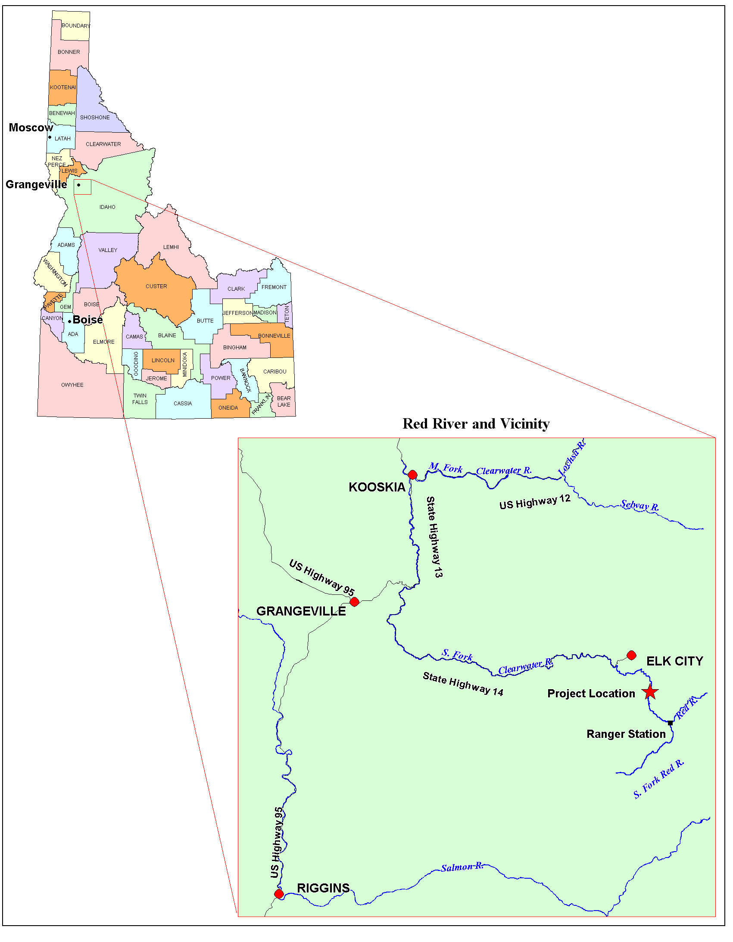
Figure 1. Location of the Lower Red River Meadow Restoration Project.
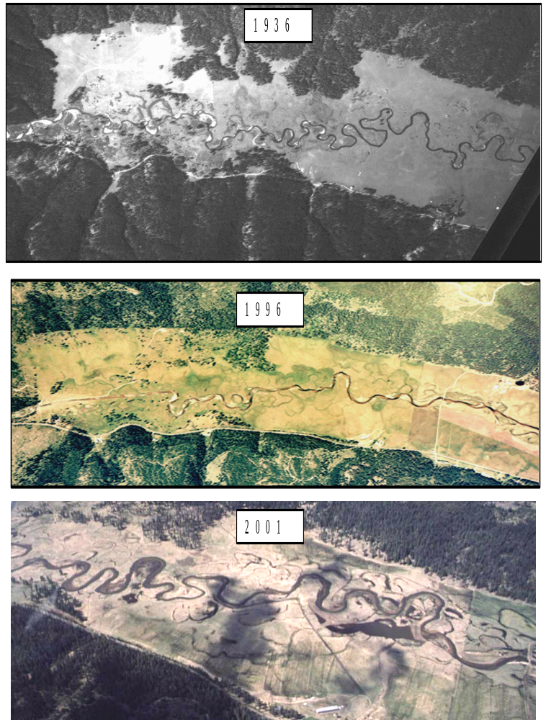
Figure 2. Aerial photographs depicting historic (1936), pre-restoration (1996), and post-restoration (2001) Red River alignments in the lower meadow.

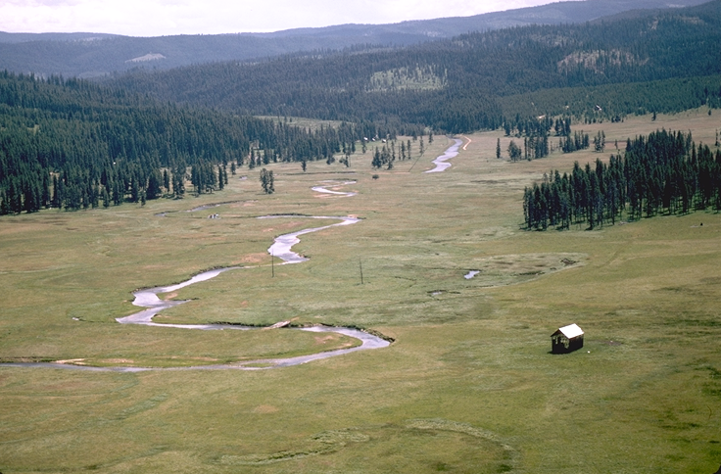
Figure 3. Close-up aerial view of the upstream portion of the Lower Red River Meadow prior to restoration work. Note the channelization and lack of a woody riparian corridor.
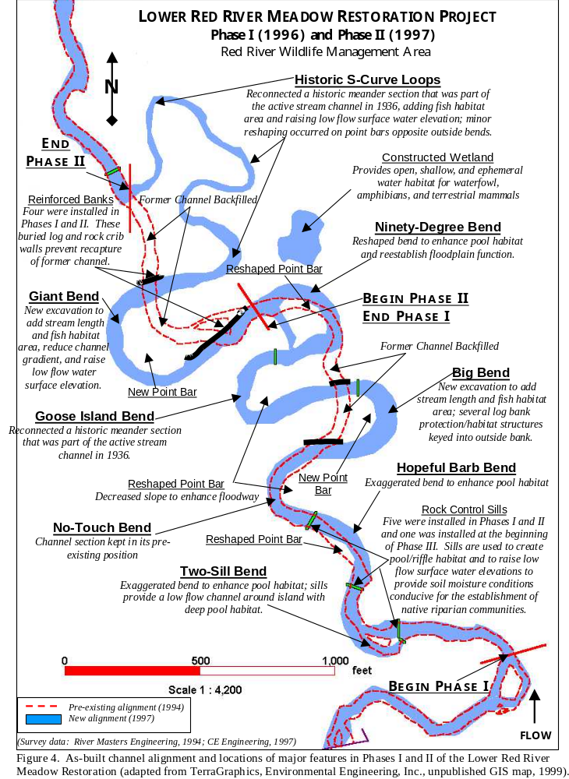
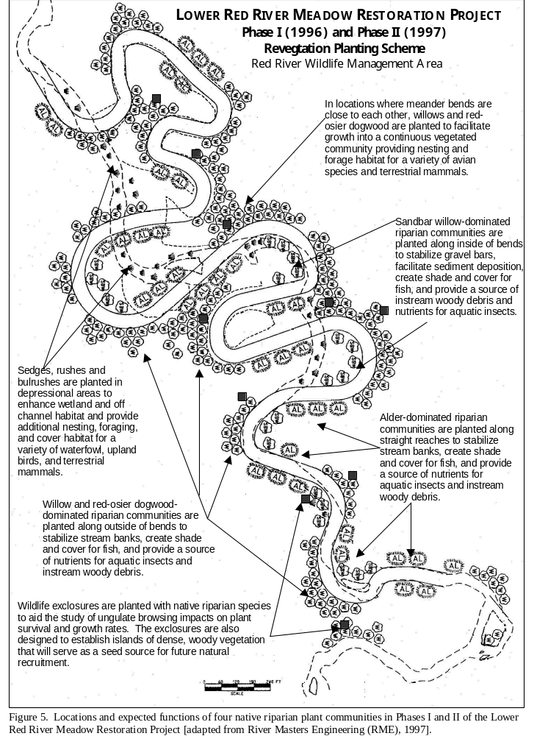
Figure 6. Channel and riparian modifications completed in Phase II and III on the Red River Wildlife Management Area (RRWMA) during the 1999 field season. (adapted from TerraGraphics, Environmental Engineering, Inc., unpublished GIS map, 1999; survey data provided by River Masters Engineering, 1994 and CE Engineering, 1997).
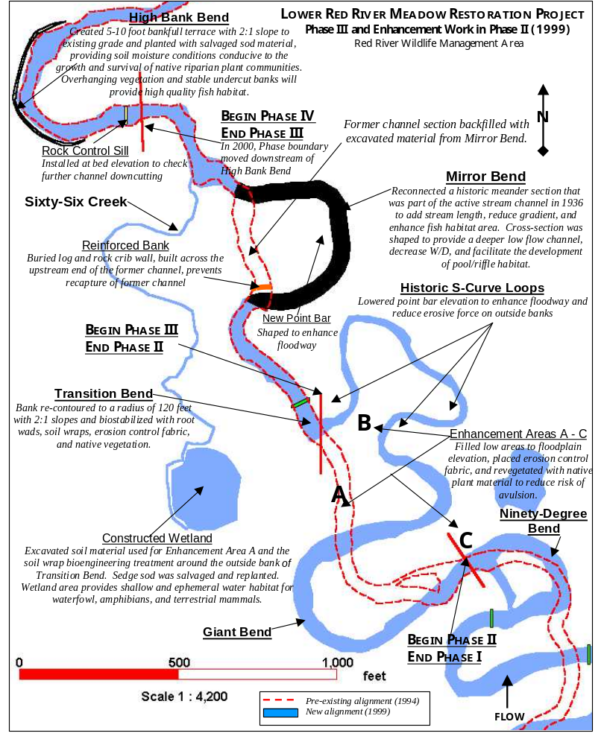

Figure 7, associated with the caption below, is available for viewing on-line only: http://boise.uidaho.edu/redriver

Figure 7. Channel and riparian modifications completed in Phase IV on the Red River Wildlife Management Area (RRWMA) during the 2000 field season. (adapted from TerraGraphics, Environmental Engineering, Inc., unpublished GIS map, 2001; survey data provided by River Masters Engineering, 1994 and UI Ecohydraulics Group, 2000).
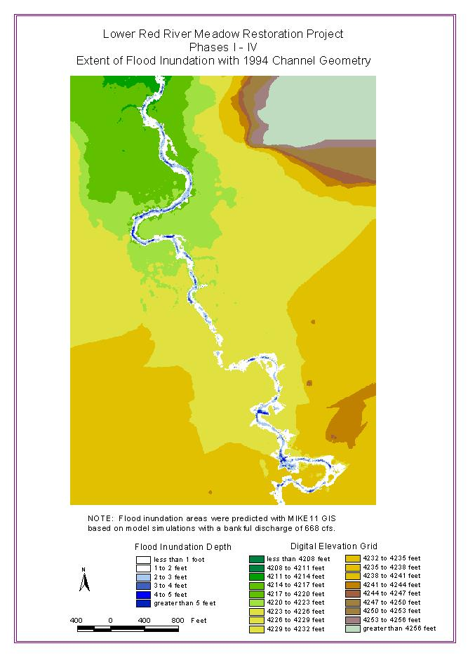
Figure 8. Areal extent and depth of inundation areas based on bankfull flow conditions (668 cfs) with the pre-restoration alignment (1994) of Red River on the Lower Red River Wildlife Management Area (map produced by UI Ecohydraulics Research Group, 2001).
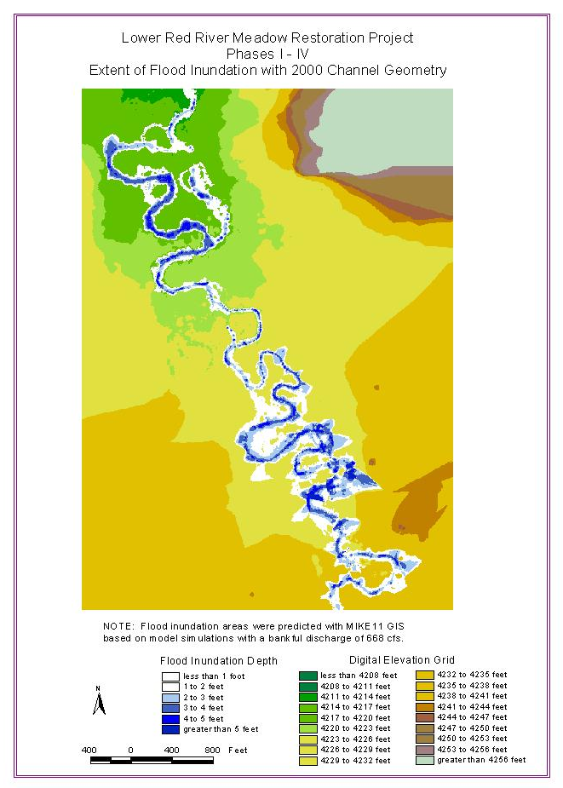
Figure 9. Areal extent and depth of inundation areas based on bankfull flow conditions (668 cfs) with the post-restoration alignment (2000) of Red River on the Lower Red River Wildlife Management Area (map produced by UI Ecohydraulics Research Group, 2001).
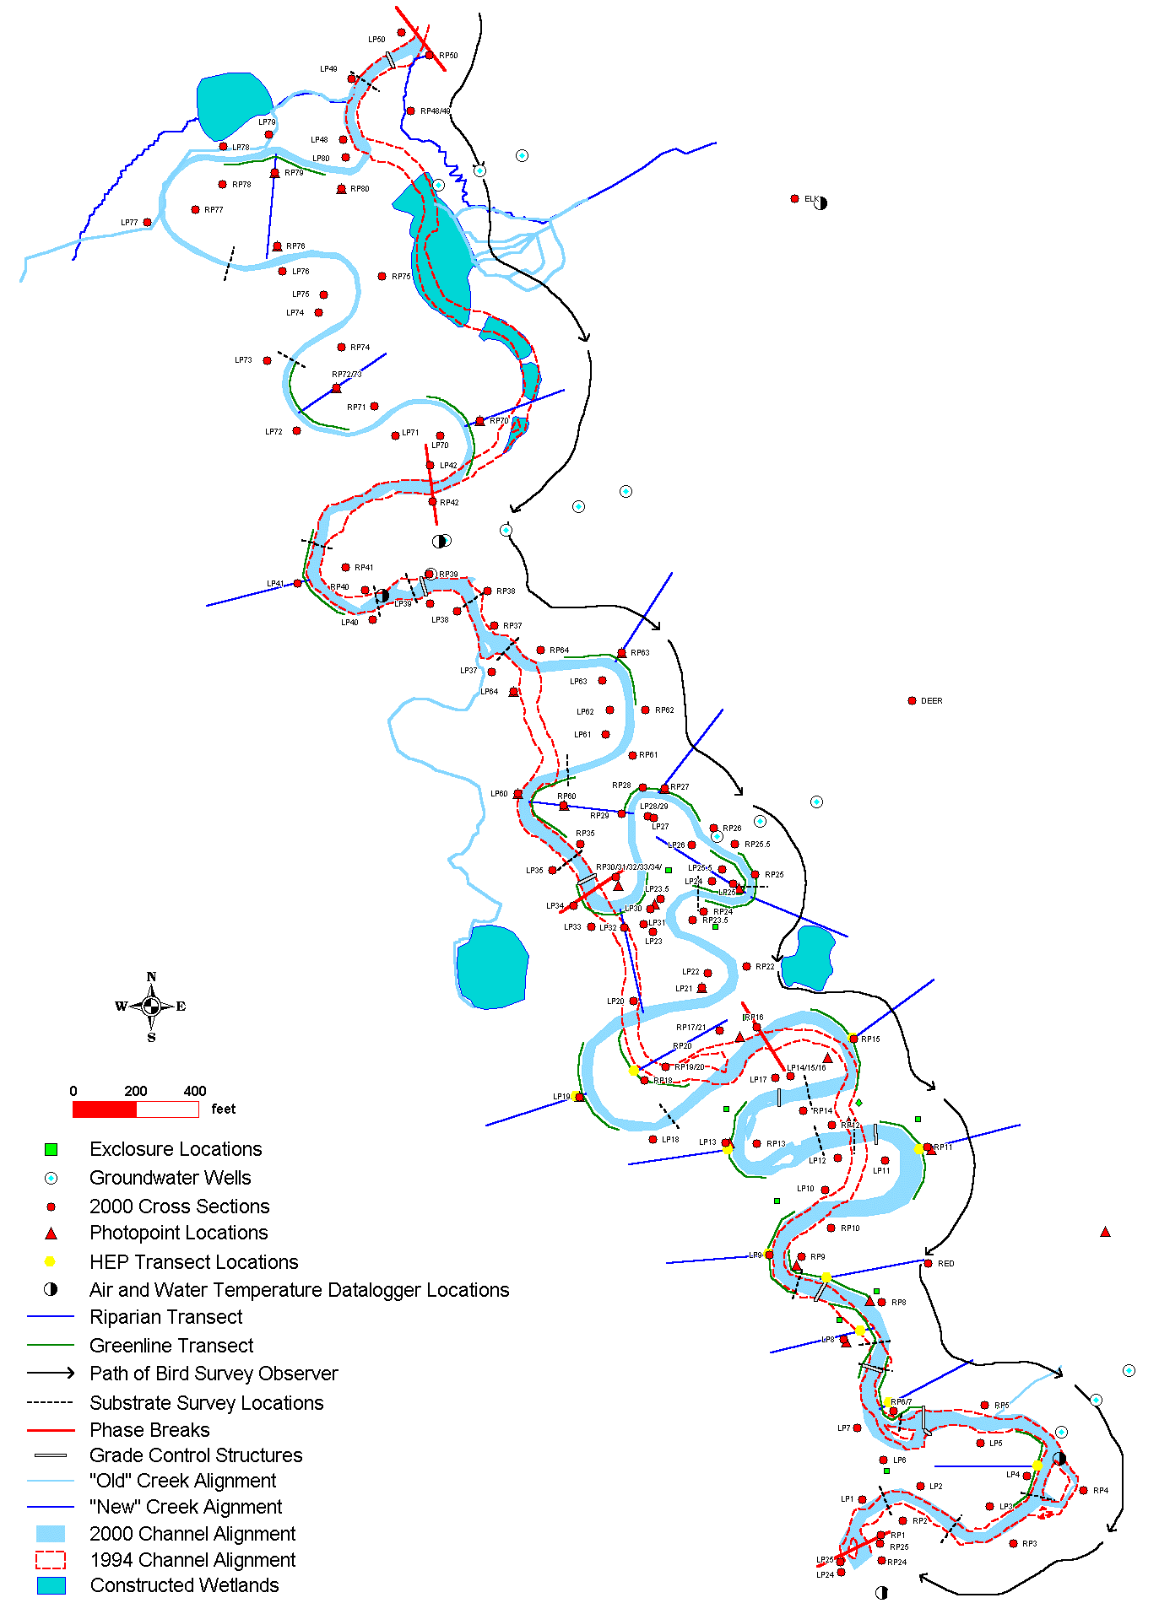
Figure 10. Overall monitoring plan map depicting locations of data collection points and transects, Phases I-IV, Lower Red River Meadow Restoration Project (map produced by TerraGraphics, Environmental Engineering, Inc., 2001; survey data provided by River Masters Engineering, 1994 and UI Ecohydraulics Group, 2000).

