Appendix C. Corps of Engineer’s Current Projects

Figures 1-4 are a mosaic of the projects arranged to show their orientation along the river. Figures 5-14 are detailed aerial photos depicting the aspects of each project.

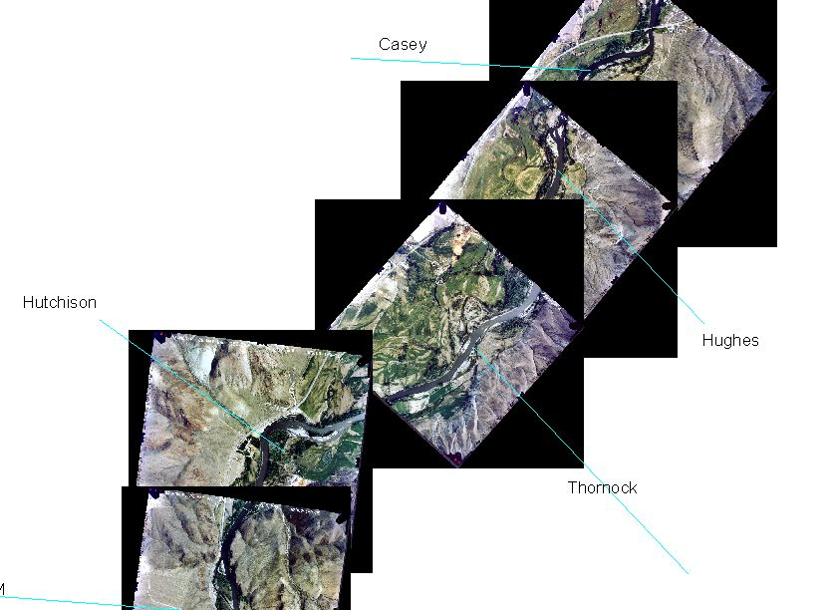
Figure 1. The first mosaic of the projects arranged to show their orientation along the river.
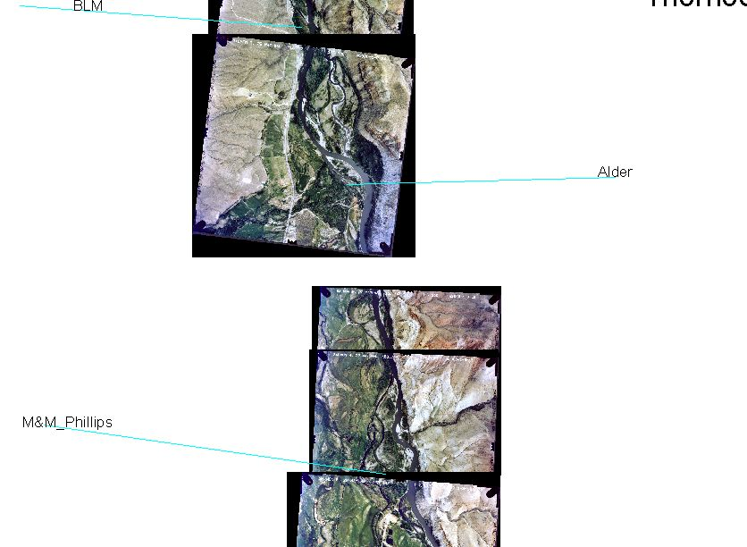
Figure 2. The second mosaic of the projects arranged to show their orientation along the river.
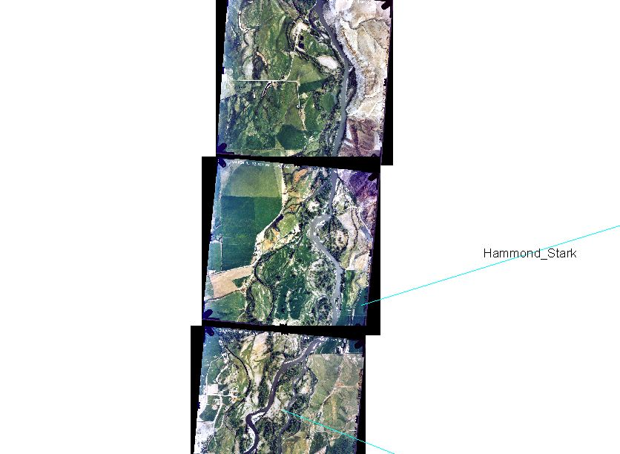
Figure 3. The third mosaic of the projects arranged to show their orientation along the river.
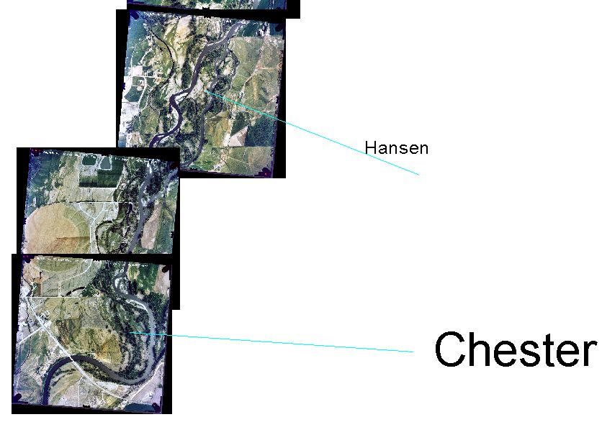
Figure 4. The forth mosaic of the projects arranged to show their orientation along the river.
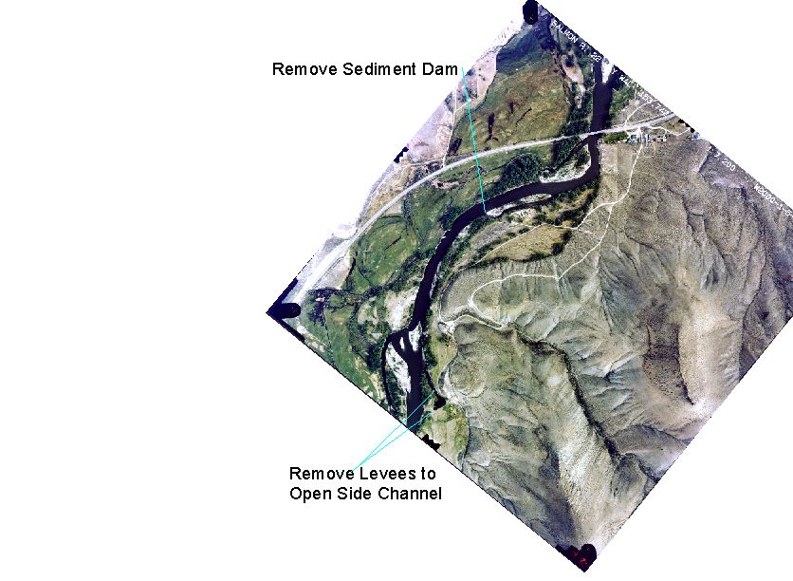
Figure 5. The project on the Casey property.

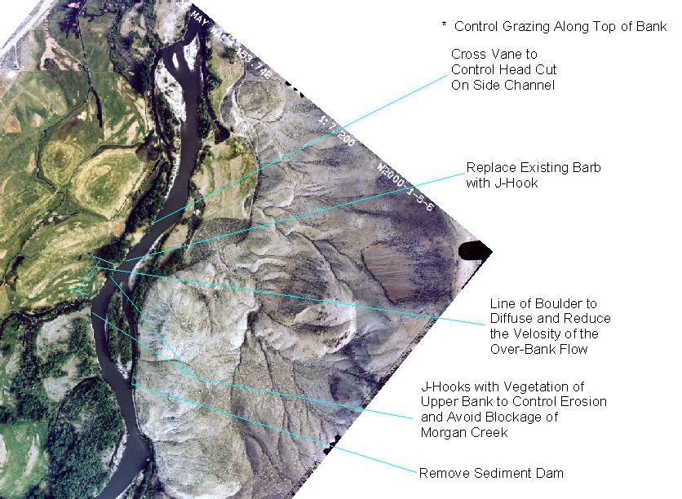
Figure 6. The project on the Hughes property.

