Bonneville Power Administration

FY 2002 Provincial Project Review

PART 2. Narrative
Project ID: 28048

Title: Protect and Restore the Crooked Fork to Colt Killed Analysis Area

Section 9 of 10. Project description

a. Abstract

The Lochsa River system offers some of the highest salmon production potential in the entire Clearwater Basin (Clearwater Subbasin Summary 2001). Within the Lochsa system three tributaries comprise the greatest production potential, Crooked Fork Creek, Brushy Fork, and Colt Killed Creek (White Sands) (McCullough and Espinosa 1996). The Clearwater National Forest identified streams with the highest fish values forest wide, Upper Crooked Fork, Lower Crooked Fork, Brushy Fork, and Lower White Sand (Colt Killed) ranked first, fourth, fifth, and sixth respectively. The Analysis Area provides critical spawning and rearing habitat for bull trout (Salvelinus confluentes), spring chinook (Oncorhynchus tshawytscha), and Snake River summer steelhead (Oncorhynchus mykiss). In addition, the drainages represent a stronghold for westslope cutthroat trout (Oncorhynchus clarki lewisi) and rainbow trout (Oncorhynchus clarki). Past management activity has degraded habitat and jeopardized stream production potential. The primary factors limiting production are sediment, temperature, loss of large woody debris, and inadequate fish passage (CNF in press). This project will initiate protection and restoration of habitat within this Analysis Area. The Nez Perce Tribe believes that effective restoration projects must be approached from a watershed scale; consequently, this project must begin with an Ecosystem Analysis at the Watershed Scale. This assessment will be coordinated through the three major management stakeholders in the Analysis Area: Nez Perce Tribe, Clearwater National Forest, and Plum Creek Timber Company. The assessment will direct restoration activity to be conducted in subsequent years. Restoration activity will include reducing road densities, providing fish passage, restoring riparian areas, controlling exotic plants, and may include stream channel improvements.

b. Technical and/or scientific background

Crooked Fork to Colt Killed Analysis Area is located within the Lochsa River Drainage, tributary to the Middle Fork of the Clearwater River (figure 1). The Analysis Area includes 272,613 acres with the Clearwater National Forest managing 87% and Plum Creek Timber Company owning 13% of the land (figure 2). There are 439 stream miles, with over 200 fish-bearing miles providing potential spawning and rearing habitat. The streams in the Analysis Area are known to support populations of spring chinook salmon (Oncorhynchus tshawytscha), Snake River steelhead (Oncorhynchus mykiss), bull trout (Salvelinus confluentes), westslope cutthroat trout (Oncorhynchus clarki lewisi), and rainbow trout (Oncorhynchus clarki) (Clearwater Biostudies various years).

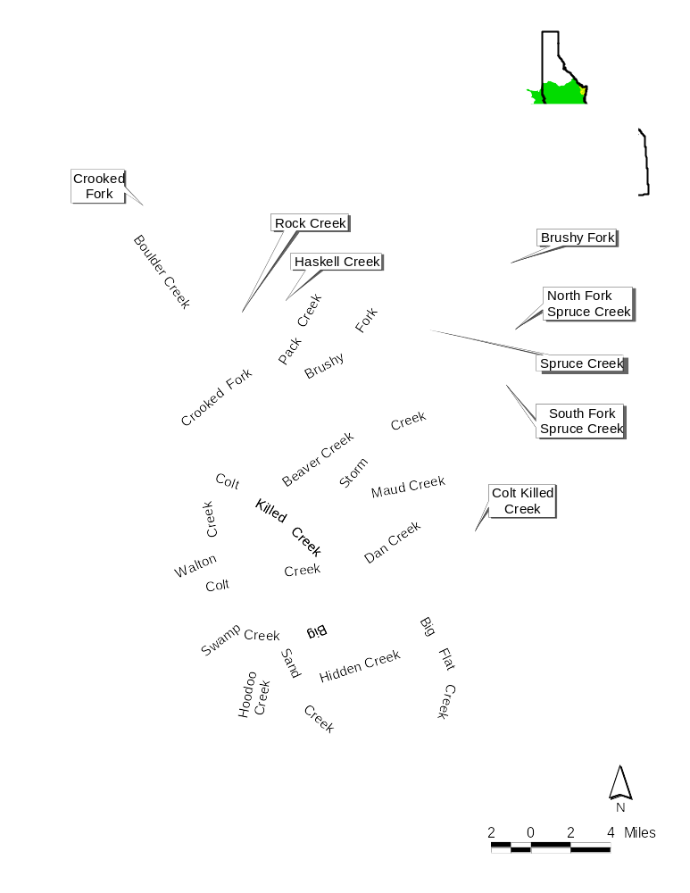
Figure 1. Detail of the Crooked Fork Creek to Colt Killed Analysis Area with location reference map. The green shaded area represents the Nez Perce Tribe Ceded Territory.
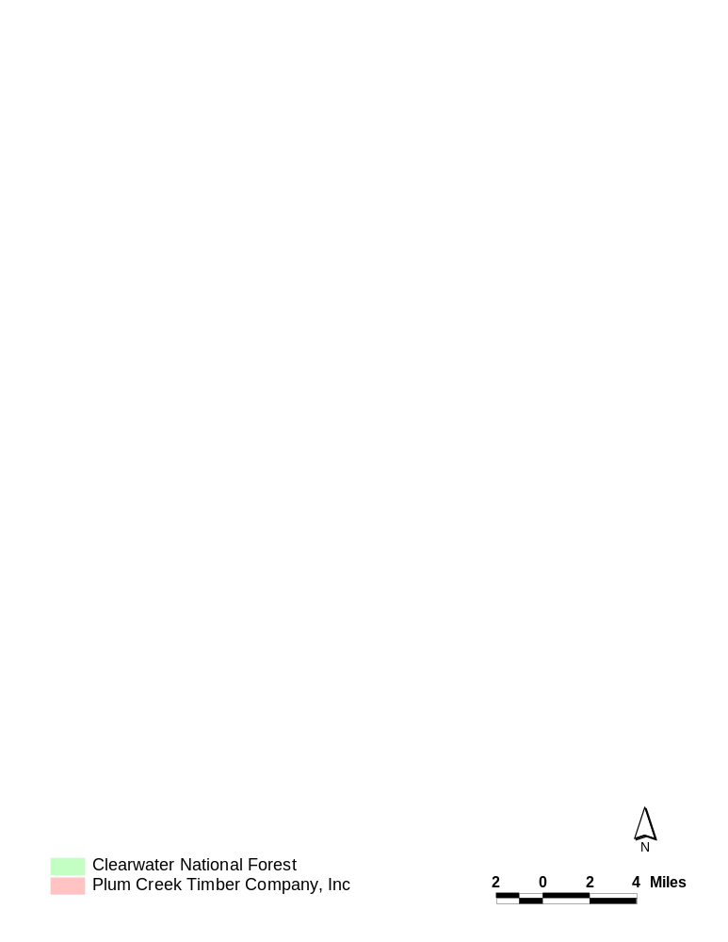

Figure 2. Land ownership in the Analysis Area.

Supporting threatened populations of anadromous and resident fish requires protection and restoration of the habitat provided by the headwaters of the Lochsa. Crooked Fork, Brushy Fork and White Sand Creek (renamed Colt Killed Creek) comprise some of the greatest salmon habitat potential in the entire Clearwater Basin (McCullough and Espinosa 1996). Crooked Fork and Brushy Fork have been cited as two of the most important anadromous salmonid producing streams in the State of Idaho (CNF 1999). Colt Killed Creek provides 10% of the Clearwater National Forest’s total habitat available to chinook salmon and steelhead trout. In a recent evaluation, the Clearwater National Forest ranked streams according to fish values forest wide: Upper Crooked Fork, Lower Crooked Fork, Brushy Fork, and Lower White Sand (Colt Killed) were the first, the fourth, the fifth, and the sixth priority respectively.

The legacies of past management activities and impacts from current management activities threaten critical habitat in the Analysis Area. The 2001 Clearwater Subbasin Summary identifies primary limiting factors to fish productivity within the Lochsa Assessment Unit to be out-of-basin factors (e.g. dams and ocean conditions), increased water temperature, sedimentation, loss of instream cover and riparian habitat, impacts from upland disturbances, exotics, and lack of connectivity and passage.

Stream surveys conducted in the Analysis Area identify primary limiting factors to fish production to be high cobble embeddedness, lack of large woody debris (LWD), lack of riparian cover, poor quality and frequency of pools, nutrient deficits, and migration barriers.

Table 1. Factors limiting fish production for selected individual streams in the Analysis Area.

Stream Name | Date of  Survey | Limiting Factors Identified By Habitat Survey  (compiled in CNF in press)
Crooked Fork | 1994 | •Lack of LWD and pools  •Lack of winter habitat  •Loss of productivity resulting from nutrient deficit
Haskell | 1996 | •High cobble embeddedness  •Poor quality pools  •Migration barriers  •Low nutrient levels
Rock | 1996
Brushy Fork | 1993 | •Poor quality pools  •Migration barriers
Spruce Creek | 1994 | •Poor winter conditions (natural)  •Poor quality and infrequent pools  •Lack of LWD  •High cobble embeddedness
Colt Killed (White Sand) | 1994-1995 | •High cobble embeddedness*  •Poor over-wintering habitat  •Migration barriers  •Low nutrient levels  *localized, may be natural

The current limiting factors result from management practices. The majority of the Analysis Area was and is managed for timber harvest. The harvest itself and the activities associated with harvest such as road building contributed to the sedimentation resulting in high cobble embeddedness (above 30% embedded) and poor quality pools, the loss of riparian cover and complexity of pool structures, the limited large woody debris, and the migration barriers. Logging roads built in riparian areas contribute to the loss of available woody debris and riparian cover (CNF 1999). There is some documentation that suggests that stream clean-outs removing large woody debris occurred in the Analysis Area in the early 1970’s (CNF 1999). Data on temperature is not sufficient to determine whether temperature is a limiting factor (CNF 1999). However, Crooked Fork, Brushy Fork, and Colt Killed Creek are tributary to the Lochsa River which is a 303(d) listed stream for temperature. More investigation is needed to determine natural fluctuations in temperature, sedimentation, and presence of large woody debris.

Estimates for the Analysis Area show the road densities to be among the highest in the Clearwater Subbasin. Using current data, average road densities are estimated to be from 5 to 7.5 miles/mi² (Clearwater Subbasin Summary 2001) (figure 3).

Roads can create watershed disturbances by increasing sedimentation through mass wasting and surface erosion. Surface erosion occurs on all roads but particularly from roads that do not receive regular maintenance (Reid and Dunne 1984, Luce and Black, 1999). Surface erosion introduces fine sediments into streams degrading spawning and rearing habitat. The steep slopes and geology of the Analysis Area also make the area at risk for mass failure from roads (McClelland et al 1997). Road prisms intercepting runoff on steep slopes and failing drainage structures increase the probability of landslides initiating from roads (Montgomery 1994). Mass failures from roads introduce catastrophic, unnatural levels of sediment into streams.

The steep slopes, geology, aspect, and precipitation of the Analysis Area create a high risk for delivery of management-associated sedimentation to fish bearing streams. The location of the roads in the highest risk areas jeopardizes the condition of critical spawning and rearing habitat. Roads in the Analysis Area have a high potential for sedimentation from both surface erosion and mass erosion. Figures 4 to 7 show the predicted high-risk areas based on Clearwater National Forest land system inventories. Figure 8 shows the location of the 1996 landslides occurring within the Analysis Area.

Roads also restrict available habitat to terrestrial wildlife. The Clearwater Subbasin Summary (2001) identifies 13 deleterious effects of roads to wildlife; among these effects are habitat degradation, increased vulnerability to harvest, and movement barriers.

Figure 3. 800 miles of mapped roads in the Analysis Area based on aerial photo interpretation. Road coverage layer is not complete.
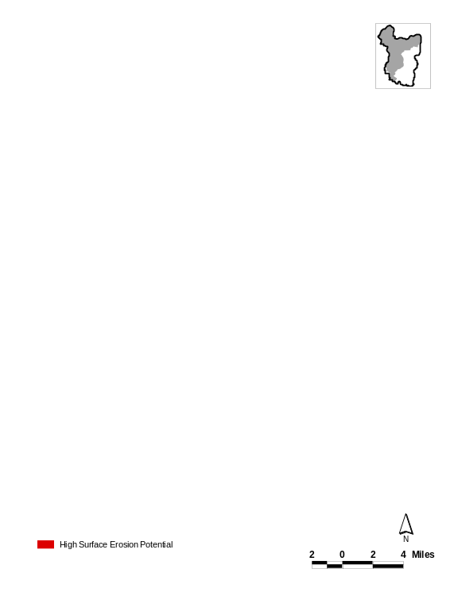

Figure 4. 40% of Analysis Area has predicted high surface erosion potential from roads and management activity.

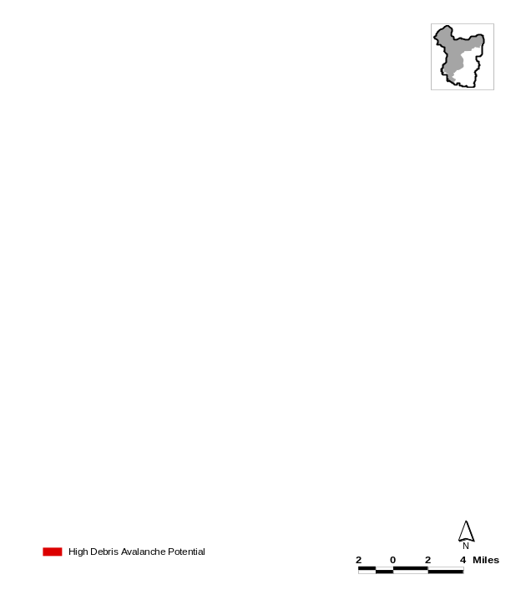
Figure 5. Areas considered at high risk for debris torrents. Highest risk areas are located above Crooked Fork Creek, which has the highest fisheries value on the Clearwater National Forest.

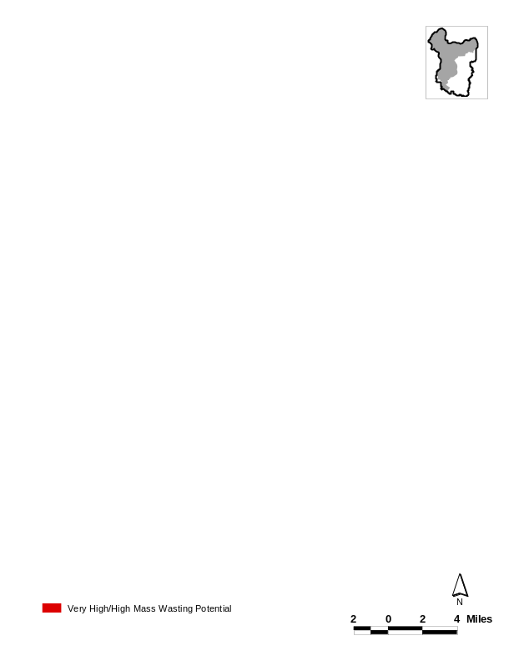

Figure 6. Locations of high landslide risk areas. Highest risk areas are located in heavily roaded areas above streams with high fisheries values.
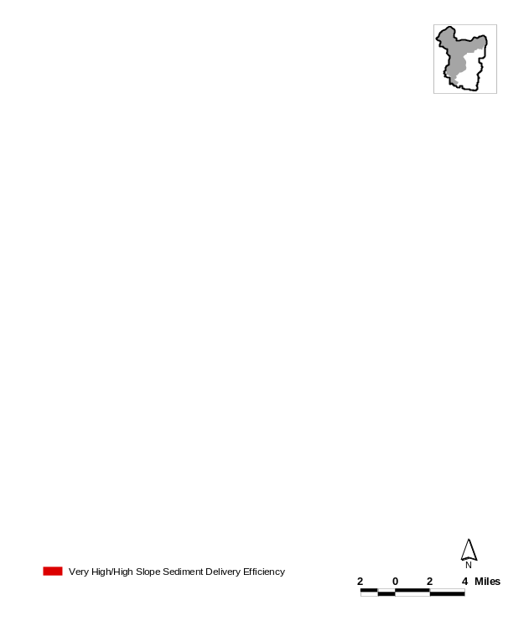
Figure 7. Areas at high risk for direct sediment delivery to streams as a result of chronic mass wasting.
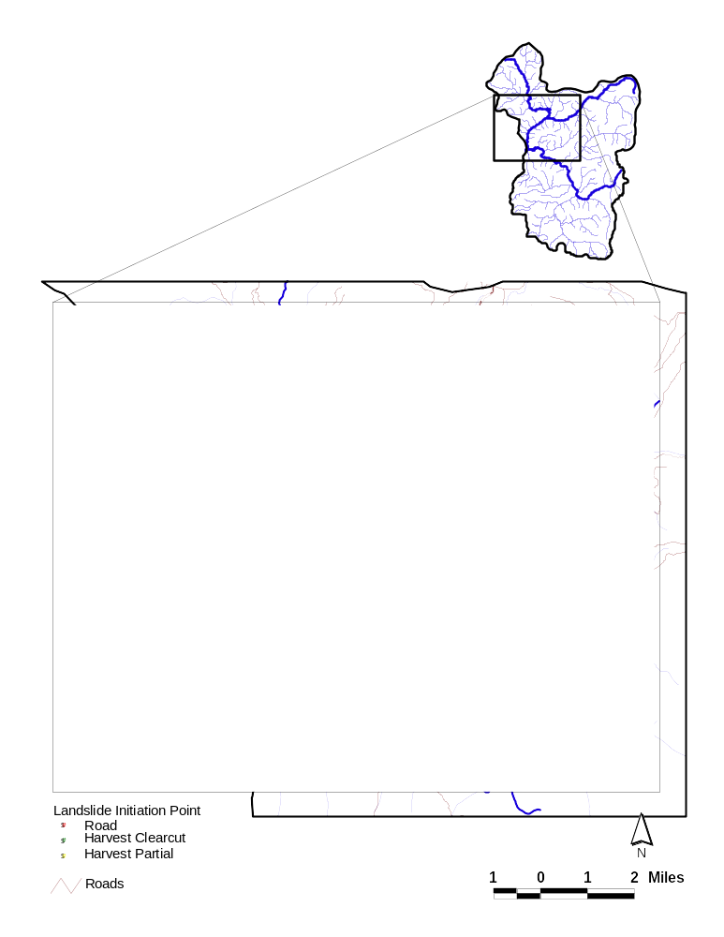
Figure 8. 1996 Landslides. 69% of landslides initiated from roads.
Culverts represent another road-associated factor harmful to aquatic resources. In general, culverts harm aquatic resources when they restrict passage and/or when they are improperly sized. Culverts that are not installed to proper stream grade often develop outlets not in contact with stream bottoms (i.e. those with waterfalls). The waterfalls do not allow passage of all life history stages of fish. In addition, movement of other aquatic species can be restricted because many organisms have no jumping ability or are too small to negotiate the height of the falls (figure 9). Undersized culverts constrict flows and increase water speeds creating high velocity barriers and eliminating substrate from culvert bottoms. Substrate, such as gravel and rocks, provide low velocity areas for organisms to rest on their upstream migration. The presence of barriers can isolate small populations, limiting or preventing genetic exchange between populations, and preventing the re-colonization of historic or recovering habitats.

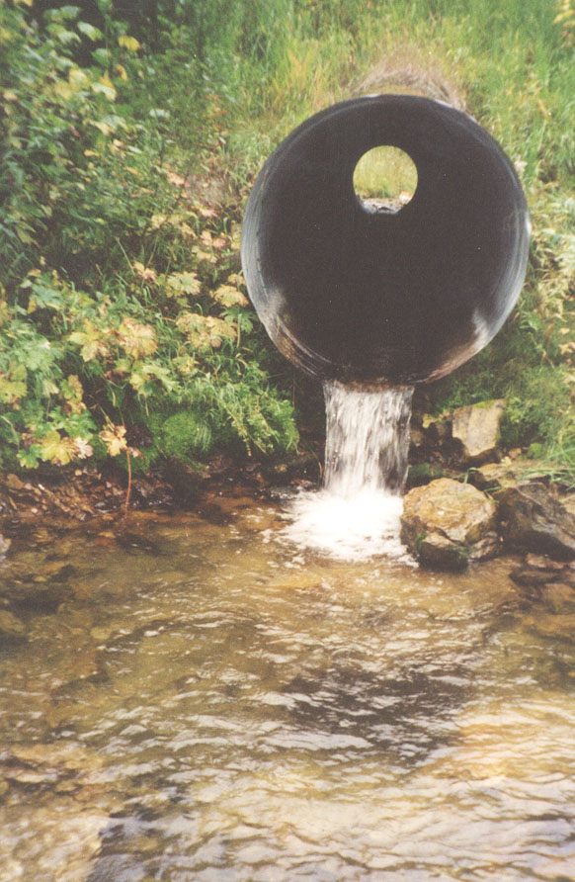
Figure 9. Example of a barrier culvert in the Upper Lochsa

Culverts also limit or prevent seasonal upstream movement by fish. Juvenile salmon and trout living in large rivers or streams often seek refuge in small tributary streams during high water events. Without access to refuge habitats, fish may be washed downstream into poor quality or overcrowded habitats. This could reduce the chances for survival for both individuals and for populations, including those already on the Endangered Species list.

Improperly sized culverts not only create passage barriers, but they also jeopardize the integrity of the road. Culverts that do not receive maintenance can cause saturation of roads and subsequent mass failure (Furniss et al 1997). Historically, most culverts were sized to accommodate 25 to 50 year storm events. In many cases, this sizing is not adequate to handle water and wood movement during large flood events. In the Lochsa, most roads served as logging access only and were abandoned after the completion of logging. Since drainage structures were intended to be temporary, culverts were frequently made of logs, and only in rare cases were any culverts consistently maintained. Most of these culverts in the Upper Lochsa are now failing or have failed. Mass failures and smaller chronic failures have been initiated where runoff collects and saturates the fillslopes (figure 10).

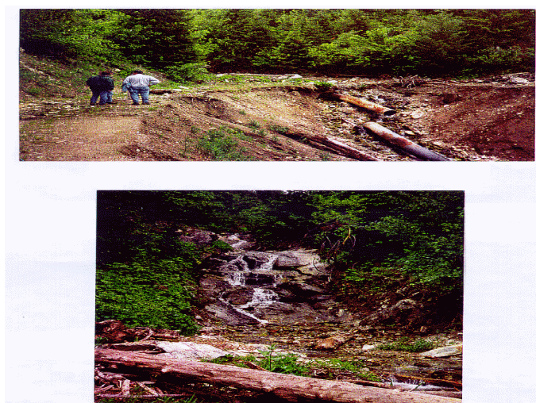
Figure 10. Mass failure in the Upper Lochsa associated with culvert.

Culvert inventories for the Clearwater Subbasin have not been completed; however, preliminary inventories suggest fish barriers will be a significant limiting factor to fish populations (Clearwater Subbasin Summary 2001). Preliminary data compiled by the Clearwater National Forest in the Crooked Fork to Brushy Fork drainages estimate that there are 307 culverts, with most of these culverts acting as barriers to fish.

While the factors limiting sustainable fish populations are known, the exact extent and watershed scale areas where restoration activity is needed have not been thoroughly examined. The Clearwater Subbasin Summary (2001) calls for watershed scale assessments to facilitate integrated resource management and planning efforts. This kind of assessment for Crooked Fork to Colt Killed Analysis Area will evaluate watershed conditions and identify factors limiting both fish and terrestrial wildlife. The results of the analysis will direct and target restoration activities.

The Ecosystem Analysis at the Watershed Scale (EAWS) will evaluate the condition of the entire Analysis Area using a holistic ridgetop to ridgetop approach incorporating both aquatic and terrestrial conditions. Baseline data on terrestrial, aquatic, and cultural resources will be compiled and used to describe current watershed conditions, patterns of use by humans and wildlife, reference conditions, and will recommend changes to management activities including a restoration plan for all species. Key components of the EAWS include assessing current fish habitat and population status, completing a roads analysis with a transportation plan, assessing fish passage barriers, and determining the extent of noxious weed invasions.

Implementation of watershed restoration projects will be directed by the recommendations developed in the EAWS. Some recommendations will require further planning, such as decommissioning unneeded logging roads in a particular section. This will require detailed road inventories in order to develop a prescription for decommissioning.

In order to effectively improve fish habitat conditions in the Crooked Fork to Colt Killed Analysis Area, land managers must coordinate activity. At the same time the Clearwater National Forest and the Nez Perce Tribe are producing the EAWS and developing a transportation plan, Plum Creek Timber Company will be completing a similar analysis for sections they own. Plum Creek Timber Company will perform these analyses as a part of their obligations under the Native Fish Habitat Conservation Plan. The three parties have agreed to come together at the completion of the respective analyses in order to coordinate restoration efforts such as decommissioning of roads and culvert replacements in areas where there is a shared interest.

c. Rationale and significance to Regional Programs

The streams in Crooked Fork to Colt Killed Analysis Area provide critical habitat to ESA listed summer steelhead and bull trout (CNF 1999, McCullough and Espinosa 1996). Implementing an Ecosystem Analysis at the Watershed Scale followed by restoration work will protect, restore, and return critical habitat to Snake River steelhead, spring chinook salmon, bull trout, and westslope cutthroat trout. By beginning the restoration effort with a comprehensive analysis, restoration projects will target areas with the most immediate needs. In addition, the guiding analysis will coordinate projects beneficial to both fish and wildlife. The Nez Perce Tribe, the Clearwater National Forest, and Plum Creek Timber Company (PCTC) have identified the Analysis Area as a high priority. Each agency agrees that there is an immediate need to complete analysis work and begin working together to develop partnering agreements on restoration work. The implementation of the restoration work will meet the goals and objectives defined by the 2001 Clearwater Subbasin Summary, the 2000 Columbia Basin Fish and Wildlife Program, the 2000 FCRPS Biological Opinion, and the FCRPS Conservation of Columbia Basin Fish: Final Basinwide Salmon Recovery Strategy.

Clearwater Subbasin Summary 2001

The Crooked Fork to Colt Killed Creek Analysis Area falls within the Lochsa Assessment Unit (LAU). The summary outlines in-basin assessment unit scale factors limiting the production of westslope cutthroat, bull trout, steelhead, chinook, and lamprey. For the LAU, limiting factors include temperature, sediment, instream cover, watershed disturbance (such as mining, timber harvest, and roading), habitat degradation, exotic introgression for bull trout and westslope cutthroat, and connectivity or limited passage to habitat for steelhead and chinook. At this time there is not enough data to determine limiting factors for lamprey.

The Summary defines needs for the fish and wildlife populations. The proposed restoration effort in the Analysis Area will satisfy the following defined needs, as compiled in the Fish and Wildlife Needs section, p.247.

Combined Aquatic and Terrestrial Needs
•Continue to develop watershed assessments at multiple scales to facilitate integrated resource management and planning efforts. (#13)
•Support timely updates of resource inventories related to land use plans to further prevent degradation of wetlands, floodplains, and other sensitive areas. (#12)
• Complete road inventories to assess impacts to aquatic and terrestrial resources. Use this information to facilitate transportation planning and reduce road densities. (#7)
•Continue and expand cooperative/shared approach to research, monitoring and evaluation. (#8)
•Protect existing pristine and key fish and wildlife habitat. (#10)
•Complete detailed 6th code subwatershed assessments to ground truth existing regional databases. (#11)

Fisheries and Aquatic Resources
Water Quality
•Reduce stream temperature, sediment and embeddedness to levels meeting appropriate standards for supporting self-sustaining populations of aquatic species. (#2)
Habitat/Passage
•Protect and restore riparian and instream habitat structure, form and function to suitable holding, spawning and rearing areas for anadromous and resident fish. (#1)
•Protect, restore and create riparian, wetland, and floodplain areas within the subbasin and establish connectivity. (#2)
•Restore a more normal hydrograph to altered watersheds. (#4).
•Inventory natural and artificial passage barriers within the subbasin and evaluate if removal or modification is warranted. (#5)
•Complete culvert inventory and assess passage and associated flow issues. (#7)
Resident Fish
•Assess the status of native species that have received little attention to date. (#2).

Wildlife and Terrestrial Needs
General
•Research broad ecological relationships and identify limiting factors for focal and other wildlife species within the subbasin. (#2)
Riparian communities
• Inventory, map, and assess the distribution of riparian and wetland communities. (#1)
Noxious Weeds
• Inventory and map the distribution of exotic weeds. (#1)
•Develop and use restoration techniques for noxious weed infested communities. (#2)
•Continue control programs for noxious weeds to restore natural habitat conditions. (#3)

In addition to defining needs for improving fish and wildlife numbers, the Clearwater Summary compiles the goals and objectives of agencies within the subbasin. The proposed restoration and protection effort meets the stated goal and objectives of many entities within the Clearwater Subbasin. These goals and objectives are detailed in the Goals and Objectives section of the Summary, p.204. The following is a summary of the common goals and objectives stated by the Nez Perce Tribe, the Clearwater National Forest, Idaho Fish and Game, and Idaho Department of Environmental Quality.

Nez Perce Tribe (NPT)

The Nez Perce Tribe Fisheries/Watershed program (NPTFW) approaches projects from a holistic, ridgetop to ridgetop perspective, encompassing all parts of the ecosystem. The overarching goal of the fisheries watershed program is to restore fisheries to levels commensurate with historical, cultural, and economic practices of the Nez Perce Tribe. Implementation of this project allows the Nez Perce Tribe to take an active role in restoring critical habitat required to support traditional fisheries.

Clearwater National Forest (CNF)

The Clearwater National Forest emphasizes a management goal to maintain high quality stream habitat and to rehabilitate degraded streams. Their management directive requires protecting water quality, stream channel integrity, and maintaining natural sediment and hydrologic regime. To meet their goals and objectives, the Clearwater National Forest will continue to collect data necessary to assess watershed health and they will support watershed restoration efforts such as road obliteration and culvert replacement. Currently the streams within the Analysis Area are not meeting the Clearwater National Forest Plan habitat and water quality standards for fish bearing streams. Implementing restoration work in the Crooked Fork to Colt Killed Analysis Area project will help the Clearwater bring these streams back into compliance with Forest Plan standards. By working cooperatively with NPT and PCTC the CNF will be more successful in meeting their management directive.

Idaho Department of Environmental Quality (IDEQ)

The Crooked Fork to Colt Killed Analysis Area project meets the stated goal of restoring cold-water biota. The project proposes riparian restoration that will reduce stream temperatures in streams tributary to the 303d listed Lochsa River. In addition, restoration will improve in-stream habitat and general watershed condition by restoring natural sediment regimes.

Idaho Department of Fish and Game (IDFG)

Idaho Fish and Game states the goal of protecting all fish and wildlife species and preserving Idaho’s rare species while rebuilding naturally reproducing populations of anadromous fish. By targeting ESA listed species of steelhead and bull trout as well as providing benefits to spring chinook and resident fish, the proposed project supports IDFG objectives.

Northwest Power Planning Council
2000 Fish and Wildlife Program (FWP)

The vision of the Northwest Power Planning Council calls for mitigating adverse effects to fish and wildlife species caused by the operation and development of the hydrosystem, producing a diverse, productive community of fish, and providing for tribal trust and treaty right harvest as well as non-tribal harvest. Implementation of the vision requires protecting and enhancing habitat and species assemblages compatible with the altered ecosystem. The planning program developed from this vision statement is a habitat based program. The implementation of the Crooked Fork to Colt Killed Analysis Area will support the vision of the FWP and its planning assumptions.

The FWP is divided into overarching objectives and basin level biological objectives. The proposed restoration projects are habitat based restoration efforts that fully support the stated FWP biological objectives including plans to restore anadromous fish, substitute for anadromous fish losses, restore resident fish losses, and restore wildlife losses.

There are four stated overarching objectives. The overarching objectives of the FWP are consistent with the focus and intent for the Crooked to Colt Killed Analysis Area project, these include:

1. Restoring the Columbia River Ecosystem to sustain an abundant, productive, and diverse community of fish and wildlife.
2. Mitigation across the basin for the adverse effects to fish and wildlife caused by the development and operation of the hydrosystem.
3. Maintain sufficient populations of fish and wildlife for abundant opportunities for tribal trust and treaty right harvest and for non-tribal harvest.
4. Recovery of ESA listed species affected by hydrosystem.

The basin level biological objectives supported by the proposed restoration in the Crooked Fork to Colt Killed Creek Analysis are as follows:

Anadromous Fish
The FWP emphasizes halting declining trends in salmon and steelhead population by restoring the widest possible distribution of naturally reproducing salmon and steelhead. Restoring and protecting the critical habitat in the Analysis Area supports this biological objective. The FWP also calls for substituting for losses to anadromous populations by improving resident fish populations.

Resident Fish
FWP biological objectives call for restoring healthy ecosystems and watersheds to preserve functional links among ecosystems, as well as expanding habitat to increase resident fish populations. The implementation of project work in the Analysis Area focuses on holistic watershed restoration including all stakeholders, addressing not only in-stream habitat improvements but treating watershed scale problems as well. Watershed scale problems include high road densities, degraded riparian areas, and invasions of noxious weeds. Restoring and protecting critical habitat within the Analysis Area benefits not only steelhead and spring Chinook, but also benefits resident rainbow trout, protects bull trout, and westslope cutthroat trout.

Wildlife Loss Mitigation
The FWP states that wildlife mitigation activities should be coordinated throughout the basin with fish restoration projects emphasizing connectivity of aquatic and terrestrial habitats. By beginning with a detailed watershed scale analysis of Crooked Fork to Colt Killed, wildlife needs and limiting factors will be included in prescriptions for watershed restoration.

2000 FCRPS Biological Opinion (BiOp)

The Crooked to Colt Killed Analysis Area proposed restoration and habitat protection projects would help Bonneville Power Administration fulfill the off-site mitigation requirements of the BiOp. The project will support habitat restoration and protection of ESU Snake River summer steelhead in critical spawning and rearing tributaries.

Restoring and protecting the Crooked Fork to Colt Killed Analysis Area meets the following actions to avoid jeopardy:

Action 152
Action agencies will coordinate their efforts and support offsite habitat enhancement measures undertaken by other Federal agencies, states, Tribes, and local governments.

By funding project work to protect, restore, and enhance the critical fisheries habitat within the Analysis Area, the action agencies will meet part of their tribal trust responsibilities.

§9.6.2.1 Actions Related to Tributary Habitat. The proposed project coordinates projects through the major stakeholders within the Analysis Area. Coordination includes planning and cost-share between the Nez Perce Tribe, United States Forest Service, and Plum Creek Timber Company. The project will coordinate restoration and protection at the watershed scale, benefiting both fish and wildlife. The project will improve watershed health, water quality, and restore fish passage.

Action 149 and Action 150

•The project begins with an ecosystem analysis at the watershed scale assessment that will document the current condition of and recommend restoration projects for both aquatic and terrestrial ecosystems.
•Implementing analysis recommendations will help restore watershed health and degraded habitat.
•Reducing road densities will reduce chronic sedimentation into streams improving water quality and helping to bring spawning and rearing streams back into compliance with the CWA, PACFISH and CRITFC water quality standards. Reduced road densities also improves wildlife habitat by reducing fragmentation and improving forage availability.
•Beginning a control program for invasive weeds as a part of restoration projects will reduce sedimentation to streams, improve native revegetation, and provide more forage opportunities to wildlife.
•Replacing culverts that do not provide fish passage will return miles of habitat to Snake River summer steelhead and spring chinook.

§9.6.5 Research, Monitoring, and Evaluation Plan

The EAWS and implementation of projects will be coordinated with and tracked by monitoring and evaluation of watershed recovery. The data collected during the watershed monitoring program and for the watershed scale analysis will be used to assess current stream habitat condition, assess the population status of anadromous and resident fish, evaluate environmental status, and determine whether management activity complies with water quality standards. After the analysis is completed, monitoring will continue to evaluate watershed response and recovery.

§9.6.5.3.4 Hatchery, Tier 3—Effectiveness Monitoring

Crooked Fork and Brushy Fork are both control streams for joint IDFG and NPT Idaho Supplementation Study, while Colt Killed Creek is a treatment stream. The study examines the success of re-introduced spring chinook. The in-stream monitoring component of the study investigates habitat types and fish abundance. Restoring and returning spawning and rearing habitat in Crooked Fork, Brushy Fork, and Colt Killed will advance the causes of this effectiveness monitoring study.

United States Fish and Wildlife Service (FWS)

For the Clearwater Subbasin, FWS states their goal as, “to mitigate and compensate for fish and wildlife resource losses caused by the construction and operation of the four lower Snake River dams and navigation lock processes” (NWPPC 2001). Specifically they state the objective of returning 21,200 spring/summer chinooks and 14,000 summer steelhead to provide for tribal and non-tribal harvest opportunities. This project will help FWS comply with tribal trust responsibilities. Because the Crooked Fork, Brushy Fork, and Colt Killed drainages provide critical spawning and rearing habitat for summer steelhead and spring chinook, implementing the restoration work in these drainages will improve and return habitat to these anadromous fish. This will advance FWS efforts to meet their goals and objectives in the Clearwater subbasin.

Conservation of Columbia Basin Fish: Final Basinwide Salmon Recovery Strategy (SRS)

Implementation of the Crooked Fork to Colt Killed Analysis Area project will help federal agencies comply with habitat objectives detailed in the SRS. Crooked Fork, Brushy Fork, and Colt Killed Creeks are tributary to the Lochsa River, which is tributary to the Middle Fork of the Clearwater. The Middle Fork is identified as a priority area for restoration by the SRS.

Compliance with Habitat Goal: Restore Tributary Habitat and the Fast Start Imperative
The project will begin with a watershed scale assessment coordinated between the three major stakeholders in the Analysis Area, NPT, PCTC, and CNF. The implementation of the assessment recommendations will forge cost-share partnerships between these stakeholders. The project will improve water quality, improve watershed health, and correct passage barriers in critical tributary habitat for ESU Snake River summer steelhead, spring chinook, and ESU bull trout.

The emphasis on habitat restoration by regional recovery directives stems mainly from the needs of threatened anadromous fish within the Columbia Basin; however, habitat restoration projects such as the proposed work in Crooked Fork to Colt Killed Analysis Area combine the needs of anadromous fish, resident fish, supports compliance with the Clean Water Act, and the Endangered Species Act. Initial planning for the proposed work has already started. An initial planning meeting forged agreements between the Nez Perce Tribe, the Clearwater National Forest, and Plum Creek Timber Company to cooperate on restoration projects where there is a common interest. The proposed work in the Crooked Fork to Colt Killed area is the foundation of this three-way partnership. Because of the diversity of benefits and the partnership between federal and non-federal land managers, the Crooked Fork to Colt Killed project work meets the Fast Start imperative.

Crooked Fork and Colt Killed Creek form the headwaters of the Lochsa River. The mainstem Lochsa is a 303(d) listed stream for temperature. Implementing riparian restoration in the upper tributaries of the Lochsa may help lower the temperature in the mainstem river. In addition to supporting CWA compliance, the proposed work will help force compliance with the ESA. In order to comply with its obligations under the ESA, Plum Creek Timber Company will be implementing the goals of their Habitat Conservation Plan. Partnering on restoration projects will help PCTC and the CNF protect populations of listed bull trout.

Plum Creek Timber Company’s Native Fish Habitat Conservation Plan (NFHCP)

Plum Creek Timber Company (PCTC) is a major stakeholder within the analysis area. In 2000, PCTC finalized an agreement with the United States Fish and Wildlife Service and the National Marine Fisheries Service that allows PCTC the right to an incidental take of bull trout in exchange for enacting the comprehensive restoration provisions detailed in the Native Fish Habitat Conservation Plan (NFHCP). The NFHCP is based on four guiding biological objectives. Implementation of these objectives is divided out among seven categories of management and restoration commitments.

The Crooked to Colt Killed Analysis Area is located within what the NFHCP defines as priority watersheds (Tier 1 and Tier 2 watersheds). A cooperative approach to watershed restoration will meet the Legacy and Restoration Commitment #Lg8, Watershed Cooperation action, which requires Plum Creek to coordinate watershed projects with major stakeholders.

PCTC states similar objectives in the NFHCP that parallel objectives detailed by this proposal. The four biological objectives and corresponding actions are as follows.

Clean Habitat: Reduce sediment delivery to streams especially from roads. Decommission surplus roads.

Connected Habitat: Inventory and replace culverts that restrict passage for resident and anadromous fish. The culvert inventories required for the proposed Analysis Area restoration projects and watershed analysis are similar in process and in goals to the NFHCP Fish Passage inventory detailed in Appendix R-6. The goals of restoring fish passage are shared between PCTC, NPT, and CNF.

Complex Habitat: The NFHCP calls for returning a diversity of instream habitat to degraded streams in order to improve rearing habitat in streams. The EAWS will help define similar areas where passive restoration will not restore stream habitat and more active stream work will be required.

Cold Habitat: The NFHCP requires that stream temperatures be in compliance with levels to support bull trout and other native resident fish. The EAWS will determine whether temperature is a limiting factor on streams within the Analysis Area and recommend appropriate riparian restoration to encourage long-term improvements in temperature.

The four C principles are supported by all actions proposed in the Crooked to Colt Killed Analysis Area. In particular, NPT, CNF, and PCTC express similar goals for eliminating unnatural levels of sedimentation to streams by decommissioning surplus roads and reconnecting habitat to all aquatic organisms by replacing barrier culverts.

Spirit of the Salmon: Anadromous Fish Restoration Plan of the Nez Perce, Umatilla, Warm Spring, and Yakama Tribes (CRITFC 1995).

Protecting and restoring the critical habitat within the Crooked Fork to Colt Killed Analysis Area meets the four stated goals for anadromous fish within the Columbia River Basin.
1. Restore anadromous fish in rivers and streams at levels to support the historical, cultural, and economic practices of the tribes.
2. Restore degraded stream and riparian habitat in order to create healthy river systems.
3. Protect Tribal sovereignty and treaty rights.
4. Reclaim anadromous and resident fish resource and the environment on which the resource depends for future generations.

Within the Clearwater Subbasin, CRITFC details specific objectives and calls for changes in land management as well as habitat restoration actions to improve watershed and stream conditions. The Crooked Fork to Colt Killed project will support the following habitat based directives:

1. Increase anadromous and resident fish populations through tribal, federal, and state coordinated supplementation, management, and habitat restoration.
2. Restrict or eliminate land management activities such as logging, road building, grazing, and mining that are harming the health of riparian ecosystems including water quality degradation, stream habitat degradation, loss of riparian vegetation, streambank destabilization, and altered hydrology.
3. Improve water quality including reducing temperatures (for cold water biota T<60F), sedimentation, and agricultural runoff.
4. Restore riparian ecosystems.
5. Restore in-stream habitat to natural conditions.
6. Restore spawning and rearing habitat.

Burned Area Emergency Rehabilitation (BAER)

During the summer of 2000, wildfires burned over 6700 acres within the Analysis Area (figure 11). The fire started on PCTC land. The effects of the fire on watershed condition have not been thoroughly evaluated. Restoration efforts have included contour falling of trees to control surface erosion and some revegetation. In fall of 2000, CNF and PCTC coordinated efforts to remove an undersized culvert on Rock Creek on a cost-share road. The CNF funded the culvert removal and stream restoration, and PCTC agreed to install a properly sized culvert when access becomes necessary beyond the stream crossing. The Nez Perce Tribe inspected the stream crossing reconstruction. This year road condition surveys will be completed in the burned area to evaluate the impacts of burned over roads on the streams. Data from the surveys will be used in the proposed EAWS.

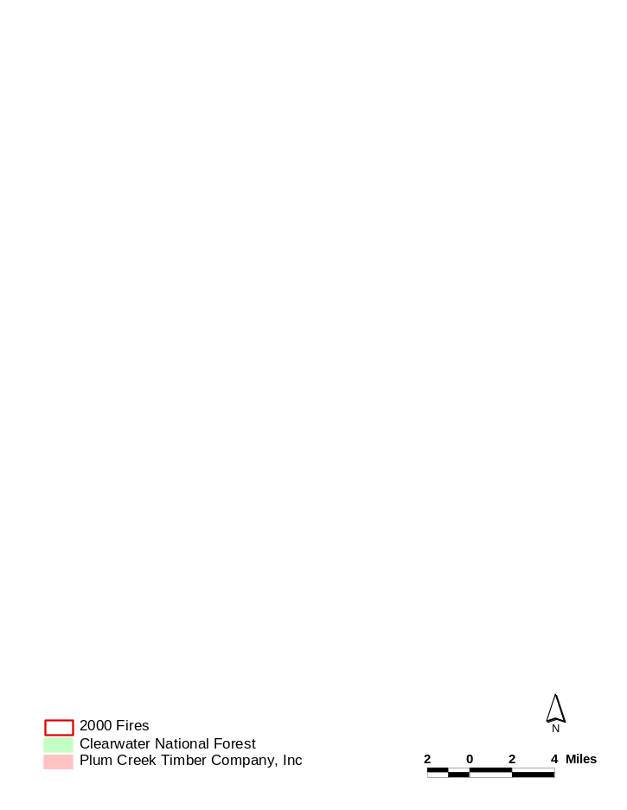
Figure 11. Locations of fires within the Analysis Area during summer of 2000. The largest fire, the Crooked Fire (located in checkerboard ownership area) is the location of BAER projects.

d. Relationships to other projects

#199607703 Protecting and Restoring the Waw'aatamnima [Fishing (formerly Squaw)] Creek to 'Imnaamatnoon [Legendary Bear (formerly Papoose)] Creek Watersheds Analysis Area

This is a comprehensive watershed restoration effort of similar scope and nature to the Crooked Fork to Colt Killed Analysis Area proposal, addressing watershed scale problems such as sedimentation associated with roads and fish barriers. Restoration projects in this Analysis Area have been ongoing since 1996. Replacement of fish barrier culverts returned miles of stream habitat to both anadromous and resident fish. Over 130 miles of failing surplus roads have been obliterated, stabilizing hillslopes and restoring watershed hydrology. The Waw’aatamnima to ‘Imnaamatnoon Analysis Area is adjacent to the Crooked Fork to Colt Killed watersheds. When addressing factors limiting to anadromous and resident fish, it doesn’t make sense to restore some streams while allowing the contiguous critical habitat to continue to degrade. Extending restoration work to drainages extending from Crooked Fork to Colt Killed Creek improves habitat within the entire Upper Lochsa, and more effectively addresses limiting habitat conditions at the ecosystem or Assessment Unit scale.

#199809802 Salmon Supplementation in Idaho Rivers

The Idaho Salmon Supplementation Studies is a cooperative research project between Idaho Fish and Game, FWS, Shoshone-Bannock Tribes, and NPT. The project examines whether salmon supplementation can be successful in producing self-sustaining populations. Within the Analysis Area, Crooked Fork and Brushy Fork are Control streams in the study, while Colt Killed is a Treatment stream for spring chinook. Successful supplementation may depend on the stream’s high quality stream habitat. Watershed restoration is critical for interpreting the results of the supplementation study.

# 19970600 Nez Perce Tribal Focus Watershed Program

The focus watershed program is a coordinated program between land managers designed to implement fish and wildlife habitat protection, enhancement, and restoration within the Clearwater subbasin. The Nez Perce Tribe Fisheries-Watershed Division and the Idaho Soil Conservation Commission share leadership within the Clearwater subbasin.

e. Project history (for ongoing projects)

this is a new project

f. Proposal objectives, tasks and methods

Within the Clearwater Subbasin, all agencies have defined the need to improve fish and wildlife habitat by the following strategies: implementing watershed scale restoration projects such as reduction of road densities and controlling invasive weeds; implementing stream scale habitat restoration such as improving bank stability, riparian area restoration; and restoring connectivity of habitat by eliminating in-stream passage barriers. In addition, there is consensus within the Clearwater Subbasin that large-scale restoration projects should begin with comprehensive ecosystem analysis.

The proposed EAWS conducted for the Analysis Area will meet the needs defined by all management agencies within the Clearwater Subbasin. The Clearwater National Forest has already begun this comprehensive Ecosystem Analysis. A complete EAWS includes chapters on the following: historic conditions and land use; current conditions, which includes all the distribution, condition, and trends of ecosystem elements; reference conditions; and restoration recommendations. The CNF has completed evaluation of current conditions for recreation use, aquatic species, and water quality. In addition, the chapter on reference conditions is completed. Information yet to be compiled includes the following: current hydrologic conditions, vegetation conditions, terrestrial species and habitat distribution, and an evaluation of human uses such as a transportation plan. Also missing are chapters on historic use and the final chapter on restoration recommendations.

Analysis Area work will begin with the completion and updating the working EAWS. Once the analysis is completed, planning for the implementation of restoration work can begin. The recommendations in the EAWS will help to target and prioritize the proposed restoration projects.

The specific project objectives and methods of implementation are detailed below.

Tasks and Methods per Objective

Objective 1: Characterize and analyze the current condition of the Analysis Area in order to guide restoration projects.

Task A. Complete and extend the Ecosystem Analysis at the Watershed Scale (EAWS) in the Crooked Fork to Colt Killed Analysis Area.
Method: EAWS are descriptive documents that characterize the current condition of management areas, defined by watershed boundaries. The area defined by the watershed boundaries from Crooked Fork Creek to Colt Killed Creek comprises the entire watershed boundary for the headwaters of the Lochsa River, which is tributary to the Middle Fork of the Clearwater. The EAWS will describe historic and current landuse, current watershed condition including aquatic and terrestrial species, reference condition, and assess the factors that are impairing ecosystem condition. The EAWS for the proposed Analysis Area has been started for the Crooked Fork to Brushy Fork drainages. To finish the document in a timely fashion the remainder of the work will be subcontracted. One FTE for the Nez Perce Tribe and one FTE for the Clearwater National Forest will be retained to guide data transfer and EAWS development for the length of the project. The CNF will provide a five member id team for two pay periods and three additional members at one-half pay period to complete the analysis and develop recommended actions to restore watershed condition as well as identify areas for further analysis.

Task B. Develop and administer EAWS contract. Collaborative effort with the CNF.
Method: Use Participating Agreement between the Nez Perce Tribe and USDA Forest Service, Nez Perce National Forest, Agreement #01-PA-11011700-035 as a model for subcontracting and sharing labor on an EAWS. Work with personnel in the legal, administrative, and contracting departments in both the NPT and CNF to develop an equitable agreement.

Task C. Oversee the data collection and composition of the EAWS. Collaborative effort with CNF. See Methods for A.

Task D. Inventory wetland areas. Collaborative effort with the CNF.
Methods: For wetland inventories, the FWS classification of wetlands will be used to delineate wetland areas. The FWS definition requires at least one positive indicator of wetlands be present for any one of the three parameters: soils, vegetation, and hydrology. This differs from the technical or legal guidelines for wetlands, which require that hydric soil, hydrophytic vegetation, and wetland hydrology all be present (USACE 1987). Inventories will be completed through aerial photo interpretation and ground truthing. Ground crews will be trained to delineate wetlands. Mapping of areas will be coordinated through the subcontractor, NPT FTE, CNF FTE, and seasonal labor. Locations will be mapped with GPS where possible and data will be compatible with GIS technology.

Task E. Inventory noxious weed invasions. Collaborative effort with the CNF.
Method: Work with EAWS subcontractor, full time personnel, and seasonal labor, to locate and map areas with noxious weeds. In addition to locations, maps will identify species and describe extent of invasion. Inventories will include presence of weeds on sections owned by Plum Creek Timber Company, since this is something that will not be included in their watershed analysis.

Task F. Complete roads analysis for all roads. Collaborative effort with the CNF.
Method: Roads analysis will follow the procedure outlined in the USDA Forest Service Roads Analysis 2001. The entire roads analysis may not be completed for all jammer roads during the first year because some ground surveys may be completed in the summer of 2002. However, the roads analysis will be completed for all system roads. Road condition surveys are in progress for both jammer roads and system roads in conjunction with Burned Area Emergency Rehabilitation (BAER) project. Data collected on roads during the BAER surveys will be used in the roads analysis.

Objective 2: Reduce sedimentation to streams from road-associated sources.

Task A. Complete a transportation plan for all roads.
Method: Using surveys, maps, and other field notes the status and future need for each road will be evaluated through an interdisciplinary team. The Clearwater National Forest will lead the development and approval of the transportation plan. The future need for each road will be evaluated comparing access needs for fire management, timber harvest, silviculture, recreation, and search and rescue with impacts to the watershed as well as maintenance costs.

Task B. Identify roads that are candidates for obliteration (also referred to as
decommissioning). Collaborative effort with the CNF.
Method: Using recommendations from EAWS, completed surveys, and the completed
Roads Analysis and Transportation Plan identify roads or road systems that are no longer needed and/or roads that are negatively impacting soil, water, or wildlife resources. Some of the jammer roads may not have completed surveys; consequently, additional surveys will be required to determine the level of obliteration required to stabilize the road.

Task C. Train survey crew. Collaborative effort with the CNF.
Methods: Pair inexperience crew persons with experienced tribal or forest employees to
learn the road condition survey methods developed by the Clearwater National Forest.

Task D. Survey roads identified as candidates for obliteration to determine the level of
treatment required to stabilize the road, reduce sedimentation, and restore drainage. Collaborative effort with the CNF.
Methods: Walk roads and collect data on road location and condition of road. Data
collected in surveys includes length of road, width of road, depth of fill material, number of drainage structures, locations of water or saturation, drainage problems on road, evidence of road failure, types of surface cover, areas of surface erosion, and types of road use such as ATV traffic, hunting trail, etc.

Task E. Map locations of roads using GPS units. Coordinated with the CNF.
Methods: Where it is possible to receive satellites, digital data collection is preferred to
string line as a method of estimating road location, road length and recording locations of failures or drainage concerns.

Task F. Using survey notes, transportation plans, maps, and aerial photos from the CNF and PCTC, identify roads not needed by each agency.
Methods: This meeting will begin the cost-share coordination process between Plum
Creek Timber Company, Clearwater National Forest, and the Nez Perce Tribe. Each agency will identify roads that are labeled as surplus. In areas of checkerboard ownership patterns many roads cross section lines and are maintained as cost-share roads. All three agencies anticipate that there will be cost-share roads identified as surplus by each party. Obliteration work in areas of common interest will be a three-way cost share and will involve coordinated labor.

Task G. Complete all NEPA and permitting processes for implementation of obliteration. Collaborative effort with the CNF.
Methods: Once roads have been identified as surplus, the NEPA process will begin before the implementation of an obliteration method. Because of the complexity of watershed management, a series of small NEPA documents may be completed in order to facilitate the decision making process for each proposed restoration project. One NEPA will cover the implementation of the road decommissioning part of the watershed restoration effort. The completion of NEPA writing will be subcontracted.

Task H. Develop partnering agreements with CNF and PCTC.
Methods: The Clearwater National Forest and the Nez Perce Tribe have a four-year history of Partnering Agreements to implement road obliteration work. This kind of agreement will be written to include three parties and will detail the planning, fiscal responsibilities, and project work.

Task I. Obliterate 25 miles of road per year. Collaborative effort with the CNF.
Methods: Road obliteration treatments vary depending on the condition and location of the road. The goals of the obliteration program include the following:
1. Reduce risk of mass failure.
2. Reduce erosion and sedimentation.
3. Restore slope hydrology.
4. Eliminate unnecessary roads.
5. Protect fisheries habitat.
Deciding on a treatment for roads is site specific. Each road in the jammer system may vary in condition and require a different level of treatment or sections of the road may require different levels of treatment in order to meet the road obliteration goals. The Clearwater National Forest road obliteration program classifies treatment according to four levels.
•Level 1: Roads have shallow culverts with few large road fills, on gentle terrain with few stream crossings. Practices used to obliterate those roads include: (1) Road surface decompaction or scarification; (2) removal of culverts; (3) minor outslope or cross drains; (4) full recontour or earth barrier at road approach to prevent motorized access; (5) revegetation of disturbed soils using native planting in combination with natural mulch.
•Level 2: Roads have a mix of shallow and deeper culverts and larger fills on moderate terrain with some stream crossings. These roads may also have small bogs or seeps that may threaten fillslope stability. Practices to obliterate these roads typically include all practices described for level 1 obliteration and include (1) removing fills at risk for failure; (2) obvious or frequent outslope or cross drains.
•Level 3: Roads have numerous deep culverts and larger fills on steep terrain with many stream crossings. These roads often have localized saturated areas or seeps that threaten fillslope stability. Practices to obliterate these roads typically include all practices described for level 1 and 2 obliteration as well as (1) removal of all deep culverts and associated fills; (2) fill removal and slope restoration to as near original contour as possible on slopes at risk.
•Level 4: Conditions along these roads vary widely. They may occur on extremely steep terrain with numerous deep culverts. They may also occur within degraded riparian habitats within 300 feet of fish bearing streams. These roads represent direct and often chronic risk of degrading fish habitat and water quality. To obliterate these roads fillslopes are recontoured to as near natural conditions as feasible.

Mitigation Practices: Several best management practices are used during obliteration of
roads to reduce sedimentation to streams. At every stream crossing, temporary sediment traps are installed. Sediment traps consist of straw bale dams or sediment fence (see figure 12) placed below crossing work. After work, sediment traps are shoveled out and pulled. At each live water crossing, flow is temporarily diverted during channel work. All disturbed soils are seeded with a non-persistent seed mix consisting of 15% perennial rye grass, 20% annual rye grass, 10% hard fescue, 35% mountain brome, 15% sheep fescue, and 5% white dutch clover. In addition, all disturbed areas are covered with natural mulch. Where natural mulch is not available on site, weed free straw is used on exposed soil. In addition, transplants of native material on recontoured or outsloped areas as well as along reconstructed channels prove very effective at reestablishing native vegetation.
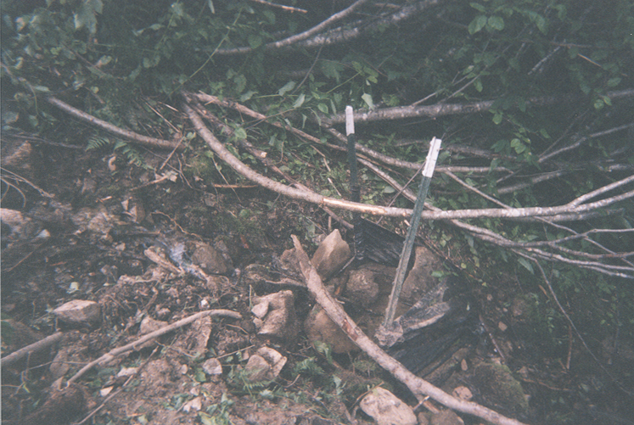
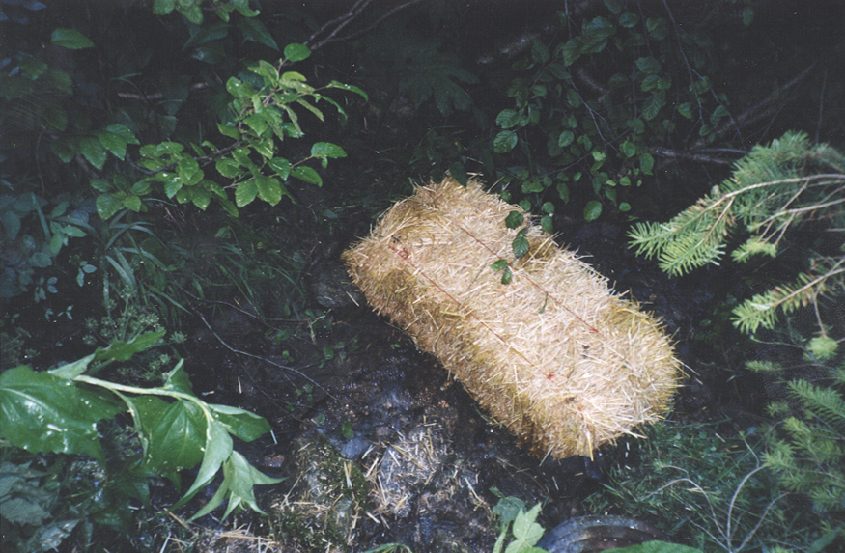

Figure 12. Examples of straw bale and silt fence sediment traps.
Objective 3: Eliminate unnatural passage barriers in order to return spawning and rearing habitat to targeted species, restore naturally functioning stream systems, and reduce system failures resulting from inadequately sized culverts.

Task A. Inventory all culverts in the project area. Collaborative effort with the CNF and PCTC.
Methods: CNF and NPT will take the lead in culvert inventory on land administered by the CNF. PCTC will inventory culverts on their land in accordance with their Habitat Conservation Plan.
Task B. Identify culverts that are fish barriers and/or are improperly sized. Collaborative effort with the CNF and PCTC.
Methods: Crews conducting inventories will be trained to recognize culverts preventing
passage to aquatic species and culverts that are not properly sized for the active channel width or
100 year flood events. Crews will look for culvert outlets not in contact with stream bottoms
(i.e. those with waterfalls) since many organisms have no jumping abilities or are too small to
negotiate the height of the falls (see figure 9). In addition, crews will calculate active channel
width and calculate the flow for a 100 year flood event. Culverts should be sized for the larger of these two measurements. Undersized culverts constrict flows and increase water speeds creating high velocity barriers and eliminating substrate from culvert bottoms. Substrate, such as gravel and rocks, provide low velocity areas for organisms to rest on their upstream migration. Crews will digitally locate culverts using GPS units. In addition, photo points will be established as a part of the surveys. Tribal and forest service personnel will collect data on land administered by CNF. PCTC crews will collect similar data on their land.

Task C. Survey three project locations per year. Collaborative effort with the CNF and PCTC.
Methods: The culvert surveys will be jointly performed with the CNF. A complete survey
of the existing areas will be performed for each of the project locations. Each survey will be taken approximately 200 feet up and down the stream thalwag or until the stream grade has been unaffected by the road crossing. The survey distance up and down the stream will be important in establishing the invert elevations for the new culvert placements. Critical data collected include grade and active channel width.

Task D. Design replacement culverts that will provide passage for all aquatic species
and that will function as a part of the stream system. Coordinated with CNF and PCTC.
Methods: Design of each project location will be done in cooperation with the CNF. The same interdisciplinary team used for culvert design in FY2000 will design these projects. This experienced team includes biologists, hydrologists, and engineers (see section 4, key personnel). References used include the Oregon Road/Stream Crossing Restoration Guide (Allen, M., A. Mirati, and E.G. Robison, 1999), Designing for Stream Simulation @ Road Crossing (Porior, D., 2000), Fish Passage Through Culverts (Baker, C.O., and F.E. Votapka, 1990) and Fish Passage Design at Road Culverts (WDFW, 1999) documents. Peer review of culvert designs will be performed Don Porior (Coos Bay BLM District Engineer), Nick Gerhart (Nez Perce National Forest Hydrologist), Pete Minard (CNF Engineer) and Thanos Papanicolaou (Washington State University Hydraulic Engineer). Each culvert will be sized first for the active stream channel and checked for the 100-year flood event, which are almost always very similar. When sizing the culvert, consideration will be given to embedding the culvert and the substrate that will fill the bottom of the culvert. Most culverts will be replaced using a pipe-arch (squash) culvert. Each squash pipe will be retrofitted with an 8-inch high baffling system to aide in retaining substrate for natural channel simulation. This baffling system has been successfully used in the Coos Bay BLM area for retaining substrate within the culvert length. Culvert inlet and outlet invert elevations will be embedded approximately 20% of the rise or 18 inches (below natural stream grade), whichever is greater, to allow for natural streambed simulation.

Task E. Complete NEPA and all permits necessary for implementation of project. Lead agency CNF.
Methods: Permitting will primarily be the responsibility of the CNF with NPTFW over-sight. The CNF will perform the required NEPA and consultation with NMFS and Fish and Wildlife Service. In addition, they will apply for the Standard In-Stream Work Permit through the Army Corps of Engineers.

Task F. Where appropriate develop cost-share agreement with PCTC and/or CNF.
Methods: As with designation of surplus roads, all agencies anticipate that culverts will be identified on cost-share roads that are undersized or are fish barriers. In these cases culvert replacements will be funded by through a three way cost-share agreement.

Task G. Develop and award culvert replacement contract. Lead agency is CNF.
Methods: Contract development and awarding will primarily be the responsibility of the
CNF with NPTFW over-sight. The contractor will be responsible for the purchase and installation of the culverts. Culverts will meet the design specifications as noted in the Forest Service Specifications for Construction of Roads and Bridges.

Task H. Administer culvert installation contract. Collaborate with CNF and PCTC.
Methods: Contract administration will be the responsibility of both the NPTFW and the
CNF. Contract administration will be performed to ensure project specification and design criteria are being met and permit requirements are fulfilled. The contract administrator will evaluate culverts during installation to ensure that gradient and stream bottom contact requirements are met.

Objective 4: Restore riparian areas and stream habitat condition in order to reduce water temperature, improve in-stream habitat complexity, and improve stream bank stability.

Task A. Survey streams to assess in-stream and riparian habitat condition. Tiered to the
NPT Watershed Recovery monitoring plan and coordinated with the CNF.
Task B. Collect baseline hydrologic data on flow, temperature, and sediment. Tiered to
the NPT Watershed Recovery monitoring plan and coordinated with the CNF.
Task C. Collect data on streams using GPS units. Collaborative effort with CNF.
Methods for A, B, and C: Riparian and stream habitat will be evaluated according to
the protocol developed for the Nez Perce Tribe Watershed Recovery Monitoring and Evaluation Plan. Methods are compiled from the Clearwater National Forest Monitoring and Evaluation Plan as well other regional large-scale monitoring plans and protocols suggested in recent scientific literature. Critical data collected include cobble embeddedness, temperature, large woody debris, habitat types, and amount of fine sediment. In these areas, fish population data is collected at stations in conjunction with the Idaho Supplementation Studies for Crooked Fork, Brushy Fork, and Colt Killed Creeks. These streams will be used as index streams for the Analysis Area. Surveys will be conducted initially as a part of the EAWS to assess current condition of streams and re-evaluate limiting factors. Monitoring stations will be established or reestablished. Initial surveys will be used as baseline data and monitoring in 2003-2006 will evaluate the efficacy of restoration efforts. Tribal crews and Forest Service crews will conduct all monitoring jointly. In some cases, cost-share contracts will be developed and stream surveys will contracted to Clearwater Biostudies, a private consulting firm that established monitoring locations in the Analysis Area during the early 90’s.

Task D. Identify areas where in-stream restoration may be required to correct limiting
factors.
Methods: The initial stream surveys, conducted as a part of the EAWS, will identify limiting factors to fish productivity in each stream. Data from the surveys will be evaluated to determine whether passive restoration will be effective in restoring stream habitat, or if active restoration is required. If passive restoration is deemed insufficient to improve habitat condition within five years, active restoration will be implemented. An example of active restoration would be the replacement of large woody debris.

Task E. Coordinate projects with the CNF and PCTC, on projects where there is a
common interest, develop partnering agreements.
Task F. Design stream restoration projects such as reintroduction of large woody debris.
Methods E and F: In areas where active restoration is necessary to improve stream conditions
NPT, CNF, and PCTC (where there is common interest) personnel will serve on interdisciplinary teams which will include hydrologists, fish biologists, and engineers to design in-stream habitat improvement projects. Projects will be coordinated across ownership boundaries. Project design may be subcontracted with funding by participating partners.

Task G. Complete NEPA and all permits necessary for implementation of project.
Methods: Permitting will be the primary responsibility of the CNF with NPTFW over-site. The CNF will perform the required NEPA and consultation with NMFS and Fish and Wildlife Service. In addition, they will apply for the Standard In-Stream Work Permit through the Army Corps of Engineers.

Task H. Develop and award stream restoration contract.
Methods: In cases where subcontracts are deemed the most cost effective and time
effective method for meeting restoration goals, contract development and awarding will primarily be the responsibility of the CNF with NPTFW over-sight.

Task I. Administer stream restoration contract.
Methods: Contract administration will be the responsibility of both the NPTFW and the CNF. Contract administration will be performed to ensure project specification and design criteria are being met and permit requirements are fulfilled.

Task J. Identify areas where active riparian restoration may be required to correct limiting factors.
Methods: For many of the streams in the Analysis Area, stream surveys conducted in the 1990s identified poor vegetation cover and lack of mature trees in riparian areas as limiting factors to in-stream habitat. Stream habitat surveys will be conducted as a part of the EAWS and will include evaluation of riparian condition. Condition is judged on percent cover and type of vegetation.

Task K. Design and implement riparian restoration projects, such as riparian plantings or noxious weed control.
Methods: As with stream restoration, the data from initial stream surveys and the EAWS may show that due to management activity some riparian areas will require active restoration. Riparian condition will be evaluated across ownership boundaries and restoration work will be coordinated through management agencies where there is shared interest.

Objective 5: Monitor and evaluate road obliteration implementation and effectiveness.

Task A. Review objectives and tasks of the road obliteration implementation and effectiveness monitoring plan.
Task B. Establish monitoring sites in the Analysis Area.
Task C. Compile and analyze data, making recommendations for improvements on the monitoring plan and with road obliteration techniques.
Task D. Coordinate data collected with the monitoring and evaluation reports produced in other project areas.
Methods: Road obliteration monitoring is a joint effort between NPT and CNF. The monitoring and evaluation program provides feedback for watershed restoration management to determine the effectiveness of methods used in road obliteration. The monitoring program evaluates sites on completed roads to determine whether (1) surface erosion is abated through revegetation and mulch; (2) obliteration has restored natural drainage patterns; (3) obliteration has improved slope stability. Ten monitoring sites are selected each year and evaluated annually for the first three years and then at 6 and 10 year intervals. Results are compiled and published in report format each year with CNF as the lead agency.

Objective 6: Monitor and evaluate culvert replacements.

Task A. Evaluate success of culvert design and installation by conducting spawning surveys to record presence of targeted species above culvert.
Task B. Inspect each culvert one year after installation. Record percent of substrate recruitment in culvert bottom, describe inlet and outlet, and record pictures at photo points.
Task C. Produce a culvert replacement monitoring and evaluation report, coordinated with culvert replacements in other project areas.
Methods: Aquatic organism passage will be evaluated for the two years following installation. Spawning surveys for bull trout, steelhead trout and Chinook salmon would be used for evaluation, as the redds (egg deposit sites) are easy to detect. The total number of redds would be counted 3 times during the spawning season of each species present. Success criteria would be the documentation of at least one redd in returned habitats. For all culverts, and in streams where adult fish currently have passage but a barrier exists for juvenile fish, physical condition surveys will be documented. These will be completed one year after installation to allow for gravel movement into the culvert. Conditions noted will include whether or not the culvert outlet is in contact with the stream bottom and the percentage of the interior culvert bottom with substrate in it. If stream bottom contact exists and substrate occurs throughout the culvert, stream channel conditions will mimic natural stream channel conditions and will create natural hydraulic and biotic connections.

Project reporting will primarily be the responsibility of the NPTFW. A detailed report will be provided upon project completion. M&E reports will be provided for three years after project completion.

Objective 7: Long-term monitoring and evaluation of watershed recovery. Tier to monitoring and evaluation proposal. Lead agency NPTFW.

Methods: The in-stream habitat and water quality data collected for the EAWS will be a part of the long term monitoring program. Methods are described in Objective 4. Monitoring of sediment metrics will be done annually until data trends show a five-year period of recovery. Monitoring of habitat parameters will occurs every 6 years. Where active stream restoration or riparian restoration techniques have been used, the monitoring program will incorporate these sites into the annual surveys.

Objective 8: Dissemination of project information and peer review. Lead agency NPTFW.
Task A. Complete quarterly and end of year reports as they become due.
Task B. Perform necessary presentations to the public and project peers.
Task C. Presentation of project and critique by Washington State University peer reviews.

Objective 9: Provide office and clerical support.
Task A. Provide clerical/office support. Office and clerical support will help in coordination of budgets, ordering supplies, and data reporting.

g. Facilities and equipment

The NPTFW in cooperation with the CNF have all the necessary facilities and equipment to fulfill this proposal. The CNF will provide the survey equipment needed. An additional vehicle lease may be needed to sufficiently provide for travel during project planning and implementation. The NPTFW and the CNF have the computers and software (AutoCAD) to perform all tasks, with the exception of road obliteration and culvert installation. All equipment required for road obliteration and culvert installation will be the responsibility of the contractor.

h. References

Reference (include web address if available online) | Submitted w/form (y/n)
Allen, M., A. Mirati, and E.G. Robison. 1999. Oregon Road/Stream Crossing Restoration Guide
Baker, C.O., and F.E. Votapka. 1990. Fish Passage Through Culverts. USDA. Report No. FHWA-FL-90-006.
Bowles, E., and E. Leitzinger. 1991. Salmon Supplementation Studies in Idaho Rivers. Portland, OR.
Clearwater Biostudies. 1997. Habitat Conditions and Salmonid Abundance in the Big Sand Creek Drainage, Powell Ranger Station. USDA-Clearwater National Forest.
Clearwater Biostudies. 1996. Habitat Conditions and Salmonid Abundance in the Upper Crooked Fork Drainage, Powell Ranger Station. USDA-Clearwater National Forest.
Clearwater Biostudies. 1995. Habitat Conditions and Salmonid Abundance at Monitoring Stations Crooked Fork, Pack Creek, Walton Creek and Warm Springs, Powell Ranger Station. USDA-Clearwater National Forest.
Clearwater Biostudies. 1994. Habitat Conditions and Salmonid Abundance in the Crooked Fork Drainage, Powell Ranger Station. USDA-Clearwater National Forest.
Clearwater Biostudies. 1994-1995. Habitat Conditions and Salmonid Abundance in the White Sands Drainage, Powell Ranger Station. USDA-Clearwater National Forest.
Clearwater Biostudies. 1994. Habitat Conditions and Salmonid Abundance in the Pack Creek, Powell Ranger Station. USDA-Clearwater National Forest.
Clearwater Biostudies. 1994. Habitat Conditions and Salmonid Abundance in the Spruce Creek, Powell Ranger Station. USDA-Clearwater National Forest.
Clearwater Biostudies. 1993. Habitat Conditions and Salmonid Abundance in the Brushy Fork Creek, Powell Ranger Station. USDA-Clearwater National Forest.
CNF. 2001. Water and Fisheries Monitoring Plan.
CNF. In press. Ecosystem Analysis at the Watershed Scale of Crooked Fork Creek to Brushy Fork Analysis Area.
CNF. 1999. Section 7 Watershed Biological Assessment Lochsa River Drainage, Clearwater River Subbasin.
CNF. 1996. White Sand Ecosystem Management Project: Final Environmental Impact Statement.
CRITFC. 1995. WY-KAN-USH-MI WA-KISH-WIT, Spirit of the Salmon. Vol. I and II. Portland, OR.
FCRPS. 2000. Biological Opinion.
FCRPS. 2000. Conservation of Columbia Basin Fish: Final Basinwide Salmon Recovery Strategy. Volume 1.
Furniss, M.J., M.A. Love, and S. A. Flanagan, 1997. Diversion Potential at Road-Stream Crossings. Water/Road Interaction Technology Series, 9777-1814-SDTC, USDA Forest Service, Technology and Development Program, San Dimas, California.
Luce, C.H. and T.A. Black, 1999. Sediment production from forest roads in Western Oregon. Water Resources Research 35(8): 2561-2570.
McClelland, D.E., R.B. Foltz, W.D. Wilson, T.W. Cundy, R. Heinemann, J.A. Saurbier, and R.L. Schuster. 1997. Assessment of the 1995 & 1996 Floods and Landslides on the Clearwater National Forest- Part I: Landslide Assessment. Report to the Regional Forester, Northern Region, US Forest Service.
McCullough, Dale A. and F.A. Espinosa. 1996. A monitoring strategy for application to salmon-bearing watersheds. Technical Report 95-5. CRITFC. Portland, Oregon.
Montgomery, D.R. 1994. Road surface drainage, channel initiation, and slope instability. Water Resources Research 30(6):1925-1932.
Nez Perce Tribe and IDFG. 1990. Clearwater River Subbasin Salmon and Steelhead Production.
Northwest Power Planning Council. 2001. Clearwater Subbasin Summary.
Northwest Power Planning Council. 2000. Fish and Wildlife Program.
Plum Creek Timber Company. 2000. Environmental Impact Statement and Native Fish Habitat Conservation Plan: Proposed Permit for Taking of Federally Protected Native Fish Species on Plum Creek Timber Company Lands. Volumes I and II. Boise, ID.
Porior, D. 2000. Designing for stream simulation @ road crossings. Bureau of Land Management. Coos Bay Oregon.
Reid, L.M. and T. Dunne. 1984. Sediment production from forest road surfaces. Water Resources Research 20(11): 1753-1761.
USACE. 1997. Wetland Delineation Manual. http://www.saj.usace.army.mil/permit/87manual.pdf
USDA. 1996. Forest Service Specifications for Construction of Roads and Bridges. Washington office.
USDA. 2001. Roads Analysis: Informing Decisions About Managing the National Forest Transportation System. Washington office.
WDFW. 1999. Fish Passage Design at Road Culverts: A Design Manual for Fish Passage at Road Crossings. Washington Department of Fish and Wildlife, Habitat and Lands Program, Environmental Engineering Division.

Section 10 of 10. Key personnel

NAME: Rebecca A. Lloyd
TITLE: Hydrologist
AGENCY: Nez Perce Tribal Fisheries/Watershed Program
HOURS: FTE

EDUCATION: B.A. Washington University in St. Louis: 1993
Environmental Science/Geology/International Studies
M.S. Indiana University, Bloomington, IN: 1999
Environmental Science specializing in Water Resources

CURRENT RESPONSIBILITIES: Project designer; road obliteration inspector; gathering, analyzing, and interpreting watershed data; represent program in various inter-disciplinary teams; assist in surveying project areas; aide in assessing water resources/quality; knowledge of current computer software programs; supervise field crews; co-coordinate program projects.

PREVIOUS EMPLOYMENT:

• May 2000- present Nez Perce Tribal Fisheries/Watershed
Hydrologist

• June 1997- August 1999 Clearwater National Forest
Biologic Technician, Road Obliteration Program

• September 1998- December 1999 School of Public and Environmental Affairs
Indiana University, Bloomington, IN
Laboratory Assistant

• June1996- May 1997 College of Natural Resources,
University of Wisconsin, Stevens Point, WI
Research Assistant

• June 1996 –December 1996 Hancock Agricultural Research Station
University of Wisconsin-Madison
Field and Lab Technician

REVELVENT JOB COMPLETIONS:

1) Road Obliteration Inspector and crew leader for four seasons. 2) Design of Nez Perce Tribe Fisheries and Watershed Monitoring and Evaluation Program. 3) Crew member on stream survey crew and Watershed Inventory Needs crew in the Bitterroot National Forest in 1995. 4) Research experience on projects designed to evaluate water quality and investigate groundwater-surface water interaction in Wisconsin.

RELEVANT TRAININGS:
- Certified in Wetland Delineation 1999, Indiana University.
- Proficient with a variety of field equipment and field skills: water quality sample collections, automated and non-automated, flow meters, Rosgen channel typing, cross-sections, pebble counts, macroinvertebrate sample collection and i.d., and fish sample collection by electroshocking and seining
- Bioengineering Techniques, NRCS 2000.
- Road Obliteration Training and road survey, 1997, USDA Forest Service

DUTIES ON PROJECT: Ms. Lloyd will be the project leader for all activities of this proposal. As project leader, Ms. Lloyd will manage all tasks of this project to final completion and monitoring and evaluation. She will be responsible for coordinating time schedules, project budget, crewmembers, and all activities with the Clearwater National Forest (CNF) and Plum Creek Timber Company. Ms. Lloyd will lead data collection for EAWS and coordinate implementation of field projects. She will serve as inspector or inspector in training for contracts on all projects.

NAME: Emmit E. Taylor Jr.
TITLE: Civil Engineer
AGENCY: Nez Perce Tribal Fisheries/Watershed Program
HOURS: FTE

EDUCATION: B.S. Civil Engineering, Colorado State University, CO, 1995

CURRENT RESPONSIBILITIES: Project leader; road obliteration inspector; culvert prioritization; culvert survey, design, contract administration and construction inspection; gathering, analyzing, and interpreting watershed data; represent program in various inter-disciplinary teams; assist in surveying project areas; aide in assessing water resources/quality; knowledge of current computer software programs; design of civil engineering projects; supervise field crews; co-coordinate program projects.

PREVIOUS EMPLOYMENT:
- August 1997 – present: Nez Perce Tribal Fisheries/Watershed
Civil Engineer
• October 1995 – August 1997: Womer and Associates Engineering and Architecture Firm Civil Engineer-In-Training
- May 1993 – October 1995: Colorado State University Tribal Transportation Program Engineering Aide

EXPERTISE: Emmit E. Taylor Jr.’s background is in Civil Engineering with an emphasis in hydrology. Mr. Taylor’s analysis, design, and construction work concentrates on stream rehabilitation, stream morphology, water quality, road obliteration, in-stream structures, and fish passage improvements.

RELEVENT JOB COMPLETIONS:
1) Inspector on West Fork of Squaw Creek bottomless arch culvert installation, 2) Inspector on installation of Badger and Wendover Creek culvert installations, 3) Survey and design of Badger and Wendover Creek culvert replacements, 4) Road obliteration project leader and inspector, 1997-present, and 5) Geiger Boulevard Environmental Analysis.

RELEVANT TRAININGS:
- Applied Fluvial Geomorphology, 1998, Wildland Hydrology
- AutoCAD R14 Fundamentals, 1998, PacifiCAD Inc.
- Fish Passage Design Workshop, 1999, USFS
- Public Works Contract Administration Training, 1999, USFS
- Riparian Proper Functioning Condition Training, 1998, Bureau of Land Mgmt.
- River Morphology & Applications, 1999, Wildland Hydrology
- Road Obliteration Training, 1998, USDA Forest Service

DUTIES ON PROJECT: Mr. Taylor will assist in culvert design and implementation of all project work. In addition, Mr. Taylor will be lead inspector and contract administrator for culvert installation.

NAME: Karen A. Smith
TITLE: Fisheries Biologist

AGENCY: USFS - Clearwater National Forest

HOURS: FTE – 2.0

EDUCATION: B.S. degree in Fisheries, Humboldt State University, California, 1986

CURRENT RESPONSIBLITIES:
- Focus on analyzing and reducing the effects of Forest Service projects on the fisheries resource through the NEPA process.
- Identifying of culverts that limit or prevent upstream migration of aquatic organisms.

DUTIES ON PROJECT:
- Site identification and assessment for aquatic organism passage;
- Assisting in site surveys;
- Leading and participating in the interdisciplinary team for completing NEPA documentation and ESA consultation;
- Resource advisor during culvert replacement;
- Post-project monitoring to assess whether project objectives are met.

PREVIOUS EMPLOYMENT:
- 1998 – present: Clearwater National Forest
Fisheries Biologist
- Currently Chairperson of the American Fisheries Society- Idaho Chapter Stream Hydraulics Comm.
- 1989 – 1998: BLM, Coos Bay, Oregon
Fisheries Biologist

QUALIFICATIONS SPECIFIC TO THE PROJECT:
I was the district lead for identifying and assisting with culvert replacement projects for the BLM between 1993 and 1998. We replaced approximately 30 large culverts in that time period. Additional culverts were identified and prioritized for later replacement. I have done the same for the Forest Service for the last 2 years and am currently working on a proposal to develop a Forest-wide culvert replacement program. In the fall of 1999 I coordinated the replacement of 2 major culverts along US Highway 12. The project was a joint effort between the Forest Service, Tribe, and Idaho Transportation Department. I also requested and received a grant for the project through the National Fish and Wildlife Foundation.

NAME: Anne Hall Connor, P.E.
TITLE: Watershed Restoration Engineer/Hydrologist
AGENCY: USFS, Clearwater National Forest

DUTIES ON PROJECT: Program manager for the road obliteration program and other watershed restoration engineering projects on the Clearwater National Forest. This involves providing technical expertise and training to the program, serving as a contracting officer's representative (COR) and overseeing the budget and management of the program. Has worked with the Nez Perce Tribe since 1997 on cost share projects involving watershed restoration. Has provided the hydrologic and hydraulic design on several large culverts including two major pipe arches on US Highway 12 installed to allow for fish passage.

DEGREES: M.S. in Civil Engineering, University of Idaho, December, 1991
B.S. in Forest Management, West Virginia University, May, 1983

CERTIFICATION STATUS: Professional Civil Engineer. Has construction certification through the Forest Service in roads, buildings, aggregate base and surfacing, and administration of public works contracts.

CURRENT RESPONSIBILITIES: Manages the road obliteration and watershed restoration program on the Clearwater National Forest. Coordinates with the Nez Perce Tribe and others on cost share projects.

PREVIOUS EMPLOYMENT: Anne has worked for the U. S. Forest Service from 1987 to present in engineering including road design and maintenance, contract preparation and construction inspection. Anne has run a growing watershed restoration and road obliteration program since 1993.

EXPERTISE: Major emphasis in graduate program was water resources engineering with thesis on Hydraulic Design of Fish Habitat Structures. Other training has included: Instream Flow Incremental Methodology, Applied Fluvial Geomorphology, Basic Road Design, Native Grass Workshop, Contract Administration.

NAME: Carol A. Smith
TITLE: Grants and Agreement Specialist
POSITION/HOURS: GS9 Detail/ FTE
AGENCY: USFS, Clearwater National Forest

DUTIES ON PROJECT: Coordinates and develops grants and agreements for the Clearwater National Forest. Has worked with the Challenge Cost Share Agreement for watershed restoration projects with the Nez Perce Tribe since 1997.

PREVIOUS EMPLOYMENT: Served as the Clearwater National Forest’s Grants and Agreements Coordinator for two years (1997 – 1999). Was a Procurement Assistant for the Clearwater National Forest from 1989-1997.

NAME: Ira Jones
TITLE: Clearwater Sub-basin Focus Coordinator / Habitat/Watershed Manager
AGENCY: Nez Perce Tribal Fisheries/Watershed Program
HOURS: FTE

CURRENT RESPONSIBILITIES: Nez Perce Tribal Fisheries/Watershed Program director; coordinate restoration activities among various agencies; analyze programs, laws, policies related to watershed management; facilitate development of criteria to identify critical fisheries habitat; prepare and plan documents for watershed habitat coordination; provide educational presentation and workshops for watershed management and proposal development; and provide assistance in proposal development, implementation, monitoring and evaluation.

DUTIES ON PROJECT: Mr. Jones will facilitate and oversee all activities within this project. He will coordinate with the Clearwater National Forest on the cost-share partnering agreement. Mr. Jones will oversee all project tasks for completion and quality of work.

PREVIOUS EMPLOYMENT:
- March 1997 – present: Nez Perce Tribal Fisheries/Watershed
Habitat/Watershed Manager
- June 1986 – March 1997: United States Forest Service, Region 1
Tribal Government Program Manager
- December 1980 – June 1986: United States Forest Service, Region 1
Facilities Manager
- July 1974- October 1979: United States Forest Service, Region 1
Fire Cache Work Leader

RELEVENT JOB COMPLETIONS:
1) Coordinated National, Multi-Regional, and Regional Civil Rights Conferences, 2) Facilitated treaty rights workshops with host tribes and multi-governmental agencies, 3) Organized and conducted Tribal Relations Training primarily for management level from the U.S. Forest Service, Tribes, Bureau of Land Management, and bureau of Indian Affairs, 4) Introduced, implemented, and managed the Inter-tribal Youth Practicums for career in natural resources and leadership within the Forest Service Regions 1, 5, 9, and 10. 5) Developed an intergovernmental Personnel Act (IPA) position to work with the Salish Kootenai College to teach environmental science courses and develop a four-year natural science curriculum at the college. This three-year position and the program developed into a four-year accredited degree program in the fall of 1996.

