Bonneville Power Administration

FY 2003 Provincial Project Review

PART 2. Narrative
Project ID: 32013
Title: Fishery Restoration of the Gold Fork River, Idaho

Section 9 of 10. Project description

a. Abstract

The first objective of this proposed project is to establish new bull trout Salvelinus confluentus and native fish assemblages in suitable habitat throughout the North and South Forks of Gold Fork River over a three to six year period. Bull trout likely were distributed throughout the drainage, but have been impacted by water and habitat management and introductions of non-native species, especially brook trout Salvelinus fontinalis. We propose to identify and prioritize stream reaches that are physically isolated, chemically eradicate brook trout in select reaches, and re-stock with native fish assemblages including bull trout. This will require construction of temporary fish migration barriers, application of one or more approved fish toxicants, followed by structured monitoring to evaluate success of treatments. No stocking will occur until brook trout abundance is reduced to acceptable levels in treatment stream sections.
The existing Gold Fork watershed bull trout population currently resides in the upper North Fork Gold Fork River in an upper stream reach. We feel that there are many opportunities to experimentally increase the number of local bull trout populations due to the topography of the watershed. We propose to conduct a careful examination of abundance, life history behavior, and genetic characteristics of remaining bull trout populations in the Gold Fork River and in the larger Payette River Basin. After this examination, we will consider the appropriateness of using the remaining local Gold Fork River populations or populations in the Payette River Basin to supplement areas of suitable habitat within the North Fork Gold Fork River watershed that have been eradicated of brook trout. An experimental treatment design will be created that will shed light on the complex problem of brook trout/bull trout population interactions. Draft Recovery Plans for bull trout from the USFWS rely heavily upon the creation of new local populations of bull trout to reach recovery goals. Critical evaluation of watershed-scale efforts to enhance bull trout and other native fishes, as proposed herein, will help assess our ability to meet bull trout recovery criteria and may provide a template for native fish restoration efforts in other drainages.
A second and related objective is the reestablishing of connectivity between the upper Gold Fork drainage, the lower mainstem habitats, and potential over wintering habitats in Cascade Reservoir. Existing diversions on the lower mainstem act as upstream migration barriers, and lower river reaches are frequently dewatered to satisfy irrigation demands. The principal strategy is to provide fish passage at the Gold Fork Diversion and other minor water diversions on the Gold Fork River or main tributaries, and to maintain adequate stream flows so fish can use the lower river as a migration corridor. We propose to work with local irrigators and landowners to conduct feasibility studies, develop alternatives, design, fund and construct fish passage facilities. At the main Gold Fork Diversion site, this possibly could include removal and replacement of the existing structure. Other minor water diversions within the drainage create seasonal fish passage barriers. These barriers will be identified, and fish-friendly alternatives will be designed and built. A guiding principle for all alternatives will be the protection of existing water rights and unimpeded water delivery from the Gold Fork River. Overall, we feel it will be feasible to create a fully connected river basin for the first time in approximately 80 years. The re-creation of a river flowing directly into Cascade Reservoir should improve the sport fishery in the reservoir. The combination of the river corridor improvements and expansion of bull trout local populations will help ensure survival of the currently isolated population of bull trout.

b. Technical and/or scientific background

The Payette River Basin was dramatically changed and isolated from the Snake and Columbia Rivers by the construction of the U.S. Bureau of Reclamation’s (BOR) Black Canyon Dam in 1923, a hydropower facility. Before dam construction the Payette River supported several species of anadromous fish (Stovall 2001). Upstream, the Payette River basin was being settled and developed during this period. By 1923 an irrigation diversion was constructed on the Gold Fork River by the Gold Fork Irrigating Company, a private irrigation company, to transfer water to the lands located east of the current Cascade Reservoir. The Gold Fork River before dam construction supported spawning populations of chinook salmon Oncorhynchus tshawytscha and steelhead O. mykiss (BCC 1996). In 1947 Cascade Dam was finished by the BOR to irrigate lands in the lower Payette River basin and provide water for hydropower at Black Canyon Dam by storing snowmelt in the upper basin (BCC 1996). Thus as a result of development of the federal hydropower system, the Payette River fisheries were isolated, segmented and denied the historical ocean derived nutrients from anadromous fish stocks.
The Gold Fork River is located in Valley County, in west central Idaho, and drains into Cascade Reservoir on the North Fork Payette River near Donnelly, Idaho (Figure 1). The Gold Fork watershed contains lands owned by the U.S. Forest Service (USFS) (64%), Bureau of Land Management (BLM) (3%), Idaho Department of Lands (IDL)(5%), Boise Cascade Corporation (BCC)(25%), and private lands (4%), (BCC 1996). The Gold Fork basin is approximately 150 square miles in size. The Gold Fork basin contains approximately 44 miles of permanent stream channel (BCC 1996).
The distribution of bull trout Salvelinus confluentus, a federally listed species, is currently extremely limited within the North Fork Payette River sub-basin. Only one known functioning population resides in the upper reaches of the North Fork Gold Fork River (NFGFR) (BCC 1996)(figure 2). We propose to definitively document the distribution and abundance of the remaining NFGFR bull trout population. We also propose that a comprehensive genetic analysis of this population be performed:
- To determine whether this remaining group of bull trout actually represents a single, randomly mating population.
- To identify the extent of hybridization between bull trout and brook trout within the NFGFR bull trout population,
- To determine the genetic variability and the genetic effective population size of this remaining population (in order to determine whether the population is at immediate genetic risk), and,
- To determine whether this population would be appropriate for use in re-introductions into areas of suitable habitat within the Gold Fork River watershed that have been eradicated of brook trout.
If the remaining NFGFR bull trout population is determined to be of sufficient size (both N and Ne), and with concurrence from the USFWS, the movement of bull trout from this local population into adjacent unoccupied habitat may be considered.
Further action proposed will be to chemically renovate tributaries or selected reaches of tributaries near the existing NFGFR bull trout population to eliminate potentially competing and hybridizing brook trout Salvelinus fontinalis. As information is collected and experimental tributary treatments show success we will investigate similar habitats within the watershed.
Brook trout removal projects for bull trout enhancement have been attempted before with varying success. Buktenikca et al. (2001) removed brook trout via electrofishing and antimycin treatments from Sun Creek, Oregon. They installed instream immigration barriers to prevent re-invasion of non-native fish. Bull trout population estimates increased from approximately 200 bull trout in 1992 to nearly 800 bull trout in 2000. The ratio of bull trout to brook trout was reversed from 1:3 to 7:1. Stelfox and Shumaker (1998) reported no improvement in bull trout numbers after removal of brook trout via anglers. Fredricks (1999) reported poor response of bull trout numbers to brook trout removal via electrofishing especially in complex habitats. Meyer and Lamansky (in review) report no success in reducing brook trout via electrofishing in Pikes Fork Creek.
The proposed chemical treatments in the NFGFR drainage will be made above either natural or man-made fish passage barriers to reduce or prevent re-invasion by brook trout. Fish toxicants will likely be formulations of rotenone, antimycin, or a combination of the two. Treatment designs will be site specific to reflect flows, temperatures, and water chemistry of each site. Coordination with other regulatory agencies will be completed prior to chemical applications.
Depending on population abundance estimates and results of the genetic investigation of the remaining NFGFR bull trout population, it may be necessary to investigate the idea of supplementing these renovated tributaries with bull trout from other populations within the Payette River Basin. Before actual movements are performed, a comprehensive genetic investigation of bull trout populations in the Payette River basin will be completed to determine the genetic structure and relatedness of these populations and to determine whether these populations would be appropriate for use in re-introductions.
To evaluate bull trout reintroduction strategies, an experimental design of treatment and control streams will be devised which will include different treatments of bull trout densities and species assemblages. Intensive monitoring of the treatment and control fish populations will be conducted. This management experiment is important because of the invasion and the competition and hybridization potential with brook trout. U.S. Fish and Wildlife Service (USFWS) Draft Recovery Plans for bull trout in Idaho rely heavily on creating new local populations of bull trout (Draft Recovery Plan for Bull Trout in the Southwest Idaho Recovery Unit, USFWS). Many areas proposed for expansion of bull trout, especially in the NF Payette River basin are in stream reaches with competing brook trout. Fish management choices are limited and largely untested for creation of new populations of bull trout.
The Gold Fork Diversion structure has been a barrier to fish migration since construction in the early 1920’s (figures 3a and b). The diversion structure lies approximately 4 miles above Cascade Reservoir. We propose to first study the feasibility of alternatives for providing fish passage at this structure. Second, we propose to implement the proposed alternative to restore passage. With the cooperation of the Gold Fork Irrigating Company and the Center Irrigation District we will investigate all possibilities for creating fish passage around this barrier. We propose to fund an Agricultural/Civil engineer supported out of the Valley County Soil and Water Conservation District office to investigate, develop alternatives, present alternatives, design structures, develop costs of alternatives, and oversee construction, of fish passage solutions. Engineering services will also be directed toward designing solutions that allow the removal of minor fish passage barriers associated with irrigation water diversion structures found within Gold Fork River and also within other North Fork Payette River sub-basin streams. The engineering work will also include irrigation delivery system studies to measure delivery efficiency and develop improvements in delivery efficiency. The possibility of creating a “water bank” which would allow any possible water savings to be marketed to create a fund for expenses and improvements within the irrigation district will be investigated.
The Gold Fork and Cascade sub-watersheds comprise 117,000 acres east of Cascade Reservoir. The land uses consist of 96,000 acres of public and private forested land, 15,600 acres of agricultural land and 5,000 acres of urban/suburban land. Approximately 6,500 acres of the agricultural land is irrigated from the Gold Fork River, with greater than 90% flood irrigated. The Cascade Reservoir Watershed Management Plan that identified beneficial uses to be restored or maintained included irrigation, fish and cold-water biota while reducing the phosphorous loading by 37%.
The Gold Fork Irrigating Company diverts virtually all river water into the Center Irrigation District Canal for irrigation. The diversion blocks all upstream fish migration and the canal has no fish screening structure. Fish moving downstream during high flows are spilled over the dam or entrained in the canal. At low flows all downstream migrating fish are captured in the canal.
Two key sub-watersheds are identified for bull trout within the Gold Fork River (Batt 1996; Steed 1998). The main Gold Fork and North Fork Gold Fork are categorized as a Priority 1 key sub-watershed; and Kennally Creek is categorized as a Priority 2 key sub-watershed. These prioritizations are defined as follows:
Priority 1 sub-watersheds are defined as:
- “suitable for spawning and initial rearing”
- “where numbers of juvenile bull trout are relatively abundant”
- connected and close to nearby unpopulated or lightly populated habitats
- will respond to restoration measures in the shortest time period
Priority 2 sub-watersheds are defined as:
- proximal and connected to refuge habitats containing bull trout
- have the potential to foster spawning and early rearing
- may not presently support bull trout or abundant numbers

According to USFS biological assessments (Burton 1998; Walker et al. 1998) the Gold Fork/North Fork Gold Fork sub-watershed is generally functioning appropriately with respect to stream temperature, large woody debris, and pool frequency. Fine sediment and low depth:width ratios are rated as “functioning at unacceptable risk.” The Gold Fork Watershed Analysis (BCC 1996) provides a narrative of reach specific habitat conditions and an inventory of physical barriers. This information will be used to detail our project designs.
Fishery surveys conducted by the Idaho Department of Fish and Game (IDFG) in 1998 (Janssen et. al., 2001) found low numbers of fish in Gold Fork River and Kennelly Creek, the largest tributary in the Gold Fork River drainage. Densities of salmonids were less than 50 fish per km in both streams.
Anderson and Robertson (1985) surveyed rainbow trout and kokanee salmon spawning and rearing habitat in the Gold Fork River and its tributaries. The surveys identified 18.75 miles of spawning habitat and 36.25 miles of rearing habitat that was unavailable to Cascade Reservoir salmonids due to the irrigation dam migration barrier. The study determined there was potential spawning habitat for 11,000 pairs of rainbow trout, resulting in an estimated contribution to the Cascade Reservoir fishery of nearly 250,000 catchable size rainbow trout annually. These estimates did not include 8 miles of stream that contained high densities of brook trout. Since this study was completed the stream miles that are dominated by brook trout have increased (BCC 1996).
The local economic impact of increased numbers of salmonids in Cascade Reservoir is significant. A U.S. Fish and Wildlife survey in 1996 determined that each angler spent an average of $52.90 per day of fishing (1996 National Survey of Hunting, Fishing and Wildlife Associated Recreation, Preliminary Findings U. S. Fish and Wildlife Service, 1997). Currently, the Cascade Reservoir fishery is experiencing severe declines in angler use due to a dramatic decline in yellow perch numbers (Janssen et. al. In press). Any increase in game fish numbers and therefore angler success rates in Cascade Reservoir would result in increased angler participation. Angler days have declined from 96,000 to 10,000 since the mid 1980’s due to declines in angler success. To recover the 86,000 angler days would mean an increase of $4.47 million dollars to the local economy. In addition the contribution of wild fish into Cascade Reservoir may allow a reduction in the numbers of hatchery rainbow trout stocked, thereby reducing the cost of maintaining a fishery in the reservoir.
Providing spawning escapement for adult salmonids from Cascade Reservoir into Gold Fork would potentially increase forage production for native predators such as bull trout. Bull trout in lakes feed primarily on fish (Bjornn, 1957; Jepson and Platts, 1959; and Rieman and Lukens, 1979). Horner (1978) and Shepard et al (1984) found that bull trout greater than 110 mm fed on fish and aquatic insects. Boag (1987) found that bull trout in an Alberta stream fed mainly on invertebrates in the upper stretches of the stream but were more piscivorous in downstream reaches.
Many resident bull trout populations including Gold Fork River population appear to be restricted to an invertebrate diet due to the lack of juvenile fish forage. Historically juvenile fish densities likely would have been much higher due to the presence of viable steelhead and salmon stocks. These anadromous stocks have been cut off in the Payette River drainage by large and small dams. The result is resident populations of bull trout with very small adults, typically less than 250 mm. Bull trout with access to larger waters with resident fish and migrating smolts can grow to over 760 mm in length. Currently the lower and much larger stretches of the Gold Fork River, where larger adult bull trout would be expected to live and grow, are food limited. Adult bull trout may also utilize Cascade Reservoir during the fall, winter and spring months taking advantage of fish prey available there. However, Cascade Reservoir would not be and is not presently considered critical bull trout habitat due to water temperature limitations.
The establishment of a year-round minimum stream flow in the Gold Fork River is a critical prerequisite to bull trout use of Cascade Reservoir. A year-round minimum flow could happen depending on alternatives selected for fish passage at the Gold Fork Diversion. The establishment of viable salmonid populations could be accomplished without a minimum stream flow as long as there were flows present in the lower river section in the spring and fall/early winter months when rainbow and kokanee would be attempting upstream migrations.
The multi-pronged approach of reconnectivity with Cascade Reservoir; the establishment of viable salmonid spawning runs from Cascade Reservoir and the utilization of vacant spawning and rearing habitats; the reduction in brook trout numbers; and the bolstering of bull trout numbers may allow for a significant bull trout recovery in the drainage. The combined approach provides a much higher likelihood of success than attempting any one of the above treatments by themselves.

c. Rationale and significance to Regional Programs

The Pacific Northwest Electric Power Planning and Conservation Act (Act) of 1980 explicitly gives the Bonneville Power Administration (BPA) the authority and responsibility “to protect, mitigate, and enhance fish and wildlife to the extent affected by the development and operation of any hydroelectric project of the Columbia River and its tributaries in a manner consistent with”…the program adopted by the Northwest Power Planning Council (Council). The Council is a planning, policy-making and reviewing body. It develops and monitors implementation of the Columbia River Basin Fish and Wildlife Program (Program). Section 4(h) of the Act establishes statutory guidelines that the Council must adhere to in the development of the Program. One of the statutory standards, 4(h) (8)(a): The Program shall, “in appropriate circumstances” include enhancement measures “as a means of achieving offsite protection and mitigation with respect to compensation for losses arising from the development and operation of the hydroelectric facilities of the Columbia River and its tributaries.”
The 2000 Columbia River Basin Fish and Wildlife Program (Council 2000) has two of its “Overarching objectives” that relate directly to this proposal.

“Mitigation across the basin for the adverse effects to fish and wildlife caused by ` the development and operation of the hydrosystem.”
“Recovery of the fish and wildlife affected by the development and operation of the hydrosystem that are listed under the Endangered Species Act.”

The Program recognizes that “Part of the anadromous fish losses has occurred in the blocked areas”. The Program has a “Resident Fish Substitution Policy” for areas in which Anadromous fish have been extirpated. The Program will:

“Restore native resident fish species…to near historic abundance throughout their historic ranges where original habitat conditions exist and where habitats can be feasibly restored.”
“Administer and increase opportunities for consumptive and non-consumptive resident fisheries for native, introduced, wild, and hatchery-reared stocks that are compatible with the continued persistence of native resident fish species and their restoration to near historic abundance…”

The Program provides strategies to accomplish biological objectives. Because the Program “ is habitat-based” strategies depend on the current and restoration potential of the habitat (Council 2000). Our proposal deals with “restorable habitat” that has been diminished in the Gold Fork River but can be restored through conventional techniques.
In 1996 the State of Idaho issued an official conservation plan for bull trout and is now expanding the strategy around the state (Batt 1996). The first phase of the State of Idaho Bull Trout Plan was to conduct problem assessments in key watersheds following the guidelines in Batt (1996). The Gold Fork and Squaw Creek Key Watersheds Bull Trout Assessment (Steed 1998) focused on two watersheds that contain isolated resident populations of bull trout. One bull trout focal habitat, which supports a single depressed population, is the upper Gold Fork River.
The North Fork Payette River has been identified as having a potential to support ten local populations of bull trout (Draft Recovery Plan for Bull Trout in the Southwest Idaho Recovery Unit, USFWS). The Gold Fork River is the only drainage within the North Fork Payette that currently sustains local populations. Only a very few remnant lone fish have been documented elsewhere in the sub-basin (Stovall 2001).
Limiting factors for bull trout identified in the Gold Fork River include the extreme isolation of bull trout to only the upper reaches of the Gold Fork River. The downstream barriers limit the population to the resident form and hence females with low fecundity, which leads to reduced annual recruitment. The abundance of brook trout compounds the bull trouts’ isolation by competition for habitat and hybridization (Steed 1998). The problem assessment also identified angler mis-identification as a possible threat to bull trout persistence.
This proposal addresses the identified needs for the Payette River fisheries in the IDFG Fisheries Management Plan 2001-2006.
Also the Southwest Basin Native Fish Watershed Group and the SW Basin Native Fish Technical Group support funding and implementation of this proposed project.
The Gold Fork River drainage is the largest watershed of Cascade Reservoir (IDEQ 1998). Under section 303 (d) of the Clean Water Act (CWA), Cascade Reservoir has been identified as water quality limited due to excessive phosphorus loading to the reservoir from the surrounding watershed (IDEQ 1998). An EPA approved total maximum daily load (TMDL) Cascade Reservoir Watershed Management Plan was created in 1996 (IDEQ 1998). Pollutant loads and low water levels in Cascade Reservoir contributed to an extensive fish kill in 1994.
The Cascade Watershed Technical Advisory Committee and the Payette River Basin Watershed Advisory Group support implementation because of the support of TMDL goals in the proposal.
As part of the information needed for the TMDL process a comprehensive Watershed Analysis (WA) was prepared by the Boise Cascade Corporation assisted by the US Forest Service (USFS) and Idaho Department of Environmental Quality (IDEQ), (BCC 1996). The WA identified the distribution of salmonid fish species within the Gold Fork drainage (figure 2). The majority of the watershed is occupied with brook trout, an introduced species. The native salmonids, redband rainbow and bull trout occupy only a remnant of the probable original distribution (BCC 1996).
The Boise-Payette-Weiser Subbasin Summary (Stovall 2001) identified common fisheries limiting factors: water resource development, poor water quality due to non-point source pollution, anthropogenic disturbances to stream habitat due to timber harvest, grazing, and road construction, mining, nonnative species competition and habitat fragmentation. The Gold Fork watershed unfortunately has experienced all of these major limiting factors. The cumulative effects of systems operation (hydropower, irrigation storage and release, irrigation diversion, etc.) agriculture, and poor water quality have generally depleted or extirpated native salmonids (Stovall 2001).
The loss of anadromous fish runs and the loss of significant marine derived nutrients that historically existed in the Payette River Basin have had an unknown effect on resident salmonid populations (Stovall 2001). In several river basins where bull trout evolved with large numbers of juvenile salmon, bull trout abundance declined when salmon declined (Ratliff and Howell 1992). Chinook salmon and steelhead spawned and reared in the Gold Fork River before the construction of Black Canyon Dam on the lower Payette River (BCC 1996).
The Sub Basin Plan identified the following general fishery needs that directly relate to problems identified in this proposal:

- Fully inventory manmade and natural migration barriers for native fish. Develop methods to identify and prioritize barrier removal projects based on assessments of risk and benefit for basin-wide native fish populations.
- Continue to inventory native salmonids in the Middle Snake Provinces to determine current status and major factors limiting their distribution and abundance… develop and implement plans and strategies for recovery where populations are at risk of extirpation.
- Install and maintain fish screens on all significant diversion structures; including flow monitoring at headgates to improve efficiency of irrigation systems.
- Provide fish passage at all flow stages around irrigation diversion structures.

Specific fishery needs in the Payette River Subbasin as identified in the Sub-Basin Summary:

- Install a fish ladder at the Gold Fork Canal diversion structure. Fish passage at this structure would open approximately 44 miles to migratory fish.
- Install fish screening on the Gold Fork Canal diversion.
- Install modern irrigation diversion structures within the Cascade Reservoir watershed to accomplish sediment and erosion control.
- Create and fund local fish screen construction programs to design and implement cost effective irrigation diversion fish screens.
d. Relationships to other projects

Our proposal relates to several ongoing and proposed projects in the middle and upper Snake River provinces, several of which relate to BPA funding. IDFG is submitting a proposal to BPA titled: "An assessment of genetic risk to resident trout populations from hybridization and introgression with hatchery rainbow trout, and an analysis of genetic population structure of Yellowstone cutthroat trout and redband trout populations in the Middle and Upper Snake River Sub-Basins" (Matt Campbell; 208-939-4114). The goals are to assess current and future genetic risks, prioritize populations for conservation and management purposes, identify suitable populations for translocations, reintroductions, and broodstock development, understand genetic population structure, and address genetic concerns in future ESA petitions. Our project will provide non-lethally collected fin-tissue from redband trout populations in the Gold Fork River Watershed and the Payette River Basin to the previously described IDFG project.

Project 199800200 Snake River Native Salmonid Assessment has already provided some baseline fishery survey data in this drainage. All information collected from this proposed project would be shared among the projects. The objectives of this project are comparable to the ongoing project; namely the restoration of native salmonid species and development of management plans. The Snake River Native Salmonid Assessment field crews likely will be assisting the pilot study in 2002 to collect Payette River Basin bull trout DNA samples. We will coordinate with this project on field sampling procedures so all data is easily transferable between projects.

The Idaho Fish Screen Improvement Project Number 199401500 could provide a wealth of technical expertise to the engineering challenges that this project will face. Existing designs from projects in the Salmon River will help speed results in this project. If possible, fabrication of fish screens could be accomplished out of the screen shop already funded by BPA.

The USFS Rocky Mountain Research Station; “Causes and Effects of Nonnative Trout Invasions in the Salmon River Basin” that deals with the base causes and mechanisms of brook trout invasion submitted a proposal in the Mountain Snake Province. Our proposal deals with developing methods to remove brook trout and hopefully expand bull trout populations on the local drainage watershed level.

Regarding projects not funded by BPA, IDFG has undertaken a research project on the population dynamics of redband trout in the Snake River desert (Dan Schill 208-465-8404). They will be surveying redband trout throughout much of the Bruneau River and other Snake River tributaries, studying growth, maturity, mortality, movement patterns, and effective population size.

The U.S. Bureau of Reclamation (BOR) has several ongoing and proposed projects in the Boise River basin (Tammy Salow 208-378-5330). In conjunction with the Boise National Forest, BOR is monitoring trends in bull trout migration and abundance with changes in habitat and environment using electrofishing, a screw trap, and a weir trap. Genetic population structure is also being determined. The genetic population structure aspect will allow us to compare and contrast the Payette and Boise Basin bull trout populations.

e. Project history (for ongoing projects)
new project n/a

f. Proposal objectives, tasks and methods

Overview of Pilot Study in 2002

Objective 1. Update fishery distribution information in the Gold Fork River watershed.

Task a. Define the stream reaches that bull trout inhabit currently within the watershed.

Task b. Collect non-lethally sampled fin tissue from resident local populations of redband trout and bull trout within the Gold Fork watershed in anticipation of receiving funds for genetic analysis.

Task c. Collect annual water temperature data for the majority of tributaries within the watershed.

Objective 2. Develop a program to document and inform anglers of the presence of bull trout in the drainage.

Task a. Conduct a creel survey during 2002 to document angler catch and abilities of anglers to identify common salmonid species following the protocol of Schill (2000).

Task b. Intensively sign the upper Gold Fork River drainage with angler informational signs, which alert anglers to the presence and protected status of bull trout.

New Proposal for funding and activities starting Federal FY2003

Objective 1. Recover the native bull trout populations in the North and South Fork Gold Fork River to population densities comparable to other viable Payette River basin population densities.

Our objective is to create and recover the salmonid fishery that has been absent in the Gold Fork River for 80 years. Historically the Gold Fork River was a salmon spawning and rearing system that was blocked by the Gold Fork Irrigation diversion. The stream is capable of providing an estimated 250,000 catchable redband rainbow trout downstream into Cascade Reservoir. The drainage is now heavily invaded with brook trout, which are competing with the native salmonids. A local population of bull trout is in the upper NF Gold Fork River and is isolated from any other bull trout populations. We propose to stabilize and enhance the NFGFR bull trout population and create new habitat for bull trout by removal of brook trout near the existing populations. An experimental design will be implemented by the creation of control and treatment tributaries. The treatment tributaries will have native salmonids reintroduced after chemical renovation and the streams will be intensively monitored for response of the experimental populations.

Planning and Design Phase

Task 1a. Complete necessary environmental, biological, and cultural assessments necessary to satisfy NEPA planning requirements.

Task 1b. Identify stream reaches that would support native salmonids if brook trout could be removed.

Task 1c. Complete consultation with USFWS and others on the experimental renovation and translocation efforts for creating new bull trout populations.

Task 1d. Identify the specific stream reaches with potential to have temporary fish passage barriers constructed, and secondly, design barriers.

Task 1e. Summarize all known fish and habitat data sets and the data collected in the 2002 pilot study.

Task 1f. Collect non-lethal fin clips from the remaining Gold Fork River bull trout population.
(We also suggest that non-lethal fin clips from redband trout encountered during field collections also be taken since no genetic work on redband trout in the Gold Fork River Watershed has been done so far.)

Task 1g. Collect non-lethal fin clips from 10-12 populations of bull trout in the Payette River Basin.
(We also suggest that non-lethal fin clips from redband trout encountered during field collections also be taken since no genetic work on redband trout in the Payette River Basin has been done so far.)

Task 1h. Comprehensively identify the genetic characteristics of the existing population of bull trout within the Gold Fork River; including identifying present levels of genetic variability and identifying possible hybridization with brook trout.

Task 1i. Comprehensively identify the genetic characteristics of sampled populations of bull trout within the Payette River Basin; including identifying possible hybridization with brook trout and identifying genetic variation both within and between populations.

Objective 2. Remove all man-made fish passage barriers within the Gold Fork River.

The second but related objective is the reconnection of the Gold Fork River watershed by creating fish passage at the Gold Fork Diversion and other minor water diversions. The Gold Fork Diversion has been an impassable fish barrier in the lower reaches since the 1920’s. We propose to conduct feasibility studies, create alternatives, design, and create fish passage at the Diversion site, up to and including removal of the structure. The proposed methodology will be to subcontract the Valley County Soil and Water Conservation District to hire an engineer to complete this aspect of the proposal. The alternatives will all have to allow for the full legal expression of all of the water rights from the Gold Fork River. Other minor water diversions exist within the drainage that also create seasonal fish passage barriers that will be designed and built. We have the endorsement of the Gold Fork Irrigating Company and the Center Irrigation District to propose and conduct a feasibility study. Fish passage at the Gold Fork Diversion will require transfer of water rights and is a complex problem. Overall we feel it will be feasible to create a fully connected river basin for the first time in approximately 80 years. The re-creation of a river flowing directly into Cascade Reservoir should improve the sport fishery in the reservoir. The combination of the river corridor improvements, recovery of salmonid populations and the expansion of bull trout local populations will help insure survival of the current isolated population of bull trout.

Planning and Design Phase

Task 2a. Evaluate all existing water structures and operations.

Task 2b. Identify water use, water availability, and water delivery efficiency and delivery constraints of the Gold Fork Irrigating Company and Center Irrigation District systems. Investigate all possible delivery alternatives for providing legal water delivery.

Task 2c. Identify best alternatives for fish passage, fish screening; design and cost estimates.

Task 2d. Estimate the amount of deliverable sediment behind Gold Fork diversion structure and define water quality concerns.

Task 2e. Present the developed alternatives to stakeholders.

Task 2f. Prioritize alternatives for fish passage construction projects.

Objective 3. Support the Cascade Reservoir Management Plan (TMDL) and the restoration of beneficial uses to Cascade Reservoir.

The Gold Fork River drainage is the largest drainage flowing into Cascade Reservoir. Best Management Practices (BMPs) are in place to reduce sediment and nutrient inputs into the watershed. All activities in this proposal will complement the TMDL management plan. Improvements to the irrigation delivery system primarily for fish passage can have major impacts to water quality. The possibility of removing the Gold Fork Diversion and transferring the point of diversion down into Cascade Reservoir is one alternative and would provide substantial water quality benefits to Cascade Reservoir.

Planning and Design Phase

Task 3a. Conduct water quality modeling of all developed irrigation alternatives for fish passage construction projects. Alternatives must complement the TMDL goals for restoration of cold-water biota in Cascade Reservoir.

Task 3b. Develop increased water quality monitoring in cooperation with TMDL goals.

Construction and Implementation Phase

Objective 1. Recover the native bull trout populations in the North and South Fork Gold Fork River to population densities comparable to other viable Payette River basin population densities.

Task 1a. Construct temporary fish migration barriers for selected treatment streams.

Task 1b. Chemically renovate brook trout populations in selected tributaries.

Task 1c. Define the success of removal treatments by conducting electrofishing surveys to document presence of brook trout.

Task 1d. Relocate bull trout and native fish assemblages into renovated tributaries.

Task 1e. Implant radio transmitters to monitor movement of transplanted fish.

Monitoring and Evaluation Phase

Objective 1. Recover the native bull trout populations in the North and South Fork Gold Fork River to population densities comparable to other viable Payette River basin population densities.

Task 1a. Evaluate experimental treatment tributaries and control tributaries by beginning a time series of fish population surveys.

Objective 4. Develop a long-term Fishery Conservation Plan for the North Fork Payette River Sub-Basin. Begin to apply knowledge gained with this set of proposed actions to plan other fishery restoration within the basin.

g. Facilities and equipment

Office housing and support facilities for the Senior Fishery Biologist are available at the IDFG McCall sub-regional office. Equipment needs are generally minor except for a computer and backpack electro shocker and summer field crew operating expenses, which were budgeted. Regional IDFG fishery management equipment will also be available for use on the project. One vehicle rental charge was also included.

Support for the Agricultural/Civil Engineer is planned at the Valley County Soil and Water Conservation District office in Cascade, ID. Staff support will also be provided through that office and the NRCS. Travel, vehicle rental and computer support have been budgeted in the subcontractor budget line.

The Washington Department of Fish and Wildlife’s genetics laboratory (Directed by Dr. James Shaklee) has agreed to do the genetic analyses of bull trout samples collected in this study. Importantly, the DNA analyses that will be run on these samples are the same DNA analyses proposed for the Genetic Inventory of Bull Trout and Westslope Cutthroat Trout in the Pend Oreille Subbasin project (24008) that will be completed by the WDFW lab.

Redband trout samples collected by this study will be sent to the Idaho Department of Fish and Game’s genetics lab at Eagle, Idaho for analysis as part of the proposed IDFG project to BPA titled: "An assessment of genetic risk to resident trout populations from hybridization and introgression with hatchery rainbow trout, and an analysis of genetic population structure of Yellowstone cutthroat trout and redband trout populations in the Middle and Upper Snake River Sub-Basins"

h. References

Reference (include web address if available online) | Submitted w/form (y/n)
Anderson D. A. and C. A. Robertson. 1985. Regional fisheries management investigations. Federal Aid to Fish and Wildlife Restoration. Job performance report, Project F-71-R-9. Idaho Department of Fish and Game, Boise.  Batt, Governor P. E. 1996. State of Idaho Bull Trout Conservation Plan. Boise, ID.  Bjornn, T. C. 1957. A survey of the fishery resources of Priest and Upper Priest lakes and their tributaries, Idaho. Idaho Department of Fish and Game, Federal Aid to Fish and Wildlife Restoration Report F-24-R, Boise.  Boag, T.O. 1987. Food habits of the bull char Salvelinus confluentus and rainbow trout Salmo gairdneri coexisting in a foothills stream in northern Alberta, Canada. Canadian Field Naturalist 101(1): 56-62.  Boise Cascade Corporation. 1996. Gold Fork River watershed assessment report. Boise Cascade Corporation. Boise, ID.  Buktenikca, M.W., B.D. Mahoney, S.F. Girdner, and G.L. Larson. 2000. Response of a resident bull trout population to nine years of brook trout removal, Crater Lake National Park, Oregon. Pages 127-132 in D. Schill, S. Moore, P. Byorth, and B. Hamre, editors. Wild Trout VII: Management in the new millennium: Are we ready? Yellowstone National Park, Wyoming.  Burton, T.A. 1998. Biological Assessment of ongoing actions, Gold Fork, Payette River Bull Trout subpopulation watershed. Boise National Forest, Boise, ID.  Council. 2000. 2000 Columbia River Basin Fish and Wildlife Program. Northwest Power Planning Council.  Fredricks, J. 1999. Exotic fish species removal: Upper Priest and Lightning Creek drainages. Annual Progress Report, Grant Number E-20, Segment Number 1. Idaho Department of Fish and Game, Coeur d’Alene, ID.  Horner, N.J. 1978. Survival, densities and behavior of salmonids fry in streams in relation to fish predation. M.S. Thesis. University of Idaho, Moscow.  IDEQ Idaho Division of Environmental Quality). 1998. Cascade Reservoir phase II watershed management plan. Division of Environmental Quality. Boise, ID.  IDFG (Idaho Department of Fish and Game). 2001. Fish Management Plan 2001-2006. Idaho Department of Fish and Game. Boise, ID.  Janssen, P.J., D. Anderson, K. Apperson and L. Hostettler. In press. Regional fishery management investigations. Federal aid in fish restoration. 2000 Job performance report, Program F-71-R-25. Idaho Department of Fish and Game, Boise.  Janssen, P.J., D. Anderson, K. Apperson and L. Hostettler. 2001. Regional fishery management investigations. Federal Aid in Fish Restoration. 1998 Job Performance Report, Program F-71-R-23. Idaho Department of Fish and Game, Boise.  Jeppson, P.W. and W.S. Platts. 1959. Ecology and control of the Columbia River Squawfish in northern Idaho lakes. Transactions of the American Fisheries Society 88(3): 197-203.  Meyer, K. and T. Lamansky. In review. Assessment of native salmonids above Hells Canyon Dam, Idaho. Idaho Department of Fish and Game annual report to Bonneville Power Administration, Report No. 01-  Rieman, B.E. and J.R. Lukens. 1979. Priest Lake creel census. Lake and reservoir investigations, Job completion report F-73-R-1. Idaho Fish and Game, Boise.  Schill, D. 2001. Angler behavior studies: the effect of three education strategies on angler ability to identify bull trout and other salmonids. Grant No. F-73-R-22. Report Period July 1, 1999 to June 30, 2000. Idaho Department of Fish and Game. Boise, ID.  Steed, R. 1998. Gold Fork and Squaw Creek key watersheds bull trout problem assessment. South West Native Fish Watershed Advisory Group.  Shepard B.B., K.L. Pratt, and P.J. Graham. 1984. Life histories of westslope cutthroat trout and bull trout in the upper Flathead River Basin, Montana. Report to the Environmental Protection Agency Contract R008224-01-5. Montana Department of fish, Wildlife and Parks. Helena.  Stelfox J.D. and G.E. Shumaker. 1998. Quirck Creek brook trout reduction program. Page 11 in Bull trout workshop abstracts. The North Pacific International Chapter of the American Fisheries Society.  Stovall S.H. Editor. 2001. Draft Boise-Payette-Weiser Subbasin Summary. Prepared for the Northwest Power Planning Council.  Walker, K., D. Hogen and D.C. Burns. 1998. Biological assessment for the potential effects of managing the Payette National Forest in The North Fork Payette River Section 7 Watershed on Columbia River bull trout. Volume 1: Ongoing Activities. Payette National Forest, McCall, ID. | n

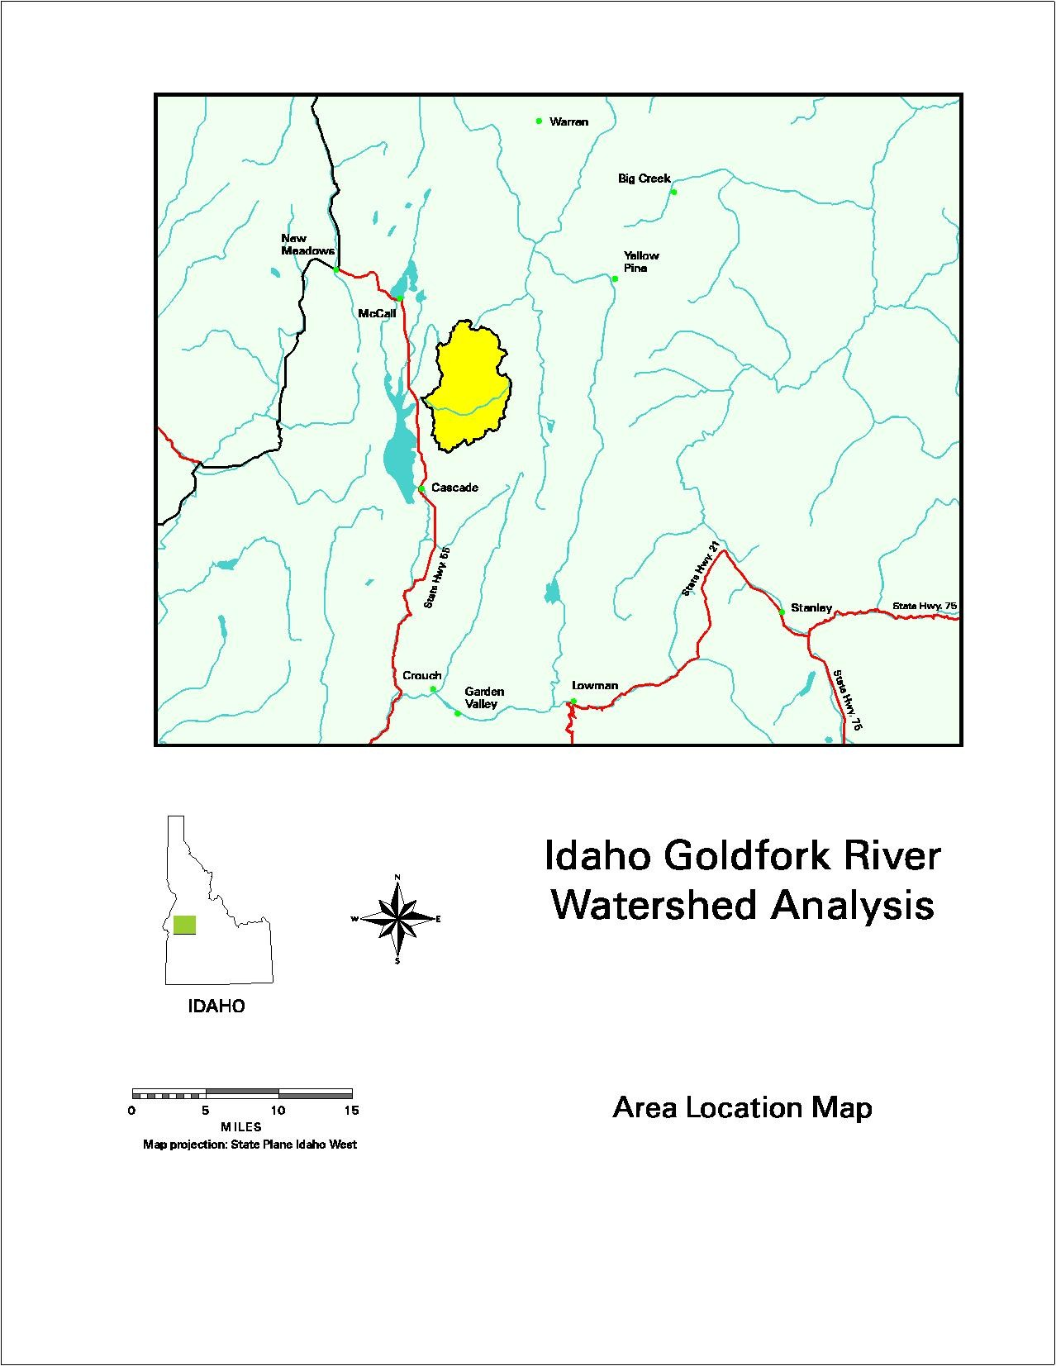

Figure 1. Location of the Gold Fork Watershed, by permission, Boise Cascade Corporation.
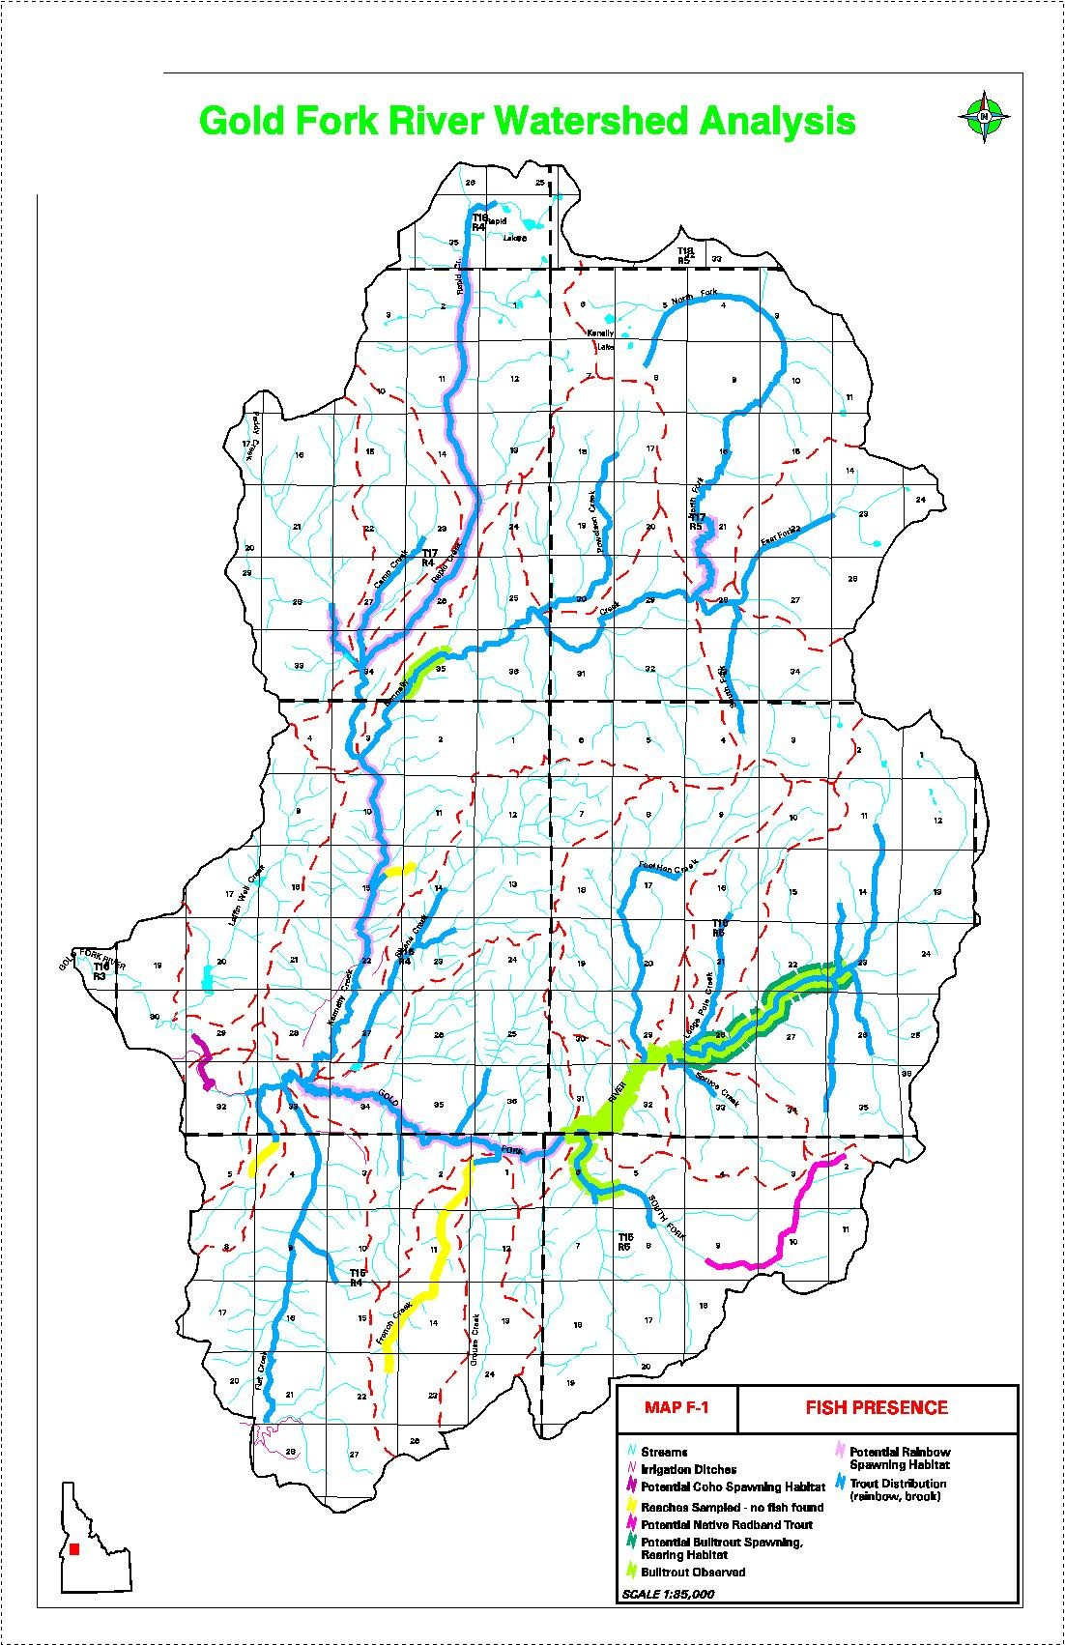

Figure 2. Estimated fish distribution in the Gold Fork Watershed in 1996. Boise Cascade Corporation 1996, by permission.
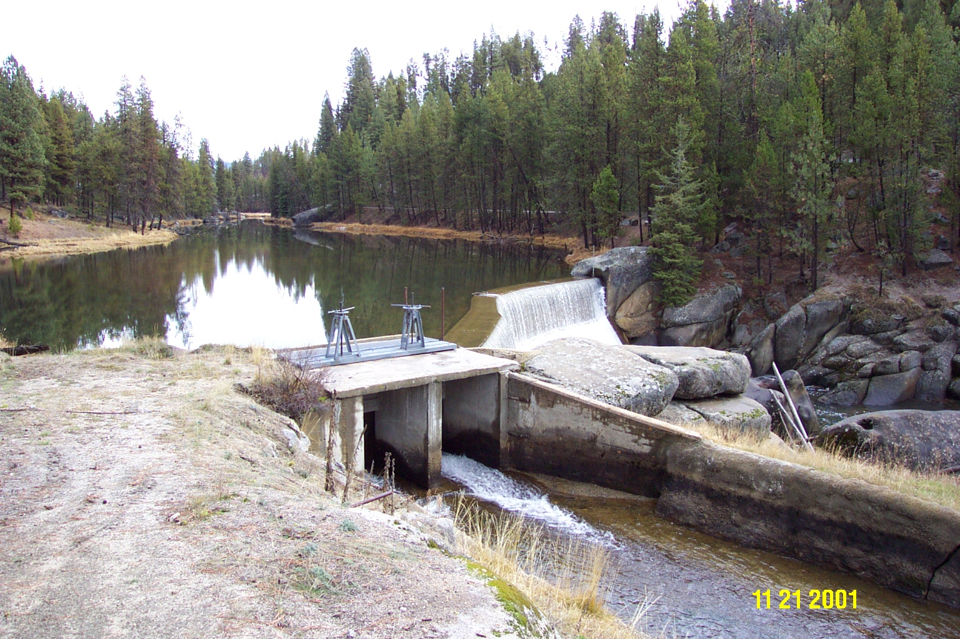

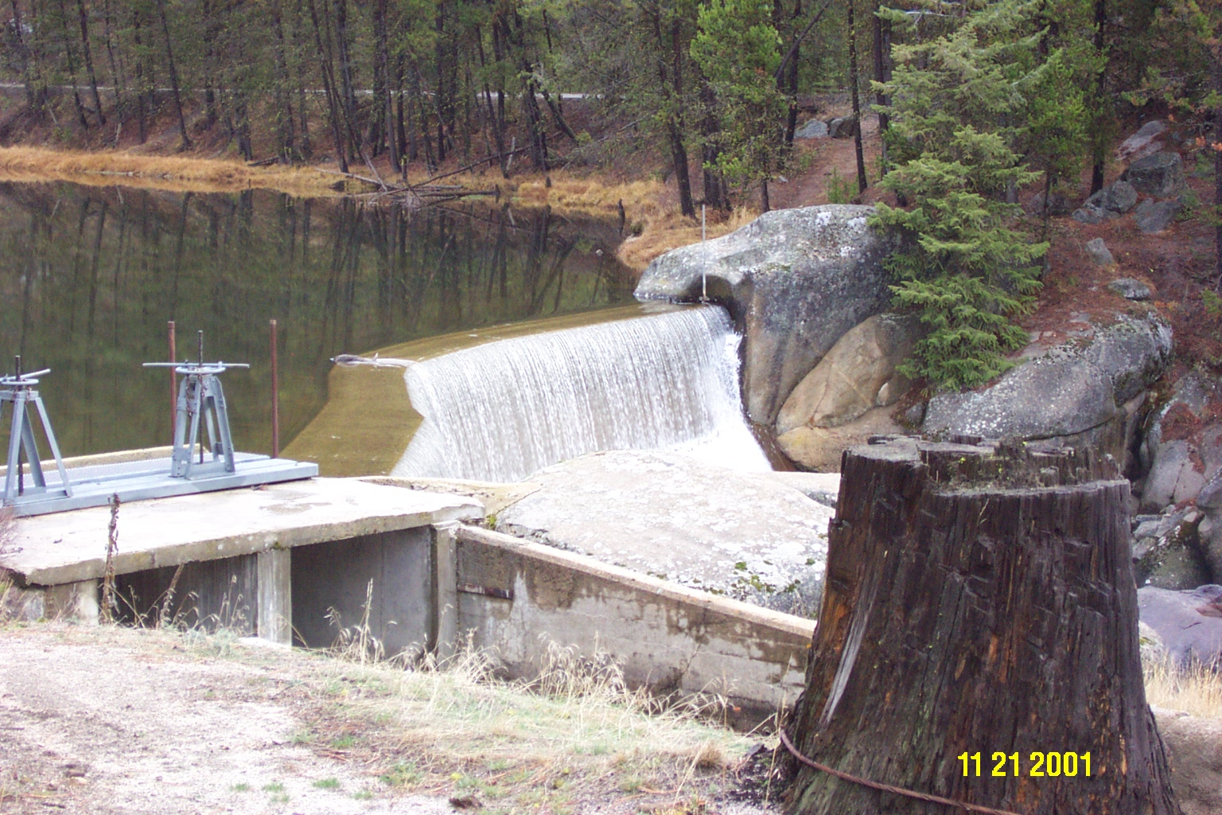

Figure 3 a and b. Looking upstream at the Gold Fork Diversion and intake to the Center Irrigation Canal.

Section 10 of 10. Key personnel
FISHERY MANAGER, REGIONAL | CLASS NO. 00802
Dale B. Allen
CLASS PURPOSE
To develop, implement, and supervise a regional fisheries management program; perform related work.
GENERAL INFORMATION
This work involves walking several miles in rugged terrain and along stream banks; standing and working in cold water four to five hours at a time; working in extreme weather conditions; lifting and carrying equipment weighing up to 60 pounds with occasional lifting and carrying up to 100 pounds for short distances. Frequent travel is required.
PRINCIPAL ACCOUNTABILITIES
1. Management. Typical responsibilities: evaluates and prepares management plans and land-acquisition priorities for fisheries programs in an assigned region; evaluates impact of natural or man-caused catastrophic events on fish populations and habitats and provides alternatives to avoid or mitigate negative effects; reviews and comments on environmental impact statements and Federal Energy Regulatory Commission permits for licensing various stages of hydropower development; develops and implements data collection; plans and conducts spawning ground surveys; interprets life-history data of various fish species; evaluates research results to plan fisheries management activities; recommends fishing seasons and regulations; develops multi-year species plan; hires and trains staff in collecting and analyzing fish data and samples; directs check-station operations to gather fish harvest data; provides input into program budget and monitors expenditures; prepares management reports; oversees department graduate research projects.
2. Field activities. Typical responsibilities: develops and implements stocking programs in streams and lakes; inspects and reports on projects affecting fisheries resources; identifies fish diseases and parasites; directs fish salvage and planting operations; enforces suction-dredging laws; inspects private fish ponds and commercial fish facilities; occasionally assists in enforcing fish and game laws.
3. Liaison and public relations. Typical responsibilities: testifies at various administrative hearings for stream flow applications, stream-channel alterations, and proposed commercial fish-farm operations; provides information regarding fisheries resources, regulations, and policies to various groups and general public; provides technical information to private consulting firms on impacts of proposed projects; participates in public and professional meetings.
MINIMUM QUALIFICATIONS
Considerable knowledge of: fish management practices to include habitat requirements, population dynamics, life history, taxonomy, ecology, and parasites and diseases of various fish; ichthyology; limnology.
Experience: supervising and training others; evaluating land and water developments to determine impact on fish resources; collecting, evaluating, and interpreting statistical and other data relating to fishery research and writing reports of findings.

BIOLOGIST, FISHERY RESEARCH SENIOR | CLASS NO. 00946
To be recruited when funded
CLASS PURPOSE
To plan and conduct field research for fish projects; analyze data and make recommendations to improve fisheries management; perform related work.
PRINCIPAL ACCOUNTABILITIES
1. Planning and field research. Typical responsibilities: conducts life history and habitat studies of fish populations; provides input into research objectives; researches technical and professional literature for relevant data; identifies specific project data required and appropriate means of collection; develops procedures and detailed work plans; interviews anglers and conducts creel census; conducts spawning ground surveys; installs and maintains fish collection devices; marks fish for future identification; samples fish population by netting, electrofishing, and similar methods; collects research and management information at fish and game check stations; measures physical and chemical characteristics of waters; supervises and assigns work to aides; provides safety training and monitors activities for accident prevention; operates and repairs various motorized and nonmotorized equipment; prepares formal proposals and project budgets for funding sources.
2. Data analysis. Typical responsibilities: compiles and analyzes data such as age composition and growth rates of fish populations; prepares project reports; makes recommendations to management based on research findings.
3. Miscellaneous activities. Typical responsibilities: presents information to professional and lay groups; conducts wildlife inventories; participates in chemical rehabilitation of lakes and reservoirs; occasionally assists in enforcing fish and game laws.

Position Description
To be recruited when funded
CIVIL ENGINEER (IRRIGATION ENGINEER)

- INTRODUCTION

This position is located in the Valley Soil and Water Conservation District office in Cascade, Idaho. The incumbent is a team member responsible for gathering information on irrigation alternatives to mitigate anadromous fish passage issues. The incumbent operates with limited direct supervision working from project objectives and tasks. The incumbent is responsible for technical quality of information developed.

B. DUTIES

- Collects, compiles, evaluates and analyzes field data to determine present conditions and proposed engineering treatment needs for irrigation designs and irrigation water management.
- Collects, compiles, evaluates and analyzes field data to determine present conditions and proposed engineering treatment needs for anadromous fish passage.
- Collects, compiles, evaluates and analyzes field data to determine present sediment conditions and effect proposed engineering treatment sediment delivery to Cascade Reservoir.
- Designs, prepares specifications and cost estimates, and prepares or supervises the preparation of civil and structural drawings for irrigation engineering practices.
- Gathers or gives technical guidance to field personnel regarding the nature, type, and extent of survey, geotechnical and other data needed for project design.
- Prepares final designs including construction drawings, specifications, inspections, staffing plan, engineer's cost estimate and bid schedule.
- Assists in determining potential solutions for resolving anadromous fish passage issues and irrigation control, delivery and application, with primary responsibility for evaluating the effects of alternative engineering solutions.
- Prepares engineering planning documents and reports, and provides working data and information concerning evaluations.
- Performs work as a member of a team, and coordinates activities with other Planning Staff members and other subject matter specialists.
- Evaluate of alternative methods for achieving project purposes, including consideration of impacts on water quality, water supply, sedimentation, channel aggredation and degredation, channel stability, local drainage and pumping requirements, hydropower, increased loading on structures.
- Ensures compliance with established policies and procedures and ensures technical criteria is followed.
- Prepares modifications resulting from unforeseen field conditions or changes in criteria that require design changes during the construction phase of the project, and coordinates construction contract modifications.
- Conducts and/or participates in a variety of briefings, meetings and conferences related to the design and/or management of this project.
- Collaborates with staff, Gold Fork Irrigating Company, Center Irrigation District, and local, state and federal agencies.
- Serves as an incidental motor vehicle operator. This duty requires the operation of a motor vehicle on both public and private roads during daylight hours and occasionally after dark. A valid Idaho driver’s license is required. Some operation of off-road vehicles may be required.

KNOWLEDGE, SKILLS AND ABILITIES

KNOWLEDGE OF ENGINEERING (hydrology, hydraulics, soil mechanics, irrigation water management, irrigation systems, structural design, engineering geology), PRINCIPLES AND ANALYTICAL TECHNIQUES in order to perform hydraulic, hydrologic, structural, and geotechnical computations and analyses for complex engineering projects.

KNOWLEDGE OF ENGINEERING PRINCIPLES, CONSTRUCTION METHODS AND MATERIALS in order to coordinate all resource management activities, and prepare designs, construction drawings and construction specifications.

ABILITY TO USE AUTO-CAD AND OTHER ENGINEERING SOFTWARE in order to complete sound structurally designs and prepare construction drawings using automated survey equipment and computer aided design equipment.

KNOWLEDGE OF SURVEY TECHNIQUES AND GEOTECHNICAL INVESTIGATIONS in order to gather or assure field data for design and construction of engineering practices.

ABILITY TO COMMUNICATE IN WRITING in order to prepare technical reports, technical specifications, and to document design and construction decisions.

ABILITY TO COMMUNICATE WITH OTHERS (e.g., VERBALLY, TDD, LIP READING, SIGN LANGUAGE, ETC.) in order to obtain information; solve problems; resolve conflicts; provide information and guidance; and to explain plans, design concepts, and specifications to both technical and non-technical individuals, groups, agency personnel or units of government.

COMPLEXITY

The Gold Fork and Cascade sub-watersheds comprise 117,000 acres within the Cascade Reservoir Watershed’s 276,000 acres. The land uses consist of 96,000 acres of public and private forested land, 15,600 acres of agricultural land and 5,000 acres of urban/suburban land. Approximately 6,500 acres of the agricultural land is irrigated, with greater than 90% flood irrigated. The Cascade Reservoir Watershed Management Plan that identified beneficial uses are to be restored or maintained, including irrigation, anadromous fish and cold water biota while reducing phosphorous loading by 37%.

The Gold Fork Irrigating Company diverts virtually all river water into the Center Irrigation District Canal for irrigation. Soils are varied in texture, depth and water-holding capacity. Climatic areas vary from high mountain valley to mountains.

The position requires a high degree of initiative, judgement and originality. The incumbent must adapt broad national and state standards and criteria to the requirements for the specific local circumstances, devise new procedures or modify existing procedures to meet the requirement of the specific conditions. The incumbent must be able to recognize, analyze and recommend action on problems for which adequate standards in the criteria are not available.

