Bonneville Power Administration

FY 2003 Provincial Project Review

PART 2. Narrative
Project ID: 31027

Title: Movements and Survival of Juvenile and Adult Bull Trout

Section 9 of 10. Project description

a. Abstract
Efforts to manage populations of bull trout have been hampered by a dearth of life history data. It is the goal of this study to provide population data on bull trout for the Columbia River Basin by studying the Lewis River stock as a model system. Bull trout within the Rush Creek watershed will be tagged with 23 mm PIT tags and monitored. A remote stationary interrogation system will bound the downstream end while an impassable waterfall will provide an upper boundary. Emigrating bull trout will be captured in a screw trap operated by WDFW below the stationary interrogation system. The proportion of recaptured bull trout will be used to estimate the total number of migrants. In stream recapture will be used to estimate population size. Back pack interrogation will be used to quantify year class survival and migratory success. Ongoing WDFW efforts to capture adult fish within the upper end of Swift Reservoir will provide opportunities to quantify the spawning migration into Rush Creek. These approaches will provide critical year class survival and migration data necessary to generate models for the long and short term management of bull trout populations within the Columbia River Basin.

b. Technical and/or scientific background

Introduction
Bull trout (Salvelinus confluentus) have historically been found throughout the Pacific northwest, including portions of the Columbia River and its tributaries (Cavender 1978; Bond 1992; Brewin and Brewin 1997). During the last century, however, populations have sharply declined in both distribution and abundance. On June 10, 1998, the Fish and Wildlife Service issued a final rule listing the Columbia River and Klamath River populations of bull trout as threatened species (63 FR 31647) under the authority of the Endangered Species Act of 1973. This decision conferred full protection of the Endangered Species Act on bull trout occurring in four northwestern States.
The distribution of bull trout is believed to be limited to temperatures below 15ºC (Fraley and Shepard 1989; Rieman and McIntyre 1995) and spawning areas are often associated with the coldest streams in a given watershed (Pratt 1992; Rieman and McIntyre 1993; Rieman et al. 1997b; Baxter et al. 1999). All life history stages of bull trout are associated with complex forms of cover, including large woody debris, undercut banks, boulders, and pools (Fraley and Shepard 1989; Goetz 1989; Hoelscher and Bjornn 1989; Sedell and Everest 1991; Pratt 1992; Thomas 1992; Rich 1996; Sexauer and James 1997; Watson and Hillman 1997). Because bull trout have more specific habitat requirements than most other salmonids (Rieman and McIntyre 1993), anthropogenic impacts can be considerable. Declines in bull trout have been linked to habitat degradation and fragmentation, dams, poor water quality and fisheries management practices.
The life history of bull trout is complex, and both resident and migratory strategies may be found (Rieman and McIntyre 1993). Resident bull trout complete their entire life cycle in or near natal streams. Migratory bull trout maintain residence in their natal stream for 1 to 4 years before migrating to either a lake (adfluvial), river (fluvial) (Fraley and Shepard 1989; Goetz 1989), or in certain coastal areas, to saltwater (anadromous) (Cavender 1978; McPhail and Baxter 1996; WDFW et al. 1997).
Upon maturity, adults return to small streams to spawn. Bull trout are iteroparous, however the frequency of repeat spawning and post-spawning mortality are poorly characterized (Leathe and Graham 1982; Fraley and Shepard 1989; Pratt 1992; Rieman and McIntyre 1996). Bull trout normally reach sexual maturity in 4 to 7 years and live as long as 12 years. Spawning occurs from August to November during periods of decreasing water temperatures. Temperatures during spawning generally range from 4 to 10ºC, with redds often constructed in stream reaches fed by springs or near other sources of cold groundwater (Goetz 1989; Pratt 1992; Rieman and McIntyre 1996). Depending on water temperature, incubation is normally 100 to 145 days (Pratt 1992), and after hatching, young remain in the substrate. Fry normally emerge from early April through May (Pratt 1992; Ratliff and Howell 1992).

Background
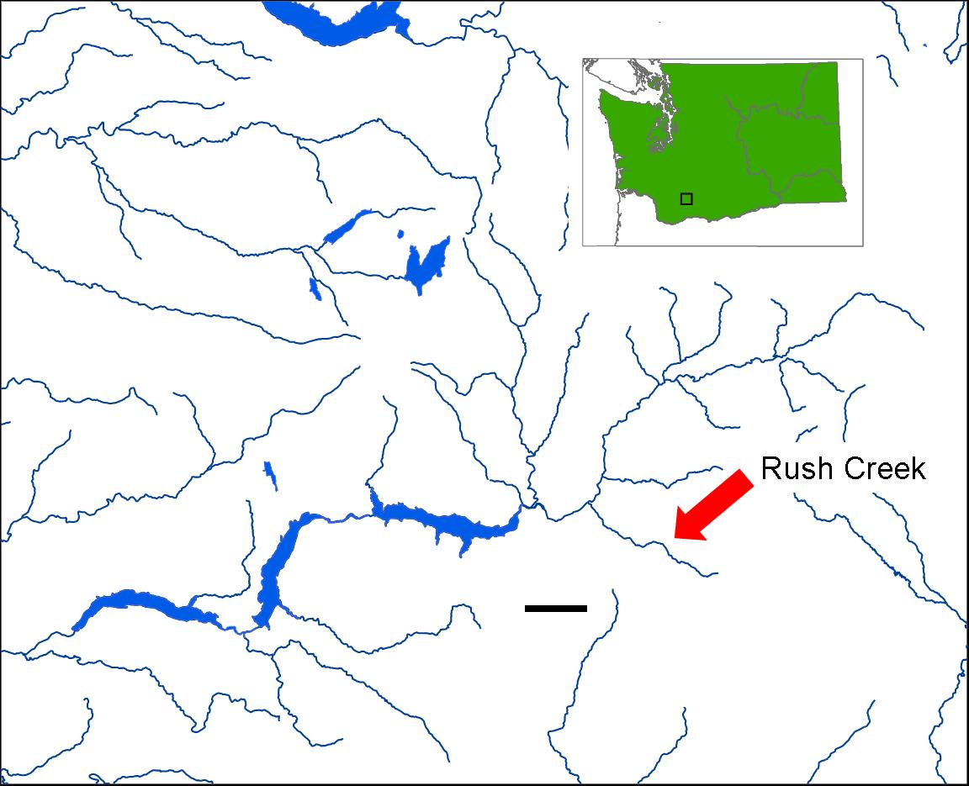
Efforts to manage populations of bull trout have been hampered by a dearth of life history data. Specifically, information on over winter survival, migratory success and the proportion of migrant juveniles have yet to be comprehensively collected for any system. It is the goal of this study to use the Rush Creek/Lewis River as a model system for collection of these data. Ongoing WDFW monitoring programs provide a sound framework on which to build rigorous life history assessments.
Ongoing monitoring programs on the North Fork Lewis River are currently aimed at providing juvenile emigration indices (using screw trap data) and long term spawning population estimates in the Swift reservoir (Figure 1). Adults are gill netted and marked as part of a mark-recapture approach using snorkeling surveys. Radio telemetry studies have demonstrated that adults spawn in two high gradient creeks, Pine and Rush Creeks (WDFW, unpublished data). The majority of spawning occurs in Rush Creek. This backdrop provides an excellent opportunity to develop an understanding and quantification of juvenile recruitment, survival and the timing and frequency of repeat spawning for adults within Rush Creek. This information is lacking and is necessary for building models to assess population strength.
Figure 1. Map showing Rush Creek, a tributary of the North Fork of the Lewis River.
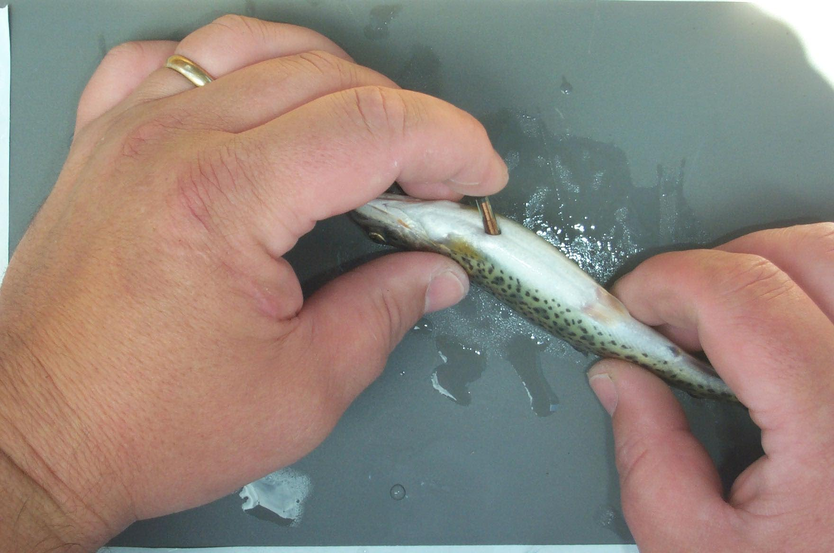
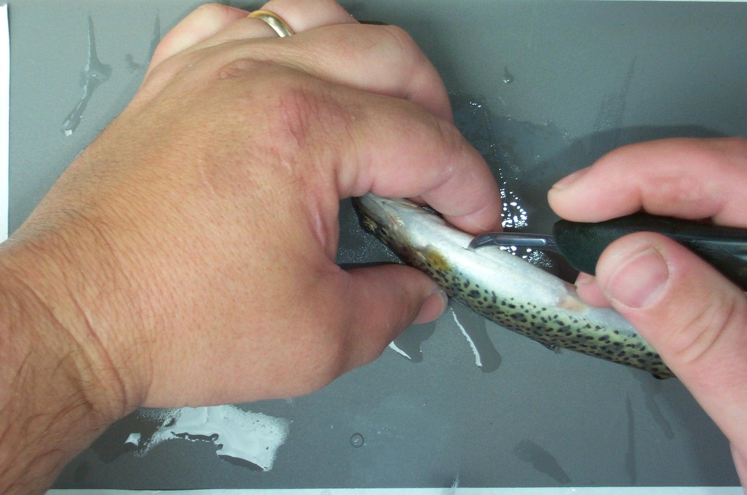
Quantification of in stream movements is challenging when using conventional trapping methods. This is particularly true when migration timing coincides with high water events. PIT tag methodologies allow for the collection of individual data and monitoring of up stream and down stream movements. The new long-range PIT tag technology proposed for use here has recently been developed to monitor movements and stream use of juvenile Atlantic salmon (Zydlewski G. et al. 2001) and has been adapted for ISO-compatible tags in the Columbia Basin (BPA project No. 2001-012-00; G. Zydlewski, unpublished data). The use of a larger ISO compatable tag (23 mm x 3.84 mm) provides an increased read range, making the construction of antennae up to 1.5 m by 4.5 m possible. Because of the increased read range, a stationary detection array can monitor the entire width and depth of a stream for PIT tagged fish, even under high water conditions.
Figure 2. Tagging procedure using a 23 mm PIT tag .
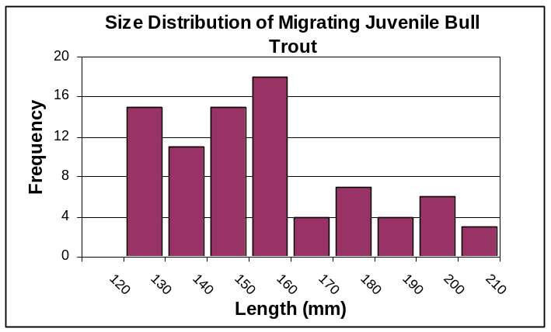
This allows virtually continuous (year-round at a 50 msec resolution) monitoring past a single point in a stream without obstructing the path of the fish. Captured fish are surgically implanted with 23 mm PIT tags (Figure 2) and released in waterways that have been equipped with interrogating arrays and data loggers. Based on previous studies, tag retention is expected to be greater than 99% and survival and growth are not likely to be discernibly affected in fish over 10 cm in length (based on Atlantic salmon, Zydlewski G. et al. 2001; coho salmon and steelhead, Zydlewski, G unpublished data and cutthroat trout Zydlewski, J unpublished data). Tag size is not likely to be problematic in bull trout because of the large size at which they migrate. All juveniles captured at the mouth of Rush Creek in 2001 were greater than 12 cm (Figure 3).
Figure 3. Size distribution of migrating juvenile bull trout captured by screw trap at the mouth of Rush Creek in 2001 (WDFW unpublished data).
While this PIT tag interrogation technique reduces the need to rely on traps for smolt movement information, when used in conjunction with smolt trapping facilities emigration numbers can be accurately estimated. This tandem methodology will be used in this study to quantify emigration, survivorship and recruitment.

A portable PIT tag interrogation device is used much like an electro fisher but without disturbing the fish. This method has been developed to monitor individual movements within a stream. A stream survey with this apparatus collects location information for individual fish that do not move with high water events or at the end the predicted smolt migration.

The coordinated use of these three methods, a stationary interrogation array, a screw trap and a backpack interrogation system will allow the estimation of key juvenile life history parameters.

c. Rationale and significance to Regional Programs
This proposed study, in both approach and in resulting information, is consistent with Reasonable and Prudent Alternatives listed in the NMFS 2000 FCRPS
Biological Opinion and the USFWS 2000 FCRPS. In reference to the NMFS Biological Opinion, this project specifically contributes to Action 193 which prescribes the use of “state of the art” and “novel methods” of fish detection. This project employs a novel development of PIT tag technology for the monitoring and evaluation of bull trout. In reference to the USFWS Biological Opinion, this proposal is consistent with Action 6 which prescribes “… an adaptive management approach…” for survival improvements for bull trout in the Columbia River Basin. Additionally, Action 8 prescribes the initiation of research concerning the upstream and downstream passage of bull trout. The approaches in this study will characterize the timing and conditions of movements for bull trout. This information is crucial for efforts to maximize passage efficacy.

d. Relationships to other projects

This project will be completed in close cooperation and collaboration with WDFW efforts to monitor bull trout in the Lewis River. Capture of adults by gill netting and juveniles by screw trap will be performed by WDFW personnel.
This project will employ the same technology employed in BPA project No. 2001-012-00 and be initiated in collaboration with Gayle Zydlewski.

e. Project history (for ongoing projects)

New Project

f. Proposal objectives, tasks and methods

Objective 1. Quantify survival and year class of Rush Creek emigrants.

This objective will be approached by completing three interelated tasks. A stationary PIT tag detection array will be constructed at Rush Creek near the confluence with the Lewis River. (Figure 4) This will provide a “lower boundry” for passive monitoring of bull trout within the system. Above this proposed site (approximately 2 km) is a greater than 20 m high falls providing an impassable upstream boundary for the study area. Within this study area, bull trout will be captured and tagged with 23 mm PIT tags. Movements past the downstream stationary array will be recorded and emmigration estimates will be calculated by operating a screw trap downstream of the array. The proportion of recaptures will be used to calulate migrant numbers. In-stream mortality will be estimated using “recapture” rates with a portable PIT tag detection system within the stream after the apparent period of migration.
Screw Traps
(green circles)
PIT tag interrogation array
Impassable Falls
Rush Creek
Swift Reservoir
Lewis River
Figure 4 . Map of study site on Rush Creek.

Task a.Construct PIT tag interrogation array
Antennas will be constructed as open coil inductor loops with PVC-coated multi-strand wire strung through PVC pipe. Each antenna will be connected to a Destron-Fearing reader that emits a 134.2 kHz electromagnetic energizing signal through the antenna (Figure 5). Readers and computers will be powered by multiple 12-V deep cycle marine batteries that are recharged by a propane generation unit. A solar trickle charger will be used to augment power. A field data logger will receive serial data output from the readers; detected tag identification numbers, date and time of detection will be recorded. The readers, batteries and/or power supplies, and data logger will be contained within a weather-proof box located outside of the immediate flood zone of the creek. Additionally, data collected in streams where active smolt traps are operated will provide capture efficiencies for traditional methods.
Reader
Data Logging PC
POWER
SUPPLY
Figure 5. Diagram of a stationary PIT tag array showing key parts of operation. Antennae are deployed in the study site and connected to Destron-Fearing reader. The reader logs data onto a computer. Power to all equipment is maintained with deep cycle batteries supplemented with a charging device.

Task b. Tag Bull Trout juveniles
In the summer and fall, up to 400 juvenile bull trout will captured from the study reach of Rush Creek. Methods will include night snorkeling and electrofishing. Electrofishing will be limited to areas where adult have not begun to spawn. Captured fish over 100 mm will be internally tagged with individually coded PIT tags (23 mm long, 3.84 mm diameter, 0.6 g) and released back into the general area of capture. At this time, length, weight, and scale samples will be collected from all fish. Scales will be analyzed to determine age. Monitoring of fish movements will be initiated immediately after release.

Task c. Operate screw trap
In the spring (April through June) WDFW will cooperate to maintain a screw trap at the mouth of Rush Creek as part of the ongoing monitoring of Bull trout. The trap will be checked daily and all capured bull trout will be lengthed, weighed and interrogated with a hand held PIT tag reader for the presence of a PIT tag. Untagged fish will be tagged and released for subsequent monitoring of spawning. Captures in the screw trap, relative to movements past the stationary interrogation array, will be used to estimate the number of down stream migrants.

Task d. Use portable system
Stream surveys using a back-pack PIT tag reader will be performed. The technology utilizes the same equipment necessary for a stationary antenna but is constructed as a hand held "wand" (similar in appearance to an electrofishing probe). This wand can be moved in the stream to locate fish without disturbing them. Manual randomized surveys below stationary antennae will determine presence or absence of tagged fish. A "three-pass approach" will be used to calculate the numbers of tagged individuals in a given reach.
A stream survey with this apparatus collects location information for individual fish that do not move with high water events or at the end the predicted smolt migration. After the assumed period of migration has taken place, stream areas will be interrogated using this mobile system to determine if fish not identified by the stationary antenna have survived. This information will be used to determine not only survival, but to quantify the proportion of resident versus migratory fish.

Objective 2. Quantify yearly adult recruitment and juvenile to adult survival.

This objective is aimed at determining migrant to adult survival by monitoring PIT tagged juveniles captured by screw trapping at the mouth of Rush Creek and a screw trap at the headwaters of Swift Reservoir. This goal is the logical progression of Objective 1. Ongoing efforts to estimate population size through visible tag and snorkeling will be augmented by PIT tagging and interrogation.

Task a. Tag emigrant juveniles.
In order to quantify emigrant to adult return rates, juveniles being tagged in Objective 1 will be monitored for subsequent return migration into Rush Creek. Untagged fish captured as part of the juvenile assessment using a screw trap will be tagged and released to augment the number of fish available for this analysis. No additional effort except this tagging will be necessary as the stationary PIT tag array will be maintained year round.

Task b. Capture and tag adults in migratory staging area
As part of the ongoing WDFW effort to estimate population levels of bull trout, adult fish will be gill netted in the head water of Swift Reservoir. In addition to the WDFW external floy tag, these fish will receive an internal 23 mm PIT tag. These fish will be counted in ongoing snorkel surveys and will be identified when migrating past the stationary array.

g. Facilities and equipment
USFWS staff members will be stationed at the Columbia River Program Office in Vancouver Washington. Suitable laboratories and office space, along with the necessary equipment are also maintained. A fleet of GSA vehicles and maintenance infrastructure will be available. Warehouse space is available in Hazel Dell, WA. A five foot screw trap and ATVs will be available.
Miscellaneous equipment, including but not limited to GPS receivers, flow meters, cellular phones, personal computers etc. will be provided by the USFWS and stored at the CRFPO.
The WDFW will provide boats equipment and personnel necessary to operate the srew trap being employed to capture juveniles for 2 months and to gill net adult bull trout during the migratory staging period.

h. References

Reference (include web address if available online) | Submitted w/form (y/n)
Baxter, J.S., E.B. Taylor, R.H. Devlin, J. Hagen, and J.D. McPhail. 1997. Evidence of natural hybridization between Dolly Varden (Salvelinus malma) and bull trout (Salvelinus confluentus) in a northcentral British Columbia watershed. Canadian Journal of Fisheries and Aquatic Sciences 54:421-429. | n
Bond, C.E. 1992. Notes on the nomenclature and distribution of the bull trout and the effects of human activity on the species. Pages 1-4 in P.J . Howell, and D.V. Buchanan, eds. Proceedings of the Gearhart Mountain bull trout workshop. Oregon Chapter of the American Fisheries Society, Corvallis, Oregon. | n
Brewin, P.A., and M.K. Brewin. 1997. Distribution maps for bull trout in Alberta. Pages 206-216 in W.C. Mackay, M.K. Brewin, and M. Monita, editors. Friends of the Bull Trout Conference Proceedings. Bull Trout Task Force (Alberta), c/o Trout Unlimited Calgary, Alberta, Canada. | n
Cavender, T.M. 1978. Taxonomy and distribution of the bull trout, Salvelinus confluentus (Suckley), from the American Northwest. California Fish and Game 64:139-174. | n
Fraley, J.J., and B.B. Shepard. 1989. Life history, ecology and population status of migratory bull trout (Salvelinus confluentus) in the Flathead Lake and River system, Montana. Northwest Science 63:133-143. | n
Goetz, F. 1989. Biology of the bull trout, Salvelinus confluentus, literature review. U.S. Forest Service, Willamette National Forest, Eugene, Oregon. | n
Hoelscher, B., and T.C. Bjornn. 1989. Habitat, density and potential production of trout and char in Pend Oreille Lake tributaries. Project F-71-R-10, Subproject III, Job No. 8. Idaho Department of Fish and Game, Boise, Idaho. | n
Leathe, S.A., and P. Graham. 1982. Flathead Lake fish food habits study. Environmental Protection Agency, through Steering Committee for the Flathead River Basin Environmental Impact Study. Contract R008224-01-4 to Montana Department of Fish, Wildlife and Parks. | n
McPhail, J.D., and J.S. Baxter. 1996. A review of bull trout (Salvelinus confluentus) life-history and habitat use in relation to compensation and improvement opportunities. Department of Zoology, University of British Columbia. Fisheries Management Report No. 104. Vancouver, British Columbia, Canada. | n
Pratt, K.L. 1992. A review of bull trout life history. Pages 5-9 in P.J. Howell, and D.V. Buchanan, eds. Proceedings of the Gearhart Mountain bull trout workshop. Oregon Chapter of the American Fisheries Society, Corvallis, Oregon. | n
Rich, C.F., Jr. 1996. Influence of abiotic and biotic factors on occurrence of resident bull trout in fragmented habitats, western Montana. M.S. Thesis, Montana State University, Bozeman, Montana. | n
Rieman, B.E., and J.D. McIntyre. 1993. Demographic and habitat requirements for conservation of bull trout. U.S. Forest Service, Intermountain Research Station. General Technical Report INT-302. | n
Rieman, B.E., and J.D. McIntyre. 1996. Spatial and temporal variability in bull trout redd counts. North American Journal of Fisheries Management 16:132-146. | n
Rieman, B.E., D.C. Lee and R.F. Thurow. 1997b. Distribution, status and likely future trends of bull trout within the Columbia River and Klamath River basins. North American Journal of Fisheries Management 17:1111-1125. | n
Sedell, J.R., and F.H. Everest. 1991. Historic changes in pool habitat for Columbia River Basin salmon under study for TES listing. Draft U.S. Department of Agriculture Report, Pacific Northwest Research Station, Corvallis, Oregon. | n
Sexauer, H.M., and P.W. James. 1997. Microhabitat use by juvenile trout in four streams located in the eastern Cascades, Washington. Pages 361-370 in W.C. Mackay, M.K. Brewin and M. Monita, editors. Friends of the Bull Trout Conference Proceedings. Bull Trout Task Force (Alberta), c/o Trout Unlimited Calgary, Alberta, Canada. | n
Thomas, G. 1992. Status of bull trout in Montana. Report prepared for Montana Department of Fish, Wildlife and Parks, Helena, Montana. | n
Washington Department of Fish and Wildlife (WDFW), FishPro Inc., and Beak Consultants. 1997. Grandy Creek trout hatchery biological assessment. March 1997. | n
Watson, G., and T.W. Hillman. 1997. Factors affecting the distribution and abundance of bull trout: and investigation at hierarchical scales. North American Journal of Fisheries Management 17:237-252. | n
Zydlewski, G.B. A. Haro, K.G. Whalen and S.D. McCormick. 2001. Performance of stationary and portable passive transponder detection systems for monitoring of fish movements Journal of Fish Biol. 58(5): 1471-1475. | n

Section 10 of 10. Key personnel

Joseph Zydlewski, Principal Investigator
Columbia River Fisheries Program Office, USFWS
Duties include the design, analysis and presentation of data, tagging of juvenile fish, construction and maintenance of PIT tag interrogation systems.

Jim Byrne, Collaborator
Washington Department of Fish and Wildlife
Duties include the design, analysis and presentation of data, coordination of personnel and equipment for adult gill netting and screw trap operation

Gayle Zydlewski, Collaborator
Abernathy Fish Technology Center, USFWS
Duties include the construction and maintenance of PIT tag interrogation arrays on Rush Creek.
Joseph Zydlewski
U.S. Fish and Wildlife Service, Columbia River Fisheries Program Office, Vancouver, WA
Experience:
2001- present Fishery Biologist, U.S. Fish and Wildlife Service, Vancouver, WA
2001- present Adjunct Faculty, Washington State University, Vancouver, WA
2000-2001 Consulting Research Physiologist, Abernathy Fish Tech. Ctr., Longview, WA
1998-1999 Postdoctoral Research Associate, University of Massachusetts, Amherst MA

1999 Lecturer, Wildlife and Fisheries Conservation, University of Massachusetts, Amherst, MA
1999 Postdoctoral Research Associate, Conte Anadromous Fish Research Center USGS/BRD, Turners Falls, MA
1999 Instructor, Five Colleges, Amherst, MA
1998-1999 Lecturer, Biology Dept., University of Massachusetts, Amherst, MA
1993-1994 Teaching Assistant, Biology Dept. University of Massachusetts, Amherst, MA
1992-1998 Research Assistant, Biology Dept. University of Massachusetts, Amherst, MA
1990-1991 Inland Fisheries Extension Agent, Peace Corps Volunteer, Sierra Leone, West Africa

Education:
B.S. Bates College Lewiston, ME 1990
Ph.D. University of Massachusetts, Amherst, MA 1998

Publications:
Zydlewski, J., S. D. McCormick, and J.G. Kunkel (in review). Early migration may be advantageous in juvenile American shad (Alosa sapidissima).
Zydlewski, G.B., S. Foott, K. Nichols, S. Hamelberg, J. Zydlewski and B.T. Bjornsson (submitted) Enhanced smolt characteristics of steelhead trout exposed to alternative hatchery conditions during the final months of rearing. Aquaculture.
Shrimpton, J.M, J. Zydlewski and S.D. McCormick (in press). The stress response of juvenile American shad to handling and confinement is greater during migration in freshwater than in seawater. Transactions of the American Fisheries Society.
Pelis, R.M., J. Zydlewski and S.D. McCormick (2001). Gill Na⁺,K⁺,Cl⁻ cotransporter localization and abundance in Atlantic salmon during seawater acclimation and smolting. American Journal of Physiology.
Zydlewski, J. and S. D. McCormick (2001). Changes in chloride cells corresponding to the natural development of osmotic tolerances in American shad (Alosa sapidissima). Journal of Experimental Zoology.
Zydlewski, J. and S. D. McCormick (1997). The ontogeny of salinity tolerance in American shad (Alosa sapidissima). Canadian Journal of Fisheries and Aquatic Sciences 54: 182-189.
McCormick, S.D., J.M. Shrimpton, and J.D. Zydlewski (1997). Temperature effects on osmoregulatory physiology of anadromous fish. In Global Warming Implications for Freshwater and marine fish. Society for Experimental Biology, Seminar Series: 61. Edited by C.M. Wood and D.G. McDonald. University Press, Cambridge, United Kingdom.
Zydlewski, J. and S. D. McCormick (1997). Loss of hyperosmoregulatory ability in migrating juvenile American shad (Alosa sapidissima). Canadian Journal of Fisheries and Aquatic Sciences 54:2377-2387.
Oberst MD, T.J. Gollan, M. Gupta, S.R. Peura, J.D. Zydlewski, P. Sudarsanan, T.G. Lawson TG. (1993). The encephalomyocarditis virus 3C protease is rapidly degraded by an ATP-dependent proteolytic system in reticulocyte lysate. Virology 193(1):28-40.

Gayle Barbin Zydlewski, Behavioral Physiologist

Experience
1999-Present: Research Fisheries Biologist, USFWS, Abernathy Fish Technology Center, Longview, WA
Current Responsibilities: To develop innovative fish culture methods in support of restoration and recovery initiatives; investigate relationships between juvenile rearing strategies and adult return rates at Regional fish hatcheries; determine the effects of modifications and enhancements to hatchery rearing environments on fish growth, behavior, and survival; develop new approaches to investigate the extent of interactions between hatchery-reared and wild fish; and evaluate restoration and recovery strategies for certain populations in decline. These duties revolve around the use of behavioral (assessment of downstream movements of smolts) and physiological (biochemical and endocrine) techniques to assess the above listed strategies.

1997-1999: Postdoctoral Research Associate, USGS/BRD, Conte Anadromous Fish
Research Center, Turners Falls, MA
Responsibilities: I conducted research to determine whether environmental factors which control the physiology of smolting also affect downstream migratory behavior of Atlantic salmon smolts. I also worked to determine the influence of endocrine changes (exogenous thyroid hormones, cortisol, growth hormone, prolactin) throughout smolting and the initiation of downstream migration. This research involved maintenance of Atlantic salmon parr and smolts for experimental studies, technical training in fish physiology (nonlethal gill biopsies, Na⁺-K⁺ ATPase activity assays, radioimmunoassays, ion analysis) and development of passive integrative transponder (PIT) systems for quantifying behavior in the laboratory and field.

Education:
School Degree and Date Received
Southeastern Massachusetts University B.S., 1990
University of Rhode Island M.S., 1992
University of Maine Ph.D., 1996

Expertise:
Examining behavior and physiology of migration. This includes design of behavioral monitoring systems and analysis of data collected with these systems. Experience in integrating physiological and behavioral aspects of migration of diadromous fishes as detailed above.

Recent Publications:
Zydlewski, G.B., A.J. Haro, K.G. Whalen, & S.D. McCormick. 2001. Performance of stationary and portable Passive Transponder detection systems for monitoring of fish movements. Journal of Fish Biology. 58(5): 1471-1475.
Zydlewski, G.B., S. Foott, K. Nichols, S. Hamelberg, J. Zydlewski, B. Th. Björnsson. In Review. Enhanced smolt characteristics of steelhead trout exposed to alternative hatchery conditions during the final month of rearing. Aquaculture.
Zydlewski, G.B., J. R. Johnson. Accepted. Response of bull trout fry to four water diversion screen types. North American Journal of Fisheries Management.
Zydlewski, G.B., S.D. McCormick, & A.J. Haro. In Review. The role of temperature in downstream migratory behavior of Atlantic salmon smolts.
Barbin, G.P., S.J. Parker, & J.D. McCleave. 1998. Olfactory clues play a critical role in the estuarine migration of silver-phase American eels. Environmental Biology of Fishes 53: 283-291.

