Bonneville Power Administration

FY 2003 Provincial Project Review

PART 2. Narrative
Project ID: 35024

Title: Evaluating the sublethal impacts of current use pesticides on the environmental health of salmonids in the Columbia River Basin.

Section 9 of 10. Project description

a. Abstract

Current use pesticides are an emerging concern for the environmental health of anadromous salmonids throughout the Columbia River Basin. Pesticides are toxic chemicals that degrade the quality of salmon habitat, and they represent a potentially important obstacle to the 2000 Fish and Wildlife Program’s habitat-based approach to rebuilding naturally producing fish populations. Pesticide use is extensive in many agricultural and urban watersheds. Recent monitoring investigations by the U.S. Geological Survey’s National Water Quality Assessment Program have shown that surface waters in major tributaries to the mainstem of the Columbia River are frequently contaminated with diverse mixtures of insecticides, herbicides, and other biocidal compounds. The consequences of pesticide exposures for the health of salmon and the viability of natural populations are largely unknown. This uncertainty creates difficult challenges for the management of threatened or endangered salmonids and the restoration of pesticide-contaminated habitats. To address important information gaps with respect to toxicity, we will use a rapid phenotypic approach to screen all major classes of current use pesticides (and pesticide mixtures) for sublethal impacts on the development, physiology, and behavior of fish using zebrafish as an experimental system (Task 1). In addition, we will evaluate the effects of ecologically realistic pesticide exposures on the sensory physiology and behavior of salmon, with an emphasis on survival, homing, and the long-term viability and genetic integrity of wild populations (Task 2). The proposed research is integrative, and will incorporate techniques in developmental biology, optical imaging, histology, immunohistochemistry, neurochemistry, neurophysiology, animal behavior, and population modeling. The work will provide new empirical and modeling data for a poorly understood and potentially critical aspect of salmon habitat quality. Our findings will apply to all river systems within the Mainstem/Systemwide Province where pesticides are known or suspected to occur.

b. Technical and/or scientific background

Throughout the Columbia River Basin, salmon habitat quality is determined by a combination of physical, biological, and chemical factors. Salmon need cool, clean water in adequate supply to survive critical periods of early development, juvenile growth, smoltification, adult migration, and spawning. Chemical habitat quality, and water pollution in particular, is a major limiting factor for salmon recovery in watersheds with significant agricultural, urban, or industrial land use coverage (NMFS, 1998). Pollution is a significant concern because exposures to environmental contaminants can undermine the health and performance of salmon in ways that may ultimately reduce survival, migratory success, and reproductive success.

Herbicides |  | Insecticides

Alachlor | Metolachlor | Azinphos-methyl*
Atrazine | Metribuzin | Carbaryl
Deethylatrazine | Napropamide | Carbofuran
Bentazon | Norflurazon | Chlorpyrifos*
Bromacil | Oryzalin | Diazinon
Bromoxynil | Pendimethalin | Ethoprop
Butylate | Prometon | Fonofos
Cyanazine | Pronamide | Malathion*
2,4-D | Propachlor | Methiocarb
DCPA | Propanil | Oxamyl
Dicamba | Simazine | cis-Permethrin
Dinoseb | Tebuthiuron | Propargite
Diuron | Terbacil | Terbufos
EPTC | Triallate
Linuron | Triclopyr
MCPA | Trifluralin

Table 1. A partial list of current use pesticides detected in surface waters of the Willamette River Basin by the USGS National Water Quality Assessment (NAWQA) program (adapted from Wentz et al., 1998). Note that only three pesticides (indicated by an asterisk) have established EPA criteria for the protection of aquatic life (EPA, 1999). Notably, aquatic life criteria for all three chemicals were exceeded in the basin.

In terms of water quality, the current use pesticides are a major source of scientific uncertainty with respect to the recovery of threatened or endangered salmon populations. Approximately 750 different pesticides (active ingredients) are registered for use in Oregon, Washington, and Idaho (B. Moran, WA Dept. Agriculture, personal communication). Collectively, these substances are designed to repel, kill, or regulate the growth of undesirable biological organisms. This diverse group includes fungicides, herbicides, insecticides, nematicides, molluscicides, rodenticides, fumigants, disinfectants, repellents, wood preservatives, and antifoulants. The most common pesticides are insecticides, herbicides, and fungicides. These are used for pest control on forested lands, agricultural crops, tree farms and nurseries, highways and utility rights of way, parks and golf courses, and residences. Pesticides often enter the aquatic environment as single chemicals or complex mixtures (Fuhrer et al., 1999). Direct applications, surface runoff, spray drift, agricultural return, and groundwater intrusions are all examples of transport processes that deliver pesticides to aquatic systems.

Pesticides are frequently detected in salmon habitat throughout the Columbia River Basin. As an example, 50 different chemicals were recently detected by the U.S. Geological Survey’s National Water Quality Assessment (NAWQA) Program in the surface waters of the Willamette Basin (Wentz et al., 1998). In addition, a USGS pilot study in the Yakima basin detected 43 different pesticides in surface waters that provide critical habitat for ESA-listed salmonids (Rinella et al., 1999). A partial list of the pesticide detection in the Willamette Basin is shown in Table 1, and these chemicals are ranked according to their frequency of detection in Table 2. As is evident from Table 2, salmonids in the lower reaches of the Willamette River system are often exposed to many different pesticides. Of concern to natural resource managers is the fact that several active ingredients have been shown to have negative impacts on the physiology or behavior of salmonids at sublethal exposure concentrations (Hansen et al., 1999a&b; Winberg et al., 1992; Moore and Waring, 2001, 1998; 1996a; Brewer et al., 2001; Beauvais et al., 2000; Scholz et al., 2000; Waring and Moore, 1997; Kruzynski and Birtwell, 1994; Morgan and Kiceniuk, 1990; Little et al., 1990).

Pesticide | Rate of Detection | Class
Atrazine | 85% | Triazine Herbicide
Simazine | 77% | Triazine Herbicide
Metolachlor | 62% | Chloracetanilide Herbicide
Diuron | 53% | Substituted Urea Herbicide
Deethylatrazine | 38% | Triazine Herbicide
Diazinon | 35% | Organophosphate Insecticide
Carbofuran | 29% | Carbamate Insecticide
Napropamide | 26% | Amide Herbicide
Terbacil | 24% | Substituted Uracil Herbicide
Chlorpyrifos* | 21% | Organophosphate Insecticide
Metribuzin | 19% | Triazine Herbicide
Prometon | 19% | Methoxytriazine Herbicide
Carbaryl | 18% | Carbamate Insecticide
EPTC | 17% | Thiocarbamate Herbicide
Ethoprop | 15% | Organophosphate Insecticide
Tebuthiuron | 15% | Substituted Urea Herbicide
2,4-D | 12% | Phenoxy Herbicide
Fonofos | 12% | Organophosphate Insecticide
DCPA | 10% | Phthalate Herbicide

Table 2. Pesticide detections in the Wilamette River Basin, ranked by the rate or frequency of detection (for chemicals detected in at least 10% of all surface water samples). Of the top ten pesticides, only chlorpyrifos (asterisk) has an EPA-established criteria for the protection of aquatic life (EPA, 1999).

Although pesticides could potentially undermine salmon recovery efforts in the mainstem and several major tributaries of the Columbia River, there are two critical scientific uncertainties associated with these chemicals. First, more than a hundred different pesticides are now a water quality concern in the Mainstem/Systemwide Province. The sublethal effects of these chemicals on the health or performance of fish have never been systematically evaluated. Moreover, for the vast majority of pesticides, the available toxicological data are inadequate for a scientific determination of the risks they pose for native fish species. Second, habitat recovery planners do not have the biological information they need to evaluate pesticides in the larger context of salmon habitat quality. For example, what is the relative significance of pesticide contamination for habitat recovery and offsite mitigation efforts in the Columbia River Basin? How do sublethal toxicological effects, as measured in the laboratory, relate to the survival or reproductive success of wild salmon? What limits, if any, do pesticides impose on the productivity or genetic integrity of at-risk salmon populations?

The objective of this proposal is to generate new empirical and modeling data that directly address these two management uncertainties. The experimental approach is outlined in Tasks 1 & 2 below.

c. Rationale and significance to Regional Programs

The stated vision of the 2000 Fish and Wildlife Program (FWP, Section III.A.1) is a Columbia River ecosystem that sustains an abundant, productive, and diverse community of fish. Where feasible, this will be accomplished by restoring the natural ecological functions and habitats of the Columbia River Basin. This includes a specific planning assumption (Section III.A.2) that the FWP is a habitat-based program that will rebuild healthy, naturally producing fish populations by protecting, mitigating, and restoring habitats and the biological systems within them, including anadromous fish migration corridors. One of the six recovery goals of the Federal Caucus is to “conserve ecosystems upon which salmon and steelhead depend”. The stated scientific principle for this goal is that “conservation requires a network of diverse, high quality, interconnected habitats and high water quality”.

Pesticides degrade water quality, and they are system-wide problem in the Columbia River Basin. This is a result of various human activities, including fire suppression on forested lands, noxious weed control, right-of-way maintenance (roads, railroads, power lines, etc.), algae control in lakes and irrigation canals, various agricultural activities, riparian habitat restoration, and urban and residential pest control. It is important to note that the term “pesticide” is a collective description of hundreds of different chemicals that have different sources, different fates in the aquatic environment, and different toxic effects on salmon and other aquatic organisms. Despite these differences, all current use pesticides are (1) specifically designed to kill, repel, or regulate the growth of biological organisms, (2) intentionally released into the environment, and (3) registered for use without specific consideration of possible sublethal toxicological effects on threatened or endangered species of Pacific salmon. In these and other respects, pesticides are very different from more conventional water quality parameters such as temperature, suspended solids, or dissolved oxygen. Unlike temperature or dissolved oxygen, pesticides are expensive and sometimes difficult (or impossible) to measure in surface waters. Our present understanding of pesticides in salmon habitat is a direct result of recent USGS monitoring efforts in a few of the tributaries to the mainstem of the Columbia River (notably the Yakima and the Willamette). As analytical methodologies have improved, the number of pesticides that have been documented in salmon habitat has increased. As a result, pesticides have recently become a core water quality and habitat concern under the ESA (NOAA, 2000a).

The FWP's primary habitat strategy (Section III.D.3) is to identify the current condition and biological potential of the habitat. Moreover, the FCRPS Biological Opinion calls for habitat actions that provide offsite mitigation (9.4.2.6 Offsite Mitigation-Habitat Plan). Identifying the actions relies heavily on the subbasin planning process. The Federal Caucus Basinwide Recovery Strategy places a specific emphasis on restoring tributary and estuarine habitat. The FWP relies heavily on the protection of, and improvements to, inland habitat as the most effective means of restoring and sustaining fish populations. Moreover, a primary strategy for research, monitoring, and evaluation (Section II.D.9) is to identify and resolve key uncertainties for the program.

Pesticides are a major source of scientific uncertainty with respect to salmon habitat quality throughout the Mainstem/Systemwide Province. To address this uncertainty, the proposed research will evaluate every major class of pesticide that is currently used in the Columbia River Basin for sublethal impacts on the key developmental, physiological, or behavioral processes in fish. Correspondingly, the results will have management applications for habitat recovery planning in every watershed where pesticides have been detected or are thought to occur in surface waters. This includes most (or all) of the major migration corridors for salmon in the Basin. In addition, the data generated will be useful for the Technical Recovery Teams (TRTs) for ESA-listed ESUs, the WA State Pesticide/ESA Task Force, various Section 7 consultations (several pending) between the Services and federal land management agencies, and a pending national consultation between EPA and NMFS on the potential impacts of pesticides on ESA-listed salmonids in the Pacific Northwest. Direct applications to other issues, including right of way maintenance and the use of chemicals for riparian habitat restoration or noxious weed control by state and local organizations, are also likely.

Finally, Section 9.0 of the 1998 National Marine Fisheries Service Federal Columbia River Power System Biological Opinion addressed several water quality issues. The main issues were water temperature and total dissolved gas. However, concern for chemical contaminants was addressed in Action 39. Return flows from the U.S. Bureau of Reclamation (BOR) Columbia Basin Project were recognized as a potential source of pesticides and other agricultural chemicals. Because of the potential for adverse effects on listed fish, detailed water quality monitoring and analysis was specified. If the monitoring reveals water quality degradation sufficient to concern for listed stocks, the BOR is to develop a remediation plan. The proposed research will provide key toxicological data to interpret the results of the monitoring plan as developed under RPA 39.

d. Relationships to other projects

The USGS NAWQA Program is currently conducting large scale monitoring efforts for pesticides in the Willamette Basin (http://water.usgs.gov/pubs/circ1161) and the Yakima Basin-Central Columbia Plateau (http://water.usgs.gov/pubs/circ1144) at a cost of several million dollars. Previous environmental fate studies in these systems have shown a clear relationship between various pesticide applications in agricultural and urban watersheds and the transport of these chemicals to surface waters that provide critical habitat for ESA-listed salmonids. The research proposed here will evaluate these monitoring results in the context of the environmental health of fish (using the zebrafish model as a surrogate for at-risk species in the Basin), with additional focused research on chinook salmon. We expect USGS efforts in the basin and our proposed research to be complimentary and, to the extent possible, coordinated.

This project will also generate sublethal pesticide toxicity data that will be very useful for the purposes of the Washington State Task Force on pesticides and ESA-listed salmon (see Appendix A – letter from Governor Locke). The Task Force is an outgrowth of the State of Washington’s Agriculture, Fish, and Water negotiations. These negotiations are, in turn, a key element of the Governor’s Salmon Recovery Strategy. The Task Force was created in 2000 to determine which pesticides could potentially harm threatened or endangered salmonids. The Task Force is an interagency technical and policy team composed of scientists and managers from NMFS, USFWS, EPA, USGS, the WA State Departments of Agriculture, Ecology, Fish and Wildlife, Natural Resources, and WSU. The State of Washington has recently invested $1.33 million dollars (via the Dept. of Agriculture) in a pesticide/salmon database and new surface water monitoring studies for pesticides in salmon habitat. The empirical data generated by the toxicological research in this proposal will significantly benefit ongoing and future Task Force efforts in Washington State.

The proposed research will also assess the potential sublethal impacts of several classes of herbicides that are the focus of Section 7 consultations between the Services and the Bureau of Land Management, the US Forest Service, and other land management agencies that use pesticides on federal lands. Ongoing consultations are focused on the use of herbicides for noxious weed control (i.e., “Endangered Species Act Formal Section 7 Consultation and Magnuson-Stevens Act Essential Fish Habitat Consultation, Ten Year Integrated Noxious Weed Management Program for the Bureau of Land Management, Vale District, Oregon [Draft]”), forest health, and fire supression. New toxicological studies will be of substantial benefit to these interagency efforts, especially for those herbicides that have little or no associated data for sublethal toxicity in fish. Also, a national Section 7 consultation between NMFS and EPA may initiate in 2002, pending the resolution of multiple citizen lawsuits filed against EPA for failing to consult on the potential impacts of registered pesticides on ESA-listed salmonids in the Pacific Northwest (see Appendix B - Letter from Curt Smitch). This proposal would generate new toxicological information for nearly all of the classes of active ingredients that are named in these lawsuits, and new data could be very useful in the event of a national consultation on pesticides and salmon.

Finally, the US BOR and the USGS are cooperating on the implementation of NMFS Biological Opinion Action Item 39 during FY 2002 and 2003. The project will characterize the water quality of irrigation returns to the Columbia River from the Columbia Basin Project. Water samples will be taken at selected mid-Columbia Basin wasteway return sites known to be occupied by listed upper Columbia River steelhead. The water samples will be subjected to broadband screening laboratory analyses capable of detecting many different pesticides. The research proposed here will address the potential sublethal toxicity of all of the classes of pesticides (organics and copper) that are presently included in the BOR monitoring effort.

e. Project history (for ongoing projects)

f. Proposal objectives, tasks and methods

PROPOSAL OBJECTIVE

Evaluate the sublethal impacts of current pesticides on the health and performance of fish and, for salmon, relate sublethal toxicity in individual fish to the viability and genetic integrity of native populations in the Columbia River Basin.

Task 1. Conduct rapid phenotypic screens for sublethal toxicity using zebrafish (Danio rerio) as a surrogate for salmon and other at-risk fish species in the Columbia River Basin.

Problem Statement

Hundreds of different current use pesticides are now a water quality concern in the mainstem of the Columbia River and most of its major tributaries. The sublethal effects of these chemicals on the health or performance of fish have never been systematically evaluated. Moreover, for the vast majority of pesticides, the available toxicological data are inadequate for a scientific determination of the risks they pose for native fish species.

Chemical exposure and adverse biological affect are the two sides to the toxicological risk equation. For anadromous salmon and other fish species, complex patterns of pesticide exposure have now been documented in several major rivers systems within the Columbia River Basin (e.g., Tables 1 & 2). The specific aim of this Task is to put these environmental monitoring data into a biological context. We will generate new empirical data that will directly address the potential impacts of all major classes of current use pesticides on the development, physiology, and behavior of fish. These studies will focus on the toxicity of individual active ingredients. We will also screen common mixtures of pesticides for additive or synergistic toxicity.

The ultimate goal of the proposed research is to generate new data that can be used to manage salmonids and other at-risk fish species in the Mainstem/Systemwide Province. Unfortunately, however, it is not technically or logistically possible to conduct rapid and sensitive toxicological screens in Pacific salmon within the timeframe of this proposal (three years). There are two reasons for this. The first is the large number of pesticides and pesticide mixtures that must be evaluated. The second is the fact that only a few, labor-intensive sublethal toxicological endpoints have been established for salmon. For example, fish are particularly vulnerable to the harmful effects of pesticides and other environmental contaminants during early stages of development (embryos and larvae). Rapid and sensitive developmental screens in salmonids are not practical because (1) salmon embryos are only seasonally available, (2) the duration of embryonic and larval development is relatively protracted, (3) basic aspects of salmon developmental biology have not been described, (4) salmon embryos are opaque, which precludes conventional in vivo optical imaging techniques, and (5) ontogenetic and molecular markers for many critical developmental processes do not exist for salmon.

Accordingly, we are proposing a novel use of the zebrafish (Danio rerio) as a surrogate experimental system for screening pesticides for harmful effects in fish. Zebrafish are a relatively new experimental model in the fields of vertebrate developmental biology, genetics, and toxicogenomics (Grunwald, 1996). Research in this system, however, is increasingly advancing our understanding of the mechanisms that control the differentiation and specification of the vertebrate embryo. Recently, the molecular and genomic tools available for zebrafish research have expanded significantly. For example, the sequence of the zebrafish genome is expected in the fall of 2002. This will make zebrafish the third vertebrate with a complete genomic sequence (behind humans and mice). Zebrafish are widely recognized as a useful model for studying human disease (Dodd et al., 2000), and they have become a major National Institute of Health (NIH)-supported experimental model for studying fundamental mechanisms of development and developmental toxicity in humans and other vertebrates (Fishman, 2001). For these reasons, we believe zebrafish will also be a good surrogate for other fish species (i.e., salmon).

Several aspects of zebrafish biology make it a particularly useful model for studying the sublethal effects of pesticides on fish. First, a zebrafish breeding colony is easy to maintain in a research laboratory, and techniques for husbandry and experimental manipulation are well documented (Detrich et al., 1998a,b; Westerfield, 1994). Zebrafish spawn year round, and a few spawning pairs can produce several hundred embryos each day. Second, embryonic and larval development proceeds very rapidly (Fig. 1). Embryonic development is complete within two days, and significant ontogenetic events (e.g. the formation of the brain and spinal cord) occur on a time scale of hours. Also, highly detailed and complete maps of the different stages of early development have been published (Kimmel et al., 1995). Third, zebrafish embryos and larvae are transparent. Therefore, different structures (and even single cells) can be imaged at high resolution using optical sectioning techniques such as Nomarski optics or confocal microscopy. This allows for the sensitive and rapid visualization of nearly all aspects of anatomical or morphological development. Fourth, many different tools are available for experimental analyses of developmental abnormalities. These include vital dyes (Baier et al., 1994), fluorescent probes (Kozlowski and Weinberg, 2000), antibodies (Ross et al., 1992), histochemical techniques (Ross et al., 1992), and other developmental markers that can be used to follow the fate of discrete cell populations or the formation of different tissues and organs. Finally, the zebrafish embryo hatches and becomes a free-swimming larva at approximately 48 hours post-fertilization (48 hpf). Larvae are sensitive to environmental stimuli and they show a range of different behaviors that can be quantified. This allows for screens of sensory and motor function, including behaviors that are critical for survival (e.g. escape reflexes).

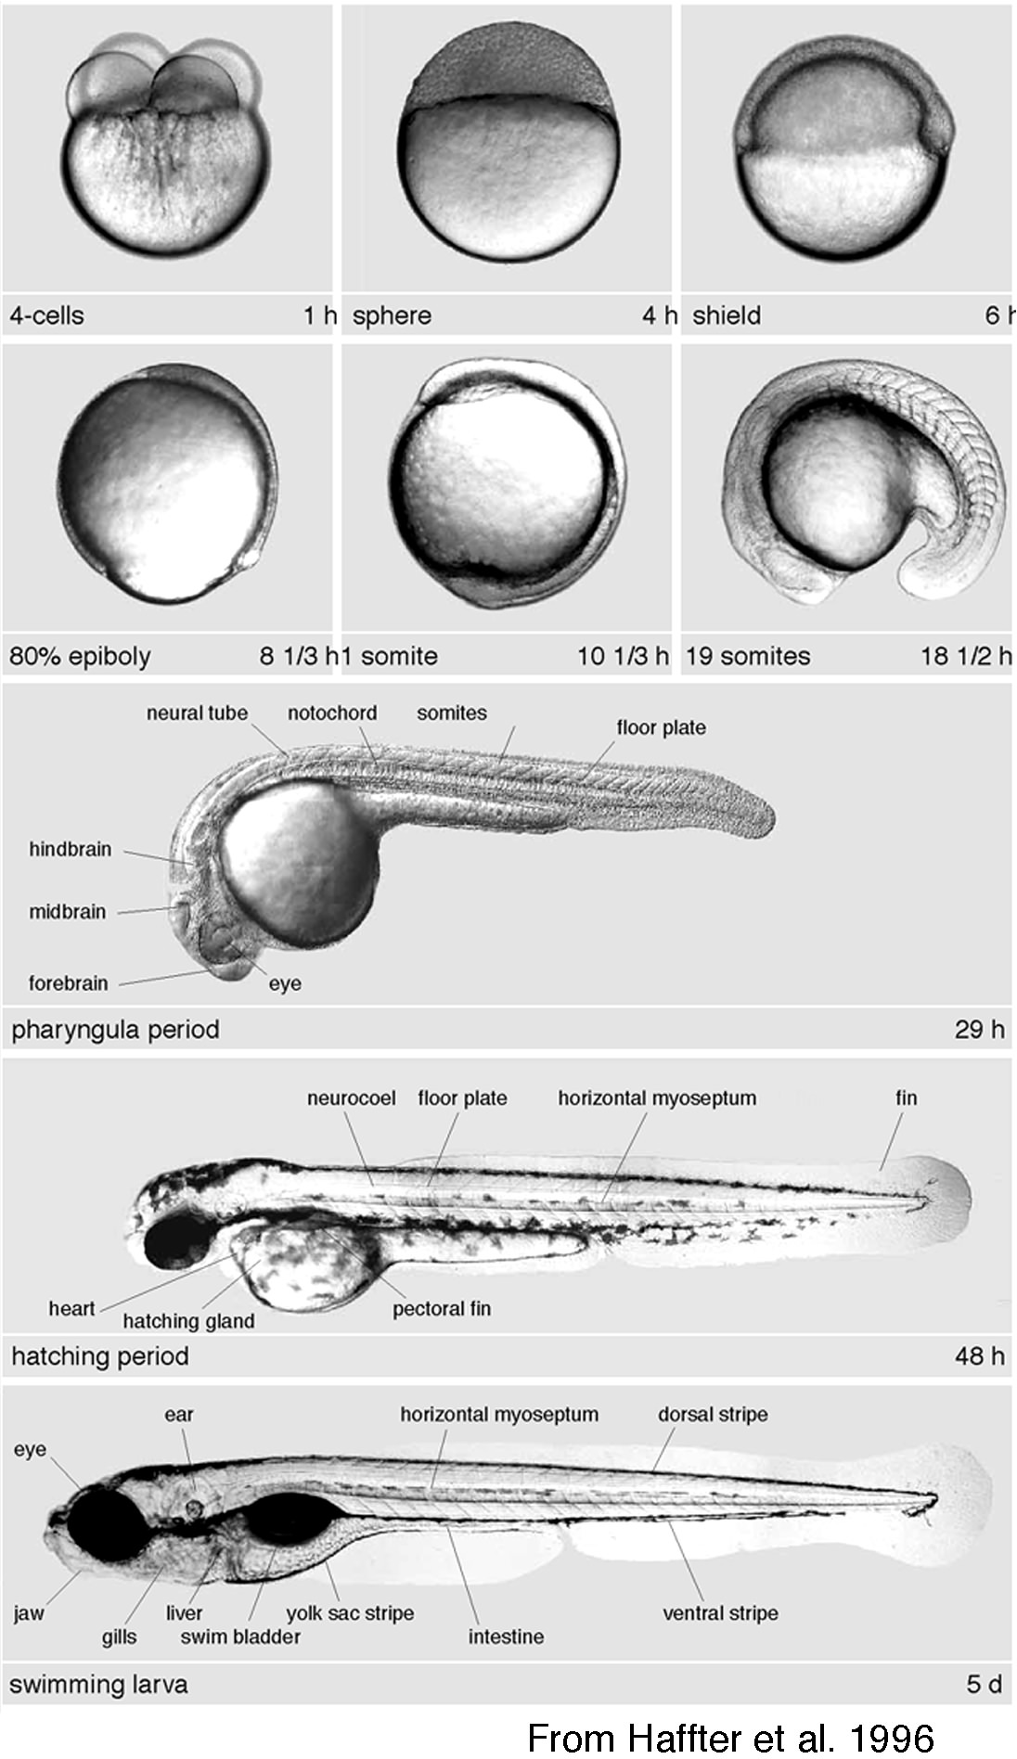

Figure 1. The early developmental stages of zebrafish. Note that major anatomical features have formed within 48 hours of fertilization (from Haffter et al., 1996).

The basic goal of a phenotypic screen is to track as many different developmental events as possible, as quickly as possible, using techniques that are both sensitive and relatively inexpensive. To this end, the zebrafish model offers the twin advantages of speed and analytical sensitivity. Phenotypic screens in zebrafish were initially used in combination with saturation mutagenesis to identify approximately 1,800 different developmental mutants (Haffter et al., 1996). In this approach, mutagenesis is used to alter a gene's sequence (and thereby its function), resulting in a heritable change in the phenotype of the fish. More recently, the phenotypic approach in zebrafish has been used to screen a library of 1,100 small molecules for their effects on vertebrate development (Peterson et al., 2000). Traditional screens fall into two categories: those that use anatomical markers to track the formation of different structures or tissues, and those that quantify physiological or behavioral performance. Anatomical screens reveal structural defects, and functional screens reveal abnormalities in the integration or expression of key physiological systems. The research we propose will use both approaches, and will focus on biological markers that have been previously (and successfully) used for mutagenesis and small molecule screens.

For the proposed studies in Task 1 (Studies 1 & 2), fertilized embryos will be obtained from wild type spawners (ABC strain) at the Northwest Fisheries Science Center's zebrafish facility. The rearing and spawning facility consists of a self-contained, recirculating ZMOD system (Marine Biotech, Inc.) with a colony capacity of 1,000 adult spawners. The facility is supervised by Dr. N.L. Scholz. For phenotypic screens, adult males and females will be paired overnight in specialized spawning chambers. The fish are kept on a regular light-dark schedule, and they normally spawn one hour after virtual dawn (~ 0900 h). Embryos will be collected each day and visually inspected using a dissecting microscope. Unfertilized eggs will be discarded, and the fertilized embryos will be staged according to Kimmel et al. (1995) and transferred to petri dishes containing rearing medium (Westerfield, 1994). The embryos will be maintained at 28˚C in controlled-temperature incubators (VWR Scientific) to ensure a constant rate of development (Kimmel et al., 1995). We estimate that >50,000 individual zebrafish will be used for the anatomical and functional pesticide screens we propose.

We expect that it will take 6-8 weeks to screen a single pesticide or a mixture of pesticides for sublethal toxicity in zebrafish. Therefore, it will not be possible to evaluate each of the ~100 priority compounds – i.e., pesticides that have been detected in salmon habitat or are a concern because of their rate of application within a given basin or watershed. Importantly, however, pesticides that belong to the same class usually share a common mechanism of toxicity. Therefore, by screening a representative chemical from each of the major classes of herbicides and insecticides, we should be able to generate in vivo data that will have direct relevance for the majority of priority pesticides currently used in the Columbia River Basin. The herbicide classes (the approximate number of active ingredients are in parentheses) will include amide (62), aromatic acid (11), dinitroalanine (13), imidazolinone (6), organophosphorus (12), phenoxy (41), thiocarbamate (19), triazine (30), uracil (6), and urea (74). The insecticide classes will include carbamate (45), nicotinoid (10), organophosphorus (126), and pyrethroid (50). Analytical grade pesticides will be purchased from commercial suppliers (e.g. ChemService).

Finally, it is important to note that we will evaluate the chemicals above for their toxicological effects on as many biological processes as is technically feasible given the current “state of the science” in the zebrafish model system. We have selected endpoints (see below) that are presumably fundamental to all fish species and will therefore have clear significance for salmonids. However, we are not proposing that zebrafish are surrogates for salmon in the strict sense that zebrafish toxicity data alone should be sufficient to guide salmon policy in watersheds with pesticide pollution. Rather, we view zebrafish as an experimental system that we can use to identify pesticides (or classes or pesticides) that may be harmful to salmon or other fish species in the Columbia River Basin. Results in zebrafish can then be validated, as appropriate, in the native species of concern. We have not included such groundtruthing experiments in this proposal because it will take our group a full three years to conduct the zebrafish phenotypic screens.

Study 1. Anatomical screens (Incardona and Scholz)

Optical imaging is a powerful and inexpensive means of monitoring normal development in transparent zebrafish embryos. For example, the mutagenesis screens mentioned earlier (Haffter et al., 1996) relied exclusively on a stereomicroscope to identify a large number of primary morphological phenotypes. This approach uses a “phenotypic checklist” to track the normal development of the notochord, somites, forebrain, midbrain-hindbrain, spinal cord, heart, vasculature, liver, enteric system, kidney, eye, otoliths, inner ear, lateral line, fins, skin and melanophores and craniofacial structures. An example of a phenotypic checklist is shown in Figure 2. Examples of contaminant-induced anatomical defects are shown in Figure 3. The resolving power of an anatomical screen can be improved with the use of imaging techniques such as Normarski optics. Nomarski allows for the three-dimensional visualization of very small structures. Examples include the chambers of the developing heart (Stainier et al., 1996) or the axons of spinal motor neurons as they innervate individual muscles in the developing body wall (Westerfield, 1990). In addition, epifluorescent microscopy can be used to follow the development of specific structures that have been labeled with a fluorescent marker (e.g. Alexandre and Ghysen, 1999) or a dye (e.g. Friedrich and Korsching, 1998). Importantly, all three in vivo imaging techniques provide a three-dimensional perspective of the zebrafish embryo over time.

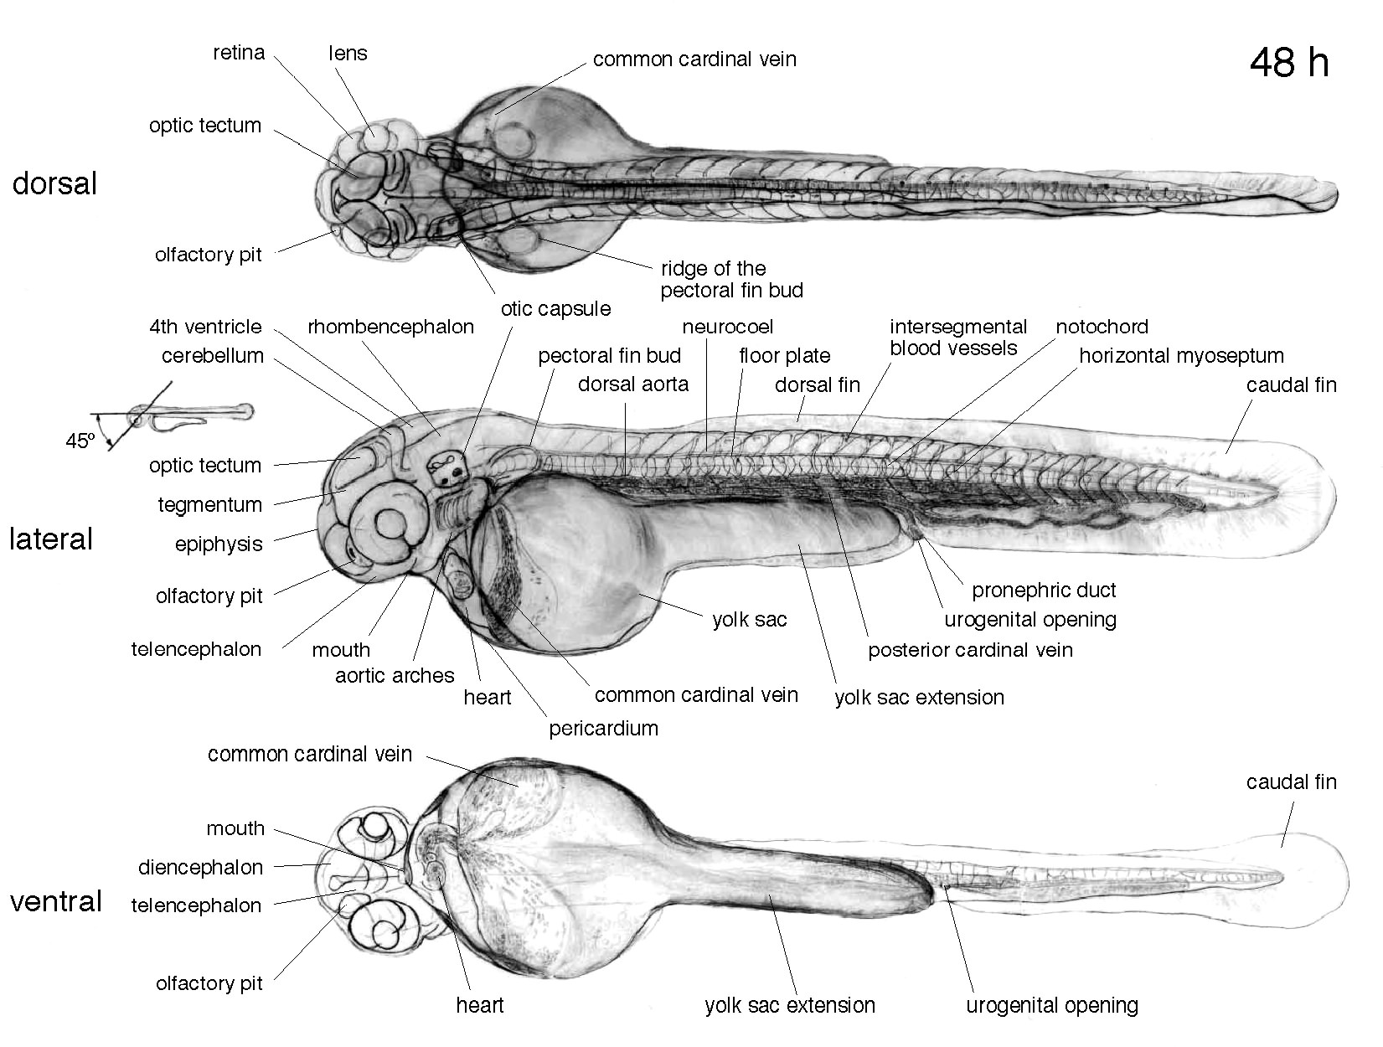

Figure 2. Phenotypic traits of a zebrafish embryo at 48 hours of development, as observed by light microscopy and Nomarski optics (from Haffter et al., 1996).

We will conduct primary and secondary screens of zebrafish morphological development following sublethal exposures to pesticides or mixtures of pesticides. The primary screen will be a high-throughput analysis using a stereomicroscope (Nikon SMZ800) and the stage-specific phenotypic checklists that have previously been published for zebrafish embryos and larvae (e.g., Fig. 2). For each exposure concentration (of 10 selected doses), we will examine 30 fish (six different groups, five fish per group) at each of five different developmental time points (24, 48, 72, 96, and 120 hours postfertilization). Therefore, the primary anatomical screen for each pesticide will include at least 1,500 individual animals. All of the primary morphological phenotypes listed above will be evaluated.

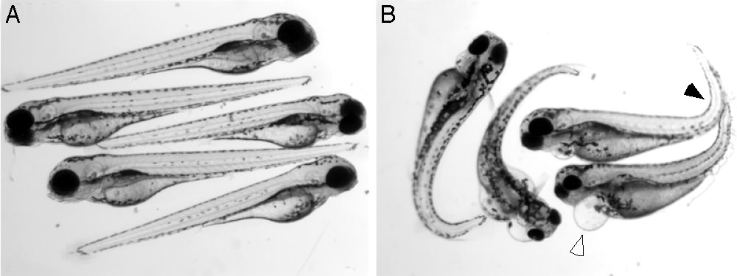

Figure 3. The effects of the dibenzothiophene on zebrafish development. Embryos were exposed from 4-52 hours post-fertilization and imaged at 5. A) Control embryos. B) Embryos exposed to 9 ppm dibenzothiophene showed consistent anatomical defects. These include cardiac edema (open arrowhead) and curvature of the posterior spinal column (filled arrowhead). (J. Incardona and N.L. Scholz, unpublished data)

Based on the findings of the primary screens, secondary anatomical screens will be used to explore toxin-induced developmental abnormalities in greater detail. Secondary techniques will include the high resolution optical sectioning of live tissues (using Nomarski and epifluorescent microscopy), and conventional histochemical and immunohistochemical techniques for analyzing fish tissues that have been fixed and embedded in paraffin or plastic and then sectioned on a microtome. The laboratory of Dr. N.L. Scholz is equipped with a Nikon Eclipse E600 compound microscope fitted with apochromatic objectives for Nomarski and epifluorescent imaging. The microscope is also equipped with a SPOT RT cooled-CCD camera (Diagnostic Instruments, Inc.) for capturing high-resolution digital images of light and epifluorescent specimens. Digital data are stored on a Macintosh G4 computer that has the appropriate software for image analysis (e.g. Adobe Photoshop) and then archived to compact disc. In addition, the equipment needed for sectioning fixed tissues and processing the sections with antibodies or histological reagents is available.

The specific techniques and markers that we use for the secondary screen will depend on the results of the primary screen. For example, if the zebrafish eye develops abnormally in response to a given pesticide, we will use a combination of histological examination and axonal tract tracing to identify more specific effects on the developing visual system. In brief, exposed zebrafish and unexposed controls will be fixed in 4% paraformaldehyde, dehydrated, and embedded according to Neuhauss et al. (1996). Thin sections (2 µm) will be stained with 1% methylene blue-1% azure solution or hemotoxylin-eosin and examined for morphological aberrations in the retina or the optic tectum using a compound microscope. In addition, the topography of retinotectal projections will be evaluated by injecting the fluorescent lipophilic tracer 1,1’-dioctadecyl-3,3,3’3’-tetramethylindocarbocyanine perchlorate (DiI) into the eye of aldehyde-fixed larvae using the injection apparatus and protocol described by Baier et al. (1996). This will allow for three-dimensional fluorescent imaging of axonal projections from the retina to the brain. If the primary anatomical screens reveal developmental abnormalities associated with other tissues, different markers and techniques will be used as appropriate to characterize these defects in greater detail.

Study 2. Functional screens (Incardona and Scholz)

Functional screens are designed to provide an integrative measure of the performance of a particular physiological system, or to evaluate the normal developmental expression of specific behaviors. Functional screens are often more clearly related to the survival of fish, and they can reveal developmental effects that may not be obvious from a morphological analysis alone. Ideally, anatomical and functional screens should be linked. That is, if a primary anatomical screen reveals a defect in the formation of the developing spinal cord in the embryo, functional screens could be designed to evaluate the impact of this defect on the swimming performance of fish as they develop into free-swimming larvae. Similarly, if pesticides impair the development of the eye or the normal projections of retinal neurons, functional screens could be designed to evaluate subsequent impacts on visually guided behaviors (e.g. schooling, predator detection and avoidance) at later life history stages. Functional assays were an important component of the initial mutagenesis screens in zebrafish, and the number of published analytical techniques continues to grow. For the research proposed here, we will conduct (at least) two standard physiological screens: one for the normal development of the cardiovascular system, and one for the pathophysiological status of individual cells in the nervous system and other embryonic and larval tissues. In addition, we will evaluate the effects of pesticides on the expression of simple motor behaviors and the detection and integration of sensory stimuli.

Zebrafish are an increasingly important model for studying the development the vertebrate heart (Stainier, 2001). For example, functional screens in zebrafish were used to identify slow mo, a gene that is required to set the rate and rhythm of the heart beat (Baker et al., 1997). The normal activity of the cardiac system is easy to visualize and quantify in transparent zebrafish embryos. It is also possible to follow normal patterns of blood circulation throughout the entire cardiovascular system. Given the obvious importance of cardiac function for the health of fish, we will screen pesticides for potential effects on heart rate and blood flow in embryos and larvae. The screens will be linked, to the extent possible, to primary and secondary anatomical screens for the development of the heart and vasculature (see above).

Many pesticides, and the insecticides in particular, are neurotoxic. This raises the possibility that sublethal exposures to these chemicals causes pathophysiological responses in neurons that eventually lead to apoptosis and cell death. Apoptosis is a tightly controlled series of signaling events that underlie programmed cell death (Wyllie et al., 1980), and exposures to contaminants have previously been shown to activate apoptotic pathways (e.g. Larm et al., 1997; Solum et al., 1997). To determine if pesticide exposures lead to cell death, we will use fluorescent markers in combination with epifluorescent microscopy to image dying cells in embryos and larvae. Specific markers will include vital stains (e.g. acridine orange; Furutani-Seiki et al., 1996) as well as antibodies (e.g. the TUNEL method of Cole and Ross, 2001). Where cell death occurs in response to pesticides, anatomical analyses will be conducted to identify the specific cell types involved, and the impacts of this toxic pathway on the formation of affected tissues.

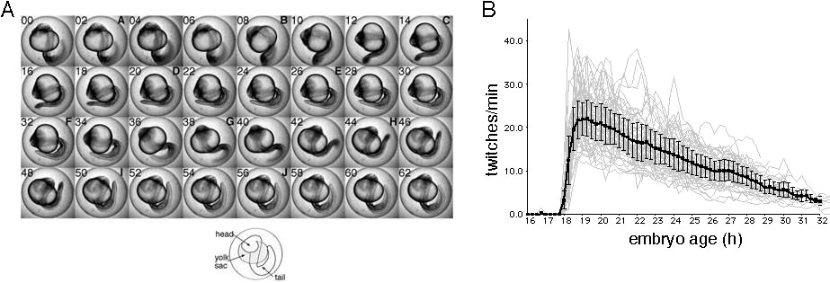

Figure 4. Zebrafish embryos exhibit spontaneous motor activity that begins around 18 hours post-fertilization. Spontaneous motor activity is thought to reflect the development of primary motor neurons and the motor circuitry used for swimming. A) Alternate frames of a movie showing the cycle of tail movement during a twitch. B) Embryonic activity (twitches/min) measured as a function of developmental age. Gray lines show data from single embryos. Black line shows mean data (± SD) from 48 embryos. (from Myers et al., 2001)

Finally, behavioral screens will be conducted to evaluate the effects of pesticides on the coordinated activity of different regions of the developing nervous system. In all cases, we will use methods that have been previously published for zebrafish. These include screens for the development of simple motor behaviors (see Fig. 4) and escape reflexes (Granato et al., 1996; Saint-Amant and Drapeau, 1998), and screens for the detection and integration of important environmental stimuli. Most of the behavioral trials will focus on free-swimming larvae. Screens for sensorimotor function will use established techniques for measuring neuroethological processes such as optomotor response (Fig. 5; see also Neuhauss et al., 1996), acoustic signal detection (Kimmel et al., 1974), olfactory function (Whitlock and Westerfield, 1995), and touch response (Ribera and Nusslein-Volhard, 1998).

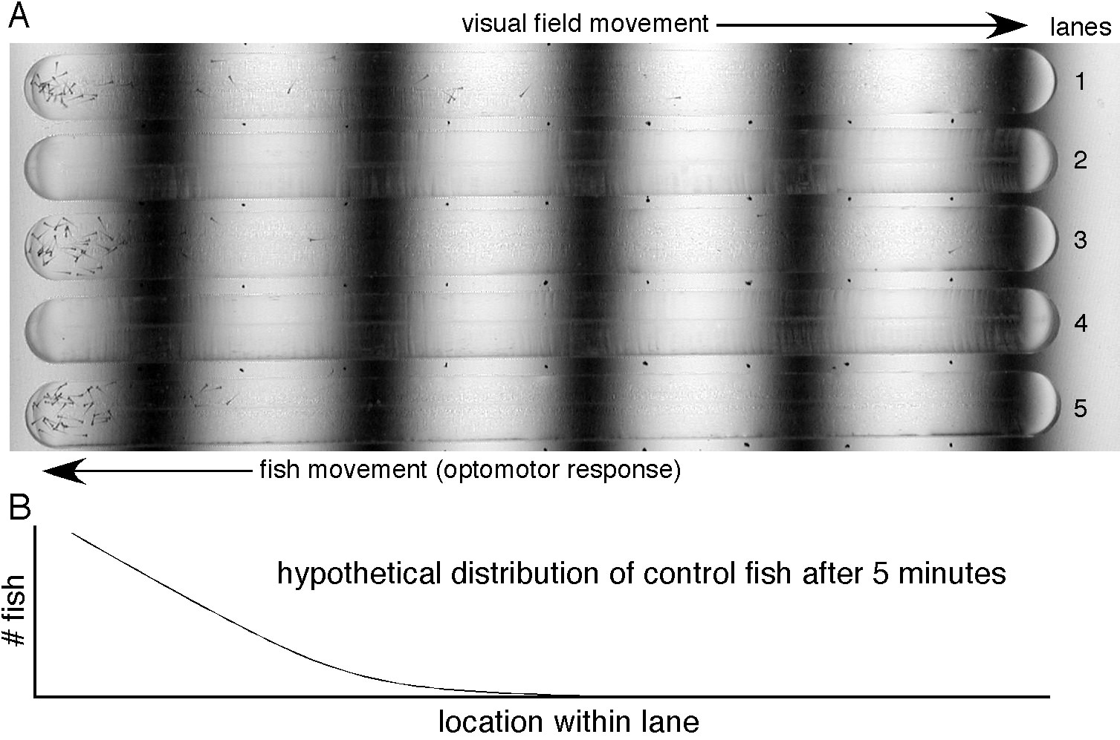

Figure 5. Free-swimming zebrafish larvae normally show a robust optomotor behavior. A) The experimental apparatus for optomotor screening consists of several ‘lanes’ milled into a plexiglass plate. The plate is placed on top of a computer monitor that is facing up. The monitor displays a field of black stripes (a sine grating). Fifty larvae were initially distributed uniformly throughout each lane (lanes 2&4 were empty for this trial). The visual field then begins moving to the right. Larvae compensate for their perceived motion by swimming to the left. A) An image after five minutes showing that the distribution of larvae shifts to the left. Lanes 2 and 4 were empty for this trial. Image is courtesy of Kathi Levebre. B) Hypothetical distribution of larvae – the basis for quantifying and comparing the behavior of large numbers of animals across different treatment groups. (K. Lefebvre and N.L. Scholz, unpublished results)

Task 2. Evaluate the effects of pesticides on the sensory physiology and behavior of salmon, with an emphasis on survival, homing, and the long-term viability and genetic integrity of wild populations.

Problem Statement

What is the relative significance of pesticide contamination for habitat recovery and offsite mitigation efforts in the Columbia River Basin? How do sublethal toxicological effects, as measured in the laboratory, relate to the survival or reproductive success of wild salmon? What limits, if any, do pesticides impose on the productivity or genetic integrity of at-risk salmon populations?

A fundamental question facing natural resource managers is whether pesticides in salmon habitat reach concentrations that are high enough to impair the physiology or behavior of exposed fish in a manner that may ultimately reduce their survival or reproductive success. Survival and reproductive success are important because these biological processes determine, in part, the viability (or recovery) of natural populations. Pesticides are, therefore, a problem of biological scale. That is, how does toxicity measured at one scale (e.g., a physiological response in an individual animal) extrapolate to higher scales of biological complexity (e.g., the dynamics of a population as a whole)? This is a common and difficult problem. It is also a major reason why toxicity data are seldom considered in conservation planning (Hansen and Johnson, 1999).

This Task will address the impacts of pesticides at different biological scales, with an emphasis on endpoints that have direct relevance for salmon conservation and habitat recovery planning. More specifically, these studies will focus on sublethal effects of pesticides on the olfactory nervous system of chinook salmon, as well as behaviors that are critical for survival and migratory success. We will use neurophysiological techniques to determine toxicity thresholds for different pesticide formulations (Study 1), compare the impacts of pesticides on sensory function and predator avoidance behaviors (Study 2), evaluate the effects of pesticides on predation vulnerability using natural predators (Study 3), determine the impacts of pesticides on homing behavior using experimental manipulations in the field (Study 4), and model the consequences of pesticide contamination in salmon habitat in terms of the demographic status and genetic integrity of natural populations (Study 5).

Several biological processes are potentially susceptible to sublethal pesticide toxicity (e.g. early development, endocrine function, immune system function, etc.). However, the potential for sublethal neurotoxicity is a particularly significant concern because (1) many insecticides and other pesticides impair key functions of vertebrate neurons and neural networks (Ehrich and Bloomquist, 2001), and (2) salmon essential behavioral patterns depend, critically, on a properly functioning nervous system. Many behaviors, including hatching, swimming, schooling, sheltering, foraging, predator avoidance, imprinting, seaward migration, homing, mate choice, and spawning are potentially vulnerable to sublethal, pesticide-induced neurotoxicity. Pesticides from several major classes are known to impair the physiology or behavior of salmonids or other fish species. These include the organophosphate insecticides (Brewer et al., 2001; Scholz et al., 2000; Beauvais et al., 2000; Moore and Waring, 1996a; Morgan and Kiceniuk, 1990), the carbamate insecticides (Waring and Moore, 1997; Carlson et al., 1998; Little et al., 1990), the pyrethroid insecticides (Moore and Waring, 2001), and the triazine herbicides (Saglio and Trijasse, 1998; Moore and Waring, 1998). Collectively, these pesticide classes account for a substantial fraction of the chemicals that have recently been detected in surface waters of the Columbia River Basin (e.g. Wentz et al, 1998).

The salmon olfactory system provides a particularly promising experimental context for studying the sublethal effects of neurotoxic pesticides. Salmon have a highly developed sense of smell, and previous studies have shown that direct measures of olfactory capacity are very sensitive indicators of sublethal neurotoxicity in fish (reviewed in Klaprat et al., 1992). Experimental techniques for measuring the functional properties of the olfactory nervous system and olfactory-mediated behaviors are well defined for salmonids. These techniques can be used to compare thresholds for pesticide-induced toxicity at different scales of biological organization, and relate laboratory determinations of physiological function to behaviors that are meaningful in the context of salmon conservation and recovery under the ESA.

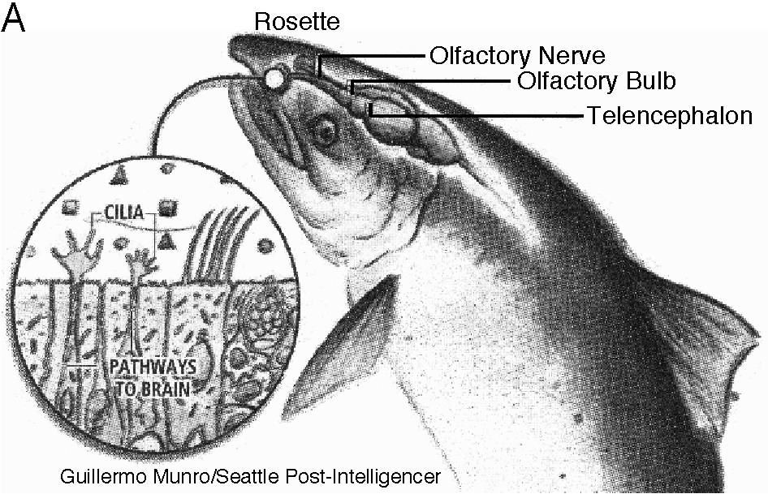

Figure 6. Architecture of the fish olfactory system. A) Illustration of the components of the olfactory nervous system. The inset highlights the ciliated olfactory receptors within the olfactory epithelium. B) Low magnification light micrograph of a single olfactory lamella from a salmon rosette, shown in cross-section and stained with haemotoxylin-eosin. Box denotes region of higher magnification shown in the next panel. C) Pseudostratified, columnar structure of the olfactory sensory epithelium. D) Freeze-fracture scanning electron micrograph of the sensory epithelium. Individual olfactory receptor neurons are visible (asterisk). Note ciliated apical dendrites and axons projecting towards the basal lamina (arrows) and olfactory forebrain. (A, from Guillermo Munro/Seattle Post-Intelligencer; B&C, M. Bushnell and N.L. Scholz, unpublished results; D, Crnjar et al., 1992)

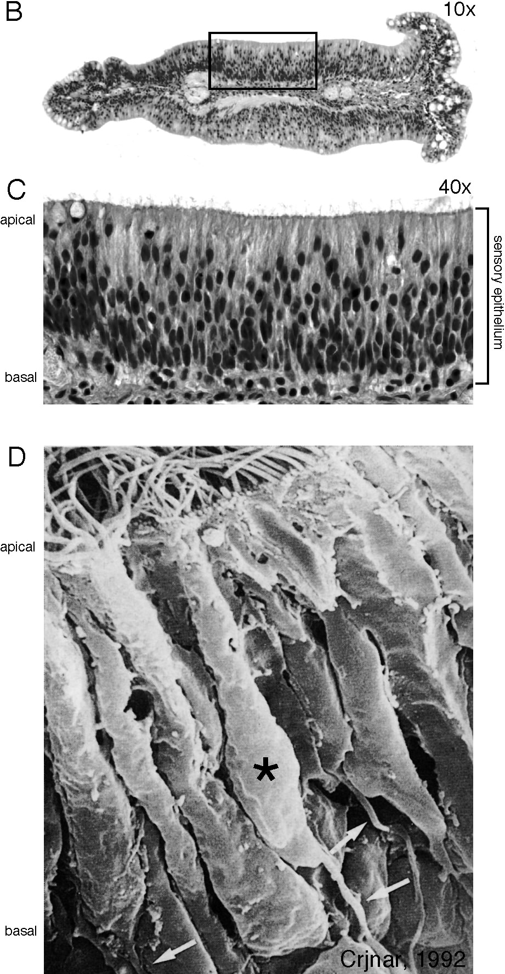

The salmon peripheral olfactory system (Fig. 6) consists of a chamber with openings to the surrounding environment and an olfactory rosette (Zeiske et al., 1992). The rosette is situated on the floor of the olfactory chamber and is composed of a longitudinal ridge surrounded by two rows of olfactory lamellae. Thousands of olfactory receptor neurons cover the surface of each lamella. These form a columnar, pseudostratified sensory epithelium (Fig. 6B&C). The individual receptor neurons are bipolar. They send a single dendrite to the apical surface of the epithelium and an axon through the basal lamina to the olfactory bulb in the forebrain (Fig. 6D). The binding of waterborne odor molecules and olfactory signal transduction takes place in cilia that extend from the apical tip of the dendrite.

The electroolfactogram (EOG) is commonly used to measure the stimulus-evoked activity of receptor neurons in the sensory epithelium. The EOG is a large negative voltage transient or field potential that is measured with an electrode placed near the surface of the sensory epithelium. The amplitude of the EOG represents a summation of the active properties of olfactory receptor cells in the epithelium (Hara, 1992). In addition, the integration of peripheral sensory information into the olfactory forebrain can be monitored using an electroencephalogram (EEG). The EEG provides a quantitative measure of the activity of interneurons and projection neurons in the olfactory bulb in response to a sensory stimulus (Hara, 1992). Therefore, the functional physiological properties of salmon olfactory neurons can be measured with paired EEG and EOG recordings (Fig. 7), and the impacts of sublethal pesticide exposures can be quantified. An example for the organophosphate insecticide chlorpyrifos is shown in Figure 8. These and other advantages of using the olfactory system for toxicity screening are briefly discussed below.

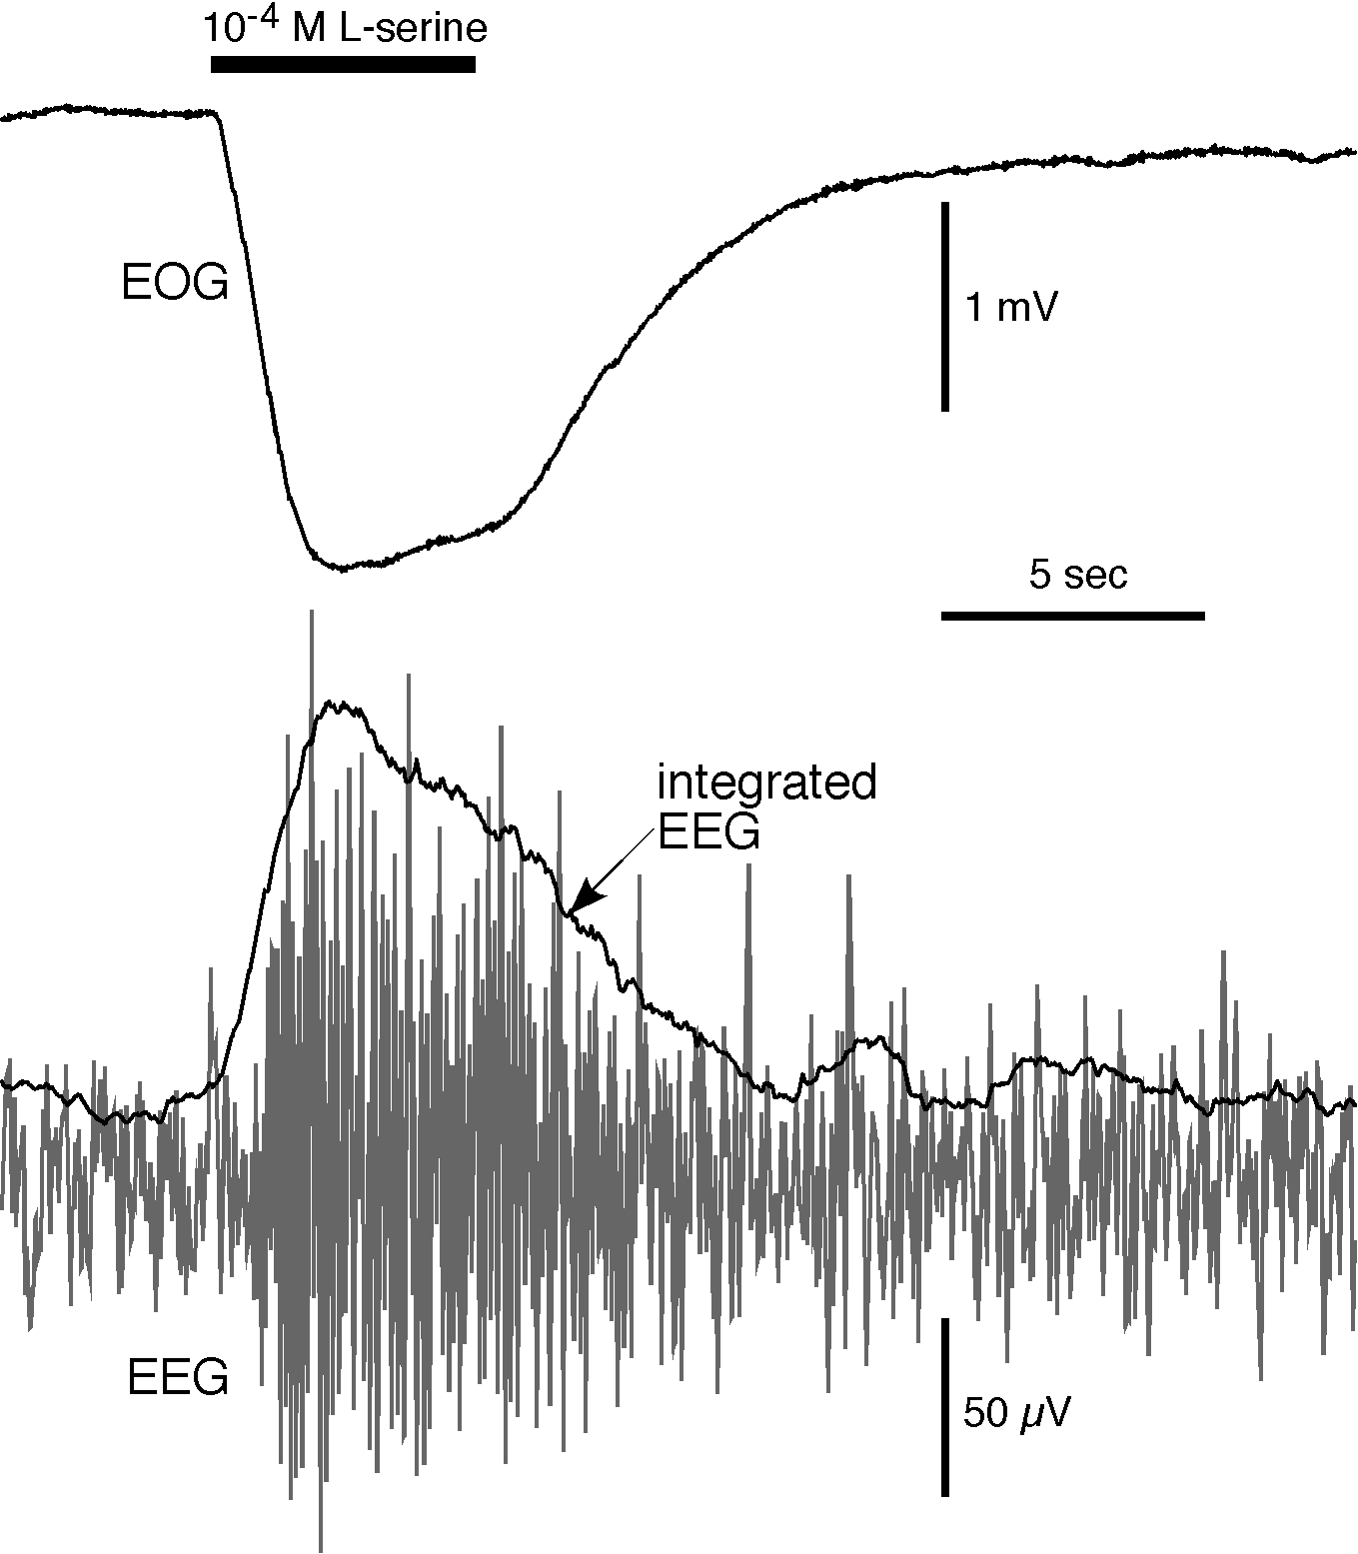

Figure 7. Example of simultaneous recordings from the olfactory epithelium (electroolfactogram, EOG) and from the olfactory bulb (electroencephalogram, EEG) evoked by the same 5 second pulse of L-serine. The EOG measures the summed response of olfactory receptors to the L-serine application. The raw EEG trace (in gray) measures the activity of neurons in the olfactory bulb in response to input from the olfactory receptors. Rectifying and integrating the raw recording produced the integrated EEG used for further analysis. The peak amplitudes of the EOG (the absolute decrease from baseline) and the integrated EEG (the relative increase in activity above baseline) are used to quantify the response evoked by the L-serine pulse. (J. Sandahl and N.L. Scholz, unpublished results)

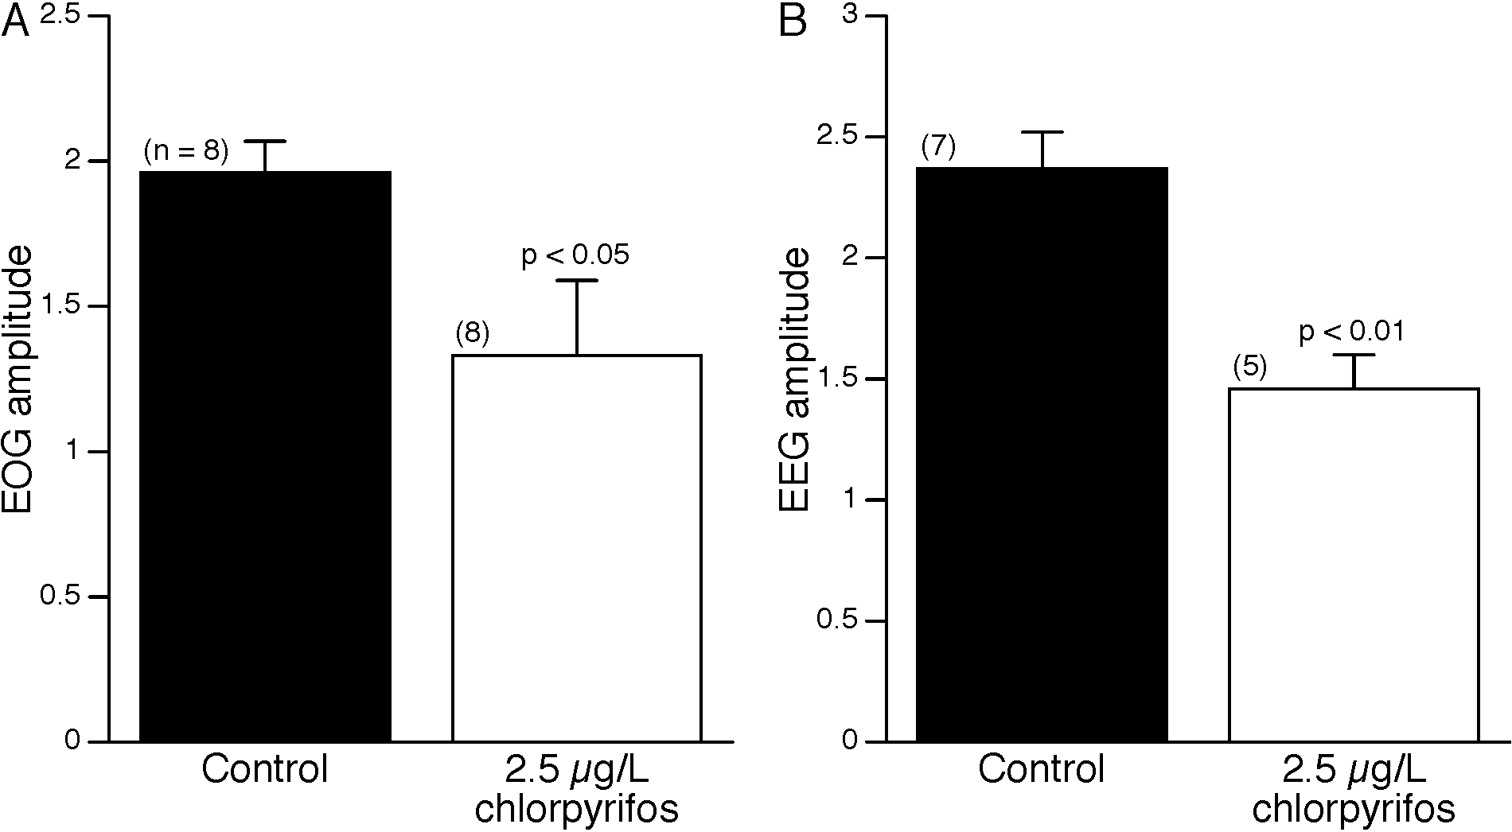

Figure 8. Seven day exposures to chlorpyrifos cause reductions in both EOG and EEG responses to natural odorants (10⁻⁵ M L-serine). Simultaneous EOG and EEG recordings were obtained from fish after exposure to carrier (control) or to 2.5 µg/L chlorpyrifos. A) EOG responses (mean ± 1 SEM) of the exposed fish were significantly reduced relative to control. B) In a similar manner, EEG responses (mean ± 1 SEM) of the exposed fish were significantly reduced relative to control. (J. Sandahl and N.L. Scholz, unpublished results)

First, primary olfactory receptor neurons are in direct contact with the surrounding environment. For this reason, they may be particularly vulnerable to the toxic impacts of chemicals in salmon habitat. Moreover, in a laboratory setting, contaminants can be applied directly to the salmon olfactory epithelium via perfusion of the olfactory chamber. This allows for precise control over the duration and concentration of a chemical exposure, and makes it possible to design exposures that are representative of environmental conditions in salmon habitat.

Second, the olfactory epithelium is easily accessible for the purpose of measuring odor-evoked voltage potentials. This allows for quantitative and reproducible analyses of nervous system function in an intact, living animal. Methods for electrophysiological recording have been established for several fish species (e.g. Evans and Hara, 1985). Also, the physiological properties of receptor neurons and the pathways for integrating chemosensory information into forebrain networks are reasonably well understood (Hara, 1992; Yoshihara et al., 2001).

Third, the olfactory nervous system is very sensitive to dissolved chemicals in the animals surrounding environment. For example, the detection thresholds for natural odorants are very low (10⁻⁷ - 10⁻¹¹ M depending on odorant; e.g. [Hara, 1972; Hara, 1973; and Moore and Waring, 1996a). The physiological sensitivity of the olfactory system makes it particularly well suited for evaluating the effects of contaminants that are present in salmon habitat at trace concentrations.

Finally and perhaps most importantly, there are clear relationships between a functioning olfactory system and the essential behavioral patterns of salmon. For example, olfaction plays a key role in the recognition and avoidance of predators (Brown and Smith, 1997), the recognition of kin (Griffiths and Armstrong, 2000), and in the reproductive synchronization of pre-spawning animals (Moore and Waring, 1996b). Moreover, a salmon’s sense of smell determines, in part, the long-term genetic integrity of wild and geographically distinct populations. Salmon rely on chemical cues to form olfactory memories (Nevitt et al., 1994) and return to their natal river system to spawn (Dittman and Quinn, 1996). Critically, the migratory patterns of adult salmon are disrupted when olfactory function is lost (Wisby and Hasler, 1954). Collectively then, environmental contaminants that damage the olfactory system could potentially impact ESA-listed salmonids at higher scales of biological organization.

Many pesticides are known to impair olfactory function in salmon or other fish species. These include the triazine herbicides (Moore and Waring, 1998), the urea herbicides (Saglio and Trijasse, 1998), the organophosphate insecticides (Moore and Waring, 1996a; Scholz et al., 2000), the carbamate insecticides (Waring and Moore, 1997), the pyrethroid insecticides (Moore and Waring, 2001; J.F. Sandahl and N.L. Scholz, unpublished results), and the inorganic pesticides. With respect to the latter class, there is solid evidence that copper is toxic to the salmon olfactory system. Copper-containing pesticides are widely used to control the growth of aquatic vegetation (algae) in lakes and irrigation canals throughout the Columbia River Basin. Copper formulations are used as fungicides on various agricultural crops and are also approved for urban and residential applications. Finally, copper is a common preservative in chemical formulations that are used to create pressure-treated wood, and copper can leach from the in-stream placement of various construction materials. All told, copper is one of the most widely used pesticides in Oregon, Washington, and Idaho.

The overall goal of Task 2 is to place sublethal, pesticide-induced neurotoxicity in the larger context of salmon survival and migratory behavior. Copper is a good choice for these studies because this pesticide is known to damage the salmonid olfactory nervous system at concentrations that have been documented in salmon habitat (Hara et al., 1976; Winberg et al., 1992; Hansen et al., 1999b; D. Baldwin and N.L. Scholz, unpublished results). Copper has also been shown to interfere with olfactory-mediated behaviors in salmon (Hansen et al., 1999a) and other fish (Beyers and Farmer, 2001). It is evident from these previous studies that even brief (< 1 hr) exposures to copper can diminish a fish's olfactory capacity. However, with the exception of avoidance (Hansen et al., 1999a), the impacts of copper on behaviors that might be considered essential for salmon survival or migratory success have not been investigated. Finally, it is worth noting that copper is also a major pollutant associated with mining activities as well as municipal and industrial discharges to salmon habitats. Therefore, we expect the results of the proposed research to have management implications that extend beyond the use of copper as a pesticide.

These studies will focus on juvenile and adult life history stages of chinook salmon. The Specific Aims of Task 2 are below:

- Establish sublethal toxicity thresholds for different copper formulations using in vivo neurophysiological recording techniques (Study 1).
- Compare physiological and behavioral thresholds for olfactory impairment following short term, sublethal copper exposures (Study 2).
- Evaluate the impacts of copper on rates of predation and mortality in juvenile chinook salmon (Study 3).
- Evaluate the impacts of copper on rates of homing and straying in adult migratory chinook salmon (Study 4).
- Model the consequences of copper contamination for salmon productivity and population integrity within a representative watershed or basin (Study 5).

Study 1. Establish sublethal toxicity thresholds for different copper formulations using in vivo neurophysiological recording techniques (Baldwin and Scholz).

The intent of this Study is to determine toxicity thresholds for copper using exposures that reflect, to the extent possible, actual ecological conditions in salmon habitats. As a pesticide, copper is used in a variety of chelated and unchelated formulations. Moreover, in terms of lethality (i.e., fish kills), the toxicity of copper is dependent on several different water quality parameters (for a review see Sorensen, 1991). These include pH, hardness, alkalinity, and the dissolved organic content of water. Surface waters throughout the Columbia River Basin can vary widely in these parameters and, therefore, the relative toxicity of copper may depend on site-specific water quality conditions. With respect to the salmon olfactory system, however, the importance of these parameters for copper toxicity has not been investigated.

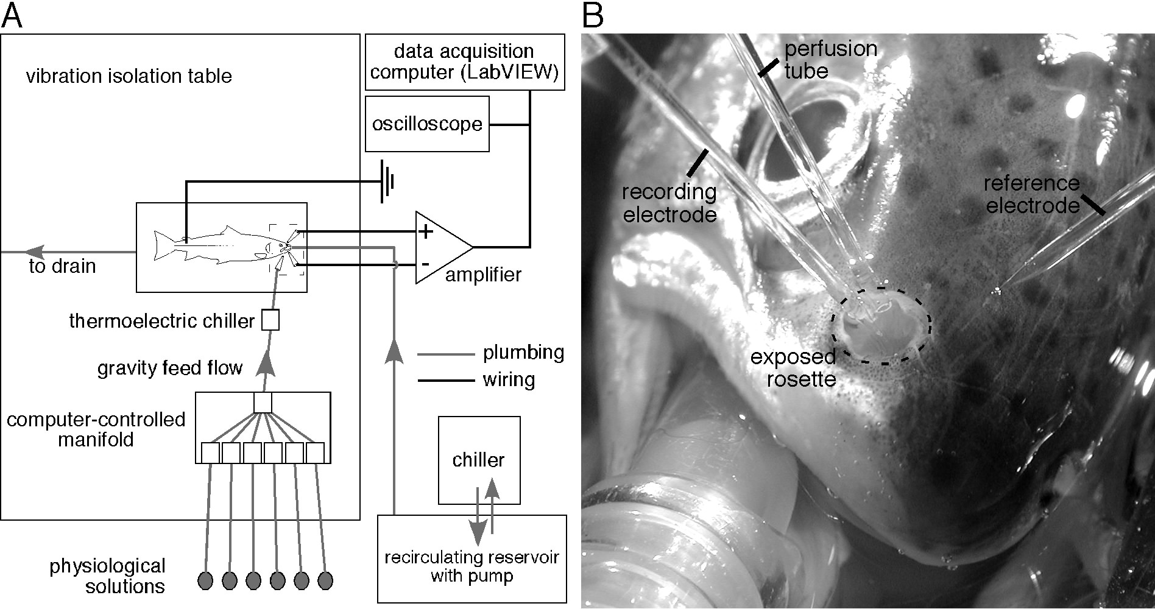

Figure 9. Apparatus for using the EOG to measure neurophysiological effects of dissolved pesticides on Pacific salmon. A) Schematic diagram showing the major components of the apparatus. The fish is anaesthetized and placed in a plexiglass holding chamber on the surface of a vibration isolation table. A reservoir of chilled water provides the gills with oxygenated water and maintains physiological (perfusion) solutions at a constant temperature (12ºC). Solutions are delivered to the exposed rosette by gravity at a constant flow rate (7 mls/min). A computer-controlled manifold allows for rapid switching between odorant and pesticide-containing solutions for perfusing over the olfactory rosette. The dashed box denotes the area shown in more detail in B. A custom LabVIEW software program controls stimulus delivery to the olfactory rosette and captures the physiological recording for later analysis. B) Photograph showing the rostrum of a coho salmon and the placement of the perfusion tube and glass microelectrodes. The mouthpiece provides a steady supply of chilled, anaesthetic-containing, oxygenated water to the animal’s gills. The perfusion tube delivers test solutions to the exposed rosette (neurosensory epithelium). The recording electrode is placed near the surface of the rosette and the reference electrode is placed nearby on the surface of the skin. The perfusion tube and the glass microelectrodes are positioned and held in place with micromanipulators.

We will use in vivo electrophysiological techniques (paired EOG and EEG recordings) to study the sublethal effects of various copper formulations on the olfactory physiology of juvenile chinook salmon. The methodology for these experiments is illustrated in Figure 9. As shown in Figure 10, our preliminary data indicate that primary olfactory receptor neurons are very sensitive to copper, and that copper diminishes the responsiveness of the olfactory epithelium to natural odorants. This finding is consistent with previous studies in other salmonids (e.g. Hara et al., 1976; Hansen et al., 1999b). For the data shown in Figure 10, EOGs were evoked by a short stimulus (10 s) of 10⁻⁵ M L-serine. Recordings were obtained before, during, and after a 30 min perfusion of water containing 10 µg/L copper chloride. The loss of olfactory capacity was quantified as a reduction in the peak amplitude of the post-exposure EOG relative to the animal’s initial baseline response. A qualitative example of a reduction in the amplitude of the odor-evoked EOG for a single fish is shown in Figure 10A. The time course for copper’s effects and the partial recovery from a 30 min exposure are shown in Figure 10B.

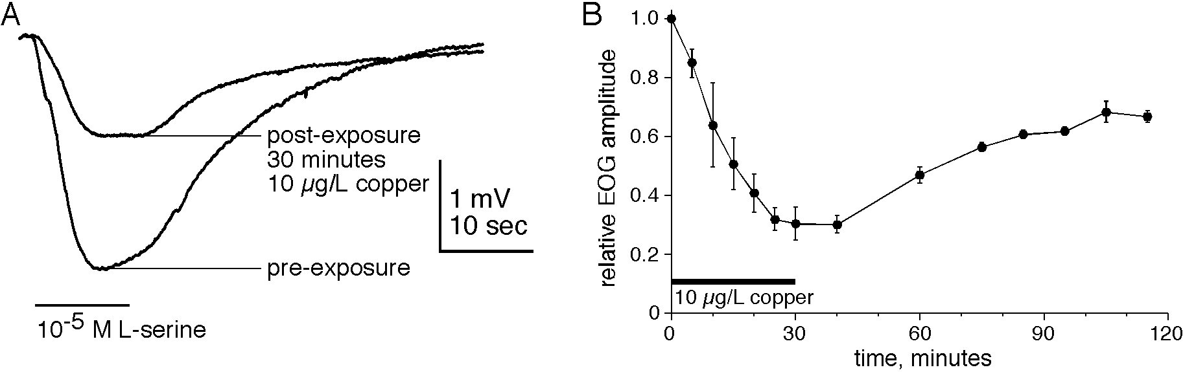

Figure 10. Short-term copper exposure (30 minutes) causes reductions in EOGs evoked by L-serine. A) EOGs obtained before and after a 30 min exposure to a nominal addition of 10 µg/L copper chloride. The copper exposure reduced the EOG response to 10⁻⁵ M L-serine by 57%. B) Time course of the copper-induced reduction in EOG responses (mean ± 1 SEM, n = 6). All the responses of each fish were normalized to the fish’s pre-exposure response prior to averaging. Responses to 10⁻⁵ M L-serine pulses were obtained at intervals during and after exposure (n = 6 for each). The horizontal bar denotes the 30-minute exposure duration. Note that the reduction starts within 10 minutes, is complete by 30 minutes, and does not completely recover even after 90 minutes of wash. (D.H. Baldwin and N.L. Scholz,unpublished results)

We will vary both the duration and concentration of exposure to different formulations of copper (chelated and unchelated). This will include short-term and direct perfusions of the nasal chamber, and longer (72 h) flow-through tank exposures for whole animals. Dose-response data will be collected using both EOG and EEG recording techniques (see Fig. 7). Thresholds for copper neurotoxicity will be calculated using the benchmark dose statistic. We will also measure time to effect and time to recovery. Finally, we will evaluate the influence of pH, alkalinity, and hardness on copper neurotoxicity. Copper exposures will be based on documented environmental concentrations in salmon habitat, and the range of values for the water quality parameters will encompass the diversity of water quality conditions in the Columbia River Basin. Following exposures, copper concentrations (dissolved and total) will be confirmed using inductively coupled plasma-mass spectrometry (ICP-MS).

Study 2. Compare physiological and behavioral thresholds for olfactory impairment following short term, sublethal copper exposures (Baldwin and Scholz).

The goal of these experiments is to determine the extent to which neurophysiological measurements of sublethal copper toxicity (Study 1) are good predictors of copper’s impacts on specific, olfactory-mediated behaviors in juvenile chinook salmon. Ideally, the behavior(s) in question would be robust, reproducible, relatively easy to quantify, and meaningful in the context of survival or reproductive success. For these reasons, we will use chemical alarm signaling and antipredator behaviors to quantify the sublethal effects of copper on salmon behavior. As with other species of fish, salmonids release an alarm pheromone into the surrounding water when they are attacked by a predator (Smith, 1992). Nearby fish that detect this cue exhibit a stereotypical suite of anti-predator behaviors. Alarm behaviors in salmonids are well-documented (Brown amd Smith, 1997; Berejikian et al., 1999) and we have previously shown that alarm responses can be used to measure the sublethal effects of the insecticide diazinon on the chinook olfactory system (Scholz et al., 2000). Moreover, in a recent study by Beyers and Farmer (2001), alarm behaviors were used to quantify the sublethal effects of copper on olfaction in Colorado pikeminnow. Alarm responses are rapid and very robust, presumably because they substantially reduce the likelihood of a fish being killed by a nearby predator (Smith 1992; Kats & Dill, 1998). For example, Mathis and Smith (1993) found that minnows exposed to a conspecific alarm pheromone survived predation by a pike for ~ 40% longer than minnows which were not. Moreover, hatchery salmon learn to associate the alarm stimulus with the smell of a predator, thus improving their survival in the wild (Berejikian et al., 1999).

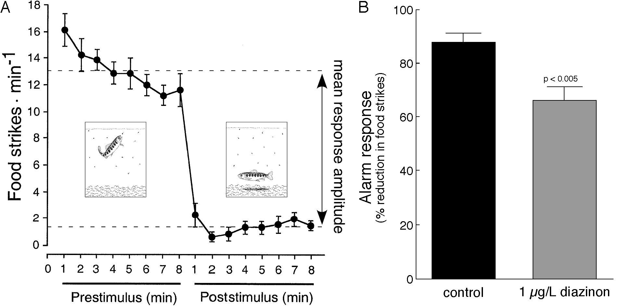

Figure 11. Diazinon reduces the alarm response of chinook parr. A) Chinook parr show an antipredator/alarm response when an alarm substance (conspecific skin extract) is added to the water. Upon addition of the extract, salmon move to the substrate and become still (insets), and they significantly reduce their rate of feeding (strikes/min). B) The alarm response of chinook parr exposed to a pesticide (diazinon) for two hours was significantly reduced compared to controls. (modified from Scholz et al., 2000)

An example of an olfactory-triggered alarm response in chinook salmon is shown in Figure 11. Upon addition of a diluted skin extract, juvenile salmon stop feeding and become motionless. The reduction in feeding rate is one of several behavioral measures that we will use to quantify the magnitude of the alarm response in control fish and fish exposed to copper. The concentration(s) of the skin extract we use will be based on the results of the electrophysiology experiments. Similarly, the number of fish used and the copper exposure concentrations and durations will be the same as for the neurophysiological dose-response assays (above). In this way, thresholds for behavioral toxicity can be directly compared to the physiological thresholds obtained from EOG and EEG recordings, and the relative sensitivities of the two measures of olfactory function can be evaluated.

In general, behavioral testing will be conducted at NWFSC and/or the Manchester Field Station using established protocols (e.g. Berejikian et al., 1999; Scholz et al., 2000). However, we will improve on previous studies with the use of digital video and computer image analysis to precisely measure the movements of fish in three dimensions. This increased automation will allow us to quantify an expanded range of behaviors, including movement rates, precise distance from substrate, etc. The baseline alarm response will be measured as the change in these behaviors (pre-stimulus versus post-stimulus), and effects of copper will be measured as a deviation from this baseline. The source of animals, water chemistry, copper analyses, and data analyses (i.e., the use of the benchmark dose statistic) will the same as for Study 1.

Study 3. Evaluate the impacts of copper on rates of predation and mortality in juvenile chinook salmon (Baldwin, Berejikian, and Scholz).

Copper and other pesticides have previously been shown to disrupt antipredator behaviors in chinook salmon (Scholz et al., 2000) and other fish species (Beyers and Farmer, 2001). If the olfactory nervous system is impaired, juvenile salmon may not respond to key environmental cues that signal a predation threat, and fish that are less responsive to alarm pheromones (Study 2) may be at a greater risk of predation. Although this has been shown to be the case in minnows (Mathis and Smith, 1993), it has not been directly investigated in salmonids. To test the hypothesis that short-term, sublethal copper exposures increase the mortality of juvenile chinook salmon due to predation, we will analyze predator-prey interactions in copper-exposed and unexposed fish. These experiments will be conduced in the behavioral testing facility at the Manchester Research Station.

We will use established procedures for evaluating predation rates for pesticide-exposed juvenile salmonids in a closed experimental system (e.g., Kruzynski and Birtwell, 1994). The NWFSC Manchester facility has the infrastructure (in terms of large tanks, flumes, raceways, and experimental streams) to conduct experiments with avian predators (kingfishers and mergansers) as well as piscivorous fish (steelhead, trout, sculpin, and pikeminnows). Juvenile chinook salmon will be exposed to copper at concentrations and durations that were previously shown to impair olfactory physiology and alarm pheromone-induced antipredator behaviors (Studies 1 & 2). Copper-exposed and unexposed fish will be placed together in a behavioral testing arena. Alarm substance will be introduced to signal a proximal predation event and, after a short delay, a predator will be allowed access to the juveniles. We will quantify predation success on the control and treatment groups in separate experiments using standard measures (Berejikian et al, 1999; Kruzynski and Birtwell, 1994) – e.g., time to first capture, overall rate of capture, total prey consumed, and predation efficiency.

Study 4. Evaluate the impacts of copper on rates of homing and straying in adult migratory chinook salmon (Dittman, Feist, Jordan, and Scholz).

Pacific salmon rely on olfactory cues to guide their upstream movements during the freshwater phase of their homeward migration. Chemical injury to the olfactory epithelium will presumably lead to an increase in straying since anosmic (nares-occluded) fish are unable to home (Wisby and Hasler, 1954). Therefore, copper and other neurotoxicic pesticides could potentially increase the incidence of straying among wild (or hatchery) salmon that must traverse contaminated surface waters during their homeward migration.

Straying, in which fish return to non-natal streams to spawn, is an adaptive mechanism for colonizing new habitat and avoiding unfavorable local conditions (reviewed by Quinn, 1993). However, an increase in the rate of straying among hatchery salmon could result in interbreeding with wild fish and thereby compromise the genetic integrity of wild populations (Quinn, 1993). Reciprocally, a high rate of straying among wild salmon can diminish the number of animals remaining to spawn in a given stream. Thus, if copper exposures render fish functionally anosmic during the freshwater phase of their adult migration, the consequence could be an increase in the rate of straying. This, in turn, could undermine the genetic integrity of at-risk ESUs.

We have shown in a preliminary study (Scholz et al., 2000) that short term exposures to diazinon (an organophosphate insecticide) significantly disrupts the homing behavior of chinook salmon. The experiments we propose here will follow the experimental design of this earlier study. In brief, chinook salmon will be collected from the University of Washington (UW) hatchery as they return to spawn. These salmon complete a short (~ 5 km) freshwater migration. The pond will be seined at regular intervals (24 h if possible), and the captured fish will be tagged and moved to concrete raceways. Fish will then be exposed to copper, transported downstream, and released. Homing in copper-exposed fish (i.e., the number of exposed fish that return to the hatchery) will be compared to control (unexposed) animals. Overall homing success, as well as the time to return, will be determined from the capture of tagged fish in subsequent seining operations at the hatchery.

Copper concentrations and exposure durations will depend, in part, on the results of Study 1. We have recently found that copper diminishes olfactory sensitivity within the first few minutes of exposure (Fig. 10), and that the impacts of copper are similar for different odorant classes across a large range of chemical stimulus concentrations (Baldwin and Scholz, unpublished results). Thus, the weight of evidence suggests that copper-exposed chinook will be less able (or unable) to resolve the odor of their “natal stream” (the outflow from the hatchery pond). However, we expect the impacts of copper to vary depending on the nature of the exposure. Whereas fish exposed to copper for a few minutes may recover over a time course of hours, longer exposures lasting a few hours have been shown to cause the death of peripheral olfactory neurons (Hansen et al., 1999b). In this event, recovery would presumably take a few to several weeks, or the time required for sensory epithelium to regenerate (Hara and Zeilinski, 1989).

To precisely determine the time course for recovery from copper exposures, a subset of the exposed fish will be retained at the hatchery. The recovery of olfactory function in these fish will be assayed at regular intervals using the odor-evoked EOG and EEG techniques outlined in Study 1. In addition, we will evaluate the pathophysiological status of olfactory receptor neurons using TUNEL immunohistochemistry and, if necessary, scanning or transmission electron microscopy.

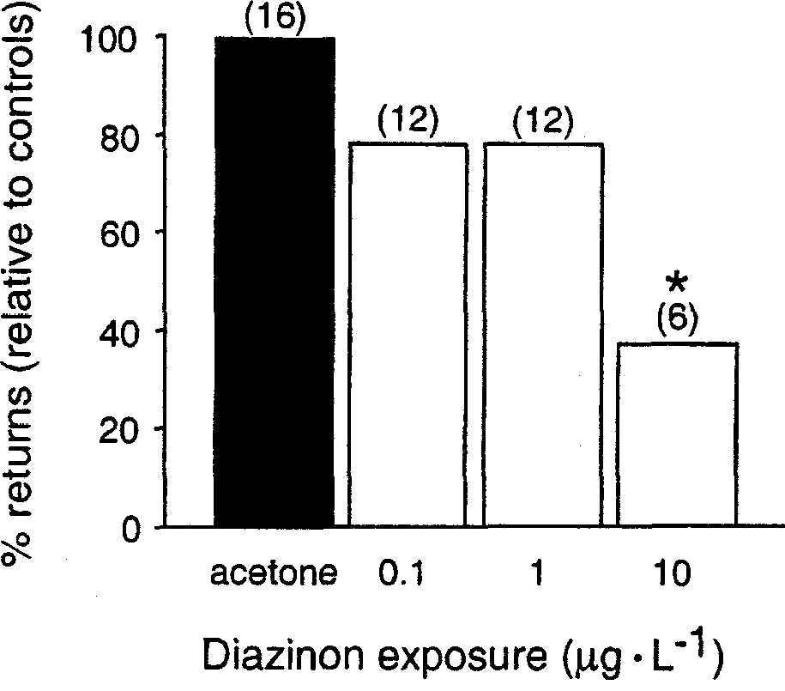

Figure 12. Pesticide exposures disrupt homing behaviors in chinook salmon. Salmon (n = 40 per treatment) were exposed to diazinon for 24 hours and released 2 kilometers downstream from a hatchery. Salmon exposed to 10 μg/l returned in significantly fewer numbers. (from Scholz et al., 2000)

Study 5. Model the consequences of copper contamination for salmon productivity and population integrity within a representative watershed or basin (Jordan, Feist, Dittman, and Scholz).

We expect to show in the first four Studies of Task 2 that copper exposures based on expected environmental conditions in many watersheds of the Columbia River Basin are sufficient to impair the sensory function and behavioral performance of juvenile and adult chinook salmon. The aim of the final task is to scale the autecological responses of individual fish up to population ecological properties. There are two primary manners in which individual behaviorial modification could be manifested at the level of populations – demographic health and genetic integrity. Any behavioral impacts of pesticide exposure that increases mortality, even during a limited ontogenetic time frame can map to population level effects. In fact, subtle changes in life stage specific survival rates can have profoundly nonintuitive impacts on population growth rates (Kareiva et al., 2000). Similarly, though in a more intuitive sense, population growth rates are directly related to reproductive success. As such, behavioral impacts due to copper exposure that decrease mating success will have strong demographic consequences.

More subtle, however, are the contributions of individual behavior to population genetic structure. As little as one effective migrant between populations each generation is sufficient gene flow to prevent genetic isolation from developing (Wright, 1969). Alternatively, given genetic structure between isolated populations, as little as one effective migrant per generation is sufficient to remove fixed allelic differences. Therefore, the potential exists for even subtle changes in stray rate to markedly influence inter-population genetic integrity. Since return migration is thought to be highly dependent on olfactory cues (Dittman and Quinn, 1996), pesticide induced anosmia may result in increased rates of straying, resulting in unnatural levels of gene flow in affected populations. This is a source of concern for chinook salmon because preliminary evidence indicates that sublethal pesticide exposures can disrupt homing behavior (Figure 12). For copper, there is additional complexity in the sense that salmon will avoid copper-contaminated surface waters if they can (Hansen et al., 1999a). This may not be an option where non-point source inputs of copper predominate. However, where behavioral avoidance occurs, copper may function as a chemical barrier to home stream migration.

In this Study we will link the mechanistic basis of pesticide impacts on chinook salmon behavior to population level effects through the use of spatially explicit population demographic and genetic models. The use of predictive mechanistic models allows us to generate testable hypotheses regarding the demographic and genetic consequences, at the level of an entire basin, of pesticide exposure on rearing and migrating chinook salmon.

The empirical models proposed for this task will test the following two hypotheses:

H₁: Pesticide exposures increase the rate of straying in wild and hatchery salmon

H₂: Pesticides limit the productivity of wild salmon populations

Our approach to both H₁ and H₂ will be to generate a spatially explicit population dynamical model based on a mechanistic representation of life stage specific population processes. The spatially explicit nature of the model allows us to ask realistic questions regarding meta-population structure with respect to both demographic and genetical dynamics. The mechanistic basis of the model’s stage specific population processes allows direct incorporation of the consequences of unnatural fish behavior. The goal of the modeling effort will be to predict the levels of demographic and genetic impact resulting from the changes in behavioral performance as measured in Studies 3 & 4.

Our modeling approach will be to construct a spatially explicit stage structured population model for a given basin and chinook ESU. The basin and ESU will be selected based on the availability of environmental monitoring data for dissolved and total copper in salmon habitat. The Willamette is a leading prospect, but the model could be applied to any river system in the Columbia River Basin. The population component of the model will be stage structured Leslie matrices. The individual populations within the ESU will be linked in a spatially explicit meta-population framework. The spatially explicit component of the model will allow us to explicitly include demographic coupling of populations through straying, as well as landscape level impacts on population processes during breeding, rearing and migration.

Life-stage based matrix population models are the most general framework for a mechanistically based population projection tool. A life-stage based matrix population model is the mathematical representation of a survival, or life table, based population process (Caswell, 2001). If an organism’s life cycle can be broken into discrete stages, a matrix model is the framework by which the within stage survival and between stage transitions are used to project the population into the future. Matrix population models differ from population level models like Beverton-Holt or Ricker stock recruitment models in that they do not impose a functional form to the inter-stage process. In fact, since the components of a matrix population model are the stage specific survivals and transition probabilities, the inherent structure of the models is mechanistic, and as such, easily accommodates mechanistically based population processes. To incorporate the effects of pesticide exposure on population processes we will estimate decreased survival probabilities for juvenile life stages based on the results of predation experiments in Study 3.

To include population processes that are mediated by landscape level impacts or that arise from demographic coupling of neighboring populations, we will place individual stage structured populations in a spatial context. The basic form of the model is similar to a classic meta-population, where individual sub-populations are coupled to varying degrees, and the entire population’s dynamics emerges from the aggregate behavior of the individual populations (Hanski, 1996). In the model the breeding, rearing and migrating areas are located within a branched network that represents the actual basin and chinook ESU.

The spatial structure comes into play in that there is not complete natal-site fidelity. To represent straying the population from each reach has a finite, although sometimes very small, probability of ending up in all of the other reaches. Therefore, all reaches are potentially demographically coupled through straying. We will determine the matrix of straying probabilities by expressing the branching structure of the reaches as a series of choices that the migrating individuals must make. We will set the probability of making the correct choice from literature values of natural stray rates (Quinn, 1993; Pascual et al., 1995; Hard and Heard, 1999). In this framework, physiological impacts on the individual’s ability to correctly navigate the stream network during migration will be included as increased probabilities of making the wrong choice at each branch. To parameterize the stray matrix for pesticide exposed fish, we will draw on the physiological results from Study 1 and the behavioral results of Study 4 to determine the degree to which exposed fish have lost their ability to discriminate olfactory signatures of their natal streams. Although this may be a somewhat simplistic view of migration, it does allow us to explicitly incorporate the behavior of individuals into the dynamics of the entire meta-population.

In addition to tracking the population dynamics of each breeding population, we also track genetic markers in each cohort. We assume that we can identify 10 loci, each with 10 possible alleles in all populations. These loci are not subject to mutation or selection, but are inherited and are subject to drift due to small breeding population size and small number of strays. By initializing the simulations with a known degree of genetic heterogeneity across the basin, we can track the impacts of demographic coupling as manifested by maintenance or loss of genetic diversity. While natural levels of gene flow and the degree to which populations of chinook salmon are reproductively isolated or locally adapted is not well understood (Myers et al., 1998), any disruption of long term patterns of gene flow are potentially detrimental to population health (Slatkin, 1987). Therefore, we will explore relative, rather than absolute, metrics of the change in population level genetic integrity.

Obviously the model, though somewhat complex, is a gross simplification of the biological, spatial and dynamical properties of salmonids; however, it captures what are generally considered to be the major features that drive patterns of population persistence and extinction (Policansky and Magnuson, 1988; Rieman and Dunham, 2000). To be of use in decision support for salmonid population management, the model must predict the dynamical consequences of imposed actions. In the case of a model population, management actions are nothing more than directed parameter variation. Thus, we will assess the impact of copper exposures on chinook populations by reporting two features of population dynamics: demographic status and genetic integrity.

g. Facilities and equipment

The proposed experiments will be conducted at the NWFSC (The Center, Seattle, WA), the University of Washington (Seattle, WA), and the Center’s Manchester Research Station (Manchester, WA). A fully equipped zebrafish breeding colony at the Center will provide embryos and larvae for the experiments in Task 1. In addition, all three facilities have the capacity to rear chinook salmon for the experiments in Task 2. The Center will provide adequate office space and computers for NRC postdoctoral associates and contract personnel. The PI supervises a research laboratory at the Center with optical and digital imaging equipment for the Studies in Task 1. This includes stereomicroscopes, a compound microscope fitted for epifluorescent and Nomarski optics, a cooled CCD digital camera for low light imaging, and an inverted compound microscope fitted with a digital camera for time-lapse imaging. The laboratory also has standard equipment that can support the electrophysiological experiments in Task 2. The Center and the Manchester field facility have tanks and an experimental stream channel for conducting the behavioral and predation assays in Task 2, and adult chinook salmon for the homing study will be available from the University of Washington Hatchery. The spatial population modeling in Task 2 will be conducted at the Center.

h. References

Abdelilah, S., Mountcastle-Shah, E., Harvey, M., Solnica-Krezel, L., Schier, A.F., Stemple, D.L., Malicki, J., Neuhauss, S.C.F., Zwartkruis, F., Stainier, D.Y.R., Rangini, Z. and Driever, W. (1996). Mutations affecting neural survival in the zebrafish Danio rerio. Development 123:217-227.
Abrams, J.M., White, K., Fessler, L.I. and Steller, H. (1993). Programmed cell death during Drosophila embryongenesis. Development 117:29-43.
Alexandre, D. and Ghysen, A. (1999). Somatotopy of the lateral line projection in larval zebrafish. Proc. Natl. Acad. Sci. USA 96(13):7558-62.
Arkoosh, M.R., Casillas, E., Clemons, E., Kagley, A.N., Olson, R., Reno, P. and Stein, J.E. (1998). Effect of pollution on fish diseases: Potential impacts on salmonid populations. J. Aquat. Anim. Health. 10:182-190.
Baatrup, E., Døving, K.B. and Winberg, S. (1990). Differential effects of mercurial compounds on the electroolfactogram (EOG) of salmon (Salmo salar L.). Ecotoxicol. Environ. Saf. 20(3):269-76.
Baier, H., Klostermann, S., Trowe, T., Karlstrom, R.O., Nüsslein-Volhard, C. and Bonhoeffer, F. (1996). Genetic dissection of the retinotectal projection. Development 123:415-425.
Baier, H., Rotter, S. and Korsching, S. (1994). Connectional topography in the zebrafish olfactory system: random positions but regular spacing of sensory neurons projecting to an individual glomerulus. Proc. Natl. Acad. Sci. USA 91(24):11646-50.
Baker, K., Warren, K.S., Yellen, G. and Fishman, M.C. (1997). Defective “pacemaker” current (Ih) in a zebrafish mutant with a slow heart rate. Proc. Natl. Acad. Sci. USA 94(9):4554-59.
Beauvais, S.L., Jones, S.B., Brewer, S.K. and Little, E.E. (2000). Physiological measures of neurotoxicity of diazinon and malathion to larval rainbow trout (Oncorhynchus mykiss) and their correlation with behavioral measures. Environ. Toxicol. and Chem. 19:1875-1880.
Berejikian, B.A., Smith, R.J., Tezak, E.P., Schroder, S.L. and Knudsen, C.M. (1999). Paired chemical alarm signals and complex hatchery rearing habitats affect anti-predator behavior and survival of chinook salmon (Oncorhynchus tshawytscha) juveniles. Can. J. Fish. Aquat. Sci. 56:830-838.
Bernhardt, R.R., Chitnis, A.B., Lindamer, L. and Kuwada, J.Y. (1990). Identification of spinal neurons in the embryonic and larval zebrafish. J. Comp. Neurol. 302(3):603-16.
Bertmar, G. (1982). Structure and function of the olfactory mucosa of the migrating baltic trout under environmental stresses, with special reference to water pollution. In: Chemoreception in fishes: Developments in aquaculture and fisheries science, Volume 8 (T.J. Hara, ed.). Elsevier. pp. 363-393.
Beyers, D.W. and Farmer, M.S. (2001). Effects of copper on olfaction of Colorado pike minnow. Environ. Toxicol. Chem. 20:907-912.
Brewer, S.K., Little, E.E., DeLonay, A.J., Beauvais, S.L., Jones, S.B. and Ellersieck, M.R. (2001). Behavioral dysfunctions correlate to altered physiology in rainbow trout (Oncorynchus mykiss) exposed to cholinesterase-inhibiting chemicals. Arch. Environ. Contam. Toxicol. 40:70-76.
Briggs, J.P. (2002). The zebrafish: a new model organism for integrative physiology. Am. J. Physiol. Reg. Integrat. Comp. Physiol. 282:R3-R9.
Brown, G.E. and Smith, R.J.F. (1997). Conspecific skin extracts elicit antipredator responses in juvenile rainbow trout (Oncorhynchus mykiss). Can. J. Zool. 75:1916-1922.
Brown, G.E. and Smith, R.J.F. (1998). Acquired predator recognition in juvenile rainbow trout (Oncorhynchus mykiss): conditioning hatchery-reared fish to recognize chemical cues of a predator. Can. J. Fish. Aquat. Sci. 55:611-617.
Brown, S.B., Evans, R.E., Thompson, B.E. and Hara, T.J. (1982). Chemoreception and aquatic pollutants. In: Chemoreception in fishes: Developments in Aquaculture and fisheries science, Volume 8 (T.J. Hara, ed.). Elsevier. pp. 395-422.
Carlson, R.W., Bradbury, S.P., Drummond, R.A. and Hammermeister, D.E. (1998). Neurological effects on startle response and escape from predation by medaka exposed to organic chemicals. Aquat. Toxicol. 43:51-68.
Caswell, H. (2001). Matrix Population Models. 2nd ed. Sinauer, Sunderland, MA.
Cole, L.K. and Ross L.S. (2001). Apoptosis in the developing zebrafish embryo. Dev. Biol. 240:123-142.
Crnjar, R., Scalera, G., Bigiani, A., Barbarossa, I.T., Magherini, P.C. and Pietra, P. (1992). Olfactory sensitivity to amino acids in the juvenile stages of the European eel Anguilla anguilla (L.). J. Fish Biol. 40:567-576.
Daly, F.J. and Sandell, J.H. (2000). Inherited retinal degeneration and apoptosis in mutant zebrafish. Anat. Rec. 258(2):145-55.
Detrich, H.W., Zon, L.I. and Westerfield, M. (1998a). The zebrafish Vol 1: Biology. New York: Academic.
Detrich, H.W., Zon, L.I. and Westerfield, M. (1998b). The zebrafish, Vol 2: Genetics and Genomics. New York: Academic.
Detzel, T. (2001). Kitzhaber asks Bush to add $500 million for salmon. The Oregonian Feb. 27, 2001.
Dittman, A.H. and Quinn, T.P. (1996). Homing in Pacific salmon: mechanisms and ecological basis. J. Exp. Biol. 199:83-91.
Dodd, A., Curtis, P.M., Williams, L.C. and Love, D.R. (2000). Zebrafish: bridging the gap between development and disease. Hum. Mol. Genet. 9:2443-2449.
Domagalski, J. (1996). Pesticides and pesticide degradation products in stormwater runoff: Sacramento River basin, California. Water Res. Bull. 32:953-964.
Ehrich, M. and Bloomquist, J.R. (2001). Pesticides. In: Handbook of Neurotoxicology, Vol.1 (E.J. Massaro, ed.). Humana Press. pp. 3-106.
Evans, R.E. and Hara, T.J. (1985). The characteristics of the electro-olfactogram (EOG): its loss and recovery following olfactory nerve section in rainbow trout (Salmo gairdneri). Brain. Res. 330(1):65-75.
Environmental Protection Agency (EPA). (1999). National recommended water quality criteria – correction. Office of Water. EPA 822-Z-99-001.
Environmental Protection Agency/Fish and Wildlife Service/National Oceanic and Atmospheric Administration (EPA/FWS/NOAA). (2001). Memorandum of agreement between the Environmental Protection Agency, Fish and Wildlife Service and National Marine Fisheries Service regarding enhanced coordination under the Clean Water Act and Endangered Species Act. Federal Register 66 (36):11201-11217.
Fairchild, W.L., Swansburg, E.O., Arsenault, J.T. and Brown, S.B. (1999). Does an association between pesticide use and subsequent declines in catch of Atlantic salmon (Salmon salar) represent a case of endocrine disruption? Environ. Health. Perspect. 107:349-358.
Fishman, M.C. (2001). Perspectives: Genomics, Zebrafish-the canonical vertebrate. Science 294:1290-1291.
Friedrich, R.W. and Korsching, S.I. (1998). Chemotopic, combinatorial, and noncombinatorial odorant representations in the olfactory bulb revealed using a voltage-sensitive axon tracer. J. Neurosci. 18(23):9977-88.
Fuhrer, et al. (1999). The quality of our nations waters: nutrients and pesticides. USGS Circular 1225.
Furutani-Seiki, M., Jiang, Y., Brand, M., Heisenberg, C., Houart, C., Beuchle, D., van Eeden, F.J.M., Granato, M., Haffter, P., Hammerschmidt, M., Kane, D.A., Kelsh, R.N., Mullins, M.C., Odenthal, J. and Nüsslein-Volhard, C. (1996). Neural degeneration mutants in the zebrafish, Danio rerio. Development 123:229-239.
Granato, M., van Eeden, F.J.M., Schach, U., Trowe, T., Brand, M., Fuurtani-Seiki, M., Haffter, P., Hammerschmidt, M., Heisenberg, C.P., Jiang, Y.J., Kane, D.A., Kelsh, R.N., Mullins, M.C., Odenthal, J. and Nüsslein-Volhard, C. (1996). Genes controlling and mediating locomotion behavior of the zebrafish embryo and larva. Development 123:399-413.
Griffiths, S.W. and Armstrong, J.D. (2000). Differential responses of kin and nonkin salmon to patterns of water flow: does recirculation influence aggression? Anim. Behav. 59:1019-1023.
Grunwald, D.J. (1996). A fin-de siecle achievement: charting new waters in vertebrate biology. Science 274:1634-1635.
Haffter, P., Granato, M., Brand, M., Mullins, M.C., Hammerschmidt, M., Kane, D.A., Odenthal, J., van Eeden, F.J.M., Jiang, Y.J., Heisenberg, C.P., Kelsh, R.N., Furutani-Seiki, M., Vogelsang, E., Beuchle, D., Schach, U., Fabian, C. and Nüsslein-Volhard, C. (1996). The identification of genes with unique and essential functions in the development of the zebrafish, Danio rerio. Development 123:1-36.
Hamdani, E.H., Stabell, O.B., Alexander, G. and Døving, K.B. (2000). Alarm reaction in the Crucian Carp is mediated by the medial bundle of the medial olfactory tract. Chem. Senses 25:103-109.
Hansen, L.J. and Johnson, M.L. (1999). Conservation and toxicology: the need to integrate the disciplines. Environ. Toxicol. and Chem. 18:2121-2122.
Hansen, J.A., Marr, J.C., Lipton, J., Cacela, D. and Bergman, H.L. (1999a). Differences in neurobehavioral responses of chinook salmon (Oncorhynchus tshawytscha) and rainbow trout (Oncorhynchus mykiss) exposed to copper and cobalt: Behavioral avoidance. Environ. Toxicol. Chem. 18:1972-1978.
Hansen, J.A., Rose, J.D., Jenkins, R.A., Gerow, K.G. and Bergman, H.L. (1999b). Chinook salmon (Oncorhynchus tshawytscha) and rainbow trout (Oncorhynchus mykiss) exposed to copper: Neurophysiological and histological effects on the olfactory system. Environ. Toxicol. Chem. 18:1979-1991.
Hanski, I.A. (1996). Metapopulation dynamics: from concepts and observations to predictive models. In: Metapopualtion biology: ecology, genetics, and evolution (I.A. Hanski and M.E. Gilpin, ed.). Academic Press. pp. 69 - 71.
Hara, T.J. (1972). Electrical responses of the olfactory bulb of Pacific salmon Oncorhynchus nerka and Oncorhynchus kisutch. J. Fish. Res. Board Can. 29:1351-1355.
Hara, T.J. (1973). Olfactory responses to amino acids in rainbow trout, Salmo gairdneri. Comp. Biochem. Physio. A 44:407-416.
Hara, T.J. (1992). Mechanisms for olfaction. In: Fish Chemoreception (T.J. Hara, ed.). Chapman & Hall. pp. 150-170.
Hara, T.J., Law, Y.M.C. and Macdonald, S. (1976). Effects of mercury and copper on the olfactory response in rainbow trout (Salmo gairdneri). J. Fish. Res. Board Can. 33:1568-1573.
Hara, T.J. and Zielinski, B. (1989). Structural and functional development of the olfactory organ in teleosts. Trans. Am. Fish. Soc. 118:183-94.
Hard, J.J. and Heard, W.R. (1999). Analysis of straying variation in Alaskan hatchery Chinook salmon (Oncorhynchus tshawytscha) following transplantaion. Can. J. Fish. Aquat. Sci. 56:578-589.
Jarrard, H.E. (1997). Postembryonic changes in the structure of the olfactory bulb of the chinook salmon (Oncorhynchus tshawytscha) across its life history. Brain Behav. Evol. 49:249-60.
Kats, L.B. and Dill, L.M. (1998). Chemosensory assessment of predation risk by prey animals. Ecosci. 5:361-394.
Kareiva, P., Marvier, M. and McClure, M. (2000). Recovery and Management Options for Spring/Summer Chinook Salmon in the Columbia River Basin. Science 290: 977-979.
Kimmel, C.B., Ballard, W.W., Kimmel, S.R., Ullmann, B. and Schilling, T.F. (1995). Stages of embryonic development of the zebrafish. Developmental Dynamics 203:253-310.
Kimmel, C.B., Patterson, J. and Kimmel, R.O. (1974). The development and behavioral characteristics of the startle response in the zebrafish. Dev. Psychobiol. 7:47-60.
Klaprat, D.A., Evans, R.E. and Hara, T.J. (1992). Environmental contaminants and chemoreception in fishes. In: Fish Chemoreception (T.J. Hara, ed.). Chapman & Hall. pp. 321-341.
Kozlowski, D.J. and Weinberg, E.S. (2000). Photoactivatable (caged) fluorenscein as a cell tracer for fate mapping in the zebrafish embryo. Methods Mol. Biol. 135:349-355.
Kruzynski, G.M. and Birtwell, I.K. (1994). A predation bioassay to quantify the ecological significance of sublethal responses of juvenile chinook salmon (Oncorhynchus tshawytscha) to the antisapstain fungicide TCMTB. Can. J. Fish. Aquat. Sci. 51:1780-1790.
Larm, J.A., Cheung, N.S. and Beart, P.M. (1997). Apoptosis induced via AMPA-selective glutamate receptors in cultured murine cortical neurons. J. Neurochem. 69:2)617-622.
Little, E.E., Archeski, R.D., Flerov, B.A. and Kozlovskaya, V.I. (1990). Behavioral indicators of sublethal toxicity in rainbow trout. Arch. Environ. Toxicol. 19: 380-385.
Mathis, A. and Smith, R.J.F. (1993). Chemical alarm signals increase the survival time of fathead minnows (Pimephales promelas) during encounters with northern pike (Esox lucius). Behav. Ecol. 4:260-265.
Mills, L.J., Klein-MacPhee, G.K. (1979). Toxicity of the New England red tide dinoflagellate to winter flounder larvae. In: Toxic dinoflagellate blooms (D.L. Taylor and H.H. Seliger, eds.). Elsevier. p. 389-394.
Moore, A. and Scott, A.P. (1991). Testosterone is a potent odorant in precocious male Atlantic salmon (Salmo salar L.) parr. Phil. Trans. R. Soc. Lond. B 332:241-244.
Moore, A. and Scott, A.P. (1992). 17α,20β-dihydroxy-4-pregnen-3-one 20-sulphate is a potent odorant in precocious male Atlantic salmon (Salmo salar L.) parr which have been pre-exposed to the urine of ovulated females. Proc. R. Soc. Lond. B Biol Sci 249(1325):205-209.
Moore, A. and Waring, C.P. (1996a). Sublethal effects of the pesticide Diazinon on olfactory function in mature male Atlantic salmon parr. J. Fish. Biol. 48:758-775.
Moore, A. and Waring, C.P. (1996b). Electrophysiological and endocrinological evidence that F-series prostaglandins function as priming pheromones in mature male Atlantic salmon (Salmo salar) parr. J. Exp. Biol. 199:2307-2316.
Moore, A. and Waring, C.P. (1998). Mechanistic effects of a triazine pesticide on reproductive endocrine function in mature male Atlantic salmon (Salmo salar L.) parr. Pest. Biochem. Physiol. 62:41-50.
Moore, A. and Waring, C.P. (2001). The effects of a synthetic pyrethroid pesticide on some aspects of reproduction in Atlantic salmon (Salmo salar L.). Aquatic Toxicol. 52:1-12.
Morgan, M.J. and Kiceniuk, J.W. (1990). Effect of fenitrothion on the foraging behavior of juvenile Atlantic salmon. Environ. Toxicol. Chem. 9:489-495.
Myers, J.M., Kope, R.G., Bryant, G.J., Teel, D., Lierheimer, L.J., Wainwright, T.C., Grant, W.S., Waknitz, F.W., Neely, K., Lindley, S.T., and Waples, R.S. (1998). Status and review of Chinook Salmon from Washington, Idaho, Oregon and California. U.S. Dept. Commer., NOAA Tech Memo. NMFS-NWFSC-35, 443.
National Marine Fisheries Service (NMFS). (1996). Factors for decline: A supplement to the notice of determination of west coast steelhead under the Endangered Species Act. Protected Species Branch, NMFS, 525 NE Oregon St., Suite 500, Portland, OR 97232. 83 p.
National Marine Fisheries Service (NMFS). (1998). Factors contributing to the decline of chinook salmon: An addendum to the 1996 west coast steelhead factors for decline report. Protected Resources Branch, NMFS, 525 NE Oregon St., Suite 500, Portland, OR 97232. 74 p.
National Oceanic and Atmospheric Administration (NOAA). (1991). Notice of policy: Policy on applying the definition of species under the Endangered Species Act to Pacific salmon. Federal Register 56 (224):58612-58618.
National Oceanic and Atmospheric Administration (NOAA). (1999). Endangered and threatened wildlife and plants; definition of “harm”. Federal Register 64 (215):60727-60731.
National Oceanic and Atmospheric Administration (NOAA). (2000a). Endangered and threatened species: Final rule governing take of 14 threatened salmon and steelhead evolutionarily significant units (ESUs). Federal Register 65 (132): 42422-42481.
National Oceanic and Atmospheric Administration (NOAA). (2000b). Designated critical habitat: Critical habitat for 19 evolutionarily significant units of salmon and steelhead in Washington, Oregon, Idaho, and California. Federal Register 65 (32):7764-7787.
Neuhauss, S.C.F., Biehlmaier, O., Seeliger, M.W., Das, T., Kohler, K., Harris, W.A. and Baier, H. (1996). Genetic disorders of vision revealed by a behavioral screen of 400 essential loci in zebrafish. J. Neurosci. 19(19):8603-8615.
Nevitt, G.A., Dittman, A.H., Quinn, T.P. and Moody, W.J. (1994). Evidence for a peripheral olfactory memory in imprinted salmon. Proc. Natl. Acad. Sci. U S A. 91:4288-4292.
Ngai, J., Dowling, M.M., Buck, L., Axel, R. and Chess, A. (1993). The family of genes encoding odorant receptors in the channel catfish. Cell 72:657-666.
Pascual, M.A., Quinn, T.P. and Fuss, H. (1995). Factors Affecting the Homing of Fall Chinook Salmon from Columbia River Hatcheries. Trans. Amer. Fish. Soc. 124:308-320.
Peterson, R.T., Link, B.A., Dowling, J.E. and Schreiber, S.L. (2000). Small molecule developmental screens reveal the logic and timing of vertebrate development. Proc. Natl. Acad. Sci. USA 97:12965-12969.
Policansky, D. and Magnuson, J.J. (1998). Genetics, metapopulations, and ecosystem management of fisheries. Ecol. Appl. 8:S119-S123.
Quinn, T.P. (1993). A review of homing and straying of wild and hatchery-produced salmon. Fish. Res. 18:29-44.
Relyea, R.A. and Mills, N. (2001). Predator-induced stress makes the pesticide carbaryl more deadly to gray treefrog tadpoles (Hyla versicolor). Proc. Natl. Acad. Sci. 98:2491-2496.
Ribera, A.B., Nusslein-Volhard, C. (1998). Zebrafish touch-insenstive mutants reveal an essential role for the developmental regulation of sodium current. J. Neurosci. 18:9181-9191.
Rieman, B.E. and Dunham, J.B. (2000). Metapopulations and salmonids: a synthesis of life history patterns and empirical observations. Ecol. of Freshwater Fish. 9:51-64.
Rinella, et al., (1999). Surface Water Quality of the Yakima River Basin, WA. USGS Water Supply Paper 2354-B.
Ross, L.S., Parrett, T. and Easter, S.S. Jr. (1992). Axonogenesis and morphogenesis in the embryonic zebrafish brain. J. Neurosci. 12(2):467-82.
Saglio, P. and Trijasse, S. (1998). Behavioral responses to atrazine and diuron in goldfish. Arch. Environ. Contam. Toxicol. 35:484-491.
Saint-Amant, L. and Drapeau, P. (1998). Time course of the development of motor behaviors in the zebrafish embryo. J. Neurobiol. 37(4):622-632.
Scholz, N.L., Truelove, N.K., French, B.L., Berejikian, B.A., Quinn, T.P., Casillas, E. and Collier, T.K. (2000). Diazinon disrupts antipredator and homing behaviors in chinook salmon (Oncorhynchus tsawytscha). Can. J. Fish. Aquat. Sci. 57:1911-1918.
Scholz, N.L. and Collier, T.K. (2000). Endangered salmon and probabilistic risk assessments for organophosphate pesticides. SETAC Globe 1:32-33.
Smith, R.J.F. (1992). Alarm signals in fishes. Rev. Fish. Biol. Fish. 2:33-63.
Slatkin, M. (1987). Gene flow and the geographic structure of natural populations. Science 236:787-792.
Solum, D., Hughes, D., Major, M.S. and Parks, T.N. (1997). Prevention of normally occurring and deafferentiation-induced neuronal death in chick brainstem auditory neurons by periodic blockade of AMPA/kainite receptors. J. Neurosci. 17(12):4744-51.
Sorensen, E.M. (1991). Metal poisoning in fish. CRC Press.
Sorensen, P.W. (1992). Hormones, pheromones and chemoreception. In: Fish Chemoreception (T.J. Hara, ed.). Chapman & Hall. pp. 199-228.
Stainier, D.Y.R. (2001). Zebrafish genetics and vertebrate heart formation. Nat. Rev. Genet. 2(1):39-48.
Stainier, D.Y.R., Fouquet, B., Chen, J., Warren, K.S., Weinstein, B.M., Meiler, S.E., Mohideen, M., Neuhauss, S.C.F., Solnica-Krezel, L., Schier, A.F., Zwartkruis, F., Stemple, D.L., Malicki, J., Driever, W. and Fishman, M.C. (1996). Mutations affecting the formation and function of the cardiovascular system in the zebrafish embryo. Development 123:285-292.
Trevarrow, B., Marks, D.L. and Kimmel, C.B. (1990). Organization of hindbrain segments in the zebrafish embryo. Neuron 4:669-679.
U.S. Fish and Wildlife Service (USFWS) and National Oceanic and Atmospheric Administration (NOAA). (1994). Endangered and threatened wildlife and plants; notice of interagency cooperative policy on information standards under the Endangered Species Act. Federal Register 59 (126):34271.
Waring, C.P. and Moore, A.P. (1997). Sublethal effects of a carbamate pesticide on pheromonal mediated endocrine function in mature male Atlantic salmon (Salmo salar) parr. Fish. Physiol. Biochem. 17:203-211.
Wentz, D.A., Bonn, B.A., Carpenter, K.D., Hinkle, S.R., Janet, M.L., Rinella, F.A., Uhrich, M.A., Waite, I.R., Laenen, A. and Bencala, K. (1998). Water quality in the Willamette Basin, Oregon, 1991-95. U.S. Geological Survey Circular 1161.
Westerfield, M. (1994). The Zebrafish Book. Eugene, University of Oregon Press.
Westerfield, M. (1990). Pathfinding and synapse formation in a zebrafish mutant lacking functional acetylcholine receptors. Neuron 4(6):867-74.
Whitlock, K.E. and Westerfield, M. (1995). Two populations of cells expressing GnRH- like immunoreactivity migrate from the olfactory organ to the central nervous system in the zebrafish Chem. Senses 20:328-328.
Winberg, S., Bjerselius, R., Baatrup, E. and Døving, K.B. (1992). The effect of Cu (II) on the electro-olfactogram (EOG) of the Atlantic salmon (Salmo salar L) in artificial freshwater of varying inorganic carbon concentrations. Ecotoxicol. Environ. Saf. 24:167-178.
Wisby, W.J. and Hasler, A.D. (1954). Effect of occlusion on migrating silver salmon (Oncorhynchus kisutch). J. Fish. Res. Board Can. 11:472-478.
Wright, S. (1969). Evolution and the Genetics of Populations, Vol. 2. The Theory of Gene Frequencies. Univ. Chicago Press, Chicago, IL.
Wyllie, A.H., Kerr, J.F.R. and Currie, A.R. (1980). Cell death: the significance of apoptosis. Int. Rev. Cytol. 68:251-306.
Yoshihara, Y., Nagao, H. and Mori, K. (2001). Neurobiology. Sniffing out odors with multiple dendrites. Science 291:835-837.
Zeiske, E., Theisen, B. and Breucker, H. (1992). Structure, development, and evolutionary aspects of the peripheral olfactory system. In: Fish Chemoreception (T.J. Hara ed.). Chapman & Hall. pp. 13-39.

Section 10 of 10. Key personnel

Nathaniel Scholz Research Zoologist Principal Investigator
John Incardona Senior NRC Postdoc Co-Investigator (Task 1)
David Baldwin NRC Postdoc Co-Investigator (Task 2)
Barry Berejikian Fisheries Research Biologist Co-Investigator (Task 2)
Andrew Dittman Fisheries Research Biologist Co-Investigator (Task 2)
Blake Feist Biological Statistician Co-Investigator (Task 2)
Christopher Jordan Fisheries Research Biologist Co-Investigator (Task 2)

Nathaniel L. Scholz, Principal Investigator

Education:
- Ph.D., Zoology, University of Washington, Seattle, WA, 1997.
- M.A., Biology, Boston University Marine Program, Boston, MA, 1991.
- B.A., Marine Biology, Boston University Marine Program, Boston, MA, 1991.

Employer: National Marine Fisheries Service, Northwest Fisheries Science Center, Environmental Conservation Division, Montlake Facility. Previous employment: National Research Council Postdoctoral Associate, National Academies of Science and Engineering (1998-1999).

Position: Research Zoologist, Team Leader (Fish Neurobiology and Development), Ecotoxicology and Environmental Fish Health Program. NMFS employee since 1999.

Present assignment: Dr. Scholz supervises a research laboratory at the NWFSC that is currently investigating the effects of pesticides on Pacific salmon, with an emphasis on species that are listed as threatened or endangered under the ESA.

Previous research/expertise: Dr. Scholz's expertise is in the areas of developmental biology, neurobiology, and animal behavior. His postdoctoral research focused on the impacts of pesticides on the neurobiology and behavior of chinook salmon. His doctoral research explored biochemical and physiological mechanisms of cell-cell signaling in the nervous system, and he studied the behavioral ecology of marine animals for his masters. He has published numerous papers in the field of neuroethology, and is regularly invited to speak at regional and national meetings and universities.

Five Relevant Publications:
Scholz, N.L. 2001. NO/cGMP signaling and the flexible organization of motor behavior in crustaceans. American Zoologist. 41:156-167.
Scholz, N.L., J. de Vente, J.W. Truman, and K. Graubard. 2001. Neural network partitioning by NO and cGMP. Journal of Neuroscience, 21:1610-1618.
Scholz, N.L., N. Truelove, B. French, B. Berejikian, T. Quinn, E. Casillas, and T.K. Collier. 2000. Diazinon disrupts antipredator and homing behaviors in chinook salmon (Oncorhynchus tshawytscha). Canadian Journal of Fisheries and Aquatic Sciences, 57:1911-1918.
Scholz, N.L., K. Graubard, and J.W. Truman. 1998. The NO/cGMP signaling pathway and the development of neural networks in postembryonic lobsters. Journal of Neurobiology, 34:208-226.
Scholz, N.L., M.F. Goy, J.W. Truman, and K. Graubard. 1996. Nitric oxide and peptide neurohormones activate cGMP synthesis in the crab stomatogastric ganglion. Journal of Neuroscience, 16:1614-1622.
John P. Incardona, Co-Investigator for Task 1 (1.0 FTE).

Education:
- M.D., Case Western Reserve University, Cleveland, OH, 1996
- Ph.D., Genetics, Case Western Reserve University, Cleveland, OH, 1995
- B.S., Honors Biology, Indiana University, Bloomington, IN, 1988

Post-doctoral Research: 1996-2001, Department of Biological Structure, University of Washington, Seattle, WA. Studies on cellular aspects of Sonic hedgehog signal transduction, and the mechanism of action of the environmental teratogen cyclopamine. Established expertise in delivery of hydrophobic compounds to embryos and tissues in vivo and in vitro, microdissection of embryos and use of molecular markers for analysis of craniofacial, neural tube, and somite development; use of antibodies and in situ hybridization, light, fluorescence and confocal microscopy; general molecular biological methods.

Position and Current Research: National Research Council Senior Associate, NMFS/NOAA Northwest Fisheries Science Center, Environmental Conservation Division. Analysis of environmental contaminant effects on fish development. Use of zebrafish as a model system for assessing the effects of pollutants on embryonic and larval development, physiology, and behavior. A major focus of this work is the use of the molecular and genetic capabilities associated with the zebrafish system to gain a more detailed mechanistic understanding of the developmental and sublethal toxic effects of aquatic pollutants.

Five Relevant Publications:
Incardona, J. P., Gruenberg, J. and Roelink, H. 2002. Sonic hedgehog induces segregation of Patched and Smoothened in late endosomes. (Current Biology 12, in press)
Incardona, J. P., Lee, J. H., Robertson, C. P., Enga, K., Kapur, R. P., and Roelink, H. 2000. Receptor-mediated endocytosis of soluble and membrane-tethered forms of Sonic hedgehog by Patched-1. Proceedings of the National Academy of Sciences U.S.A. 97: 12044-12049.
Incardona, J. P., Gaffield, W., Lange, Y., Cooney, A., Pentchev, P. G., Liu, S., Watson, J. A., Kapur, R. P. and Roelink, H. 2000. Cyclopamine inhibition of Sonic hedgehog signal transduction is not mediated through effects on cholesterol transport. Developmental Biology 224: 440–452.
Incardona, J.P., W. Gaffield, R.P. Kapur, and H. Roelink. 1998. The teratogenic Veratrum alkaloid cyclopamine inhibits Sonic Hedgehog signal transduction. Development 125:3553-3562.
Incardona, J.P. and T.L. Rosenberry. 1996. Replacement of the glycoinositol phospholipid anchor of Drosophila acetylcholinesterase with a transmembrane domain does not alter sorting in neurons and epithelia but results in behavioral defects. Molecular Biology of the Cell 7:613-630.
David H. Baldwin, Co-investigator for Task 2 (1.0 FTE).

Education:
- Ph.D., Zoology, University of Washington, Seattle, WA, 2000.
- B.A., Biology, Reed College, Portland, OR, 1986.

Employer: National Marine Fisheries Service, Northwest Fisheries Science Center, Environmental Conservation Division.

Position: National Research Council Postdoctoral Associate, Ecotoxicology and Environmental Fish Health Program (Fish Neurobiology and Development).

Present assignment: Member of the Fish Neurobiology and Development Team. Dr. Baldwin’s primary responsibility is establishing and performing electrophysiological recordings from the salmon olfactory system.

Previous research/expertise: Dr. Baldwin is a neurophysiologist whose research has focused on sensory physiology and behavior. His graduate research dealt with the role of specific visual pathways in the behavior of the fruit fly, Drosophila melanogaster. These experiments involved genetic manipulation, electrophysiological recording, and behavioral testing. His additional skills include immunocytochemistry, image analysis, and computer programming.

Recent Publications:
Nakamura, M., Baldwin, D.H., Hannaford, S., Palka, J., and Montell, C. 2002. Defective proboscis extension response (DPR), a member of the Ig superfamily required for the gustatory response to salt. Journal of Neuroscience, 22:3463-3472.
Christie, A.E., D.H. Baldwin, E. Marder, and K. Graubard. 1997. Organization of the stomatogastric neuropil of the crab, Cancer borealis, as revealed by modulator immunocytochemistry. Cell and Tissue Research, 288: 135-148.
Christie, A.E., D. Baldwin, G. Turrigiano, K. Graubard, and E. Marder. 1995. Immunocytochemical localization of multiple cholecystokinin-like peptides in the stomatogastric nervous system of the crab Cancer borealis. Journal of Experimental Biology, 198:263-271.
Baldwin, D.H. and K. Graubard. 1995. Distribution of fine neurites of stomatogastric neurons of the crab Cancer borealis: evidence for a structured neuropil. Journal of Comparative Neurology, 356:355-367.
Zirpel, L., D. Baldwin, and K. Graubard. 1993. Nickel induces oscillatory behavior and enhanced synaptic and electrotonic transmission between stomatogastric neurons of Panulirus interruptus. Brain Research, 617:205-213.
Barry A. Berejikian, Co-investigator for Task 2 (0.32 FTE).

Education:
- Ph.D., Fisheries Science, University of Washington, Seattle, WA, 1995.
- M.S., Fisheries Science, University of Washington, Seattle, WA, 1992.
- B.S., Fisheries Science, California Polytechnic State University, San Luis Obispo, CA., 1990.

Employer: National Marine Fisheries Service, Northwest Fisheries Science Center, Resource Enhancement & Utilization Technologies Division, Manchester Research Station.

Position: Fisheries Research Biologist, Team Leader (Behavioral Ecology). NMFS employee since 1994.

Present assignment: Project Leader of the BPA funded Assessment of Captive Broodstock Technologies Project (93-056). Dr. Berejikian’s responsibilities include identifying the effects of captive rearing on adult reproductive behavior and success. Dr. Berejikian is also a Principal Investigator on the “NATURES” project, evaluating the effects environmental parameters on the behavioral attributes of salmonids, including anti-predator behavior.

Previous research/expertise: Dr. Berejikian is a behavioral ecologist. His graduate research dealt with juvenile steelhead behavior and predator-prey interactions. He is an expert in quantifying Pacific salmon breeding behavior and success and juvenile behavioral ecology of salmonids. He has published numerous papers and is regularly invited to speak at national and international meetings.

Five Relevant Publications:
Berejikian, B. A., E. P. Tezak, and S. L. Schroder. 2001. Reproductive behavior and breeding success of captively reared chinook salmon (Oncorhynchus tshawytscha). N. Am. J. Fish. Manage. 21:255-260.
Berejikian, B. A., E. P. Tezak, L. Park, S. L. Schroder, E. P. Beall, and E. LaHood. 2001. Male dominance and spawning behavior of captively reared and wild coho salmon (Oncorhynchus kisutch). Can. J. Fish. Aquat. Sci. 58: 804-810.
Berejikian, B. A., E. P. Tezak, and A. L. LaRae. 2000. Female mate choice and spawning behavior of chinook salmon (Oncorhynchus tshawytscha) under experimental conditions. J. Fish. Biol. 57: 647-661.
Berejikian, B. A., R. J. F. Smith, E. P. Tezak, S. L. Schroder, and C. M. Knudsen. 1999. Chemical alarm signals and complex hatchery rearing habitats affect anti-predator behavior and survival of chinook salmon (Oncorhynchus tshawytscha) juveniles. Can. J. Fish. Aquat. Sci. 56: 830-838.
Berejikian, B. A. 1995. The effects of hatchery and wild ancestry and experience on the relative ability of steelhead trout fry (Oncorhynchus mykiss) to avoid a benthic predator. Can. J. Fish. Aquat. Sci. 52: 2076-2082.
Andrew H. Dittman, Co-investigator for Task 2 (0.32 FTE).

Education:
- Ph.D., Fisheries/Pharmacology, University of Washington, Seattle, WA, 1994.
- B.A., Biochemistry, Dartmouth College, Hanover, NH, 1982.

Employer: National Marine Fisheries Service, Northwest Fisheries Science Center, Resource Enhancement & Utilization Technologies Division.

Position: Fisheries Research Biologist, Behavioral Ecology/Integrative Fish Biology, NMFS employee since 2000.

Present assignment: Principal Investigator for the Imprinting/Homing components of the BPA funded Assessment of Captive Broodstock Technologies Project (93-056). Dr. Dittman’s responsibilities include development of rearing and reintroduction strategies to minimize straying in captively reared salmon populations.

Previous research/expertise: Dr. Dittman is an integrative biologist whose research focuses on olfactory physiology and olfactory–mediated behaviors in fishes. The focus of his current research is olfactory imprinting and homing in salmon. His graduate research dealt with behavioral and biochemical mechanisms involved in olfactory imprinting and homing. His post-doctoral research focused on the endocrine control of maturation and migratory behavior in salmon and the molecular physiology of fish olfaction. He is an expert in a wide range of techniques from field-based behavior to molecular biology. He has published numerous papers and is regularly invited to speak at national and international meetings.

Five Relevant Publications:
Speca, D. J., D. M. Lin, P. W. Sorensen, E. I. Isacoff, J. Ngai, and A. H. Dittman. 1999. Functional identification of a goldfish odorant receptor. Neuron, 23:487-498.
Nevitt, G. A, and A. H. Dittman. 1998. A new model for olfactory imprinting in salmon. Integrative Biology, 1:215-223.
Dittman, A. H., T. P. Quinn, G.A. Nevitt, B. Hacker, and D. R. Storm. 1997. Sensitization of olfactory guanylyl cyclase to a specific odorant in coho salmon. Neuron, 19:381-389.
Dittman, A. H., T. P. Quinn, and G. A. Nevitt. 1996. Timing of imprinting to natural and artificial odors by coho salmon (Oncorhynchus kisutch). Canadian Journal of Fisheries and Aquatic Sciences, 53:434-442.
Dittman, A. H. and T. P. Quinn. 1996. Pacific salmon homing: mechanisms and ecological basis. Journal of Experimental Biology, 199:83-91.
Blake E. Feist, Co-investigator for Task 2 (0.32 FTE).

Education:
- Ph.D., Fisheries Science, University of Washington, Seattle, WA, 1999.
- M.S., Fisheries Science, University of Washington, Seattle, WA, 1991.
- B.S., Zoology, University of Wisconsin, Madison, WI., 1986.

Employer: National Marine Fisheries Service, Northwest Fisheries Science Center, Environmental Conservation Division, Watershed Program.

Position: Statistician (Biology), NMFS employee since 1999.

Present assignment: I am responsible for designing and participating in research that examines the relationship between Pacific salmon fitness and survival, and terrestrial/estuarine habitat type and condition. I use a landscape scale approach for building spatial models for most of my research, but I also study the effect of differing spatio-temporal scales on ecosystems.

Previous research/expertise: I am a spatial ecologist, but I have extensive experience in basic ecology, ethology, neurobiochemistry, and biology. My doctoral research focused on the spatio-temporal dynamics of the invasion of a non-indigenous aquatic plant in Pacific Northwest estuaries. For my master’s research, I examined the impact of industrial noise on the estuarine ecology of juvenile Pacific salmon. I have published my research in the peer reviewed literature and I am frequently invited to present at scientific symposia. In addition, I have given numerous guest lectures at the University of Washington, on topics ranging from spatial ecology to GIS technology.

Five Relevant Publications:
Feist, B.E., E.A. Steel, G.R. Pess, and R.E. Bilby. What is the correct scale for habitat analyses aimed at prioritizing restoration efforts for salmon? Animal Conservation. In Review.
Feist, B.E., and E.O. Box. 2002. Vegetation and Ecosystem Mapping. In: Encyclopedia of Science and Technology. McGraw-Hill publishers, New York, NY (invited). In Press.
Levin, P.S., S. Achord, B.E. Feist, and R.W. Zabel. 2002. Non-indigenous brook trout and the demise of Pacific salmon: a forgotten threat? Proceedings of the Royal Society of London - Biology. In Press.
Pess, G.R., D.R. Montgomery, R.E. Bilby, E.A. Steel, B.E. Feist, and H.M. Greenberg. 2002. Correlation of landscape characteristics and land use on coho salmon (Oncorhynchus kisutch) abundance, Snohomish River, Washington State, USA. Canadian Journal of Aquatic and Fisheries Science. 59:613-623.
Feist, B.E., and C. A. Simenstad. 2000. Expansion rates and recruitment frequency of exotic smooth cordgrass, Spartina alterniflora (Loisel), colonizing unvegetated littoral flats in Willapa Bay, Washington. Estuaries. 23(2):267-274.
Chris Jordan, Co-investigator for Task 2 (0.32 FTE).

Education:
- Ph.D., Zoology, University of Washington, Seattle, WA, 1994.
- B.A., Biology with honors, University of Chicago, Chicago, Illinois, 1985.

Employer: National Marine Fisheries Service, Northwest Fisheries Science Center, Conservation Biology Division and Cumulative Risk Initiative.

Position: Operations Research Analyst (Mathematical Population Biologist). NMFS employee since 1999.

Present assignment: Population risk assessment modeling, spatial population dynamical modeling and basic population processes exploration with historical data sets. In addition, leading the development of a region wide monitoring and evaluation program for anadromous salmonid population status and recovery action effectiveness.

Previous research/expertise:

- Research Assistant Professor Washington State Univ., Pullman 1999 - present
- Assistant Professor University of Colorado, Boulder 1995 - 1999
- Research Associate University of Chicago, Chicago 1994 - 1995

Training and research experience includes mathematical modeling of populations and physiological processes and experimental approaches to neurobiological bases of behavior, fluid dynamics and population processes.

Five Relevant Publications:
Jordan, C.E. 2001. A predictive mathematical model to simulate swimming in the medicinal leech Hirudo medicinalis. J. Theor. Biol. In review.
McClure, M. M., B. L. Sanderson, E. E. Holmes, and C. E. Jordan. 2001. A large-scale, multi-species risk assessment: Anadromous salmon in the Columbia River Basin. Ecol. Apps. In Review.
Jordan, C.E. 1998. Scale effects in the kinematics and dynamics of swimming leeches. Can. J. Zool., 76(10):1869-1877.
Steinberg, E.K. and C.E. Jordan. 1997. Using genetics to learn about the ecology of threatened species: the allure and the illusion of measuring genetic structure in natural populations. In: Conservation Biology. eds, P. Fiedler and P. Kareiva. Chapman Hall, New York.
Jordan, C.E. 1996. Coupling internal and external mechanics to predict swimming behavior: a general approach? Amer. Zool. 36:710-722.
Appendix A
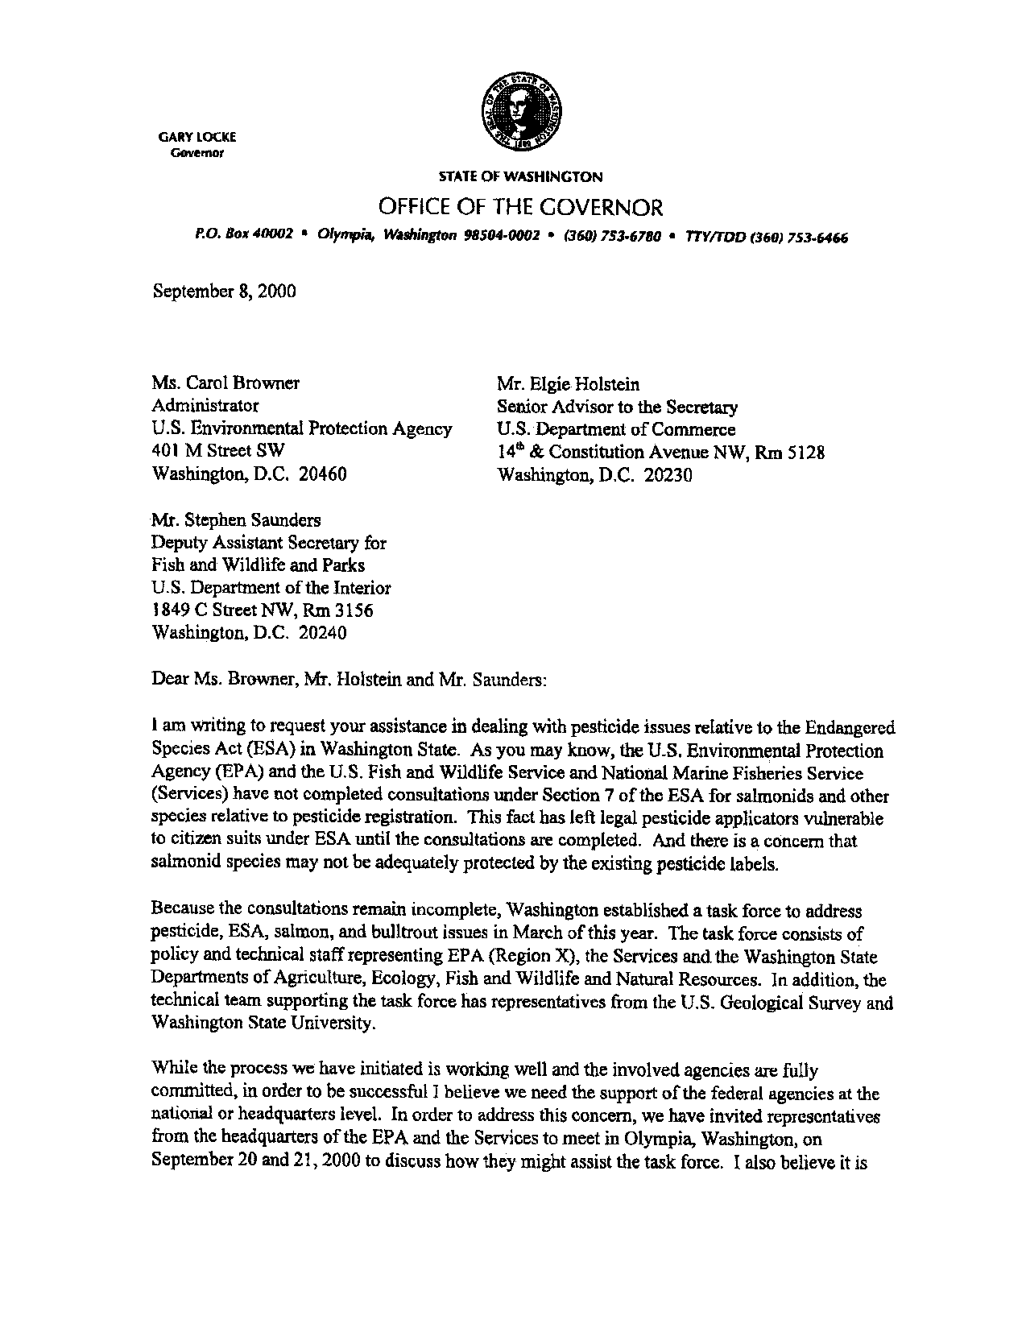
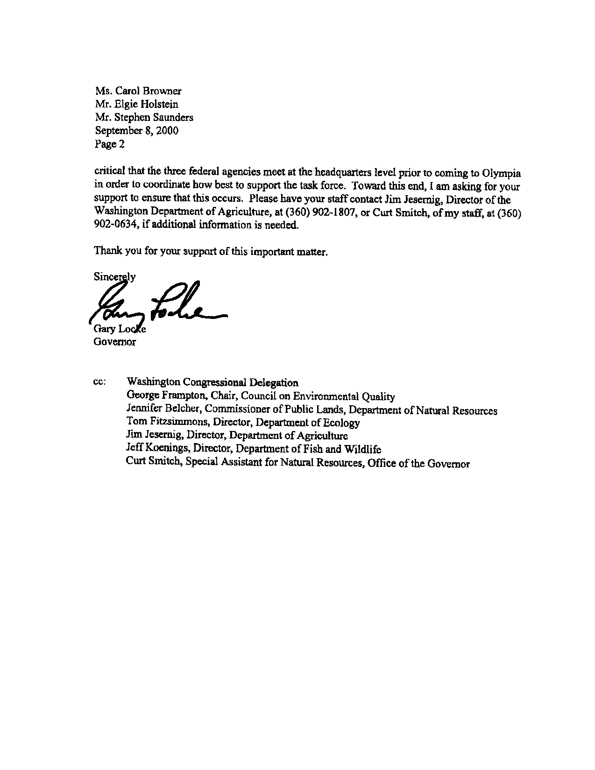
Appendix B


