Bonneville Power Administration

FY 2003 Provincial Project Review

PART 2. Narrative
Project ID: 35055

Title: Role of Bacteria as Indicator Organisms for Watershed Assessment and in Determining Bacterial Fish Pathogen Relationships with Fauna of Abernathy Creek

Section 9 of 10. Project description

a. Abstract

A greater understanding of the relationships of fish and their respective environments is emerging. With this understanding is a need for innovative ways to detect and monitor watershed health and predict fish epizootics. Polymerase chain reaction (PCR) and species-specific primers can be used to show the presence of aquatic bacteria in water and tissues of living organisms. By utilizing these primers and PCR, the bacteria and their relationships to aquatic life can be discerned. By identifying and using specific bacteria (indicator species) found in the water and in other aquatic life, an assessment of the health of the system and a determination of the relationships of fish pathogens with other aquatic bacteria may be possible. Monitoring bacterial indicator species may make it possible to detect the onset of habitat degradation and predict harmful pathogen growth. If an assessment is possible, management actions could be taken to promote health of the system and/or minimize fish loss due to epizootics.

b. Technical and/or scientific background

Scientific research on bacteria has shown these organisms to be an integral component of any ecological system and provide the trophic base of the food web (Hall and Meyer, 1998; Janakiraman and Leff, 1999). The surrounding aquatic life depends on stability in the bacterial population. If the fauna changes too much or too quickly, it can have an adverse affect on the survivability of other aquatic organisms. Some bacteria require other bacteria to survive. Others require the presence of plant and animal life to live. Many are commensal parasites with plants and animals. They assist them in uptake and break down of specific nutrients that are necessary for larger organisms to survive. At the same time, bacteria are utilized as food resources for zooplankton and aquatic invertebrates (Hall and Meyer, 1998). These larger organisms help to continue the nutrient cycles and provide food for larger predators such as large invertebrates, birds, and fish. While some bacteria are beneficial to larger life forms, there are some that inflict disease killing plants and animals. Whatever the case is for each type of bacteria that exist in a system, they are essential in keeping balance in the ecosystem.
Aquatic habitats undergo several seasonal changes each year that affect the balance of bacterial faunas (Leff, 1998). These are natural influences on bacteria and their populations will change with conditions. At times, extreme changes in the ecosystem occur (i.e. overuse or pollution), resulting in a bacterial population that does not recover and the system becomes “sick.” The bacterial assemblage is unbalanced and affects the ability and health of other aquatic life, such as fish, to survive. The assemblage remains in this state until certain criteria are met and the balance is restored.
Scientists are currently developing techniques and procedures to assess bacterial imbalances equated with freshwater habitats (Lemke, Michael et. al., 1997; Lemke, M. et al, 1997). Most studies select indicator bacteria(s) to detect pollution, contamination points, or water quality (Francy, 2000; Lemke, M. 1997). Other studies utilize indicators for assemblage and microcosm analysis (Leff, 1994; Leff, 1998; Koetsier, 1997). To do so, many are utilizing PCR and DNA analysis.
DNA amplification and species-specific primers or probes are frequently used to identify bacteria that exist in the aquatic environment, whether or not they are culturable (Hall and Meyer, 1998; Leff et al., 1995; Pickup and Rhodes, 1997). Although the technique will not isolate or enumerate bacteria, it does identify presence, source, and transport down a stream or watershed. The procedure requires only one water sample per site or a minimal tissue sample from an organism to detect the presence of several bacterial species. These primers and probes can be used for both water samples and tissue samples from aquatic organisms. Thus, interrelationships can be determined between aquatic bacteria and other aquatic organisms, such as fish pathogens, fish, and invertebrates.

c. Rationale and significance to Regional Programs

Current programs are placing more and more emphasis on the importance of understanding the entire aquatic environment, an “ecosystem” approach. Thus, many research studies are correlating a specific interest, for example species distribution, with information on the surrounding aquatic habitat. This project proposes the use of bacteria as indicators of aquatic inter-relationships and ecosystem health. Data collected will help in the refinement of current principles and theories on watershed health determination. As such, the proposed study will aid investigations into: 1) what makes a watershed healthy; 2) how do we balance human use and the needs of the environment; 3) and can we better protect endangered aquatic species.
This project will provide tools and methods that may aid in Bonneville Power Administration (BPA) programs such as: the Pollution Prevention and Abatement Program (PP&A) by aiding in determining sources for contamination and providing tools to monitor successes of restoration projects and pollution prevention activities; the Water Protection Service by aiding in detection of contamination by drainage systems and underground storage tanks; and the Watershed Management Program by providing an affordable and quick technique to assessing watersheds. Other agencies that will benefit from the research would be: the Environmental Protection Agency (EPA) from the development of a technique that will assist in determining watershed health and monitoring for water contamination; the National Marine Fisheries Service (NMFS) by the utilization of a tool to promote healthy watersheds that contribute to increased fish stocks and keeping a balance in the ecosystem; the Bureau of Reclamation (BOR) by addressing the biomass capabilities of ecosystems and watersheds; the U.S. Fish and Wildlife Service (USFWS) by also addressing biomass capabilities of watersheds and providing research into methods that can monitor successes of projects that protect and maintain natural biodiversities; and other state and local agencies that are interested in aquatic habitats, watershed analysis, and fishery resources. The information produced will aid in identifying when detrimental or productive changes have occurred in our watersheds.
Such indicators will help us understand the impact of change on the ecosystem and their effect on fish populations listed under the Endangered Species Act (ESA). Indicators will confirm compliance to National Environmental Policy Act (NEPA) standards by assessing bacterial components altered by development, pollution, or overuse in watersheds. These indicators will help the National Estuary Program (NEP) to determine compliance to the Clean Water Act (CWA) and will provide answers in areas where it is not.

d. Relationships to other projects

Abernathy Fish Technology Projects:
The location of Abernathy Fish Technology Center (AFTC), a U.S. Fish and Wildlife Service (USFWS) applied fisheries research center, located on Abernathy Creek outside of Longview, Washington, is a unique situation in which to conduct several areas of fisheries research. The scientists work closely together to develop projects that can greatly enhance watershed knowledge, hatchery production and management techniques, and natural and hatchery fish research. This provides a more complete understanding of aquatic systems through development of new techniques in monitoring fish health, natural habitats, population movements, and hatchery environments.
There are currently three other projects that are being proposed at this time. The first project is, “The use of small stream PIT tag monitoring methods to evaluate movements, life history characteristics and survival of salmonids,” with Dr. Gayle Zydlewski as lead investigator. The study’s purpose is the development of new PIT tag methodologies to monitor microhabitat use and out migration timing of juvenile steelhead trout, cutthroat trout, and coho salmon. Fish tissue sampling in the proposed project will be coordinated with fish collection for the Dr. Zydlewski study. This will minimize the impact on study populations and habitat.
The second project is, “Comparison of Bacterial Fish Populations in Hatchery Water Environs and in Adjacent Creek Water Environs and the Possibility of Transfer Between the Two,” with Dr. Peter Taylor as principle investigator. The purpose of this study is to systematically address the on-going interest in disease transmission between hatchery and wild fish. Dr. Taylor and I will be able to share biological and water samples.
The third project is, “Evaluation of two captive rearing methods for assisting with recovery of naturally spawning populations of steelhead and coho salmon,” Dr. Donald Campton as principle invetigator. The purpose of this study is to evaluate how hatchery environments can be used to aid in the recovery process of endangered species, such as lower Columbia River steelhead.
By having all four projects occurring at once in one same creek, we minimize impacts on the habitat while gaining knowledge needed for watershed analysis and fishery management. However, the proposed project is independent of the above projects. If all of the others were not funded, the proposed project is can be accomplished anyhow.

Other Regional Projects

The proposed project relates to regional programs as listed above in the Rationale and Significance to Regional Programs section of this form. The following projects are samples of projects that have been proposed within the last year. These projects indicate a growing need of having adequate tools and theories to assess watersheds and restoration project successes. Except for project 22041, all of these projects would have benefited from the research of the proposed project directly or indirectly.
Project 22041, “Using Microbial Fingerprinting to Rapidly Assess Ecosystem Responses to Watershed Restoration Efforts and Assist in Prioritizing Future Activities,” with Darin Saul as principle investigator, has similar objectives to the proposed project. This project also proposes that ecosystem responses to watershed restorations and human impacts will be identified by changes in the microbial fauna and will give indications to where restoration should be done.
Project 20057, “Strategies for Riparian Recovery: Plant Succession and Salmon,” with Dr. Judith Li as principle investigator, stress the importance of maintaining and recovering riparian growth for preserving and supporting salmon. The proposed project relates to this project indirectly by increasing the understanding of the relation of fish to their surroundings. Thus, by understanding their relation to aquatic microorganisms, relation of microorganism to the riparian growth can be discerned.
Project 22020, “Assess Washougal and its tributaries,” with Jeff Breckel as principle investigator, is identifying, inventorying, and mapping existing high quality and at-risk habitats to develop a list of priority restoration projects. These types of projects will benefit from the proposed study because it will give information regarding habitat quality through understanding integral relations of aquatic organisms and the habitat. Using indicator bacteria will allow the assessment of microorganisms that have relationships with aquatic organisms and habitat. Thus, giving a true assessment of habitat quality.
The last project, 22019, “Use a Multi-Watershed Approach to Increase the Rate of Learning from Columbia Basin Watershed Restoration Projects,” with David Marmorek as principle investigator, is using data from restoration projects in multiple watersheds to learn about the effects of restoration projects on aquatic populations and to optimize future projects. The proposed project will provide insights into assessing impacts of restoration on aquatic populations through monitoring changes in indicator bacterial populations.
Many projects that assess watersheds and ecosystems do it at the macro level. The proposed project assesses habitats at the micro level. Using assessments at the micro level allow a more complete understanding of aquatic habitats and interrelationships that can be applied throughout the region. These projects listed above show the growing interest of watershed assessments and the true value they have on water quality and restoring fish stocks. It is important to understand the microbial relations to these environments if habitat and fishery restoration projects are going to succeed.

e. Project history (for ongoing projects)

This is a new project.

f. Proposal objectives, tasks and methods

Objective and Tasks:
The primary objective of this project is to develop techniques to find and use specific bacteria as indicator species in determining the health and ability of a watershed to support fish. A secondary objective is to relate bacterial fish pathogens, such as Aeromonas salmonicida (furunculosis) and Flavobacterium psychrophila (bacterial cold water disease), to changes in the bacterial fauna.
The tasks under these objectives are: 1) identify bacterial species which are present and widespread in the watershed, 2) determine bacterial associations with invertebrates and their type of relationships, 3) determine the influence the bacteria have on the health of selected fish, 4) take measurements of environmental conditions and map land uses for purposes of relating these to the presence and population of bacterial assemblages that are found and, 5) determine the relationships of the above four tasks to assess the health of the watershed.

Methods:
This project has three main components: The first component comprises of task 1 which is to collect and identify bacteria, sequence and analyze rDNA strands of selected bacteria, and then produce primers to use to monitor bacterial change in the environment and in selected organisms. The second component combines tasks 2, 3, and 4 to collect water, invertebrate, and fish tissue samples as part of observing changes of bacterial presence and localities versus the environmental conditions of the creek at sample areas. The last component is to analyze the data to assess relationships between the aquatic organisms and watershed health.

Task 1
For the first component, bacteria will be collected, grown, and isolated on general media from water samples as part of the selection process. Bacteria found in the water column will be collected by filtering water samples through nitrocellulose filters and placed on Tryptic Soy Agar (TSA) for growth and then transferred to another plate of TSA for isolation. Isolated bacteria will then be sent to Microbial ID, Inc. to determine the fatty-acid fingerprint of each and checked against a database to determine the species of the organism. Organisms will also be tested in the laboratory with API 20E test strips (BioMerieux Vitek, Inc., Hazelwood, Missouri), Triple Sugar Iron slants (TSI), Glucose Motility Deeps (GMD), Simmon’s citrate slants, Bile Esculin Agar (BEA), and MacConkey Agar (MAC) for nutrient requirements and cataloging purposes. Once an organism has been identified, analysis of its 16s rDNA and production of its primers will begin.
The proposed project does not intend to relate the entire microbial species community structure to watershed health. This is technologically impossible at this time due to limiting factors such as non-culturable bacteria, the inability to re-isolate others, and the complexity of the bacterial community. This project proposes to screen for organisms that have been shown in previous research to be widespread and to be correlated to habitat quality. The following bacteria (or similarly related bacteria) will be organisms of interest:

Species | Commonly found in | Relationship to Environment | Reference
Acinetobacter calcoaceticus | soil and water | thrives in polluted areas | Lemke et. al., 1997; Lemke and Leff, 1999
Aeromonas caviae | common in streams | possible inverse relation to allochthonus or benthic imputs | Janakiraman and Leff, 1999
Aeromonas salmonicida | fish, lake and streams (1) | fish pathogen, otherwise unknown relation to environment | Morgan et. al., 1992; Pickup and Rhodes, 1997
Aeromonas spp. | widespread in nutrient rich waters and sewage | increase in concentration may indicate fecal contamination in surface waters | Brion et. al., 2000
Bacillus thuringiensis | insects, soils, water | insect pathogen, indicator of insecticide use | Janakiraman and Leff, 1999
Beijerinckia spp. | soils, in acid environments, water | acid tolerant, possible indicator of acidity | Holt, et. al., 1994; Glenn, raw data
Burkholderia (Pseudomonas) cepacia | common in streams and soils | possible relation to allochthonus or benthic imputs, does not thrive in polluted waters | Leff et. al., 1995; Lemke et. al., 1997; Leff et. al., 1998; Janakiraman and Leff, 1999; Lemke and Leff, 1999; McArthur et. Al., 1992
Flavobacter psycrophila | salmonids, freshwater | fish pathogen
Flavobacterium spp. | soil and water | common bacteria | Holt et. al., 1994; Leff et. Al., 1994
Lampropedia spp. | organically rich environments, freshwater | common bacteria, found in Abernathy Creek | Holt et. al., 1994; Glenn, raw data
Proteus vulgaris | human and animal commensal parasite, water | indicator of fecal material | Holt et. al., 1994; Glenn, raw data
Pseudomonas aeruginosa | soil and water | denitrifier, possible indicator of “stored” rich nutrient water. | Ellis and Yu, 1995; Brion et. al., 2000
Pseudomonas pickettii | natural materials, freshwater, and soil | common bacteria | McArthur et. al., 1992; McArthur and Tuckfield, 2000
Pseudomonas putida | soil, water, mineral enrichments | found to degrade recalcitrant carbon compounds, otherwise has an unknown relation | Lemke et. al., 1997; Lemke and Leff, 1999
Vibrio spp. | require saline environments | pathogenic, saline environments | Brion et. al., 2000
Xanthomonas spp. | associated with plants | common bacteria | Holt et. al., 1994
1. Aeromonas salmonicida is culturable in nutrient rich waters, but has been found to enter into the non-culturable but viable (NCBV) state at reduced nutrient levels.

Tasks 2, 3, and 4
After the primers are developed, monitoring will then commence as part of the second component. During the monitoring stage, water and intestinal tissue samples from invertebrates and fish will be collected at 10 locations on scheduled dates. The ten sample sites can be seen on the maps provided. Except for sample sites 1, 2, and 8, sample sites are located approximately 50m downstream from other named creeks in the watershed. Sample sites 1 and 2 are located in the headwaters and sample site 8 is located below the hatchery effluent. Sampling is set to occur in the early spring to early fall. These seasons were selected because water temperatures will be in ranges to support bacteria and insect larvae of interest. Water samples will be collected twice a month or every other week from April - October. Water samples, upon arrival at center will be centrifuged to form a pellet and frozen at –80C until analyses are performed. Invertebrate and fish intestinal tissue samples will be collected mid-April, July or August, and then in mid-October, corresponding with the beginning, middle, and end of the test period. These tissue samples will also be frozen at -80C until analyses are performed.
Digestive tract samples will be collected by cutting out portions of the intestinal tract. Samples of the outer body of invertebrates and fish will be collected by swabbing and/or by scraping surfaces with sterile swabs or microscope coverslips. Swabs will be placed in nutrient broth to be spun down and froze. Samples collected by scraping will be placed directly into microfuge tubes, spun down and then frozen. Sampling of invertebrates will involve collecting 10 specimens of caddisfly, stonefly, and mayfly larvae per site. These will be picked off streambed surfaces. Two crayfish per site will be collected by netting. Collection of steelhead and cutthroat trout to be sacrificed will be accomplished by electrofishing.
During the period in which the investigation is set to take place we plan to monitor and collect environmental data on: pH; water temperature; total hardness; dissolved oxygen; ammonia; nitrate; nitrite; turbidity; carbon dioxide; chloride; alkalinity; and phosphate levels. In addition to the environment data, land practices will be determined by the use of survey maps to show where logging, housing, and land uses are occurring in the watershed. By comparing these conditions to the presence of our indicator bacteria, we should be able to relate presence to the conditions of the watershed. This will then allow us to assess the quality and stability of the watershed.

Task 5
The last component will be accomplished at the time that all samples have been analyzed and the data entered on a computer spreadsheet. Relationships between the aquatic life and indicator bacteria will then be compared and assessed. At this time, the data from the chemical tests and from literature on these organisms will also be used to draw conclusions of impacts of human use in the watershed and how they are affecting the ecosystem. This will provide a standard baseline from where changes in indicator bacteria populations will indicate positive or detrimental changes in the environment. Thus, giving an assessment of the watershed for the benefit of fisheries and water management.
Associations and relationships will be determined by statistical analysis. After a preliminary consultation with a biostatistician, we will probably use logistic regression or principle components analysis (PCA) to examine the relationships between the microbial community and the environmental factors. The logistic regression will allow the analysis of my categorical response variables, the presence or absence of a bacterial species, given the measurements of the environmental and land use independent variables. The PCA will allow me to make a univariate “composite” of the multivariate independent variables for comparison to microbial community structure. Specifically, the PCA will allow the data of the presence or absence of other microbial species to be used as variables in determining inter-bacterial relations, bacterial vs aquatic life relationships, and bacterial vs environment. By using these statistical models, determination of a bacterial species as indicators of watershed health should hypothetically be possible. These types of multivariate analyses will require working closely with a statistician to ensure proper sampling design, data analysis, and interpretation.

Map 1
Upper Watershed of Abernathy Creek

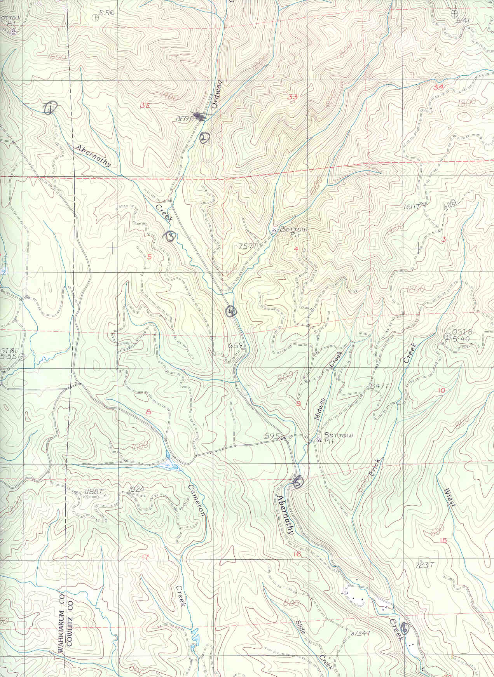

Map 2
Lower Watershed of Abernathy Creek
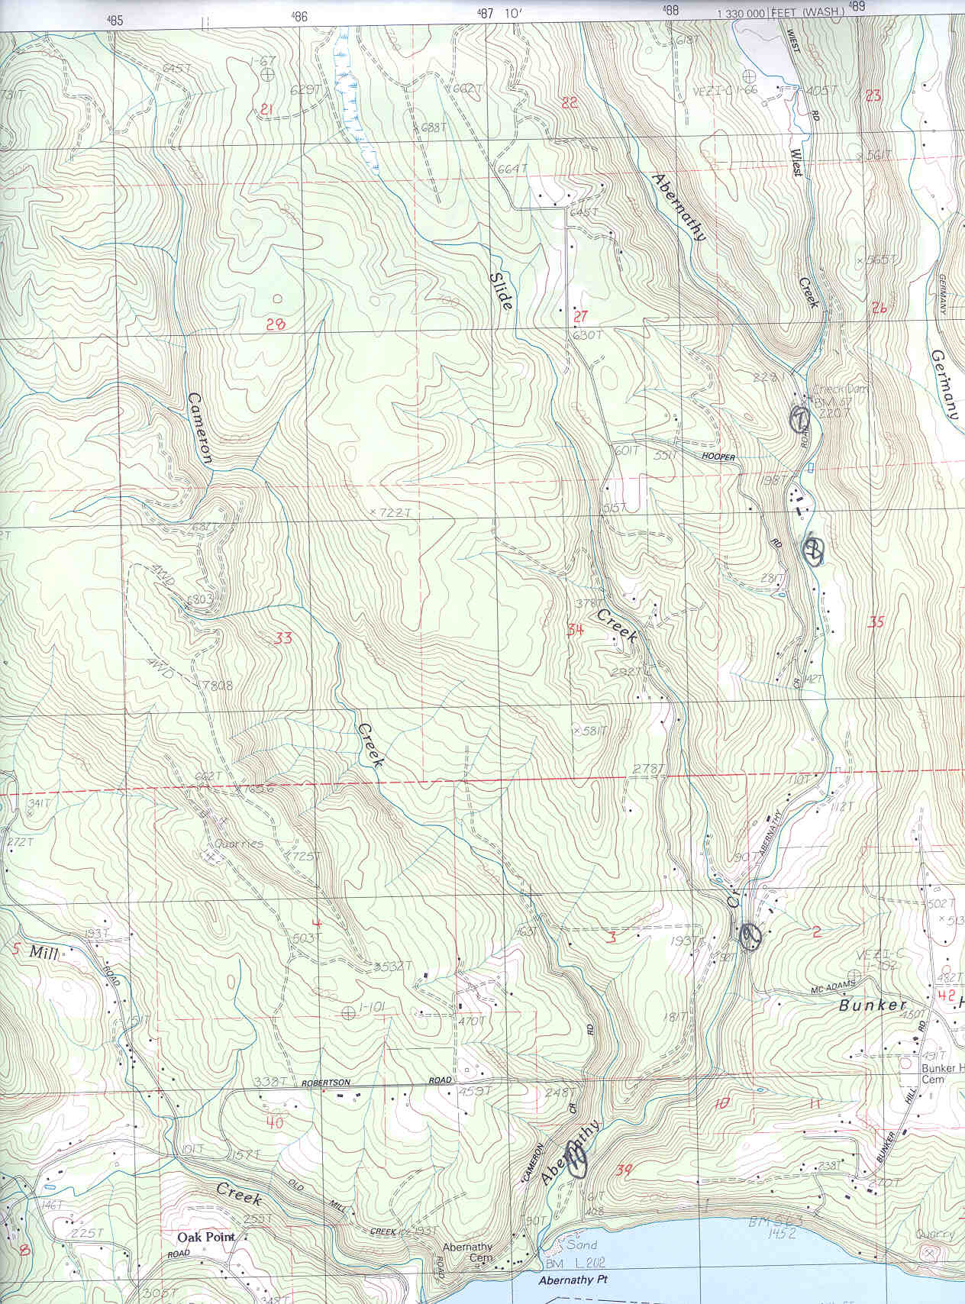

g. Facilities and equipment

Abernathy Fish Technology Center, Longview, Washington:
Stratagene Robocyclers (PCR equipment in Pathology Lab)
Sequencer (DNA sequencing equipment in Genetics Lab)

Microbial ID, Inc., Newark, Delaware (contracted out):
Bacterial identification by analysis of fatty-acid fingerprints.

Genosys Biotechnologies, Inc. (contracted out):
Will produce the 16s rDNA primers.

h. References

Reference (include web address if available online) | Submitted w/form (y/n)
Brion, G. M., H. H. Mao, and S. Lingireddy. 2000. New approach to use of total coliform test for watershed management. Water Science and Technology 42(1-2): 65-69
Ellis, J. Bryan and Wang Yu. 1995. Bacteriology of Urban Runoff: The Combined Sewer as a Bacterial Reactor and Generator. Water Science and Technology 31(7): 303-
310
Francy, Donna S., Dennis R. Helsel, and Rebecca A. Nally. 2000. Occurrence and
distribution of microbiological indicators in groundwater and stream water.
Water Environment Research 72(2): 152-161
Hall, Robert O., Jr. and Judy L. Meyer. 1998. The trophic significance of bacteria in a
detritus-based stream food web. Ecology 79(6): 1995-2012
Holt, John G., Noel R. Kreig, Peter H. A. Sneath, James T. Staley, and Stanley T. Williams. 1994. Bergey’s Manual of Determinative Bacteriology, 9th ed. Williams and Wilkins, Baltimore, Md.
Janakiraman, Anuradha and Laura G. Leff. 1999. Comparison of survival of different
species of bacteria in freshwater microcosms. Journal of Freshwater Ecology
14(2): 233-240
Koetsier III, Peter; J. Vaun McArthur and Laura G. Leff. 1997. Spatial and temporal
response of stream bacteria to sources of dissolved organic carbon in a
blackwater stream system. Freshwater Biology 37: 79-89
Leff, Laura G., Adam A. Leff and Michael J. Lemke. 1998. Seasonal changes in
planktonic bacterial assemblages of two Ohio streams. Freshwater Biology 39:
129-134
Leff, Laura G., J. Vaun McArthur, Judy L. Meyer, Lawrence J. Shimkets. 1994. Effect of
macroinvertebrates on detachment of bacteria from biofilms in stream
microcosms. Journal of The North American Benthological Society 13(1): 74-79
Leff, L.G.; R.M. Kernan, J.V. McArthur, and L.J. Shimkets. 1995. Identification of
aquatic Burkholderia (Pseudomonas) cepacia by hybridization with species-
specific rRNA gene probes. Applied and Environmental Microbiology 61():
1634-1636
Lemke, Michael J., Christopher J. McNamara, Laura G. Leff. 1997. Comparison of
methods for the concentration of bacterioplankton for in situ hybridization.
Journal of Microbiological Methods 29: 23-29
Lemke, M.J., B.J. Brown, L.G. Leff. 1997. The response of three bacterial populations to
pollution in a stream. Microbial Ecology 34:224-231
Lemke, M. J. and L. G. Leff. 1999. Bacterial Populations in an Anthropogenically Disturbed Stream: Comparison of Different Streams. Microbial Ecology 38: 234-243
McArthur, J. Vaun, Laura G. Leff, and Michael H. Smith. 1992. Genetic diversity of bacteria along a stream continuum. Journal of the North American Benthological Society 11(3): 269-277
McArthur, J. Vaun and R. Cary Tuckfield . 2000. Spatial Patterns in Antibiotic Resistance among Stream Bacteria: Effects of Industrial Pollution. Applied and Environmental Microbiology 66(9): 3722-3726
Morgan, J. A. W., K. J. Clarke, G. Rhodes, and R. W. Pickup. 1992. Non-culturable Aeromonas salmonicida in lake water. Microbial Releases 1:71-78
Pickup, R.W. and G. Rhodes. 1997. Detection of specific bacteria in water: implications of survival strategy. The Microbiological Quality of Water. Freshwater Biological Association, Ambleside; p. 28-34

Section 10 of 10. Key personnel

Richard Glenn
5607 Finch Dr. #133

Longview, WA. 98632
Home:(360) 636-6762 Work:(360) 425-6072

Education: *22 Graduate quarter credits in Fisheries: emphasis Parasites and Diseases
*1997, B.S. in Zoology w/ minor in Chemistry at Oregon State University,
Corvallis, OR. 97333
*1999, A.A. at Clackamas Community College, Oregon City, OR.

Related Work Experience

U.S. Fish and Wildlife Service
Abernathy Fish Technology Center
1440 Abernathy Creek Rd.

Longview, WA. 98632

*Microbiologist
Current Position: 9/13/01-present 40 hours a week Pay Scale: GS-05/07/09
Supervisor’s name: Pete Taylor - Pathologist
--Projects in process:
1) Ecological relationships between aquatic bacterial assemblages in the environment
and other aquatic life.
2) Technical project to prove verticle transmission of bacterial cold water disease. My
portion of the project requires me to remove the yolk from inside fish eggs, test for the
presence of the bacteria, discuss possible changes and questions to the protocols we are
using, and keep track of data and findings on the computer.
3) Bacterial load study that examines total bacteria count of water flowing through a
hatchery environment. Study compares bacterial fauna in water to epizootic outbreaks in
the hatchery.
--Duties:
1) Develop applied research projects to aid in advancing techniques to enhance fish
pathogen detection, develop processes to assessing bacterial relations of fish pathogens,
find sources of pathogens, and provide applicable research to assist hatcheries and fishery
management.
2) Assist senior level pathologist in research projects
3) Other duties listed below in Pathology Lab of Biological Science Laboratory Technician

*Biological Science Laboratory Technician
Position Period: 9/13/99-9/13/01 40 hours a week Pay Scale: GS-05
Supervisor’s name: Pete Taylor - Pathologist
50% Pathology Lab-
--Projects that were worked on:
1) Technical project to prove verticle transmission of bacterial cold water disease.
2) The use of high salt concentrations to slow or prevent growth of fish pathogens and
the physiological effects of salt solutions on fish during treatment.
3) Independent research on the ecological relationships between aquatic bacterial
assemblages in the environment and other aquatic life.
Duties:
--Utilize DAPI epifluorescence to stain bacteria for microscopy to determine total count.
--Maintain virulent strains so challenges reflect real-life infection rates
--Obtain data on the infection rates of an organism on its host tissues they are found in.
--Keep detailed data of mortality on computer spreadsheets and give written
reports/progress of success of challenges to other researchers on the station.
--Perform DNA extraction/purification and PCR on thermocycler to amplify DNA.
Analyze resulting DNA by use of agarose gel electrophoresis.
--Prepare media plates and vials, streak plates and inoculate vials for isolation,
production, and determination of bacterial fish pathogens.
--Remove tissue samples of the liver, kidney, gill, spleen, mucous, blood, ovarian fluid,
eggs, and yolk from eggs for bacterial infection analyses.
--Identify organisms by using individual and pre-prepared biochemical kits; such as API
20E strips and Minitek analysis. Perform agglutination tests for positive identification of
bacteria.
--Operate and prepare cultures for freeze drying. Prepare spreadsheets and maintain a
laboratory stock room, keep a record (MSDS) of chemicals and media agents, and
purchase supplies weekly. Operate autoclave for sterilization of equipment and media.
--Visit hatcheries on occasion to retrieve ovarian fluid and eggs for research/analysis on
disease isolation and identification techniques.
--Outreach with a teenager who learning about fish development and raising trout.

50% Chemistry Lab
--Run approximate analysis to determine the content percentages in fish, fish feed, and
water quality. Perform protein analyses, moisture tests, ashing, lipid extraction by Folsch
test, Acid hydrolysis and Soxtek ether extraction device.
--Check water quality of hatchery effluent for increased sediment.
--Use Digestdahl apparatus, Mettler balances, spectrophotometers, muffle furnace, drying
oven, ultrasound flow meter, still, and evaporator.
--Use and dispose of highly toxic chemicals. Handle and clean glassware. Determine
reliability and precision of glassware. Calibrate micropipetters.
--Preparation of fish and feed samples for protein, lipid, moisture, and ash analysis.
--Update MSDS chemical binder and keep track of inventory on a computer.

Other Laboratory and Fishery Duties- Provide assistance to applied researchers and
perform other fishery duties that require:
--Calculate feed ratios, weigh out fish to determine daily feed allowance, clean tanks,
pick mortality, and observe fish for diseases.
--Assist nutritionist in collecting liver and blood samples, measuring blood hematocrit
percentages, weights, and lengths for analysis.
--Assist physiologist in obtaining blood plasma, taking weights, lengths, gill biopsy, and
taking pictures of fish for initial data.
--Assist in electroshocking in creek to capture young steelhead trout.

Oregon State University
Salmon Disease Lab,
34347 NE Electric Rd.
Corvallis, OR. 97330.
Employed: 11/30/98- 6/15/99 8 hours a week. Pay: $7.00 hr.
Supervisor’s Name: Jerri Bartholomew
*Microbiologist Laboratory Technician: Aid in research of Myxobolus cerebralis,
causative parasite of whirling disease in salmonids. Involved filtering water samples for
triactinosporidians (TAMs), screening for Tubifex tubifex, intermediate host.
Microscopic concentration examination of wet mounts of TAMs from worms and spores
from head cartilage of rainbow trout. Cut heads off and smash to obtain spores from fish.
Use of Microsoft Excel for data entry. Involved research investigation on the background
and current procedures being used to develop better methods to isolate and purify
sporites of the protozoan parasite Required use and understanding of Percoll gradient
separation, sonication for lysing organisms, and a vital staining technique of the parasites
being examined.

U.S. Fish and Wildlife Service
Eagle Creek National Fish Hatchery
34288 SE Rainbow Rd.

Estacada, OR. 97023
3/16/98- 9/25/98 40 hours a week Pay Scale: WG/03- $11.06
Supervisor’s Name: Doug Dysart.
*Laborer: Assisted in fish culture operations such as spawning, incubation, mortality
picking and counting, feeding, pond cleaning, egg count and selection. Observed fish and
their behaviors for signs of epizootics. Data entry into database using dBaseIV. As part
of “Fishing Day,” ran a booth to help children to clean and measure fish they caught.

Other Qualifications:
*Computer Software: Have used databases such as DbaseIV, Lotus Access, and have
used MSWorks, MSExcel, and MSWord, Quattro Pro, Word Perfect, Windows ‘95,‘98,
NT, Star Office operating system and products.

Job Related Training Course

National Conservation Training Center
Sheperdstown, WV
Introduction to Fish Health (2 semester credits) August 14-18, 2000
*Course taught techniques and identification of fish diseases. Learned about
microbiological techniques in bacterial isolation, differential stains, and media types.
Shown how to recognize infections and what symptons to look for. Discussed potential
chemicals and medicines that can be used.

