Bonneville Power Administration

FY 2003 Provincial Project Review

PART 2. Narrative
Project ID: 35057

Title: HABITAT CONDITION AND RESTORATION POTENTIAL OF COLUMBIA RIVER FLOOD PLAINS: A CRITICAL, MISSING ELEMENT OF FISHERIES RECOVERY SCIENCE AND POLICY

Section 9 of 10. Project description

a. Abstract

Abstract

The ISRB report “Return to the River” (2002) and many other scientific papers argue persuasively that complexes of aquatic and terrestrial habitats found in healthy alluvial flood plains are essential to spawning and early life stages of anadromous salmon, resident salmonids, other native fishes (e.g., sturgeon) and assemblages of vegetation, invertebrates, amphibians, reptiles, birds and mammals that utilize riparian habitats. Our research has shown that alluvial flood plains are critical centers of ecological organization, owing to dynamic, non-linear processes that form an interactive river landscape. Our work in the Yakima, Snake and Upper Columbia shows that Columbia River fisheries cannot be expected to flourish in the absence of normative floodplain structure and function. Unfortunately, the status of floodplain ecology in the CR is known only for a few areas of the entire Basin, specifically the Yakima, Flathead and Upper Snake.
The primary objective of our study is to identify, assess and rank the alluvial flood plains of the entire Columbia Basin. Our analysis will be based on level of ecological integrity in relation to various sources of human disturbance such as flow regulation and floodplain revetment. We see this as a critical tool for BPA and other US and Canadian agencies in selecting sites and approaches for the restoration and conservation of flood plains, and the organisms that depend on them, throughout the Columbia River Basin. We will answer the following questions.
- Where do the alluvial flood plains occur in the Columbia River Basin?
- Which flood plains are in intact ecologically?
- Which flood plains have experienced major change in ecosystem structure and function and to what degree?
- What actions are necessary to restore damaged flood plains to a normative condition that will sustain ESA-listed species?
- What actions (e.g., land and water acquisitions) are necessary to protect and sustain intact and restored flood plains in the context of the Columbia River system as a whole?

We will use an USA and Canadian team of scientists with expertise in hydrology, geomorphology, river and riparian ecological science, remote sensing and advanced computing. We will address the questions posed above using a novel set of research tools that we have developed and tested, including remotely sensed and ground truthed quantification of quantity and quality of habitats in relation to human activities. Our tools and approach are specifically relevant to the restoration, preservation and enhancement of at-risk, native fisheries in the Columbia Basin. We will identify intact flood plains, identify those where restoration to normative condition is possible and those where restoration likely is not possible. This analysis will be organized at the subbasin scale. We will provide specific recommendations and actions needed to restore prioritized flood plains. This proposal is directly responsive to the recommendations of the ISG “Return to the River” document, the intent of the Endangered Species Act and its BIOP process, and the stated recovery goals of the BPA-NWPPC’s operational framework.

b. Technical and/or scientific background

Technical and Scientific Background

1. Problem Identification

BPA and other agencies have made and will continue to make very large investments in the restoration of rivers in the Columbia Basin. Although there are other species of concern, a significant portion of the efforts have been directed toward anadromous salmon and, to a less extent, resident salmonids. The focus of these fish restoration efforts to date has been on supplementation, mainstem passage and isolated habitat studies. In recent years, there has been a shift of focus to restoring habitat, primarily in alluvial floodplain portions of major rivers and in spawning areas in tributaries. However, these strategies and accompanying projects are not working effectively, in part, because they do not integrate the full range of floodplain ecological processes and structural variation that are necessary to provide the life cycle requirements of salmonids and other species.

Much of these efforts directed at flood plains are being made to reconnect back channels, restore riparian vegetation and generally restore salmonid habitat. Yet, in our view, these actions are being taken without a solid, scientific understanding of the range of processes, both abiotic and biotic, that drive ecological processes in flood plains. What we propose here is an interdisciplinary approach to assessing the health and restoration potential of alluvial flood plains throughout the Columbia River system.

The Columbia River fisheries cannot be managed, restored or sustained without a thorough understanding of floodplain ecology. Over the last twenty years, our group has made a substantial contribution to that understanding (see attached vitae or visit our website at http://www.umt.edu/biology/flbs/). During the past 2 years, we have developed new applications of floodplain assessment by linking both satellite-based and airborne-based remotely-sensed data to specific ecological processes, structure and condition. We believe the application of these new technologies and their linkages to river floodplain processes represent a new and revolutionary approach to river ecology and to directing sound management.

We believe we can effectively apply our long-term research and understanding of ecological principles with our new technologies to the restoration of alluvial flood plains in the Columbia Basin. Based on our experience in river ecology (e.g., PIs have authored >200 journal articles in river ecology) and management (e.g., Stanford served on the Independent Scientific Advisory Board (ISAB) of the NWPPC, Hauer is senior author of the HGM assessment guidebook for gravel bed rivers), it is our thesis that most restoration efforts in river systems have been remarkably unsuccessful. This is especially true whenever management has been focused on, or applied to, specific target species or family groups of vertebrates (e.g., salmonids). Our research over the past 30 years of working in Pacific Northwest river systems points to the necessity for the application of restoration principles directed at the appropriate spatial and temporal scales to restore the proper function of ecosystem processes and support of the biotic structure. This must be done prior to addressing species-specific habitat or management issues that are almost universally directed at manipulation of specific habitats or populations. This approach has generally proven inadequate, because it fails to account for ecosystem level processes or biologically significant temporal regimes that manifest at large spatial scales.

BPA and the NWPPC, other federal, state and tribal agencies and to a lesser extent Canadian agencies now recognize the disparity between past patchwork approaches to restoration and system-wide success in the restoration of salmon and other species. Management agencies throughout the basin are searching for a synthetic, ecosystem approach to protecting and restoring ecological functions, temporal dynamics to habitats, and biodiversity of the Columbia River Basin.

2. Flood Plains as Centers of Biocomplexity and Salmonid Conservation

Floodplains are centers of biophysical organization throughout the world’s river systems (Stanford 1998). They support a complex array of organisms from unique invertebrate communities (Stanford and Ward 1988) to grizzly bears, large ungulates and wolves in some unaltered systems in the Pacific northwest (Jamieson 2001). Large alluvial flood plains of gravel-bed rivers are enormously complex, both above and below ground. The legacy of scour, deposition, inundation and drought associated with the dynamic biophysical attributes of catchment water yield (Naiman and Decamps 1997) result in an expansive, spatially-explicit, 3-dimensional floodplain mosaic (Figure 1 and Panel 1). In the Columbia and its subbasin rivers, key processes of cut and fill alluviation, channel avulsion and production and entrainment of LWD (large wood debris) directly affect the ecological integrity of these river flood plains and their capacity to maintain species in natural distributions and abundances. Lateral, vertical and longitudinal linkages, through which water and materials flux in a dynamic fashion, are maximized on expansive river flood plains producing inherently high biodiversity and biocomplexity (e.g., Junk et al. 1989, Gregory et al. 1991, Stanford and Ward 1993, Decamps and Tabacchi 1994, Decamps 1996, Naiman and Decamps 1997, Ward et al. 1999, Hauer et al. 2002). Under natural conditions, biodiversity and biocomplexity is great on these flood plains because of the convergence of aquatic and terrestrial biotic assemblages at multiple spatial and temporal scales, and because convergence trajectories are regularly and predictably disturbed by flooding. These biophysical linkages that characterize the natural, high-function flood plains of the pre-settlement Columbia Basin were critical to the sustained and highly complex anadromous and resident salmonid populations found throughout the basin in the early 1800’s.

Several studies from across western North America have revealed progressive declines in the extent and health of floodplain gallery forests (Rood and Mahoney 1990, Bradley et al. 1992, Braatne et al. 1996, Mahoney and Rood 1998). The primary causes of these declines throughout the CR Basin have been impacts related to damming, water diversions and the clearing of floodplain habitats for agricultural use and livestock grazing (Braatne et al. 1996). Most of the research on dam-induced declines has occurred along rivers supporting prairie and Fremont cottonwoods (Johnson et al. 1976, Bradley and Smith 1986, Rood and Heinze-Milne 1989, Rood and Mahoney 1990, Snyder and Miller 1991, Johnson 1992, Rood et al. 1995, Richter and Richter 2000). These studies have shown that declines in riparian cottonwoods are related to suppression of seedling recruitment. Since cottonwoods are a relatively short-lived tree (100-200 years), declines in seedling recruitment over the past century have lead to widespread loss of riparian cottonwood ecosystems along alluvial floodplain reaches.

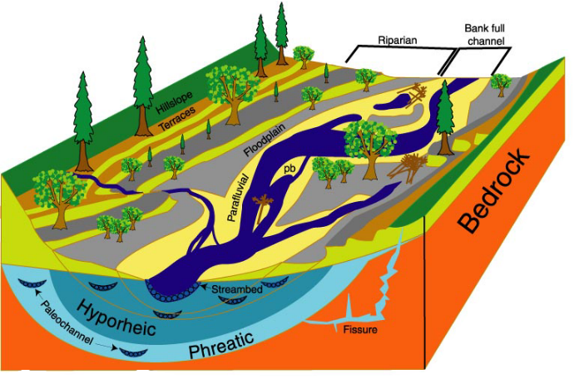
Figure 1. At left, an idealized view of the 3-D structure of alluvial river ecosystems, emphasizing dynamic longitudinal, lateral and vertical dimensions and the role of large wood eroded from the riparian zone (Stanford 1998). This landscape, produced by the legacy of cut and fill alluviation, is linked to the natural-cultural setting of the catchment. Hence, the size of the flood plain and extent of its alluvial aquifer (hyporheic and phreatic ground waters) can be substantially larger than indicated here, extending to the valley walls. Below is an idealized 2-D structure of a subsurface flow pathway illustrating the flow of water and the biogeochemistry of surface and groundwater interactions on flood plains, especially as mediated by complex interstitial flow paths (paleochannels) within the channel and riparian bed sediments.

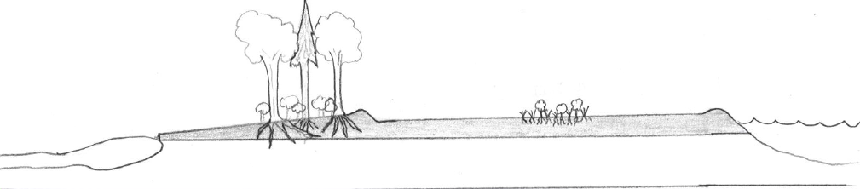
P
N
Higher DO Lower Carbon Lower SRP/N
N
Lower DO
Very Low Carbon
Higher SRP/N
River
Springbrook

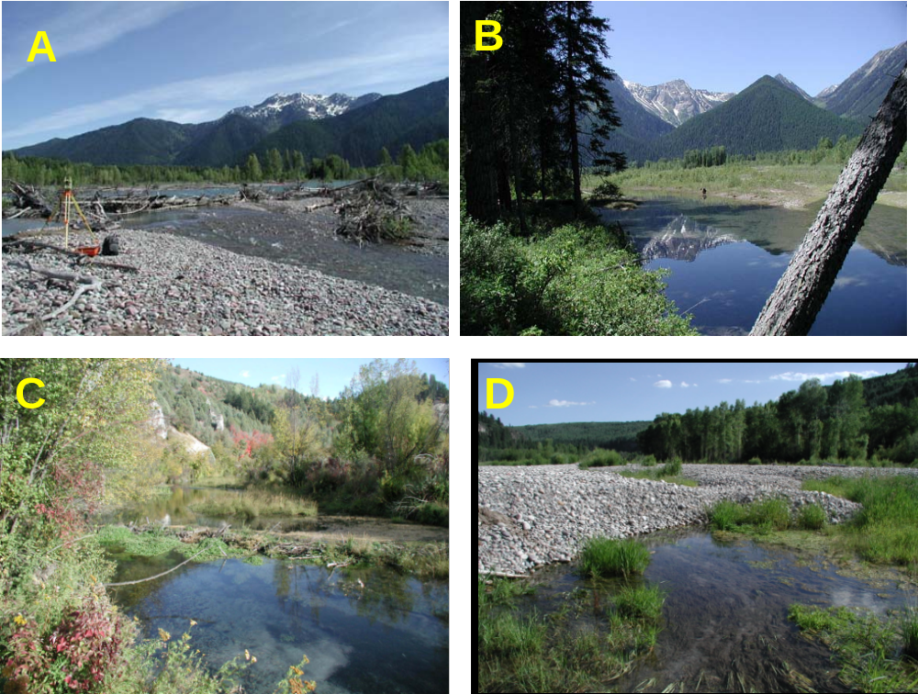
Panel 1. (A) Channel avulsion mediated by large wood producing a new channel with the potential to become the new main channel. (B) Floodplain pond formed in the thalweg of an old, abandoned channel. (C) A “wall-based” spring brook channel on the flood plain with beaver dam. (D) Groundwater flow through the preferential flow pathway at the base of a recent gravel flood-bar deposit over an old, abandoned channel.

Our research in the last two decades, coupled with that of others, has developed the following view of rivers and their flood plains (cf. Junk 1990, Stanford and Ward 1993, Ward 1997, Naiman 1998, Stanford 1998). This view is presented here with special reference to the Columbia and its subbasin rivers and their associated flood plains:

- The alluvial flood plains of gravel bed rivers are naturally dynamic and have an expansive spatial distribution of cut and fill alluviation. This creates a 3-dimensional, complex array of resource patches and interfaces, which we refer to as the Shifting Habitat Mosaic, SHM (Stanford et al 2001)
- The alluvial flood plains of gravel-bed rivers are laced with subsurface zones of preferential flow consisting of a latticework of cobble and fine bed-sediments sorted by changes in stream-power during flooding events and the processes of cut and fill alluviation (Stanford et al. 1994, Lorang and Hauer 2002).
- Integral to the process of cut and fill alluviation is the avulsion of the main river channel, often occupying a previous river channel and the filling of the recently abandoned channel with river-borne fines. The created subsurface paleochannels continue to route river water at high velocities (up to 10 cm/s) from localized injection points (avulsion nodes) through the floodplain bed-sediments that compose the aquifer. Spring brooks, ponds and other distinctive alluvial features occur wherever the saturated water table intersects the surface (Stanford et al. 1994).
- The highly porous, subsurface zones of preferential flow are occupied by a complex groundwater food web driven by epilithic bacteria that metabolize dissolved organic matter from the riparian zone and the river (Ellis et al. 1998).
- C, N and P transformations in the groundwater stimulate productivity bursts in upwelling zones (Bansak 1998, Pepin and Hauer 2002).
- Virtually all anadromous and resident salmonid fishes are dependant during some critical life history stages (e.g., spawning, juvenile rearing) on upwelling zones, spring brooks and other habitat features exclusively found in and on the 3-dimensional floodplain SHM (Stanford 1998, Baxter and Hauer 2000)
- Surficial habitats of the floodplain mosaic (e.g., cottonwood forest, spring brooks and ponds) are critical features of regional biodiversity, biocomplexity and ecosystem integrity (Stanford 1998, Stanford and Ward 2001, Hauer et al. 2002).

3. The CWA, River Ecosystem Integrity, Human Disturbance, and Salmonid Conservation

The physical complexity and hydrologic variability that characterized the natural, high-function flood plains of the Columbia Basin were fundamental drivers of material (e.g., water, oxygen, carbon, nitrogen and phosphorus) flux and storage, including thermal regimes. Important modifiers of natural floodplain-system dynamics throughout the Columbia and its subbasins are flow regulation (e.g., dams and diversions) and geomorphic manipulations (e.g., levees and revetments). Regardless of the plethora of biotic interactions (e.g., competition, predation, genetics and exotic specie) that may impinge on salmonid populations, restoration and sustainable conservation can only be achieved if the physical templates that allowed these species to evolve in the basin are first restored and conserved.

Major U.S. federal legislation governs the requirement that our freshwater ecosystems be restored and maintained. For example, the objective of the Federal Clean Water Act (CWA) is “… to restore and maintain the chemical, physical and biological integrity of the Nation’s waters [Sec. 101(a)]. ” Another example from CWA states that “It is the national goal that wherever attainable, an interim goal of water quality which provides for the protection and propagation of fish, shellfish and wildlife and provides for recreation in and on the water ...[Sec. 101(a)(2)].”

During the decade of 1990-1999, major advances were accomplished in the conceptualization of ecosystem integrity and the methodologies for quantifying response to human disturbance. Through the mandate of the CWA, the US EPA focused on biological indicators of ecosystem integrity and development of the Index of Biological Integrity in response to the human disturbance gradient (see Figure 2a). Simultaneously, the US Army COE focused on functional indicators of ecosystem integrity and floodplain assessment and the development of the Hydrogeomorphic approach (HGM; Brinson et al. 1995) in response to the human disturbance gradient (see Figure 2b).

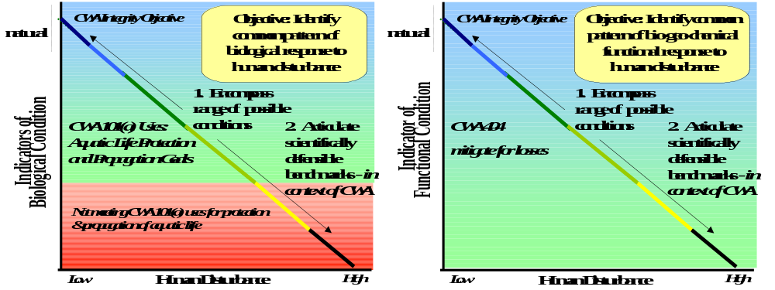
Figure 2. Relationship between the Human Disturbance gradient (x-axis) and indicators of (a) Biological Condition (y-axis left panel) and of (b) Functional Condition (y-axis right panel). Objectives and concepts are similar whether used for establishing biologically-based water quality criteria for the CWA 101(a) [EPA] or establishing criteria and mitigation for losses of function CWA 404 [COE].

a
b

The most recent advances in the concepts of ecological assessment and evaluation of ecosystem integrity explicitly link the IBI and HGM approaches (Stevenson and Hauer 2002). Through initiative of US EPA headquarters, the approaches described above in Figure 2 are being integrated into biologically and functionally based standards through action by the U.S. EPA Tiered Aquatic Life Use Workgroup (Annapolis 3/19-22/2002) and development of Tiered Aquatic Life Use Support criteria (Figure 3). We will employ this approach in the proposed research to rank flood plains of the Columbia and subbasin rivers and evaluate potential for restoration. We emphasize that this approach is consistent with recent direction of both EPA and COE as directed through the CWA.

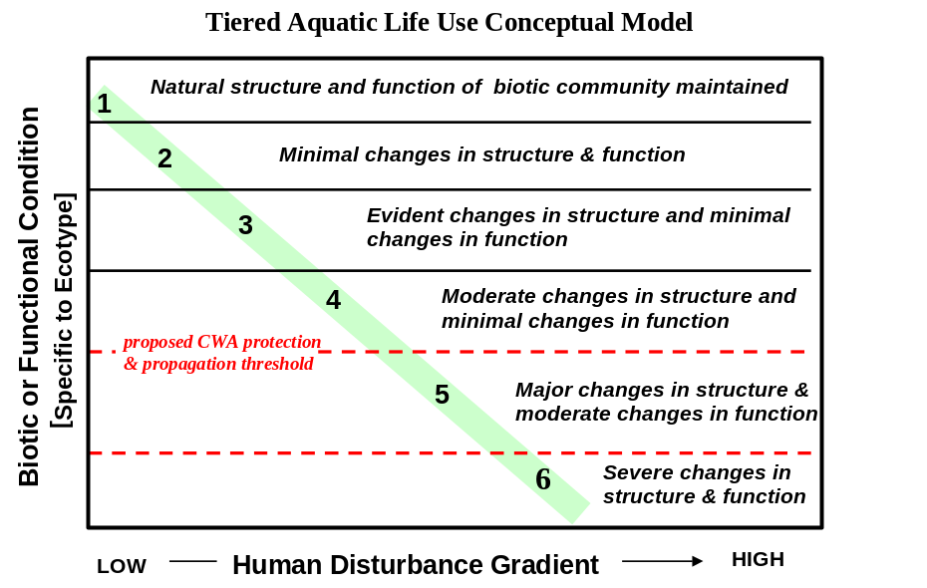
Figure 3. Tiered criteria in narrative form of structure and function response to the Human Disturbance Gradient. Development of a “reference data set” is accomplished through calibration sites (i.e., in our case flood plains) and based on quantification of response variables (metrics) that are then used to rank other floodplain systems.

We believe this is the most advanced conceptual model of examining the array of metrics that may be used to evaluate ecosystem integrity and departure from the pristine condition as a result of various gradients impacted by human disturbance. We intend to build on this model, relate it more specifically to salmonids and wildlife concerns and test this model in a specific habitat element within river systems. We intend to develop an approach that considers the range of abiotic and biotic factors that affect alluvial flood plains (e.g., geomorphology and the hydrograph to salmon carcass contributions to nutrient cycling and bio-mechanical feedback provided by cottonwood and beaver).

c. Rationale and significance to Regional Programs

Rationale and Significance to Regional Programs

1. Significance for BPA and NWPPC Programs and Initiatives

A variety of documents and programs within BPA express the view that we need to look at function and process in deciding on conservation priorities in the Basin. Habitat recovery programs in the Columbia Basin are being driven by a series of strategic papers (described below). These programs were summarized recently in “Return to the River: A review of salmon recovery strategies for the Columbia River Basin” by the Independent Scientific Advisory Board (ISRB 2002). This report provides an overview and critique of recovery strategies in the US portion of the CR Basin including:

- Four Northwest States Governors’ Plan
- NWPPC 2000 Fish and Wildlife Program
- NMFS 2000 Federal Columbia River Power System Biological Opinions
- Basin-wide Recovery Strategy (All H paper)

Additional papers that are relevant to these overall issues include:

- Tribal salmon recovery reports (Spirit of the River)
- Interior Columbia Basin Ecosystem Management Plan USFWS
- Biological Opinion on FCRPS operations affecting Salmon
- Biological Opinion on FCRPS operations affecting Bull Trout and Kootenai White Sturgeon
- State salmon strategies
- Subbasin summaries

ISRB 2002 notes in all of these documents that:

- new approaches that reflect a functional ecosystem approach to salmon recovery are being developed
- qualitative models to assess recover actions are being used
- estuary, tributary habitat and features of mainstem habitat are now being considered in addition to water temperature, flow and gas saturation issues
- a watershed planning process is being developed that tailors recovery actions to restoring natural conditions
- acknowledges the importance of using natural conditions as a guide to restoration

In our view, this project reflects the application of all of these elements to a critical river system element (i.e., alluvial flood plains). This proposed work will provide a logical and critical component in the overall conceptual framework for restoring ecological function, habitat and species in the Basin.

ISRB 2002 also discusses tributary habitat and notes that present work “lacks a strong conceptual foundation for determining desired habitat conditions.” They also note that the role of natural disturbance is not well understood. We intend to provide that conceptual framework for mainstem flood plains and provide a tool for understanding natural disturbance on these flood plains.

They also note that institutional cooperation between agencies is critical. This project will be carried out on both sides of the US–Canada border and will provide a management tool that will be available for all the various federal, state and provincial/ federal and tribal agencies in both countries. It will therefore provide a critical element in effective, adaptive management strategies on both sides of the border.

To our knowledge this will be the first project in the Basin that considers all of the Basin (i.e., both the US and Canadian portions) and looks in depth at functional ecosystem response to change across the entire Basin.

We have provided below examples of how this work addresses critical issues that have been identified through various planning and priority setting processes in the Basin.

a. Fish and wildlife program document

This project addresses the following portions of the 2000 Columbia River Basin Fish and Wildlife Program document:

- This program will be accomplished by protecting and restoring natural ecological functions, habitats and biological diversity in the Colombia Basin (Page 13).
- Where impacts have irrevocably changed the ecosystem, the program will protect and enhance the habitat and species assemblages compatible with that altered system (Page 13).
- Maintain and restore healthy ecosystems and watersheds which preserve functional links among ecosystem elements to ensure the continued existence of a diversity of species (Page 17).
- Protect and expand habitat and ecosystem functions as the means to significantly increase the abundance, productivity and life history diversity of resident fish (Page 17).

In addition, the Table describing intact, restorable, compromised and eliminated habitat conditions on Page 19, is in line with our thinking of how we need to approach restoration in alluvial flood plains. This project will quantify decisions on the status of alluvial flood plains (i.e, intact, restorable, etc.) and provide managers with precise measures of what attributes define each of these categories.

b. Biological Opinions on Salmon and resident fish

All of the biological opinions examine CR fisheries recovery in context of factors limiting production. In all cases, quantity and quality of freshwater habitat for each life stage is a primary issue. In general, all opinions are influenced by or lead to designation of critical habitat for listed species.

Unfortunately, designation of critical habitat or habitat quantity and quality has been elusive in theory and practice, because the various life stages of the fishes vary in habitat preference and not all preference are well understood. Juvenile rearing is usually downstream from or adjacent to spawning sites, often in off-channel or shallow water habitats that have not been traditional areas of study. Moreover, in many if not all cases, listed species likely are using degraded habitats that otherwise would be viewed as marginal. A good example is spawning by fall chinook in Marion Drain in the Yakima. Spring chinook in the Methow use reaches of the river that actually cease flowing some years.

Herein, we propose that the most endangered habitat for listed species, indeed all native salmonid fishes of the CR, are large flood plains of the subbasins and the mainstem river. The report, Return to the River, concluded that few of the flood plains of the CR system remain in a normative state, capable of supporting salmonid productivity. That conclusion was based entirely on qualitative data; in fact, the designation of floodplain reaches was done from cursory analysis of channel slope on large-scale maps. Degradation was evaluated mainly in terms of presence or absence of significant flow abstraction or regulation. Yet, a recently completed 5-year analysis of the Yakima River showed that listed species are dependent on off-channel habitats, such as spring brooks and backwaters (Snyder in press).

Given that flood plains appear to be centers of biophysical organization within river corridors and that they are critical habitats, it seems essential that recovery plans be responsive to the quantity and quality of floodplain habitat and prospects for restoration of those habitats if they are substantially degraded. To our knowledge, such analysis has been done only for the Yakima. Hence, the proposed work is an essential, missing piece of the biological opinion process for CR listed species.

c. Mainstem habitat plan

Schaller et al. 2002 provides a description of requirements for mainstem and systemwide habitat recovery. They note that a major objective would be to reconnect the flood plain and reverse riparian simplification (Action 35- modifying current operations to benefit the Columbia River ecosystem). A pilot study is underway to assess the feasibility of enhancing the function of ecological communities on the mainstem. BPA and others are to survey mainstem habitats, develop plans for improvement and initiate improvements in three reaches (Action 155). These plans would identify habitat modifications required for reconnecting backwater sloughs, silted in lateral channels and alcoves, reestablishing and enhancing historic wetlands, acquiring and enhancing riparian zones and stabilizing daily water levels.

d. Subbasin planning process

Subbasin planning is the basic mechanism being used by the Council and BPA to identify conservation priorities in the Basin. The eventual product in this project would provide a tool, for managers in each subbasin, for identifying best actions and priorities for action on alluvial flood plains. The application of this process would follow a path similar to what has occurred in the Yakima Basin, where basic research in the Yakima reaches project and related work has created an understanding among managers there of the importance of alluvial flood plains for salmonids. This has resulted in major management actions (acquisition and restoration) on the flood plains (Yakama Indian Nations Yakima/Klickitat Fisheries Research Program (Project No. 20510), Riparian/Wetland Restoration Project (No. 9206200), and Habitat/Watershed Project (No. 20547).

The Yakima subbasin summary provides an example of how this project would address issues identified in a typical subbasin plan. The importance of floodplain habitats for salmonids is widely referenced throughout the Yakima Subbasin Summary Plan (Berg et al. 2001). Recent results from the EDT analysis for spring chinook, as reported in the subbasin summary, further indicated the importance of alluvial reaches to salmonids. They noted that 60% of the restoration potential in the subbasin lies within eight alluvial reaches of the river basin.

This proposed project would contribute to achieving the following goals and objectives listed in the Yakima Subbasin Summary (Page 315):

Goal 1: Maintain and protect high quality riparian habitat areas.
Objective 1: Maintain reaches and upland areas in good condition (Strategy 5.7)
Objective 2: Reduce impacts on riparian and wetland areas (Strategy 4)
Objective 6: Improve mapping of habitat elements in the subbasin.

Goal 2: Restore degraded areas and return natural ecosystem function to river corridors
Objective 2: Restore and maintain habitat for critical life stages of salmonids
Objective 5: Identify areas appropriate for riparian habitat restoration
Objective 8: Restore degraded wetland and riparian habitats

Goal 4: Increase the information and knowledge required to restore fish and wildlife populations and their habitats.
Objective 1: Develop and use methodologies to monitor change in habitat.
Objective 2: Continue ongoing and develop new research to monitor and improve water, habitat and fish and wildlife populations.

The Yakima Subbasin summary also notes the importance of floodplain connectivity and normative flows in the Statement of Fish and Wildlife Needs (for the Yakima Nations Wetland and Riparian habitat restoration project) on Page 353. It also notes the importance of these actions to maintain riparian habitat on Page 374.

e. Ecosystem diagnosis and treatment

Ecosystem Diagnosis and Treatment (EDT) is a conceptual approach to restoring salmonid populations that has been applied in several areas of the Northwest. (Although it is called EDT, a more appropriate description would be species centric, habitat element diagnosis and treatment). The essential element in EDT is that of using limiting factor analysis to identify where managers should concentrate their efforts in restoring fish populations (spawning gravels vs. rearing habitat vs. near ocean habitat). To date, Ecosystem Diagnosis and Treatment has been used only to develop species specific recovery plans (e.g., Yakima, Snake, etc.). What we are proposing herein is to use an “EDT-like” process (that more directly fits the “Ecosystem” descriptor of EDT) to identify priorities for action in a major and critical ecosystem element, (i.e. alluvial flood plains), in the Basin.

f. SWAN – Salmon Watershed Analysis Model

This model is being used to identify productivity for salmon at the coarse level at 4th-5th field HUCs. Our proposal would contribute to that process.

g. Potential climate change

Climate change issues are identified as a potential issue that has not been addressed in planning for the Basin in ISRB 2002. Long term changes in temperature and precipitation will alter basic processes in rivers and flood plains. The model proposed in this project will provide effective tools for relating basic changes in the hydrograph resulting from climate shifts to changes in habitat values and fish species response.

2. Significance for Programs Within Canada

In general, thinking on the importance of alluvial flood plains has not evolved in the Canadian portion of the system to the same degree as it has in the US portion. Apart from overview documents meant to provide direction to the Columbia Basin Trust, which emphasize the importance of alluvial flood plains (Jamieson 1997 and Jamieson and Cooley 1997) and an overview of the ecology of hardwoods, including cottonwoods (Jamieson et al. 2001), most restoration work has been species centric as expressed in the fisheries strategic plan and the Region IV wildlife strategic plan. The “Water Management Program”, a joint venture between the BC Government and BC Hydro that is looking at revisions to flows and reservoir levels, has been initiated in the last year. Most effort to date has focused on littoral zones on major reservoirs rather than mainstem rivers or alluvial flood plains. This effort will provide a very important advance in our understanding of river system function in Canada, and will have a major influence on future management decisions in the Canadian portion of the Basin.

d. Relationships to other projects

Relationships to Other Projects

BPA Funded Project on the Yakima River

PROJECT NO 20034, TITLED: THE IMPACT OF FLOW REGULATION ON RIPARIAN COTTONWOOD ECOSYSTEMS (PI: J. Braatne, B. Jamieson)

Funding from the BPA Innovative Projects Program has been used to initiate this study on the impact of regulated flows on riparian cottonwoods in the Yakima River Basin. This innovative study was designed to address several ecological and resource management questions, including: 1) How does flow regulation alter the population structure of riparian cottonwoods? 2) Does the areal extent of existing cottonwood forests differ from historic conditions? 3) Can regulated flows be modified to promote the recovery of riparian cottonwood ecosystems? To date, our study has shown that current patterns of flow regulation within the Yakima Basin are having a significant negative effect on the recruitment of cottonwood seedlings. We have developed a preliminary model for modifying flow regimes to promote the recovery of riparian cottonwoods.

NSF Funded Biocomplexity Grant (Middle Fork Flathead River)

BIOCOMPLEXITY – DYNAMIC CONTROLS ON EMERGENT PROPERTIES OF RIVER FLOOD PLAINS (PIs: J. Stanford, R. Hauer, M. Lorang)

The fundamental concept of our biocomplexity proposal is that alluvial flood plains are regional centers of ecological organization. Specifically, the key processes are cut and fill alluviation, channel avulsion and production and entrainment of LW (large wood). Ground water routing through the flood plain and upwelling back to the surface mainly involves penetration of river water into zones of high hydraulic conductivity (paleochannels) created by the legacy of channel scour and fill. The strong interaction between short-duration, high stream-power floods, channel movement, increased roughness due to live and dead wood and upwelling of ground water creates a complex, dynamic array of resource patches and interfaces, which we refer to as the shifting habitat mosaic. This mosaic allows many species to coexist in the flood plain landscape (biodiversity hotspots). We expect that biophysical linkages to the shifting habitat mosaic and its drivers determine flux and storage of heat, oxygen, carbon, nitrogen and phosphorus. Important modifiers of system dynamics include drought, wildfire, flow and geomorphic regulation (dams and revetments) and invasions of nonnative species.

We used our conceptual model and empirical data from two decades of research on the expansive gravel-cobble flood plains of the Flathead River system in Montana to derive a set of working hypotheses that relate explicitly to emergent properties of these and other similar flood plains. The team also began modification of an existing, novel computer simulation model that is being used to route water above and below ground during specified base-peak-base flow regima through the Nyack flood plain, which has especially well defined boundaries owing to its geologic setting. The existing model is novel because it is spatially explicit and describes and tests the 3-dimensional linkages between surface and subsurface features and processes. We plan integrating the current routing model with above and below ground hydrologic, heat transport and biogeochemical cycling models, initialized from both remote sensing information and our hypothesis-oriented studies and experiments, allowing spatially explicit quantification of floodplain structure, materials, heat and nutrient fluxes through time. This computational approach will be developed and validated at our Montana study site first and then in comparison to other sites in the USA and Europe.

BOR Funded Studies on the Yakima River

Summary of the Yakima Floodplain Studies

The Flathead Lake Biological Station recently completed a detailed study of floodplain ecology. Flood plains were identified and described in detail as shifting habitat mosaics driven by the interactions between surface and subsurface flow, sediment load and riparian vegetation. We developed a novel remote-sensing tool for quantifying habitat distribution, type, abundance and quality (Whited in press, Whited in press). Shallow water and off-channel habitats were found to be critical habitat for juvenile salmonids, including the listed populations. These critical habitats are substantially degraded in the Yakima, primarily by years of flow regulation and revetment construction. The spatial distribution of intact floodplain habitat has been reduced 40-70%. Peak flows are not substantially regulated; therefore, floodplain reaches that are not revetted (e.g., the lower half of the gap to gap flood plain) contain a natural array of habitat types. However, base flow manipulations have substantially reduced the quality of these habitats. Coupled with the fact that part of the system is totally de-watered on drier years and substantially abstracted every year, the prospect for recovery of listed species is not high without substantial re-regulation of the base flow. This kind of information is needed for all the subbasins and the main stem CR if recovery plans are to be scientifically credible.

Linking Fluvial Processes to Floodplain Ecology of the Yakima River: Stream Flow, Sediment Loads and the Potential for Geomorphic Work (PIs: M. Lorang, J. Stanford)

This research was aimed at quantifying fluvial geomorphic processes that create and maintain shallow water habitats in five key reaches of the Yakima River. The priority reaches are the five major floodplain units (Cle Elum, Kittitas, Naches, Union Gap, and Wapato) of the Yakima River, Washington, identified as likely critical to salmon recovery (Snyder and Stanford 2001). The underpinning hypothesis is that the river can to do the work of naturally restoring shallow water habitats in the five key reaches identified as critical for productivity of juvenile salmon and steelhead. Key fluvial processes are channel avulsion and cut and fill alluviation. These processes shape the floodplain landscape resulting in a continual shifting mosaic of habitat both above and below ground. Maintaining this shifting habitat mosaic is dependent on the ability of the river to move freely about the historical flood plain. It is also dependent on a balance between stream power, to accomplish the geomorphic work of channel avulsions, and cut and fill alluviation; and on a sufficient supply of sediment to build new bars and islands and prevent channel incision that would disconnect important surface and groundwater interactions. Hence, there were two main objectives for this work. One was to determine which areas of the flood plains had the highest potential to be reworked by fluvial processes and the other was to develop a sediment budget for each of the five reaches.

The spatial distribution of stream power, shear stress, sediment mobility and volumetric flux, within the five reaches covered by multispectral imagery, were then modeled in a GIS. The results of those analyses formed the basis for the sediment budget and provided an objective methodology to quantifiably determine floodplain zones of both high and moderate potential for geomorphic work. Maps were produced that delineate these zones for each of the five floodplain reaches. The maps integrate results from the analysis of modeled stream power and shear stress over various discharge regimes, and are meant to serve as aids in the decision making process of prioritizing land acquisition efforts.

Stream flow and sediment loads were analyzed by linking remote sensing multispectral imagery with on the ground measures of flow velocity, water depth, substrate size and surface topography. Results from that analysis found that over a 30-year period a volume of sediment equivalent to 25% of the total sediment stores available in the floodplain reaches themselves was transported through each reach. The Union Gap reach was at 45% underscoring the dependence of that reach on sediment supply from the Naches River. All five reaches are dependent on sediment influx from upstream and bank erosion within to maintain geomorphic activity and functionality of ground water / surface water connectivity in the flood plain. Future bank stabilization efforts within the reaches and upstream will impact restoration efforts in these critical reaches.

ASSESSING SALMONID HABIT ON FLOOD PLAINS OF THE YAKIMA RIVER SYSTEM, WASHINGTON, USING REMOTE SENSING (PIs: J. Stanford, M. Lorang)

This research covers science activities from August 2000 to December 2001 for the following Bureau of Reclamation contract: “Assessing salmonid habitat on flood plains of the Yakima river system, Washington, using remote sensing.” The objective of this work was to quantify habitat types in six relatively intact flood plains (Cle Elum, Kittitas, Selah, Naches, Union Gap and Wapato reaches) in the upper Yakima River. Using the similar remote sensing and GIS methodology described in BOR report “Analysis of flow and habitat relations in the lower Yakima river, Washington, associated with proposed water exchange”, we quantified in-stream habitat for six flood plain reaches.
Although discharge varied greatly through the six flood plain reaches (min of 14 m³ s⁻¹ in the Naches reach to a max of 104 m³ s⁻¹ in the Kittitas reach), some general conclusions can be made. In all reaches, gravel ponds occupied a large portion of the flood plain water (average of 33%). For example, in the Selah reach, 62% of the surface water within the flood plain was contained in gravel ponds. Our results suggest that flood plains with the lowest proportion of gravel ponds had the highest level of channel complexity (high number of separations per river km.)
The Wapato and Naches reaches had relatively high levels of complexities (> 5.4 separations per river km) even with the lowest discharges (15 and 14 m³ s⁻¹ for the Wapatio and Naches, respectively) of all reaches. The Naches and Wapato also had the lowest proportion of floodplain water occupied by gravel ponds (7 and 20%, respectively). In contrast, the Selah reach had the highest proportion of the floodplain water occupied by gravel ponds (62%) and also had the lowest channel complexity (average of 1.29 separations per river km).
Similarly, the Naches and Wapato have a relatively large area of off-channel habitat (16 and 12%, respectively), while the Selah reach had the lowest amount (< 2%). The high percentage of off-channel habitat in the Naches and Wapato suggest these flood plains provide suitable habitat for juvenile salmonids. The Union Gap and Kittitas reach also had a relatively high percentage of off-channel habitat (12% for both reaches). In contrast, the Cle Elum reach had a very low percentage (4) of off-channel habitat.
The Kittitas reach had the highest complexity (averaged 8.81 separations per river km), although this number is probably higher than the other reaches because the Kittitas reach had the highest discharge (104 m³ s⁻¹). In a similar study in the lower Yakima River, Whited et al. (2002) showed that channel complexity decreased as flow was reduced.

ANALYSIS OF FLOW AND HABITAT RELATIONS IN THE LOWER YAKIMA RIVER, WASHINGTON, ASSOCIATED WITH PROPOSED WATER EXCHANGE (PI: J. STANFORD)

This report covers science activities from August 1999 to July 2001 for the following Bureau of Reclamation contract: “Analysis of Flow and Habitat Relations in the lower Yakima River, Washington, associated with proposed water exchange.” The objective of this work was to quantify changes in habitat associated with flows that would likely occur in the lower river (Prosser to the Columbia River confluence) with or without the proposed pump exchange.

Regional mapping of in-stream habitats under variable flows were investigated using an integrated system of airborne remote sensing and ground surveys along a 70 km section of the lower Yakima River from the Prosser diversion to the mouth of the river.

Although the lower Yakima is a confined reach, airborne multispectral imagery coupled with appropriate ground truth data proved to be a viable method for regional mapping of diverse riverine habitats under different flows. We concluded from our remote sensing analysis of habitat availability that higher base flows created more aquatic habitat with potentially greater ecological stability than at the lower base flows. Our results showed substantial changes in lower Yakima River habitats with only moderate changes in flow (~500 cfs), especially in off-channel areas regarded as important salmonid refugia. Under low summer flows, off-channel habitats were less abundant, more isolated and had shallower depths and warmer temperatures relative to high flow conditions. We observed robust food webs in shoreline and off-channel habitats at both flows associated with antecedent conditions (no flow fluctuation). These results indicate that food is not limiting in these environments if the flows are not fluctuated as the river is reduced to the base flow.

In the lower Yakima, off-channel habitats are naturally scarce, even under high summer flow conditions, due to the confinement of the river within basalt (ancient lava) formations. Therefore, any decrease or degradation in off-channel habitats is likely to have a negative impact on salmonid populations. The establishment of biologically-based flows involving restoration of peak flows and stabilization of base flows, however, may improve in-stream and off-channel habitats by moderating summer temperature extremes and increasing ecological connectivity in the lateral, vertical and longitudinal dimensions (e.g., Stanford and Ward 1992).

BOR Funded Studies on the Upper Snake River

BIOLOGICALLY BASED SYSTEM MANAGEMENT FOR THE UPPER SNAKE RIVER BASIN (PIs: R. Hauer, M. Lorang)

The Bureau of Reclamation undertook the Snake River Resources Review (SR3) in 1995 to collect Snake River Basin information on Social, Recreational, Hydrologic, and Natural and other resources. The goal of SR³ was to incorporate credible information into a decision support system for use in system wide trade-off analysis related to water management. After review of existing information, it was determined that the information was not sufficient to credibly determine the relationship between river flow and reservoir storage/elevations and aquatic resources. With that, SR³ has sought assistance from the University of Montana, Flathead Lake Biological Station (FLBS) in the development of biologically-based system management information to provide a link between system management and biological conditions on which aquatic resources depend. Biological information will be used to aid resource specialists in determining potential effects to aquatic resources related to proposed river system management changes. This information will be given to decision makers in order to understand the potential consequences of proposed system changes.

This effort to date has entailed a two-phase process consisting of a Synthesis Phase and an Investigation Phase. The effort was initiated in the fall of 2000 and currently has a conclusion date of March 31, 2003. FLBS is following the Investigation Phase with a Remote Sensing and Modeling Phase, whose purpose is to: a) fill critical data gaps identified during Phase 2 and b) extend the application of site-specific data collected in Phase 2 to other floodplain reaches through the use of Hyperspectral imagery, GIS application and modeling. Primary focus of the work will continue to be on the river and flood plain between Palisades Dam and Heise, Idaho with secondary focus between Heise and American Falls Reservoir.

US Army COE Funded Studies on the Upper Yellowstone River

A HYDROGEOMORPHIC (HGM) FUNCTIONAL ASSESSMENT AND CUMULATIVE IMPACT ANALYSES: A CASE STUDY OF YELLOWSTONE RIVER FLOOD PLAINS. (PI: R. Hauer)

Although this research did not occur in the CR Basin, it is directly relevant to the proposed research. Flooding of the Yellowstone River in 1996 and 1997 caused extensive cut and fill alluviation, a redistribution of course river sediment and reworking of the Yellowstone River flood plains. This resulted in private land owners requesting permits for bank stabilization. We used the Hydrogeomorphic (HGM) approach to functional assessment to evaluate flood plains and associated wetland/riparian complexes. Field and remotely-sensed data were obtained for two time periods: current condition (2000), backcast condition (1976), and developed for two potential future scenarios, one stipulating the removal of river bank and floodplain stabilization structures; the other stipulating the continued placement of stabilization structures along all eroding banks in the study reaches. Current functional capacity index (FCI) scores across flood plains ranged from 0.59 to 0.80. FCIs for each of eight functions were about 0.1 units higher for the backcast and future scenario with removal of stabilization structures than for the current condition. However, FCIs were as much as 0.3 units lower than current conditions when stipulating the scenario of continued placement of stabilization structures. In this case study, we determined the cumulative effects of human impact on the functional integrity of the river-floodplain system and provided a framework for alternative analysis for future management action.

Kamchatka Steelhead Project (PI: J.A. Stanford)

Since 1999, the FLBS has been involved in holistic study of salmon rivers in Kamchatka in cooperation with the Moscow State University and the Wild Salmon Center (Portland, OR). Kamchatka rivers are notably undisturbed by human activities, owing to a century of strategic military isolation and protection. Abundant spawning runs of all species of Pacific salmon, including six life history types of the mykizha (rainbow-steelhead) (cf. Stanford in press), and charr occur in the larger rivers that have extremely complex flood plains with braided channels, cottonwood gallery riparia and many types of fringing, shallow-water nursery habitats. Marine nutrients from the salmon runs support robust populations of brown bears and other consumers in very dynamic and unrestricted habitat mosaics of these floodplain environments. These intact and fully functional floodplain rivers provide a natural baseline for ecosystem-level analysis of rivers on the North American side of the Pacific Rim.

e. Project history (for ongoing projects)

Not applicable.

f. Proposal objectives, tasks and methods

Proposal Objectives, Tasks and Methods

Proposal Objectives and Research Rationale

This research will be directed toward the riverine flood plains of the Columbia River and its Subbasins. The reason we will focus on flood plains is directly related to the discussion above in the Section Technical and Scientific Background, that flood plains are centers of biodiversity, bioproduction and ecosystem organization. Virtually all salmonids (as well as many species of plants, amphibians, birds and mammals) are acutely tied, for some critical part of their life history, to the processes and shifting habitat mosaics found exclusively on river flood plains. Thus, regardless of approach to salmonid restoration in the Columbia River Basin, without addressing ecosystem level requirements that are manifest across the river flood plains, restoration efforts will likely continue to languish, regardless of efforts and resources applied elsewhere.

The primary objectives of our research are to: 1) identify the alluvial flood plains of the Columbia and Subbasin Rivers, 2) assess and rank the condition of ecological integrity and evaluate the restoration potential of the alluvial flood plains of the Columbia and Subbasin Rivers through a step-wise, spatially hierarchical process; and 3) through this process select candidate sites for floodplain restoration and describe the elements of restoration that will be needed (e.g. flow re-regulation, levee removal). Through this process we will also provide insight into approaches necessary and steps needed to be taken to achieve ecological integrity of Columbia and Sub-basin river flood plains, with emphasis on restoration and conservation of salmonid populations.

1. Identify Alluvial Floodplains

We will identify and characterize, basin-wide, the distribution of flood plains in the Columbia River and its subbasin rivers, throughout the river/stream network to include all 4th order rivers and larger. Our research group has developed specific, spatially explicit algorithms to identify and describe flood plains imbedded in a large landscape. We rely for this step, in the hierarchical analysis, primarily on existing data, but analyze those data in an innovative and novel way. We will use USGS digital orthoquad and DEM data to determine the location and spatial dimension of agraded floodplain reaches. These data are analyzed using algorithms and computer processing of existing digital images to identify slopes and geomorphic features unique to floodplain surfaces.

These analyses, using existing data bases and images, will provide for the first time a unique examination of the distribution and abundance of agraded flood plains in the Columbia Basin. We have employed this approach already in the upper Snake River, Yakima River and the Flathead River subbasins, where we have ongoing research projects on river flood plains. Our approach has proven highly successful in identifying flood plain versus non-flood plain reaches. The results of this effort will be used directly in the floodplain assessment and ranking procedures.

2. Assess and Rank the Condition and Evaluate the Potential for Restoration

Analyses to assess and rank basin flood plains will be conducted across the hierarchical spatial scales of the entire CR basin, the floodplain scale and the habitat-patch scale. Assessment and subsequent rankings will be placed in the conceptual framework of the Tiered Aquatic Life Use Model described in Figure 3.

The Basin-wide Spatial Scale

Across all flood plains identified through the process described above, we will apply an assessment procedure developed by our research team. We will use the geomorphic data obtained through the identification process, as well as existing hydrologic, dam site, thematic overlays and existing ortho-digital and CIR images to provide analysis of ecosystem function potential. We will apply organizational criteria across all identified flood plains based on reach stream order, ecoregion or province, and in relation to major hydrologic regulation and geomorphic modifications.

We will conduct these analyses to capture the initial range of variation, from the natural-undisturbed flood plains and across the human disturbance gradient manifest at the ecosystem spatial scale. This includes identifying reference (pristine) conditions and inherent variation through the complete range of flood plains experiencing degradation. We will use known flood plains in wilderness and low impact reaches to establish reference conditions. We have also been conducting research on large alluvial, gravel-bed rivers on the Kamchatka Peninsula in Russia. These rivers will be used as “surrogate markers” of reference condition for the largest flood plains that have no analog of undisturbed reference in the Columbia Basin. We will include analysis of metrics (i.e., indicator variables) that describe response to specific types of disturbance that can be identified at this spatial scale (e.g., hydrologic modifications owing to dams and diversions, geomorphic modification owing to major human-built structures). At the basin wide spatial scale all data are currently available, but require appropriate analysis.

This will include the distribution of salmonid fishes, the level of system connectivity (downstream dams) and other catchment level attributes that bear on the importance of flood plains as habitat for salmonids. From the basin wide analysis, we will develop organizational criteria for all identified flood plains based on ecoregion or province, reach-specific stream order, relation to major hydrologic regulation, relation to major geomorphic modification and relation to anadromous and resident salmonids.

Floodplain Reach and Habitat Spatial Scales

The goal of analyses at the floodplain reach spatial scale is to link geomorphic, hydrologic and habitat characteristics to indicators of degradation across the human disturbance gradient as it manifests at the floodplain-reach spatial scale. We will select representative flood plains (approximately 20 - 24) from the range of flood plains identified in Step 1 (above) and characterized at the broad scale from the basin wide analyses. We will select these flood plains for detailed study from a broad geographic representation of the CR Basin and from across the range of variation in the Human Disturbance Gradient (see Figure 3). Our approach will consist of information and analysis interaction between 1) remotely-sensed data, 2) floodplain-specific geomorphic data, 3) floodplain-specific hydrologic data, 4) channel and floodplain aquatic habitat classification and 5) floodplain gallery forest and other vegetative habitat classification. This can be conceptualized in the following illustration (Figure 4).

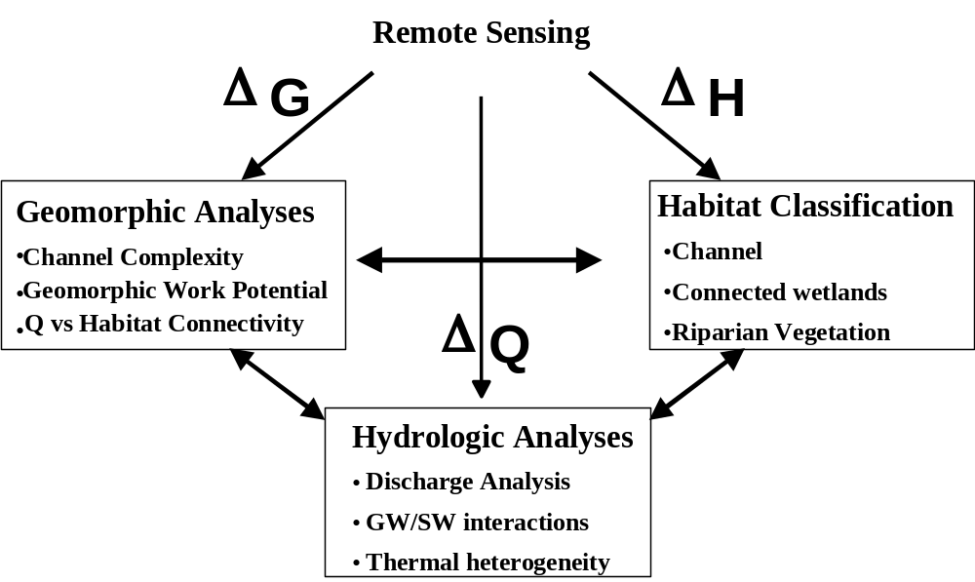
Figure 4. Conceptual approach to the remotely sensed data, change in hydrologic regime, geomorphic characteristics and channel and floodplain habitats. Each of these variables is affected by human disturbance. Our research team has uniquely developed analysis procedures that link AISA hyperspectral imagery to ground-based metrics addressed in each of the components described in the figure and discussed at greater detail in the proposal below.

AISA Hyperspectral Imagery

FLBS deploys an AISA Hyperspectral Sensor from high performance, slow flying aircraft for the acquisition of remotely-sensed imagery. The AISA system features a SPECIM 256-band spectrophotometer with full control of in-flight waveband configuration and a real-time fiber optic downwelling irradiance sensor (FODIS). Our AISA system also features a Systron-Donner C-MIGITS III Miniature Integrated GPS/INS Tactical System, containing a Digital Quartz Inertial Measurement Unit (DQI) with a 12-channel L1 C/A Code GPS Engine. The C-MIGITS III sensor tags each image line from the push-broom acquisition hyperspectral sensor. The GPS coordinates are derived from up to 12 GPS satellites and linked with inertial referencing for precision, synergistic Guidance, Navigation, and Control (GNC) of the total image acquisition. Data is stored during acquisition on a hot-swap removable U160 SCSI drive. Images are post-processed for geo-reference and geo-rectification using Caligeo software. Because we deploy our own hyperspectral sensor, we maintain full control over image quality and are able to respond to stochastic events, such as flooding. This also enables us to acquire the image data at a fraction of the cost of subcontracting to an “outside” provider.

Through our work at FLBS, we have developed empirical linkages between the AISA hyperspectral imagery to specific driver and response variables and metrics fundamental to river and river floodplain processes and structures. Using proprietary applications developed at FLBS, we are able to assess broad landscapes at extremely fine detail. Although a virtual impossibility only a couple years ago, recent technological advances recently acquired by FLBS coupled with an application developed at FLBS within the past year, now permit us to link hydrographic, geomorphic, biogeochemical, vegetative and spatially explicit habitat features of river landscapes to fine scale hyperspectral imagery. We are now typically acquiring imagery at the 1m resolution scale configured to 20 to 50 hyperspectral wavebands. Waveband-specific linkages allow us to evaluate river landscape variation from near-bed shear stress and the movement of bed-material to habitat features critical to the life histories of highly valued plants and animals (e.g., salmonids, lady’s tress orchid, and cottonwoods).

Why hyperspectral analyses? Hyperspectral imagery collected at fine-scale resolution allows us to separate fine and often subtle differences in reflectance characteristics between different types of habitats (e.g., deep water, shallow water, fast water, slow water, large cobble and small cobble) and different types of vegetation (e.g., mature cottonwood, immature cottonwood, conifer, grasses, etc.). To the very best of our knowledge, FLBS is the only river research group worldwide that has successfully made these particular linkages. We describe below the linkages that we have made between hyperspectral imagery and various floodplain characteristics, features, structures and processes. These linkages allow us to project these floodplain attributes across entire floodplain landscapes and evaluate ecological response to the human disturbance gradients.
Linkages of Floodplain Characteristics to Hyperspectral Analyses

Hydrologic Regimes and Characteristics

A fundamental premise of developing the decision support system (DSS) for Columbia Basin flood plains within the context of a biologically based system management (BBSM) is that it is possible to determine and implement normative flows. In this case, a “normative” flow may be defined by the following two attributes: 1) sufficient water flux, seasonal timing and frequency through key reaches to produce a natural distribution and abundance of habitats within the context of a shifting habitat mosaic and 2) maintain naturally occurring flux rates of water during base flow conditions to maintain levels of bioproduction and refugia (sensu Sedell et al. 1990).

We believe that successful river restoration will largely be dependent on both implementing 1) normative flows that will serve to sustain and rejuvenate the complex of riverine and floodplain habitats and 2) habitat protection and restoration by preventing “engineering solutions” to falsely-perceived erosion “problems” or in channel habitat improvements. The key documents that support this conceptual foundation are Stanford et al. (1996), Stanford and Gonser (1998), Stanford (1998), Independent Scientific Group (1999, 2000) and Hauer et al. (2002a).

Hydrologic regimes are monitored by the USGS. We will analyze daily stream flow for the period of record in each study reach, which can be found through the USGS website http://water.usgs.gov/nwis/nwis. We will conduct a complete hydrologic analyses that we have developed to specifically evaluate the ecologically significant relationships separating natural from regulated river flows (Stanford et al. 1996, Hauer et al. 2002b). These analyses include daily discharge, recurrence intervals of annual peak discharge, linear and curvilinear regression analyses of regulated and non-regulated reaches or temporal periods, and analyses of daily percentage changes in discharge (e.g., Figure 5). Each of these metrics has a fundamentally different effect on hydrologic interactions with geomorphic change, thermal complexity, habitat complexity and the floodplain vegetation matrix.

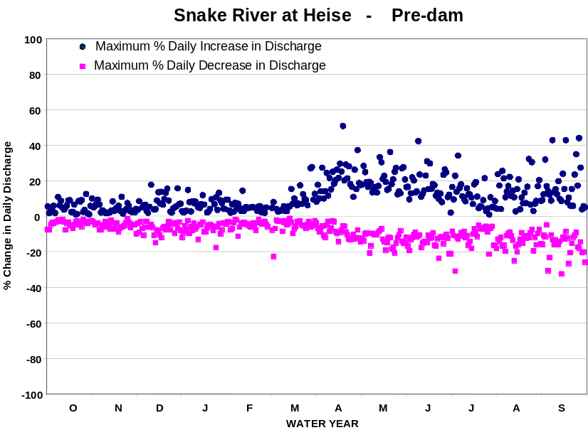
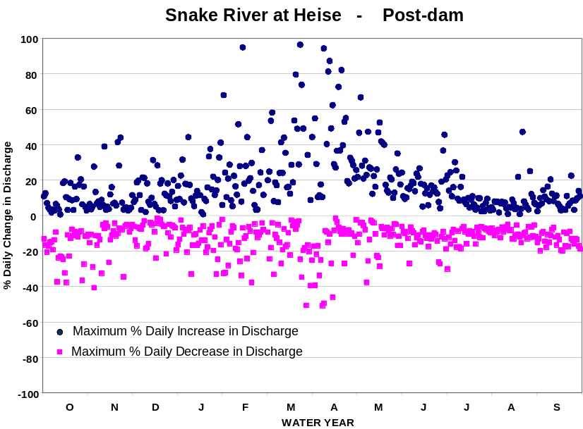
Figure 5. Examples of % daily change as affected by river regulation. In this example one can observe the maximum daily % increase in discharge and maximum daily % decrease in discharge during the 30-year period from 1921 – 1950 representing the pre-dam condition (upper panel) and from 1961 – 2000 representing the post-dam condition (lower panel). These examples are taked from discharge data on the Snake River Idaho, below Palasades Dam.

Geomorphic Analyses

To understand the physical component of the shifting habitat mosaic and relate the impacts due to human disturbance, we need to complete a three phase geomorphic analysis (Fig. 4). All three phases of the geomorphic analysis utilize Hyperspectral imagery. We use automate GIS analyses of points or nodes where channel flow converges or separates as a measure of channel complexity (Figure 6). In this way, we can rapidly assess channel complexity and relate that to measures of human disturbance (e.g., total length of bank protection). Channel complexity is typically reduced as a function of various levels of human interference that reduce with the ability of the river to actively move about its flood plain and changes that effect the supply of sediment.

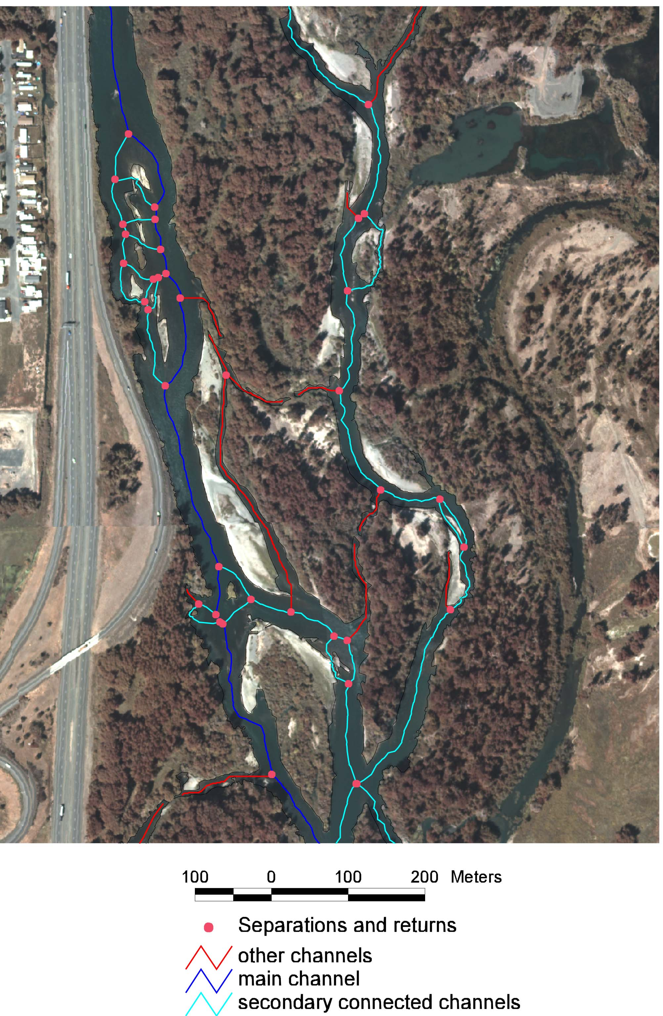
Figure 6. An example of a channel complexity index (nodes of flow separation and returns) determined from an automated GIS analysis technique applicable to hyperspectral imagery (see Whited et al. 2002 for methodological details).

The second phase of the geomorphic assessment is to determine the potential for geomorphic work to be accomplished across the flood plain. We want to know where potential avulsion nodes may develop and how many. We also want to know where in the channel and across the flood plain we expect processes of cut-and-fill alluviation to occur. The first step is to combine the hyperspectral imagery with on the ground measures of flow velocity and water depth (Figure 7). Velocity profile data are correlated spatially by using a GPS (Global Positioning System) receiver co-located with the position of the ADP (Acoustic Doppler velocity Profiler). Both the ADP and GPS data are recorded simultaneously on a field laptop and those data are then related to individual pixels from the airborne hyperspectral digital imagery. In this way, pixel intensity can be correlated to flow velocity and water depth. The velocity and depth data corresponding to a specific area of water surface captured by the imagery are then used in a GIS to classify the flow velocity and depth for all pixels in the reach image. (See Whited et al. 2002 for detailed descriptions of the methodology.)

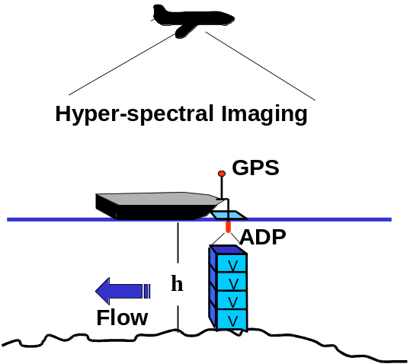
Figure 7. A schematic showing the correlation of Hyperspectral imagery over a square area of water surface with flow velocity (V) and depth (h) data measured with the ADP and location measured with a GPS.

We will be using a survey grade GPS to accurately measure the slope of the water surface (Figure 7). Once slope (S), water depth (h) and flow velocity (V) are known, a GIS can be used to calculate an estimate of stream power (P) in Watts/m of stream width for every pixel in the multi-spec image using the following equation

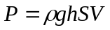 (1)

where ρ and g are the density of water and the gravitational constant respectively. The absolute value of stream power is not as important as the spatial pattern, because we are not balancing the absolute value of stream power with some measure of bank or bed resistance. A map of the standard deviation of high stream power is simply used to show spatially where along the river corridor stream power is high or low relative to the mean (Figure 8). With that information we can further model, with a GIS, the spatial distribution of stream power (Figure 8).
Figure 8. An example of a key hydraulic property (stream power) mapped across a portion of the Nyack flood plain on the (middle fork of the Flathead River) in Montana by classifying multispectral imagery (1999) from on the ground measures of instream topographic and velocity profiles. Major bank erosion and subsequent channel migration (yellow dotted line Box A) occurred during May and June of 2000 and 2001. Bank erosion was also active in the area corresponding to red zones in Box B on this map underscoring the predictive power of this analysis.

Modeling the spatial distribution of stream power provides a valuable tool for predicting where channel avulsions are likely to occur, as well as where processes of cut and fill alluviation are apt to be more active. This is an important step in assessing the potential of stream power to do geomorphic work. It is not possible at this time to estimate stream power at any other stage of discharge then that when the images were collected. However, to further delineate what portions of flood plain are likely to be reworked during floods, it is necessary to objectively assess that potential in a quantitative manner. We can estimate shear stress with only the water depth and slope as input variables. Therefore, if we know the topography of the flood plain it becomes possible to model water depth above some reference point. We will use the discharge stage level during image acquisition as our relative elevation of reference.

One meter contour intervals derived from the 30 m² DEM data available from the USGS can be overlain on the multi-spec imagery and allow for a first order estimate of terrain slope to be made. However, this level of topographic information is not of a sufficient resolution to delineate floodplain topography, especially important features like backwater channels that may provide new channels following a future avulsion. It is also not feasible to use traditional survey methods to measure the topography adequately over many kilometers of a river corridor. To obtain sufficient topographic information to model shear stress during various flood discharge stage levels, we will combine vegetation habitat classification from the Hyperspectral imagery with several cross-sectional topographic surveys (See Lorang et al. 2002 for methodological details). In the process, we will gather as much varied topography across as many cover type features as possible. This combination of data can produce a high resolution (10 cm vertical) DEM of the flood plain (Figure 9 left panel).
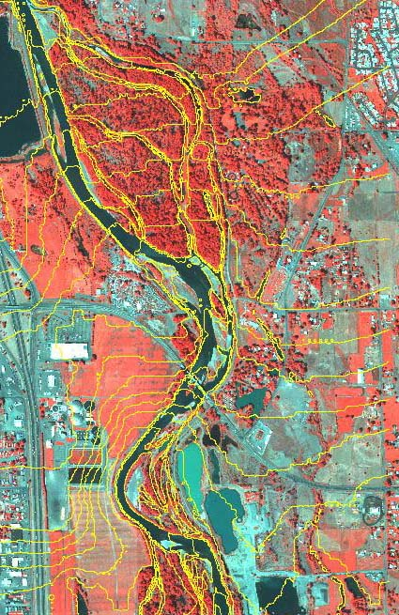
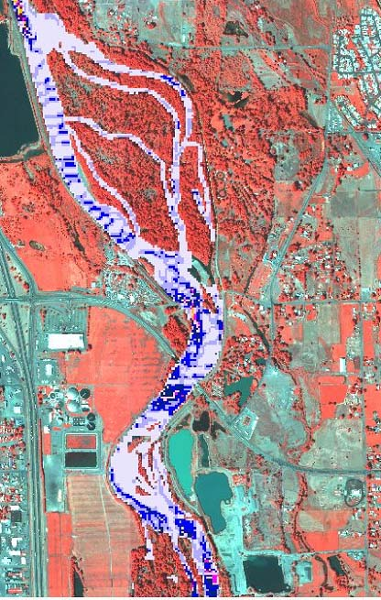
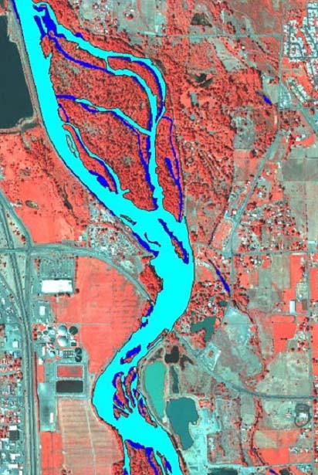
Figure 9. A multispectral image showing an overlay of modeled topography (far left panel) and a comparison (middle panel) of a modeled flood discharge (dark blue, middle panel) to actual flood of 1996 (light blue, middle panel). Based on the modeled topography and the spatial distribution of shear stress in the flood plain, we are able to project sheer stress at flood stage discharge (far right panel, darker blue corresponds to higher sheer stress and ability of the river to move bed material).

By using the new higher resolution DEM, we can model inundation of the flood plain at progressively higher (10 cm) increments (Fig. 8 middle panel). Comparing the modeled flood inundation (1.5 m stage above image discharge) with the inundation depicted in the 1996 geo-rectified photograph taken during the 1996 flood, we can show that the modeled topography and simulated flood compare very closely (Figure 9 middle panel). Once flood inundation is simulated for each stage increment, water depths for the inundated areas are calculated. Using the water depths and the slope of the flood plain (Figure 9 left panel), it is possible to calculate shear stress (Figure 9 right panel) throughout the floodplain reach for any discharge. Displaying the spatial distribution of shear stress in this manner allows a qualitative comparison between shear stress in the main channel and shear stress in the flooded off-channels for that particular stage level of discharge. If shear stress in an off-channel has a similar magnitude as in the main channel (see Fig. 8 right panel) one could conclude that similar levels of geomorphic work could be accomplished in the off-channel. The final step in assessing the geomorphic work potential comes from combining stream power and shear stress modeling results to further delineate areas of the flood plain with high, moderate or low potentials for geomorphic work. This is done by overlaying the stream power results on to the shear stress and correlating where bank erosion and flood channel connectivity are likely (Figure 10).

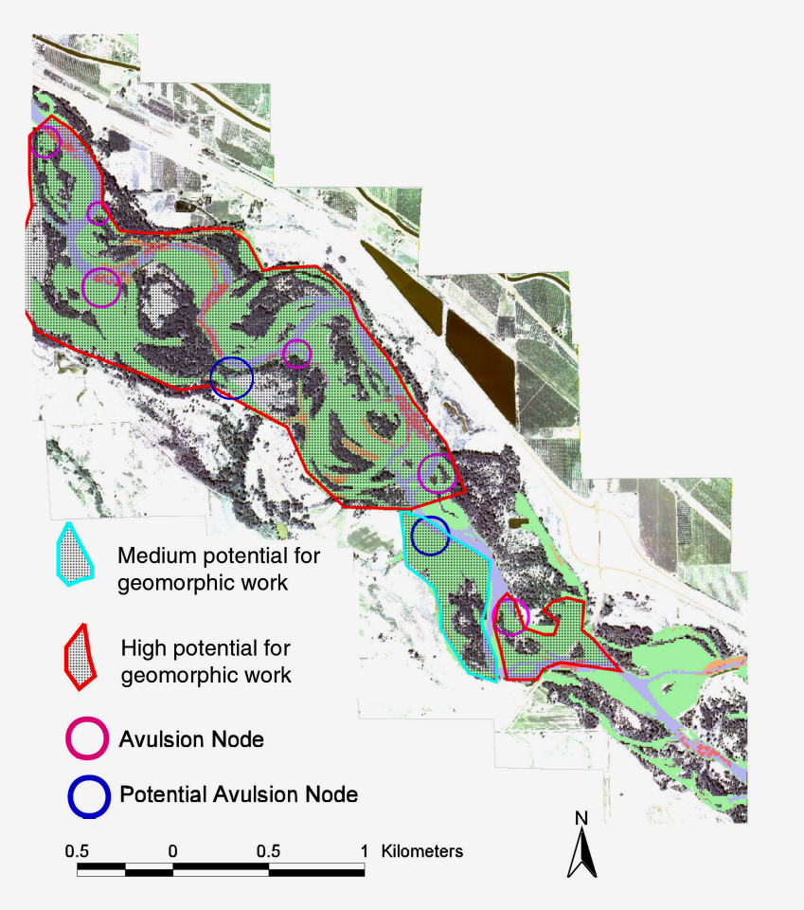
Figure 10. An example of a final map for the Wapato Reach on the Yakima River with the avulsion nodes and zones of potential to do geomorphic work overlain on to the multi-spec image. This method allows delineation of zones with different potentials for geomorphic work.

Spatially explicit characterization of potential to do geomorphic work like these (Figure 10), can be used to assess the impact from various levels of human disturbance and assess the potential for habitat restoration by allowing the river to do the work. This would typically be accomplished by returning the river to “normative flows” and or removing bank stabilization structures. In either case, we have developed the tools to assess a whole range of mitigation alternatives for restoring various levels of human floodplain disturbances. The final phase in the geomorphic assessment is to evaluate habitat connectivity and hydrologic discharge (e.g., discharge, GW/SW interactions, thermal regimes)(Figure 4). By using the new higher resolution DEM we can model inundation of the flood plain at progressively higher (10 cm) increments (Figure 9 middle panel). We can also combine the floodplain DEM with the detailed channel geometry used to estimate stream power. In this way, we can estimate the loss of off-channel habitat and disconnection from those habitats for any chosen discharge regime.
Aquatic Habitat Characterization

Regional mapping of major habitats for river systems can provide a useful measure of the relative abundance and distributions of aquatic plants and animals, since the type, condition and heterogeneity of channel habitats strongly influence nutrient exchanges and associated plant and animal communities (Bisson and Montgomery 1996). Habitat characteristics change through time as floods and droughts alter hydrology, sediment transport and distributions of vegetation and other biota on daily, seasonal and interannual time scales. Intermediate levels of disturbance tend to promote biodiversity by maintaining environmental gradients and associated habitat complexity in space and time (Ward and Stanford 1983, Huston 1994). Spatial and temporal characterization of these features is therefore important for monitoring and management of river communities (Triska 1984, Montgomery and Buffington 1993, Bencala et al. 1993). However, traditional field-based survey techniques for assessing large river (i.e., ≥ 4th order) and floodplain habitats are often slow, costly and subject to error because of the large areas involved and the spatially complex and temporally dynamic nature of these systems (Paine and Levin 1981, Poole et al. 1997).

We employ an integrated system of airborne remote sensing and ground surveys for regional mapping of instream habitats. We collect our hyperspectral digital imagery by deploying our Airborne AISA Hyperspectral Imager in conjunction with field survey measurements used to quantify the spatial extent, condition and temporal changes of selected river habitat characteristics. Geomorphic structure measures are quantified (e.g., channel complexity, number and size of habitats) (Figure 11). Water depth and velocity are classified for instream habitats, temperature and turbidity. Remote sensing classification accuracies for islands, exposed rocks and water surfaces are greater than 99%, while more detailed depth/flow classifications remain at a very high rate (70%) (Whited et al. 2002). While high turbidity (>5 NTU) shadows and bi-directional reflectance factor reduce classification accuracies, the overall effect of these factors is minimal. Our analysis suggests that airborne hyperspectral imagery coupled with appropriate ground truth data, is a highly useful method for regional mapping of diverse riverine habitats under variable flows.

Based on our past studies, we have found that field measures of specific conductance and.benthic chlorophyl provide strong indicators of nutrient rich upwelling ground water. We also know that ion chemistry and benthic chlorophyll differs greatly in flood plain aquatic and semi-aquatic habitats formed by upwelling groundwater. Therefore, we will sample benthic chlorophyll and water for major ion analysis in the lab to augment and confirm field measures of specific conductance. Ion and chlorophyl sampling will be limited in scope but a routine part of the ground truthing done by the field teams. We expect that we can then further classify the imagery using relations between spectal signal intensity in the hyperspectral imagery and field measures of specific conductance of the water. We have not yet related specific conductance to the spectral variation in a hyperspectral image, but we hope to further develop this application to better quantify ecological integrity of the flood plain.

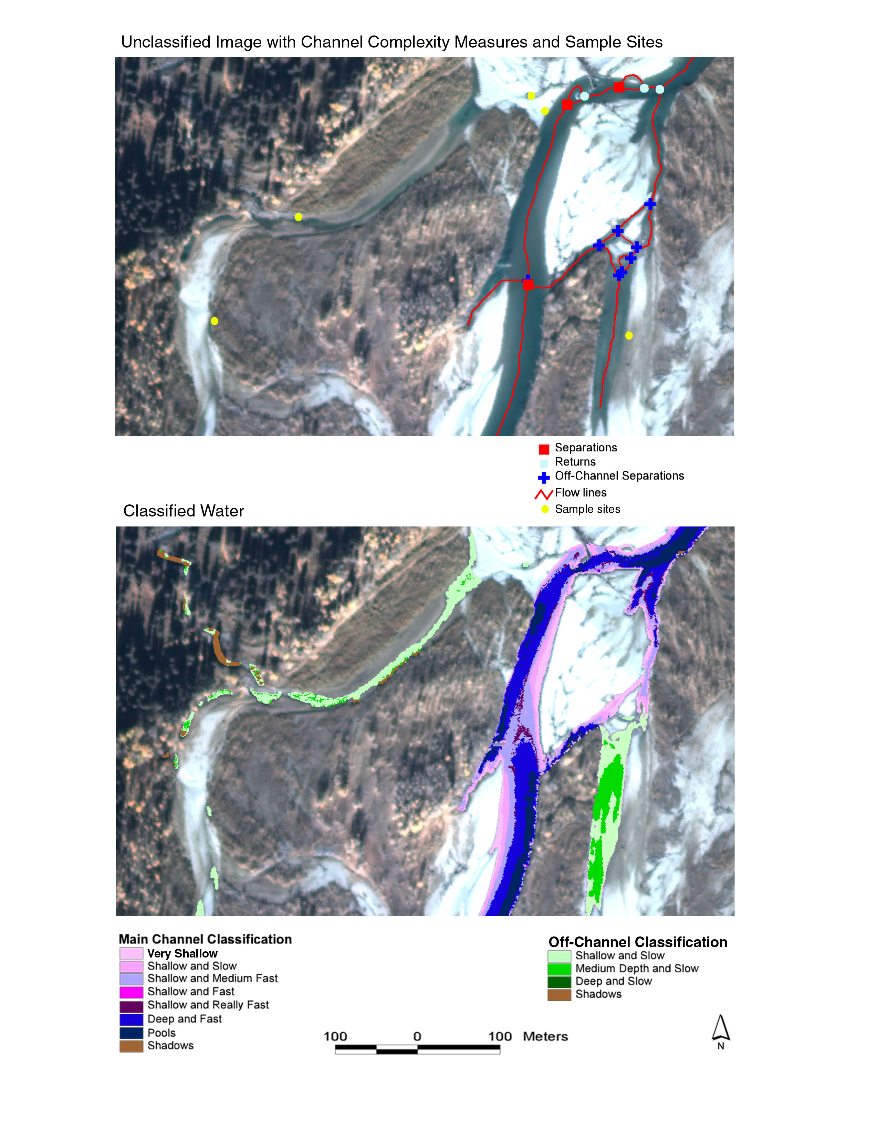
Figure 11. Top panel, unclassified image of channel and aquatic habitat complexity. Lower panel, classified image of a spectrum of water characterization by depth and velocity from Whited et al. 2002.

Floodplain Gallery Forest Characterization

Our approach is to relate riparian vegetation to fluvial geomorphic processes associated with the various flow hydraulics and sediment fluxes driving the seasonal dynamics of floodplain alluvial environments. We have developed this approach to provide a spatially explicit characterization across the entire alluvial flood plain of the following riparian vegetation parameters.

- Age and size class distribution of riparian cottonwood populations – diverse age and size class of local cottonwood populations are indicative of complex geomorphic settings with fluvial processes capable of maintaining vigorous riparian cottonwood forests (Braatne et al. 1996, Scott et al. 1996, Mahoney and Rood 1998). Spatially explicit quantification of riparian cottonwood stands will be complemented by age and size class determinations of distinct floodplain populations.
- Species diversity and distribution of native willow populations (i.e., rhizomatous, shrub and tree growth forms) – similar to cottonwoods, diverse age classes and species composition among differing growth forms of willow correspond to complex floodplain environments. Willow populations will likewise be quantified by species and growth form.
- Species diversity and distribution of other riparian woody plants (e.g., alder, dogwood, roses, currants, sheppardia, etc.) – diverse stands and age classes of cottonwoods and willows commonly support additional tree and shrub species that provide critical forage and cover for a number of avian and wildlife species (Braatne and Jamieson 2001, Jamieson and Braatne 2001). Associated woody riparian plants will be quantified by species and areal extent.
- Diversity and distribution of floodplain wetland communities – natural alluvial flood plains commonly support a number of emergent and scrub-shrub wetland communities in side-channel reaches, spring brooks, oxbow lakes and/or seasonal ponds arising from peak flows onto the diverse topography of alluvial floodplain environments (Hauer et al. 2001). The areal extent of floodplain wetlands will be characterized in relation to wetland type.
- Areal extent/ratio of floodplain forest to shrub and herbaceous plant communities – a relative index of habitat diversity for alluvial flood plains can be attained by mapping the areal extent of riparian forests to shrub and herbaceous plant communities. Each community type has unique seasonal patterns of growth and productivity to which riparian birds and wildlife are closely attuned.
- Diversity of native to exotic riparian plants – altered flow regimes and land-use modifications of floodplain habitats have promoted the invasion of flood plains by exotic woody and herbaceous plants. The attending loss in native plant biodiversity lowers riparian habitat diversity and river productivity. Species diversity and richness measures of native and exotic plants will be complemented by spatially explicit indices of the extent of native to exotic riparian plant communities.

In this approach, we link the vegetative characteristics with specific waveband characteristics acquired from the AISA hyperspectral sensor (Figure 12). This gives us the unique ability to characterize the distribution and diversity of the riparian plant communities in relation to the geomorphic and hydrologic indices outlined in previous sections of this proposal (above) in spatially explicit ways. The integrative assessment of riparian vegetation indicators meshes seamlessly into the three-step process of 1) identification, 2) assessment and ranking and 3) evaluation of restoration potential for alluvial floodplain reaches of the mainstem Columbia and associated subbasins.

Flood plains that are disconnected have scenscent riparian forests, especially cottonwoods (Rood and Heinzie-Milne 1989, Rood and Mahony 1990, Braatne et al. 1996, Scott et al. 1996, Mahoney and Rood 1998, Rood et al. 1998, Braatne and Jamieson 2001). Age structure of riparian forests is central to understanding the role of wood in floodplain dynamics and the degree of ecological disconnection that has occurred via the full array of human activities. We expect that the hyperspecral imagery will correlate with tree age and health, which should provide a more subtle indication of influences on floodplain integrity, especially from recently changed hydrographs (e.g., the trees may be water stressed owing to abstraction of flow). Moreover, we expect that carbon and nitrogen ratios in tree leaves, among other physiological measures, will be indicators of stress and that stressed leaves will have a different spectral signal than healthy leaves. We want to correlate C:N ratios to the spectral signal in the hyperspectral imagery, and thereby, do whole floodplain determinations of tree health from the hyperspectral imagery. Therefore, collection of leaves will be limited in scope but a routine part of the ground truthing done by the field teams followed by lab analysis of C:N ratios.

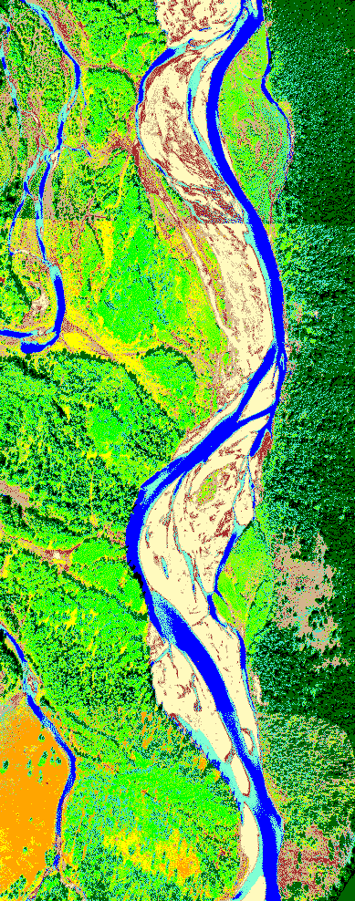
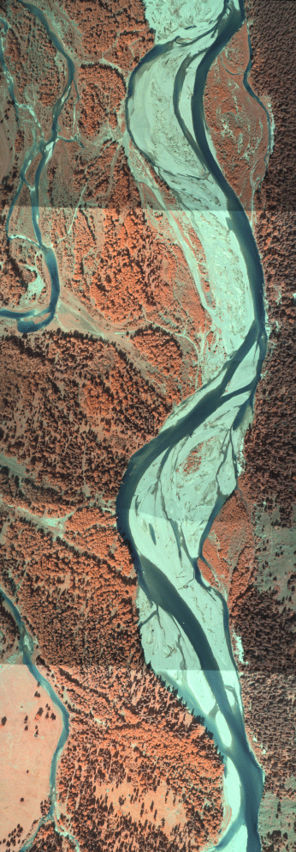
Figure 12. The image on the far left represents a hyperspectral composite aerial imagery series of the Nyack flood plain and middle fork Flathead River near Glacier National Park acquired. The images were obtained at an approximate 1.0m spatial resolution. We assemble our AISA hyperspectral images into a virtually seamless image mosaic using Caligeo software, designed to work specifically with the AISA imager. The software allows flight lines of pushbroom aerial images to be accurately assembled in a rapid and cost effective manner. Both supervised and unsupervised classification techniques are then used to produce a map of critical landcover features (at left) from the image mosaic.
Mature conifer forest
Deciduous forest, shrub (cottonwood, willow)
Grassland
Bare ground, sparse vegetation
Shaded
Wet gravel / coarse woody debris
Exposed gravel bar
Active channel
Shallow water, deposition zone
Mixed deciduous/conifer forest
Agriculture (pasture)

Mature conifer forest
Deciduous forest, shrub (cottonwood, willow)
Grassland
Bare ground, sparse vegetation
Shaded
Wet gravel / coarse woody debris
Exposed gravel bar
Active channel
Shallow water, deposition zone
Mixed deciduous/conifer forest
Agriculture (pasture)
Figure 2. The image on the far left represents a digital color
infrared aerial photograph series of the Nyack Floodplain and
middle fork Flathead River near Glacier National Park acquired
on 28 August, 1997. The images were obtained at an approximate
0.5m spatial resolution and assembled into a virtually seamless
image mosaic using Digital Image Mosaic Environment (DIME)
software which allows large numbers of aerial images to be
accurately assembled in a rapid and cost effective manner. Both
supervised and unsupervised classification techniques were then
used to produce a map of critical landcover features (at left) from
the image mosaic.

3. Select Candidate Sites and Describe the Elements for Floodplain Restoration.

Each of the approximately 20 – 24 intensively studied flood plains investigated at the Floodplain to Habitat spatial scales, as described above, will be evaluated for restoration potential. These analyses will be based on a combination of the degree of departure from the pristine, “natural” condition (as described in Figure 3) and the nature of the human disturbance. For example, if the human disturbance gradient on a particular flood plain includes domestic encroachment into the flood plain with the construction of hardened, protective bank structures, the “potential” for restoration is significantly different from that of a flood plain with levees protecting agricultural landuse. Likewise, some flood plains that have been disconnected from hydrologic and geomorphic processes as a result of dam regulation may be more easily restored than others, depending on the type of regulation, water and flow resource use and the natural characteristics of the flood plains.

We will conduct these analyses in an iterative process that allows us to perform future-casting scenarios. Our research group is highly familiar with this process as developers of the HGM approach to floodplain assessment in the northern Rocky Mountain ecoregion (Hauer et al. 2002). The HGM approach was developed in response to the CWA section 404 regulatory program of the US Army Corps of Engineers. The HGM approach to floodplain assessment closely adheres to the principles of ecological assessment of ecosystem integrity (see Figures 2 and 3 above). The specific analyses conducted on the 20 – 24 “study flood plains” will then be applied across the range of floodplain landscapes identified and ranked in the Basin wide analyses.

Our selected spatial and temporal scales are specifically relevant to the restoration, preservation and enhancement of salmonid fisheries in the Columbia Basin. The deliverables of our study will contribute explicitly to the goals of fisheries restoration in the CR. We will identify and prioritize the subbasins where intact flood plains exist and those where restoration to normative condition is possible. We will provide specific recommendations, approaches and actions necessary to restore flood plains throughout the CR impaired by specific human disturbances. This proposal is in direct response to firm recommendations of the ISG “Return to the River” document.

g. Facilities and equipment

Flathead Lake Biological Station, The University of Montana

The University of Montana’s Flathead Lake Biological Station (FLBS), a Research Center of Excellence, is located on the east shore of Flathead Lake, approximately 90 miles north of the main UM campus in Missoula. Station lands include 70 acres at Yellow Bay on the east shore of Flathead Lake (ca. 50 acres are in the Biological Station's old growth Douglas Fir-Ponderosa Pine forest). FLBS also owns ca. 90 acres of other shoreline holdings, the south half of Bull Island and the Bird Islands.

The 5100 ft² Elrod Laboratory houses faculty, staff and administrative offices, a research library and 4 wet labs with temperature-controlled, artificial lotic and lentic microcosms. The FLBS facility is well equipped with major field and laboratory equipment needed for this project.

The 4500 ft² Freshwater Research Laboratory (FRL) has an elemental analysis lab, optics room, zoobenthos and plankton museum, wet lab, sample prep facility, electronics repair shop, photographic lab and offices. The optics room is equipped with 5 Leitz inverted and fluorescence microscopes (to 1400x) for microbial work and 4 Wild M5 stereoscopes with Volpe fiber optics lights and power focusing stands for research in entomology or dissections. Leitz (Leica) cameras are used for field photography and photomicroscopy and the darkroom is equipped with a Leitz enlarger. Major analytical equipment in the FRL includes the following listed instrumentation: Beckman LS6500 Scintillation Counter, Perkin-Elmer 5000 Atomic Absorption Spectrophotometer with microprocessor controlled graphite furnace and auto sample loader, Perkin-Elmer 559 and Perkin-Elmer Lambda 1 UV-VIS Spectrophotometers, Dionex DX100 dual channel Ion Chromatograph with PC controller, FISONS CHN Analyzer, Tekmar Dohrmann Apollo 9000 TOC system, Technicon Autoanalyzer I (for SRP, NO₂+N0₃, NH₃ and SiO₂), ATP Photometer, and Perkin-Elmer Sigma 300 ECD Chromatograph.

A variety of field equipment is available that we routinely use in our research: a 30' twin-diesel powered research vessel (Jessie B) with GPS, radar, multibeam sonar, high band fm communications and customized hydraulics driving gurdies, capstans, winches and lifting frames for sampling, several 4x4 vehicles, 16' MonArk research boat with 150 hp outboard engine and a wide variety of limnological work nets, dredges and water samplers. FLBS also has two new multisensor (CTD) systems, a Hydrolab for routine sampling and a Sealogger by Sea Tech, Inc. which has multi-port sensor configuration. The Sealogger is cast from the Jessie B with a sensor arrangement of DO, specific conductance, pH, PAR, fluorometry and transmittance. We maintain cold water diving gear and have a heavy-duty compressor for filling SCUBA tanks.

Field equipment routinely used in our river, floodplain and wetland limnological research includes: Leica GPS, A Leica Survey Total Station, Sontek (ADP) acoustic doppler velocity profiler, Sontek hand-held ADP, Terraplus ground penetrating radar (GPR) system, 16 Campbell and Omnidata multi-channel field data recorders, ~80 miniature data loggers that record temperature, 4 digital cameras and a wide variety of stream and wetland sampling gear (e.g., nets, piezometers and pH meters.

A significant added capability to all our limnological research is in the area of Remote Sensing and GIS. The GIS/RS Lab is equipped with high-end NT-2000 workstations (NSF-FSML 1999) and a HP Design-Jet 750C wide carriage plotter. We recently acquired an Airborne Imaging Spectro-radiometer for Applications (AISA) hyperspectral imaging system. This camera is mounted in a Cessna 206 that we hire out of Kalispell. Our limnological research, especially our floodplain research, requires acquisition of high resolution airborne imagery of unpredictable events, for example, flooding autumnal leaf color change.

Facilities and Equipment for Subcontractor

University of Idaho, Moscow

The Department of Fish and Wildlife is housed in the College of Natural Resources at the University of Idaho, Moscow. As a subcontractor to FLBS, the department will provide office and laboratory space in support of UI faculty and students working on this project. The Floodplain Ecology Lab is well equipped with scientific instruments for ecological studies of streams, rivers and associated alluvial flood plains, including: 1) Leica TCR705 Total Station, 2) Trimble ProXRS GPS Unit, 3) 2 - Campbell 20RX dataloggers and microclimate stations, 4) 2 - Laser Levels, 5) plant community sampling equipment (tree corers, dbh tapes, densiometers, etc.), 6) groundwater piezometers and mini-piezometers, 7) motorboats, rafts, canoes and associated gear and 8) 2 - Dell Computer Workstations; peripherals to the UI GIS Lab network include a Calcomp 9100 digitizing tablet (48 X 54 in), a Calcomp color plotter, a SPARC laser printer. Primary GIS software (ARC/Info 8.0.1, ARCview 3.2, ERDAS imagine 8.4, Applix, gear CD-masting) is augmented by statistical and other analytical software packages. Thus, facilities and equipment available through the Floodplain Ecology Lab readily complement the research facilities and equipment provided by the UMT – Flathead Lake Biological Station.

Equipment Justification

The project requires ground truth data to be collected for 20 to 24 flood plains spread across the entire Columbia Basin flood plain. This will require two seasonal teams of scientists and field technicians. Each team will require a four-wheel drive crew cab vehicle for carrying crew members, electronic equipment and a specially equipped cataraft with trailer. The raft will require construction of an all-aluminum frame capable of holding an Acoustic Doppler velocity Profiler (ADP), laptop computer and survey grade GPS. The ADP will measure flow velocity and water depth and the GPS will provide horizontal coordinates and accurate vertical elevation to measure slope of the water surface. Each cataraft will require a small (10-hp) four-cylinder outboard to hold position in the river for discharge measurements. These data will be correlated with the hyperspectral imagery in a GIS with storage and access needs requiring a computer server.

h. References

Reference (include web address if available online) | Submitted w/form (y/n)
(Replace this text with your response; use regular Word commands to add/del/move rows)
Bansak, T. S. 1998. The influence of vertical hydraulic exchange on habitat heterogeneity and surficial primary production on a large alluvial flood plain of the Middle Fork Flathead River. The University of Montana, Missoula. 68 pp. | N
Baxter, C. V. and F. R. Hauer. 2000. Geomorphology, hyporheic exchange and selection of spawning habitat by bull trout (Salvelinus confluentus). Canadian Journal of Fisheries and Aquatic Sciences 57:1470-1481. | N
Bencala, K. E., J. H. Duff, J. W. Harvey, A. P. Jackman and F. J. Triska. 1993. Modelling within the stream-catchment continuum, pp. 163-187. IN: Jackman, A. J., M. B. Beck and M. J. McAleer (ed.), Modelling Change in Environmental Systems. John Wiley and Sons Ltd. | N
Bisson, P. A. and D. R. Montgomery. 1996. Valley segments, stream reaches and channel units, pp. 23-52. IN: Hauer, F. R. and G. A. Lamberti (ed.), Methods in Stream Ecology. Academic Press, Inc. San Diego. | N
Braatne, J. H., S. B. Rood and P. E. Heilman. 1996. Life history, ecology and conservation of riparian cottonwoods in North America, pp. 57-85. IN: Stettler, R.F., H. D. Bradshaw, P .E. Heilman and T. M. Hinckley (eds.), Biology of Populus: Implications for Management and Conservation. National Research Council, Ottawa. | N
Bradley, P. M., M. Fernandez Jr. and F. H. Chapelle. 1992. Carbon limitation of denitrification rates in an anerobic groundwater system. Environmental Science & Technology 26:2377-2381 | N
Bradley, W. C., and A. I. Mears. 1980. Calculations of flows needed to transport coarse fraction of Boulder Creek alluvium at Boulder, Colorado. Bulletin of the Geological Society of America 86:1057-1090. | N
Bradley, C. E. and D. G. Smith. 1986. Plains cottonwood recruitment and survival on a prairie meandering river floodplain, Milk River, southern Alberta and northern Montana. Can. J. Bot. 64:1433-1442. | N
Brinson, M. M., F. R. Hauer, L. C. Lee, W. L. Nutter, R. D. Theinhardt, R. D. Smith and D. Whigham. 1995. A Guidebook for Application of Hydrogeomorphic Assessments to Riverine Wetlands. Technical Report WRP-DE-11. U. S. Army Corps of Engineers, Waterways Experiment Station, Washington, DC. 217 pp. | N
Buffington, J. M., and D. R. Montgomery. 1997. A systematic analysis of eight decades of incipient motion studies, with special reference to gravel-bedded rivers. Water Resources Research 33:1993-2029. | N
Cooley, N. J. and B. Jamieson. 1997. Identification of Options for Environmental Enhancement in the Columbia River basin. For: Columbia Basin Trust. | N
Decamps, H. 1996. Edgardo Baldi Memorial Lecture. The renewal of floodplain forests along rivers: a landscape perspective. Verh. Internat. Verein. Limnol. 26:35-59. | N
Decamps, H. and E. Tabacchi. 1994. Species richness in vegetation along river margins, IN: Giller, P. S., A. G. Hildrew and D. G. Raffaelli (eds.), Aquatic Ecology: Scale, Pattern and Process. Blackwell Scientific Publications, London, England. | N
Ellis, B. K., J. A. Stanford and J. V. Ward. 1998. Microbial assemblages and production in alluvial aquifers of the Flathead River, Montana, USA. Journal of the North American Benthological Society 17(4):382-402. | N
Hauer, F. R., C. N. Dahm, G. A. Lamberti and J. A. Stanford. 2002. Landscapes and ecological variability of rivers in North America: factors affecting restoration strategies. IN: Wissmar, R. C. and P. A. Bisson (eds.), Strategies for Restoring River Ecosystems: Sources of Variability and Uncertainty in Natural and Managed Systems. Special Publication of Am. Fish. Soc. In press. | N
Hauer, F. R., D. B. Fagre, and J. A. Stanford. 2002. Hydrologic processes and nutrient dynamics in a pristine mountain catchment. Verh. Internat. Verein. Limnol. In press. | N
Huston, M. A. 1994. Biological Diversity: The Coexistence of Species on Changing Landscapes. Cambridge University Press, Cambridge, 681 pp. | N
Huston, M. A. and D. L. DeAngelis. 1994. Competition and coexistence: the effects of resource transport and supply rates. The American Naturalist 144(6):954-977. | N
ISAB. 2001. A review of salmon recovery strategies for the Columbia River Basin. For: NWPPC and NMFS, Portland, Or. By the Independent Scientific Advisory Board. Available at: www.nwcouncil.org. | N
Independent Scientific Group (R.N. Williams, chair, P. A. Bission D. L. Bottom, L. D. Calvin, C. C. Coutant, M. W. Ehro Jr., C. A. Frissell, J. A. Lichatowich, W. J. Liss, W. E. McConnaha, P. R. Mundy, J. A. Stanford and R. R. Whitney). 1999. Return to the River: Scientific issues in the restoration of salmonid fishes in the Columbia River. Fisheries 24(3): 10-19. | N
Independent Scientific Group. 2000. Return to the River 2000: Restoration of the Salmonid Fishes in the Columbia River Ecosystem. Northwest Power Planning Council Document 2000-12. Northwest Power Planning Council,
Jamieson, B. and J. Braatne. 2001. The impact of flow regulation on riparian cottonwood ecosystems in the Columbia Basin. Northwest Power Planning Council and Bonneville Power Administration, Portland, Oregon. | N
Jamieson, B, E. Peterson, M. Peterson and I. Parfitt. 2001. The conservation of hardwoods in the Columbia Basin. For: Columbia Basin Fish and Wildlife Compensation Program. Available at: cbfishwildlife.org. | N
Jamieson, B. 1997. Identification of Issues and Opportunities in terrestial ecosystem management in the Columbia River basin. For: Columbia Basin Trust. | N
Johnson, W. C., R. L. Burgess and W. R. Keammerer. 1976. Forest overstory vegetation and environment on the Missouri River floodplain in North Dakota. Ecol. Monogr. 46:59-84. | N
Johnson, W. C. 1992. Dams and riparian forests: case study from the upper Missouri River. Rivers 3(4):229-242. | N
Junk, W. J. and R. L. Welcomme. 1990. Floodplains, pp. 491-524. IN: Patten, B. C. (ed.), Wetlands and Shallow Continental Water Bodies. SPB Academic Publishing bv, The Hague. | N
Locking, T. 1983. Hydrology and sediment transport in an anastamosing reach of the Upper Columbia River, B.C. MSc. Thesis, U. of Calgary. | N
Lorang, M. S. and F. R. Hauer. 2002. Flow competence evaluation of streambed stability: An assessment of the technique and limitations of application. J. North Am. Benthol. Soc. In press. | N
Lorang, M. S, D.C. Whited, P. L. Matson and J.A. Stanford 2002. Linking Fluvial Processes to Floodplain Ecology of the Yakima River: Stream Flow, Sediment Loads and the Potential for Geomorphic Work Bureau of Reclamation. 38 pgs. | N
Mahoney, J. M. and S. B. Rood. 1998. Streamflow requirements for cottonwood seedling recruitment - an integrative model. Wetlands 18(4):634-645. | N
Naiman, R. J. 1998. Biotic stream classification, pp. 97-119. IN: Naiman, R. J. and R. E. Bilby (ed.), River Ecology and Management: Lessons from the Pacific Coastal Ecoregion. Springer-Verlag, New York. | N
Naiman, R. J. and H. Decamps. 1997. The ecology of interfaces: Riparian zones. Ann. Rev. Ecol. Syst. 28:621-658. | N
Paine, R. T. and S. A. Levin. 1981. Intertidal landscapes: Disturbance and the dynamics of pattern. Ecological Monographs 51(2):145-178. | N
Pepin, D. M. and F. R. Hauer. 2002. Benthic responses to groundwater – surface water exchange in two alluvial rivers. J. N. Am. Benthol. Soc. In press. | N
Poole, G. C., C. A. Frissell and S. C. Ralph. 1997. In-stream habitat unit classification: Inadequacies for monitoring and some consequences for management. Journal of the American Water Resources Association 33(4):879-896. | N
Richter, B. D., and H. E. Richter. 2000. Prescribing flood regimes to sustain riparian ecosystems along meandering rivers. Conservation Biology 14:1467-1478. | N
Rood, S. B. and S. Heinze-Milne. 1989. Abrupt downstream forest decline following river damming in southern Alberta. Can. J. Bot. 67:1744-1749. | N
Rood, S.B., A.R. Kalischuk and J.M. Mahoney. 1998. Initial cottonwood seedling recruitment following the flood of the century of the Oldman River, Alberta, Canada. Wetlands 15:557-570. | N
Rood, S. B. and J. M. Mahoney. 1990. Collapse of riparian poplar forests downstream from dams in western prairies: probable causes and prospects for mitigation. Environmental Management 14(4):451-464. | N
Rood, S. B., J. M. Mahoney, D. E. Reid and L. Zilm. 1995. Instream flows and the decline of riparian cottonwoods along the St. Mary River, Alberta. Canadian Journal of Botany 73:1250-1260. | N
Scott, M. L., J. M. Friedman and G. T. Auble. 1996. Fluvial processes and the establishment of bottomland trees. Geomorphology 14:327-329. | N
Sedell, J. R., G. H. Reeves, F. R. Hauer, J. A. Stanford and C. P. Hawkins. 1990. Role of refugia in recovery from disturbances: modern fragmented and disconnected river systems. Environ. Manage. 14(5):711-724. | N
Snyder, E. B., D. J. Eitemiller, C. P. Arango, M. L. Uebelacker and J. A. Stanford. In press. Floodplain Hydrologic Connectivity and Fisheries Restoration in the Yakima River, U.S.A. Verh. Internat. Verein. Limnol. | N
Snyder E. B. and J. A. Stanford. 2001. Review and synthesis of data related to instream flow provision in the Yakima River ecosystem, Washington. Bureau of Reclamation. 122 pgs. | N
Snyder E. B. and J. A. Stanford. 2002. Derivation of normative flows for a damaged floodplain river ecosystem. Draft report, Bureau of Reclamation. In prep. | N
Snyder, W. D. and G. C. Miller. 1992. Changes in riparian vegetation along the Colorado River and Rio-Grande, Colorado. Great Basin Naturalist 52(4):357-363. | N
Stanford, J. A. 1998. Rivers in the landscape: introduction to the special issue on riparian and groundwater ecology. Freshwater Biology 40(3):402-406. | N
Stanford, J. A., N. J. Gayeski, D. S. Pavlov, K. A. Savvaitova and K. V. Kuzishchin. In press. Biophysical Complexity of the Krutogorova River (Kamchatka, Russia). Verh. Internat. Verein. Limnol. | N
Stanford, J. A. and T. Gonser. 1998. Special Issue. Rivers in the Landscape: riparian and groundwater ecology. Freshwater Biology 40(3):401-585. | N
Stanford, J. A. and J. V. Ward. 1992. Emergent properties of ground water ecology: Conference conclusions and recommendations for research and management, pp. 409-415. IN: Stanford, J. A. and J. J. Simons (ed.), Proceedings of the First International Conference on Ground Water Ecology. American Water Resources Association, Bethesda. 419 pp. | N
Stanford, J. A. and J. V. Ward. 1993. An ecosystem perspective of alluvial rivers: connectivity and the hyporheic corridor. Journal of the North American Benthological Society 12:48-60. | N
Stanford, J. A. and J. V. Ward. 2001. Revisiting the serial discontinuity concept. Regulated Rivers: Research and Management 17:303-310. | N
Stanford, J. A., J. V. Ward, and B. K. Ellis. 1994. Ecology of the alluvial aquifers of the Flathead River, Montana. Pages 367-390 in J. Gilbert, D.L. Danielopol and J.A. Stanford, editors. Groundwater Ecology. Academic Press, San Diego. | N
Stanford, J. A., J. V. Ward, W. J. Liss, C. A. Frissell, R. N. Williams, J. A. Lichatowich and C. C. Coutant. 1996. A general protocol for restoration of regulated rivers. Regulated Rivers 12:391-413. | N
Stevenson, R. J. and F. R. Hauer. 2002. Relating HGM and IBI approaches for environmental assessment of wetlands. J. N. Am. Benthol. Soc. In press. | N
Triska, F. J. 1984. Role of wood debris in modifying channel geomorphology and riparian areas of a large lowland river under pristine conditions: a historical case study. Verh. Internat. Verein. Limnol. 22:1876-1892. | N
Ward, J. V. 1997. An expansive perspective of riverine landscapes: pattern and process across scales. GAIA 6(1):52-60 | N
Ward, J. V. and J. A. Stanford. 1983a. The intermediate-disturbance hypothesis: An explanation for biotic diversity patterns in lotic ecosystems, pp. 347-356. IN: Fontaine III, T. D. and S. M. Bartell (ed.), Dynamics of Lotic Ecosystems. Ann Arbor Science, The Butterworth Group, Kent. | N
Ward, J. V. and J. A. Stanford. 1983b. The serial discontinuity concept of lotic ecosystems, pp. 29-42. IN: Fontaine, T. D. I. and S. M. Bartell (ed.), Dynamics of Lotic Ecosystems. Ann Arbor Science Publishers, Ann Arbor. | N
Ward, J. V., K. Tockner and F. Schiemer. 1999. Biodiversity of floodplain river ecosystems: ecotones and connectivity. Regulated Rivers: Research and Management 15:125-139. | N
Whited, D. C., J. Stanford and J. Kimball. In press. Application of airborne multi-spectral digital imagery to characterize riverine habitat. Verh. Internat. Verein. Limnol. | N
Whited, D., J. A. Stanford and J. S. Kimball. In press. Application of airborne multispectral digital imagery to quantify riverine habitats at different base flows. River Research and Applications. | N

Section 10 of 10. Key personnel

Project coordination - Overall project management will be the responsibility of Dr. Jack Stanford. Mr. Bob Jamieson and Dr. Steward Rood will manage the Canadian portion of the work. We intend to make the project as seamless as possible across the 49th parallel.

PI Roles

Dr. Jack Stanford, Jessie M. Bierman Professor of Ecology and Director at the Flathead Lake Biological Station of The University of Montana. FTE-0.5

Dr. Stanford will provide assistance on all technical aspects of the project and coordination / oversight of research activities throughout the duration of the project.

Dr. Ric Hauer, Endowed Research Professor of Limnology at the Flathead Lake Biological Station. FTE-0.66

Dr. Hauer will directly oversee the collection of Hyperspectral data in collaboration with Dr. Lorang, and oversee the collection and analysis of all ground truth data.

Dr. Mark Lorang, Assistant Professor of Physical Limnology at the Flathead Lake Biological Station. FTE-0.5

Dr. Lorang will work in conjunction with Dr. Hauer on the collection of Hyperspectral data and the collection and analysis of all ground truth data.

Dr. Jeffrey Braatne, Assistant Professor of Floodplain Ecology, Dept. of Fish, Wildlife and Range, University of Idaho, Moscow. FTE-0.3

Dr. Braatne will coordinate and carry out the collection of riparian vegetation data and analysis specifically as it relates to the life history and ecology of riparian cottonwoods.

Dr. Stewart Rood, Professor, University of Lethbridge. FTE-0.25

Dr. Rood will work with Mr. Jamieson on the coordination of the Canadian floodplain work. He and Dr. Braatne will collaborate on assessment of Flow Regulation Impacts on Riparian Cottonwood Ecosystems.

Mr. Bob Jamieson, President of BioQuest International Consulting, Ltd. FTE-0.5

Mr. Jamieson will provide liaison with various groups within BPA and NWPPC that are working in similar directions (EDT, SWAN, Wildlife Habitat Mapping Project) and with policy level groups working toward ecosystem restoration. He will also facilitate work on the Canadian side of the Basin in collaboration with Drs. Hauer and Rood.
JACK A. STANFORD

Bierman Professor and Director
Flathead Lake Biological Station
The University of Montana
311 Bio Station Lane
Polson, Montana 59860-9659
Phone: (406) 982-3301; FAX: (406) 982-3201

stanford@selway.umt.edu; www.umt.edu/biology/flbs

EDUCATION:
B.S. Fisheries Science Colorado State University 1969
M.S. Limnology Colorado State University (E. B. Reed, Advisor) 1971
Ph.D. Limnology University of Utah (A. R. Gaufin, Advisor) 1975

PROFESSIONAL EXPERIENCE:
Jessie M. Bierman Professor of Ecology, The University of Montana (1985-present).
Director, Flathead Lake Biological Station (1980-present).
Associate Professor (1979-1981) and Assistant Professor (1974-1979), Department of Biological Sciences, North Texas State University, Denton, Texas.

BACKGROUND:
Dr. Stanford is the Jessie M. Bierman Professor of Ecology and Director at the Flathead Lake Biological Station of The University of Montana. Dr. Stanford’s research emphasizes natural and cultural interactions of large catchment ecosystems in western North America. He has published 120 juried papers and books in limnology and ecology since receiving his Ph.D. from the University of Utah in 1975. He is most noted for his long-term studies of the 22,241 km2 Flathead River-Lake ecosystem in Montana and British Columbia. Recently, Dr. Stanford began extensive work on the ecology of salmon rivers in Kamchatka, Russia, with colleagues at Moscow State University. He is a Board member of the Wild Salmon Center, Portland, OR, which is devoted to conservation of salmon rivers around the Pacific Rim. He has served on many national and international science review panels and editorial boards concerning the ecology and conservation of fishes. See www.umt.edu/biology/flbs for details.

SELECTED PUBLICATIONS (from 120):
Stanford, J. A. and B. K. Ellis. In press. Natural and cultural influences on ecosystem processes in the Flathead River Basin (Montana, British Columbia). IN: Baron, J. S. (ed.), Rocky Mountain Futures: An Ecological Perspective. Island Press, Covelo, CA.
Stanford, J. A., N. J. Gayeski, D. S. Pavlov, K. A. Savvaitova and K. V. Kuzishchin. In press. Biophysical complexity of the Krutogorova River (Kamchatka, Russia). Verh. Internat. Verein. Limnol. 28:000-000.
Whited, D., J. A. Stanford and J. S. Kimball. In press. Application of airborne multispectral digital imagery to quantify riverine habitats at different base flows. River Research and Applications 18:00-00.
Stanford, J. A. and J. V. Ward. 2001. Revisiting the serial discontinuity concept. Regulated Rivers: Research and Management 17:303-310.
Stanford, J. A. and T. Gonser (eds.). 1998. Rivers in the Landscape: special issue on Riparian and Groundwater Ecology. Freshwater Biology 3:402-585.
F. RICHARD HAUER
FLBS Professor of Limnology
Flathead Lake Biological Station
The University of Montana
311 Bio Station Lane, Polson, Montana 59860-9659
Phone: (406) 982-3301; FAX: (406) 982-3201
rhauer@selway.umt.edu; www.umt.edu/biology/flbs

EDUCATION:
B.S. Fisheries and Wildlife Michigan State University (Honors) 1973
M.S. Limnology Michigan State University (P. I. Tack, Advisor) 1975
Ph.D. Limnology University of North Texas (J. A. Stanford, Advisor) 1980

PROFESSIONAL EXPERIENCE:
2001-present FLBS Professor of Limnology, The University of Montana
1994-2001 Research Professor, Flathead Lake Biological Station, The University of Montana

BACKGROUND:
Dr. Hauer holds the FLBS Endowed Chair in Limnology with primary research emphasis in stream and river ecology. He has taught Stream Ecology at The University of Montana’s Flathead Lake Biological Station since 1983 and has taught numerous other courses in the limnological and ecological sciences over his career. In addition to over 25 years of conducting basic research in river ecology, Dr. Hauer has served on the science panel for the US Army Corps of Engineers’ development of the Hydrogeomorphic (HGM) approach to wetland assessment (Brinson, Hauer and others 1995). He has since senior authored the HGM guidebook for river flood plains in the Northern Rocky Mountain Ecoregion. Dr. Hauer has also been involved in the most recent EPA development of the “Tiered Aquatic Use Life Support” approach to aquatic ecosystem assessment. Dr. Hauer co-edited and was a contributing author of the book “Methods in Stream Ecology” published by Academic Press. He is also President-elect of the North American Benthological Society.

SELECTED PUBLICATIONS:(from 62):
Hauer, F. R., C. N. Dahm, G. A. Lamberti, and J. A. Stanford. 2002. Landscapes and ecological variability of rivers in North America: factors affecting restoration strategies. IN: Wissmar, R. C. and P. A. Bisson (editors). Strategies for restoring river ecosystems: Sources of variability and uncertainty in natural and managed systems. Special Publication of Am. Fish. Soc. In press.
Pepin, D. M. and F. R. Hauer. 2002. Benthic responses to groundwater – surface water exchange in two alluvial rivers. J. N. Am. Benthol. Soc. In press.
Stevenson, R. J. and F. R. Hauer. 2002. Relating HGM and IBI approaches for environmental assessment of wetlands. J. N. Am. Benthol. Soc. In press.
Hauer, F. R., G. C. Poole, J. T. Gangemi, and C. V. Baxter. 1999. Large woody debris in bull trout spawning streams of logged and wilderness watersheds in northwest Montana. Can. J. Fish. Aquat. Sci. 56:915-924.
Hauer, F. R. and G. A. Lamberti (editors.). 1996. Methods in Stream Ecology. Academic Press, New York. 674 pp.
MARK S. LORANG
Flathead Lake Biological Station
The University of Montana
311 Bio Station Lane
Polson, Montana 59860-9659
Phone: (406) 982-3301; FAX: (406) 982-3201
mlorang@selway.umt.edu; www.umt.edu/biology/flbs

EDUCATION:
B.A. Geology The University of Montana 1983
M.S. Oceanography Oregon State University (P.D. Komar, Advisor) 1992
Ph.D. Oceanography Oregon State University (P.C. Klingeman, Advisor) 1997

PROFESSIONAL EXPERIENCE:
Research Assistant Professor, Flathead Lake Biological Station, The University of Montana (2000-present)
Visiting Assistant Professor, Geography Department, University of Oregon (1998-2000)
Post Doctoral Fellow, Geography Department, University of Southern California (1997-1998)

BACKGROUND:
Dr. Lorang is an Assistant Professor of Physical Limnology at the Flathead Lake Biological Station. His expertise is linking fluid hydraulics and sediment transport with ecological responses in coastal and fluvial environments. He has taught a variety of graduate courses at the University of Oregon and the University of Southern California (Geog 525 Hydrology and Water Resources, Geog. 571 Fundamentals of Sediment Transport, Geog. 573 Fluvial Geomorphology, among others). He was an invited speaker for the “1999 Salmon in Crisis Series” sponsored by the University of Oregon where he gave a talk titled “Linking Flow Regimes and Sediment Transport Processes to Salmonid Habitat.” He recently returned from Vienna, Austria where he gave an invited lecture at the University of Vienna titled “Linking Fluvial Geomorphology to River Ecology.” Dr. Lorang and his colleagues at FLBS have two funded research projects in the Columbia Basin: Linking Fluvial Processes to Floodplain Ecology of the Yakima River, Washington: Stream Flow, Sediment Loads and the Potential for Geomorphic Work and Floodplain Ecology of the Snake River, Idaho and Wyoming: Review and Synthesis of Data, Historical Condition, Current Status and Prospects for Restoration of Critical Ecosystem Functions. Both projects are sponsored by the Bureau of Reclamation. Dr. Lorang is also modeling sediment flux and fluvial geomorphic response on the Nyack flood plain of the Middle Fork of the Flathead River in northwestern Montana as part of an NSF grant to study biocomplexity in the environment.

SELECTED PUBLICATIONS (1999-2002):
Bauer, B. O., M. S. Lorang and D. J. Sherman. In press. Estimating boat-wake-induced levee erosion using sediment suspension measurements. J. Waterway Port Coast and Ocean Eng.
Lorang, M. S. and F. R. Hauer. In press. Flow competence evaluation of streambed stability: An assessment of the technique and limitations of application. J. North Am. Benthol. Soc.
Lorang, M. S. and G. Aggett. In press. Impacts related to dam removal: Icicle Creek, Washington, USA. Proceedings of the 30th Binghamton Symposium in Geomorphology.
Lorang, M. S. 2000. Predicting threshold mass and stable boulder mass for a beach. J. Coastal Research 16(2):432-445.
Wilson, J. P. and M. S. Lorang. 1999. Spatial models of soil erosion and GIS, pp. 83-103. IN: Fotheringham, A. S. and M. Wegener. Spatial Models and GIS - New Potential and New Models. Chichester, Taylor and Francis.
JEFFREY H. BRAATNE
Department of Fish & Wildlife
University of Idaho
Moscow, ID 83844-1136
braatne@uidaho.edu

EDUCATION:
1978 B.A. Departments of Biology & Botany, University of Montana, Missoula 1989 Ph.D. Department of Botany, University of Washington, Seattle
Additional training (1994-1998): Applied Fluvial Geomorphology I&II and River Restoration (Wildland Hydrology, Pagosa Springs, CO); Stable Isotope Ecology (BIO581, University of Utah, Salt Lake City, UT); Federal, State and Local Clean Water and Wetland Regulations I&II (Seattle Law Review Board).

EMPLOYMENT HISTORY:
Assistant Professor of Floodplain Ecology, Dept. of Fish, Wildlife and Range, Univ. of Idaho, Moscow (2001-present)
Adjunct Professor/Instructor, Flathead Lake Biological Station, The Univ. of Montana (2000-present)
Adjunct Research Professor, Biology Dept., University of Lethbridge, Alberta (1997-present)
Affiliate Associate Professor/Instructor, Forestry Dept., University of Washington, Seattle (1994-present)
Ecological Research Contractor, Seattle, WA (1995-present)

BACKGROUND:
Dr. Braatne is an ecologist with expertise in the ecology of alluvial floodplains and physiological ecology of riparian and wetland plants. Over the last ten years, he has been an active participant in the Univ. of Washington/Washington State Univ. Black Cottonwood Research Program. His research and teaching interests focus on the physiology and ecology of riparian cottonwoods and willows in western North America. Some recent research topics include: a) physiological and morphological responses of willows and cottonwoods to drought and flooding, b) fluvial/ecological modeling of riparian plant communities and c) impacts of stream-flow modifications on riparian plant communities and floodplain landscapes. Recent studies have focused upon ecology of riparian plant communities along the lower Snake (Hells Canyon) and Salmon River Corridors. Dr. Braatne currently teaches undergraduate & graduate courses on stream, riparian and wetland ecology at the Univ. of Idaho.

SELECTED PUBLICATIONS (1996-2002):
Braatne, J.H., S.B. Rood, L. Gom and R.K. Simons. 2002. Modeling the response of riparian vegetation to regulated flows along the Hells Canyon reach of the Snake River. Geomorphology (for submission).
Shafroth, P.B., M.L. Scott, G.T. Auble, J.M. Friedman and J.H. Braatne. In press. Potential responses of riparian vegetation to dam removal. Bioscience 52.
Wissmar, R.C., J.H. Braatne, R. Beschta and S.B. Rood. In press. Variability of riparian ecosystems and implications for restoration. IN: Wissmar, R.C. and P.A. Bisson (eds.), Strategies for Renewing River Ecosystems: Variability and Uncertainty of Biophysical Functions and their Consequences. Am. Fisheries Society.
Braatne, J.H., R.F. Stettler and S.B. Rood. 2002. Conservation and restoration strategies for native riparian poplars in western North America. IN: van Damm, B. and F. Lefrevbe (eds.), Genetic Diversity in River Populations of European Black Poplar: Implications for Riparian Ecosystem Management. Csiszar Nyomda Kft., Budapest.
Braatne, J.H., S.B. Rood and P.E. Heilman. 1996. Life history, ecology and conservation of riparian cottonwoods in North America, pp. 57-85. IN: Stettler, R.F., H.D. Bradshaw, P.E. Heilman and T.M. Hinckley (eds.), Biology of Populus: Implications for Management and Conservation. National Research Council, Ottawa.
BOB JAMIESON
BioQuest International Consulting Ltd.
Box 73, Ta Ta Creek, British Columbia, Canada VOB 2HO
Phone: (250) 422-3322
bjamieson@cintek.com

EDUCATION:
B.Sc. Department of Biology, University of Calgary, Calgary, Alberta 1970

PROFESSIONAL EXPERIENCE:
1980-2002 President, BioQuest International Consulting Ltd.
1992-1994 East Kootenay Coordinator, Commission on Resources and Environment

BACKGROUND:
Bob Jamieson has over 30 years experience in resource management and handling complex multidisciplinary projects. He recently managed a major project for Bonneville Power Administration that applied world-class expertise on ecological function and riparian vegetation issues from one Canadian and three American universities to the restoration of riparian function in river reaches below flow regulating dams in the Columbia Basin. He brings an in-depth knowledge of the political, social and resource landscape of the Canadian portion of the Columbia Basin to the project. Bob has worked on a variety of consulting projects in the tourism field; in land use planning (management plans for parks and wildlife areas, regional land use planning,); in the wildlife field (movements of elk, wildlife use of avalanche paths, the distribution and population density of large mammals in West Africa) and in the management of riparian areas along major rivers. In recent years, his primary role has been interpreting science and scientific results from a variety of sources and applying them in long-term management plans for large land areas. He has developed skills in interpreting complex (and sometimes contradictory) scientific results to the public and interest groups. He has also developed expertise in working with diverse interest groups in his role as the East Kootenay Coordinator for the Commission on Resources and Environment, where he assisted in developing a regional land-use plan for the East Kootenay. Bob is a leader in promoting understanding of issues related to riparian cottonwood systems in the Canadian portion of the Columbia Basin.

SELECTED PUBLICATIONS (1997-2001):
Jamieson, B. and J. Braatne. 2001. The impact of flow regulation on riparian cottonwood ecosystems in the Columbia Basin. Northwest Power Planning Council and Bonneville Power Administration, Portland, Oregon.
Jamieson, B., D. Hamilton, D. Crampton and R. Deloise. 2000. A terrestrial ecosystem conservation funding strategy for the Columbia Basin Trust. Prepared for Columbia Basin Trust, Environment Sector Steering Committee.
Jamieson, B. and E. Hennan. 1998. The Columbia Wetlands Wildlife Management Area: Operational Plan - 1998-2002. Prepared for Land Management Section, Wildlife Branch, Cranbrook, B.C.
Cooley, N. J. and B. Jamieson. 1997. Identification of options for environmental enhancement in the Columbia River Basin. Prepared for Columbia Basin Trust.
Jamieson, B. and G. Allen. 1997. Elk Valley riparian assessment. Prepared for Columbia Basin Fish and Wildlife Compensation Program, Nelson, B.C.
STEWART B. ROOD
Department of Biological Sciences
University of Lethbridge
Lethbridge, Alberta, Canada T1K 3M4
Phone: (403) 329-2327; Fax: (403) 329-2082
email: rood@uleth.ca

EDUCATION:
B.Sc. (with Distinction) Physiological Psychology Biology University of Alberta 1976
Ph.D. Plant Physiology University of Calgary 1981
Post-Doctoral Fellowship NSERC, Faculty of Forestry University of Toronto 1982

PROFESSIONAL EXPERIENCE:
Assistant, Associate and Currently Full Professor, University of Lethbridge (1983-present)
Chair, Department of Biological Sciences, University of Lethbridge (1991-1994, 1997)
Coordinator, Environmental Science Program, University of Lethbridge (1994-1996)

BACKGROUND:
Dr. Rood is an international expert on riparian cottonwoods and the influence of damming and river flow regulation on riparian (floodplain) woodlands. He has conducted studies of hydrology, fluvial geomorphology and especially, the ecophysiology of riparian trees. These multidisciplinary studies have shared the theme of investigating environmental consequences of damming and instream flow regulation. He is currently involved in the development of dam operation strategies for conservation and restoration of riparian woodlands in western North America. He has conducted studies of riparian cottonwoods in Alberta, British Columbia, Oregon, Idaho, Montana, Nevada and Utah.

SELECTED PUBLICATIONS:
Mahoney, J.M. and S.B. Rood. 1998. Streamflow requirements for cottonwood seedling recruitment - an integrative model. Wetlands 15:634-645.
Rood, S.B., A.R. Kalischuk and J.M. Mahoney. 1998. Initial cottonwood seedling recruitment following the flood of the century of the Oldman River, Alberta, Canada. Wetlands 15:557-570.
Rood, S.B. and J.M. Mahoney. 1996. River damming and riparian cottonwoods along the Marias River, Montana. Rivers 5(3):195-207.
Rood, S.B. and J.M. Mahoney. 1990. The collapse of poplar forests downstream from dams in the Western Prairies: probable causes and prospects for mitigation. Environmental Management 14:451-464.
Rood, S.B. and S. Heinze-Milne. 1989. Abrupt downstream forest decline following river damming in southern Alberta. Can. J. Bot. 67:1744-1749.

