Bonneville Power Administration

FY 2003 Provincial Project Review

PART 2. Narrative
Project ID: 199201000

Title: Habitat Restoration/Enhancement Fort Hall Reservation

Section 9 of 10. Project description

a. Abstract

Streams on the Fort Hall Reservation have suffered from decades of unrestricted grazing and rapid flooding and drafting of American Falls Reservoir. Negative impacts from loss of bank vegetation and resultant lateral scouring and downcutting of streambanks include: siltation of spawning gravels, loss of object cover and pool depth, increasing width to depth ratios of stream channels and resulting increases in water temperature. The primary goal of the project is to facilitate recovery of native fish and wildlife populations to near historic levels on the Fort Hall Reservation. Enhancement and restoration techniques thus far have included use of instream structures to provide cover for fishes and direct flow from unstable streambanks (i.e. rock and wood wing dams and barbs), sloping of streambanks, revegetation with native riparian species and fencing of project areas and sensitive riparian areas. Since 1992, overall fish population densities have increased seven fold from pre-project levels in Clear Creek. Stream depth has increased significantly in project areas, and new areas of clean spawning gravels have been created. Many areas of actively eroding streambank have been stabilized, revegetated and protected with exclosure fencing. Monitoring and evaluation since project inception in 1992 has included collection of baseline and annual data on relevant biotic and abiotic variables, including; fish community composition, biomass and densities, invertebrate community composition and densities, channel morphology, riparian health, and water quality parameters.

b. Technical and/or scientific background

The distribution and abundance of Yellowstone cutthroat trout (Oncorhynchus clarki bouvieri) have declined in the Snake River Plain of Idaho through habitat degradation, genetic introgression and exploitation (Thurow et al. 1988; May 1996). Habitat degradation has included negative impacts from intensive livestock grazing (stream bank sloughing, channel instability, erosion and sedimentation) and habitat fragmentation from impoundments and diversions. In addition, many of the impoundments in the Upper Snake River system are relatively shallow and eutrophic, with no temperature stratification. Rapid flooding and drafting of reservoirs increases bank sloughing of tributary spring creeks, particularly during periods of freezing and thawing. Diversion of water for irrigation creates dewatered reaches of streams, severe flow reductions, degraded water quality and increased water temperatures. Many remaining populations of cutthroat trout exist as localized remnants of original sub-populations with little or no connectivity (May 1996).
The Fort Hall Indian Reservation is located in southeastern Idaho, near Pocatello, and covers roughly 544,000 acres. Reservation surface-water resources are two large, mountainous watersheds drained by the Blackfoot and Portneuf rivers which eventually flow through the Snake River plain and enter its channel at river miles 750 and 726. Ferry Butte, at the confluence of the Blackfoot and Snake rivers, is the northern boundary of an undeveloped 29,000 acre prairie draining numerous springs known as the Fort Hall Bottoms. These spring streams flow southwesterly into the lower channel of the Portneuf River, where 27,000 acres of the Bottoms have been flooded by American Falls Reservoir. The overarching objective of the project is to restore fluvial salmonid habitat that has been degraded by past anthropogenic uses, primarily agriculture, irrigation, livestock grazing, and impounded and regulated river flows.
In March 1992, a comprehensive project was initiated combining instream structures, riparian fencing and riparian planting. Livestock management plans which included rest-rotation grazing schemes were developed and implemented. Monies acquired through a permit fishing program have been used to purchase grazing leases and pasture leases for the benefit of fish and wildlife. Measurable objectives include narrower and deeper stream channels, clear spawning gravels, raise water tables, stabilize banks, aggrade silt, provide fish cover, and reduction in summer water temperatures.
The original focus of the restoration project (the first two years) was instream structures, fencing and riparian plantings. Numerous studies have been undertaken by other researchers to evaluate the effectiveness of stream restoration and protection techniques in restoring streams that have been altered. Instream structures have increased pools, usable spawning gravel, and undercut banks in an Oregon stream (House and Boehne 1986) and salmonid biomass in two Arizona streams (Rinne 1981). Well designed instream structures are generally expensive and must be considered as part of an overall plan that considers factors which initially produced poor habitat (Cederholm et al. 1997). Through time the restoration project was modified to focus on protection and restoration of streambanks and riparian areas throughout the Fort Hall Indian Reservation. Techniques have been modified through the years but still rely on exclosure fencing and riparian planting. Stream bank revegetation combined with fencing to exclude livestock has had widespread success in improving riparian vegetation, bank stability, water quality, stream morphology (Madsen 1995; Clary and Webster 1989; Duff 1977) and avifaunal diversity (Dobkin 1998), and although more difficult to prove, well designed studies have shown an associated increase in trout biomass (Madsen 1995; Platts 1981; Platts and Rinne 1985). Many of the streams on the Fort Hall Reservation are spring fed and low gradient; riparian restoration is likely more important than creating instream structures. Moreover, restoration through protection of streambanks and revegetation has proven to be an effective strategy on Reservation streams during the first nine years of the project.

c. Rationale and significance to Regional Programs

Councils 2000 Fish and Wildlife Program

This project addresses the following objectives from the Councils 2000 Fish and Wildlife Program. How these objectives are addressed are in italics.

Overarching Objectives.

❒ A Columbia River ecosystem that sustains an abundant, productive, and diverse
community of fish and wildlife.----The primary goal of this project is to protect and restore Snake River basin ecosystems to normative conditions which support diverse native assemblages of aquatic life. These goals are achieved through on the ground protection/restoration activities and collaboration with other private, state and federal stakeholders on achieving desired habitat conditions.
- Mitigation across the basin for the adverse effects to fish and wildlife caused by the development and operation of the hydrosystem.----This project provides direct mitigation for damage to riverine ecosystems in and along the Upper Snake River by operations of Palisades and American Falls reservoirs.
- Sufficient populations of fish and wildlife for abundant opportunities for tribal trust and treaty right harvest and for non-tribal harvest.---- This project indirectly increases numbers of fish on and off the Fort Hall Indian Reservation and provides for treaty right harvest of native and non-native fishes under the Fort Bridger Treaty of 1868. In addition, benefits to spring creek fisheries on the Fort Hall Bottoms directly enhance off Reservation harvest in the Snake River and American Falls Reservoir by providing cold water refugia and spawning and rearing habitat.

Objectives for Biological Performance
Resident Fish Losses

- Maintain and restore healthy ecosystems and watersheds, which preserve functional links among ecosystem elements to ensure the continued persistence, health and diversity of all species including game fish species, non-game fish species, and other organisms.----This project helps link both land and water as ecosystem elements through protection and restoration of riparian areas and fish habitat on and off the Fort Hall Reservation.
- Protect and expand habitat and ecosystem functions as the means to significantly increase the abundance, productivity, and life history diversity of resident fish at least to the extent that they have been affected by the development and operation of the hydrosystem.----This project protects and expands fish habitat and ecosystem functions through restoration/enhancement activities. Monitoring of key habitat elements throughout the projects history has allowed adaptive management and refinement of techniques to significantly effect abundance and productivity of fish.
- Achieve population characteristics of these species within 100 years that, while fluctuating due to natural variability, represent on average full mitigation for losses of resident fish.----Protection of riparian areas from livestock grazing with fencing and altered grazing regimes (and attitudes) is fundamental to this restoration project. Continued protection will, over the long term, allow for natural variability of resident fish populations and provide conditions conducive to perpetuation of native fish assemblages.

Upper Snake Subbasin Summary

This project addresses several major limiting factors to native fishes outlined in the subbasin summary, specifically, riparian and stream channel disturbance from livestock grazing and agricultural practices. In addition, other anthropogenic disturbances resulting in altered flow regimes have limited maintenance and recovery of native fish species in the basin. This project addresses restoration of altered habitat through protection and restoration projects (fencing, rest-rotation grazing schemes, riparian revegetation). In addition, project funds are used to collaborate with other managers in the basin to pursue goals related to hydrosystem operation and agricultural diversion screening for the benefit of fish and wildlife. Work continues on other limiting factors crucial to recovery of native Yellowstone cutthroat trout, including introgression and competition with exotics.

d. Relationships to other projects

The Blackfoot, Snake and Portneuf rivers run through state, private and federal land in addition to reaches within the Fort Hall Reservation. Work done on these rivers involves collaborative efforts with state and federal agencies, including; Idaho Dept. of Fish and Game and the Bureau of Land Management. The Resident Fisheries Program participates in Basin Advisory Groups and Watershed Advisory Groups to develop solutions to water quality problems in the Blackfoot, Upper Snake, Bear and Portneuf watersheds.

Much of the labor intensive work done on the project is completed with the help of Salmon Corps, an offshoot of AmeriCorps. The Salmon Corps (averaging 15-20 members) have proved invaluable in implementing low cost, low tech restoration activities related to this project.

e. Project history (for ongoing projects)

The primary goals of the project are to narrow and deepen stream channels, clear spawning gravels, raise water tables, stabilize banks, aggrade silt, provide fish cover, and reduce summer water temperatures.
Placement of evergreen revetments along eroding banks has increased juvenile rearing cover (Figure 1) and stabilized eroding banks by aggrading sediment and reducing current velocity. Habitat enhancements (excavation of sediment, placement of large woody debris and log weirs) in 1.9 km of Clear Creek initially increased wild trout populations over 2,000% over pre-treatment levels. Density and biomass of fishes have since dropped to 200% of pre-treatment levels (Figure 2), primarily because deep holes have since filled with sediment (Figure 3). In Clear Creek, repeated measures analysis of variance was used to compare stream depth, silt depth and gravel substrate in treatment and control strata in 1994, 1997, and 2000. The maximum water level analysis included data collected in 1993. In the 300 series, percent gravel substrate decreased in treatment strata from 1994 to 2000 and from 1997 to 2000 (p<0.05) and increased in control strata from 1994-1997 (p<0.05). In the 200 series, percent gravel substrate increased in treatment strata from 1997 to 2000 and 1994 to 2000 (p<0.05) and percentage gravel decreased in control strata from 1994 to 2000 (p<0.05)(Figure 3). There was no interaction between treatment and controls related to maximum water depth in the 300 series of Clear Creek (Figure 3). Maximum silt levels in the 200 series controls increased from 1997-2000 and from 1994-2000. Maximum silt in the 200 series treatments did not change between the years 1994, 1997, and 2000 (p<0.05). Positive effects from restoration efforts are continuing in the 200 series of Clear Creek with increases in spawning gravels and a trend of decreasing silt in treatment strata. Results of restoration efforts in the 300 series of Clear Creek are more ambiguous. The 300 Series of Clear Creek is more sinuous, lower in gradient and flow velocities are less than in the 200 series. These factors may have influenced the degree to which instream structures have restored/created habitat in Clear Creek. Within two years a bison exclosure fence around 2.5 km of Clear Creek in the upper pasture reduced bare banks from a 30% frequency to less than 5%, along with an associated re-growth of upper-bank willows, dogwoods and birch. Bank stabilization and revegetation work on Spring Creek series 200 and 300, since 1993, has reduced eroding, unvegetated banks from 15% frequency down to 9% along 9 km of stream. Areas of stream that have been fenced during the past nine years have shown marked improvements in bank stability and density of riparian plant species, (Figure 4). Over thirty five structures/sites on Spring Creek, Big Jimmy Creek and Diggie Creek have been restored using the aforementioned restoration techniques (Figures 5-6) (Taki and Arthaud 1993; Arthaud and Taki 1994; Arthaud et al. 1995, Arthaud et al. 1996; Moser and Colter 1997, Moser 1998; Moser 1999; Moser 2000; Moser 2001). Over the life of the project approximately;

• 17 kilometers of riparian vegetation has been protected with jack and rail and barbed wire fence. The majority of fencing has been on Spring Creek, Clear Creek, Diggie Creek, Wood Creek and West Fork Bannock Creek.

• 5 kilometers of evergreen revetments has been placed to protect stream banks, aggrade sediment and/or provide cover for juvenile fishes. The majority of evergreen revetments have been placed at the head end of Spring Creek.

• 800 willow poles, 10,000 willow pole cuttings and 16,000 willow shoots have been planted along riparian areas on the Fort Hall Bottoms. Willows have been planted on Spring Creek, Clear Creek and Diggie Creek.

Efficacy of instream structures, riparian plantings, bank stabilization and riparian protection projects have been monitored in terms of biotic and abiotic variables over the duration of the project. Table 1 shows variables that have been monitored consistently over the life of the restoration project. Annual reports have been produced each year of the project and are available in printed form or electronically for the past three years. Report titles and authors are as follows;

Arthaud, D. L. and D. Taki. 1994. Fort Hall Reservation Stream Enhancement: Shoshone-Bannock Tribes 1993 Annual Report to Bonneville Power Administration, Project 92-10, Portland, OR.
Arthaud, D.L., Colter, C.G., and J. Gregory. 1995. Fort Hall Reservation Stream Enhancement: Shoshone-Bannock Tribes 1995 Annual Report to Bonneville Power Administration, Project 92-10, Portland, OR.
Arthaud, D.L., C.G. Colter, and D.C. Moser. 1996. Fort Hall Reservation Stream Enhancement: Shoshone-Bannock Tribes 1996 Annual Report to Bonneville Power Administration, Project 92-10, Portland, OR.
Moser, D.C. And C.G. Colter. 1997. Fort Hall Reservation Stream Enhancement: Shoshone-Bannock Tribes 1997 Annual Report to Bonneville Power Administration, Project 92-10, Portland, OR.
Moser, D.C 1998. Fort Hall Reservation Stream Enhancement: Shoshone-Bannock Tribes 1998 Annual Report to Bonneville Power Administration, Project 92-10, Portland, OR.
Moser, D.C 1999. Fort Hall Reservation Stream Enhancement: Shoshone-Bannock Tribes 1998 Annual Report to Bonneville Power Administration, Project 92-10, Portland, OR.
Moser, D.C 2000. Fort Hall Reservation Stream Enhancement: Shoshone-Bannock Tribes 1998 Annual Report to Bonneville Power Administration, Project 92-10, Portland, OR.
Moser, D.C 2001. Habitat Restoration/Enhancement Fort Hall Reservation: Shoshone-Bannock Tribes 1998 Annual Report to Bonneville Power Administration, Project 92-10, Portland, OR.
Taki, D. and D. Arthaud. 1993. Fort Hall Reservation Stream Enhancement: Shoshone-Bannock Tribes 1992 Annual Report to the Bonneville Power Administration, Project 92-10, Portland OR.

Activities in 2003 will include cost effective restoration techniques refined over the past ten years, primarily, exclosure fencing, hand sloping and planting of bare streambanks and placement of evergreen revetments. In addition, efforts to optimize management of land and water use, especially in relation to irrigation and ranching, will continue to be a priority for this project.

f. Proposal objectives, tasks and methods

Objectives and Tasks

Objective 1: Collect baseline data at future restoration project locations.

Task 1.1: Measure stream habitat variables in project locations for pre and post treatment evaluation (Table 1).

Variables to be evaluated will include, but are not be limited to: stream cross-section profiles, substrate composition, instream vegetation composition, water temperature, discharge, bank vegetation composition/stability, pool : riffle ratio, pH, DO, specific conductance, total dissolved solids, riparian vegetation composition, and canopy density.

Task 1.2: Obtain fish and invertebrate compositions, population estimates, genetic information, and trends for all streams that will be affected by habitat restoration efforts (Table 1).

A backpack electrofisher will be used to sample fish in small streams, a tote barge to sample moderately sized streams, and an electrofishing boat to sample Portneuf and Blackfoot rivers, Bannock, Spring and lower Clear creeks. Estimates will be made using the Peterson mark-recapture method from boat samples and the Zippin multiple pass method (or modified single pass method to reduce injury) with the backpack and tote barge electrofishers. Invertebrates will be sampled with Serber and/or Hess samplers and Ponar substrate dredges.

Objective 2: Evaluate success of habitat improvement structures and install new structures to increase existing juvenile and adult salmonid habitat.

Task 2.1: Evaluate habitat enhancement projects implemented in previous years to determine which methods most effectively increased salmonid biomass, usable habitat and bank stability (Table 1). Analysis of variance (ANOVA) will be used to compare pre and post treatment stream width, maximum water depth, mean water depth, maximum silt depth and mean wetted silt depth. ANOVA will also be used to compare changes in substrate pertaining to usable spawning gravel after structure placement. Species diversity indices will be used to quantify aquatic invertebrate community health. Fish populations will be sampled during spring or fall to determine which type of habitat enhancement had the greatest success increasing numbers and biomass of trout.

Task 2.2: Construct and install selected habitat structures in project areas (Table 2). Unstable banks on Spring Creek, Clear Creek and Diggie Creek will be protected using simple wing dams, barbs and woody structures at multiple sites along the length of the stream. Big Jimmy, Jeff Cabin, Diggie, Jimmy Drinks, Ross Fork and Bannock creeks may also be treated similarly. No river mile locations are available, but project areas are parallel to Snake River miles 726 through 750.

Task 2.3: Maintain and repair bank and channel treatments.

Objective 3: Protect and restore all riparian habitats of Reservation streams so they support diverse, productive native assemblages of species.

Task 3.1: Slope stream banks if necessary. Plant willow poles and/or cottonwood and seedlings of native riparian grasses on heavily eroded and unstable bank areas. If soil in upper banks becomes dry, water on an as needed basis.

Task 3.2: Erect fences to protect riparian areas and critical spawning habitats. Erect fence to protect bank revegetation where banks have been sloped. Exclosures will be erected on spring streams and springs Reservation wide (approximately two miles annually).

Task 3.3: Maintain fences and monitor riparian revegetation mortality seasonally. Exclosures will remain in place as long as necessary, until changing grazing leases or restored riparian vegetation warrant removal.

Objective 4: Promote fisheries management objectives in the Snake River Basin, primarily normative or natural river operations that support diverse native assemblages of species.

Task 4.1: Participate in forums and meetings that affect regional use, storage, and regulation of Snake River flows to promote fisheries restoration on and off the Fort Hall Reservation (Basin Advisory Groups, Watershed Advisory Groups, United States Forest Service, Bureau of Reclamation, Natural Resource Conservation Service, Bureau of Land Management).

Task 4.2: Solicit, design and cost-share projects pertaining to Snake, Portneuf, Blackfoot Rivers and reservoir habitat enhancement and management.

Objective 5: Prepare annual reports on project progress and results. Disseminate results of adaptively developed restoration methodologies .

Task 5.1: Analyze data and draft an annual report containing information listed in the terms and conditions of the restoration/enhancement project (contract 92-10).

Task 5.2: Produce peer reviewed journal articles which present project results.

g. Facilities and equipment

All office space and field equipment is currently provided for at the Shoshone-Bannock Tribes Fisheries Department. The fisheries department has two backpack electrofishers, a tote barge electrofisher, and a Smith-Root boat electrofisher for estimation of fish population densities and biomass. Other field equipment includes; trailers, generators, water quality monitoring equipment, meter tapes, invertebrate sampling equipment, etc. All major equipment necessary for implementation and monitoring have been purchased during previous years of this project. Replacement and repair of existing items may be necessary in future.

h. References

Reference (include web address if available online) | Submitted w/form (y/n)
Arthaud, D. L. and D. Taki. 1994. Fort Hall Reservation Stream Enhancement: Shoshone-Bannock Tribes 1993 Annual Report to Bonneville Power Administration, Project 92-10, Portland, Oregon.
Arthaud, D.L., C.G. Colter, and D.C. Moser. 1996. Fort Hall Reservation Stream Enhancement: Shoshone-Bannock Tribes 1996 Annual Report to Bonneville Power Administration, Project 92-10, Portland, OR.
Arthaud, D.L., C.G. Colter, and J. Gregory. 1995. Fort Hall Reservation Stream Enhancement: Shoshone-Bannock Tribes 1995 Annual Report to Bonneville Power Administration, Project 92-10, Portland, Oregon.
Cederholm, C.J., R.E. Bilby, P.A. Bisson, T.W. Bumstead, B.R. Fransen, W.J. Scarlett, and J.W. Ward. 1997. Response of juvenile coho salmon and steelhead to placement of large woody debris in a coastal Washington stream. North American Journal of Fisheries Management, 17:947-963.
Clary, W.P. and B.F. Webster. 1989. Managing Grazing Areas of Riparian Areas in the Intermountain Region. USDA Forest Service, Intermountain Research Station, GTR INT-263.
Dobkin D.S., A.C. Rich and W.H. Pyle. 1998. Habitat and Avifaunal recovery from livestock grazing in a riparian meadow system of the northwestern Great Basin. Conservation Biology, 12:209-221.
Duff, D.A. 1977. Livestock grazing impacts on aquatic habitat in Big Creek, Utah. Paper presented at the symposium on livestock interactions with wildlife, fish, and their environments, May 1977, Sparks, Nevada. University of California, Davis, California, USA.
House, R.A. and P.L. Boehne. 1986. Effects of instream structures on salmonid habitat and populations in Tobe Creek, Oregon. North American Journal of Fisheries Management 7: 351-356.
Madsen, B.L. 1995. Danish watercourses-ten years with the New Watercourse Act. Danish Environmental Protection Agency, Ministry of Environment and Energy, Denmark.
May, B.E. 1996. Yellowstone cutthroat trout Oncorhynchus clarki bouvieri. Pages 11-34 in D.A. Duff, (ed). Conservation assessment for inland cutthroat trout. U.S. Forest Service, Intermountain Region, Ogden, Utah.
Mesa, M.G. and C.B. Schreck. 1989. Electrofishing mark-recapture and depletion methodologies evoke behavioral and physiological changes in cutthroat trout. Transactions of American Fisheries Society 118: 644-658.
Moser, D.C 1998. Fort Hall Reservation Stream Enhancement: Shoshone-Bannock Tribes 1998 Annual Report to Bonneville Power Administration, Project 92-10, Portland, OR.
Moser, D.C 1999. Fort Hall Reservation Stream Enhancement: Shoshone-Bannock Tribes 1998 Annual Report to Bonneville Power Administration, Project 92-10, Portland, OR.
Moser, D.C 2000. Fort Hall Reservation Stream Enhancement: Shoshone-Bannock Tribes 1998 Annual Report to Bonneville Power Administration, Project 92-10, Portland, OR.
Moser, D.C 2001. Fort Hall Reservation Stream Enhancement: Shoshone-Bannock Tribes 1998 Annual Report to Bonneville Power Administration, Project 92-10, Portland, OR.
Moser, D.C. And C.G. Colter. 1997. Fort Hall Reservation Stream Enhancement: Shoshone-Bannock Tribes 1997 Annual Report to Bonneville Power Administration, Project 92-10, Portland, OR.
Platts, W.S. 1981. Impairment, protection, and rehabilitation of Pacific salmonid habitats on sheep and cattle ranges. Pages 82-92 in Proceedings: propagation, enhancement, and rehabilitation of anadromous salmonid habitat in the Pacific northwest. Humboldt State University, Arcata, California, USA.
Platts, W.S. and J.N. Rinne. 1985. Riparian stream enhancement management and research in the Rocky Mountains. North American Journal of Fisheries Management 5: 115-125.
Rinne, J.N. 1981. Stream habitat improvements and native trout. USDA, Forest Service research note RM-409.
Taki, D. and D. Arthaud. 1993. Fort Hall Reservation Stream Enhancement: Shoshone-Bannock Tribes 1992 Annual Report to the Bonneville Power Administration, Project 92-10, Portland Oregon.
Thurow, R.F., C.E. Corsi, and V.K. Moore. 1988. Status, ecology, and management of Yellowstone cutthroat trout in the Upper Snake River drainage, Idaho. American Fisheries Society Symposium, 4:25-36.
(Replace this text with your response; use regular Word commands to add/del/move rows)

Section 10 of 10. Key personnel

Curriculum Vitae

David C. Moser
Shoshone-Bannock Tribes Fisheries Department
P.O. Box 306 Fort Hall, ID
208-478-3761
FAX: 478-3742
e-mail: moser@poky.srv.net

Education

Bachelor of Science, Humboldt State University, 1989.
Major: Freshwater Fisheries
Major Advisor: Terry Roelofs, Ph.D.

Master of Science, Idaho State University, 1993.
Major: Aquatic Ecology
Major Advisor: G. Wayne Minshall, Ph.D.

Experience
Most recent experience:
Resident Fisheries Coordinator - Shoshone-Bannock Tribes – 1998-Present Supervises and/or directs the work of biologists, technicians, and other staff members working under Bonneville Power Administration (BPA), Bureau of Indian Affairs (BIA), and Bureau of Reclamation (BOR) contracts and projects. Responsible for maintaining existing and future BPA, BIA, and BOR projects and funding, including; Fort Hall Reservation Stream Restoration, Shoshone-Bannock/Shoshone-Paiute Joint Aquaculture Facility, Wetlands Plant Nursery Program, and Permit Fishing Program. Responsible for proposing, designing, budgeting, implementing, and monitoring fisheries enhancement contracts and projects. Represents the Tribes through the Resident Fish Committee of the Columbia Basin Fish and Wildlife Authority and through the Northwest Power Planning Council to coordinate and further Tribal goals and policies. Represents the Tribes in Basin Advisory Groups, Watershed Advisory Groups, and other fisheries management forums throughout the northwest. Conducts inventories of stream habitat conditions within and outside Fort Hall Reservation boundaries. Collects and analyzes fish population data, macroinvertebrate data, stream channel morphology, and water quality data. Assists in preparing and presenting information on reservation fisheries to the general public, educational institutions, and other fisheries groups. Analyzes data collected and prepares quarterly and annual reports.

Resident Fisheries Biologist/Program Manager - Shoshone-Bannock Tribes – 1997-1998 Position in Resident Fisheries Program (RFP) responsible for soliciting, implementing, and maintaining Bonneville Power Administration and other contracts; planning biologically sound long-range fisheries restoration programs on and off the Fort Hall Reservation; assists in managing fishery resources, personnel, budgets, and equipment, under the RFP Coordinator. Technical consultant during the Bear River Federal Energy Regulatory Commission relicensing process. Compiled, analyzed, and wrote annual resident fish reports for the Bonneville Power Administration and the Bureau of Indian Affairs in 1996 and 1997.

Publications and Presentations

Moser, D.C. and G.W. Minshall. 1996. Effects of Localized Disturbance on Macroinvertebrate Community Structure in relation to Mode of Colonization and Season. Am. Midl. Nat. 135:92-101.

Moser, D.C. 1998. Fort Hall Reservation Stream Enhancement: Shoshone-Bannock Tribes 1998 Annual Report to Bonneville Power Administration, Project 92-10, Portland, OR.

Moser, D.C. 1999. Fort Hall Reservation Stream Enhancement: Shoshone-Bannock Tribes 1999 Annual Report to Bonneville Power Administration, Project 92-10, Portland, OR.

Moser, D.C. 2000. Fort Hall Reservation Stream Enhancement: Shoshone-Bannock Tribes 2000 Annual Report to Bonneville Power Administration, Project 92-10, Portland, OR.

Moser, D.C. 2001. Fort Hall Reservation Stream Enhancement: Shoshone-Bannock Tribes 2000 Annual Report to Bonneville Power Administration, Project 92-10, Portland, OR.

Table 1 - Schedule of physical and biological parameter monitoring (more than one temporal regime represents some sites that are sampled more intensively for increased level of evaluation).
Parameter | Monthly | Annually | Biennially | 3-5 years
Physical
temperature (C) | X
dissolved oxygen (mg/L) | X
pH | X
conductivity (u/mhos) | X
stream depth (m) |  |  | X | X
bank composition/stability |  |  | X | X
sediment profiles/cross sections |  |  | X | X
thalweg profiles |  |  | X | X
substrate composition |  |  | X | X
cover area/composition |  |  | X | X
Biological
revegetation survival/growth |  | X |  | X
fish population/biomass |  | X | X | X
invertebrate density/comp. |  |  | X | X
riparian vegetation survival. |  | X |  | X
riparian veg. coverage |  |  |  | X
instream veg. coverage |  |  |  | X

Table 2 – Partial list of streams on the Fort Hall Indian Reservation which have restoration and or protection sites or are candidates for restoration/protection.
Stream | Current Site Potential | Habitat Type
Diggie Creek | CP | Bottoms/Wetland
Spring Creek | CP | Bottoms/Wetland
Portneuf River | F | Bottoms/Wetland
Clear Creek | CP | Bottoms/Wetland
Big Jimmy Creek | C | Bottoms/Wetland
Jeff Cabin Creek | F | Bottoms/Wetland
Bannock Creek | F | Bottoms/Wetland
W.F. Bannock Creek | C | Mountain/Meadow
Rattlesnake Creek | F | Mountain/Meadow
Portneuf Headwaters | CP | Mountain/Meadow
Moonshine Creek | P | Mountain/Meadow
South Fork Ross | F | Mountain/Meadow
Ross Fork Creek | F | Mountain/Meadow
Mill Creek | F | Timberline/Alpine
30-Day Creek | F | Timberline/Alpine
C = current or past project area P = pending project area F = future project area

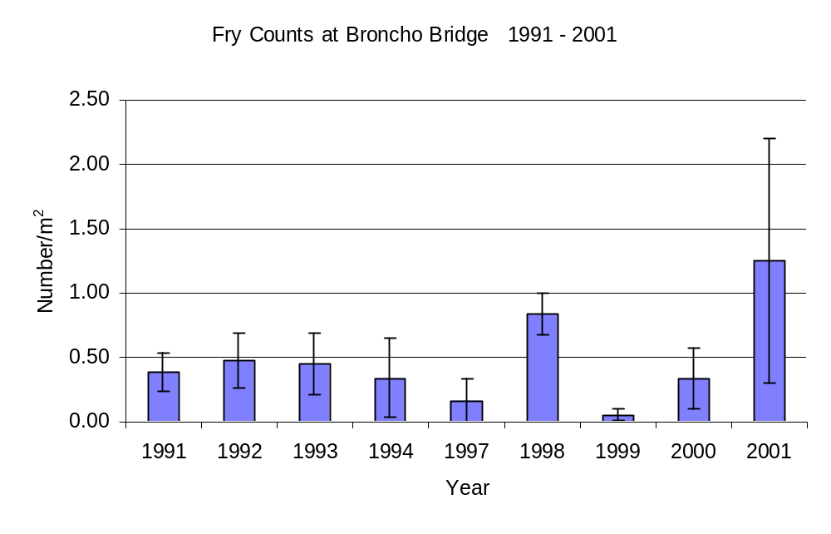Figure 1. - Mean yearly numbers of fry associated with revetments on upper Spring Creek, 1991-2001. Low numbers in 1999 and 2000 are associated with replacement of revetments making counts difficult (n=3-7 for each year).
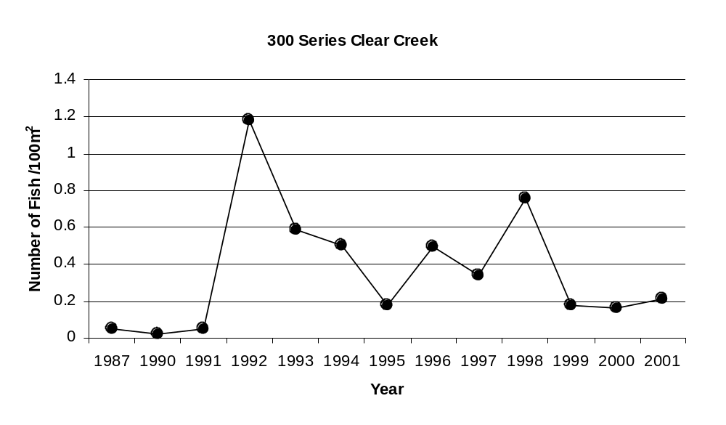
Figure 2. - Number of fish/ 100m² from 1987 to 2001 in the 300 series of Clear Creek. Restoration work began in 1991.

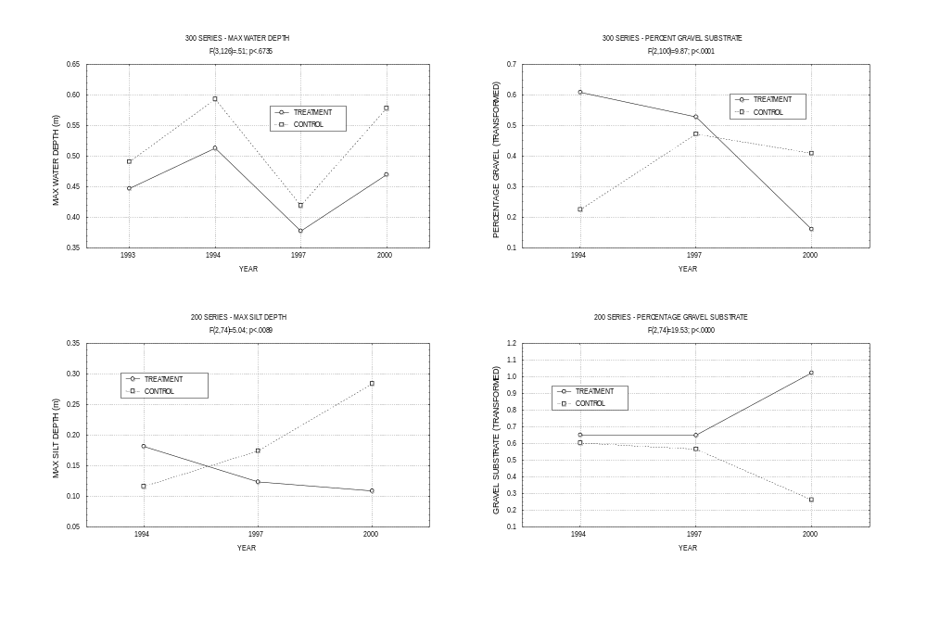
Figure 3. - Plot of means of silt and water depth, percentage gravel, in treatments and controls, Clear Creek, 2000 (n=10).

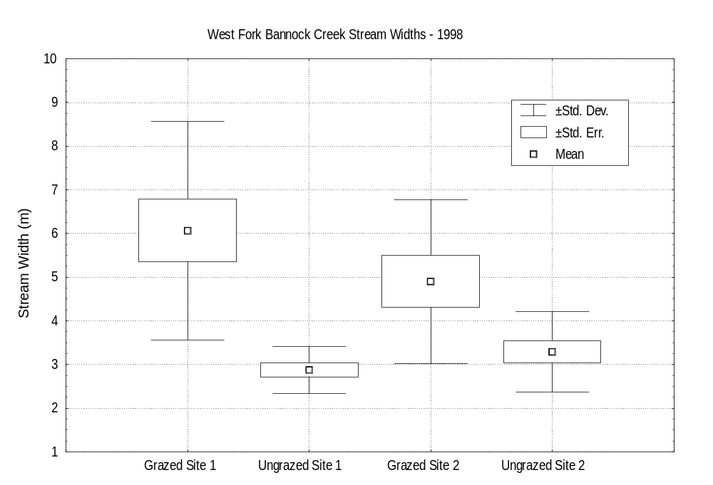

Figure 4. - Stream width in grazed and ungrazed sections of West Fork Bannock Creek, 1998 (n=10-15).

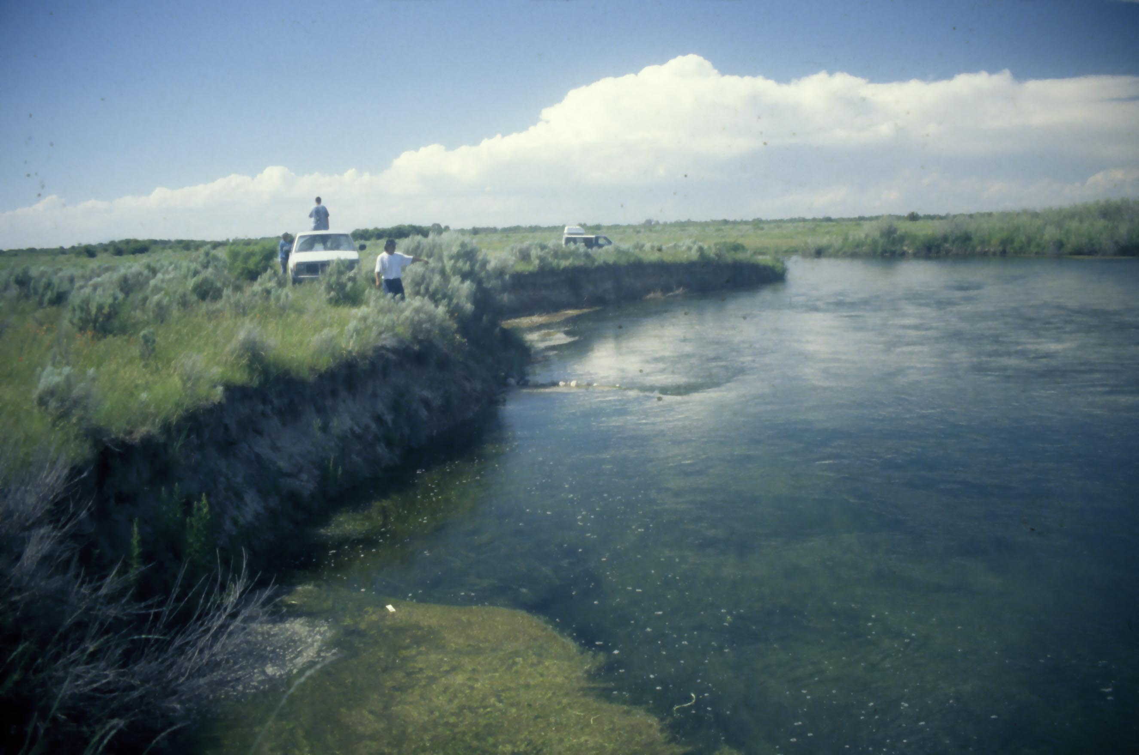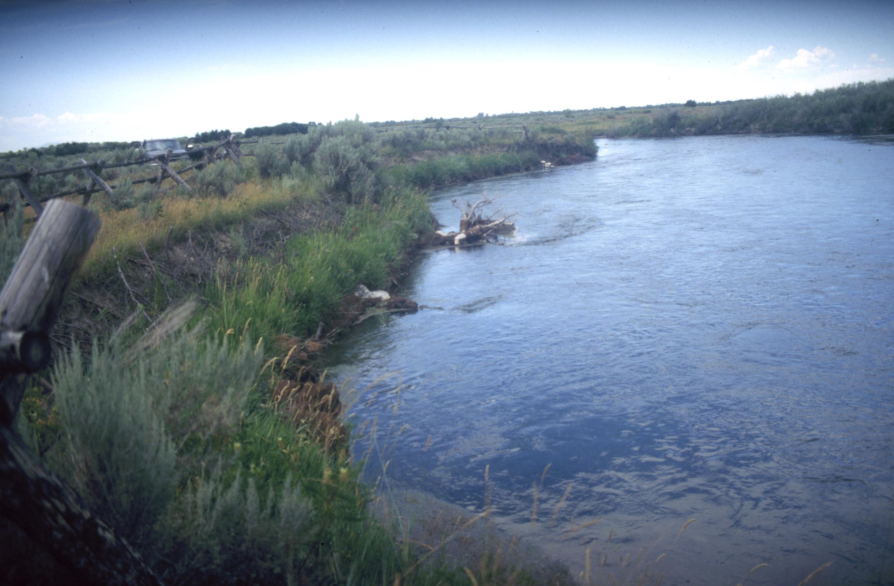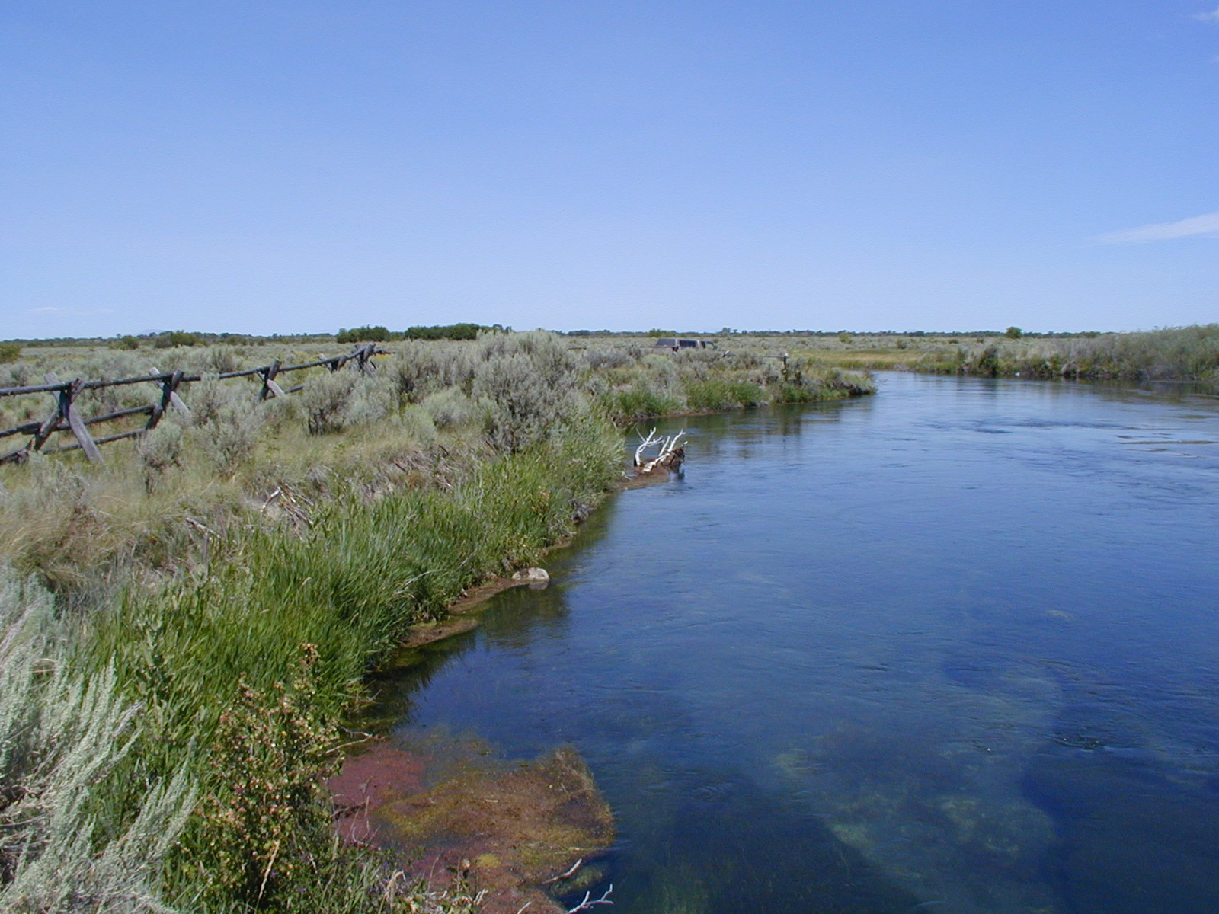
Figure 5. - Photo point, Frustration Hole, Spring Creek, 1995, 1997 and 2001. This site was sloped, seeded and fenced.

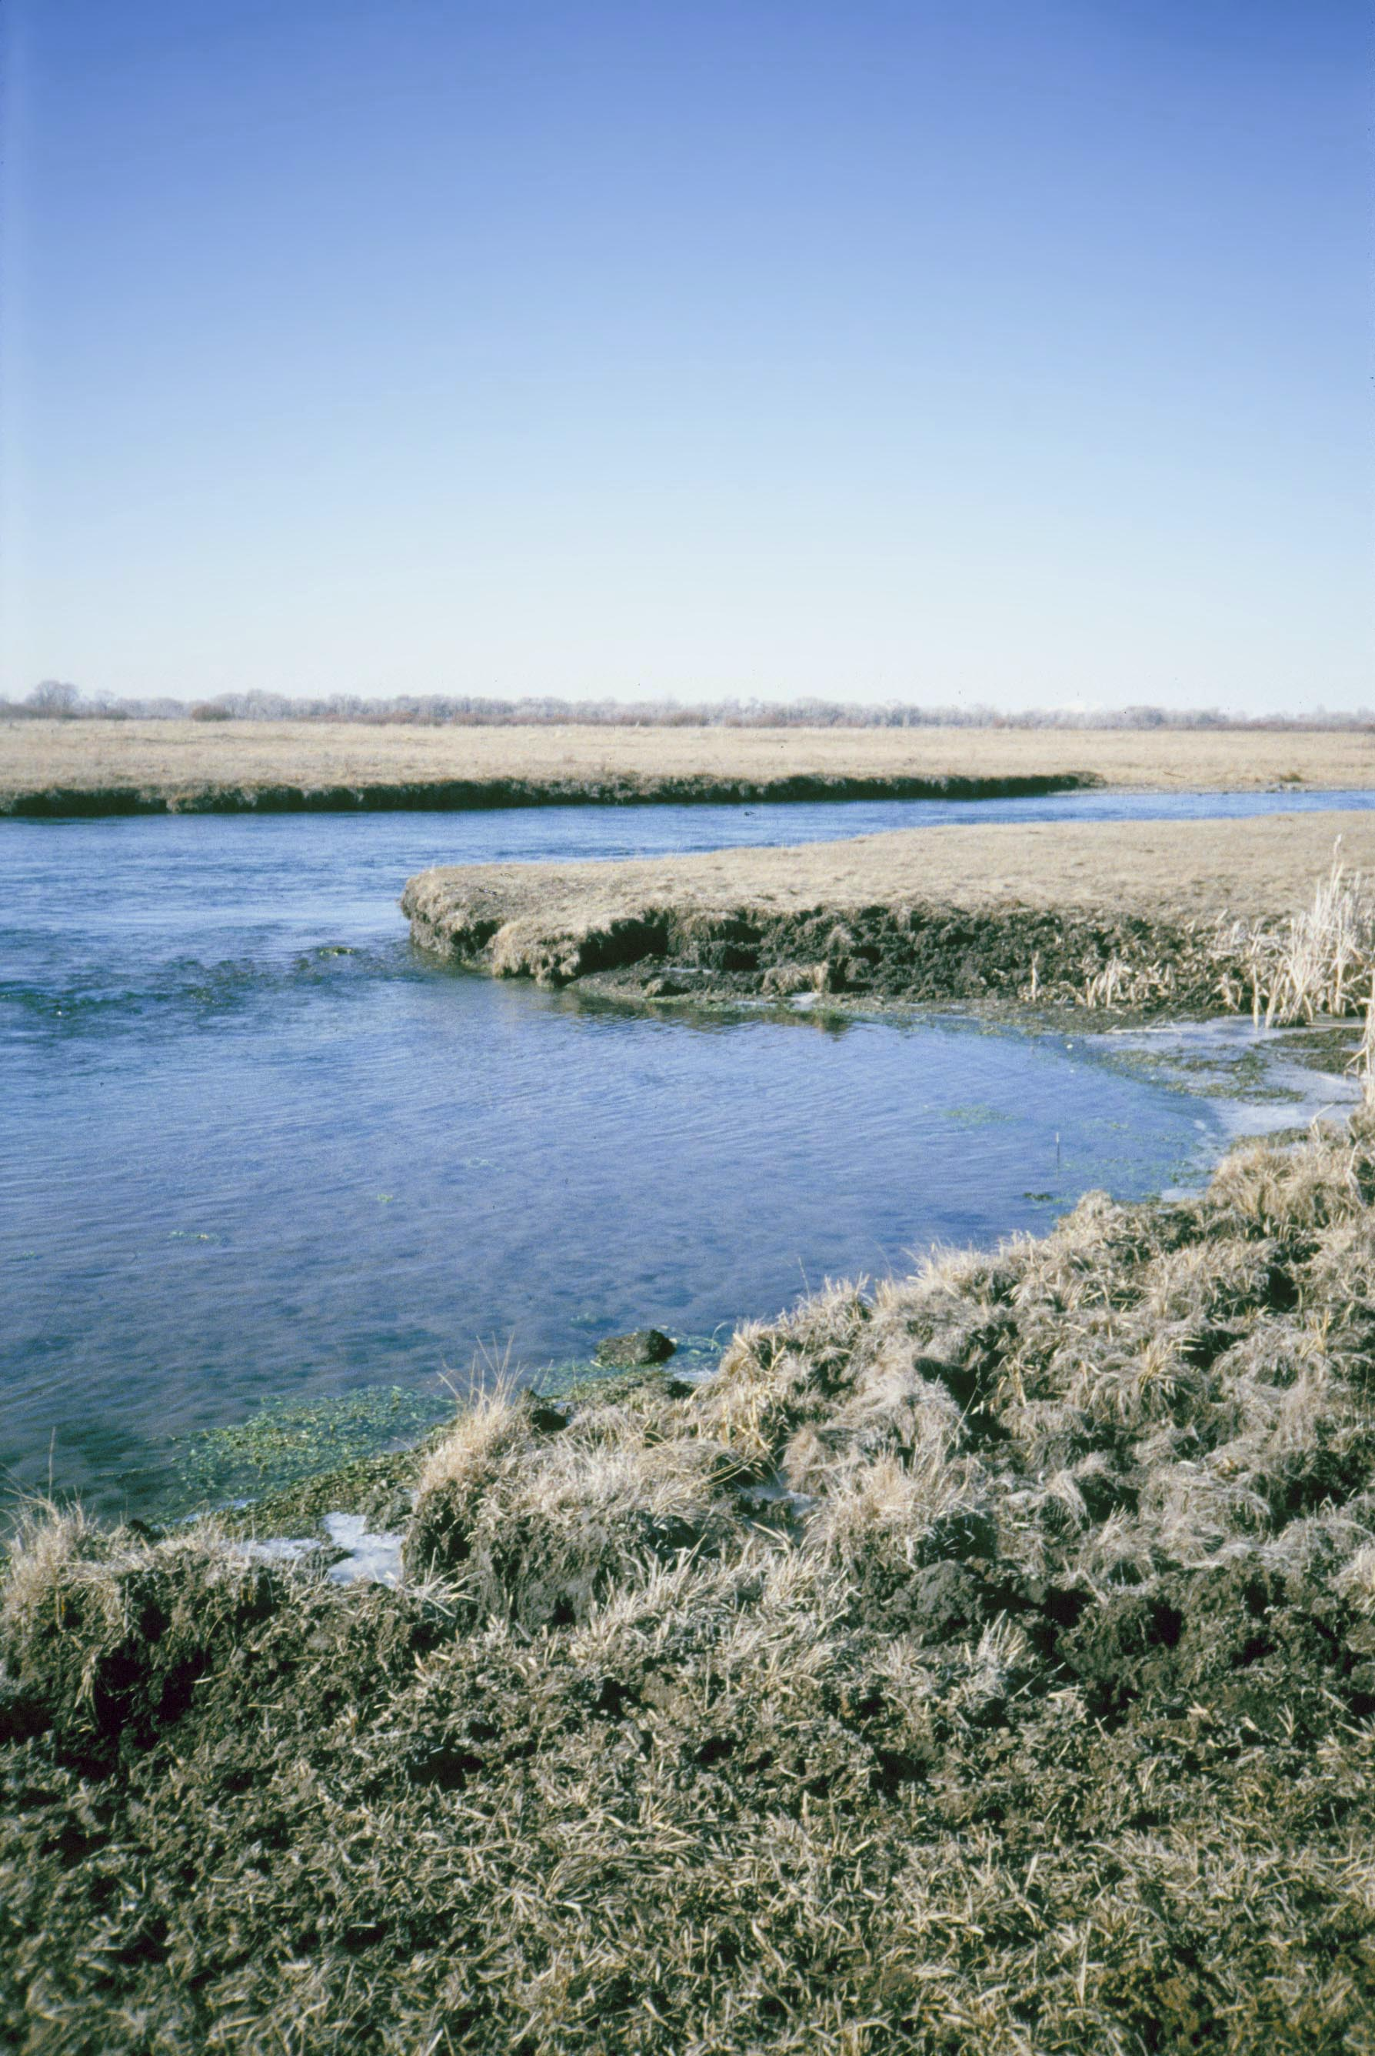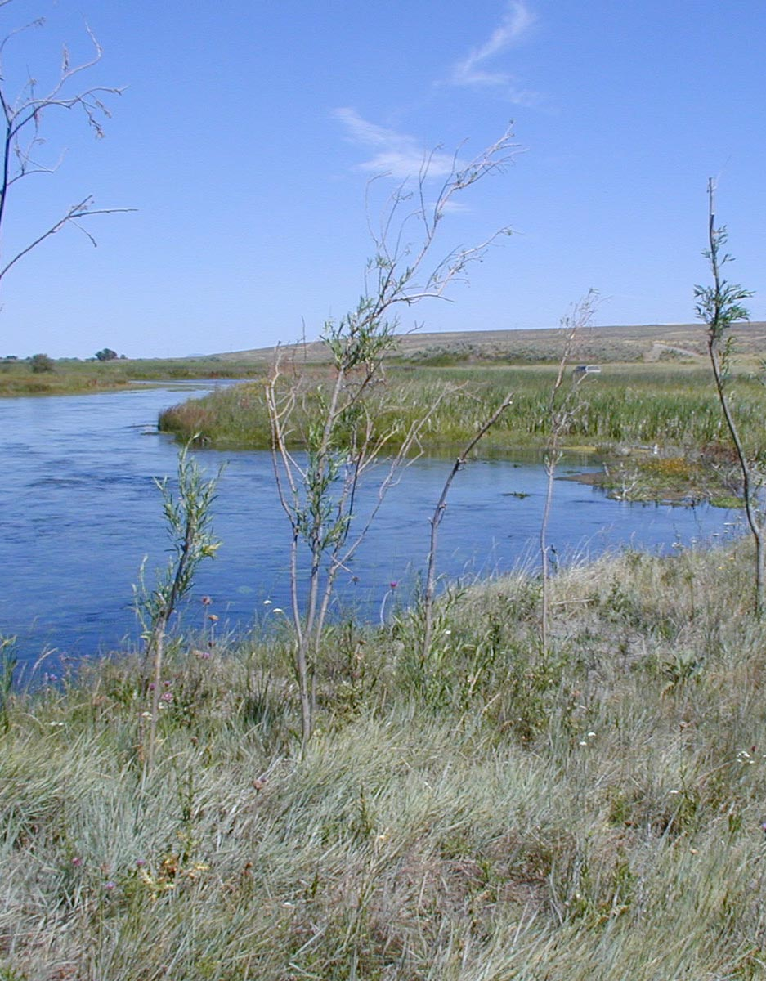

Figure 6. - Photo point head end of Spring Creek 1990 and 2001. This area was exclosure fenced in 1992 and planted with willows in 2001.

