199206200 - Yakama Nation - Riparian/Wetlands Restoration

Sponsor: Yakama Confederated Tribes
Province: Columbia Plateau Subbasin: Yakima
Budgets: FY07: $1,575,163 FY08: $1,623,313 FY09: $1,673,842
Short description: Continue implementation on YN Wetlands/Riparian Restoration Project by protecting and restoring native floodplain habitats along anadromous fish-bearing waterways in the agricultural area of the Yakama Reservation (~2,000 acres per year).
Recommendation: Response requested

This is an important project and the habitat conservation goals in some critical areas of the Yakima basin are being achieved. What is missing is evidence of a strong biological monitoring component. The proposal states that their website will be updated in FY 07 to include all the biological monitoring results, but reviewers would benefit from an interim product which covers 1992-2005. Seven years of data might reveal trends to determine if the restoration is working. A synthesis should be provided in summary form in a response to show benefits to focal species.
________________________________________________________________________

Requested Response to ISRP Comments

Biological monitoring of project protection and restoration activities.

This project consists of protection and restoration of floodplain habitats along the Yakima River, Toppenish and Satus Creeks on the Yakama Reservation in south central Washington. Currently over 20,000 acres are protected and undergoing restoration. This acreage is divided into distinct management units. A site-specific management plan is developed for each management unit. The site-specific plans identify restoration goals and the measures required to meet the goals for each propertry. A monitoring plan is also included in each site-specific plan to track the progress toward the realization of the goals for each property.

South Lateral A Wildlife Area

Though monitoring activities are occurring for all of the management units, for the purposes of this report, one management unit will be used to demonstrate the monitoring components used in this project. The unit chosen is the South Lateral A Wildlife Area. This 440 acre property along Toppenish Creek was purchased in 1993. This property, once consisting of creek channel, wetland and upland habitats, was leveled for irrigated agricultural development beginning in the 1920’s and continuing through the 1980’s. The restoration goals for the South Lateral A property are listed below. These goals are taken from the site-specific management plan for the South Lateral A Wildlife Area. The monitoring of the progress toward these goals will be presented for each goal in the plan.

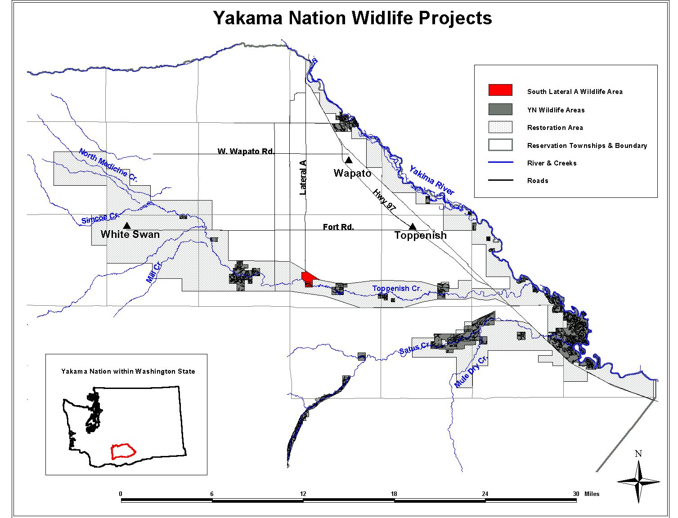
Figure 1. Location of the South Lateral A property in relation to the other lands protected in the Yakama Nation’s Wetlands and Riparian Restoration Project.

Restoration Goals for the South Lateral A Wildlife Area:
- Re-establishment of the north channel of Toppenish Creek on the property in such a manner that natural flows are allowed to return through the property and on to the adjacent lands downstream.

- Restoration of the floodplain landscape as close as possible to a pre-irrigation condition. This includes reestablishing natural land contours and hydrologic conditions necessary for wetland, riparian and upland restoration.

- Restoration of native vegetation communities associated with the floodplain landscape.

- Manage lands to provide benefits to wetland and riparian associated wildlife. This includes the reestablishment of reproduction habitat for waterfowl, upland game birds, wetland and riparian dependent songbirds, and furbearers. This also includes feeding, migration, and wintering habitat for herons, sandhill cranes, waterfowl, raptors, songbirds, and other wetland and riparian associated species.

- Manage lands to provide benefits to anadromous fish. This includes the restoration of riparian tree and shrub communities to shade the creek and to provide woody debris for juvenile hiding cover. Provide flow management in wetlands to allow passage of adult and juvenile salmonids.

- Restore culturally important vegetation for traditional use by the Yakama People. This includes tule and great basin wild rye enhancement.

- Provide access for traditional resource utilization for Yakama enrolled members. Provide supervised access for the non-enrolled public for the purposes of small game hunting, non-consumptive wildlife activities, and educational purposes.

Monitoring of the Progress Toward Meeting the Restoration Goals for the South Lateral A Wildlife Area:

Goal 1) Re-establishment of the north channel of Toppenish Creek on the property in such a manner that natural flows are allowed to return through the property and on to the adjacent lands downstream.

Toppenish Creek reconnection: In 1995 a large landscape restoration project was implemented. This project used historic aerial photographs to recreate, as best as possible, the pre-irrigation landscape features of the property. In 1996, additional restoration was completed to enhance the flood passage capabilities of the property.

Monitoring information for this goal is included in the discussion for Goal 2 below.

Goal 2) Restoration of the floodplain landscape as close as possible to a pre-irrigation condition. This includes reestablishing natural land contours and hydrologic conditions necessary for wetland, riparian and upland restoration.

Landscape restoration: In addition to the creek channel reconnection, the 1995 project was also designed to recreate, as much as possible, pre-irrigation landscape conditions. These include channel, wetland and upland area recreations according to historic photos and current landscape constraints.

North Channel and Landscape Features
Restoration and monitoring for these 2 goals involved the use of historic photos. The earliest aerial photos of this property were taken in 1937 (Fig. 2). Disturbance had already occurred by this time. Wetland and channel features, however, can be seen. The north channel, though disturbed by this date, is also visible. Additional aerial photos were created approximately every 10 years since 1937. The gradual conversion of the property to its state at the time of purchase can be seen in these photos. The photo from the 1980’s represents the condition upon inclusion into this project (Fig. 3).

Restoration of the landscape features, including the north channel occurred in 1995-1996. The 2002 aerial photo is used to compare the restored landscape with the historic (Fig. 4).
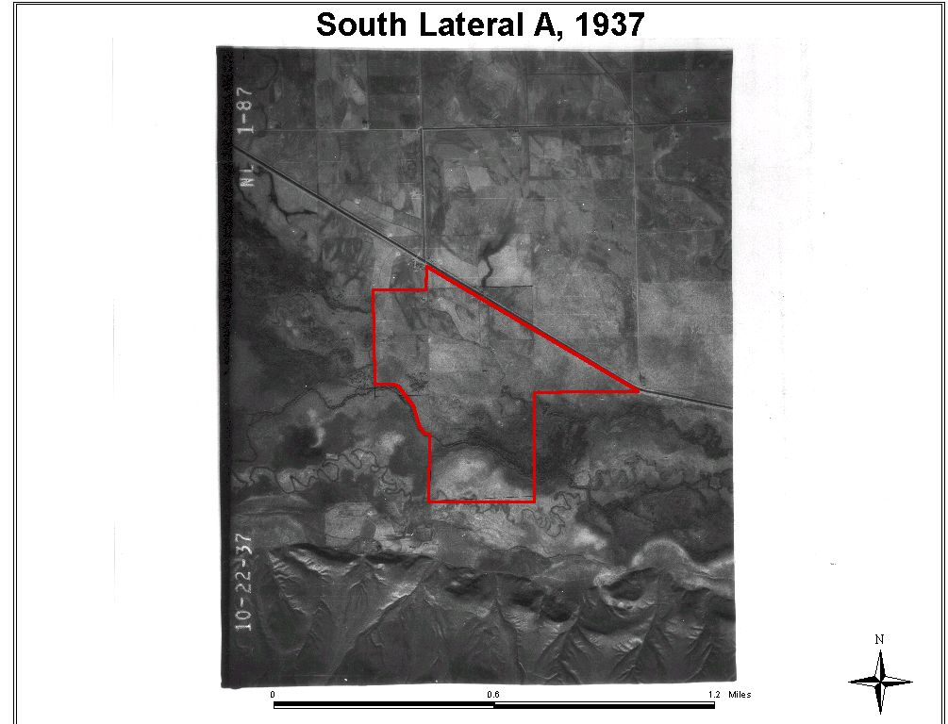
Figure 2. South Lateral A property aerial view – 1937.

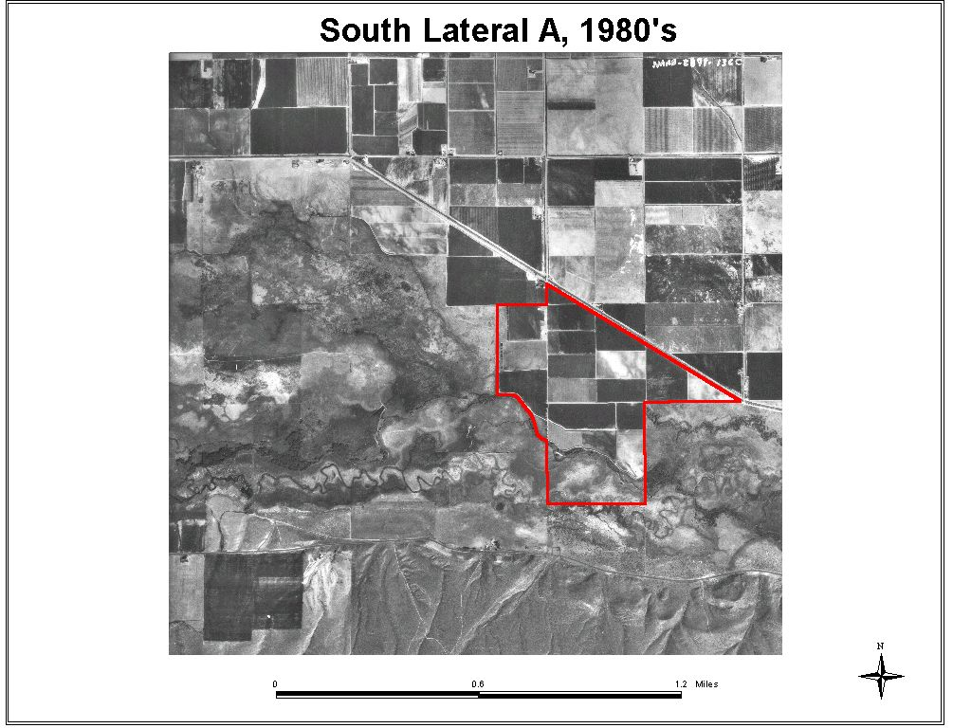
Figure 3. South Lateral A property aerial view – 1980’s.

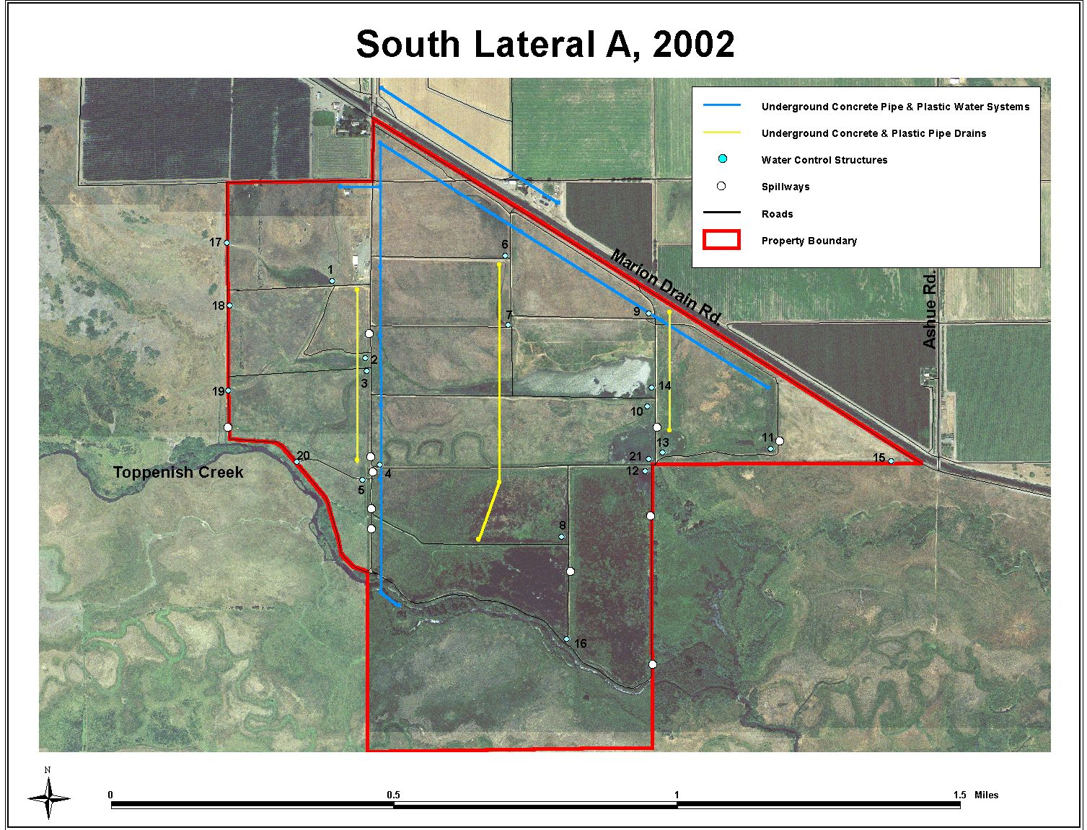
Figure 4. South Lateral A, 2002.
Groundwater Monitoring
In addition to aerial photo interpretation, hydrologic restoration is being monitored through the use of a series of piezometers and surface water measuring locations. This monitoring effort began in 2005. In addition to showing the hydrologic response of restoration on the South Lateral A property, this project is designed to document the hydrologic effects of a large agricultural drain on the Toppenish Creek hyporheic zone, and to measure the response to a large channel and wetland reconnection project that is occurring from the South Lateral A property downstream for 3 miles. Grade control structures are being installed to raise the level of the currently incised creek channels to their historic elevation. This work will be occurring in August and September of 2006. The monitoring at this point documents the baseline conditions (Figs. 5-6).
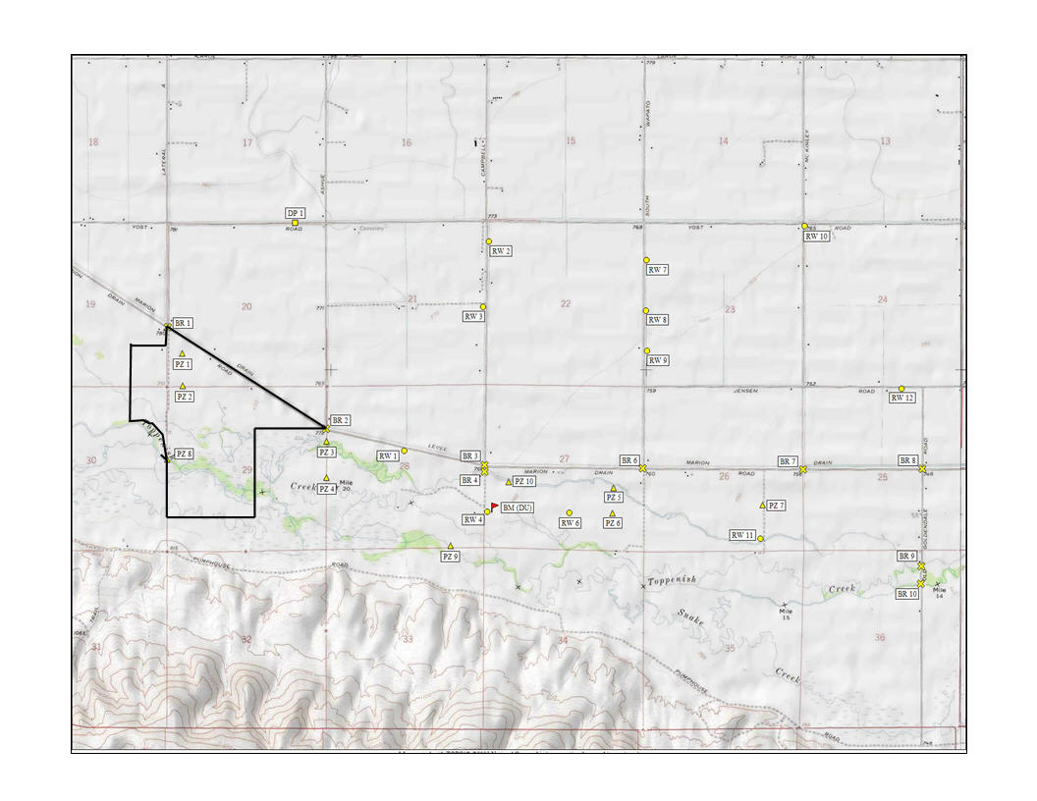
Figure 5. Locations of groundwater and surface water monitoring sites on South Lateral A property and adjacent areas.

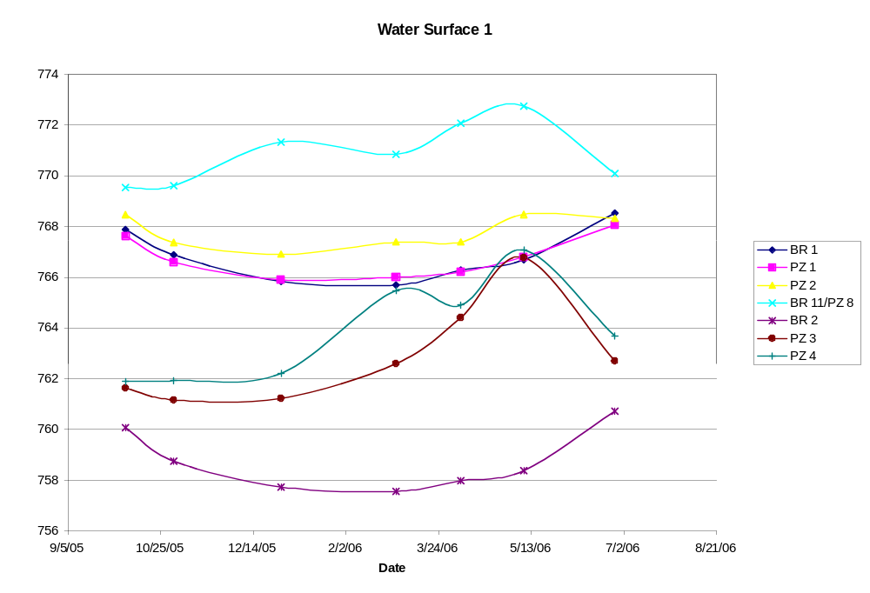
Figure 6. An example of the baseline water surface elevations on the South Lateral A Wildlife Area.
Goal 3) Restoration of native vegetation communities associated with the floodplain landscape.

Vegetation monitoring consists of quantitative, qualitative and photomonitoring components. Because the Toppenish Creek corridor still contains a source of native wetland and riparian plant seed, most of the revegetation of these areas is being allowed to occur naturally. The exceptions to this are the limited areas that were planted with willow and cottonwood cuttings in 1996 and 1997 by a Salmon Corps crew. These plantings occurred along the channels and wetlands recreated in the 1995-1996 project. Upland areas do not re-vegetate naturally, and are being replanted to Great Basin wild rye.

1) Comparison of vegetation cover type acres between 1995 and 2005 using vegetation cover type maps

Table 1. Extent of vegetation cover types on the South Lateral A Wildlife Area.
Year | Agriculture acres | Shrub-Steppe/Grassland acres | Emergent Wetlands acres
1995 | 361 | 46 | 0
1999 | 1 | 257 | 139
2005 | 17 | 259 | 140
change 1995-2005 | -344 | +213 | +140

Vegetation cover type maps of the South Lateral A property have been compiled in 1995, 1998, and 2005. A comparison of cover types from 1995, when restoration was initiated, and 2005 shows that some vegetation cover types (Figs. 7-8) show substantial change between 1995 and 2005. Most of this change occurred in from 1995 to 1999, which reflects the conversion of agricultural lands to more natural cover types. While different methods (grid dot-count in 1995, GIS heads up digitizing in 2005) were used to interpret cover types from aerial photos, observations by Yakama Nation Wildlife staff and management confirm the direction and magnitude of the change. In addition, GIS analysis showed that in 2005 over 40 acres of the emergent wetland consisted of tule, tule/cattail, and wapato dominated areas. These are important cultural resources and contribute substantially to the value of the South Lateral A site. Cover type definitions can be found in Bich 1991.

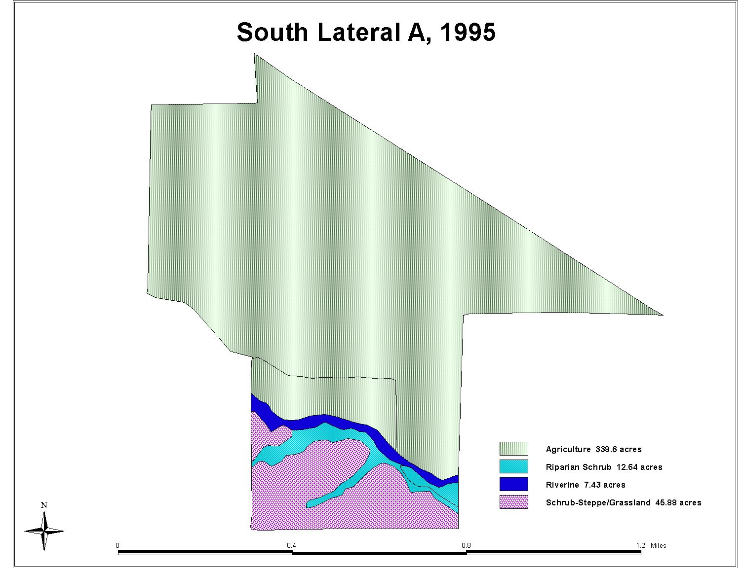
Figure 7. South Lateral A baseline habitat cover types – 1995.

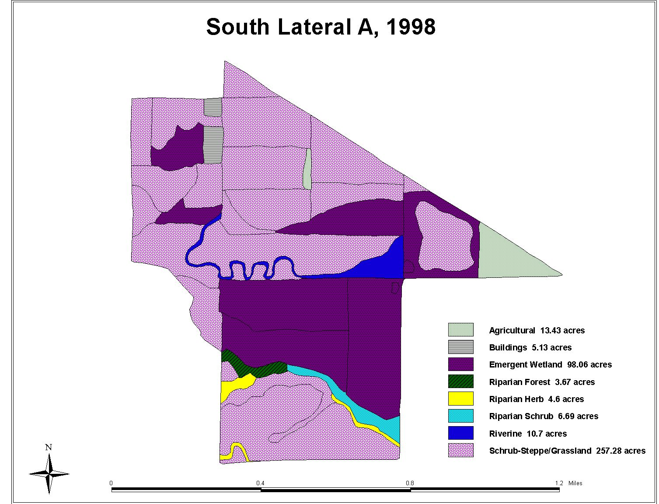
Figure 8. South Lateral A habitat cover types – 1998.
2) Comparison of extent of riparian scrub along Toppenish Creek from 1992 to 2005.

Table 2. The extent of riparian scrub habitat on the South Lateral A property.
Year | Acres of Riparian Scrub | Linear feet of scrub polygons (perimeter/2)
1992 | 3.4 | 1260
2005 | 4.8 | 2265
Percentage change | + 41 % | + 80 %

The boundary of riparian scrub was delineated along Toppenish Creek within the South Lateral A boundary. Area and perimeter were calculated using ArcView GIS. Results are shown in Table 2. A time series of the area described can be seen in Figure 9.

3) Vegetation point intercept transect data.

Table 3. Pooled averages for 4 grassland transects, 1998 (Raedeke 2000) and 2005 data (Ashley 2005).
Year | Cover Type | Total % canopy cover
1998 | Shrub-Steppe Grassland | 58
2005 | Shrub-Steppe Grassland | 92
 | Percent change | + 59

Total mean canopy cover increased for all transects, perhaps as a result of recovery from agriculture and grazing use.

Table 4. Pooled averages for 2 riparian scrub, 1992 (Raedeke 2000) and 2005 (Ashley 2005).
Year |  | species | mean height (ft) | % canopy cover
1992 | Riparian Shrub | All species | 0 | 3
2005 | Riparian Shrub | willow species | 6.4 | 34
2005 | Riparian Shrub | Russian olive | 3.8 | 0.3
 | Percent change (willow only for 2005) |  |  | 1033

Mean canopy cover and height increased substantially from 1992 to 2005, reflecting the increase in extent and stature of riparian scrub along Toppenish Creek. This data shows a similar trend for shrubs as does the riparian shrub cover data shown in Table 2. The increase in shrubs can be also be observed visually (Fig 9.).

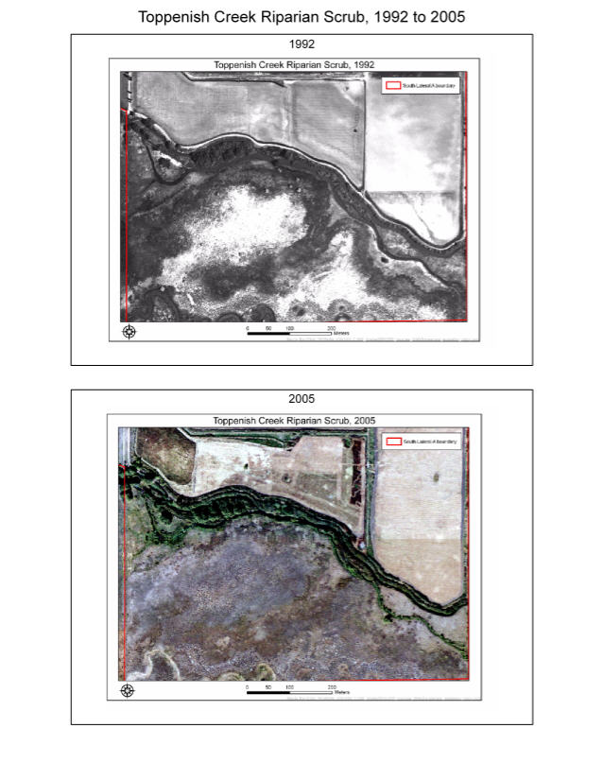
Figure 9. Riparian scrub on the South Lateral A property 1992 and 2005.

Photomonitoring

Photomonitoring sites have been developed to provide visual documentation of vegetation changes over time. The photos included here are a subset of those developed for the property. These photos (Figs. 10-20) were chosen to show the change in vegetation pre- and post restoration. Some of the photos were taken before the property was purchased.

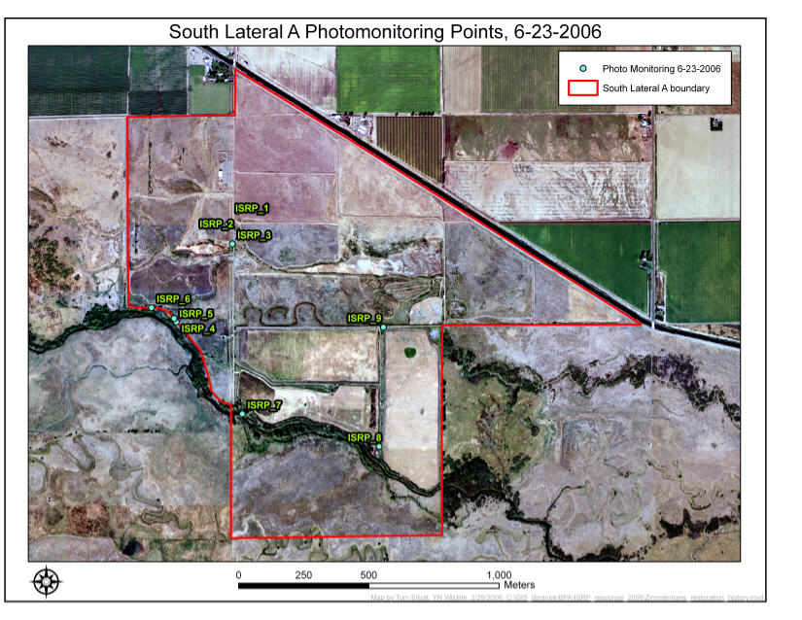
Figure 10. Photomonitoring locations on the South Lateral A Wildlife Area. This photo was taken in August 2005 when the wetlands on the property were drawn down for management purposes.
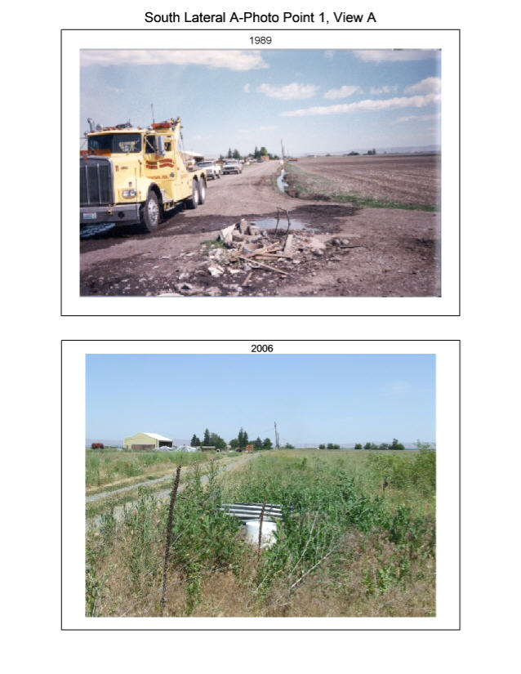
Figure 11. Photopoint 1, View A – looking north. Hay and wheat fields have been converted to native grass.

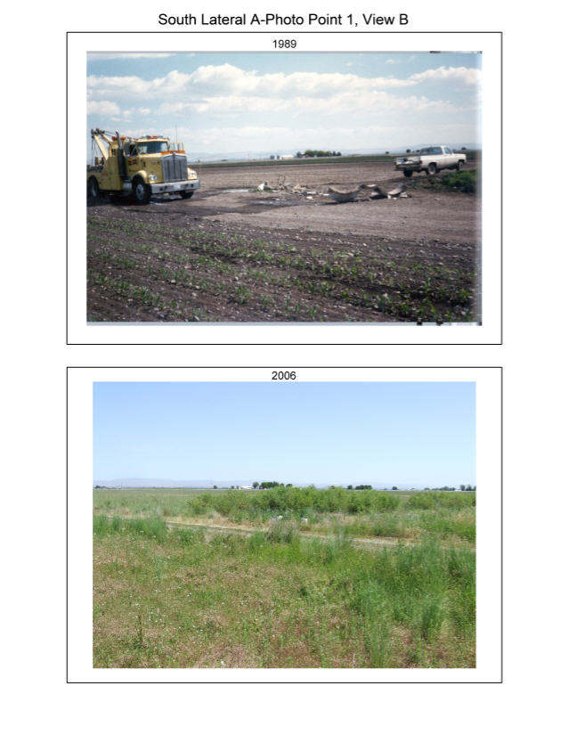
Figure 12. Photopoint 1, View B – looking northeast. Hay and wheat fields have been converted to native grass and shrubs.

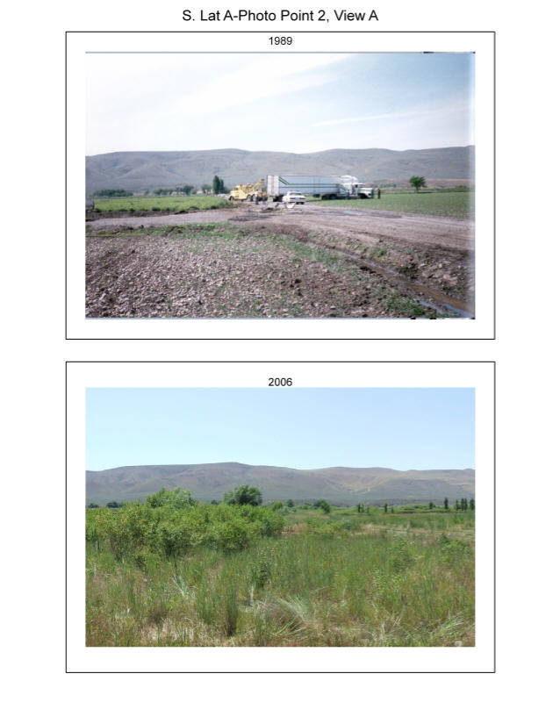
Figure 13. Photopoint 2, View A – looking southwest. Hay and wheat fields have been converted to native grass and shrubs.

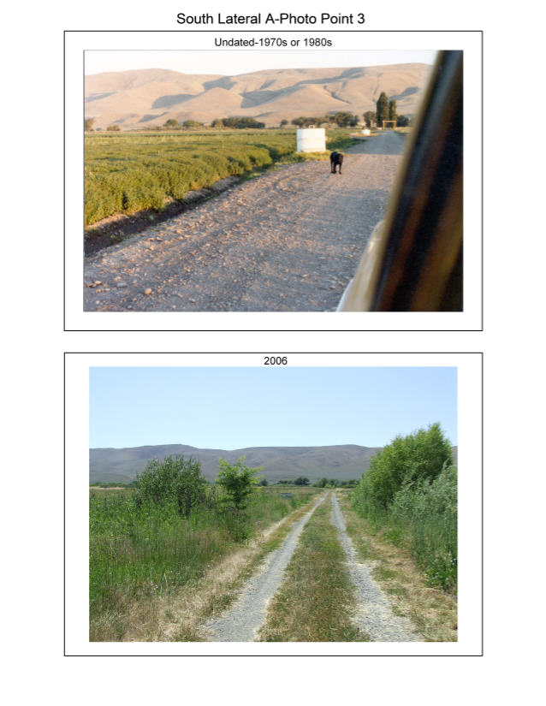
Figure 14. Photopoint 3, – looking south. Hay and wheat fields have been converted to native grass and shrubs.

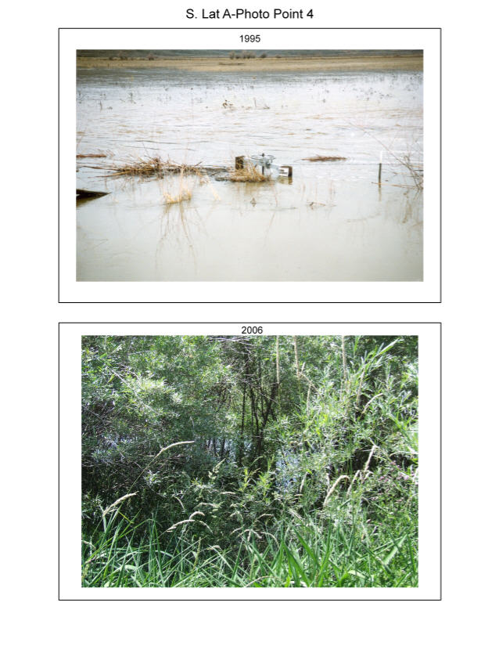
Figure 15. Photopoint 4, – looking west. No riparian vegetation existed pre-restoration on this portion of Toppenish Creek.

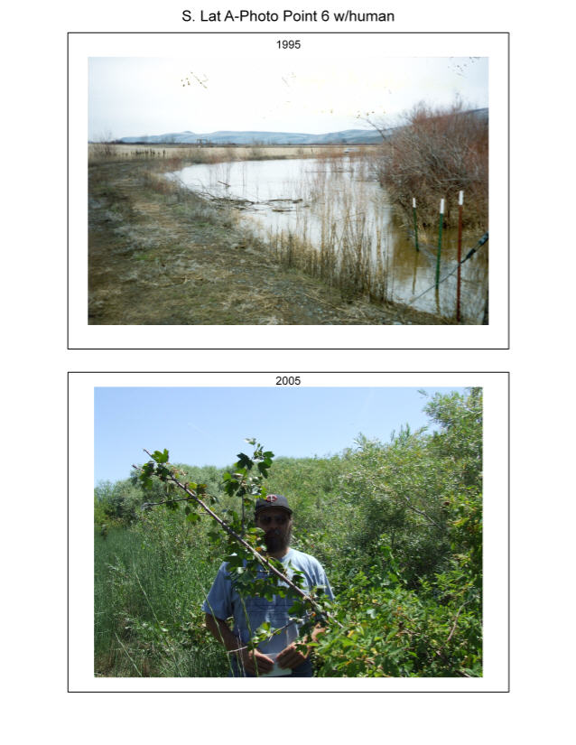
Figure 16. Photopoint 6, with human – looking southeast. Currant and willow have returned to previously barren areas on Toppenish Creek.

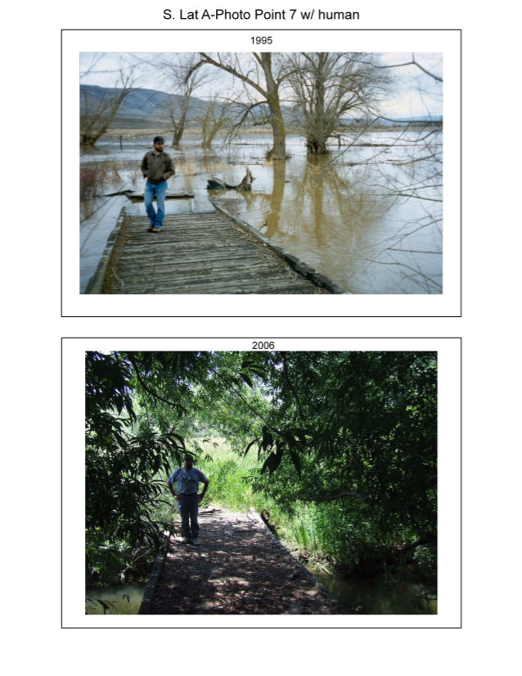
Figure 17. Photopoint 7, with subject – looking south. Willow and grass restoration on Toppenish Creek.

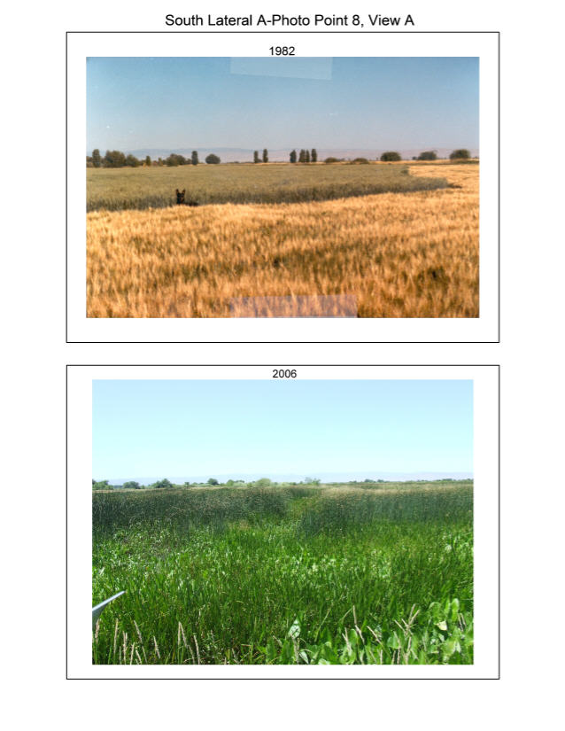
Figure 18. Photopoint 8, View A – looking northwest. A wheat and barley field has been restored to a tule, wapato, burreed dominated emergent marsh.

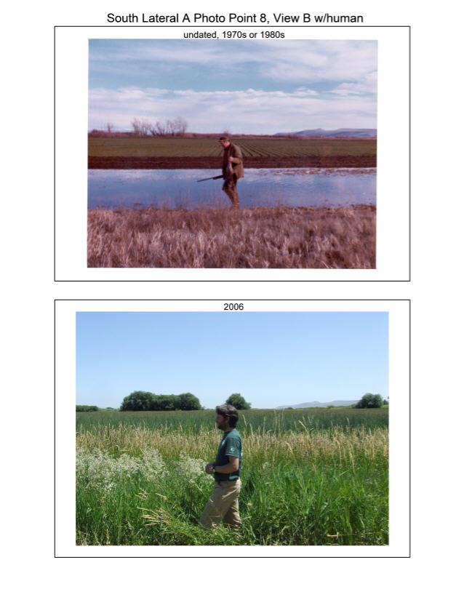
Figure 19. Photopoint 8, View B, with subject – looking east. A wheat and barley field has been restored to a tule, wapato, burreed dominated emergent marsh.

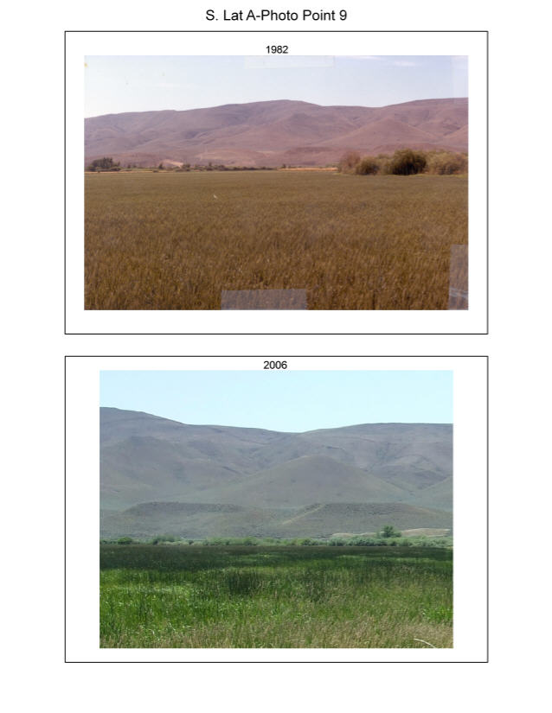
Figure 20. Photopoint 9, – looking south. A wheat and barley field has been restored to a tule, wapato, burreed dominated emergent marsh.

Summary

In general, vegetation cover of grassland, emergent wetland, and riparian shrub have increased substantially on the South Lateral A property from the early 1990s to the 2005, as shown by GIS cover type mapping and vegetation point intercept data. These trends correspond to the direct observations of managers and staff. This change may be attributed to 2 major factors: the cessation of agricultural use for crops and grazing, and concomitant management actions to restore floodplain hydrology, control exotic plants, and restore native grassland vegetation. The improvement in the integrity of the vegetation has provided wildlife habitat, cultural resources, and aesthetic values for an area that is key to ongoing restoration in the Toppenish Creek floodplain.

Goal 4) Manage lands to provide benefits to wetland and riparian associated wildlife. This includes the reestablishment of reproduction habitat for waterfowl, upland game birds, wetland and riparian dependent songbirds, and furbearers. This also includes feeding, migration, and wintering habitat for herons, sandhill cranes, waterfowl, raptors, songbirds, and other wetland and riparian associated species.

The actions described above also benefit the wildlife resources of the property. In addition the benefits derived from hydrologic and habitat restoration, conditions favorable to wildlife will be maintained through strict control on human access into the property. Because a major portion of the Yakama Nation’s Wetland and Riparian Restoration Project is devoted to the restoration of native plant and hydrologic conditions (habitat), artificial nesting structures will only be used under very special circumstances. There are currently no plans to utilize them in any matter on the property. Responses of wildlife to our restoration efforts are monitored through annual counts and banding operations. We conduct annual counts on non-game birds, quail and pheasant broods, breeding eagles, doves and waterfowl, wintering waterfowl and bald eagles. Due to the landscape nature of these counts, they are not specific to individual properties that we have under restoration, but provide us with trend data in areas containing these properties. We also conduct annual operations banding waterfowl and doves.

Mourning Dove Coo-Counts

In conjunction with the United States Fish and Wildlife Services Webless Migratory Game Bird Program, we conduct mourning dove call-counts to estimate the number of breeding mourning doves. Protocol and routes are chosen by the USFWS. These routes do not change and provide continental population estimates. The population estimates are used to set dove seasons and bag limits. On the Yakama Reservation these counts are conducted annually on 2 routes the last full week in May. Since 2000, the number of breeding pairs has increased 23% (Fig. 21). The increase is greater on the Pumphouse route which follows Toppenish Creek where the South Lateral A Wildlife Area is located.

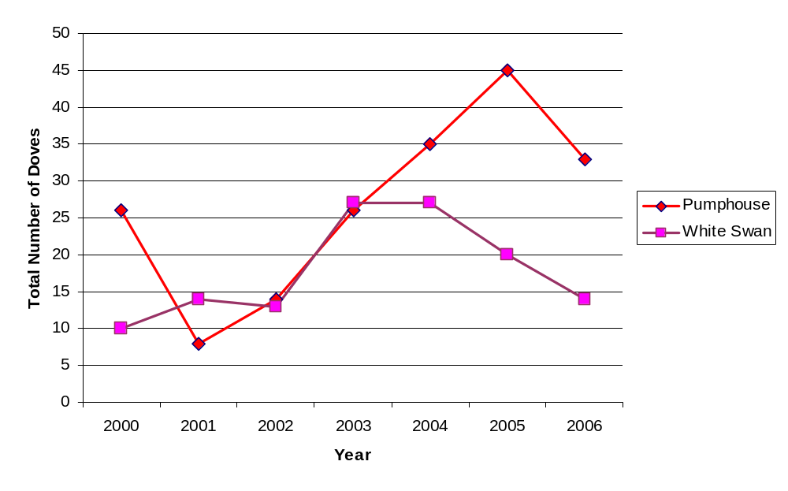
Figure 21. Total number of mourning doves seen and heard on the Pumphouse and White Swan dove call count routes on the Yakama Reservation from 2000 through 2005.

Non-Game Birds

With the help of the Yakima Valley Chapter of the Audubon Society, we began documenting birds found on 5 restoration properties. Volunteers visit these properties at least once during each season and record the species and numbers of each species seen during the visit. The number of bird species seen ranged between 6 and 66 per visit. The highest total number of species observed are found on the South Lateral A property (Fig. 22) and on the Satus property. This is probably a result of the diverse habitat found on this property and these properties are farther along in their restoration than the other properties. The lowest number of species observed occurred on Campbell Road property even though it is less than 2 miles from the South Lateral A property. The Campbell Road property, however, did host nesting ravens in 2005. We are just beginning to restore this property. These surveys allow us to document any changes in bird diversity as restoration continues over the course of the next few years. Currently, we are analyzing data and attempting to modify protocol to provide the most reliable data to monitor our restoration efforts. Results from these surveys will allow us to make better management decisions on lands managed by the Yakama Nation Wildlife Resource Management Program.
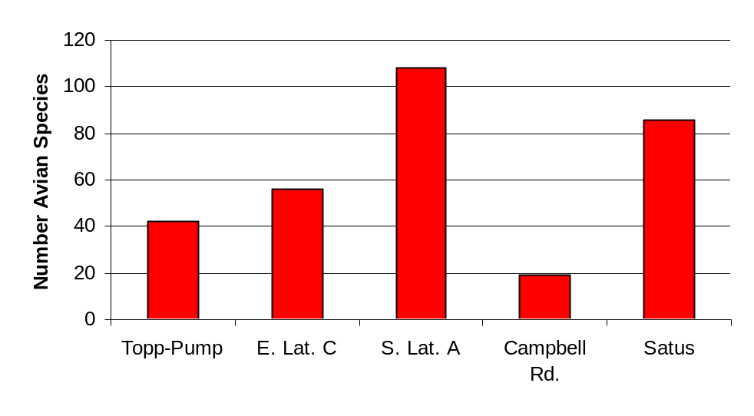
Figure 22. Number of avian species found on Toppenish-Pumphouse (Topp-Pump), East Lateral C (E. Lat. C), South Lateral A (S. Lat. A), Campbell Road (Campbell Rd.) and Satus Wildlife Area (Satus) properties.

Waterfowl Breeding Pair Counts

We conduct waterfowl breeding pair annually during the second week of May. These counts are conducted at 15 different sites. These counts allow us to monitor duck responses to our restoration efforts and make proper management decisions. In 1999, we added South Lateral A to the Breeding Pair Counts. Counts have remained relatively constant over the last 4 years (Fig. 23). When adjusted for the area surveyed, the South Lateral A property produces 11 times as many mallards per acre as is produced on average throughout the valley.

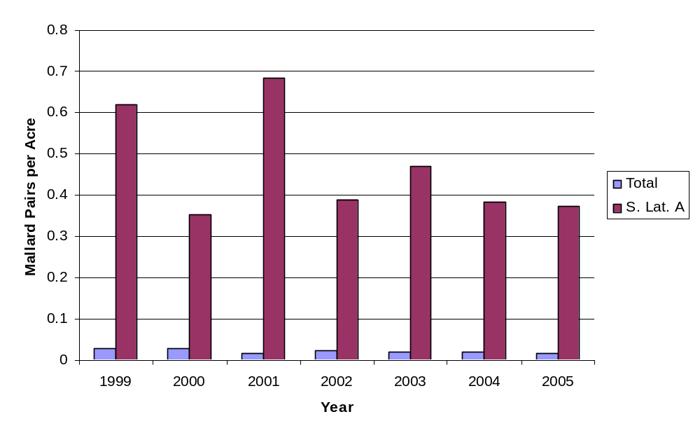
Figure 23. Number of mallard pairs per acre counted during pair counts conducted in May on the Lower Yakima Valley compared to South Lateral A properties.

Mid-Winter Waterfowl Counts

In conjunction with the U.S. Fish and Wildlife Service, we conduct winter waterfowl counts during January and February. These counts provide us an estimate of the wintering waterfowl population and the distribution of wintering waterfowl. The Toppenish Creek count is divided into 4 areas. No waterfowl hunting is allowed in both the West Refuge (W. Refuge) and East Refuge (E. Refuge). Both these areas contain land managed by the U.S. Fish and Wildlife Service and the Yakama Nation Wildlife Management Program. The Toppenish National Wildlife Refuge allows very limited hunting on a small portion of the refuge and is managed by the U. S. Fish and Wildlife Service. The Mid-Toppenish Creek (Mid-Topp) is a mixture of land owned by private individuals, duck hunting clubs, U.S. Fish and Wildlife Service, and the Yakama Nation Wildlife Management Program. South Lateral A is in the Mid Topp portion of Toppenish Creek. Mallard counts from January show a large portion of the wintering waterfowl using the refuges (Fig. 24). This is probably due to hunting pressure on other portions of Toppenish Creek. After the hunting season, the mallard distribution shifts towards the Mid Topp area as indicated by the February counts (Fig. 25). This shows that Mid Topp is an important waterfowl wintering area that provides important food for waterfowl.

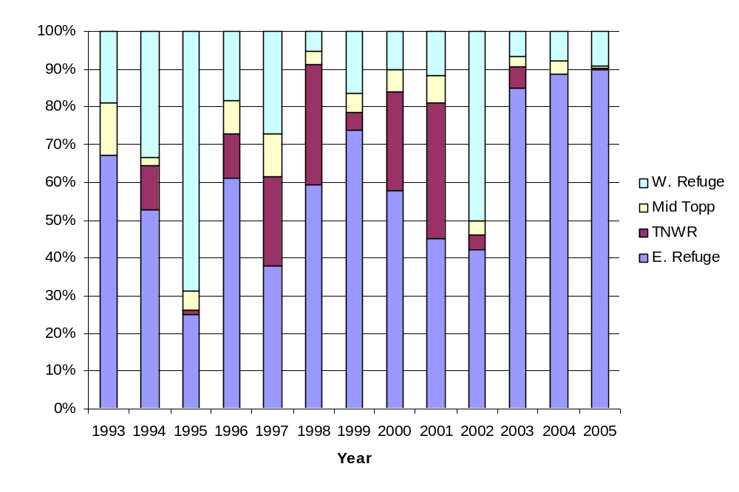

Figure 24. Distribution (percent of wintering population) of wintering mallard on Toppenish Creek during January waterfowl counts on the Lower Yakima Valley.

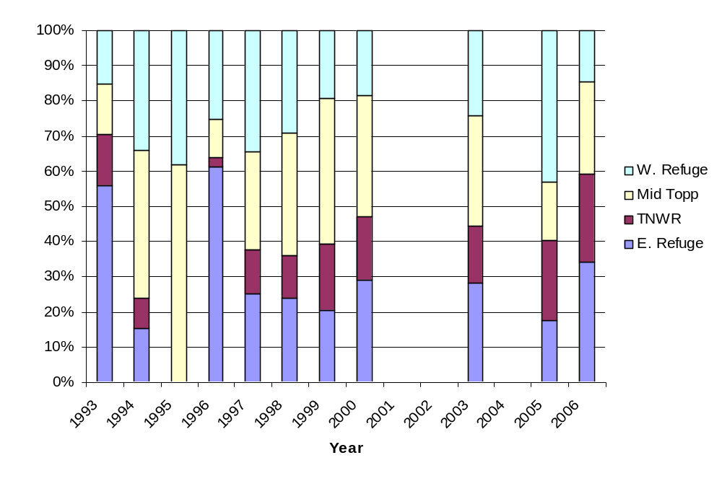

Figure 25. Distribution (percent of wintering population) of wintering mallard on Toppenish Creek during February waterfowl counts on the Lower Yakima Valley.
Goal 5) Manage lands to provide benefits to anadromous fish. This includes the restoration of riparian tree and shrub communities to shade the creek and to provide woody debris for juvenile hiding cover. Provide flow management in wetlands to allow passage of adult and juvenile salmonids.

As with wildlife, the anadromous fish goals are tied in to the restoration of the hydrologic and vegetative conditions. Restoration of native hydrologic conditions provides for safe passage by adult and juvenile salmonids. Wetland and floodplain reconnection allows for the natural recharging of groundwater necessary for maintaining the quantity and quality of water necessary for salmonid needs.

Monitoring of salmonids populations in the Toppenish Creek watershed is conducted by the Yakama Nation Fisheries Program under contract with Bonneville Power Administration (Project Number 199603501). One example of this effort is provided in the table below.

 | Ladder Counts (July 1 to June 30) |  |  |  | Redd Counts
Year Ending | Prosser Wild | Prosser Hatchery | Roza Wild | Roza Hatchery | Satus | Toppenish | Ahtanum | Naches Tribs
1985 | 2191 | 0 | 6 | 0 | * | * | * | *
1986 | 2230 | 0 | 3 | 0 | * | * | * | *
1987 | 2424 | 41 | 0 | 0 | * | * | * | *
1988 | 2601 | 239 | 0 | 0 | 445 | * | * | *
1989 | 1066 | 96 | 0 | 0 | 404 | 45 | * | *
1990 | 727 | 87 | 0 | 0 | 289 | 26 | * | *
1991 | 730 | 104 | 0 | 0 | 125 | * | * | *
1992 | 2012 | 251 | 107 | 9 | * | * | * | *
1993 | 1104 | 80 | 15 | 0 | 73** | * | * | *
1994 | 540 | 14 | 28 | 0 | 114 | * | * | *
1995 | 838 | 87 | 22 | 1 | 85*** | * | * | *
1996 | 450 | 54 | 90 | 2 | 148 | * | * | *
1997 | 961 | 145 | 22 | 0 | 76 | 5** | * | *
1998 | 948 | 165 | 51 | 0 | 190 | 13** | * | *
1999 | 1018 | 52 | 14 | 0 | 130 | 78 | * | *
2000 | 1571 | 40 | 14 | 0 | 169 | 185 | 11 | *
2001 | 3032 | 57 | 133 | 7 | 102 | 355 | 8 | *
2002 | 4491 | 34 | 236 | 2 | 240 | 111*** | 13*** | *
2003 | 2190 | 45 | 128 | 6 | 319 | 161*** | 16*** | *
2004 | 2739 | 16 | 211 | 2 | 93 | 56*** | 12*** | 94
2005 | 3377 | 74 | 224 | 0 | 108 | 99 | 16 | 140
* No survey
** Partial survey.
*** Survey affected by poor redd visibility

Cultural Resources

Goal 6) Restore culturally important vegetation for traditional use by the Yakama People. This includes tule and great basin wild rye enhancement.

Natural revegetation has allowed for a large increase in wetland plants important to the Yakama People. This is due to the efforts of restoring the native hydrologic and landscape components of the property. Tule beds, nearly non-existent when the property was farmed, are now common enough to provide harvest opportunities each year to many tribal members. As the upland and riparian areas develop, they will also soon be providing opportunities for the harvest of wild rye, dogwood and wild rose. Wildlife resource use is occurring in the form of waterfowl harvest. Yakama tribal members use of the property for waterfowl and furbearer harvest is increasing annually.

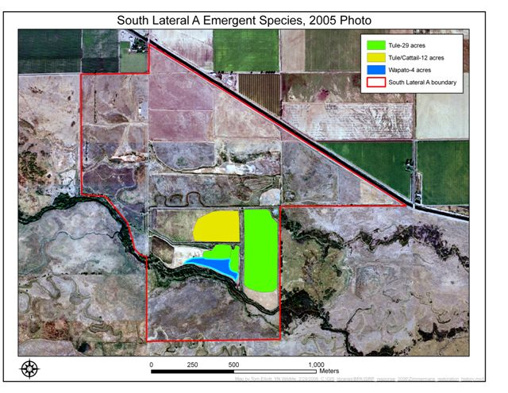
Figure 26. Extent of tule and wapato in the south wetland areas of the South Lateral A Wildlife Area.

The acquisition of the South Lateral A property by the Yakama Nation’s Wetlands Restoration Project has allowed the Yakama Nation to restore many of its traditional use plants.

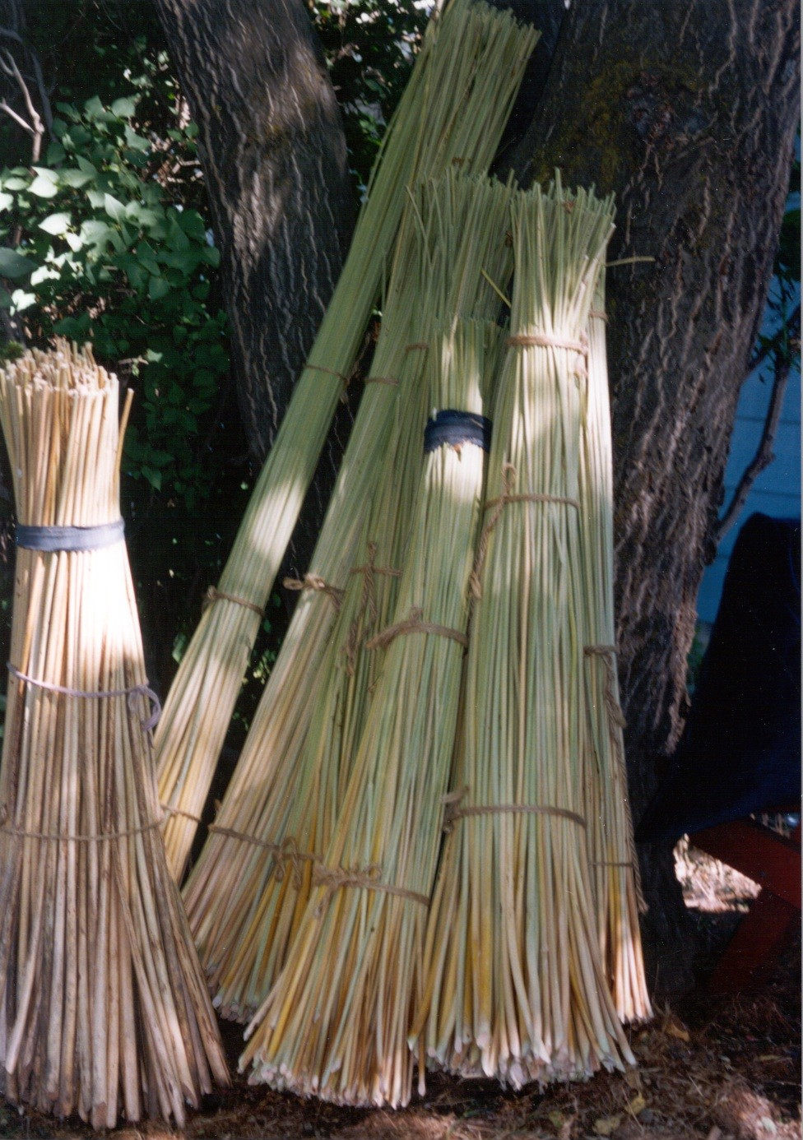

Tule: (Scirpus acutus)
Restoration activities have succeeded in producing 29 acres of tule and an additional 12 acres of mixed tule and cattail. (Fig. 26) This wetland plant was not present on the property until after restoration activities began. At the South Lateral A property tule reed has succeeded in establishing itself due to better wetlands management practices. The success of this restoration activity has been accomplished by the annual draining, mowing, and burning of the tule ponds. These activities have resulted in a higher quality tule according to tribal member interviews.

Wapato: (Saggitaria sp.)

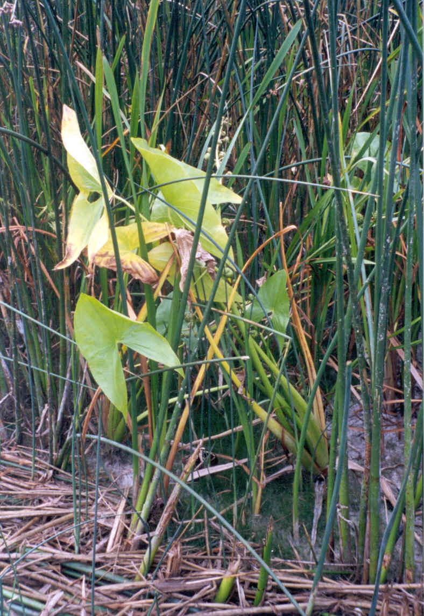

Wapato (Saggitaria sp.) was also not present on the South Lateral A property prior to the project’s restoration activities (Fig. 26). Large patches of Wapato are now present on the South Lateral A property. Future monitoring will determine the exact acreage of this wetland plant.

Great Basin Wild Rye: (Elymus condensatus) The acreage of Great Basin Wild Rye has increased on the south side of the property since restoration activities began in 1996.

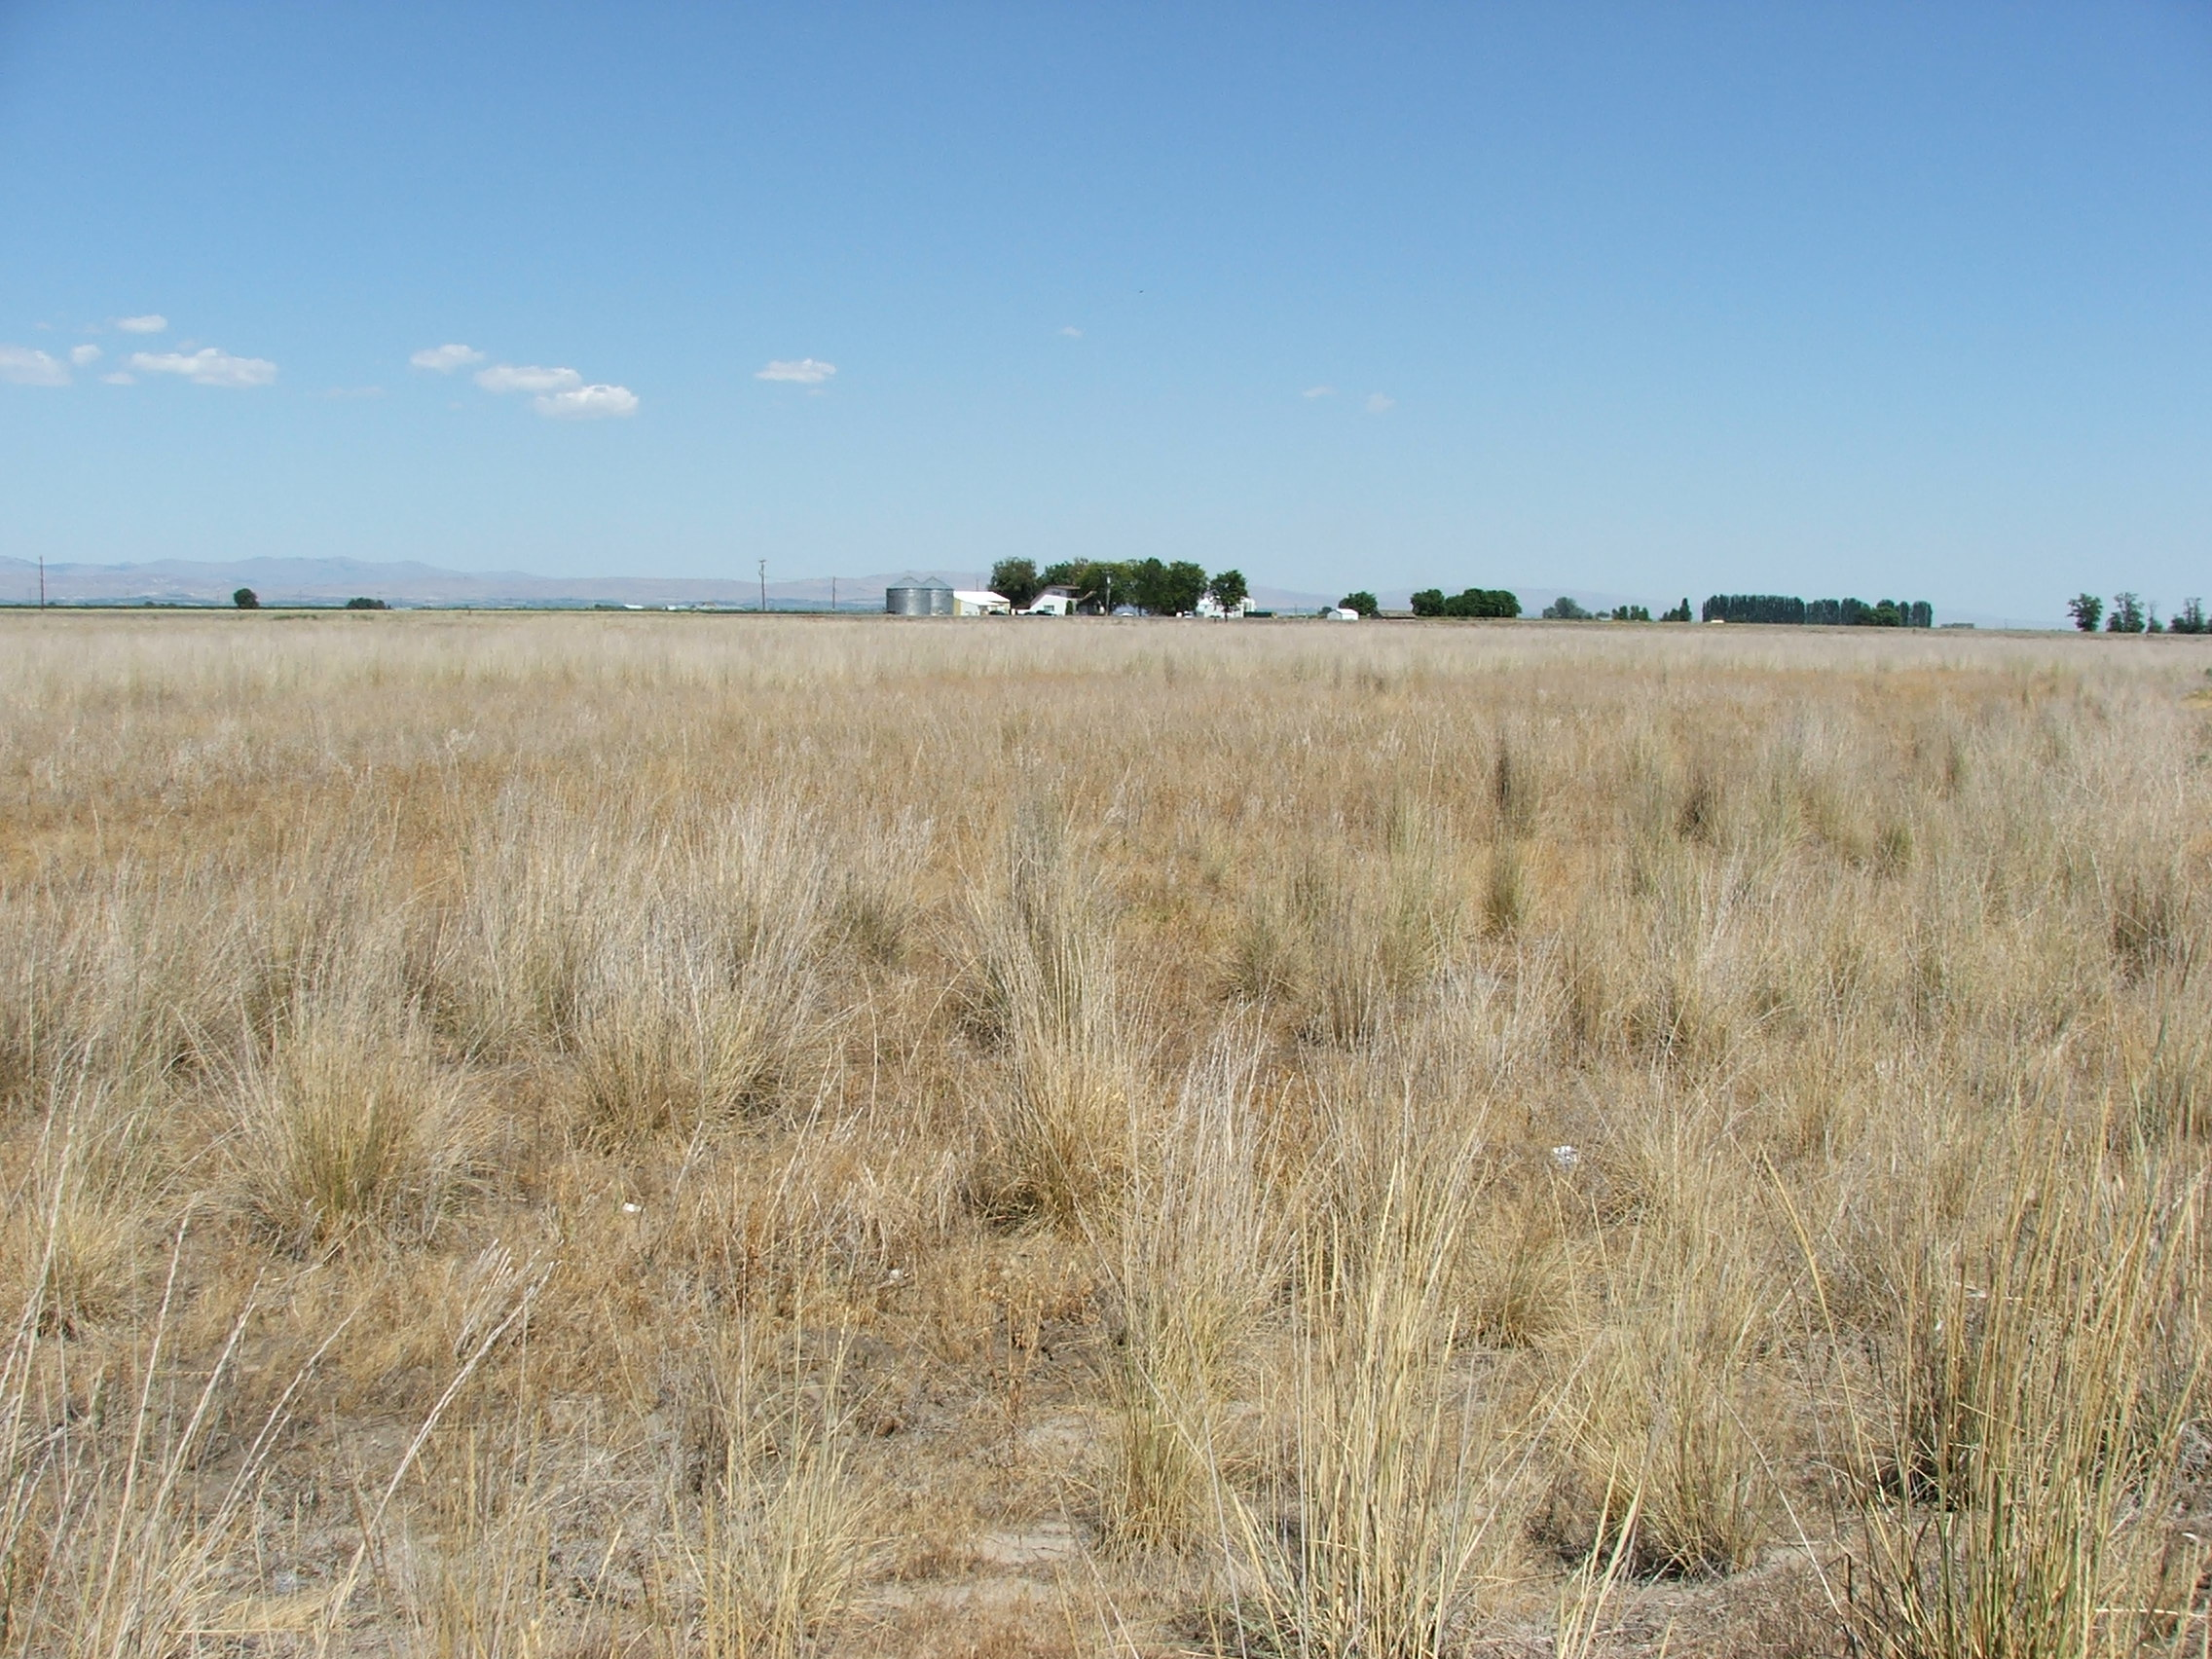

Goal 7) Provide access for traditional resource utilization for Yakama enrolled members. Provide supervised access for the non-enrolled public for the purposes of small game hunting, non-consumptive wildlife activities, and educational purposes.

Fences and gates have been installed on the property to restrict the accessibility of the property. An access management plan has been developed to ensure that the human use is compatible with resource protection and enhancement. The property has proved to be very attractive to those partaking in tule and waterfowl harvest activities.

Tule: (scirpus acutus)

The South Lateral A property represents one of the greatest successes of the Yakama Nation’s Wetlands Restoration Project with the emergence of culturally significant marsh plants. The most important of these plants is the tule reed. The tule reed continues to be harvested by the Yakama people on an annual basis at the South Lateral A property. The South Lateral A property is open to Yakama Nation members each year for three weeks in mid to late summer for tule cutting. Traditional activities such as this have significant spiritual meaning to the Yakama People. We do not require harvest reporting of this sensitive information, therefore we do not monitor harvest. Casual observation shows tule harvest occurs regularly when the property is open. It is used in a variety of ways all of which are intimately tied to the Yakama culture and their traditional belief systems. Yakama women are responsible for the annual harvest of tule reeds although men and children sometimes accompany them in the harvest. Tule reeds are selected for harvest based on size and length. Cracked or split reeds are discarded as are reeds exhibiting black spot. The harvested tules are then tied into bundles and used to create woven mats.

Wapato: (Saggitaria sp.)

Another success has been the emergence of the traditional food plant Wapato which is called “stinstin” in the Yakama language. It is also known by the name “Indian Potato” or “Duck Potato”. Every year since restoration activities were initiated on the South Lateral A property, Wapato has flourished and multiplied in number. Yakama women traditionally harvested the plant by wading into the marsh and pulling the roots up with their feet as noted by Lewis and Clark in 1806. Monitoring traditional harvesting and use of Wapato is problematic at this time. Future restoration activities will monitor the effects of draining and burning the areas of Wapato concentration at the South Lateral A property.

Great Basin Wild Rye: (Elymus condensatus) Because these stands are just reaching maturation, traditional use of great basin rye has not been documented at this time. Future use of mature plants is anticipated.

Dogbane: (Agrocynum cannabium)

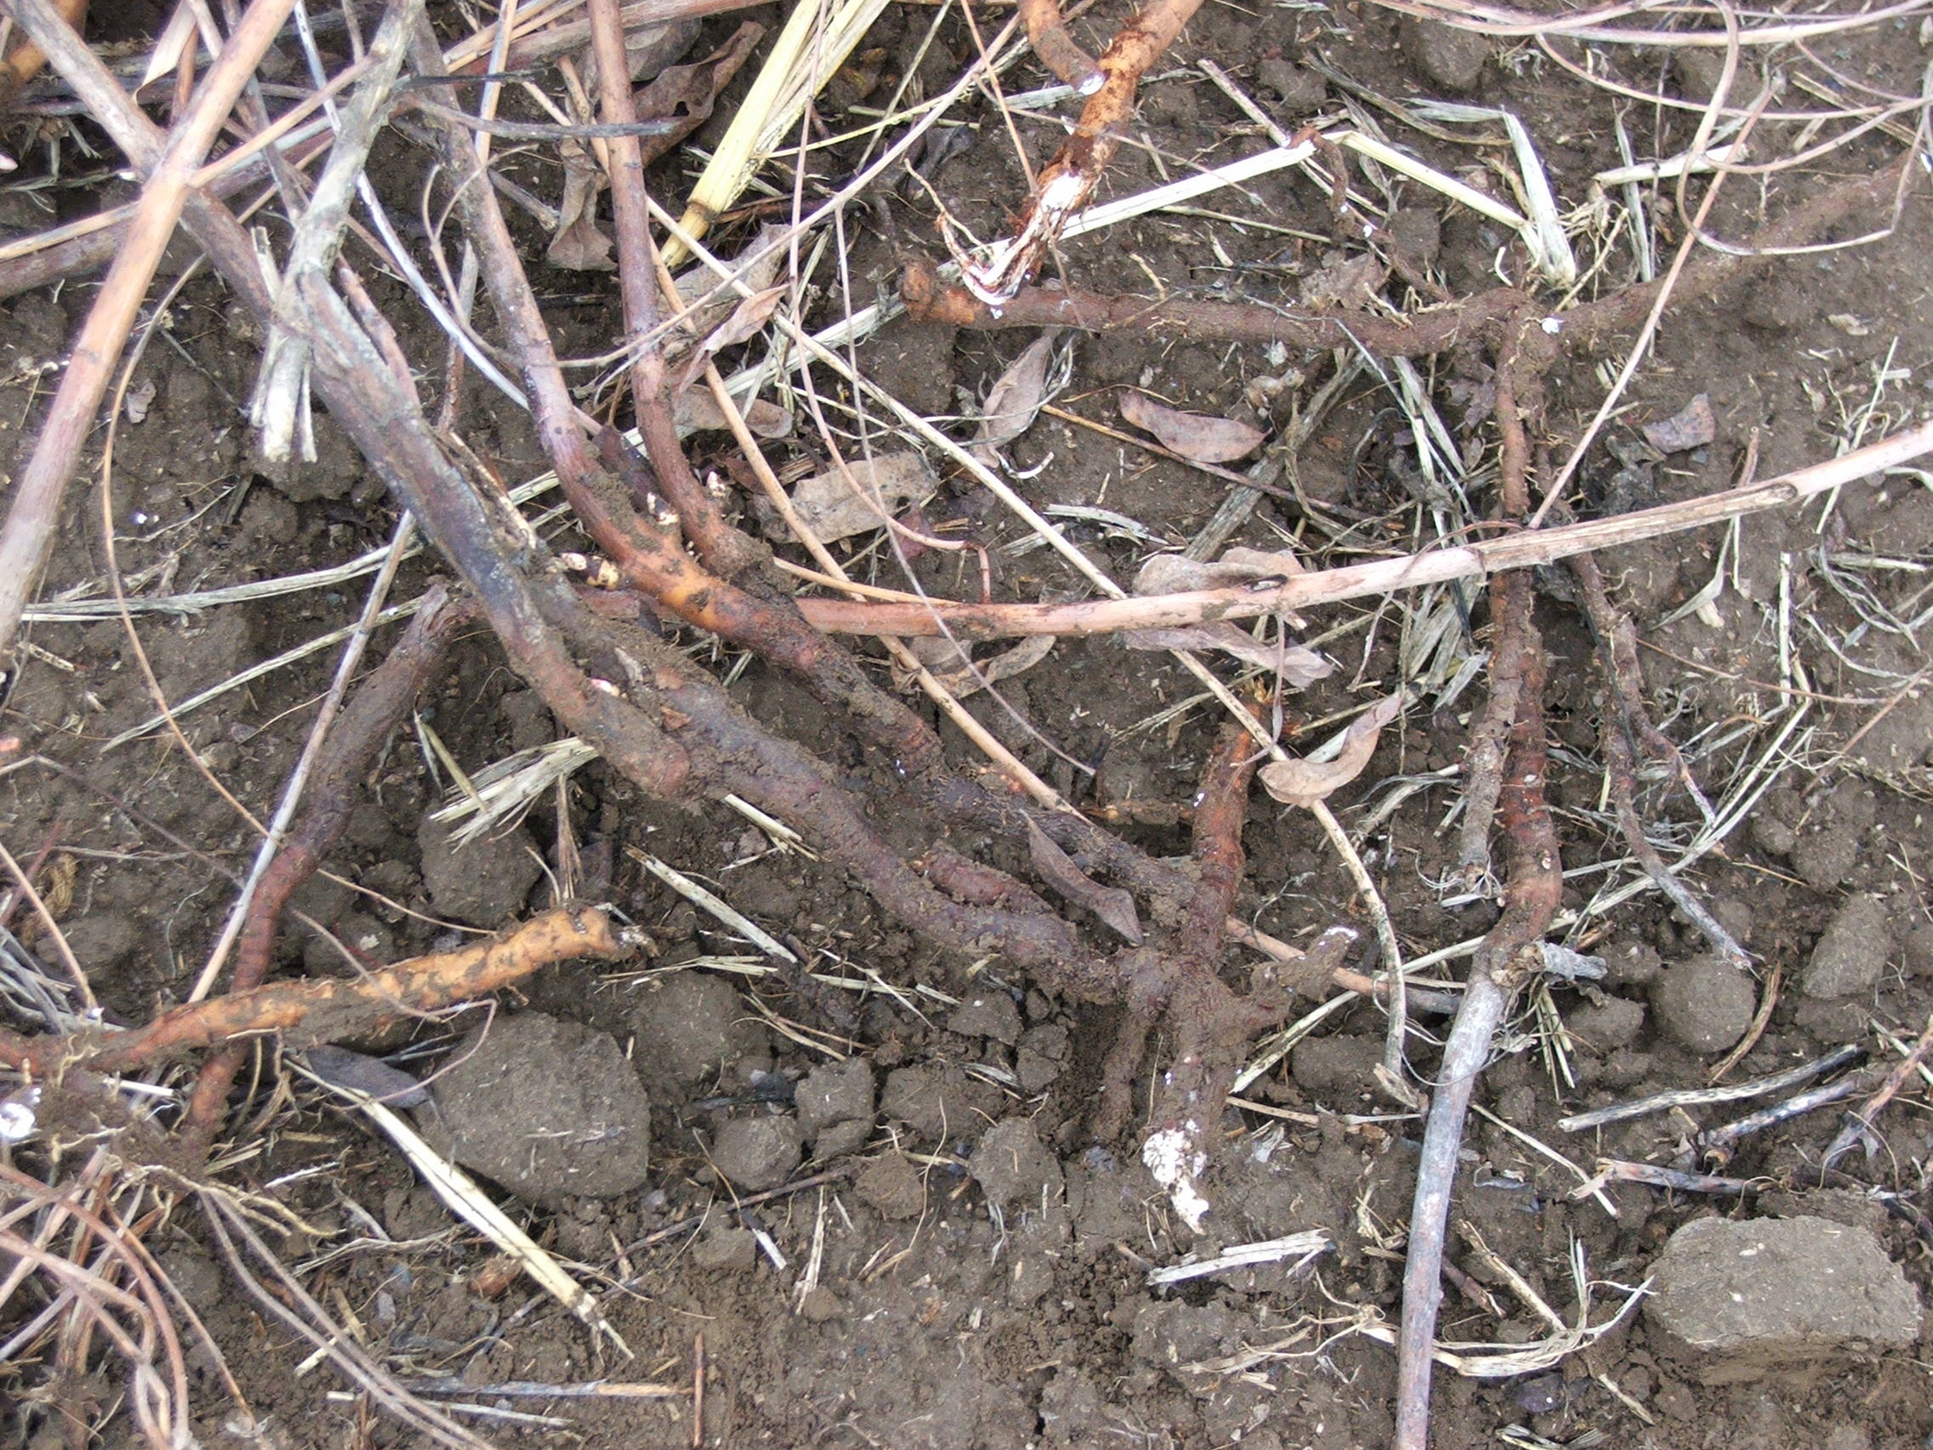

In November of 2005 the Yakama Nation Cultural Resources Program requested the Wetland Restoration Project’s assistance in the transplanting of Indian Hemp also known as dogbane to the South Lateral A property from a hop field on the reservation. The Yakama people call this “taxus” in their language. This species is traditionally used in weaving because of its fiber. Eighty- eight percent of the transplanted plants were successful in re-establishing themselves at the South Lateral A property. Monitoring tribal members’ use of this resource has not yet been implemented due to its recent introduction.

Waterfowl
Additional traditional resource utilization access to the South Lateral A property is also provided to Yakama Nation members for the purpose of waterfowl hunting. Yakama Nation members may hunt on any day at the South Lateral A property. Once again, because of the traditional nature of this activity, harvest reporting is inappropriate and not allowed. Casual estimates of tribal use range from fifteen to twenty hunter days per year.

References

Ashley, P. (2006). Yakama Nation HEP Data, 2002-2005, Yakama Nation Wildlife Program. Entered and summarized HEP transect data from 2002-2005.

Bich, J.P., T. Hames, et al. (1991). The Yakama Indian Nation Wildlife Mitigation Plan: For Bonneville, The Dalles, John Day, and McNary Dams. Draft Report for Public Comment. Portland, Oregon, Yakima Indian Nation Wildlife Resources Management, PO Box 151, Toppenish, WA 98948 for the Northwest Power Planning Council, 851, S.W. Sixth Avenue, Suite 1100, Portland, OR 97204-1348: 62.

Hames, T. (2000). Fiscal Year 2000 Annual Report, Yakama Nation Wetlands and Riparian Restoration Project. Toppenish, Washington, Yakama Nation Wildlife Resource Management Program to the Bonneville Power Administration: 48 plus figures and appendices.

Raedeke, K.J. and D.A. Raedeke (2000). Habitat Evaluation Procedures: Wildlife Management Areas Yakama Nation, Washington. Toppenish, WA, Yakama Nation Fish and Wildlife Program, PO Box 151 Toppenish, WA 98948: 42, plus 3 appendices.

