Project Narrative: Final Version
7/14/06

Project ID: #200719400

Title: Oak Flats Acquisition and Habitat Restoration
A. Abstract

Oak Flats is 357 acres of intact riparian and floodplain habitat near the confluence of the Naches and Tieton Rivers in Yakima County, WA. It is in a strategic and critical location for fish and wildlife in the Naches River basin. It is entirely bisected by the Naches River and is nearly surrounded by state ownership, particularly, the Oak Creek Wildlife Area. It is immediately adjacent to Highway 410 and Clemans Mountain, approximately 18 miles west of the city of Yakima.

This project proposes two phases to benefit fish and wildlife in the Yakima basin. Phase I would acquire the property and correct problems associated with the upstream major water diversion, open up side channel habitats, and restore natural floodplain function. Phase I would abate the immediate threat of residential development, and enable natural processes to fully occur. Phase II (not part of this grant request) would involve consolidation and improvement of irrigation diversions, and construction of off channel rearing habitats.

The project proposes to purchase fee title to these parcels, remove infrastructure impediments to restore natural river system function, and improve habitat components to benefit salmonid species. Acquisition of these parcels would guarantee protection of existing high-quality stream, riparian, and floodplain habitat within a reach identified in the Yakima Subbasin plan as Mid-elevation Naches River and would allow future habitat enhancements to best return the area to a natural functioning ecosystem. Improving elements such as off-channel rearing, floodplain functionality, riparian habitats, and water diversion efficiencies in this reach are identified the Yakima Subbasin plan as critical components for salmonid species. The Washington Department of Fish and Wildlife will provide match for this project through in-kind services and will absorb future operations and maintenance costs through management of the Oak Creek Wildlife Area.

The city of Yakima is the major landowner of the site. The city has determined the property is surplus to their needs and wishes to sell it. The owner of the small private in holding (to the city’s larger parcel) has expressed an interest in negotiating the sale of his parcel as well. The site is flat, has over 1.2 miles of river frontage, with graveled access roads directly to Highway 410. It is a prime location for rural development that would drastically reduce the area’s habitat value for fish and wildlife species, and likely eliminate enhancement or restoration opportunities. This project represents perhaps the last, best opportunity to protect in perpetuity a major portion of the remaining unprotected lands along the Naches River.
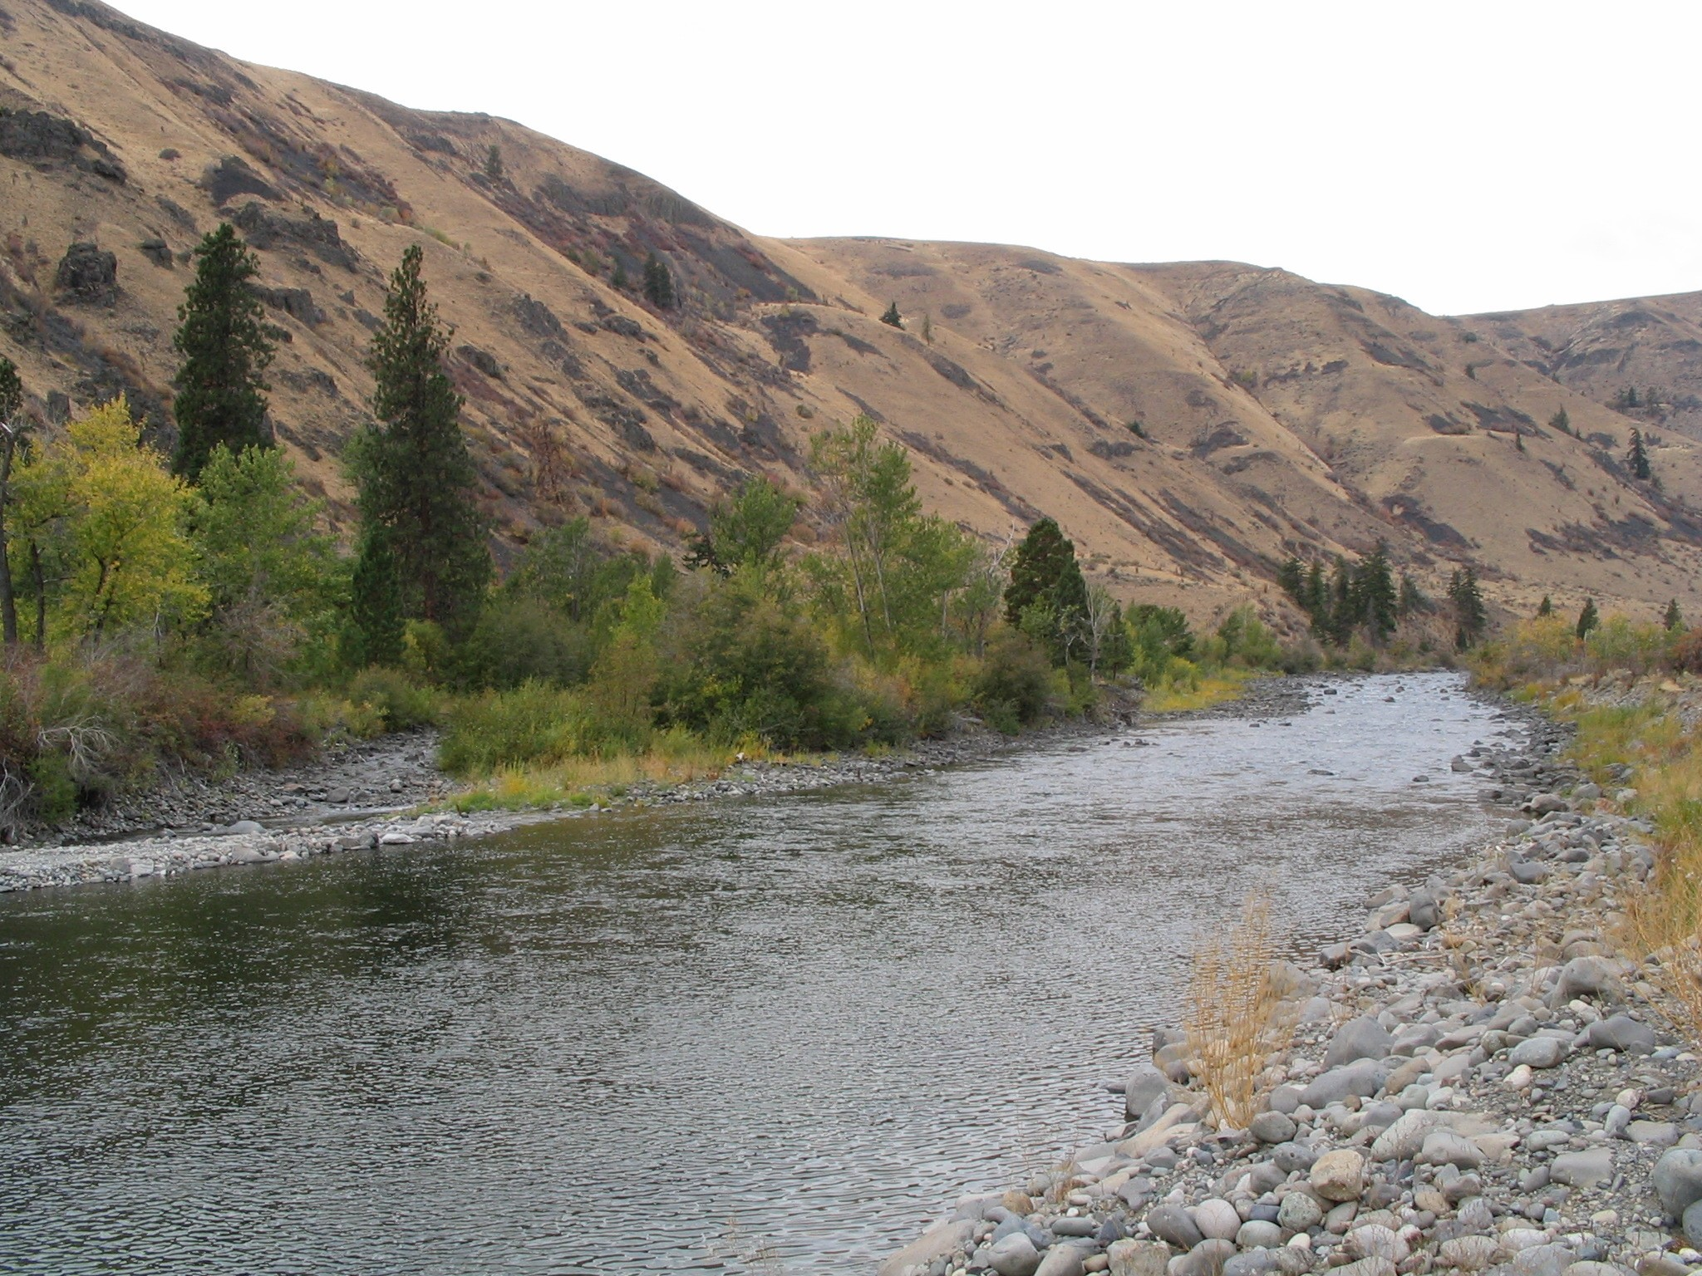Naches River on Oak Flats 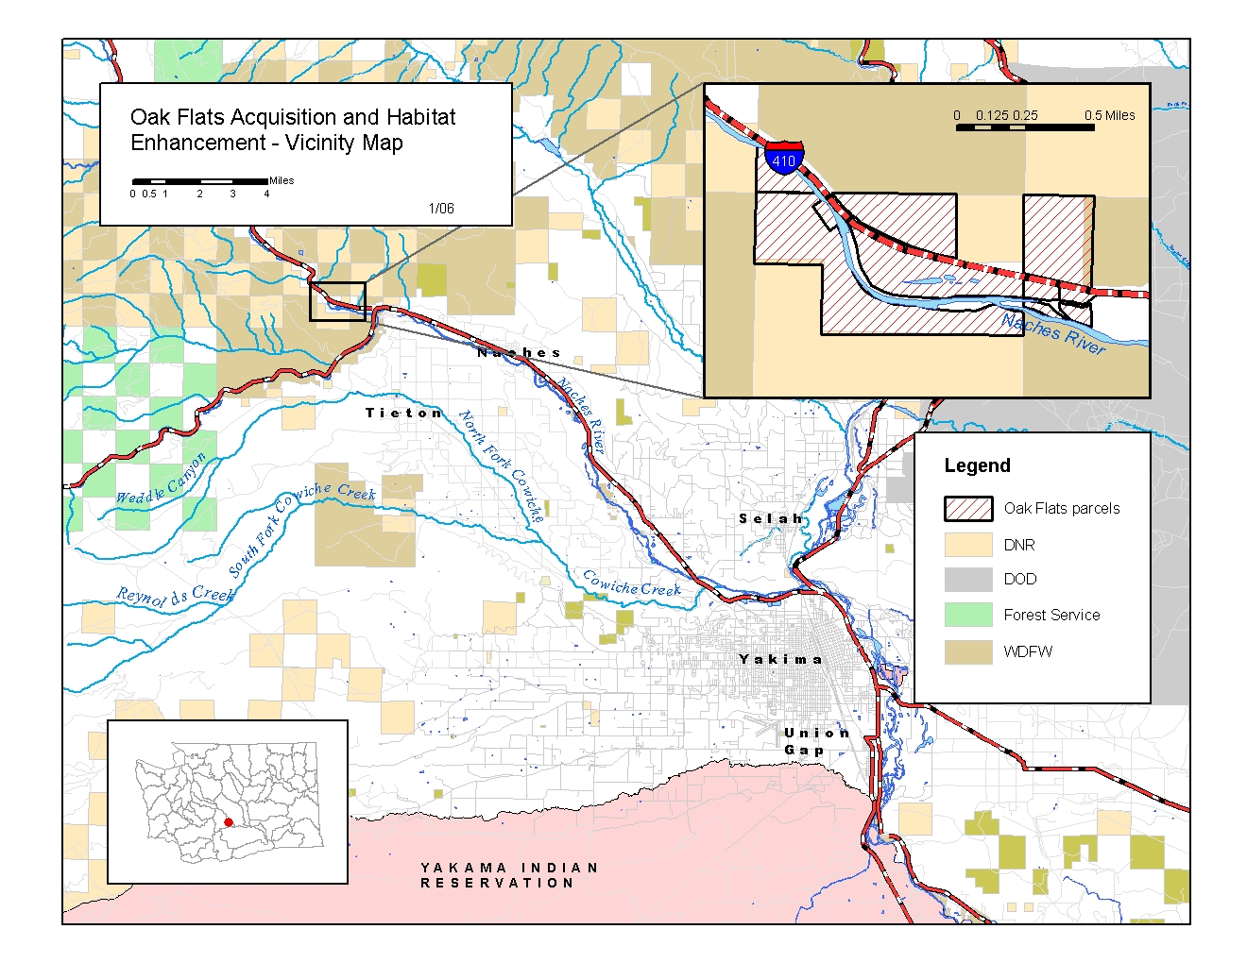
Oak Flats Locator map
B. Technical and/or scientific background
The project site is within the middle reaches of the Naches River, an area rich in fish and wildlife resources. It is located along the eastern edge of the Cascades, in a canyon setting near the forest edge, and within the shrub steppe habitat. Riparian habitats line the river.

The Naches Selah Irrigation District (NSID) operates a major irrigation diversion on the property that has been the subject of much discussion over the years. Abandoned and new facilities exist on the project site. NSID is considered a partner in this project.

Fish: Species present include federally listed bull trout and mid-Columbia steelhead, Chinook and coho salmon, resident Westslope cutthroat trout, whitefish, and others. Steelhead use the area for migration and rearing. Bull trout have been captured, radio-marked, and repeatedly relocated within this reach and on the project site, and are known to use this area year around. Spring Chinook from the American, Bumping and Naches River use the site for migration and rearing. Young over winter and rear in this portion of the Naches, and on the project area. The site is so strategic in the Naches basin that the Yakama Nation once considered this site for the Yakima River Supplementation facility (now located in Cle Elum).

Populations of target fish species in the Naches basin are low. Approximately 2,000 adult spring Chinook pass through this area headed for spawning grounds in the Little Naches, Bumping and American Rivers each year. Steelhead occur in low numbers as well, with only several hundred to just over 1,000 returning to the Naches in most years. Coho have been recently reintroduced to the system, and are beginning to return each year in larger numbers, which is still below 1,000 for the system. Juveniles of these species rear throughout the Naches system, and pre smolts have been located below the project. Bull trout numbers are largely unknown, but are believed to be only in the few hundred for the entire system. Ongoing radio telemetry work on bull trout has located wintering fish on the project area. (source, J. Cummins, WDFW). This project would support recovery and population increases for all of these species.

Wildlife Species and Habitats: Species associated with forest edge, riparian and shrub steppe habitats occur here. In particular, a winter concentration of federally threatened bald eagles uses the area as well, along with bighorn sheep, mule deer, and elk. Beaver, muskrat, and numerous passerine birds are found in the riparian habitats along the river.
Several focal habitats identified in the Yakima sub basin plan occur on the site: shrub-steppe, oak woodlands, riparian, and Ponderosa pine. Shrub steppe habitats are in good condition, largely due to the lack of fire or grazing by domestic stock for many years. Prickly pear cactus, an unusual species, occur here. Small stands of Oregon White oak represent the northernmost extent of this habitat type in the Yakima basin. Riparian vegetation is dense, and provides habitats for many species, as well as stabilizing the riverbanks.

This project would enable better population connectivity across the Naches River for bighorn sheep, mule deer and elk, all priority species for WDFW. Currently an elk fence cuts off access for these animals on both sides the river here, and could be relocated after completion of this acquisition. There are approximately 120 bighorn sheep in the Tieton River area, and 160 on Clemans mountain that are inhibited from exchange due to the fence along the project area. The same concept applies to elk. Approximately 2,600 elk winter on the south side of the Naches, and 2,000 north in the Wenas valley, with the Oak Flats project between these populations. This project would help with connectivity for these animals, as well as the hundreds of mule deer that use this range. If this land is sold for development, this possibility is eliminated, and damage concerns on developed lands from these animals will increase.

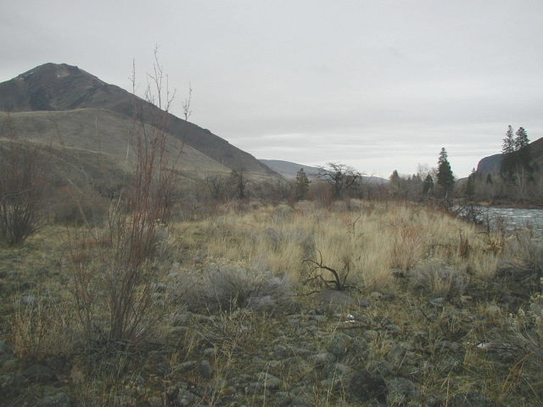
Oak Flats shrub steppe and mixed habitats

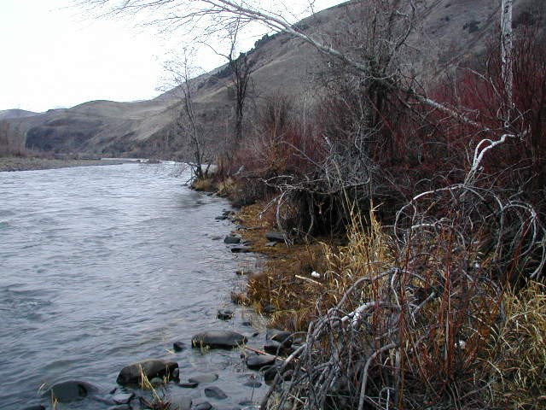
Riparian vegetation on Oak Flats

Fish habitats: Natural side channels shaded by cottonwood groves provide important rearing habitat for salmonids. Several of these channels occur along the Naches River, mostly on the south bank within two side channels. Opportunities for expansion of these exist in the future.
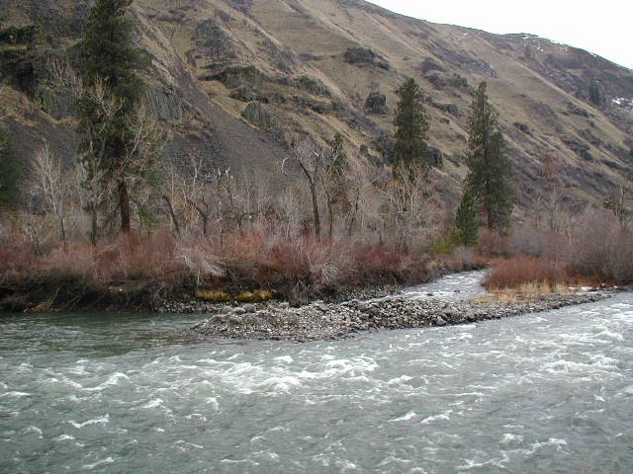
Bottom end of side channel habitat along Naches River, south bank, Oak Flats

On the north bank, an alluvial floodplain terrace contains old flow channels that were formerly used for irrigation conveyance from the upper abandoned diversion works. These channels could be reconnected to the river and provide excellent off channel rearing habitat in the future. The best opportunities for creation of limiting off channel rearing habitats on this project exist here, on the north bank.
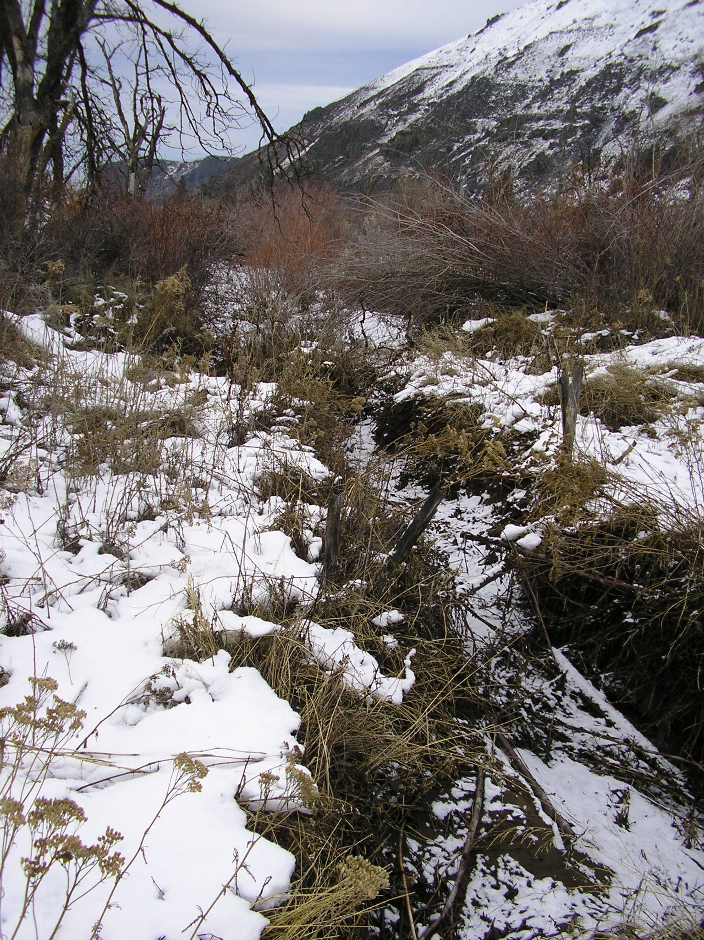
Old channel habitat on Oak Flats

Hydrologic resources of the site support a large downstream wetland along Highway 410, with connected emergent and open water habitats. A fish-passable perennial overflow channel that partially drains these wetlands at the junction of Highways 12 and 410, is a Washington State Department of Transportation mitigation site. Chinook salmon parr were observed ascending this temperature-moderated channel during January 2005. This wetland pond is productive thermal refuge during winter.

Irrigation infrastructure has been a major factor affecting Naches River channel morphology in the project area. Channel armoring along with riverbed dredging and filling, both associated with the creation of impoundments and conveyance channels for the facilitation of gravity diversions have all been constructed, utilized, reconstructed and/or abandoned. These disturbances tend to increase local entrainment of bed material, which can creates instability and bed scour downstream. Moderate disconnection of the south-bank floodplain that is now part of the Oak Creek Wildlife Area from groundwater can be concluded based on its live and dead vegetation and geomorphology. This project would help reconnect this area. A relatively young alluvial terrace with poorly developed soils occurs on the north bank. Areas of floodplain accessed by floodwater in 1996 are scoured laterally into the higher terrace.

There are two diversion structures within the Oak Flats. An abandoned and deteriorated concrete dam spans the Naches River at the upper end. This was associated with an intake for the City of Yakima’s municipal water supply (now relocated southeast of the
Town of Naches).
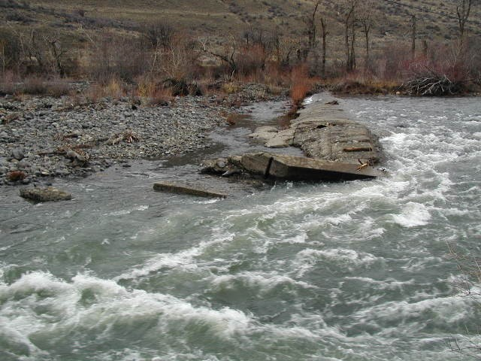

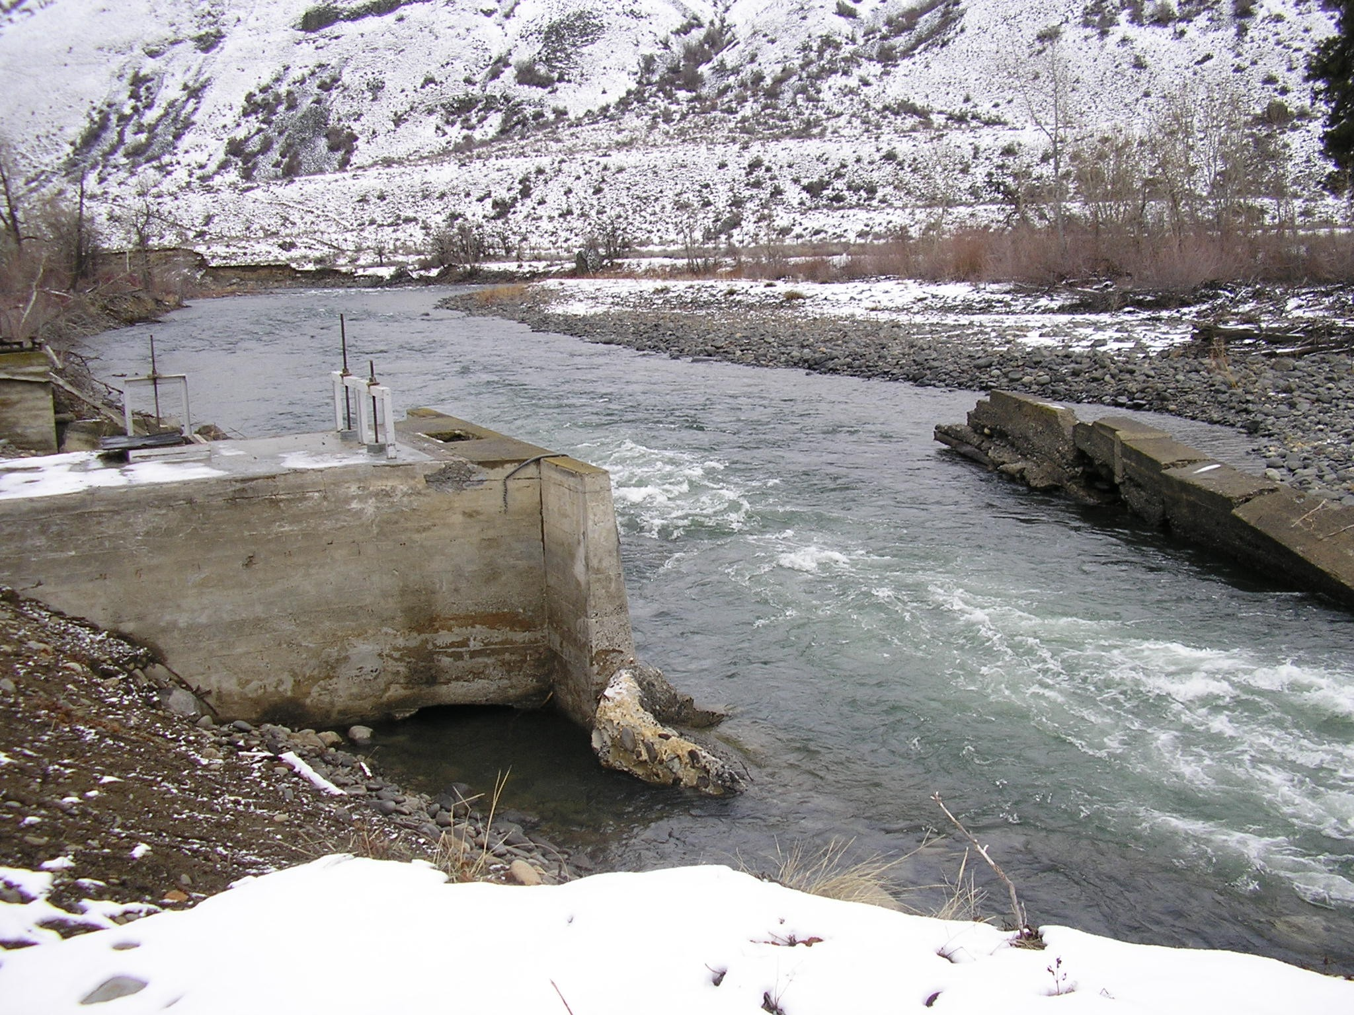
Old Water diversion structures at upper end Oak Flats project, proposed to be removed in Phase I. Above view is just to right of lower view.

A second active water diversion site serves the Naches Selah Irrigation District (NSID). The second structure, a now-massive armored gravel check-dam, located at about the middle of the Oak flats area, is annually reformed, in part, by the NSID.
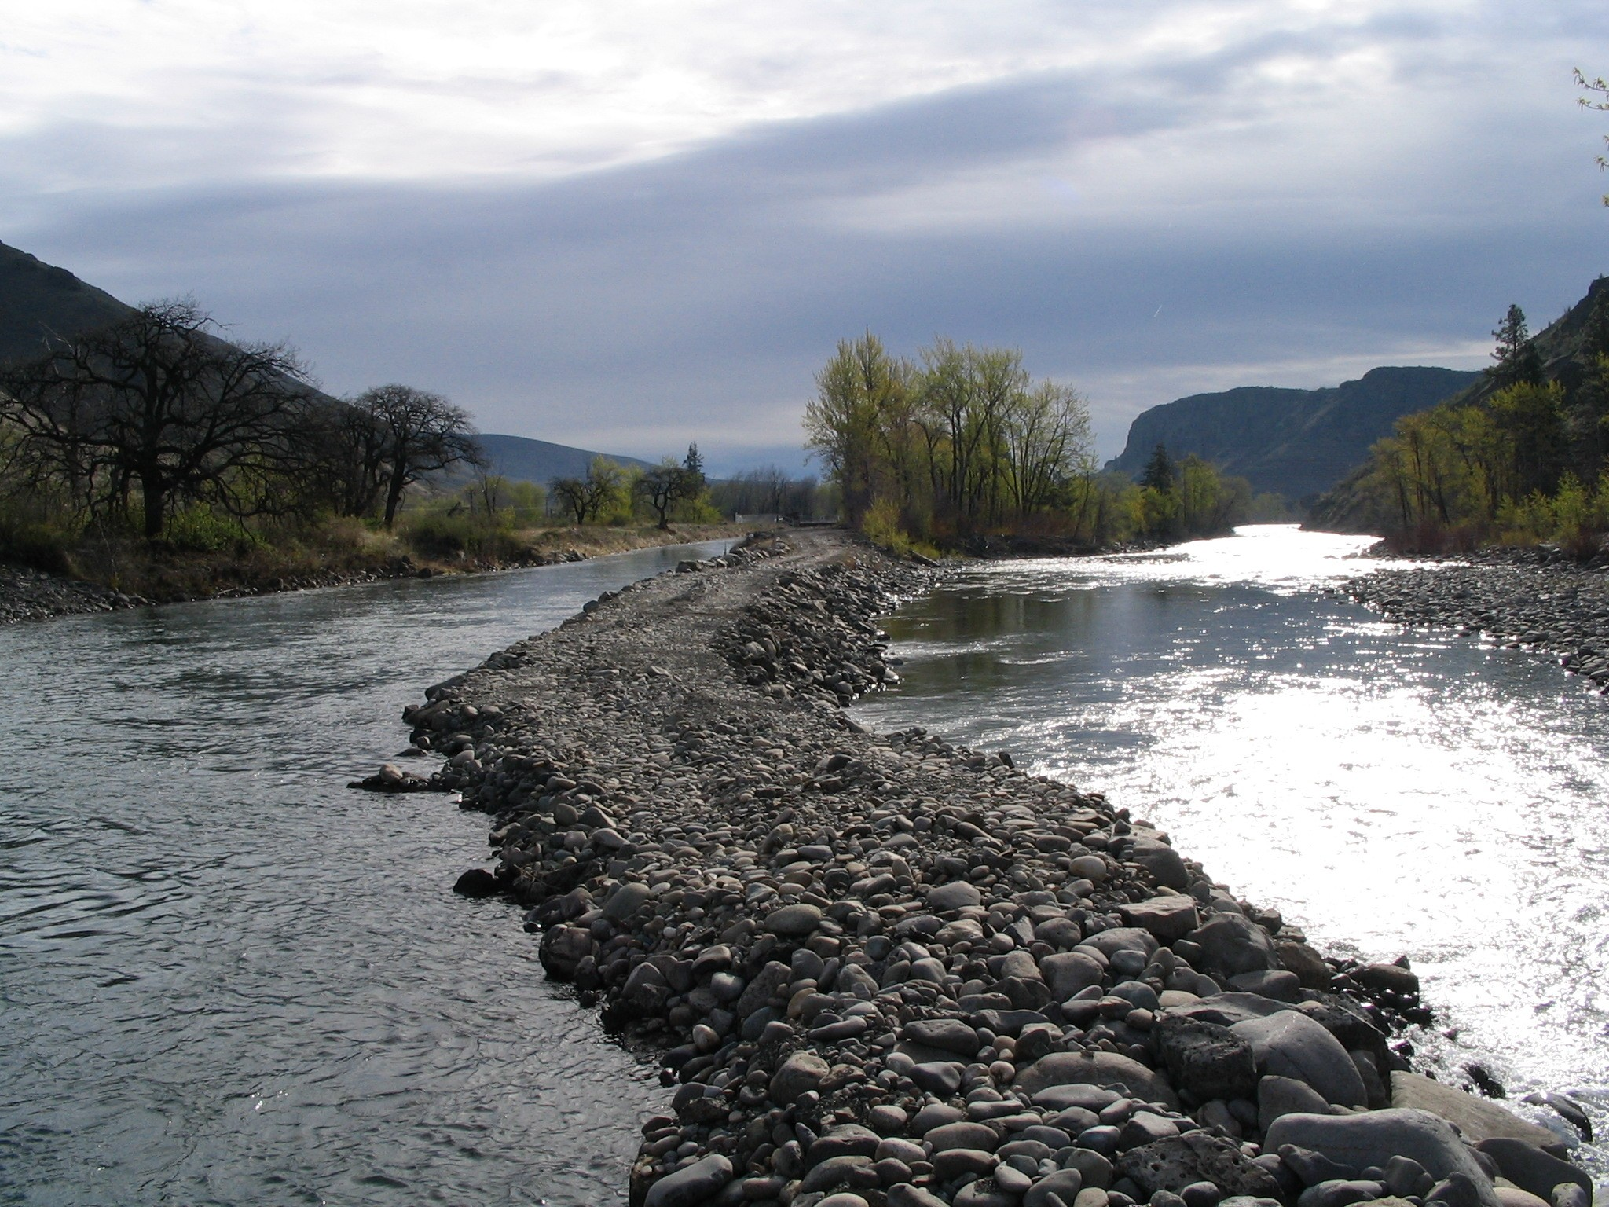
NSID wing dam across Naches River, 2005. Oak Flats project site.

Due to the streambed degradation that results, it has progressively needed to be higher, wider, and longer (angled upstream) to provide a diversionary pool with equivalent elevation over time. Whereas a partial “wing dam” sufficed to achieve the needed hydraulic head in the past, the current structure spans bank-to-bank and only side channels convey non-critical channel flow around the structure. This presents increasing challenges to adult as well as juvenile fish passage conditions. Phase II would correct this situation utilizing roughened channels, or other appropriate channel modification methods, and reduce the influences of this diversion on the Naches River. It may be possible to consolidate all diversions in the future to this site, and enable the removal of the downstream Wapatox dam, one mile below, as well.

As a significant part of Phase I, removal of the abandoned upper diversion works will likely eliminate much of the right bank channel constraint and encourage waters to utilize the floodplain. Renewed lateral hydraulic scour would reduce down-stream energies, help arrest bed scour, and encourage sediment deposition from the more sediment-rich flows. In combination, these processes will encourage increased sinuosity in- and off-channel avulsion along- the high-energy main channel. Phase I removal of this structure, and removal of remnants of old dikes along the left bank that constrain the river in high flows, would improve natural flood plain function, and therefore fish habitat.

Initial restorative efforts will focus on removal of approx. 750 feet of remnant dikes that were originally installed by the City of Yakima to divert high river flow away from the pipelines, water diversion structures, and settlement ponds used to treat Naches River water for municipal use. The large in-stream concrete headgate structure and remnant concrete diversion dam will also be demolished and removed by use of a large tracked excavator. These structures currently constrict flow and increase velocity considerably, down cutting the main river channel and impacting fish passage (photo above). Some of the large debris may be spread out and placed in the deeper channel to help retain bedload sediments and reduce velocity.

The diversion pipeline / open ditch channel and connective ponds supports heavy willow thickets and other riparian vegetation and will be retained, and with removal of the river containment dikes, will convert to a more natural side channel. An outlet passage from the end of this open ditch back to the main channel will be constructed downstream, utilizing a small backhoe. Additional side channel recruitment and channel migration will be promoted by lowering or removing upstream restrictions. All of this restoration work will benefit salmonid species by increasing off-channel rearing and feeding habitats.

The NSID has expressed desire to improve their diversion scenario by using a site significantly farther upstream. Opportunity to create a more acceptable off-channel diversionary system for the NSID’s water requires considerable land acreage upstream, not currently held. Permitting and construction of such a system could much more easily integrate with a comprehensive floodplain restoration plan and property retained in public ownership. This project would help facilitate these goals.

In short, acquisition of this land, from a willing seller, the City of Yakima, and working with the NSID and other partners to improve habitat, would greatly benefit fish and wildlife in the Yakima basin. Without this project, this land will likely be lost to residential development, and opportunities for habitat work will be gone.

C. Rationale and significance to regional programs
Bull trout are identified in the Oak Creek Management Plan as a focal species associated with naturally functioning mountain stream eco-types providing clear, cold water, shaded stream channels, and appropriate streambed substrate to promote redd development. One of the highest priorities in this management plan has been protection of these habitats. An extension of this objective would be acquisition of and eventual enhancement of salmonid habitat found within the Naches River reach in the Oak Flats project.

Staff from the Oak Creek Wildlife Area, who would manage the site, will work with WDFW regional staff to monitor habitat conditions on the site, and the results of restoration work. Habitat information would be maintained by WDFW. Monitoring of populations of target fish species would continue through the large Yakima Klickitat Fisheries Project, working cooperatively with the Yakama Nation, WDFW w/ USFWS bull trout study, and USFS habitat and population monitoring upstream on the Wenatchee National Forest. Restoration work would occur under contracts, likely administered by WDFW, who would ensure the work was accomplished to high standards.

Currently, the City of Yakima is willing to negotiate the sale of these parcels exclusively with WDFW to secure permanent protection of this riverine habitat for fish and wildlife use, but land developers have also been identified that are interested in purchase negotiations. Accepted biological opinion holds that if rural development occurs within natural stream corridors, fragmentation and loss of habitat and reduced riparian function will occur.

This project relates directly with the strategies identified in Chapter 1 of the Yakima Sub Basin Plan under Section 1.1.1, to protect habitat locations currently functioning at a high level and important to the overall life history of one or more focal species by directly purchasing land offered by a willing seller. A similar objective is identified in Table 6 of the Plan Supplement (Nov 26, 2004) as a primary strategy to improve Interior Riparian Wetlands by maintaining and/or improving the instream and groundwater hydrologic regime. Also, in Chapter 3, Section 3.5.6 of the Sub Basin Plan, loss of off-channel habitat is identified with placement of obstructions associated with infrastructure, such as would result from allowing rural development to occur on the project area.

The EDT model in the Yakima Sub basin plan identifies this area within the “Naches River” in their analysis for various species. Ranking under the EDT model ladder chart for Naches spring Chinook (Sub basin plan fig 2-101, p. 2-386) ranks the Naches geographic area (project included) as Protection benefit, Category A, rank #1. The same ranking criteria for steelhead, ranks this area as Protection benefit Category B, rank #2, out of 9. For Coho, in a similar ranking criteria, both for Protection and Restoration, the Naches area ranks as Category A, and rank #1. Thus, utilizing the EDT method, the Oak Flats project in within an area that ranks very, very high for work necessary to protect and restore Chinook, steelhead, and coho.
D. Relationships to other projects

This project would support the recovery efforts of many projects that have occurred in the Yakima and Naches River basins. In Chapter 3 of the Yakima Sub Basin Plan - Within the Yakima Subbasin, on-the-ground restoration and conservation projects are described in Appendix G and H. The restoration and conservation projects section in this chapter summarizes information about these projects to illustrate the current management directions and strategies.

Significant portions of the Naches are in protected status well upstream, particularly beginning 14 miles NW where the system enters the Wenatchee National Forest. There are about 3 miles of river protected in the lower reaches of the Naches, approximately 8 miles downstream (Yakama Nation/ BPA projects), and about 1 mile owned by WDFW just upstream from the project area. There is a pressing need to protect more of the Naches River in this section of the stream.

Recently, in stream flow has been improved through Bureau of Reclamation acquisition of the nearby Wapatox canal and hydroelectric project. This project provides more instream flows for the lower Naches River, beginning about 1 mile downstream of Oak Flats, by eliminating the small-scale hydroelectric generation on this antiquated system. Protection of the Oak Flats river reach just upstream supports this effort by providing habitat for fish directly benefiting from increased Naches flows.

This project supports goals of the Oak Creek Management plan. The Oak Creek Wildlife Area is a long term project of the WDFW. Efforts have been made to consolidate and link blocks of lands here for many years. Recently, the Tieton Project partnered WDFW w/ The Nature Conservancy, Rocky Mountain Elk Foundation, the U.S. Fish and Wildlife Service, (supported by Yakima County), to acquire 10,400 acres of timber company inholding lands. The Foundation for North American Wild Sheep worked with WDFW recently to acquire a small inholding parcel on Clemans Mountain, within 2 miles of Oak Flats. WDFW is currently working with WA DNR on a land trade to block up management ownerships in this region. All of the state lands in the area will go to WDFW. This project compliments and expands these efforts by connecting blocks of Oak Creek across the Naches River in a very important area for fish, wildlife and recreation.
WDFW actively seeks to acquire inholdings, such as this one, to their wildlife areas. This project would link WDFW lands north and south of the Naches River, in the only location where this is possible now.

E. Project history (for ongoing projects)
N / A - New project

F. Proposal biological objectives, work elements, and methods
All of the elements in this project would support these, and other, objectives stated in the Yakima Sub basin plan:
Restore riparian and floodplain function
Floodplain functionality & protection-
Reconnect side channel habitats
Improve habitat diversity by restoring flow to stream channels, side channels, etc.
Restore channel form by removal of levees, diversion dams.
Reduce stream and river constriction
Replace/ redesign diversion dams to allow passage
Improve stream function by reducing disturbance to riparian zones, and replanting
Protect & supplement cottonwood and P. pine riparian groves
Protect significant focal habitats- including shrub steppe, riparian and oak woodlands.
G. Facilities and equipment

All major facilities and equipment that will be used to support this project after acquisition will be provided by existing infrastructure on the adjacent WDFW Oak Creek Wildlife Area. This parcel would be a natural addition to the adjacent Oak Creek Wildlife Area.

The project lands will be administered from the Oak Creek headquarters office, located less than three highway miles south of the project boundary. All contemporary administrative support equipment such as computers, printers, fax, telephone service, GPS units, and field vehicles are available for use. Heavy equipment such as bulldozers, backhoe, tractors, front-end loaders, and large trucks are also available to implement future construction and/or habitat enhancement projects, with available staff trained in use and operations.

H. References

Yakima Sub-Basin Plan 2004
Yakima Sub-Basin Plan Supplement 2004
Oak Creek Wildlife Area Management Plan 1995
Comprehensive Water Conservation Plan for Naches-Selah Irrigation District 1995
Jeff Bernatowicz, WDFW, pers. Comm.
Eric Anderson, WDFW, pers. Comm.
Todd Newson, Yakama Nation, pers. Comm..
Mike Mizelle, WDFW, pers. Comm..
Jim Cummins, WDFW, pers. Comm.
I. Key personnel
Ken Bevis – WDFW Habitat Biologist

Eric Bartrand – WDFW Habitat Biologist

Eric Anderson – WDFW Fish Biologist

John McGowan – WDFW Wildlife Biologist / Oak Creek Wildlife Area manager

